State of Florida |  | Public Service Commission  Capital Circle Office Center ● 2540 Shumard Oak Boulevard  Tallahassee, Florida 32399-0850  -M-E-M-O-R-A-N-D-U-M-
DATE: | May 30, 2019
TO: | Office of Commission Clerk (Teitzman)
FROM: | Division of Accounting and Finance (D. Smith, Mouring, Snyder, L. Smith, D. Buys)  Division of Economics (Draper, Galloway, Guffey)  Division of Engineering (Buys, Thompson)  Office of the General Counsel (Dziechciarz, Weisenfeld)
RE: | Docket No. 20190110-EI – Petition for limited proceeding for recovery of incremental storm restoration costs related to Hurricane Michael and approval of second implementation stipulation, by Duke Energy Florida, LLC.
AGENDA: | 06/11/19 – Regular Agenda – Interested Persons May Participate
COMMISSIONERS ASSIGNED: |  |  | All Commissioners
PREHEARING OFFICER: |  |  | Fay
CRITICAL DATES: |  |  | 06/28/19 (Requested Implementation Date)
SPECIAL INSTRUCTIONS: |  |  | None

Case Background
On April 30, 2019, Duke Energy Florida, LLC (DEF or Company) filed a petition for a limited proceeding seeking authority to implement an interim storm restoration recovery charge to recover a total of $223.5 million for the incremental restoration costs related to Hurricane Michael and to replenish its storm reserve. This amount includes $2.5 million for: interest, bond issuance expense, and the regulatory assessment fee gross-up. DEF’s storm reserve was depleted as a result of Hurricanes Irma and Nate and DEF is seeking to replenish the storm reserve to the level authorized in the Second Revised and Restated 2017 Settlement Agreement (2017 Settlement) approved by the Commission in Order No. PSC-2017-0451-AS-EU.
DEF filed its petition pursuant to the provisions of the 2017 Settlement. Pursuant to the 2017 Settlement, DEF can recover storm costs, without a cap on the level of charges on customer bills, on an interim basis beginning 60 days following the filing of a petition for recovery. DEF proposes to implement an interim charge for a 12-month period effective July 2019. The interim charge results in an increase of $6.95 per 1,000 kilowatt hour (kWh) on a residential bill.
Included in the petition (and attached to this recommendation as Attachment A) is a proposed Second Implementation Stipulation (Stipulation). The Stipulation, if approved, would allow DEF to apply the tax savings approved by the Commission in Order No. PSC-2019-0053-FOF-EI to offset the storm recovery surcharge that was requested in this docket, and would replenish the storm reserve to a level authorized in the 2017 Settlement. The authorized level in the 2017 Settlement was $132 million. DEF, the Office of Public Counsel, Southern Alliance for Clean Energy, and White Springs Agricultural Chemical, Inc. agreed to the Stipulation. Florida Retail Federation, and Florida Industrial Power Users group took no position on the Stipulation.
The appropriate time for the Commission to discuss and vote on the Stipulation is after the Commission renders a decision on Issue 1. If approved, then pursuant to Paragraph 4 of the Stipulation DEF will withdraw the proposed Eighty-Fifth Revised Tariff Sheet No. 6.105, and Issue 2 will be rendered moot.
The Commission has jurisdiction over this matter pursuant to Sections 366.04, 366.05, 366.06, and 366.076, Florida Statutes.

Discussion of Issues
Issue 1: Should the Commission authorize DEF to implement an interim storm restoration recovery charge?
Recommendation: Yes, the Commission should authorize DEF to implement an interim storm restoration recovery charge. Once the total actual storm costs are known, DEF should be required to file documentation of the total storm costs for Commission review and true-up of any excess or shortfall. (Snyder, Mouring)
Staff Analysis: As stated in the Case Background, DEF filed a petition for a limited proceeding seeking authority to implement an interim storm restoration recovery charge to recover a total of $223.5 million for the incremental restoration costs related to Hurricane Michael. The $223.5 million includes $2.5 million for interest, bond issuance expense, and a regulatory assessment fee gross-up. The petition was filed pursuant to the provisions of the 2017 Settlement approved by the Commission in Order No. PSC-2017-0451-AS-EU. Pursuant to Paragraph 38 of the 2017 Settlement, DEF can begin recovery of storm costs, without a cap, 60 days following the filing of a petition for recovery. DEF has requested an interim storm restoration recovery charge to implement for a 12-month period, effective July 2019 through June 2020.
In its petition, DEF asserts that it incurred total retail recoverable costs of approximately $223.5 million as a result of Hurricane Michael. DEF further asserts that this amount was calculated in accordance with the Incremental Cost and Capitalization Approach (ICCA) methodology prescribed in Rule 25-6.0143, Florida Administrative Code (F.A.C.).
The approval of an interim storm restoration recovery charge is preliminary in nature and is subject to refund pending further review once the total actual storm restoration costs are known. After the actual costs are reviewed for prudence and reasonableness, and are compared to the actual amount recovered through the interim storm restoration recovery charge, a determination will be made whether any over/under recovery has occurred. The disposition of any over/under recovery, and associated interest, would be considered by the Commission at a later date.
Based on a review of the information provided by DEF in its petition, staff recommends that the Commission authorize DEF to implement an interim storm restoration recovery charge subject to refund. Once the total actual storm costs are known, DEF should be required to file documentation of the storm costs for Commission review and true-up of any excess or shortfall. Staff emphasizes that this recommendation is only for interim recovery charges and is not a confirmation or endorsement of the prudence of DEF’s forecasted costs and plans. This recommendation only allows DEF to begin recovery on an interim basis in accordance with the 2017 Settlement. This interim recovery is subject to refund following a hearing or formal proceeding where the veracity and prudence of DEF’s actual restoration costs can be fully vetted.

Issue 2: Should the Commission approve DEF’s proposed Hurricane Michael interim storm cost recovery surcharges?
Recommendation: Yes. The Commission should approve DEF’s Hurricane Michael interim storm cost recovery surcharges as proposed in the petition effective with the first billing cycle of July 2019, subject to a final true-up. (Guffey)
Staff Analysis: DEF is seeking approval of interim storm cost recovery surcharges associated with Hurricane Michael as shown in revised Tariff Sheet Nos. 6.105 and 6.106 (Attachment B to this recommendation). The surcharges will be applicable to all rate classes. Tariff Sheet Nos. 6.105 and 6.106 describe the proposed interim storm cost recovery surcharges and define the storm cost recovery surcharge, respectively. Page 4 of Appendix A of DEF’s petition shows the storm cost recovery allocation factors for all rate classes. For residential customers, the surcharge is 0.695 cents per kilowatt hour (kWh), which equates to $6.95 on a 1,000 kWh residential bill.
Conclusion: Staff recommends that the Commission approve DEF’s proposed Hurricane Michael interim storm cost recovery surcharges to be effective with the first billing cycle of July 2019 and ending with the last billing cycle of June 2020, subject to a final true-up.

Issue 3:
What is the appropriate security to guarantee the amount collected subject to refund through the interim storm restoration recovery charge?

Recommendation:
The appropriate security to guarantee the funds collected subject to refund is a corporate undertaking. (L. Smith, D. Buys)

Staff Analysis:
Staff recommends that all funds collected subject to refund be secured by a corporate undertaking. The criteria for a corporate undertaking include sufficient liquidity, ownership equity, profitability, and interest coverage to guarantee any potential refund. Staff reviewed DEF’s financial statements to determine if the Company can support a corporate undertaking to guarantee the funds collected for recovery of incremental storm restoration costs related to Hurricane Michael. DEF’s 2016, 2017, and 2018 financial statements were used to determine the financial condition of the Company. DEF’s financial performance demonstrates adequate levels of ownership equity, profitability, and interest coverage, but marginal liquidity due to negative working capital. However, the Company participates in Duke Energy Corporation’s money pool and has access to additional funds if needed.
Staff believes DEF has adequate resources to support a corporate undertaking in the amount requested. Based on this analysis, staff recommends that a corporate undertaking of $223.5 million is acceptable. This brief financial analysis is only appropriate for deciding if the Company can support a corporate undertaking in the amount proposed and should not be considered a finding regarding staff's position on other issues in this proceeding.

Issue 4: Should this docket be closed?

Recommendation: No, this docket should remain open pending final reconciliation of actual recoverable Hurricane Michael storm costs with the amount collected pursuant to the interim storm restoration recovery charge, and the calculation of a refund or additional charge if warranted. (Dziechciarz, Weisenfeld)
Staff Analysis: This docket should remain open pending final reconciliation of actual recoverable Hurricane Michael storm costs with the amount collected pursuant to the interim storm restoration recovery charge, and the calculation of a refund or additional charge if warranted.

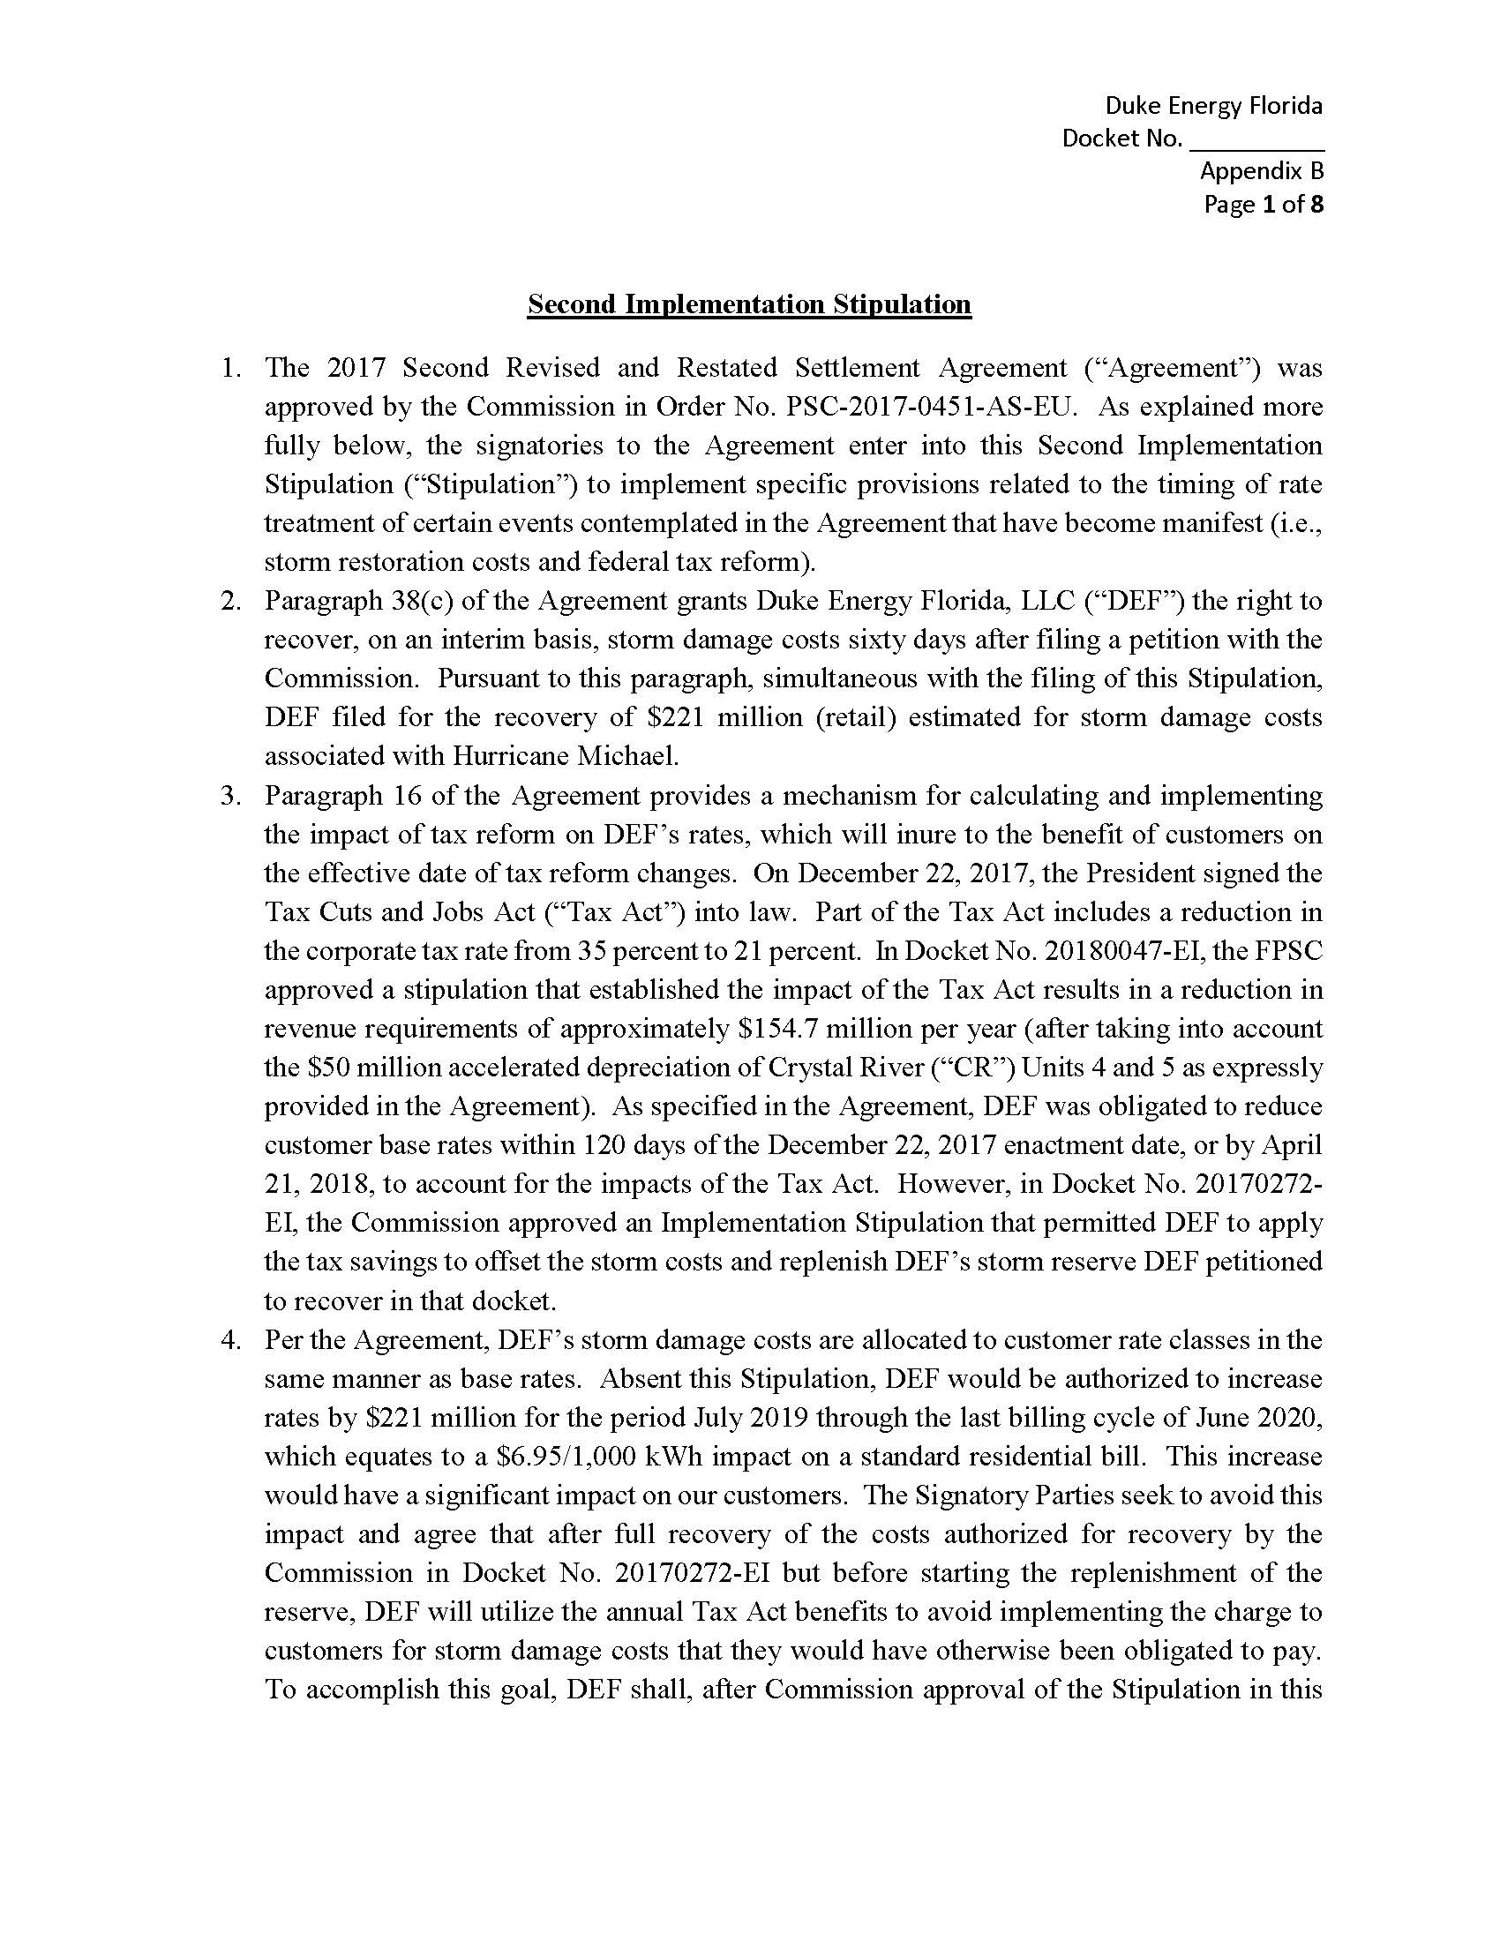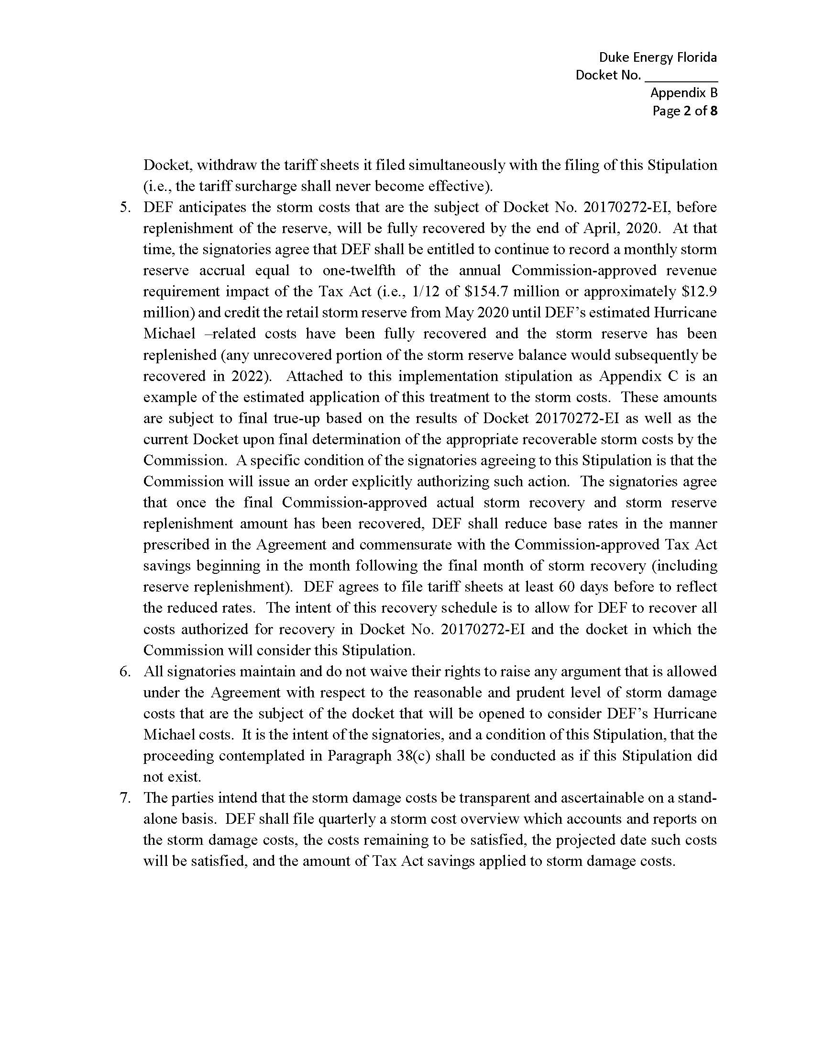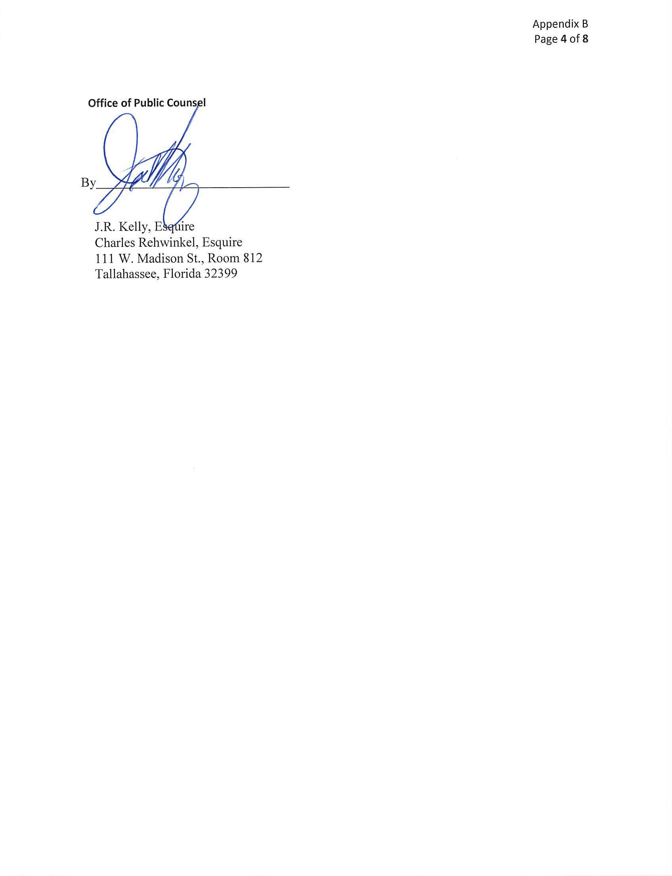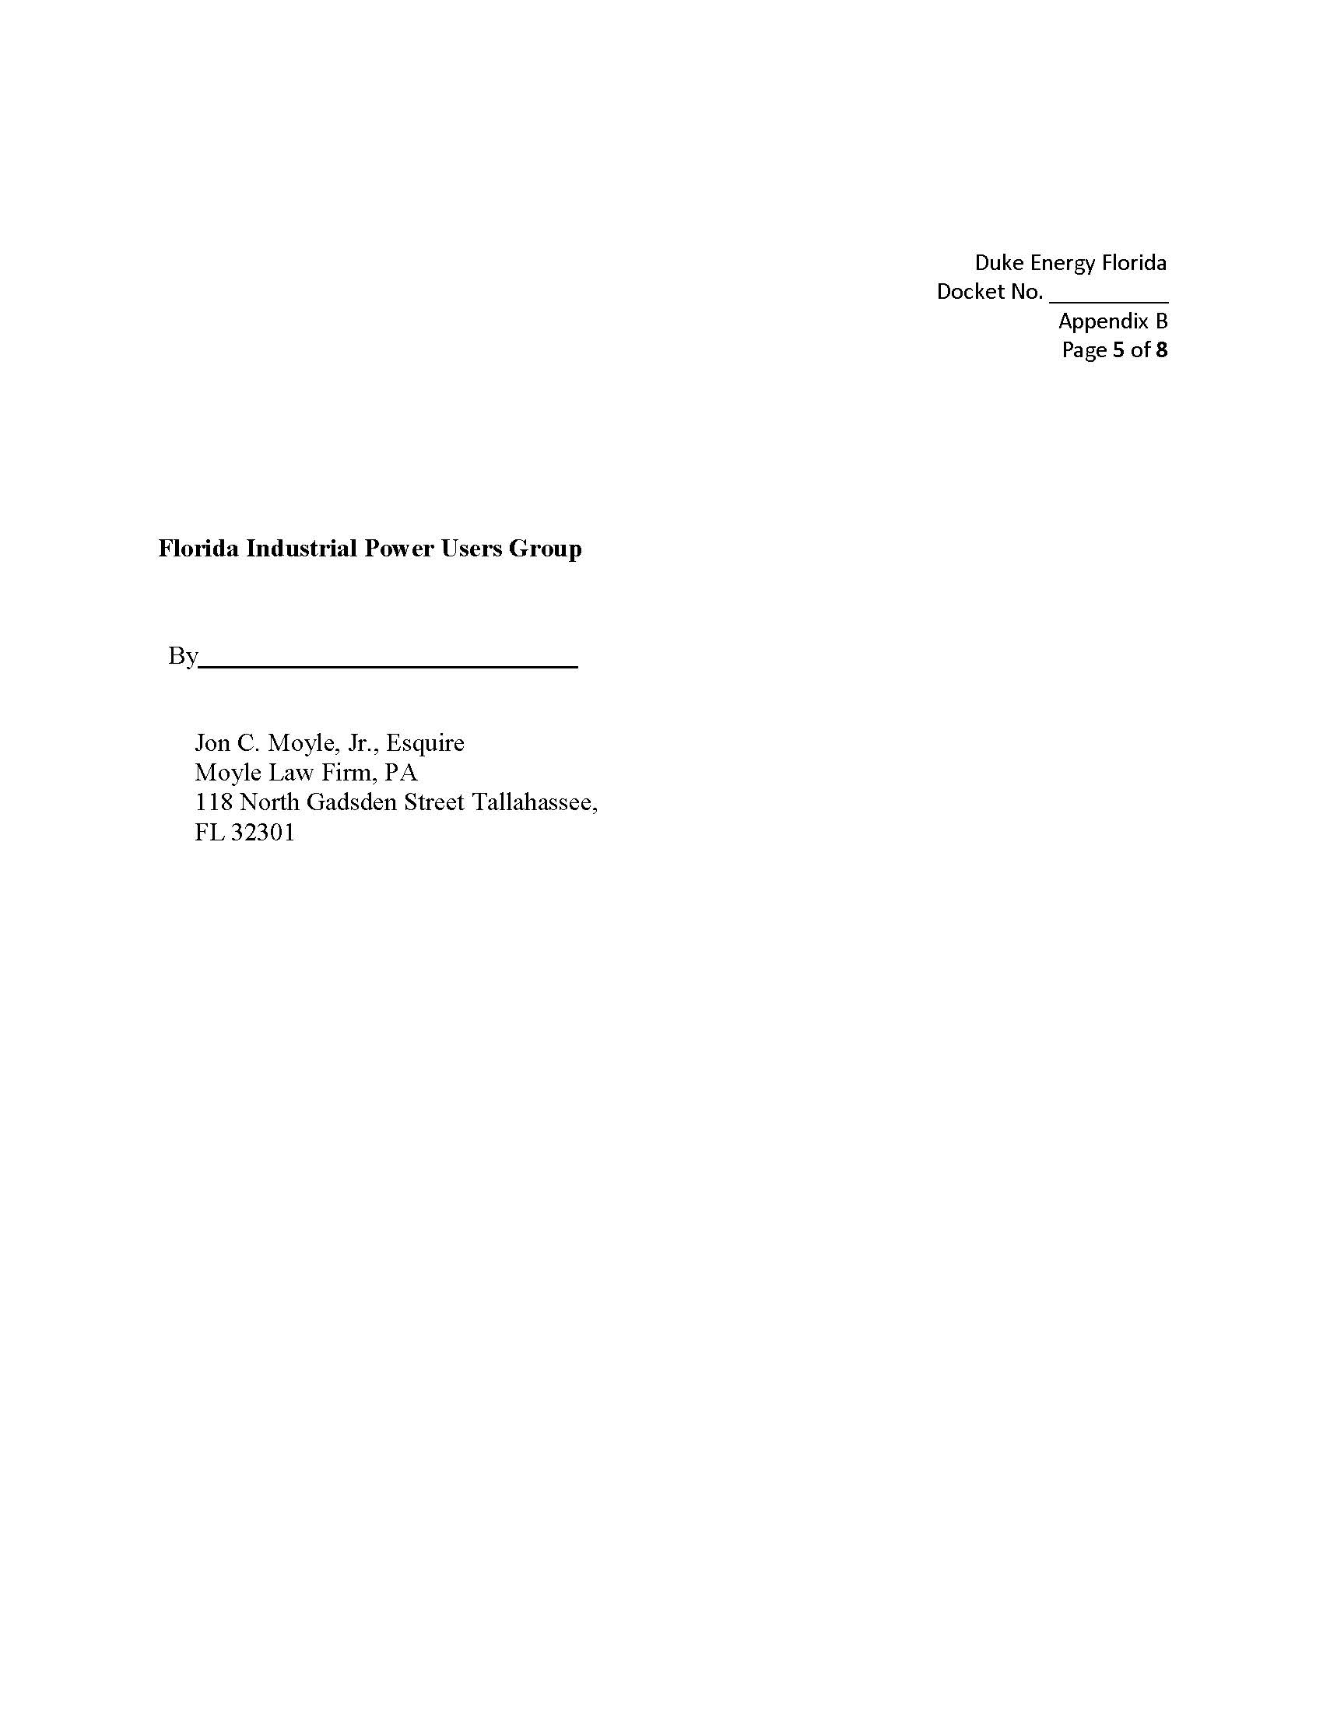
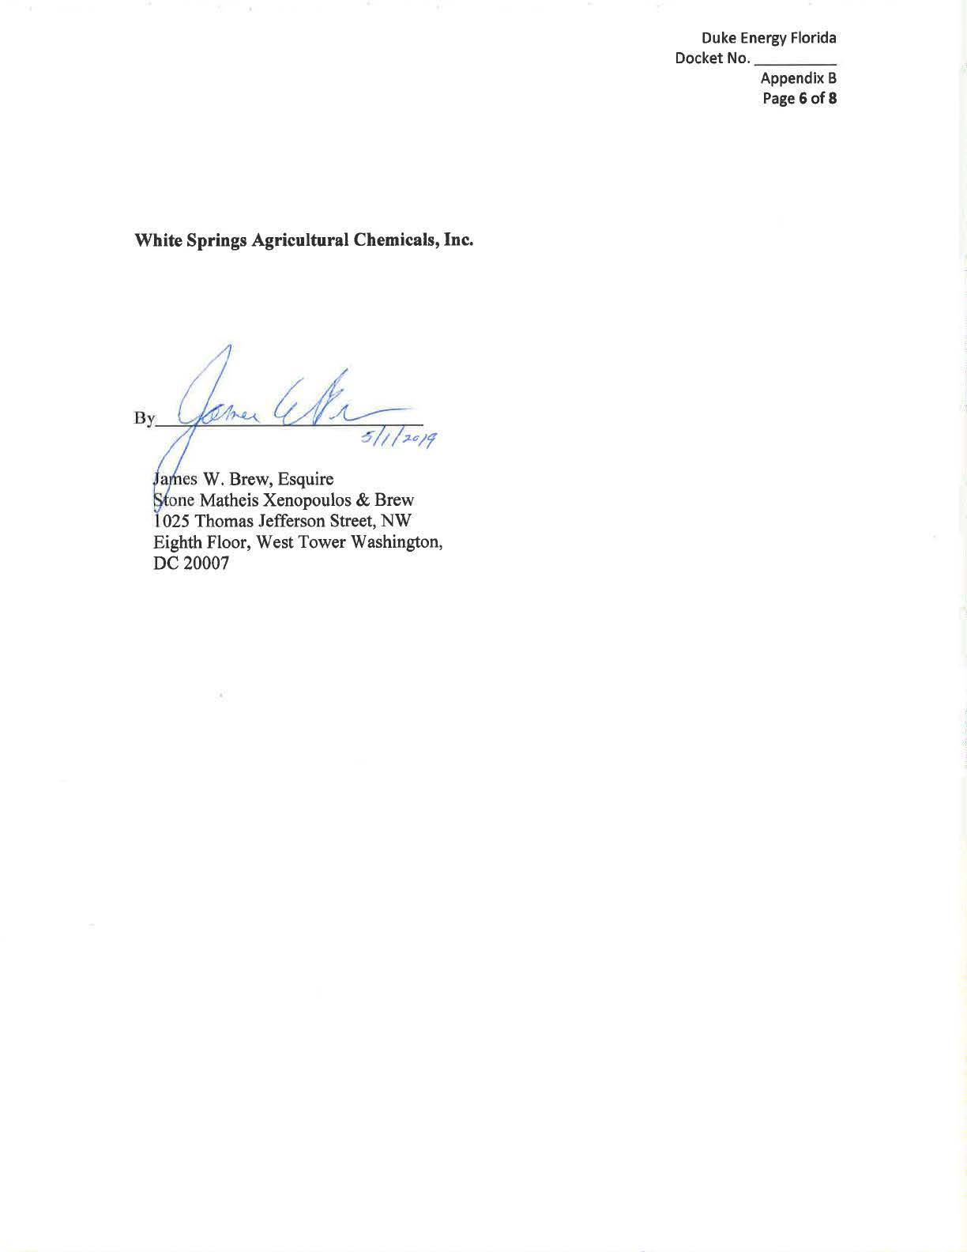
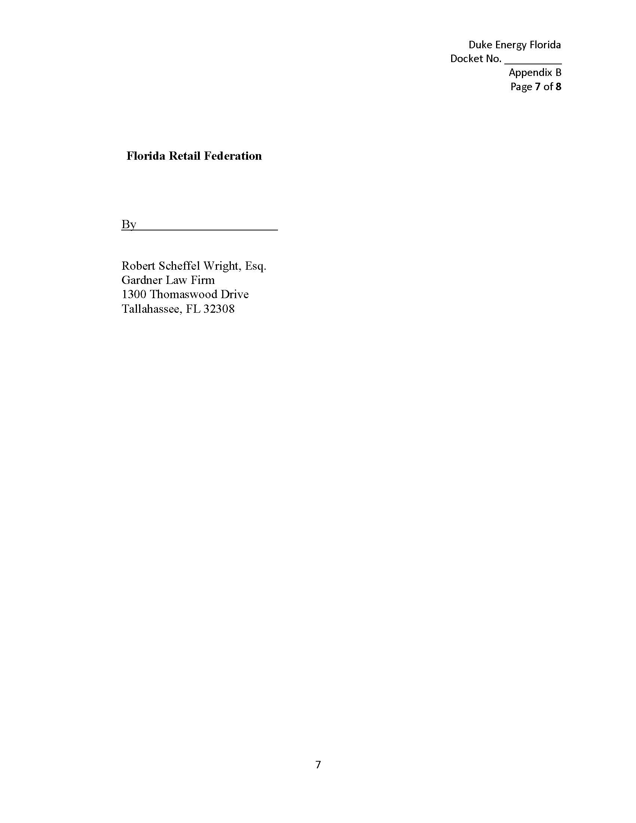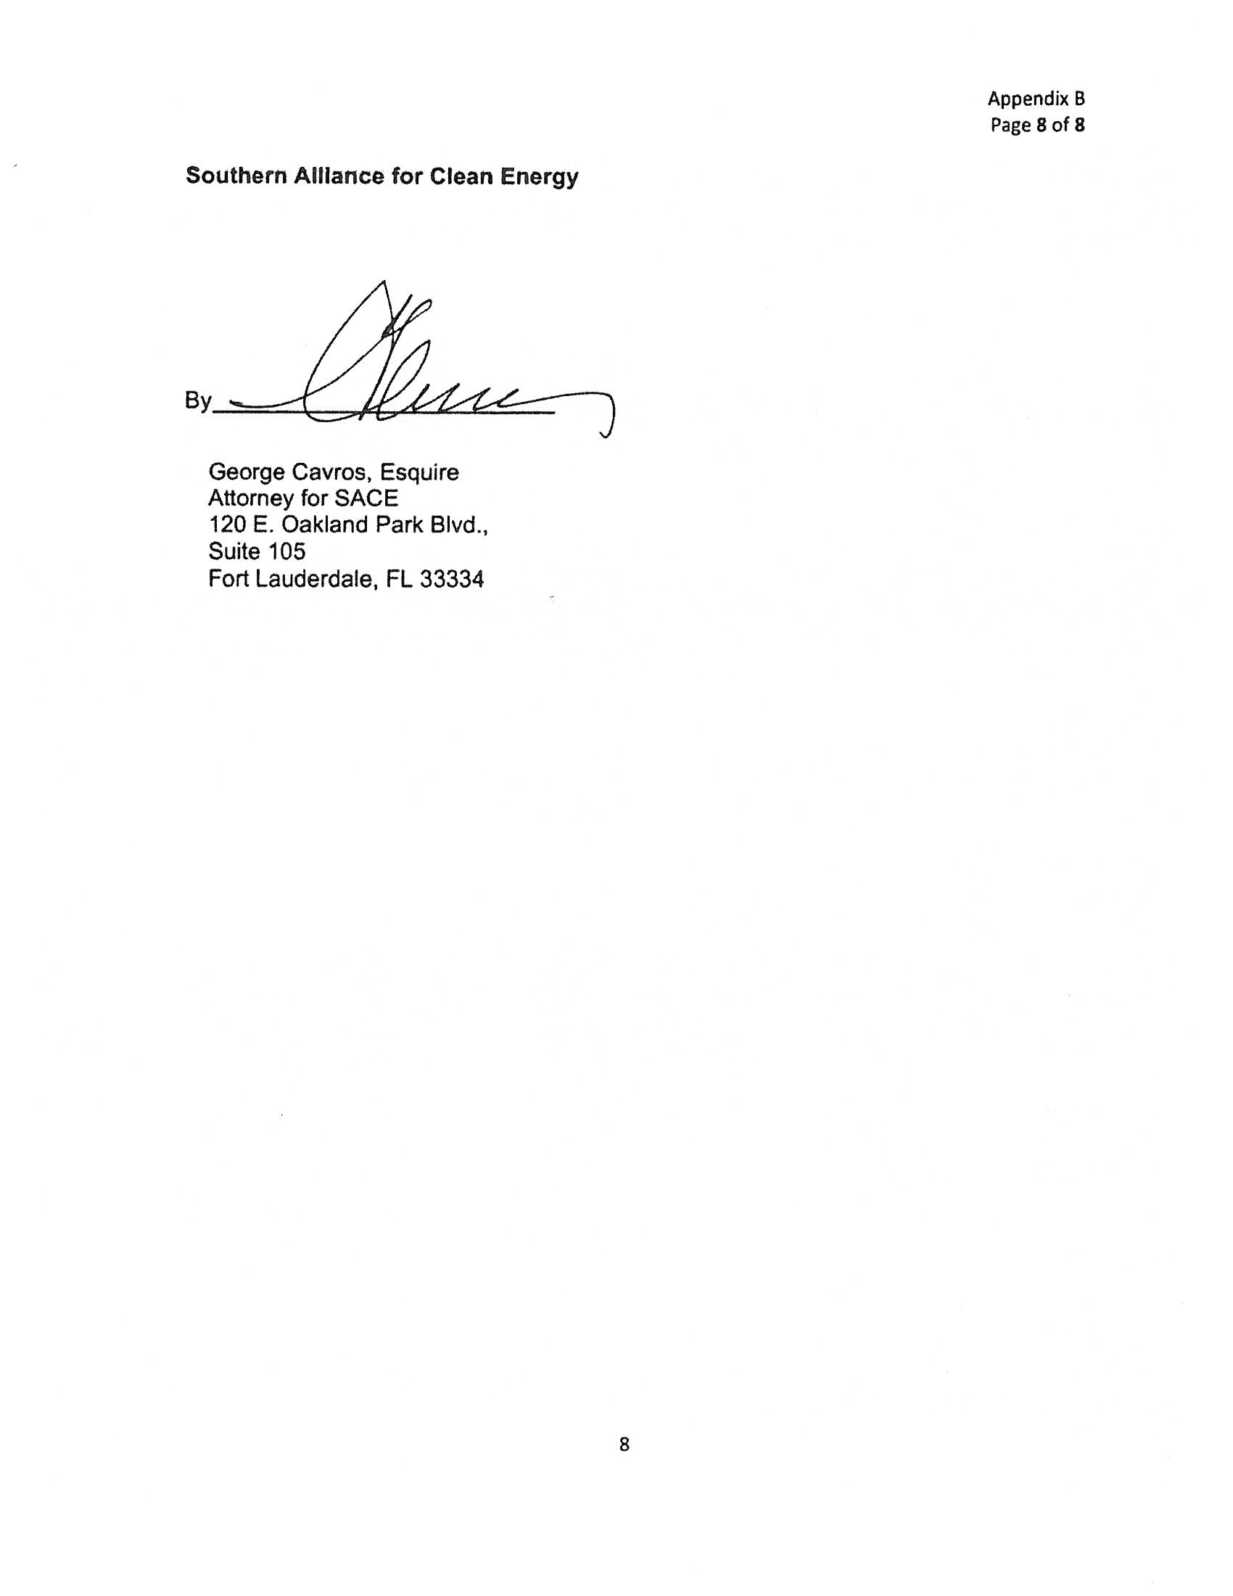
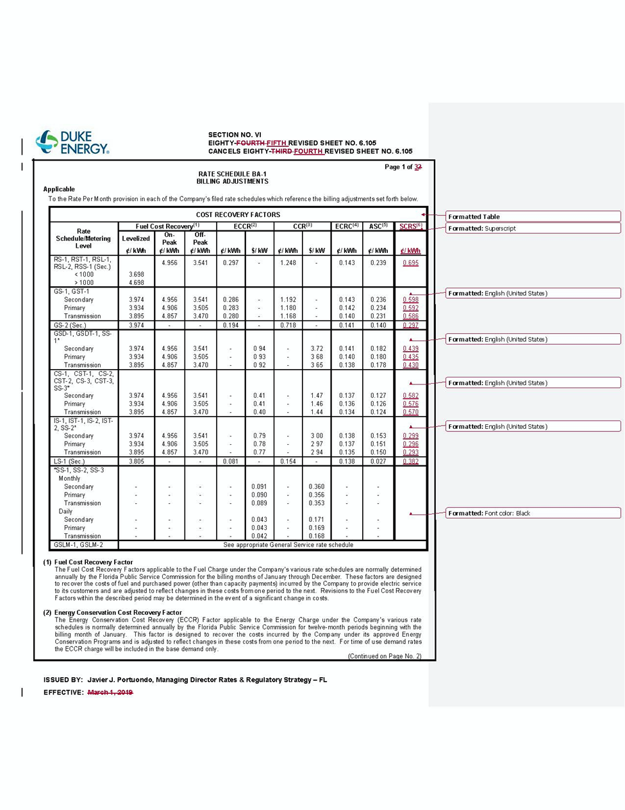

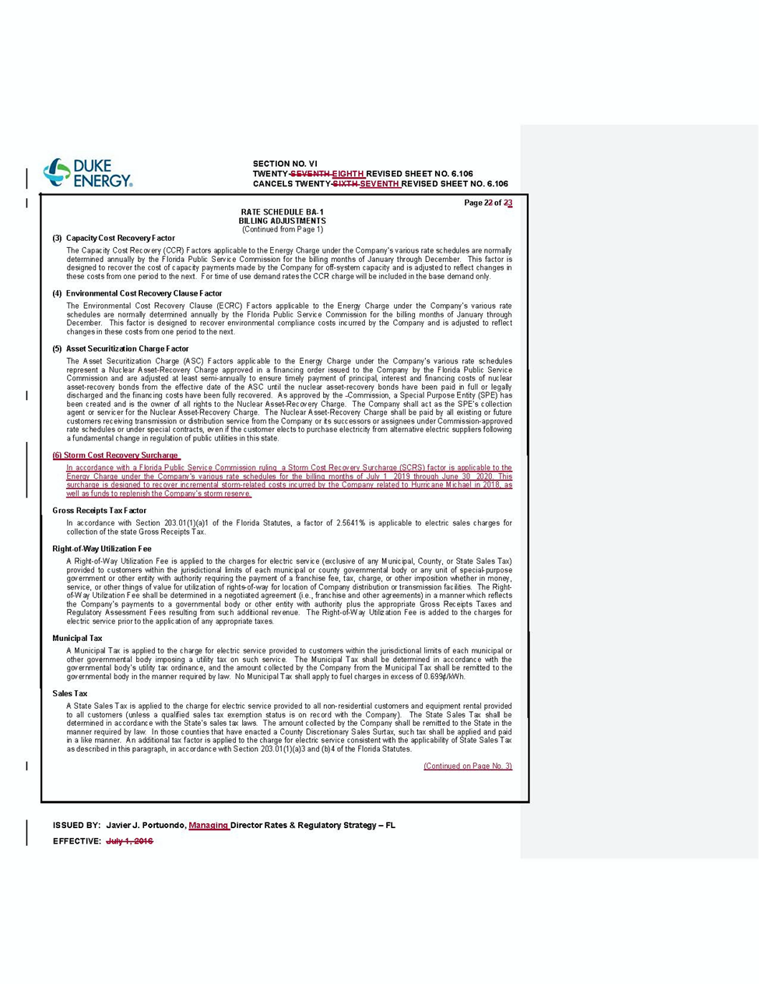
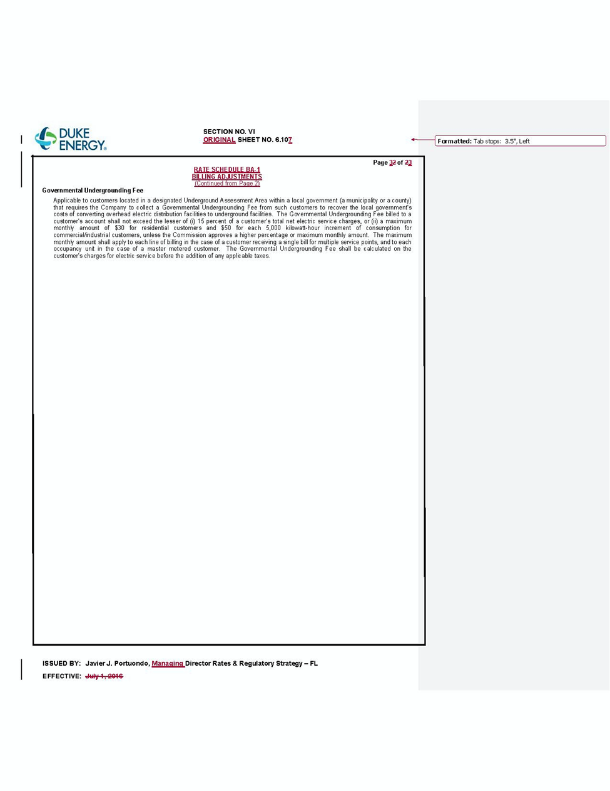

Order No. PSC-2017-0451-AS-EU, issued November 20, 2017, in Docket No. 20170183-EI, In re: Application for limited proceeding to approve 2017 second revised and restated settlement agreement, including certain rate adjustments, by Duke Energy Florida, LLC.
The Stipulation seeks to avoid volatility in customer rates by recognizing and then utilizing annual tax reform benefits resulting from the 2017 Tax Act as a direct offset to avoid implementing separate cost recovery of storm damage costs that customers would have otherwise have been obligated to pay. If approved, DEF will be entitled to record a monthly storm reserve accrual equal to one-twelfth of the approved annual revenue requirement impact of the Tax Act (approximately $12.9 million), and credit the retail storm reserve from May 2020 through full recovery of the final approved actual storm recovery amount. Once the final approved actual storm recovery amount has been recovered, or offset, DEF will reduce base rates in the manner prescribed in the 2017 Settlement.
Order No PSC-2019-0053-FOF-EI, issued February 1, 2019, in Docket No. 20180047-EI, In re: Consideration of the tax impacts associated with Tax Cuts and Jobs Act of 2017 for Duke Energy Florida, LLC.

