State of Florida |  | Public Service Commission  Capital Circle Office Center ● 2540 Shumard Oak Boulevard  Tallahassee, Florida 32399-0850  -M-E-M-O-R-A-N-D-U-M-
DATE: | May 30, 2019
TO: | Office of Commission Clerk (Teitzman)
FROM: | Division of Engineering (Thompson, Doehling, Ellis)  Office of the General Counsel (DuVal)
RE: | Docket No. 20190082-EQ – Petition for approval of renewable energy tariff and standard offer contract, by Florida Power & Light Company.
AGENDA: | 06/11/19 – Regular Agenda – Proposed Agency Action – Interested Persons May Participate
COMMISSIONERS ASSIGNED: |  |  | All Commissioners
PREHEARING OFFICER: |  |  | Administrative
CRITICAL DATES: |  |  | None
SPECIAL INSTRUCTIONS: |  |  | None

Case Background
Section 366.91(3), Florida Statutes (F.S.), requires each investor-owned utility (IOU) to continuously offer to purchase capacity and energy from renewable generating facilities and small qualifying facilities. Florida Public Service Commission (Commission) Rules 25-17.200 through 25-17.310, Florida Administrative Code (F.A.C.), implement the statute and require each IOU to file with the Commission, by April 1 of each year, a revised standard offer contract based on the next avoidable fossil fueled generating unit of each technology type identified in the utility’s current Ten-Year Site Plan. On April 1, 2019, Florida Power & Light Company (FPL) filed a petition for approval of its revised standard offer contract and rate schedule based on its 2019 Ten-Year Site Plan. The Commission has jurisdiction over this standard offer contract pursuant to Sections 366.04 through 366.055, and 366.91, F.S.

Discussion of Issues

Issue 1:
Should the Commission approve the revised renewable energy tariff and standard offer contract filed by Florida Power & Light Company?

Recommendation:
Yes. The provisions of FPL’s revised renewable energy tariff and standard offer contract conform to all requirements of Rules 25-17.200 through 25-17.310, F.A.C. FPL’s revised standard offer contract provides flexibility in the arrangements for payments so that a developer of renewable generation may select the payment stream best suited to its financial needs. Staff recommends that FPL’s revised renewable energy tariff and standard offer contract be approved as filed. (Thompson)

Staff Analysis:
Section 366.91(3), F.S., and Rule 25-17.250, F.A.C., require that FPL, an IOU, continuously make available a standard offer contract for the purchase of firm capacity and energy from renewable generating facilities (RF) and small qualifying facilities (QF) with design capacities of 100 kilowatts (kW) or less. Pursuant to Rules 25-17.250(1) and (3), F.A.C., the standard offer contract must provide a term of at least 10 years, and the payment terms must be based on the utility’s next avoidable fossil-fueled generating unit identified in its most recent Ten-Year Site Plan, or if no avoided unit is identified, its next avoidable planned purchase. FPL has identified a 1,886 megawatt (MW) natural gas-fired combined cycle (CC) as its next fossil-fueled generating unit in its 2019 Ten-Year Site Plan. The projected in-service date of this unit is June 1, 2026. Staff believes this unit is sufficient as the avoided unit for standard offer purposes; however, FPL’s projected reliability need in 2026 is only 106 MW. Staff would note that approval of a standard offer contract is not an approval to construct future generating units.
Under FPL’s standard offer contract, the RF/QF operator commits to certain minimum performance requirements based on the identified avoided unit, such as being operational and delivering an agreed upon amount of capacity by the in-service date of the avoided unit, and thereby becomes eligible for capacity payments in addition to payments received for energy. The standard offer contract may also serve as a starting point for negotiation of contract terms by providing payment information to an RF/QF operator, in a situation where one or both parties desire particular contract terms other than those established in the standard offer.
In order to promote renewable generation, the Commission requires the IOU to offer multiple options for capacity payments, including the options to receive early or levelized payments. If the RF/QF operator elects to receive capacity payments under the normal or levelized contract options, it will receive as-available energy payments only until the in-service date of the avoided unit (in this case June 1, 2026), and thereafter, begin receiving capacity payments in addition to the energy payments. If either the early or early levelized option is selected, then the operator will begin receiving capacity payments earlier than the in-service date of the avoided unit. However, payments made under the early capacity payment options tend to be lower in the later years of the contract term because the net present value (NPV) of the total payments must remain equal for all contract payment options.
Table 1 contains FPL’s estimates of the annual payments for each payment option available under the revised standard offer contract to an operator with a 50 MW facility, operating at a capacity factor of 94 percent, which is the minimum capacity factor required under the contract to qualify for full capacity payments. Normal and levelized capacity payments begin with the projected in-service date of the avoided CC unit (June 1, 2026).

Table 1 - Estimated Annual Payments to a 50 MW Renewable Facility
(94% Capacity Factor)
Year | Energy Payment | Capacity Payment (By Type)
 |  | Normal | Levelized | Early | Early Levelized
 | $(000) | $(000) | $(000) | $(000) | $(000)
2020 | 8,328 | - | - | - | -
2021 | 7,973 | - | - | - | -
2022 | 7,790 | - | - | 2,059 | 2,439
2023 | 8,020 | - | - | 2,110 | 2,439
2024 | 8,920 | - | - | 2,163 | 2,439
2025 | 10,151 | - | - | 2,217 | 2,439
2026 | 10,696 | 3,270 | 3,746 | 2,272 | 2,439
2027 | 11,045 | 3,352 | 3,746 | 2,329 | 2,439
2028 | 11,213 | 3,435 | 3,746 | 2,387 | 2,439
2029 | 11,663 | 3,521 | 3,746 | 2,447 | 2,439
2030 | 12,237 | 3,609 | 3,746 | 2,508 | 2,439
2031 | 12,943 | 3,700 | 3,746 | 2,571 | 2,439
2032 | 13,837 | 3,792 | 3,746 | 2,635 | 2,439
2033 | 13,592 | 3,887 | 3,746 | 2,701 | 2,439
2034 | 13,972 | 3,984 | 3,746 | 2,769 | 2,439
2035 | 13,261 | 4,084 | 3,746 | 2,838 | 2,439
2036 | 13,353 | 4,186 | 3,746 | 2,909 | 2,439
2037 | 14,435 | 4,290 | 3,746 | 2,981 | 2,439
2038 | 13,925 | 4,398 | 3,746 | 3,056 | 2,439
2039 | 15,361 | 4,508 | 3,746 | 3,132 | 2,439
Total | 232,717 | 54,015 | 52,442 | 46,084 | 43,897
NPV (2020$) | 106,878 | 20,069 | 20,069 | 20,068 | 20,067

Source: FPL’s Response to Staff’s First Data Request

FPL’s revised renewable energy tariff and standard offer contract, in type-and-strike format, are included as Attachment A to this recommendation. Revisions include updates to the avoided unit, dates, and payment information which reflect the current economic and financial assumptions for the avoided unit costs.

Conclusion
The provisions of FPL’s revised renewable energy tariff and standard offer contract conform to all requirements of Rules 25-17.200 through 25-17.310, F.A.C. FPL’s revised standard offer contract provides flexibility in the arrangements for payments so that a developer of renewable generation may select the payment stream best suited to its financial needs. Staff recommends that FPL’s revised renewable energy tariff and standard offer contract be approved as filed.

Issue 2:
Should this docket be closed?

Recommendation:
Yes. This docket should be closed upon issuance of a consummating order, unless a person whose substantial interests are affected by the Commission’s decision files a protest within 21 days of the issuance of the Commission’s Proposed Agency Action Order. Potential signatories should be aware that, if a timely protest is filed, FPL’s standard offer contract may subsequently be revised. (Duval)

Staff Analysis:
This docket should be closed upon the issuance of a consummating order, unless a person whose substantial interests are affected by the Commission’s decision files a protest within 21 days of the issuance of the Commission’s Proposed Agency Action Order. Potential signatories should be aware that, if a timely protest is filed, FPL’s standard offer contract may subsequently be revised.

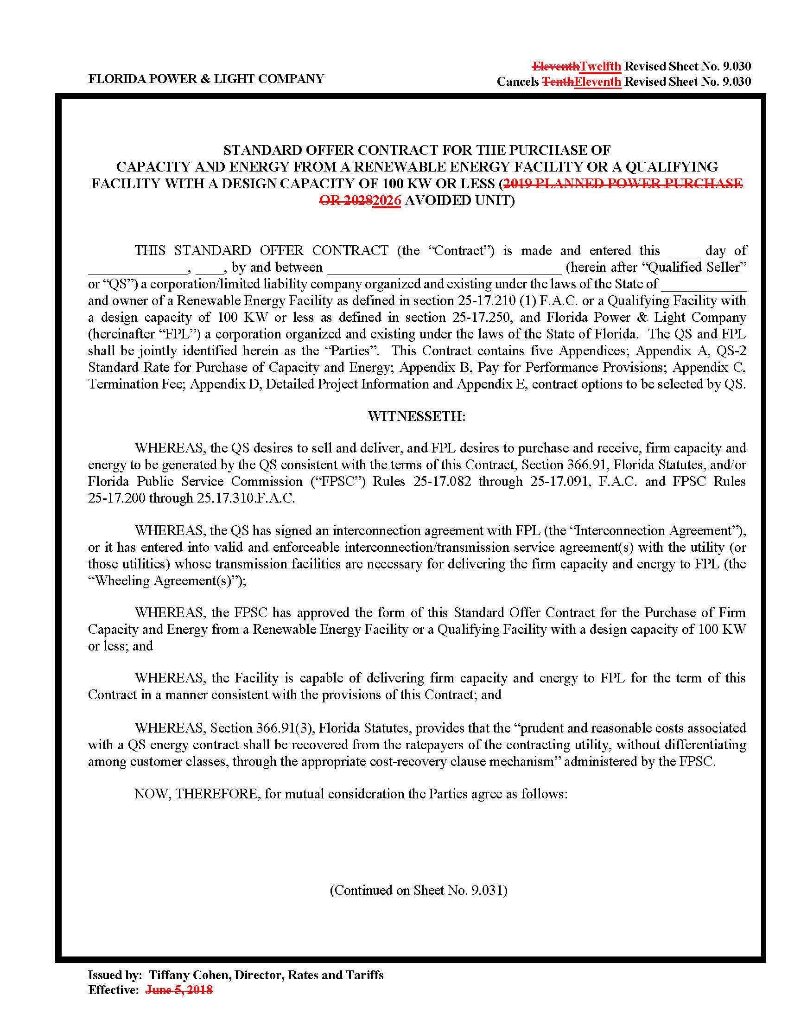

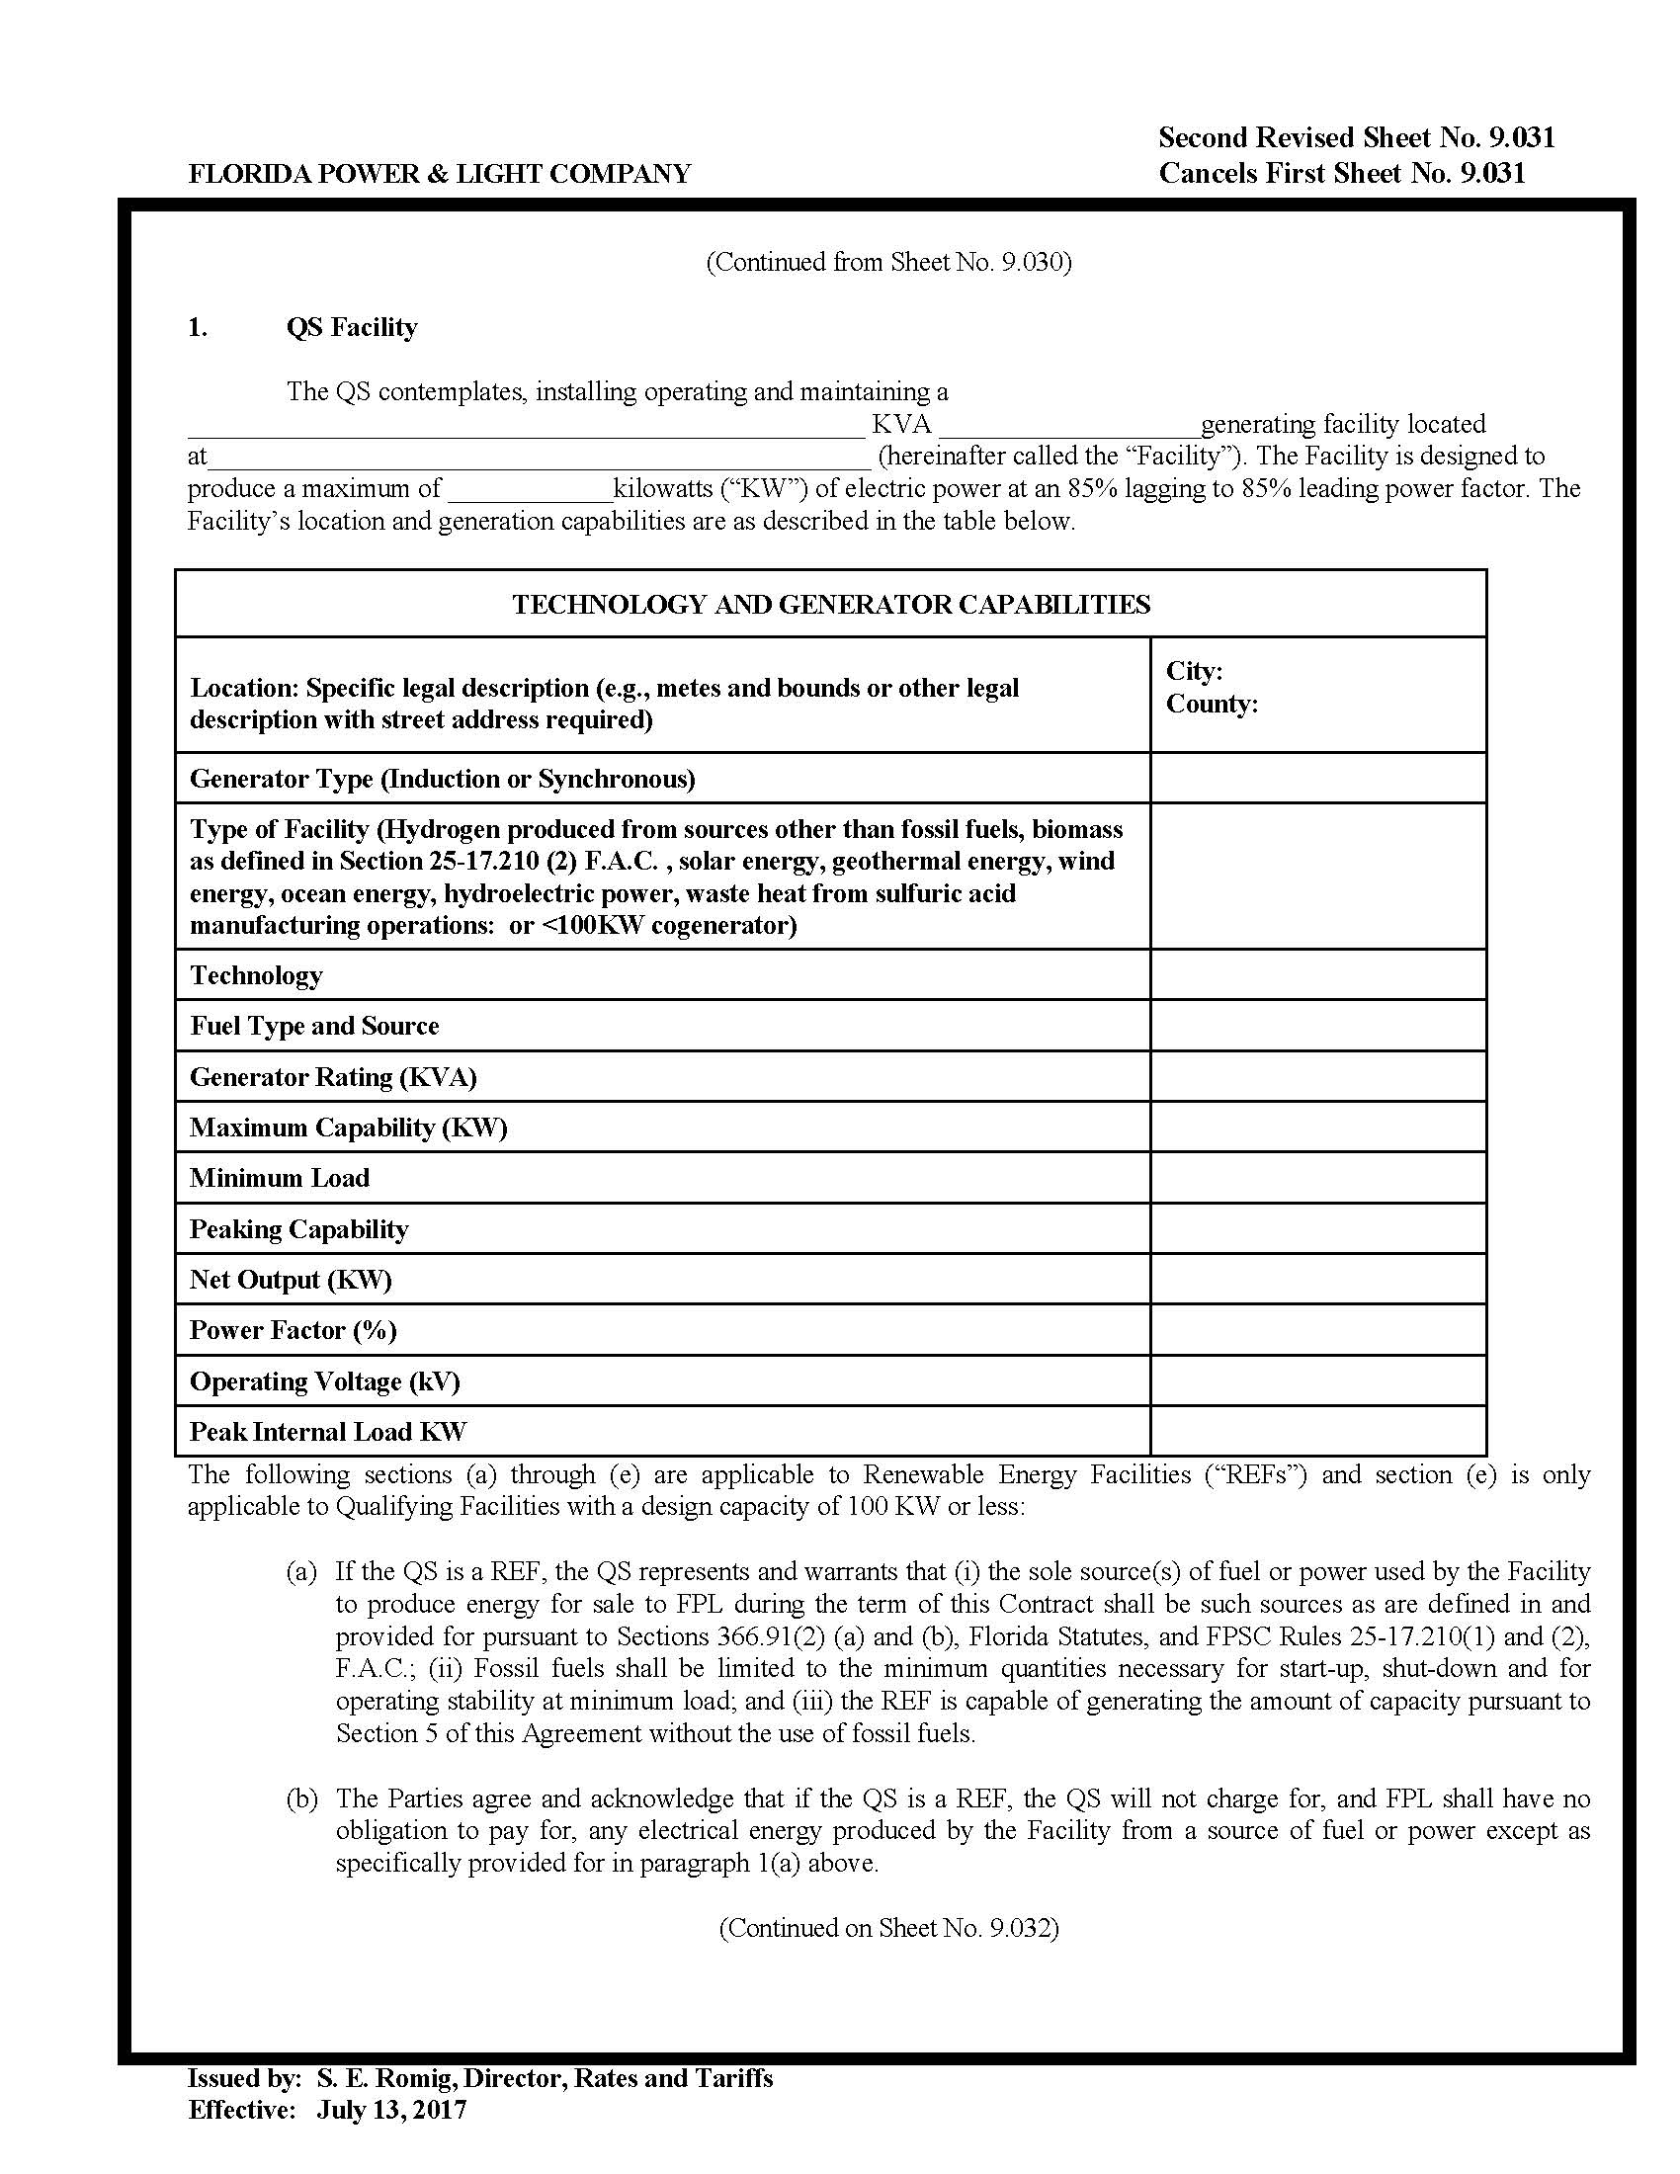

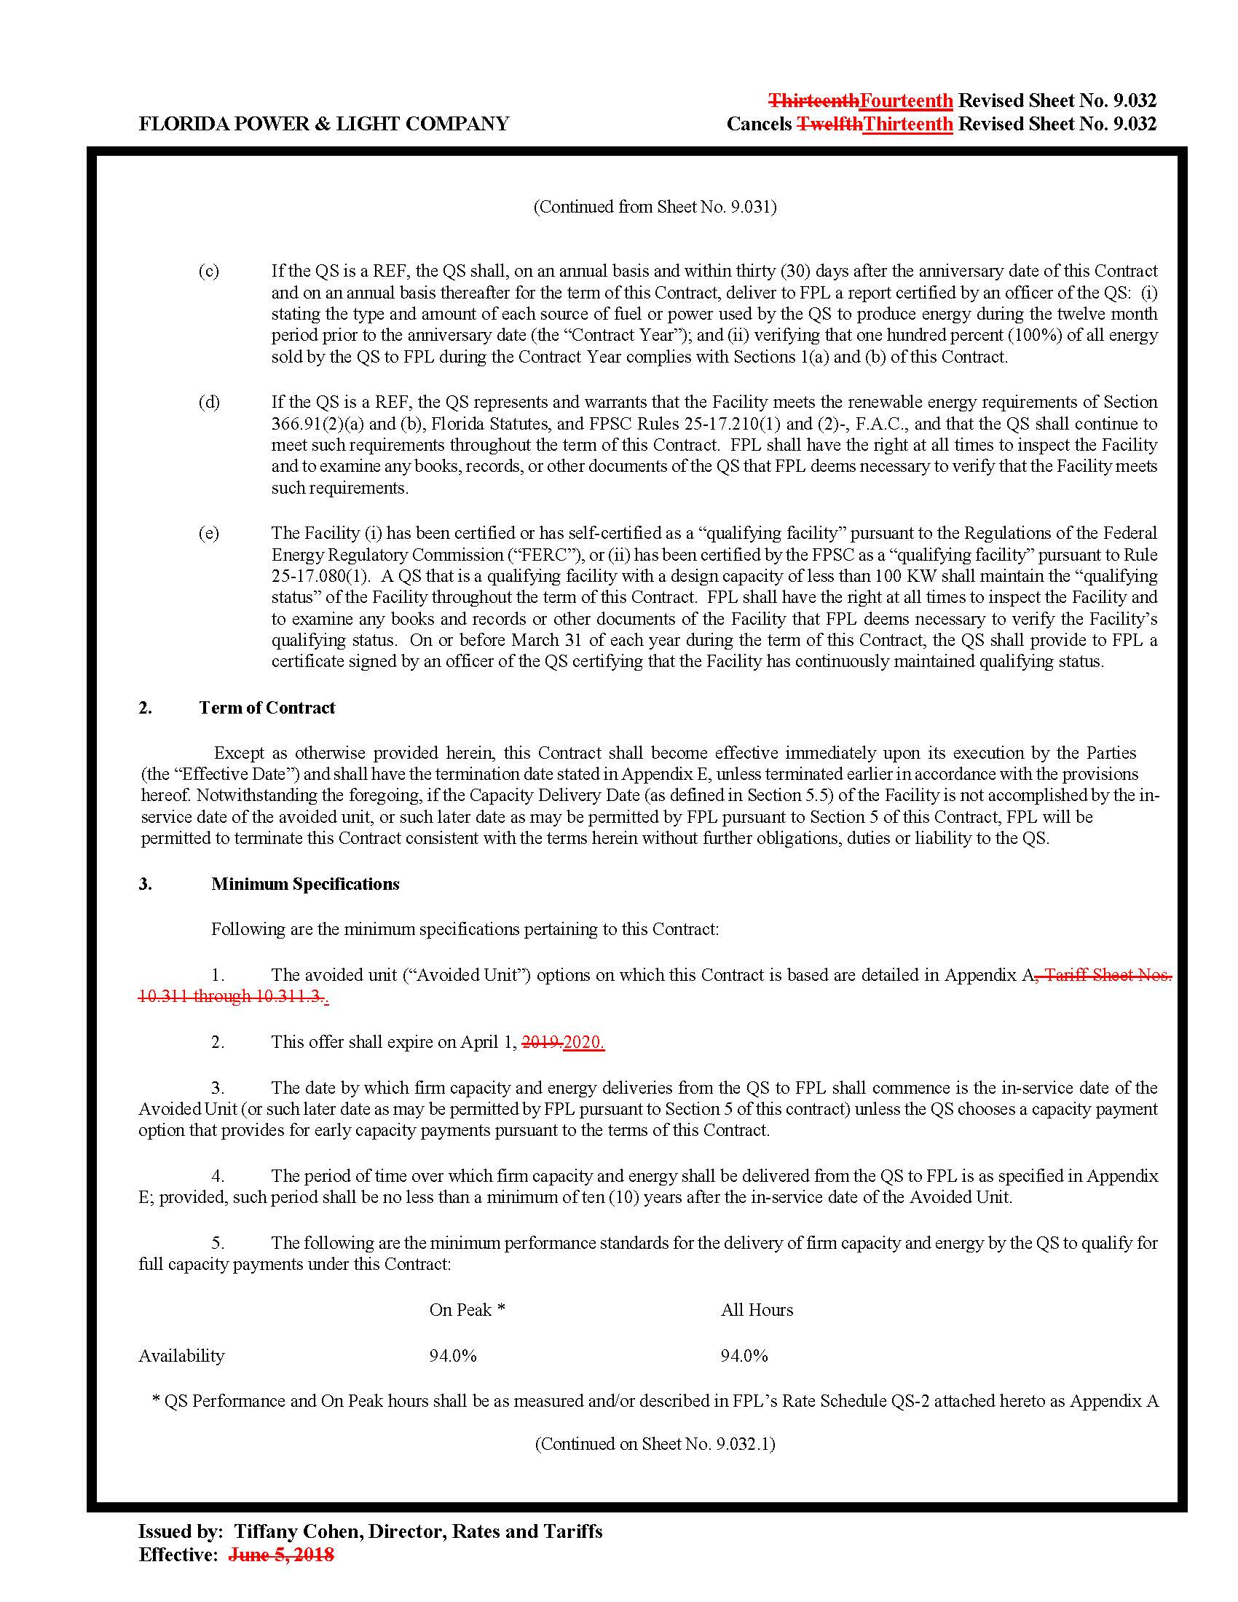

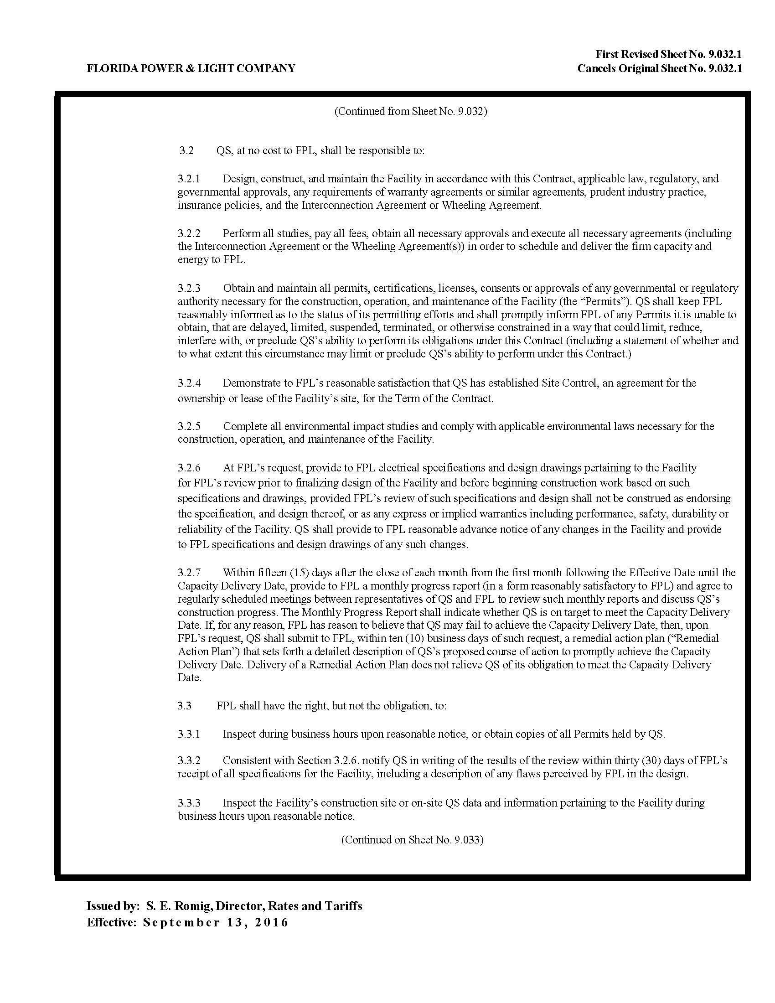

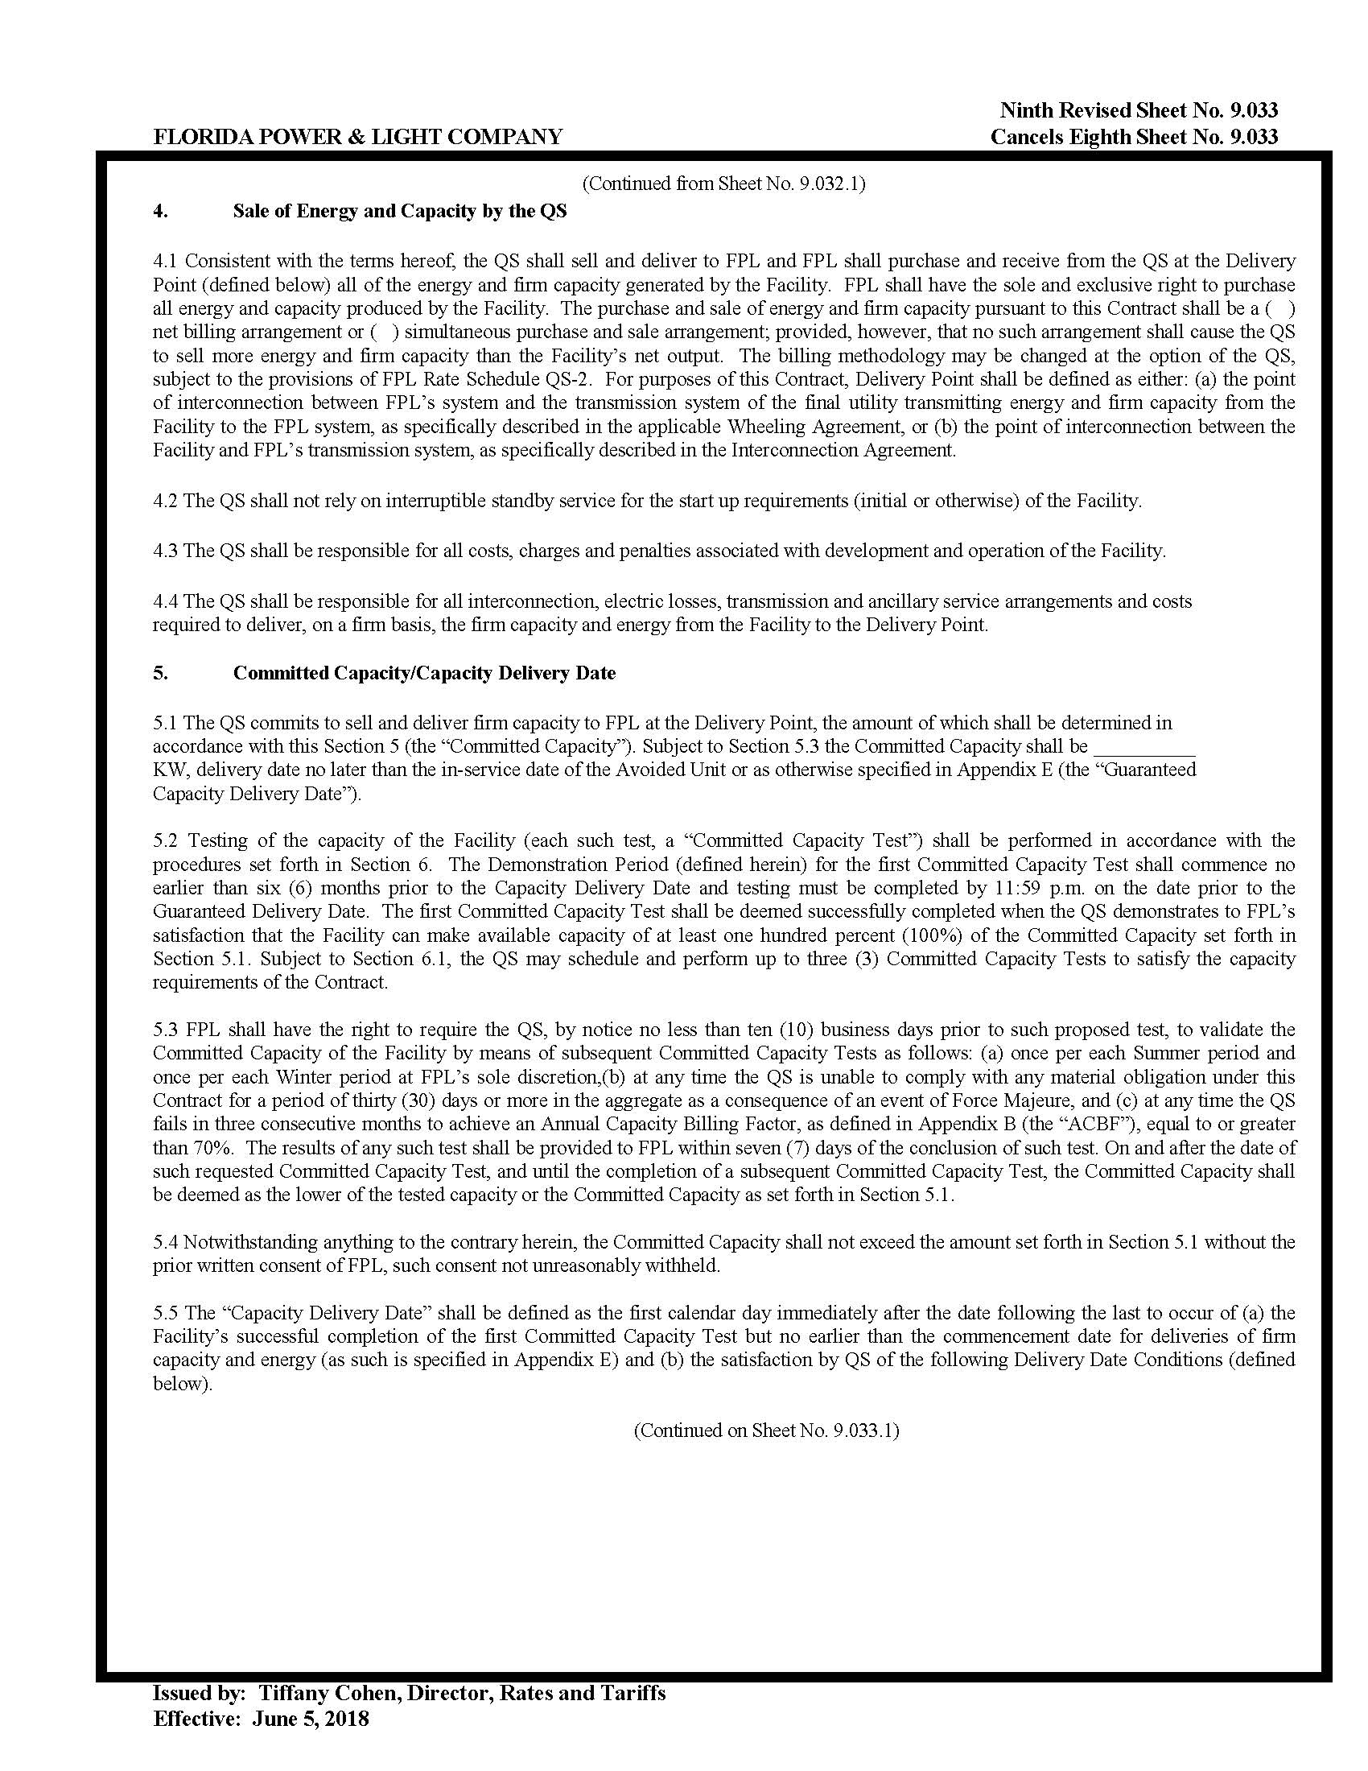

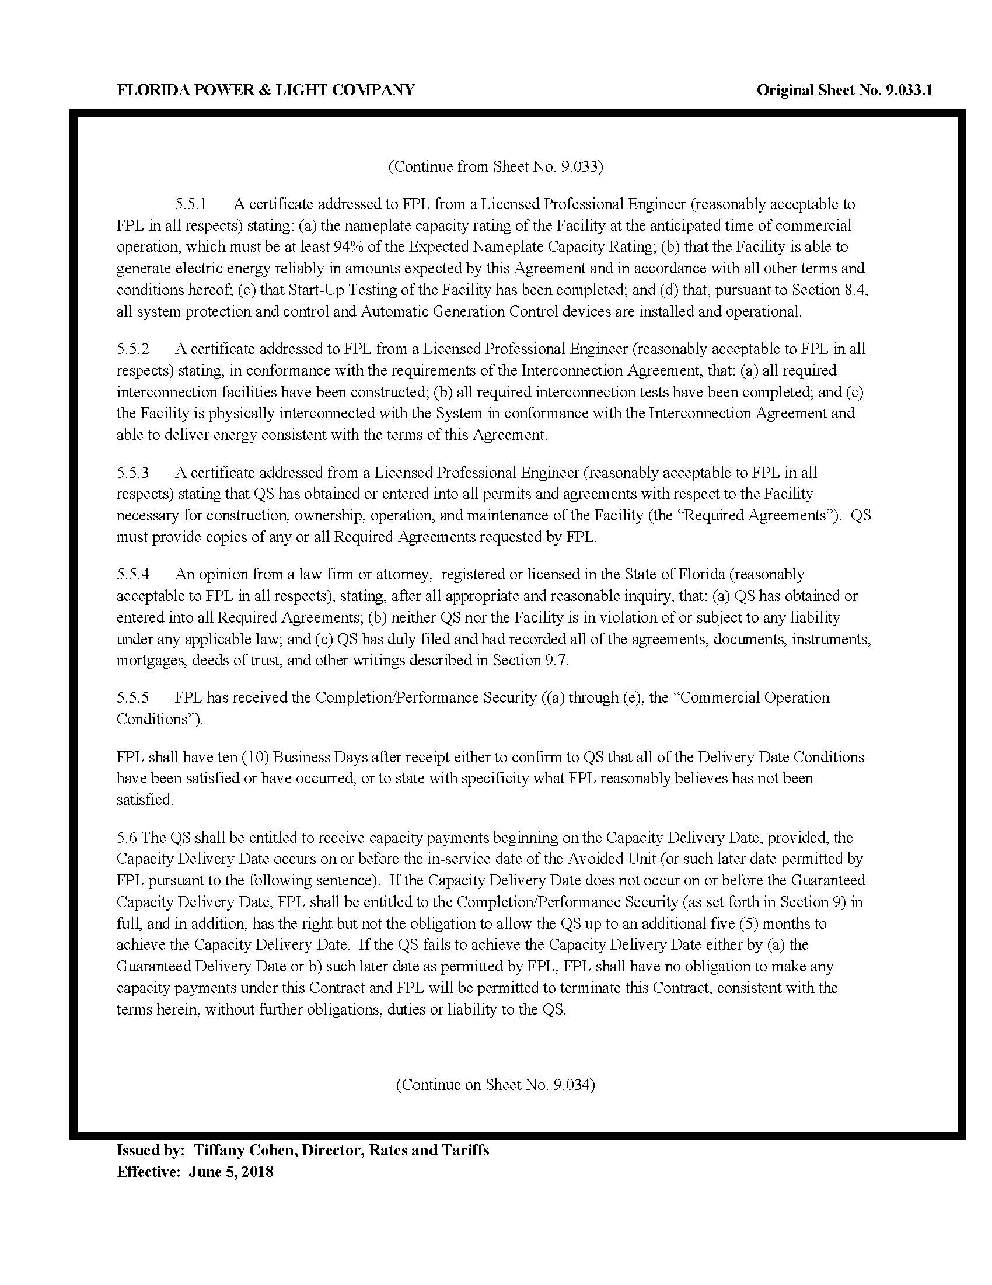

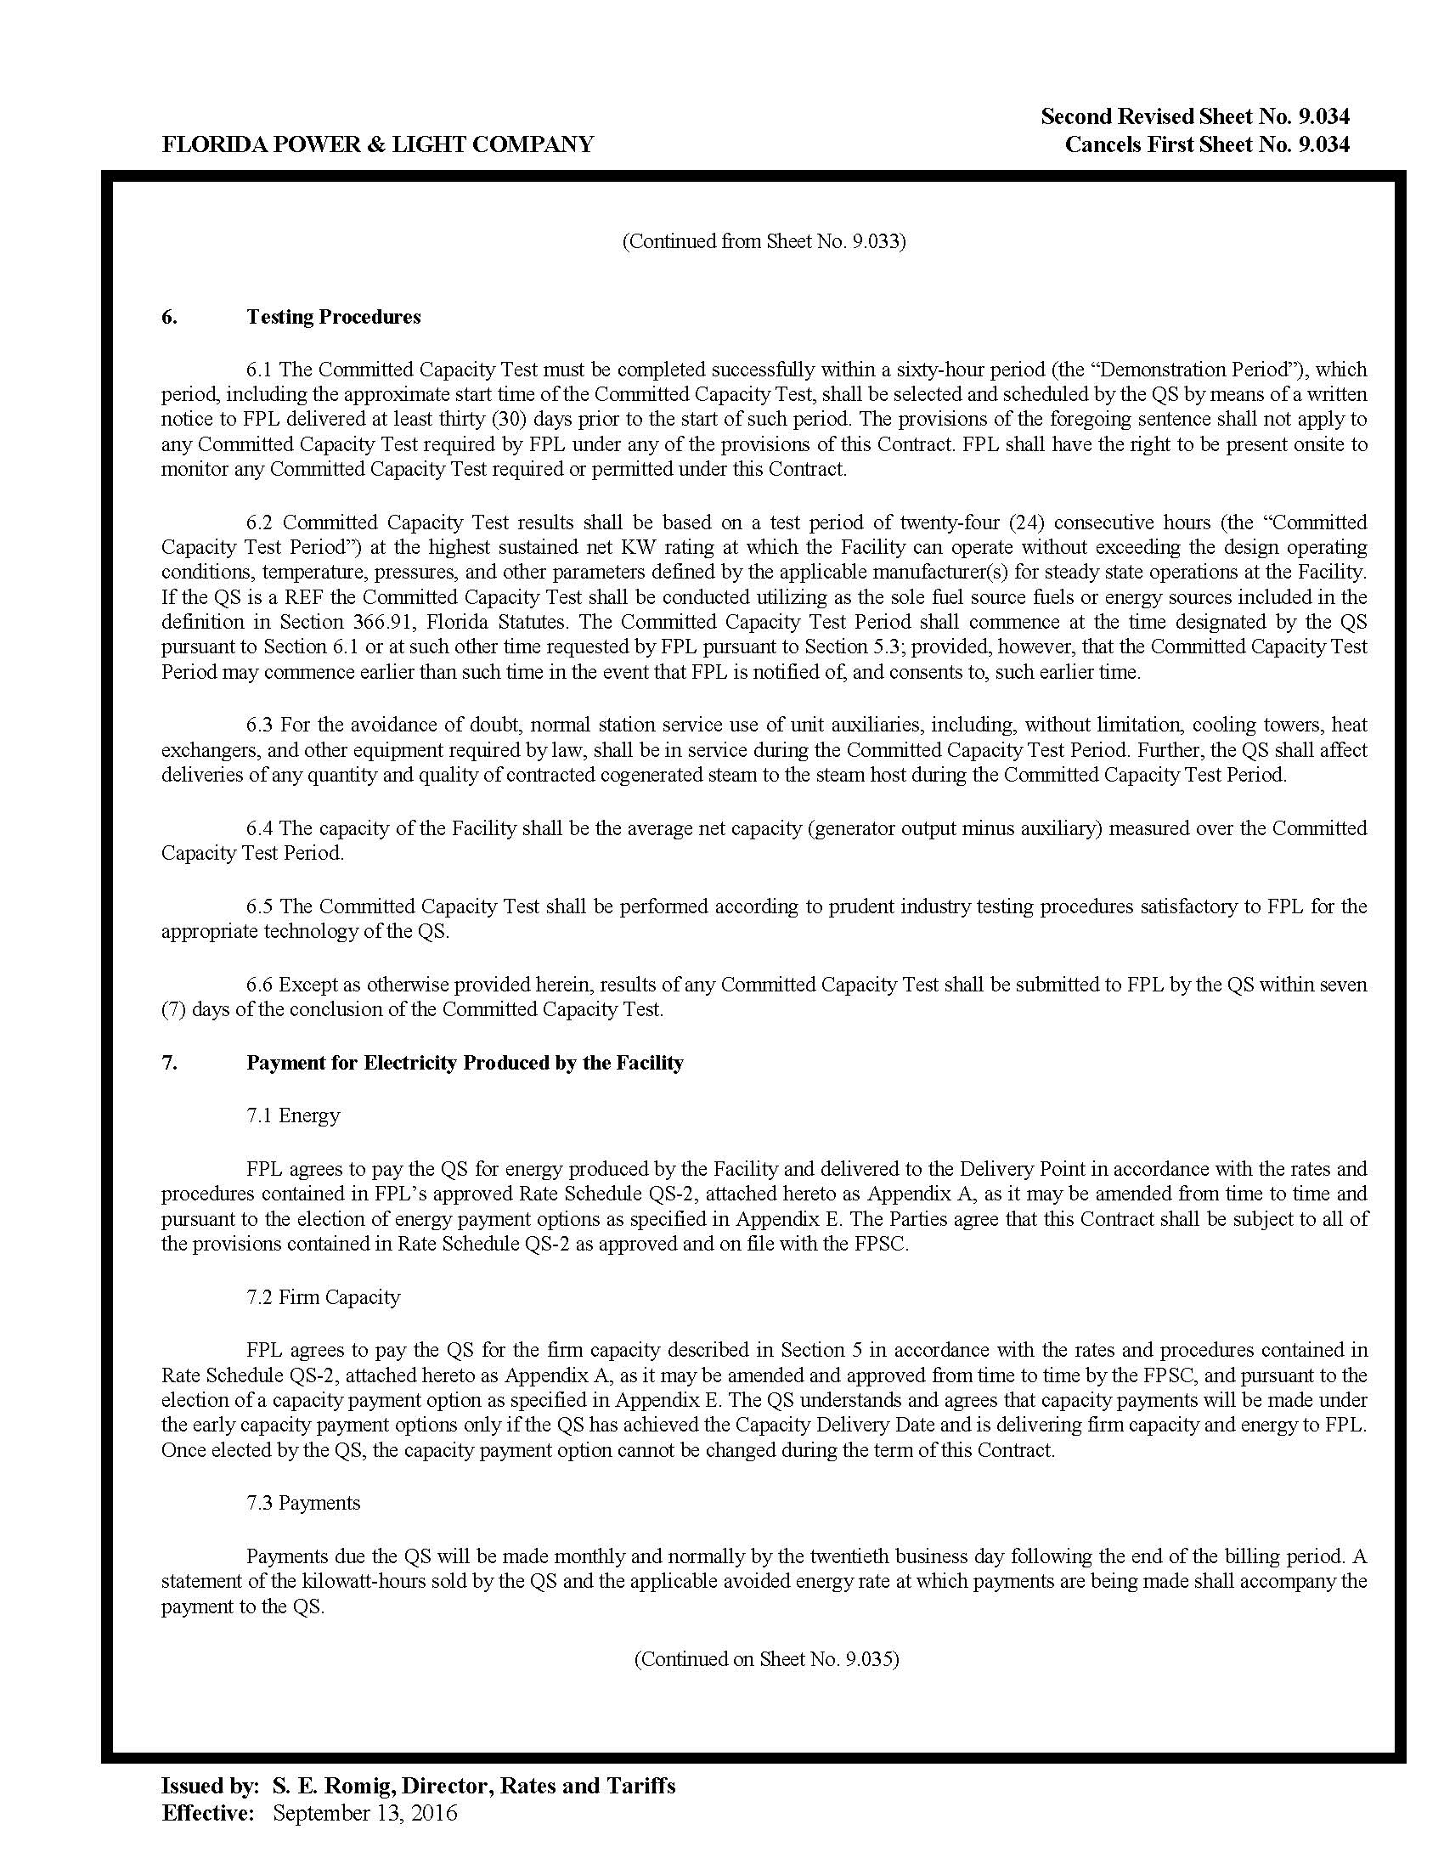

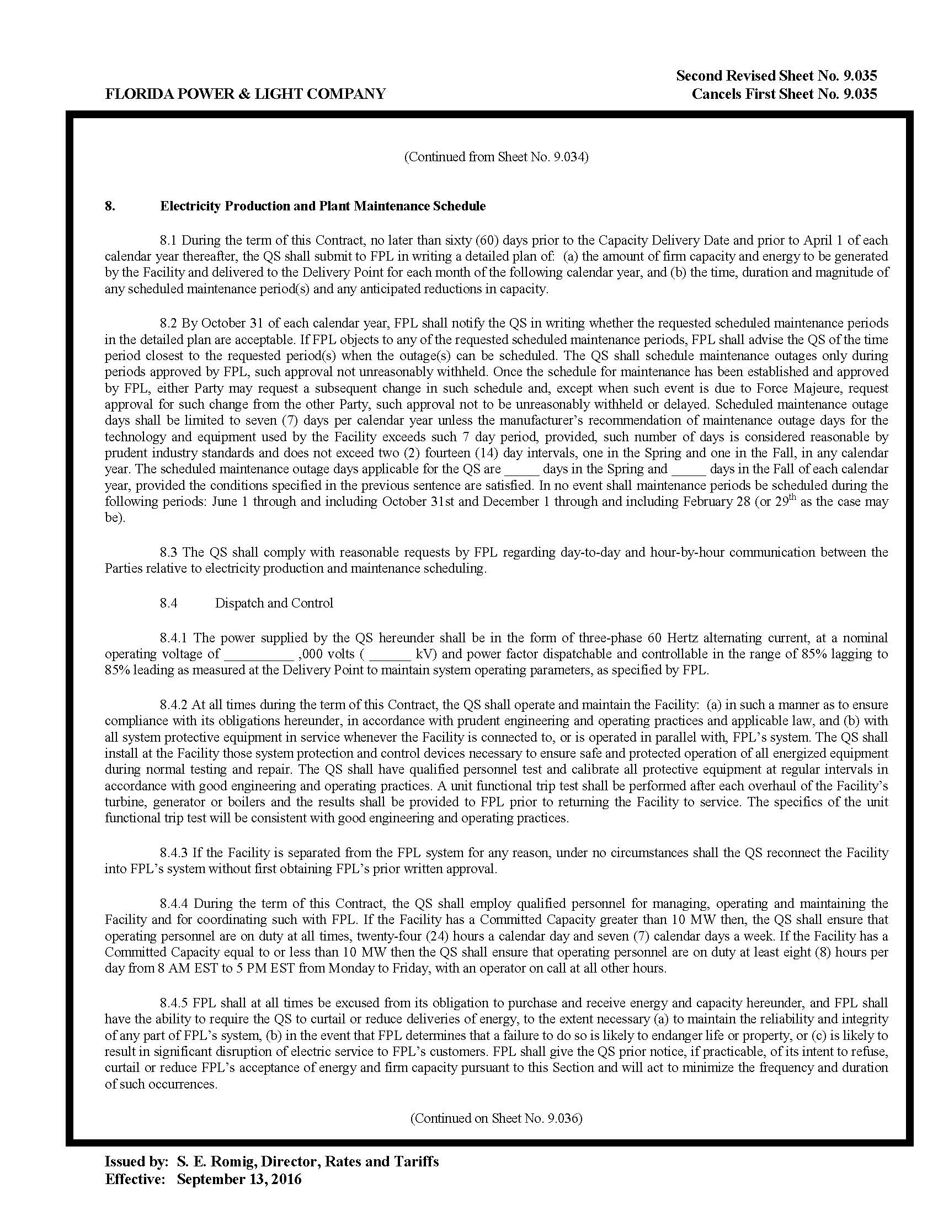

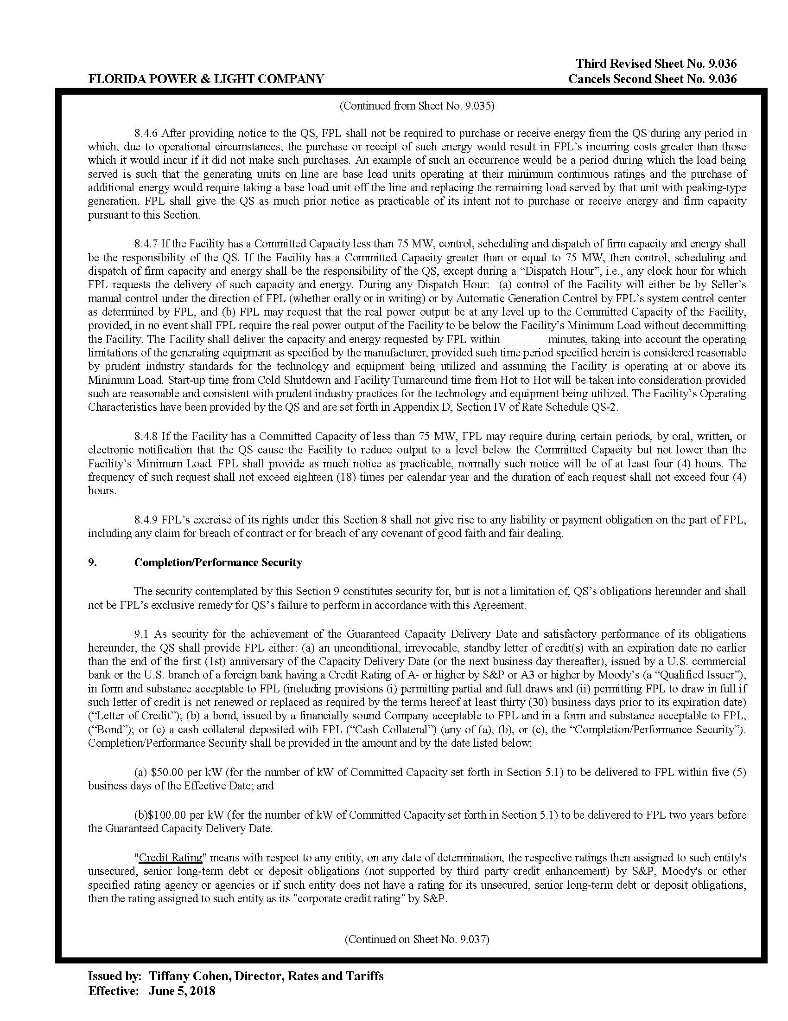

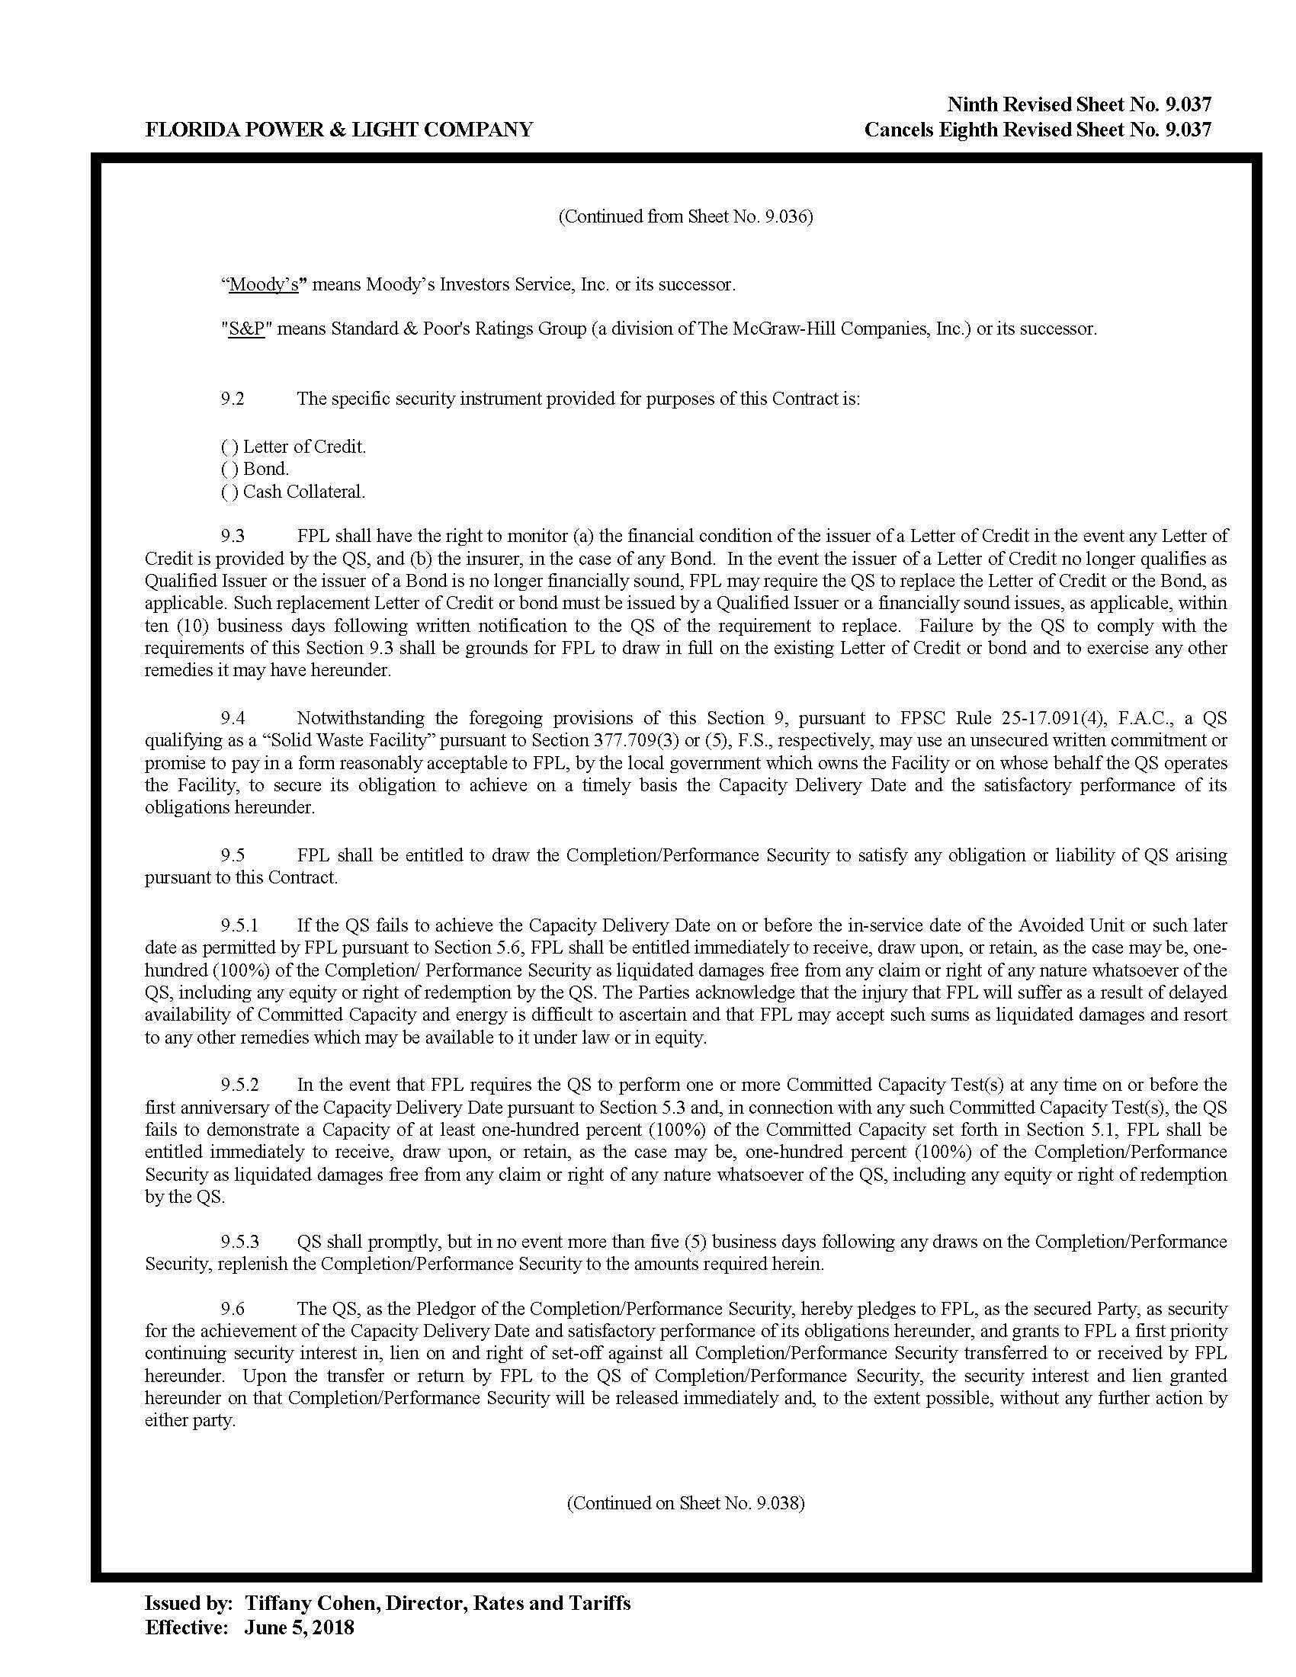

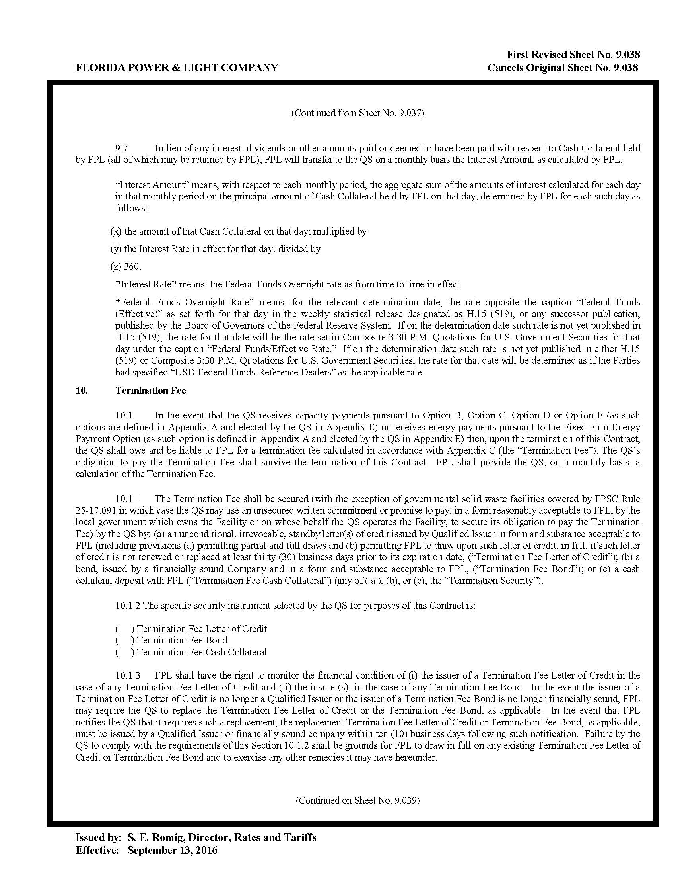

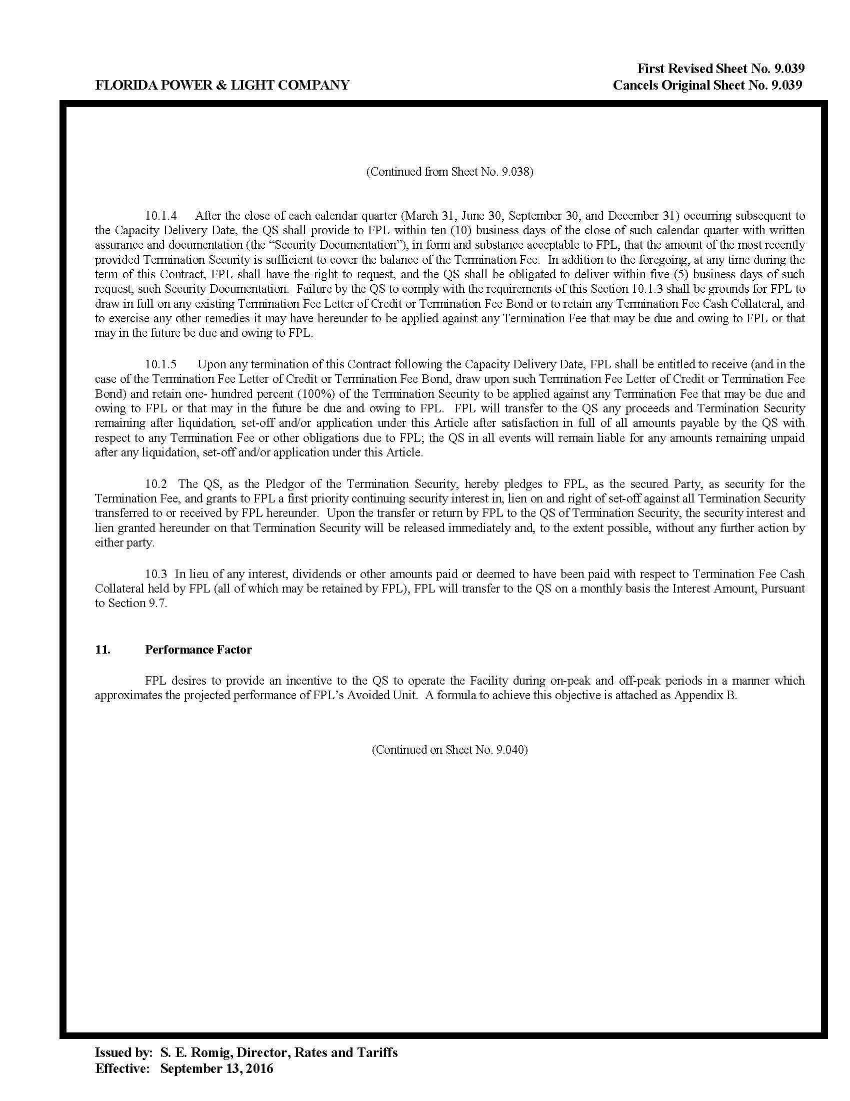

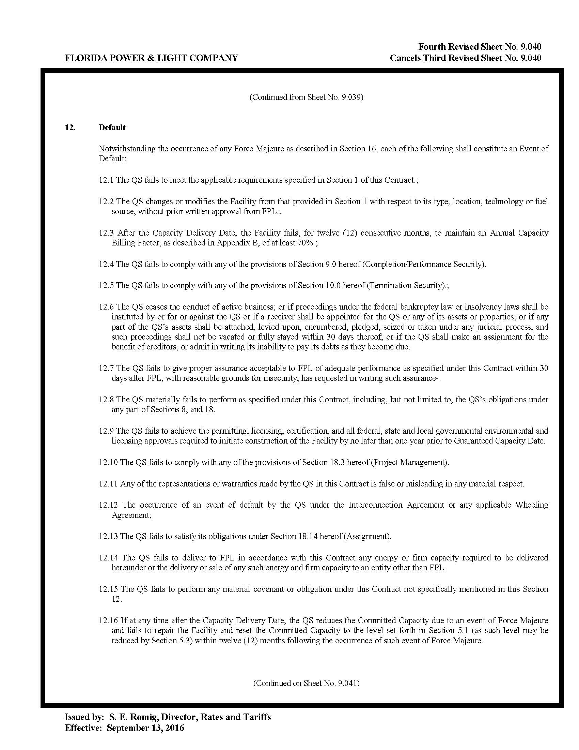

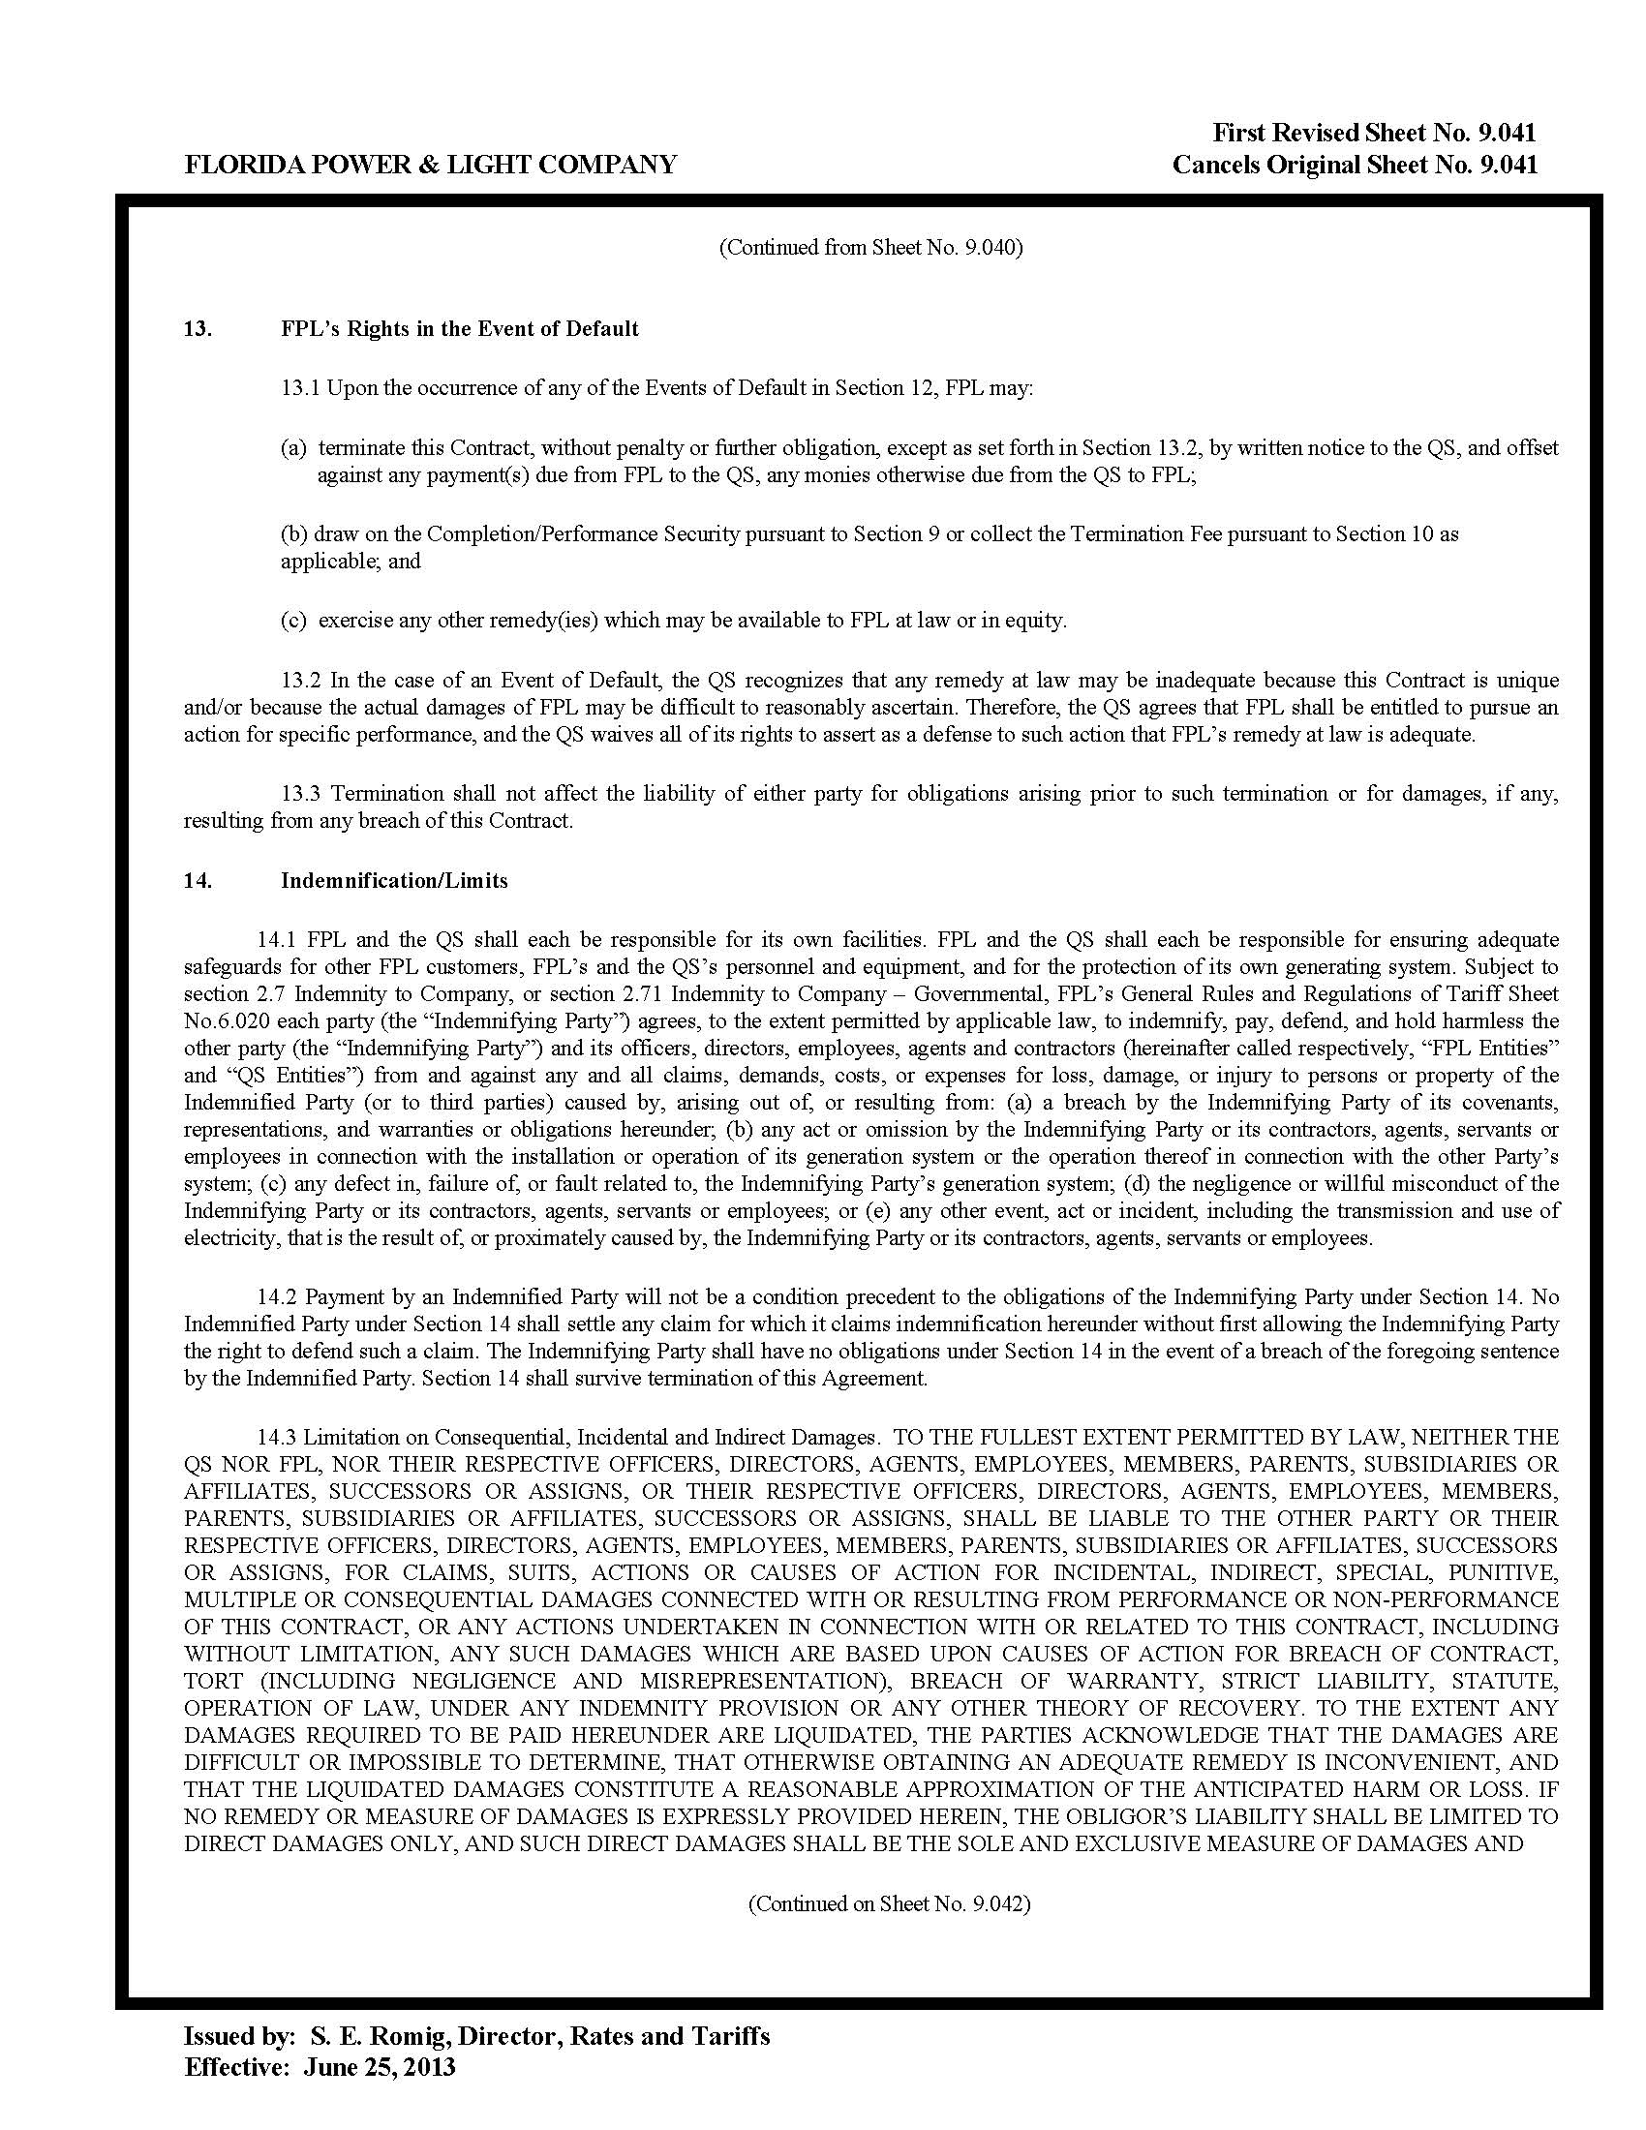

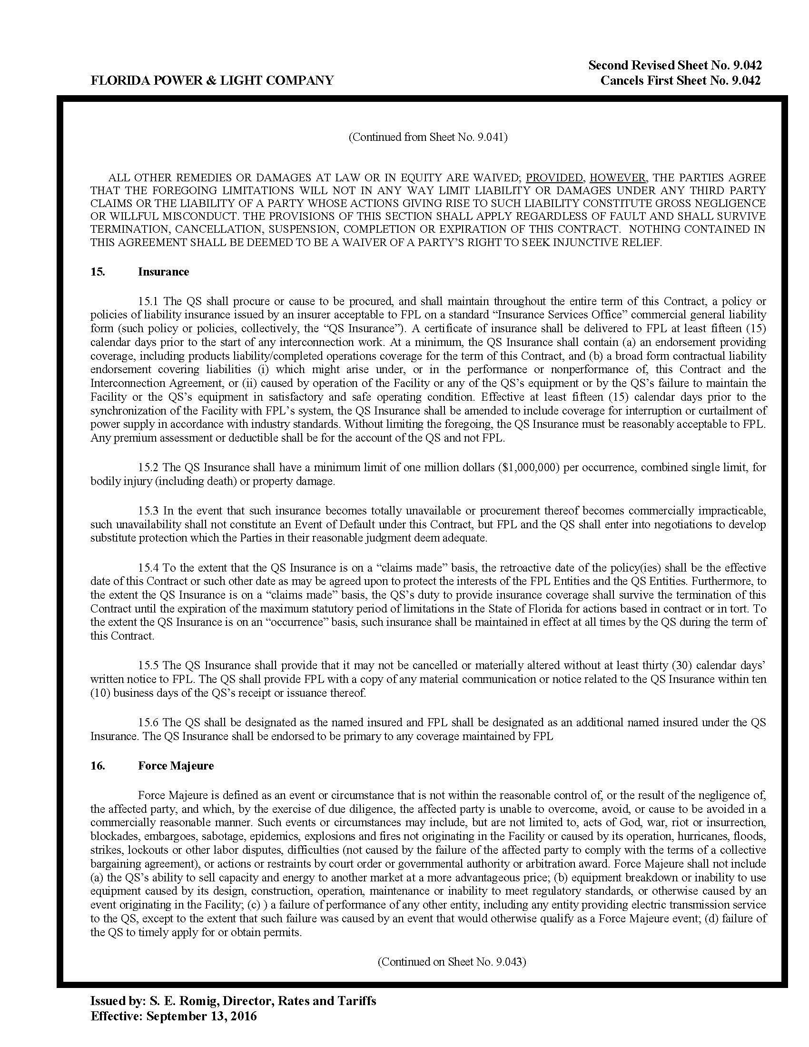

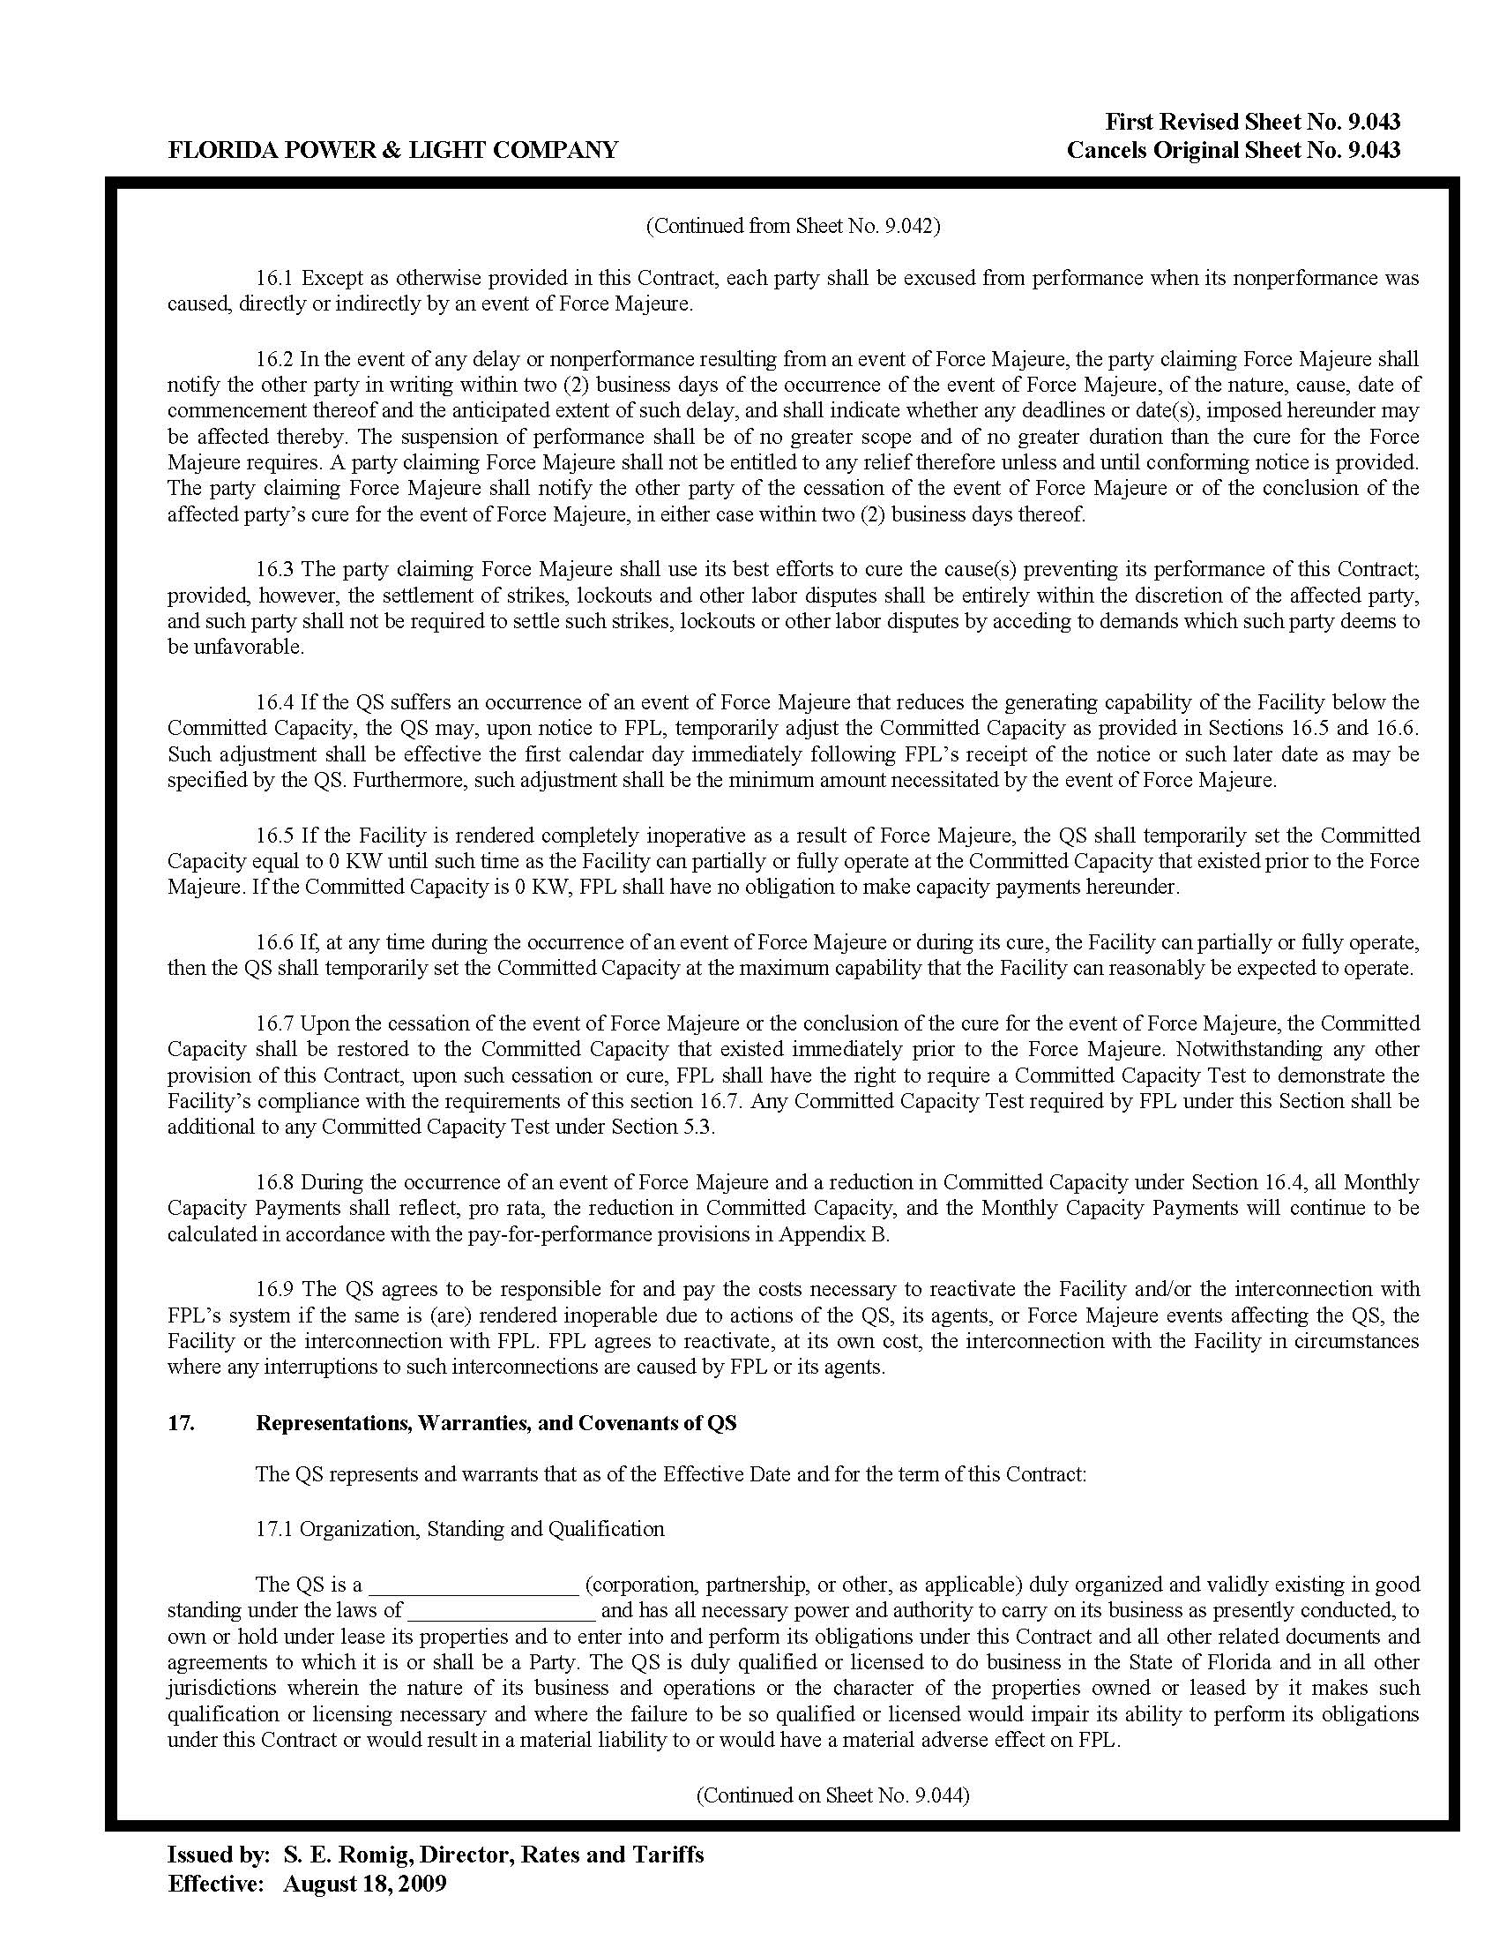

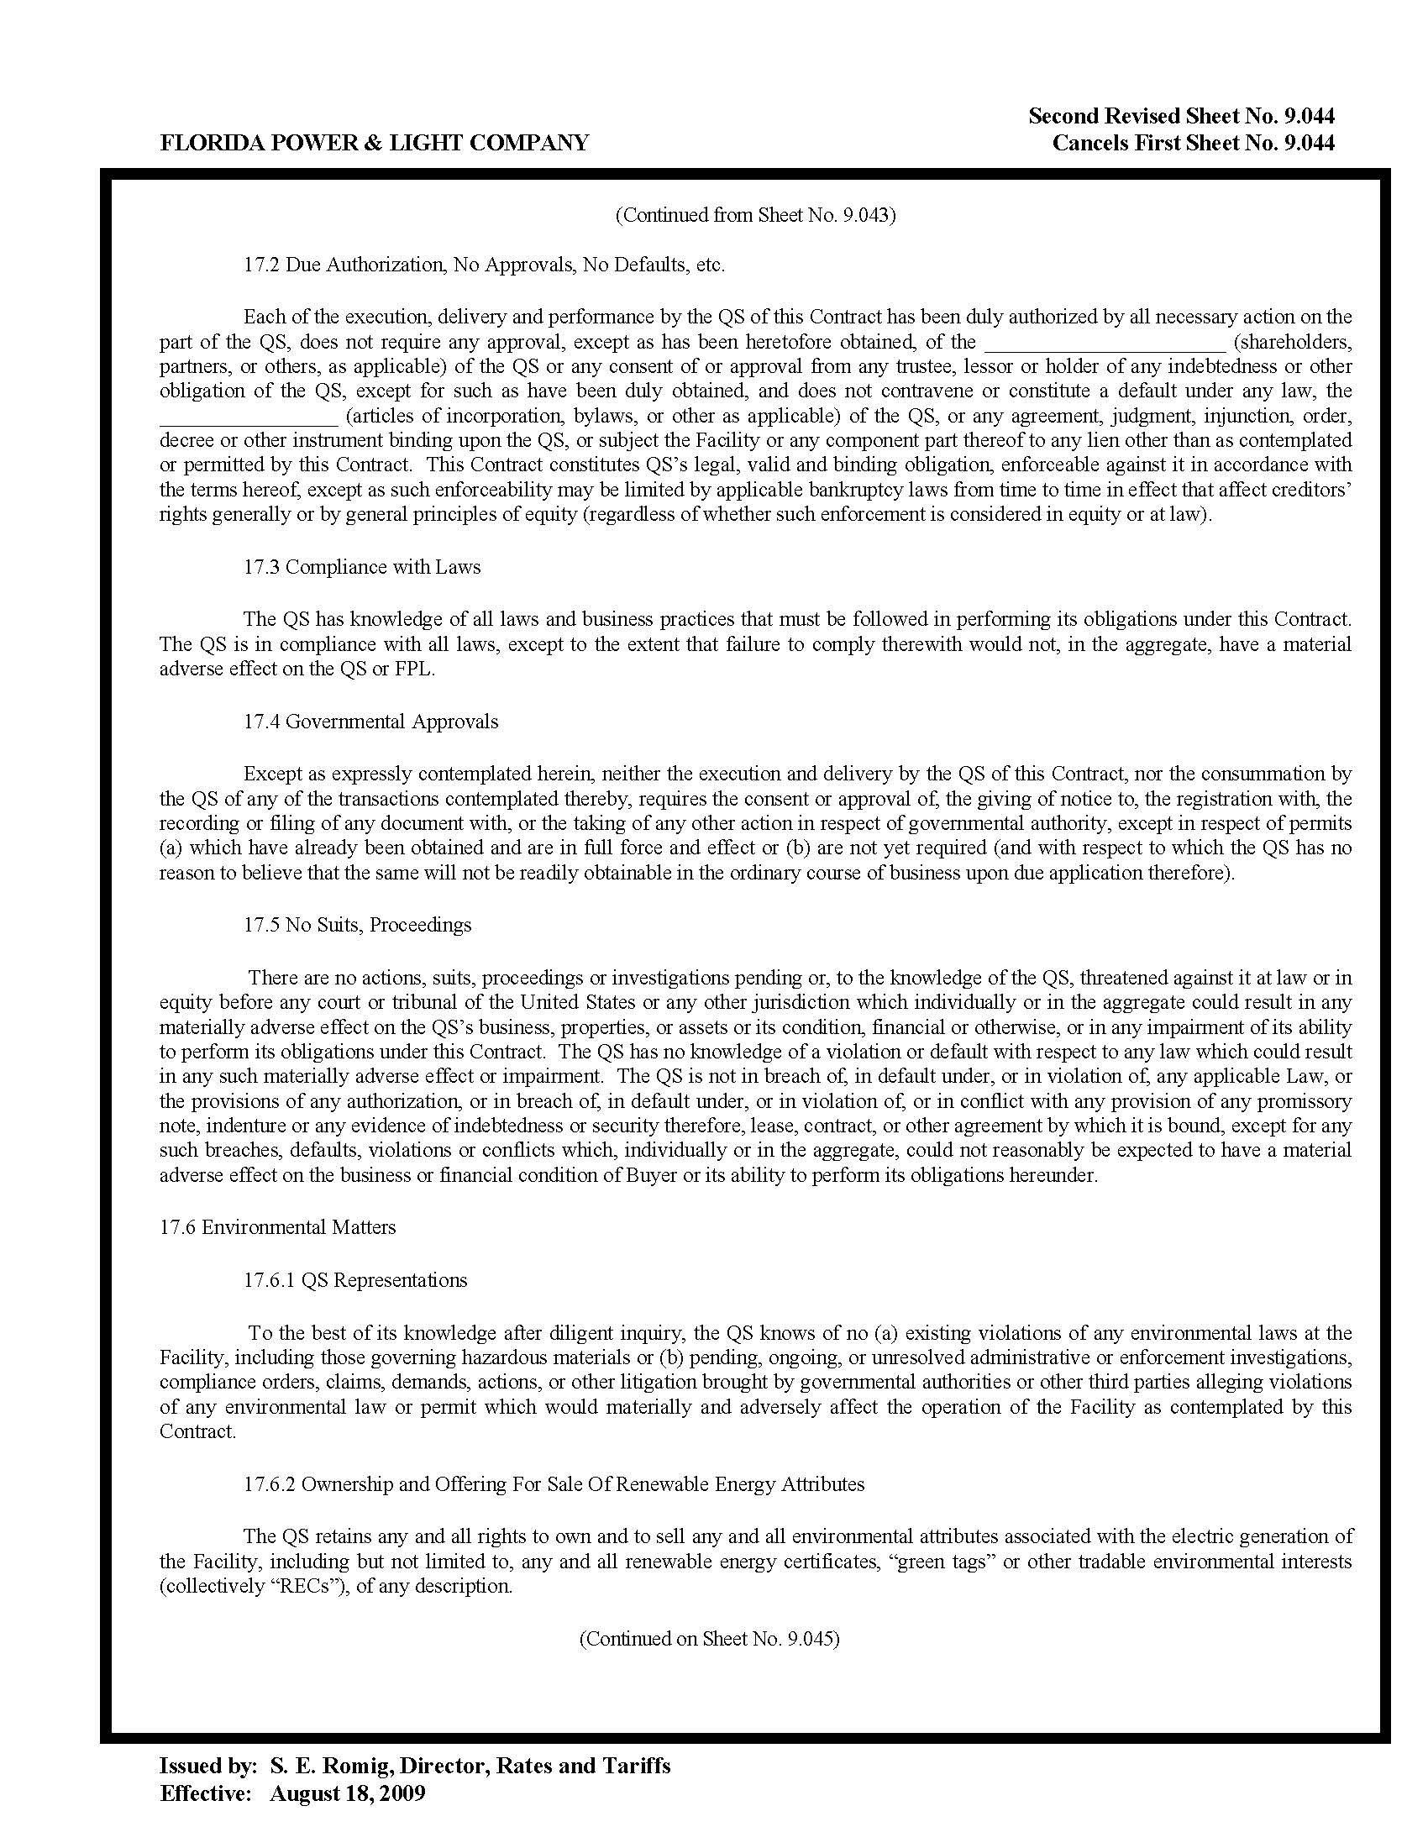

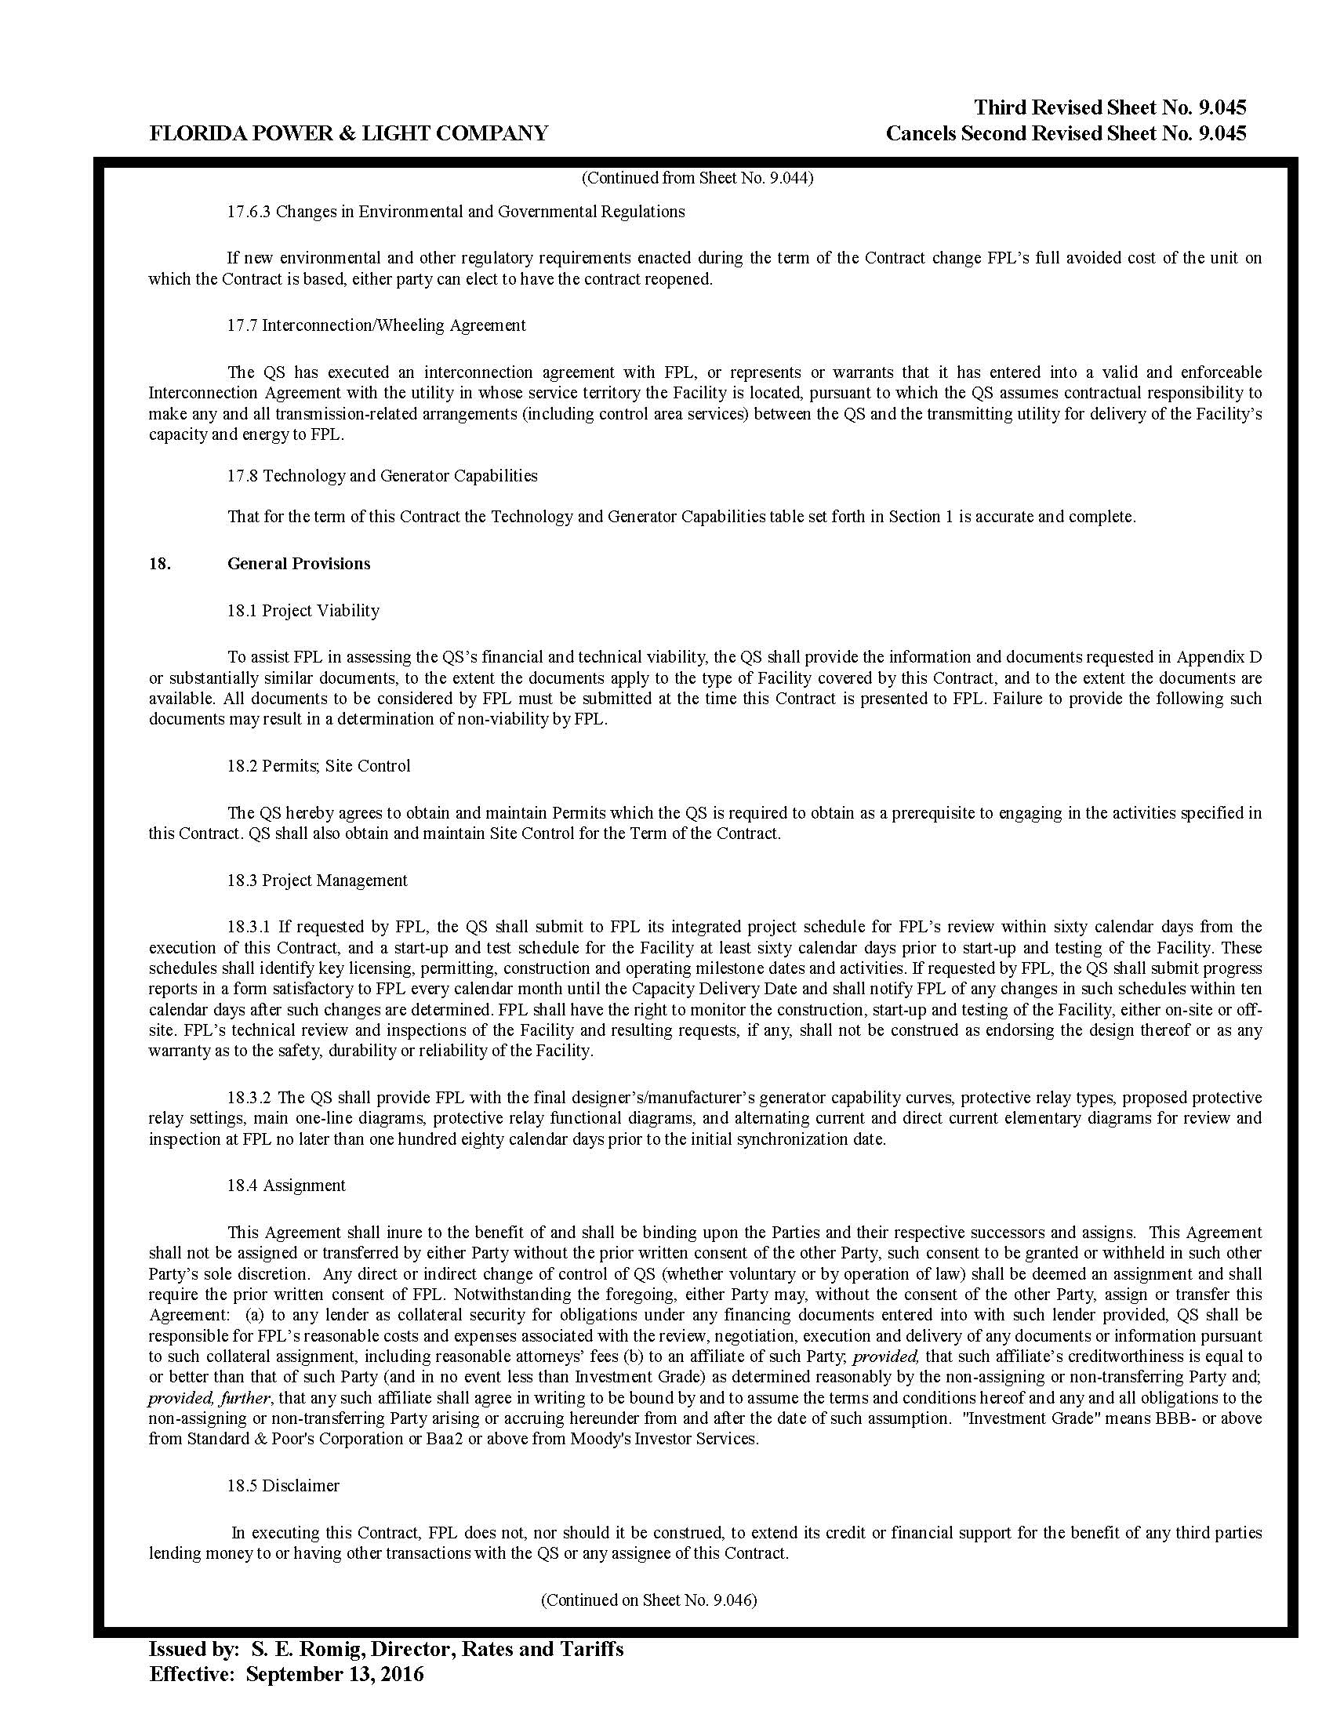

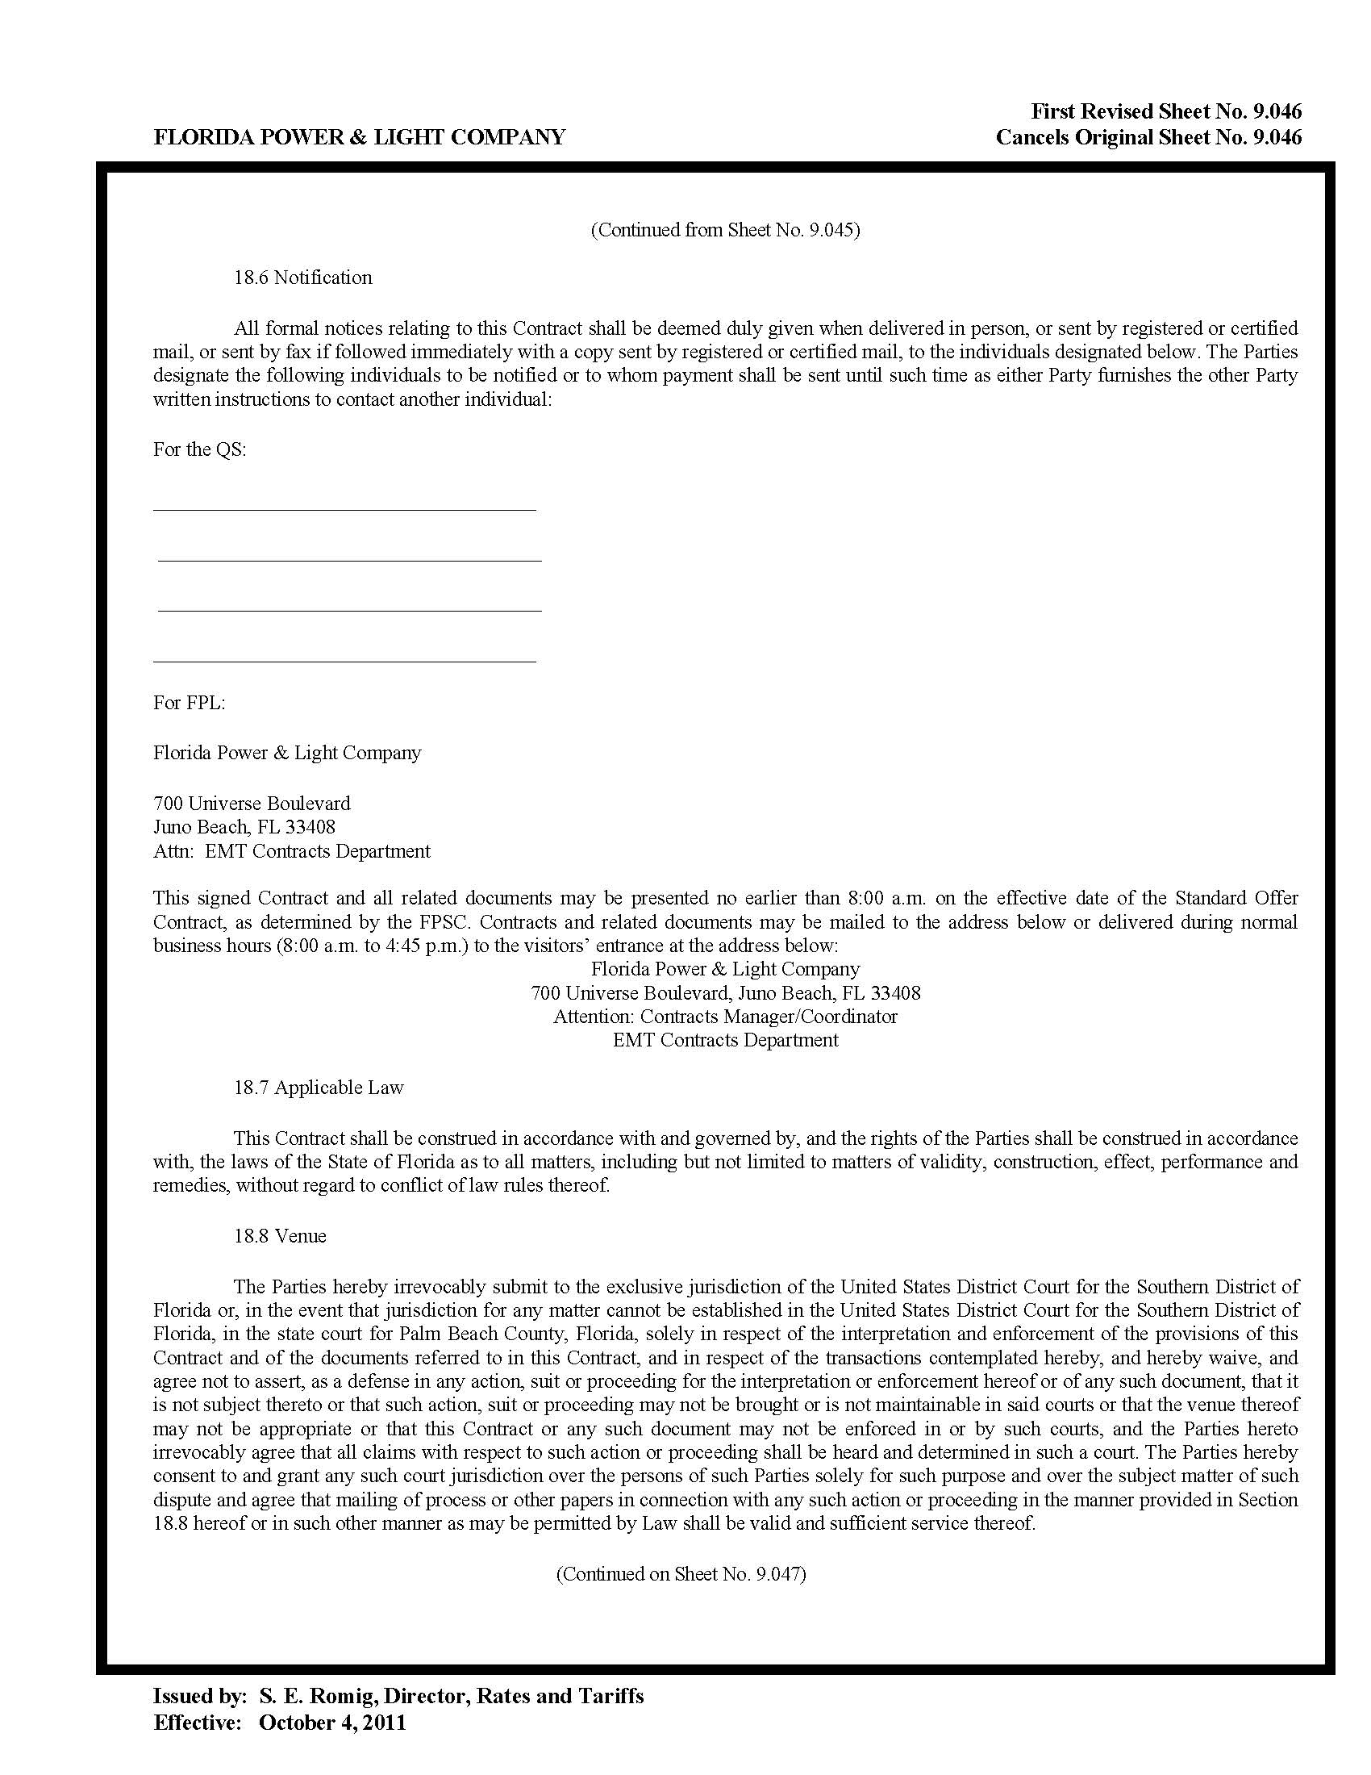

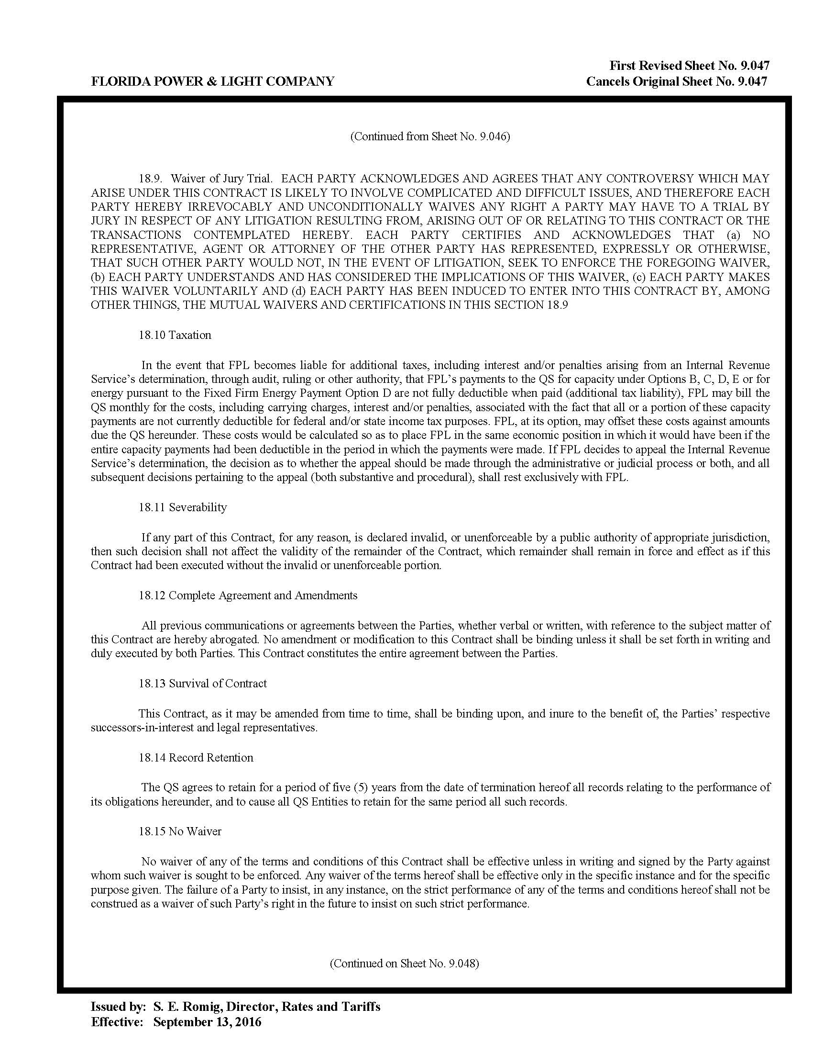

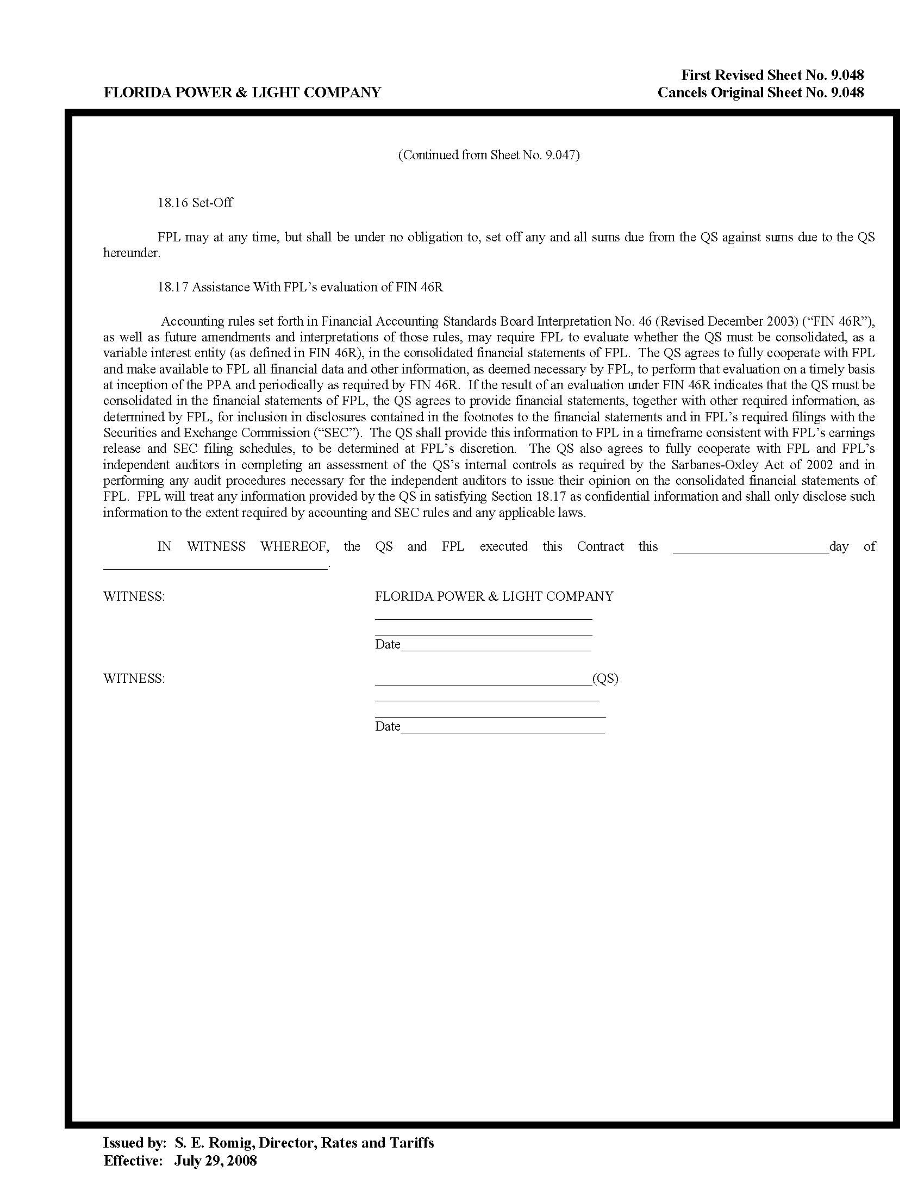

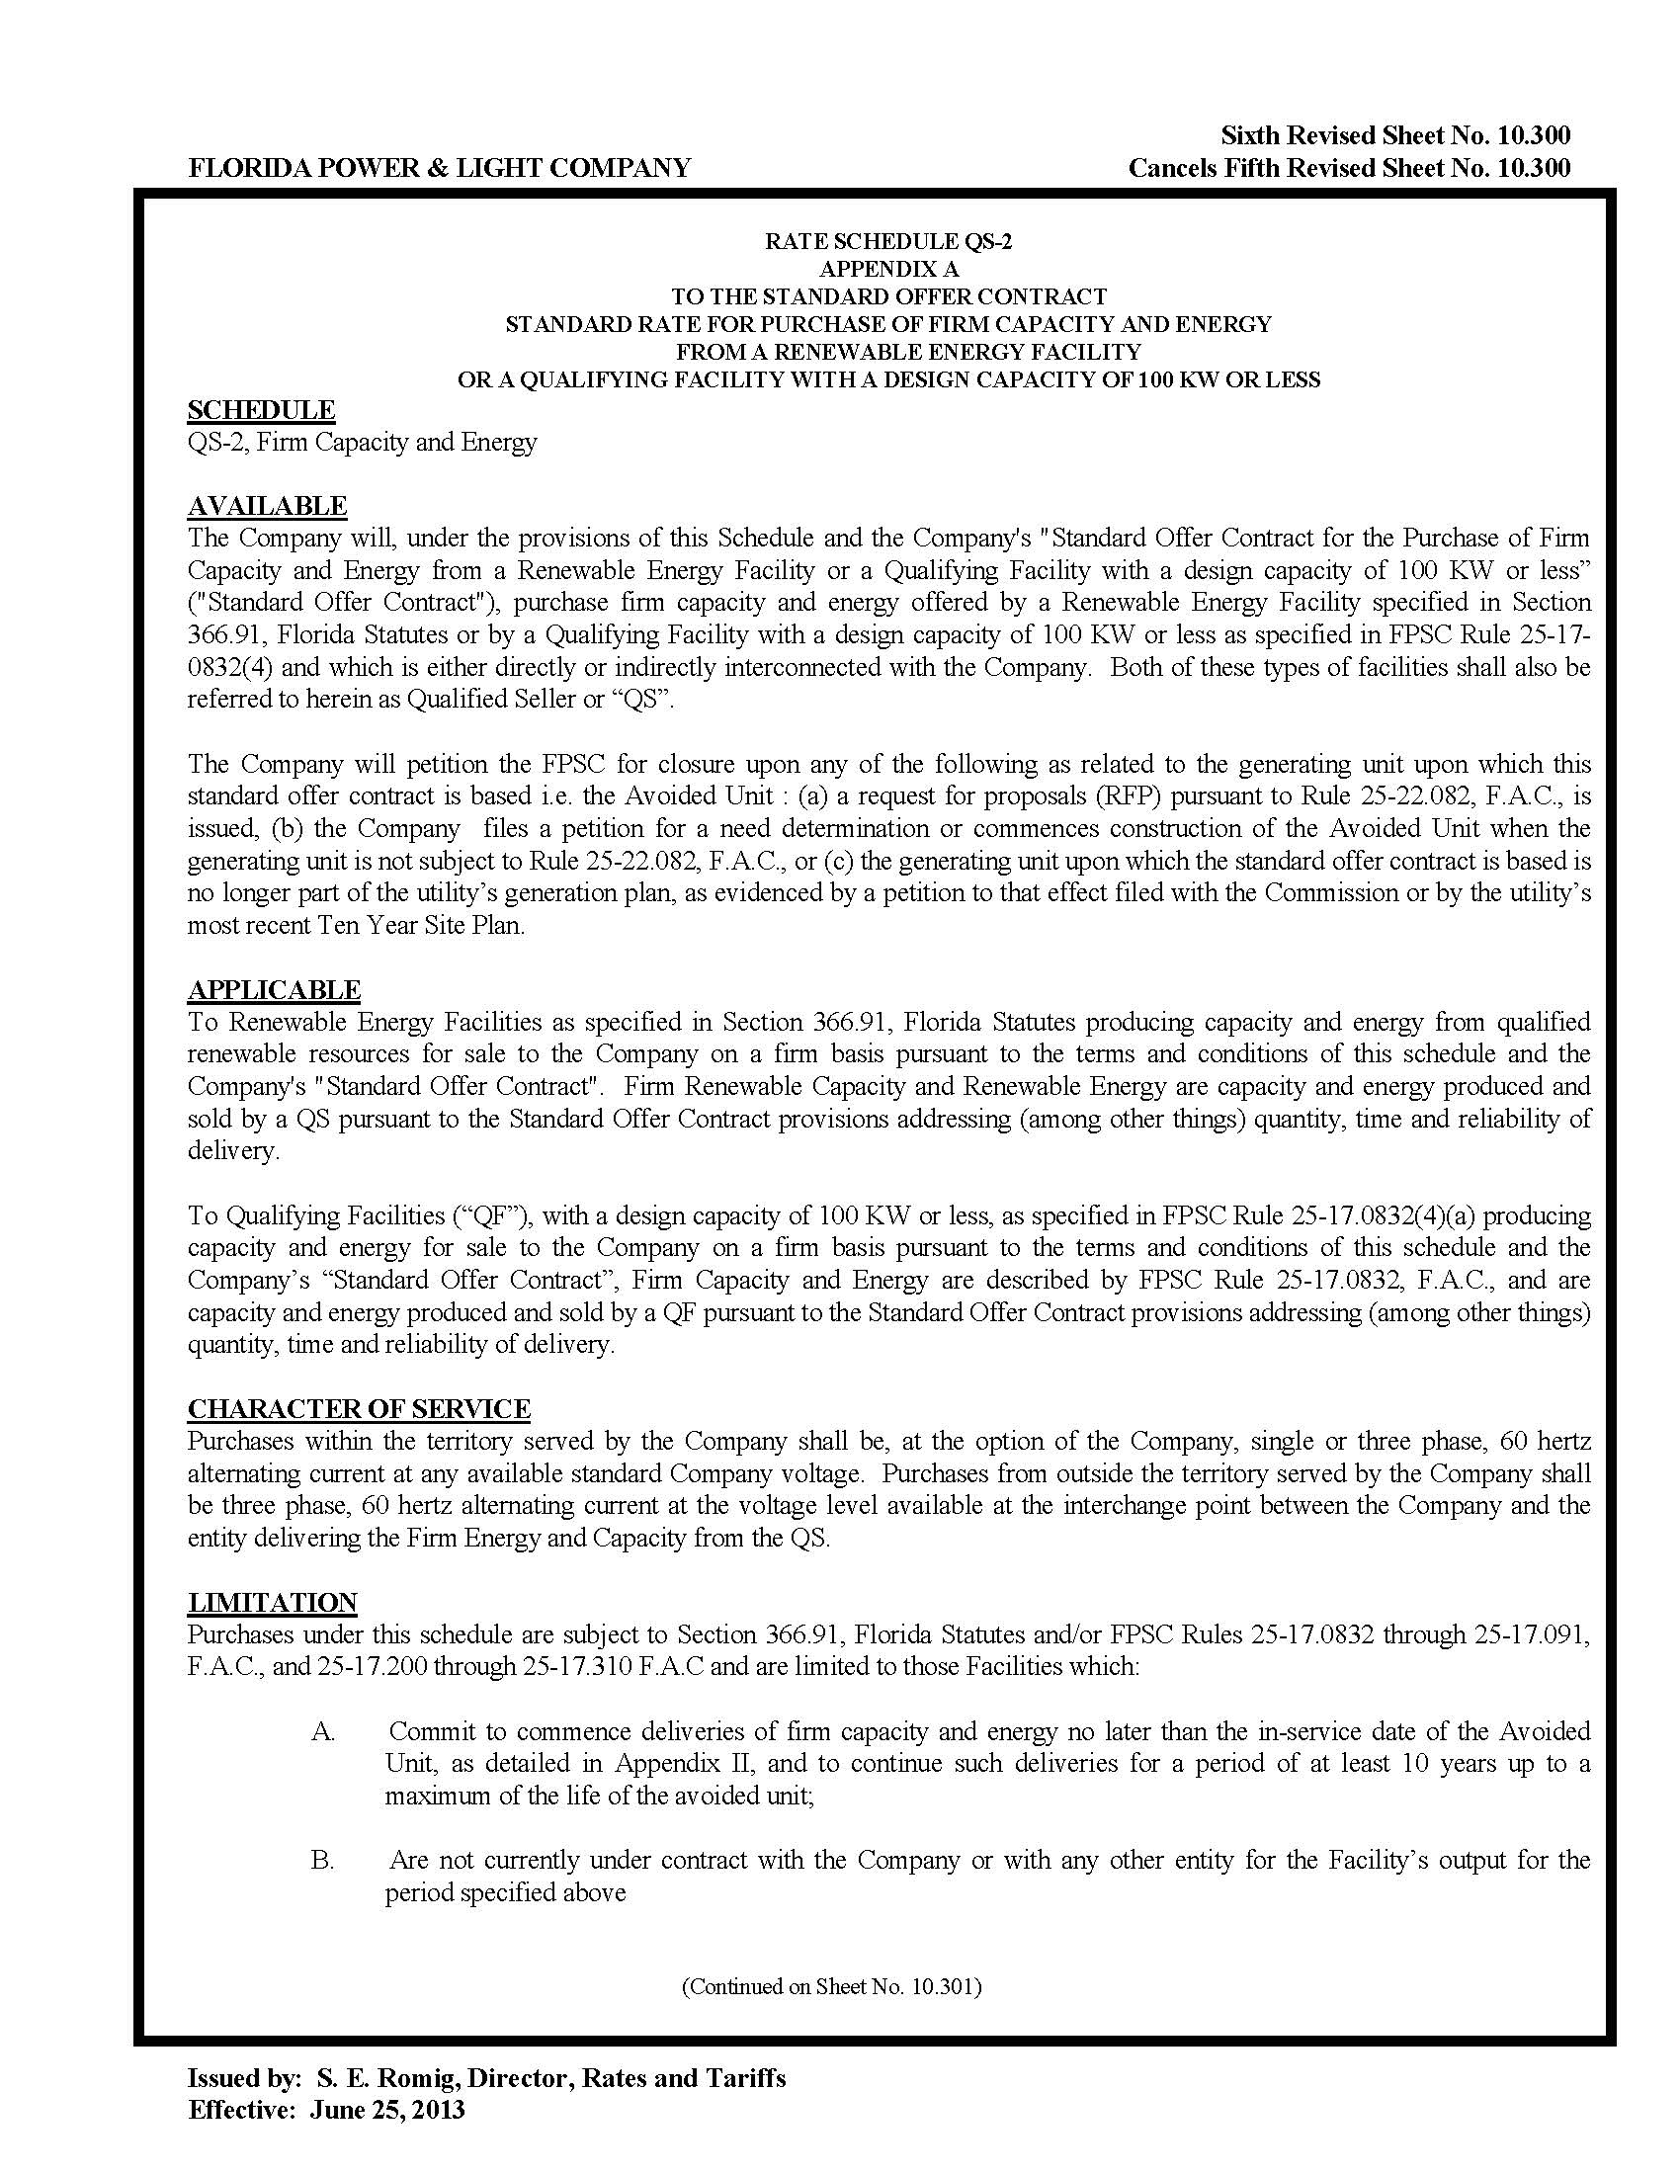

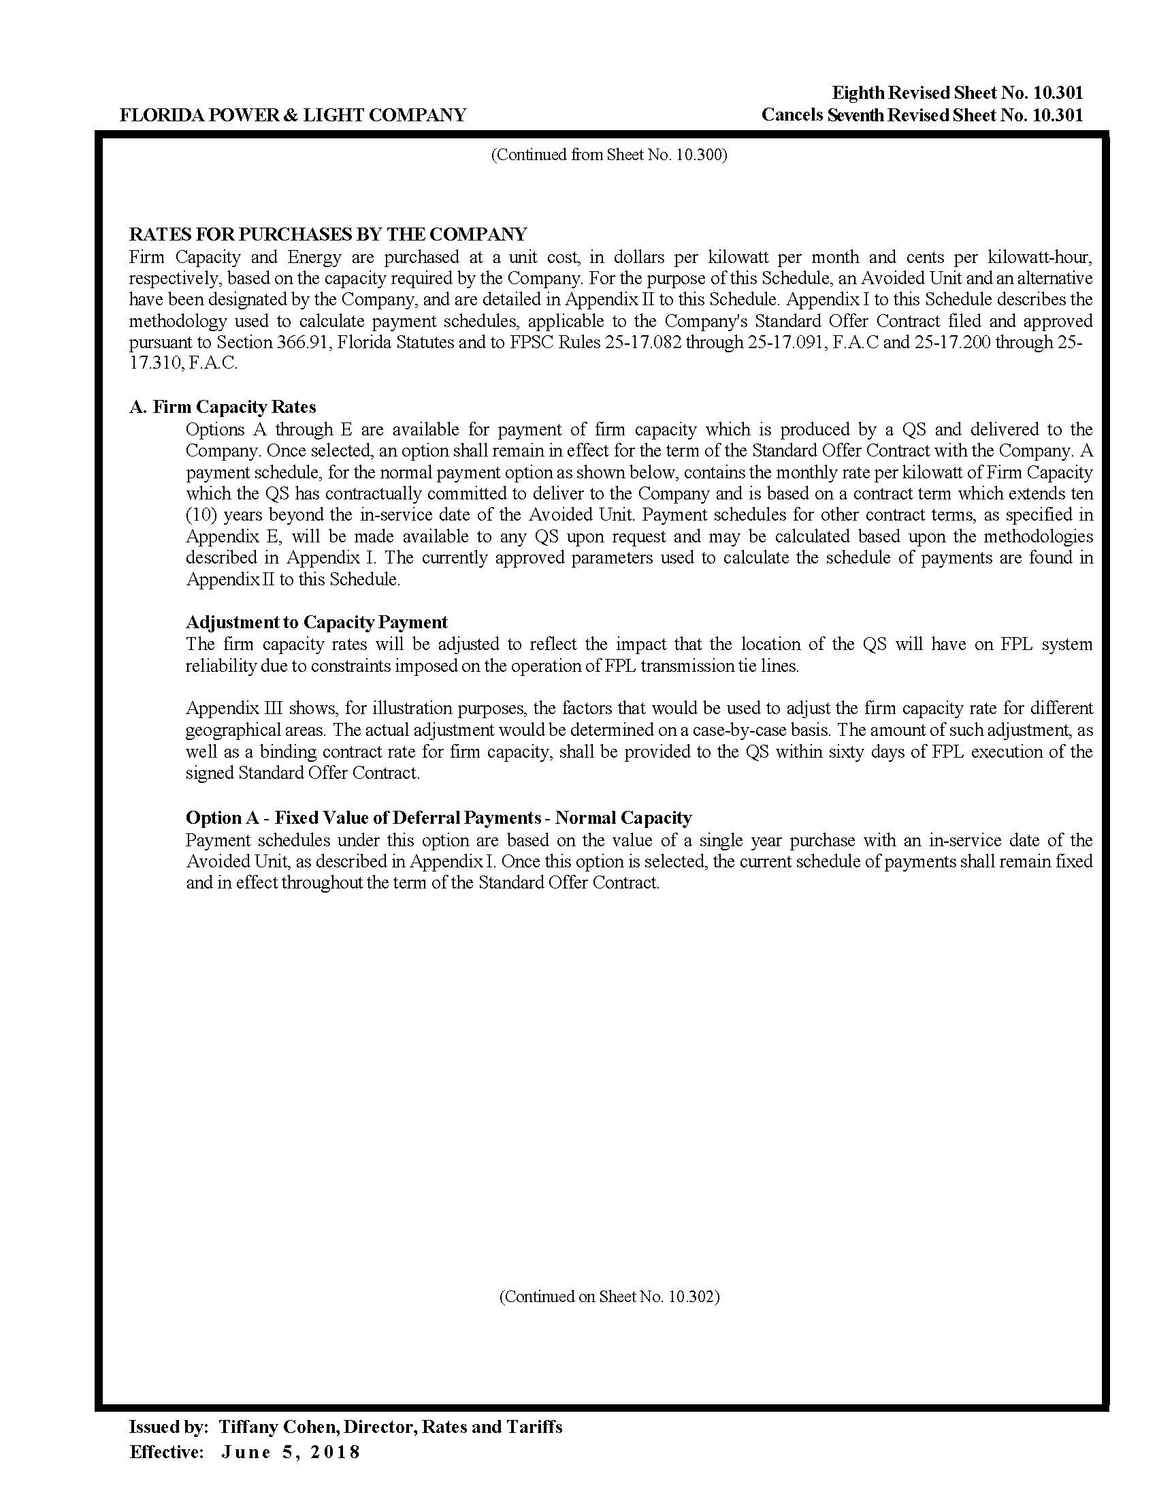

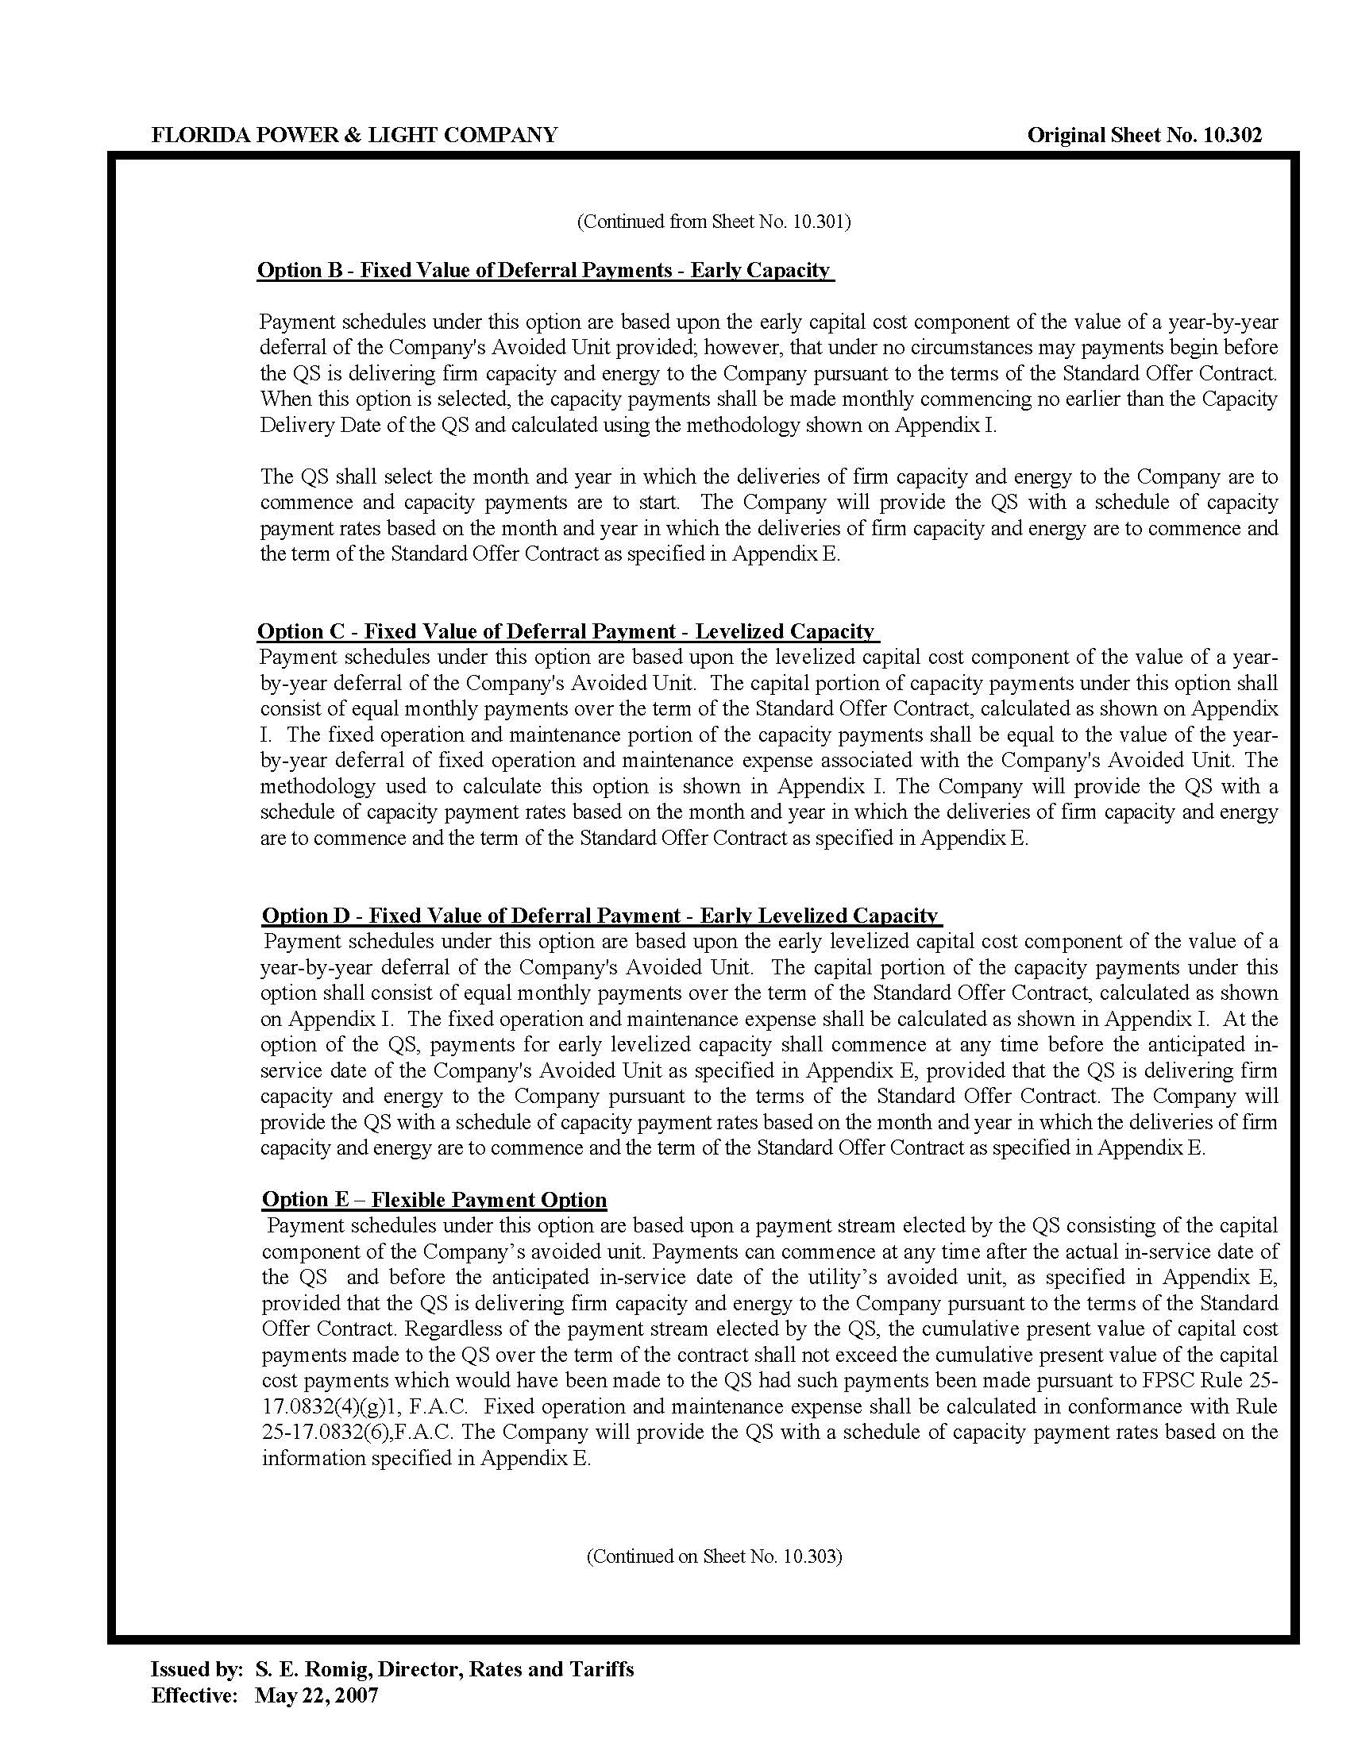

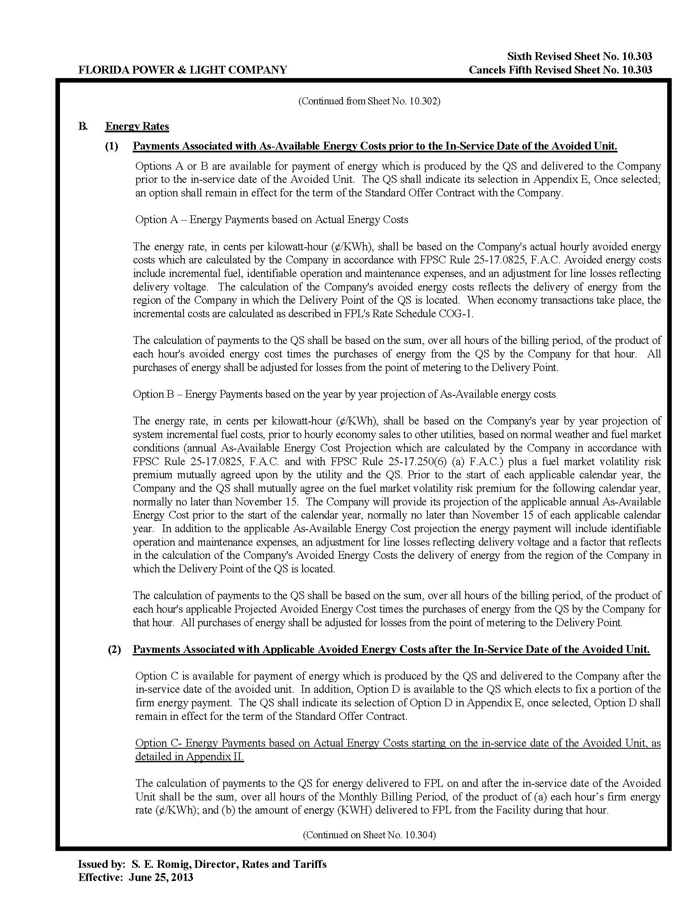

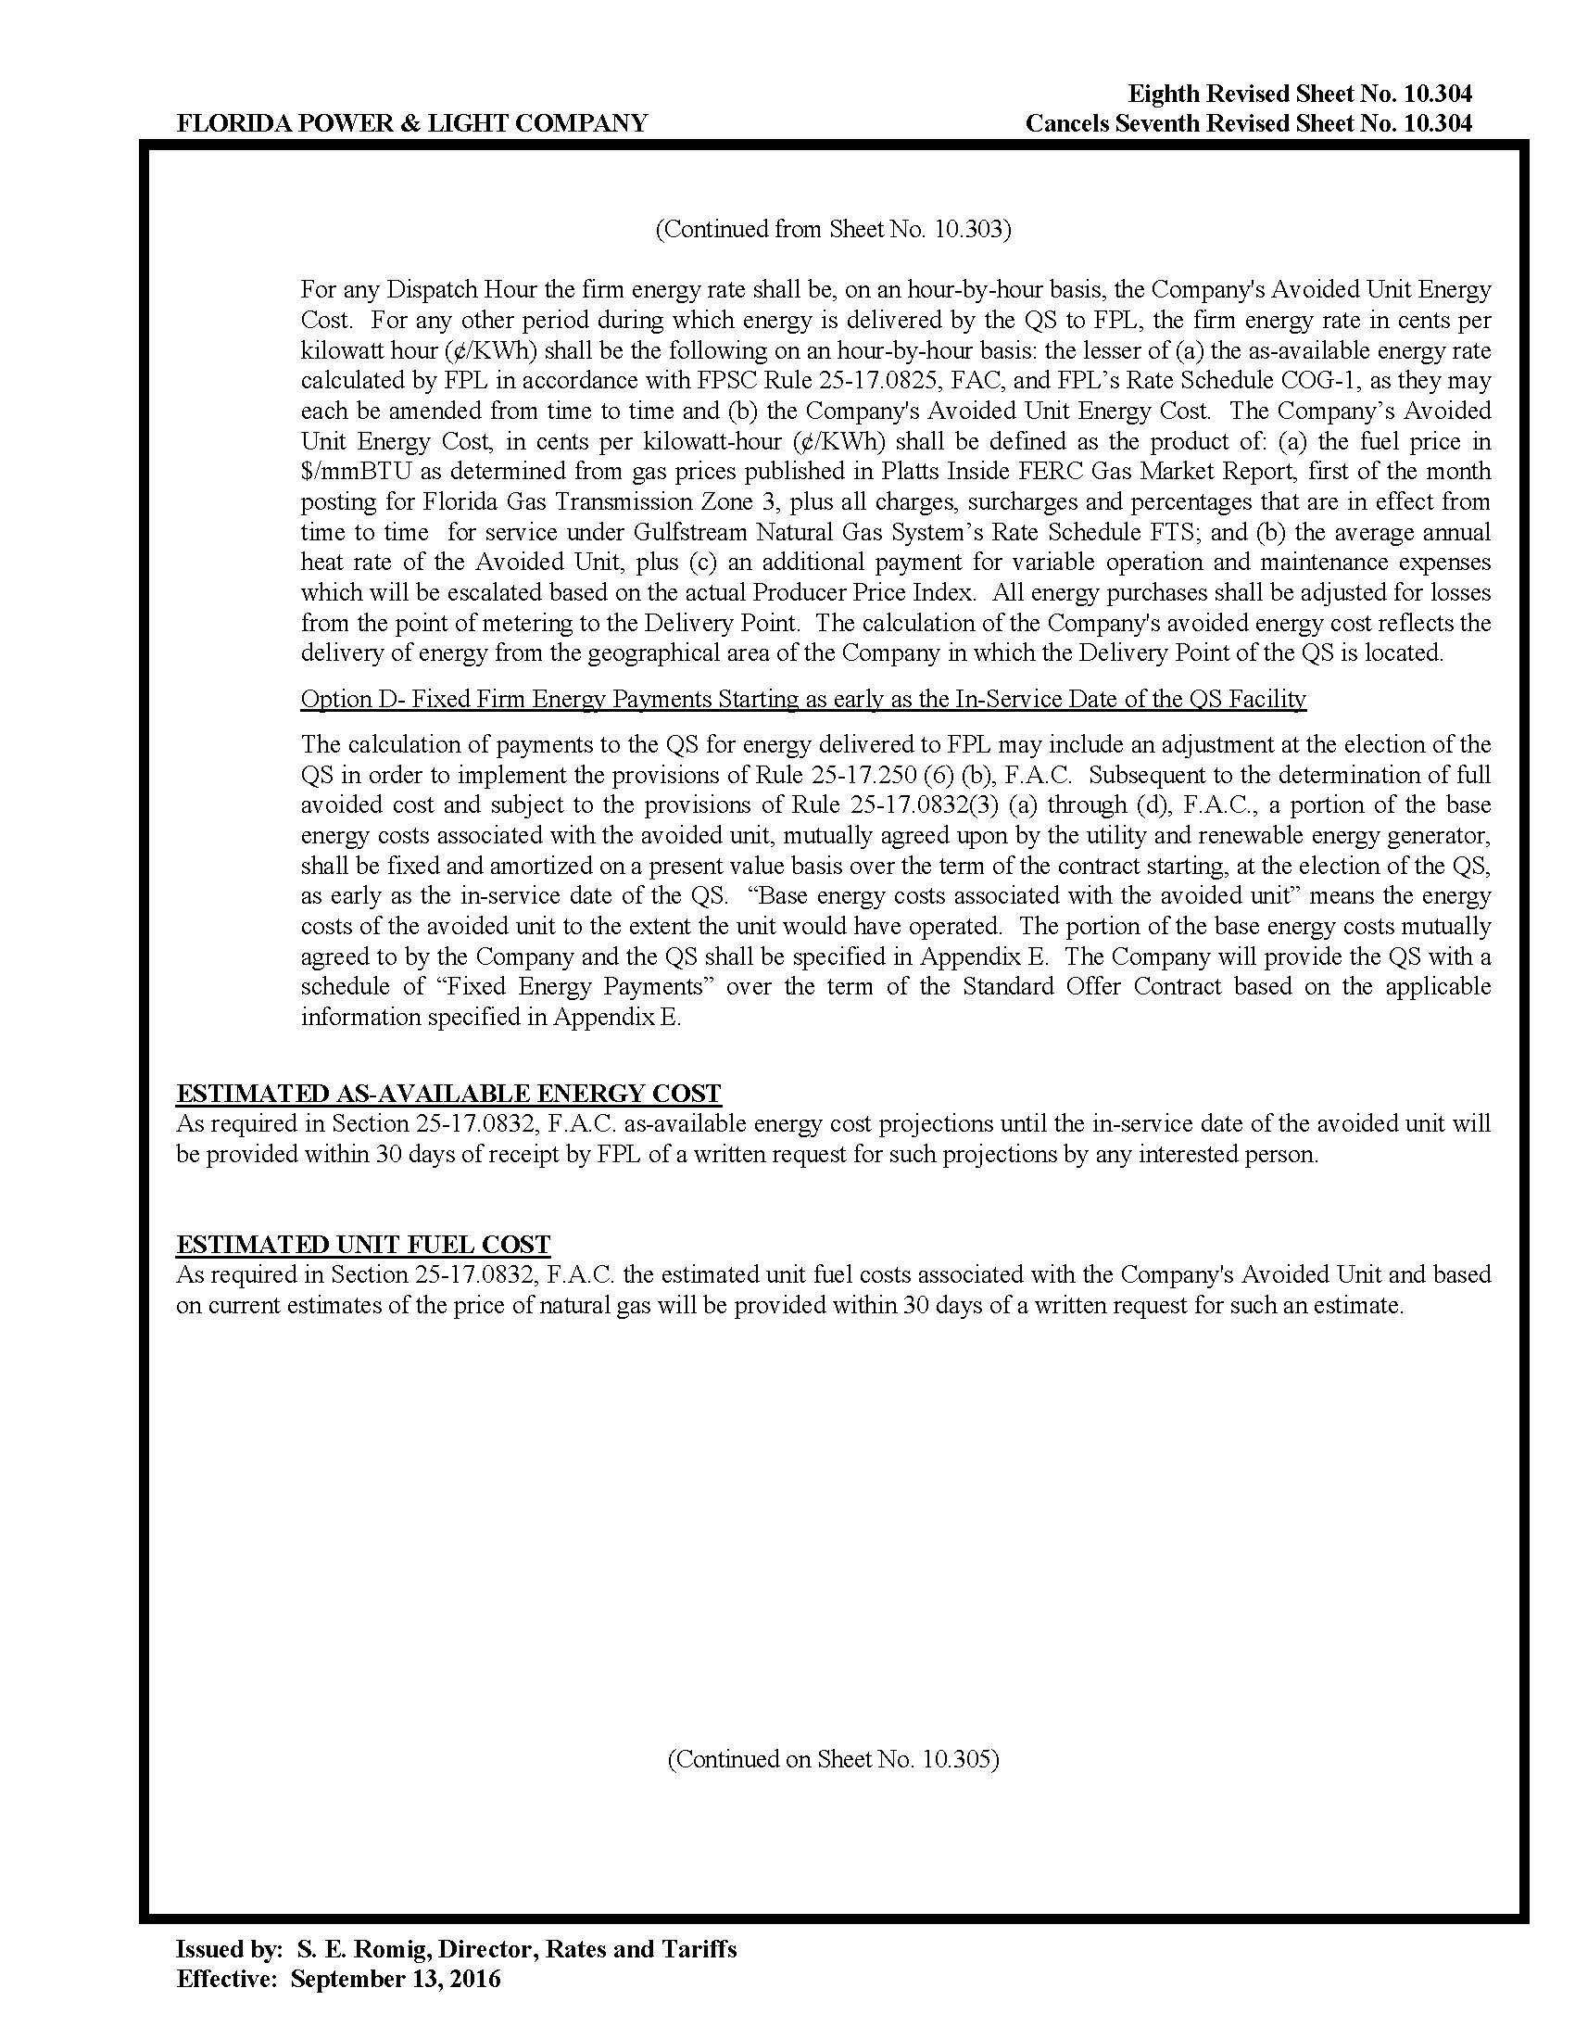

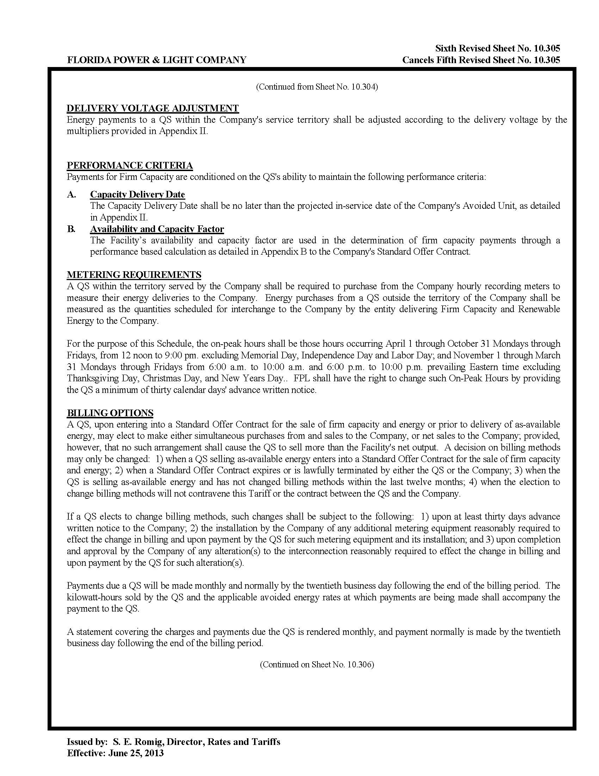

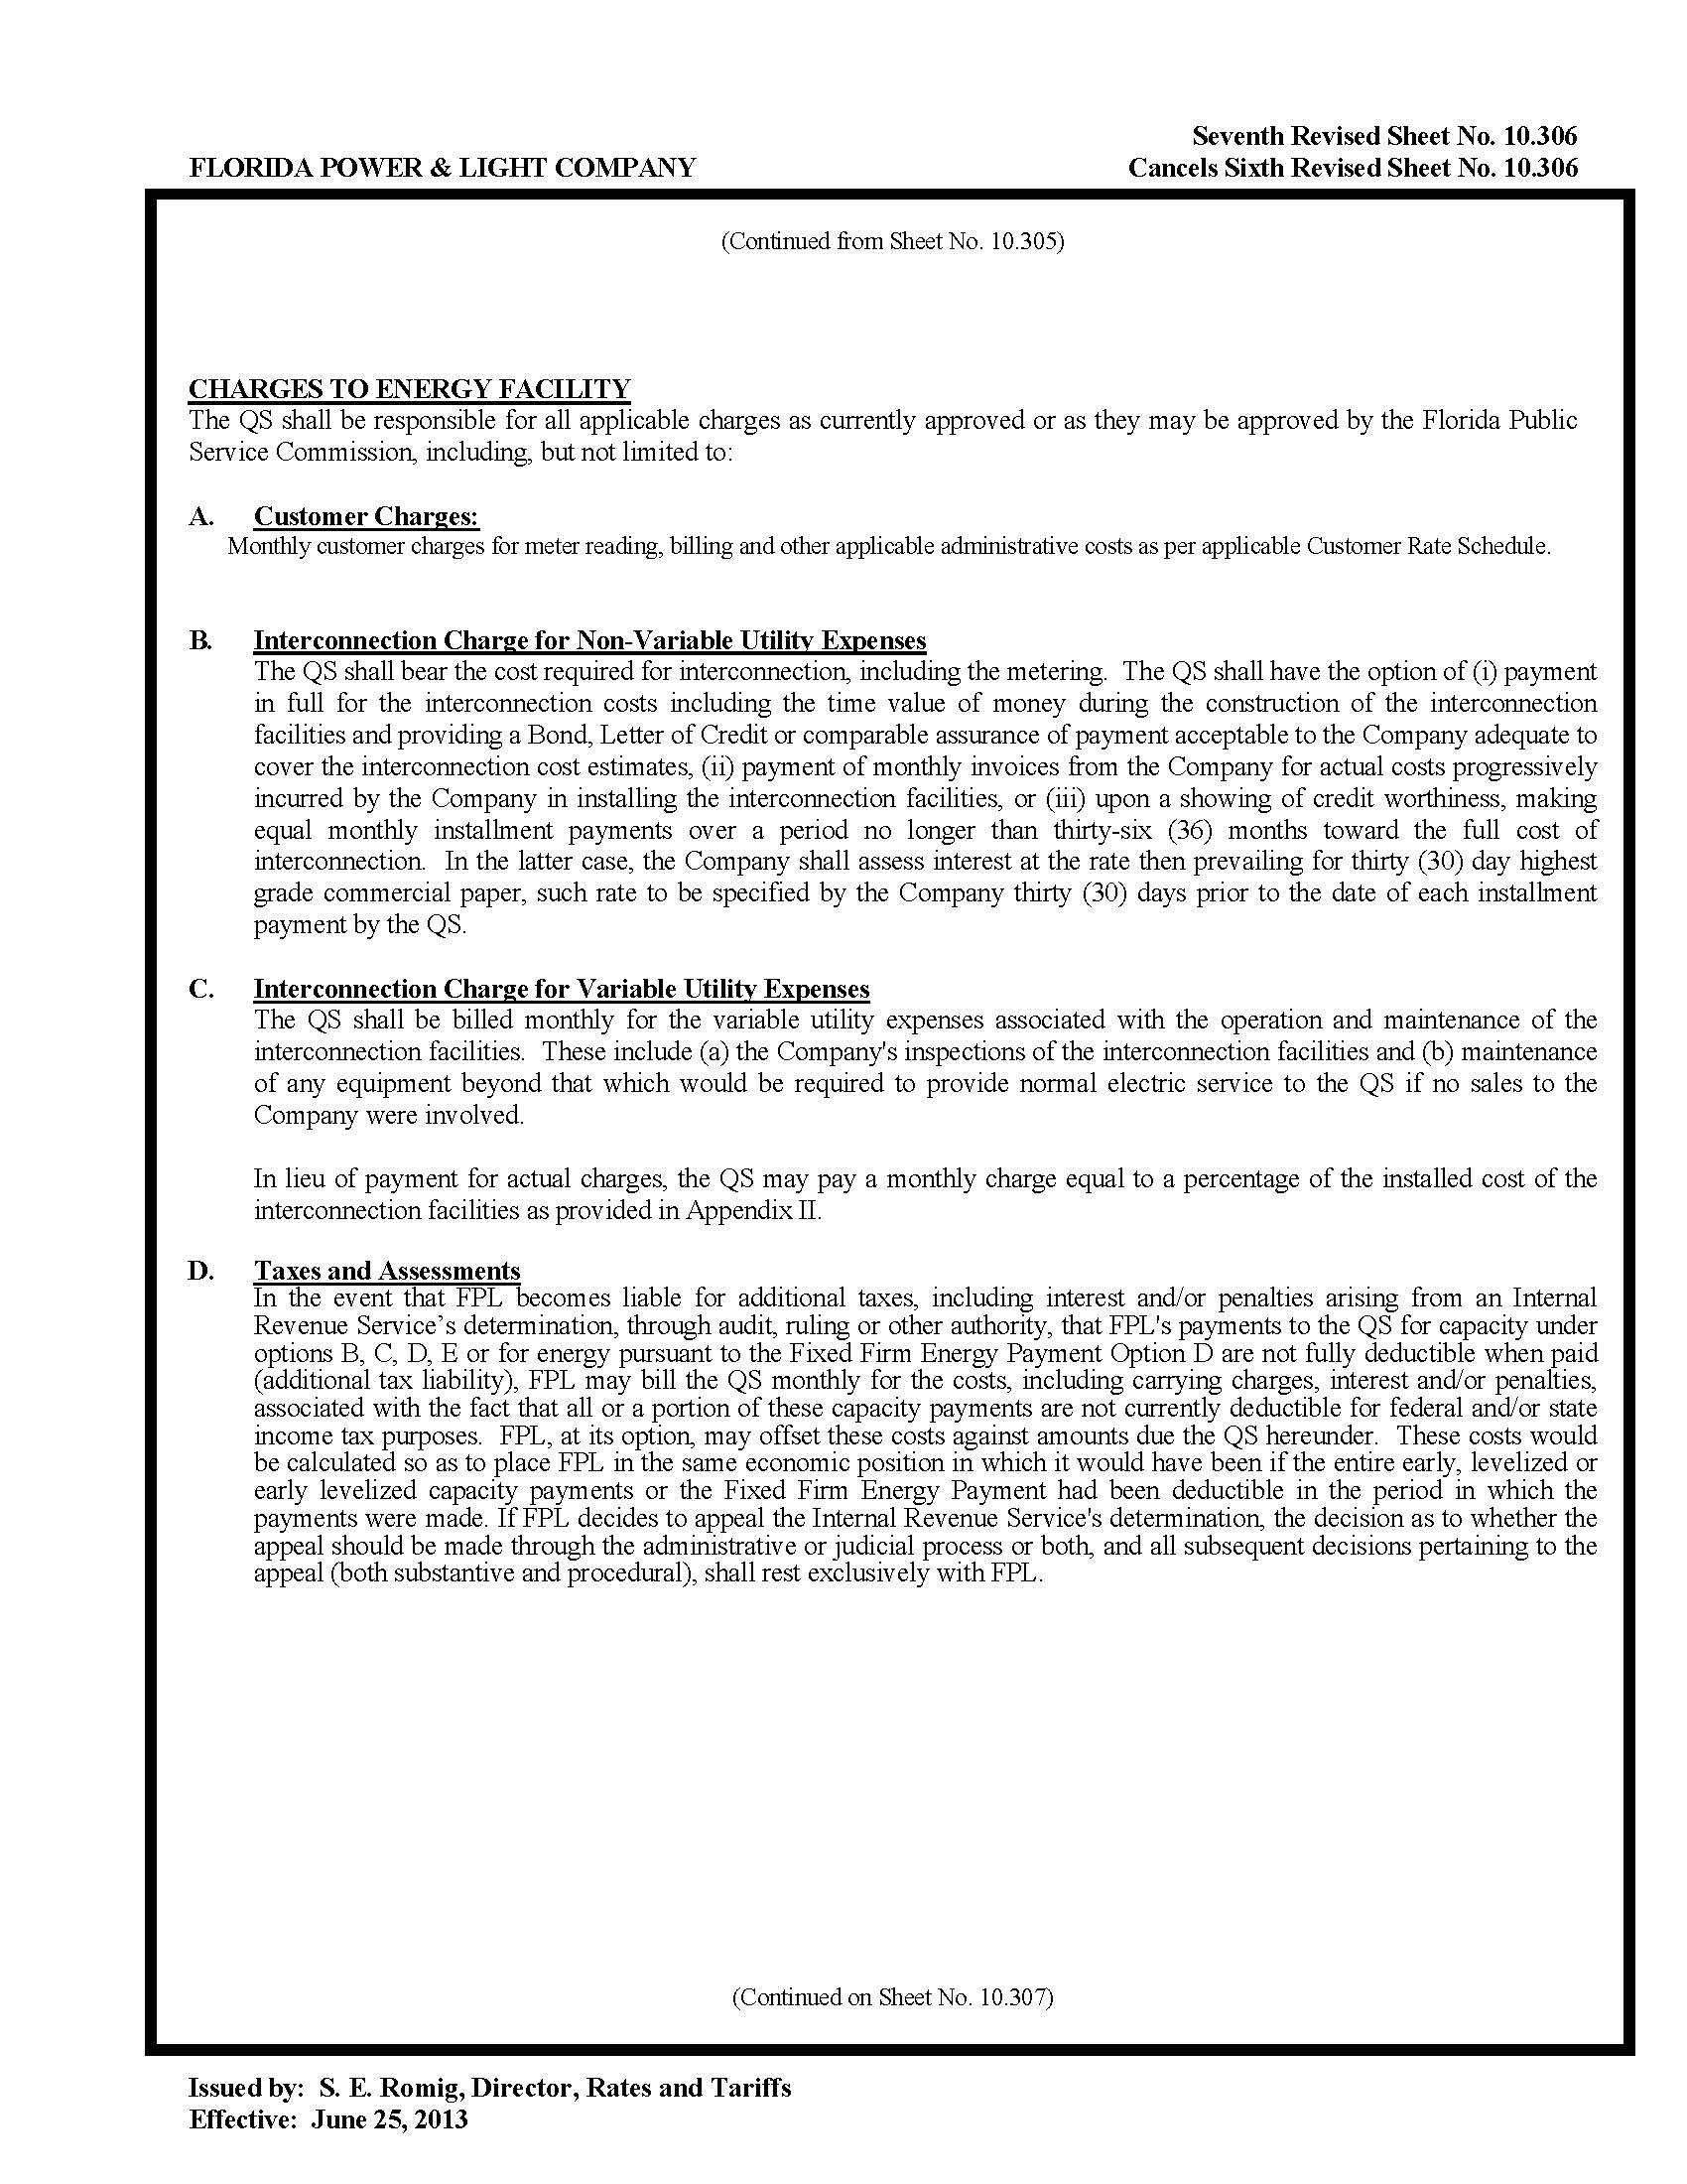

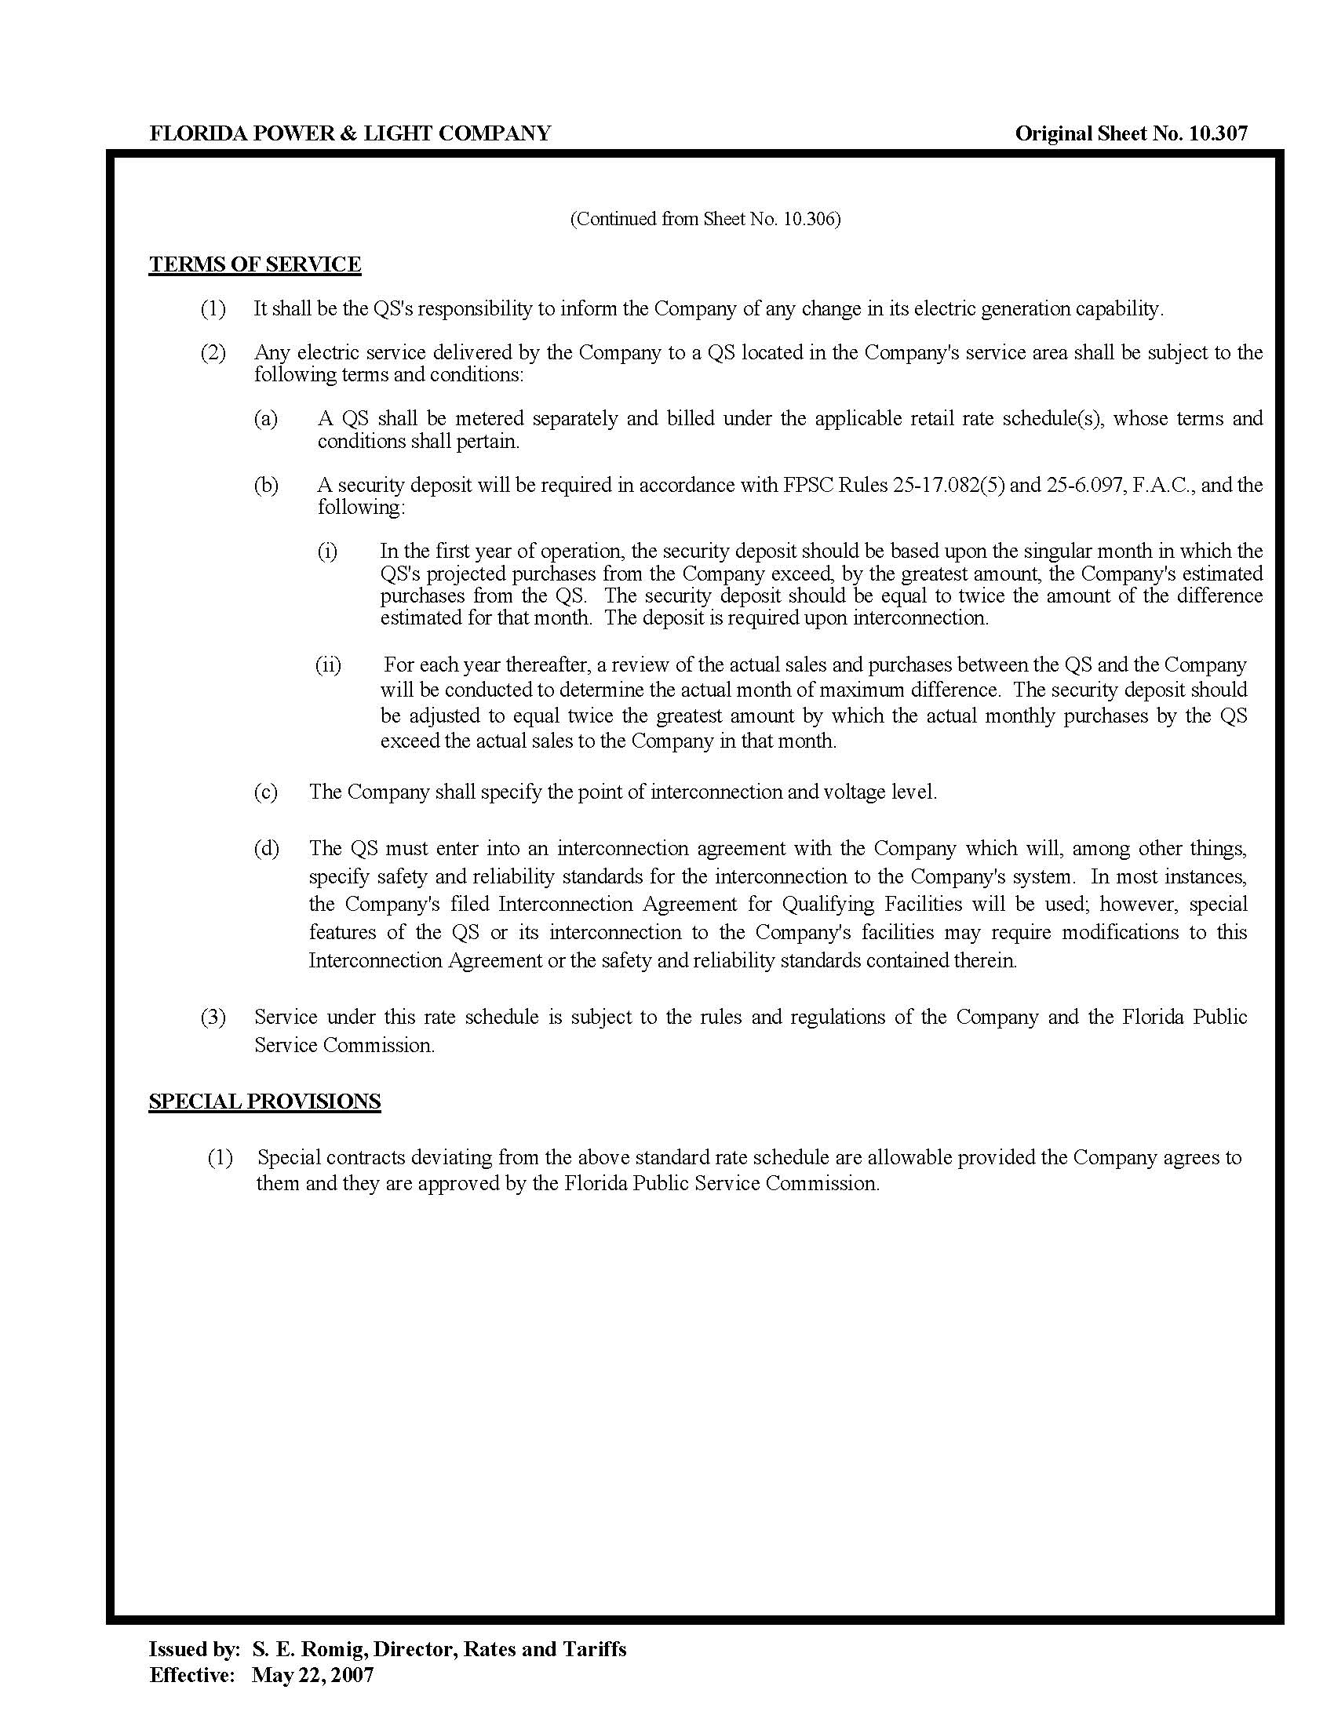

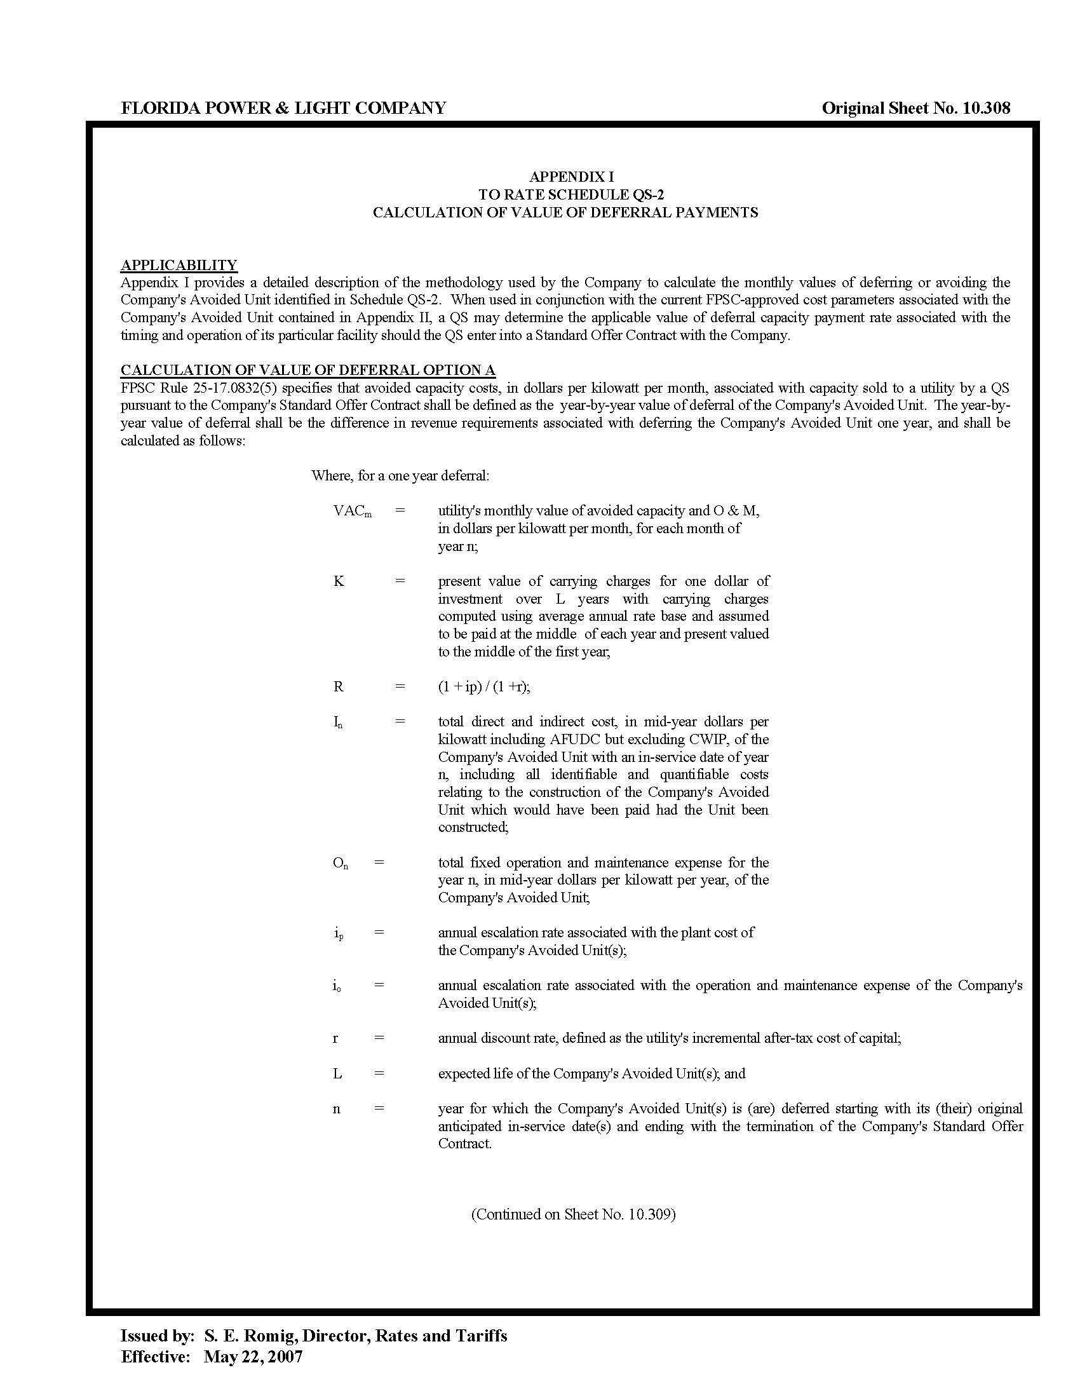

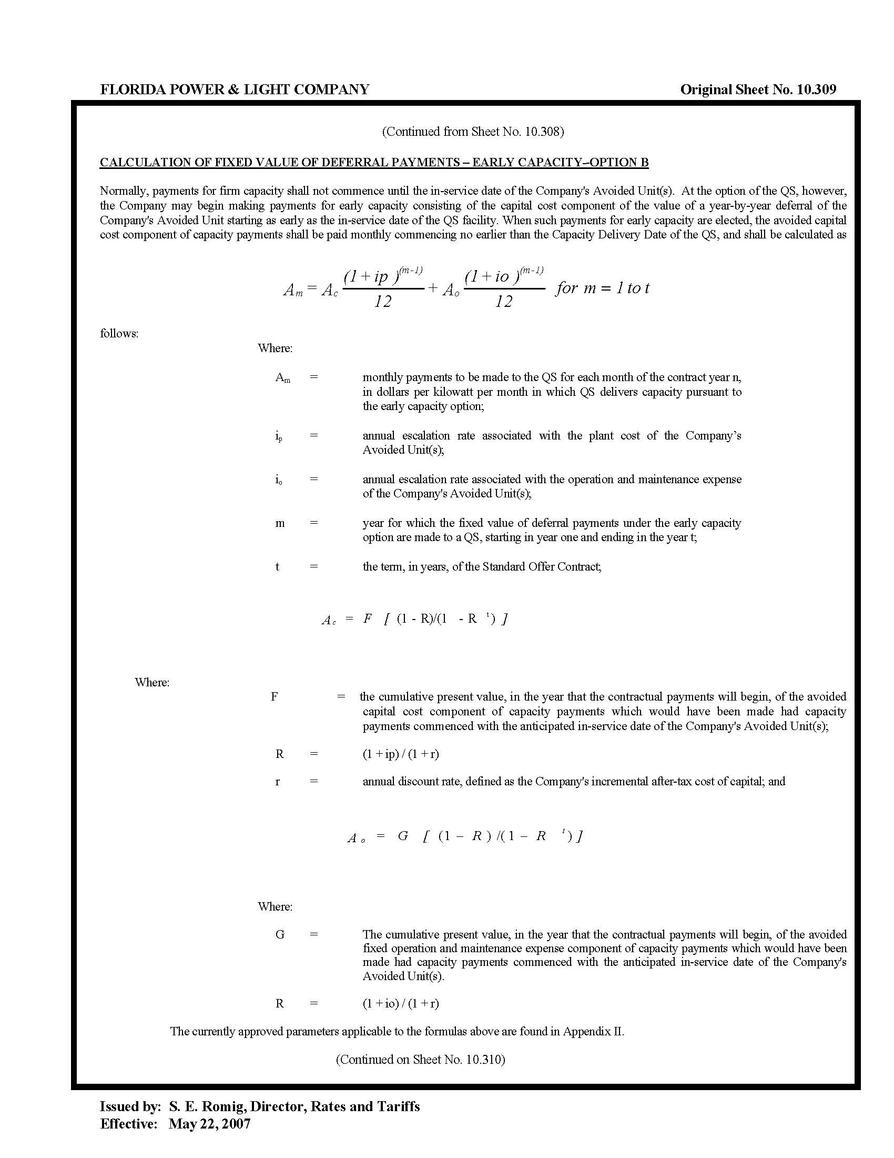

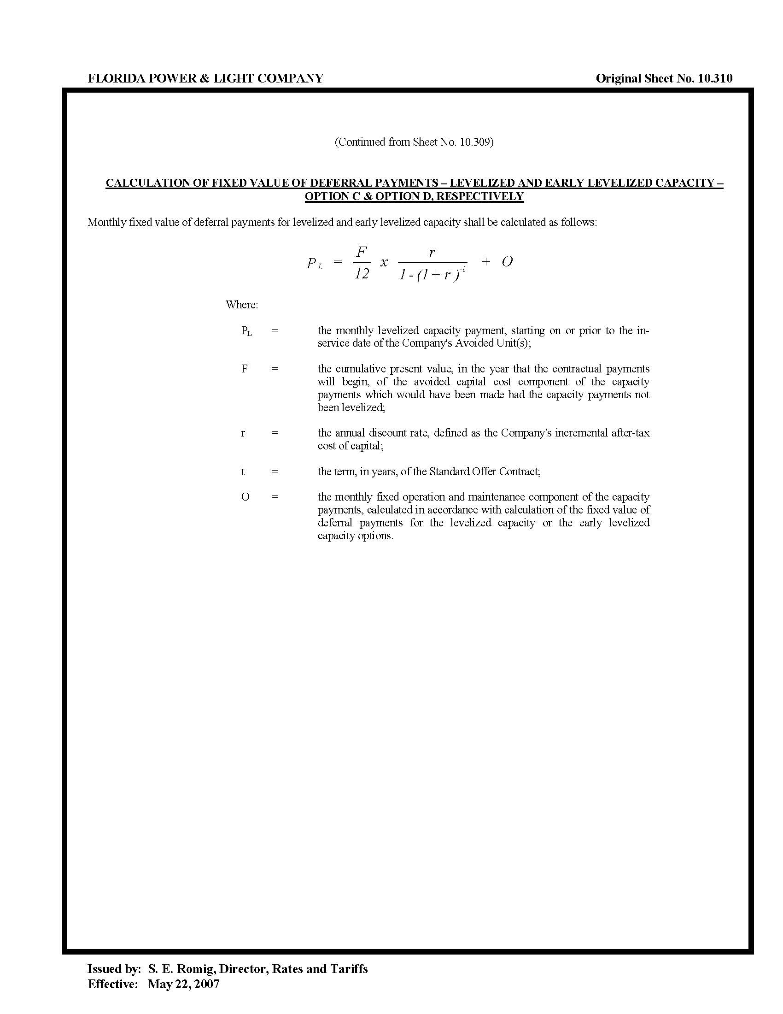

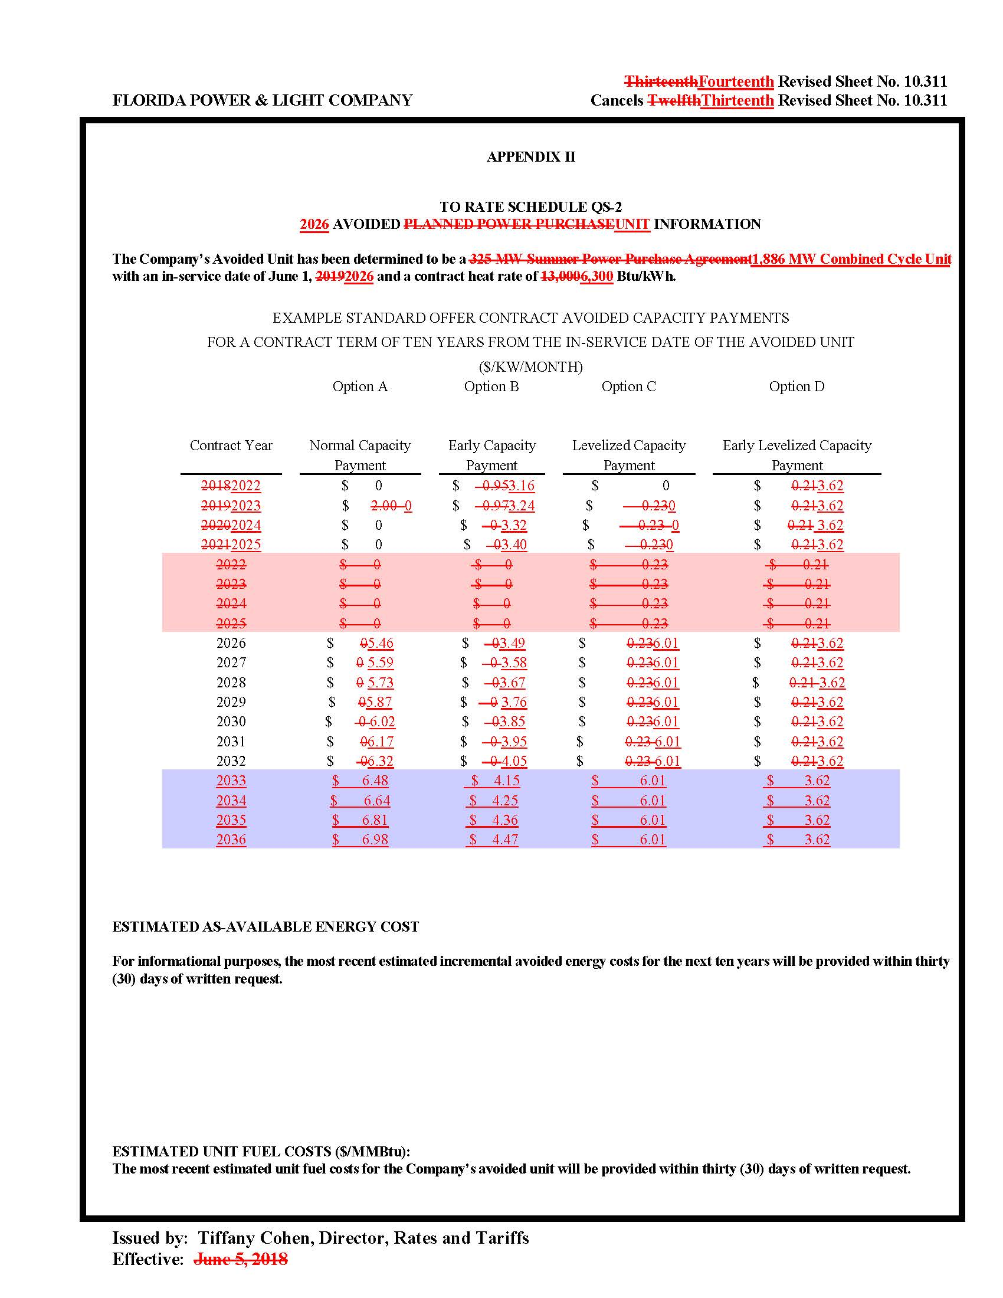

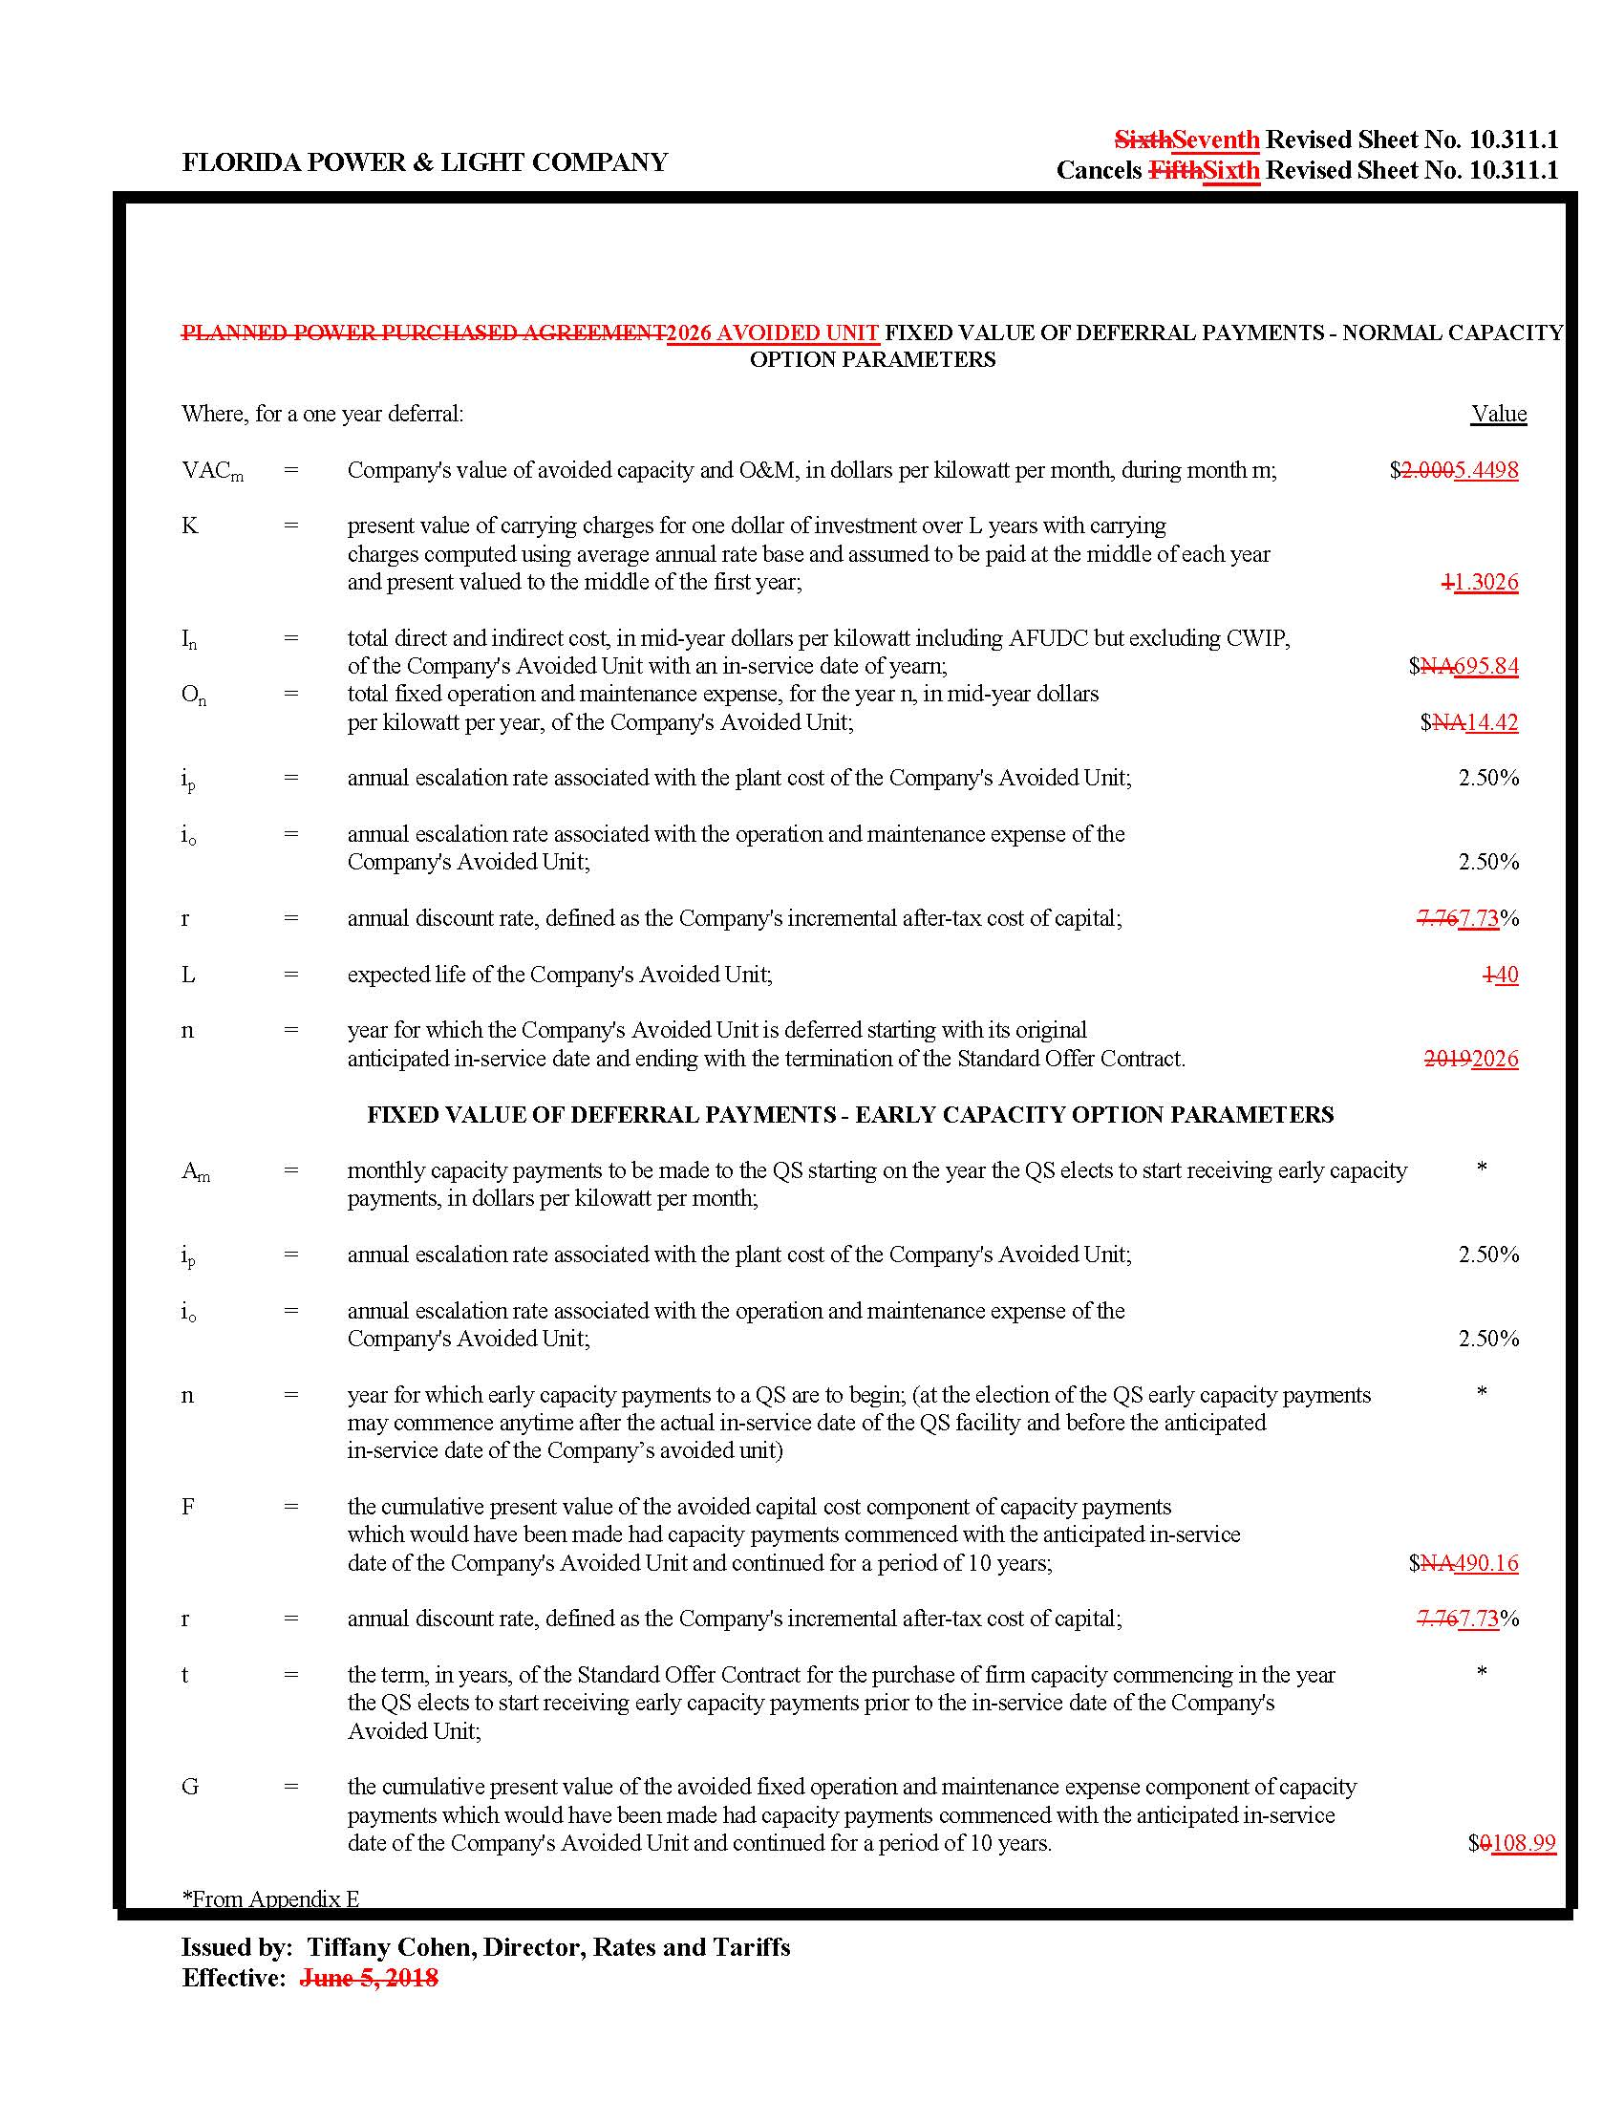

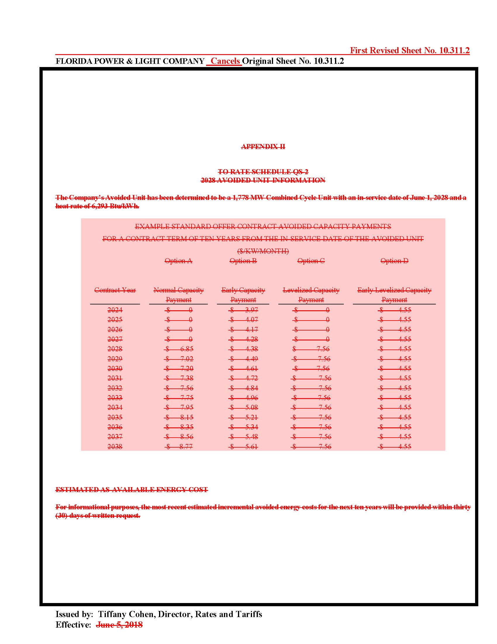

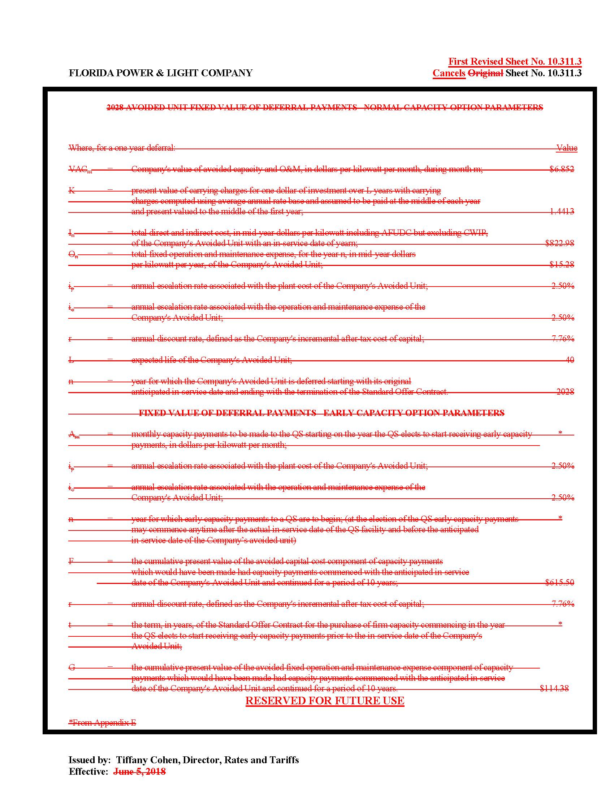

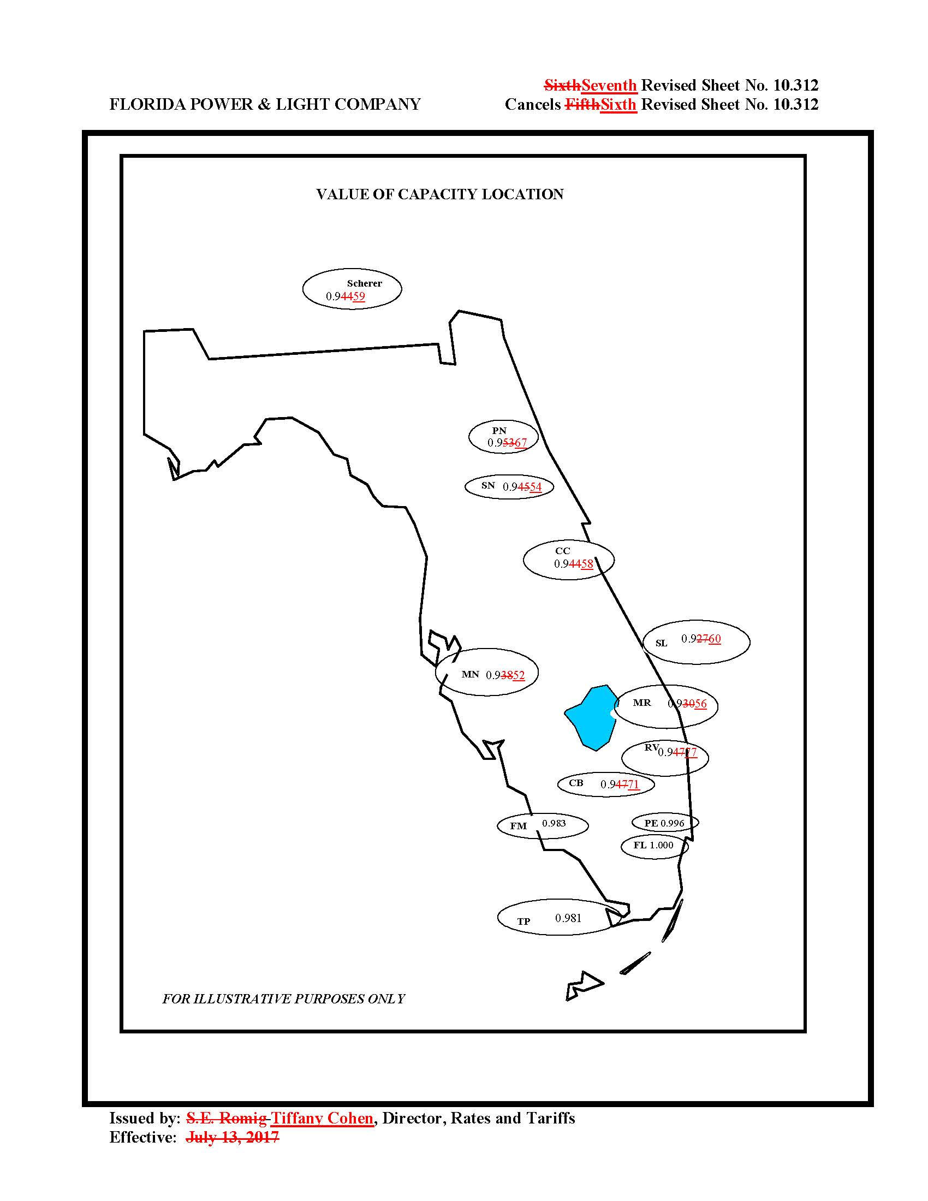

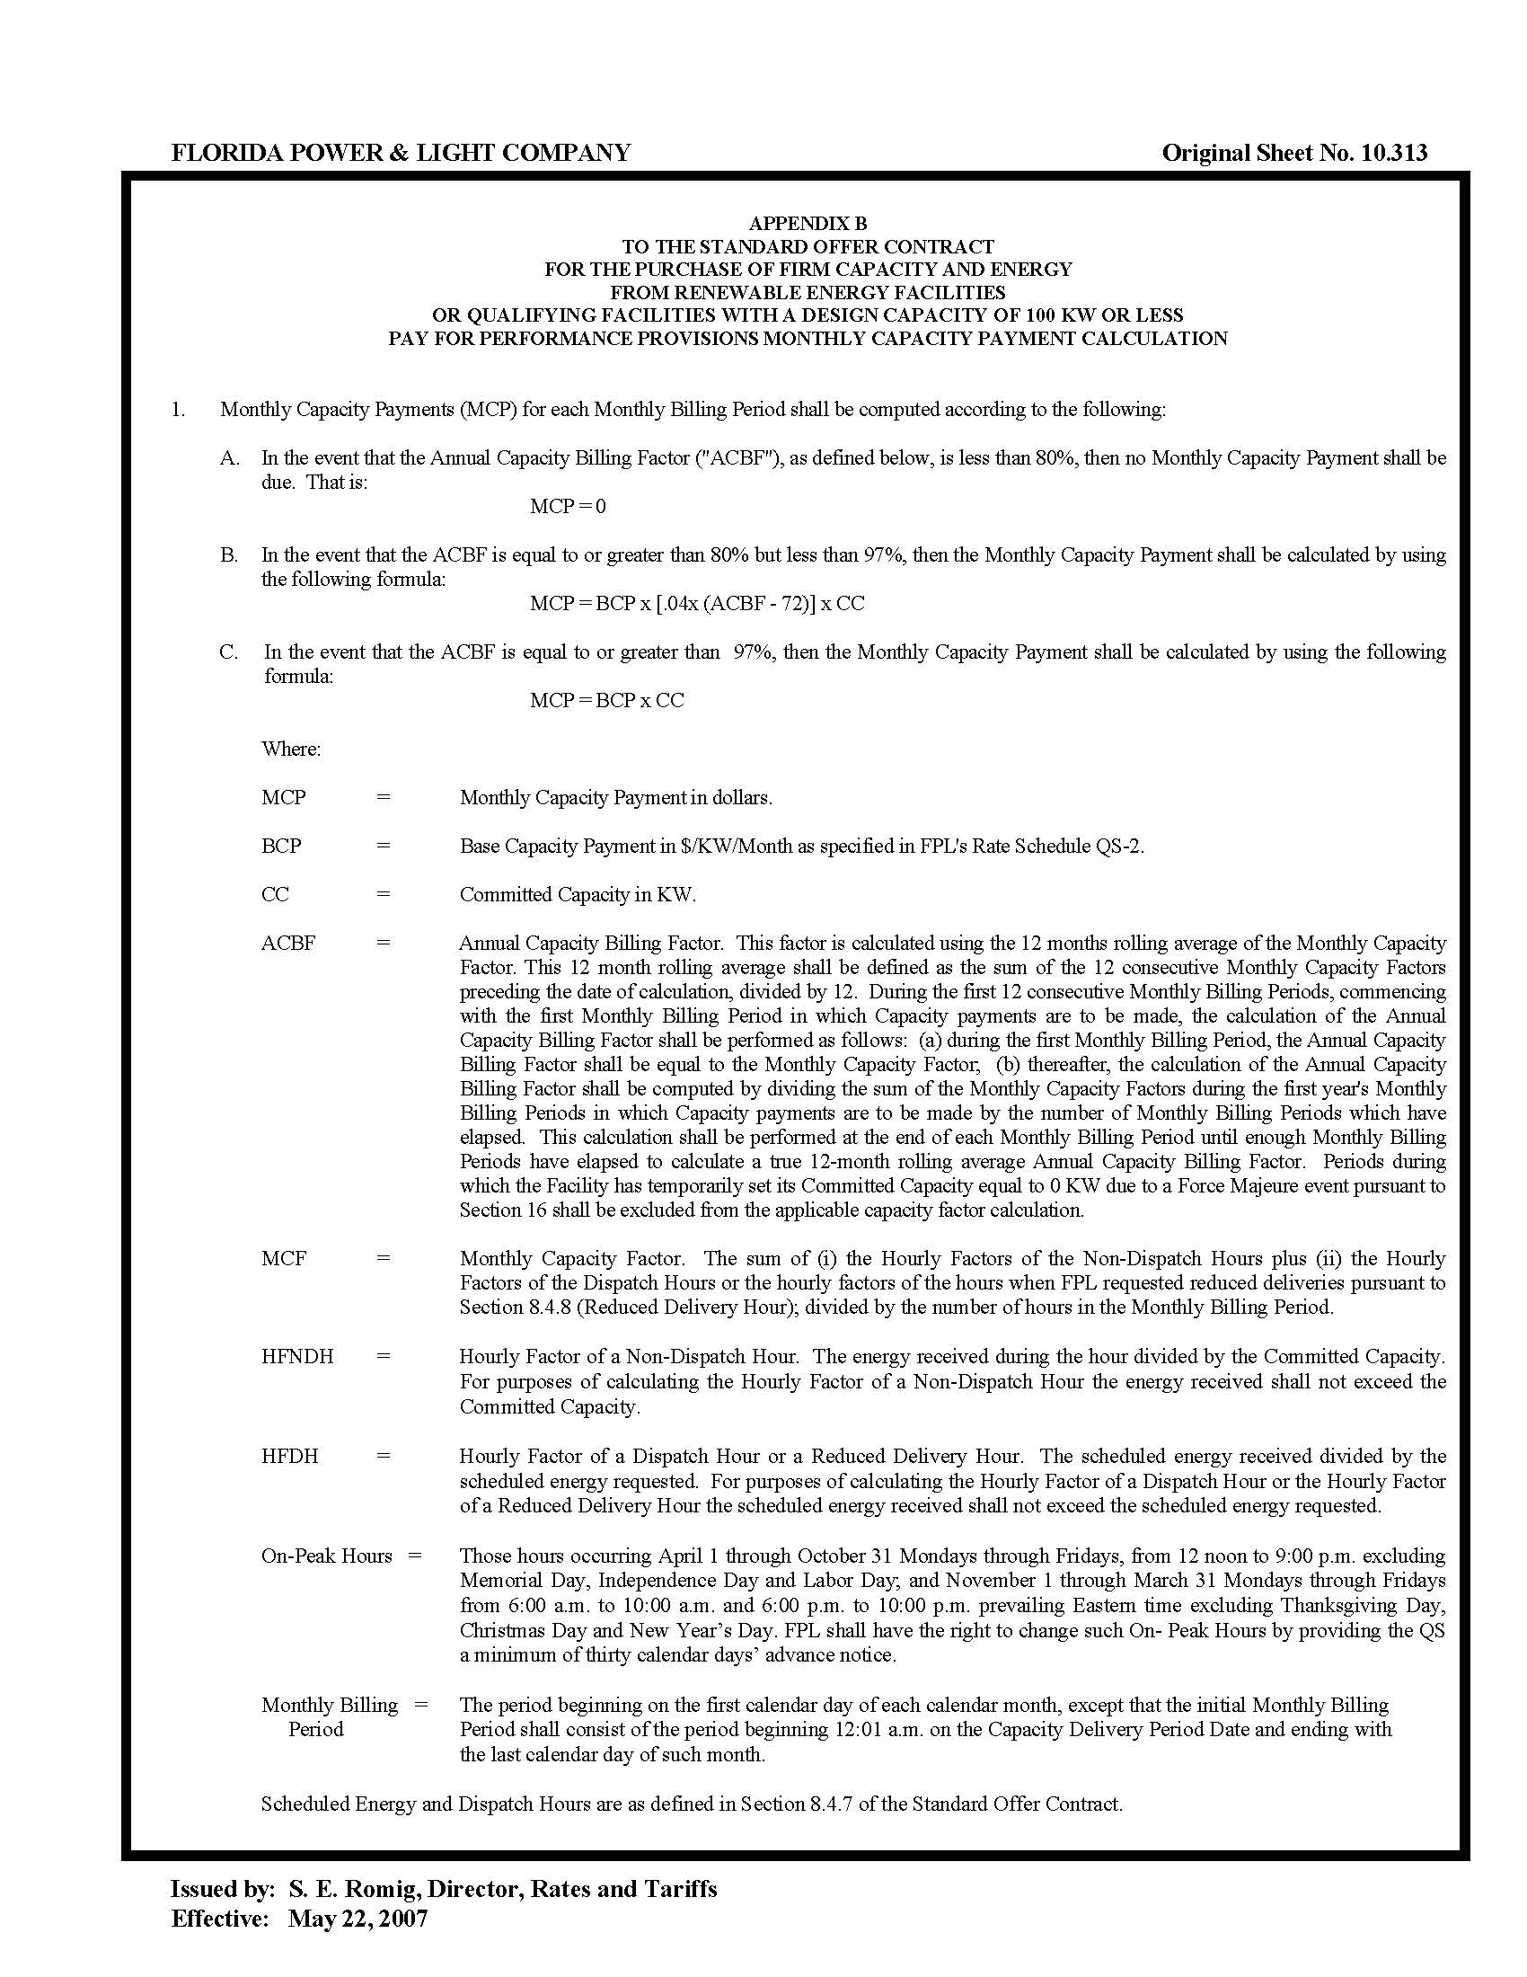

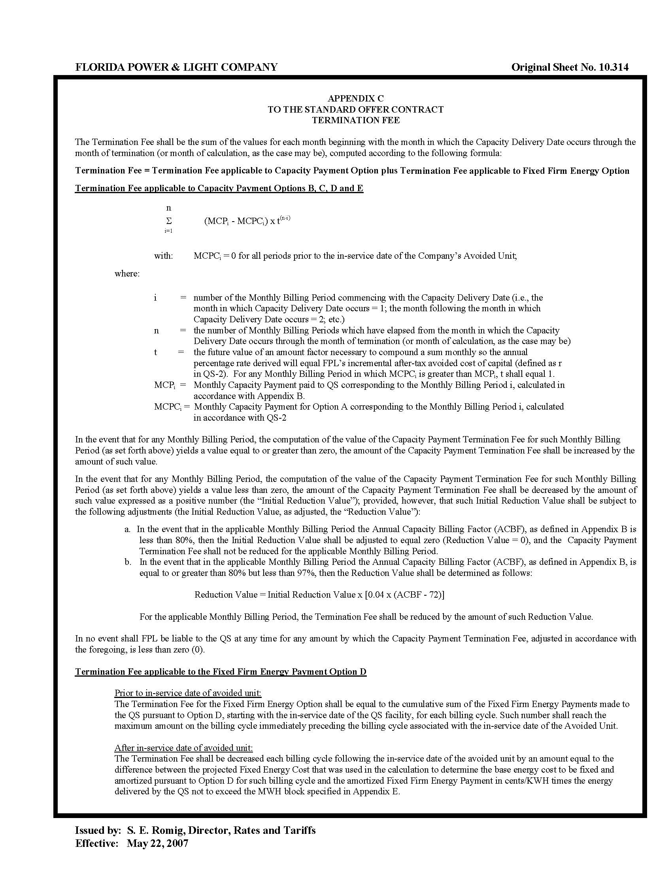

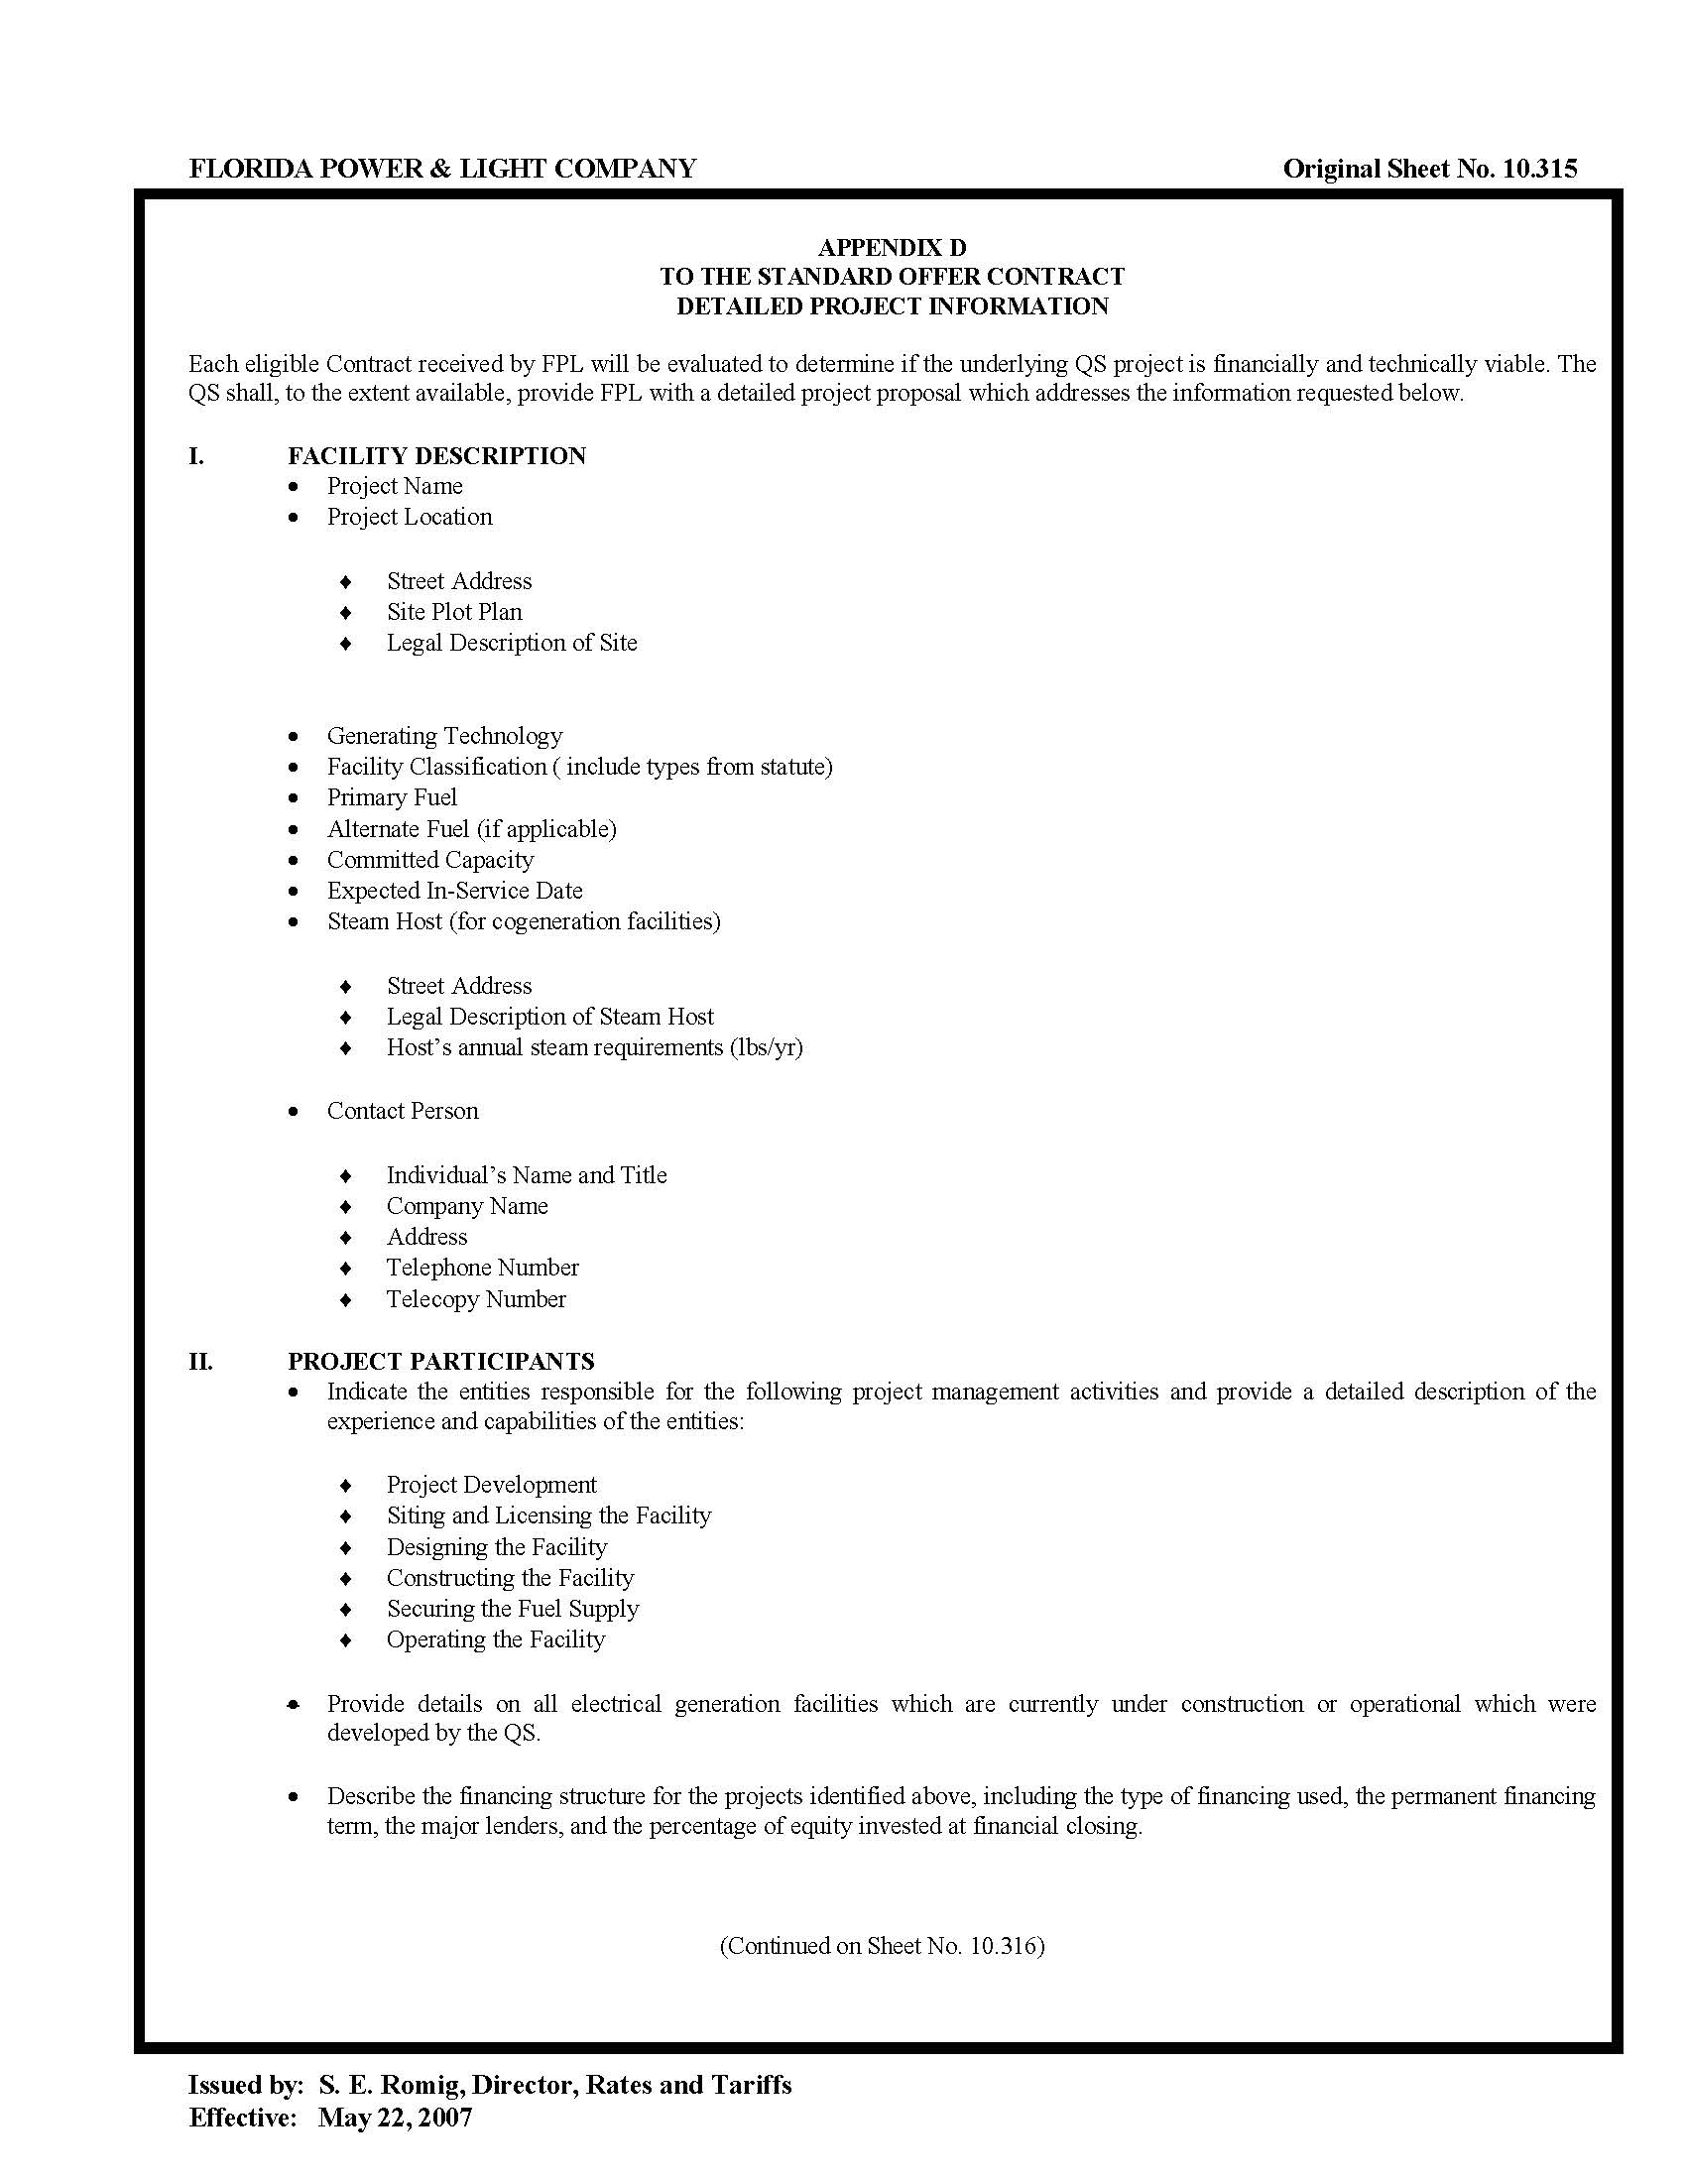

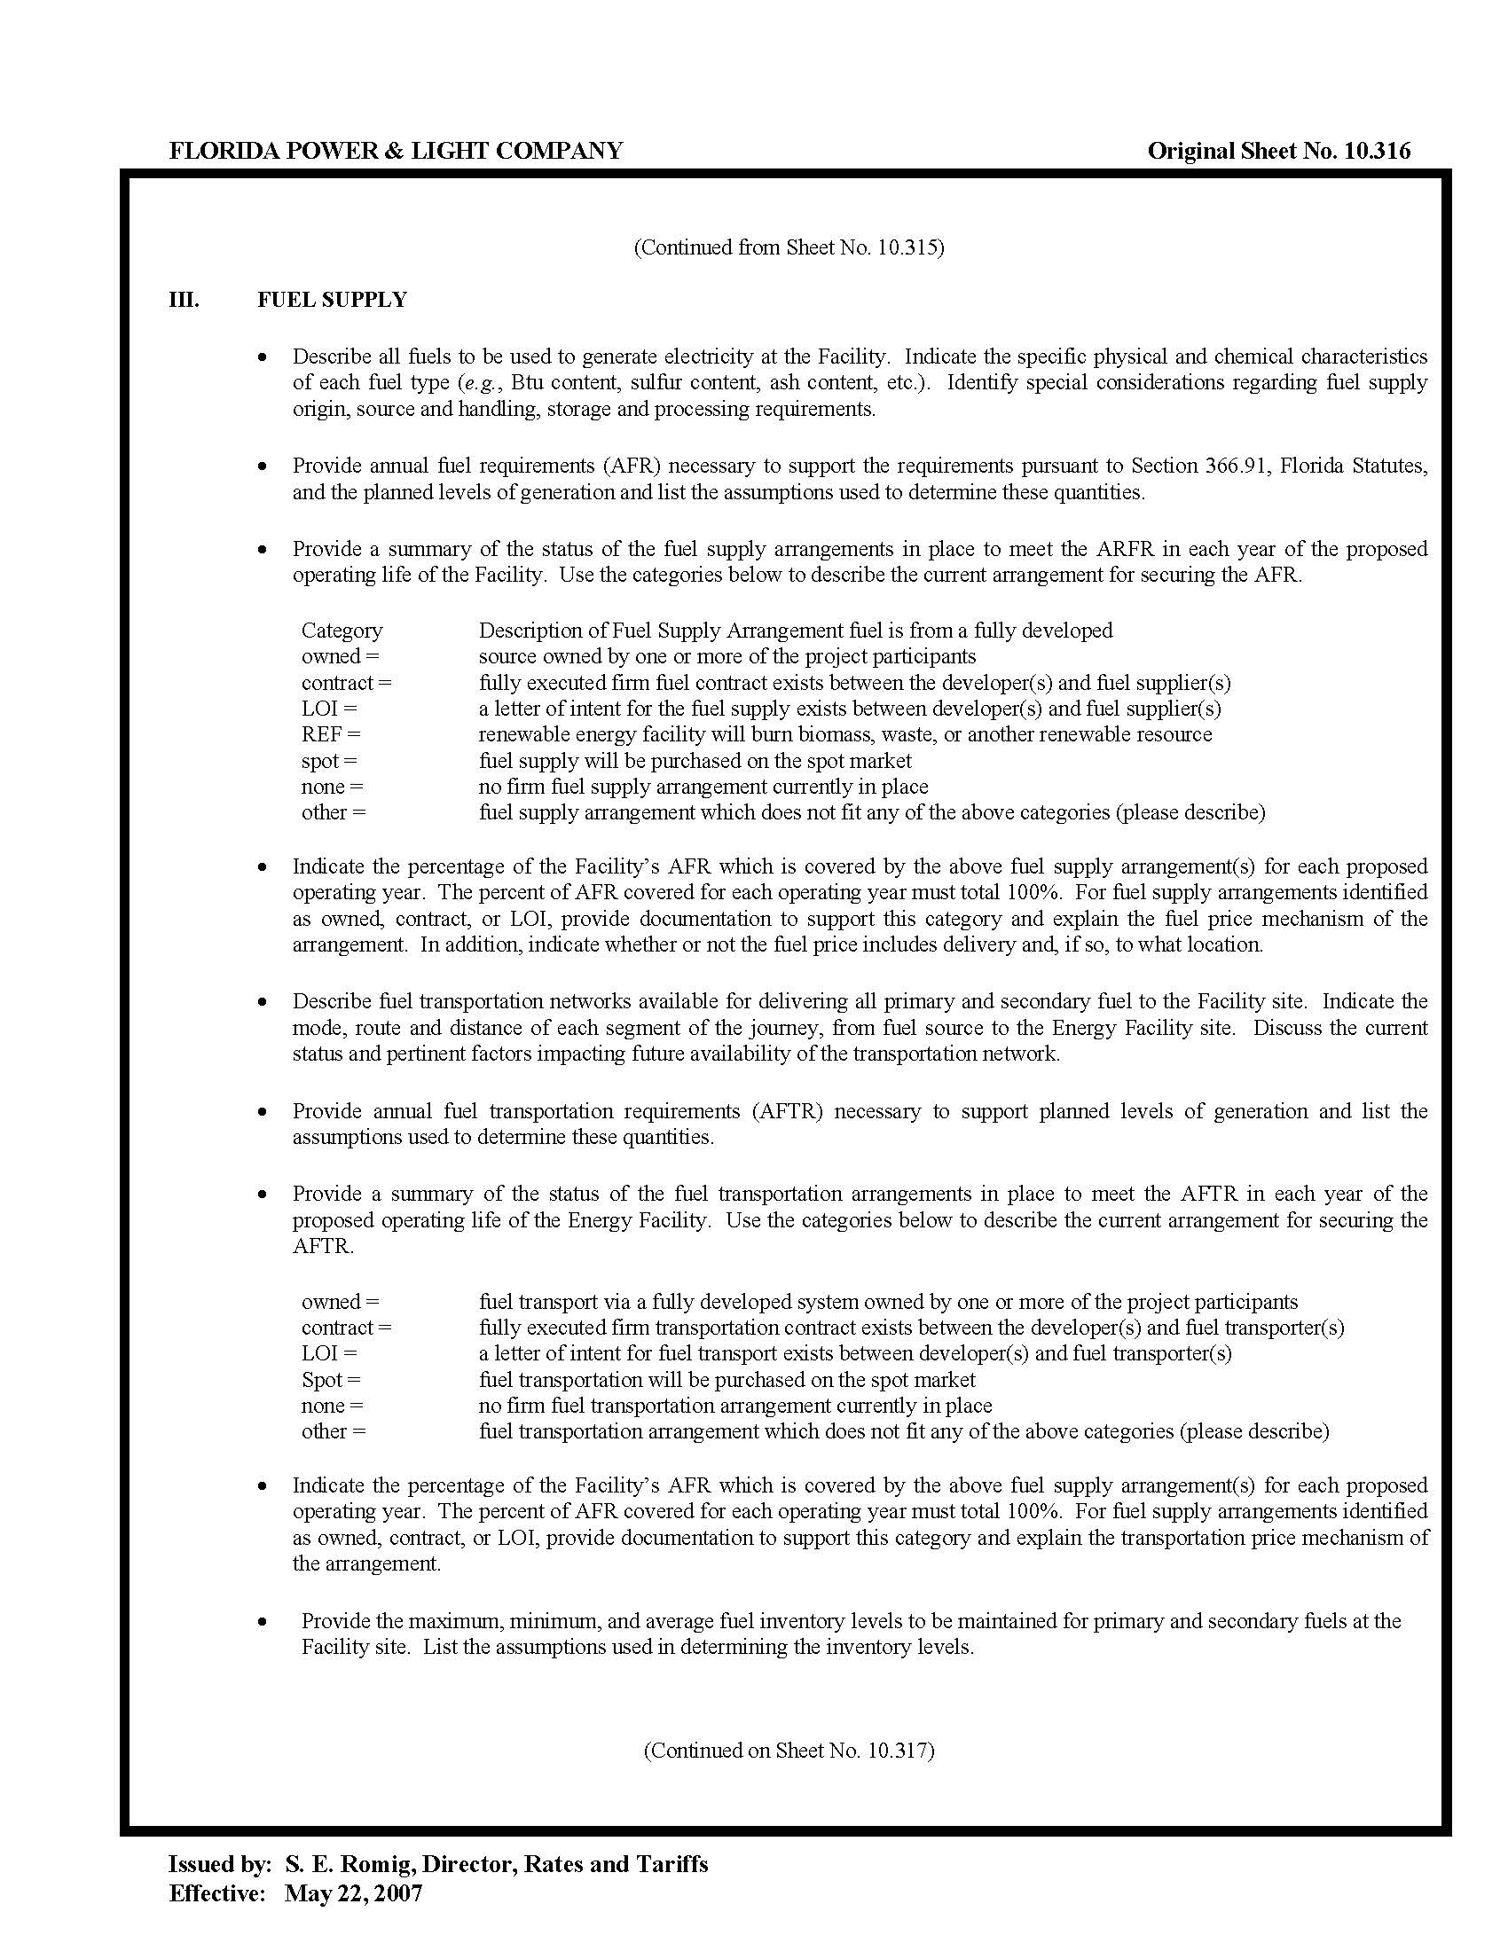

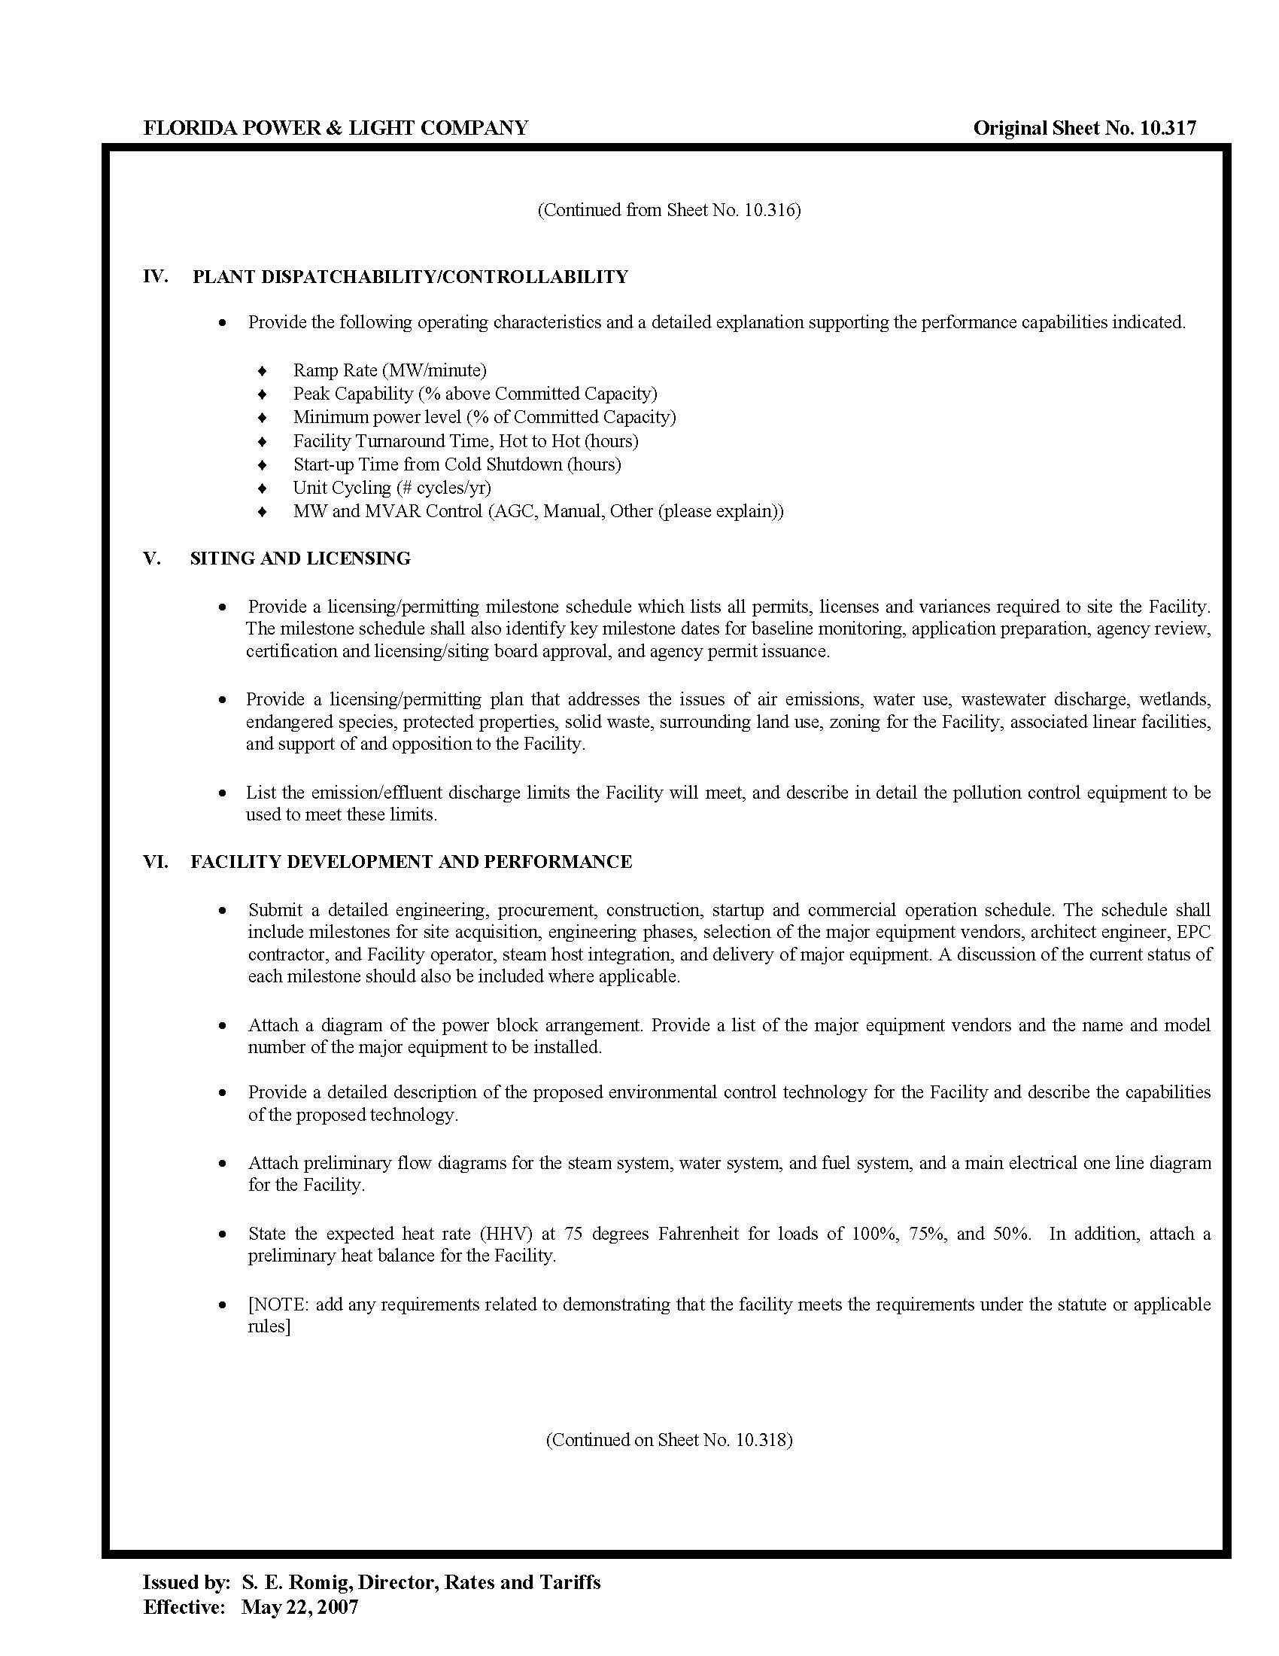

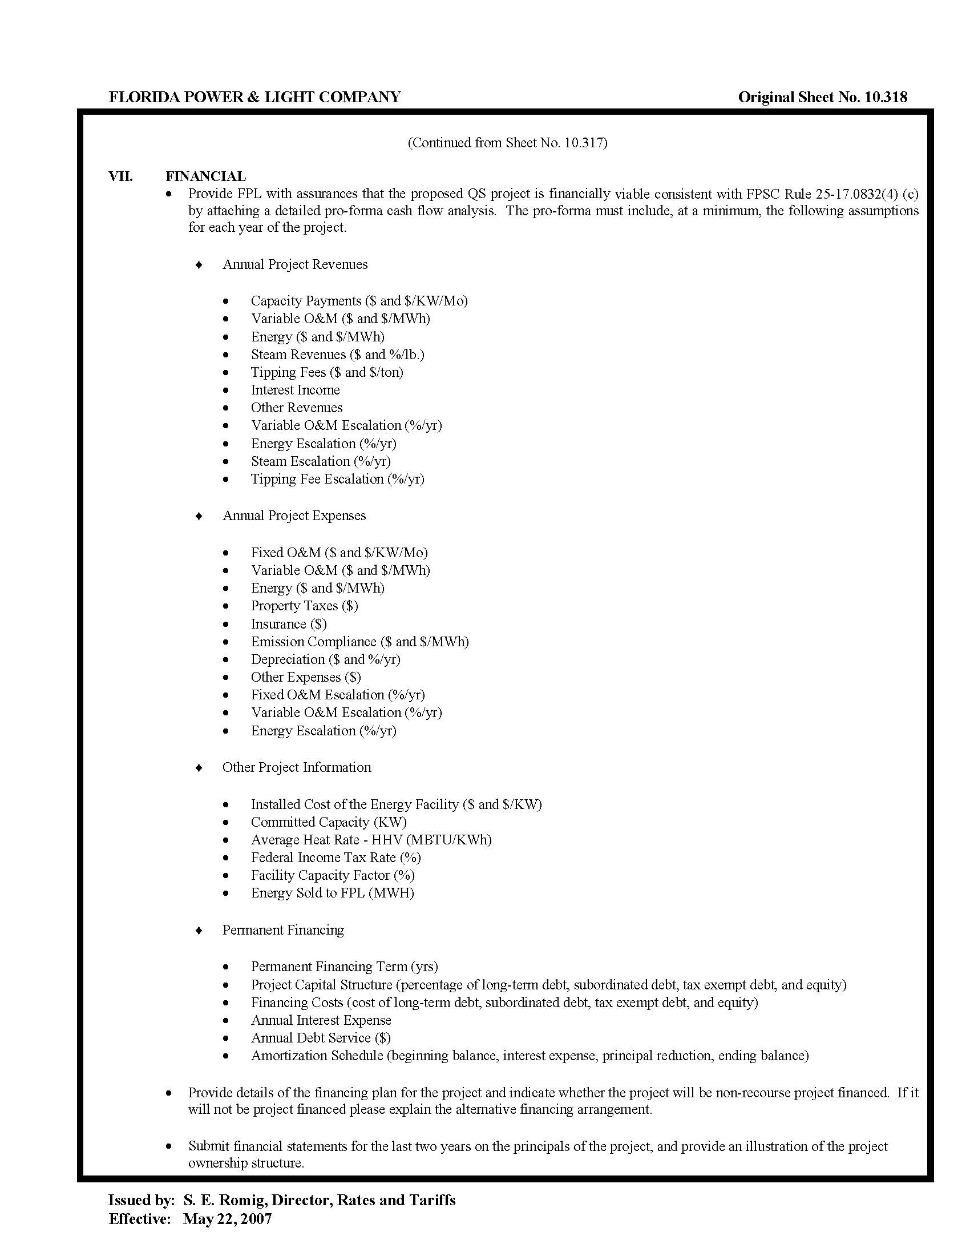

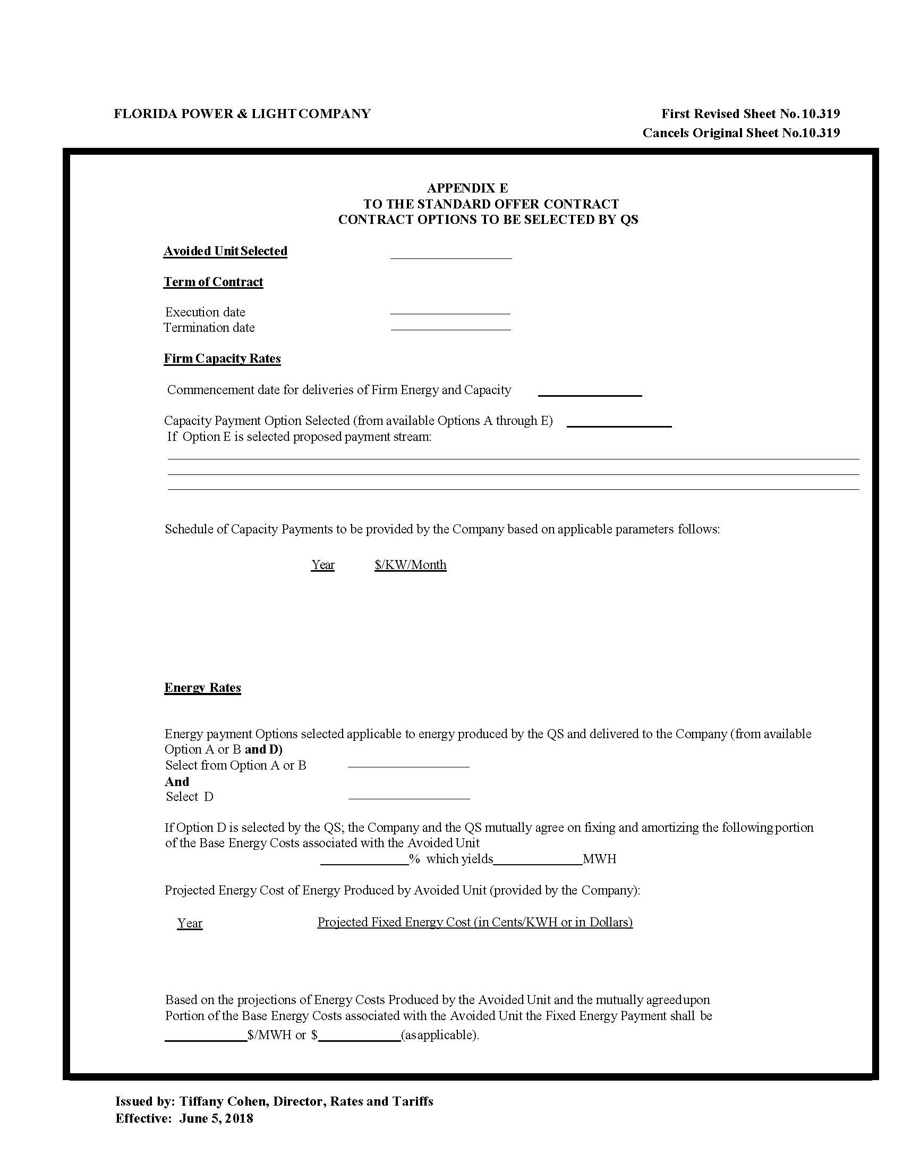

Differences due to rounding.
Document No. 03715-2019, filed April 15, 2019, in Docket No. 20190082-EQ.

