BEFORE THE FLORIDA PUBLIC SERVICE COMMISSION

In re: Petition for approval of shared solar tariff, by Tampa Electric Company. | DOCKET NO. 20180204-EI  ORDER NO. PSC-2019-0215-TRF-EI  ISSUED: June 3, 2019

The following Commissioners participated in the disposition of this matter:

ART GRAHAM, Chairman
JULIE I. BROWN
DONALD J. POLMANN
GARY F. CLARK
ANDREW GILES FAY

ORDER APPROVING TAMPA ELECTRIC COMPANY’S SHARED SOLAR TARIFF

BY THE COMMISSION:

Background
On November 2, 2018, Tampa Electric Company (TECO or Company) filed its Petition for Approval of Shared Solar Tariff (Petition), requesting creation of a new, optional shared solar tariff (SSR-1 Tariff or tariff). The proposed SSR-1 Tariff will allow TECO’s customers to purchase energy produced from a TECO-owned solar energy source to replace all or a portion of their monthly energy consumption, which would normally be generated by TECO’s system generating resources. Under the tariff, participants will pay a Shared Solar Charge for energy produced by a 17.5 megawatt (MW) portion of the Lake Hancock solar project (Lake Hancock). Participants will be charged the Shared Solar Charge for all subscribed energy, in addition to the base and energy charges. In order to recognize the renewable nature of the energy source, participants will be exempted from paying the fuel and purchased power charge and the Environmental Cost Recovery Clause (ECRC) charge for all energy purchased under the SSR-1 tariff in the original Petition. On February 8, 2019, TECO amended the tariff to eliminate language excluding SSR-1 Tariff participants from the ECRC after concluding that it would be appropriate for participating customers to be charged the ECRC.

On February 15, 2019, TECO amended the tariff to clarify language indicating that SSR-1 Tariff participants will pay the fuel charge for any portion of their energy usage not covered under the SSR-1 Tariff. On March 22, 2019, TECO filed an amended Petition, adding language that limits the SSR-1 Tariff to the 17.5 MW portion of Lake Hancock. In TECO’s original Petition, the Company stated that the total output of the SSR-1 Tariff portion of Lake Hancock was 17.7 MW. TECO later clarified that the output is now 17.5 MW, based on the expected output of the six inverters assigned to the SSR-1 Tariff.

TECO is currently operating under the Commission-approved 2017 Amended and Restated Stipulation and Settlement Agreement (Settlement). The Settlement restricts any change in base rates for the years 2019 through 2021, other than Solar Base Rate Adjustment (SoBRA) additions. SoBRA has been established as a mechanism for TECO to recover the costs of 600 MW of new solar capacity.

Commission staff, members of the Office of Public Counsel, and Company representatives attended noticed informal meetings on December 10, 2018, and February 28, 2019, to discuss matters within the docket. On December 12, 2018, TECO waived the 60-day tariff suspension deadline. On March 22, 2019, TECO waived the 60-day tariff suspension deadline once more, to allow this matter to be heard at the May 14, 2019 Agenda Conference. Staff issued five data requests to TECO on this matter. Attachment A contains the proposed tariff pages reflecting all three amendments. We have jurisdiction over this matter pursuant to Sections 366.05 and 366.06, Florida Statutes.

Decision

The Proposed Tariff

Under the proposed SSR-1 Tariff, residential (RS) and small commercial (GS) customers will be able to purchase solar energy on a basis of 25, 50, or 100 percent of their monthly energy usage. Large commercial (GSD and IS) customers will be able to purchase energy in 1,000 kilowatt-hour (kWh) blocks; the initial amount cannot exceed their prior 12-month average. Participants who move may retain their SSR-1 Tariff participation at their new address within the TECO service territory, but may not transfer their SSR-1 rate to another customer. TECO stated that the program does not reserve any allocation of available energy to a particular customer class.

The Shared Solar Charge will be $0.063 per kWh. The $0.063 charge was designed to recover the costs of the system, operating and maintenance (O&M) costs, and program administrative costs, at full subscription. Customers who join the tariff will pay the $0.063 charge in lieu of the current fuel and purchased power charge for all subscribed energy consumption. The fuel and purchased power charge is comprised of mostly variable costs related to buying and transporting fuel for generation, as well as purchased power. This charge is recovered through the Fuel Cost Recovery Clause (FCRC). Thus, participating customers will be paying toward the recovery of the development and maintenance of the solar project, instead of charges associated with fueling traditional means of generation.

Under the tariff, participating customers will avoid paying FCRC charges only on the percentage of energy subscribed under the SSR-1 Tariff. For example, a customer subscribing to receive 25 percent of their energy under the SSR-1 Tariff will continue to pay the FCRC charges on the remaining 75 percent of their energy usage. Participants in the SSR-1 Tariff will continue to pay all other charges, such as the base service charge and energy charge, for all energy used.

TECO indicated that participation in the tariff will be capped at 95 percent of energy produced by the solar unit. The remaining 5 percent will serve as a buffer against over-subscription. TECO further stated that the output of the SSR-1 site and customer energy consumption will be reviewed annually in order to ensure that the usage rate does not exceed the 95 percent cap. In the event that subscribed energy falls below generation levels, a customer waiting list will be available to add participants going forward. If subscriptions approach the cap, TECO will allow customer attrition to limit energy usage before adding new customers.

TECO stated that any Renewable Energy Credits (RECs) associated with the tariff will not be eligible for resale by the Company. TECO will retain ownership of, or retire, all RECs. Customers could request to have RECs deposited into a designated account at their own expense. Any charges to the customer will be limited to the administrative expense of establishing the REC transfer.

The Company conducted a third-party study to evaluate existing community solar programs and incorporated some of the best practices derived from those programs into the SSR-1 Tariff. TECO also performed a customer survey among e-bill customers in August 2016, with approximately 25,000 responses, or about 3.4 percent of its customer base. Based on the survey results, the Company estimates the potential participation is about 11 percent of the residential customer base. TECO concluded that there is a market potential of approximately 24,000 residential customers for a shared solar program with an incremental cost of $0.04 per kWh over retail. The SSR-1 Tariff amounts to approximately $0.034 per kWh over the Company’s current retail energy rates. Given the survey results and size of the SSR-1 unit, it is likely that TECO will be able to achieve full participation in the tariff after an initial ramp-up period. Under the new tariff, TECO indicated it will be ready to start accepting participants for the SSR-1 Tariff in June 2019.

The Lake Hancock Site

The Lake Hancock project, located in Polk County, was fully operational as of April 25, 2019. The facility has a total capacity of approximately 49.5 MW, of which 32.0 MW has been approved for cost recovery by us in the Company’s second tranche of SoBRA. The remaining 17.5 MW SSR-1 portion of Lake Hancock was built as additional generation above what the Company was constructing for its second tranche of SoBRA. TECO stated that under the proposed tariff, the 17.5 MW portion of Lake Hancock that is reserved for the SSR-1 Tariff will not be eligible for SoBRA recovery at any point in time. The panels responsible for the 17.5 MW of capacity are connected to 6 inverters that are reserved for SSR-1 service. The SSR-1 unit will generate enough energy for approximately 2,600 residential customers at the 100 percent subscription level.

TECO has planned 600 MW of solar generation under its SoBRA, which is also the cap imposed on the SoBRA by the Settlement. The Company stated that if the tariff was not approved, the 17.5 MW, reserved for SSR-1 use at Lake Hancock, would have been included in a future tranche of TECO’s SoBRA. Under the new tariff, the Company stated it will construct an additional 17.5 MW of solar capacity to meet the 600 MW capacity cap for the SoBRA. TECO shall return to us for approval in order to request any future additions to the SSR-1 Tariff. The 17.5 MW referenced in the Shared Solar Petition is an incremental addition to TECO’s overall generation.

Subscriber Benefits

TECO stated that the main objective of the SSR-1 Tariff is to provide customers who cannot otherwise install rooftop solar with an opportunity to receive some, or all, of their power from a TECO-owned solar energy source. Customers in the following situations might have been otherwise prohibited from participating in solar: if they rent or lease, cannot afford the upfront costs of rooftop solar, or have roof conditions which are poor for purposes of solar energy production. Customers participating in the proposed tariff program will be able to do so on a month-to-month basis with no commitment beyond the first month. TECO has designed the tariff so that new subscribers could join at any time, assuming unsubscribed energy is available; otherwise, they will be put on a waiting list.

Based on TECO’s survey results, customer demand currently exceeds the 17.5 MW output of this site and that the waiting list is growing. In order for additional solar capacity to be added to the SSR-1 Tariff, the utility must obtain our approval. By participating in the SSR-1 Tariff, TECO’s customers are directly encouraging the growth of solar generation in Florida.

A future financial incentive may also exist for participants in the tariff. According to TECO’s fuel price forecast, fuel prices are expected to increase to levels above the Shared Solar Charge of $0.063 per kWh. This means that a cross-over point likely exists during the tariff’s span, where an SSR-1 participating customer may eventually pay a lower rate than a customer under the traditional rate structure.

Levelized Cost Calculation

As discussed in the Company’s Petition, the initial energy charge of $0.063 per kWh is based on the levelized rate for full recovery of the revenue requirements of the 17.5 MW portion of Lake Hancock and the administrative costs of the SSR-1 program at full subscription.

Revenue Requirement

The Company provided a detailed breakdown of the revenue requirement which utilized the same fixed unit price of $1,494 per kilowatt (kW) installed as in TECO’s Second SoBRA proceeding. Fixed O&M expenses are notably lower than in the Second SoBRA, reducing from $7.70/kW-year to $4.03/kW-year, based on an updated O&M agreement TECO reached with a third party. For program administrative costs, TECO utilized higher initial start-up costs, and then escalating administrative costs over the duration of the SSR-1 Tariff. Administrative costs are listed as $156,708 for the first year and $105,048 for the second year, with an annual 2.1 percent escalation thereafter. These costs are made up of call center operations, program management, marketing, training, software, and other expenses.

Levelized Cost Rate

To determine the levelized cost rate, TECO used full subscription, such that it would collect the full revenue requirement from only 95 percent of the energy output of the 17.5 MW of Lake Hancock. The Company included the effects of degradation of the unit over time and assumed a capacity factor of 25.8 percent, slightly lower than the 26.3 percent used in the second SoBRA docket. Overall, the Company’s proposed $0.063 per kWh rate appears reasonable based upon Lake Hancock and SSR-1 Tariff program costs.

Recovery of the 17.5 MW Portion of Lake Hancock

TECO indicated that the 17.5 MW SSR-1 portion of Lake Hancock will become part of the Company’s total cost of service, thereby impacting surveillance reporting, including during the TECO Settlement period. However, all revenue collected under the SSR-1 Tariff will also be included in surveillance reporting, thus offsetting the cost and revenue requirements. While the cost and expense of the 17.5 MW portion of Lake Hancock, and the revenue collected to offset such cost and expense, will be included in surveillance reporting, the actual cost, expense, and revenue are uncertain in amount.

Upon approval of the proposed Shared Solar Program and Tariffs, the 17.5 MW SSR-1 portion of Lake Hancock will be included in the revenue requirements of future rate proceedings, as an addition to base rates. The revenues collected under the tariff will be revenue credited to the revenue requirement as an offset. Since the proposed Shared Solar Charge ($0.063 per kWh) has been shown to cover the costs of the unit and administration of the tariff at full subscription, the revenue credit will allow for a lower rate than if TECO recovered the unit through its SoBRA. While the Company proposes a Shared Solar Charge to completely offset the capacity costs and O&M expenses, both the costs and revenues of the program have the potential to ultimately impact base rates throughout most of the program period (the years after the Settlement period). Overall, the revenue credit is expected to offset the revenue requirement of the unit to limit any impact on base rates.

Impact of the SSR-1 Tariff on Non-participants

TECO initially indicated that the SSR-1 Tariff has been designed so that, over the life of the shared solar facility, non-participating customers would experience minimal, if any, bill impacts due to the program. At full subscription of the unit, TECO’s initial analysis indicated that non-participants would pay $0.12 more per month for electricity in 2019 due to the impact of an increase in the fuel charge, but that bill impact amount would be reduced to $0.01 more per month by 2048.

TECO later revised its response, stating that its initial response was based on the concept that there would be no change in non-solar generation, wherein the fuel impact reflected the same amount of MW but fewer fuel clause participants. TECO indicated that such an outcome would be a theoretical worst case scenario. The Company reanalyzed the impact to non-participants based on what it described as the most likely scenario, wherein the program’s solar capacity (17.5 MW) would reduce the dispatch of TECO’s total non-solar capacity. At full subscription, TECO indicated that the program should result in no impact to non-participants. The Company also indicated that less than full subscription would benefit non-participants by reducing fuel rates charged through the FCRC.

As discussed earlier, we recognize that TECO’s proposed Shared Solar Charge is designed to generate sufficient revenue to offset the revenue requirement of the program, and while actual results may vary, the rate, as proposed, appears to be sufficient to protect the general body of ratepayers. This assessment is further supported by the fact that the capacity of this proposed community solar program is limited to 17.5 MW.

Another possible impact on rates will be whether or not the displacement of non-solar generation under the program will be sufficient to fully offset the program’s lost fuel revenue. Lost fuel revenue under the tariff is associated with the participants not paying the fuel charge. The 17.5 MW at Lake Hancock is considered incremental solar capacity, thus allowing for fuel savings that would not otherwise be available to the general body of ratepayers given the 600 MW solar capacity restriction defined in the Settlement and TECO’s stated intention to maximize its SoBRA construction to 600 MW. At full capacity, the fuel savings associated with the incremental plant have been determined to be roughly equivalent to the lost fuel revenue.
Under the special conditions presented in this docket, related to the Settlement, we agree with the Company’s assertion that any future non-participant rate impacts can be expected to be minimal. The avoided fuel costs can be expected to offset the lost fuel revenues. In regard to base rate impacts, the revenue from the Shared Solar Charge can be expected to offset the revenue requirement of the 17.5 MW unit. Upon review, we expect that non-participants are not likely to pay higher rates with the implementation of the SSR-1 Tariff.

Compliance with the Settlement

TECO obtained verification from the Settlement signatories to confirm that the proposed SSR-1 Tariff is in accordance with the terms of the Settlement. Paragraph 12 of the Settlement, requires that new or revised tariffs requested by TECO must not increase existing base rates or other non-optional charges to customers. The Office of Public Counsel, Florida Retail Federation, Florida Industrial Power Users Group, and Federal Executive Agencies stated that the tariff does not conflict with the terms of the Settlement. The WCF Hospital Utility Alliance stated that it has no position.

We reviewed the SSR-1 Tariff proposal in light of the various provisions of the Settlement. As stated previously, neither base rates nor the fuel charge are expected to be impacted during the Settlement period by the proposed tariff. The SSR-1 Tariff provides an additional 17.5 MW of solar generation that would not otherwise be available to TECO’s customers, thereby creating fuel savings to counteract the lost fuel revenue associated with the participants’ fuel clause exemption. Further, the tariff does not violate the Settlement.

Reporting Requirements

Due to the fact that this tariff is a new concept, we require annual reporting from TECO for the first three years of the tariff in order to determine customer acceptance and financial performance. The reporting criteria include the tariff’s participation and waiting list levels, energy sales amounts, costs, and revenues, in order to analyze the impacts on both participants and non-participants.

The SSR-1 Tariff provides a reasonable alternative to customers who cannot otherwise invest in solar generation. We find that that the Shared Solar Charge of $0.063 per kWh reasonably offsets the unit costs and administration of the SSR-1 Tariff. We share TECO’s expectation that the tariff will provide benefits to the participants, while having minimal impact on the general body of ratepayers.

After a thorough review of the extensive matters provided in this docket, we approve TECO’s petition for approval of a new shared solar tariff. The tariff shall become effective after TECO completes its tariff-related billing systems, which is expected to be in June 2019. TECO shall notify us as soon as this is completed and the effective date of the tariff is known. TECO shall file summary reports with us containing prior year results of the SSR-1 Tariff by March 1 of 2020, 2021, and 2022, including SSR-1 participation and waiting list levels, energy sales amounts, costs, and revenues in this docket.

Based on the foregoing, it is

ORDERED by the Florida Public Service Commission that we approve Tampa Electric Company’s petition for approval of a new shared solar tariff. It is further

ORDERED that the tariff shall become effective after the utility completes its tariff-related billing systems, which is expected to be in June 2019, and that the utility shall notify Commission staff as soon as this is completed and the effective date of the tariff is known. It is further

ORDERED that the utility shall file summary reports in this docket, containing prior year results of the SSR-1 Tariff by March 1 of 2020, 2021, and 2022, including SSR-1 participation and waiting list levels, energy sales amounts, costs, and revenues. It is further

ORDERED that if a protest is filed within 21 days of issuance of the Order, the tariff, if in effect at that time, shall remain in effect with any charges held subject to refund pending resolution of the protest. It is further

ORDERED that if no timely protest is filed, this docket shall be closed upon the issuance of a Consummating Order.

By ORDER of the Florida Public Service Commission this 3rd day of June, 2019.

/s/ Adam J. Teitzman
ADAM J. TEITZMAN
Commission Clerk
Florida Public Service Commission
2540 Shumard Oak Boulevard
Tallahassee, Florida 32399
(850) 413-6770
www.floridapsc.com

Copies furnished: A copy of this document is provided to the parties of record at the time of issuance and, if applicable, interested persons.

WLT

NOTICE OF FURTHER PROCEEDINGS

The Florida Public Service Commission is required by Section 120.569(1), Florida Statutes, to notify parties of any administrative hearing or judicial review of Commission orders that is available under Sections 120.57 or 120.68, Florida Statutes, as well as the procedures and time limits that apply. This notice should not be construed to mean all requests for an administrative hearing or judicial review will be granted or result in the relief sought.

Mediation may be available on a case-by-case basis. If mediation is conducted, it does not affect a substantially interested person's right to a hearing.

The Commission's decision on this tariff is interim in nature and will become final, unless a person whose substantial interests are affected by the proposed action files a petition for a formal proceeding, in the form provided by Rule 28-106.201, Florida Administrative Code. This petition must be received by the Office of Commission Clerk, 2540 Shumard Oak Boulevard, Tallahassee, Florida 32399-0850, by the close of business on June 24, 2019.

In the absence of such a petition, this Order shall become final and effective upon the issuance of a Consummating Order.

Any objection or protest filed in this docket before the issuance date of this order is considered abandoned unless it satisfies the foregoing conditions and is renewed within the specified protest period.

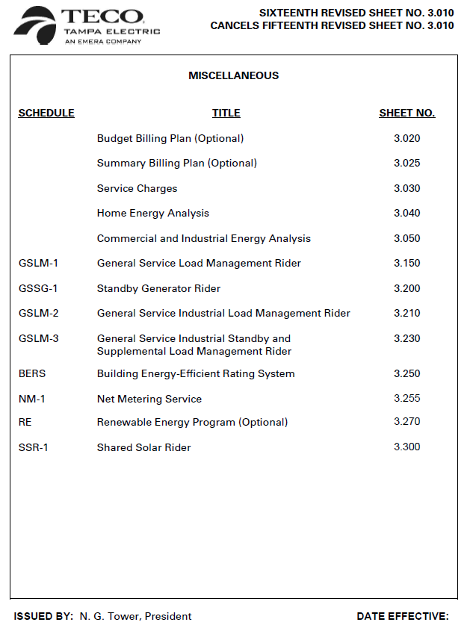
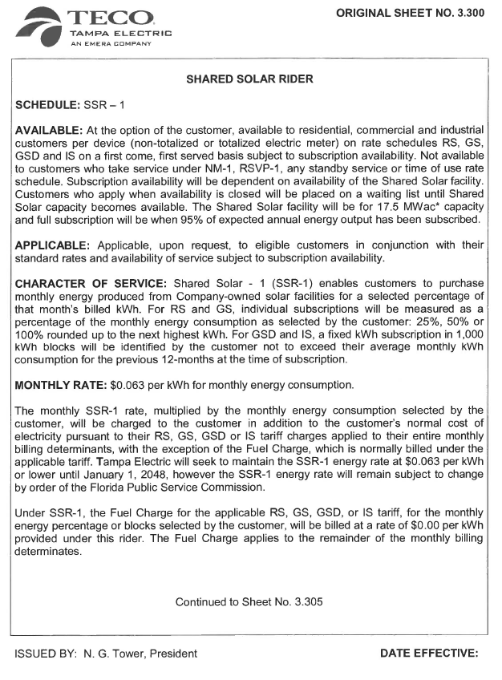
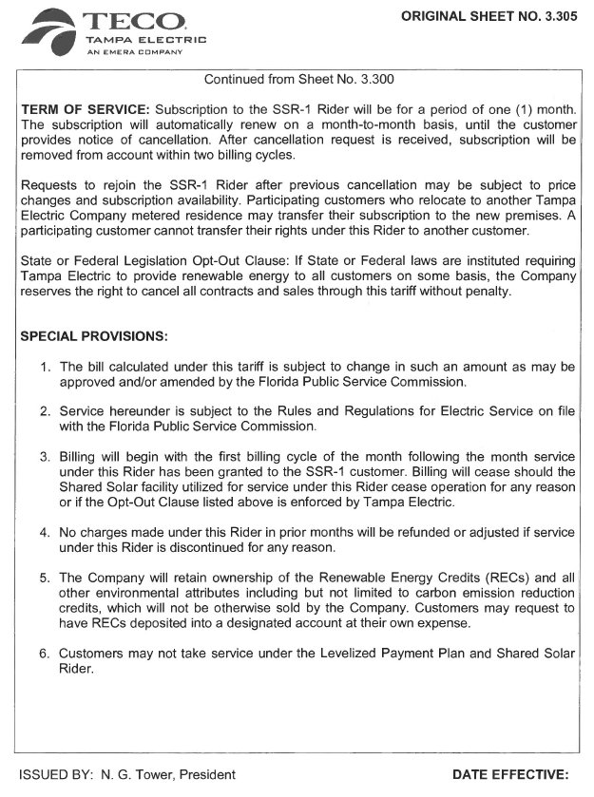

TECO currently offers the Renewable Energy Program (REP) to its customers. In that program, customers pay $5 per 200 kilowatt-hour (kWh) block of renewable energy, produced by photovoltaic arrays, biomass fuel, and other renewable energy sources. TECO states the REP will not be closed or changed at this time.
The originally-proposed tariff required Commission approval for any price change to participating customers.
TECO’s response to staff’s First Data Request, No. 3.
Order No. PSC-2017-0456-S-EI, issued September 27, 2017, in Docket No. 20170210-EI, In re: Petition for limited proceeding to approve 2017 amended and restated stipulation and settlement agreement.
A REC is a tradeable, non-tangible energy commodity that represents the environmental attributes of one megawatt-hour of electricity generated from an eligible renewable energy resource.
TECO’s response to staff’s First Data Request, No. 22A.
The incremental cost over traditional rates of $0.034 was calculated by subtracting TECO’s current FCRC factor for residential customers ($0.02913) from the Shared Solar Charge ($0.063), resulting in a difference of $0.03387.
Order No. PSC-2018-0571-FOF-EI, issued June 29, 2018, in Docket No. 20180133-EI, In re: Petition for limited proceeding to approve second SoBRA.
Staff’s Second Set of Interrogatories, No. 11, filed September 13, 2018, in Docket No. 20180133-EI.
TECO’s response to staff’s Fourth Data Request, No. 5.
TECO’s response to staff’s First Data Request, No. 9.
Order No. PSC-2017-0456-S-EI, issued November 27, 2017, in Docket No. 20170210-EI, In re: Petition for limited proceeding to approve 2017 amended and restated stipulation and settlement agreement.
TECO’s response to staff’s Fourth Data Request, No. 1B.
TECO’s response to staff’s First Data Request, No. 28A.
Full subscription will be equal to 95 percent of the energy produced by the 17.5 MW, reserved for SSR-1 Tariff use, at Lake Hancock.
Order No. PSC-2018-0571-FOF-EI, issued June 29, 2018, in Docket No. 20180133-EI, In re: Petition for limited proceeding to approve second SoBRA.
TECO’s response to staff’s First Data Request, No. 1.
The Settlement restricts any change in base rates through 2021, other than SoBRA additions.
TECO’s response to staff’s First Data Request, No. 7.
TECO’s response to staff’s First Data Request, No. 5.
TECO’s response to staff’s Fourth Data Request, No. 1.
Order No. PSC-2017-0456-S-EI, issued November 27, 2017, in Docket No. 20170210-EI, In re: Petition for limited proceeding to approve 2017 amended and restated stipulation and settlement agreement, Attachment A, Page 10 of 43, and TECO’s Response to Vote Solar’s Motion to Leave to File Amicus Curiae Memorandum, dated March 18, 2019, Paragraph 8.
Order No. PSC-2017-0456-S-EI, issued November 27, 2017, in Docket No. 20170210-EI, In re: Petition for limited proceeding to approve 2017 amended and restated stipulation and settlement agreement, Attachment A, Page 27 of 43,

