BEFORE THE FLORIDA PUBLIC SERVICE COMMISSION

In re: Consideration of the tax impacts associated with Tax Cuts and Jobs Act of 2017 for Florida Power & Light Company. | DOCKET NO. 20180046-EI  ORDER NO. PSC-2019-0225-FOF-EI  ISSUED: June 10, 2019

The following Commissioners participated in the disposition of this matter:

ART GRAHAM, Chairman
JULIE I. BROWN
DONALD J. POLMANN
GARY F. CLARK
ANDREW GILES FAY
APPEARANCES:

WADE LITCHFIELD, ESQUIRE, General Counsel; MARIA J. MONCADA and JOHN BUTLER, ESQUIRES, Florida Power & Light Company, 700 Universe Boulevard, Juno Beach, Florida 33408-0420
On behalf of Florida Power & Light Company (FPL)

J. R. KELLY, ESQUIRE, Public Counsel; CHARLES J. REHWINKEL, ESQUIRE, Deputy Public Counsel; PATRICIA A. CHRISTENSEN and THOMAS A. DAVID, ESQUIRES, Office of Public Counsel, c/o The Florida Legislature, 111 West Madison Street, Room 812, Tallahassee, Florida 32399-1400
On behalf of the Citizens of the State of Florida (OPC)

JON C. MOYLE, JR., IAN WALDICK, and KAREN PUTNAL, ESQUIRES, Moyle Law Firm, PA, The Perkins House, 118 North Gadsden Street, Tallahassee, Florida 32301
On behalf of the Florida Industrial Power Users Group (FIPUG)

Robert Scheffel Wright and John T. LaVia, III, ESQUIRES, Gardner, Bist, Bowden, Bush, Dee, LaVia & Wright, P.A., 1300 Thomaswood Drive, Tallahassee, Florida 32308
On behalf of the Florida Retail Federation (FRF)

ROBERT J. FRIEDMAN, ESQUIRE, USAF Utility Law Field Support Center, Air Force Legal Operations Agency, 139 Barnes Drive, Suite 1, Tyndall Air Force Base, Florida 32403
On behalf of Federal Executive Agencies (FEA)

SUZANNE BROWNLESS, ESQUIRE, Florida Public Service Commission, 2540 Shumard Oak Boulevard, Tallahassee, Florida 32399-0850
On behalf of the Florida Public Service Commission (Staff)
MARY ANNE HELTON, ESQUIRE, Deputy General Counsel, Florida Public Service Commission, 2540 Shumard Oak Boulevard, Tallahassee, Florida 32399- 0850
Advisor to the Florida Public Service Commission

Keith hetrick, ESQUIRE, General Counsel, Florida Public Service Commission, 2540 Shumard Oak Boulevard, Tallahassee, Florida 32399-0850
Florida Public Service Commission General Counsel

FINAL ORDER APPROVING FLORIDA POWER & LIGHT COMPANY’S
TREATMENT OF TAX IMPACTS OF TAX CUTS AND JOBS ACT OF 2017

BY THE COMMISSION:

BACKGROUND

This docket was opened by the Florida Public Service Commission (Commission) on February 21, 2018, to consider the tax impacts affecting Florida Power & Light Company (FPL) as a result of the passage of the Tax Cuts and Jobs Act of 2017 (TCJA). An administrative hearing was held on February 5, 2019, in which Exhibit Nos. 1-22 were admitted into the record. Further, the testimonies of Scott R. Bores and Ralph C. Smith, witnesses for FPL and the Office of Public Counsel (OPC), respectively, were inserted into the record as though read. Issues 1-17 and 20, addressing the quantification of tax savings, were stipulated by the parties, approved by the Commission, and are found in Attachment A. At the February 5 hearing, Issues 18 and 19 were reserved and the parties given an opportunity to file Initial and Reply Briefs on these issues on February 22, 2019, and March 8, 2019, respectively. The hearing was then continued until April 16, 2019, at which time parties were given 40 minutes per side for oral argument on Issues 18 and 19. FPL, OPC, Florida Retail Federation (FRF), Florida Executive Agencies (FEA), and Florida Industrial Users Group (FIPUG) filed Initial Briefs on February 22, 2019. FPL, OPC, FRF, and FIPUG filed Reply Briefs on March 8, 2019.
At the April 16, 2019, hearing, OPC, FPL, FEA, FIPUG, and FRF presented oral argument on Issues 18 and 19. We have jurisdiction over this matter based on Chapter 366, Florida Statutes (F.S.).

DECISION

Treatment of Reserve Amount

FPL, OPC, FRF, and the South Florida Hospital and Healthcare Association (SFHHA) entered into a settlement agreement (2016 Settlement Agreement) resolving FPL’s 2016 rate case that was approved by the Commission by Order No. PSC-16-0560-AS-EI, issued on December 15, 2016. At issue is whether FPL may debit the Reserve Amount created by Section 12 of the 2016 Settlement Agreement to pay for Hurricane Irma storm costs, or whether FPL must use the Storm Cost Recovery Mechanism (SCRM) created by Section 6 of the 2016 Settlement Agreement to do so.

Sections 12(a) and (b) of the 2016 Settlement Agreement establish a Reserve Amount consisting of the depreciation reserve surplus remaining at the end of 2012 ($104 million), a portion of FPL’s fossil dismantlement reserve ($146 million), and a theoretical depreciation reserve surplus as of January 1, 2017 ($1 billion). (Attachment B) The 2016 Settlement Agreement provides that until FPL’s base rates are set in a general base rate proceeding, FPL may amortize any reserve amount remaining at the end of 2016 up to $1.0 billion of the theoretical depreciation reserve surplus with “amounts to be amortized in each year of the Term left to FPL’s discretion.” FPL’s use of the Reserve Amount is limited in three ways. First, FPL cannot amortize “less than the actual amount of deprecation reserve surplus remaining at the end of 2016.” Second, FPL must amortize at least the amount of the available Reserve Amount necessary to maintain a return on equity (ROE) of at least 9.6 percent. Third, FPL may not amortize the Reserve Amount in an amount that results in an ROE greater than 11.6 percent. FPL is further precluded from initiating a base rate case until it exhausts the Reserve Amount. Finally, FPL may not amortize any remaining Reserve Amount after December 31, 2020, unless it notifies the parties by no later than March 31, 2020, that it does not intend to seek a general rate base increase which becomes effective before January 1, 2022.

Section 6 of the 2016 Settlement Agreement (Attachment C) continues the SCRM first found in FPL’s 2013 Stipulation and Settlement (2013 Settlement). Section 6 sets forth the mechanism by which FPL may recover through a storm surcharge up to $4.00/1,000 kWh for a 12 month period for monthly residential bills. Storm costs exceeding $800 million may be recovered with the imposition of a surcharge greater than $4.00/1,000 kWh or extending beyond a 12 month period. Only costs related to a named tropical storm by the National Hurricane Center or its successor may be recovered and Rule 25-6.0143, Florida Administrative Code (F.A.C.), applies. Final storm costs are determined in a limited proceeding docket in which parties may contest the amount of FPL’s claimed storm costs but not the SCRM mechanism itself.

It is FPL’s positon that the resolution of this issue turns on the interpretation of Sections 6 and 12 of the 2016 Settlement Agreement. FPL argues that it is not required to use the SCRM to recover the storm costs associated with Hurricane Irma nor is it prohibited from using the Reserve Amount to pay Hurricane Irma costs with those costs replenished by ratepayers from tax savings. It is FPL’s position that as long as it is earning within its authorized range of rate of return (9.6-11.6 percent), it has full discretion to use the tax savings however it wishes without having to consult with the parties to the 2016 Settlement Agreement or ask permission of the Commission. FPL argues that resolution of this issue is based on contract law which requires first an analysis of the plain language of the 2016 Settlement Agreement and if that language is not dispositive, consideration of extrinsic evidence regarding the intent of the parties at the time the 2016 Settlement Agreement was executed. Under FPL’s analysis, it is the understanding of the signatories to the 2016 Settlement Agreement, not the understanding of the Commission at the time of approval, that is dispositive.

Based on the plain language of the 2016 Settlement Agreement, FPL concludes the following:

- That the purpose of the Reserve Amount was to allow FPL to maintain its earnings throughout the 2016 Settlement Agreement’s four-year contract term (Term) within its authorized rate of return range of 9.6-11.6 percent. That being the case, all parties understood that throughout the Term, FPL would be making debits and credits to the Reserve Amount at FPL’s sole discretion.

- The whole purpose of the Reserve Amount was to allow FPL to respond to unanticipated changed circumstances either in the form of tax savings or Hurricane Irma storm costs.

- There is no restriction on the types of expenses that can be paid with Reserve Amount funds or the types of revenues that can be placed into the Reserve Amount. Further, there is no provision in the 2016 Settlement Agreement that states that the Reserve Amount is extinguished when it reaches a zero balance.

- The plain language of Section 6 of the 2016 Settlement Agreement does not require FPL to use the SCRM to recover storm costs. Rather, Section 6 of the 2016 Settlement Agreement allows FPL to implement a surcharge under the terms and restrictions listed if FPL so wishes. Implicit in this argument is the understanding that it is the language of the 2016 Settlement Agreement, not the language of Order No. PSC-16-0560-AS-EI, that is relevant.
- The 2016 Settlement Agreement does not address the disposition of any savings or losses resulting from the enactment of the TCJA at all. This was intentional as all parties to the 2016 Settlement Agreement were fully aware that a tax savings bill was being widely discussed should Trump win the presidency.

- Prior to filing its petition to initiate a rate case for FPL on December 5, 2018, OPC was informed of FPL’s treatment of its tax savings and did not object. Nor did OPC, FRF, or FIPUG object when FPL twice informed the Commission of its treatment of its tax savings at the February 6, 2018, Commission Agenda Conference. Nothing has changed between that time and this.

- Interpretation of the 2016 Settlement Agreement as Intervenors suggest is a de facto request to modify the settlement terms due to changed circumstances (Hurricane Irma, size of tax savings) and not supported by either the plain language of the settlement or the parties’ intent at the time of executing the settlement.

- If a “public interest” standard or “fair, just, and reasonable rates” standard is applied to modify the terms of the 2016 Settlement Agreement to require an immediate reduction in base rates as FRF suggests, this is tantamount to rewriting the 2016 Settlement Agreement terms resulting in a premature termination of the 2016 Settlement Agreement.

- In order to apply a “public interest” or “fair, just, and reasonable rates” standard to support a modification of the 2016 Settlement Agreement, the Commission must place the terms of the Settlement Agreement on the same footing as a decision of the Commission. This ignores the fact that the 2016 Settlement Agreement was negotiated between the signatories and was presented to the Commission by the signatories for approval as a whole without modification. Further, if settlement agreement terms can be modified based on these standards, parties will be discouraged from entering into settlement agreements since they will never become completely final even upon Commission approval. This action would be contrary to the Commission’s long-standing policy of encouraging and giving great weight and deference to settlements.

OPC, FRF, and FIPUG have interpretations of the 2016 Settlement Agreement, as well as of Order No. PSC-16-0560-AS-EI, contrary to that of FPL.

OPC argues the following:

- Citizens of Florida v. Graham, 213 So. 3d 703,706,713-4, 710 (Fla. 2017), states that by the approval of settlement agreements the Commission “adopts” “the corresponding settlement provisions as Commission policy.” Therefore, it is inappropriate to evaluate the 2016 Settlement Agreement under contract law. Here the Commission is construing and applying its own order and policies. Sierra Club v. Brown, 243 So. 3d 903 (Fla. 2018). Thus, the Commission should apply administrative law standards for modification of Commission ratemaking orders and policies, e.g., significantly changed circumstances which the parties were unable to predict or control. Here those significantly changed circumstances are the Hurricane Irma storm damage costs and the significant tax savings generated by the TCJA.

- It is the Commission’s understanding of the terms of the 2016 Settlement Agreement at the time the Commission approved the agreement as memorialized in Order No. PSC-16-0560-AS-EI that is controlling, not the parties’ intent at the time of negotiating the agreement. Thus, the sentence in Order No. PSC-16-0560-AS-EI which states, “[t]his charge [current storm damage cost recovery mechanism] will be used to replace incremental costs associated with the named storm as well as to replenish the storm reserve to the level in effect as of August 31, 2016,” mandates the use of the SCRM to recover Hurricane Irma storm costs.

- The 2016 Settlement Agreement is silent with regard to unanticipated, material changes in circumstances.

- Because the 2016 Settlement Agreement is Commission policy, FPL was required to contact the parties to the agreement as well as request permission from the Commission in order to use the Reserve Amount to pay off Hurricane Irma storm costs. FPL did neither but acted unilaterally without either the parties’ knowledge or the Commission’s approval. This proceeding is an effort to get post hoc approval of FPL’s illegal actions.

- The Reserve Amount cannot be used to pay for storm costs and once extinguished cannot be replenished with tax savings.

- Because the Reserve Amount cannot be replenished, the $649.6 million annual tax savings in 2018 create immediate overearnings of $540 million which requires that a rate case be immediately initiated as requested in Docket No. 20180224-EI.

FEA agrees with the positions taken by the Office of Public Counsel.

FRF generally agrees with OPC with slight differences:

- The 2016 Settlement Agreement and Order No. PSC-16-0560-AS-EI adopting that agreement are a combined statement of Commission policy which must be evaluated using the same standard applied by the Florida Supreme Court when it approved that order on appeal: that the resulting rates must be “fair, just, and reasonable” and “in the public interest.” FRF argues that in Sierra Club v. Brown, 243 So. 3d 903 (Fla. 2018), the Florida Supreme Court upheld the Commission’s position that settlement agreements are to be approved if in the public interest. Further, noting that the Commission had not clearly defined “public interest,” the Court stated that the items listed in Section 366.06(1), F.S., for the Commission to consider in fixing rates were applicable, e.g., costs, effect on ratepayers, ensuring reliability of service, etc.

- Because the Reserve Amount has been extinguished and cannot be restored with the $540 million in tax savings generated by the passage of the Tax Cut and Jobs Act of 2017, FPL is currently earning more than 11.6 percent, the top of its equity range set in the 2016 Settlement Agreement, and customers are paying rates that are not cost based and therefore neither fair, just, and reasonable, nor in the public interest.

- Because FPL is currently overearning, the Commission should immediately move forward with a general base rate case as requested by OPC, FRF, and FIPUG in Docket No. 20180224-EI with a 2019 test year. FRF contends that only a base rate case that evaluates all of FPL’s costs and revenues can determine how much of FPL’s realized tax savings should be flowed back to ratepayers or retained by FPL.

- FPL unilaterally violated the 2016 Settlement Agreement by failing to use the SCRM as intended by the parties at the time of the execution of the agreement and the Commission at the time of its approval as demonstrated by the history of the Reserve Amount and the SCRM and evidence presented at the 2016 rate case hearing. FPL never discussed its plan for payment of Hurricane Irma costs with FRF before it made its accounting entries in December 2017 or before either this docket or the Hurricane Irma storm docket, Docket No. 20180049-EI, were opened.

- FPL’s comparison of its treatment of tax savings to that of TECO’s and DEF’s treatment of tax savings is misleading for several reasons. First, both TECO and DEF met with the parties to their rate case settlements prior to taking action. Second, TECO and DEF sought Commission approval of their proposed use of tax savings. Third, both TECO and DEF agreed to reduce base rates when their storm restoration costs were fully paid.

- Like TECO and DEF, FPL could have recovered its Hurricane Irma costs by amortizing its storm costs over a period of time and using its tax savings to pay for this expense. With this approach, there would be no storm surcharge causing an increase in customers’ rates and after the storm costs were paid off, base rates could have been decreased to reflect the tax savings.

- FRF is not seeking to rewrite the 2016 Settlement Agreement but to enforce the Commission’s decision approving the agreement as stated in Order No. PSC-16-0560-AS-EI which states that the SCRM “will be used” by FPL to recover storm restoration costs.

- FPL’s argument that its use of the Reserve Amount to recover Hurricane Irma costs have allowed it to maintain rate stability throughout the term of the 2016 Settlement Agreement and possibly one or two years beyond is specious. FRF takes the position that the 2016 Settlement Agreement does not grant FPL the right to extend the agreement or limit the parties’ ability to request a rate case after the minimum term has expired.
- Neither FRF nor any of the other parties to the 2016 Settlement Agreement could have known that income tax reform would be passed at the time the agreement was signed. No discussion of tax reform occurred during the negotiations.

FIPUG agrees with the other Intervenors generally but initially took a slightly different tack with regard to the remedy to be imposed on FPL as discussed below:

- FIPUG is not a signatory to the 2016 Settlement Agreement and it is, therefore, not binding on FIPUG.

- The 2016 Settlement Agreement is not binding on the Commission as it has “statutory obligations and responsibilities that cannot be constrained by the contractual settlement agreements of third parties,” i.e., the responsibility to set fair, just, and reasonable rates. Therefore, the Commission has the ability to recognize the substantial change in circumstances caused by the passage of the TCJA and to modify the rates set by Order No. PSC-16-0560-AS-EI so that they will be in the public interest.

- The substantial change in circumstances here is the large tax savings generated by the passage of the TCJA. Under such circumstances, the doctrine of administrative finality does not apply and the Commission can make changes to the rates previously approved by Order No. PSC-16-0560-AS-EI in the public interest.

- The most pressing issue in this docket is setting a date certain when ratepayers will receive a base rate reduction to reflect the $772.3 million in tax savings realized by FPL as was done by TECO, Gulf, and DEF. In order to implement this decrease in base rates, FPL should be required to submit a plan to the Commission for its review and approval. This approach is consistent with the Commission’s statutory duties under Sections 366.041 and 366.06, F.S.

- In addition to requiring FPL to submit a plan to return the tax savings, the Commission should require FPL to file for a base rate case as requested by FIPUG, FRF, and OPC in Docket No. 20180224-EI.

In its Reply Brief, FIPUG appears to have modified its rationale rejecting a contract interpretation approach, implicit in its arguments above, arguing the following:

- Because the signatories never had a meeting of the minds with regard to the operation of the Reserve Amount, admittedly a crucial and essential part of the 2016 Settlement Agreement, there was no meeting of the minds and therefore, no contract was formed. Goff v. Indian Lake Estates, Inc., 178 So. 2d 910, 912 (Fla. 2d DCA 1965); Perkins v. Simmons, 153 Fla. 595 (Fla. 1943). That being the case, the 2016 Settlement Agreement should be set aside as void ab initio.

Analysis

The parties have divergent theories about how this Commission should review and enforce the 2016 Settlement Agreement to determine the rate impacts, if any, of the TCJA and Hurricane Irma. Having considered the parties’ arguments, and for reasons discussed below, we adopt a different approach that both rejects and acknowledges some elements of all arguments. We agree with FPL that a contract law analysis standard is appropriate to resolve this dispute. We disagree to the extent that FPL argues that the “public interest” standard is somehow applied differently to a decision regarding a settlement agreement verses an order of the Commission that establishes “fair, just, and reasonable” rates following an evidentiary hearing in a rate proceeding.

OPC seems to argue that a settlement establishes our policy and therefore should be subject to administrative law standards for modification of orders, and applying an administrative law standard allows us to modify an agreement to reflect the plain meaning of the agreement under conditions as they exist today due to changed circumstances. While we agree with OPC that a settlement agreement is evaluated in the public interest, we disagree with OPC to the extent that it argues that the terms of any approved settlement become our policy. Settlements have no precedential value beyond the case at hand. As such, a settlement agreement is a binding and enforceable agreement between the signatories.

Under FRF’s theory, we must use the same approach we followed when approving the settlement agreement in the first place - the resulting rates must be “fair, just, and reasonable” and in the “public interest.” FRF’s statement of law may be correct, but it does not prohibit us from applying a contract law analysis in order to resolve an issue between the parties regarding the meaning of an approved settlement agreement.

FIPUG, who was not a signatory to the 2016 Settlement Agreement, argues that this Commission always has the ability to unwind settlement agreements and modify rates due to our ongoing statutory obligations to set fair, just, and reasonable rates and based upon any substantial change in circumstances (i.e. TCJA). We agree that we have a continuing obligation to ensure that fair, just, and reasonable rates are charged to utility customers, but we must exercise our ability to modify rates with great restraint and only under extraordinary and changed circumstances. The issue here is not whether the TCJA is an extraordinary circumstance necessitating an adjustment to rates. The issue is whether the 2016 Settlement Agreement provisions allow FPL to credit the Reserve Amount with the tax savings resulting from the TCJA, including whether the Reserve Amount can be used for storm restoration costs. The answer to these questions is based upon an interpretation of the 2016 Settlement Agreement. Therefore, it is not necessary or appropriate for this Commission to set aside the entire agreement. Furthermore, FIPUG’s argument that there was no meeting of the minds regarding the 2016 Settlement Agreement is unpersuasive given the actions of the parties over the two and one-half years the agreement has been in effect.
The following legal analysis conveys the applicable framework and law for a decision in this matter. As recognized by the Florida Supreme Court, there are:

differences between the functions and orders of courts and those of administrative agencies, particularly those regulatory agencies which exercise a continuing supervisory jurisdiction over the persons and activities regulated. For one thing, although courts seldom, if ever, initiate proceedings on their own motion, regulatory agencies such as the commission often do so. Further, whereas courts usually decide cases on relatively fixed principles of law for the principal purpose of settling the rights of the parties litigant, the actions of administrative agencies are usually concerned with deciding issues according to a public interest that often changes with shifting circumstances and passage of time.

These differences between courts and administrative agencies are not unique to Florida. For instance, in Indiana, the Court of Appeals was asked to review a decision of the Indiana Utility Regulatory Commission (IURC) where the Commission denied the rate treatment sought by the Northern Indiana Public Service Company (NIPSCO). The Indiana Court affirmed the IURC’s decision to deny NIPSCO’s request, because approval would have violated a rate settlement previously approved by the IURC. The Indiana Court stated:

settlement carries a different connotation in administrative law and practice from the meaning usually ascribed to settlement of civil actions in a court. While trial courts perform a more passive role and allow the litigants to play out the contest, regulatory agencies are charged with a duty to move on their own initiative where and when they deem appropriate. Any agreement that must be filed and approved by an agency loses its status as a strictly private contract and takes on a public interest gloss.

According to the Indiana Court, “regulatory settlements are distinguishable from agreements that are governed purely by contract law.” The IURC has “broad authority to supervise settlement agreements” and “be proactive in protecting the public interest.”

We also have “continuing supervisory jurisdiction” over the utilities we regulate. When reviewing a settlement agreement, we look to see whether the settlement agreement is in the public interest. As in other tribunals, settlement agreements continue to be favored in our jurisprudence. At times, however, all signatories may not agree with the implementation or enforcement of a settlement agreement approved by this Commission. We are in that posture now with respect to the 2016 Settlement Agreement.

The 2016 Settlement Agreement would have no effect but for our approval. The signatories do not have the ability or authority to set rates or terms of service - only we have such authority under Chapter 366, F.S. When a territorial agreement is approved by us, it takes on two natures. It has characteristics of both a contract and an order of this Commission. Because a territorial agreement takes on both of these natures, it is subject to both contract law and the law surrounding our orders.

In Beard, the Court specifically held that though the law of contracts applies to the interpretation of territorial agreements, the law surrounding our orders applies to the modification or termination of those agreements. In Johnson, the Court acknowledged and impliedly approved of our use of “well-settled principles of contractual construction” to resolve an ambiguity in a territorial agreement between the City of Homestead and FPL. Thus, even though territorial agreements become part of the order that approved them, we still apply contract law if asked to interpret those agreements. Likewise, the same analysis that applies to territorial agreements should be applied to settlement agreements that resolve ratemaking petitions before us.

When a dispute arises over the terms of a settlement agreement, differences of opinion in interpretation by the parties, or that an ambiguity allegedly exists, we have historically used “well-established principles of contractual construction” to interpret the agreement and resolve any settlement implementation questions. Any settlement agreement, or interpretation thereof, which must be approved by us loses its status as a strictly private contract and takes on a “public interest gloss.” This case is no different, and our application of the principles of contract construction should be cloaked or viewed through the public interest lens.
When reviewing the 2016 Settlement Agreement using a contract law analysis, one first looks at the plain meaning of the language in the agreement and gives effect to the plain and ordinary meaning of its terms. Further, an interpretation that “gives a reasonable meaning to all provisions of a contract is preferred to one which leaves a part useless or inexplicable.” An unambiguous contract must be enforced as written. A court “may not rewrite contracts, add meaning that is not present, or otherwise reach results contrary to the intentions of the parties.”
If the contract language is ambiguous, extrinsic evidence can be used to determine the intent of the parties at the time of executing the agreement. However, extrinsic evidence cannot be used to vary or change the terms of the contract but only to explain, clarify, or elucidate the ambiguous language, the relation of the parties, and the circumstances surrounding them when they entered into the contract.

The contract law standard is applicable here because the parties are essentially arguing about both the meaning of Sections 6 and 12 of the 2016 Settlement Agreement, as well as how those sections were intended to work together.

The Reserve Amount

Looking at the plain language of Section 12, it is clear that the Reserve Amount was intended to be available for the entire four year term of the 2016 Settlement Agreement. Intervenors’ contention that the Reserve Amount was extinguished in December 2017 when the balance fell to zero is not supported by any language in the agreement nor does it make sense when the purpose of the Reserve Amount is considered. The Reserve Amount was intended to allow FPL to maintain earnings within its agreed upon 9.6-11.6 percent range by making debits and credits to the Reserve Amount. The whole idea behind the Reserve Amount was that the ability to debit and credit this reserve would allow FPL to maintain a steady earnings profile, stabilize base rates, and stay out for the four year minimum term and perhaps one or two years more. FPL’s argument that it would have left a dollar in the Reserve Amount if it had any reason to believe the Reserve Amount would be extinguished when it was reduced to a zero balance rings true.

If the possibility of extinguishing the Reserve Amount prior to the end of the 2016 Settlement Agreement term was intended by the parties there would be specific language in the 2016 Settlement Agreement stating the conditions under which extinguishment would occur. No such language exists. However, there is specific language in the 2016 Settlement Agreement that details what actions are necessary for FPL to extend the Reserve Amount beyond the end of the agreement term. Given the intended purpose of the Reserve Amount and the complete absence of any terms related to terminating the Reserve Amount before the end of the term, we find that the Reserve Amount cannot be extinguished during the term of the agreement.

Upon review of the plain language of Section 12, it is also evident that there are no restrictions on what type of funds can be debited or credited to the Reserve Amount. There are, however, specific provisions stating that FPL must amortize not less than the actual amount of depreciation reserve surplus remaining at the end of 2016 ($250 million) and must amortize at least the amount of available Reserve Amount necessary to maintain a return on equity of at least 9.6 percent and may not amortize any Reserve Amount that pushes its return on equity higher than 11.6 percent. That being the case, we find that there is no language in Section 12 prohibiting FPL from either debiting the Reserve Amount to pay for Hurricane Irma costs or crediting the Reserve Amount with tax savings realized from the passage of the TCJA.

The Storm Cost Recovery Mechanism

The Intervenors argue that even if the Reserve Amount cannot be extinguished during the term of the 2016 Settlement Agreement and the language of Section 12 does not prohibit FPL from crediting tax savings to the Reserve Amount, the language of Section 6 prohibits FPL from using the Reserve Amount to pay for Hurricane Irma storm restoration costs. The Intervenors take the position that the SCRM is the exclusive means by which FPL can recover storm restoration costs outside of a base rate case. In order to support this position, Intervenors rely on one sentence in a section of Order No. PSC-16-0560-AS-EI describing the SCRM: “This charge will be used to replace incremental costs associated with the named storm as well as to replenish the storm reserve to the level in effect as of August 31, 2016.” When describing Section 6 of the Settlement in the order, we were describing the storm cost recovery mechanism that is available to FPL under the 2016 Settlement Agreement. In other words, to the extent that the utility chooses to use the SCRM available under the 2016 Settlement Agreement to recover storm costs, it will use the charge as specified in the 2016 Settlement Agreement. However, the 2016 Settlement Agreement does not limit the available methods for storm recovery.

Further, the actual language of Section 6(a) states that “[n]othing shall preclude FPL from petitioning the Commission to seek recovery of costs associated with any storms.” The SCRM is available regardless of how much money is in the Reserve Amount or FPL’s actual achieved rate of return. Finally, all parties agree that FPL is free to recover storm costs in a base rate proceeding during the term of the agreement, if FPL’s earnings drop below 9.6 percent. When all of these terms are read together, it is clear that FPL’s use of the SCRM is completely discretionary and that the SCRM is not intended to be the only means for recovery of storm restoration costs. For these reasons, we find that FPL is not required to use the SCRM for the recovery of storm costs in this docket.

The last contract analysis argument is FIPUG’s contention that because the signatories never had a meeting of the minds with regard to the operation of the Reserve Amount, admittedly a crucial and essential part of the 2016 Settlement Agreement, there was no meeting of the minds and no contract was formed. That being the case, FIPUG argues that the 2016 Settlement Agreement is void ab initio. FIPUG makes this argument as a non-signatory to the 2016 Settlement Agreement. However, alleged and after-the-fact misunderstandings do not invalidate or void an agreement that has been approved by the Commission and has become final. In this case, the dispute over Sections 6 (SCRM) and 12 (Reserve Amount) are but two pieces of a multi-piece agreement that was presented to the Commission for approval as a whole and approved by this Commission as a whole. Indeed the standard for review of settlement agreements is “whether the agreement – as a whole – resolved all the issues, ‘established rates that were just, reasonable, and fair, and that the agreement is in the public interest.’”

Based on the above, we find that the 2016 Settlement Agreement allows FPL to credit the Reserve Amount with the tax savings resulting from the TCJA.

Tax Savings Treatment

The rates which were the result of the 2016 Settlement Agreement were based on the fact that FPL was assessed federal corporate income taxes at a rate of 35 percent. The federal income tax expense associated with that 35 percent rate is part and parcel of the revenue requirements and rates agreed to by the parties when the 2016 Settlement Agreement was signed and also when the 2016 Settlement Agreement was approved by us. There is no dispute that the TCJA lowered that corporate federal income tax rate from 35 to 21 percent, a 40 percent decrease. The parties have stipulated in this docket that the effect of that decrease in federal corporate income taxes is $649.6 million without the Reserve Amount credits and $772.3 million with the Reserve Amount credits.

In December 2017, FPL recorded to O&M expense incremental Hurricane Irma costs that had been initially charged to the storm reserve and then amortized all of the Reserve Amount available at the time. The amortization offset most, but not all, of the incremental Hurricane Irma costs, resulting in a one-time reduction in FPL’s earnings for 2017. FPL expects that from 2018 through 2020, tax savings under the TCJA will enable FPL to partially reverse the one-time amortization of all of the available Reserve Amount, while staying within the authorized ROE range. By combining expected tax savings with the flexible amortization of the Reserve Amount under the 2016 Settlement Agreement, FPL takes the position that it provided customers with a nearly immediate economic benefit by avoiding an interim storm charge due to Hurricane Irma entirely, and that the Reserve Amount will provide a future benefit by continuing to operate under the 2016 Settlement Agreement for at least one year beyond the four year term of the agreement. Under this analysis, FPL’s treatment of the savings associated with the TCJA has already resulted in a direct benefit to customers. FPL argues that the benefit was experienced almost immediately, its magnitude was significant, and it was made possible by the flexibility afforded by the Reserve Amount in the 2016 Settlement Agreement. Therefore, FPL argues it should be authorized to use savings associated with the TCJA to facilitate credits to the Reserve Amount allowing it to continue operating under the 2016 Settlement Agreement for at least one year beyond the agreement’s four year term.

OPC argues that the TCJA significantly reduced the corporate tax rate, from 35% to 21%, which for FPL is an annual and ongoing revenue requirement reduction of $649.6 million presuming the inability to make credits to the Reserve Amount after December 31, 2017. There is no question this reduction is a benefit to FPL created entirely by customer overpayments and this benefit should be returned to customers in the form of a $649.6 million credit in the income statement with any earnings above 11.6 percent disposed of in Docket No. 20180224-EI. FEA agrees with the positions taken by OPC.

FRF takes a slightly different tack from OPC arguing that the federal income tax savings realized by FPL as a result of the TCJA should be treated as what they are – a dramatic windfall reduction in FPL’s cost of providing service, with the corresponding recognition of the increase in FPL’s earnings resulting from this dramatic cost decrease. Treated appropriately in this manner, FPL’s earnings exceeded the 11.6 percent rate of return ceiling provided in the 2016 Settlement Agreement by more than $540 million, thereby triggering the rights of the FRF and OPC to seek base rate reductions pursuant to the 2016 Settlement Agreement. FRF and OPC, joined by FIPUG, have sought such reductions in the Joint Petition Docket, Docket No. 20180224. For these reasons, FRF argues that the Commission should proceed with the general rate case requested in the Joint Petition. According to FRF, only by the principled examination of FPL’s costs and revenues through these proceedings will the Commission be able to ensure that FPL’s rates are fair, just, and reasonable, as required by the standard that the Commission applied in approving the 2016 Settlement Agreement.

FIPUG did not submit a statement of position on this issue either in its Initial Brief or Reply Brief filed on February 22 and March 8, 2019, respectively. However, FIPUG has consistently argued that FPL should be required to set forth a plan to reduce base rates by the tax savings amount at a date certain.

Analysis

At its most basic level, what to do with FPL’s tax savings boils down to whether FPL’s current rates continue to be fair, just, and reasonable given the unique circumstances present in this case. FPL is the only electric investor-owned utility with a Reserve Amount. FPL contends that allowing it to continue to operate the Reserve Amount and use the Reserve Amount to pay for the prudently incurred costs of Hurricane Irma is appropriate because it is not overearning. That approach is consistent with our decision in Reedy Creek, the only other case in which we have dealt with a reduction in the federal corporate income tax rate. In Reedy Creek, the Court affirmed our rationale for dealing with a decrease in federal corporate income taxes from 48 to 46 percent:

Recognizing that consumer rates are determined on a projected estimate of costs including taxes, the Commission announced that should this tax reduction result in revenue to the utilities exceeding a fair and reasonable return upon their investment, the utilities could be required to refund these revenues to the consumers.
Allowing FPL to retain the tax savings leaves the 2016 Settlement Agreement intact which is consistent with our encouragement of settlements as a means of resolving complex issues in an administratively efficient and cost-effective manner. Retention of the tax savings also allows FPL to maintain the rates set in the 2016 Settlement Agreement for at least the four year term of the agreement and possibly for at least one year more. Further, FPL customers have already benefited from use of the Reserve Amount to offset most of the Hurricane Irma costs in 2017, thereby avoiding the imposition of a storm cost recovery surcharge while staying within the allowed rate of return range of 9.6 to 11.6 percent. The continued operation of the Reserve Amount, coupled with the retention of the tax savings, maintains the current rates without exceeding the allowed rate of return at this time. Further, it maintains the mechanisms approved in the 2016 Settlement Agreement consistent with the concept of administrative finality for rate orders.

We have the inherent authority to modify rates set by evidentiary hearing or approval of a settlement agreement when, due to changed circumstances, those rates are no longer fair, just, and reasonable and, therefore, no longer in the public interest. The current rates are the result of the 2016 Settlement Agreement, which taken as a whole, we previously determined to be fair, just, and reasonable and in the public interest. There is no question that the revenue requirement impact of $772.3 million associated with the lowering of the federal corporate tax rate from 35 to 21 percent is significant. However, on balance, for the reasons stated above, the current rates continue to be fair, just, and reasonable and in the public interest.

Having reached that conclusion, however, we recognize the need to closely monitor FPL’s earnings and require that FPL file two reports: 1) a monthly Reserve Amount report beginning with entries as of January 1, 2019 through June 30, 2019, which record and explain each and every debit and credit, with the first report due on August 15, 2019, filed monthly thereafter until the Reserve Amount is no longer in existence; and 2) an annual projected Earnings Surveillance Report filed quarterly using a rolling 12 month average with the first report filed on August 15, 2019, and every quarter thereafter until Florida Power & Light Company files a test year letter for new base rates.

Based on the foregoing, it is

ORDERED by the Florida Public Service Commission that the stipulations of the parties with regard to Issues Nos. 1-17 and 20 are approved as stated in Exhibit 22, attached to this order as Attachment A. It is further

ORDERED that the Reserve Amount established by Section 12 of the 2016 Settlement Agreement is not extinguished when its balance reaches zero. It is further

ORDERED that the 2016 Settlement Agreement allows Florida Power & Light Company to credit the Reserve Amount with the tax savings resulting from the Tax Cuts and Jobs Act of 2017. It is further
ORDERED that neither the 2016 Settlement Agreement, nor Order No. PSC-16-0560-AS-EI approving the 2016 Settlement Agreement, mandate the exclusive use of the Storm Cost Recovery Mechanism found in Section 6 of the 2016 Settlement Agreement for the recovery of costs associated with named tropical storms. It is further

ORDERED that the terms and provisions of the 2016 Settlement Agreement shall continue to function as they have been since inception and that the rates based upon the 2016 Settlement Agreement, approved by Order No. PSC-16-0560-AS-EI, shall remain in effect until modified by this Commission. It is further

ORDERED that Florida Power & Light Company shall file two reports: 1) a monthly Reserve Amount report beginning with entries as of January 1, 2019 through June 30, 2019, which record and explain each and every debit and credit, with the first report due on August 15, 2019, filed monthly thereafter until the Reserve Amount is no longer in existence; and 2) an annual projected Earnings Surveillance Report filed quarterly using a rolling 12 month average with the first report filed on August 15, 2019, and every quarter thereafter until Florida Power & Light Company files a test year letter for new base rates. It is further

ORDERED that this docket shall be closed when the time for filing an appeal of this order has run with no appeal having been filed or, an appeal having been filed, until the appeal is resolved by a court of appropriate jurisdiction.

By ORDER of the Florida Public Service Commission this 10th day of June, 2019.

/s/ Adam J. Teitzman
ADAM J. TEITZMAN
Commission Clerk
Florida Public Service Commission
2540 Shumard Oak Boulevard
Tallahassee, Florida 32399
(850) 413-6770
www.floridapsc.com

Copies furnished: A copy of this document is provided to the parties of record at the time of issuance and, if applicable, interested persons.

SBr

NOTICE OF FURTHER PROCEEDINGS OR JUDICIAL REVIEW

The Florida Public Service Commission is required by Section 120.569(1), Florida Statutes, to notify parties of any administrative hearing or judicial review of Commission orders that is available under Sections 120.57 or 120.68, Florida Statutes, as well as the procedures and time limits that apply. This notice should not be construed to mean all requests for an administrative hearing or judicial review will be granted or result in the relief sought.

Any party adversely affected by the Commission's final action in this matter may request: 1) reconsideration of the decision by filing a motion for reconsideration with the Office of Commission Clerk, 2540 Shumard Oak Boulevard, Tallahassee, Florida 32399-0850, within fifteen (15) days of the issuance of this order in the form prescribed by Rule 25-22.060, Florida Administrative Code; or 2) judicial review by the Florida Supreme Court in the case of an electric, gas or telephone utility or the First District Court of Appeal in the case of a water and/or wastewater utility by filing a notice of appeal with the Office of Commission Clerk, and filing a copy of the notice of appeal and the filing fee with the appropriate court. This filing must be completed within thirty (30) days after the issuance of this order, pursuant to Rule 9.110, Florida Rules of Appellate Procedure. The notice of appeal must be in the form specified in Rule 9.900(a), Florida Rules of Appellate Procedure.

ATTACHMENT A

BEFORE THE FLORIDA PUBLIC SERVICE COMMISSION

In re: Consideration of the tax impacts associated with Tax Cuts and Jobs Act of 2017 for Florida Power & Light Company | Docket No: 20180046-EI  Date: January 29, 2019

STIPULATIONS ON ISSUE Nos. 1-17 AND 20

Florida Power & Light Company (“FPL”) and the Office of Public Counsel (“OPC”) hereby agree to stipulate Issue Nos. 1-17 and 20 as set forth below. Regarding these stipulations, The Florida Industrial Power Users Group takes no position, and the Florida Retail Federation and Federal Executive Agencies have no objection.

ISSUE 1: What is the forecasted tax expense for the tax year 2018 at a 21 percent federal corporate tax rate?
Due to the dispute in Issue 18 over whether FPL may credit the amortization reserve with savings resulting from the Tax Cuts and Jobs Act of 2017 (“Tax Act”), the parties have agreed to stipulate to alternative positions on this Issue, with and without the credits.
FPL’s forecasted tax expense for the tax year 2018 at a 21 percent federal corporate tax rate is $430.6 million with the credits, and $523.6 million without the credits.
ISSUE 2: What is the forecasted tax expense for the tax year 2018 at a 35 percent federal corporate tax rate?
FPL’s forecasted tax expense for the tax year 2018 at a 35 percent federal corporate tax rate is $1,029.1 million.
ISSUE 3: What is the forecasted NOI for the tax year 2018 at a 21 percent federal corporate tax rate?
Due to the dispute in Issue 18 over whether FPL may credit the amortization reserve with savings resulting from the Tax Act, the parties have agreed to stipulate to alternative positions on this Issue, with and without the credits.
FPL’s forecasted NOI for the tax year 2018 at a 21 percent federal corporate tax rate is $2,406.2 million with the credits, and $2,680.08 million without the credits.
ISSUE 4: What is the forecasted NOI for the tax year 2018 at a 35 percent federal corporate tax rate?
FPL’s forecasted NOI for the tax year 2018 at a 35 percent federal corporate tax rate is $2,175.4 million.
ISSUE 5: What is the forecasted capital structure for the tax year 2018 at a 21 percent federal corporate tax rate?
Due to the dispute in Issue 18 over whether FPL may credit the amortization reserve with savings resulting from the Tax Act, the parties have agreed to stipulate to alternative positions on this Issue, with and without the credits.
FPL’s forecasted capital structure for the tax year 2018 at a 21 percent federal corporate tax rate is $36,142.2 million with the credits, and $36,227.5 million without the credits.
ISSUE 6: What is the forecasted capital structure for the tax year 2018 at a 35 percent federal corporate tax rate?
FPL’s forecasted capital structure for the tax year 2018 at a 35 percent federal corporate tax rate is $36,317.7 million.
ISSUE 7: What is the forecasted jurisdictional adjusted base revenue requirement for the tax year 2018 using a 21 percent federal corporate tax rate?
Due to the dispute in Issue 18 over whether FPL may credit the amortization reserve with savings resulting from the Tax Act, the parties have agreed to stipulate to alternative positions on this Issue, with and without the credits.
FPL’s forecasted jurisdictional adjusted base revenue requirement for the tax year 2018 using a 21 percent federal corporate tax rate is $5,842.8 million with the credits, and $5,965.6 million without the credits. FPL’s position incorporates OPC witness Smith’s recommendation.
ISSUE 8: What is the forecasted jurisdictional adjusted revenue requirement for the tax year 2018 using a 35 percent federal corporate tax rate?
FPL’s forecasted jurisdictional adjusted base revenue requirement for the tax year 2018 using a 35 percent federal corporate tax rate is $6,615.2 million.
ISSUE 9: What is the annual jurisdictional adjusted base revenue requirement increase/decrease due to the enactment of the Tax Cuts and Jobs Act of 2017 for the tax year 2018?
Due to the dispute in Issue 18 over whether FPL may credit the amortization reserve with savings resulting from the Tax Act, the parties have agreed to stipulate to alternative positions on this Issue, with and without the credits.
FPL’s forecasted annual jurisdictional adjusted base revenue requirement decrease due to the enactment of the Tax Cuts and Jobs Act of 2017 for the tax year 2018 is $772.3 million with the credits, and $649.6 million without the credits.
ISSUE 10: Were “protected excess deferred taxes” for 2018 using a 21 percent federal corporate tax rate appropriately calculated?
Yes. FPL utilized ARAM to turn around the protected excess deferred income taxes over the remaining book depreciable life of the underlying assets.
ISSUE 11: Were “unprotected excess deferred taxes” for 2018 using a 21 percent federal corporate tax rate appropriately calculated?
Yes. FPL’s calculations utilize 10-year straight-line amortization for property-related unprotected excess deferred taxes and cap amortization at ten years for non-property related unprotected excess deferred taxes.
ISSUE 12: Were Accumulated Deferred Income Taxes (ADIT) for 2018 appropriately calculated?
Yes.
ISSUE 13: Are classifications of the excess ADIT between “protected” and “unprotected” appropriate?
Yes.
ISSUE 14: How should unprotected excess ADITs be flowed back to FPL customers?
FPL will turn around unprotected excess deferred income taxes for the benefit of customers via base rates, over the turnaround periods consistent with Issue 11 and OPC witness Smith’s recommendation, regardless of whether they relate to base rate or adjustment clause assets.
ISSUE 15: How should protected excess ADITs be flowed back to FPL customers?
FPL will turn around protected excess deferred income taxes for the benefit of customers via base revenue requirements, over the turnaround periods specified by the normalization requirements, regardless of whether they relate to base or adjustment clause assets.
ISSUE 16: Should FPL seek a private letter ruling from the IRS regarding its classification of the excess ADIT relating to cost of removal/negative net salvage as “protected”?
ISSUE WITHDRAWN.
ISSUE 17: If FPL seeks a private letter ruling and the IRS rules therein (or issues other relevant guidance) that the excess ADIT relating to cost of removal/negative net salvage is to be treated as “unprotected”, what process should be followed for the reclassification?
The Parties acknowledge that FPL does not have the ability within the PowerPlan financial system to segregate the cost of removal portion of excess deferred income taxes from those of salvage, and that FPL therefore classifies the excess accumulated deferred taxes relating to cost of removal/negative net salvage as protected. If the IRS issues guidance that cost of removal/negative net salvage is to be treated as “unprotected,” the Parties agree that the cost of removal/negative net salvage shall be accounted for using the Average Rate Assumption Method (“ARAM” or “protected method”) and the deficient deferred taxes will be recovered over the remaining life of the asset.

ISSUE 20: Should this docket be closed?
Yes. Upon issuance of an order resolving all outstanding issues, this docket should be closed.

Respectfully submitted this 29th day of January 2019.

Maria J. Moncada  Senior Attorney  maria.moncada@fpl.com  John T. Butler  john.butler@fpl.com  Attorneys for Florida Power & Light Company  700 Universe Boulevard  Juno Beach, Florida 33408  By: s/ Maria J. Moncada  Maria J. Moncada  Florida Bar No. 0773301 | Patricia A. Christensen  Associate Public Counsel  Stephanie Morse  Associate Public Counsel  Charles Rehwinkel  Deputy Public Counsel  Office of Public Counsel,  On behalf of the Citizens of the State of Florida  c/o The Florida Legislature  111 West Madison Street, Room 812  Tallahassee, Florida 32399-1400  By: s/ Patricia A. Christensen  Maria J. Moncada  Florida Bar No. 0773301  .

CERTIFICATE OF SERVICE
Docket No. 20180046-EI
I HEREBY CERTIFY that a true and correct copy of the foregoing has been furnished by electronic service on this 29th day of January 2019 to the following:
Suzanne Brownless  Johana Nieves  Office of General Counsel  Florida Public Service Commission  2540 Shumard Oak Boulevard  Tallahassee, FL 32399-0850  sbrownle@psc.state.fl.us  jnieves@psc.state.fl.us | J. R. Kelly  Patricia Ann Christensen  Charles Rehwinkel  Stephanie Morse  Office of Public Counsel  c/o The Florida Legislature  111 West Madison St., Room 812  Tallahassee, FL 32399-1400  kelly.jr@leg.state.fl.us  christensen.patty@leg.state.fl.us  rehwinkel.charles@leg.state.fl.us  morse.stephanie@leg.state.fl.us
Jon C. Moyle, Jr., Esq.
Karen A. Putnal
Moyle Law Firm, P.A.
118 North Gadsden Street
Tallahassee, FL 32301
jmoyle@moylelaw.com
kputnal@moylelaw.com
Attorneys for Florida Industrial Power Users Group
Maj. Andrew J. Unsicker
Capt. Joshua D. Yanov
Capt. Robert Friedman
Thomas Jernigan
Ebony Payton
TSgt. Ryan Moore
139 Barnes Drive, Suite 1
Tyndall AFB FL 32403
(850) 283-6347
andrew.unsicker@us.af.mil
joshua.yanov@us.af.mil
robert.friedman.5@us.af.mil
lanny.zieman.1@us.af.mil
thomas.jernigan.3@us.af.mil
ebony.payton.ctr@us.af.mil
ryan.moore.5@us.af.mil
Attorneys for Federal Executive Agencies
Robert Scheffel Wright
John T. LaVia
Gardner Law Firm
1300 Thomaswood Drive
Tallahassee FL 32308
(850) 385-0070
(850) 385-5416
jlavia@gbwlegal.com
schef@gbwlegal.com
Attorneys for Florida Retail Federation

By: s/ Maria J. Moncada
Maria J. Moncada
Florida Bar No. 0773301

ATTACHMENT B
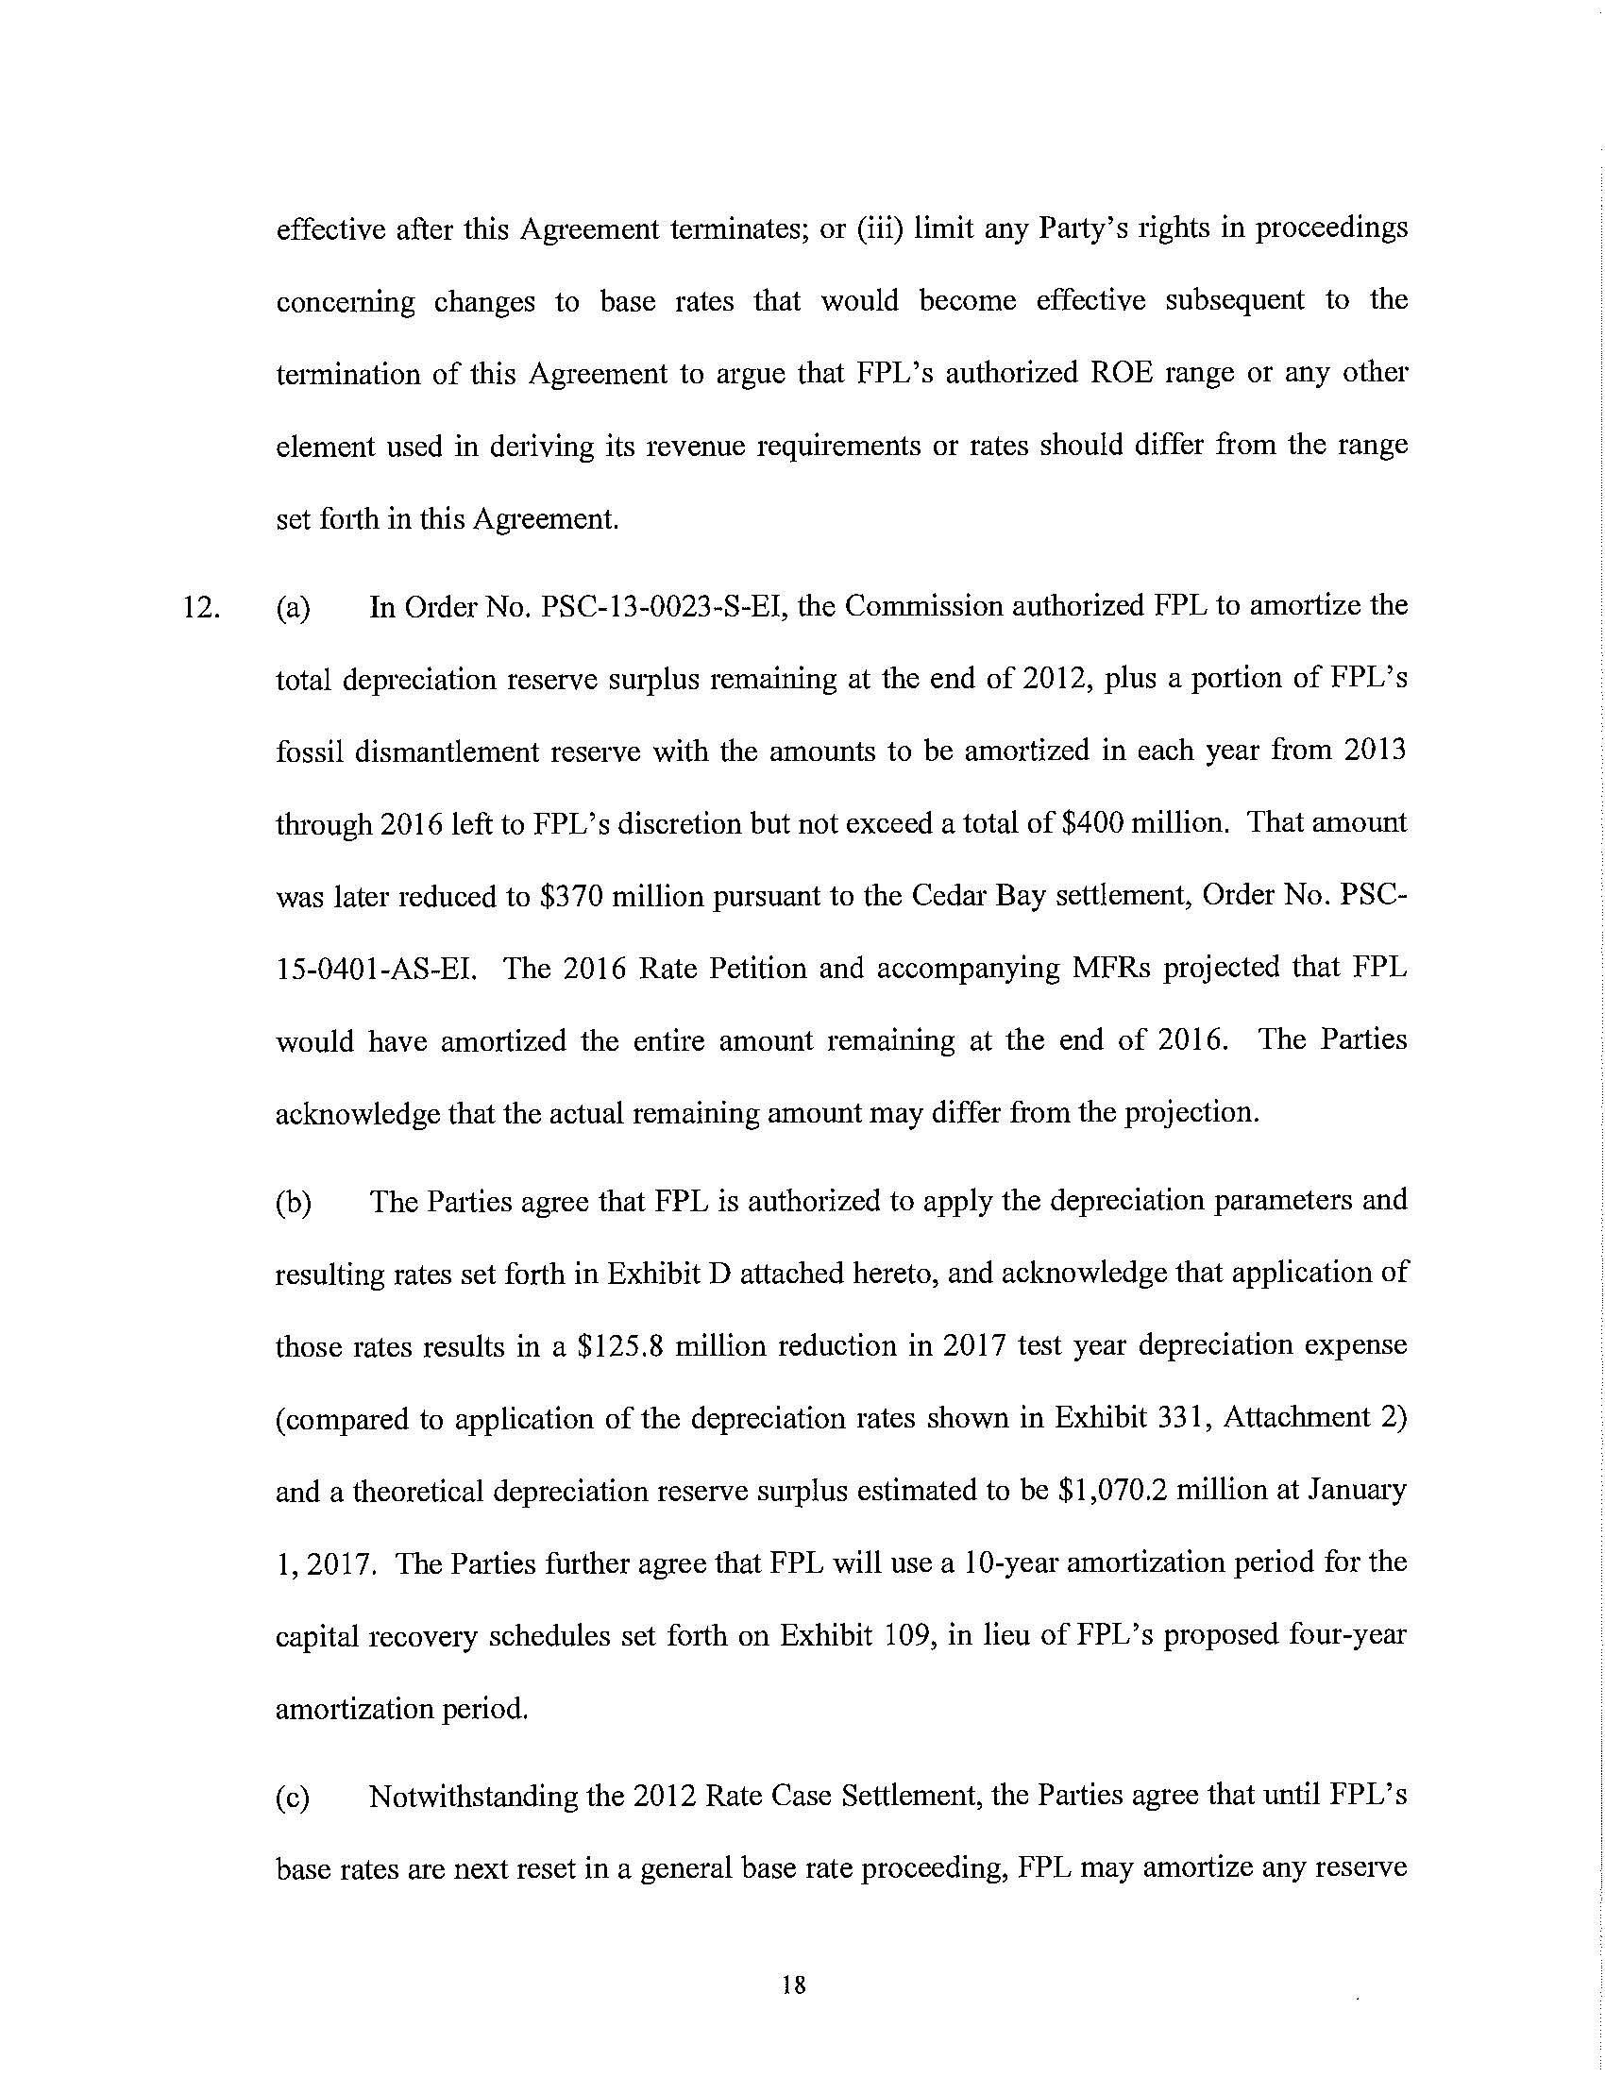

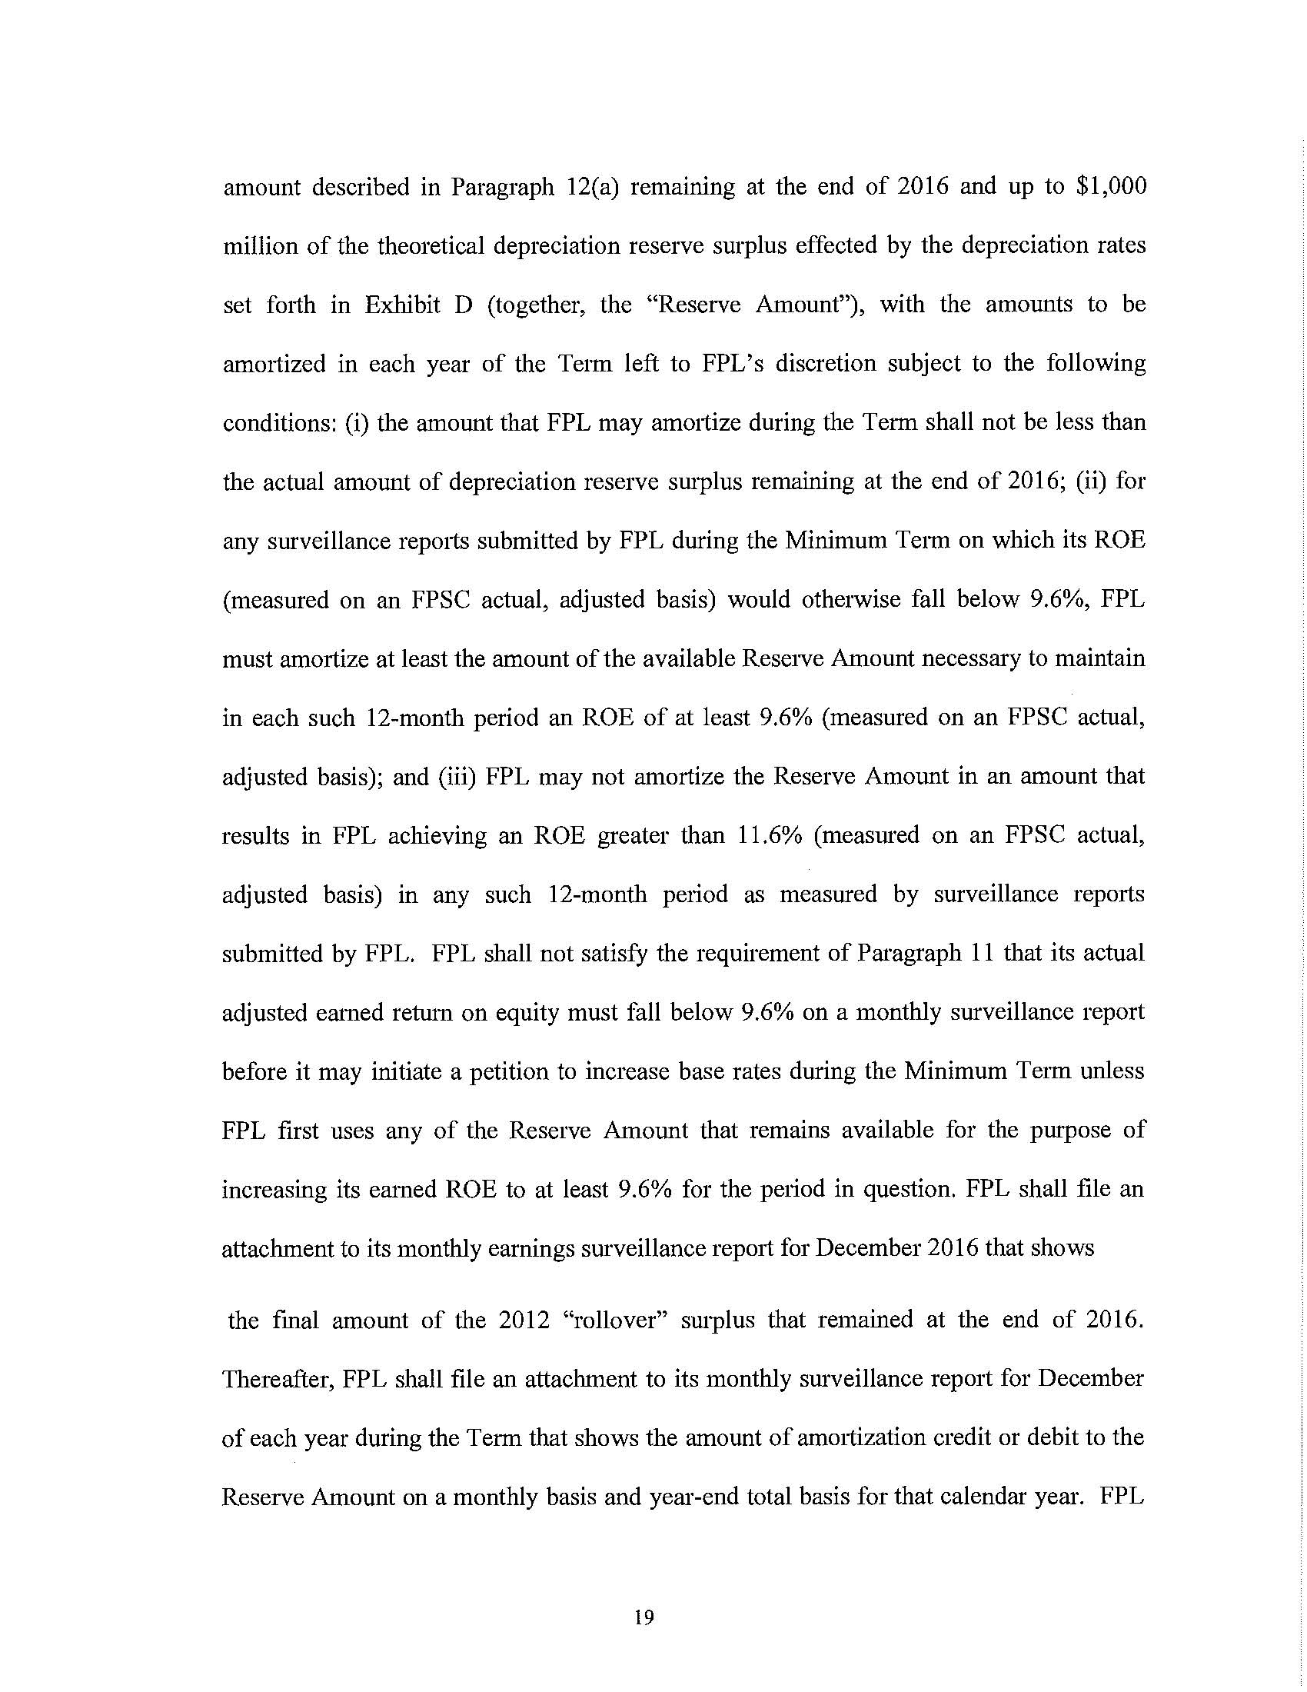

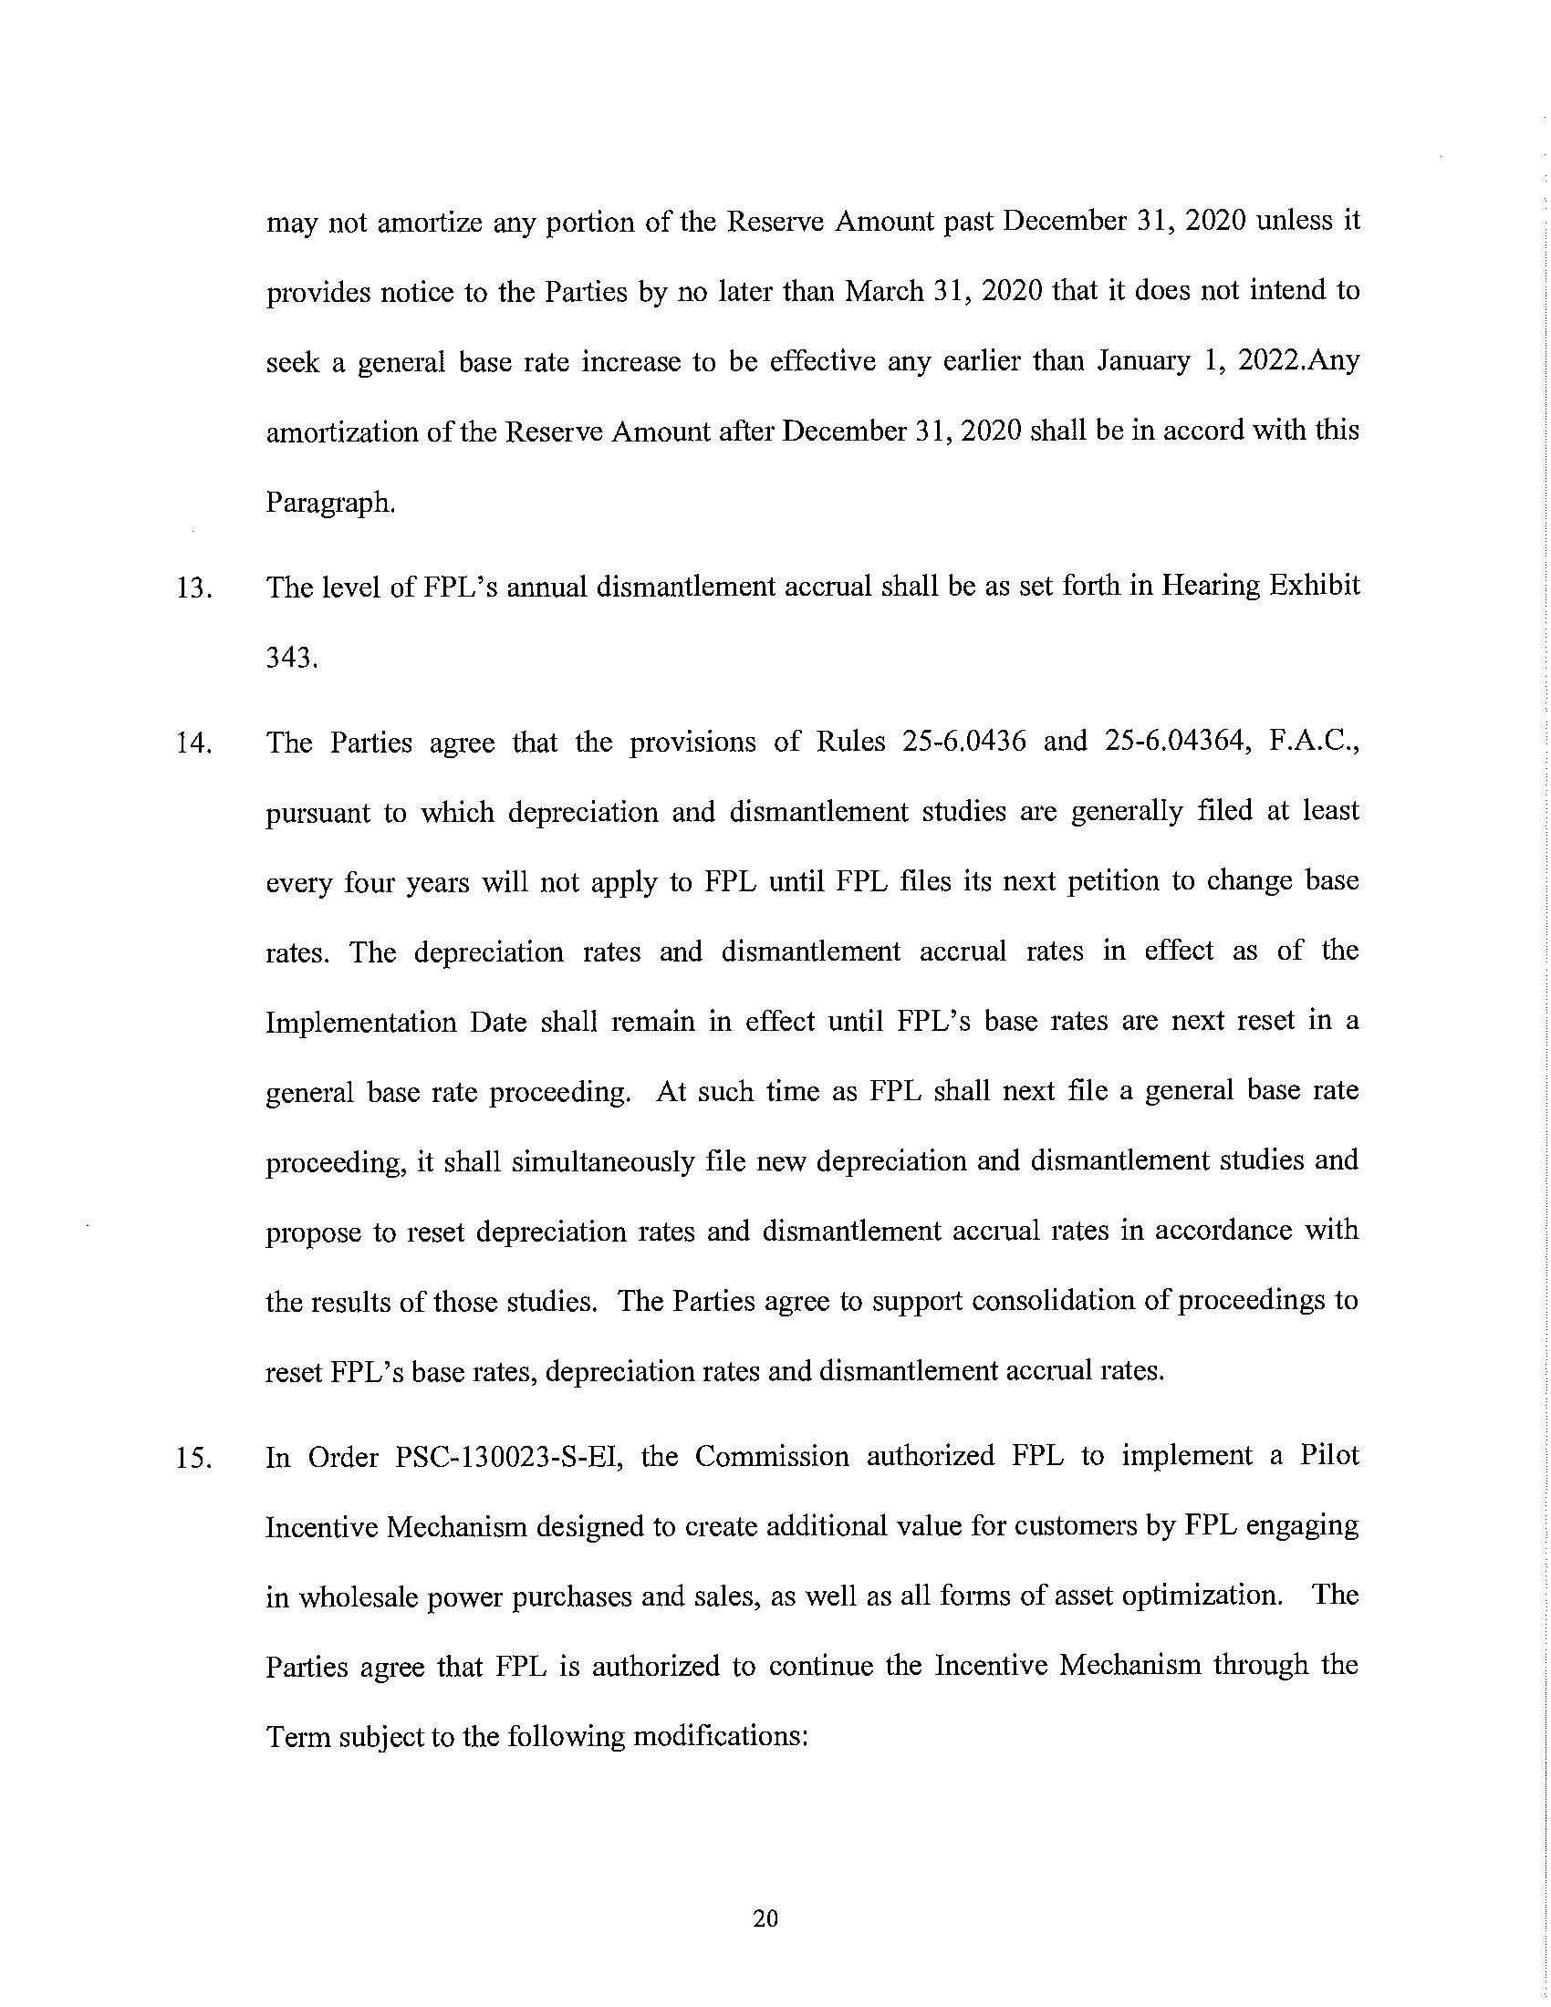
ATTACHMENT C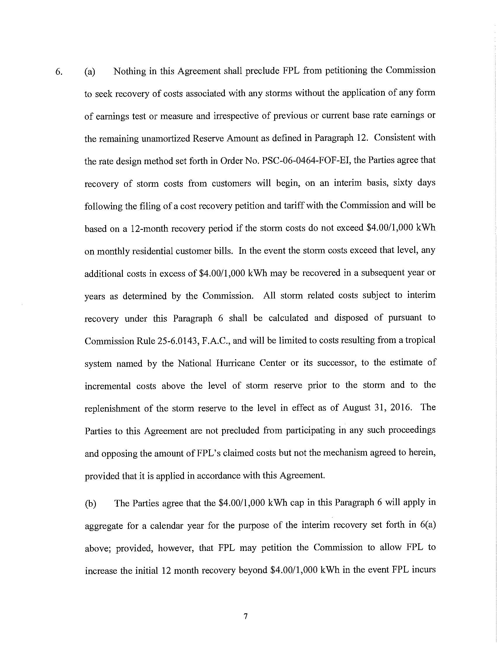
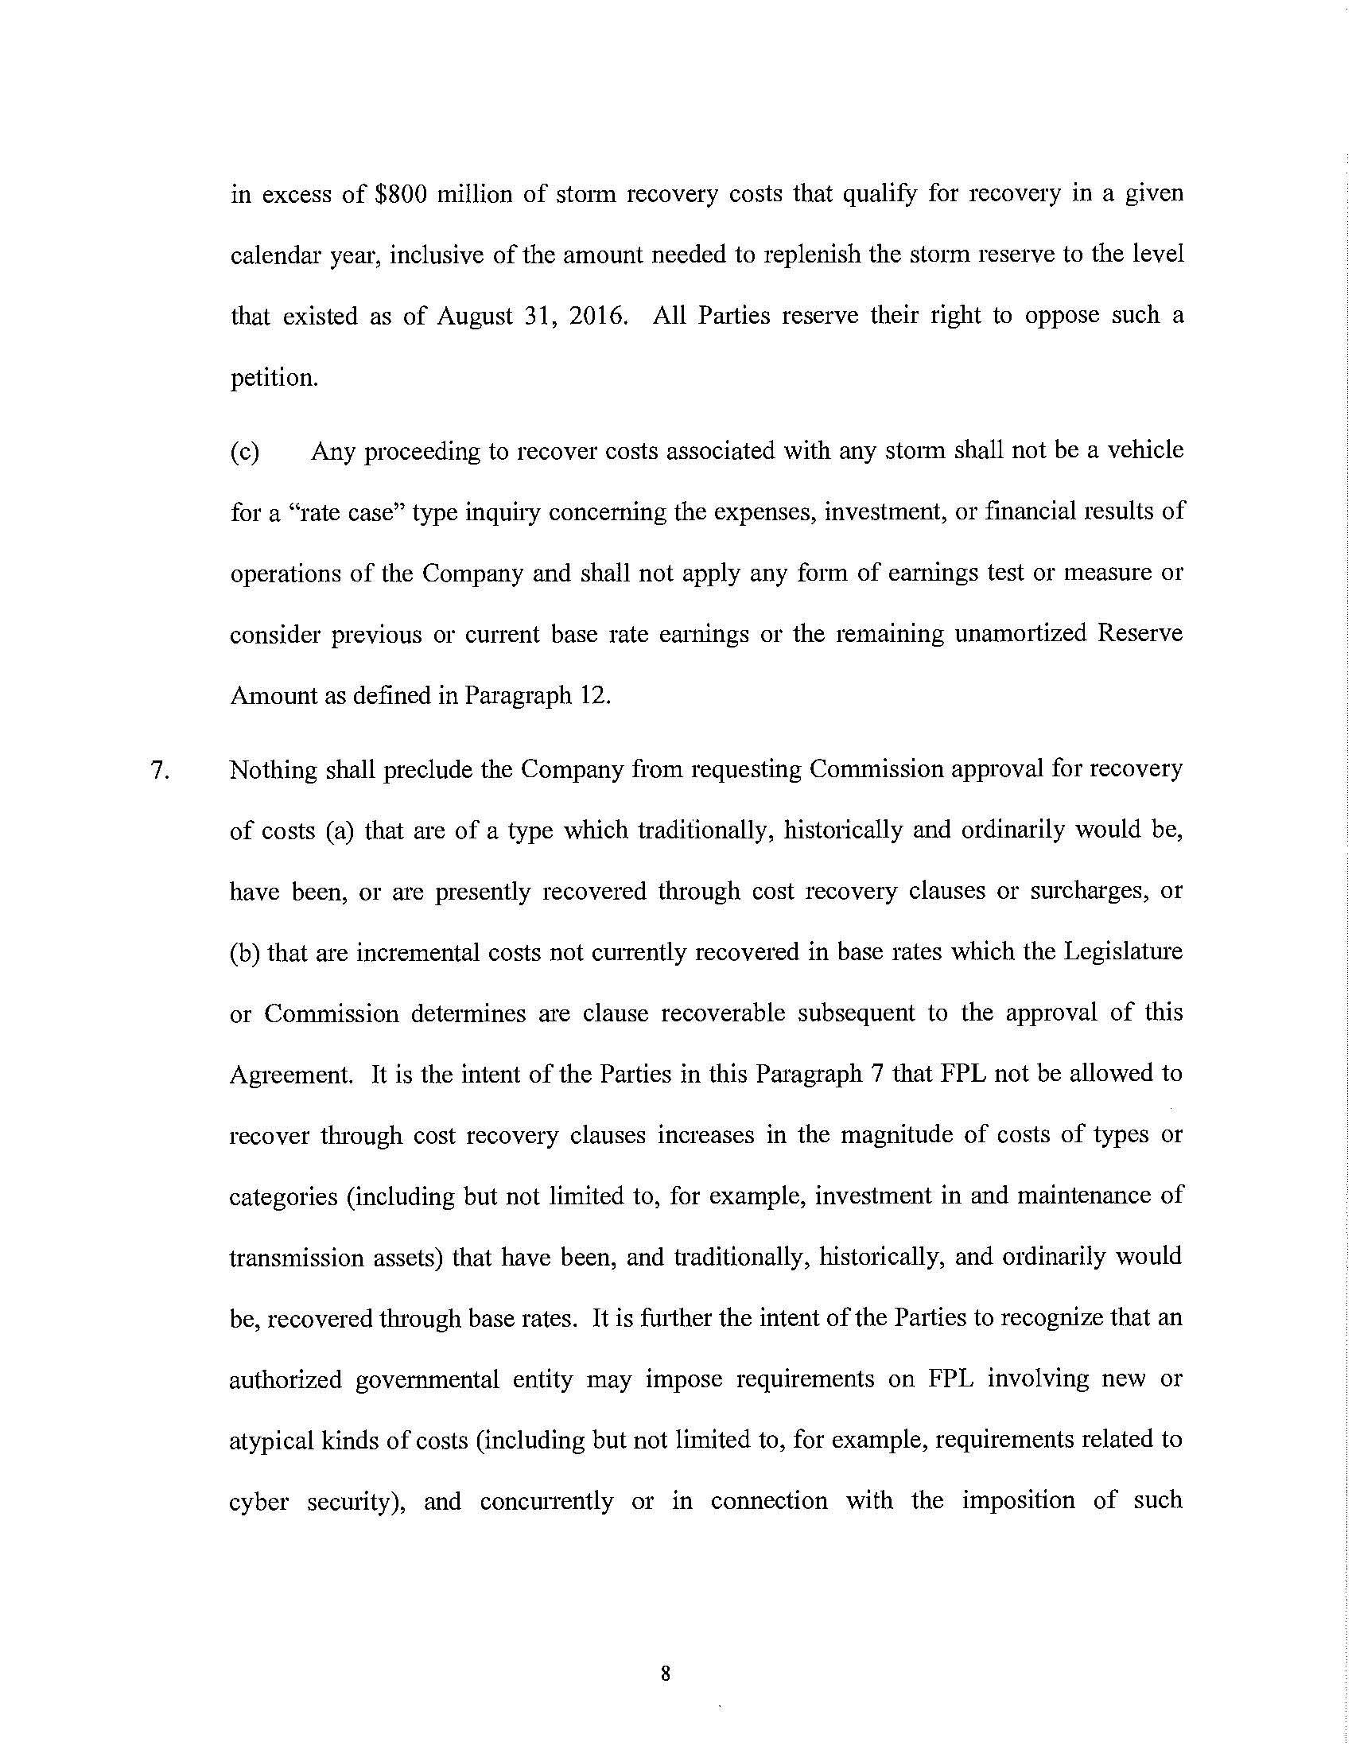

Issue 18: Does the 2016 Settlement Agreement allow FPL to credit the Amortization Reserve with the tax savings resulting from the Tax Cuts and Jobs Act of 2017; Issue 19: How should the savings associated with the Tax Cuts and Jobs Act of 2017 be treated?
The term “Amortization Reserve” is used in Issue 18 and by FPL and other parties to refer to the accounting mechanism established by Section 12 of the 2016 Settlement Agreement. “Reserve Amount” is the term used in Section 12 for the same accounting mechanism instead of “Amortization Reserve” and will be used in this order.
Order No. PSC-16-0560-AS-EI, issued December 15, 2016, in Docket No. 160021-EI, In re: Petition for rate increase by Florida Power & Light Company.
Section 12(c).
Section 12(c).
Id.
Id.
Order No. PSC-13-0023-S-EI, issued January 14, 2013, in Docket No. 120015-EI, In re: Petition for increase in rates by Florida Power & Light Company.
Section 6(a).
Section 6(b).
It is unclear whether OPC is also asking for an immediate base rate reduction of either the $540 million overearnings or the $649.6 million tax savings that it has calculated FPL realized in 2018. However, OPC contends that reducing base rates to account for tax savings is consistent with actions taken by Gulf Power Company (Gulf) (Order No. PSC-2018-0180-FOF-EI), Tampa Electric Company (TECO) (Order No. PSC-2018-0457-FOF-EI), and Duke Energy Florida, LLC (DEF) (Order No. PSC-2019-0053-FOF-EI).
PSC Order No. 22353, issued on December 29, 1989, in Docket No. 890216-TL, In re: Petition of Citizens of the State of Florida for a limited proceeding to reduce General Telephone Company of Florida’s authorized rate of return on equity: In re: Investigation into the proper application of Rule 25-14.003, relating to tax savings refunds for 1988 and 1989 for GTE Florida Incorporated.
Peoples Gas System, Inc. v. Mason, 187 So. 2d 335, 339 (Fla. 1966) (Emphasis added).
Northern Indiana Public Service. Co. v. Indiana Office of Utility Consumer Counselor, 826 N.E. 2d 112 (Ind. Ct. App. 2005).
Northern Indiana Public Service. Co. v. Indiana Office of Utility Consumer Counselor, 826 N.E. 2d at 118, citing Citizens Action Coalition of Indiana, Inc. v. Northern Indiana Public Service Co., 796 N.E. 2d 1264, 1267-68 (Ind. Ct. App. 2003), quoting Citizens Action Coalition of Indiana v. PSI Energy, Inc., 664 N.E. 2d 401, 406 (Ind. Ct. App 1996).(Emphasis added.)
Northern Indiana Public Service Co. v. Indiana Office of Utility Consumer Counselor, 826 N.E.2d at 118, citing Indiana Bell Telephone Company, Inc. v. Office of Utility Consumer Counselor, 725 N.E.2d 432, 435 (Ind. Ct. App. 2000).
Northern Indiana Public Service Co., 826 N.E. 2d at 119.
Peoples, 187 So. 2d at 339.
Sierra Club v. Brown, 243 So. 2d 903, 909 (Fla. 2018).
Id.
City of Homestead v. Beard, 600 So. 2d 450, 453 (Fla. 1992); See: City of Homestead v. Johnson, 760 So. 2d 80, 84 (Fla. 2000).
Beard, 600 So. 2d at 453.
Johnson, 760 So. 2d at 84.
Golf Scoring Systems Unlimited , Inc. v. Remedio,877 So. 2d 827, 829 (Fla. 4th DCA 2004).
Premier Insurance Company v. Adams, 632 So. 2d 1054, 1057 (Fla. 5th DCA 1994).
Harrington v. Citizens Property Insurance Corporation, 54 So. 3d 999, 1002 (Fla. 4th DCA 2010).
Id.
Friedman v. Virginia Metal Products Corporation, 56 So. 2d 515, 517 (Fla. 1952).
Id.
“FPL provides notice to the Parties by no later than March 31, 2020 that it does not intend to seek a general base rate increase to be effective any earlier than January 1, 2022.” Section 12(c).
Section 12(c)(i), (ii) and (iii).
Order No. PSC-16-0560-AS-EI at 3.
Section 6(a).
Sierra Club, 243 So. 3d at 909.
Docket No. 20180224-EI, In re: Petition for enforcement of 2016 Settlement and permanent base rate reductions against Florida Power & Light Company.
Id.
Reedy Creek Utilities Co. v. Florida Public Service Comm., 418 So. 2d 249 (Fla. 1982).
Reedy Creek 418 So. 2d at 250.
Peoples Gas System v. Mason, 187 So. 2d 335 (Fla. 1966)

