State of Florida |  | Public Service Commission  Capital Circle Office Center ● 2540 Shumard Oak Boulevard  Tallahassee, Florida 32399-0850  -M-E-M-O-R-A-N-D-U-M-
DATE: | July 25, 2019
TO: | Office of Commission Clerk (Teitzman)
FROM: | Division of Economics (Higgins)  Division of Accounting and Finance (Mouring, D. Smith, Cicchetti)  Division of Engineering (Doehling)  Office of the General Counsel (Brownless)
RE: | Docket No. 20190107-EI – Petition for approval of commencement date for depreciation of AMI program assets, by Tampa Electric Company.
AGENDA: | 08/06/19 – Regular Agenda – Proposed Agency Action - Interested Persons May Participate
COMMISSIONERS ASSIGNED: |  |  | All Commissioners
PREHEARING OFFICER: |  |  | Clark
CRITICAL DATES: |  |  | None
SPECIAL INSTRUCTIONS: |  |  | None

Case Background
On April 23, 2019, Tampa Electric Company (TECO or Company) filed its Petition for Approval of Commencement Date for Depreciation of its AMI (Advanced Metering Infrastructure) assets (Petition). In the Petition, TECO requests Florida Public Service Commission (Commission) approval “to commence” depreciating its AMI assets on or about January 1, 2022.
Integral to the instant petition is TECO’s 2017 Amended and Restated Stipulation and Settlement Agreement (2017 Settlement), which was approved in November of that same year. The 2017 Settlement contains certain provisions regarding the deployment and transition from Automatic Meter Reading (AMR) technology, to AMI technology.
Two separate staff data requests seeking additional information regarding the Petition were issued on May 7, 2019, and May 30, 2019. The Company responded to Staff’s First Data Request on May 14, 2019, and Staff’s Second Data Request on June 13, 2019. Additionally, the Company filed an updated response to Staff’s First Data Request, No. 15, on June 17, 2019.
Staff is not currently aware of any questions or concerns from the public with respect to this matter. Also, the parties to the 2017 Settlement do not oppose the Company’s requested relief in this proceeding.
The Commission has jurisdiction in this matter pursuant to Sections 366.04, 366.05, and 366.06, Florida Statutes (F.S.).

Discussion of Issues

Issue 1:
Should the Commission approve TECO's requested accounting treatment related to its AMI meters?

Recommendation:
Yes. Staff recommends that the Commission approve TECO’s requested accounting treatment related to its AMI meters. (Brownless, Higgins)

Staff Analysis:

Background
On April 23, 2019, TECO filed a petition effectively requesting authorization to suspend and reverse the depreciation expense on assets comprising its AMI program and recommence the depreciation expense on those assets on January 1, 2022. TECO first began installing and recording depreciation expense for AMI meters in 2016 and is in the process of replacing all of its current AMR meters with AMI meters. TECO estimates that AMI meters will be deployed system wide by year-end 2021 along with all of the back-office functions and communication systems necessary to make the AMI meters fully functional. Once the AMI meters are fully functional, the system will be able to provide customer service tools, remote connection/disconnection of service, and information regarding an individual customer’s energy usage.

TECO is currently depreciating AMI meter investment for both regulatory and federal income tax purposes from the point of purchase. The specific accounting treatment TECO is proposing is to remove current AMI meter investment from Plant in Service Account 101 and place it into Construction Work in Progress (CWIP) Account 107. Future AMI meter investment made from 2019 through 2021 would also be placed in CWIP Account 107 where such assets would not be depreciated. On January 1, 2022, the date that TECO estimates the AMI infrastructure will be fully functional, AMI meter investment would be booked to plant and depreciation expense would begin anew.

The depreciation expense associated with the 2016 through May 2019 AMI meter investment that TECO is proposing be reversed totals approximately $460,000. TECO states that reversing the prior AMI depreciation would be “immaterial to the presentation of its financial statements as a whole.”

The accounting method by which meters are depreciated is addressed in Rule 25-6.0142, Florida Administrative Code (F.A.C.). Rule 25-6.0142(1), F.A.C., incorporates the Uniform System of Accounts prescribed by the Code of Federal Regulations, Title 18, Chapter I, Subchapter C, Part 101, into the rule. By this incorporation, meters are given “cradle-to-grave” accounting treatment. “Cradle-To-Grave Accounting” is defined in the rule as “[a]n accounting method which treats a unit of plant as being in service from the time it is first purchased until it is finally junked or disposed of in another manner.” Further, meters that are in the “shop for refurbishing or in stock/inventory awaiting reinstallation [are] treated as being in service.” Applying this rule to the present situation, TECO must begin depreciating its AMI meters from the date of purchase.

IRS Reg. Sec. 1.167(a)-(11)(e)(1) treats the depreciation of plant assets differently. For purposes of depreciation for federal taxes, an asset is placed in service when it is “first placed in a condition or state of readiness and availability for a specifically assigned function.” Applying this regulation to the present situation, TECO concludes that it does not have to begin depreciating the AMI meters until the date that they are fully functional, i.e., until the back-office functions and communications systems necessary to allow the AMI meters to fully perform are in place, currently estimated to be by January 1, 2022.

For tax years 2016 and 2017, TECO depreciated both AMI and AMR meters for federal tax purposes. TECO has not yet filed its 2018 federal tax return which is due between October 1 and 15, 2019. TECO intends to claim zero tax deprecation for AMI for 2018 and to true-up for the cumulative tax depreciation it took for years prior to 2018, thus aligning the federal tax treatment with the treatment requested here.

The depreciation of AMR meters is also addressed in Section 8 of TECO’s 2017 Settlement approved by Order No. PSC-2017-0456-S-EI. Section 8(b) states as follows:

(b) Notwithstanding the non-deferral language in Paragraph 4, unless the company proposes a special capital recovery schedule and the Commission approves it, if coal-fired generating units or other assets are retired or planned for retirement of a magnitude that would ordinarily or otherwise require a special capital recovery schedule, such assets will continue to be depreciated using their then existing depreciation rates and special capital recovery issues will be addressed in conjunction with the company’s next depreciation study. If the company installs Automated Meter Infrastructure (“AMI”) meters and retires Automated Meter Reading (“AMR”) meters during the Term, such assets will continue to be depreciated using their then existing depreciation rates and special capital recovery issues will be addressed in conjunction with the company’s next depreciation study.

[Emphasis added.]

TECO takes the position that Section 8(b) requires it to continue depreciating its AMR meters even if replaced by AMI meters. TECO also takes the position that Section 8(b) does not address the depreciation treatment of AMI at all. TECO acknowledges that the language of Section 8(b) can reasonably be read to mean that both AMI and AMR meters will be depreciated concurrently during the term of the 2017 Settlement. However, TECO argues that the signatories to the 2017 Agreement did not intend that result. TECO states that the use of the term “assets” in Section 8(b) “refers to the AMR meters that would be replaced by AMI meters resulting in an unrecovered net book value amount.” TECO also states that the use of the term “rates” was a “scrivener’s error” and should have been “rate” to “reflect the fact that there is only one approved rate for meters in Account 370 - Meters.”

TECO’s response to Staff’s First Data Request No. 22 in the 2017 Settlement docket indicates that, at the time that the 2017 Settlement was signed, the Company did intend to depreciate both its AMI and AMR meters concurrently at an annual rate of 7.2 percent from 2017 through 2021 (the 2017 Settlement term). [Attachment A]

The Office of Public Counsel (OPC) agrees that TECO’s request “does not violate the terms of the 2017 Agreement and does not object to the relief requested in the Petition.” The Florida Industrial Power Users Group (FIPUG) and the Florida Retail Federation (FRF) “do not object to the relief requested in the Petition.” The West Central Florida Hospital Utility Association (HUA) does not have a position on the Petition. Likewise, the Federal Executive Agencies (FEA) do not have a position on the Petition.

The reasons given by TECO for approval of the requested AMI accounting treatment are as follows:

- Every signatory to the 2017 Settlement either supports the proposed treatment of AMI depreciation or does not object to it. [Staff First Data Request No. 15, revised on June 17, 2019]

- The change in depreciation treatment of AMI meters will match IRS Sec. 1.167(a)-(11)(e)(1)’s treatment since they are not currently providing their “specifically designed function.” [Petition at 7; Staff Second Data Request No. 1]

- Allowing depreciation of AMI meters when all AMI installations and back-office system integration are complete, estimated to be January 2022, prevents any intergenerational inequities. [Petition at ¶ 14]

- The continued depreciation of AMR meters will decrease the undepreciated net book value of those assets which will in turn reduce, or may eliminate, the amount of a capital recovery schedule for those assets in TECO’s next depreciation study filed with its next base rate case.

- Per Section 9 of the 2017 Settlement, as implemented by Order No. PSC- 2019-0234-AS-EI, due to the passage of the Tax Cuts and Jobs Act of 2017 (TCJA) TECO is required to make a one-time bill credit of $11,500,000 in January of 2020.

- The passage of the TCJA in December of 2017 also resulted in the loss of bonus depreciation on additions to utility plant which has a negative impact on accumulated deferred income taxes in the Company’s capital structure. This negative impact will increase in the future as less income tax is deferred. [Staff’s First Data Request No. 5; Staff’s Second Data Request at No. 6]

- As of the March 2019 Earnings Surveillance Report, TECO’s rate of return (ROR) is 6.14 percent and its return on equity (ROE) is 10.18 percent. TECO’s current return on equity earnings range is 9.25 percent to 11.25 percent with a mid-point of 10.25 percent. [Staff’s Second Data Request No. 6] The proposed accounting treatment for AMI would result in approximately a $233,000 higher net operating income and 1 basis point increase in return on equity in the March 2019 Earnings Surveillance Report. [Staff’s Data Request No. 7] TECO projects that by 2021, if this petition is not approved, AMI depreciation expense will have a 19.2 basis points negative impact on ROE. [Staff Data Request No. 7]

Analysis

The first issue to address in determining whether TECO’s petition should be granted is to determine the procedural nature of TECO’s request to delay depreciation of the AMI assets. In short, is this: 1) a de facto request for a waiver of Rule 25-6.0142(3), F.A.C., or 2) an addition to, or clarification of, the 2017 Settlement?

A request for waiver of a rule is controlled by Section 120.542, F.S., and Chapter 28-104, F.A.C., which require that the petition for waiver be so named and filed with both the agency and the Joint Administrative Procedures Committee (JAPC). Further, the request must state: 1) the rule or portion of the rule for which waiver is requested; 2) the statute the rule is implementing; 3) the type of action requested; 4) the “specific facts that demonstrate a substantial hardship or violation of principles of fairness that would justify a waiver or variance for the petitioner”; 5) the “reason why the variance or the waiver requested would serve the purposes of the underlying statute”; and 6) whether the waiver is temporary or permanent. TECO’s petition does not meet these requirements. While some of the facts plead by TECO could demonstrate why the variance would serve the purposes of the underlying statutes, there is no argument developed on this point. Additionally, TECO has not filed its petition with JAPC nor asked the Commission to follow the procedures set forth in Section 120.542(6), F.S. Thus, in its present form, the petition does not contain the required information for processing it as a rule waiver even if the procedural filing requirements had been followed or could now be initiated.

At the most basic level, TECO’s request seeks to supplement Section 8(b) of the 2017 Settlement by addressing the depreciation treatment of AMI meters both during and at the end of the settlement term thereby allowing AMI meters to be treated differently than they otherwise would be under Rule 25-6.0142, F.A.C. For this reason, staff recommends that TECO’s request be treated as an addition to, or clarification of, Section 8(b) of the 2017 Settlement.

The standard for determining whether TECO’s request to supplement the 2017 Settlement should be granted is whether the requested accounting treatment is in the public interest when the 2017 Settlement is taken as whole. This is the same standard the Commission applied when initially determining whether the 2017 Settlement should be approved.

Upon review of TECO’s response to Staff’s First Data Request No. 22 in the 2017 Settlement docket, staff is of the opinion that TECO and the other signatories to the 2017 Settlement intended to depreciate both the AMR and AMI meters during the 2017 Settlement term. This treatment is consistent with Rule 25-6.0142, F.A.C., and the plain language of Section 8(b). It appears that the parties to the 2017 Settlement were concerned about leaving as small an amount as possible of undepreciated AMR expense at the end of the settlement term. This goal is reasonable given that TECO was receiving bonus depreciation under federal tax provisions at that time. The loss of bonus depreciation is a significant change in circumstances. Further, staff agrees that TECO’s proposal to reverse all depreciation entries associated with AMI meters will have a very small impact on its financial statements.

Additionally, the Commission’s approval of the 2017 Settlement was based, in part, on the fact that the parties negotiated a “stay out” provision of four years during which time base rates would not change, for reasons other than those provided for in the 2017 Settlement, unless TECO earned above or below its authorized range of 9.25 to 11.25 percent. The passage of the TCJA, which took place after the execution of the 2017 Settlement, has had an unexpected negative financial impact on TECO by eliminating bonus depreciation and thereby effectively decreasing the amount of TECO’s zero cost capital. If no change is made to the depreciation treatment of AMI meters, the greater level of depreciation expense will further depress TECO’s ability to earn within its authorized rate of return range at current base rates.

OPC does not consider TECO’s proposal to violate the terms of the 2017 Settlement nor does any other signatory to the 2017 Settlement oppose TECO’s request. It is clear that TECO’s proposed treatment of the AMI meters will have the effect of decreasing pressure on its ability to earn within its authorized range and increase the likelihood that TECO can maintain its current base rates until December 31, 2021. Given these factors, it is staff’s recommendation that the 2017 Settlement, using TECO’s proposed treatment of the AMI meters, when taken as a whole, continues to be in the public interest.

Conclusion
Staff recommends that the Commission approve TECO’s requested accounting treatment related to its AMI meters because TECO’s proposed treatment of AMI meter depreciation expense, when evaluated in light of the whole 2017 Settlement, continues to be in the public interest.
Issue 2:
Should TECO continue recording depreciation expense on existing AMR meters during the term of the 2017 Settlement?

Recommendation:
Yes. The continued depreciation of existing AMR meters is consistent with the 2017 Settlement. (Brownless, Higgins)

Staff Analysis:
It is staff’s opinion that the terms of Section 8(b) of the Company’s 2017 Settlement, approved by Order No. PSC-2017-0456-S-EI, require TECO to continue recording depreciation of its AMR assets if replaced by AMI assets during the term of the settlement. As such, this issue has already been addressed and ruled upon. Further, if AMR assets are still in use or in-service as defined by Rule 25-6.0142(2)(d), F.A.C., after the 2017 Settlement period, those assets should continue to be depreciated at the then Commission-approved rate.
Conclusion
Staff recommends the Company continue to follow the terms of the 2017 Settlement, specifically Section 8(b), as it relates to the bookkeeping of AMR meters during the settlement period.

Issue 3:
Should this docket be closed?

Recommendation:
If no person whose substantial interests are affected by the proposed agency action files a protest within 21 days of the issuance of the order, this docket should be administratively closed upon the issuance of a consummating order. (Brownless)

Staff Analysis:
At the conclusion of the protest period, if no protest is filed, this docket should be administratively closed upon the issuance of a consummating order.

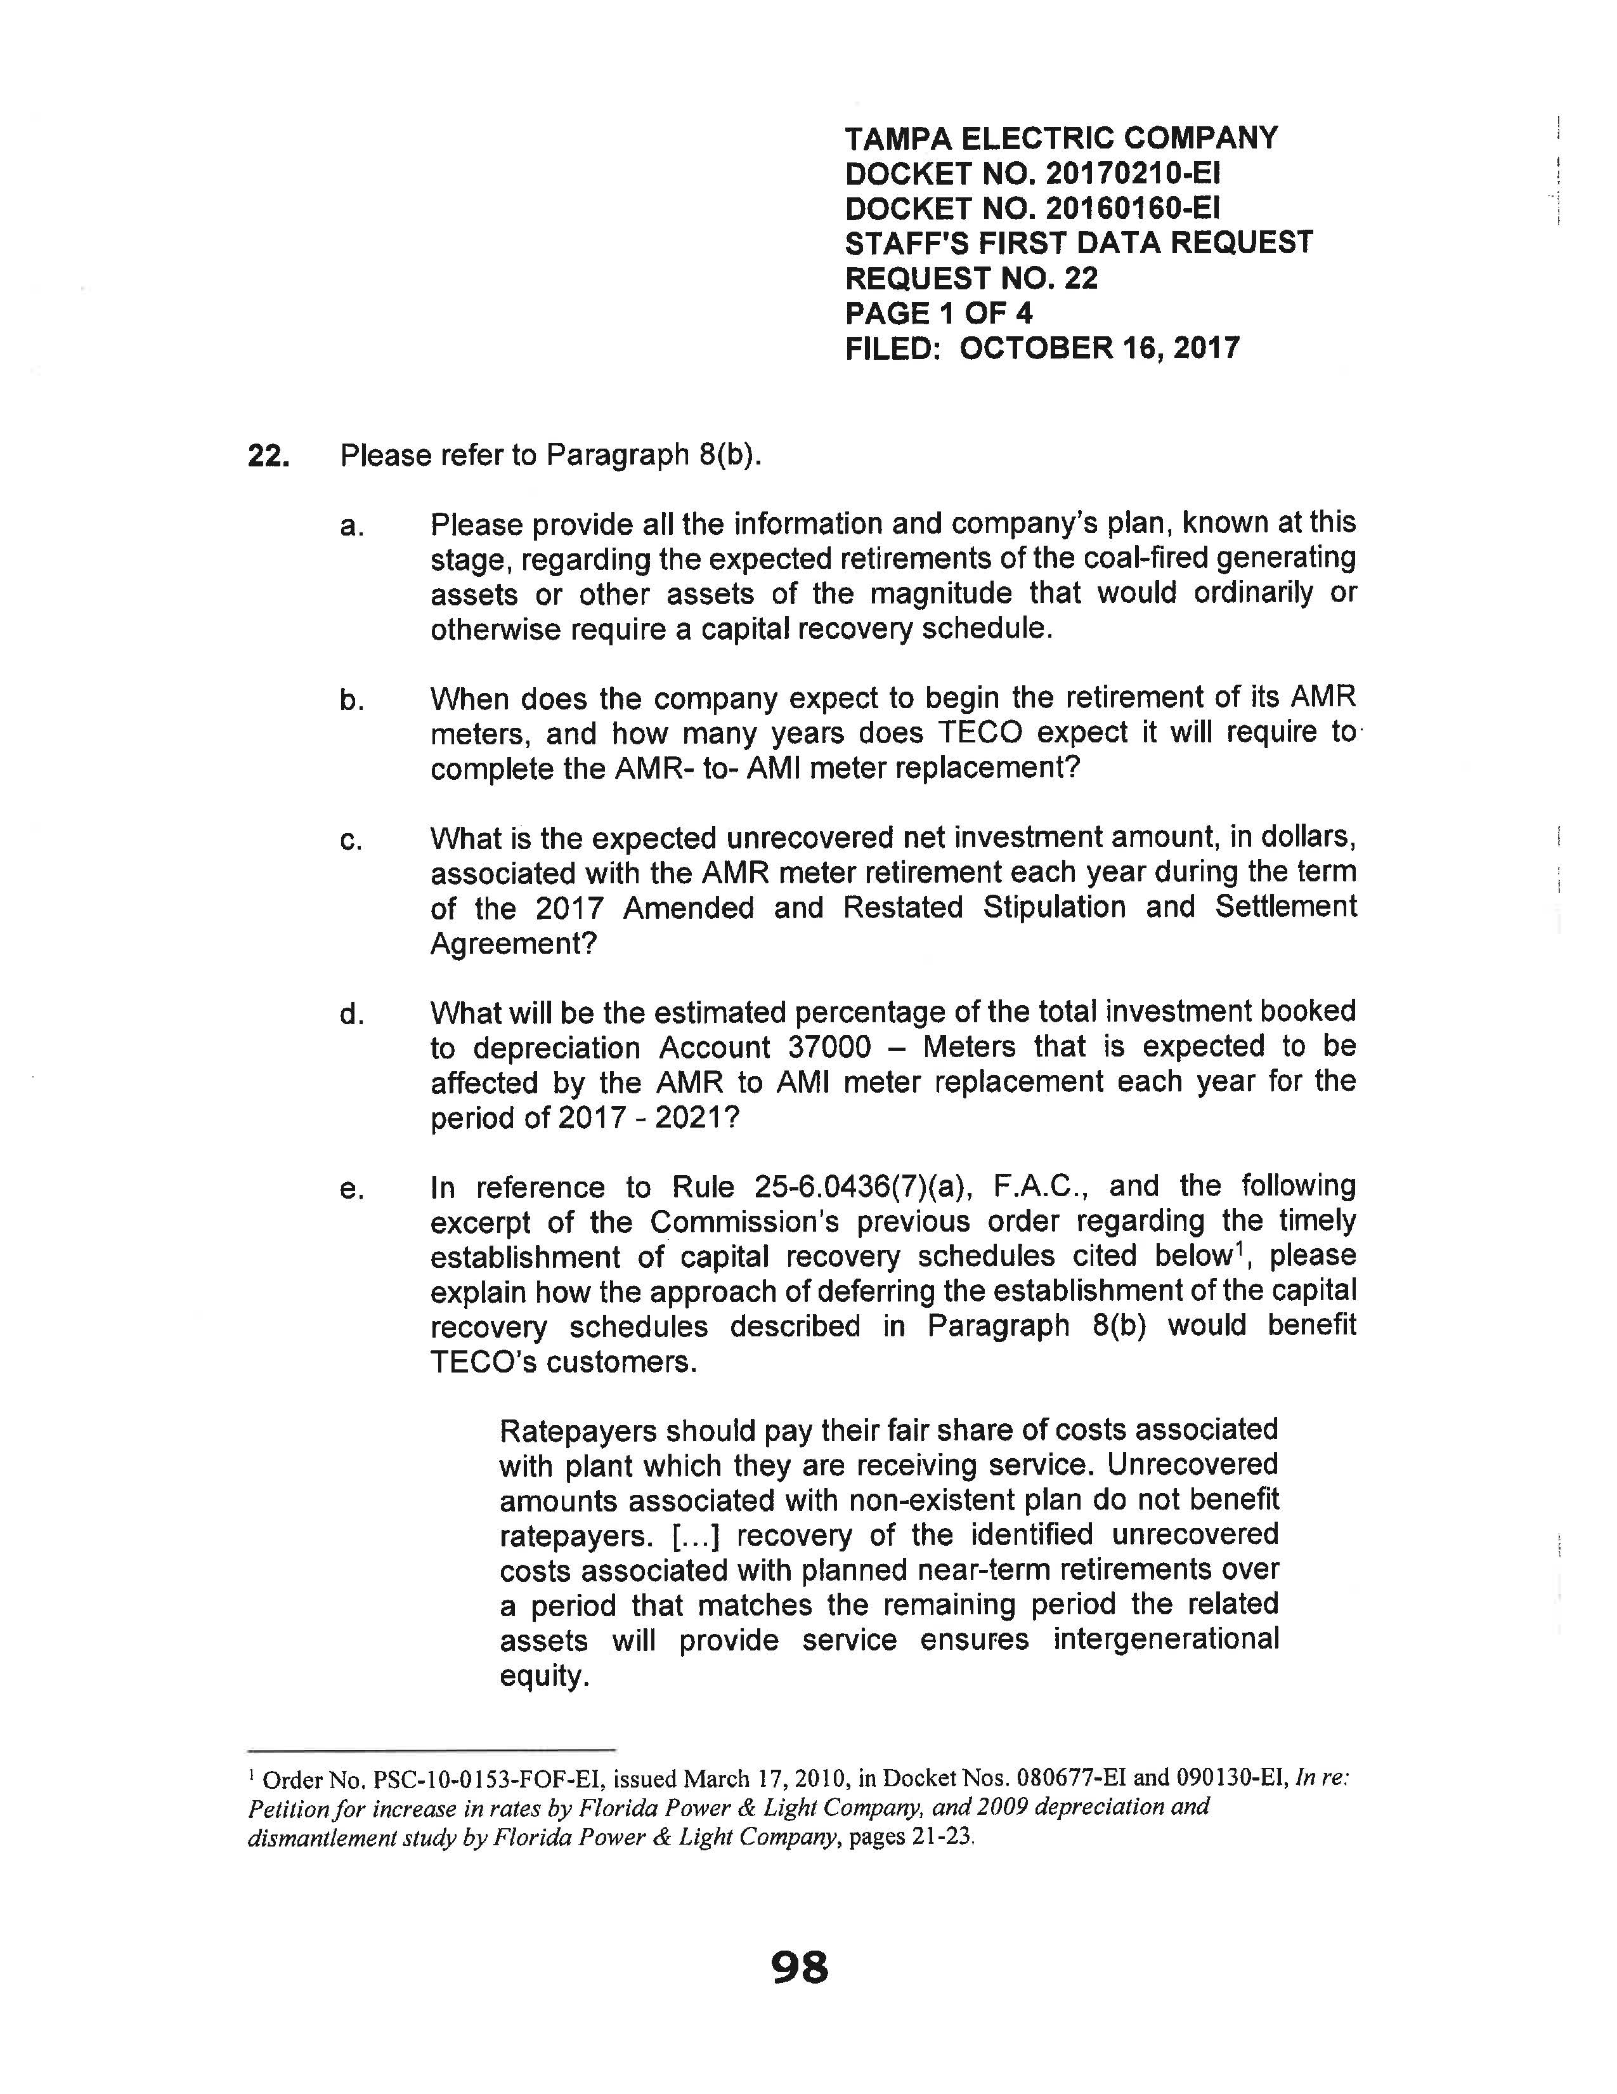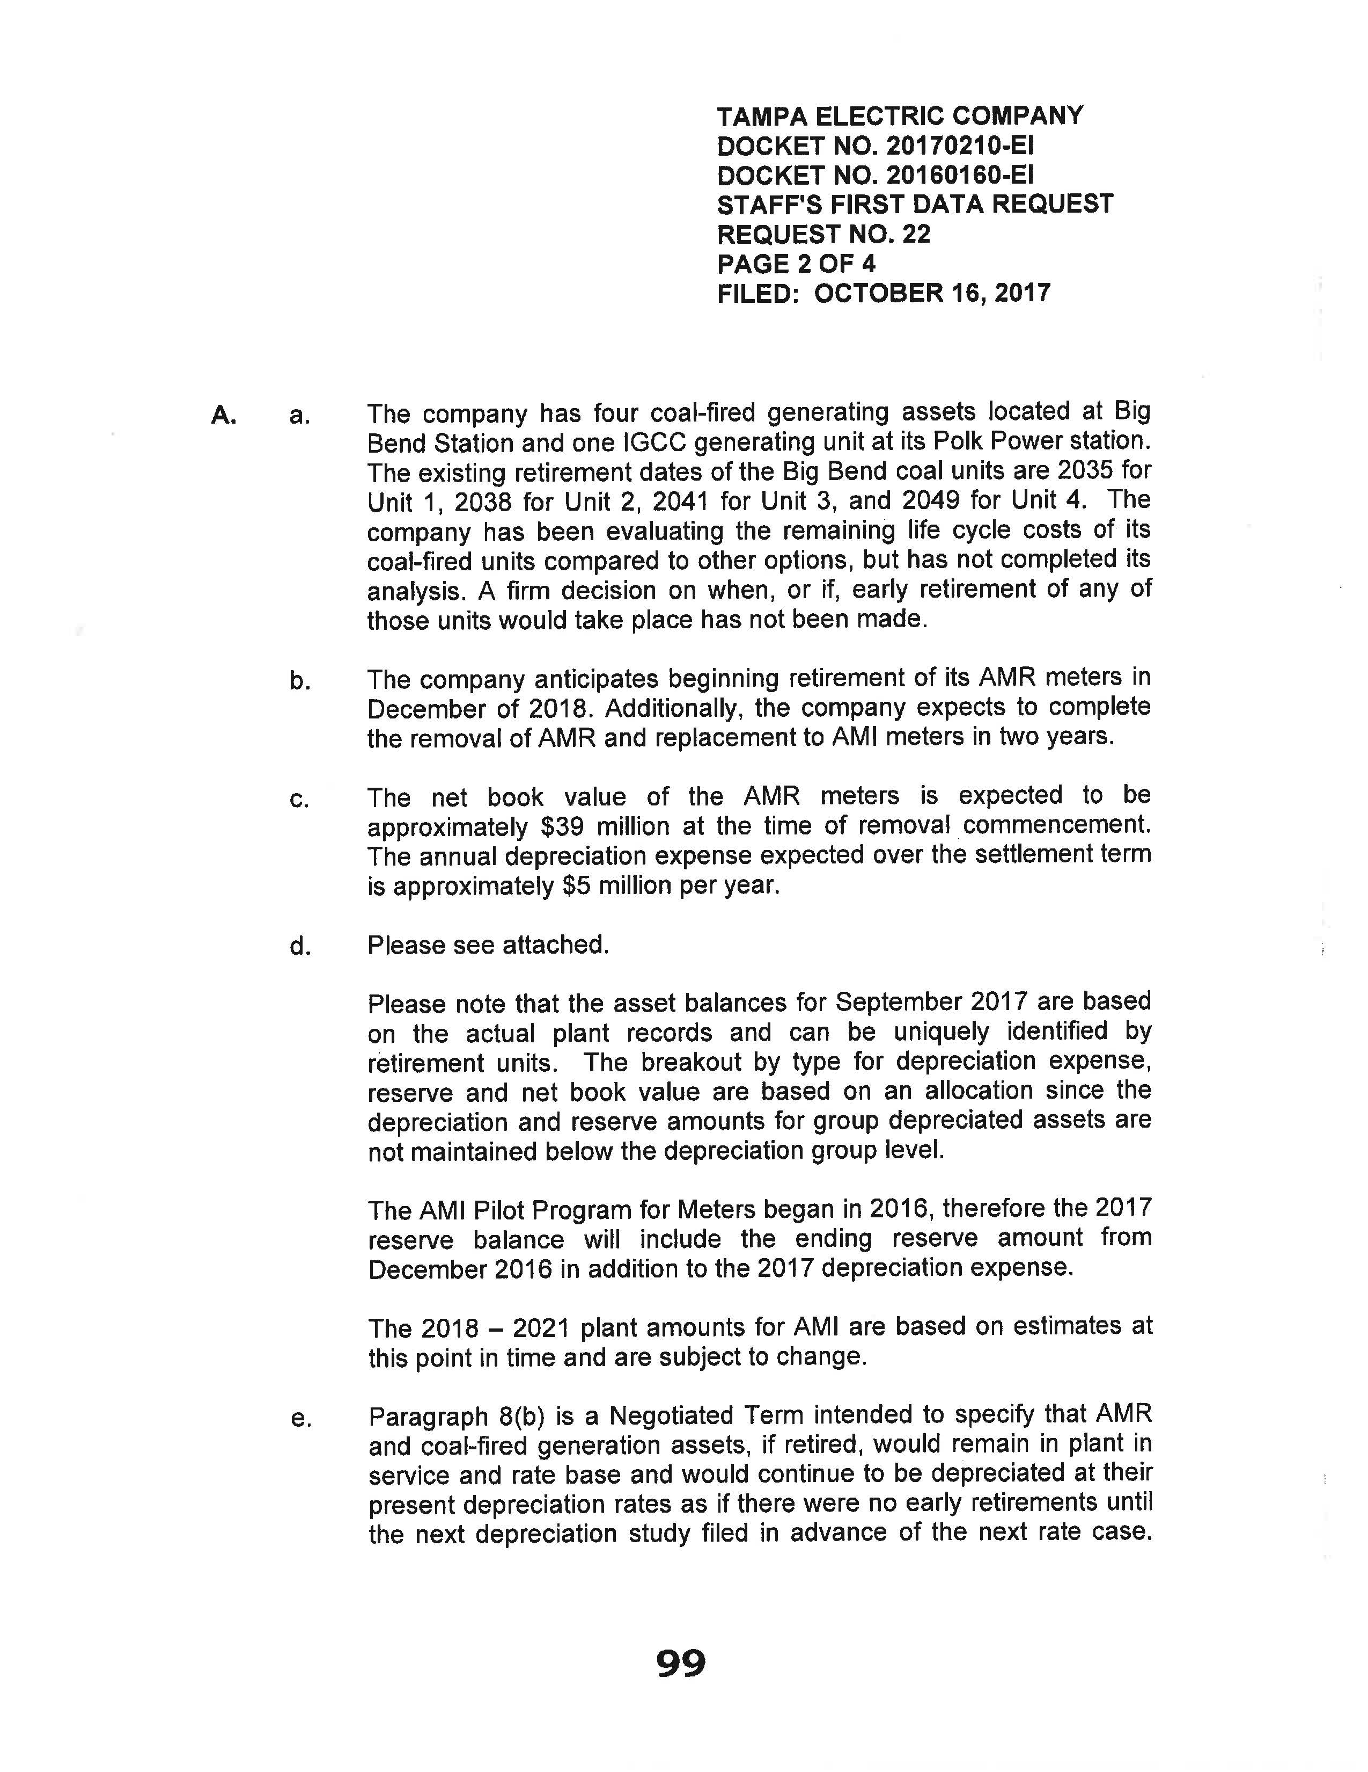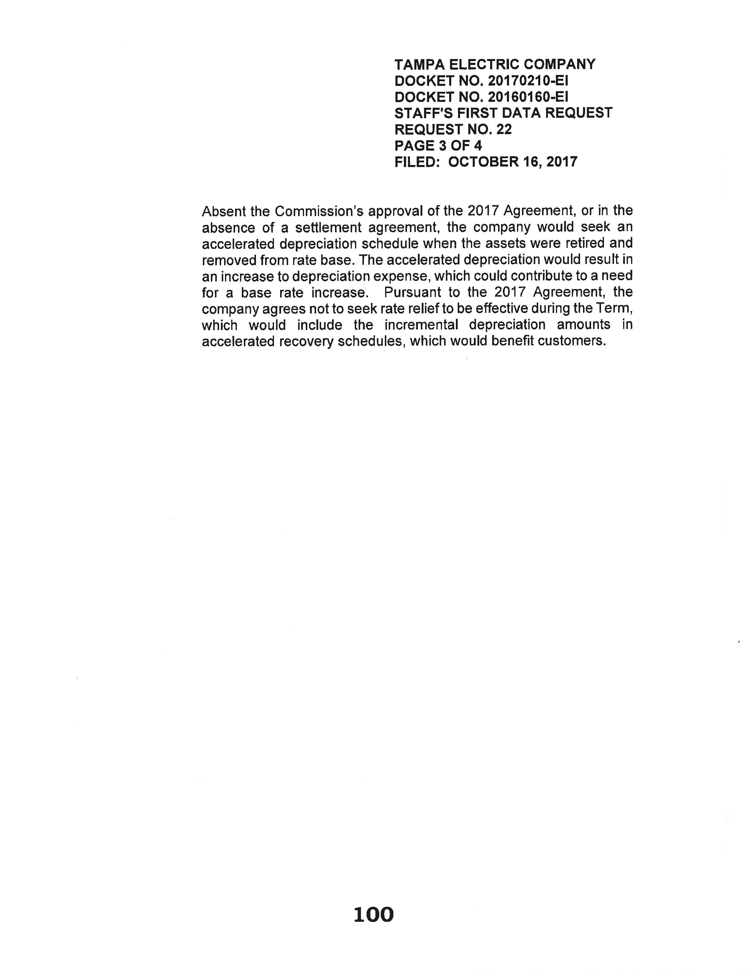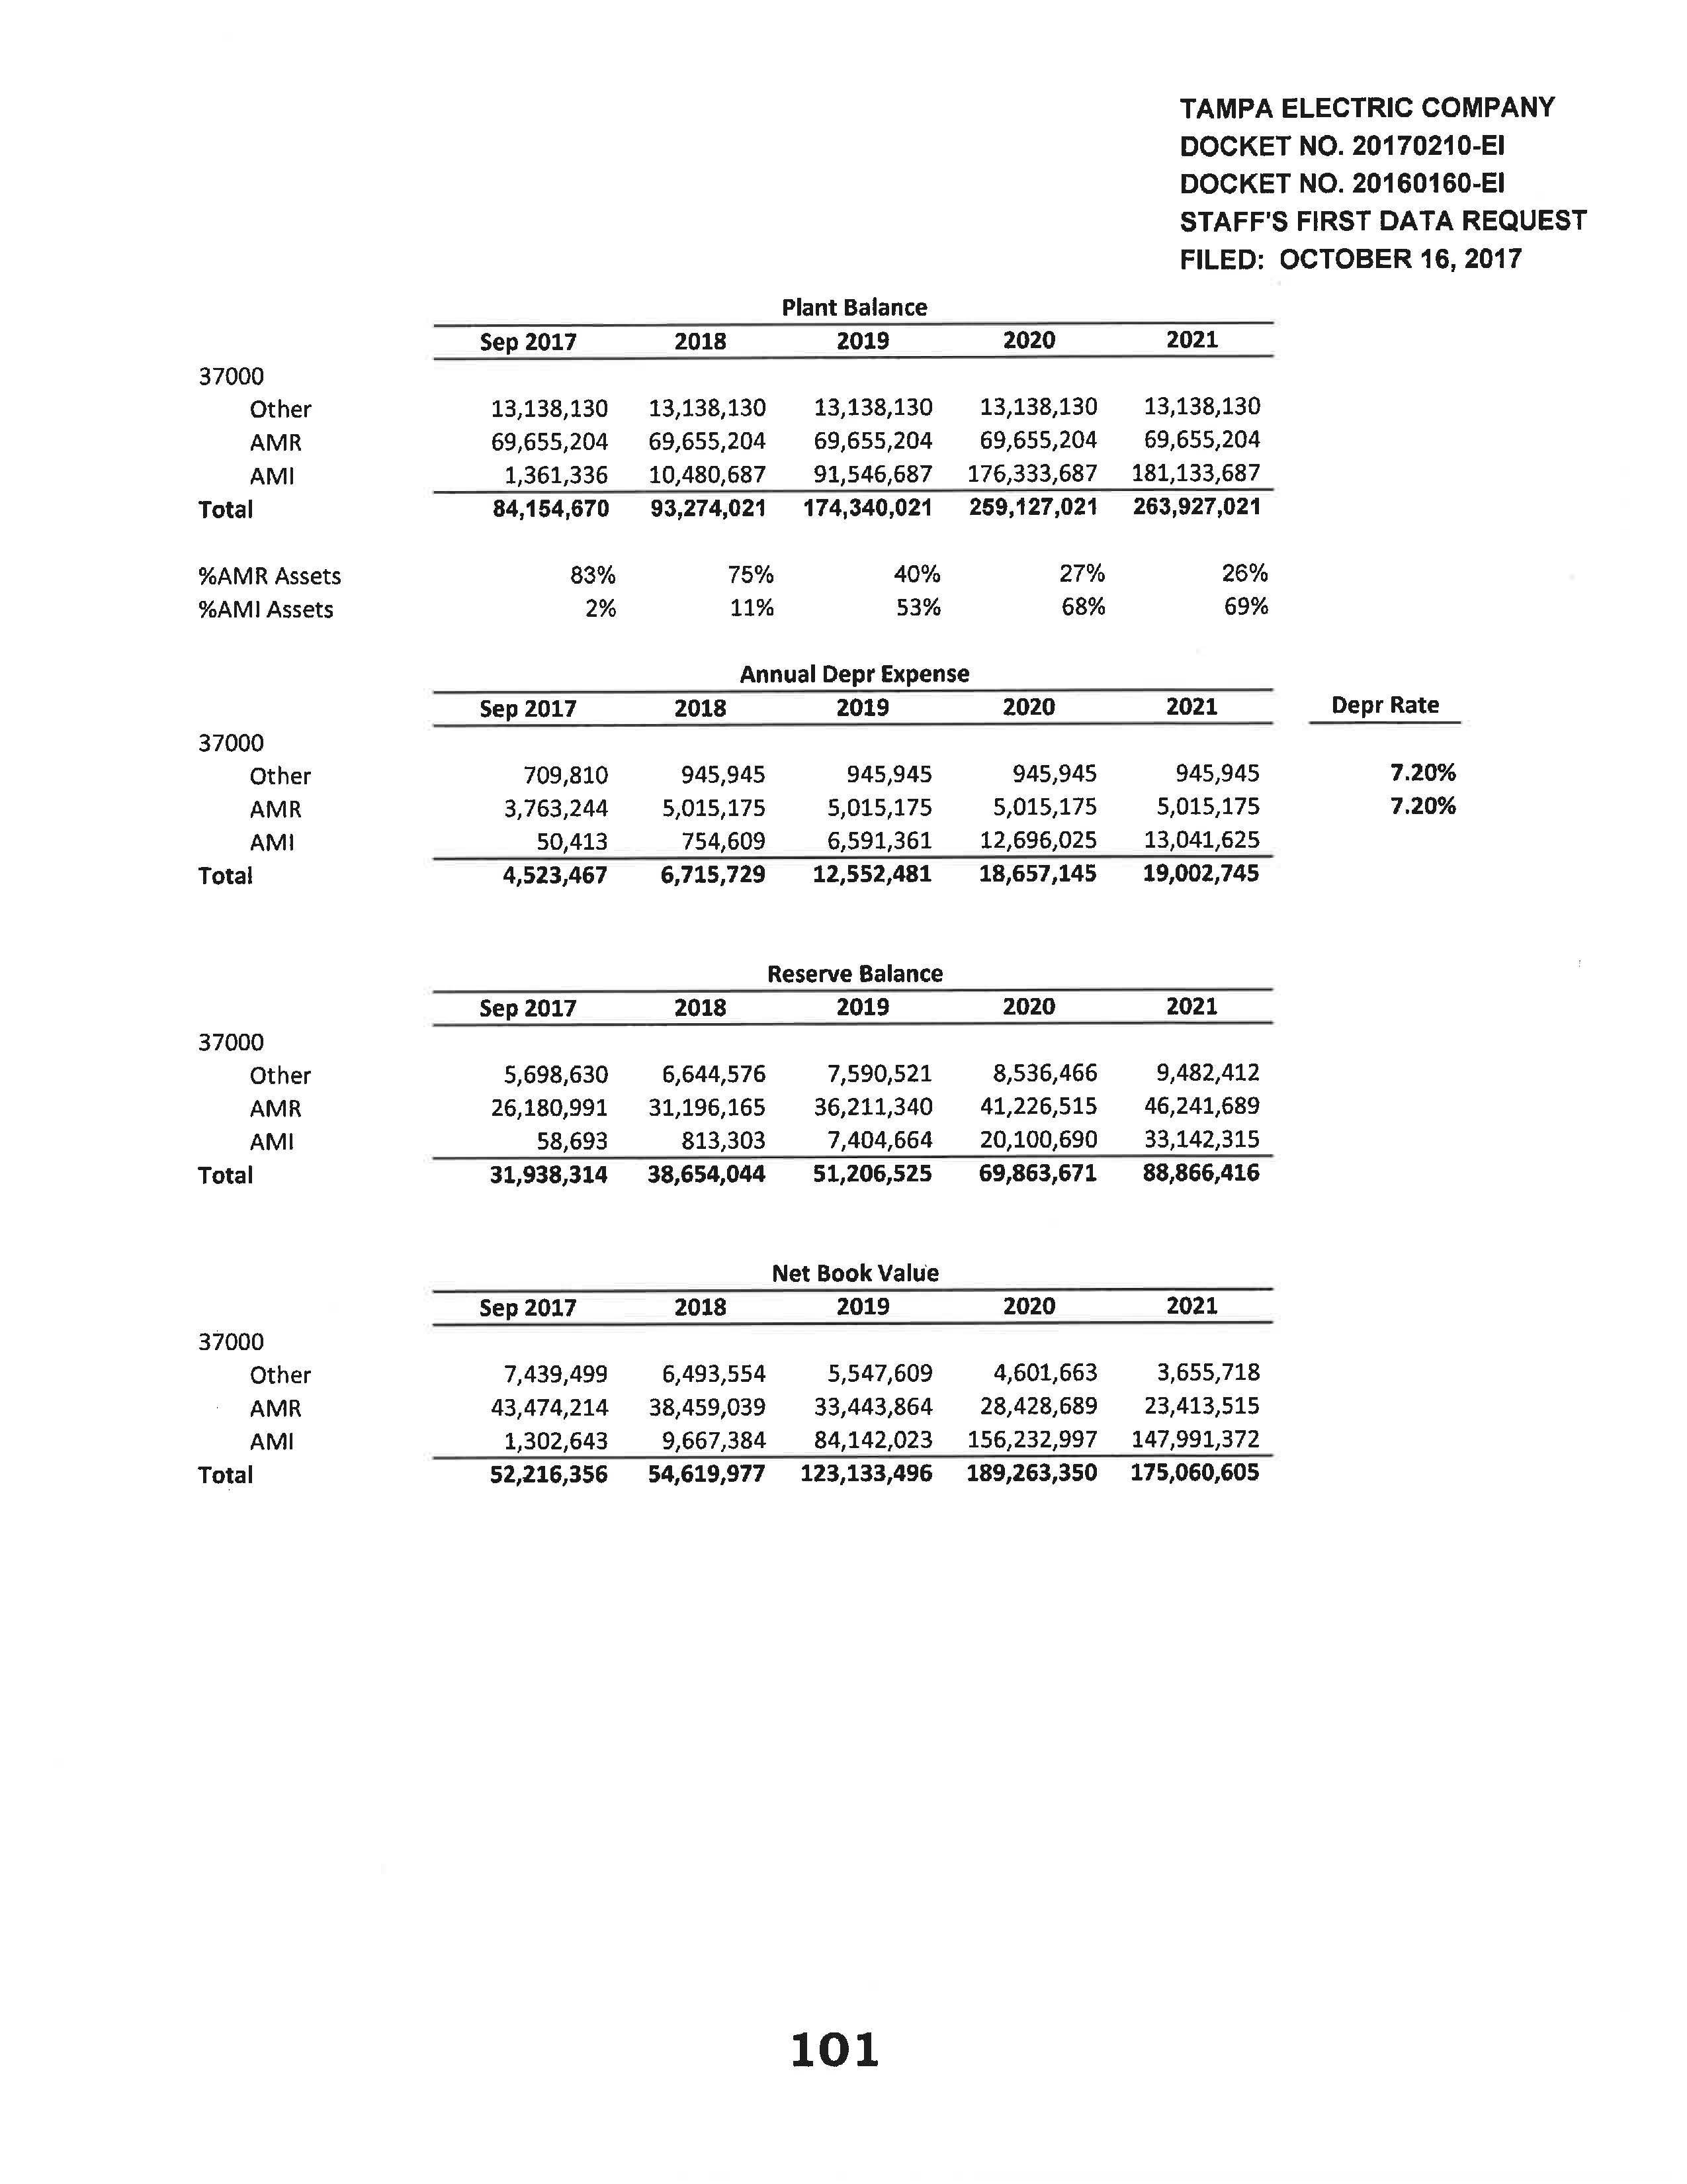

Order No. PSC-2017-0456-S-EI, issued November 27, 2017, in Docket No. 20170210-EI, In re: Petition for limited proceeding to approve 2017 amended and restated stipulation and settlement agreement, by Tampa Electric Company, and Docket No. 20160160-EI, In re: Petition for approval of energy transaction optimization mechanism, by Tampa Electric Company.
Id.
TECO’s Response to Staff’s Second Data Request No. 4.
Id.
Rule 25-6.0142(2)(d), F.A.C.
Order No. PSC-2017-0456-S-EI.
The 2017 Settlement term is from November 2017 through December 31, 2021.
TECO’s response to Staff’s First Data Request No. 6.
Id.
TECO’s response to Staff’s First Data Request No. 15, as revised on June 17, 2019.
Id.
Id.
Document No. 05189-2019.
Order No. PSC-2019-0234-AS-EI, issued June 14, 2019, in Docket No. 20170271-EI, In re: Petition for recovery of costs associated with named tropical systems during the 2015, 2016, and 2017 hurricane seasons and replenishment of storm reserve subject to final true-up, Tampa Electric Company.
Sections 350.115, 366.041, and 366.06(1), F.S.
Order No. PSC-2017-0456-S-EI.
2017 Settlement at Section 1; Order No. PSC-2017-0456-S-EI at 3, 5.
Order No. PSC-2017-0456-S-EI.

