State of Florida |  | Public Service Commission  Capital Circle Office Center ● 2540 Shumard Oak Boulevard  Tallahassee, Florida 32399-0850  -M-E-M-O-R-A-N-D-U-M-
DATE: | July 25, 2019
TO: | Office of Commission Clerk (Teitzman)
FROM: | Division of Economics (Guffey, Coston)  Office of the General Counsel (Simmons)
RE: | Docket No. 20190127-GU – Petition for approval of transportation service agreement with Florida Public Utilities Company by Peninsula Pipeline Company, Inc.
AGENDA: | 08/06/19 – Regular Agenda – Proposed Agency Action - Interested Persons May Participate
COMMISSIONERS ASSIGNED: |  |  | All Commissioners
PREHEARING OFFICER: |  |  | Brown
CRITICAL DATES: |  |  | None
SPECIAL INSTRUCTIONS: |  |  | Place before Docket No. 20190128-GU.

Case Background
On June 10, 2019, Peninsula Pipeline Company, Inc. (Peninsula) filed a petition seeking approval of a firm transportation service agreement (Agreement) between Peninsula and Florida Public Utilities Company (FPUC), collectively the parties. Peninsula operates as a natural gas transmission company as defined by Section 368.103(4), Florida Statutes (F.S.). FPUC is a local distribution company (LDC) subject to regulatory jurisdiction of the Commission pursuant to Chapter 366, F.S.
By Order No. PSC-07-1012-TRF-GP, Peninsula received approval of an intrastate gas pipeline tariff that allows it to construct and operate intrastate pipeline facilities and to actively pursue agreements with natural gas customers. Peninsula provides transportation service only; it does not engage in the sale of natural gas. Pursuant to Order No. PSC-07-1012-TRF-GP, Peninsula is allowed to enter into certain gas transmission agreements without prior Commission approval. However, Peninsula is requesting Commission approval of this proposed Agreement as it does not fit any of the criteria enumerated in the tariff for which Commission approval would not be required. The parties are subsidiaries of Chesapeake Utility Corporation (Chesapeake), and agreements between affiliated companies must be approved by the Commission pursuant to Section 368.105, F.S., and Order No. PSC-07-1012-TRF-GP.
Pursuant to the proposed Agreement (Attachment A to the recommendation), Peninsula will construct and operate natural gas pipelines in western Palm Beach County. During its evaluation of the petition, staff issued two data requests to the parties for which responses were received on July 2 and July 15, 2019. The Commission has jurisdiction over this matter pursuant to Sections 366.05(1), 366.06, and 368.105, F.S.

Discussion of Issues

Issue 1:
Should the Commission approve the proposed Agreement between Peninsula and FPUC dated May 17, 2019?

Recommendation:
Yes, the Commission should approve the proposed Agreement between Peninsula and FPUC dated May 17, 2019. (Guffey)

Staff Analysis:
FPUC provides natural gas service to residential, commercial, and industrial customers in Palm Beach County and receives deliveries of natural gas to serve these customers from the Florida Gas Transmission (FGT) interstate pipeline. The petition explains that the proposed Agreement has been necessitated by a request for service by FPUC to enable FPUC to provide service to existing and future customers in this area, specifically the Florida Research Park and four new residential developments that plan on utilizing natural gas. The four residential developments are in various stages of development. The parties project that the new developments will serve approximately 10,000 residential, commercial, and industrial customers. In addition, the parties explained, the proposed pipeline interconnections will enhance FPUC’s ability to provide industrial customers in the area with higher natural gas pressure.
To address the increase in customers and demand, the parties entered into the proposed Agreement. The proposed Agreement specifies an initial term of 20 years and thereafter shall be extended for additional 10-year increments, unless either party gives no less than 180 days written notification of termination. Pursuant to the proposed Agreement, Peninsula will undertake the three new projects described below and shown in Attachment B to the recommendation.
First, Peninsula would construct an interconnection with the Florida Southeast Connection, LLC, (FSC) along State Road 710 near the Florida Research Park in Palm Beach County. The FSC is a wholly owned subsidiary of NextEra Energy, Inc., and owns and operates natural gas pipelines in central Florida. The FSC pipeline connects to the interstate Sabal Trail Pipeline and became operational in June 2017. Peninsula would then construct 4,000 feet of 6 inch steel pipeline to a new custody transfer point with FPUC’s distribution system to serve, among other things, the Florida Research Park.
Second, Peninsula would construct an interconnection with the FSC near the Florida Turnpike. From this interconnection point, Peninsula would build 30,000 feet of 8 inch steel pipeline, 300 feet of 4 inch steel pipeline, and 1,000 feet of 2 inch steel pipeline to two new custody transfer points with FPUC’s distribution system to serve the Avenir and Ancient Tree residential developments.
Finally, Peninsula would construct an interconnection with Florida City Gas. From this interconnection, Peninsula would construct approximately 18,000 feet of 12 inch steel pipeline to a new custody transfer point with FPUC’s distribution system to serve the Arden residential development. Peninsula would also construct approximately 32,000 feet of 8 inch steel pipeline and 6,000 feet of 6 inch polyethylene pipeline to serve the West Lake residential development.
In response to staff’s first data request, the parties state that FPUC did not issue a Request for Proposals (RFP) to obtain bids from other entities to construct the pipeline. However, Peninsula did engage in a conversation with the FSC regarding the possibility of FSC building the pipeline in south Florida. According to Peninsula, FSC declined to bid on the pipeline construction portion of the project citing laterals of this size and operational specifications are not something they are interested in pursuing.
The parties assert that the negotiated monthly reservation charge in the proposed Agreement is consistent with a market rate since they are within the ranges of rates set forth in similar agreements as required by Section 368.105(3)(b), F.S. FPUC is proposing to recover its payments to Peninsula through the Purchased Gas Adjustment (PGA) and the swing service rider mechanisms, consistent with other gas transmission pipeline costs incurred by FPUC. The swing service rider allows FPUC to recover intrastate capacity costs from their transportation customers and is a cents per therm charge that is included in a monthly gas bill of transportation customers. FPUC provided information showing that the impact on the PGA will be minor ($0.01823 per therm for 2019). While FPUC will incur costs associated with this service expansion, any new load will help spread the costs over a larger customer base.
The benefit of Peninsula, as opposed to FPUC, constructing the new pipeline is primarily that Peninsula’s construction and ownership of the pipeline will avoid FPUC undertaking the costs and risks for the three projects, which in turn protects FPUC’s ratepayers. Peninsula stated that engineering and permitting is currently underway with construction projected to be completed by January 2020. Approval of this petition would also allow FPUC to transport gas via the FSC interstate pipeline and Florida City Gas pipeline, in addition to the FGT pipeline.

Conclusion
Based on the petition and the parties’ responses to staff’s data requests, staff believes that the proposed Agreement is cost effective, reasonable, meets the requirements of Section 368.105, F.S., and benefits FPUC’s customers. Staff therefore recommends approval of the proposed Agreement between the parties dated May 17, 2019.

Issue 2:
Should this docket be closed?

Recommendation:
Yes. If no protest is filed by a person whose substantial interests are affected within 21 days of the issuance of the Order, this docket should be closed upon the issuance of a Consummating Order. (Simmons)

Staff Analysis:
If no protest is filed by a person whose substantial interests are affected within 21 days of the issuance of the Order, this docket should be closed upon the issuance of a Consummating Order.

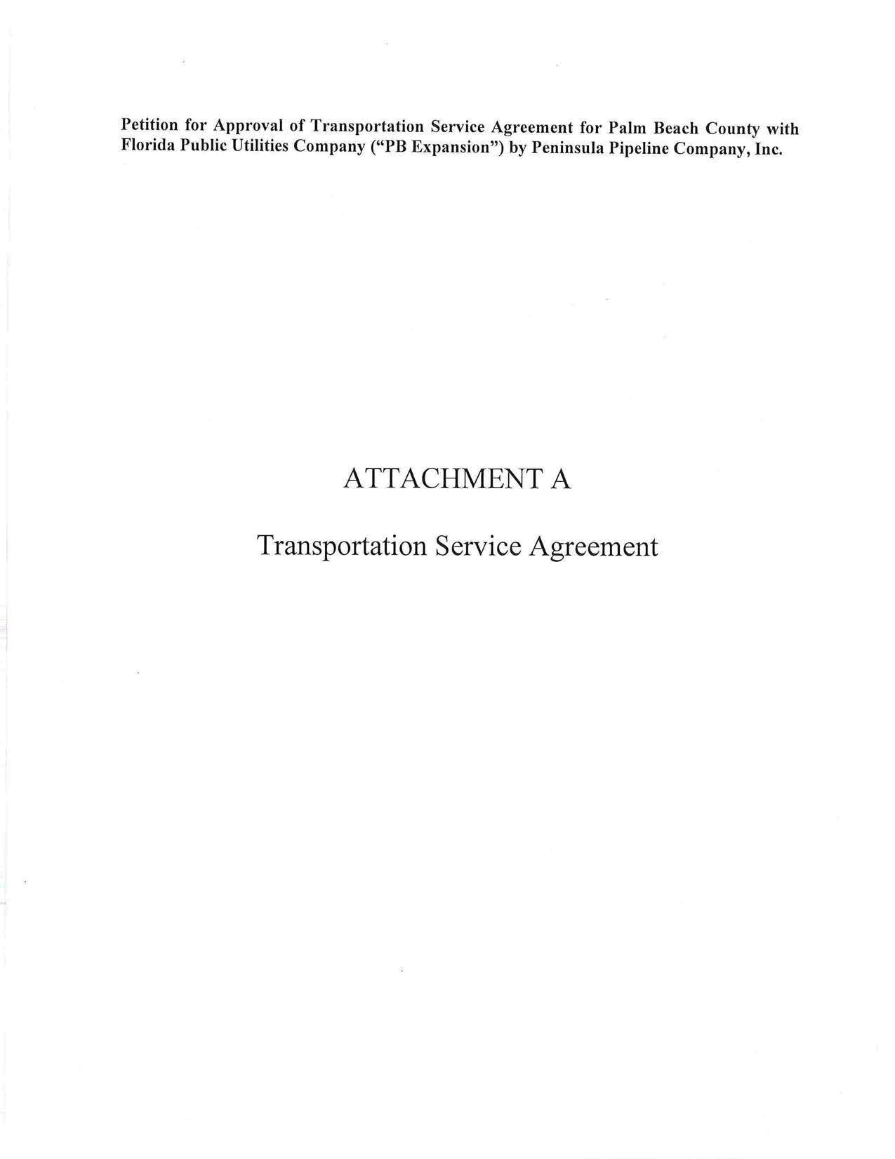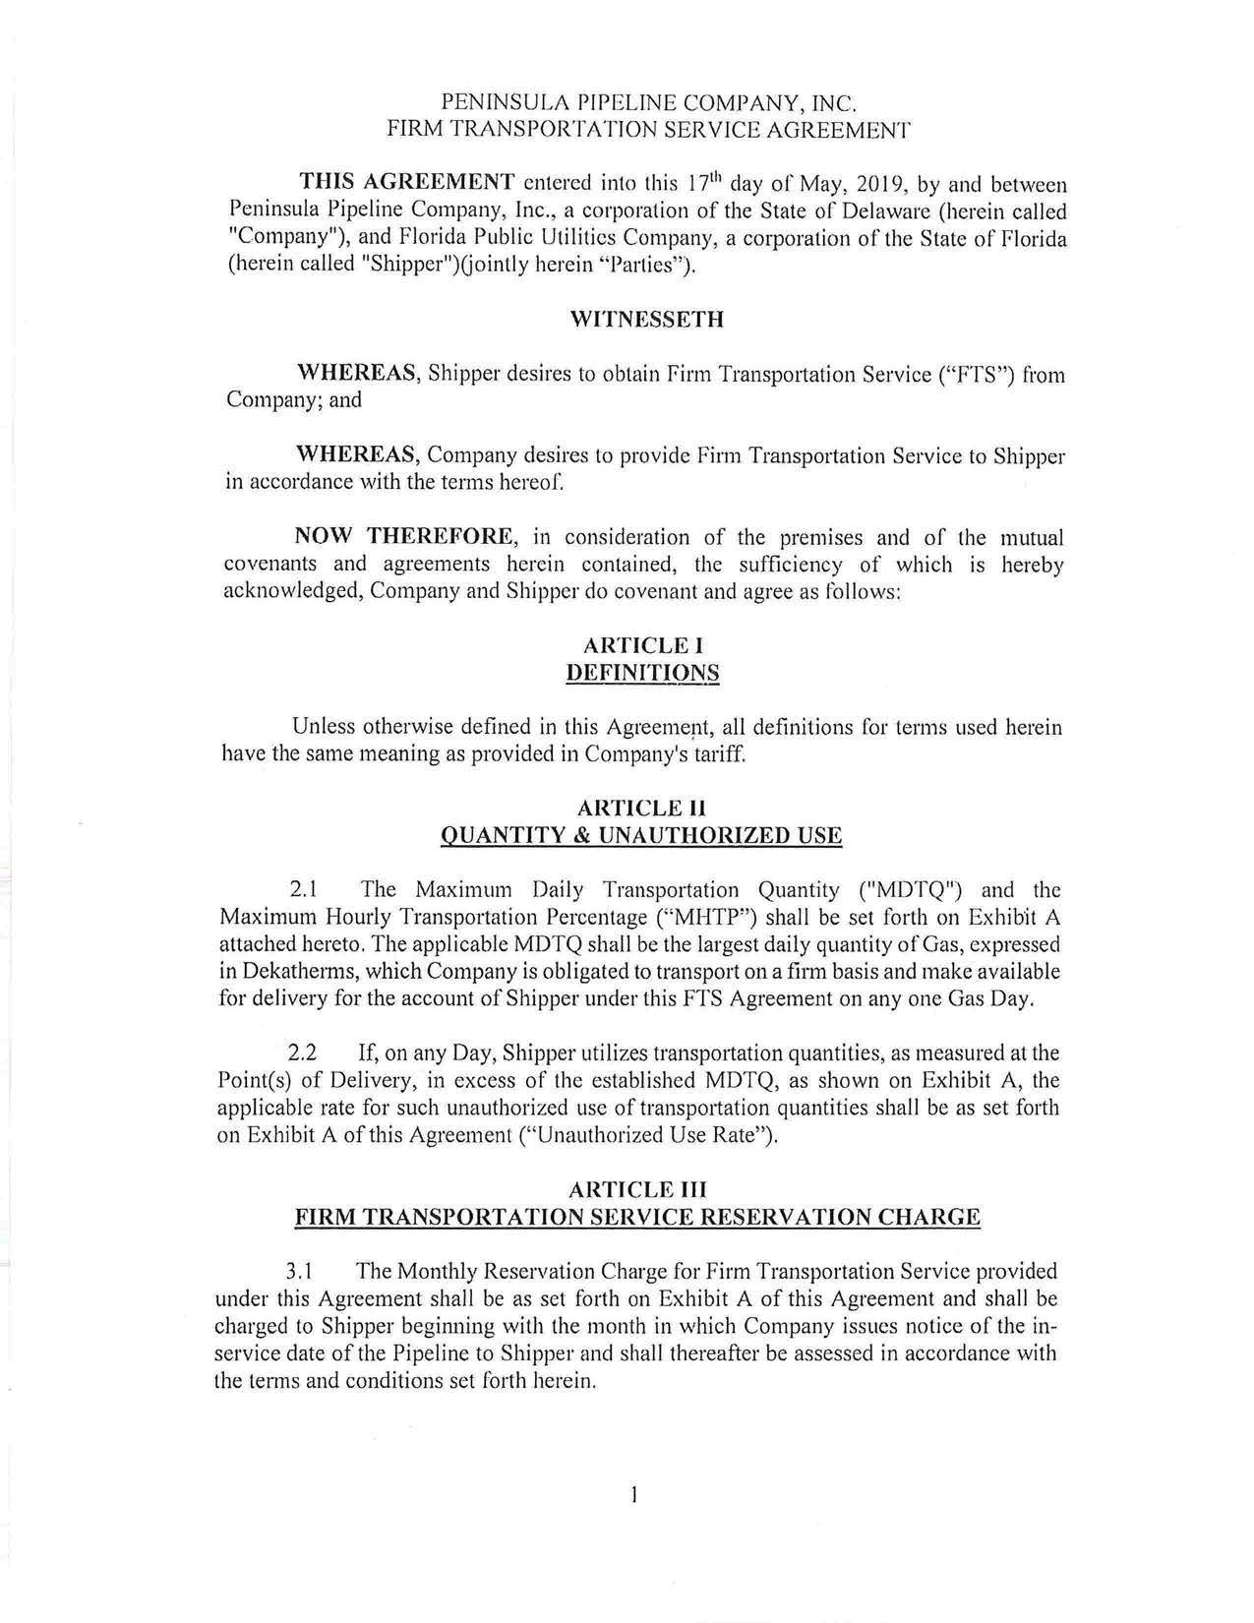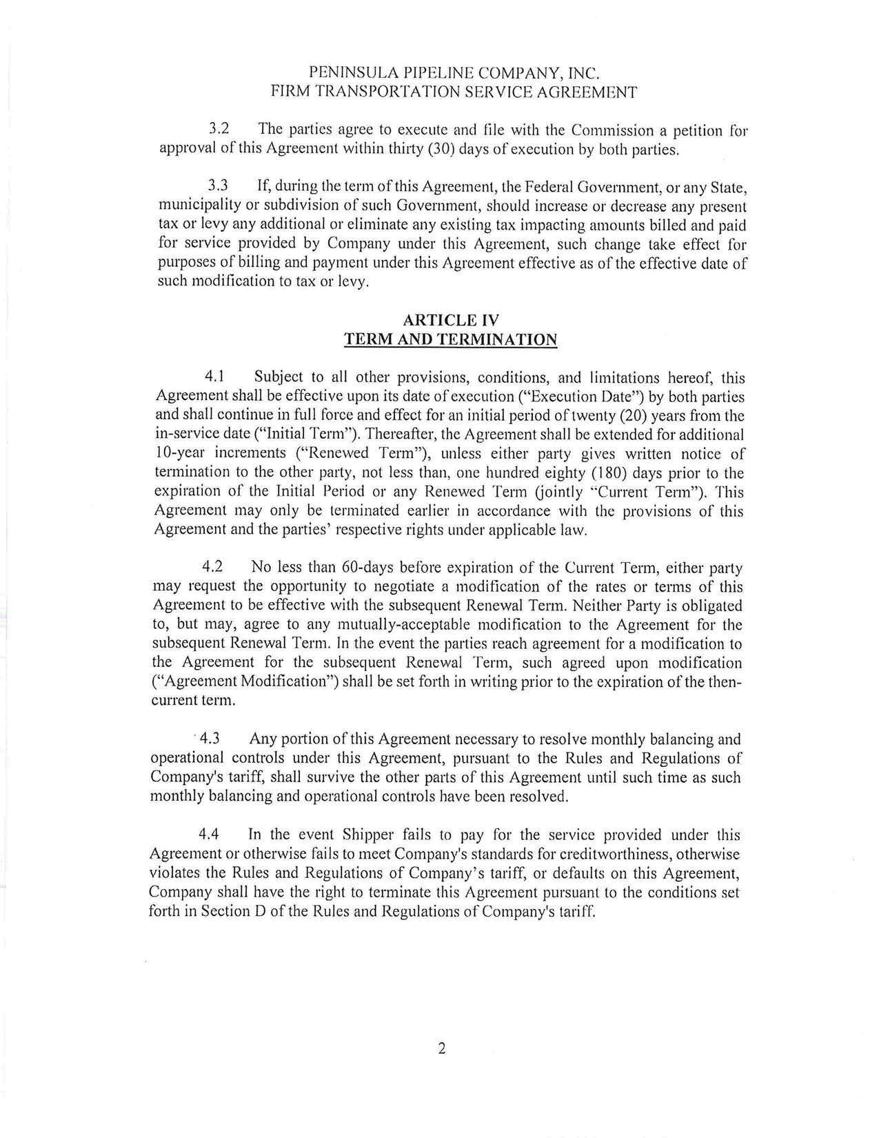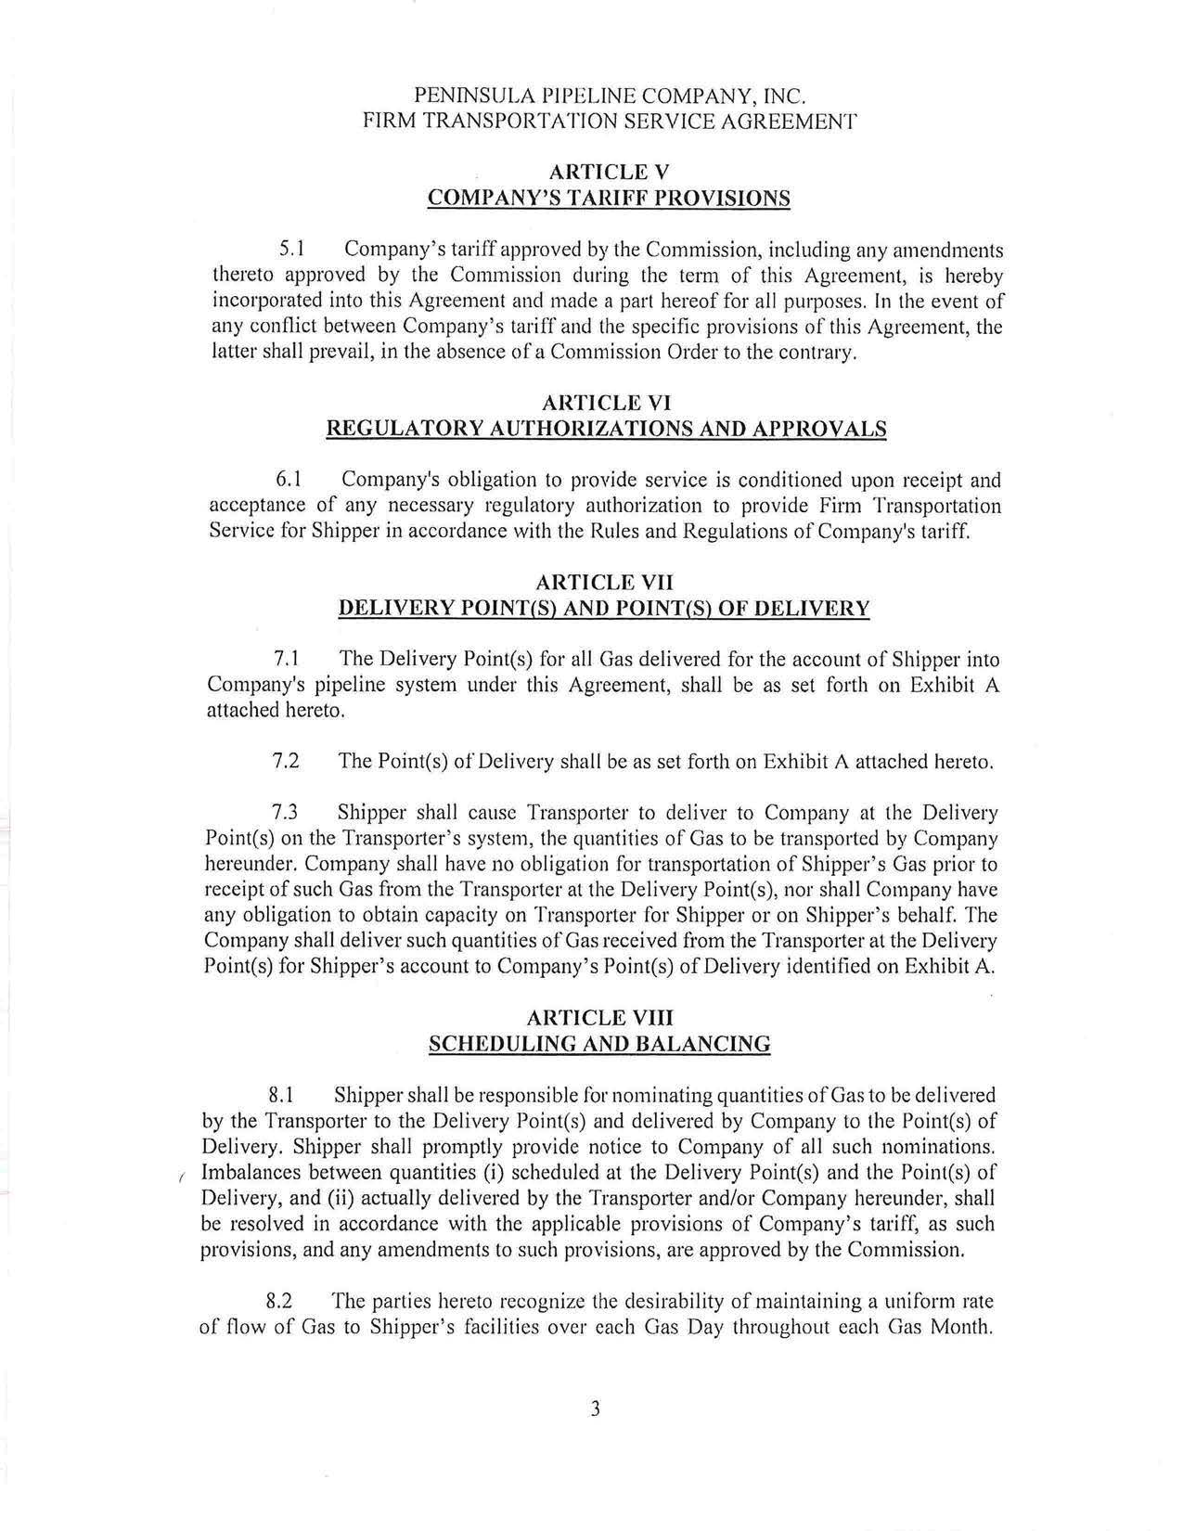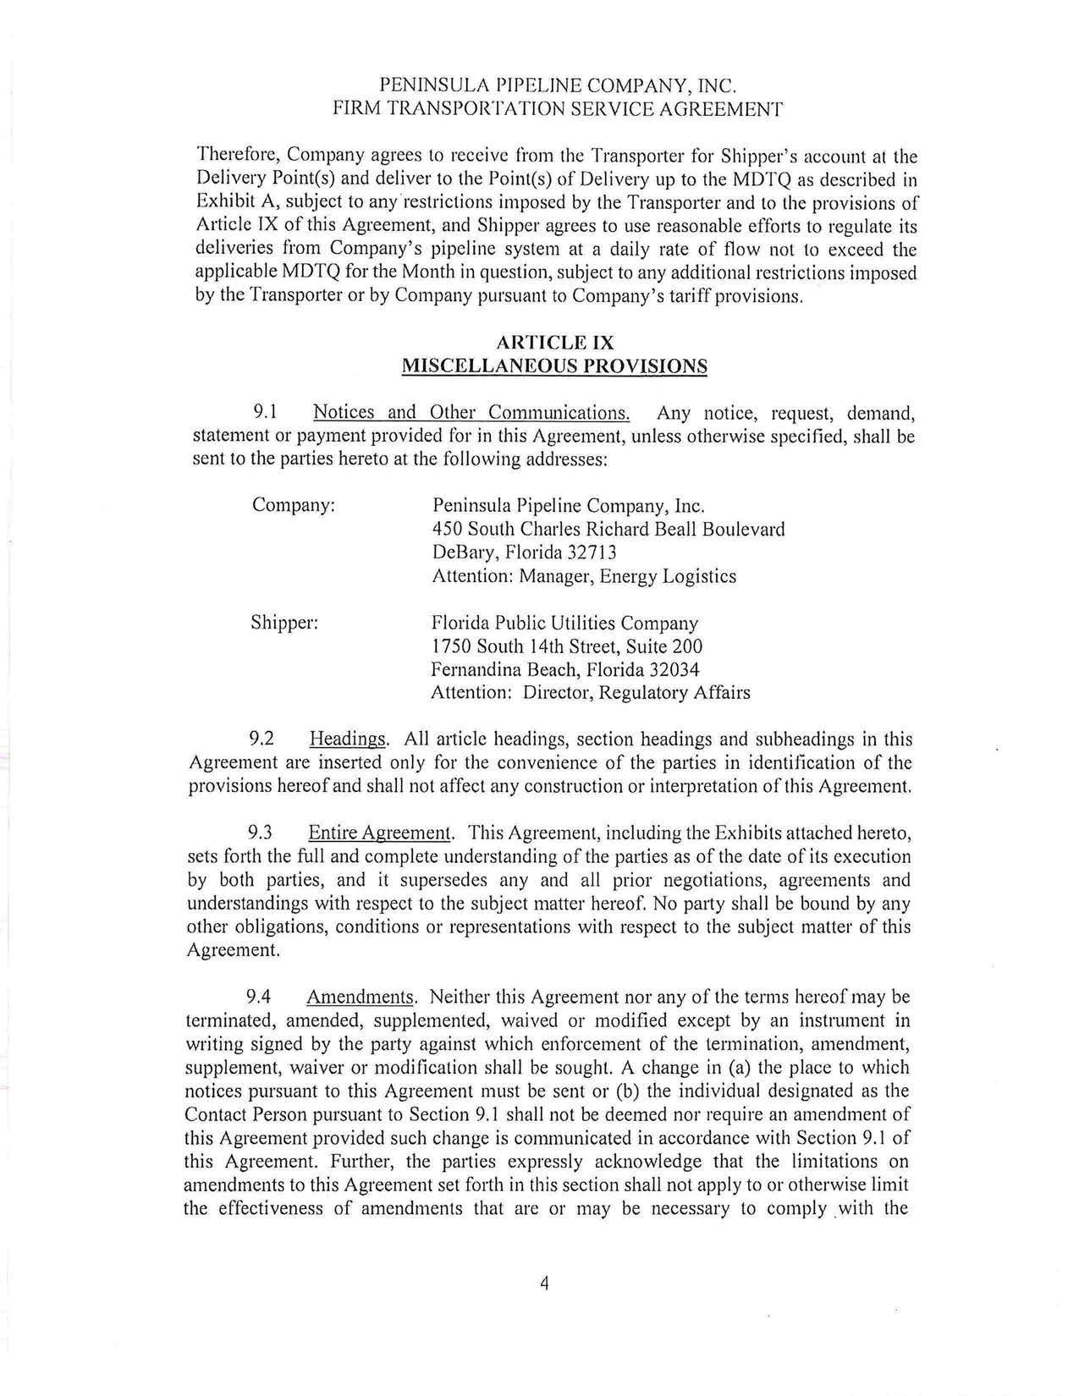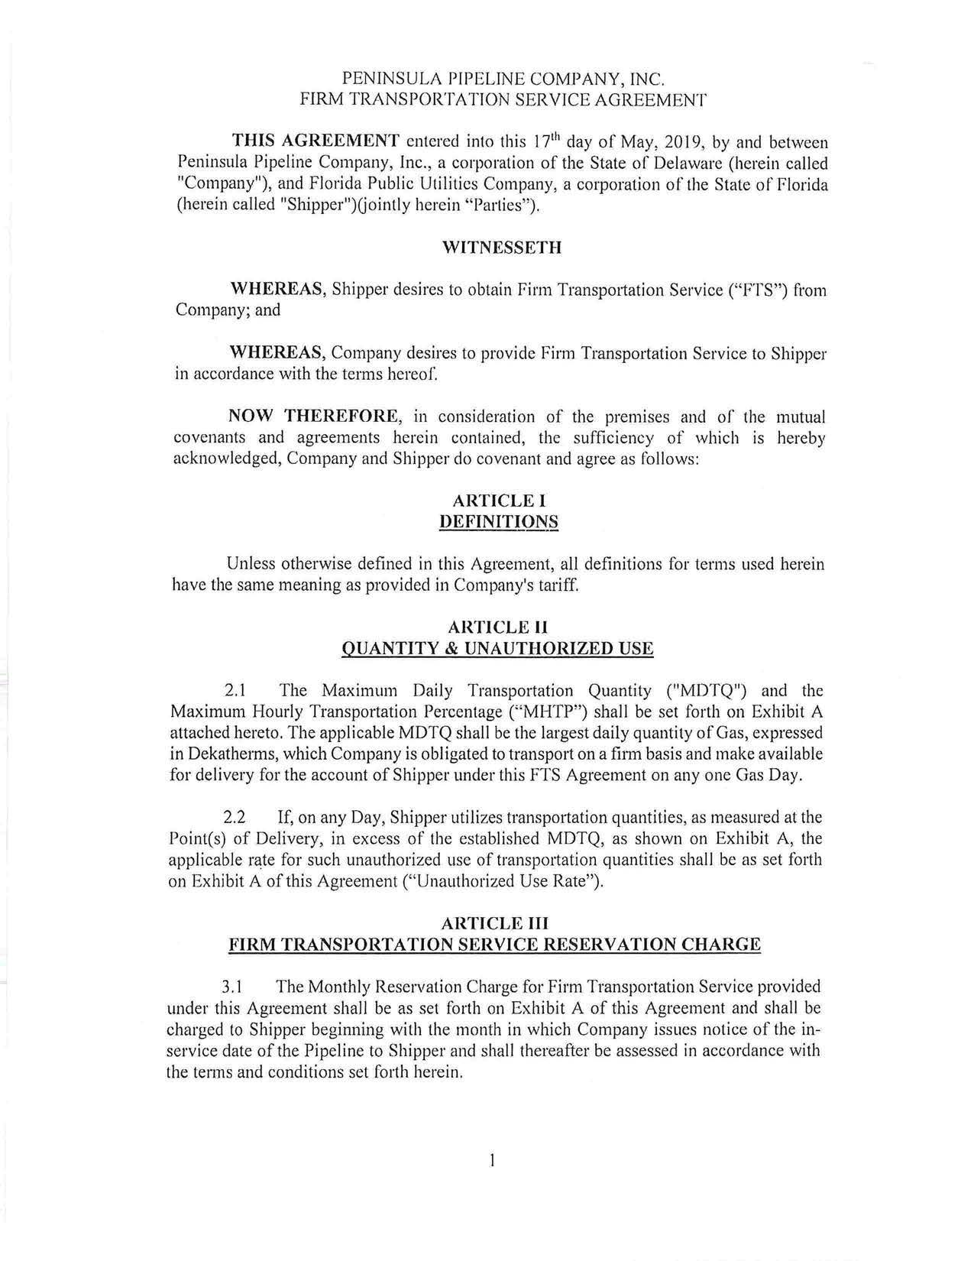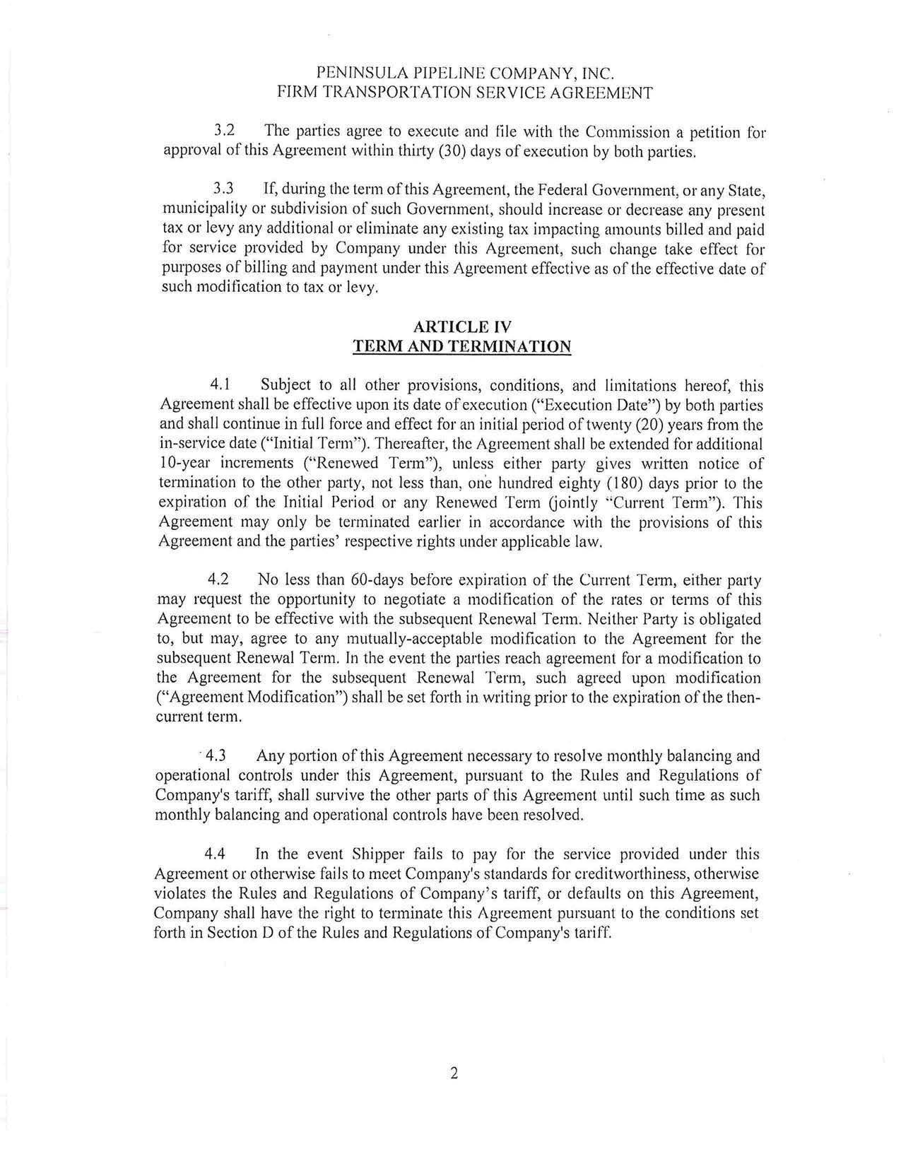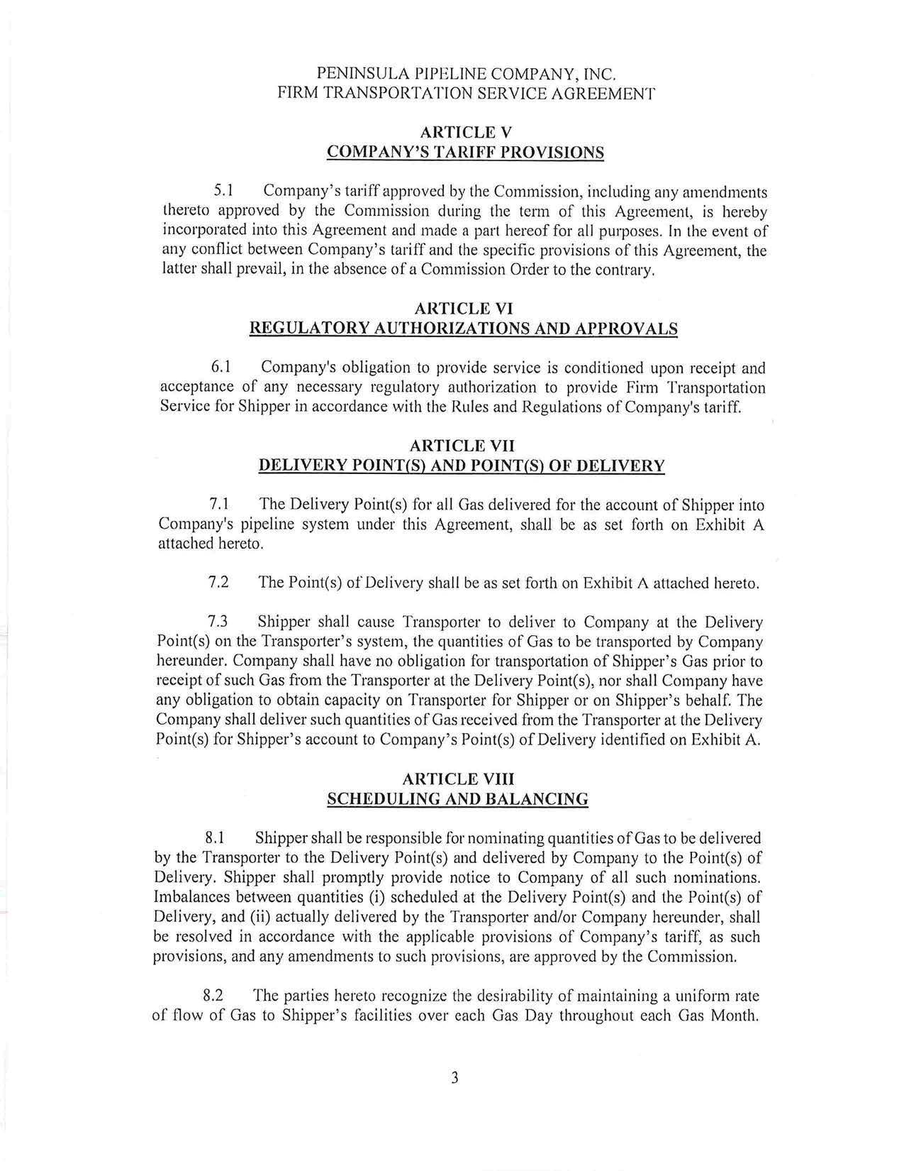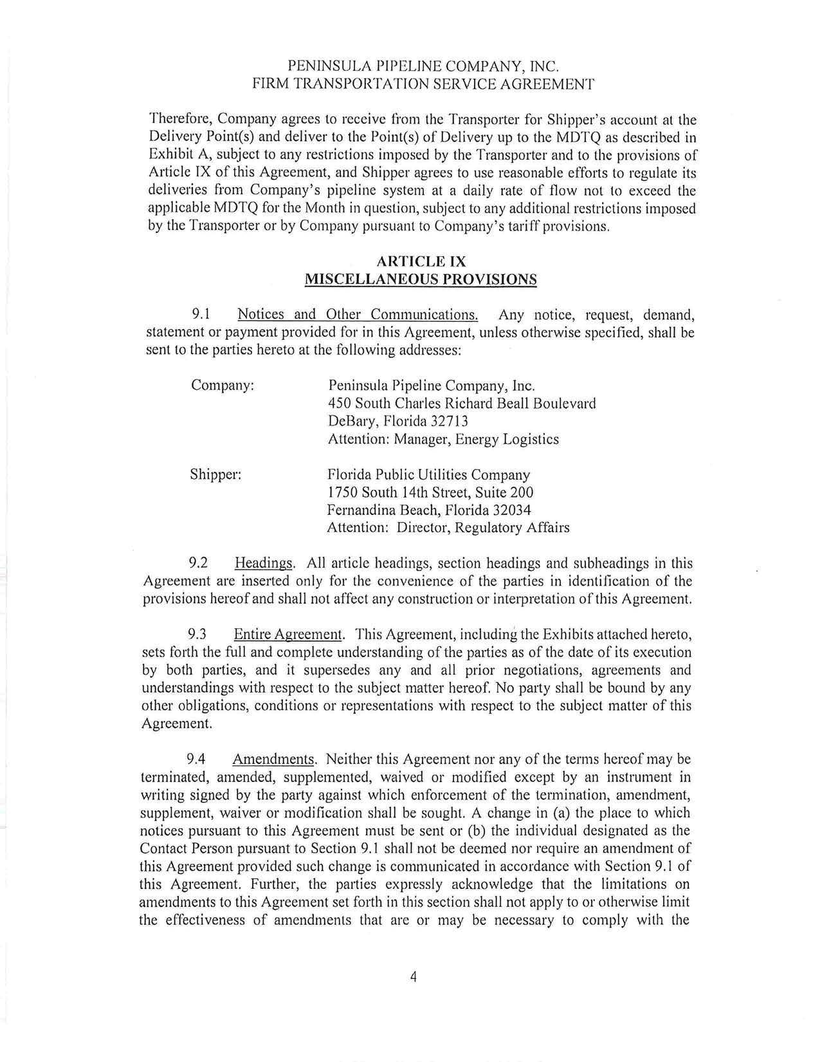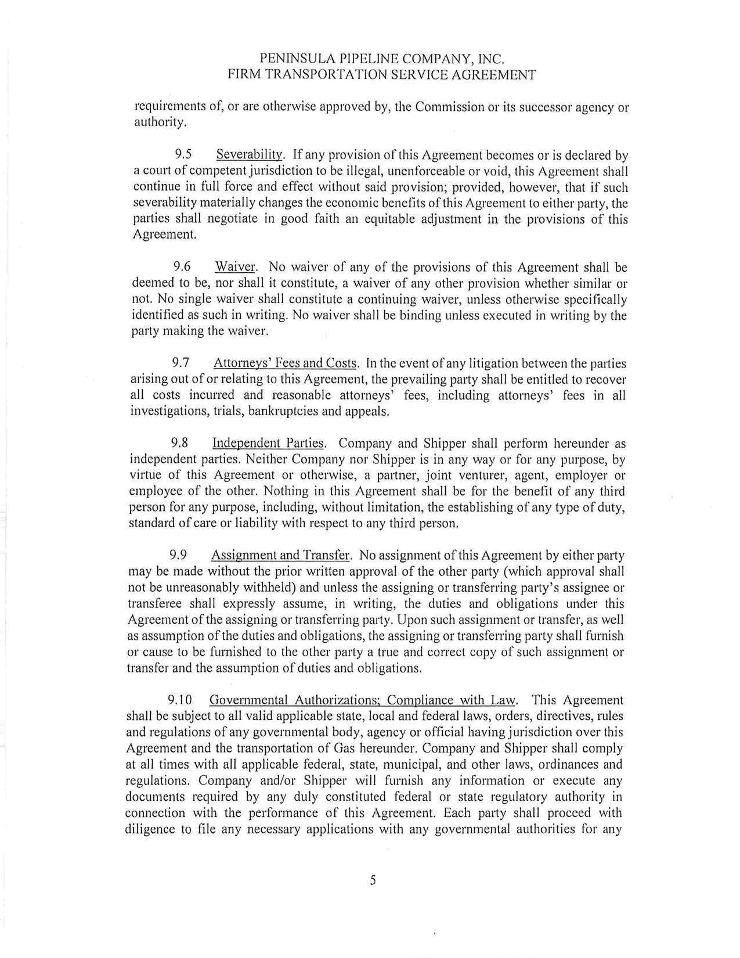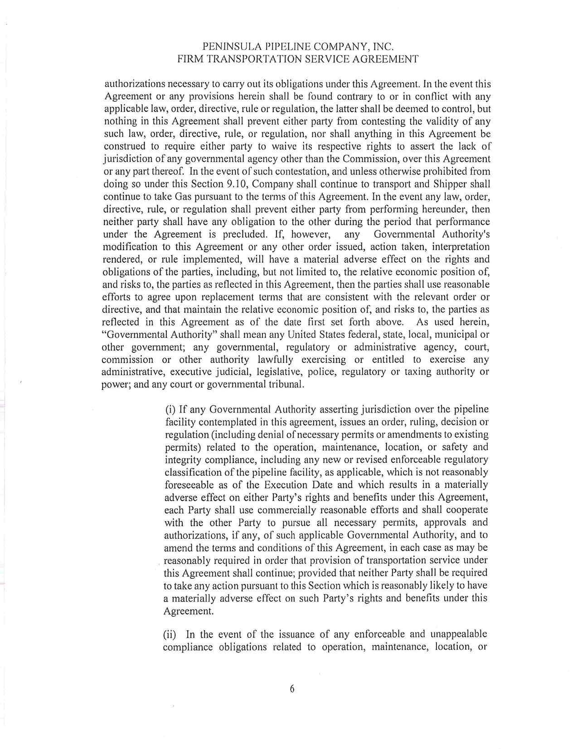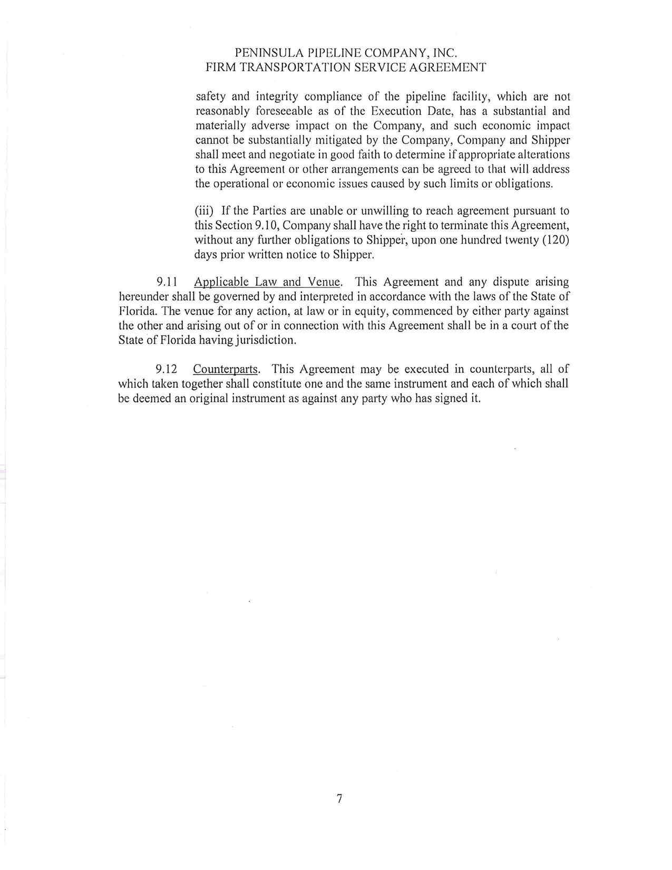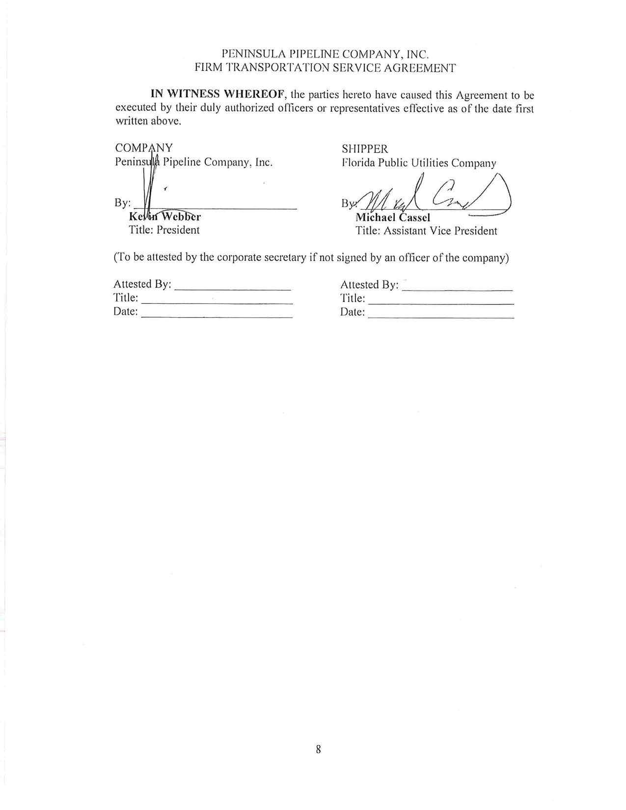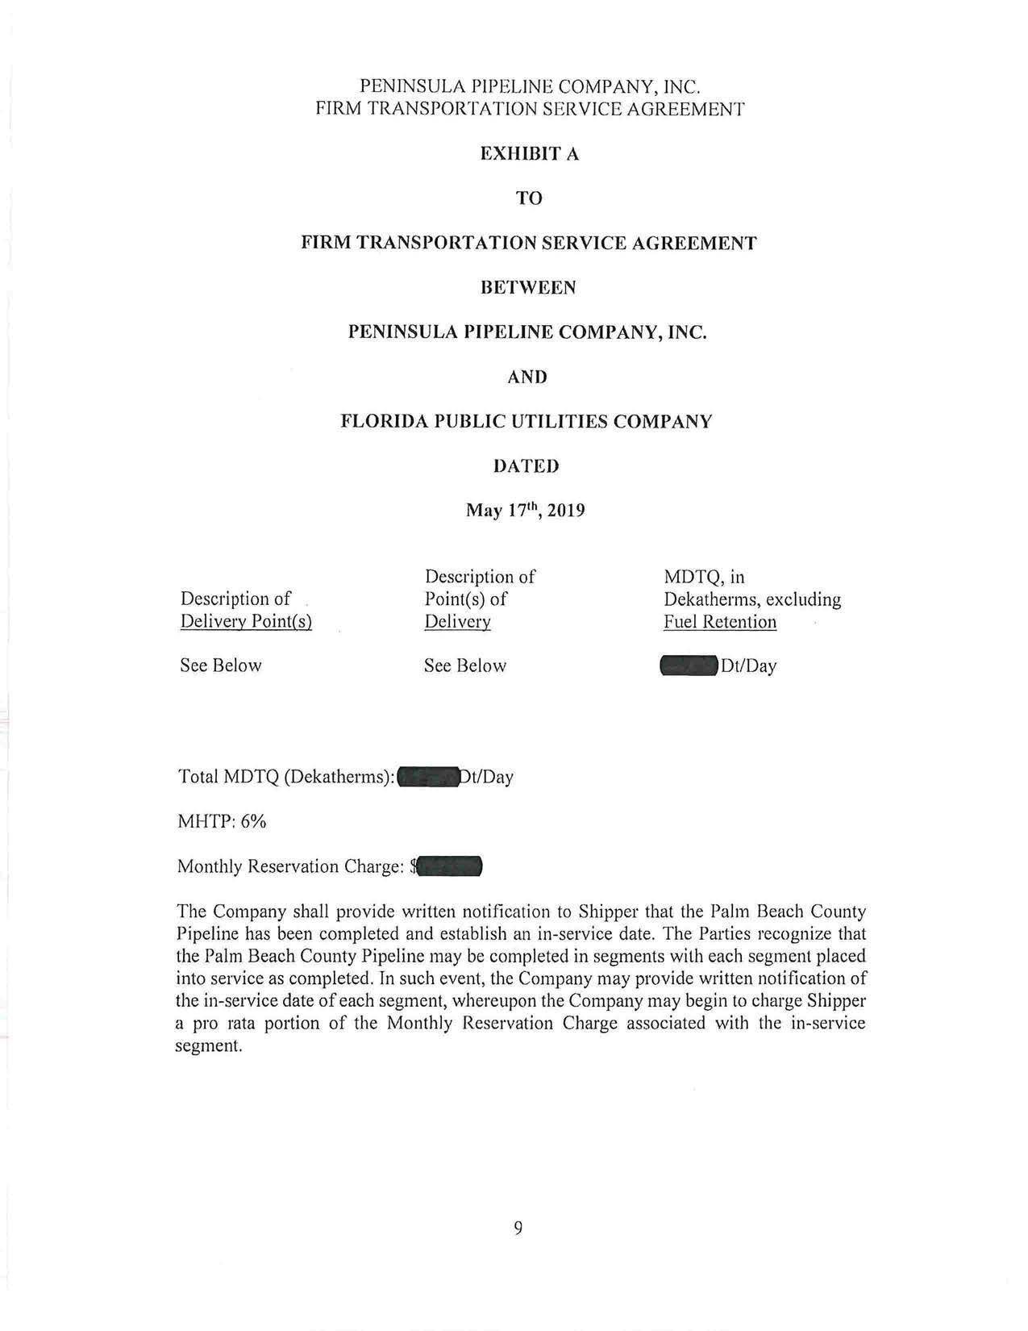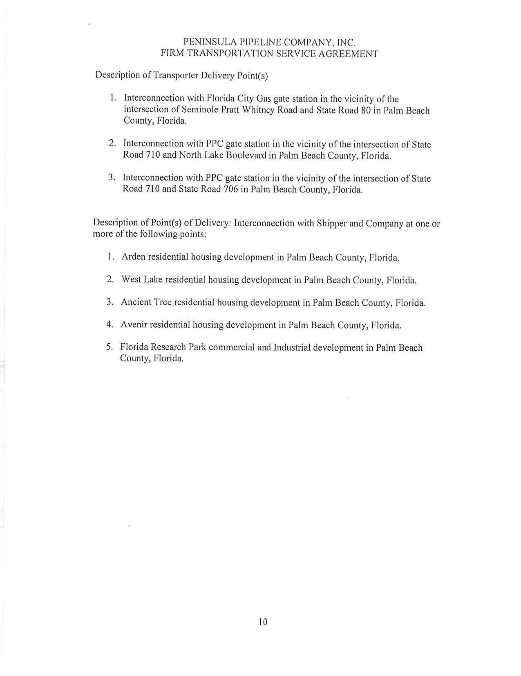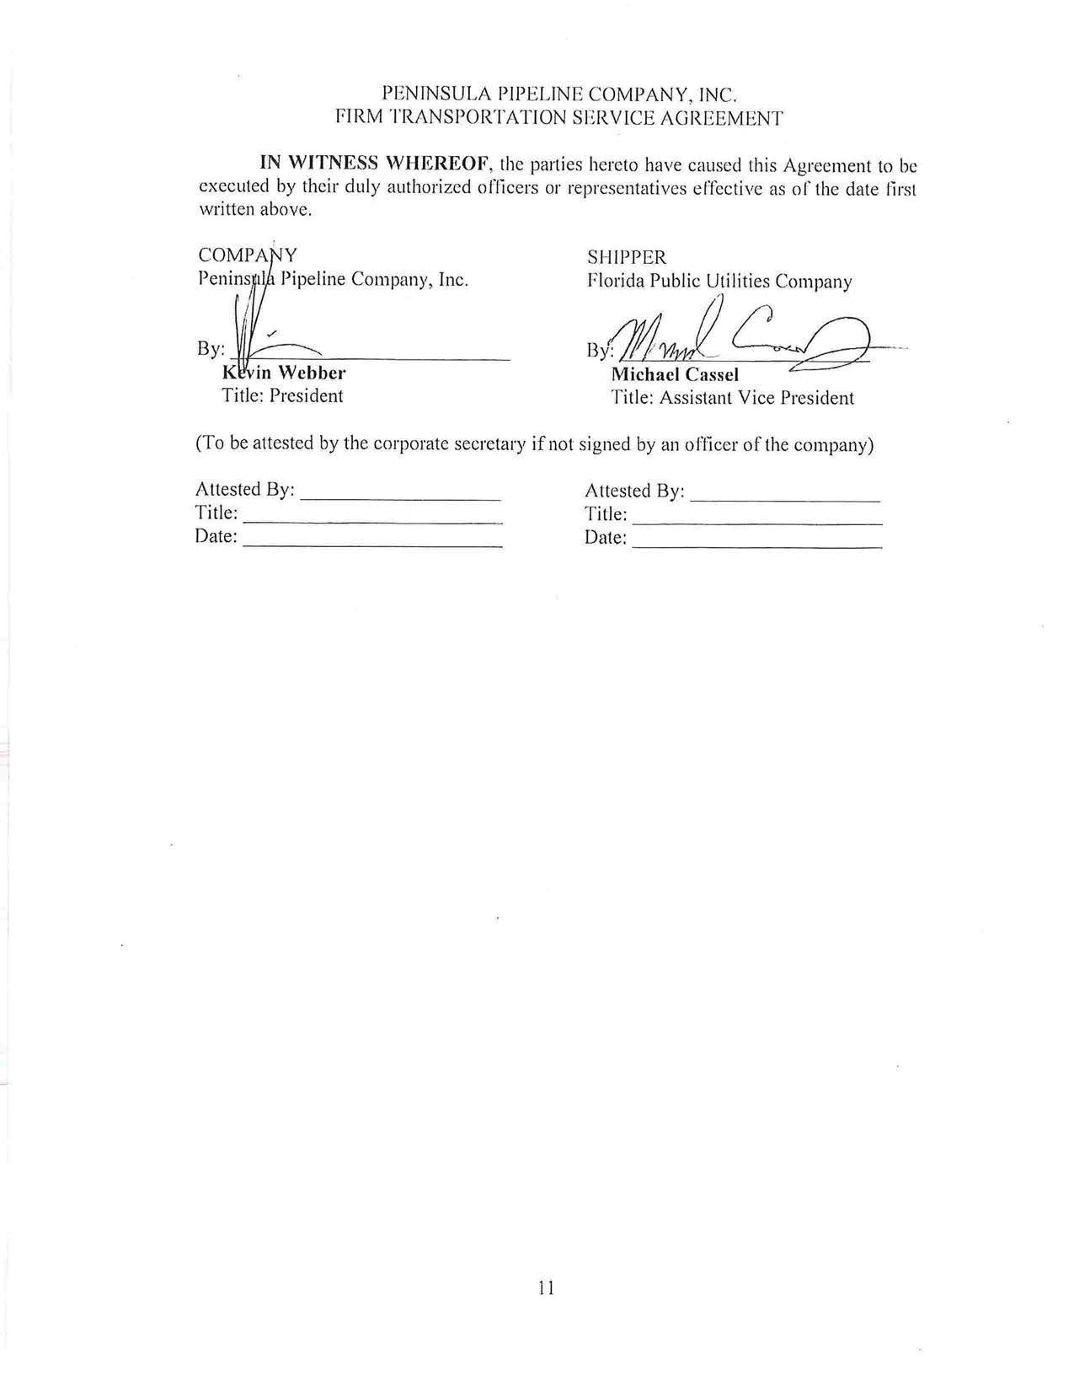
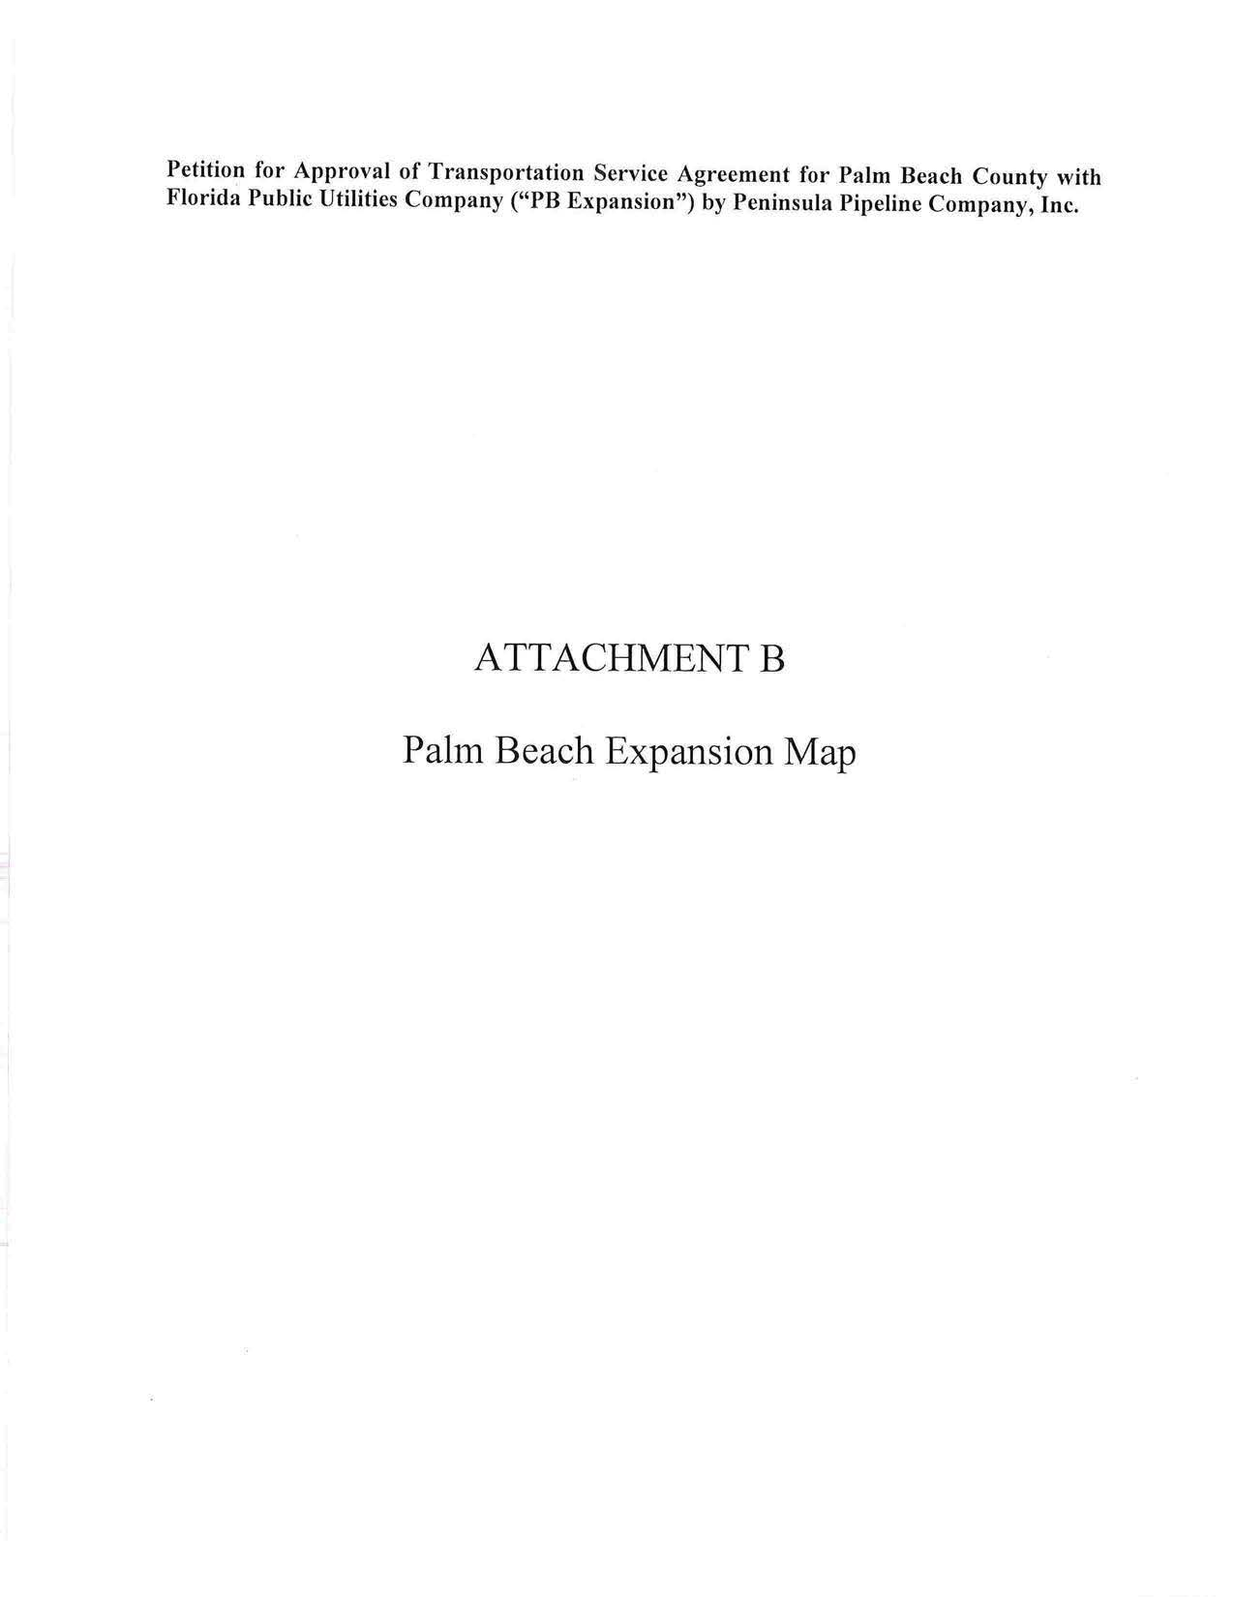
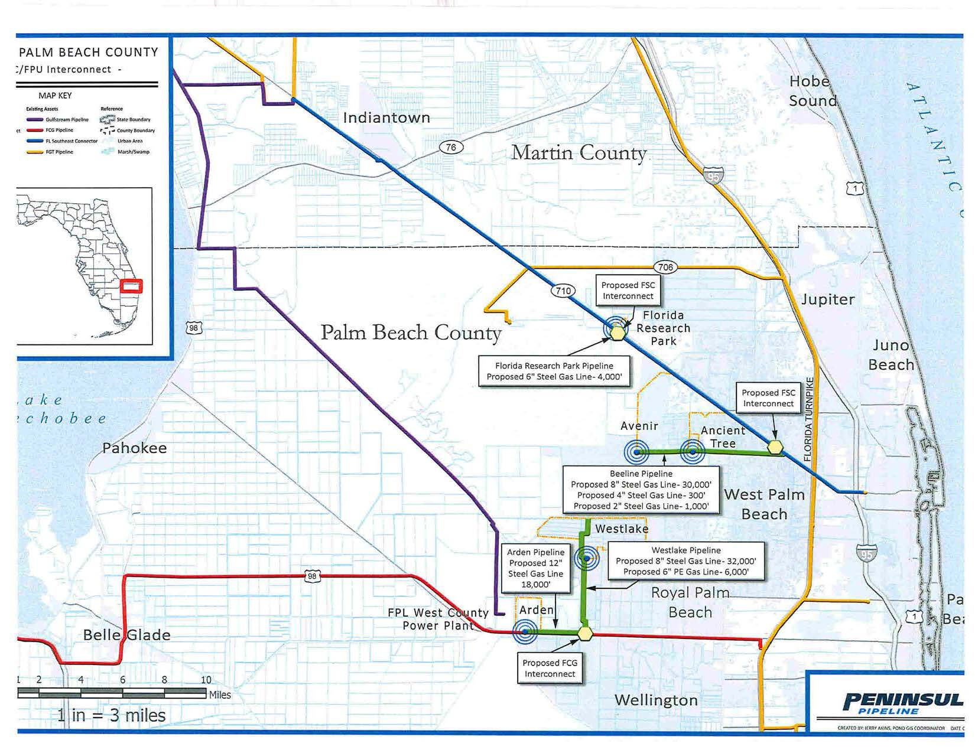

Order No. PSC-06-0023-DS-GP, issued January 9, 2006, in Docket No. 050584-GP, In re: Petition for declaratory statement by Peninsula Pipeline Company, Inc. concerning recognition as a natural gas transmission company under Section 368.101, F.S., et seq.
Order No. PSC-07-1012-TRF-GP, issued December 21, 2007, in Docket No. 070570-GP, In re: Petition for approval of natural gas transmission pipeline tariff by Peninsula Pipeline Company, Inc.
Peninsula Pipeline Company, Inc., Intrastate Pipeline Tariff, Original Vol. 1, Original Sheet No. 11, Section 3.
Peninsula Pipeline Company, Inc., Intrastate Pipeline Tariff, Original Vol. 1, Original Sheet No. 12, Section 4.
Follow up email response of July 15, 2019 from FPUC clarified that the Florida Southeast Connector referenced on page 5 of the petition should be Florida Southeast Connection.
This arrangement is referred to as an LDC to LDC interconnection and allows FPUC to receive natural gas deliveries to serve its customers through a pipeline owned by Florida City Gas.
Order No. PSC-2018-0557-TRF-GU, issued November 20, 2018, in Docket No. 20180158-GU, In re: Joint petition for approval of swing service rider, by Florida Public Utilities Company, Florida Public Utilities Company-Indiantown Division, Florida Public Utilities Company-Fort Meade, and Florida Division of Chesapeake Utilities Corporation.

