State of Florida |  | Public Service Commission  Capital Circle Office Center ● 2540 Shumard Oak Boulevard  Tallahassee, Florida 32399-0850  -M-E-M-O-R-A-N-D-U-M-
DATE: | July 25, 2019
TO: | Office of Commission Clerk (Teitzman)
FROM: | Division of Economics (Guffey, Coston)  Office of the General Counsel (Simmons)
RE: | Docket No. 20190128-GU – Petition for approval of transportation service agreement with Florida Division of Chesapeake Utilities Corporation by Peninsula Pipeline Company, Inc.
AGENDA: | 08/06/19 – Regular Agenda – Proposed Agency Action - Interested Persons May Participate
COMMISSIONERS ASSIGNED: |  |  | All Commissioners
PREHEARING OFFICER: |  |  | Brown
CRITICAL DATES: |  |  | None
SPECIAL INSTRUCTIONS: |  |  | Place after Docket No. 20190127-GU.

Case Background
On June 10, 2019, Peninsula Pipeline Company, Inc. (Peninsula) filed a petition seeking approval of a firm transportation service agreement (Agreement) between Peninsula and the Florida Division of Chesapeake Utilities Corporation, d/b/a Central Florida Gas (CFG), collectively the parties. Peninsula operates as a natural gas transmission company as defined by Section 368.103(4), Florida Statutes (F.S.). CFG is a local distribution company (LDC) subject to the regulatory jurisdiction of the Commission pursuant to Chapter 366, F.S.
By Order No. PSC-07-1012-TRF-GP, Peninsula received approval of an intrastate gas pipeline tariff that allows it to construct and operate intrastate pipeline facilities and to actively pursue agreements with natural gas customers. Peninsula provides transportation service only; it does not engage in the sale of natural gas. Pursuant to Order No. PSC-07-1012-TRF-GP, Peninsula is allowed to enter into certain gas transmission agreements without prior Commission approval. However, Peninsula is requesting Commission approval of this proposed Agreement as it does not fit any of the criteria enumerated in the tariff for which Commission approval would not be required. The parties are subsidiaries of Chesapeake Utility Corporation (Chesapeake), and agreements between affiliated companies must be approved by the Commission pursuant to Section 368.105, F.S., and Order No. PSC-07-1012-TRF-GP.
Pursuant to the proposed Agreement (Attachment A to the recommendation), Peninsula will acquire, construct, and operate a natural gas pipeline, and construct a new interconnection in Polk County. During its evaluation of the petition, staff issued two data requests to the parties for which responses were received on July 2 and July 15, 2019. The Commission has jurisdiction over this matter pursuant to Sections 366.05(1), 366.06, and 368.105, F.S.

Discussion of Issues

Issue 1:
Should the Commission approve the proposed Agreement between Peninsula and CFG dated May 17, 2019?

Recommendation:
Yes, the Commission should approve the proposed Agreement between Peninsula and CFG dated May 17, 2019. (Guffey)

Staff Analysis:
CFG provides natural gas service to residential, commercial, and industrial customers in Polk County, and receives deliveries of natural gas to serve these customers over interstate transmission pipelines owned by Gulfstream and Florida Gas Transmission (FGT). In addition, CFG uses a connection with Peoples Gas System (which is referred to as an LDC to LDC interconnection) and a section of intrastate pipeline in Haines City owned by Peninsula.
The parties have entered into the proposed Agreement to allow CFG to meet increased demand in the Polk County area. The proposed Agreement specifies an initial term of 20 years and thereafter shall be extended for additional 10-year increments, unless either party gives no less than 180 days of written notification of termination. The proposed Agreement has the added benefit of providing CFG with an additional source of gas (via the Gulfstream interstate pipeline) and enhancing an existing interconnection with the FGT pipeline. The specific projects are discussed below and shown in Attachment B to the recommendation.
First, Peninsula would acquire 1,200 feet of existing 12 inch steel pipeline from Calpine. The Calpine pipeline is shown as the short blue line on Attachment B and already connects to the existing Gulfstream Gate Station (south of Calpine). The Calpine pipeline would also connect with a new interconnection Peninsula would construct directly to the south of Derby Avenue and to the east of Calpine pipeline. This interconnection would give CFG a secondary source of natural gas from Gulfstream.
Second, Peninsula would acquire from CFG 13,000 feet of 10 inch steel pipeline that runs from CFG’s Lake Blue Gate Station north to the newly proposed interconnection south of Derby Avenue. This is shown as the red line on Attachment B. Peninsula would increase the pressure on this pipeline resulting in the pipeline operating as a transmission pipeline (and not a distribution pipeline). CFG explained that Peninsula, as a transmission pipeline operator, would be more suited to provide the on-going operations and maintenance and meet the Pipeline and Hazardous Materials Safety Administration’s compliance and safety requirements. Peninsula would increase the pressure on the 10 inch steel pipeline by installing a regulator at the existing Lake Blue Gate Station.
Finally, from the new interconnection south of Derby Avenue, Peninsula would construct 800 feet of 6 inch polyethylene pipeline to the north where it would interconnect with CFG’s distribution system in the vicinity of Derby Avenue in Polk County. The polyethylene pipeline is shown as the short green line on Attachment B.
In response to staff’s first data request, the parties stated that CFG did not issue a Request for Proposals (RFP) from other entities to construct the pipeline. Peninsula, however, engaged in discussions with FGT about extending its existing pipeline in Polk County. CFG stated that FGT declined to bid on the pipeline construction portion of the project citing that constructing and operating laterals such as those proposed in this petition are not a focus of FGT’s expansion activities.
The parties assert that the negotiated monthly reservation charge contained in the proposed Agreement is consistent with a market rate since they are within the ranges of rates set forth in similar agreements as required by Section 368.105(3)(b), F.S. CFG is proposing to recover its payments to Peninsula through its swing service rider mechanism consistent with other gas transmission pipeline costs incurred by CFG. The swing service rider allows CFG to recover intrastate capacity costs from their transportation customers and is a cents per therm charge that is included in the monthly gas bill of transportation customers. While CFG will incur costs associated with this service expansion, any new load will help spread the costs over a larger customer base.
The benefit of Peninsula, as opposed to CFG, constructing the new pipeline is primarily that Peninsula’s construction and ownership of the pipeline will avoid CFG undertaking the costs and risks for the three projects, which in turn protects CFG’s ratepayers. Peninsula anticipates the pipeline construction to be completed by September 2019.

Conclusion
Based on the petition and the parties’ responses to staff’s data requests, staff believes that the proposed Agreement is cost effective, reasonable, meets the requirements of Section 368.105, F.S., and benefits CFG’s customers. Staff therefore recommends approval of the proposed Agreement between the parties dated May 17, 2019.

Issue 2:
Should this docket be closed?

Recommendation:
Yes. If no protest is filed by a person whose substantial interests are affected within 21 days of the issuance of the Order, this docket should be closed upon the issuance of a Consummating Order. (Simmons)

Staff Analysis:
If no protest is filed by a person whose substantial interests are affected within 21 days of the issuance of the Order, this docket should be closed upon the issuance of a Consummating Order.

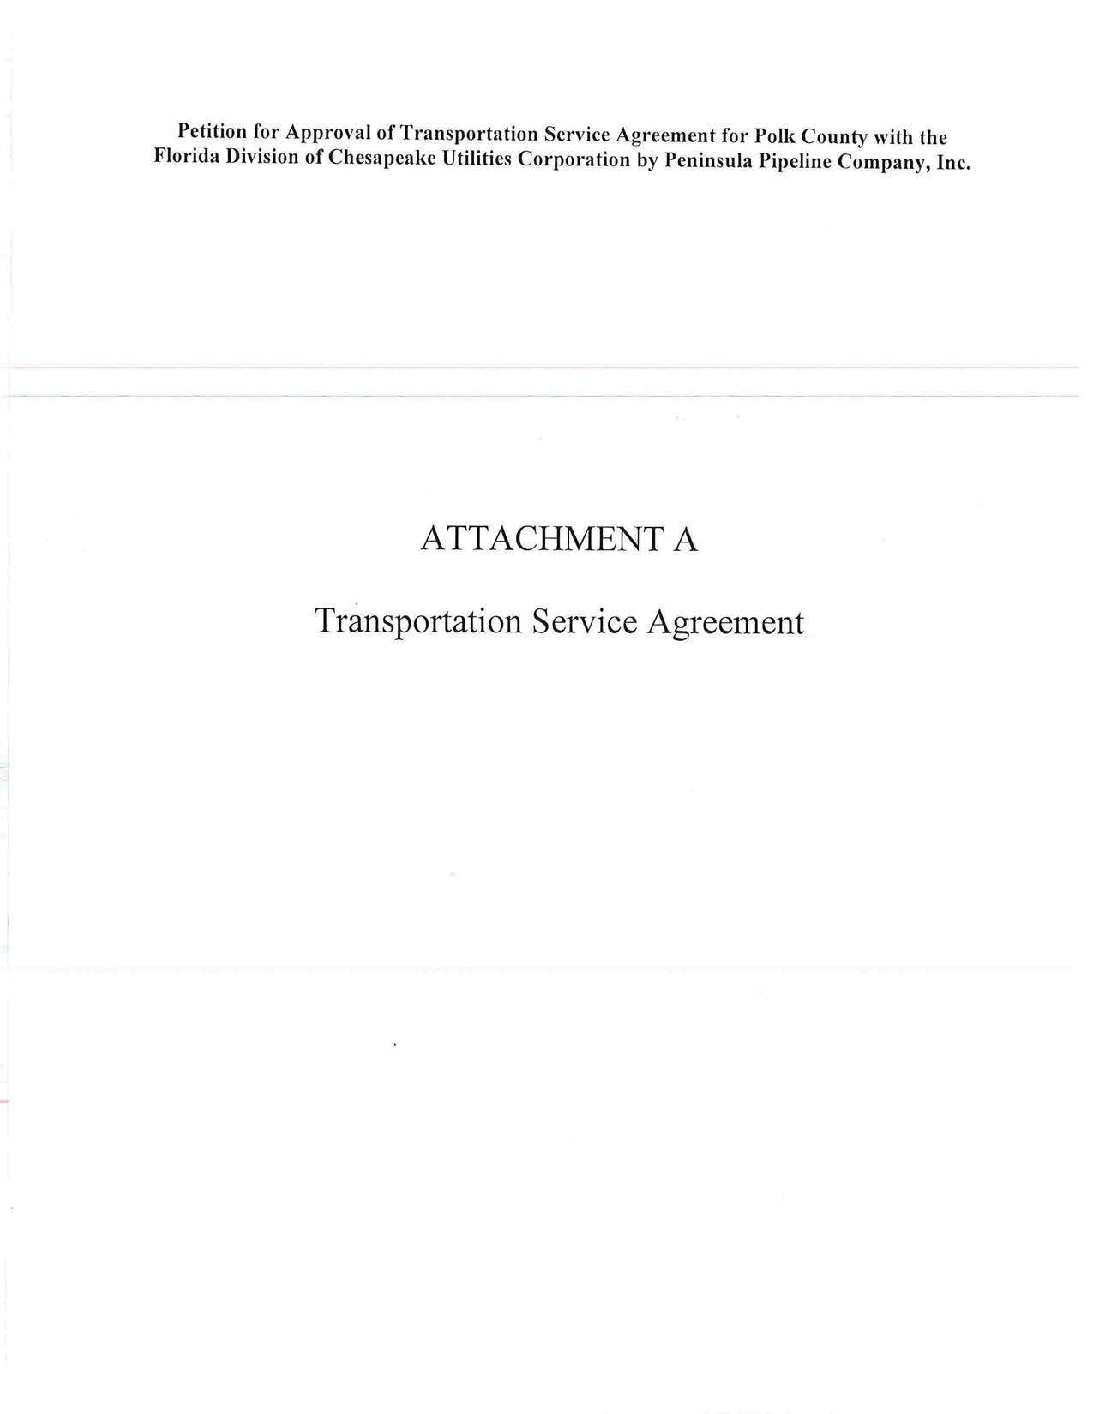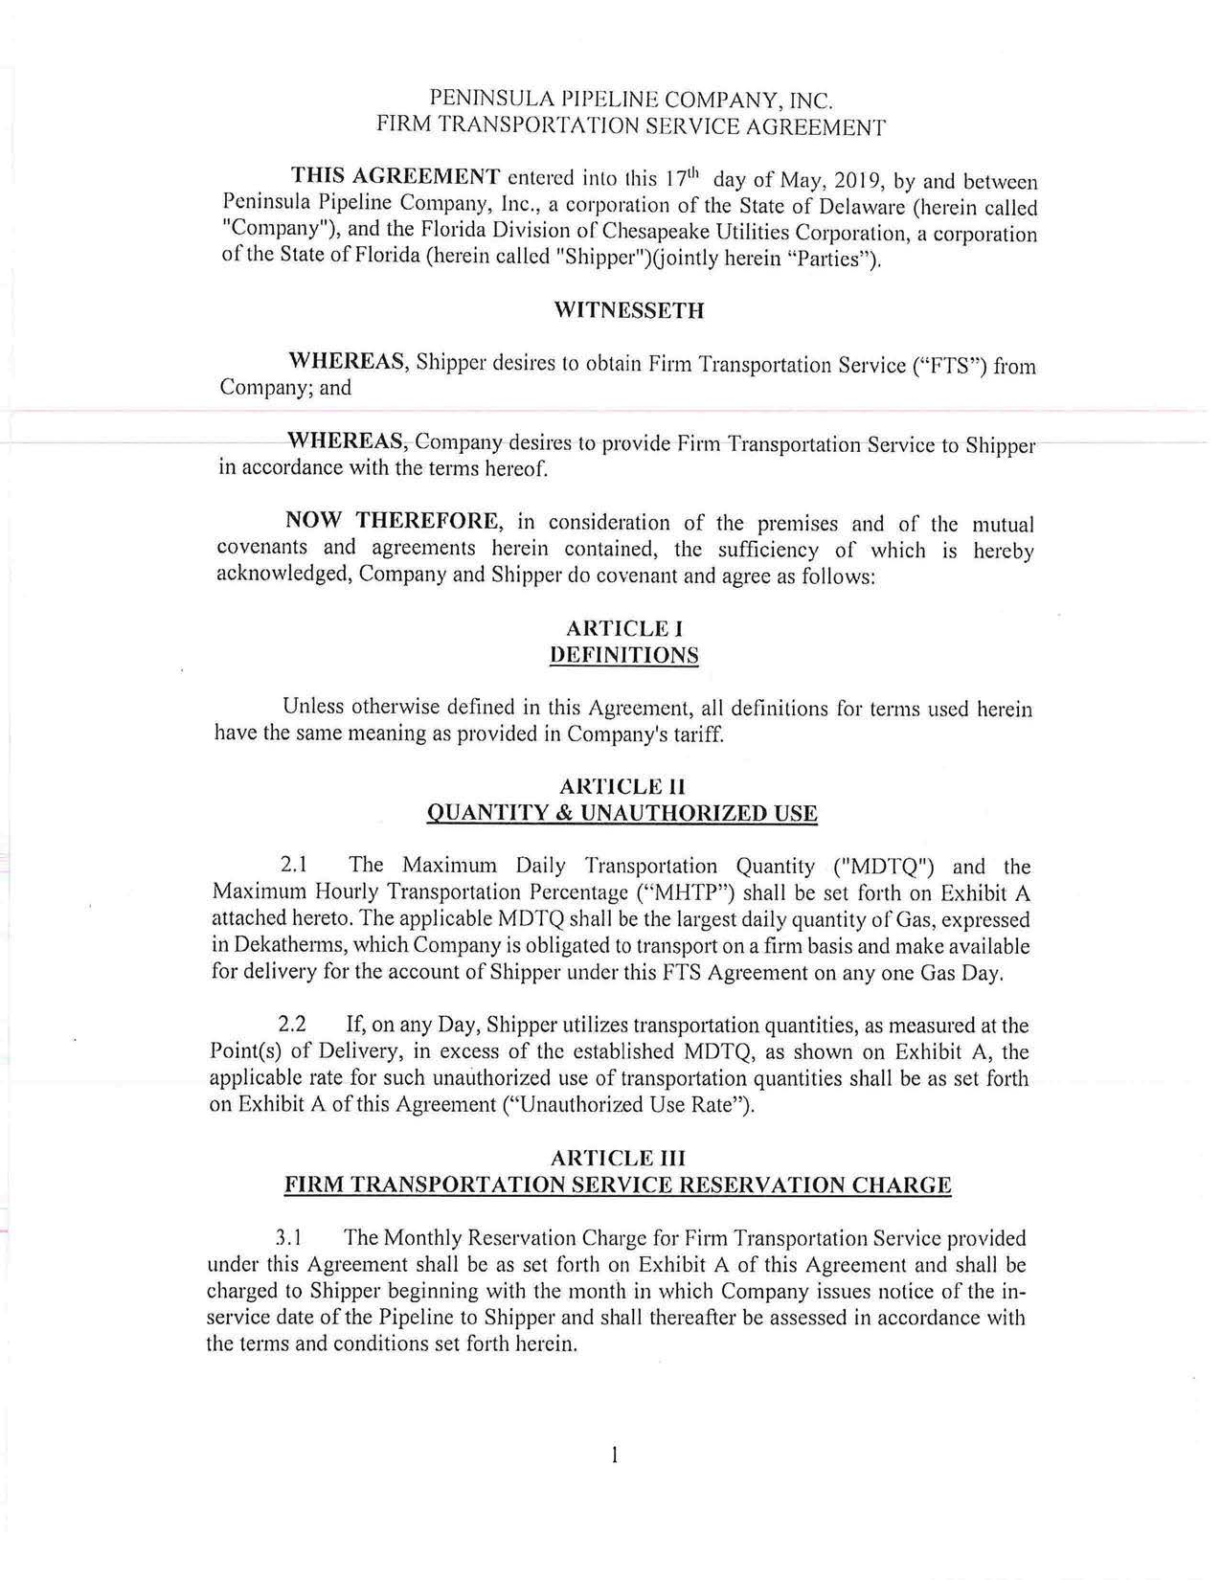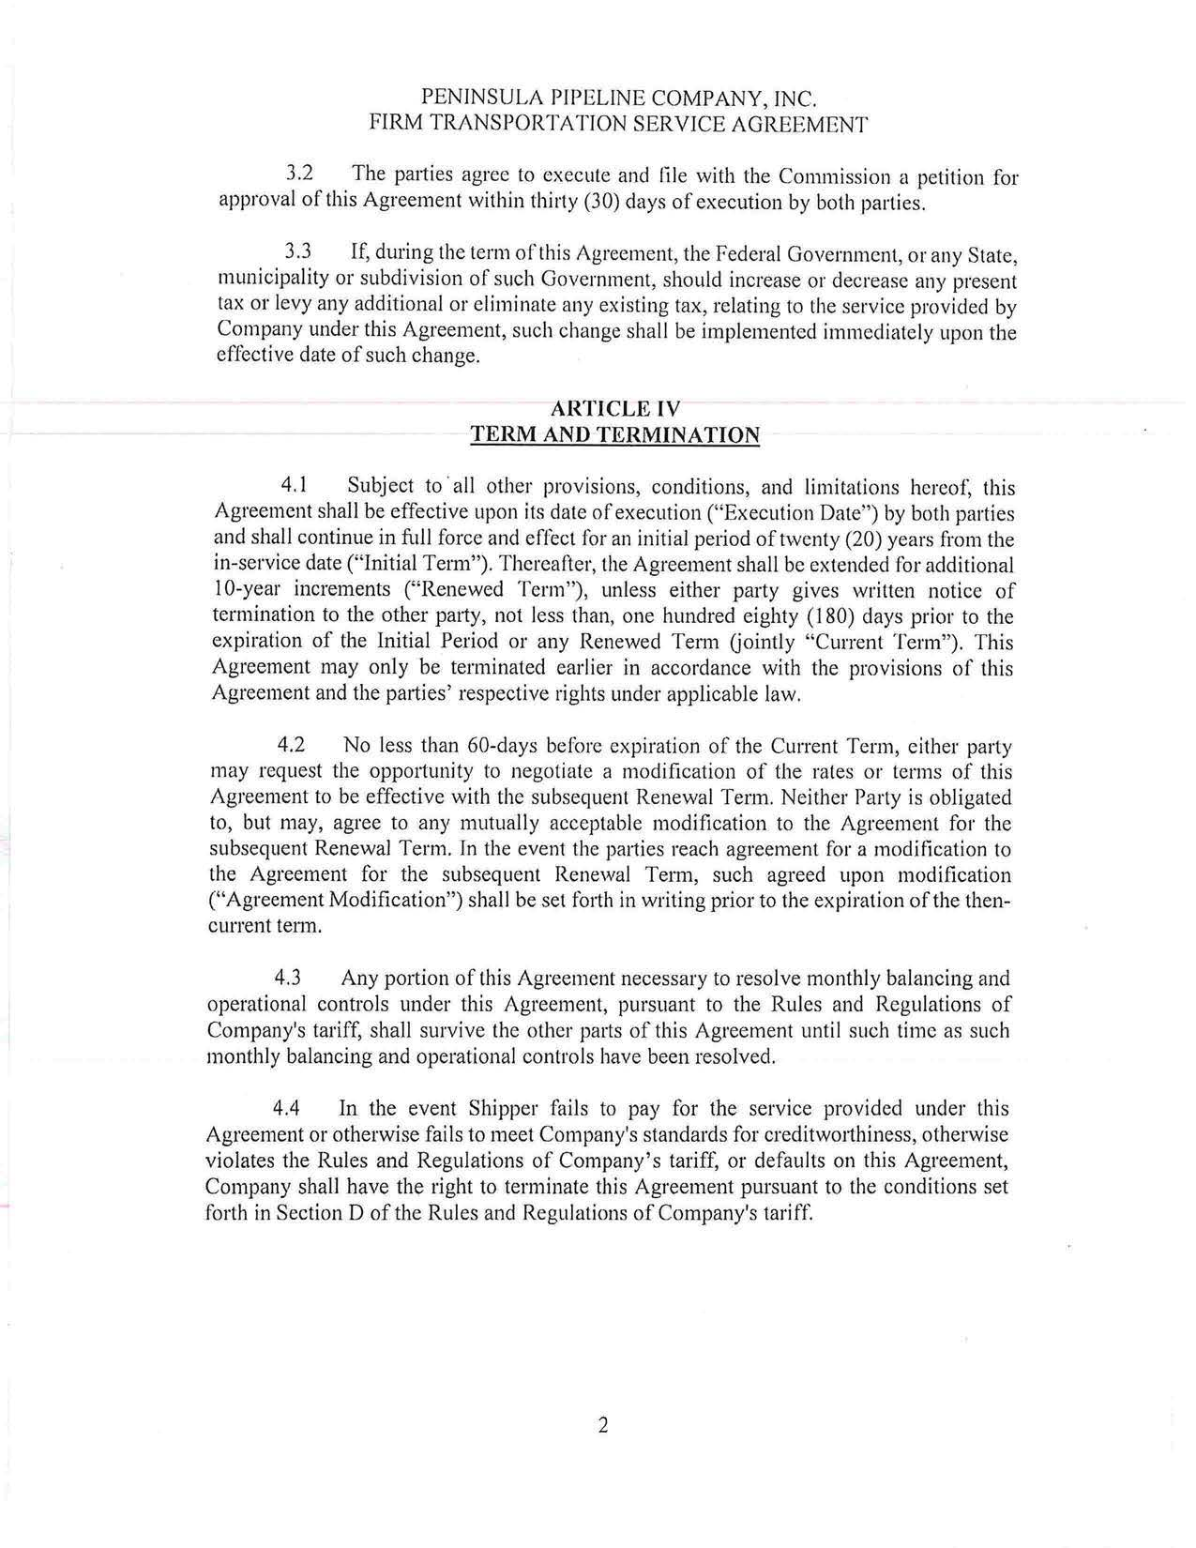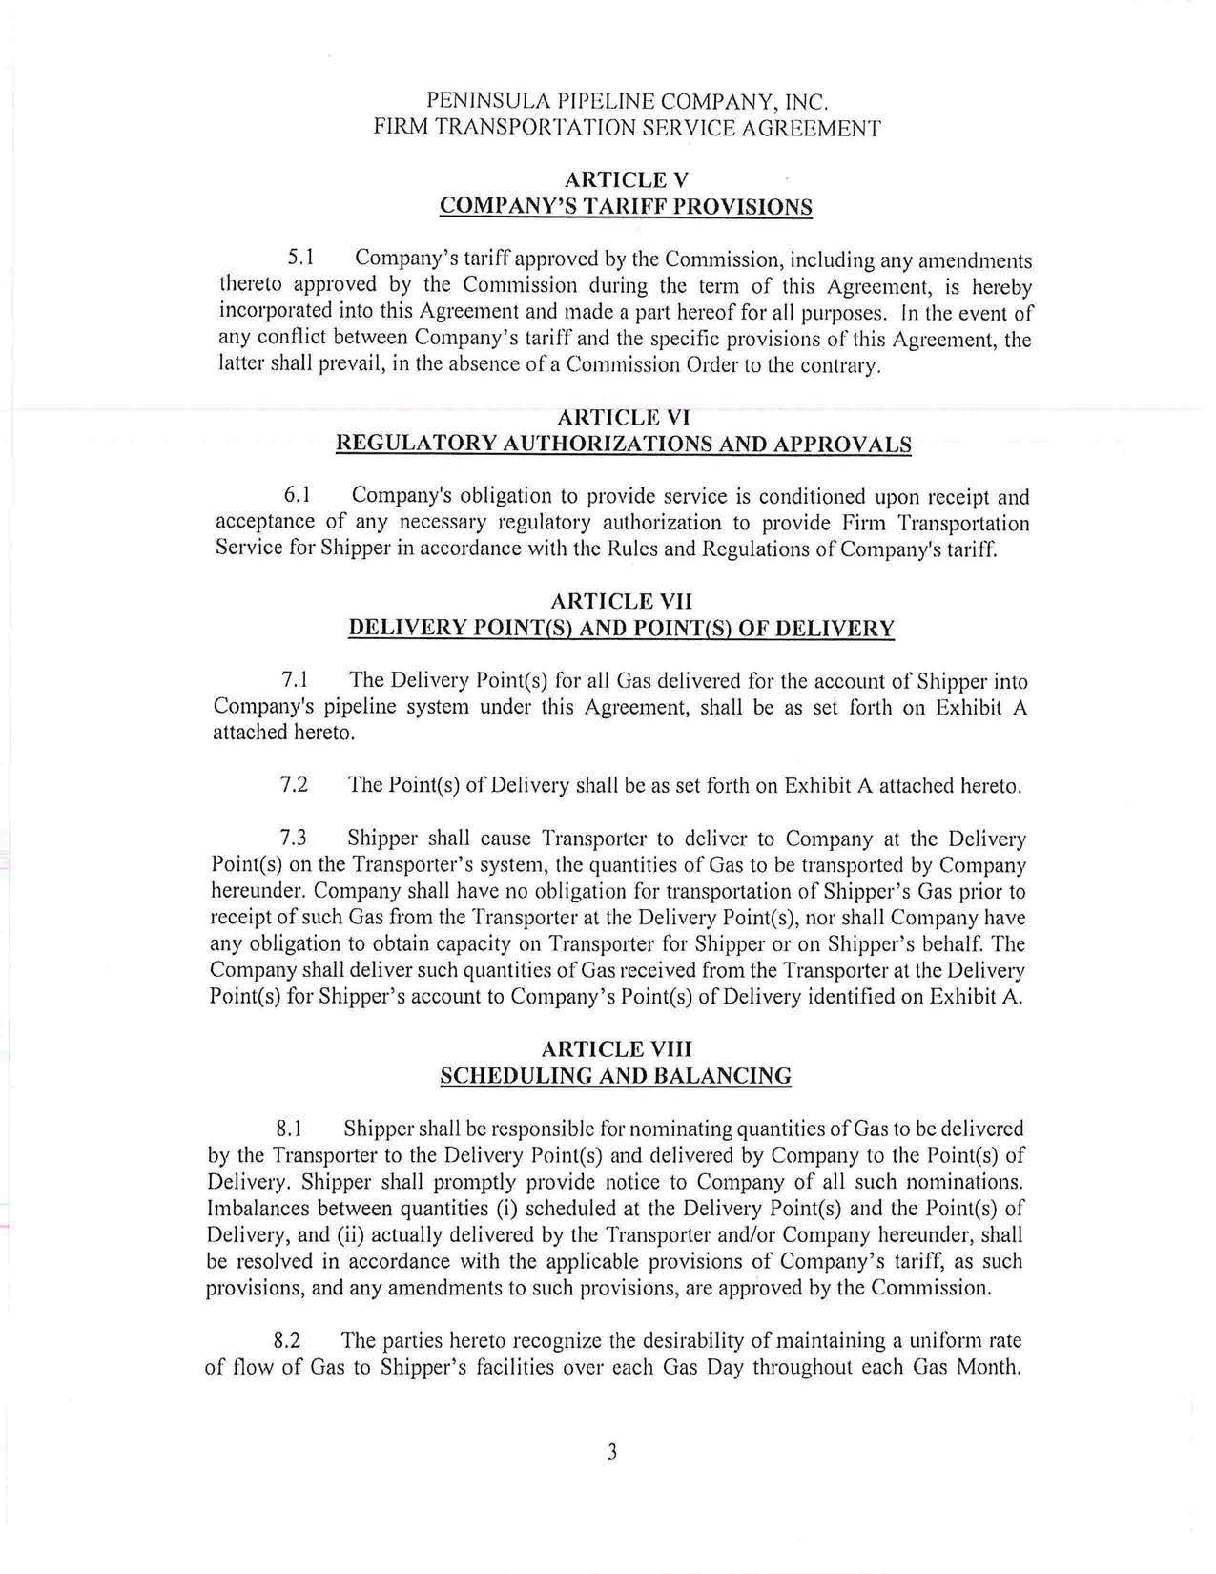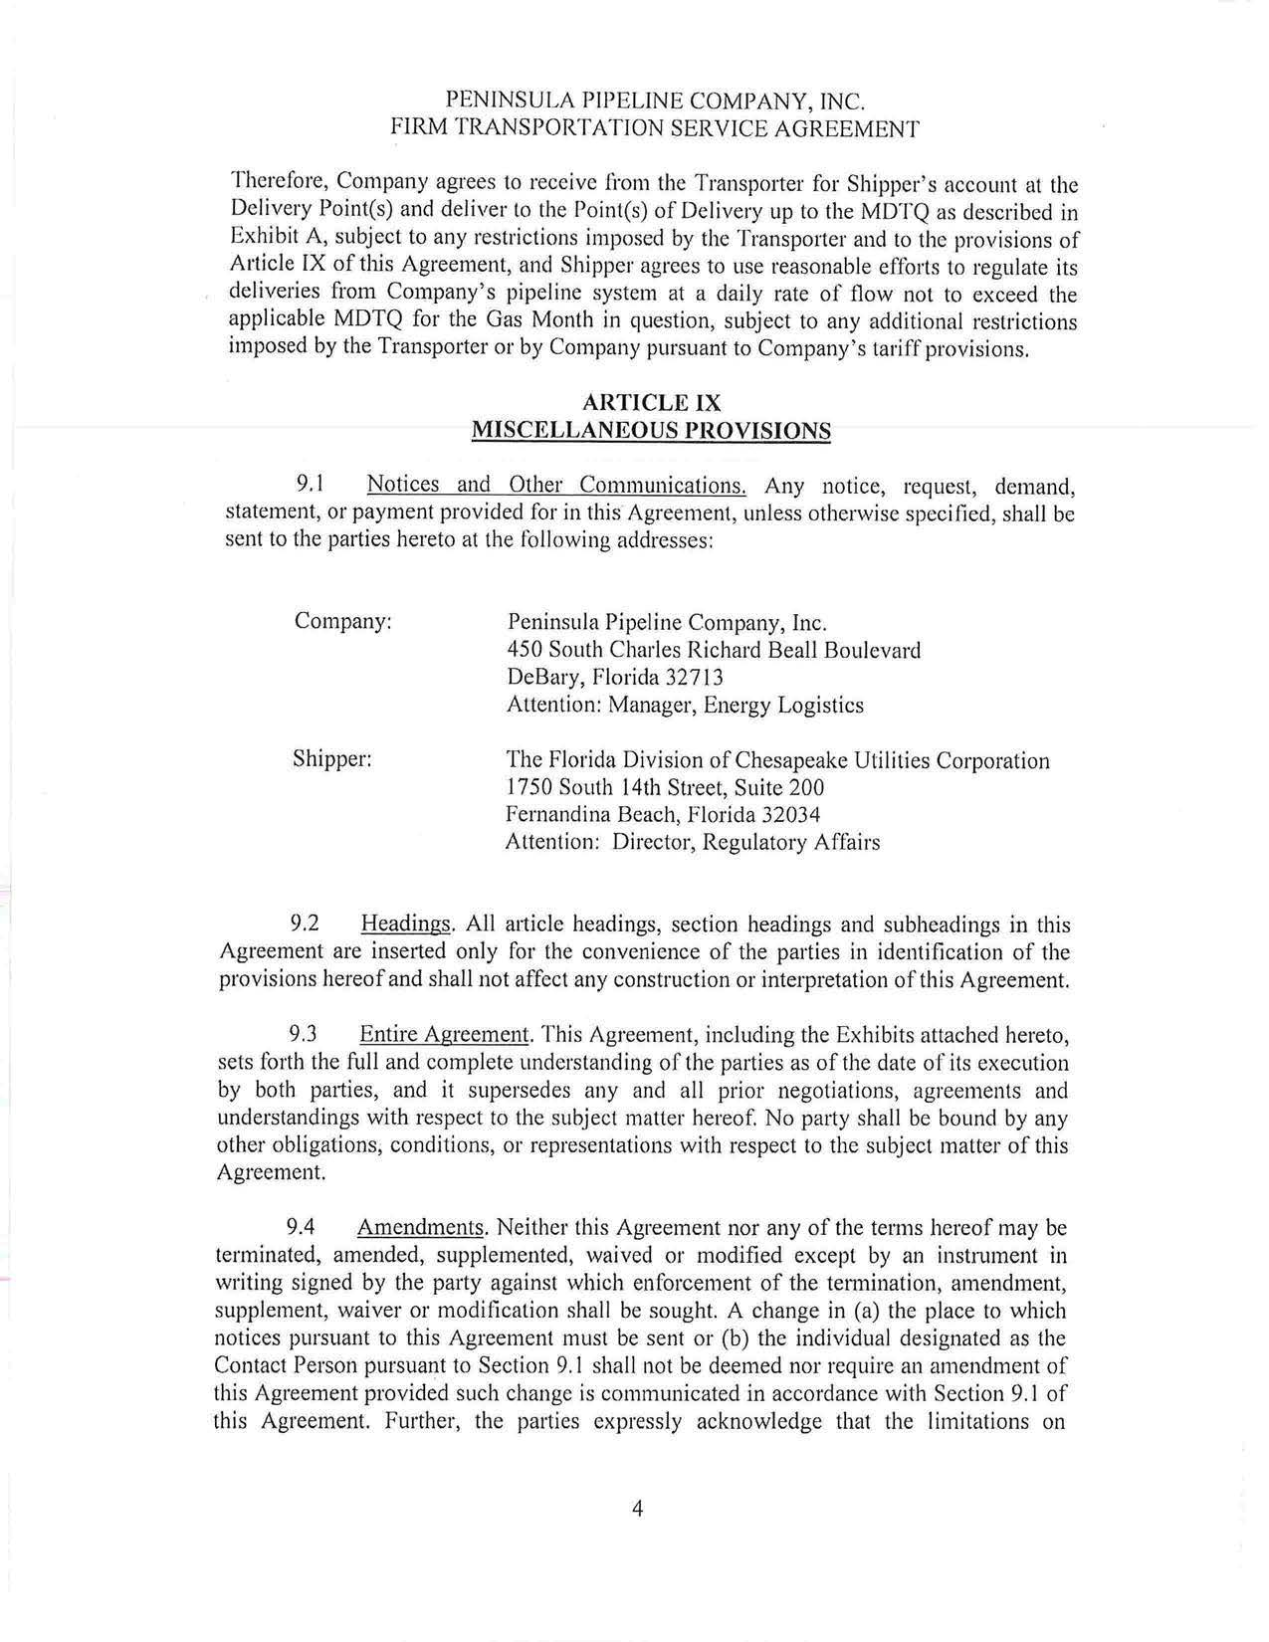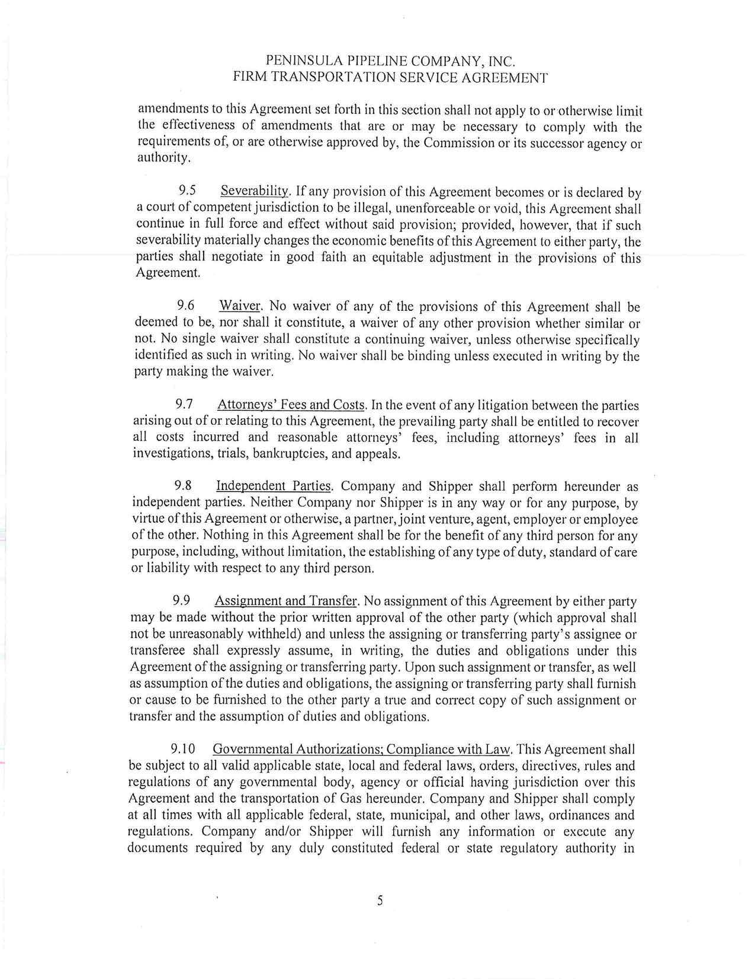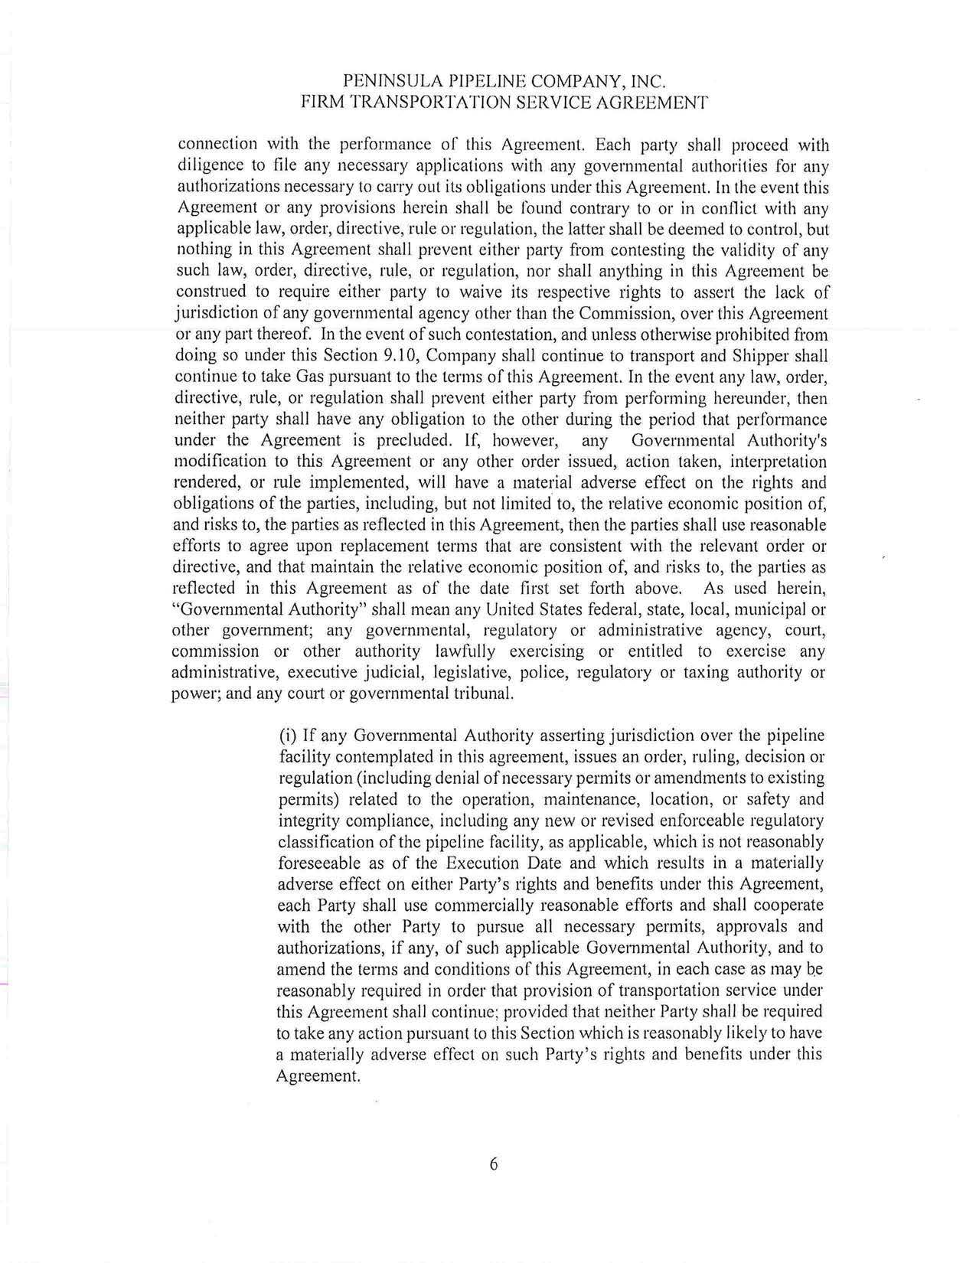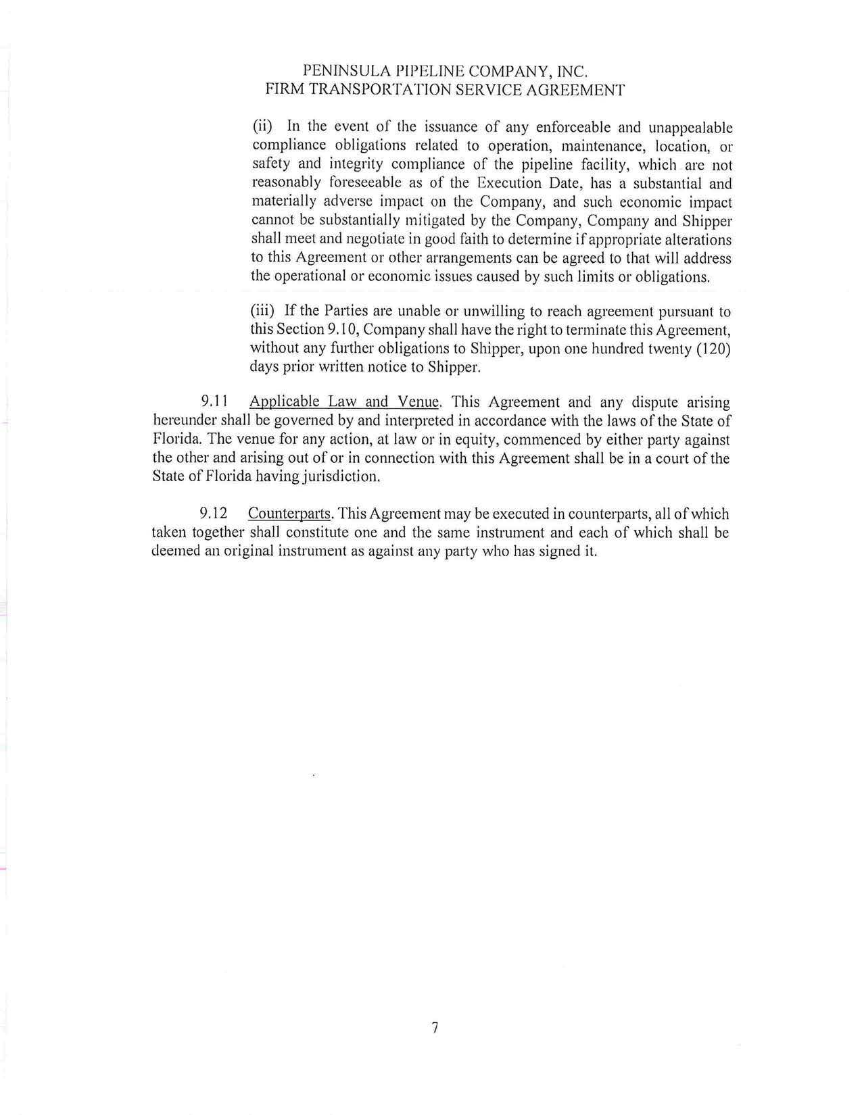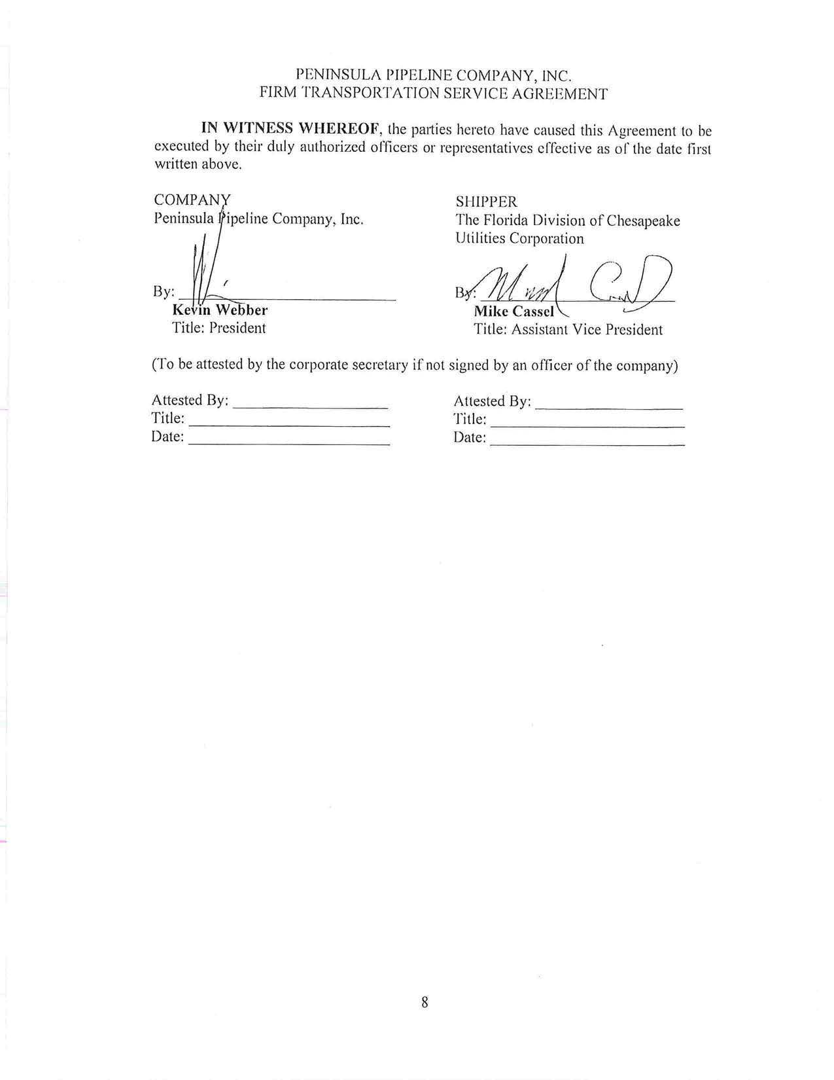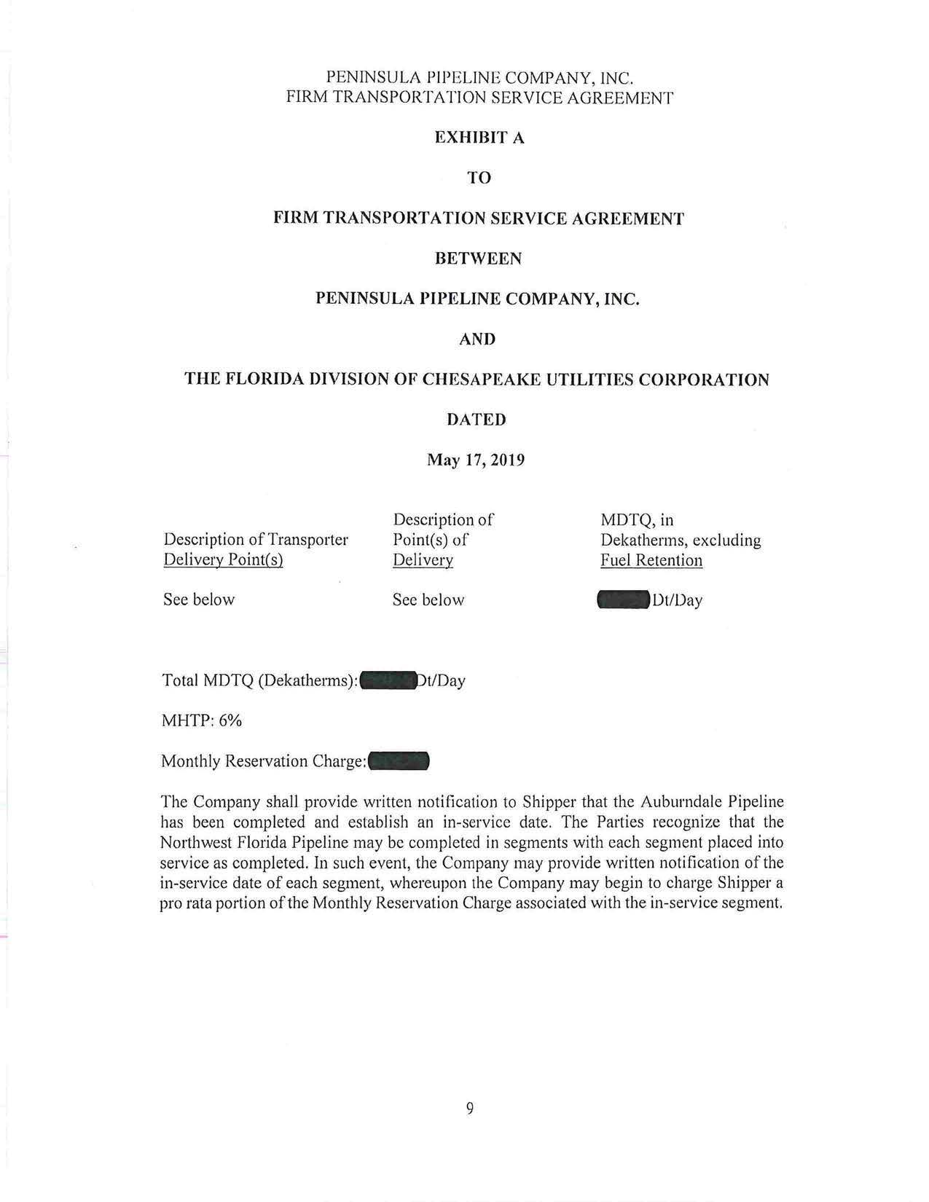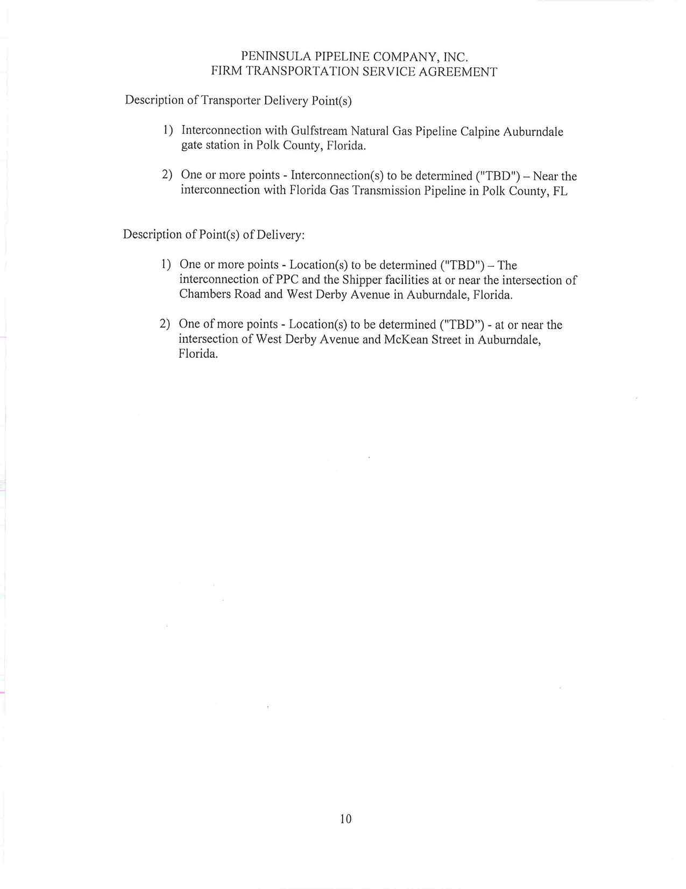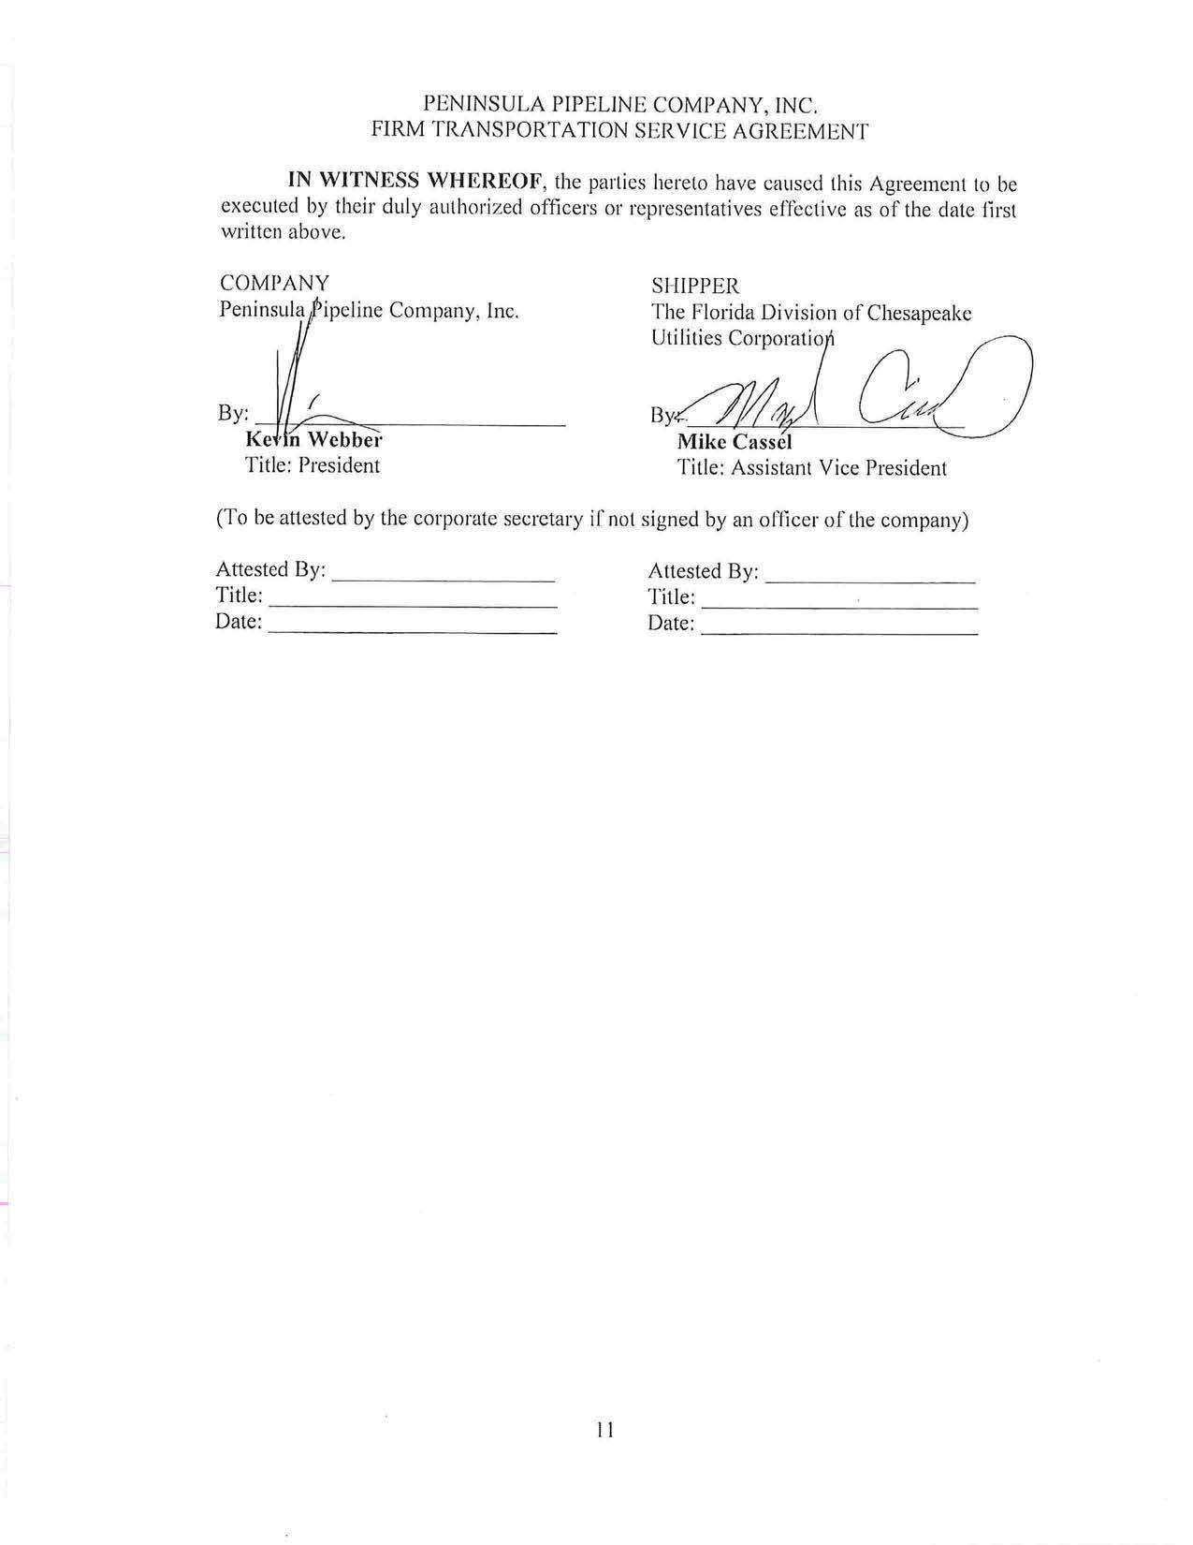
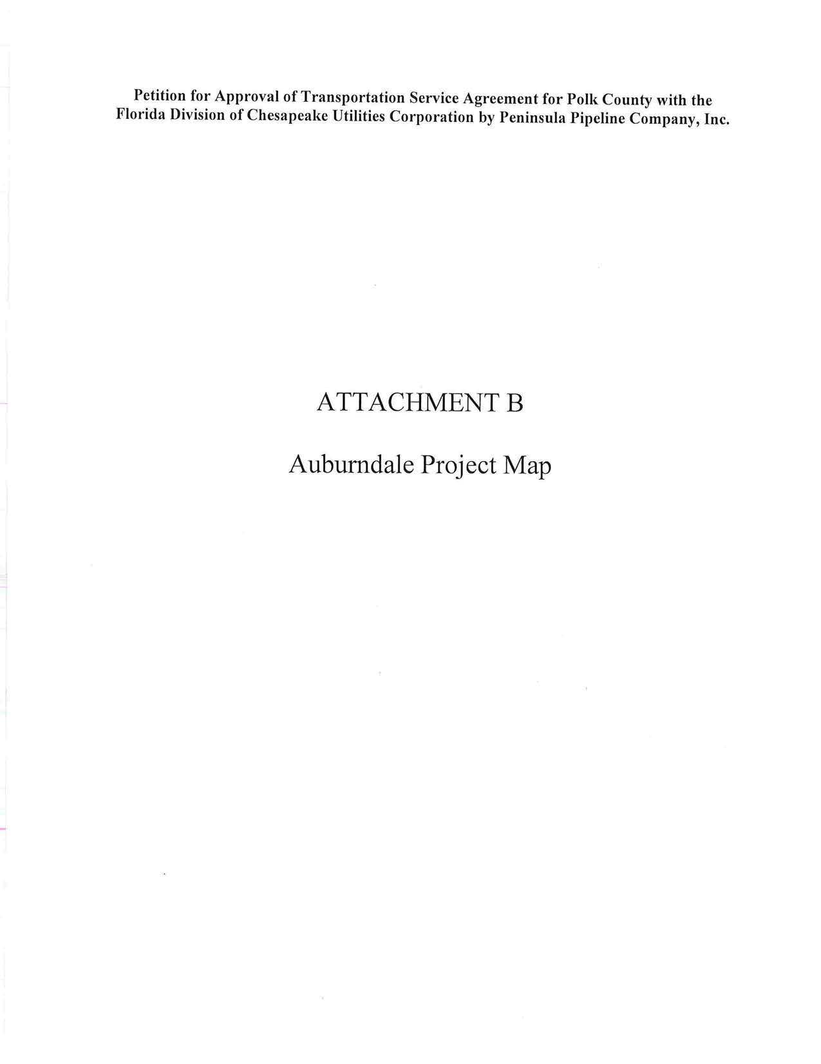
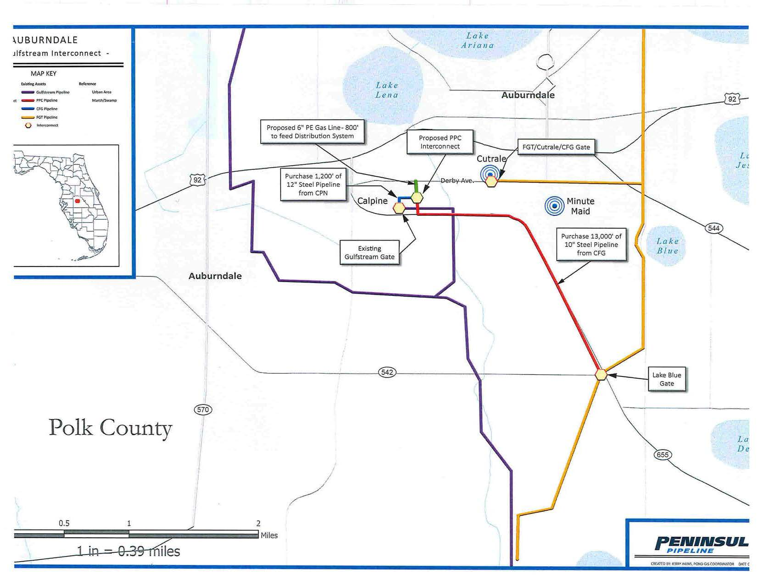

Order No. PSC-06-0023-DS-GP, issued January 9, 2006, in Docket No. 050584-GP, In re: Petition for declaratory statement by Peninsula Pipeline Company, Inc. concerning recognition as a natural gas transmission company under Section 368.101, F.S., et seq.
Order No. PSC-07-1012-TRF-GP, issued December 21, 2007, in Docket No. 070570-GP, In re: Petition for approval of natural gas transmission pipeline tariff by Peninsula Pipeline company, Inc.
Peninsula Pipeline Company, Inc., Intrastate Pipeline Tariff, Original Vol. 1, Original Sheet No. 11, Section 3.
Peninsula Pipeline Company, Inc., Intrastate Pipeline Tariff, Original Vol. 1, Original Sheet No. 12, Section 4.
Order No. PSC-2018-0557-TRF-GU, issued November 20, 2018, in Docket No. 20180158-GU, In re: Joint petition for approval of swing service rider, by Florida Public Utilities Company, Florida Public Utilities Company-Indiantown Division, Florida Public Utilities Company-Fort Meade, and Florida Division of Chesapeake Utilities Corporation.
CFG does not purchase gas for its customers.

