REVISED
07/26/19

State of Florida |  | Public Service Commission  Capital Circle Office Center ● 2540 Shumard Oak Boulevard  Tallahassee, Florida 32399-0850  -M-E-M-O-R-A-N-D-U-M-
DATE: | July 26, 2019
TO: | Office of Commission Clerk (Teitzman)
FROM: | Division of Economics (Ramos, Hudson)  Division of Accounting and Finance (Fletcher, Norris, Sewards)  Office of Auditing and Performance Analysis (Deamer)  Office of the General Counsel (Brownless, Schrader)
RE: | Docket No. 20170086-SU – Investigation into the billing practices of K W Resort Utilities Corp. in Monroe County.
AGENDA: | 08/06/19 – Regular Agenda – Interested Persons May Participate
COMMISSIONERS ASSIGNED: |  |  | Brown, Polmann, Fay
PREHEARING OFFICER: |  |  | Brown
CRITICAL DATES: |  |  | None
SPECIAL INSTRUCTIONS: |  |  | None

Case Background
This docket was opened to investigate the billing practices of K W Resort Utilities Corporation (KWRU) to determine if KWRU had violated any Commission order, rule or statute. An audit was conducted by Commission staff for the period of April 2013 through March 2017, in which KWRU was found to have charged rates inconsistent with its tariffs. Based on this audit, Order No. PSC-2018-0444-PAA-SU (Order No. PSC-2018-0444) was issued on August 31, 2018.
The proposed agency action portion of Order No. PSC-2018-0444 found that:

- The April 2013 through March 2017 audit period utilized by Commission staff was reasonable.

- The appropriate time period for the refunds was April 2013 through March 2016.

- KWRU was required to refund Safe Harbor (Safe Harbor) $26,408 with interest in accordance with Rule 25-30.360, Florida Administrative Code (F.A.C.).

- KWRU was required to refund Sunset (Sunset) $41,034 with interest in accordance with Rule 25-30.360, F.A.C.

- KWRU was not required to refund rates charged for pools due to KWRU’s reasonable belief that the approved tariff for pools it had for Key West Golf Club–HOA “was applicable to any additional customers with pools.”

- KWRU did not have to refund general service customers that were billed base facility charges (BFC) based on units instead of Florida Keys Aqueduct Authority (FKAA) metered rates for several reasons: 1) the error occurred during the transition from flat to volumetric for residential customers in which a billing software error incorrectly identified these customers as residential units; 2) the billing determinants in KWRU’s 2009 rate case may have been based on units rather than meter sizes; and 3) KWRU corrected its billing practices following the implementation of Order No. PSC-16-0123-PAA-SU.

- KWRU’s settlement with Roy’s Trailer Park was a reasonable solution to address that customer’s corrected outstanding balance from being billed by KWRU based on units instead of FKAA meters.

The show cause portion of Order No. PSC-2018-0444 directed KWRU to show cause why it should not be fined a $10,000 penalty for violations of Sections 367.081(1) and 367.091(3), Florida Statutes (F.S.).

The Office of Public Counsel (OPC) filed a protest of the PAA Order on September 21, 2018. In its protest, OPC raised the issues of whether Rule 25-30.350, F.A.C., requires that refunds be granted for the entire period that overbilling took place, 2009 through April 2016, and the calculation of customer refunds. KWRU filed a Cross Petition for Formal Evidentiary Hearing (Cross Petition) on October 1, 2018. In its Cross Petition, KWRU protested the $10,000 penalty (Show Cause Order) and the refunds ordered for Safe Harbor and other customers. On March 14, 2019, Order No. PSC-2019-0101-PCO-SU (OEP) was issued setting a final hearing on the PAA order issues raised by OPC and KWRU for September 17-18, 2019.

On May 17, 2019, KWRU and OPC filed a Joint Motion for Approval of Stipulation and Settlement (Stipulation and Settlement). The Stipulation and Settlement is contained in Attachment A. The Stipulation and Settlement has the following provisions:
- Fourth Avenue, LLC shall be refunded $1,004.34 and ITNOR Waters Edge shall be refunded $1,025.49 within 30 days of Commission approval of the Stipulation and Settlement.
- OPC will withdraw its protest of the PAA Order filed on September 21, 2019.
- OPC takes no position on refunds to Safe Harbor or Sunset.
- The Stipulation and Settlement does not address the Show Cause portion of Order No. PSC-2018-0444.
- KWRU will limit its contested issues to refunds to Safe Harbor and Sunset (PAA Order) and the penalty (Show Cause Order).
- The Stipulation and Settlement must be approved by the Commission without modification.
On May 28, 2019, KWRU filed a Motion to Abate Proceedings. In its Motion to Abate, KWRU argued that the Stipulation and Settlement allowed both the PAA and Show Cause portions of Order No. PSC-2018-0444 to be resolved at an Agenda Conference, thereby negating the necessity for a formal evidentiary hearing. On June 4, 2019, KWRU filed the direct testimony of Christopher A. Johnson. The Motion to Abate was granted on June 14, 2019, by Order No. PSC-2019-0235-PCO-SU, suspending the hearing schedule in this docket until further notice.
On June 14, 2019, KWRU also filed an Offer of Settlement (KWRU Offer) to resolve the remaining issues in this docket not addressed in the Stipulation and Settlement. The KWRU Offer is contained in Attachment B. The KWRU Offer contains the following provisions:
- The Settlement Agreement and Release between Safe Harbor and KWRU dated May 12, 2016, Exhibit CAJ-9 to witness Johnson’s direct testimony, releases KWRU from any refund which may be due to Safe Harbor in this docket for overbilling and no additional refunds are necessary.
- The Settlement Agreement and Release between Sunset and KWRU dated October 23, 2019, Exhibit CAJ-8 to witness Johnson’s direct testimony, states that the payment of $41,034.00 by KWRU to Sunset is a complete satisfaction of any claim that Sunset is owed any additional refunds for overbilling by KWRU and no additional refunds are necessary.
- KWRU is willing to pay a penalty of $2,500.00 for improper billing.
Unlike most cases when a settlement is reached by the parties where an evidentiary hearing is scheduled, staff is making a substantive recommendation to the Commission on Issues 1 and 2, the Stipulation and Settlement and KWRU’s Offer, both of which were filed to resolve the unique facts and posture of this case. The order protested here involved refunds to customers for which staff is not a party, and a fine for which staff is a party and acts in a prosecutorial role. Because all issues have become so intertwined, staff believes the most expedient process is to make substantive recommendations on all settlement and stipulation issues before the Commission.

This recommendation addresses both the Stipulation and Settlement and KWRU Offer. A complete resolution of both the PAA Order issues and Show Cause issue can only be achieved if both the Settlement and Stipulation addressed in Issue 1 and Settlement Offer addressed in Issue 2 are approved. The Commission has jurisdiction pursuant to Section 367.081, F.S.

Discussion of Issues

Issue 1:
Should the Commission approve the Stipulation and Settlement jointly filed by KW Resort Utilities Corporation and the Office of Public Counsel?

Recommendation:
Yes. (Brownless, Schrader)

Staff Analysis:
The Stipulation and Settlement filed by the parties on May 17, 2019, proposes to settle several legal and billing issues addressed in Order No. PSC-2018-0444 that were protested by OPC and cross-protested by KWRU. Specifically, the Stipulation and Settlement requires KWRU to issue refunds to two additional KWRU customers: $1,004.34 to Fourth Ave., LLC, and $1,025.49 to ITNOR Waters Edge, within 30 days of the Commission’s approval of the Stipulation and Settlement. These refunds would be paid in addition to any refunds issued up until the time of the filing of the Stipulation and Settlement,
OPC also agrees to withdraw its protest of the PAA Order and take no position regarding further refunds to Safe Harbor or Sunset and to take no position on the imposition of a penalty. The parties also state that the Stipulation and Settlement “is in the best interests of both the Utility and its customers.” In sum, OPC has agreed to waive its right to a hearing on the factual and legal PAA Order issues it protested in exchange for the payment of refunds to two additional customers incorrectly billed by the use of BFCs based on the number of units or individual dwellings present behind a master meter, rather than based on the customer’s meter size.
Under the terms of the Stipulation and Settlement, KWRU is able to contest the refunds for Safe Harbor and Sunset (PAA Order issues) and the penalty issue (Show Cause Order issue). In its Motion to Abate, KWRU made the representation that approval of the Stipulation and Settlement would enable KWRU to resolve both the PAA and Show Cause Order issues “at the Commission Conference, negating the necessity for a formal administrative hearing.” From this statement, Commission staff concludes that if given an opportunity to present oral argument on the PAA and Show Cause Order issues at an Agenda Conference, KWRU envisions waiving its right to an evidentiary hearing on these issues.
Both OPC and KWRU have entered into the Stipulation and Settlement in good faith and represent that it is in the public interest. The Stipulation and Settlement resolves some protested billing issues and provides an administratively efficient means of resolving the issues that remain: Safe Harbor and Sunset refunds and the $10,000 penalty. Given these unique facts, the Stipulation and Settlement appears to be in the public interest and to fairly and reasonably settle the issues between KWRU and OPC in this docket.

Issue 2:
Should KWRU's Offer of Settlement be approved?

Recommendation:
Yes, if the Commission votes to approve Issue 1. If the Commission does not vote to approve Issue 1, this case should be set for hearing with appropriate modifications to the filing dates made in Order No. PSC-2019-0101-PCO-SU, Order Establishing Procedure. (Brownless, Schrader)

Staff Analysis:
The KWRU Offer of Settlement (KWRU Offer) proposes to settle the remaining issues in this docket that were not addressed by the Stipulation and Settlement. The KWRU Offer asks that the Commission approve resolutions to the refund amounts due to Safe Harbor and Sunset and approve a lower amount for the Show Cause penalty.
Regarding the remaining refunds due to Safe Harbor and Sunset, KWRU filed the Settlement Agreement and Release it has reached with each party as Exhibits to witness Christopher Johnson’s Prefiled Direct Testimony filed on June 4, 2019. The KWRU Offer asserts that the Settlement Agreement and Release reached with Safe Harbor on May 12, 2016, resolved a number of issues between KWRU and Safe Harbor “including, but not limited to, mutual obligations for refunds between the parties.” Further, the KWRU Offer states that, pursuant to this agreement and release, “any refund which may be due to Safe Harbor in this docket is deemed satisfied and no additional refunds are necessary.” For Sunset, the KWRU Offer states that the Settlement Agreement and Release, dated October 23, 2018, reached between KWRU and Sunset, provides that in consideration of a payment made by KWRU to Sunset of $41,034.00, Sunset released KWRU from all claims related to any further refunds due that are addressed in Order No. PSC-2018-0444.
Regarding the Show Cause penalty, KWRU states that Commission staff, during the August 6, 2018 Agenda Conference recommended a penalty of $1,000; however the Commission increased this penalty to $10,000. KWRU argues that this penalty “greatly exceeds a reasonable amount based upon the particular circumstances of the KWRU tariff at that time.” In support of this argument, KWRU points to the arguments it previously made at the August 6, 2018 Agenda Conference, pointing in particular to the following discussion from the Conference:
Ms. [Patti] Daniels: ….I do want to reiterate and emphasize to you is that Mr. Friedman is absolutely correct that the –the tariff lacked clarity for many, many years…
Commissioner Brown: Are you – Patti, are you saying, though, that staff had a role in some of the confusion that occurred?
Ms. Daniels: Absolutely Commissioner.
Commissioner Brown: Is that why staff is recommending a nominal fee of a thousand dollar fine?
Ms. Daniel: Absolutely.
In consideration of its arguments, KWRU’s Settlement requests that the Commission approve a penalty of $2,500 to resolve the Show Cause portion of Order No. PSC-2018-0444.
Regarding the refunds to Safe Harbor and Sunset, it appears that KWRU and those customers have reached a mutually agreeable resolution of the amounts due to those customers. Regarding the Show Cause penalty, it appears that while KWRU did violate its approved tariff, KWRU has reasonably shown that Commission staff had at least some role in the confusion that KWRU asserts it had regarding the interpretation and application of the tariff. Finally, KWRU has corrected its billing practices and is currently billing in accord with its tariff. Given these unique facts, acknowledging the agreements between KWRU and both Marinas and accepting a lower penalty of $2,500 appears to be reasonable and in the public interest.
Due to the unique facts in this case, a complete resolution of both the PAA Order issues and Show Cause issue can only be achieved if both the Settlement and Stipulation addressed in Issue 1 and the Settlement Offer addressed in Issue 2 are approved. Therefore, if the Commission approves the Stipulation and Settlement in Issue 1, staff would also recommend approval of the KWRU Offer. If the Commission does not vote to approve the Stipulation and Settlement in Issue 1, then staff recommends that the KWRU Offer not be accepted and that this matter be set for hearing with appropriate modifications to the filing dates established in Order No. PSC-2019-0101-PCO-SU.

Issue 3:
Should this docket be closed?

Recommendation:
Staff recommends that if the Commission approves both the Stipulation and Settlement and the KWRU Offer, and if no person whose substantial interests are affected by the proposed agency action files a protest within 21 days of issuance of the order, this docket should be administratively closed upon the issuance of a consummating order. If the Commission does not approve both the Stipulation and Settlement and the KWRU Offer, this docket should remain open pending resolution at hearing. (Brownless, Schrader)

Staff Analysis:
Staff recommends that if the Commission approves both the Stipulation and Settlement and the KWRU Offer, and if no person whose substantial interests are affected by the proposed agency action files a protest within 21 days of issuance of the order, this docket should be administratively closed upon the issuance of a consummating order. If the Commission does not approve both the Stipulation and Settlement and the KWRU Offer, this docket should remain open pending resolution at hearing.

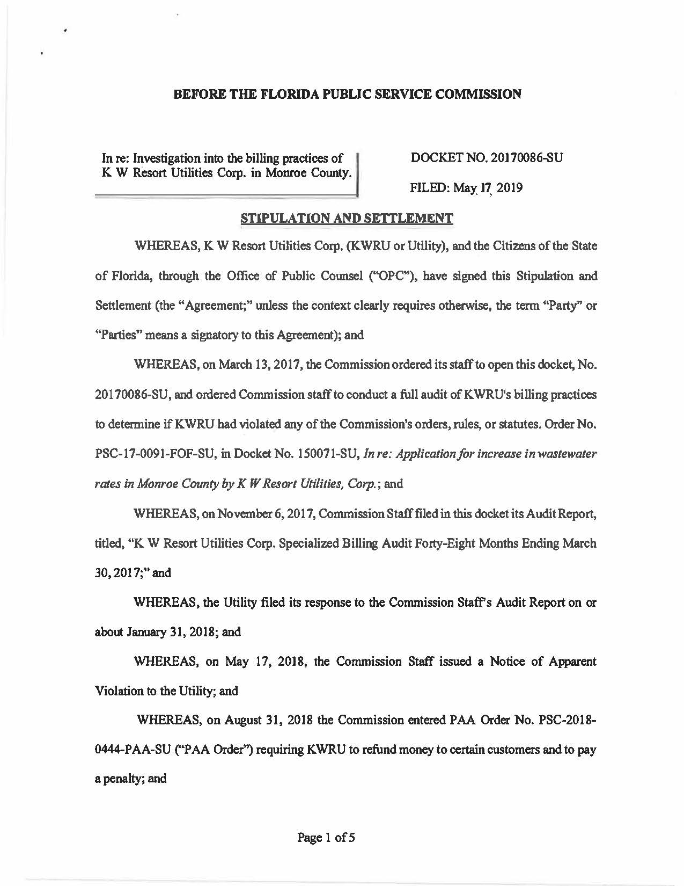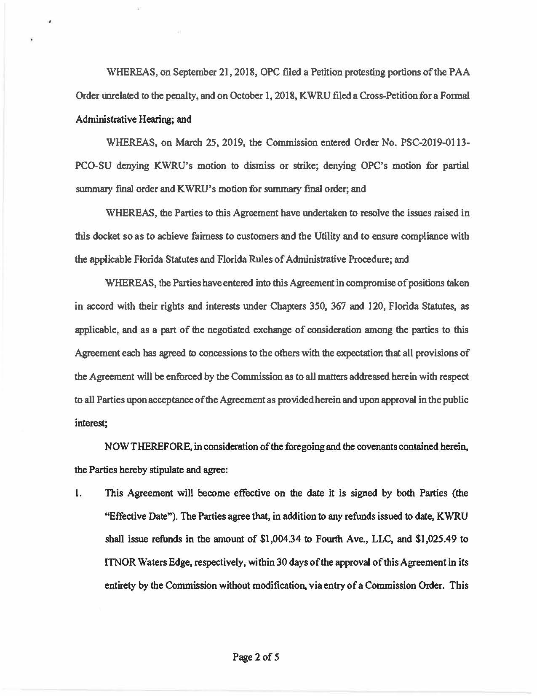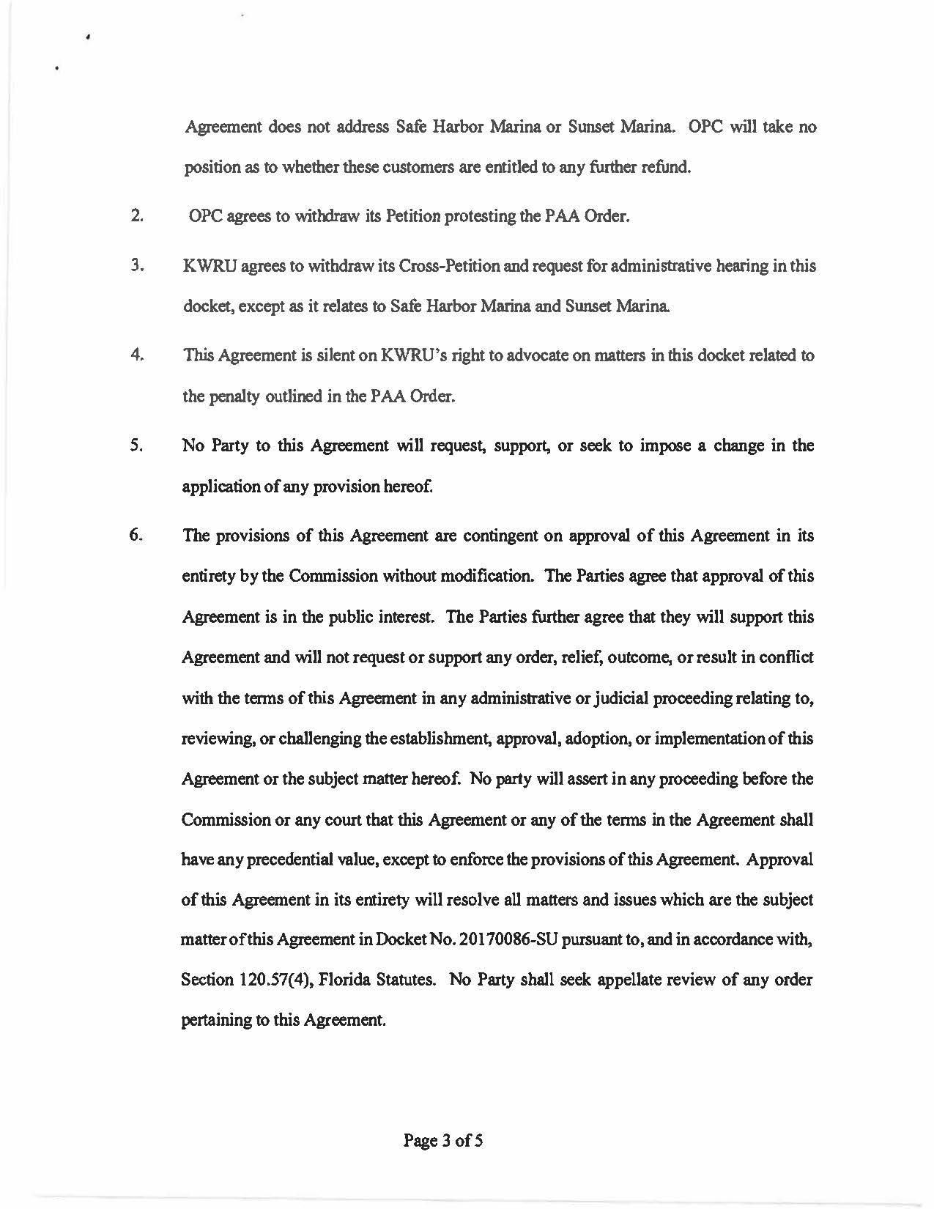

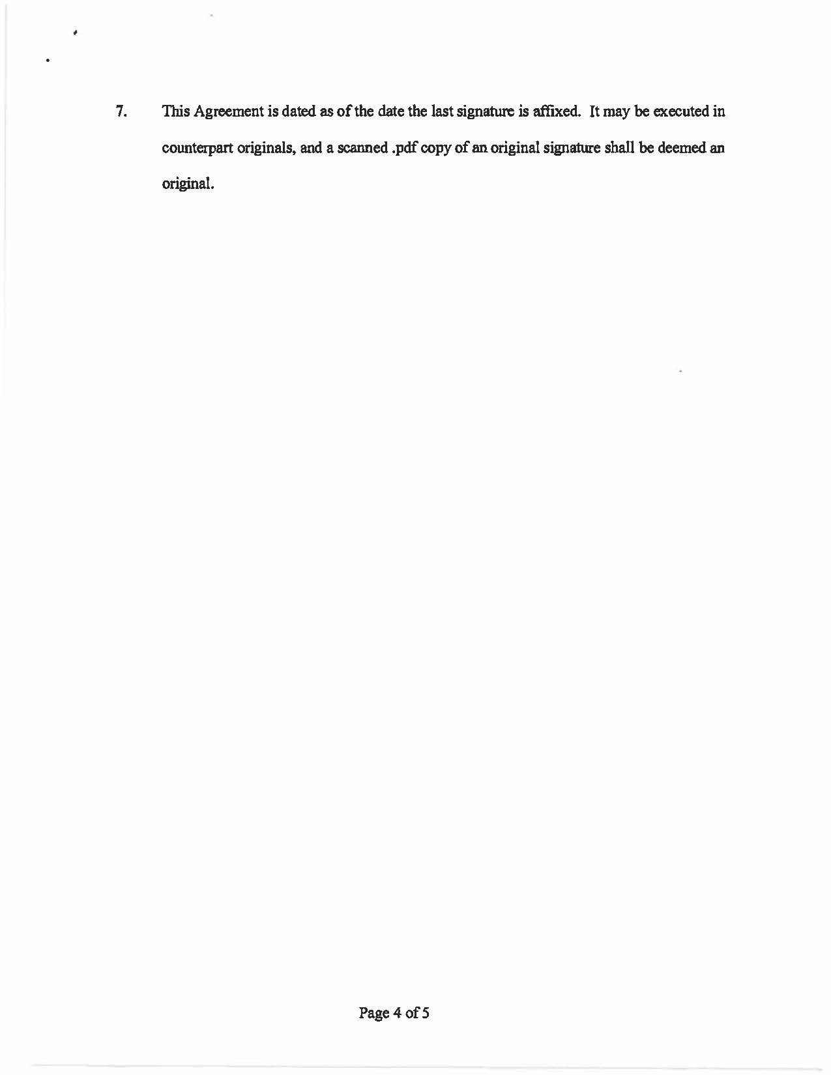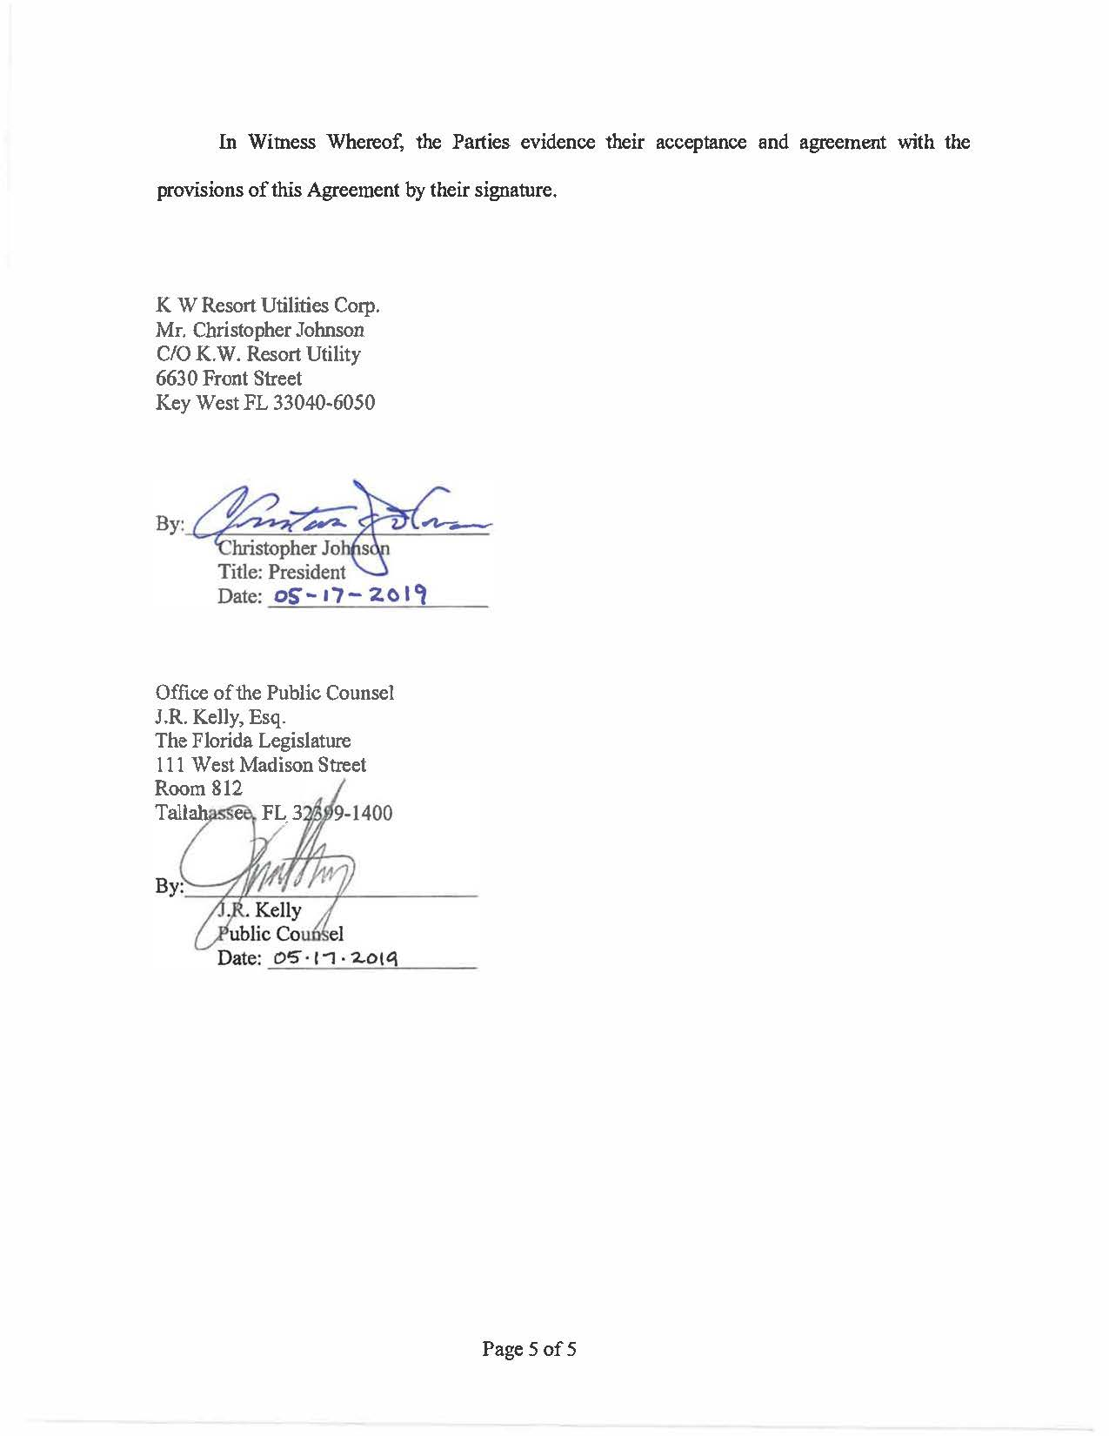

P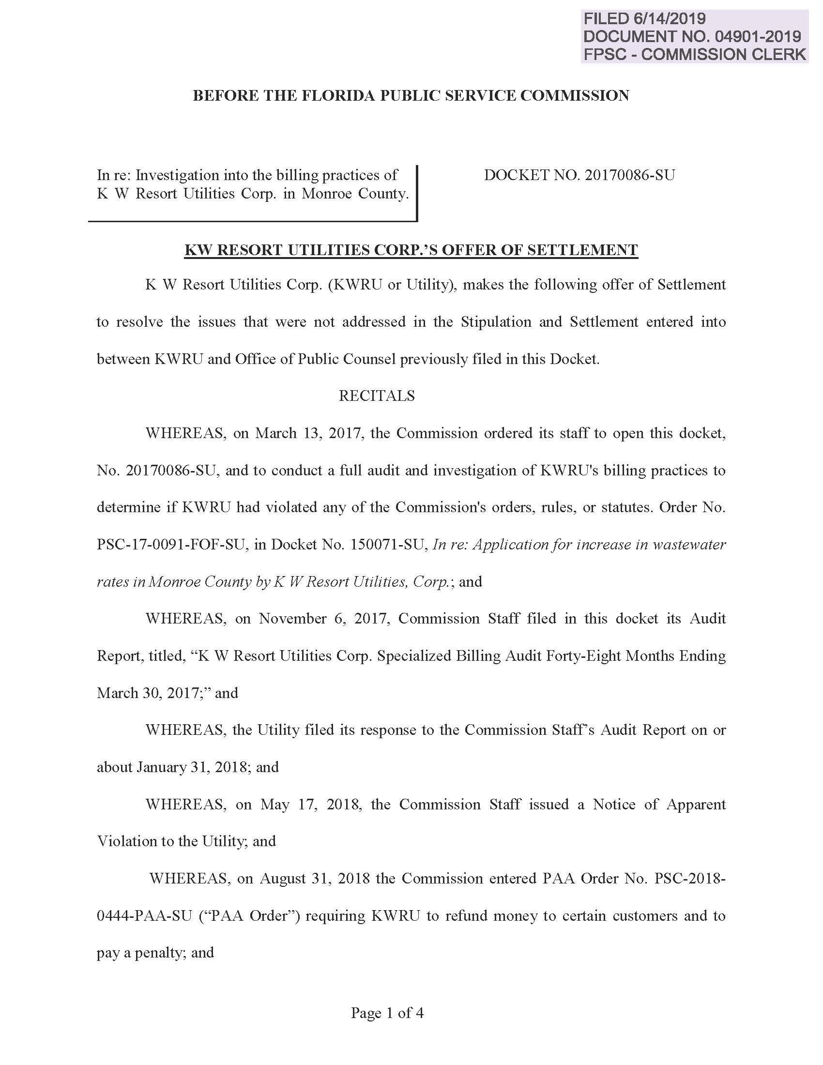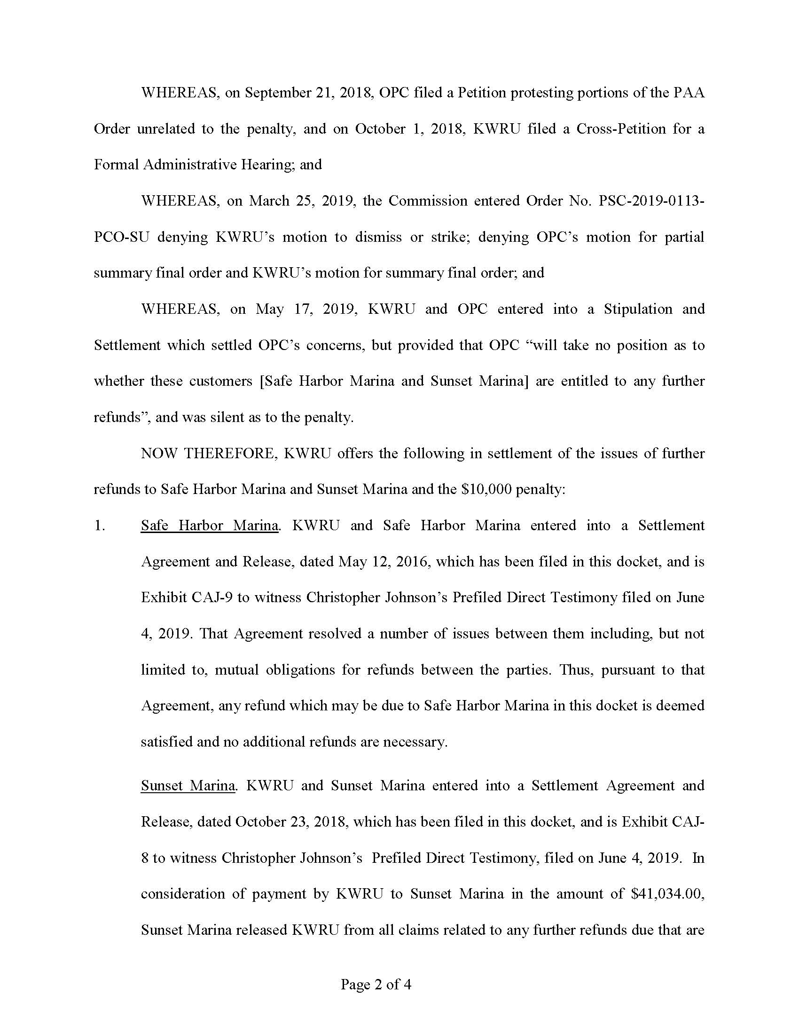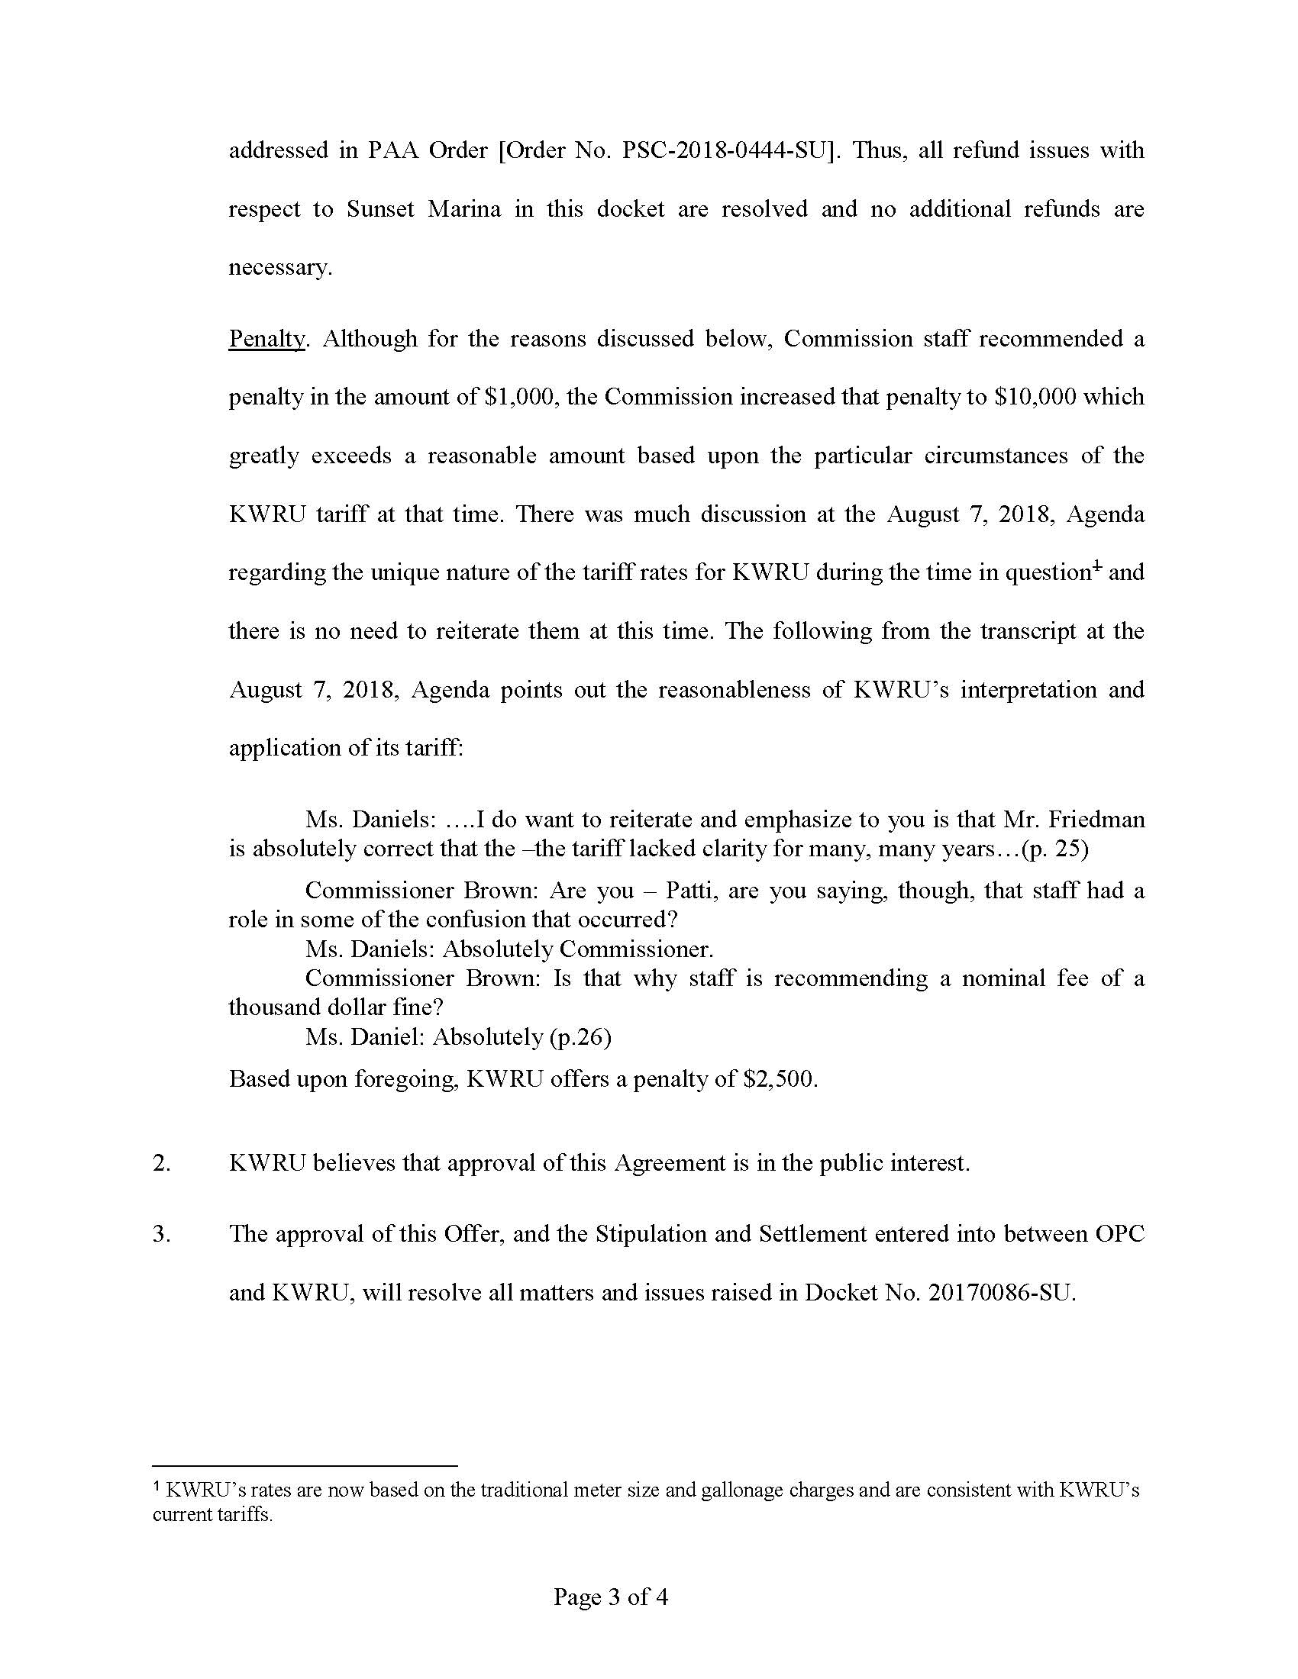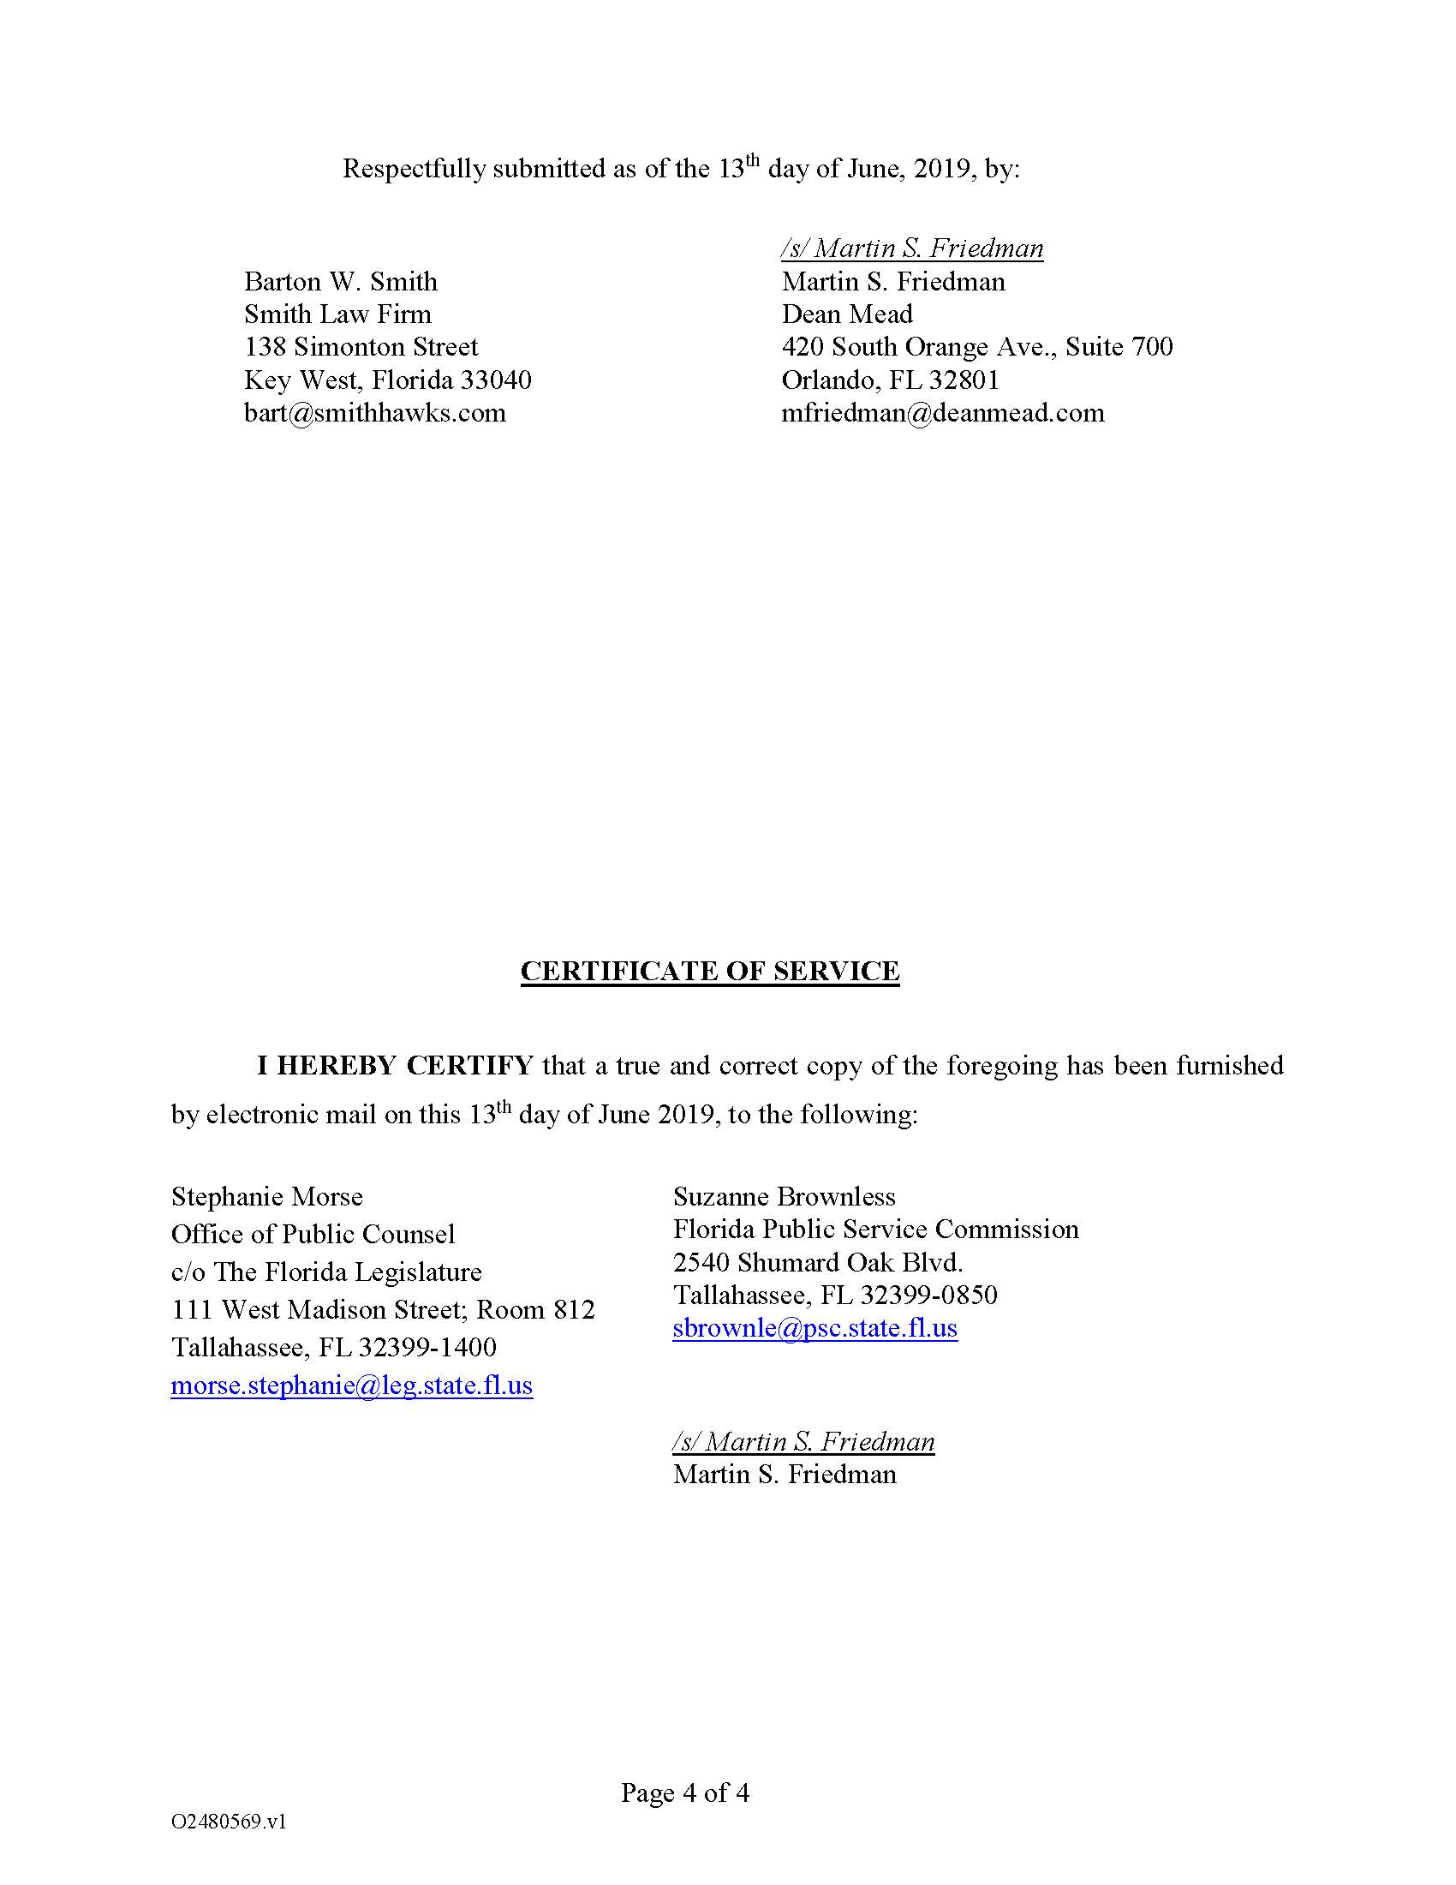

Order No. PSC-16-0123-PAA-SU, issued March 23, 2016, in Docket No. 150071-SU, In re: Application for increase in wastewater rates in Monroe County by K W Resort Utilities Corporation.
Order No. PSC-2018-0444 has two parts. The first part is proposed agency action (PAA) regarding the calculation of refunds for KWRU customers, which will be referenced herein as the PAA Order. The second part is a show cause order as to why KWRU should not be penalized $10,000 which shall be referenced herein as the Show Cause Order.
Order No. PSC-16-0123-PAA-SU, issued March 23, 2016, in Docket No. 150071-SU, In re: Application for increase in wastewater rates in Monroe County by K W Resort Utilities, Corp.
Agenda Conference 25-26, Aug 6, 2018.

