BEFORE THE FLORIDA PUBLIC SERVICE COMMISSION

In re: Evaluation of storm restoration costs for Florida Power & Light Company related to Hurricane Irma. | DOCKET NO. 20180049-EI  ORDER NO. PSC-2019-0319-S-EI  ISSUED: August 1, 2019

The following Commissioners participated in the disposition of this matter:

ART GRAHAM, Chairman
JULIE I. BROWN
DONALD J. POLMANN
GARY F. CLARK
ANDREW GILES FAY
APPEARANCES:

KENNETH M. RUBIN, KEVIN DONALDSON, and CHRISTOPHER WRIGHT, ESQUIRES, Florida Power & Light Company, 700 Universe Boulevard, Juno Beach, Florida 33408-0420
On behalf of Florida Power & Light Company (FPL)

CHARLES J. REHWINKEL, STEPHANIE A. MORSE, and PATRICIA A. CHRISTENSEN, ESQUIRES, Office of Public Counsel, c/o The Florida Legislature, 111 West Madison Street, Room 812, Tallahassee, Florida 32399-1400
On behalf of the Citizens of the State of Florida (OPC)

JON C. MOYLE, JR. and KAREN PUTNAL, ESQUIRES, Moyle Law Firm, PA, The Perkins House, 118 North Gadsden Street, Tallahassee, Florida 32301
On behalf of the Florida Industrial Power Users Group (FIPUG)

Robert Scheffel Wright and John T. LaVia, III, ESQUIRES, Gardner, Bist, Bowden, Bush, Dee, LaVia & Wright, P.A., 1300 Thomaswood Drive, Tallahassee, Florida 32308
On behalf of the Florida Retail Federation (FRF)

SUZANNE BROWNLESS, ESQUIRE, Florida Public Service Commission, 2540 Shumard Oak Boulevard, Tallahassee, Florida 32399-0850
On behalf of the Florida Public Service Commission (Staff)

MARY ANNE HELTON, ESQUIRE, Deputy General Counsel, Florida Public Service Commission, 2540 Shumard Oak Boulevard, Tallahassee, Florida 32399-0850
Advisor to the Florida Public Service Commission

Keith hetrick, ESQUIRE, General Counsel, Florida Public Service Commission, 2540 Shumard Oak Boulevard, Tallahassee, Florida 32399-0850
Florida Public Service Commission General Counsel

FINAL ORDER APPROVING STIPULATION AND SETTLEMENT AGREEMENT

BY THE COMMISSION:
BACKGROUND

This docket was opened by the Florida Public Service Commission (Commission) on February 22, 2018, to evaluate the storm restoration costs for FPL related to Hurricane Irma. On August 31, 2018, FPL filed a petition requesting recovery of Hurricane Irma costs along with supporting testimony and exhibits. OPC, FRF, and FIPUG are parties to this docket.

On June 7, 2018, Order No. PSC-2018-0290-PCO-EI, was issued establishing procedures to be followed in this docket. On November 16, 2018, Order No. PSC-2018-0539-PCO-EI was issued which modified testimony filing dates and set the final hearing for June 11-14, 2019. On December 28, 2018, OPC filed a Motion for Extension of Testimony Filing Dates Established by Order No. PSC-2018-0539-PCO-EI, which was denied by Order No. PSC-2019-0017-PCO-EI, issued January 8, 2019. The Prehearing Conference was held on May 20, 2019, with the Prehearing Order, Order No. PSC-2019-0205-PHO-EI, issued on May 31, 2019.

On June 6, 2019, FPL and OPC filed a Joint Motion to Approve a Stipulation and Settlement (Storm Settlement) which resolved all of the outstanding issues in this docket and proposed procedures for processing invoices from third-party storm restoration contractors in the future. Neither FRF nor FIPUG were signatories to the Storm Settlement. On June 7, 2019, Order No. PSC-2019-0224-PCO-EI was issued, which cancelled the June 11-14, 2019 final hearing to allow FRF and FIPUG to take positions on the Storm Settlement by no later than June 12, 2019. FIPUG filed its response to the Storm Settlement on June 12, 2019, stating that it had signed the Storm Settlement and supported it. FRF advised all parties at this time that it would take no position on the Storm Settlement.

A final hearing was held on July 9, 2019, in which the testimony of Eduardo DeVarona, Thomas Gwaltney, Ronald Reagan, Manuel Miranda, Keith Ferguson and Kristin Manz, on behalf of FPL, and Helmuth Schultz, on behalf of OPC, were inserted into the record as though read and 59 exhibits were admitted. A panel of three FPL witnesses, Manuel Miranda, Keith Ferguson and Kristin Manz, were sworn and testified regarding the Storm Settlement terms. In addition, they explained the cell phone application developed by FPL to track third party storm restoration contractors’ invoices and payments. At the conclusion of the hearing, the parties waived briefs and a bench vote was taken.

We have jurisdiction pursuant to Sections 366.04, 366.05, and 366.06, Florida Statutes (F.S.).

Storm Settlement

The Storm Settlement has three parts: (1) “Financial Terms” contained in Sections 1-4; (2) “Process Provisions” contained in Sections 5-20; and (3) “Other Provisions” contained in Sections 21-26. The Financial Terms in Sections 1-4 deal with issues that have been identified in this docket in the Prehearing Order while the Process Provisions in Sections 5-20 are matters that were not identified as issues. The Other Provisions are conditions associated with the Commission’s approval of the Storm Settlement itself, restrictions on the parties’ ability to contest the Storm Settlement, and each party’s right to pursue its position on any issue raised in this docket in future proceedings.

The Financial Terms of the Storm Settlement are as follows:

- The effective date of the Storm Settlement is the date of the Final Order issued in this docket. [Section 1]

- $50 million of the storm restoration costs requested by FPL will be treated as follows:

$25 million will be reclassified as capital added to FPL’s Plant in Service balance [Section 2];

$20 million will be treated as non-incremental costs recognized as base Operations and Maintenance (O&M) expense [Section 3]; and

$5 million of Other Expense will be used to reduce the Reserve Amount, as described in Section 12 of the 2016 Settlement Agreement, available for amortization. [Section 4]

The Process Provisions, which apply to third party storm restoration contractors, crews, and vendors (Contractors), are as follows:

- For the 2019 storm season, Phase I of FPL’s smart phone application (App) will be used for entry, recording, and approval of time and expenses for line crews and vegetation management crews. [Section 6]

- For the 2020 storm season, Phase II of the App will have additional functionalities to upload invoices and receipts as well as documenting exceptions to required reporting or work procedures and flagging non-compliant charges and time. [Section 7]

- FPL will use a Crew Tracking App which allows the company to geographically track storm restoration crews during mobilization and demobilization. [Section 8]

- Billing begins when Contractors begin to travel after acquisition. [Section 9]
- Contractors are only compensated for actual travel time which includes stops for fuel, meals, weigh stations, and repairs. [Section 10]

- Establishes a threshold of 500 miles of travel per 16-hour day which includes stops for fuel, meals, weigh stations, and repairs, [Section 11]

- FPL will manage external line crew contracts to avoid paying double time. [Section 12]

- Meals and fueling, after Contractors are on-boarded, are expected to be provided at or by the base camp with exceptions entered into the App. [Section 13]

- FPL will not “poach” Contractors who are committed to another utility or are part of another utility’s mutual aid allocation without the consent of the other utility. [Section 14]

- FPL will continue to participate in the Southeastern Electric Exchange and Edison Electric Institute mutual assistance groups. [Section 15]

- FPL will provide extensive supporting documentation in virtual (sortable spreadsheet) or physical files, e.g., regular and overtime payroll and related overheads, App data, travel data. [Section 16]

- FPL will engage an outside independent audit firm to audit FPL’s requested storm restoration costs for the first named tropical storm whose damages exceed $250 million with auditing costs recovered from ratepayers through a storm surcharge or from a storm reserve. Pre-filed direct testimony will be filed after any required audit is concluded. [Sections 17, 18]

- After the conclusion of the next storm cost recovery docket, the parties will discuss the maximum number of written discovery requests that will be served in future storm cost cases and provide any agreed upon number to the Commission staff for possible inclusion in the next storm cost recovery docket’s Order Establishing Procedure. [Section 19]

Although included in the Process Provisions section, Section 20 actually addresses a financial calculation: the incremental cost methodology for capitalized costs. The parties have agreed that a combined simple average of hourly internal FPL and embedded contractor rates that are of the type normally incurred in the absence of a storm will be used to determine amounts to capitalize to plant, property, and equipment along with the materials and other cost of equipment.

The Other Provisions are: (1) that the Storm Settlement will have no precedential value; (2) that a modified version of Exhibit HWS-3 will be admitted into the record; (3) that the Storm Settlement is contingent upon approval by the Commission in its entirety without modification; (4) that parties to the Storm Settlement will support it before the Commission; (5) that no party will argue that proposed Issue 1A should have been addressed or was waived in this docket; and (6) that the Storm Settlement resolves all outstanding issues, is in the public interest, and no party will file an appeal of any order issued in this docket.

DECISION

The standard for approval of a settlement agreement is whether it is in the public interest. A determination of public interest requires a case-specific analysis based on consideration of the proposed settlement taken as a whole.

The Storm Settlement resolves all issues in this docket, as well as providing for significant improvements in both the real time management of restoration tasks as well as cost verification. Crew tracking, contractor invoicing, and utility billing review procedures will be improved through the smart phone Phase I and Phase II applications that are designed to better monitor and verify contractor charges during storm restoration events. The Storm Settlement also provides for an outside audit of FPL’s requested storm restoration costs for the first named tropical storm whose damages exceed $250 million prior to submittal for Commission approval. These procedures are the result of negotiations between OPC and FPL and they are a reasonable attempt to address both the cost as well as discovery issues that are part of every storm restoration docket.

The Financial Terms contained in the Storm Settlement will result in: (1) total storm restoration costs being reduced from $1,273,545,000 to $1,253,545,000, reflecting the reclassification of storm restoration costs to non-incremental costs to be recovered in base Operation and Maintenance expenses; (2) reclassification of $25 million in costs as capitalized, resulting in cost recovery over the various lives of the plant assets rather than immediately as a storm restoration cost expense; and (3) a reduction in the Reserve Amount of $5 million decreasing the Reserve Amount to $1.245 billion.

The Storm Settlement has been signed by OPC, FPL and FIPUG, three of the four parties to this docket, with the fourth party, FRF, taking no position. The signatories represent a broad segment of FPL’s customer base including both residential and commercial classes. Having carefully reviewed the Storm Settlement, the exhibits entered into the record, and the testimony provided by FPL and OPC witnesses, we find that, taken as a whole, it provides a reasonable resolution of all issues raised in this docket. We find, therefore, that the Storm Settlement, Attachment A hereto, is in the public interest, and we hereby approve it.

Based on the foregoing, it is

ORDERED by the Florida Public Service Commission that the Joint Motion of the Office of Public Counsel and Florida Power & Light Company to Approve Stipulation and Settlement Agreement is hereby granted. It is further

ORDERED that the Stipulation and Settlement filed on June 6, 2019, referred to herein as Storm Settlement, attached hereto as Attachment A, and incorporated by reference, is hereby approved. It is further

ORDERED that in the event no timely appeal is filed, Docket No 20180049-EI shall be closed.

By ORDER of the Florida Public Service Commission this 1st day of August, 2019.

/s/ Adam J. Teitzman
ADAM J. TEITZMAN
Commission Clerk
Florida Public Service Commission
2540 Shumard Oak Boulevard
Tallahassee, Florida 32399
(850) 413-6770
www.floridapsc.com

Copies furnished: A copy of this document is provided to the parties of record at the time of issuance and, if applicable, interested persons.
SBr

NOTICE OF FURTHER PROCEEDINGS OR JUDICIAL REVIEW

The Florida Public Service Commission is required by Section 120.569(1), Florida Statutes, to notify parties of any administrative hearing or judicial review of Commission orders that is available under Sections 120.57 or 120.68, Florida Statutes, as well as the procedures and time limits that apply. This notice should not be construed to mean all requests for an administrative hearing or judicial review will be granted or result in the relief sought.

Any party adversely affected by the Commission's final action in this matter may request: 1) reconsideration of the decision by filing a motion for reconsideration with the Office of Commission Clerk, 2540 Shumard Oak Boulevard, Tallahassee, Florida 32399-0850, within fifteen (15) days of the issuance of this order in the form prescribed by Rule 25-22.060, Florida Administrative Code; or 2) judicial review by the Florida Supreme Court in the case of an electric, gas or telephone utility or the First District Court of Appeal in the case of a water and/or wastewater utility by filing a notice of appeal with the Office of Commission Clerk, and filing a copy of the notice of appeal and the filing fee with the appropriate court. This filing must be completed within thirty (30) days after the issuance of this order, pursuant to Rule 9.110, Florida Rules of Appellate Procedure. The notice of appeal must be in the form specified in Rule 9.900(a), Florida Rules of Appellate Procedure.

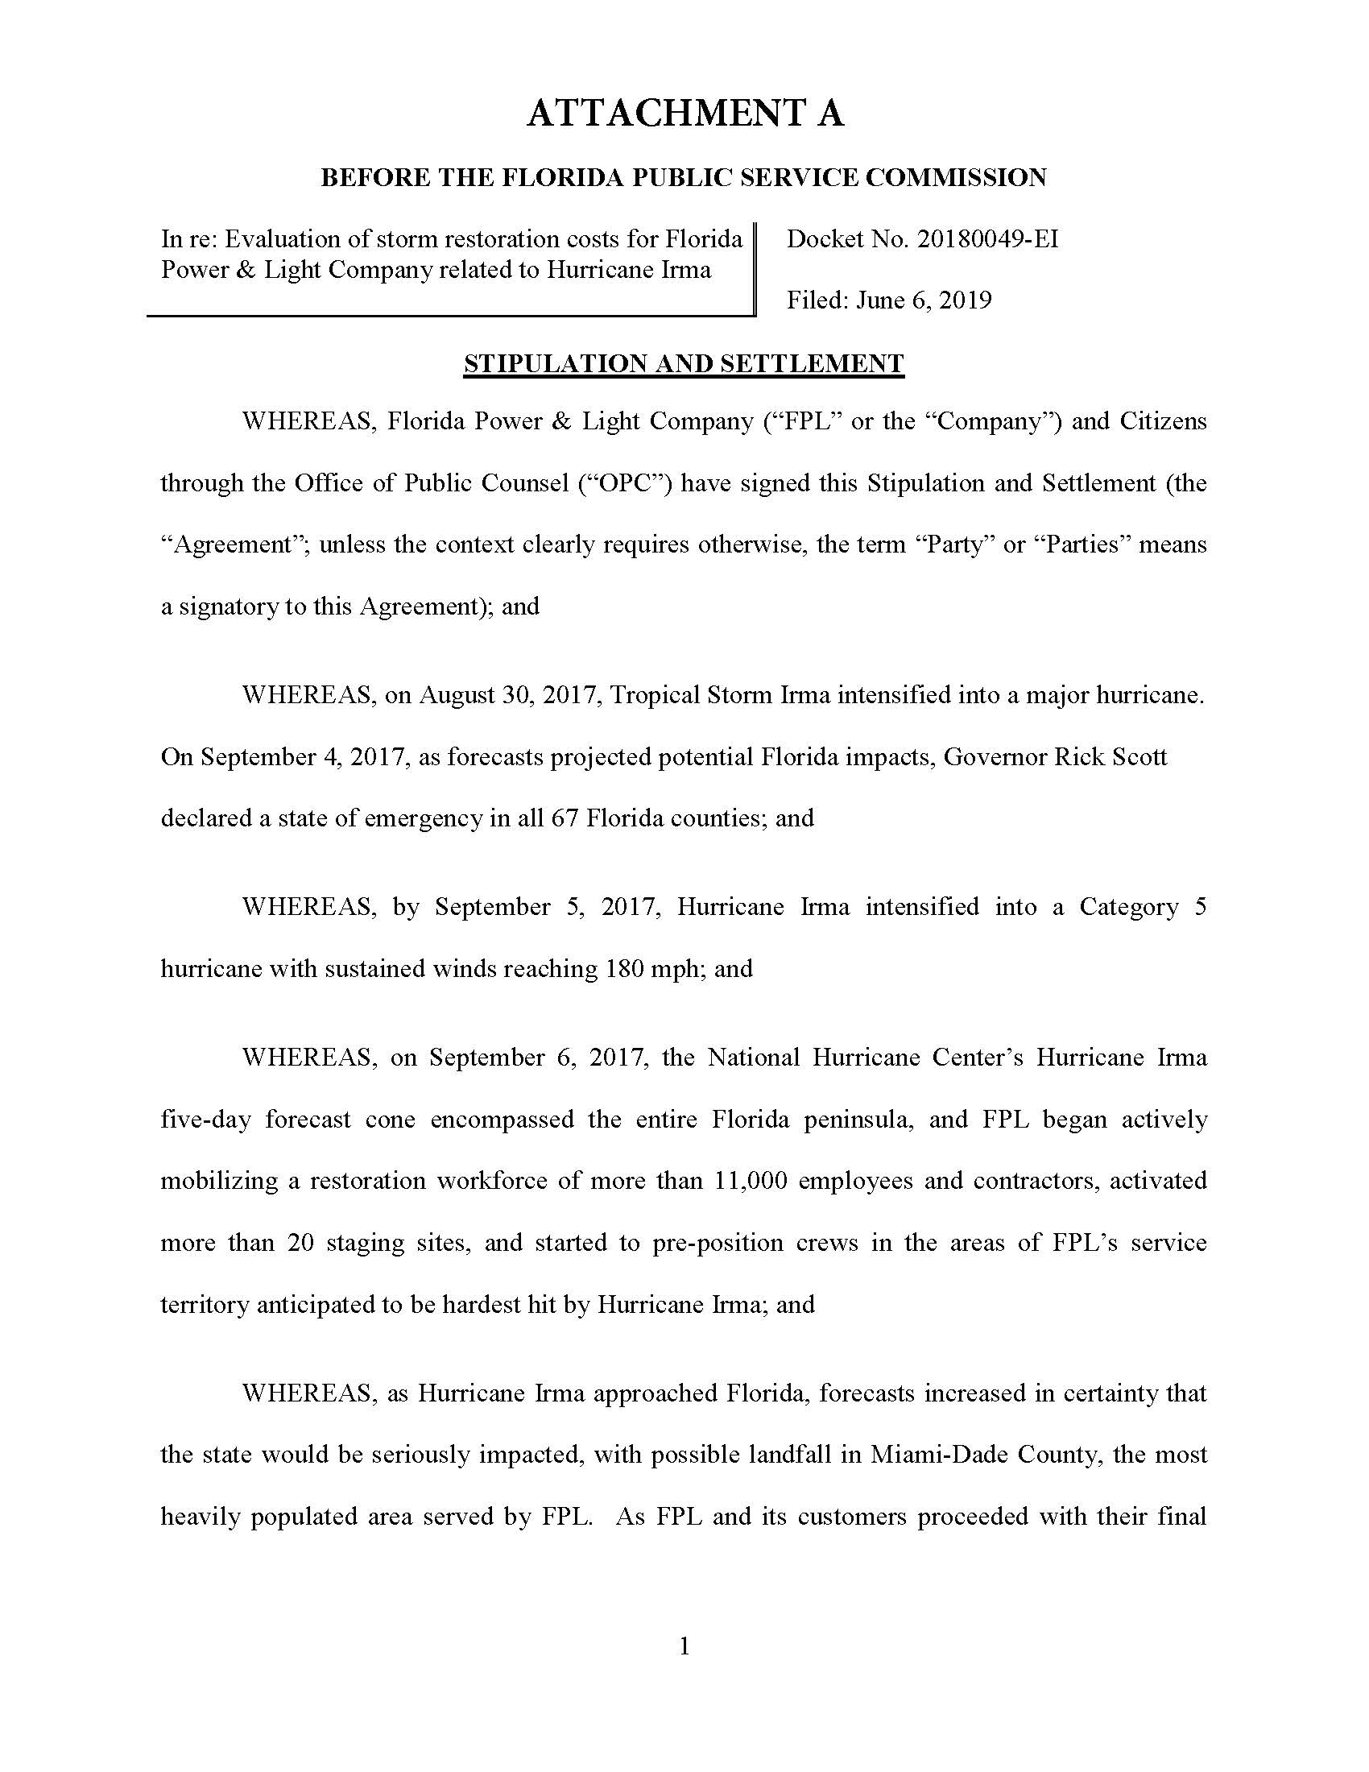
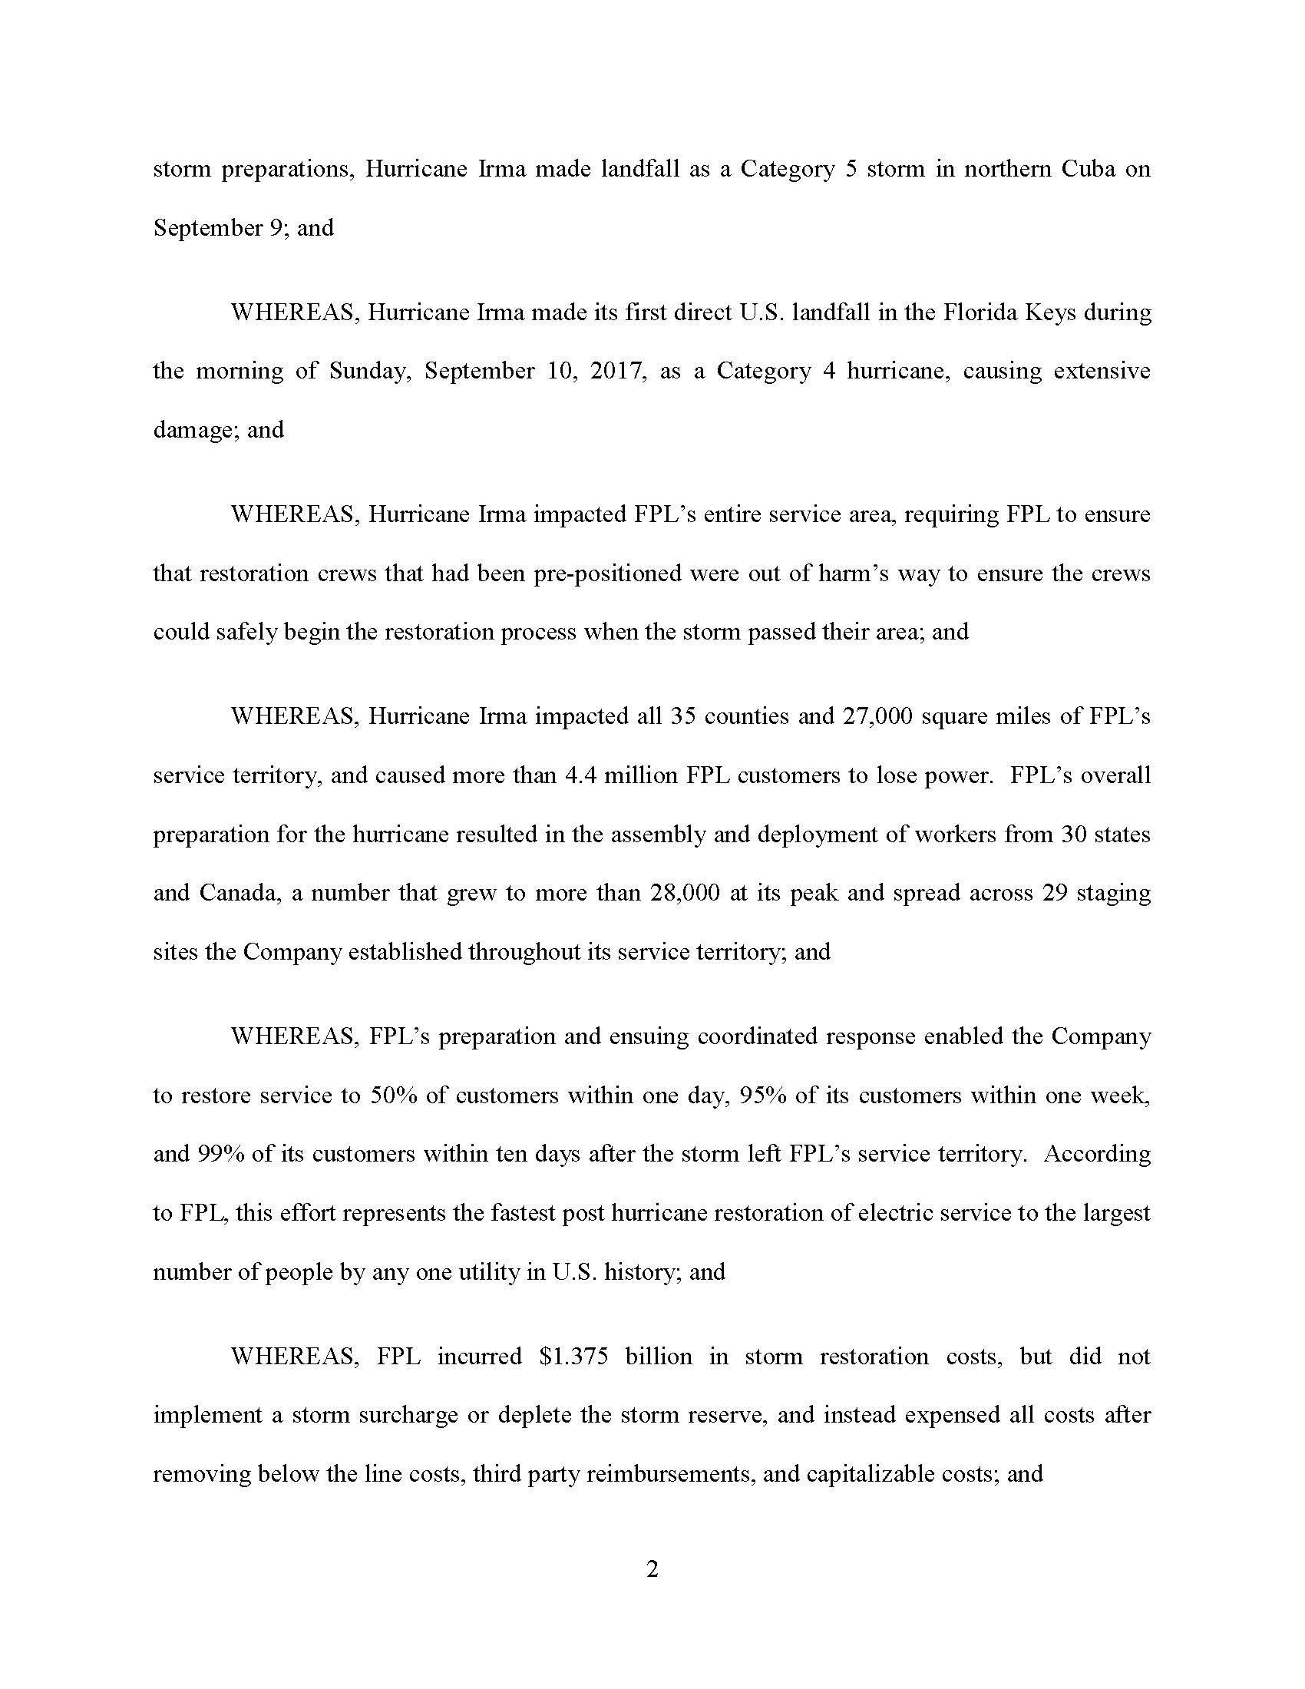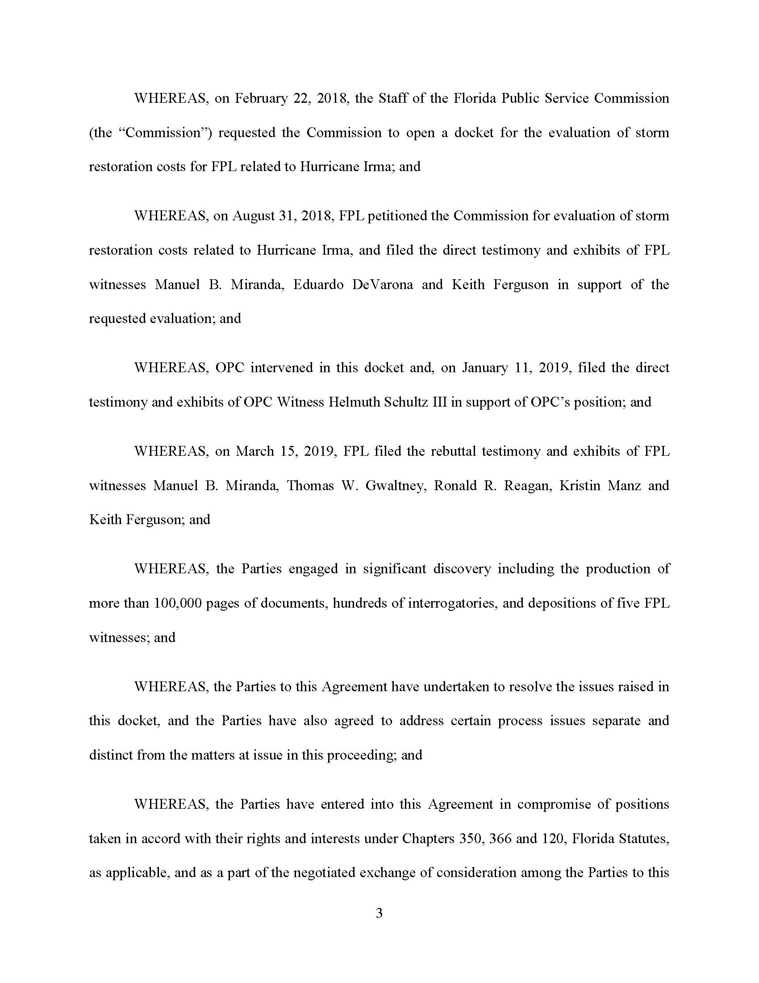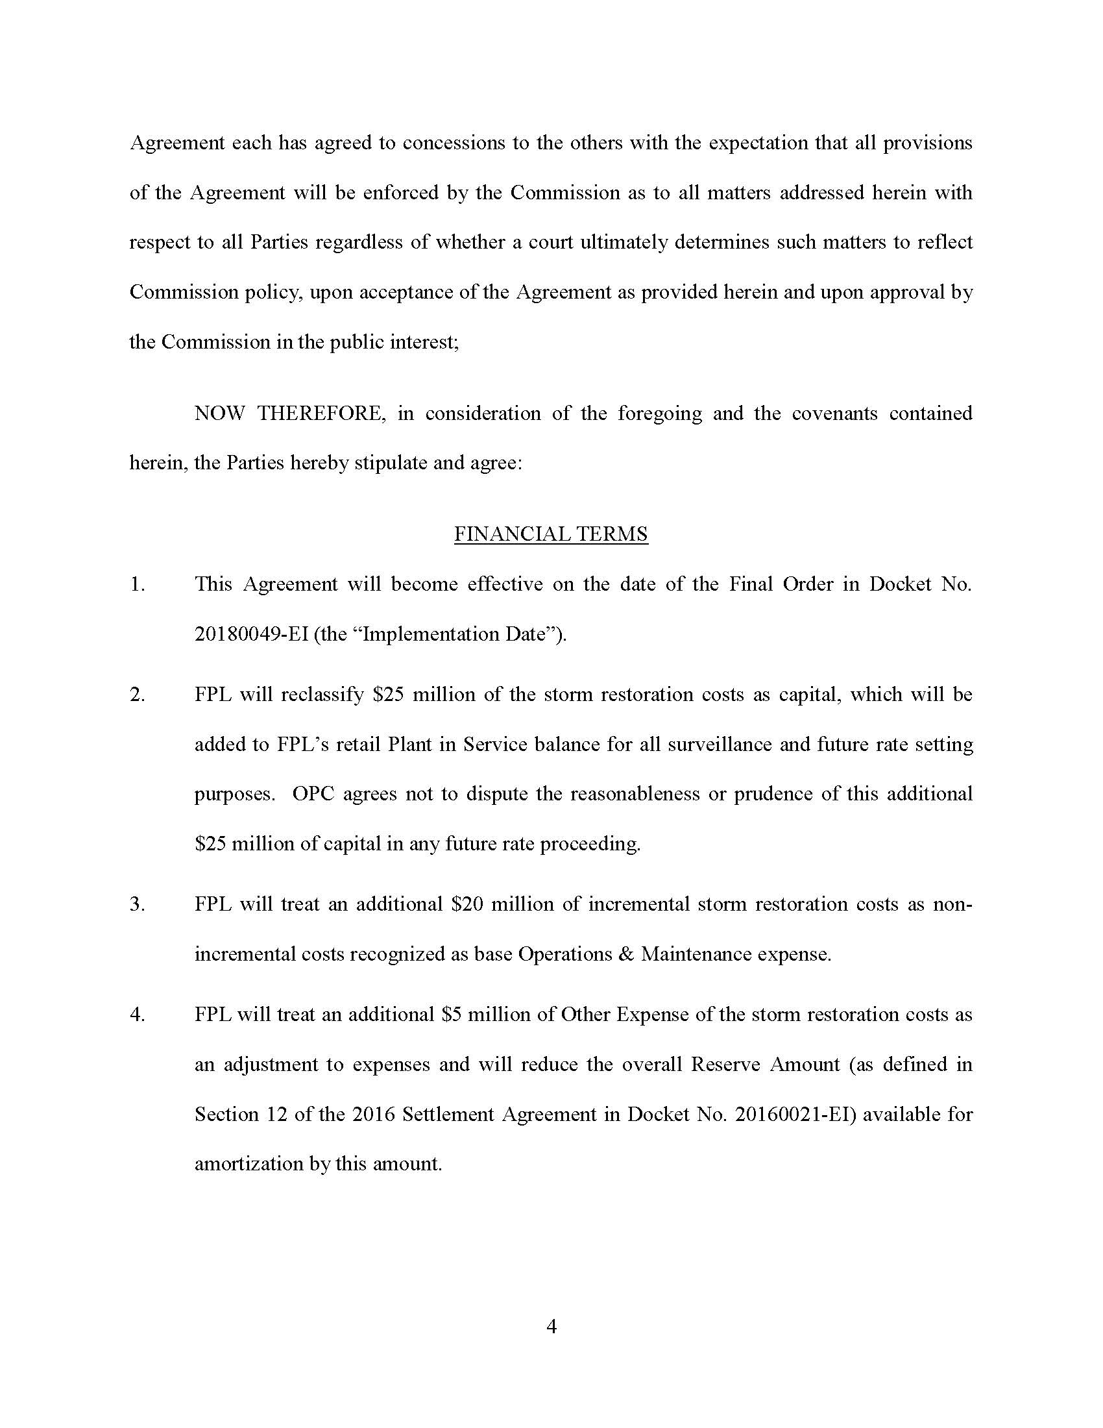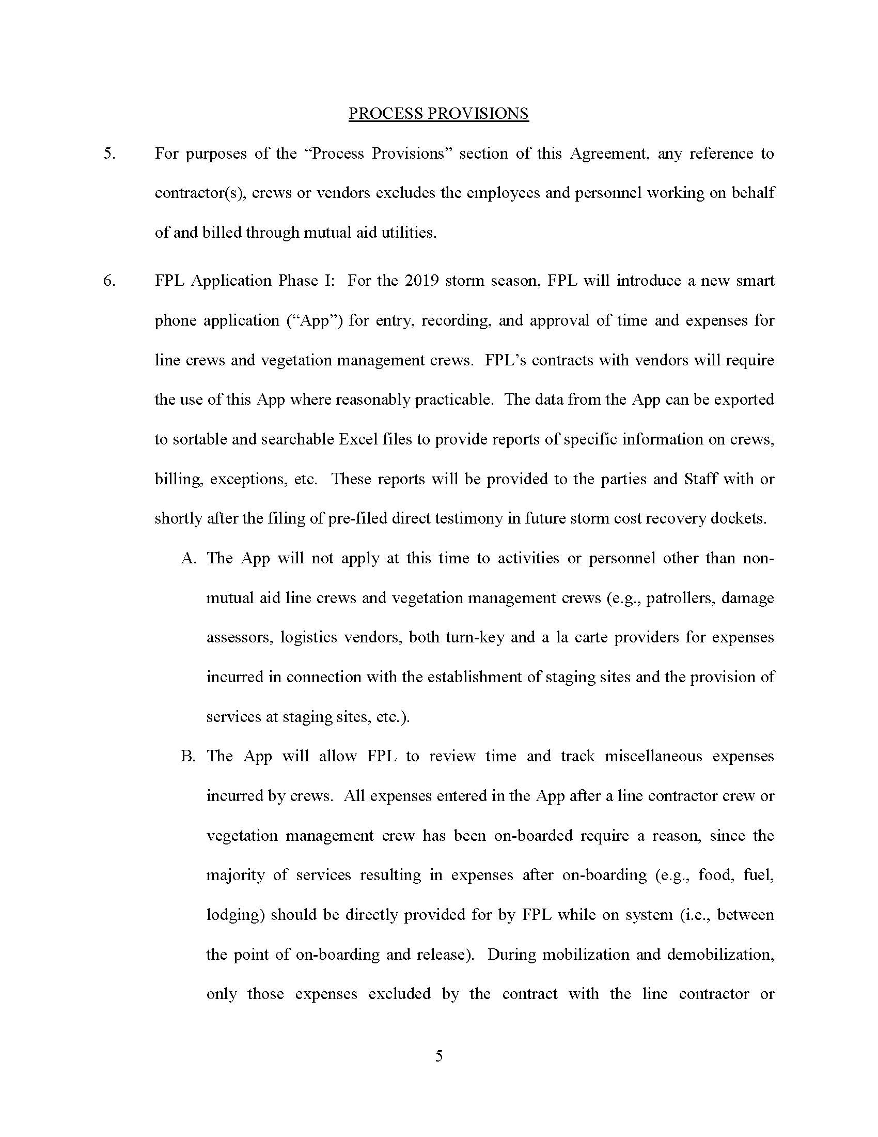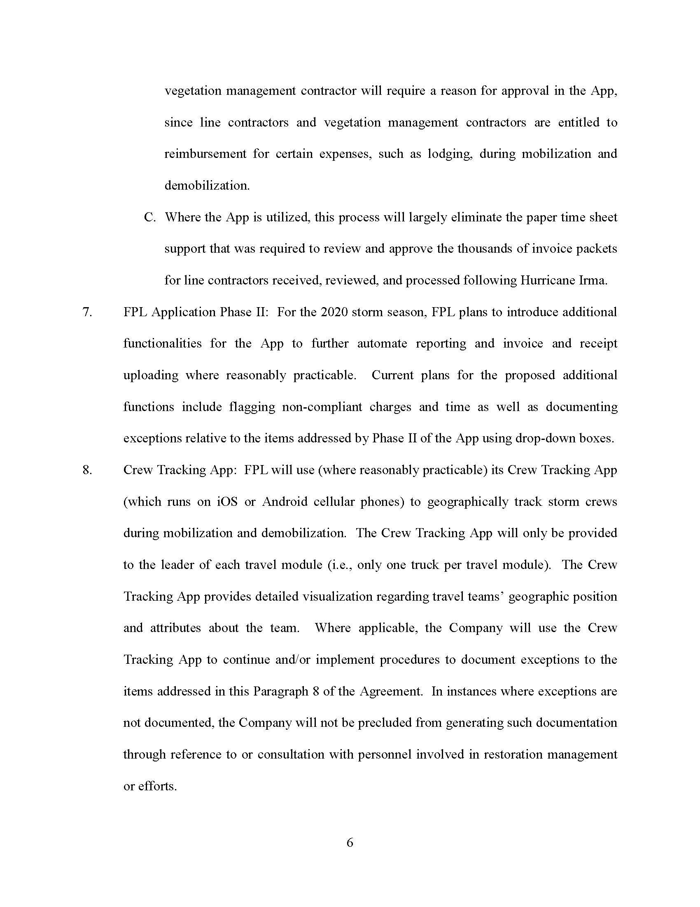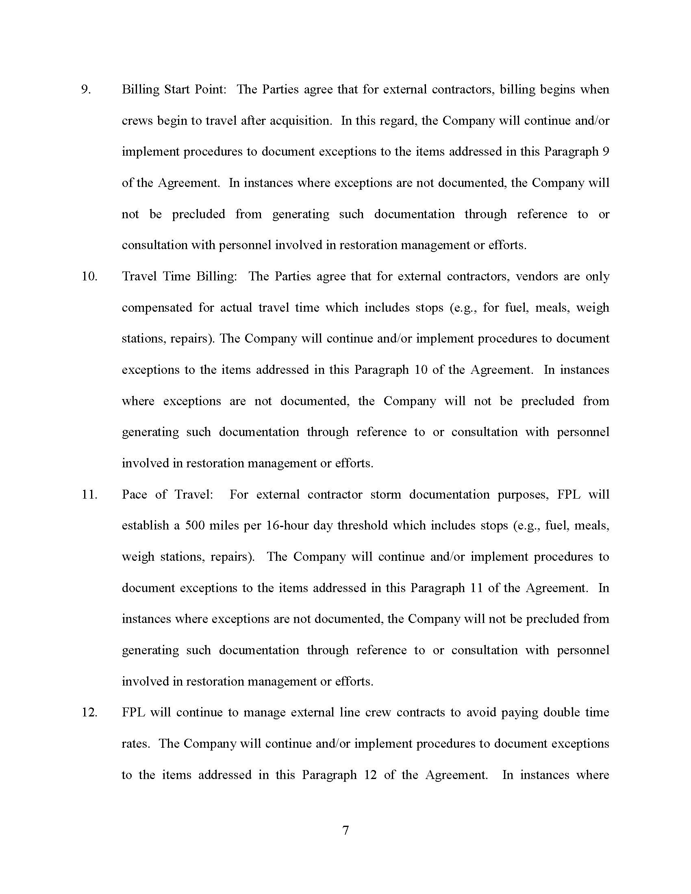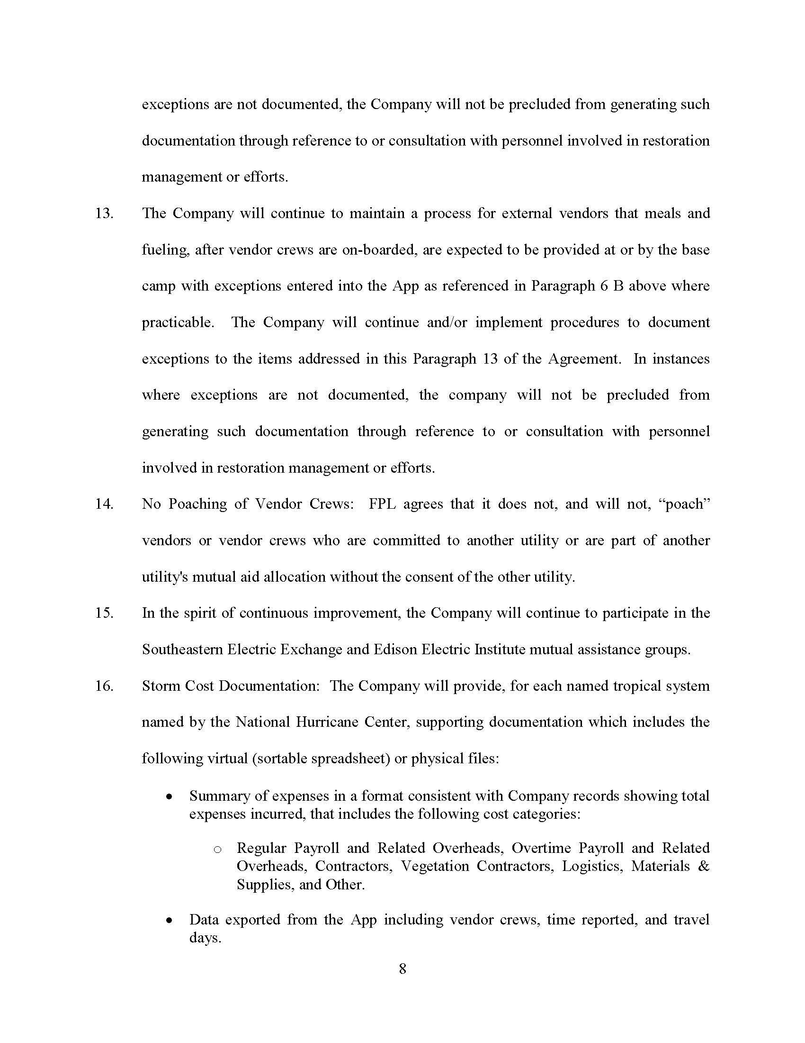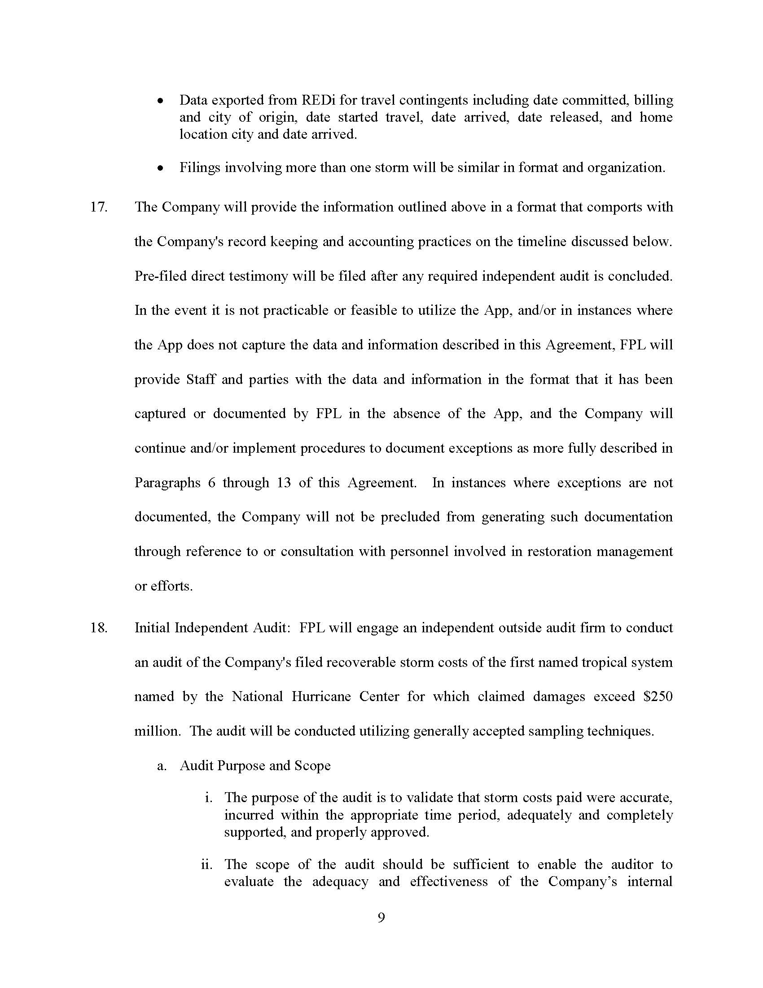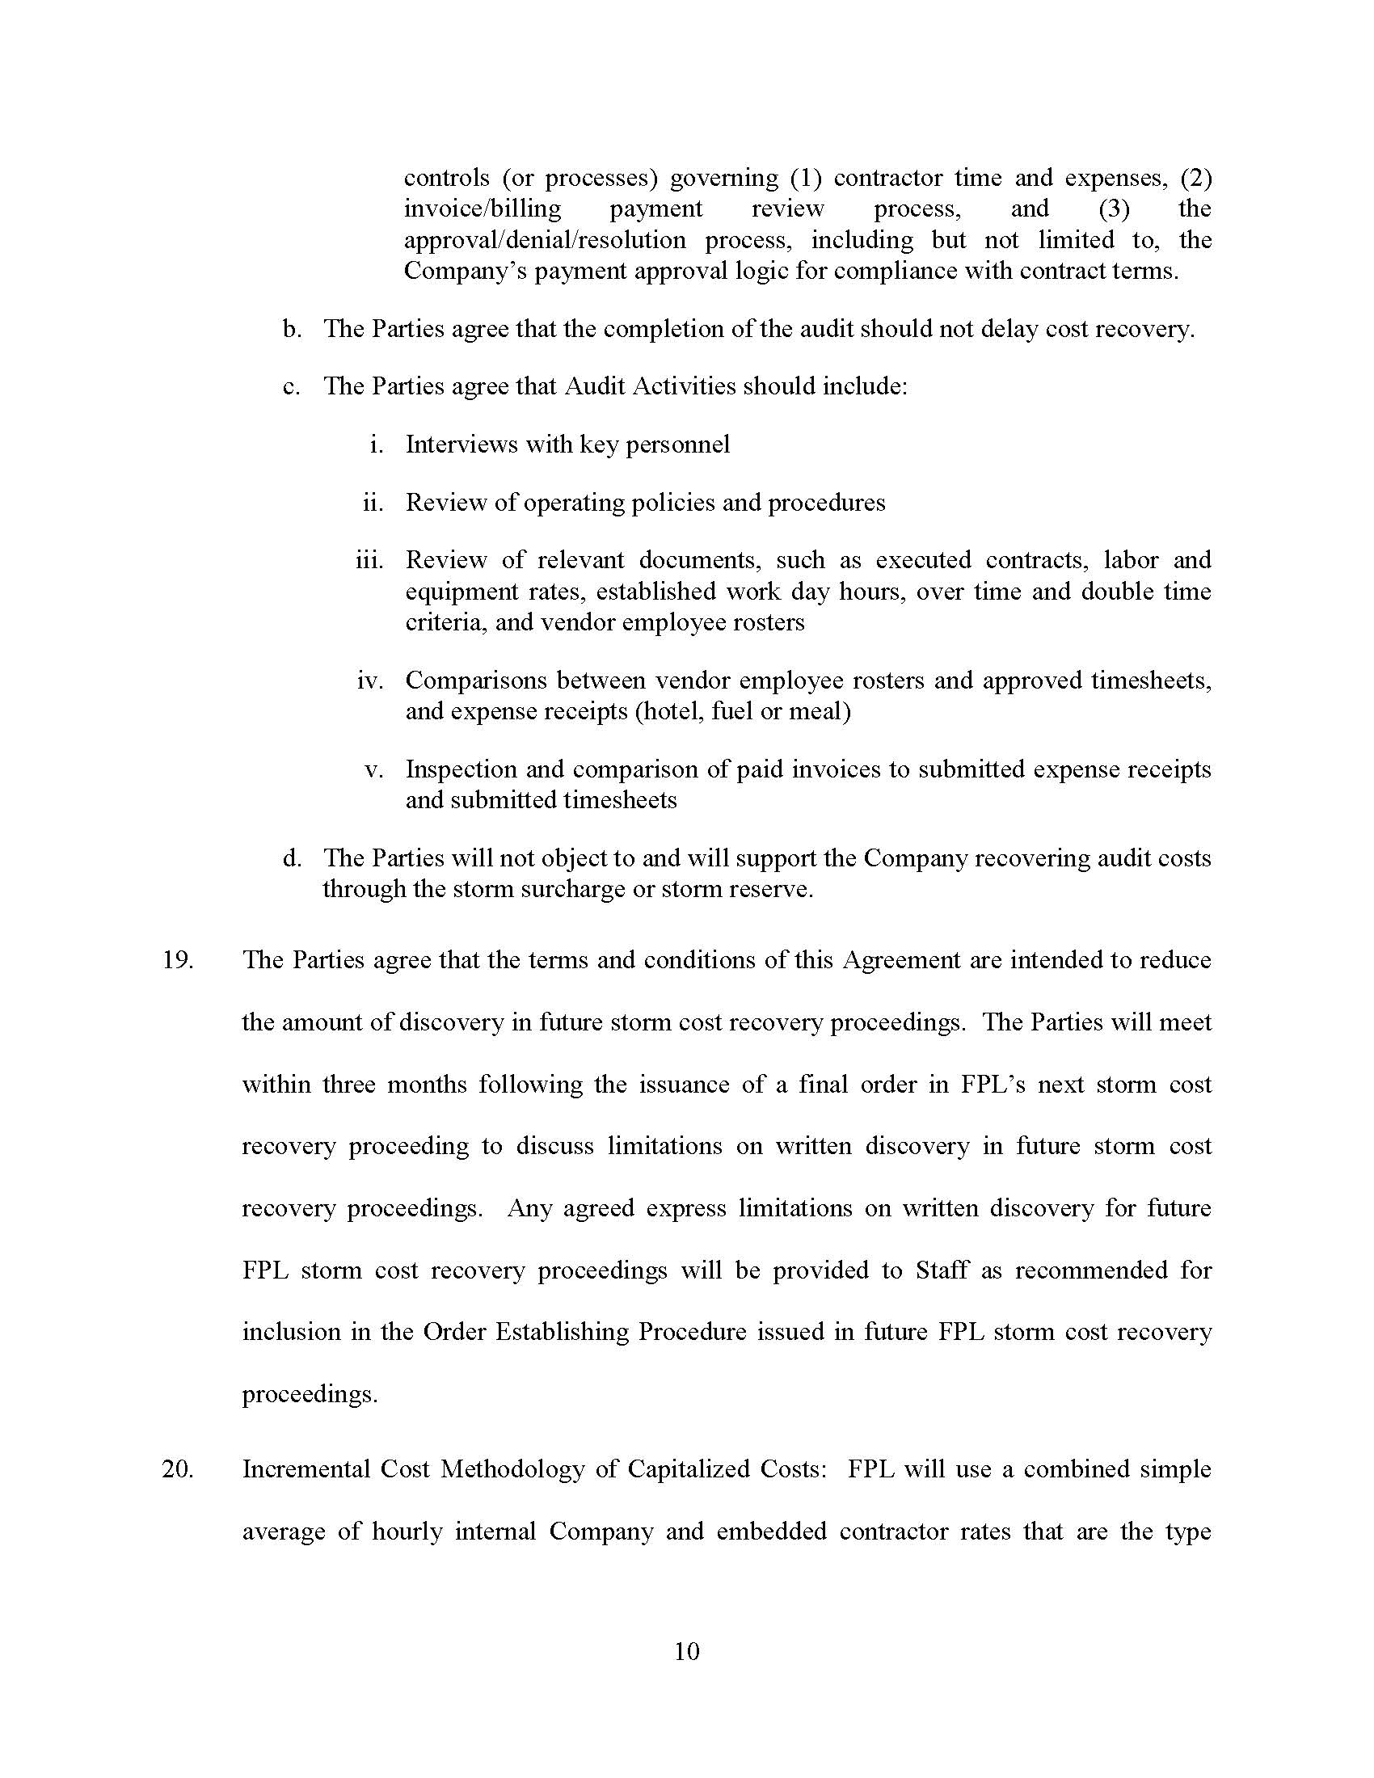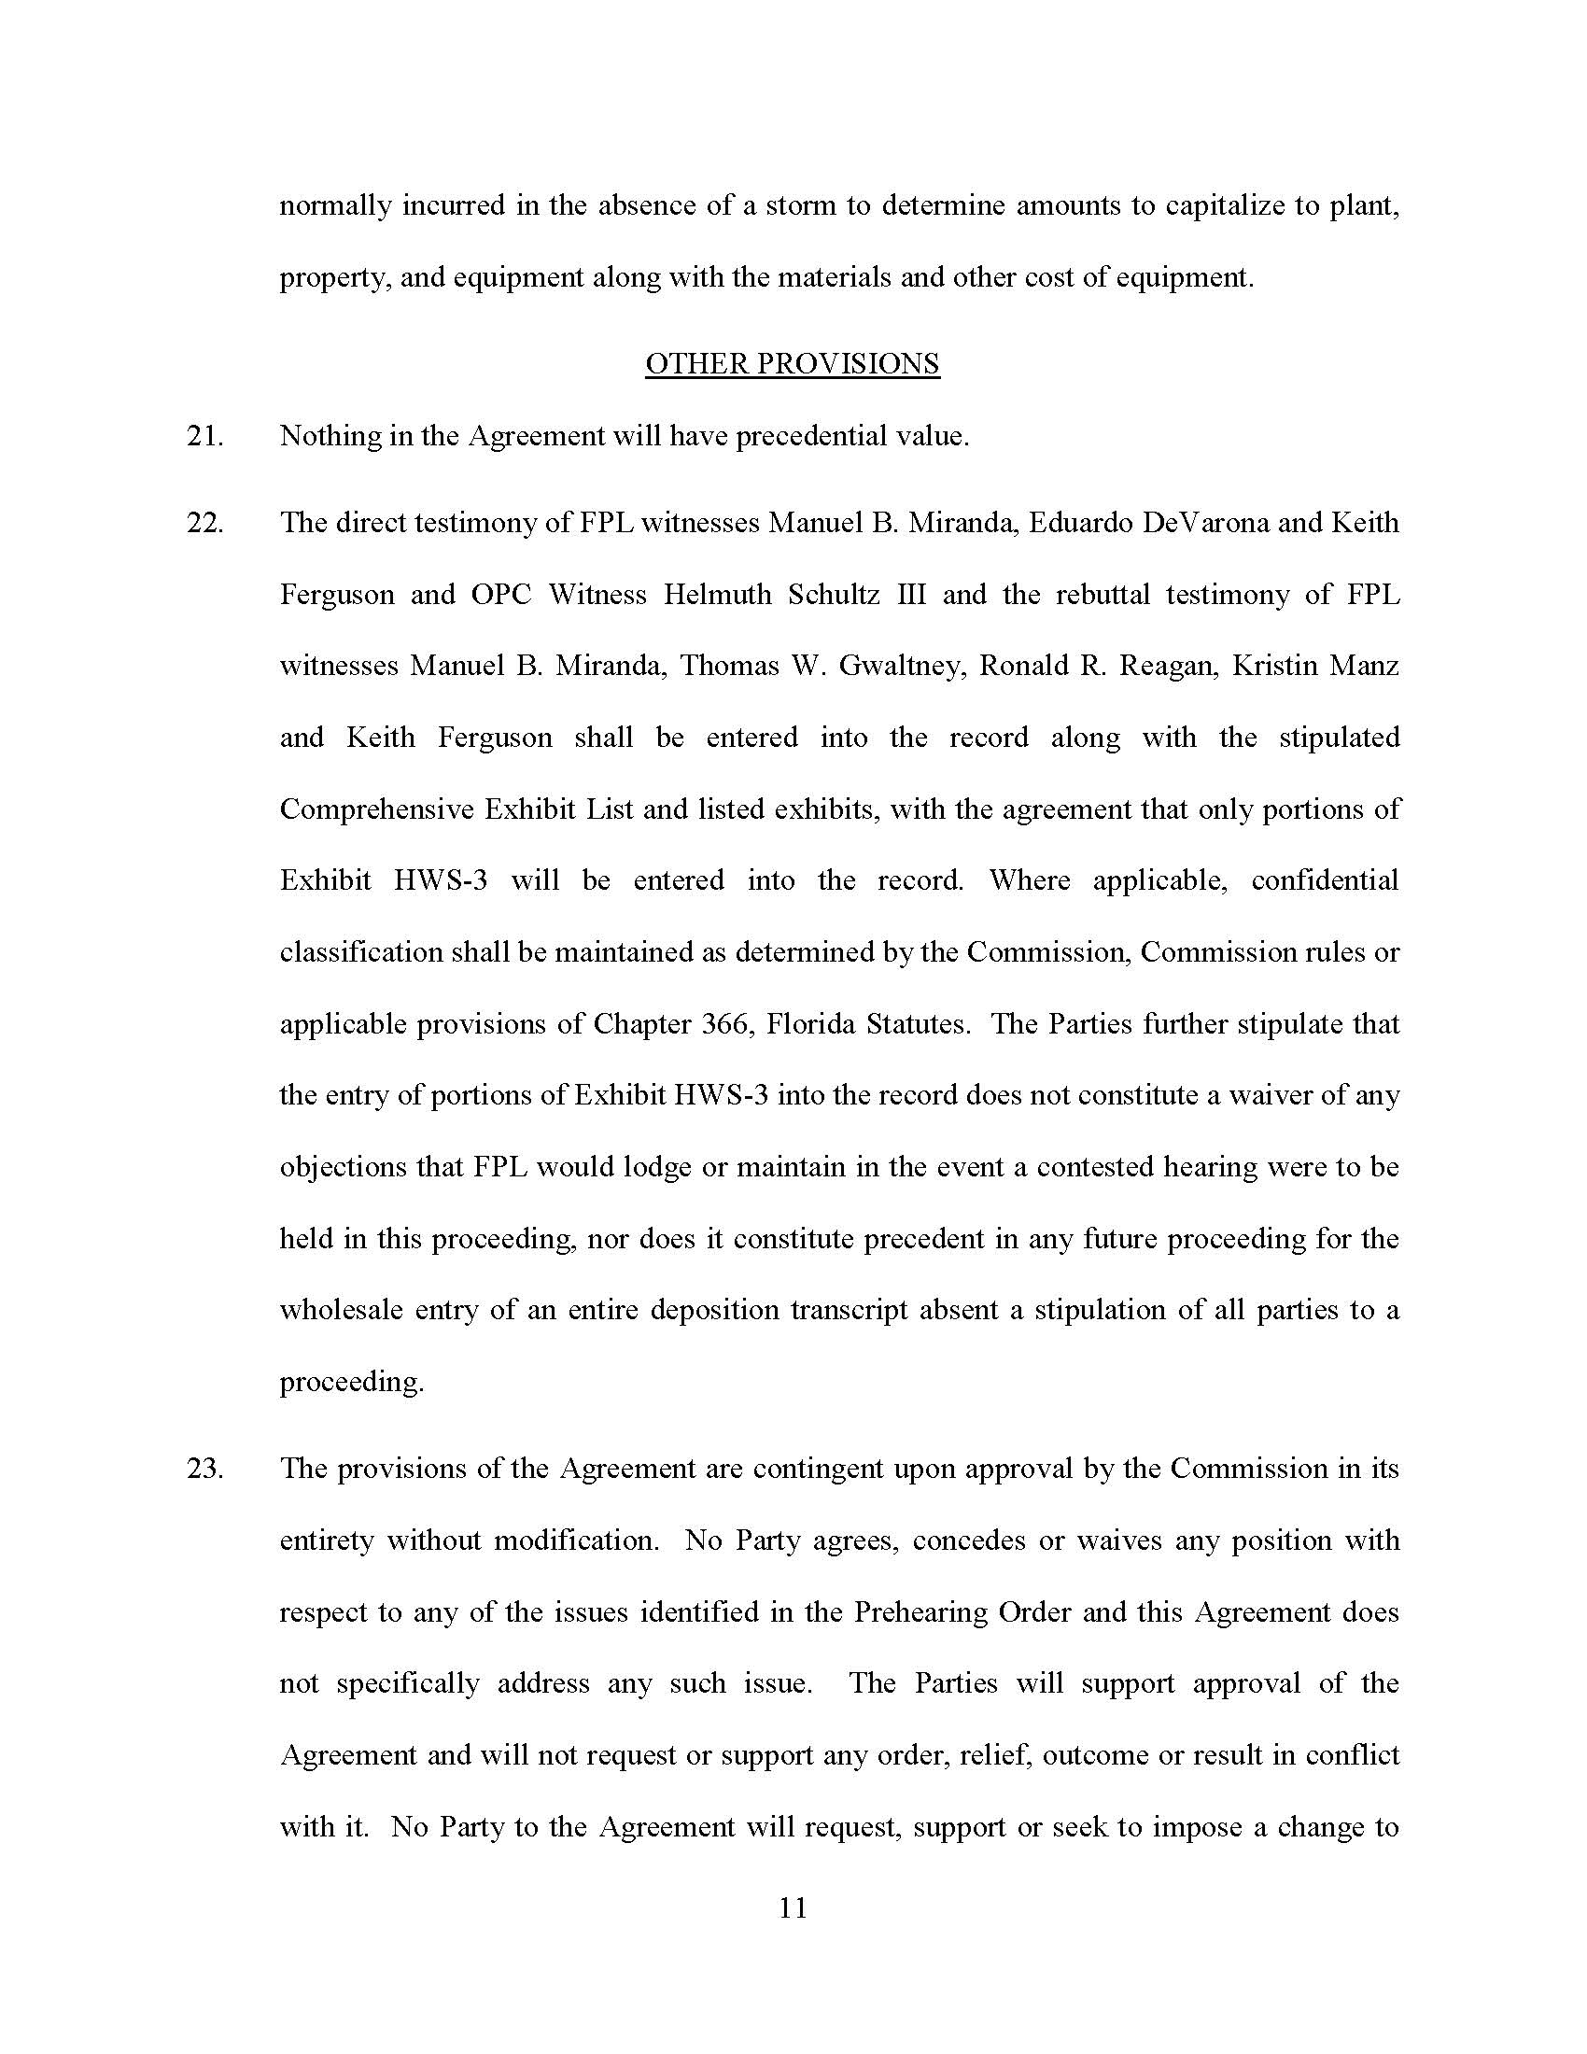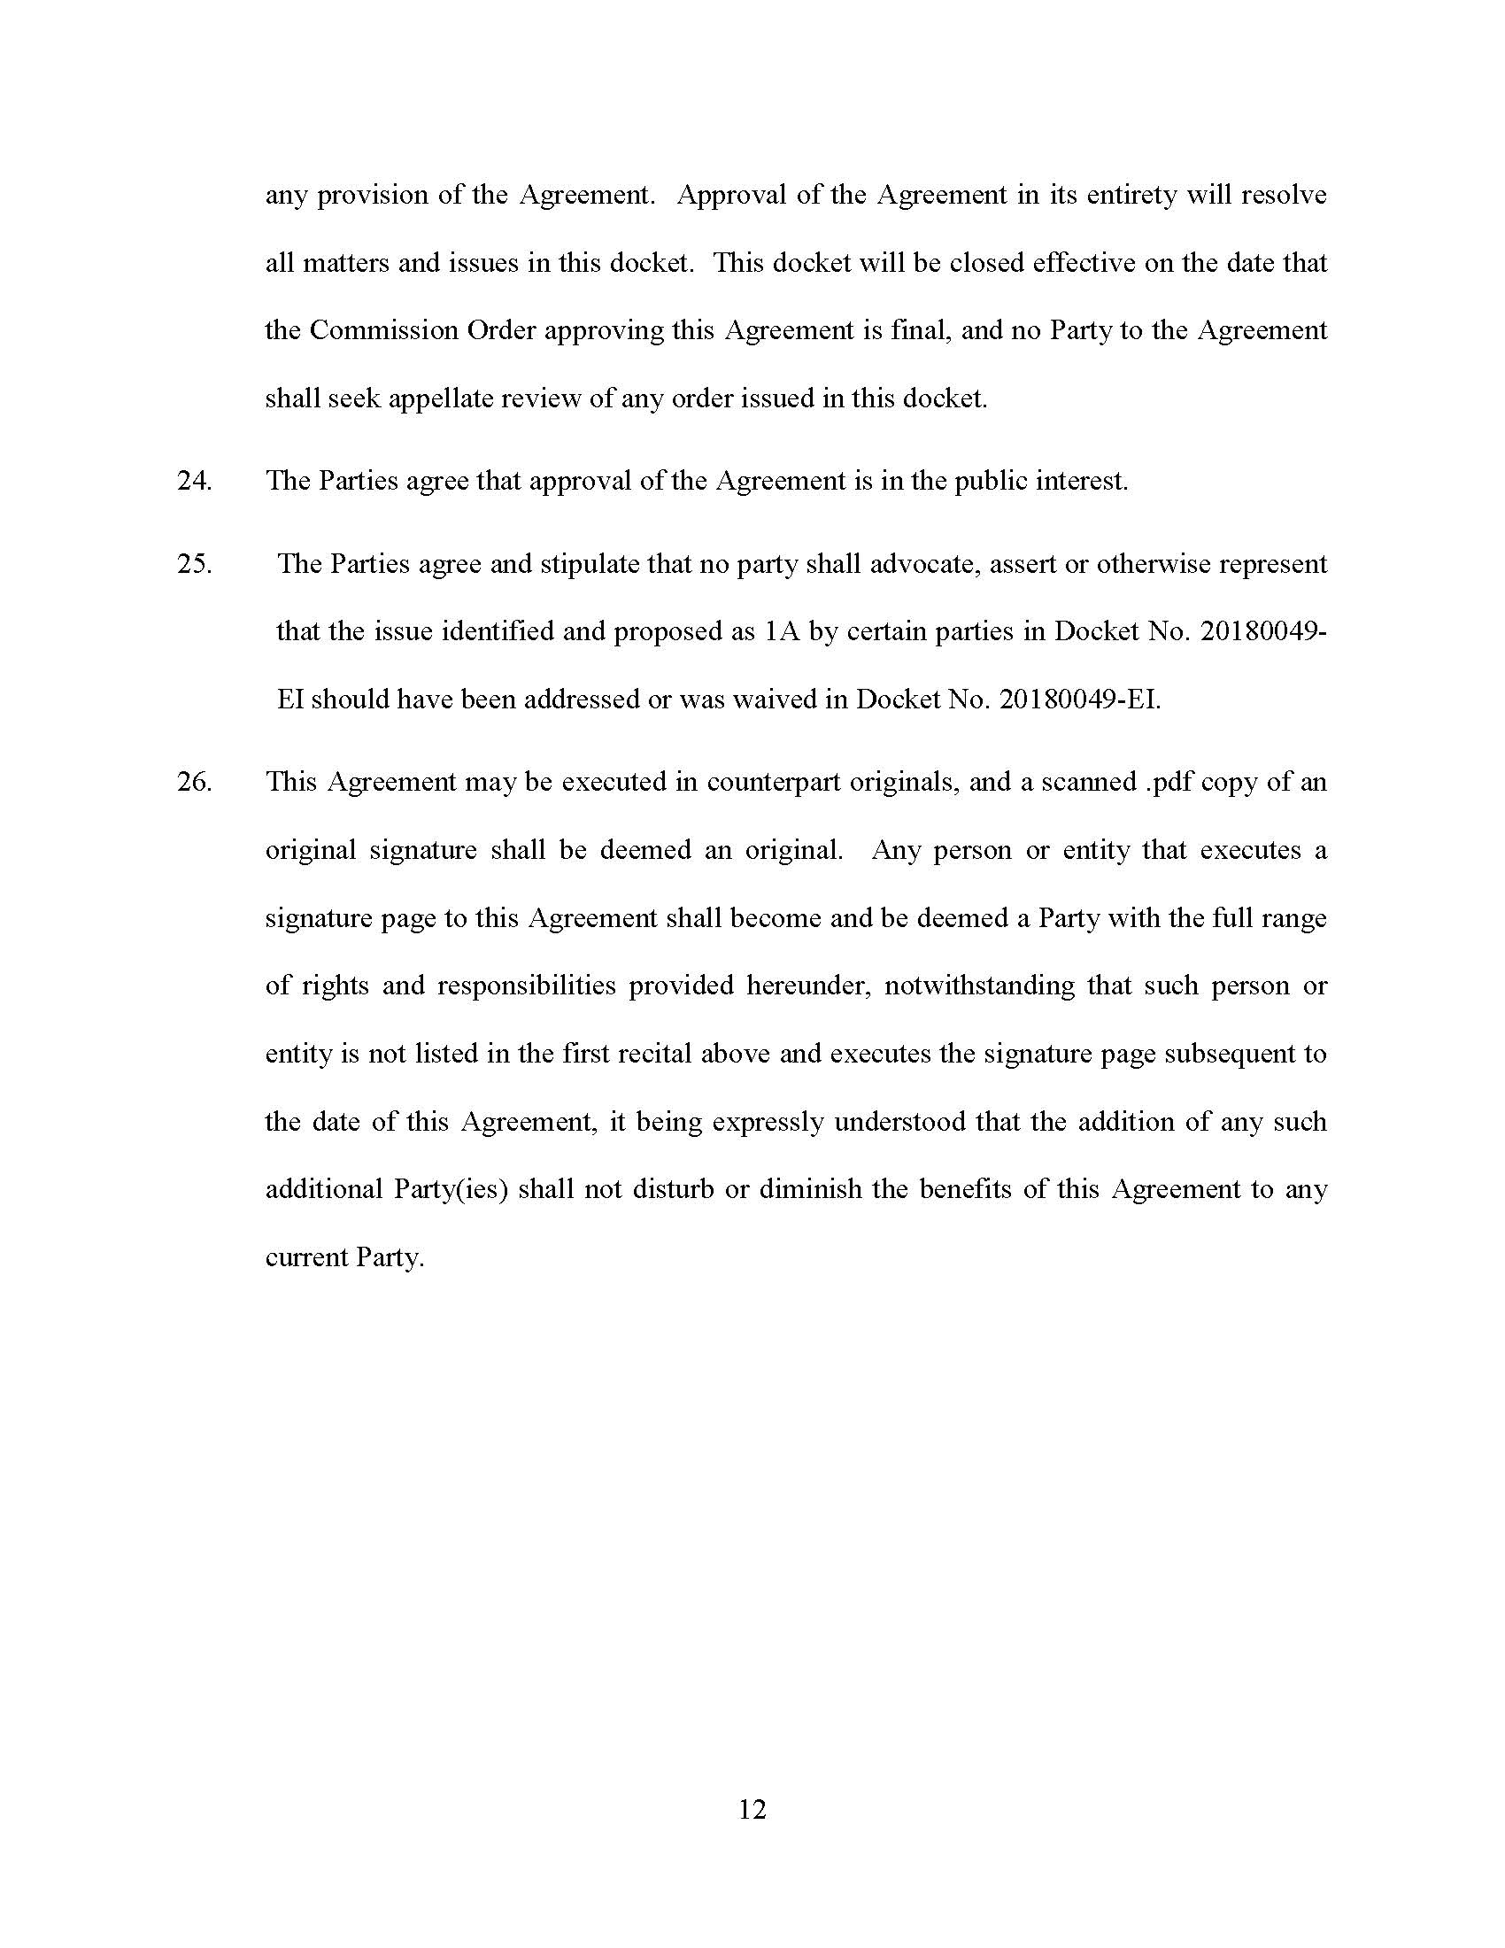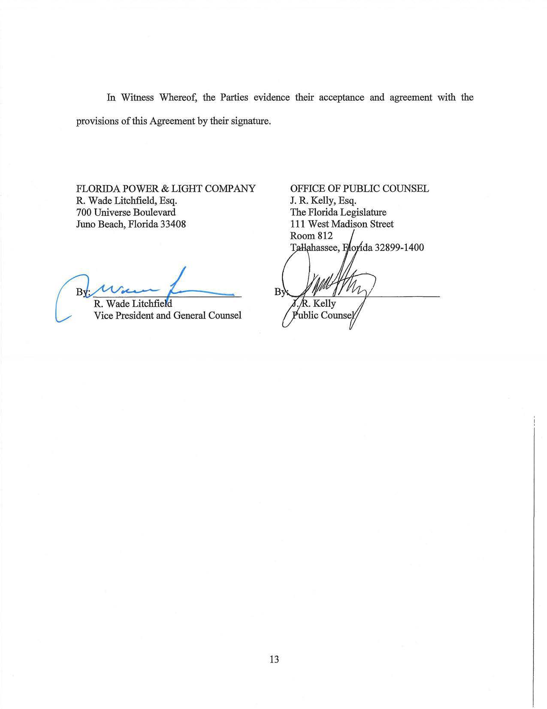

Order No. PSC-2018-0234-PCO-EI, issued May 8, 2018.
Order No. PSC-2018-0298-PCO-EI, issued June 8, 2018.
Order No. PSC-2018-0299-PCO-EG, issued June 8, 2018.
Helmuth Schultz’s Ex. 3, transcripts of the depositions of FPL’s corporate representative panel on November 15, 2018, and December 13, 2018, with deposition exhibits.
Issue 1A: Was FPL required to use the Storm Cost Recovery Mechanism (SCRM) described in Order No. PSC-2016-0560-AS-EI for the recovery of FPL’s reasonable and prudent Hurricane Irma restoration costs?
Sierra Club v. Brown, 243 So. 3d 903, 910-913 (Fla. 2018); Order No. PSC-13-0023-S-EI, issued on January 14, 2013, in Docket No. 120015-EI, In re: Petition for increase in rates by Florida Power & Light Company; Order No. PSC-11-0089-S-EI, issued February 1, 2011, in Docket Nos. 080677 and 090130, In re: Petition for increase in rates by Florida Power & Light Company and In re: 2009 depreciation and dismantlement study by Florida Power & Light Company; Order No. PSC-10-0398-S-EI, issued June 18, 2010, in Docket Nos. 090079-EI, 090144-EI, 090145-EI, 100136-EI, In re: Petition for increase in rates by Progress Energy Florida, Inc., In re: Petition for limited proceeding to include Bartow repowering project in base rates, by Progress Energy Florida, Inc., In re: Petition for expedited approval of the deferral of pension expenses, authorization to charge storm hardening expenses to the storm damage reserve, and variance from or waiver of Rule 25-6.0143(1)(c), (d), and (f), F.A.C., by Progress Energy Florida, Inc., and In re: Petition for approval of an accounting order to record a depreciation expense credit, by Progress Energy Florida, Inc.; Order No. PSC-05-0945-S-EI, issued September 28, 2005, in Docket No. 050078-EI, In re: Petition for rate increase by Progress Energy Florida, Inc.
Order No. PSC-13-0023-S-EI, at p. 7.
As defined in Section 12(a) of FPL’s 2016 Settlement approved by Order No. PSC-16-0560-AS-EI, issued December 15, 2016, in Docket No. 20160021-EI, In re: Petition for rate increase by Florida Power & Light Company.

