State of Florida |  | Public Service Commission  Capital Circle Office Center ● 2540 Shumard Oak Boulevard  Tallahassee, Florida 32399-0850  -M-E-M-O-R-A-N-D-U-M-
DATE: | August 22, 2019
TO: | Office of Commission Clerk (Teitzman)
FROM: | Office of the General Counsel (Harper)  Division of Accounting and Finance (Norris, Sewards)  Division of Economics (Hudson, Ramos, Guffey)
RE: | Docket No. 20190152-WS – Proposed Amendment of Rule 25-30.350, F.A.C., Underbillings and Overbillings for Water and Wastewater Service, and Rule 25-30.360, F.A.C., Refunds.
AGENDA: | 09/05/19 – Regular Agenda – Rule Proposal – Interested Persons May Participate
COMMISSIONERS ASSIGNED: |  |  | All Commissioners
PREHEARING OFFICER: |  |  | Fay
RULE STATUS: |  |  | Proposal May Be Deferred
SPECIAL INSTRUCTIONS: |  |  | None

Case Background
Rule 25-30.350, Underbillings and Overbillings for Water and Wastewater Service, Florida Administrative Code (F.A.C.), addresses underbillings and overbillings by water and wastewater companies. Subsection (2) of the rule provides the criteria for underbillings and allows the customer to pay for the unbilled service over the same time period as the time period during which the underbilling occurred or some other mutually agreeable time period. In addition, the rule sets forth the criteria by which an overbilling is determined and sets forth the procedure for how the refund amount should be calculated based on available records. This rulemaking does not amend any of the underbillings requirements. The focus of this rulemaking is on the overbillings portion of Rule 25-30.350, F.A.C.

Rule 25-30.360, Refunds, F.A.C., provides a process for disbursing overbilling refunds to water and wastewater customers. The rule sets forth the procedures for the timing of refunds, basis of the refund, cases where refunds include interest, the method of refund distribursement, security money collected subject to a refund, and refund reports.
On April 18, 2019, Office of Public Counsel (OPC) filed a petition for declaratory statement that sought clarification on how the Commission applies Rule 25-30.350, F.A.C., and Rule 25-30.360, F.A.C., in the case of overbillings. On June 24, 2019, OPC withdrew its petition for declaratory statement after staff agreed to initiate rulemaking to explore whether Rule 25-30.350, F.A.C., and Rule 25-30.360, F.A.C., should be amended to clarify the process that the Commission uses to refund overbillings.
A Notice of Development of Rulemaking was published in Volume 45, No. 120, of the Florida Administrative Register on June 20, 2019. A rule development workshop was held on July 15, 2019. Representatives from OPC and Utilities Inc. Florida were in attendance.
This recommendation addresses whether the Commission should amend Rules 25-30.350 and 25-30.360, F.A.C. The Commission has jurisdiction pursuant to Sections 120.54, 367.081, 367.091, and 367.161, Florida Statutes (F.S.).

Discussion of Issues

Issue 1:
Should the Commission amend Rule 25-30.350, Underbillings and Overbillings for Water and Wastewater Service, F.A.C., and Rule 25-30.360, Refunds, F.A.C.?

Recommendation:
Yes, the Commission should amend Rule 25-30.350, F.A.C., and Rule 25-30.360, F.A.C, as set forth in Attachment A. The Commission should certify Rules 25-30.350 and 25-30.360, F.A.C., as minor violation rules. (Harper, Sewards, Norris, Hudson, Guffey, Ramos)

Staff Analysis:
Rule 25-30.350, F.A.C., sets forth the procedure for calculating overbillings. Rule 25-30.360, F.A.C., sets forth the procedure for disbursing the amount of refunds. Staff believes that both Rule 25-30.350, F.A.C., and Rule 25-30.360, F.A.C., work in conjunction, i.e., once the Commission determines that a water or wastewater utility has overbilled a customer pursuant to Rule 25-30.350, F.A.C., any refund required due to overbilling must be disbursed by the utility pursuant to Rule 25-30.360, F.A.C. Staff recommends that both rules be amended to clarify that the two rules are to function in conjunction with each other.
Staff recommends that subsection (3) of Rule 25-30.350, F.A.C., include a reference to Rule 25-30.360, F.A.C., to clarify that if there is a determination of overbilling, any refunds for overbillings must be disbursed pursuant to Rule 25-30.360, F.A.C. Similarly, in subsection (1) of Rule 25-30.360, F.A.C., staff recommends adding a reference to Rule 25-30.350, F.A.C., to clarify that before a refund can be disbursed, the calculation for overbillings must first be made pursuant to Rule 25-30.350, F.A.C. In other words, all refund calculations are made pursuant to Rule 25-30.350, F.A.C., and the disbursement of the refunds are made pursuant to Rule 25-30.360, F.A.C.
In addition, staff recommends removing the discretionary language in subsection (1) of Rule 25-30.360, F.A.C., and the reference to the customer deposit rule. Subsection (1) should instead state that unless another rule specifically sets forth procedures for making refunds, Rule 25-30.360, F.A.C., is applicable in the case of a customer refund.

Minor Violation Rules Certification
Rules 25-30.350 and 25-30.360, F.A.C., are on the Commission’s list of minor violation rules. Pursuant to Section 120.695, F.S., as of July 1, 2017, the agency head shall certify whether any part of each rule filed for adoption is designated as a minor violation rule. A minor violation rule is a rule that would not result in economic or physical harm to a person or an adverse effect on the public health, safety, or welfare or create a significant threat of such harm when violated. Staff recommends that the Commission continue to certify both rules as minor violation rules.

Statement of Estimated Regulatory Costs
Pursuant to Section 120.54(3)(b)1., F.S., agencies are encouraged to prepare a statement of estimated regulatory costs (SERC) before the adoption, amendment, or repeal of any rule. A SERC was prepared for this rulemaking and is appended as Attachment B. As required by Section 120.541(2)(a)1., F.S., the SERC analysis includes whether the rule amendments are likely to have an adverse impact on economic growth, private sector job creation or employment, or private sector investment in excess of $1 million in the aggregate within five years after implementation. Staff notes that none of the impact/cost criteria will be exceeded as a result of the recommended revisions.

The SERC concludes that the amendments to Rules 25-30.350 and 25-30.360, F.A.C., will likely not directly or indirectly increase regulatory costs in excess of $200,000 within 1 year after implementation. Further, the SERC concludes that the amendment of the rules will not likely increase regulatory costs, including any transactional costs, or have an adverse impact on business competitiveness, productivity, or innovation in excess of $1 million in the aggregate within five years of implementation. Thus, the amendment of the rules does not require legislative ratification, pursuant to Section 120.541(3), F.S.

In addition, the SERC states that the amendments to Rules 25-30.350 and 25-30.360, F.A.C., would have no impact on small businesses, would have no implementation or enforcement cost on the Commission or any other state and local government entity, and would have no impact on small cities or small counties. The SERC states that no additional transactional costs are likely to be incurred by individuals and entities required to comply with the requirements.

Conclusion
The Commission should amend Rules 25-30.350 and 25-30.360, F.A.C., as set forth in Attachment A. The Commission should certify Rules 25-30.350 and 25-30.360, F.A.C., as minor violation rules.

Issue 2:
Should this docket be closed?

Recommendation:
Yes. If no requests for hearing or comments are filed, the rules may be filed with the Department of State, and this docket should be closed. (Harper)

Staff Analysis:
If no requests for hearing or comments are filed, the rules may be filed with the Department of State, and this docket should be closed.

25-30.350 Underbillings and Overbillings for Water and Wastewater Service.
(1) A utility may not backbill customers for any period greater than 12 months for any undercharge in billing which is the result of the utility’s mistake.
(a) The utility shall allow the customer to pay for the unbilled service over the same time period as the time period during which the underbilling occurred or some other mutually agreeable time period. The utility shall not recover in a ratemaking proceeding, any lost revenues which inure to the utility’s detriment on account of this provision.
(b) The revised bill shall be calculated on a monthly basis, assuming uniform consumption during the month(s) subject to underbilling, based on the individual customer’s average usage for the time period covered by the underbilling. The monthly bills shall be recalculated by applying the tariff rates in effect for that time period. The customer shall be responsible for the difference between the amount originally billed and the recalculated bill. All calculations used to arrive at the rebilled amount shall be made available to the customer upon the customer’s request.
(2) In the event of an overbilling, the utility shall refund the overcharge to the customer based on available records. If the commencement date of the overbilling cannot be determined, then an estimate of the overbilling shall be made based on the customer’s past consumption.
(3) In the event of an overbilling, the customer may elect to receive the refund as a one-time disbursement, if the refund is in excess of $20, or as a credit to future billings. Refunds for overbillings shall be disbursed pursuant to Rule 25-30.360, F.A.C.
Rulemaking Authority 350.127(2), 367.121 FS. Law Implemented 367.091, 367.121 FS. History–New 11-10-86, Amended 6-17-13, ______________.

25-30.360 Refunds.
(1) Applicability. With the exception of deposit refunds, Aall refunds under this chapter ordered by the Commission shall be made in accordance with the provisions of this rule, unless another rule in this chapter specifically sets forth the procedure for making refunds otherwise ordered by the Commission. The calculation for overbillings shall be pursuant to Rule 25-30.350, F.A.C., and disbursed pursuant to this rule.
(2) Timing of Refunds. Refunds must be made within 90 days of the Commission’s order unless a different time frame is prescribed by the Commission. A timely motion for reconsideration temporarily stays the refund, pending the final order on the motion for reconsideration. In the event of a stay pending reconsideration, the timing of the refund shall commence from the date of the order disposing of any motion for reconsideration. This rule does not authorize any motion for reconsideration not otherwise authorized by Chapter 25-22, F.A.C.
(3) Basis of Refund. Where the refund is the result of a specific rate change, including interim rate increases, and the refund can be computed on a per customer basis, that will be the basis of the refund. However, where the refund is not related to specific rate changes, such as a refund for overearnings, the refund shall be made to customers of record as of a date specified by the Commission. In such case, refunds shall be made on the basis of usage. Per customer refund refers to a refund to every customer receiving service during the refund period. Customer of record refund refers to a refund to every customer receiving service as of a date specified by the Commission.
(4) Interest.
(a) In the case of refunds which the Commission orders to be made with interest, the average monthly interest rate until refund is posted to the customer’s account shall be based on the 30 day commercial paper rate for high grade, unsecured notes sold through dealers by major corporations in multiples of $1,000 as regularly published in the Wall Street Journal.
(b) This average monthly interest rate shall be calculated for each month of the refund period:
1. By adding the published interest rate in effect for the last business day of the month prior to each month the refund period and the published rate in effect for the last business day of each month of the refund period divided by 24 to obtain the average monthly interest rate;
2. The average monthly interest rate for the month prior to distribution shall be the same as the last calculated average monthly interest rate.
(c) The average monthly interest rate shall be applied to the sum of the previous month’s ending balance (including monthly interest accruals) and the current month’s ending balance divided by 2 to accomplish a compounding effect.
(d) Interest Multiplier. When the refund is computed for each customer, an interest multiplier may be applied against the amount of each customer’s refund in lieu of a monthly calculation of the interest for each customer. The interest multiplier shall be calculated by dividing the total amount refundable to all customers, including interest, by the total amount of the refund, excluding interest. For the purpose of calculating the interest multiplier, the utility may, upon approval by the Commission, estimate the monthly refundable amount.
(e) Commission staff shall provide applicable interest rate figures and assistance in calculations under this Rule upon request of the affected utility.
(5) Method of Refund Distribution. For those customers still on the system, a credit shall be made on the bill. In the event the refund is for a greater amount than the bill, the remainder of the credit shall be carried forward until the refund is completed. If the customer so requests, a check for any negative balance must be sent to the customer within 10 days of the request. For customers entitled to a refund but no longer on the system, the company shall mail a refund check to the last known billing address except that no refund for less than $1.00 will be made to these customers.
(6) Security for Money Collected Subject to Refund. In the case of money being collected subject to refund, the money shall be secured by a bond unless the Commission specifically authorizes some other type of security such as placing the money in escrow, approving a corporate undertaking, or providing a letter of credit. The company shall provide a report by the 20th of each month indicating the monthly and total amount of money subject to refund as of the end of the preceding month. The report shall also indicate the status of whatever security is being used to guarantee repayment of the money.
(7) Refund Reports. During the processing of the refund, monthly reports on the status of the refund shall be made by the 20th of the following month. In addition, a preliminary report shall be made within 30 days after the date the refund is completed and again 90 days thereafter. A final report shall be made after all administrative aspects of the refund are completed. The above reports shall specify the following:
(a) The amount of money to be refunded and how that amount was computed;
(b) The amount of money actually refunded;
(c) The amount of any unclaimed refunds; and
(d) The status of any unclaimed amounts.
(8) Any unclaimed refunds shall be treated as cash contributions-in-aid-of-construction.
Rulemaking Authority 350.127(2), 367.121 FS. Law Implemented 367.081, 367.0814, 367.082(2) FS. History–New 8-18-83, Formerly 25-10.76, 25-10.076, Amended 11-30-93, ________.

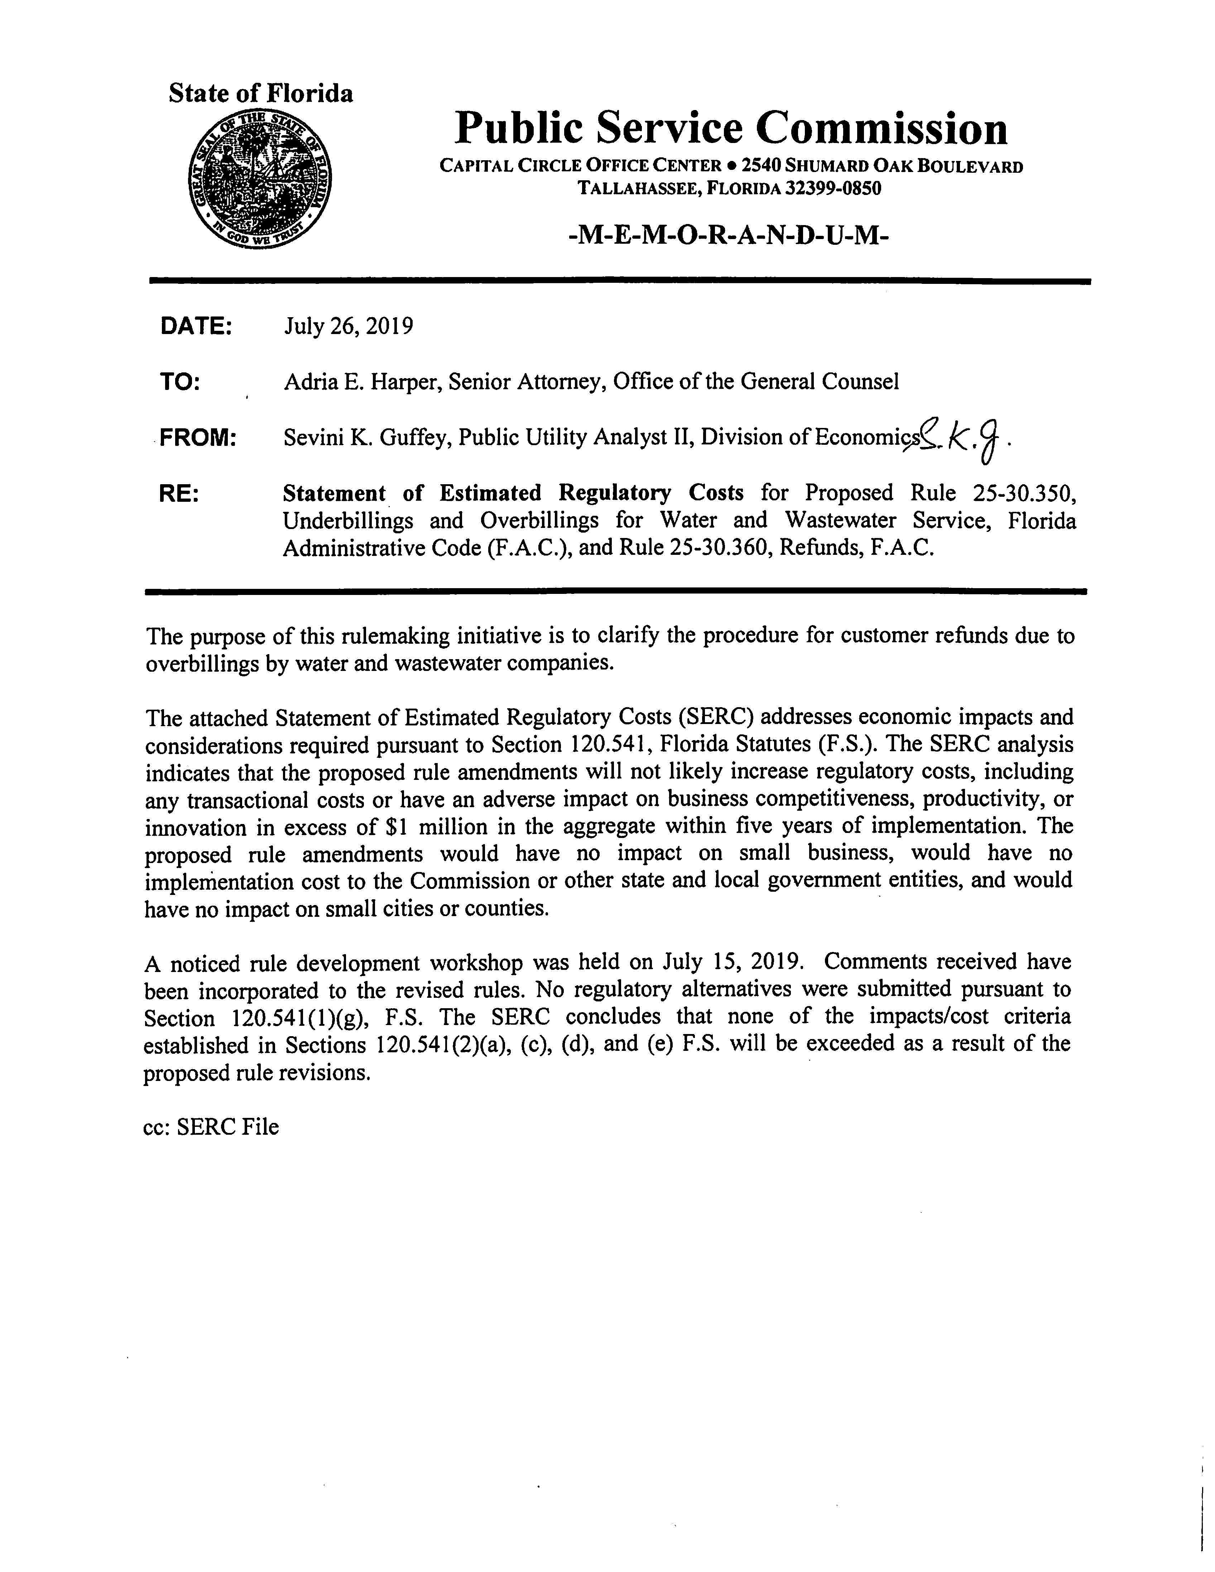

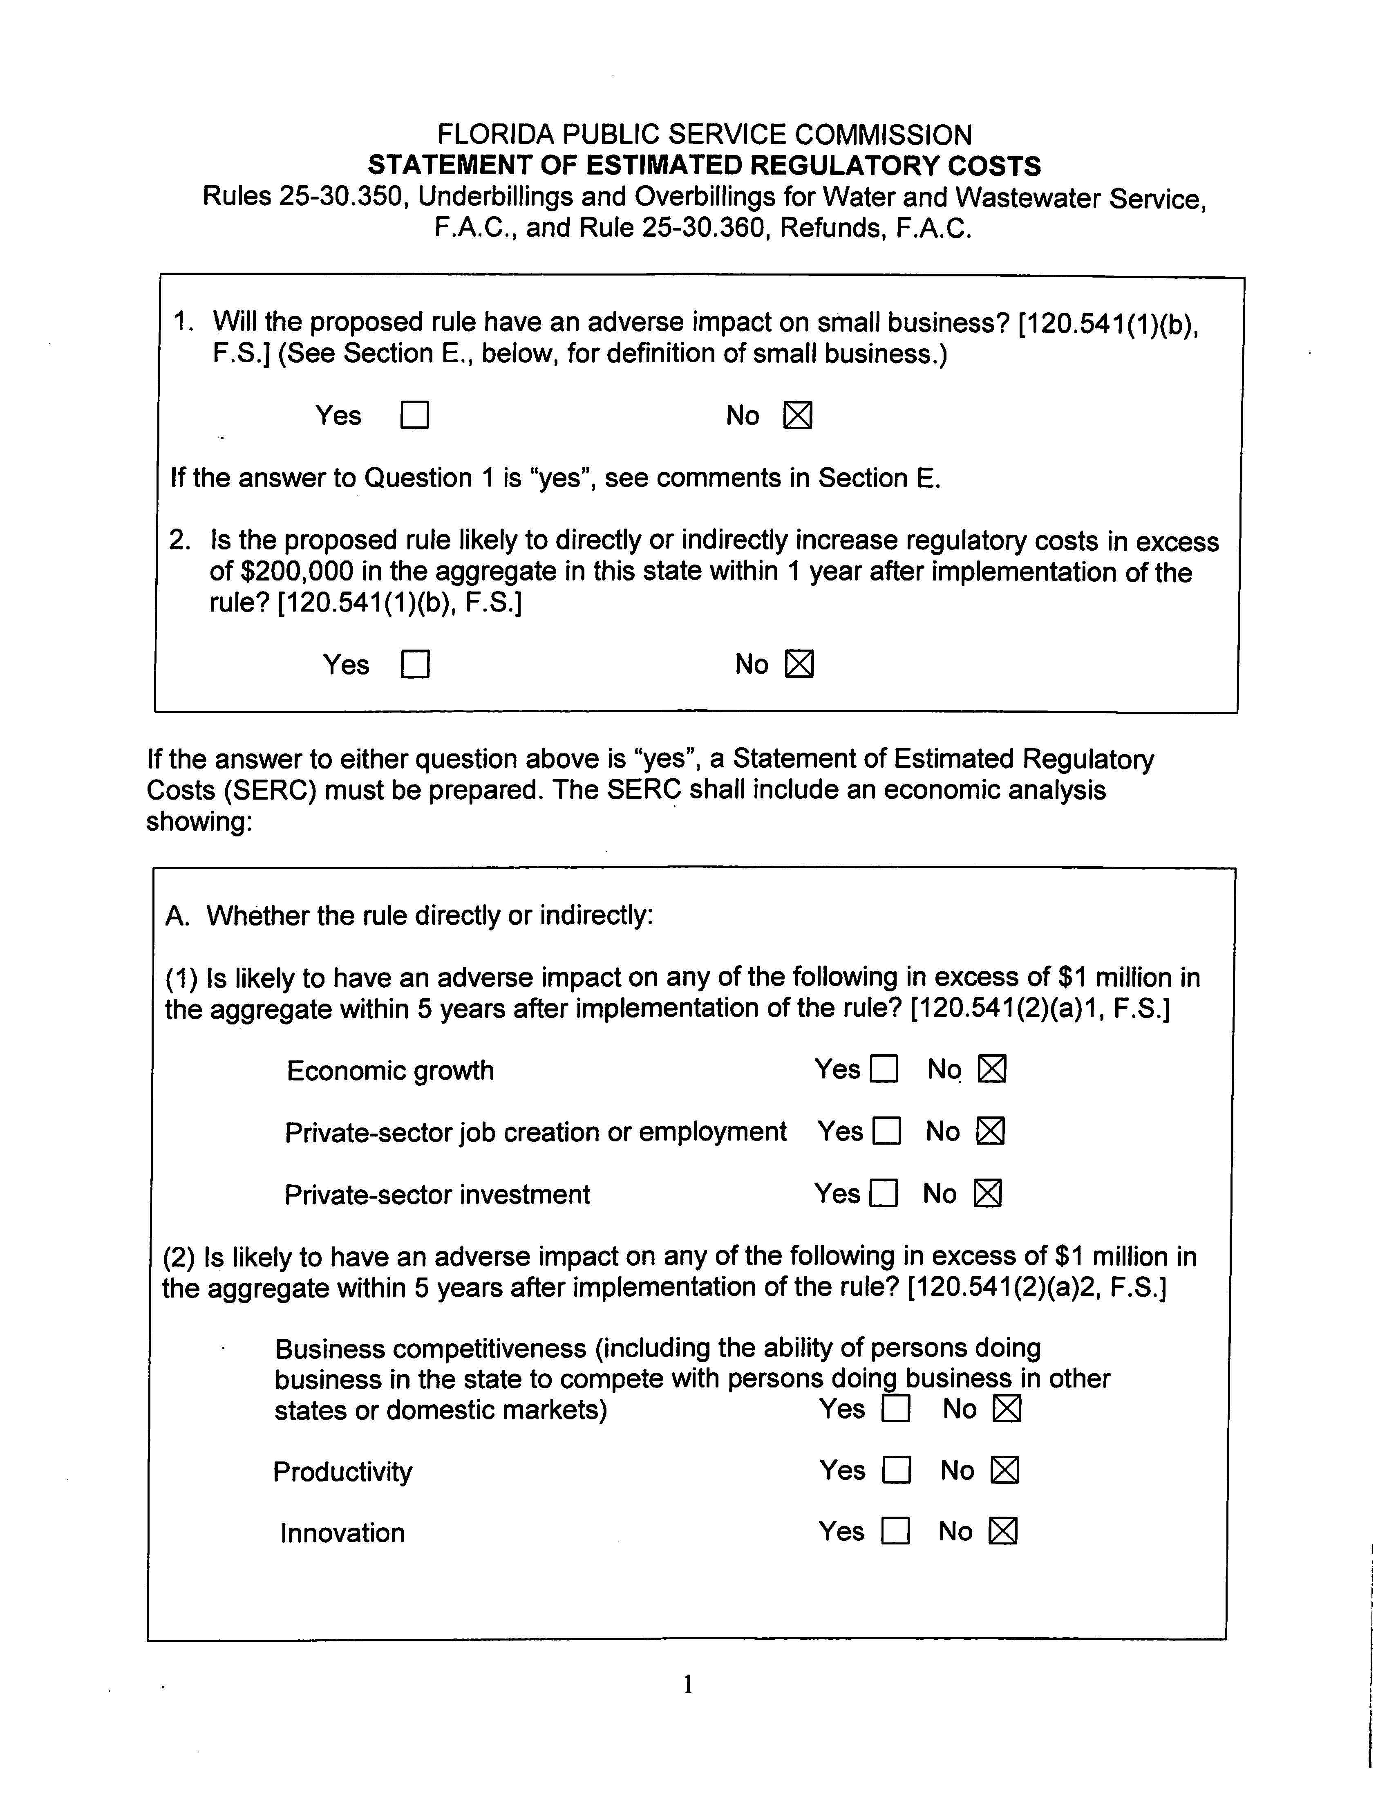

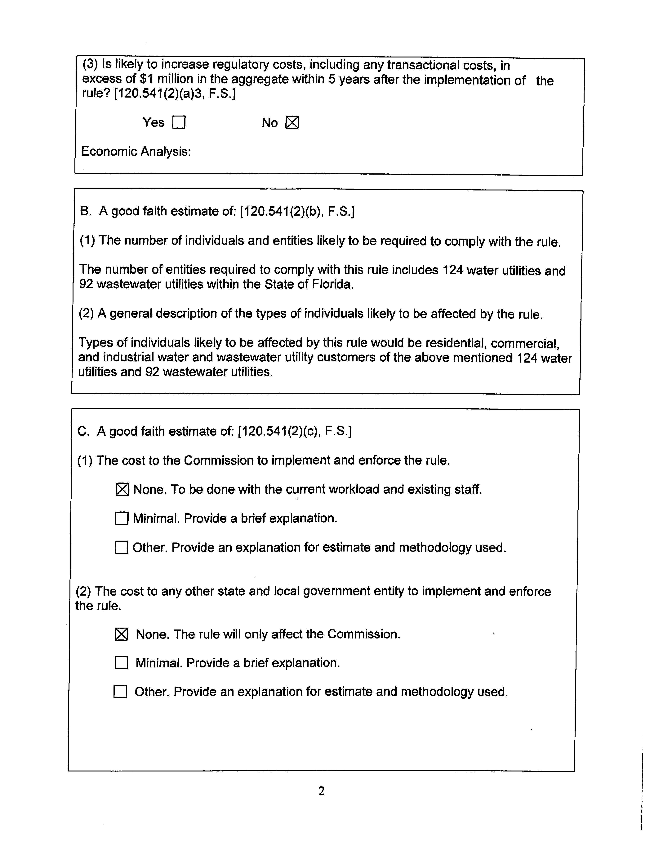

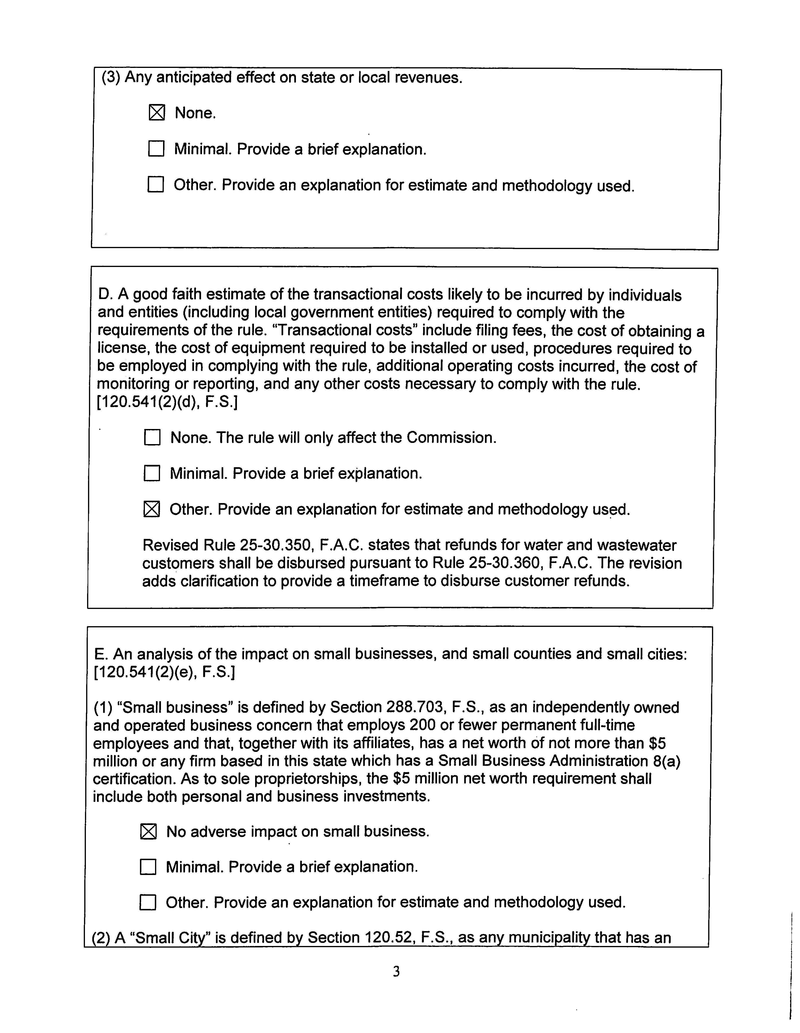

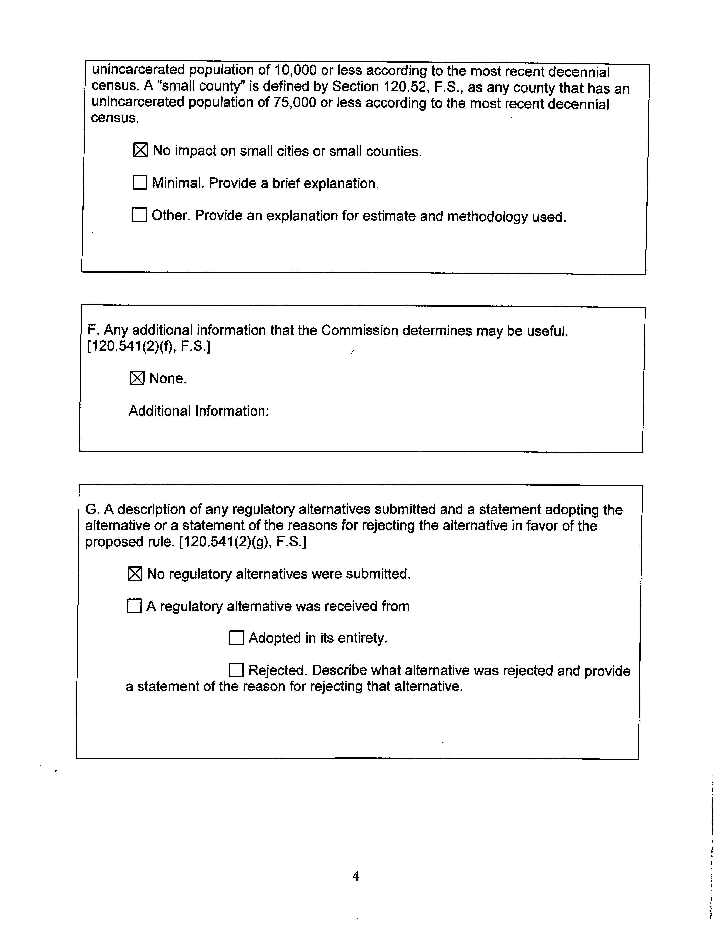

For example, a customer could receive monies back from a utility pursuant to Rule 25-30.311, Customer Deposits, F.A.C. Because Rule 25-30.311, F.A.C., specifically sets forth a procedure from making refunds, it would continue to be an exception to the more general refund requirements of Rule 25-30.360, F.A.C.

