State of Florida |  | Public Service Commission  Capital Circle Office Center ● 2540 Shumard Oak Boulevard  Tallahassee, Florida 32399-0850  -M-E-M-O-R-A-N-D-U-M-
DATE: | August 27, 2019
TO: | Office of Commission Clerk (Teitzman)
FROM: | Office of the General Counsel (King)  Division of Economics (Guffey, Coston)
RE: | Docket No. 20190041-WS – Proposed adoption of Rule 25-30.0115, F.A.C., Definition of Landlord and Tenant.
AGENDA: | 09/05/19 – Regular Agenda – Rule Proposal – Interested Persons May Participate
COMMISSIONERS ASSIGNED: |  |  | All Commissioners
PREHEARING OFFICER: |  |  | Administrative
RULE STATUS: |  |  | Proposal may be deferred
SPECIAL INSTRUCTIONS: |  |  | None

Case Background
At the January 8, 2019 Agenda Conference, staff brought a recommendation to the Commission in Docket No. 20180142-WS recommending that the Commission issue an order to show cause to Palm Tree Acres for providing water and wastewater services without a certificate of authorization in contravention of Section 367.031, Florida Statutes (F.S.). The core issue was whether Palm Tree Acres is a utility subject to the Commission’s jurisdiction.
Section 367.021(12), F.S., defines a utility subject to the Commission’s jurisdiction as “every person, lessee, trustee, or receiver owning, operating, managing, or controlling a system, or proposing construction of a system, who is providing, or proposes to provide, water or wastewater service to the public for compensation,” except for those individuals and entities exempted from Commission regulation as a utility in Section 367.022, F.S. Palm Tree Acres argued that it was one of the entities exempted from Commission regulation under Section 367.022, F.S. Specifically, it argued that it fit the exemption in Section 367.022(5), F.S., which provides that “[l]andlords providing service to their tenants without specific compensation for the service” are exempt from the Commission’s jurisdiction.
Staff and certain residents of Palm Tree Acres argued that Palm Tree Acres was not a landlord as that term is used in Section 367.022(5), F.S., nor were the residents that owned their lots tenants.
Four days before the January 8, 2019 Agenda Conference, Palm Tree Acres sent the Commission a letter arguing that staff’s interpretation of “landlord” and “tenant” in Section 367.022(5), F.S., constituted a rule of general applicability that was not adopted pursuant to the requirements of the Administrative Procedure Act. Thus, if the Commission pursued enforcement action via staff’s interpretation of Section 367.022(5), F.S., Palm Tree Acres would initiate an unadopted rule challenge. Palm Tree Acres reinforced this intention at the January 8, 2019 Agenda Conference.
At the January 8, 2019 Agenda Conference, the Commission voted to defer consideration of staff’s recommendation and initiated rulemaking to explore the possibility of adopting a rule defining “landlord” and “tenant” as used in Section 367.022(5), F.S.
Notice of initiation of rulemaking appeared in the February 15, 2019 edition of the Florida Administrative Register (vol. 45, issue 32). The notice also set the time and place for a staff-led rule development workshop, which was held on March 4, 2019. The workshop was attended by representatives from the Florida Manufactured Housing Association (FMHA); the Goss family, who owns several mobile home parks in Florida, including Palm Tree Acres; and the Office of Public Counsel (OPC). All three filed post-workshop comments on March 18, 2019.
This recommendation addresses whether the Commission should propose the adoption of a new rule to define the terms “landlord” and “tenant” in Section 367.022(5), F.S. The Commission has jurisdiction pursuant to Sections 120.54, 367.121(1)(f), and 367.022, F.S.

Discussion of Issues

Issue 1:
Should the Commission propose the adoption of Rule 25-30.0115, F.A.C., Definition of Landlord and Tenant?

Recommendation:
Yes, the Commission should propose the adoption of Rule 25-30.0115, F.A.C., as set forth in Attachment A. Additionally, the Commission should certify the rule as a minor violation rule. (King, Guffey)

Staff Analysis:
Section 367.021(12), F.S., defines a utility subject to the Commission’s jurisdiction as “every person, lessee, trustee, or receiver owning, operating, managing, or controlling a system, or proposing construction of a system, who is providing, or proposes to provide, water or wastewater service to the public for compensation.” Section 367.022, F.S., provides exemptions from Commission regulation for a finite group of individuals and entities. Section 367.022(5), F.S., contains an exemption for “[l]andlords providing service to their tenants without specific compensation for the service.” Staff is recommending that the Commission propose a new rule that would define the terms “landlord” and “tenant,” as used in that exemption. As set forth in Attachment A, staff’s recommended rule language reads as follows:
25-30.0115 Definition of Landlord and Tenant
As used in Section 367.022(5), F.S.:
(1) “landlord” is the party who conveys a possessory interest in real property to a tenant by way of a lease and who provides water and/or wastewater service to the tenant at that property; and
(2) “tenant” is the party to whom the possessory interest in real property is conveyed by the landlord by way of a lease and who receives water and/or wastewater service from the landlord at that property.
The recommended language is based on the plain and ordinary meaning of landlord and tenant, and related terms, as defined by the eleventh edition of Black’s Law Dictionary. Black’s Law Dictionary defines landlord as “[s]omeone who rents a room, building, or piece of land to someone else.” A lessor, which Black’s deems a synonym to landlord, is “[s]omeone who conveys real or personal property by lease.” A tenant is “[s]omeone who holds or possesses lands or tenements by any kind of right or title.” And a lessee is “[s]omeone who has a possessory interest in real or personal property under a lease.”
Finally, Black’s also defines a “landlord-tenant relationship.” The relationship is created by lease, either express or implied, and must include “a landlord’s reversion, a tenant’s estate, [and] transfer of possession and control of the premises.” During the rulemaking process, staff used the word “agreement” instead of “lease” in discussions of potential rule language. However, staff recommends using “lease” instead of “agreement” because the former is more precise.
The only addition staff made to these dictionary definitions was a clause mandating that the landlord provide and the tenant receive the water and wastewater services at the conveyed property. This requirement comports with a plain reading of the text of Section 367.022(5), F.S., and the Legislature’s declared intent of Commission regulation of water and wastewater utilities as it appears in Section 367.011, F.S.
Staff’s recommended definitions of landlord and tenant are also consistent with previous Commission practice. The decision in Order No. PSC-92-0746-FOF-WU is on point. In that case, the Commission denied Gem Estates’ request for an exemption from Commission jurisdiction under Section 367.022(5), F.S., because the mobile home owners in Gem Estates owned their own land. Because the residents owned their lots, the subdivision owner was not a landlord.

Stakeholder Comments
Staff received comments from the Goss family, FMHA, and OPC. OPC and the Goss family also submitted suggested changes to staff’s recommended language. The Goss family and FMHA disagreed with staff’s recommended language, and the Goss family’s suggested language is substantially different from staff’s recommended language. OPC, on the other hand, generally agreed with staff’s recommended language, but made one suggested change that does not change the substance of staff’s recommended language.
The Goss family owns 27 mobile home parks in Florida, including Palm Tree Acres. The crux of its argument is that staff’s definitions of landlord and tenant are too narrow and ignore certain landlord-tenant relationships recognized in Chapter 723, F.S. Consistent with its argument that both mobile home park and mobile home subdivision owners should be considered landlords, the Goss family suggests the following changes to staff’s recommended language:
(1) “landlord” is the party who conveys a possessory interest in, or access to, real property to a tenant by way of agreement between the two parties and who provides water and/or wastewater service to the tenant as part of that conveyance at that property; and
(2) “tenant” is the party to whom the possessory interest in, or access to, real property is conveyed by the landlord and who receives water and/or wastewater service from the landlord as part of that conveyance at that property.

The Florida Mobile Home Act
The Goss family’s suggested language, which is based mainly on Chapter 723 of the Florida Statutes, is substantially different from staff’s recommended language. Specifically, the Goss family argues that Chapter 723, also known as the Florida Mobile Home Act, labels mobile home subdivision owners as landlords and labels owners of lots in that subdivision as tenants. Therefore, the Goss family argues the Commission should likewise recognize mobile home subdivision owners as landlords in interpreting the exemption in Section 367.022(5), F.S. FMHA echoed this argument in its post-workshop comments, but it did not suggest specific rule language.
The Goss family supports this argument with the example of Palm Tree Acres, which is both a mobile home park and a mobile home subdivision regulated under Chapter 723. The Goss family argues that Palm Tree Acres is a landlord in its capacity as a mobile home subdivision because even though it does not rent the lot owners their lots, it is renting the lot owners access to and use of common amenities in the park/subdivision. This argument trades on a conflation of two terms of property law: license and lease.
A tenant under a lease is one who has been given a possession of land which is “exclusive even of the landlord except as the lease permits his entry, and saving always the landlord’s right to enter to demand rent or to make repairs.” A licensee is one who has a “mere permission to use land, dominion over it remaining in the owner and no interest in or exclusive possession of it being given” to the occupant.
Turner v. Fla. State Fair Auth., 974 So. 2d 470, 473–74 (Fla. 2d DCA 2008) (quoting Seabloom v. Krier, 219 Minn. 362, 18 N.W.2d 88, 91 (1945)); License, Black’s Law Dictionary (11th ed. 2019). Staff believes that by granting lot owners access to and use of a park’s common areas, a mobile home subdivision owner creates a licensor-licensee relationship rather than a landlord-tenant relationship. See Napoleon v. Glass, 229 So. 2d 883, 885 (Fla. 3d DCA 1969).
To conform the Commission’s definitions of landlord and tenant to the Goss family’s interpretation of Chapter 723, F.S., the Goss family’s suggested rule language, unlike staff’s recommended language, does not include the phrase “at the property.” Instead, the Goss family suggests that the definitions require that the provision water and wastewater services be part of the conveyance to the lot owners of access to or use of other property and services.
However, the landlord/tenant exemption makes little sense if the water and wastewater services are not provided at the leased property. In Section 367.011(3), F.S., the Legislature specifically declared that Commission regulation of water and wastewater utilities is predicated on concerns about public health, safety, and welfare. Such concerns arise in the context of public utilities because the service is essential and the customer only has one choice of provider at any given location. But a tenant purchasing water and wastewater services from his or her landlord for delivery at the real property conveyed by the parties’ lease has the ability to switch utilities by moving at the end of the lease. Landowners lack this ability because to move they would have to sell their property, presumably at a significant loss if the sole utility provides subpar services, charges excessive rates, or disconnects service to the property.
Additionally, staff disagrees with the broader arguments of the Goss family and FMHA that Chapter 723 defines mobile home subdivision owners as landlords and the owners of lots mobile home subdivisions as tenants. Chapter 723 is aimed primarily at regulating the relationship between a mobile home park owner and a mobile home owner who rents a lot from the park. See § 723.004, F.S. (finding there are factors unique to the relationship between a mobile home park owner and one who rents a lot from a mobile home park owner). Given the plain and ordinary definition of a landlord-tenant relationship is based on the conveyance of a possessory interest in real property, it should be no surprise that those terms would appear in statutes primarily regulating a relationship in which one person—a mobile home park owner—conveys a possessory interest in real property to another—a mobile home owner. The Goss family appears to argue that because Section 723.002(2), F.S., applies 8 of Chapter 723’s almost 70 sections to mobile home subdivision owners and owners of lots in mobile home subdivisions, that somehow a landlord-tenant relationship is created between the subdivision owner and the lot owner. However, none of those 8 sections create a landlord-tenant relationship between mobile home subdivision owners and lot owners.
It is telling that the Goss family relies mainly on Section 723.058(3), F.S., to support its argument that Chapter 723 labels mobile home subdivision owners as landlords. That section provides that
No mobile home owner, owner of a lot in a mobile home subdivision, or purchaser of an existing mobile home located within a park or mobile home subdivision, as a condition of tenancy, or to qualify for tenancy, or to obtain approval for tenancy in a mobile home park or mobile home subdivision, shall be required to enter into, extend, or renew a resale agreement.
At best, Section 723.058(3), F.S., uses the terms “lot owner” and “tenancy” in the same sentence. However, nowhere does Section 723.058(3), F.S., define a lot owner as a tenant or a subdivision owner as a landlord. The term “tenancy” is used, not as a term of art, but colloquially as a term to describe one’s ability to take up residence in the park/subdivision. In short, the section prohibits a mobile home park or subdivision owner from conditioning one’s ability to reside in the park or subdivision on the execution of a resale agreement. Using Section 723.058(3), F.S., to imply that the entire chapter is intended to create a landlord-tenant relationship between a mobile home subdivision owner and a lot owner is not supported by the law.
Additionally, staff believes it is outside the scope of the Commission’s statutory authority to interpret Section 367.022(5), F.S., in a way that goes beyond the plain and ordinary meaning of the terms used by the Legislature in that section. Nothing in Chapters 723 or 367 indicate that the Commission should refer to Chapter 723 in defining terms used in Section 367.022(5), F.S. Moreover, as discussed above, the Commission has consistently used the plain and ordinary meaning of the terms “landlord” and “tenant” when applying Section 367.022(5), F.S.

The Cost of Regulation
The Goss family and FMHA’s second argument is that regulating mobile home subdivisions as utilities will saddle the subdivision’s residents with much higher costs for water and wastewater services; therefore, the Commission should interpret “landlord” and “tenant” in a way that avoids imposing these costs. In a May 4, 2018 letter to the Commission’s General Counsel, FMHA argued that staff’s interpretation of Section 367.022(5), F.S., would subject “many of its member[]” parks and subdivisions to costly regulation. But in its post-workshop comments, FMHA stated that it could identify few parks and subdivisions, if any, that would be subject to regulation under staff’s recommended rule.
The Goss family again turned to Palm Tree Acres as an example of these increased costs. It presented analysis showing that Palm Tree Acres’ 19 lot owners would pay approximately $469 per month for water and wastewater services if Palm Tree Acres was regulated by the Commission. However, it appears that the analysis allocates regulatory costs to only those 19 customers, even though the utility currently has 244 customers. If the analysis had properly allocated those costs to all 244 customers, the monthly cost for those 19 customers would likely be considerably lower.
Staff has considered the stakeholder comments regarding the alleged increased costs of regulation, but finds them unpersuasive. First, as explained above, staff’s recommended language is consistent with previous Commission practice. The scope of the Commission’s jurisdiction remains unchanged, which means the rule would not bring any entities under the Commission’s jurisdiction that were not previously subject to its jurisdiction.
Second, as explained above, the Goss family’s suggested changes are not consistent with the plain and ordinary meaning of the terms landlord and tenant. Staff recommends definitions that hew to the plain and ordinary definitions of those words as found in Black’s Law Dictionary for two reasons. One, Florida courts have developed well-established law guiding statutory interpretation that is based on using the plain and ordinary meaning of words as discerned by dictionaries. W. Fla. Reg’l Med. Ctr., Inc. v. See, 79 So. 3d 1, 8–9 (Fla. 2012). Two, the Commission’s interpretation of statutes is no longer afforded deference when reviewed by courts. Art. V, § 21, Fla. Const.; Citizens v. Brown, 269 So. 3d 498, 504 (Fla. 2019). Therefore, if a court was asked to review the Commission’s interpretation of Section 367.022(5), F.S., as embodied in Rule 25-30.0115, F.A.C., the validity of the Commission’s interpretation would depend almost completely on whether its interpretation conformed to the well-established rules of statutory interpretation used by courts. See W. Fla. Reg’l Med. Ctr., 79 So. 3d at 8–9.
The Commission’s rules are designed to implement the purposes of statutes. Many of those statutes contain broad policy goals that afford the Commission discretion in crafting programs to achieve those purposes. But Section 367.022, F.S., is different. It prescribes the Commission’s jurisdiction in clear and definite terms. It does not give the Commission discretion to decide the limits of its jurisdiction. When the terms of a statute are plain and unambiguous, changing that plain meaning is solely within the purview of the Legislature.

Written or Oral Agreements
OPC largely agreed with staff’s proposed rule language. It did, however, suggest the following change: “(1) ‘landlord’ is the party who conveys a possessory interest in real property to a tenant by way of agreement, either written or oral, and who provides water and/or wastewater service to the tenant at that property . . . .”
OPC’s concern is that, in the absence of its suggested addition, a landlord-tenant relationship could be limited based on whether the lease is written or oral. Staff recommends the Commission determine that this clarification is unnecessary. A lease of real property can be made orally or in writing, and the current language incorporates both.

Minor Violation Rules Certification
Pursuant to Section 120.695, F.S., beginning July 1, 2017, for each rule filed for adoption, the agency head must certify whether any part of the rule is designated as a rule the violation of which would be a minor violation. Under Section 120.695(2)(b), F.S., a violation of a rule is minor if it does not result in economic or physical harm to a person or adversely affect the public health, safety, or welfare or create a significant threat of such harm. Rule 25-30.0115, F.A.C., will be a minor violation rule. The rule is purely informational; therefore, a violation will not result in economic or physical harm to a person or an adverse effect on the public health, safety, or welfare or create a significant threat of such harm. Therefore, for the purposes of filing the rule for adoption with the Department of State, staff recommends that the Commission certify proposed Rule 25-30.0115, F.A.C., as a minor violation rule.

Statement of Estimated Regulatory Costs
Pursuant to Section 120.54(3)(b)1., F.S., agencies are encouraged to prepare a statement of estimated regulatory costs (SERC) before the adoption, amendment, or repeal of any rule. A SERC was prepared for this rulemaking and is appended as Attachment B. As required by Section 120.541(2)(a)1., F.S., the SERC analysis includes whether the rule is likely to have an adverse impact on economic growth, private sector job creation or employment, or private sector investment in excess of $1 million in the aggregate within 5 years after implementation. The adoption of this rule will not cause any of the impact/cost criteria to be exceeded.

The SERC concludes that the rule will not likely increase, directly or indirectly, regulatory costs in excess of $200,000 in the aggregate in Florida within 1 year after implementation. Further, the SERC concludes that the rule will not likely increase regulatory costs, including any transactional costs or have an adverse impact on business competitiveness, productivity, or innovation in excess of $1 million in the aggregate within 5 years of implementation. Thus, the rule does not require legislative ratification, pursuant to Section 120.541(3), F.S.

In addition, the SERC states that the rule would have no impact on small businesses, would have no implementation or enforcement cost on the Commission or any other state and local government entity, and would have no impact on small cities or small counties. The SERC states that there will be no transactional costs likely to be incurred by individuals and entities required to comply with the requirements.

Conclusion
The Commission should propose the adoption of Rule 25-30.0115, F.A.C., as set forth in Attachment A. Additionally, the Commission should certify the rule as a minor violation rule.

Issue 2:
Should this docket be closed?

Recommendation:
Yes. If no requests for hearing or comments are filed, the rule should be filed with the Department of State, and the docket should be closed. (King)

Staff Analysis:
If no requests for hearing or comments are filed, the rule should be filed with the Department of State, and the docket should be closed.

25-30.0115 Definition of Landlord and Tenant
As used in Section 367.022(5), F.S.:
(1) “landlord” is the party who conveys a possessory interest in real property to a tenant by way of a lease and who provides water and/or wastewater service to the tenant at that property; and
(2) “tenant” is the party to whom the possessory interest in real property is conveyed by the landlord by way of a lease and who receives water and/or wastewater service from the landlord at that property.
Rulemaking Authority 350.127(2), 367.121(1)(f) FS. Law Implemented 367.022(5) FS. History-New ______.

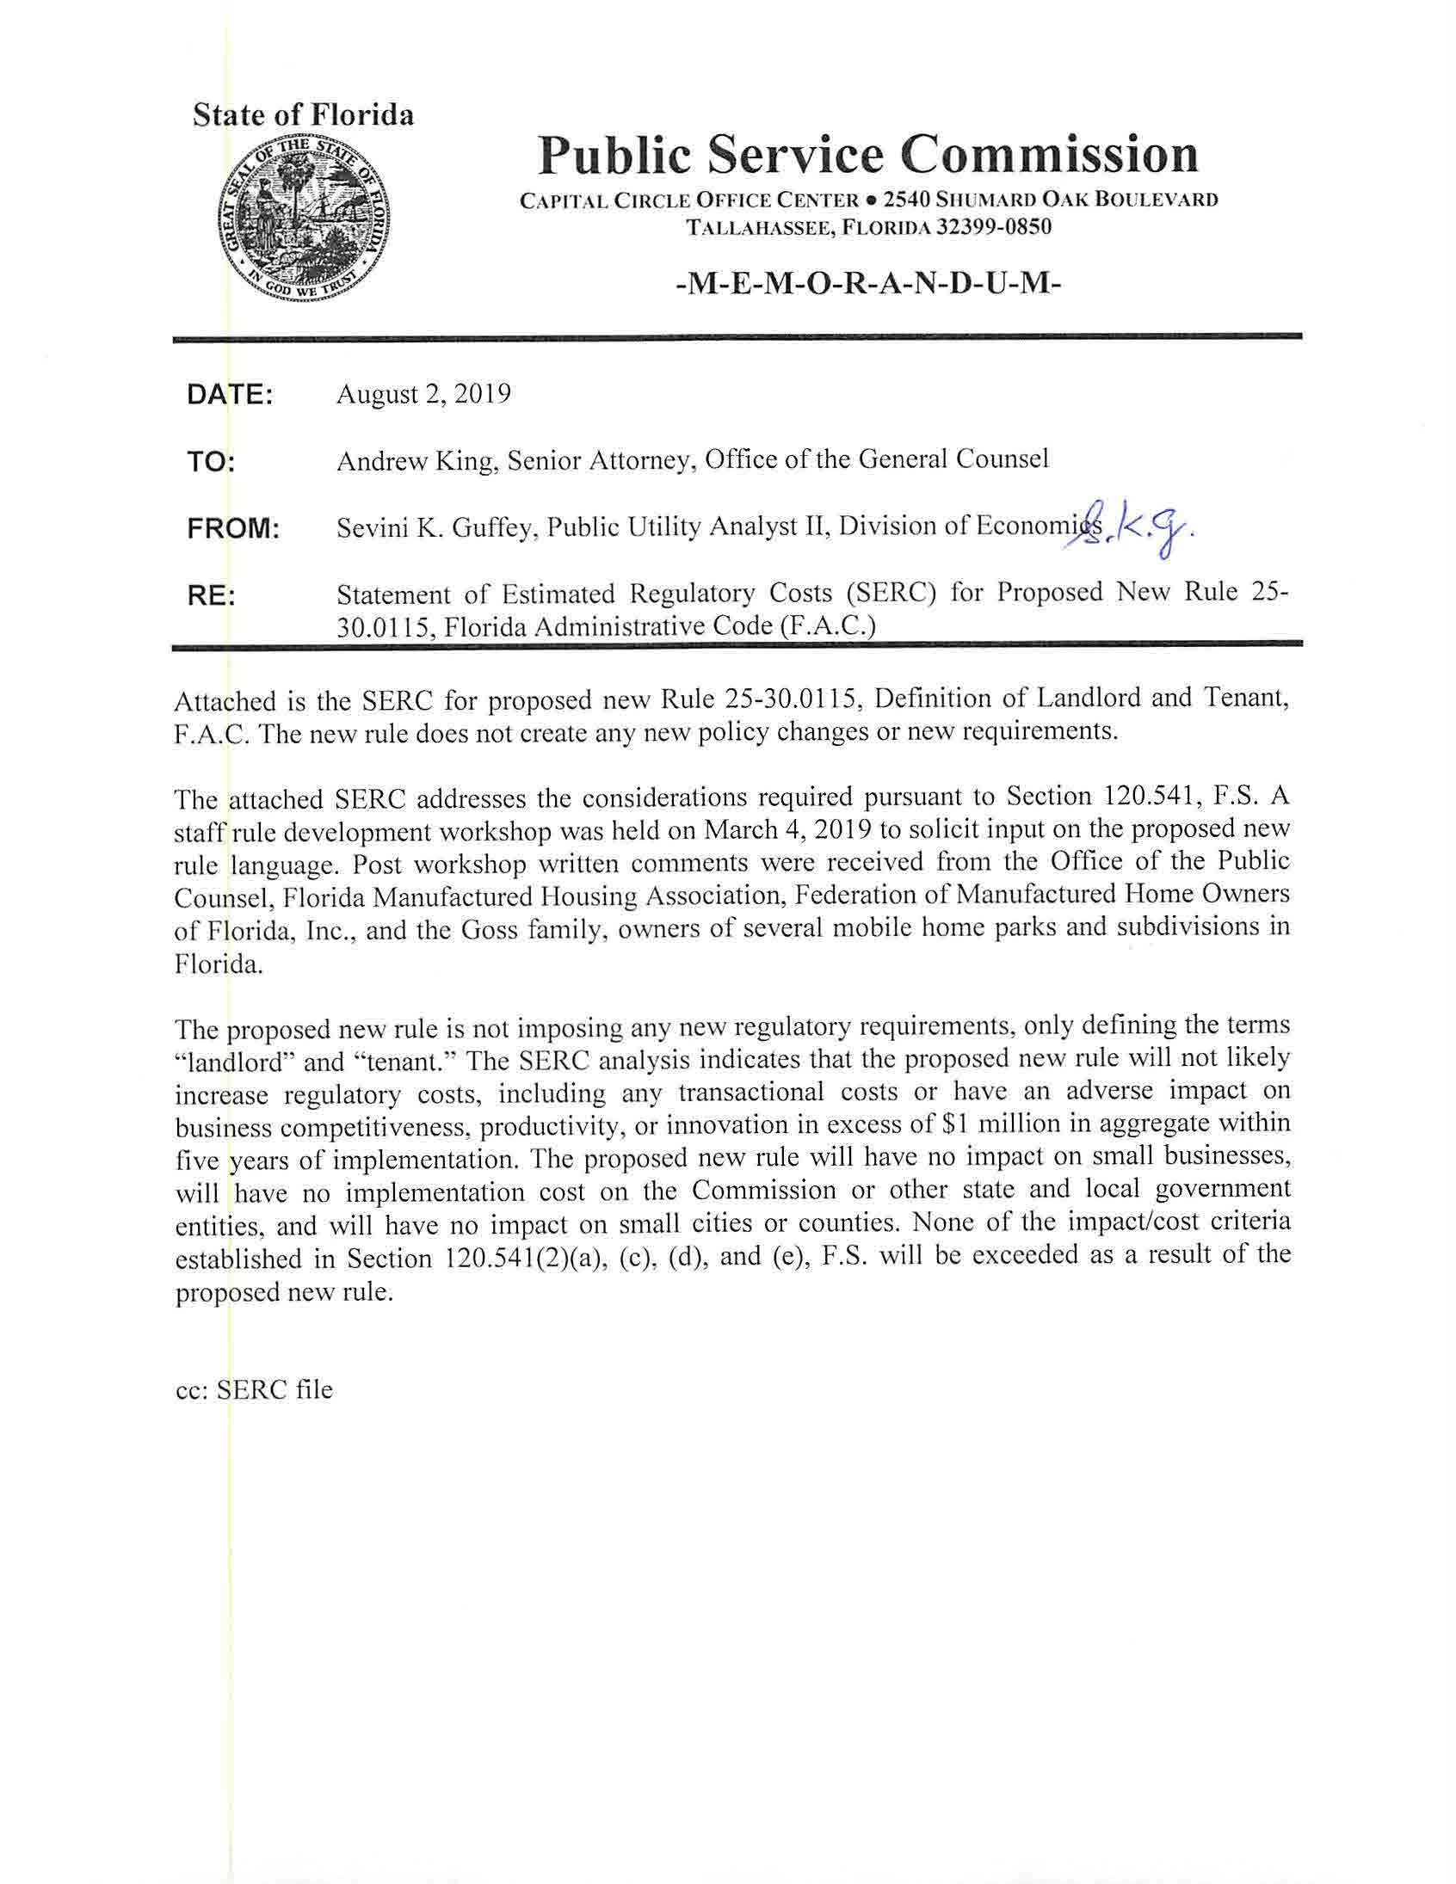

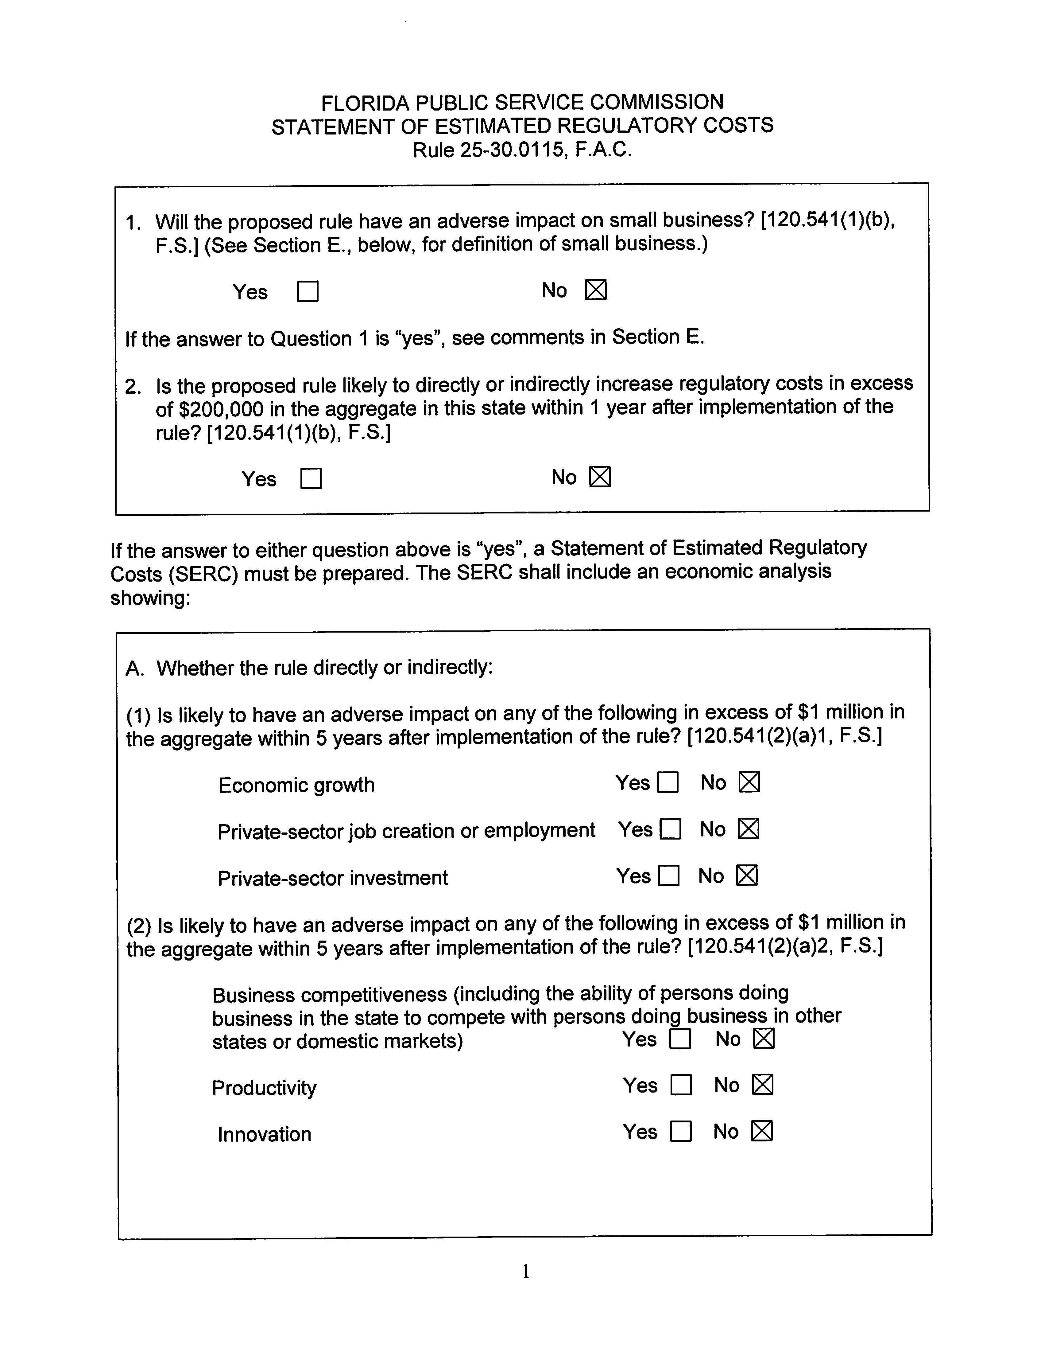

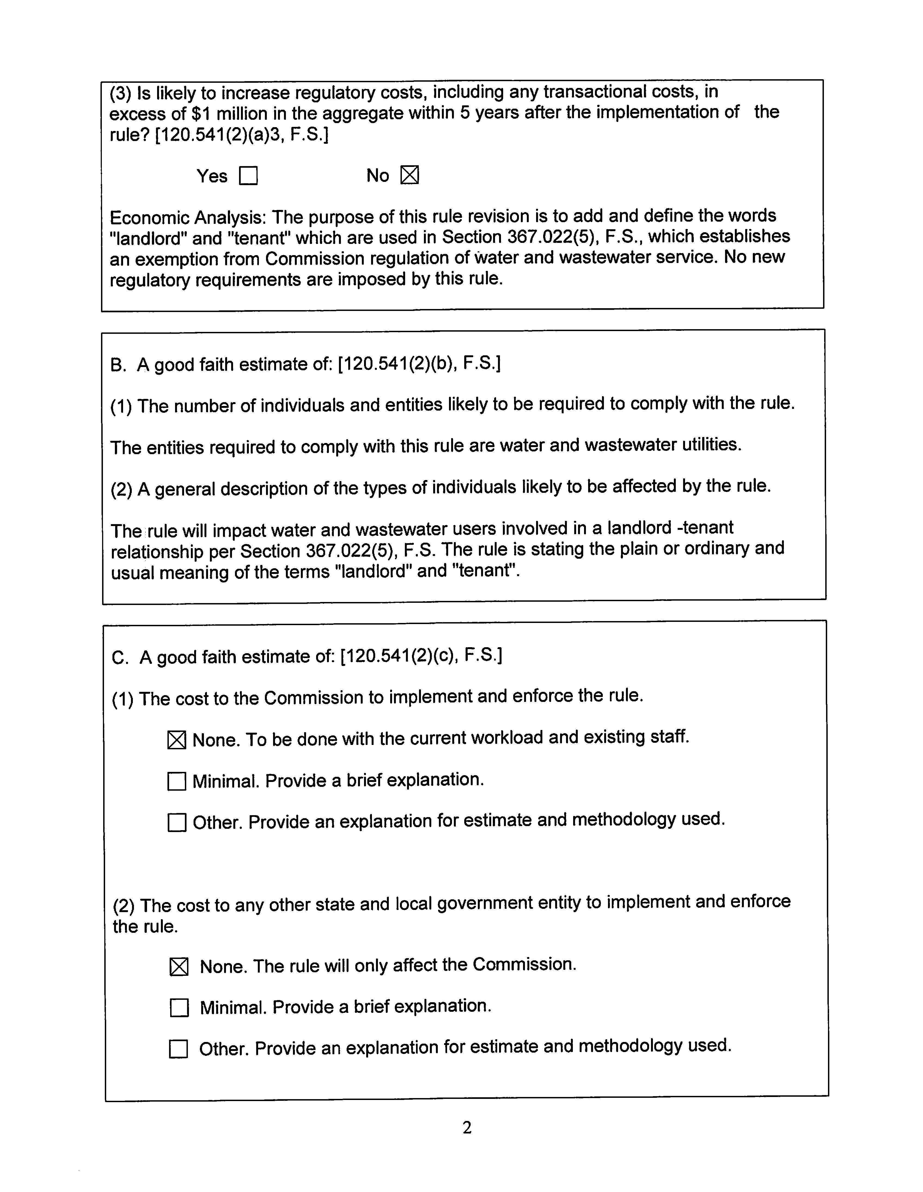

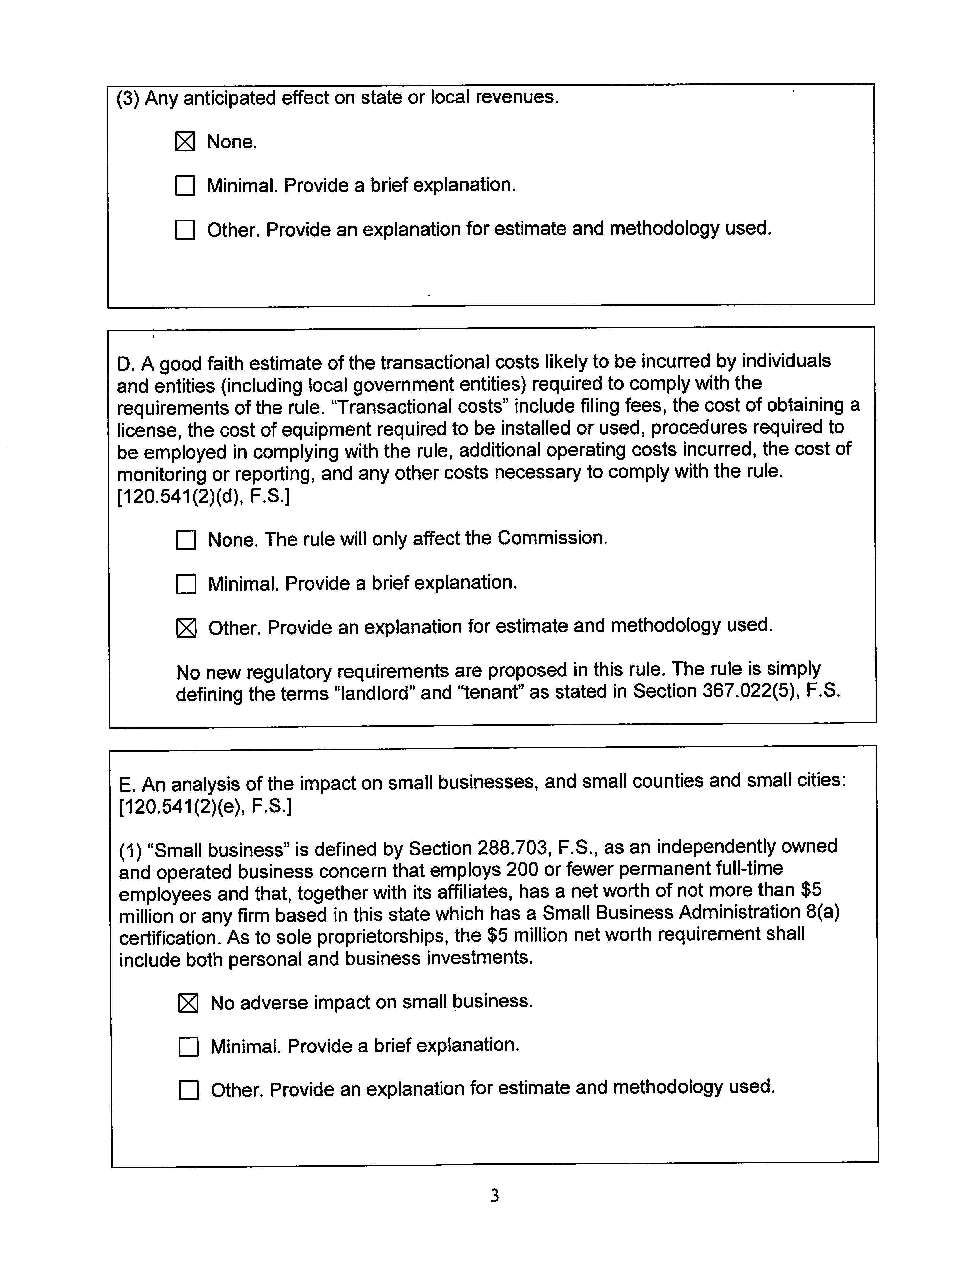

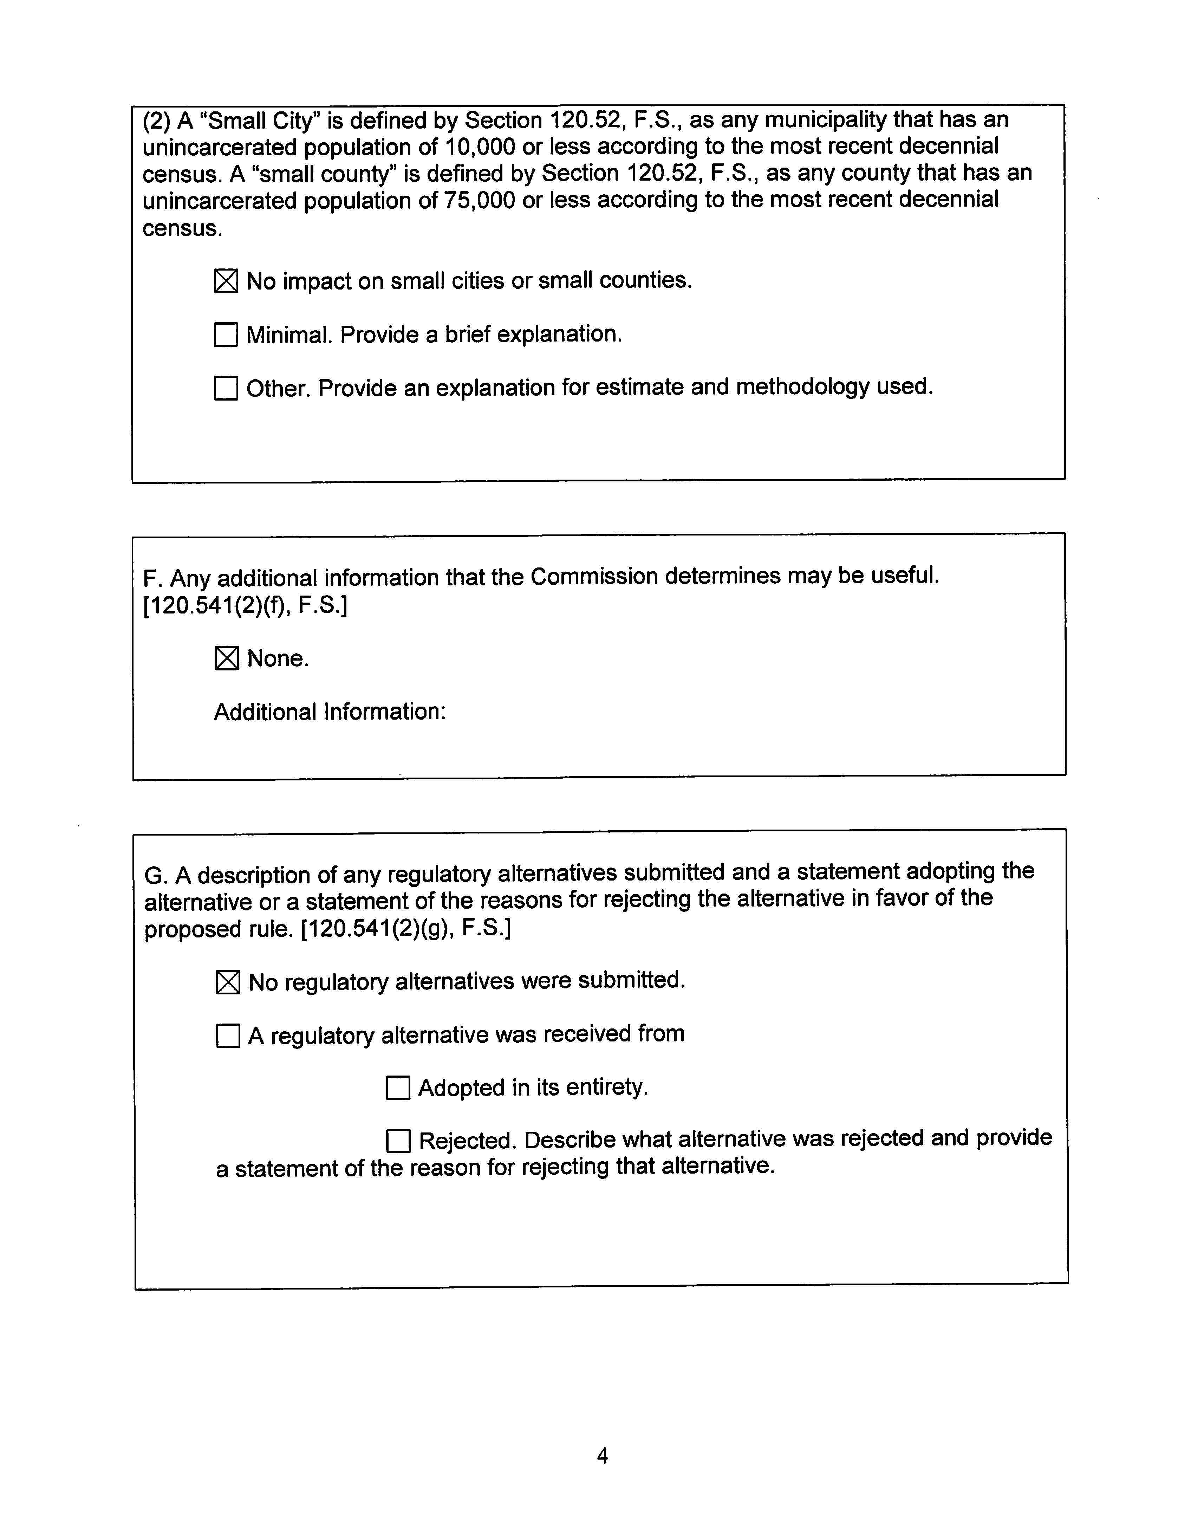

Document No. 07686-2018, filed in Docket No. 20180142, Initiation of show cause proceedings against Palm Tree Acres Mobile Home Park, in Pasco County, for Noncompliance with Section 367.031, F.S., and Rule 25-30.033, F.A.C.
E.g., Order 24806, issued July 11, 1991, in Docket 19910385-SU, In re: Request for exemption from Florida Public Service Commission regulation for a wastewater treatment plant in Highlands County by Oak Leafe Wastewater Treatment Plant (noting “some of Oak Leafe’s residents will own their lots,” citing the definition for “tenant” in Section 83.43(4), F.S., and declaring that Oak Leafe will not provide service solely to tenants); Order 21711, issued August 10, 1989, in Docket No. 19890514-WS, In Re: Request by Rubidel Recreation, Inc. for Exemption from FPSC Regulation for Water and Sewage Treatment Facilities in Lake County (“Because there will be property owners in the [utility’s] service area . . . , . . . the utility does not meet the requirements of [the exemption in Section 367.022(5), F.S.].”); see, e.g., Order 24311, issued April 2, 1991, in Docket No. 1990733-WS, In Re: Request for Exemption from Florida Public Service Commission Regulation for Water and Wastewater Systems in Lake County by Stewart/Barth Utility (holding that the utility was not a landlord for the tenants of condominiums not owned by the utility); Order 23150, issued July 5, 1990, in Docket No. 19870060-WS, In re: Resolution by Board of Sumter County Commissioners declaring Sumter County subject to jurisdiction of Florida Public Service Commission (deciding that a mobile home park owner qualified as a landlord where several of its residents possessed their lots under 99-year leases).
Issued August 4, 1992, in Docket No. 19920281-WU, In re: Request for exemption from Florida Public Service Commission regulation for provision of water service by Gem Estates Water System in Pasco County.
As previously discussed, the word “agreement” was used in earlier drafts of the rule, but staff is recommending that the proposed rule use “lease” instead of “agreement” because the former is more precise.
As previously discussed, the word “agreement” was used in earlier drafts of the rule, but staff is recommending that the proposed rule use “lease” instead of “agreement” because the former is more precise.
Florida’s Statute of Frauds, which can be found in Section 725.01, F.S., limits an oral lease of real property to a length of one year or less.

