Market Potential Study of Demand-Side Management in Gulf Power’s Service Territory
Submitted to Gulf Power

April, 2019

(This page intentionally left blank)

Contents

1 Executive Summary 1
1.1 Methodology 1
1.1.1 EE Potential 1
1.1.2 DR Potential 1
1.1.3 DSRE Potential 2
1.2 Savings Potential 2
1.2.1 EE Potential 2
1.2.2 DR Potential 4
1.2.3 DSRE Potential 6
2 Introduction 8
2.1 Market Potential Study Approach 8
2.2 EE Potential Overview 10
2.3 DR Potential Overview 10
2.4 DSRE Potential Overview 11
3 Baseline Forecast Development 12
3.1 Market Characterization 12
3.1.1 Customer Segmentation 12
3.1.2 Forecast Disaggregation 14
3.1.2.1 Electricity Consumption (kWh) Forecast 14
3.1.2.2 Peak Demand (kW) Forecast 14
3.1.2.3 Estimating Consumption by End-Use Technology 14
3.2 Analysis of Customer Segmentation 15
3.2.1 Residential Customers (EE, DR, and DSRE Analysis) 15
3.2.2 Non-Residential (Commercial and Industrial) Customers (EE and DSRE Analysis) 16
3.2.3 Commercial and Industrial Customers (DR Analysis) 18
3.3 Analysis of System Load 18
3.3.1 System Energy Sales 18
3.3.2 System Demand 19
3.3.3 Load Disaggregation 19
4 DSM Measure Development 22
4.1 Methodology 22
4.2 EE Measures 22
4.3 DR Measures 25
4.4 DSRE Measures 25
5 Technical Potential 27
5.1 Methodology 27
5.1.1 EE Technical Potential 27
5.1.2 DR Technical Potential 30
5.1.3 DSRE Technical Potential 32
5.1.3.1 PV Systems 32
5.1.3.2 Battery Storage Systems 33
5.1.3.3 CHP Systems 34
5.1.4 Interaction of Technical Potential Impacts 35
5.2 EE Technical Potential 37
5.2.1 Summary 37
5.2.2 Residential 37
5.2.3 Non-Residential 39
5.2.3.1 Commercial Segments 39
5.2.3.2 Industrial Segments 40
5.3 DR Technical Potential 42
5.3.1 Residential 42
5.3.2 Non-Residential 43
5.3.2.1 Small C&I Customers 43
5.3.2.2 Large C&I Customers 43
5.4 DSRE Technical Potential 45
6 Economic Potential 46
6.1 DSM Cost-Effective Screening Criteria 46
6.1.1 Cost-Effectiveness Test Perspectives 46
6.1.2 Economic Potential Screening Methodology 47
6.1.3 Economic Potential Sensitivities 48
6.2 EE Economic Potential 49
6.2.1 Summary 49
6.2.2 Residential – RIM Scenario 50
6.2.3 Non-Residential – RIM Scenario 51
6.2.3.1 Commercial Segments 51
6.2.3.2 Industrial Segments 53
6.2.4 Residential – TRC Scenario 55
6.2.5 Non-Residential – TRC Scenario 56
6.2.5.1 Commercial Segments 56
6.2.5.2 Industrial Segments 58
6.3 DR Economic Potential 60
6.4 DSRE Economic Potential 62
7 Achievable Potential 63
7.1 Achievable Potential Methodology 63
7.1.1 Utility Program Costs and Incentives 63
7.1.2 Market Adoption Rates 63
7.2 EE Achievable Potential 64
7.2.1 Summary 64
7.2.2 Residential – RIM Scenario 66
7.2.3 Non-Residential – RIM Scenario 66
7.2.3.1 Commercial Segments 66
7.2.3.2 Industrial Segments 68
7.2.4 Residential – TRC Scenario 71
7.2.5 Non-Residential – TRC Scenario 73
7.2.5.1 Commercial Segments 73
7.2.5.2 Industrial Segments 75
7.3 DR Achievable Potential 77
7.3.1 Non-Residential DR Achievable Potential Details 77
7.3.1.1 Small C&I Achievable Potential 77
7.3.1.2 Large C&I Achievable Potential 77
7.4 DSRE Achievable Potential 79
8 Appendices 80
Appendix A EE MPS Measure List A-1
Appendix B DR MPS Measure List B-1
Appendix C DSRE Measure List C-1
Appendix D Customer Demand Characteristics D-1
Appendix E Economic Potential Sensitivities E-1
Appendix F Market Adoption Rates F-1

List of Figures
Figure 2-1: Approach to Market Potential Modeling 10
Figure 3-1: Residential Customer Segmentation 16
Figure 3-2: Commercial Customer Segmentation 17
Figure 3-3: Industrial Customer Segmentation 17
Figure 3-4: Electricity Sales Forecast by Sector 19
Figure 3-5: Residential Baseline (2020) Energy Sales by End-Use 20
Figure 3-6: Commercial Baseline (2020) Energy Sales by End-Use 20
Figure 3-7: Industrial Baseline (2020) Energy Sales by End-Use 21
Figure 5-1: Methodology for Estimating Cooling Loads 31
Figure 5-2: Residential EE Technical Potential by End-Use (Energy Savings) 37
Figure 5-3: Residential EE Technical Potential by End-Use (Summer Peak Savings) 38
Figure 5-4: Residential EE Technical Potential by End-Use (Winter Peak Savings) 38
Figure 5-5: Commercial EE Technical Potential by End-Use (Energy Savings) 39
Figure 5-6: Commercial EE Technical Potential by End-Use (Summer Peak Savings) 39
Figure 5-7: Commercial EE Technical Potential by End-Use (Winter Peak Savings) 40
Figure 5-8: Industrial EE Technical Potential by End-Use (Energy Savings) 40
Figure 5-9: Industrial EE Technical Potential by End-Use (Summer Peak Savings) 41
Figure 5-10: Industrial EE Technical Potential by End-Use (Winter Peak Savings) 41
Figure 5-11: Residential DR Technical Potential by End-Use 43
Figure 5-12: Small C&I DR Technical Potential by End-Use 43
Figure 5-13: Large C&I DR Technical Potential by Segment 44
Figure 6-1: Residential EE Economic Potential by End-Use – RIM Scenario (Energy Savings) 50
Figure 6-2: Residential EE Economic Potential by End-Use - RIM Scenario (Summer Peak Savings) 50
Figure 6-3: Residential EE Economic Potential by End-Use (Winter Peak Savings) - RIM Scenario 51
Figure 6-4: Commercial EE Economic Potential by End-Use (Energy Savings) – RIM Scenario 51
Figure 6-5: Commercial EE Economic Potential by End-Use (Summer Peak Savings) – RIM Scenario 52
Figure 6-6: Commercial EE Economic Potential by End-Use (Winter Peak Savings) – RIM Scenario 52
Figure 6-7: Industrial EE Economic Potential by End-Use (Energy Savings) – RIM Scenario 53
Figure 6-8: Industrial EE Economic Potential by End-Use (Summer Peak Savings) – RIM Scenario 53
Figure 6-9: Industrial EE Economic Potential by End-Use (Winter Peak Savings) – RIM Scenario 54
Figure 6-10: Residential EE Economic Potential by End-Use (Energy Savings) – TRC Scenario 55
Figure 6-11: Residential EE Economic Potential by End-Use (Summer Peak Savings) - TRC Scenario 55
Figure 6-12: Residential EE Economic Potential by End-Use (Winter Peak Savings) - TRC Scenario 56
Figure 6-13: Commercial EE Economic Potential by End-Use (Energy Savings) – TRC Scenario 56
Figure 6-14: Commercial EE Economic Potential by End-Use (Summer Peak Savings) – TRC Scenario 57
Figure 6-15: Commercial EE Economic Potential by End-Use (Winter Peak Savings) – TRC Scenario 57
Figure 6-16: Industrial EE Economic Potential by End-Use (Energy Savings) – TRC Scenario 58
Figure 6-17: Industrial EE Economic Potential by End-Use (Summer Peak Savings) – TRC Scenario 58
Figure 6-18: Industrial EE Economic Potential by End-Use (Winter Peak Savings) – TRC Scenario 59
Figure 6-19: Residential DR Economic Potential by End-Use – RIM and TRC Scenario 60
Figure 6-20: Small C&I DR Economic Potential by End-Use – RIM and TRC Scenario 61
Figure 6-21: Large C&I DR Economic Potential by Segment – RIM and TRC Scenario 61
Figure 7-1: Achievable Potential by Sector – TRC Scenario 65
Figure 7-2: Commercial EE Achievable Potential by End-Use (Energy Savings) – RIM Scenario 67
Figure 7-3: Commercial EE Achievable Potential by End-Use (Summer Peak Savings) – RIM Scenario 67
Figure 7-4: Commercial EE Achievable Potential by End-Use (Winter Peak Savings) – RIM Scenario 68
Figure 7-5: Industrial EE Achievable Potential by End-Use (Energy Savings) – RIM Scenario 69
Figure 7-6: Industrial EE Achievable Potential by End-Use (Summer Peak Savings) – RIM Scenario 69
Figure 7-7: Industrial EE Achievable Potential by End-Use (Winter Peak Savings) – RIM Scenario 70
Figure 7-8: Residential EE Achievable Potential by End-Use (Energy Savings) – TRC Scenario 71
Figure 7-9: Residential EE Achievable Potential by End-Use (Summer Peak Savings) - TRC Scenario 72
Figure 7-10: Residential EE Achievable Potential by End-Use (Winter Peak Savings) - TRC Scenario 72
Figure 7-11: Commercial EE Achievable Potential by End-Use (Energy Savings) – TRC Scenario 73
Figure 7-12: Commercial EE Achievable Potential by End-Use (Summer Peak Savings) – TRC Scenario 74
Figure 7-13: Commercial EE Achievable Potential by End-Use (Winter Peak Savings) – TRC Scenario 74
Figure 7-14: Industrial EE Achievable Potential by End-Use (Energy Savings) – TRC Scenario 75
Figure 7-15: Industrial EE Achievable Potential by End-Use (Summer Peak Savings) – TRC Scenario 76
Figure 7-16: Industrial EE Achievable Potential by End-Use (Winter Peak Savings) – TRC Scenario 76
Figure 7-17: Large C&I DR Achievable Potential by Segment – RIM and TRC Scenario 78
Figure -8-1: Average Water Heaters Load Shapes for DEI Customers D-2
Figure 8-2: Average Pool Pumps Load Shapes for DEI Customers D-3
Figure 8-3: Aggregate Load Shapes for Gulf Large C&I Customers D-4
Figure 8-4 Bass Model Market Penetration with Respect to Time F-1
Figure 8-5: Residential Program Enrollment as a function of Incentive F-3
Figure 8-6: Large C&I Program Enrollment as a function of Incentive F-4

List of Tables
Table 1-1: EE Technical Potential 2
Table 1-2: EE Economic Potential 3
Table 1-3: EE Achievable Potential 4
Table 1-4: DR Technical Potential 4
Table 1-5: DR Economic Potential 5
Table 1-6: DR Achievable Potential 5
Table 1-7: DSRE Technical Potential 6
Table 1-8: DSRE Economic Potential 7
Table 3-1: Customer Segmentation 13
Table 3-2: End-Uses 13
Table 3-3: Summary of Customer Classes for DR Analysis 18
Table 4-1: Measure Applicability Factors 24
Table 4-2: EE Measure Counts by Sector 24
Table 5-1: EE Technical Potential by Sector 37
Table 5-2: DR Technical Potential 42
Table 5-3: DSRE Technical Potential 45
Table 6-1: Components of Cost-Effectiveness Calculations 46
Table 6-2: Ratepayer Impact Measure (RIM) 47
Table 6-3: Total Resource Cost (TRC) 47
Table 6-4: Participant Cost Test (PCT) 47
Table 6-5: Economic Potential EE Measure Counts by Scenario 49
Table 6-6: EE Economic Potential by Sector 49
Table 6-7: DR Economic Potential 60
Table 6-8: DSRE Economic Potential 62
Table 7-1: Achievable Potential EE Measure Counts by Scenario 64
Table 7-2: EE Achievable Potential 65
Table 7-3: EE Commercial Achievable Potential by End-Use – RIM Scenario 66
Table 7-4: EE Industrial Achievable Potential by End-Use – RIM Scenario 68
Table 7-5: EE Residential Achievable Potential by End-Use – TRC Scenario 71
Table 7-6: EE Commercial Achievable Potential by End-Use – TRC Scenario 73
Table 7-7: EE Industrial Achievable Potential by End-Use – TRC Scenario 75
Table 7-8: DR Achievable Potential 77

Executive Summary
In October, 2017, the seven electric utilities subject to the Florida Energy Efficiency and Conservation Act (FEECA Utilities) retained Nexant, Inc. for the purpose of identifying and characterizing the market for demand-side management (DSM) opportunities, including energy efficiency (EE) improvement and building retrofits, peak load reductions from demand response (DR), and demand-side renewable energy (DSRE) systems. The main objectives of the study included:
- Assessing technical potential of demand-side resources for reducing customer electric energy consumption and seasonal peak capacity demands.
- Assessing economic potential and achievable potential for a subset of FEECA Utilities over the 10-year study period (2020-2029).
This report provides the detailed methodology and results for the analysis of Gulf Power’s (Gulf) service territory.

Methodology
Nexant estimates DSM savings potential by applying an analytical framework that aligns baseline market conditions for energy consumption and demand with DSM opportunities. After describing the baseline condition, Nexant applies estimated measure savings to disaggregated consumption and demand data. The approach varies slightly according to the type of DSM resources and available data; the specific approaches used for each type of DSM are described below.

EE Potential
This study utilized Nexant’s Microsoft Excel-based EE modeling tool, TEA-POT (Technical / Economic / Achievable POTential). This modeling tool was built on a platform that provides the ability to calculate multiple scenarios and recalculate potential savings based on variable inputs such as sales/load forecasts, electricity prices, discount rates, and actual program savings. The methodology for the EE potential assessment was based on a hybrid “top-down/bottom-up” approach, which started with the current utility load forecast, then disaggregated it into its constituent customer-class and end-use components. Our assessment examined the effect of the range of EE measures and practices on each end-use, taking into account current market saturations, technical feasibility, and costs. These unique impacts were aggregated to produce estimates of potential at the end-use, customer class, and system levels.

DR Potential
The assessment of DR potential in Gulf’s service territory was an analysis of mass market direct load control programs for residential and small commercial and industrial (C&I) customers, and an analysis of DR programs for large C&I customers. The direct load control program assessment focused on the potential for demand reduction through heating, ventilation, and air conditioning (HVAC), water heater, and pool pump load control. These end-uses were of particular interest because of their large contribution to peak period system load. For this analysis, a range of direct load control measures were examined for each customer segment to highlight the range of potential. The assessment further accounted for existing DR programs for Gulf when calculating the total DR potential. The large C&I programs assessment used publicly available data on mature DR programs and current Florida large C&I DR programs to derive estimates of price responsiveness to program incentives and marketing techniques. Using these estimates, the maximum incentive and enrollment scenario was calculated to estimate the potential.

DSRE Potential
The DSRE technologies included in this study are rooftop solar photovoltaic (PV) systems, battery storage systems charged from customers’ PV systems, and combined heat and power (CHP) systems. The study leveraged the customer segmentation and load disaggregation data assembled for the EE and DR analyses, and used a “bottom-up” modeling approach to estimate the potential of the various DSRE technologies for residential, commercial and industrial customers. Individual distributed generation models were created for the three DSRE technologies studied to estimate market potential.

Savings Potential
Nexant estimated DSM savings potential according to three standard scenarios: technical, economic, and achievable potential. Each scenario is defined using slightly different criteria, which are described in the subsequent sections.

EE Potential
Technical Potential
EE technical potential describes the savings potential when all technically feasible EE measures are fully implemented, ignoring all non-technical constraints on electricity savings, such as cost-effectiveness and customer willingness to adopt EE.
The estimated technical potential results are summarized in Table 1-1.
Table 1-1: EE Technical Potential
 | Savings Potential
 | Summer  Peak Demand (MW) | Winter  Peak Demand (MW) | Energy  (GWh)
Residential | 391 | 199 | 1,464
Non-Residential | 231 | 129 | 1,105
Total | 621 | 328 | 2,568
Economic Potential
EE economic potential applies a cost-effectiveness screening to all technically feasible measures and includes full implementation of all measures that pass this screening. Measure permutations were screened individually and the economic potential represents the sum of the demand and energy savings associated with all measure permutations passing the economic screening.
Economic potential was determined for two scenarios: a Rate Impact Measure (RIM) scenario and Total Resource Cost (TRC) scenario. Additional sensitivities were also analyzed, which are described in Section 6.1.3 and results presented in Appendix E.
The estimated economic potential results are summarized in Table 1-2.
Table 1-2: EE Economic Potential
 | Savings Potential
 | Summer  Peak Demand (MW) | Winter  Peak Demand (MW) | Energy  (GWh)
RIM SCENARIO
Residential | 0 | 3 | 4
Non-Residential | 75 | 36 | 110
Total | 75 | 39 | 114
TRC SCENARIO
Residential | 182 | 173 | 836
Non-Residential | 167 | 124 | 926
Total | 348 | 297 | 1,762
Achievable Potential
Achievable potential estimates the demand and energy savings feasible with utility-sponsored programs, while considering market barriers and customer adoption rates for DSM technologies.
Similar to the economic potential analysis, measures were screened to determine which are cost-effective from both the RIM and TRC perspectives. The achievable potential includes estimated program costs and incentives, whereas the economic potential scenario does not.
Table 1-3 summarizes the results for the estimated EE achievable potential, representing the cumulative savings over the ten-year study period (2020-2029) based on the sum of annual incremental savings.

Table 1-3: EE Achievable Potential
 | Savings Potential
 | Summer  Peak Demand (MW) | Winter  Peak Demand (MW) | Energy  (GWh)
RIM SCENARIO
Residential | 0 | 0 | 0
Non-Residential | 5 | 2 | 6
Total | 5 | 2 | 6
TRC SCENARIO
Residential | 20 | 19 | 98
Non-Residential | 21 | 10 | 124
Total | 40 | 29 | 222

DR Potential
Technical Potential
DR technical potential describes the magnitude of loads that can be managed during conditions when grid operators need peak capacity. For residential and small C&I customers where DR generally takes the form of direct utility control, technical potential for DR is limited by the loads that can be controlled remotely at scale such as heating, cooling, water heaters, and pool pumps. For large C&I customers this included their entire electric demand during a utility’s system peak, as many of these types of customers will forego virtually all electric demand temporarily if the financial incentive is large enough.
The estimated technical potential results are summarized in Table 1-4.
Table 1-4: DR Technical Potential
 | Savings Potential
 | Summer Peak Demand  (MW) | Winter Peak Demand  (MW)
Residential | 465 | 667
Non-Residential | 493 | 430
Total | 958 | 1,098

Economic Potential
DR economic potential incorporates the economic screening criteria described above for EE potential, and the results are summarized in Table 1-5.
Table 1-5: DR Economic Potential
 | Savings Potential
 | Summer Peak Demand  (MW) | Winter Peak Demand  (MW)
Residential | 465 | 667
Non-Residential | 493 | 430
Total | 958 | 1,098

Achievable Potential
DR achievable potential incorporates the economic screening criteria described above for EE potential, and the results are summarized in Table 1-6.
Table 1-6: DR Achievable Potential
 | Savings Potential
 | Summer Peak Demand  (MW) | Winter Peak Demand  (MW)
Residential | 0 | 0
Non-Residential | 15 | 11
Total | 15 | 11

DSRE Potential
Technical Potential
DSRE technical potential estimates quantify all technically feasible distributed generation opportunities from PV systems, battery storage systems charged from PV, and CHP technologies based on the customer characteristics of each FEECA utility’s customer base.
Table 1-7: DSRE Technical Potential
 | Savings Potential
 | Summer  Peak Demand (MW) | Winter  Peak Demand (MW) | Energy  (GWh)
PV Systems
Residential | 24 | 104 | 2,072
Non-Residential | 111 | 48 | 952
Total | 135 | 151 | 3,024
Battery Storage charged from PV Systems
Residential | 65 | 222 | -
Non-Residential | - | - | -
Total | 65 | 222 | -
CHP Systems
Total | 252 | 99 | 1,243

Economic Potential
DSRE economic potential incorporates the economic screening criteria described above for EE potential, and the results are summarized in Table 1-8.
Table 1-8: DSRE Economic Potential
 | Savings Potential
 | Summer  Peak Demand (MW) | Winter  Peak Demand (MW) | Energy  (GWh)
PV Systems
Residential | - | - | -
Non-Residential | - | - | -
Total | - | - | -
Battery Storage from PV Systems
Residential | 65 | 222 | -
Non-Residential | - | - | -
Total | 65 | 222 | -
CHP Systems
Total | - | - | -

Achievable Potential
DSRE achievable potential incorporates the achievable screening criteria described above for EE potential. Nexant found there to be no cost-effective potential attainable for Gulf for PV systems, battery storage systems, or CHP systems.

Introduction
In October, 2017, the seven electric utilities subject to the Florida Energy Efficiency and Conservation Act (FEECA Utilities) retained Nexant, Inc. for the purpose of identifying and characterizing the market for demand-side management (DSM) opportunities, including energy efficiency (EE) improvement and building retrofits, peak load reductions from demand response (DR), and demand-side renewable energy (DSRE) systems. The main objectives of the study included:
- Assessing technical potential of demand-side resources for reducing customer electric energy consumption and seasonal peak capacity demands.
- Assessing economic potential and achievable potential for a subset of FEECA Utilities over the 10-year study period (2020-2029).
This report provides the detailed methodology and results for the analysis of Gulf Power’s (Gulf) service territory.
The following deliverables were developed by Nexant as part of the project and are addressed in this report:
- DSM measure list and detailed assumption workbooks
- Disaggregated baseline demand and energy use by year, state, sector, and end-use
- Baseline technology saturations, energy consumption, and demand
- List of cost-effective EE, DR, and DSRE measures
- Potential demand and energy savings for technical, economic and achievable potential scenarios
- Estimated utility costs to acquire the achievable potential
Supporting calculation spreadsheets

Market Potential Study Approach
DSM market potential studies (MPS) typically include three scenarios: technical, economic, and achievable potential. Each scenario is defined by specific criteria, which collectively describe levels of opportunity for DSM savings. Nexant estimates levels of DSM potential according to the industry standard categorization, as follows:
- Technical Potential is the theoretical maximum amount of energy and capacity that could be displaced by DSM, regardless of cost and other barriers that may prevent the installation or adoption of a DSM measure. For this study, technical potential included full application of commercially available DSM technologies to all residential, commercial, and industrial customers in the utility’s service territory.
- Economic Potential is the amount of energy and capacity that could be reduced by DSM measures that are considered cost-effective. This study used the Ratepayer Impact Measure (RIM) test perspective and Total Resource Cost (TRC) test perspective, which were both coupled with the Participant Cost Test (PCT) and a two-year payback to determine cost-effectiveness.
- Achievable Potential is the DSM savings feasible when considering how utility-sponsored program might address market barriers and affect customer adoption of DSM technologies. Nexant’s achievable potential applied the same cost-effectiveness screening as the economic potential analysis, with the addition of utility program costs and incentives.
Quantifying these levels of DSM potential is the result of an analytical process that refines DSM opportunities from the theoretical maximum to realistic measure savings. Nexant’s general methodology for estimating DSM market potential is a hybrid “top-down/bottom-up” approach, which includes the following steps:
- Develop a baseline forecast: the study began with a disaggregation of the utility’s official electric energy forecast to create a baseline electric energy forecast. This forecast does not include any utility-specific assumptions around DSM performance. Nexant applied customer segmentation and consumption data from each utility and data from secondary sources to describe baseline customer-class and end-use components.
- Collect cost and impact data for measures: For those measures passing the qualitative screening, conduct market research and estimate costs, energy savings, measure life, and demand savings. We differentiated between the type of cost (capital, installation labor, maintenance, etc.) to separately evaluate different implementation modes: retrofit (capital plus installation labor plus incremental maintenance); new construction (incremental capital and incremental maintenance); and burnout costs (incremental capital and incremental maintenance).
- Identify DSM opportunities: DSM opportunities applicable to Gulf’s climate and customers were analyzed to best depict DSM market potential. Effects for a range of DSM technologies for each end-use could then be examined, while accounting for current market saturations, technical feasibility, measure impacts, and costs.

Figure 2-1 provides an illustration of the MPS process, with the assessment starting with the current utility load forecast, disaggregated into its constituent customer-class and end-use components, and calibrated to ensure consistency with the overall forecast. Nexant considered the range of DSM measures and practices application to each end-use, accounting for current market saturations, technical feasibility, and costs. These unique impacts were aggregated to produce estimates of potential at the technology, end-use, customer class, and system levels.
Figure 2-1: Approach to Market Potential Modeling
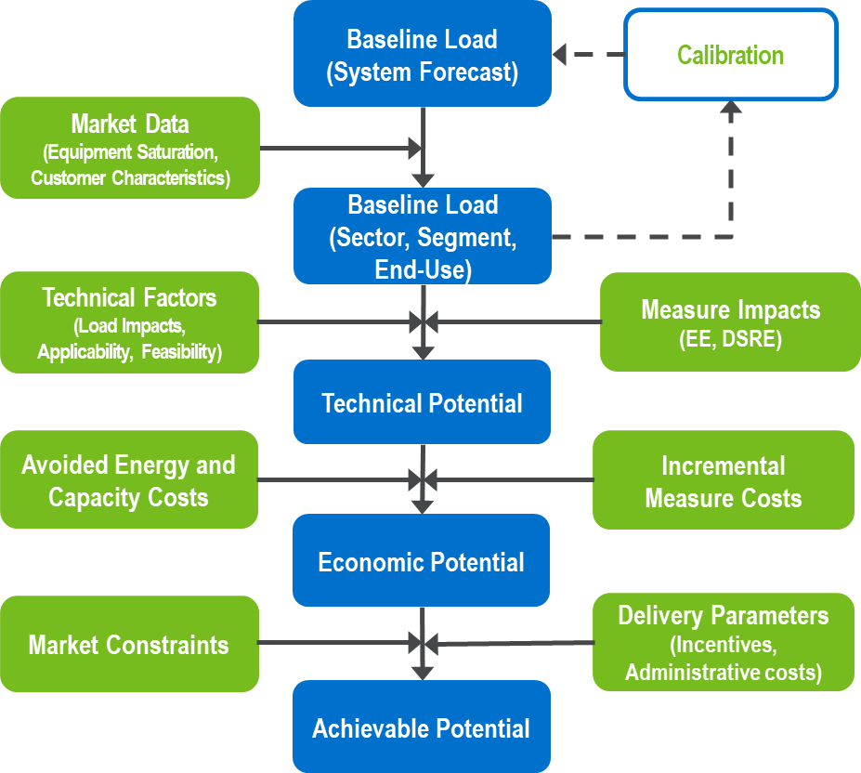
Nexant estimated DSM savings potential based on a combination of market research, analysis, and a review of Gulf’s existing DSM programs, all in coordination with Gulf. Nexant examined EE, DR, and DSRE opportunities; this report is organized to offer detail on each DSM category.

EE Potential Overview
To estimate EE market potential, this study utilized Nexant’s Microsoft Excel-based modeling tool, TEA-POT (Technical / Economic / Achievable POTential). This modeling tool was built on a platform that provides the ability to calculate multiple scenarios and recalculate potential savings based on variable inputs such as sales/load forecasts, electricity prices, discount rates, and actual utility program savings. The model provides transparency into the assumptions and calculations for estimating market potential.

DR Potential Overview
To estimate DR market potential, Nexant considered customer demand during utility peaking conditions, projected customer response to DR measures, the marginal benefit and cost of recruiting a customer for DR, and customer enrollment. Customer demand was determined by looking at interval data for a sample of each customer segment and determining the portion of a customer’s load that could be curtailed during the system peak. Projected customer response to DR measures was developed based on the performance of existing Florida DR programs and other DR programs in the US. Cost-effectiveness was estimated based on demand reductions, how well reductions coincide with system peaking conditions, the benefits of reducing demand during peaking conditions, and cost information. Enrollment rates were determined as a function of the incentive paid to a customer as well as the level of marketing for each DR measure.

DSRE Potential Overview
The DSRE technologies included in this study are rooftop solar photovoltaic (PV) systems, battery storage systems, and combined heat and power (CHP) systems. Nexant leveraged the customer segmentation and load disaggregation data assembled for the EE and DR analyses and used a “bottom-up” modeling approach to estimate the potential of the various DSRE technologies in the residential, commercial, and industrial sectors. Individual distributed generation models were created for the three DSRE technologies studied to estimate market potential.

Baseline Forecast Development

Market Characterization
The Gulf base year energy use and sales forecast provided the reference point to determine potential savings. The end-use market characterization of the base year energy use and reference case forecast included customer segmentation and load forecast disaggregation. The characterization is described in this section, while the subsequent section addresses the measures and market potential energy and demand savings scenarios.

Customer Segmentation
In order to estimate EE, DR, and DSRE potential, the sales forecast and peak load forecasts were segmented by customer characteristics. As electricity consumption patterns vary by customer type, Nexant segmented customers into homogenous groups to identify which customer groups are eligible to adopt specific DSM technologies, have similar building characteristics and load profiles, or are able to provide DSM grid services.
Nexant segmented customers according to the following:
- By Sector – how much of Gulf’s energy sales, summer peak, and winter peak load forecast is attributable to the residential, commercial, and industrial sectors?
- By Customer – how much electricity does each customer typically consume annually and during system peaking conditions?
- By End-Use – within a home or business, what equipment is using electricity during the system peak? How much energy does this end-use consume over the course of a year?
Table 3-1 summarizes the segmentation within each sector. The customer segmentation is discussed in Section 3.1.1. In addition to the segmentation described here for the EE and DSRE analyses, the residential customer segments were further segmented by heating type (electric heat, gas heat, or unknown) and by annual consumption bins within each sub-segment for the DR analysis. The goal of this further segmentation for DR was to understand which customer groups were most cost-effective to recruit and allow for more targeted marketing of DR programs.
Table 3-1: Customer Segmentation
Residential | Commercial |  | Industrial
Single Family | Assembly | Miscellaneous | Agriculture and Assembly | Primary Resources Industries
Multi-Family | College and University | Offices | Chemicals and Plastics | Stone/Glass/ Clay/Concrete
Manufactured Homes | Grocery | Restaurant | Construction | Textiles and Leather
 | Healthcare | Retail | Electrical and Electronic Equipment | Transportation Equipment
 | Hospitals | Schools K-12 | Lumber/Furniture/ Pulp/Paper | Water and Wastewater
 | Institutional | Warehouse | Metal Products and Machinery | Other
 | Lodging/ Hospitality |  | Miscellaneous Manufacturing
From an equipment and energy use perspective, each segment has variation within each building type or sub-sector. For example, the energy consuming equipment in a convenience store will vary significantly from the equipment found in a supermarket. To account for this variation, the selected end-uses describe energy consumption patterns that are consistent with those typically studied in national or regional surveys, such as the U.S. Energy Information Administration’s (EIA) Residential Energy Consumption Survey (RECS), Commercial Building Energy Consumption Survey (CBECS) and Manufacturing Energy Consumption Survey (MECS), among others. The end-uses selected for this study are listed in Table 3-2.
Table 3-2: End-Uses
Residential End-Uses | Commercial End-Uses | Industrial End-Uses
Space heating | Space heating | Process heating
Space cooling | Space cooling | Process cooling
Domestic hot water | Domestic hot water | Compressed air
Ventilation and circulation | Ventilation and circulation | Motors/pumps
Lighting | Interior lighting | Fan, blower motors
Cooking | Exterior lighting | Process-specific
Appliances | Cooking | Industrial lighting
Electronics | Refrigeration | Exterior lighting
Miscellaneous | Office equipment | HVAC
 | Miscellaneous | Other
For DR, the end-uses targeted were those with controllable load for residential customers (i.e. HVAC, water heaters, and pool pumps) and small C&I customers (HVAC). For large C&I customers, all load during peak hours was included assuming these customers would potentially would be willing to reduce electricity consumption for a limited time if offered a large enough incentive during temporary system peak demand conditions.

Forecast Disaggregation
A common understanding of the assumptions and granularity in the baseline load forecast was developed with input from Gulf. Key discussion topics reviewed included:
- How are current DSM offerings reflected in the energy and demand forecast?
- What are the assumed weather conditions and hour(s) of the day when the system is projected to peak?
- How much of the load forecast is attributable to customers that are not eligible for DSM programs?
- How are projections of population increase, changes in appliance efficiency, and evolving distribution of end-use load shares accounted for in the peak demand forecast?
If separate forecasts are not developed by region or sector, are there trends in the load composition that Nexant should account for in the study?

Electricity Consumption (kWh) Forecast
Nexant segmented the Gulf electricity consumption forecast into electricity consumption load shares by customer class and end-use. The baseline customer segmentation represents the electricity market by describing how electricity was consumed within the service territory. Nexant developed these forecasts for the years 2020-2029, and based it on data provided by Gulf, primarily their 2017 Ten-Year Site Plan, which was the most recent plan available at the time the studies were initiated. The data addressed current baseline consumption, system load, and sales forecasts.

Peak Demand (kW) Forecast
A fundamental component of DR potential was establishing a baseline forecast of what loads or operational requirements would be absent due to existing dispatchable DR or time varying rates. This baseline was necessary to assess how DR can assist in meeting specific planning and operational requirements. We utilized Gulf’s summer and winter peak demand forecast, which was developed for system planning purposes.

Estimating Consumption by End-Use Technology
As part of the forecast disaggregation, Nexant developed a list of electricity end-uses by sector (Table 3-2). To develop this list, Nexant began with Gulf’s estimates of average end-use consumption by customer and sector. Nexant combined these data with other information, such as utility residential appliance saturation surveys, to develop estimates of customers’ baseline consumption. Nexant calibrated the utility-provided data with data available from public sources, such as the EIA’s recurring data-collection efforts that describe energy end-use consumption for the residential, commercial, and manufacturing sectors.
To develop estimates of end-use electricity consumption by customer segment and end-use, Nexant applied estimates of end-use and equipment-type saturation to the average energy consumption for each sector. The following data sources and adjustments were used in developing the base year 2020 sales by end-use:

Residential sector:
- The disaggregation was based on Gulf rate class load shares and intensities.
- Baseline intensity was calibrated to account for differences in end-use saturation, fuel source, and equipment saturation as follows:
  - Gulf rate class load share is based on average per customer.
  - Nexant made conversions to usage estimates generated by applying utility-provided residential saturation surveys (RSS) and EIA end-use modeling estimates.

Commercial sector:
- The disaggregation was based on Gulf rate class load shares, intensities, and EIA CBECS data.
- Segment data from EIA and Gulf.
- Baseline intensity was calibrated to account for differences in end-use saturation, fuel source, and equipment saturation as follows:
  - Rate class load share based on EIA CBECS and end-use forecasts from Gulf.

Industrial sector:
- The disaggregation was based on rate class load shares, intensities, and EIA MECS data.
- Segment data from EIA and Gulf.
- Baseline intensity was calibrated to account for differences in end-use saturation, fuel source, and equipment saturation as follows:
  - Rate class load share based on EIA MECS and end-use forecasts from Gulf.

Analysis of Customer Segmentation
Customer segmentation is important to ensuring that a MPS examines DSM measure savings potential in a manner that reflects the diversity of energy savings opportunities existing across the utility’s customer base. Gulf provided Nexant with data concerning the premise type and loads characteristics for all customers for the MPS analysis. Nexant examined the provided data from multiple perspectives to identify customer segments. Nexant’s approach to segmentation varied slightly for non-residential and residential customers, but the overall logic was consistent with the concept of expressing the customers in terms that were relevant to DSM opportunities.

Residential Customers (EE, DR, and DSRE Analysis)
Segmentation of residential customer accounts enabled Nexant to align DSM opportunities with appropriate DSM measures. Nexant used utility customer data, supplemented with EIA data, to segment the residential sector by customer dwelling type (single family, multi-family, or manufactured home). The resulting distribution of customers according to dwelling unit type is presented in Figure 3-1.
Figure 3-1: Residential Customer Segmentation
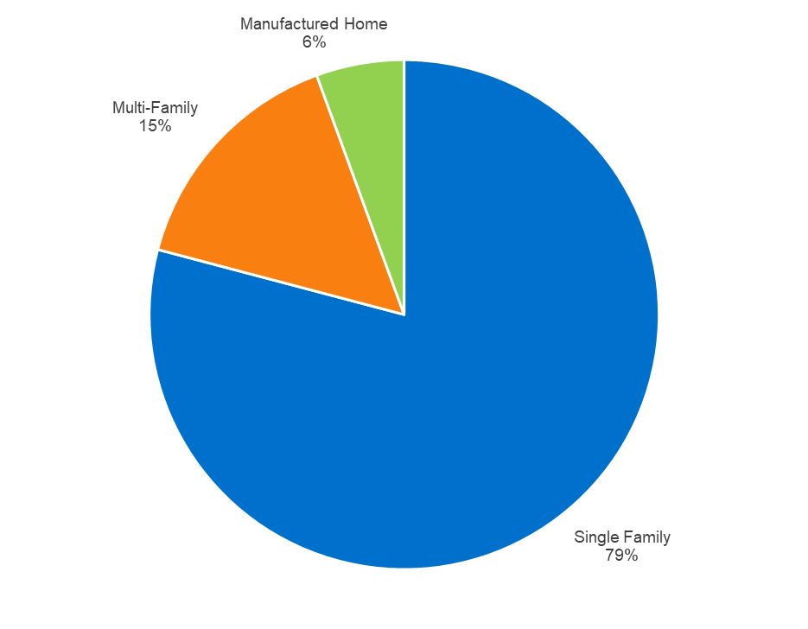

Non-Residential (Commercial and Industrial) Customers (EE and DSRE Analysis)
For the EE and DSRE analysis, Nexant segmented C&I customers using the utility’s North American Industry Classification System (NAICS) or Standard Industrial Classification (SIC) codes, supplemented by data produced by the EIA’s CBECS and MECS. Nexant classified the customers in this group as either commercial or industrial, on the basis of DSM measure information available and applicable to each. For example, agriculture and forestry DSM measures are commonly considered industrial savings opportunities. Nexant based this classification on the types of DSM measures applicable by segment, rather than on the annual energy consumption or maximum instantaneous demand from the segment as a whole. The estimated energy sales distributions Nexant applied are shown below in Figure 3-2 and Figure 3-3.
Figure 3-2: Commercial Customer Segmentation
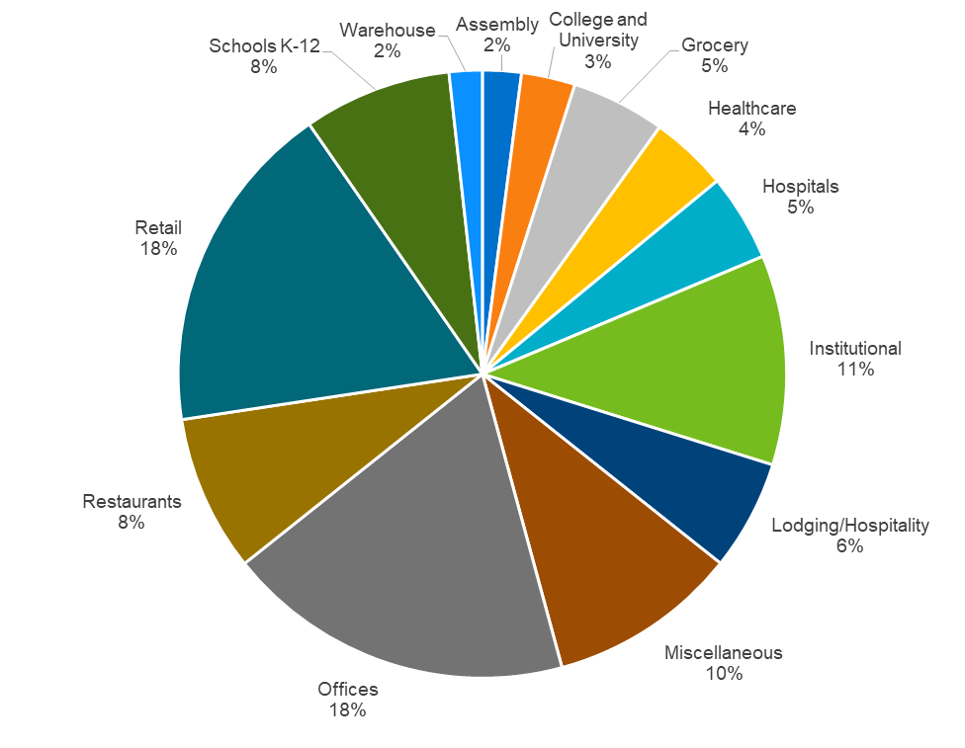
Figure 3-3: Industrial Customer Segmentation
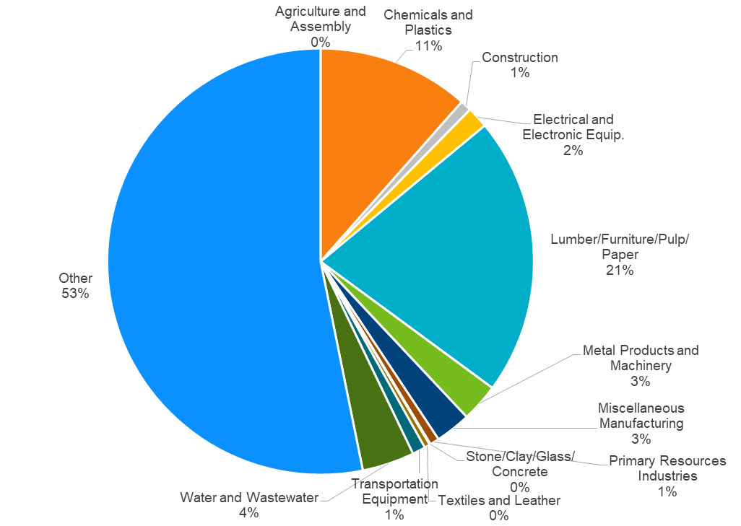

Commercial and Industrial Customers (DR Analysis)
For the DR analysis, Nexant divided the non-residential customers into the two customer classes of small C&I and large C&I using rate class and annual consumption. For the purposes of this analysis, small C&I customers are those on the General Service (GS) tariff. Large C&I customers are all customers on the General Service Demand (GSD) and Large Power Service (LP) tariff. Nexant further segmented these two groups based on customer size. For small C&I segmentation was determined using annual customer consumption and for large C&I the customer’s maximum demand was used. Both customer maximum demand and customer annual consumption were calculated using billing data provided by Gulf.
Table 3-3 shows the account breakout between small C&I and large C&I.
Table 3-3: Summary of Customer Classes for DR Analysis
Customer Class | Customer Size | Number of Accounts
Small C&I | 0-15,000 kWh | 22,217
 | 15,001-25,000 kWh | 4,443
 | 25,001-50,000 kWh | 2,613
 | 50,001 kWh + | 423
 | Total | 29,696
Large C&I | 0-50 kW | 9,686
 | 51-300 kW | 4,903
 | 301-500 kW | 462
 | 501 kW + | 158
 | Total | 15,209

Analysis of System Load

System Energy Sales
While the technical and economic potential are based on the year 2020’s system load forecast, achievable potential is applied over the entire 10-year study period (2020-2029). Figure 3-4 summarizes the electric sales forecast by sector over the study period.
Figure 3-4: Electricity Sales Forecast by Sector
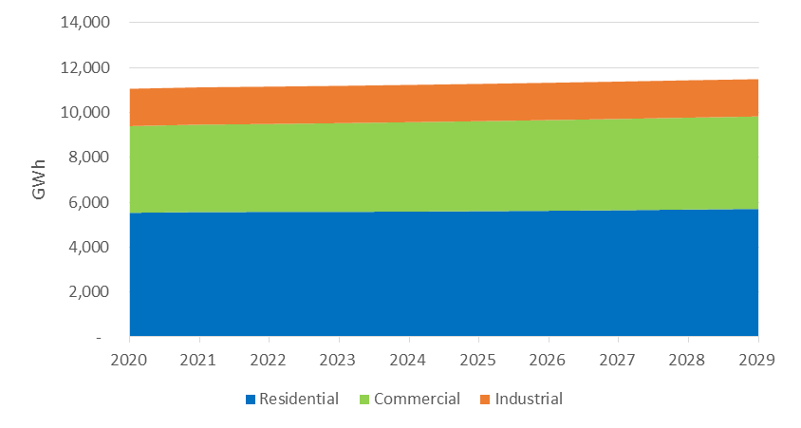

System Demand
To determine when DR would be cost-effective to implement, Nexant first established peaking conditions for each utility by looking at when each utility historically experienced its maximum demand. The primary data source used to determine when DR resources will be needed was the historical system load for Gulf. The data provided contained the system loads for all 8,760 hours of the most recent five years leading up to the study (2011-2016). The utility summer and winter peaks were then identified within the utility-defined peaking conditions. For the FEECA Utilities the summer peaking conditions were defined as July and August from 4:00-5:00 PM and the winter peaking conditions were defined as January from 7:00-8:00 AM. The seasonal peaks were then selected as the maximum demand during utility peaking conditions.

Load Disaggregation
The disaggregated loads for the base year 2020 by sector and end-use are illustrated in Figure 3-5, Figure 3-6 and Figure 3-7.
Figure 3-5: Residential Baseline (2020) Energy Sales by End-Use
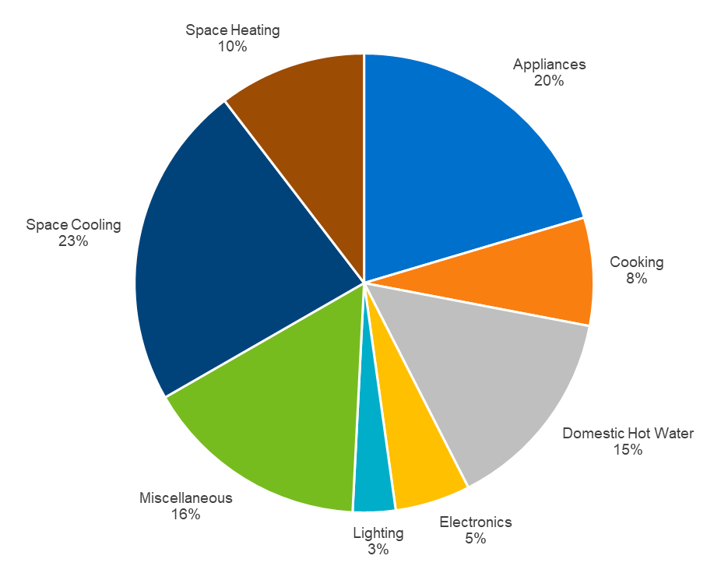
Figure 3-6: Commercial Baseline (2020) Energy Sales by End-Use
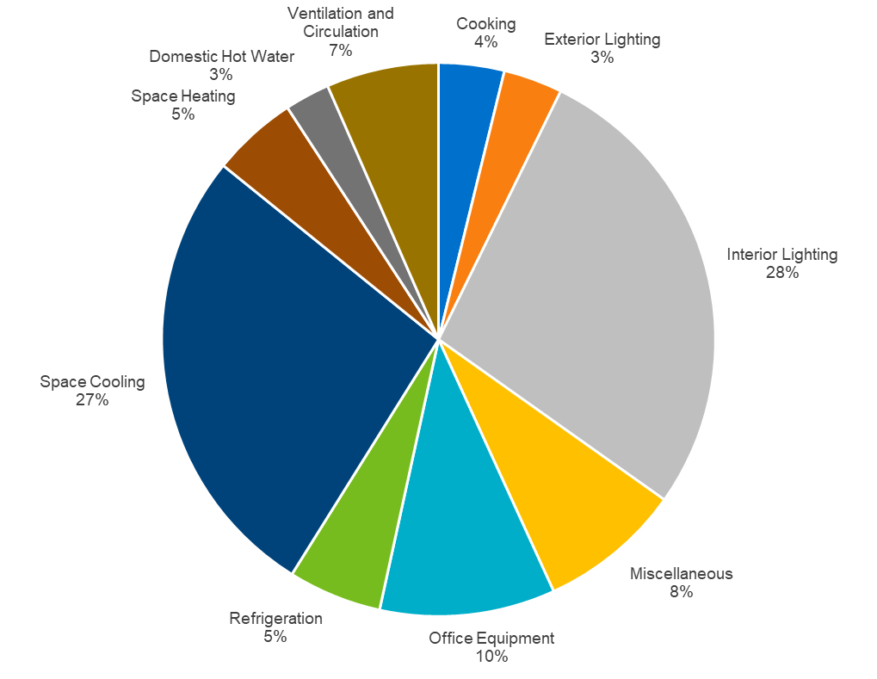
Figure 3-7: Industrial Baseline (2020) Energy Sales by End-Use
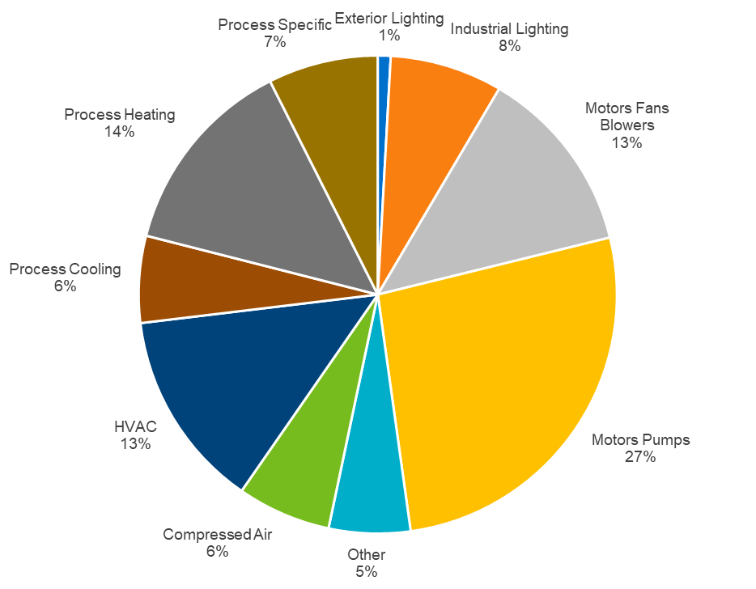

DSM Measure Development
Market potential is described by comparing baseline market consumption with opportunities for savings. Describing these individual savings opportunities results in a list of DSM measures to analyze. This section presents the methodology to develop the measure lists.

Methodology
Nexant identified a comprehensive catalog of DSM measures for the study. The measure list is the same for all FEECA Utilities. The iterative vetting process with the utilities to develop the measure list began by initially examining the list of measures included in the 2014 Goals docket. This list was then adjusted based on proposed measure additions and revisions provided by the FEECA Utilities. Nexant further refined the measure list based on reviews of Nexant’s DSM measure library, compiled from similar market potential studies conducted in recent years throughout the United States, including recent studies for Georgia Power Company and Duke Energy Carolinas, as well as measures included in other utility programs where Nexant is involved with program design, implementation, or evaluation. In addition, Nexant evaluated whether each measure had the appropriate data available to estimate impacts in the potential analyses. A draft version of the measure list was shared with interested parties Earthjustice/Southern Alliance for Clean Energy (SACE) for Nexant and the FEECA Utilities to gather and consider their input. The results of that consideration were provided to Earthjustice/SACE and later shared with the Florida Public Service Commission Staff (Staff) and all other interested parties at an informal meeting held by Staff. The extensive, iterative review process involving multiple parties has ensured that the study included a robust and comprehensive set of DSM measures.
See Appendix A for the list of EE measures, Appendix B for the list of DR measures, and Appendix C for the list of DSRE measures analyzed in the study.

EE Measures
EE measures represent technologies applicable to the residential, commercial, and industrial customers in the FEECA Utilities’ service territories. The development of EE measures included consideration of:
- Applicability and commercial availability of EE technologies in Florida. Measures that are not applicable due to climate or customer characteristics were excluded, as were “emerging” technologies that are not currently commercially available to FEECA utility customers.
- Current and planned Florida Building Codes and federal equipment standards (Codes & standards) for baseline equipment. Measures included from prior studies were adjusted to reflect current Codes & standards as well as updated efficiency tiers, as appropriate.
- Eligibility for utility DSM offerings in Florida. For example, behavioral measures were excluded from consideration as they are not allowed to be counted towards utility DSM goals. Behavioral measures are intended to motivate customers to operate in a more energy-efficient manner (e.g., setting an air-conditioner thermostat to a higher temperature) without accompanying: a) physical changes to more efficient end-use equipment or to their building envelope, b) utility-provided products and tools to facilitate the efficiency improvements, or c) permanent operational changes that improve efficiency which are not easily revertible to prior conditions. These types of behavioral measures were excluded because of the variability in forecasting the magnitude and persistence of energy and demand savings from the utility’s perspective. Additionally, behavioral measure savings may be obtained in part from the installation of EE technologies, which would overlap with other EE measures included in the study.
Upon development of the final EE measure list, a Microsoft Excel workbook was developed for each measure to quantify measure inputs necessary for assessment of the measure’s potential and cost-effectiveness. Relevant inputs included the following:
- Measure description: measure classification by type, end-use, and subsector, and description of the base-case scenario.
- kWh savings: Energy savings associated with each measure were developed through engineering algorithms or building simulation modeling, taking weather zones and customer segments into consideration as appropriate. Reference sources used for developing residential and commercial measure savings included a variety of Florida-specific, as well as regional and national sources, such utility-specific measurement & verification (M&V) data, technical reference manuals (TRM) from other jurisdictions, ENERGY STAR calculators, and manufacturer or retailer specifications on particular products. Industrial measure savings were primarily based on Department of Energy’s (DOE) Industrial Assessment Center database, using assessments conducted in the Southeast region, as well as TRMs, utility reference data, and Nexant DSM program experience.
Energy savings were applied in Nexant’s TEA-POT model as a percentage of total baseline consumption. Peak demand savings were determined using utility-specific load shapes or coincidence factors.
- Measure Expected Useful Lifetime: Sources included the Database for Energy Efficient Resources (DEER), the American Society of Heating, Refrigerating and Air Conditioning Engineers (ASHRAE) Handbook, and other regional and national measure databases and EE program evaluations
- Measure Costs: Per-unit costs (full or incremental, depending on the application) associated with measure installations. Sources included: TRMs, ENERGY STAR calculator, online market research, RSMeans database, and other secondary sources.
Measure Applicability: A general term encompassing an array of factors, including: technical feasibility of installation, and the measure’s current saturation as well as factors to allocate savings associated with competing measures. Information used was primarily derived from data in current regional and national databases, as well as Gulf’s program tracking data. These factors are described in Table 4-1.
Table 4-1: Measure Applicability Factors
Measure Impact | Explanation | Sources
Technical Feasibility | The percentage of buildings that can have the measure physically installed. Various factors may affect this, including, but not limited to, whether the building already has the baseline measure (e.g., dishwasher), and limitations on installation (e.g., size of unit and space available to install the unit). | Various secondary sources and engineering experience.
Measure Incomplete Factor | The percentage of buildings without the specific measure currently installed. | Utility RASS; EIA RECS, CBECS; MECS; ENERGY STAR sales figures; and engineering experience.
Measure Share | Used to distribute the percentage of market shares for competing measures (e.g., only blown-in ceiling insulation or spray foam insulation, not both would be installed in an attic). | Utility customer data, Various secondary sources and engineering experience.

As shown in Table 4-2, the measure list includes 248 unique energy-efficiency measures. Expanding the measures to account for all appropriate combinations of segments, end-uses, and construction types resulted in 4,186 measure permutations.
Table 4-2: EE Measure Counts by Sector
Sector | Unique Measures | Permutations
Residential | 91 | 546
Commercial | 127 | 3,298
Industrial | 30 | 342

DR Measures
The DR measures included in the measure list utilize the following DR strategies:
- Direct Load Control. Customers receive incentive payments for allowing the utility to control their selected equipment, such as HVAC or water heaters.
- Critical Peak Pricing (CPP) with Technology. Electricity rate structures that vary based on time of day. Includes CPP when the rate is substantially higher for a limited number of hours or days per year (customers receive advance notification of CPP event) coupled with technology that enables customer to lower their usage in a specific end-use in response to the event (e.g., HVAC via smart thermostat).
- Contractual DR. Customers receive incentive payments or a rate discount for committing to reduce load by a pre-determined amount or to a pre-determined firm service level upon utility request.
- Automated DR. Utility dispatched control of specific end-uses at a customer facility.
DR initiatives that do not rely on the installation of a specific device or technology to implement (such as a voluntary curtailment program) were not included.
A workbook was developed for each measure which included the same measure inputs as previously described for the EE measures. In addition, the DR workbook included:
- Expected load reduction from the measure, based on utility technical potential, existing utility DR programs, and other nationwide DR programs if needed.
For technical potential, Nexant did not break out results by measure because all of the developed measures target the end-uses estimated for technical potential. Individual measures were only considered for economic and achievable potential.

DSRE Measures
The DSRE measure list includes rooftop PV systems, battery storage systems charged from PV systems, and CHP systems.
PV Systems
PV systems utilize solar panels (a packaged collection of PV cells) to convert sunlight into electricity. A system is constructed with multiple solar panels, a DC/AC inverter, a racking system to hold the panels, and electrical system interconnections. These systems are often roof-mounted systems that face south-west, south, and/or, south-east. The potential associated with roof-mounted systems installed on residential and commercial buildings was analyzed.
Battery Storage Systems Charged from PV Systems
Distributed battery storage systems included in this study consist of behind-the-meter battery systems installed in conjunction with an appropriately-sized PV system at residential and commercial customer facilities. These battery systems typically consist of a DC-charged battery, a DC/AC inverter, and electrical system interconnections to a PV system. On their own battery storage systems do not generate or conserve energy, but can collect and store excess PV generation to provide power during particular time periods; which for DSM purposes would be to offset customer demand during the utility’s system peak.
CHP Systems
In most CHP applications, a heat engine creates shaft power that drives an electrical generator (fuel cells can produce electrical power directly from electrochemical reactions). The waste heat from the engine is then recovered to provide steam or hot water to meet on-site needs. Common prime mover technologies used in CHP applications and explored in this study include:
- Steam turbines
- Gas turbines
- Micro turbines
- Fuel Cells
- Internal combustion engines
A workbook was developed for each measure which included the inputs previously described for EE measures and prime mover operating parameters.

Technical Potential
In the previous sections, the approach for DSM measure development was summarized, and the 2020 base year load shares and reference-case load forecast were described. The outputs from these tasks provided the input for estimating the technical potential scenario, which is discussed in this section.
The technical potential scenario estimates the savings potential when all technically feasible DSM measures are implemented at their full market potential without regard for cost-effectiveness and customer willingness to adopt the most impactful EE, DR, or DSRE technologies. Since the technical potential does not consider the costs or time required to achieve these savings, the estimates provide a theoretical upper limit on electricity savings potential. Technical potential is only constrained by factors such as technical feasibility and applicability of measures. For this study, technical potential included full application of the commercially available DSM measures to all residential, commercial, and industrial customers in the utility’s service territory.

Methodology

EE Technical Potential
EE technical potential refers to delivering less electricity to the same end-uses. In other words, technical potential might be summarized as “doing the same thing with less energy, regardless of the cost.”
DSM measures were applied to the disaggregated utility electricity sales forecasts to estimate technical potential. This involved applying estimated energy savings from equipment and non-equipment measures to all electricity end-uses and customers. Technical potential consists of the total energy and demand that can be saved in the market which Nexant reported as a single numerical value for each utility’s service territory.
The core equation used in the residential sector EE technical potential analysis for each individual efficiency measure is shown in Equation 5-1 below, while the core equation used in the nonresidential sector technical potential analysis for each individual efficiency measure is shown in Equation 5-2.
Equation 5-1: Core Equation for Residential Sector Technical Potential
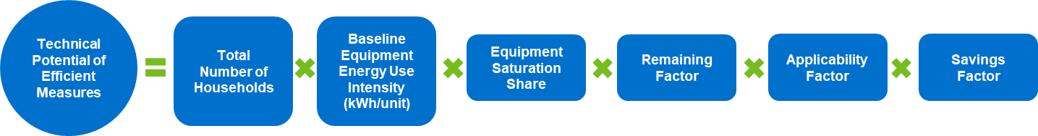
Where:
Baseline Equipment Energy Use Intensity = the electricity used per customer per year by each baseline technology in each market segment. In other words, the baseline equipment energy-use intensity is the consumption of the electrical energy using equipment that the efficient technology replaces or affects.
Equipment Saturation Share = the fraction of the end-use electrical energy that is applicable for the efficient technology in a given market segment. For example, for residential cooling, the saturation share would be the fraction of all residential electric customers that have central air conditioners in their household.
Remaining Factor = the fraction of equipment that is not considered to already be energy efficient. To extend the example above, the fraction of central air conditioners that is not already the most energy efficient technology.
Applicability Factor = the fraction of units that is technically feasible for conversion to the most efficient available technology from an engineering perspective (i.e., it may not be possible to install LEDs in all light sockets in a home because the available styles may not fit in every socket).
Savings Factor = the percentage reduction in electricity consumption resulting from the application of the efficient technology.
Equation 5-2: Core Equation for Non-Residential Sector Technical Potential
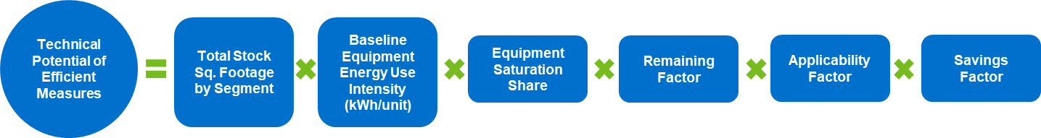
Where:
Total Stock Square Footage by Segment = the forecasted square footage level for a given building type (e.g., square feet of office buildings).
Baseline Equipment Energy Use Intensity = the electricity used per square foot per year by each baseline equipment type in each market segment.
Equipment Saturation Share = the fraction of total end-use energy consumption associated with the efficient technology in a given market segment. For example, for packaged terminal air-conditioner (PTAC), the saturation share would be the fraction of all space cooling kWh in a given market segment that is associated with PTAC equipment.
Remaining Factor = the fraction of equipment that is not considered to already be energy efficient.
Applicability Factor = the fraction of the equipment or practice that is technically feasible for conversion to the efficient technology from an engineering perspective (i.e., it may not be possible to install Variable Frequency Drives (VFD) on all motors in a given market segment).
Savings Factor = the percentage reduction in electricity consumption resulting from the application of the efficient technology.
It is important to note that the technical potential estimate represents electricity savings potential at a specific point in time. In other words, the technical potential estimate is based on data describing status quo customer electricity use and technologies known to exist today. As technology and electricity consumption patterns evolve over time, the baseline electricity consumption will also change accordingly. For this reason, technical potential is a discrete estimate of a dynamic market. Nexant reported the technical potential for 2020, based on currently known DSM measures and observed electricity consumption patterns.

Measure Interaction and Competition
While the technical potential equations listed above focus on the technical potential of a single measure or technology, Nexant’s modeling approach does recognize the overlap of individual measure impacts within an end-use or equipment type, and accounts for the following interactive effects:
- Measure interaction: Installing high-efficiency equipment could reduce energy savings in absolute terms (kWh) associated with non-equipment measures that impact the same end-use. For example, installing a high-efficiency heat pump will reduce heating and cooling consumption which will reduce the baseline against which attic insulation would be applied, thus reducing savings associated with installing insulation. To account for this interaction, Nexant’s TEA-POT model ranks measures that interact with one another and reduces the baseline consumption for the subsequent measure based on the savings achieved by the preceding measure. For technical potential, interactive measures are ranked based on total end-use energy savings percentage.
- Measure competition: The “measure share”—as defined above—accounted for competing measures, ensuring savings were not double-counted. This interaction occurred when two or more measures “competed” for the same end-use. For example, a T-12 lamp could be replaced with a T-8 or linear LED lamp.

Addressing Naturally-Occurring EE
Because the anticipated impacts of efficiency actions that may be taken even in the absence of utility intervention are included in the baseline forecast, savings due to naturally-occurring EE were considered separately in the potential estimates. Nexant verified with Gulf’s forecasting group to ensure that the sales forecasts incorporated two known sources of naturally-occurring efficiency:
- Codes and Standards: The sales forecasts already incorporated the impacts of known Code & standards changes. While some changes have relatively little impact on overall sales, others—particularly the Energy Independence and Security Act (EISA) and other federal legislation—will have noticeable influence.
Baseline Measure Adoption: The sales forecast excluded the projected impacts of future DSM efforts, but included already implemented DSM penetration.
By properly accounting for these factors, the potential study estimated the net penetration rates, representing the difference between the anticipated adoption of efficiency measures as a result of DSM efforts and the “business as usual” adoption rates absent DSM intervention. This is true even in the technical potential, where adoption was assumed to be 100%.

DR Technical Potential
The concept of technical potential applies differently to DR than for EE. Technical potential for DR is effectively the magnitude of loads that can be curtailed during conditions when utilities need peak capacity reductions. In evaluating this potential at peak capacity the following were considered: which customers are consuming electricity at those times? What end-uses are in play? Can those end-use loads be managed? Large C&I customers generally do not provide the utility with direct control over particular end-uses. Instead, many of these customers will forego virtually all electric demand temporarily if the financial incentive is large enough. For residential and small C&I customers where DR generally takes the form of direct utility control, technical potential for DR is limited by the loads that can be controlled remotely at scale.
This framework makes end-use disaggregation an important element for understanding DR potential, particularly in the residential and small C&I sectors. Nexant’s approach used for load disaggregation is more advanced than what is used for most potential studies. Instead of disaggregating annual consumption or peak demand, Nexant produced end-use load disaggregation for all 8,760 hours. This was needed because the loads available at times when different grid applications are needed can vary substantially. Instead of producing disaggregated loads for the average customer, the study was produced for several customer segments. For Gulf, Nexant examined three residential segments based on customer housing type, four different small C&I segments based on customer size, and four different large C&I segments based on customer size, for a total of 11 different customer segments.
Technical potential, in the context of DR, is defined as the total amount of load available for reduction that is coincident with the period of interest; in this case, the system peak hour for the summer and winter seasons. Thus, two sets of capacity values are estimated: a summer capacity and a winter capacity.
As previously mentioned, for technical potential purposes, all coincident large C&I load is considered dispatchable, while residential and small C&I DR capacity is based on specific end-uses. Summer DR capacity for residential customers was comprised of air-conditioning (AC), pool pumps, and water heaters. For small C&I customers, summer capacity was based on AC load. For winter DR capacity, residential was based on electric heating, pool pumps, and water heaters. For small C&I customers, winter capacity was based on electric heating.
AC and heating load profiles were generated for residential and small C&I customers using a sample of customers provided by Gulf. This sample included a customer breakout based on size and housing type for each rate class. Nexant then used the interval data from these customers to create an average load profile for each customer segment.
The average load profile for each customer segment was combined with historical weather data, and used to estimate hourly load as a function of weather conditions. AC and heating loads were estimated by first calculating the baseline load on days when cooling degree days (CDD) and heating degree days (HDD) were equal to zero, and then subtracting this baseline load. This methodology is illustrated by Figure 5-1 (a similar methodology was used to predict heating loads).
Figure 5-1: Methodology for Estimating Cooling Loads
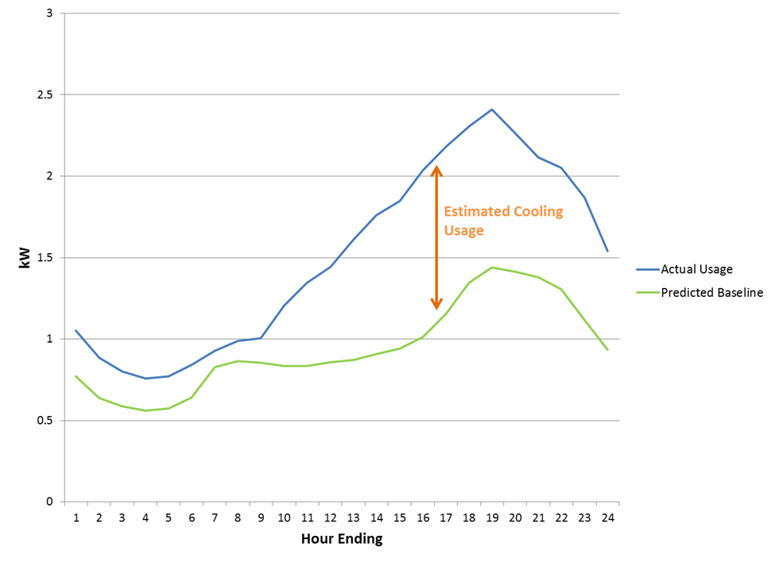
This method was able to produce estimates for average AC/heating load profiles for the seven different customer segments within the residential and small C&I sectors.
Profiles for residential water heater and pool pump loads were estimated by utilizing end-use load data from CPS Energy’s Home Manager DR.
For all eligible loads, the technical potential was defined as the amount that was coincident with system peak hours for each season, which are July and August from 4:00-5:00 PM for summer, and January from 7:00-8:00 AM for winter.
For technical potential, there was also no measure breakout needed, because all measures will target the end-uses’ estimated total loads. Individual measures are only considered for economic and achievable potential.
In order to account for existing Gulf DR programs, all customers currently enrolled in a DR offering were excluded from Gulf’s technical potential. This methodology was consistent across all three sectors.

DSRE Technical Potential

PV Systems
To determine technical potential for PV systems, Nexant estimated the percentage of rooftop square footage in Florida that is suitable for hosting PV technology. Our estimate of technical potential for PV systems in this report is based in part on the available roof area and consisted of the following steps:
- Step 1: Outcomes from the forecast disaggregation analysis were used to characterize the existing and new residential, commercial and industrial building stocks. Relevant parameters included number of facilities, average number of floors, and average premises square footage.
- Step 2: The total available roof area feasible for installing PV systems was calculated. Relevant parameters included share of pitched and flat roofs and unusable area due to other rooftop equipment.
- Step 3: Estimated the expected power density (kW per square foot of roof area).
- Step 4: Using PVWatts, secondary research, and M&V evaluations of PV systems, Nexant used its technical potential PV calculator to calculate energy generation/savings using researched system capacity factors.
The methodology presented in this report uses the following formula to estimate overall technical potential of PVs:
Equation 5-3: Core Equation for Solar Technical Potential
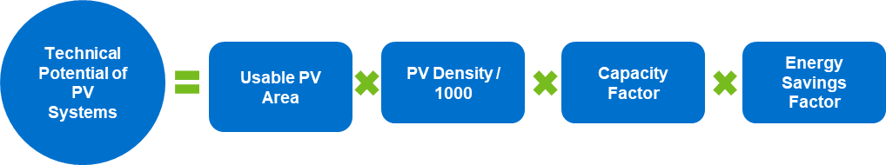

Where:
Usable PV Area for Residential: (Total Floor Area / Average No. of Stories) x ((% of Sloped Roofs x Usable Area of Sloped Roofs) + (% of Flat Roofs x Usable Area of Flat Roofs))
Usable PV Area for Commercial: Total Floor Area x ((% of Sloped Roofs x Usable Area of Sloped Roofs) + (% of Flat Roofs x Usable Area of Flat Roofs))
PV Density (Watts/Square foot): Maximum power generated in Watts per square foot of solar panel.
Capacity Factor: Annual Energy Generation Factor for PV
Energy Savings Factor: AC Energy Conversion factor for each kW of the system, obtained from PVWatts. Energy Savings Factor = Alternating Current System Output (kWh)/ Direct Current System Size (kW)

Battery Storage Systems
Battery storage systems on their own do not generate power or create efficiency improvements, but store power for use at different times. Therefore, in analyzing the technical potential for battery storage systems, the source of the stored power and overlap with technical potential identified in other categories was considered.
Battery storage systems that are powered directly from the grid do not produce annual energy savings but may be used to shift or curtail load during particular time periods. As the DR technical potential analyzes curtailment opportunities for the summer and winter peak period, and battery storage systems can be used as a DR technology, the study concluded that no additional technical potential should be claimed for grid-powered battery systems beyond that already attributed to DR.
Battery storage systems that are connected to on-site PV systems also do not produce additional energy savings beyond the energy produced from the PV system. However, PV-connected battery systems do create the opportunity to store energy during period when the PV system is generating more than the home or business is consuming, and use that stored power during utility system peak periods. To determine the additional technical potential peak demand savings for “solar plus storage” systems, our methodology consisted of the following steps:
- Develop an 8,760 hour annual load shape for a PV system based on estimated annual hours of available sunlight.
- Compare the PV generation with a total home or total business 8,760 hour annual load shape to determine the hours that the full solar energy is used and the hours where excess solar power is generated.
- Develop a battery charge/discharge 8,760 load profile to identify available stored load during summer and winter peak periods, which was applied as the technical potential.

CHP Systems
The CHP analysis created a series of unique distributed generation potential models for each primary market sector (commercial and industrial).
Only non-residential customer segments whose electric and thermal load profiles allow for the application of CHP were considered. The technical potential analysis followed a three-step process. First, minimum facilities size thresholds were determined for each non-residential customer segment. Next, the full population of non-residential customers were segmented and screened based on the size threshold established for that segment. Finally, the facilities that were of sufficient size were matched with the appropriately sized CHP technology.
To determine the minimum threshold for CHP suitability, a thermal factor was applied to potential candidate customer loads to reflect thermal load considerations in CHP sizing. In most cases, on-site thermal energy demand is smaller than electrical demand. Thus, CHP size is usually dictated by the thermal load in order to achieve improved efficiencies.
The study collected electric and thermal intensity data from other recent CHP studies. For industrial customers, Nexant assumed that the thermal load would primarily be used for process operations and was not modified from the secondary data sources for Florida climate conditions. For commercial customers, the thermal load is more commonly made up of water heating, space heating, and space cooling (through the use of an absorption chiller). Therefore, to account for the hot and humid climate in Florida, which traditionally limits weather-dependent internal heating loads, commercial customers’ thermal loads were adjusted to incorporate a higher proportion of space cooling to space heating as available opportunities for waste heat recovery.
After determination of minimum kWh thresholds by segment, Nexant used the utility-provided customer data with NAICS or SIC codes as well as annual consumption data, and categorized all non-residential customers by segment and size. Customers with annual loads below the kWh thresholds are not expected to have the consistent electric and thermal loads necessary to support CHP and were eliminated from consideration.
In general, internal combustion engines are the prime mover for systems under 500kW with gas turbines becoming progressively more popular as system size increases above that. Based on the available load by customer, adjusted by the estimated thermal factor for each segment, CHP technologies were assigned to utility customers in a top-down fashion (i.e. starting with the largest CHP generators).

Measure Interaction
PV systems and battery storage charged from PV systems were analyzed collectively due to their common power generation source; and therefore the identified technical potential for these systems is additive. However, CHP systems were independently analyzed for technical potential without consideration of the competition between DSRE technologies or customer preference for a particular DSRE system. Therefore, results for CHP technical potential should not be combined with PV systems or battery storage systems for overall DSRE potential but used as independent estimates.

Interaction of Technical Potential Impacts
As described above, the technical potential was estimated using separate models for EE, DR, and DSRE systems. However, there is interaction between these technologies; for example, a more efficient HVAC system would result in a reduced peak demand available for DR curtailment. Therefore, after development of the independent models, the interaction between EE, DR, and DSRE was incorporated as follows:
- The EE technical potential was assumed to be implemented first, followed by DR technical potential and DSRE technical potential.
- To account for the impact of EE technical potential on DR, the baseline load forecast for the applicable end-uses was adjusted by the EE technical potential, resulting in a reduction in baseline load available for curtailment.
- For DSRE systems, the EE and DR technical potential was incorporated in a similar fashion, adjusting the baseline load used to estimate DSRE potential.
  - For the PV analysis this did not impact the results as the EE and DR technical potential did not affect the amount of PV that could be installed on available rooftops.
  - For the battery storage charged from PV systems, the reduced baseline load from EE resulted in additional PV-generated energy being available for the battery systems and for use during peak periods. The impact of DR events during the assumed curtailment hours was incorporated into the modeling of available battery storage and discharge loads.
  - For CHP systems, the reduced baseline load from EE resulted in a reduction in the number of facilities that met the annual energy threshold needed for CHP installations. Installed DR capacity was assumed to not impact CHP potential as the CHP system feasibility was determined based on energy and thermal consumption at the facility. It should be noted that CHP systems not connected to the grid could impact the amount of load available for curtailment with utility-sponsored DR. Therefore, CHP technical potential should not be combined with DR potential but used as independent estimates.

EE Technical Potential

Summary
Table 5-1 summarizes the EE technical potential by sector:
Table 5-1: EE Technical Potential by Sector
 | Savings Potential
 | Summer  Peak Demand (MW) | Winter  Peak Demand (MW) | Energy  (GWh)
Residential | 391 | 199 | 1,464
Non-Residential | 231 | 129 | 1,105
Total | 621 | 328 | 2,568

Residential
Figure 5-2, Figure 5-3, and Figure 5-4 illustrates the residential sector EE technical potential by end-use.
Figure 5-2: Residential EE Technical Potential by End-Use (Energy Savings)
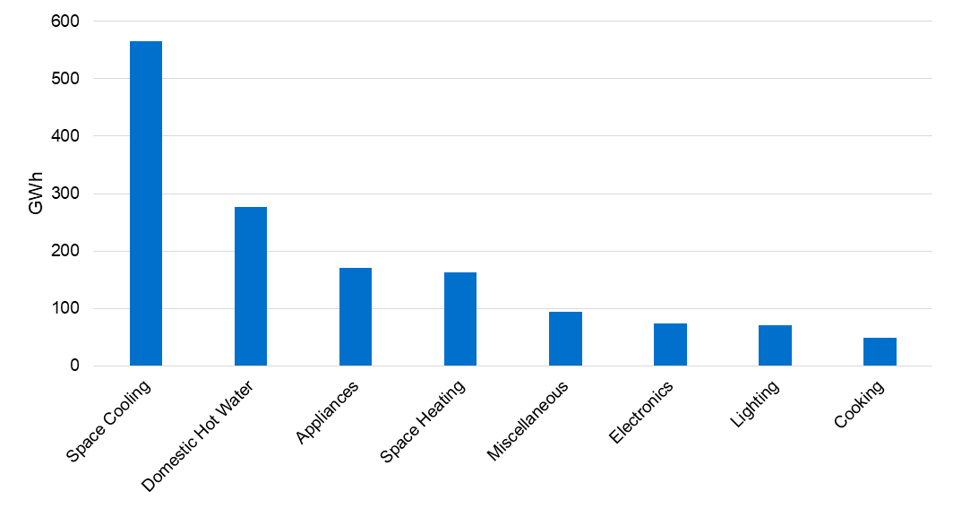

Figure 5-3: Residential EE Technical Potential by End-Use (Summer Peak Savings)
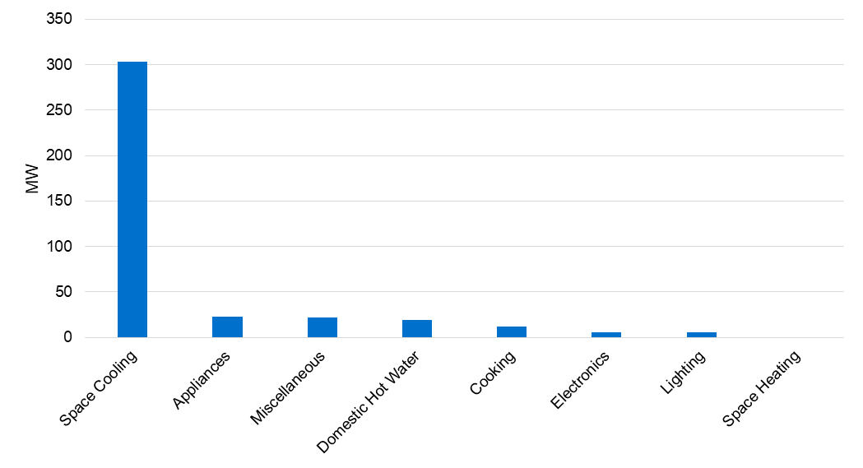

Figure 5-4: Residential EE Technical Potential by End-Use (Winter Peak Savings)
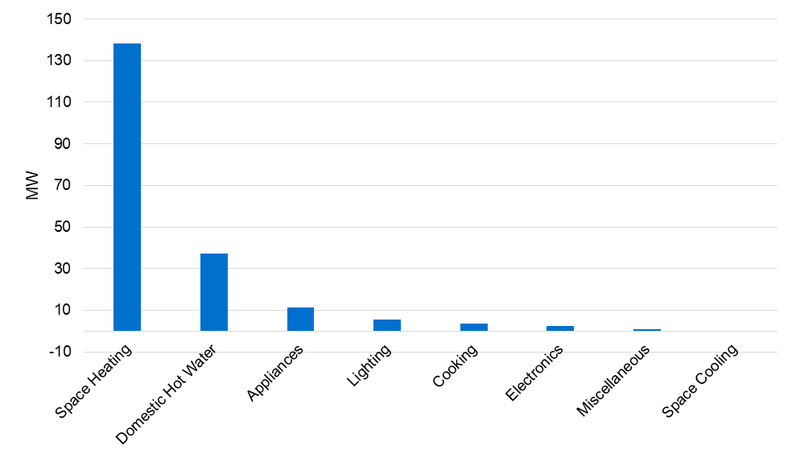

Non-Residential

Commercial Segments
Figure 5-5, Figure 5-6, and Figure 5-7 illustrates the commercial sector EE technical potential by end-use.
Figure 5-5: Commercial EE Technical Potential by End-Use (Energy Savings)
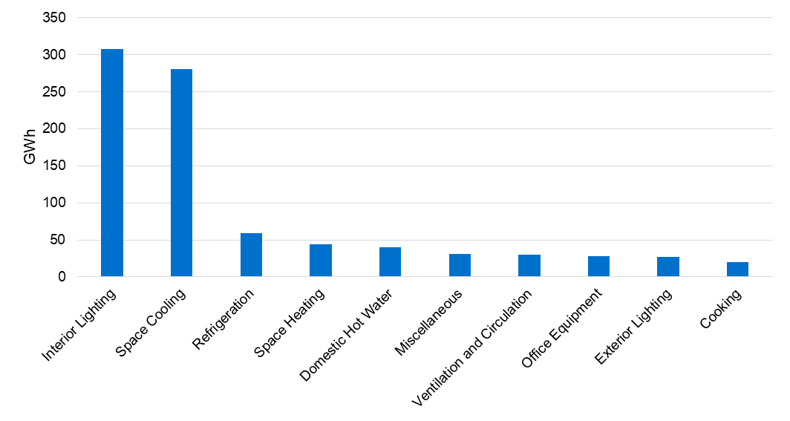
Figure 5-6: Commercial EE Technical Potential by End-Use (Summer Peak Savings)
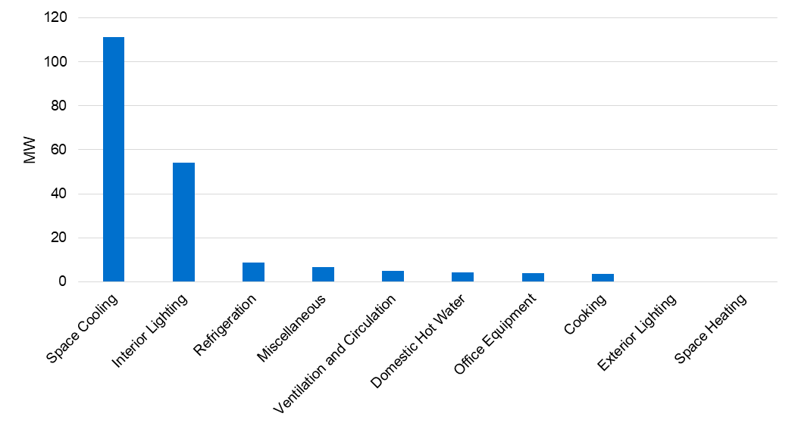
Figure 5-7: Commercial EE Technical Potential by End-Use (Winter Peak Savings)
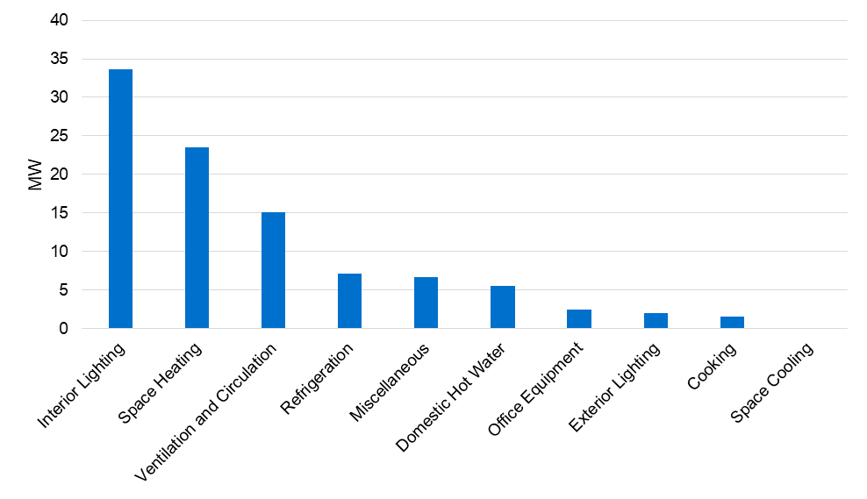

Industrial Segments
Figure 5-8, Figure 5-9, and Figure 5-10 illustrates the industrial sector EE technical potential by end-use.
Figure 5-8: Industrial EE Technical Potential by End-Use (Energy Savings)
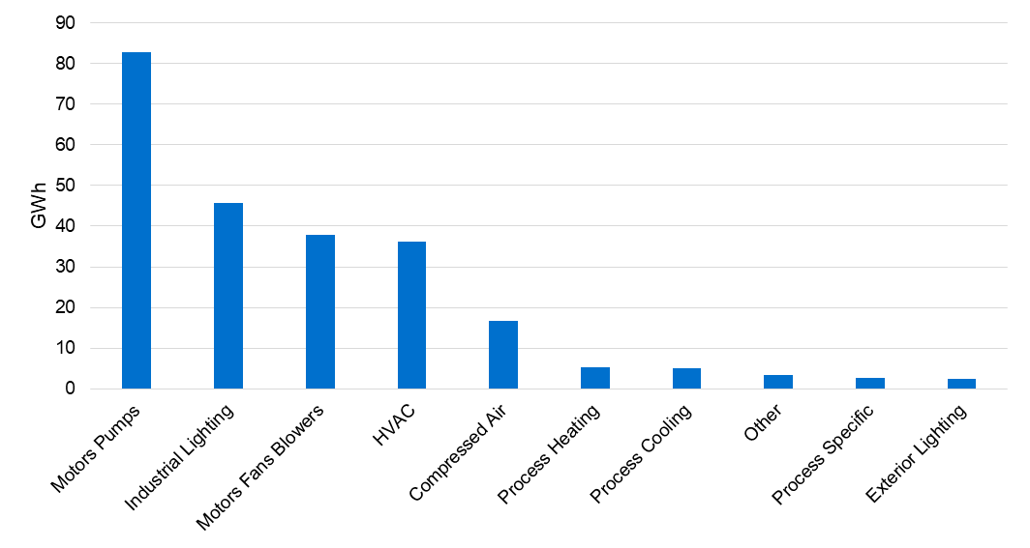
Figure 5-9: Industrial EE Technical Potential by End-Use (Summer Peak Savings)
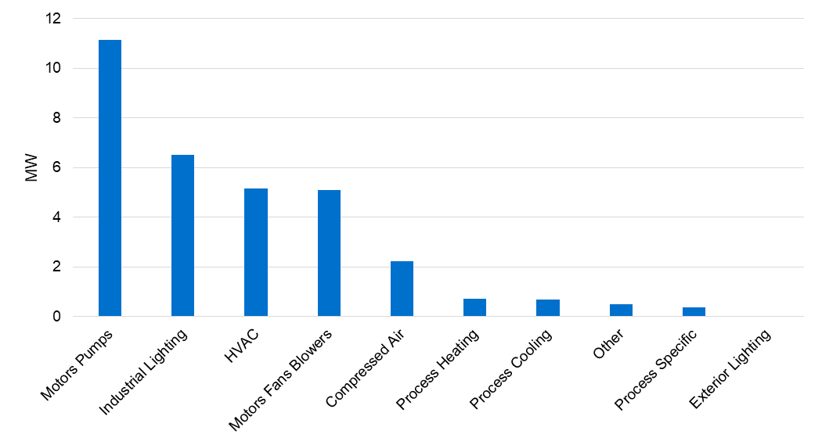

Figure 5-10: Industrial EE Technical Potential by End-Use (Winter Peak Savings)
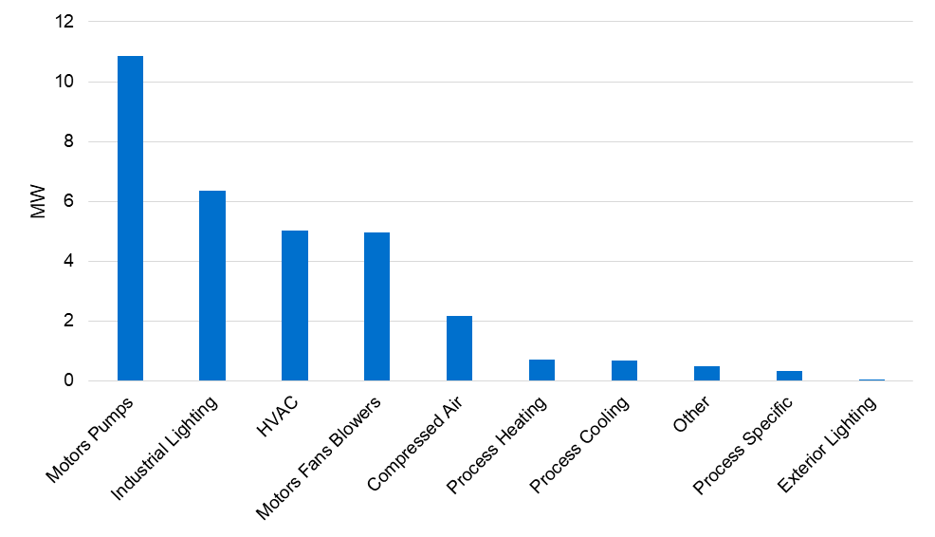

DR Technical Potential
Technical potential for DR is defined for each class of customers as follows:
- Residential & Small C&I customers – Technical potential is equal to the aggregate load for all end-uses that can participate in Gulf’s current programs plus DR measures not currently offered in which the utility uses specialized devices to control loads (i.e. direct load control programs). This includes cooling and heating loads for residential and small C&I customers and water heater and pool pump loads for residential customers. Not all demand reductions are delivered via direct load control of end-uses. The magnitude of demand reductions from non-direct load control such as time varying pricing, peak time rebates and targeted notifications is linked to cooling and heating loads.
- Large C&I customers – Technical potential is equal to the total amount of load for each customer segment (i.e., that customers reduce their total load to zero when called upon).
Table 5-2 summarizes the seasonal DR technical potential by sector:
Table 5-2: DR Technical Potential
 | Savings Potential
 | Summer Peak Demand  (MW) | Winter Peak Demand  (MW)
Residential | 465 | 667
Non-Residential | 493 | 430
Total | 958 | 1,098

Residential
Residential technical potential is summarized in Figure 5-11.

Figure 5-11: Residential DR Technical Potential by End-Use
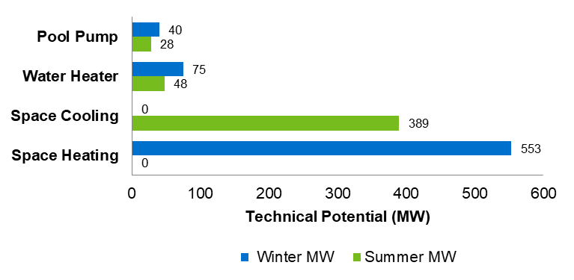

Non-Residential

Small C&I Customers
For small C&I technical potential, Nexant looked at cooling and heating loads only. Small C&I technical potential is provided in Figure 5-12.
Figure 5-12: Small C&I DR Technical Potential by End-Use
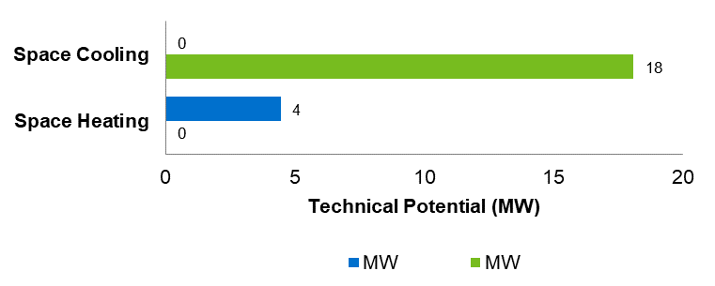

Large C&I Customers
Figure 5-13 provides the technical potential for large C&I customers, broken down by customer size.
Figure 5-13: Large C&I DR Technical Potential by Segment
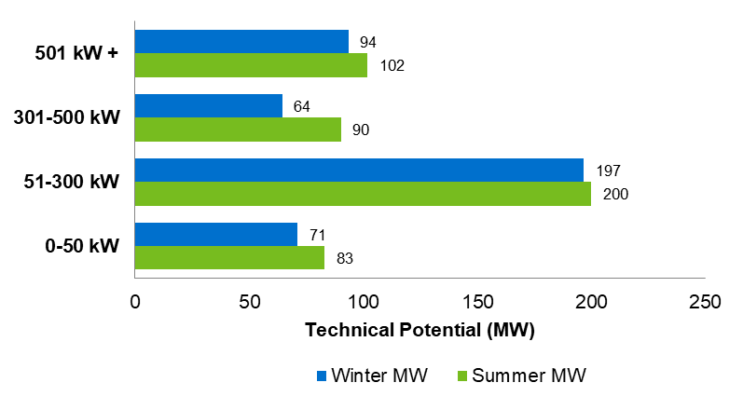

DSRE Technical Potential
Table 5-3 section the results of the DSRE technical potential for each customer segment.
Table 5-3: DSRE Technical Potential
 | Savings Potential
 | Summer Peak Demand (MW) | Winter  Peak Demand (MW) | Energy (GWh)
PV Systems
Residential | 24 | 104 | 2,072
Non-Residential | 111 | 48 | 952
Total | 135 | 151 | 3,024
Battery Storage from PV Systems
Residential | 65 | 222 | -
Non-Residential | - | - | -
Total | 65 | 222 | -
CHP Systems
Total | 252 | 99 | 1,243

Economic Potential
The economic potential scenario estimates the savings potential when all technically feasible DSM measures that are cost-effective to implement are applied at their full market potential (i.e. 100% adoption rate). The economic potential was the sum of the demand and energy savings associated with all measure permutations passing the economic screening.

DSM Cost-Effective Screening Criteria

Cost-Effectiveness Test Perspectives
When analyzing DSM measures, different cost-effectiveness tests are considered to reflect the perspectives of different stakeholders. The Ratepayer Impact Measure (“RIM”) addresses an electric utility customer perspective, which considers the net impact on electric utility rates associated with a measure or program. The Total Resource Cost (“TRC”) addresses a societal perspective, which considers costs of DSM measure or program relative to the benefits of avoided utility supply costs. The Participant Cost Test (“PCT”) addresses a participant perspective, which considers net benefits to those participating in a DSM program.
Descriptions follow of methods for allocating costs and benefits within each cost-effectiveness indicator (RIM, TRC, and PCT); the calculations remain consistent with the Florida Cost Effectiveness Manual.
Table 6-1: Components of Cost-Effectiveness Calculations
Component | Definition
Customer Incremental Costs | All incremental costs incurred by the customer to purchase, install, operate, and maintain a DSM measure
Utility Program Costs | Utility administrative and marketing costs and capital expenditures required to implement a DSM measure
Utility Incentives | Costs provided by the utility to the participant to encourage the purchase, installation, operation, and maintenance of a DSM measure
Utility Supply Costs | Utility costs of supplying electricity to the customer, including generation, transmission, and distribution costs
Electric Bill Impacts | Impacts on a participating customer’s electric bill due the installation of a DSM measure
Utility Electric Revenues | Impacts on the utility’s electric revenues due to the installation of a DSM measure

Table 6-2: Ratepayer Impact Measure (RIM)
Component | Definition
Benefit | Increase in utility electric revenues  Decrease in avoided electric utility supply costs
Cost | Decrease in utility electric revenues  Increase in avoided electric utility supply costs  Utility program costs, if applicable  Utility incentives, if applicable

Table 6-3: Total Resource Cost (TRC)
Component | Definition
Benefit | Decrease in electric utility supply costs
Cost | Increase in electric utility supply costs  Customer incremental costs (less any tax incentives)  Utility program costs, if applicable

Table 6-4: Participant Cost Test (PCT)
Component | Definition
Benefit | Decrease in electric bill  Utility incentives, if applicable
Cost | Increase in electric bill  Customer incremental costs (less any tax incentives)

Economic Potential Screening Methodology
Based on discussion with the FEECA Utilities and consistent with prior DSM analyses in Florida, for development of the economic potential, two scenarios were considered, a RIM-scenario and a TRC-scenario, for which the following economic screening process was followed:
- Criteria for RIM Scenario:
  - Achieve a cost-benefit ratio of 1.0 or greater from the RIM perspective. For the economic potential, the RIM benefits included avoided electric utility supply costs, while RIM costs include decreases in utility electric revenues. The economic potential screening did not consider utility incentives or utility program costs as a component of the measure’s cost-effectiveness (these are reflected in the Achievable Potential analysis).
- Criteria for TRC Scenario:
  - Achieve a cost-benefit ratio of 1.0 or greater from the TRC perspective. For the economic potential, the TRC benefits included avoided electric utility supply costs, while TRC costs included customer incremental cost to implement the measure. The economic potential screening did not consider utility DSM program costs as a component of the measure’s cost-effectiveness (these are reflected in the Achievable Potential analysis).
The cost-effectiveness screening described above was applied to each DSM measure permutation based on the installation of the measure in the Base Year (2020) of the study. Therefore, avoided energy cost benefits were applied beginning in Year 1 and extended through the useful life of the measure; avoided generation costs began at the in-service year for new generation based on utility system load forecasts.

Economic Potential Sensitivities
Based on direction from the FEECA Utilities and the Order Establishing Procedure, the economic potential analysis included the following additional sensitivities:
- Sensitivity #1: Higher Fuel Prices. For this sensitivity, both the RIM and TRC scenarios were screened as described above, but the fuel cost forecast that is a component of the electric utility supply costs was adjusted to a “high fuel” scenario.
- Sensitivity #2: Lower Fuel Prices. For this sensitivity, both the RIM and TRC scenarios were screened as described above, but the fuel cost forecast was adjusted to a “low fuel” scenario.
- Sensitivity #3: Baseline for free-ridership sensitivities. For this sensitivity, both the RIM and TRC scenarios were screened as described above, with the addition of utility DSM program costs as a component of the measure’s cost-effectiveness. In addition, measures must achieve a cost-benefit ratio of 1.0 or greater from the PCT perspective (utility incentives were not considered for this screening component for economic potential). Measures also must achieve a participant simple payback of two years or longer. To determine simple payback for the economic potential analysis, total customer incremental cost to implement the measure was compared with decreases in electric bills. Utility incentives were not considered for this screening component for economic potential.
- Sensitivity #4: Shorter free-ridership exclusion periods. For this sensitivity, both the RIM and TRC scenarios were screened as described for Sensitivity #3, but the simple payback screening criteria was reduced to one year or longer.
- Sensitivity #5: Longer free-ridership exclusion periods. For this sensitivity, both the RIM and TRC scenarios were screened as described for Sensitivity #3, but the simple payback screening criteria was increased to three years or longer.
Each of these sensitivities resulted in a unique set of measures passing the cost-effectiveness criteria for both RIM and TRC scenarios. The economic potential for the passing measures were evaluated in Nexant’s TEA-POT model, and the results of the economic sensitivities are provided in Appendix E.

EE Economic Potential
This section provides the results of the EE economic potential for each sector. Table 6-5 summarizes the number of unique measures and measure permutations by sector that passed the cost-effectiveness screening for each scenario:
Table 6-5: Economic Potential EE Measure Counts by Scenario
Sector | Unique Measures | Permutations
RIM SCENARIO
Residential | 1 | 1
Commercial | 8 | 142
Industrial | 12 | 152
Total | 21 | 295
TRC SCENARIO
Residential | 44 | 233
Commercial | 90 | 2,032
Industrial | 29 | 734
Total | 163 | 2,999

Summary

Table 6-6 summarizes the EE economic potential by sector and by scenario (RIM and TRC):

Table 6-6: EE Economic Potential by Sector
 | Savings Potential
 | Summer  Peak Demand (MW) | Winter  Peak Demand (MW) | Energy  (GWh)
RIM SCENARIO
Residential | 0 | 3 | 4
Non-Residential | 75 | 36 | 110
Total | 75 | 39 | 114
TRC SCENARIO
Residential | 182 | 173 | 836
Non-Residential | 167 | 124 | 926
Total | 348 | 297 | 1,762

Residential – RIM Scenario
Figure 6-1, Figure 6-2, and Figure 6-3 illustrate the residential EE economic potential by end-use for the RIM scenario.
Figure 6-1: Residential EE Economic Potential by End-Use – RIM Scenario (Energy Savings)
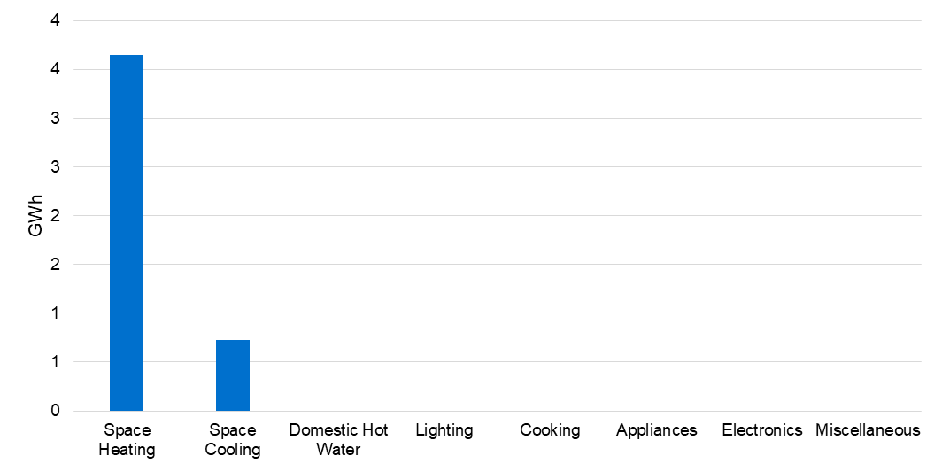

Figure 6-2: Residential EE Economic Potential by End-Use - RIM Scenario (Summer Peak Savings)
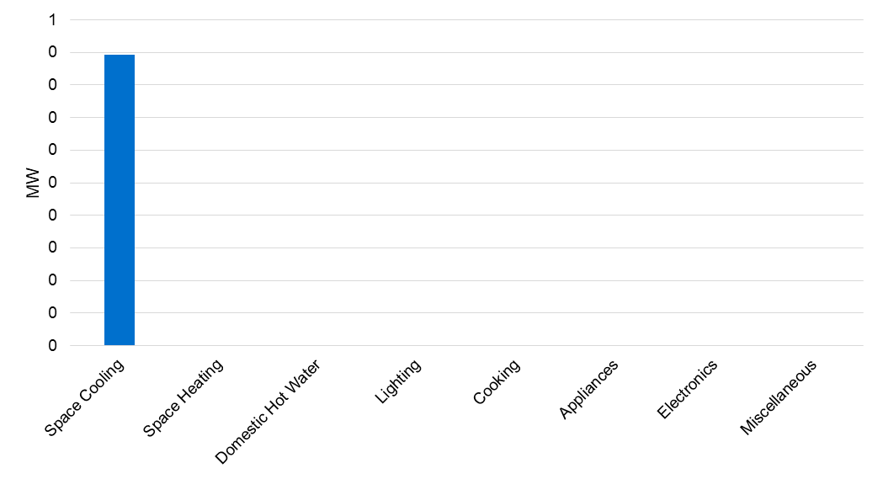

Figure 6-3: Residential EE Economic Potential by End-Use (Winter Peak Savings) - RIM Scenario
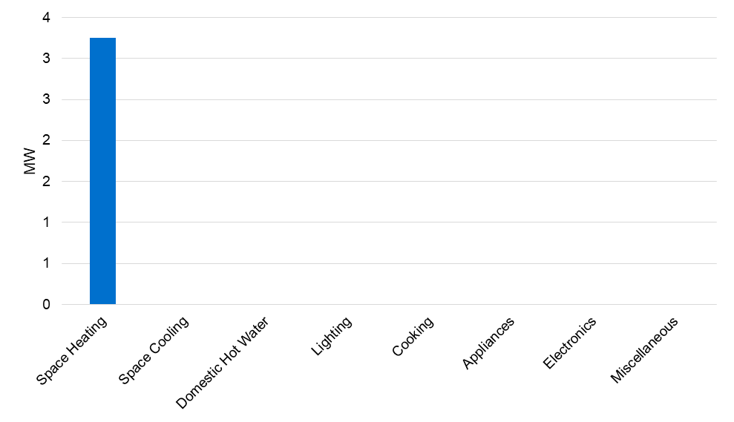

Non-Residential – RIM Scenario

Commercial Segments
Figure 6-4, Figure 6-5, and Figure 6-6 illustrate the commercial EE economic potential by end-use for the RIM scenario.
Figure 6-4: Commercial EE Economic Potential by End-Use (Energy Savings) – RIM Scenario
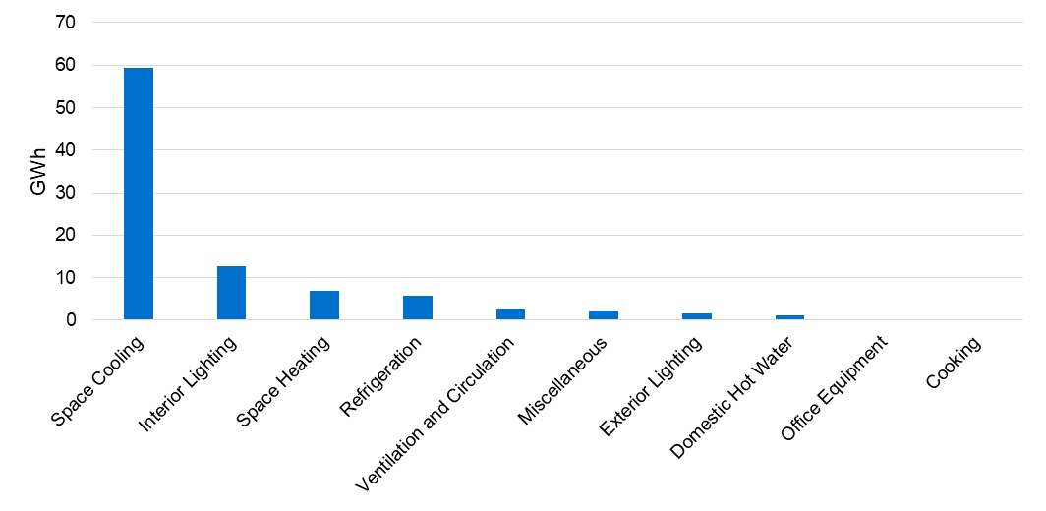
Figure 6-5: Commercial EE Economic Potential by End-Use (Summer Peak Savings) – RIM Scenario
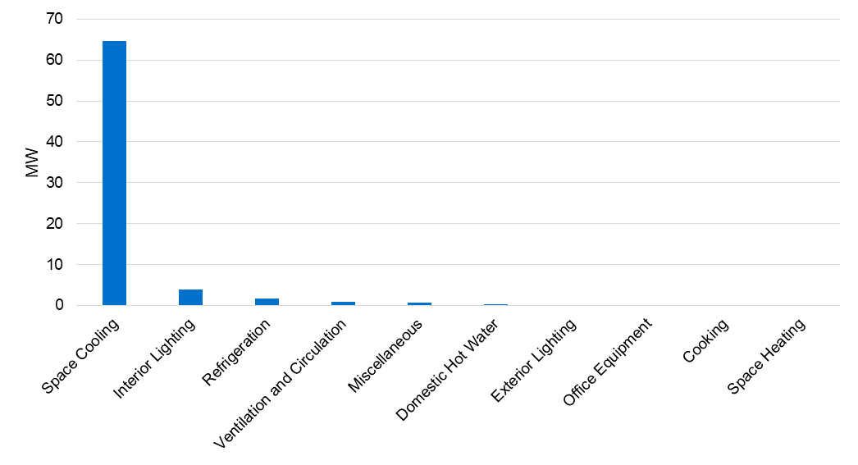
Figure 6-6: Commercial EE Economic Potential by End-Use (Winter Peak Savings) – RIM Scenario
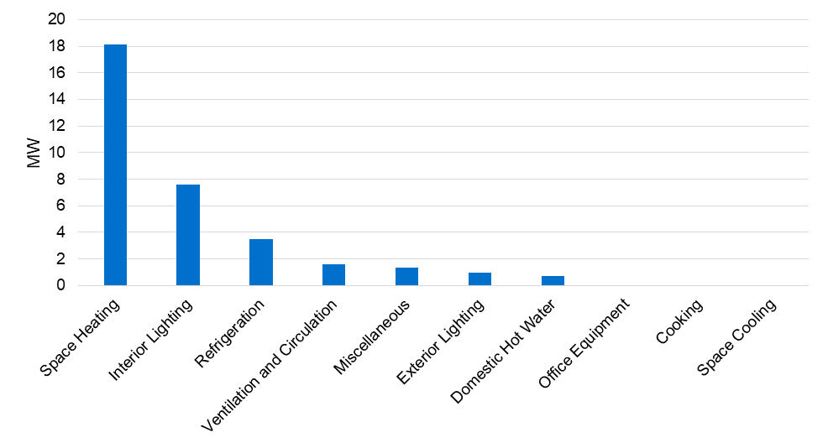

Industrial Segments
Figure 6-7, Figure 6-8, and Figure 6-9 illustrate the industrial EE economic potential by end-use for the RIM scenario.
Figure 6-7: Industrial EE Economic Potential by End-Use (Energy Savings) – RIM Scenario
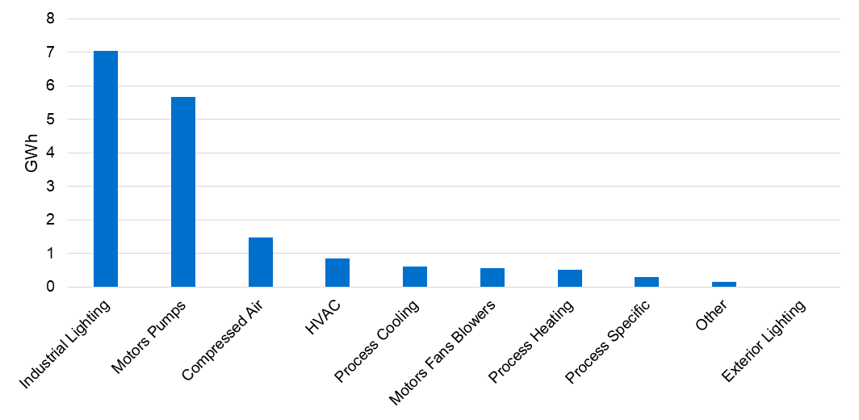

Figure 6-8: Industrial EE Economic Potential by End-Use (Summer Peak Savings) – RIM Scenario
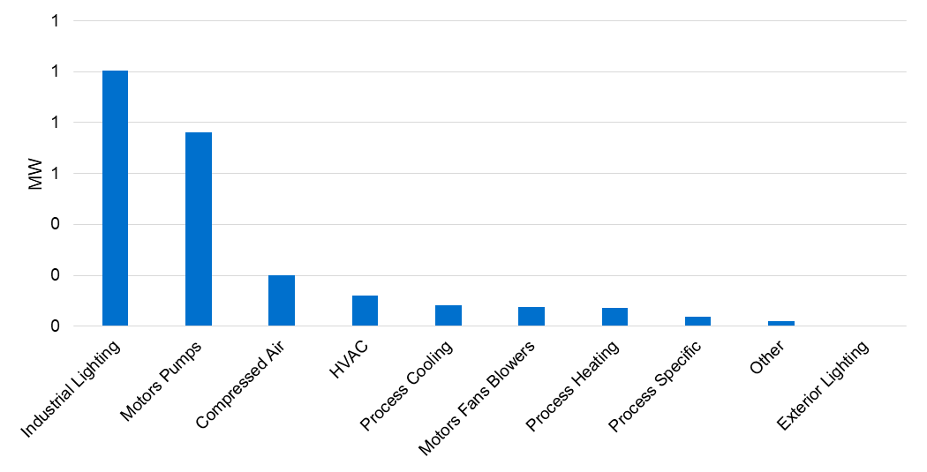

Figure 6-9: Industrial EE Economic Potential by End-Use (Winter Peak Savings) – RIM Scenario
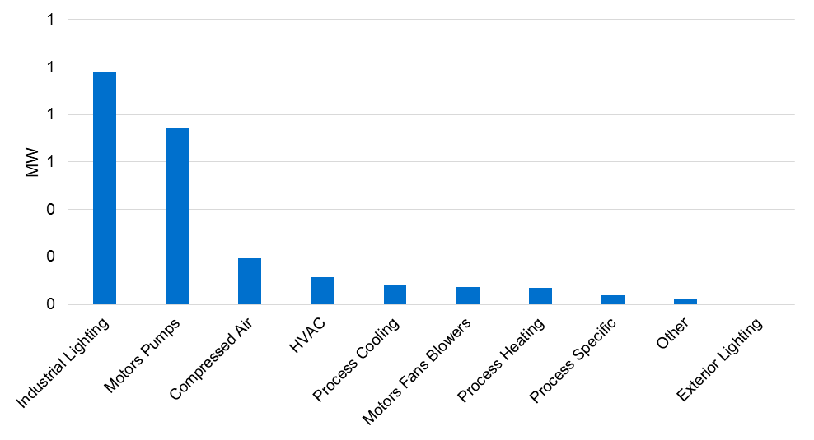

Residential – TRC Scenario
Figure 6-10, Figure 6-11, and Figure 6-12 illustrate the residential EE economic potential by end-use for the TRC scenario.
Figure 6-10: Residential EE Economic Potential by End-Use (Energy Savings) – TRC Scenario
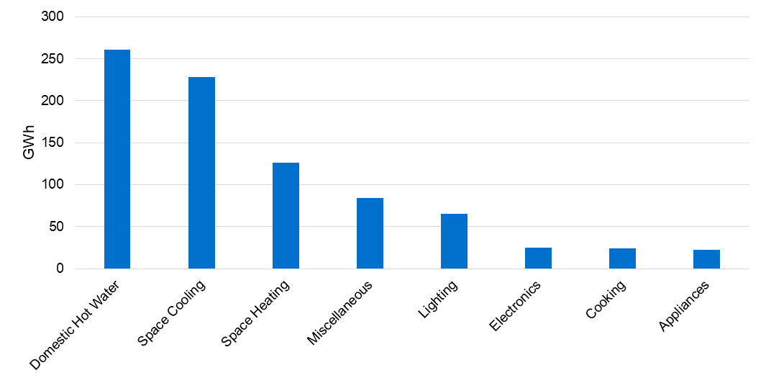

Figure 6-11: Residential EE Economic Potential by End-Use (Summer Peak Savings) - TRC Scenario
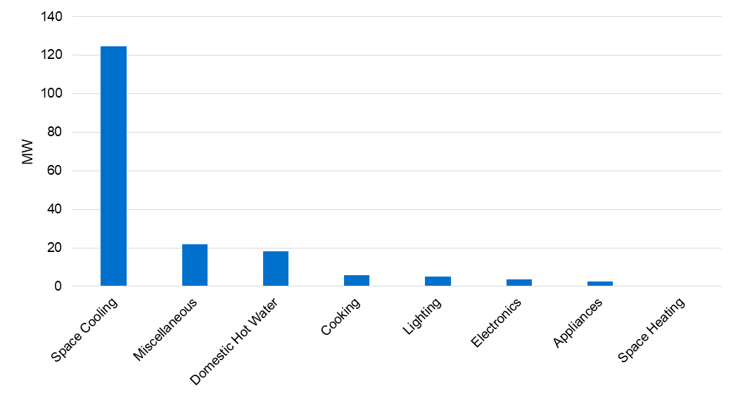
Figure 6-12: Residential EE Economic Potential by End-Use (Winter Peak Savings) - TRC Scenario
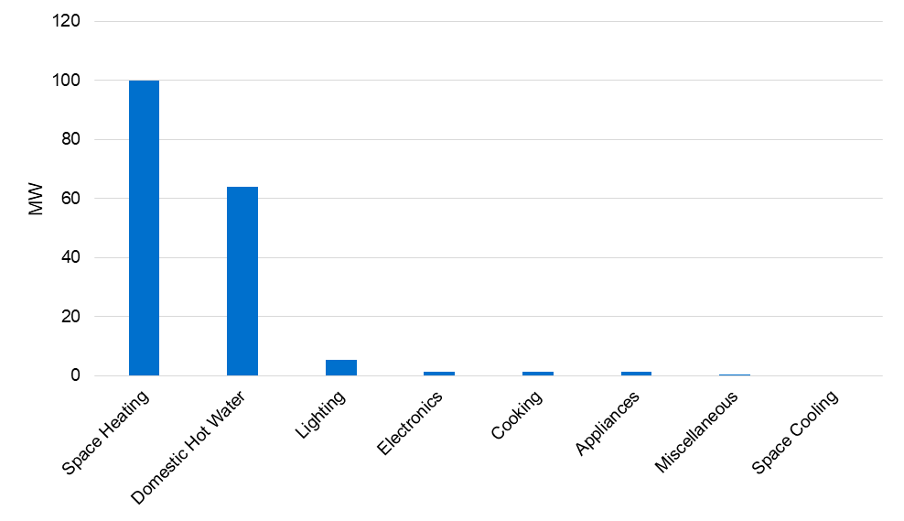

Non-Residential – TRC Scenario

Commercial Segments
Figure 6-13, Figure 6-14, and Figure 6-15 illustrate the commercial EE economic potential by end-use for the TRC scenario.
Figure 6-13: Commercial EE Economic Potential by End-Use (Energy Savings) – TRC Scenario
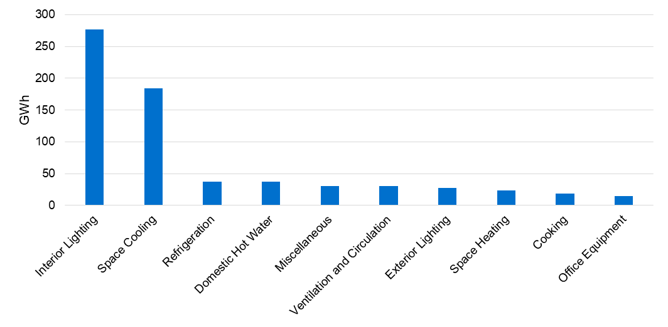
Figure 6-14: Commercial EE Economic Potential by End-Use (Summer Peak Savings) – TRC Scenario
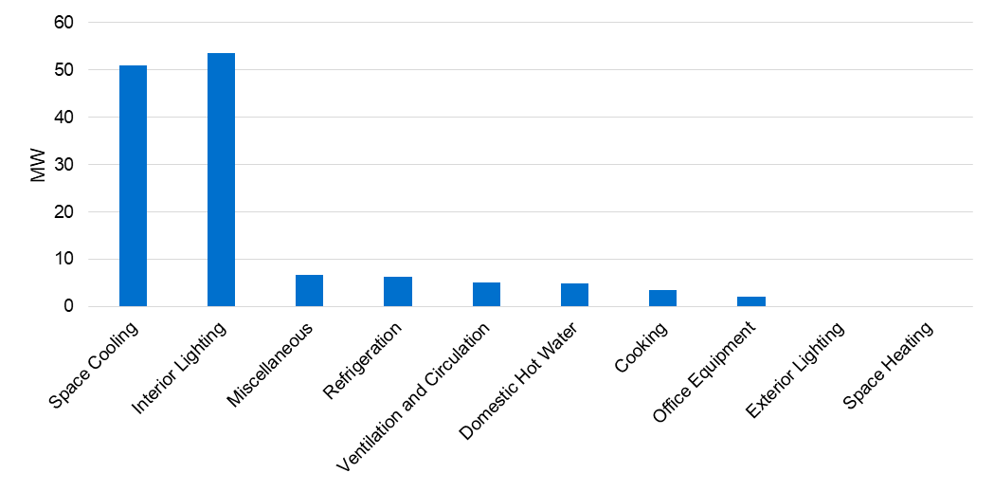
Figure 6-15: Commercial EE Economic Potential by End-Use (Winter Peak Savings) – TRC Scenario
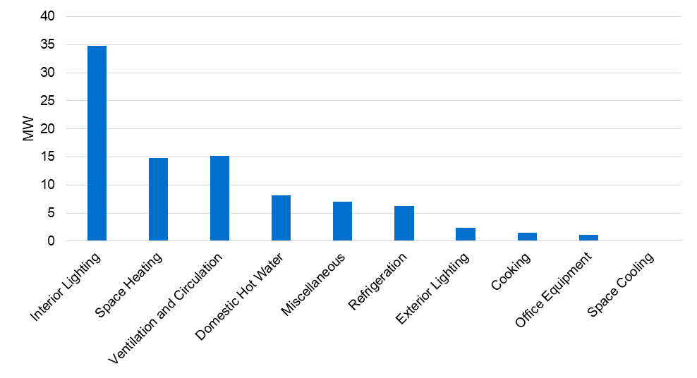

Industrial Segments
Figure 6-16, Figure 6-17 and Figure 6-18 illustrate the industrial EE economic potential by end-use for the TRC scenario.
Figure 6-16: Industrial EE Economic Potential by End-Use (Energy Savings) – TRC Scenario

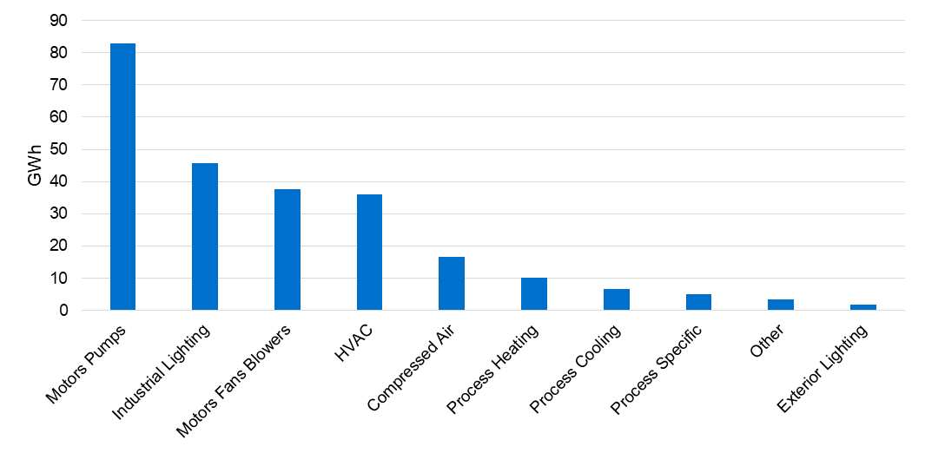
Figure 6-17: Industrial EE Economic Potential by End-Use (Summer Peak Savings) – TRC Scenario
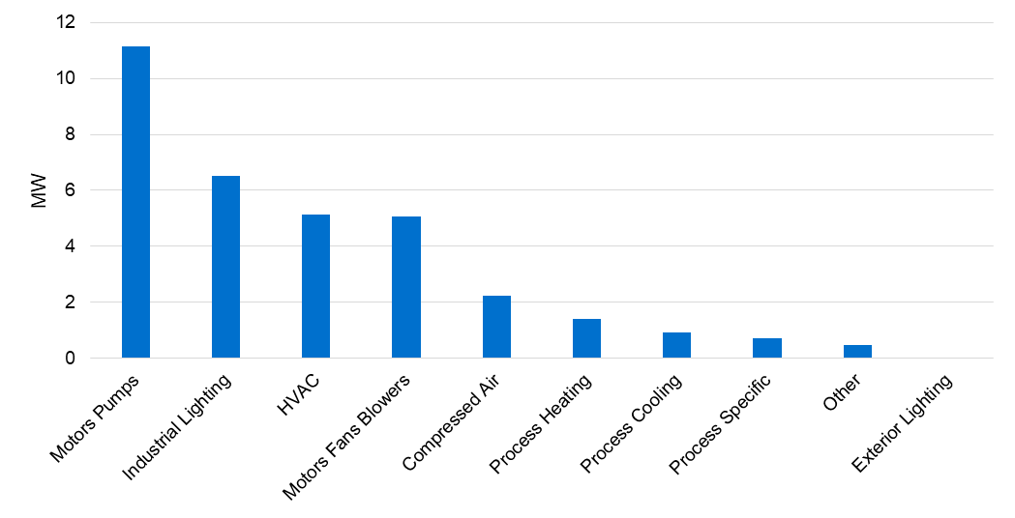

Figure 6-18: Industrial EE Economic Potential by End-Use (Winter Peak Savings) – TRC Scenario
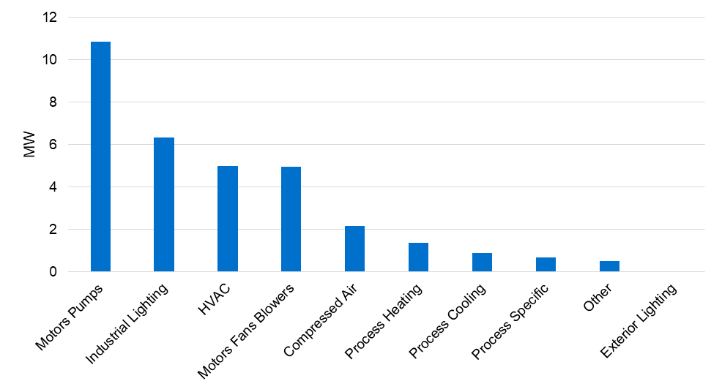

DR Economic Potential
Because of the costs included in the RIM and TRC screening methodology for DR, all measures passed the EP screen for Gulf. Therefore, the EP for DR is the same as the TP for Gulf.
Table 6-7: DR Economic Potential
 | Savings Potential
 | Summer Peak Demand  (MW) | Winter Peak Demand  (MW)
Residential | 465 | 667
Non-Residential | 493 | 430
Total | 958 | 1,098

Results for residential customer segments are presented in Figure 6-19. Note that because there are minimal customer costs and bill savings associated with the DR measures used, all measures passed the economic screen and the potential did not change from the technical potential, since based on the RIM and TRC screening requirements all of the load that can technically be curtailed can be curtailed cost-effectively.
Figure 6-19: Residential DR Economic Potential by End-Use – RIM and TRC Scenario
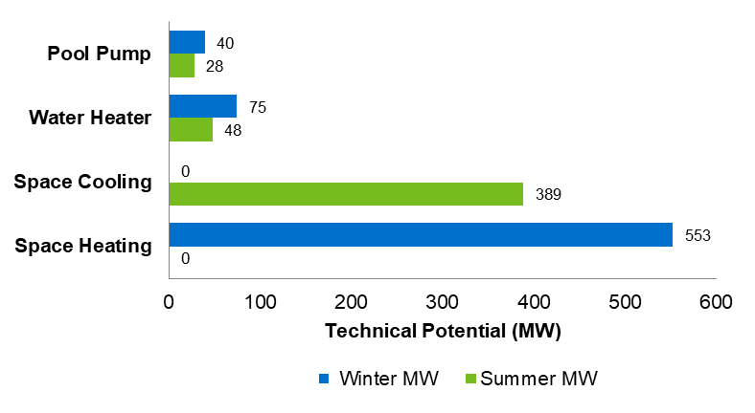

Similar figures are presented for small C&I and large C&I customers.
Figure 6-20: Small C&I DR Economic Potential by End-Use – RIM and TRC Scenario

Figure 6-21: Large C&I DR Economic Potential by Segment – RIM and TRC Scenario

DSRE Economic Potential
Table 6-8 summarizes the EE economic potential by sector for the RIM-scenario.
Table 6-8: DSRE Economic Potential
 | Savings Potential
 | Summer Peak Demand (MW) | Winter  Peak Demand (MW) | Energy (GWh)
RIM SCENARIO
PV Systems
Residential | - | - | -
Non-Residential | - | - | -
Total | - | - | -
Battery Storage from PV Systems
Residential | 65 | 222 | -
Non-Residential | - | - | -
Total | 65 | 222 | -
CHP Systems
Total | - | - | -

Nexant found there to be no cost-effective potential attainable for Gulf for PV systems, battery storage systems, or CHP systems for the TRC-scenario.

Achievable Potential
Nexant incorporated realistic assumptions about program delivery when estimating achievable market potential. Nexant estimated the cost-effective savings realistically achievable by utility-sponsored DSM programs in the Gulf jurisdiction by incorporating utility program costs and utility incentive costs, and with consideration of economic constraints and market demand for DSM services in Florida.

Achievable Potential Methodology

Utility Program Costs and Incentives
Prior to the development of the achievable potential, Gulf performed a cost-effectiveness re-screening of all measures that passed the economic potential screening, under both the RIM and TRC scenarios, to incorporate estimated utility program costs and utility incentives for each measure. Nexant provided Gulf with program cost estimates by sector and end-use, which were developed from data on current Florida DSM programs as well as other regional utility program offerings. Gulf provided Nexant with the set of measures passing the re-screening to use for the achievable potential analysis, and the estimated incentive amount for each measure, which was developed as follows:
- In the RIM scenario, two incentive values were analyzed. First, the RIM net benefit for the measure was calculated based on total RIM benefits minus RIM costs. Next, the incentive amount that would drive the simple payback to two years for each measure was calculated. The final incentive applied for the measure was based on the lower of these two values.
- In the TRC scenario, the incentive amount required to drive the simple payback to two years for each measure was used as the final incentive for the measure.

Market Adoption Rates
To estimate the adoption rate of DSM based on the utility program costs and incentives described above, Nexant incorporated Gulf DSM program data as well as secondary data from other utility sponsored DSM programs. This approach leveraged program performance data from a variety of DSM programs across many utilities to develop a meta-analysis of program performance that broadly describes customers’ program adoption rates over time. This approach applied standard economic theories on product diffusion to develop a catalog of market adoption curves across a variety of DSM technologies and programs.
Nexant used this market performance data, historic Gulf program performance data, and secondary data sources to calibrate the measures passing the cost-effectiveness screening in the TEA-POT model. Secondary data sources for EE measures included ENERGY STAR data on qualified product shipments and other utility-sponsored program performance data. The adoption rate of DR also incorporated Gulf DR marketing and participation data as well as secondary data from other well-developed DR programs. This approach leveraged historic marketing strategies and customer responses to marketing as well as incentive level.

EE Achievable Potential
This section provides the detailed results of the EE achievable potential. Table 7-1 summarizes the number of unique measures and measure permutations by sector that passed the cost-effectiveness screening for each scenario:
Table 7-1: Achievable Potential EE Measure Counts by Scenario
Sector | Unique Measures | Permutations
RIM SCENARIO
Residential | 0 | 0
Commercial | 4 | 18
Industrial | 6 | 32
Total | 10 | 50
TRC SCENARIO
Residential | 16 | 73
Commercial | 53 | 887
Industrial | 20 | 204
Total | 89 | 1,164

Summary
Table 7-2 summarizes the 10-year portfolio EE achievable potential for all customers across the residential and non-residential sectors. Impacts are presented as cumulative impacts, which represent savings achieved over the ten-year study period (2020-2029) based on the sum of annual incremental savings.

Table 7-2: EE Achievable Potential
 | Savings Potential
 | Summer  Peak Demand (MW) | Winter  Peak Demand (MW) | Energy  (GWh)
RIM SCENARIO
Residential | 0 | 0 | 0
Non-Residential | 5 | 2 | 6
Total | 5 | 2 | 6
TRC SCENARIO
Residential | 20 | 19 | 98
Non-Residential | 21 | 10 | 124
Total | 40 | 29 | 222

Figure 7-1 shows achievable energy savings potential by sector for the TRC scenario. The RIM scenario is not presented as only non-residential measures passed the cost-effectiveness screening.
Figure 7-1: Achievable Potential by Sector – TRC Scenario
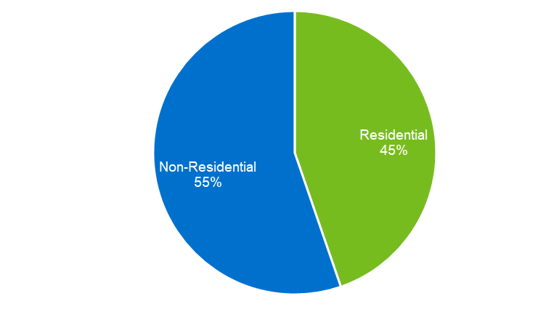

Residential – RIM Scenario
The residential sector did not have any EE measures that passed the achievable potential cost-effectiveness screening for the RIM scenario.

Non-Residential – RIM Scenario

Commercial Segments
Table 7-3 summarizes the cumulative commercial EE achievable potential by end-use for the RIM Scenario.
Table 7-3: EE Commercial Achievable Potential by End-Use – RIM Scenario
 | Cumulative Impacts
 | Summer Peak Demand (MW) | Winter Peak Demand (MW) | Energy (GWh)
Interior Lighting | 0 | 0 | 0
Exterior Lighting | 0 | 0 | 0
Office Equipment | 0 | 0 | 0
Cooking | 0 | 0 | 0
Refrigeration | 0 | 0 | 0
Space Heating | 0 | 2 | 0.4
Space Cooling | 5 | 0 | 5
Ventilation and Circulation | 0 | 0 | 0
Domestic Hot Water | 0 | 0 | 0
Miscellaneous | 0 | 0 | 0

Figure 7-2, Figure 7-3, and Figure 7-4 illustrate the cumulative commercial EE achievable potential by end-use for the RIM scenario.
Figure 7-2: Commercial EE Achievable Potential by End-Use (Energy Savings) – RIM Scenario
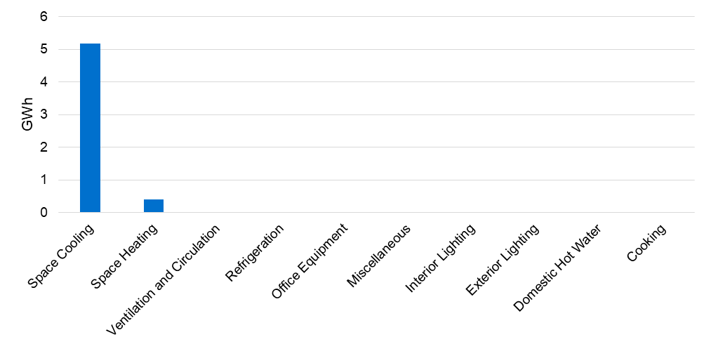
Figure 7-3: Commercial EE Achievable Potential by End-Use (Summer Peak Savings) – RIM Scenario
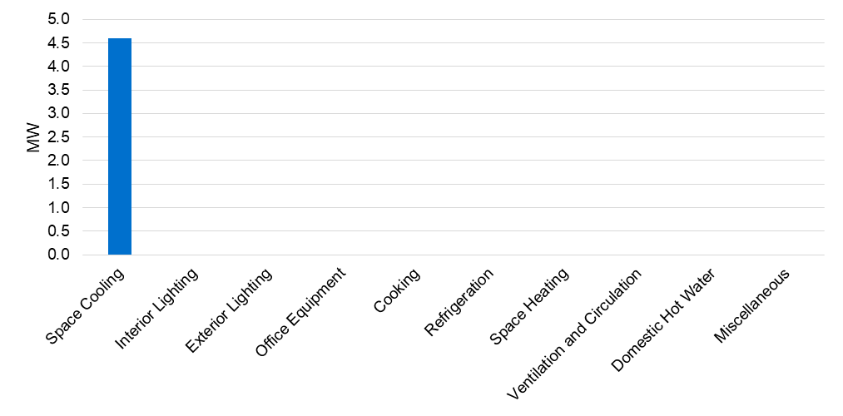

Figure 7-4: Commercial EE Achievable Potential by End-Use (Winter Peak Savings) – RIM Scenario
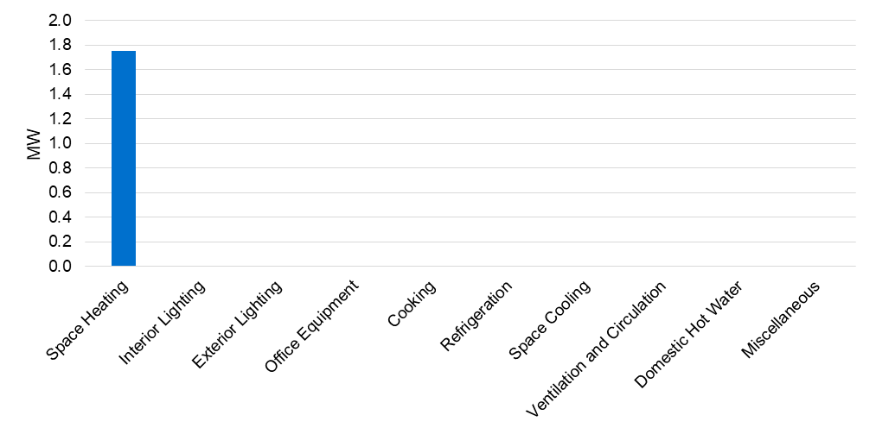

Industrial Segments
Table 7-4 summarizes the cumulative industrial EE achievable potential by end-use for the RIM Scenario.
Table 7-4: EE Industrial Achievable Potential by End-Use – RIM Scenario
 | Cumulative Impacts
 | Summer Peak Demand (MW) | Winter Peak Demand (MW) | Energy (GWh)
Industrial Lighting | 0.04 | 0.04 | 0.3
Process Cooling | 0.01 | 0.01 | 0.1
Process Heating | 0.01 | 0.01 | 0.1
HVAC | 0.0009 | 0.0009 | 0.006
Process Specific | 0.00004 | 0.00004 | 0.0003
Compressed Air | 0 | 0 | 0
Motors Pumps | 0 | 0 | 0
Motors Fans Blowers | 0 | 0 | 0
Other | 0 | 0 | 0
Exterior Lighting | 0 | 0 | 0

Figure 7-5, Figure 7-6, and Figure 7-7 illustrate the cumulative industrial EE achievable potential by end-use for the RIM scenario.
Figure 7-5: Industrial EE Achievable Potential by End-Use (Energy Savings) – RIM Scenario
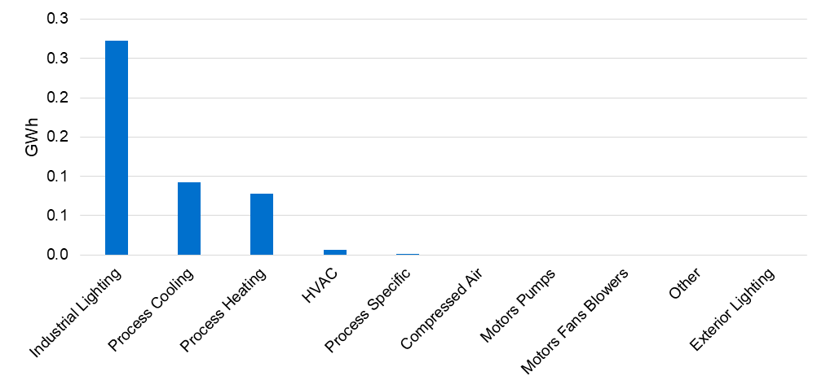
Figure 7-6: Industrial EE Achievable Potential by End-Use (Summer Peak Savings) – RIM Scenario
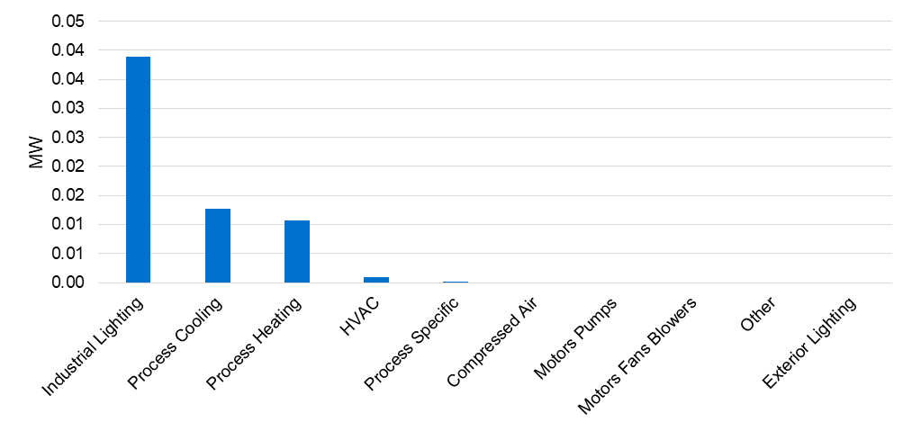

Figure 7-7: Industrial EE Achievable Potential by End-Use (Winter Peak Savings) – RIM Scenario
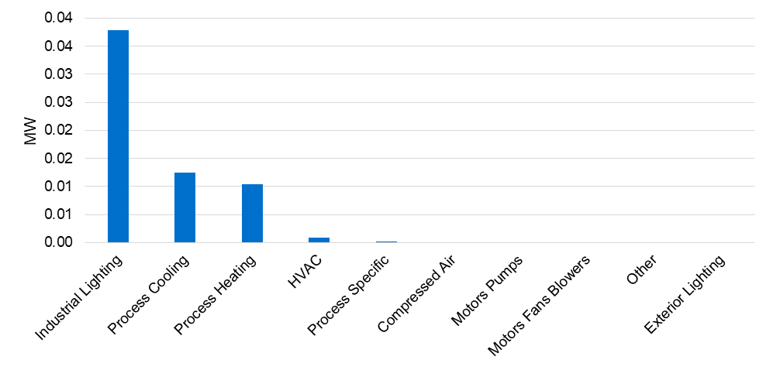

Residential – TRC Scenario
Table 7-5 summarizes the cumulative residential EE achievable potential by end-use for the TRC Scenario.
Table 7-5: EE Residential Achievable Potential by End-Use – TRC Scenario
 | Cumulative Impacts
 | Summer Peak Demand (MW) | Winter Peak Demand (MW) | Energy (GWh)
Space Heating | 0 | 9 | 11
Space Cooling | 12 | 0 | 22
Domestic Hot Water | 2 | 8 | 31
Lighting | 2 | 2 | 25
Cooking | 1 | 0.2 | 3
Appliances | 0 | 0 | 0
Electronics | 0.4 | 0.1 | 2
Miscellaneous | 2 | 0 | 3

Figure 7-8, Figure 7-9, and Figure 7-10 illustrate the cumulative residential EE achievable potential by end-use for the TRC scenario.
Figure 7-8: Residential EE Achievable Potential by End-Use (Energy Savings) – TRC Scenario
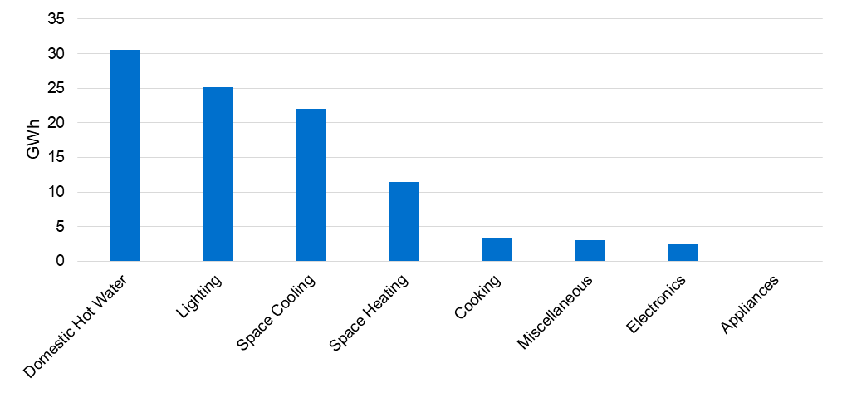
Figure 7-9: Residential EE Achievable Potential by End-Use (Summer Peak Savings) - TRC Scenario
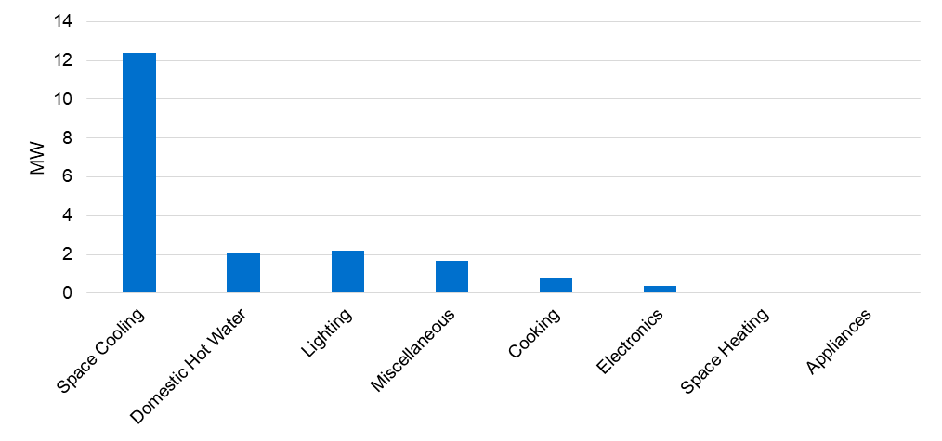
Figure 7-10: Residential EE Achievable Potential by End-Use (Winter Peak Savings) - TRC Scenario
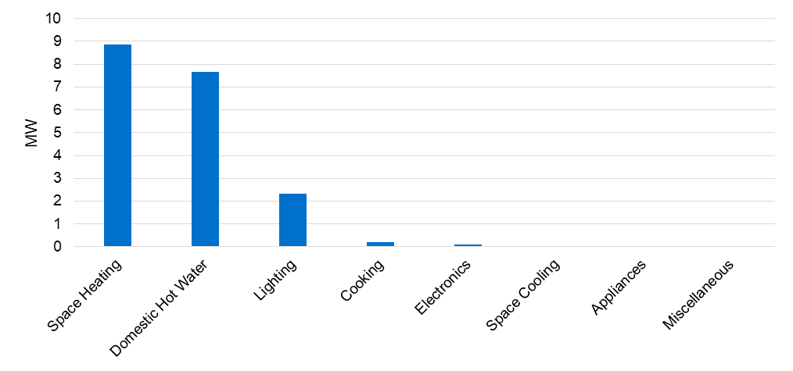

Non-Residential – TRC Scenario

Commercial Segments
Table 7-6 summarizes the cumulative commercial EE achievable potential by end-use for the TRC Scenario.
Table 7-6: EE Commercial Achievable Potential by End-Use – TRC Scenario
 | Cumulative Impacts
 | Summer Peak Demand (MW) | Winter Peak Demand (MW) | Energy (GWh)
Interior Lighting | 1 | 0.5 | 13
Exterior Lighting | 0 | 0.02 | 6
Office Equipment | 0.2 | 0.1 | 1
Cooking | 1.1 | 0.5 | 6
Refrigeration | 0.8 | 0.3 | 6
Space Heating | 0 | 3 | 7
Space Cooling | 11 | 0 | 47
Ventilation and Circulation | 0.3 | 1 | 3
Domestic Hot Water | 0.2 | 0.1 | 2
Miscellaneous | 2 | 0.6 | 9

Figure 7-11, Figure 7-12, and Figure 7-13 illustrate the cumulative commercial EE achievable potential by end-use for the TRC scenario.
Figure 7-11: Commercial EE Achievable Potential by End-Use (Energy Savings) – TRC Scenario
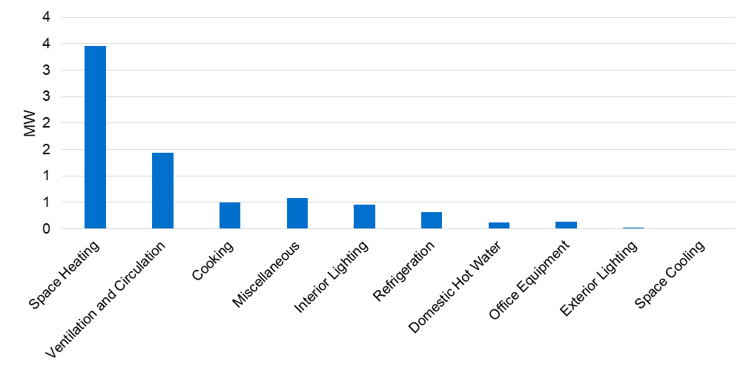
Figure 7-12: Commercial EE Achievable Potential by End-Use (Summer Peak Savings) – TRC Scenario
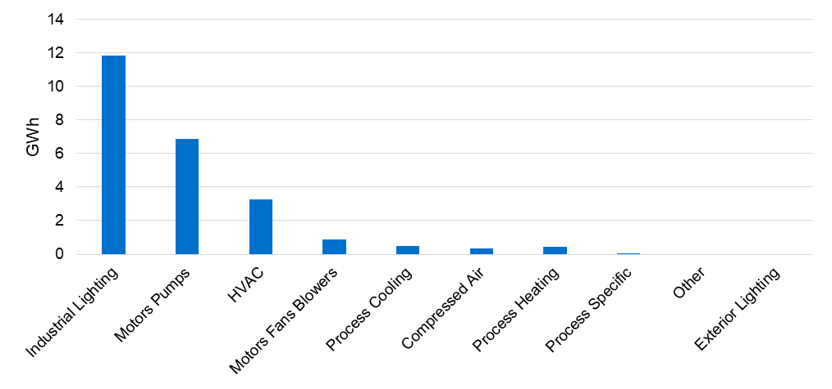

Figure 7-13: Commercial EE Achievable Potential by End-Use (Winter Peak Savings) – TRC Scenario
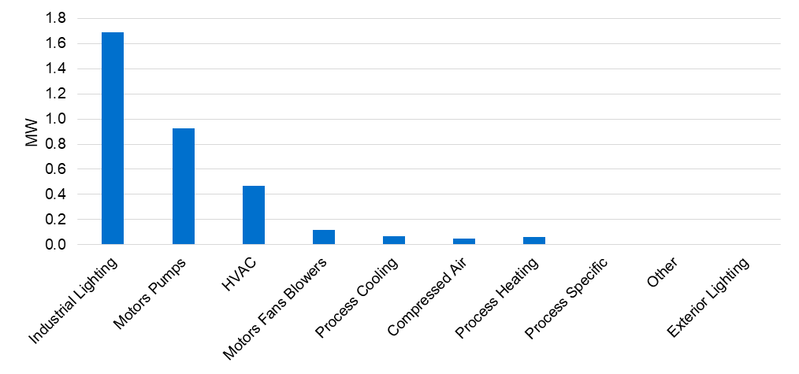

Industrial Segments
Table 7-7 summarizes the cumulative industrial EE achievable potential by end-use for the TRC Scenario.
Table 7-7: EE Industrial Achievable Potential by End-Use – TRC Scenario
 | Cumulative Impacts
 | Summer Peak Demand (MW) | Winter Peak Demand (MW) | Energy (GWh)
Industrial Lighting | 2 | 2 | 12
Process Cooling | 1 | 1 | 7
Process Heating | 0.5 | 0.5 | 3.27
HVAC | 0.1 | 0.1 | 0.9
Process Specific | 0.07 | 0.06 | 0.5
Compressed Air | 0.05 | 0.05 | 0.3
Motors Pumps | 0.06 | 0.06 | 0.5
Motors Fans Blowers | 0.005 | 0.005 | 0.03
Other | 0 | 0 | 0
Exterior Lighting | 0 | 0 | 0

Figure 7-14, Figure 7-15, and Figure 7-16 illustrate the cumulative industrial EE achievable potential by end-use for the TRC scenario.
Figure 7-14: Industrial EE Achievable Potential by End-Use (Energy Savings) – TRC Scenario

Figure 7-15: Industrial EE Achievable Potential by End-Use (Summer Peak Savings) – TRC Scenario

Figure 7-16: Industrial EE Achievable Potential by End-Use (Winter Peak Savings) – TRC Scenario
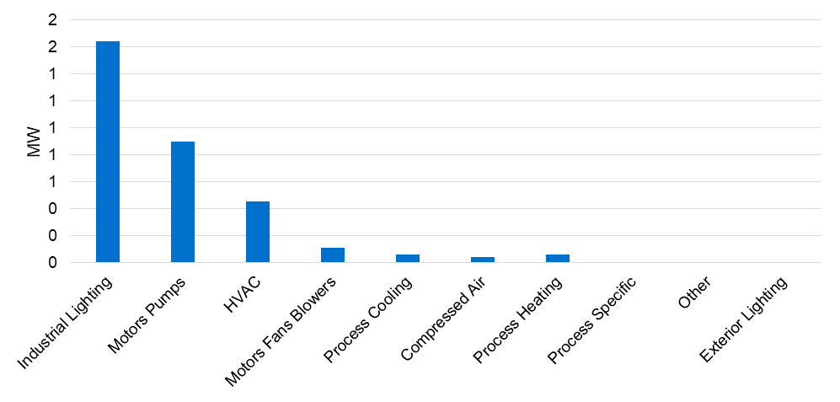

DR Achievable Potential
This section presents the estimated overall achievable potential for DR opportunities. The results are provided separately for summer and winter peaking capacity. The results are further broken down by customer segment. All results presented reflect the projected achievable DR potential by 2029 for both RIM and TRC scenarios, as all measures either passed or failed for both screening scenarios. Large C&I customers were the only customer segment that had measures pass the achievable potential screening. Therefore, only non-residential customers have incremental DR achievable potential.
Table 7-8: DR Achievable Potential
 | Savings Potential
 | Summer Peak Demand  (MW) | Winter Peak Demand  (MW)
Residential | 0 | 0
Non-Residential | 15 | 11
Total | 15 | 11

Non-Residential DR Achievable Potential Details

Small C&I Achievable Potential
Small C&I customers do not provide any additional DR potential, as no small C&I measures passed the achievable potential screen.

Large C&I Achievable Potential
For Gulf, all of the DR potential comes from the large C&I sector. These customers comprise a large portion of the overall system load, and are expected to have considerably high participation rates if incentive levels are sufficiently high. The participation rate presented here represents the percentage of the overall peak period load from each customer segment that would be available for curtailment if DR programs are properly incentivized and marketed. They reflect a saturated market (i.e., all customers are properly informed of the program and given the opportunity to enroll). Figure 7-17 shows the achievable potential for each Large C&I customer segment.
Figure 7-17: Large C&I DR Achievable Potential by Segment – RIM and TRC Scenario
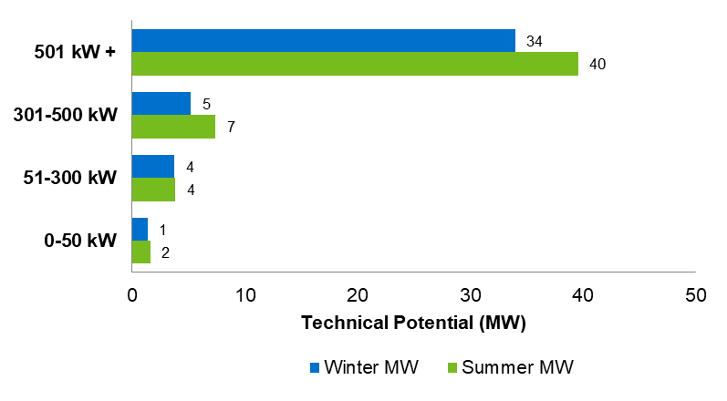

DSRE Achievable Potential
Nexant found there to be no cost-effective potential attainable for Gulf for PV systems, battery storage systems, or CHP systems for the TRC-scenario or the RIM-scenario.

Appendices

EE MPS Measure List
For information on how Nexant developed this list, please see Section 4.
Measures that are new for the 2019 MPS are indicated with an asterisk.

Residential Measures
Measure | End-Use | Description | Baseline
Energy Star Clothes Dryer | Appliances | One Electric Resistance Clothes Dryer meeting current ENERGY STAR® Standards | One Clothes Dryer meeting Federal Standard
Energy Star Clothes Washer | Appliances | One Clothes Washer meeting current ENERGY STAR® Standards | One Clothes Washer meeting Federal Standard
Energy Star Dishwasher | Appliances | One Dishwasher meeting current ENERGY STAR® Requirements | One Dishwasher meeting Federal Standard
Energy Star Freezer | Appliances | One Freezer meeting current ENERGY STAR® Standards | One Freezer meeting Federal Standard
Energy Star Refrigerator | Appliances | One Refrigerator meeting current ENERGY STAR® Standards | One Refrigerator meeting Federal Standard
Heat Pump Clothes Dryer* | Appliances | One Heat Pump Clothes Dryer | One Clothes Dryer meeting Federal Standard
Removal of 2nd Refrigerator-Freezer | Appliances | No Refrigerator | Current Market Average Refrigerator
High Efficiency Convection Oven* | Cooking | One Full-Size Convection Oven meeting current ENERGY STAR® Standards | One Standard Economy-Grade Full-Size Oven
High Efficiency Induction Cooktop* | Cooking | One residential induction cooktop | One standard residential electric cooktop
Drain Water Heat Recovery* | Domestic Hot Water | Hot Water Loop with 50 Gallon Electric Resistance Heater and Drain Water Heat Exchanger | Standard Hot Water Loop with 50 Gallon Electric Resistance Heater, No Drain Water Heat Recovery
Faucet Aerator | Domestic Hot Water | Low-flow lavatory faucet aerator, flow rate: 1.0 gpm | Federal lavatory flow rate standard, 1994, flow rate: 2.2 gpm
Heat Pump Water Heater | Domestic Hot Water | Heat Pump Water Heater (EF=2.50) | Code-Compliant 50 Gallon Electric Resistance Water Heater
Heat Trap | Domestic Hot Water | Heat Trap | Existing Water Heater without heat trap
Hot Water Pipe Insulation | Domestic Hot Water | 1' of Insulated Pipe in Unconditioned Spaces, Insulation of R-5 | 1' of Pipe in Unconditioned Spaces with Code Minimum of 1"of Insulation
Instantaneous Hot Water System* | Domestic Hot Water | Instantaneous Hot Water System | Standard Efficiency Storage Tank Water Heater
Low Flow Showerhead | Domestic Hot Water | Low-Flow Handheld Showerhead, Flow Rate: 1.50 gpm | Standard Handheld Showerhead, Flow Rate: 2.50 gpm
Solar Water Heater | Domestic Hot Water | Solar Powered 50 Gallon Electric Resistance Water Heater (EF = 1.84) | Code-Compliant 50 Gallon Electric Resistance Water Heater
Thermostatic Shower Restriction Valve* | Domestic Hot Water | Hot Water Loop with 50 Gallon Electric Resistance Heater and Pressure Balance Shower Valves | Standard Hot Water Loop with 50 Gallon Electric Resistance Heater and Standard Shower Valves
Water Heater Blanket | Domestic Hot Water | 50 Gallon Electric Resistance Water Heater with Insulated Tank Wrap (R-11) | Market Average 50 Gallon Electric Resistance Water Heater, No Tank Wrap
Water Heater Thermostat Setback | Domestic Hot Water | 50 Gallon Electric Resistance Water Heater with Temperature Set-point of 125°F | Market Average 50 Gallon Electric Resistance Water Heater, Temp. Set-point = 130°F
Water Heater Timeclock | Domestic Hot Water | Water Heater Timeclock | Existing Water Heater without time clock
Energy Star Air Purifier* | Electronics | One 120 CFM Air Purifier meeting current ENERGY STAR® Standards | One Standard Air Purifier
Energy Star Audio-Video Equipment | Electronics | One DVD/Blu-Ray Player meeting current ENERGY STAR® Standards | One Market Average DVD/Blu-Ray Player
Energy Star Imaging Equipment* | Electronics | One imaging device meeting current ENERGY STAR® Standards | One non-ENERGY STAR® imaging device
Energy Star Personal Computer | Electronics | One Personal Computer (desktop or laptop) meeting current ENERGY STAR® Standards | One non-ENERGY STAR® Personal Computer
Energy Star TV | Electronics | One Television meeting current ENERGY STAR® Standards | One non-ENERGY STAR® Television
Smart Power Strip | Electronics | Smart plug strips for entertainment centers and home office | Standard entertainment center or home office usage, no smart strip controls
CFL - 15W Flood | Lighting | CFL (assume 15W) replacing EISA-2020 compliant baseline lamp (65w flood) | EISA-2020 compliant baseline lamp (65W flood)
CFL - 15W Flood (Exterior) | Lighting | CFL (assume 15W) replacing EISA-2020 compliant baseline lamp (65w flood) | EISA-2020 compliant baseline lamp (65W flood)
CFL-13W | Lighting | CFL (assume 13W) replacing EISA-2020 compliant baseline lamp (60w equivalent) | EISA-2020 compliant baseline lamp (60W equivalent)
CFL-23W | Lighting | CFL (assume 23W) replacing EISA-2020 compliant baseline lamp (100w equivalent) | EISA-2020 compliant baseline lamp (100W equivalent)
Exterior Lighting Controls* | Lighting | Timer on Outdoor Lighting, Controlling 120 Watts | 120 Watts of Lighting, Manually Controlled
Interior Lighting Controls* | Lighting | Switch Mounted Occupancy Sensor, 120 Watts Controlled | 120 Watts of Lighting, Manually Controlled
LED - 14W | Lighting | LED (assume 14W) replacing EISA-2020 compliant baseline lamp (100w equivalent) | EISA-2020 compliant baseline lamp (100W equivalent)
LED - 9W | Lighting | LED (assume 9W) replacing EISA-2020 compliant baseline lamp (60w equivalent) | EISA-2020 compliant baseline lamp (60W equivalent)
LED - 9W Flood | Lighting | LED (assume 9W) replacing EISA-2020 compliant baseline lamp (65w flood) | EISA Compliant Halogen Lamp
LED - 9W Flood (Exterior) | Lighting | LED (assume 9W) replacing EISA-2020 compliant baseline lamp (65w flood) | EISA Compliant Halogen Lamp
LED Specialty Lamps-5W Chandelier* | Lighting | 5 W Chandelier LED | Standard incandescent chandelier lamp
Linear LED* | Lighting | Linear LED Lamps in Linear Fluorescent Fixture | Standard (32w) T8 lamps in Linear Fluorescent Fixture
Low Wattage T8 Fixture | Lighting | Low Wattage (28w) T8 Lamps in Linear Fluorescent Fixture | Standard (32w) T8 lamps in Linear Fluorescent Fixture
Energy Star Bathroom Ventilating Fan* | Miscellaneous | Bathroom Exhaust Fan meeting current ENERGY STAR Standards | Bathroom Exhaust Fan meeting Federal Standard
Energy Star Ceiling Fan* | Miscellaneous | 60" Ceiling Fan Meeting current ENERGY STAR Standards | Standard, non-ENERGYSTAR Ceiling Fan
Energy Star Dehumidifier* | Miscellaneous | One Dehumidifier meeting current ENERGY STAR Standards | One Dehumidifier meeting Federal Standard
Heat Pump Pool Heater* | Miscellaneous | Heat Pump Swimming Pool Heater | Electric Resistance Swimming Pool Heater
Solar Pool Heater* | Miscellaneous | Solar Swimming Pool Heater | Electric Resistance Swimming Pool Heater
Solar Powered Pool Pumps | Miscellaneous | Solar Powered Pool Pump | Single Speed Pool Pump Motor
Two Speed Pool Pump | Miscellaneous | Dual Speed Pool Pump Motor | Single Speed Pool Pump Motor
Variable Speed Pool Pump | Miscellaneous | Variable Speed Pool Pump Motor | Single Speed Pool Pump Motor
15 SEER Central AC | Space Cooling | 15 SEER Central AC | Code-Compliant Central AC, 14 SEER
16 SEER Central AC | Space Cooling | 16 SEER Central AC | Code-Compliant Central AC, 14 SEER
17 SEER Central AC | Space Cooling | 17 SEER Central AC | Code-Compliant Central AC, 14 SEER
18 SEER Central AC | Space Cooling | 18 SEER Central AC | Code-Compliant Central AC, 14 SEER
21 SEER Central AC | Space Cooling | 21 SEER Central AC | Code-Compliant Central AC, 14 SEER
Central AC Tune Up | Space Cooling | System tune-up, including coil cleaning, refrigerant charging, and other diagnostics | Existing Typical Central AC without Regular Maintenance/tune-up
Energy Star Room AC | Space Cooling | Room AC meeting current ENERGY STAR standards | Code-Compliant Room AC
Solar Attic Fan* | Space Cooling | Standard Central Air Conditioning with Solar Attic Fan | Standard Central Air Conditioning, No Solar Attic Fan
14 SEER ASHP from base electric resistance heating | Space Cooling, Space Heating | 14 SEER Air Source Heat Pump | Base AC, 14 SEER, Electric resistance heating, 3.41 HSPF
15 SEER Air Source Heat Pump | Space Cooling, Space Heating | 15 SEER Air Source Heat Pump | Code-Compliant ASHP, 14 SEER, 8.2 HSPF
16 SEER Air Source Heat Pump | Space Cooling, Space Heating | 16 SEER Air Source Heat Pump | Code-Compliant ASHP, 14 SEER, 8.2 HSPF
17 SEER Air Source Heat Pump | Space Cooling, Space Heating | 17 SEER Air Source Heat Pump | Code-Compliant ASHP, 14 SEER, 8.2 HSPF
18 SEER Air Source Heat Pump | Space Cooling, Space Heating | 18 SEER Air Source Heat Pump | Code-Compliant ASHP, 14 SEER, 8.2 HSPF
21 SEER Air Source Heat Pump | Space Cooling, Space Heating | 21 SEER Air Source Heat Pump | Code-Compliant ASHP, 14 SEER, 8.2 HSPF
21 SEER ASHP from base electric resistance heating | Space Cooling, Space Heating | 21 SEER Air Source Heat Pump | Base AC, 14 SEER, Electric resistance heating, 3.41 HSPF
Air Sealing-Infiltration Control | Space Cooling, Space Heating | Standard Heating and Cooling System with Improved Infiltration Control | Standard Heating and Cooling System with Standard Infiltration Control
Ceiling Insulation(R12 to R38) | Space Cooling, Space Heating | Blown-in insulation in ceiling cavity/attic, older (pre-1982) homes | Existing ceiling insulation based on building code at time of construction
Ceiling Insulation(R19 to R38) | Space Cooling, Space Heating | Blown-in insulation in ceiling cavity/attic, existing (1982-1985) homes | Existing ceiling insulation based on building code at time of construction
Ceiling Insulation(R2 to R38) | Space Cooling, Space Heating | Blown-in insulation in ceiling cavity/attic, older (pre-1982) homes | Existing ceiling insulation based on building code at time of construction
Ceiling Insulation(R30 to R38) | Space Cooling, Space Heating | Blown-in insulation in ceiling cavity/attic, existing (1986-2016) homes | Existing ceiling insulation based on building code at time of construction
Duct Insulation | Space Cooling, Space Heating | Standard Electric Heating and Central AC with Insulated Ductwork | Standard Electric Heating and Central AC with Uninsulated Ductwork
Duct Repair | Space Cooling, Space Heating | Duct Repair to eliminate/minimize leaks, includes testing and sealing | Standard Electric Heating and Central AC with typical duct leakage
Energy Star Certified Roof Products | Space Cooling, Space Heating | Energy Star Certified Roof Products | Standard Black Roof
Energy Star Door* | Space Cooling, Space Heating | 21ft2 of Opaque Door meeting current Energy Star Requirements | 21ft2 of Opaque Door meeting current FL Code Requirements
Energy Star Windows | Space Cooling, Space Heating | 100ft2 of Window meeting current Energy Star Version Requirements | 100ft2 of Window current FL energy code requirements
Floor Insulation* | Space Cooling, Space Heating | Increased Floor Insulation (R-13) | Standard Electric Heating and Central AC with Uninsulated Floor
Green Roof* | Space Cooling, Space Heating | Vegetated Roof Surface on top of Standard Roof | Standard Black Roof
Ground Source Heat Pump* | Space Cooling, Space Heating | Ground Source Heat Pump | Code-Compliant ASHP, 14 SEER, 8.2 HSPF
Heat Pump Tune Up | Space Cooling, Space Heating | System tune-up, including coil cleaning, refrigerant charging, and other diagnostics | Standard Heating and Cooling System without Regular Maintenance/tune-up
Home Energy Management System* | Space Cooling, Space Heating | Typical HVAC by Building Type Controlled by Home Energy Management System (smart hub and hub-connected thermostat) | Typical HVAC by Building Type, Manually Controlled
Programmable Thermostat | Space Cooling, Space Heating | Pre-set programmable thermostat that replaces manual thermostat | Standard Heating and Cooling System with Manual Thermostat
Radiant Barrier | Space Cooling, Space Heating | Radiant Barrier | No radiant barrier
Sealed crawlspace* | Space Cooling, Space Heating | Encapsulated and semi-conditioned crawlspace | Naturally vented, unconditioned crawlspace
Smart Thermostat* | Space Cooling, Space Heating | Thermostats that include "smart" features such as occupancy sensors, geo-fencing, multi-zone sensors | Standard Heating and Cooling System with Manual Thermostat
Spray Foam Insulation(Base R12) | Space Cooling, Space Heating | Open cell spray foam along roofline in older (pre-1982) homes | Existing ceiling insulation based on building code at time of construction
Spray Foam Insulation(Base R19) | Space Cooling, Space Heating | Open cell spray foam along roofline in existing (1982-1985) homes | Existing ceiling insulation based on building code at time of construction
Spray Foam Insulation(Base R2) | Space Cooling, Space Heating | Open cell spray foam along roofline in older (pre-1982) homes | Existing ceiling insulation based on building code at time of construction
Spray Foam Insulation(Base R30) | Space Cooling, Space Heating | Open cell spray foam along roofline in existing (1986-2016) homes | Existing ceiling insulation based on building code at time of construction
Storm Door* | Space Cooling, Space Heating | 21ft2 of Opaque Door meeting current Energy Star Version Requirements | 21ft2 of Opaque Door meeting current FL Code Requirements
Variable Refrigerant Flow (VRF) HVAC Systems* | Space Cooling, Space Heating | Variable Refrigerant Flow (VRF) HVAC Systems | Code-Compliant ASHP, 14 SEER, 8.2 HSPF
Wall Insulation | Space Cooling, Space Heating | Increased Exterior Above-Grade Wall Insulation (R-13) | Market Average Existing Exterior Above-Grade Wall Insulation
Window Sun Protection | Space Cooling, Space Heating | Window Film Applied to Standard Window | Standard Window with below Code Required Minimum SHGC
HVAC ECM Motor | Space Heating | Variable Speed Electronically Commutated Motor for an Electric Furnace | Permanent Split Capacitor Motor for Electric Furnace

Commercial Measures
Measure | End-Use | Description | Baseline
Efficient Exhaust Hood | Cooking | Kitchen ventilation with automatically adjusting fan controls | Kitchen ventilation with constant speed ventilation motor
Energy Star Commercial Oven | Cooking | One 12-Pan Combination Oven meeting current ENERGY STAR® Standards | One Standard Economy-Grade 12-Pan Combination Oven
Energy Star Fryer | Cooking | One Standard Vat Electric Fryer meeting current ENERGY STAR® Standards | One Standard Economy-Grade Standard Vat Electric Fryer
Energy Star Griddle | Cooking | One Griddle meeting current ENERGY STAR® Standards | One Conventional Griddle
Energy Star Hot Food Holding Cabinet | Cooking | One Hot Food Holding Cabinet meeting current ENERGY STAR® Standards | One Standard Hot Food Holding Cabinet
Energy Star Steamer | Cooking | One 4-Pan Electric Steamer meeting current ENERGY STAR® Standards | One Standard Economy-Grade 4-Pan Steamer
Induction Cooktops | Cooking | Efficient Induction Cooktop | One Standard Electric Cooktop
Drain Water Heat Recovery | Domestic Hot Water | Hot Water Loop with 50 Gallon Electric Resistance Heater and Drain Water Heat Exchanger | Standard Hot Water Loop with 50 Gallon Electric Resistance Heater, No Drain Water Heat Recovery
Energy Star Commercial Dishwasher | Domestic Hot Water | One Dishwasher meeting current ENERGY STAR® Requirements | One Dishwasher meeting Federal Standard
Faucet Aerator | Domestic Hot Water | Low-flow lavatory faucet aerator, flow rate: 1.0 gpm | Federal lavatory flow rate standard, 1994, flow rate: 2.2 gpm
Heat Pump Water Heater | Domestic Hot Water | Efficient 50 Gallon Electric Heat Pump Water Heater | Code-Compliant 50 Gallon Electric Heat Pump Water Heater
Hot Water Circulation Pump Control | Domestic Hot Water | Recirculation Pump with Demand Control Mechanism | Uncontrolled Recirculation Pump
Hot Water Pipe Insulation | Domestic Hot Water | 1' of Insulated Pipe in Unconditioned Spaces, Insulation of R-4 | 1' of Pipe in Unconditioned Spaces with Code Minimum of 1"of Insulation
Instantaneous Hot Water System* | Domestic Hot Water | Instantaneous Hot Water System | Code-Compliant Electric Storage Water Heater
Low Flow Shower Head* | Domestic Hot Water | Low-Flow Handheld Showerhead, Flow Rate: 1.50 gpm | Standard Handheld Showerhead, Flow Rate: 2.50 gpm
Low-Flow Pre-Rinse Sprayers | Domestic Hot Water | Low-Flow Pre-Rinse Sprayer with Flow Rate of 1.6 gpm | Pre-Rinse Sprayer 10% Less Efficient than Federal Standard
Solar Water Heater | Domestic Hot Water | Solar Powered 50 Gallon Electric Resistance Water Heater (EF = 4.05) | Code-Compliant 50 Gallon Electric Heat Pump Water Heater
Tank Wrap on Water Heater* | Domestic Hot Water | 50 Gallon Electric Resistance Water Heater with Insulated Tank Wrap (R-11) | Market Average 50 Gallon Electric Resistance Water Heater, No Tank Wrap
Thermostatic Shower Restriction Valve* | Domestic Hot Water | Hot Water Loop with 50 Gallon Electric Resistance Heater and Pressure Balance Shower Valves | Standard Hot Water Loop with 50 Gallon Electric Resistance Heater and Standard Shower Valves
Bi-Level Lighting Control (Exterior)* | Exterior Lighting | Bi-Level Controls on Exterior Lighting, 500 Watts Controlled | 500 Watts of Lighting, Manually Controlled
CFL - 15W Flood | Exterior Lighting | CFL (assume 15W) replacing EISA-2020 compliant baseline lamp (65w flood) | EISA-2020 compliant baseline lamp (65W flood)
High Efficiency HID Lighting | Exterior Lighting | One Pulse Start Metal Halide 200W | Average Lumen Equivalent High Intensity Discharge Fixture
LED - 9W Flood | Exterior Lighting | LED (assume 9W) replacing EISA-2020 compliant baseline lamp (65w flood) | EISA-2020 compliant baseline lamp (65W flood)
LED Display Lighting (Exterior)* | Exterior Lighting | One Letter of LED Signage, < 2ft in Height | One Letter of Neon or Argon-mercury Signage, < 2ft in Height
LED Exterior Lighting | Exterior Lighting | One 65W LED Canopy Light | Average Lumen Equivalent Exterior HID Area Lighting
LED Parking Lighting* | Exterior Lighting | One 160W LED Area Light | Average Lumen Equivalent Exterior HID Area Lighting
LED Street Lights* | Exterior Lighting | One 210W LED Area Light | Average Lumen Equivalent Exterior HID Area Lighting
LED Traffic and Crosswalk Lighting* | Exterior Lighting | LED Crosswalk Sign | Energy Star Qualifying Crosswalk Sign
Outdoor Lighting Controls | Exterior Lighting | Install Exterior Photocell Dimming Controls, 500 Watts Controlled | 500 Watts of Lighting, Manually Controlled
Bi-Level Lighting Control (Interior)* | Interior Lighting | Bi-Level Controls on Interior Lighting, 500 Watts Controlled | 500 Watts of Lighting, Manually Controlled
CFL-23W | Interior Lighting | CFL (assume 23W) replacing EISA-2020 compliant baseline lamp (100w equivalent) | EISA-2020 compliant baseline lamp (100W equivalent)
High Bay Fluorescent (T5) | Interior Lighting | One 4' 4-Lamp High Bay T5 Fixture | Average Lumen Equivalent High Intensity Discharge Fixture
High Bay LED | Interior Lighting | One 150W High Bay LED Fixture | Weighted Existing Fluorescent High-Bay Fixture
Interior Lighting Controls | Interior Lighting | Install Interior Photocell Dimming Controls, 500 Watts Controlled | 500 Watts of Lighting, Manually Controlled
LED - 14W | Interior Lighting | LED (assume 14W) replacing EISA-2020 compliant baseline lamp (100w equivalent) | EISA-2020 compliant baseline lamp (100W equivalent)
LED Display Lighting (Interior) | Interior Lighting | One Letter of LED Signage, < 2ft in Height | One Letter of Neon or Argon-mercury Signage, < 2ft in Height
LED Linear - Fixture Replacement* | Interior Lighting | 2x4 LED Troffer | Lumen-Equivalent 32-Watt T8 Fixture
LED Linear - Lamp Replacement | Interior Lighting | Linear LED (21W) | Lumen-Equivalent 32-Watt T8 Lamp
Premium T8 - Fixture Replacement | Interior Lighting | Reduced Wattage (28W) T8 Fixture with Low Ballast Factor | Lumen-Equivalent 32-Watt T8 Fixture
Premium T8 - Lamp Replacement | Interior Lighting | Replace Bulbs in T8 Fixture with Reduced Wattage (28W) Bulbs | 32-Watt T8 Fixture
Efficient Battery Charger* | Miscellaneous | Single-phase Ferro resonant or silicon-controlled rectifier charging equipment with power conversion efficiency >=89% & maintenance power <= 10 W | FR or SCR charging stations with power conversion efficiency < 89% or > 10 W
Efficient Motor Belts* | Miscellaneous | Synchronous belt, 98% efficiency | Standard V-belt drive
ENERGY STAR Commercial Clothes Washer* | Miscellaneous | One Commercial Clothes Washer meeting current ENERGY STAR® Requirements | One Commercial Clothes Washer meeting Federal Standard
ENERGY STAR Water Cooler* | Miscellaneous | One Storage Type Hot/Cold Water Cooler Unit meeting current ENERGY STAR® Standards | One Standard Storage Type Hot/Cold Water Cooler Unit
Engine Block Timer* | Miscellaneous | Plug-in timer that activates engine block timer to reduce unnecessary run time | Engine block heater (typically used for backup generators) running continuously
Regenerative Drive Elevator Motor* | Miscellaneous | Regenerative drive produced energy when motor in overhaul condition | Standard motor
Solar Pool Heater* | Miscellaneous | Solar Swimming Pool Heater | Electric Resistance Swimming Pool Heater
Heat Pump Pool Heater* | Miscellaneous | Heat Pump Swimming Pool Heater | Electric Resistance Swimming Pool Heater
Two Speed Pool Pump* | Miscellaneous | Dual Speed Pool Pump Motor | Single Speed Pool Pump Motor
Variable Speed Pool Pump* | Miscellaneous | Variable Speed Pool Pump Motor | Single Speed Pool Pump Motor
Solar Powered Pool Pump* | Miscellaneous | Solar Powered Pool Pump Motor | Single Speed Pool Pump Motor
VSD Controlled Compressor | Miscellaneous | Variable Speed Drive Control - includes all non-HVAC applications | Constant speed motors & pumps
Facility Energy Management System | Multiple End-Uses | Energy Management System deployed to automatically control HVAC, lighting, and other systems as applicable | Standard/manual facility equipment controls
Retro-Commissioning* | Multiple End-Uses | Perform facility retro-commissioning, including assessment, process improvements, and optimization of energy-consuming equipment and systems at the facility | Comparable facility, no retro-commissioning
ENERGY STAR Imaging Equipment | Office Equipment | One imaging device meeting current ENERGY STAR® Standards | One non-ENERGY STAR® imaging device
Energy Star PCs | Office Equipment | One Personal Computer (desktop or laptop) meeting current ENERGY STAR® Standards | One non-ENERGY STAR® Personal Computer
Energy Star Servers | Office Equipment | One Server meeting current ENERGY STAR Standards | One Standard Server
Energy Star Uninterruptable Power Supply* | Office Equipment | Standard Desktop Plugged into Energy Star Uninterruptable Power Supply at 25% Load | Standard Desktop Plugged into Uninterruptable Power Supply at 25% Load
Network PC Power Management* | Office Equipment | One computer and monitor attached to centralized energy management system that controls when desktop computers and monitors plugged into a network power down to lower power states. | One computer and monitor, manually controlled
Server Virtualization | Office Equipment | 2 Virtual Host Server | 20 Single Application Servers
Smart Strip Plug Outlet* | Office Equipment | One Smart Strip Plug Outlet | One Standard plug strip/outlet
Anti-Sweat Controls | Refrigeration | One Medium Temperature Reach-In Case with Anti-Sweat Heater Controls | One Medium Temperature Reach-In Case without Anti-Sweat Heater Controls
Automatic Door Closer for Walk-in Coolers and Freezers | Refrigeration | One Medium Temperature Walk-In Refrigerator Door with Auto-Closer | One Medium Temperature Walk-In Refrigerator Door without Auto-Closer
Demand Defrost | Refrigeration | Walk-In Freezer System with Demand-Controlled Electric Defrost Cycle | Walk-In Freezer System with Timer-Controlled Electric Defrost Cycle
Energy Star Commercial Glass Door Freezer* | Refrigeration | One Glass Door Freezer meeting current ENERGY STAR® Standards | One Glass Door Freezer meeting Federal Standards
Energy Star Commercial Glass Door Refrigerator* | Refrigeration | One Glass Door Refrigerator meeting current ENERGY STAR® Standards | One Glass Door Refrigerator meeting Federal Standards
Energy Star Commercial Solid Door Freezer* | Refrigeration | One Solid Door Freezer meeting current ENERGY STAR® Standards | One Solid Door Freezer meeting Federal Standards
Energy Star Commercial Solid Door Refrigerator* | Refrigeration | One Solid Door Refrigerator meeting current ENERGY STAR® Standards | One Solid Door Refrigerator meeting Federal Standards
Energy Star Ice Maker | Refrigeration | One Continuous Self-Contained Ice Maker meeting current ENERGY STAR® Standards (8.9 kWh / 100 lbs of ice) | One Continuous Self-Contained Ice Maker meeting Federal Standard
Energy Star Refrigerator* | Refrigeration | One Refrigerator meeting current ENERGY STAR® Standards | One Refrigerator meeting Federal Standard
Energy Star Vending Machine | Refrigeration | One Refrigerated Vending Machine meeting current ENERGY STAR® Standards | One standard efficiency Refrigerated Vending Machine
Floating Head Pressure Controls | Refrigeration | Medium-Temperature Refrigeration System with 5HP Compressor and Adjustable Condenser Head Pressure Control Valve | Medium-Temperature Refrigeration System with 5 HP Compressor without Adjustable Condenser Head Pressure Control Valve
Freezer-Cooler Replacement Gaskets | Refrigeration | New Door Gasket on One-Door Medium Temperature Reach-In Case | Worn or Damaged Door Gasket on One-Door Medium Temperature Reach-In Case
High Efficiency Refrigeration Compressor | Refrigeration | High Efficiency Refrigeration Compressors | Existing Compressor
High R-Value Glass Doors | Refrigeration | Display Door with High R-Value, One-Door Medium Temperature Reach-In Case | Standard Door, One-Door Medium Temperature Reach-In Case
Night Covers for Display Cases | Refrigeration | One Open Vertical Case with Night Covers | One Existing Open Vertical Case, No Night Covers
PSC to ECM Evaporator Fan Motor (Reach-In)* | Refrigeration | Medium Temperature Reach-In Case with Electronically Commutated Evaporator Fan Motor | Medium Temperature Reach-In Case with Permanent Split Capacitor Evaporator Fan Motor
PSC to ECM Evaporator Fan Motor (Walk-In, Refrigerator) | Refrigeration | Medium Temperature Walk-In Case with Electronically Commutated Evaporator Fan Motor | Medium Temperature Reach-In Case with Permanent Split Capacitor Evaporator Fan Motor
Refrigerated Display Case LED Lighting* | Refrigeration | 60" Refrigerated Case LED Strip | Lumen-Equivalent 32-Watt T8 Fixture
Refrigerated Display Case Lighting Controls* | Refrigeration | Occupancy Sensors for Refrigerated Case Lighting to reduce run time | Market-Share Weighted Existing Linear Fluorescent Fixture
Strip Curtains for Walk-ins | Refrigeration | Walk-in cooler with strip curtains at least 0.06 inches thick covering the entire area of the doorway | Walk-in cooler without strip curtains
Chilled Water Controls Optimization* | Space Cooling | Deploy an algorithm package on the chiller to totalize the available power inputs and calculate the cooling load, and accordingly apply small set-point adjustments to the plant control system | Standard chilled water controls
Chilled Water System - Variable Speed Drives | Space Cooling | 10HP Chilled Water Pump with VFD Control | 10HP Chilled Water Pump Single Speed
Cool Roof | Space Cooling | Cool Roof - Includes both DX and chiller cooling systems | Code-Compliant Flat Roof
High Efficiency Chiller (Air Cooled, 50 tons) | Space Cooling | High Efficiency Chiller (Air Cooled, 50 tons) | Code-Compliant Air Cooled Positive Displacement Chiller, 50 Tons
High Efficiency Chiller (Water cooled-centrifugal, 200 tons) | Space Cooling | Water Cooled Centrifugal Chiller with Integral VFD, 200 Tons | Code-Compliant Water Cooled Centrifugal Chiller, 200 Tons
Thermal Energy Storage | Space Cooling | Deploy thermal energy storage technology (ice harvester, etc.) to shift load | Code compliant chiller
Air Curtains* | Space Cooling, Space Heating | Air Curtain across door opening | Door opening with no air curtain
Airside Economizer* | Space Cooling, Space Heating | Airside Economizer | No economizer
Ceiling Insulation(R12 to R38) | Space Cooling, Space Heating | Blown-in insulation in ceiling cavity/attic | Market Average Existing Ceiling Insulation in older steep slope, residential style commercial building
Ceiling Insulation(R19 to R38) | Space Cooling, Space Heating | Blown-in insulation in ceiling cavity/attic | Market Average Existing Ceiling Insulation in older steep slope, residential style commercial building
Ceiling Insulation(R2 to R38) | Space Cooling, Space Heating | Blown-in insulation in ceiling cavity/attic | Market Average Existing Ceiling Insulation in older steep slope, residential style commercial building
Ceiling Insulation(R30 to R38) | Space Cooling, Space Heating | Blown-in insulation in ceiling cavity/attic | Market Average Existing Ceiling Insulation in older steep slope, residential style commercial building
Dedicated Outdoor Air System on VRF unit* | Space Cooling, Space Heating | Code-Compliant VRF utilizing Dedicated Outdoor Air System | Code-Compliant PTHP
Destratification Fans* | Space Cooling, Space Heating | Destratification Fans improve temperature distribution by circulating warmer air from the ceiling back down to the floor level | No destratification fan
Duct Insulation | Space Cooling, Space Heating | Standard Electric Heating and Central AC with Insulated Ductwork (R-8) | Standard Electric Heating and Central AC with Uninsulated Ductwork (R-4)
Duct Sealing Repair | Space Cooling, Space Heating | Duct Repair to eliminate/minimize leaks, includes testing and sealing | Standard AC with typical duct leakage
Energy Recovery Ventilation System (ERV) | Space Cooling, Space Heating | Unitary Cooling Equipment that Incorporates Energy Recovery | Current Market Packaged or Split DX Unit
Facility Commissioning* | Space Cooling, Space Heating | Perform facility commissioning to optimize building operations in new facilities | Standard new construction facility with no commissioning
Floor Insulation* | Space Cooling, Space Heating | Increased Floor Insulation (R-19) | Market Average Existing Floor Insulation
Geothermal Heat Pump | Space Cooling, Space Heating | Geothermal Heat Pump | Code-Compliant Air Source Heat Pump
Green Roof* | Space Cooling, Space Heating | Green Roof | Code-Compliant Flat Roof
High Efficiency Chiller (Water cooled-positive displacement, 100 tons) | Space Cooling, Space Heating | Water Cooled Positive Displacement Chiller with Integral VFD, 100 Tons | Code-Compliant Water Cooled Positive Displacement Chiller, 100 Tons
High Efficiency Data Center Cooling* | Space Cooling, Space Heating | High Efficiency CRAC (computer room air conditioner) | Standard Efficiency CRAC
High Efficiency DX 135k- less than 240k BTU | Space Cooling, Space Heating | High Efficiency DX Unit, 15 tons | Code-Compliant Packaged or Split DX Unit, 15 Tons
High Efficiency PTAC | Space Cooling, Space Heating | High Efficiency PTAC | Code-Compliant PTAC
High Efficiency PTHP | Space Cooling, Space Heating | High Efficiency PTHP | Code-Compliant PTHP
Hotel Card Energy Control Systems | Space Cooling, Space Heating | Guest Room HVAC Unit Controlled by Hotel-Key-Card Activated Energy Control System | Guest Room HVAC Unit, Manually Controlled by Guest
HVAC tune-up | Space Cooling, Space Heating | PTAC/PTHP system tune-up, including coil cleaning, refrigerant charging, and other diagnostics | Existing PTAC/PTHP without Regular Maintenance/tune-up
HVAC tune-up_RTU | Space Cooling, Space Heating | Rooftop Unit (RTU) System tune-up, including coil cleaning, refrigerant charging, and other diagnostics | Existing typical RTU without Regular Maintenance/tune-up
Infiltration Reduction - Air Sealing* | Space Cooling, Space Heating | Reduced leakage through caulking, weather-stripping | Standard Heating and Cooling System with Moderate Infiltration
Low U-Value Windows* | Space Cooling, Space Heating | 100ft2 of Window meeting current Energy Star Standards | 100ft2 of Window meeting Florida energy code
Programmable Thermostat* | Space Cooling, Space Heating | Pre-set programmable thermostat that replaces manual thermostat | Standard Heating and Cooling System with Manual Thermostat
Roof Insulation | Space Cooling, Space Heating | Roof Insulation (built-up roof applicable to flat/low slope roofs) | Code-Compliant Flat Roof
Smart Thermostat* | Space Cooling, Space Heating | Thermostats that include "smart" features such as occupancy sensors, geo-fencing, multi-zone sensors | Standard Heating and Cooling System with Manual Thermostat
Variable Refrigerant Flow (VRF) HVAC Systems* | Space Cooling, Space Heating | Variable Refrigerant Flow (VRF) HVAC Systems | Code-Compliant PTHP
Wall Insulation* | Space Cooling, Space Heating | Increased Exterior Above-Grade Wall Insulation | Market Average Existing Exterior Above-Grade Wall Insulation
Warehouse Loading Dock Seals* | Space Cooling, Space Heating | Seals to reduce infiltration losses at loading dock | Loading dock with no seals
Water Cooled Refrigeration Heat Recovery* | Space Cooling, Space Heating | The heat reclaim system transfers waste heat from refrigeration system to space heating or hot water | No heat recovery
Waterside Economizer* | Space Cooling, Space Heating | Waterside Economizer | No economizer
Window Sun Protection | Space Cooling, Space Heating | Window Sun Protection (Includes sunscreen, film, tinting or overhang to minimize heat gain through window) | Standard Window with below Code Required Minimum SHGC
ECM Motors on Furnaces | Space Heating | Variable Speed Electronically Commutated Motor for an Electric Furnace | Permanent Split Capacitor Motor for Electric Furnace
10HP Open Drip-Proof(ODP) Motor* | Ventilation and Circulation | High Efficiency 10 HP Open-Drip Proof Motor, 4-Pole, 1800 RPM | 10 HP Open-Drip Proof Motor with EPACT 1992 Efficiency
CO Sensors for Parking Garage Exhaust* | Ventilation and Circulation | Enclosed Parking Garage Exhaust with CO Control | Constant Volume Enclosed Parking Garage Exhaust
Demand Controlled Ventilation | Ventilation and Circulation | Return Air System with CO2 Sensors | Standard Return Air System, No Sensors
High Speed Fans | Ventilation and Circulation | High Speed Fan, 24" - 35" Blade Diameter | Standard Speed Fan, 24" - 35" Blade Diameter
VAV System* | Ventilation and Circulation | Variable Air Volume Distribution System | Constant Air Volume Distribution System

Industrial Measures
Measure | End-Use | Description | Baseline
Building Envelope Improvements | HVAC | Facility envelope improvements to improve thermal efficiency. Individual improvements may include additional insulation, cool roof, infiltration reduction, improved fenestration efficiency | Typical existing facility
HVAC Equipment Upgrades | HVAC | Equipment upgrades to improve operating efficiency. Includes high efficiency HVAC equipment (including DX units and chillers), HVAC VFDs, economizers, ECM motors | Market average HVAC equipment at existing facilities
HVAC Recommissioning | HVAC | Diagnostic evaluation and optimization of facility HVAC system | Comparable facility, no retro-commissioning
HVAC Improved Controls | HVAC | Improved control technologies such as EMS, thermostats, demand controlled ventilation | Standard/manual HVAC controls
Efficient Lighting - High Bay | Industrial Lighting | Efficient high bay lighting fixtures, including HID and LED | Market average high bay lighting
Efficient Lighting - Other Interior Lighting | Industrial Lighting | Efficient interior lighting, including conversion to efficient linear fluorescent, LEDs, and delamping | Market average interior lighting
Lighting Controls – Interior* | Industrial Lighting | Improved control technologies for interior lighting, such as time clocks, bi-level fixture controls, photocell controls, and occupancy/vacancy sensors | Standard/manual interior lighting controls
Efficient Lighting – Exterior* | Exterior Lighting | Efficient exterior lighting, including exterior walkway lighting, pathway lighting, security lighting, and customer-owned street lighting | Market average exterior lighting
Lighting Controls - Exterior | Exterior Lighting | Improved control technologies for exterior lighting, such as time clocks, bi-level fixture controls, photocell controls, and motion sensors | Standard/manual exterior lighting controls
Compressed Air System Optimization | Compressed Air | Compressed air system improvements, including system optimization, appropriate sizing, minimizing air pressure, replace compressed air use with mechanical or electrical functions | Standard compressed air system operations
Compressed Air Controls | Compressed Air | Improved control technologies for compressed air system, including optimized distribution system, VFD controls | Standard compressed air system operations with manual controls
Compressed Air Equipment | Compressed Air | Equipment upgrades to improve operating efficiency, including motor replacement, integrated VFD compressed air systems, improved nozzles, receiver capacity additions | Market average compressed air equipment
Fan Improved Controls | Motors Fans Blowers | Improved fan control technologies | Standard/manual fan controls
Fan System Optimization | Motors Fans Blowers | Fan system optimization | Standard fan operation
Fan Equipment Upgrades | Motors Fans Blowers | Equipment upgrades to improve operating efficiency, including motor replacement, VFD installation | Market average fan equipment
Pump Improved Controls | Motors Pumps | Improved pump control technologies | Standard/manual pump controls
Pump System Optimization | Motors Pumps | Pump system optimization | Standard pump system operations
Pump Equipment Upgrade | Motors Pumps | Equipment upgrades to improve operating efficiency, including motor replacement, VFD installation | Market average pump equipment
Motor Equipment Upgrades | Motors Pumps | Equipment upgrades to improve operating efficiency, including motor replacement, efficient drives, ECM motors, VFD installation | Market average motors
Motor Improved Controls | Motors Pumps | Improved motor control technologies | Standard/manual motor controls
Motor Optimization | Motors Pumps | Motor system optimization, including replacing drive belts, electric actuators, pump/motor rewinds | Standard motor operation
Process Heat Improved Controls | Process Heating | Improved process heat control technologies | Standard/manual process heat controls
Process Heat System Optimization | Process Heating | Process heat system optimization | Standard process heat system operations
Process Heat Equipment Upgrade | Process Heating | Equipment upgrades to improve operating efficiency | Market average process heating equipment
Process Other Systems Optimization | Process Specific | Process other system optimization | Standard process other system operations
Process Other Equipment Upgrades | Process Specific | Equipment upgrades to improve operating efficiency of industry-specific process equipment, such as injection molders, extruders, and other machinery | Market average process equipment
Process Refrig System Optimization | Process Cooling | Process refrigeration system optimization, including ventilation optimization, demand defrost, and floating head pressure controls | Standard process refrigeration system operations
Process Refrig Controls* | Process Cooling | Improved process refrigeration control technologies | Standard/manual process refrigeration controls
Process Refrig Equipment Upgrade* | Process Cooling | Equipment upgrades to improve operating efficiency, including efficient refrigeration compressors, evaporator fan motors, and related equipment | Market average process refrigeration equipment
Plant Energy Management | Multiple End-Uses | Facility control technologies and optimization to improve energy efficiency, including the installation of high efficient equipment, controls, and implementing system optimization practices to improve plant efficiency | Standard/manual plant energy management practices

The following EE measures from the 2014 Technical Potential Study were eliminated from the current study:

2014 EE Measures Eliminated from Current Study
Sector | Measure | 2014 End-Use
Residential | AC Heat Recovery Units | HVAC
Residential | HVAC Proper Sizing | HVAC
Residential | High Efficiency One Speed Pool Pump (1.5 hp) | Motor
Commercial | LED Exit Sign | Lighting-Exterior
Commercial | High Pressure Sodium 250W Lamp | Lighting-Interior
Commercial | PSMH, 250W, magnetic ballast | Lighting-Interior
Industrial | Compressed Air-O&M | Compressed Air
Industrial | Fans - O&M | Fans
Industrial | Pumps - O&M | Pumps
Industrial | Bakery - Process (Mixing) - O&M | Process Other
Industrial | O&M/drives spinning machines | Process Other
Industrial | O&M - Extruders/Injection Moulding | Process Other

DR MPS Measure List

Residential Measures
Measure | Type | Season | Measure Description
Central air conditioner - Load Shed | Direct load control | Summer | Direct load control program where utility provides day ahead notification that it will send remote signal to shed AC unit load during peak usage period.
Central Heating - Load Shed | Direct load control | Winter | Direct load control program where utility provides day ahead notification that it will send remote signal to shed AC unit load during peak usage period.
Central air conditioner - 50% cycling | Direct load control | Summer | Direct load control program where utility provides day ahead notification that it will send remote signal to cycle AC unit during peak usage period
Central Heating - 50% cycling | Direct load control | Winter | Direct load control program where utility provides day ahead notification that it will send remote signal to cycle AC unit during peak usage period
Smart thermostats - Utility Installation* | Direct load control | Summer and Winter | Similar to AC load control program, but allows customers to participate using a compatible smart thermostat rather than an AC switch
Smart thermostats – BYOT* | Direct load control | Summer and Winter | Similar to AC load control program, but allows customers to participate using a compatible smart thermostat rather than an AC switch
CPP + Tech | Pricing | Summer and Winter | Electricity rate that varies based on time of day. Can be same rate schedule for every day during a given season (time of use, or TOU) and with critical peak pricing (CPP) days when peak period rates are substantially higher for a limited number of days per year (customers receive advance notification of CPP event). Customers also receive technology that they can pre-program to curtail load when an event is called.
Water heater switches | Direct load control | Summer and Winter | Load control switch that is installed on a water heater
Pool pump switches | Direct load control | Summer and Winter | Load control program with switch installed on pool pump
Room AC* | Direct load control | Summer | Load control program that is focused on room AC units rather than central AC

Small C&I Measures
Measure | Type | Season | Measure Description
Central air conditioner - Load Shed | Direct load control | Summer | Direct load control program where utility provides day ahead notification that it will send remote signal to shed AC unit load during peak usage period.
Central Heating - Load Shed* | Direct load control | Winter | Direct load control program where utility provides day ahead notification that it will send remote signal to shed AC unit load during peak usage period.
Central air conditioner - 50% cycling | Direct load control | Summer | Direct load control program where utility provides day ahead notification that it will send remote signal to cycle AC unit during peak usage period
Central Heating - 50% cycling* | Direct load control | Winter | Direct load control program where utility provides day ahead notification that it will send remote signal to cycle AC unit during peak usage period
Smart thermostats - Utility Installation* | Direct load control | Summer and Winter | Similar to AC load control program, but allows customers to participate using a compatible smart thermostat rather than an AC switch
Smart thermostats – BYOT* | Direct load control | Summer and Winter | Similar to AC load control program, but allows customers to participate using a compatible smart thermostat rather than an AC switch
CPP + Tech | Pricing | Summer and Winter | Electricity rate that varies based on time of day. Can be same rate schedule for every day during a given season (time of use, or TOU) and with critical peak pricing (CPP) days when peak period rates are substantially higher for a limited number of days per year (customers receive advance notification of CPP event). Customers also receive technology that they can pre-program to curtail load when an event is called.

Large C&I Measures
Measure | Type | Season | Measure Description
CPP + Tech* | Pricing | Summer and Winter | Electricity rate that varies based on time of day. Can be same rate schedule for every day during a given season (time of use, or TOU) and with critical peak pricing (CPP) days when peak period rates are substantially higher for a limited number of days per year (customers receive advance notification of CPP event). Customers also receive technology that they can pre-program to curtail load when an event is called.
Auto DR* | Utility-controlled loads | Summer and Winter | Custom load control of specific end-uses/processes that is triggered by utility signal to building management system; customer can sometimes opt-out of specific events
Firm Service Level | Contractual | Summer and Winter | Customer commits to a maximum usage level during peak periods and, when notified by the utility, agrees to cut usage to that level.
Guaranteed Load Drop* | Contractual | Summer and Winter | Customer agrees to reduce usage by an agreed upon amount when notified

No DR measures from the 2014 Technical Potential Study were eliminated from the current study.

DSRE Measure List

Residential Measures
Measure | Measure Description
PV System | Roof-mounted system, including multiple panels, AC/DC inverter, racking system, and electrical system interconnections
Battery Storage from PV System* | Lithium-ion battery system designed to integrate with an on-site PV system to store and discharge excess energy from PV generation

Non-Residential Measures
Measure | Measure Description
PV System | Roof-mounted system, including multiple panels, AC/DC inverter, racking system, and electrical system interconnections
Battery Storage from PV System* | Lithium-ion battery system designed to integrate with an on-site PV system to store and discharge excess energy from PV generation
CHP – Fuel Cell* | An electrochemical cell-based generator that reacts hydrogen fuel with oxygen
CHP – Micro Turbine* | Small combustion turbine that burns gaseous or liquid fuel to drive a generator
CHP – Gas Turbine* | A combustion turbine that burns gaseous or liquid fuel to drive a generator
CHP – Reciprocating Engine* | An engine that uses one or more pistons to convert pressure into rotational motion
CHP - Steam Turbine* | A turbine that extracts thermal energy from pressured steam to drive a generator

No DSRE measures from the 2014 Technical Potential Study were eliminated from the current study.

Customer Demand Characteristics
Customer demand on peak days was analyzed by rate classes within each sector. Outputs presentation includes load shapes on peak days and average days, along with the estimates of technical potential by end-uses. The two end-uses, Air Conditioning and Heating, were studied for both residential and large C&I customers; however, in residential sector, another two end-uses were also incorporated into the analyses, which are Water Heaters and Pool Pumps.
Residential and Small C&I
Air Conditioning (Residential and Small C&I)
The cooling load shapes on the summer peak weekday and average weekdays were generated from hourly load research sample in Gulf territory for 2015. A regression model was built to estimate relationship between load values and cooling degree days (CDD) (shown as Equation (1)). The p-values of the model and coefficient are both less than 0.05, which means that they are of statistically significance. The product of actual hourly CDD values and coefficient would be used as cooling load during that hour in terms of per customer.
Equation (1):
$${Load}_{t}= {CDD}_{t}* β_{1}+i. month+ε$$
Where:
$t$ Hours in each day in year 2015
${Load}_{t}$ Load occurred in each hour
${CDD}_{t}$ Cooling Degree Day value associated with each hour
$β_{1}$ Change in average load per CDD
$i.month$ Nominal variable, month
$ε$ The error term
To study the peak technical potential, a peak day was selected if it has the hour with system peak load during summer period (among May to September). Technical potential for residential customers was then calculated as the aggregate consumption during that summer peak hour.
Space Heating (Residential and Small C&I)
Similar to the analyses for air conditioning, the heating load shapes on peak day and average days were obtained from the same hourly load research profile in 2013 and 2014, and the peak day was defined as the day with system peak load during winter period. The regression model was modified to evaluate relationship between energy consumption and heating degree days (HDD) (shown as Equation (2)), but the technical potential was calculated in the same way as illustrated earlier.
Equation (2):
$${Load}_{t}= {HDD}_{t}* β_{1}+i. month+ε$$
Where:
$t$ Hours in each day in year 2015
${Load}_{t}$ Load occurred in each hour
${HDD}_{t}$ Heating Degree Day value associated with each hour
$β_{1}$ Change in average load per HDD
$i.month$ Nominal variable, month
$ε$ The error term

Water Heaters (Residential Only)
Interval load data by end-use are not available for individual customers in Gulf territory, so the analyses of water heaters was completed based on end-use metered data from CPS (San Antonio) Home Manager Program. As water heater loads were assumed to be relatively constant throughout the year (used for summer and winter), average load profiles for water heaters on CPS’s 2013 system peak were assumed to be representative for residential customers in Gulf territory.
Figure -8-1: Average Water Heaters Load Shapes for DEI Customers
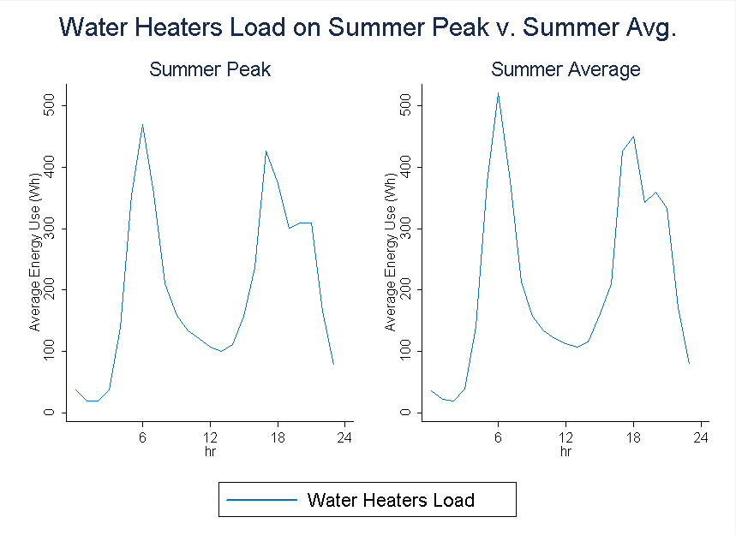
It is apparent from the Figure 8-3 that there is not much difference from peak usage and average usage, which proves that water heater loads has low sensitivity to weather. There are two spikes in a day, indicating two shifts when people would be likely to take showers. The time periods with highest consumption are 5:00 am – 7:00 am and 5:00 pm – 8:00 pm.
Pool Pumps (Residential Only)
Likewise, pool pump loads were assumed to be fairly constant throughout the summer time as well, so the average load profiles for pool pumps from CPS’s project were also used to represent for residential customers in Gulf territory.
Figure 8-2: Average Pool Pumps Load Shapes for DEI Customers

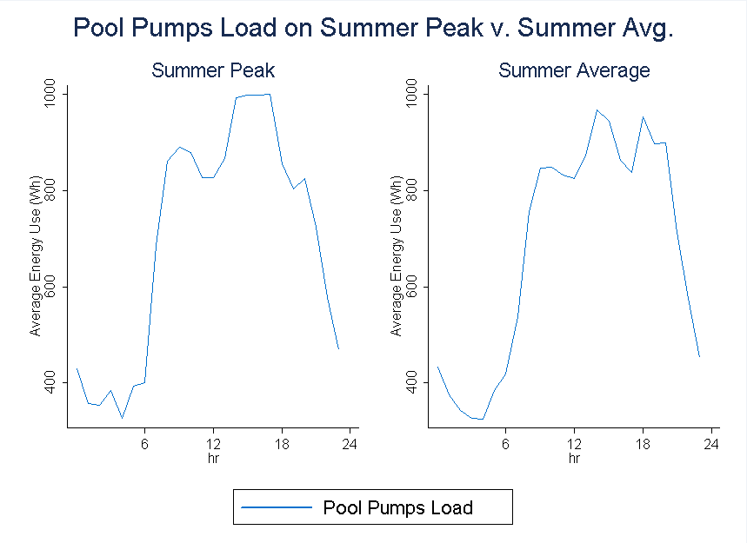
According to the Figure 8-4, the peak hours for pool pumps are 3:00 pm to 6:00 pm, and there is minor sensitivity with weather observed by comparing peak loads and average loads.

Large C&I Customers
Estimates of technical potential were based on one year of interval data (2015) for all customers in the GSD rate classes. Customers were categorized into one of four max demand segments for the purpose of analysis. Technical potential for these customers was defined as the aggregate usage within each segment during summer and winter peak system hours.
Visual presentations of the results are shown below. These graphs are useful to identify the segments with the highest potential.
Figure 8-3: Aggregate Load Shapes for Gulf Large C&I Customers
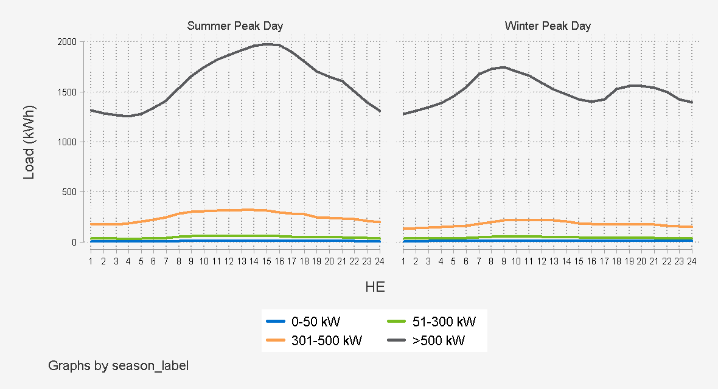

Economic Potential Sensitivities
As part of the assessment of economic potential, the study included analysis of sensitivities related to future fuel costs and free ridership, as follows:
Sensitivity #1: Higher Fuel Prices
For this sensitivity, both the RIM and TRC scenarios were screened as described for the Baseline scenario in Section 6.1.2 (cost-benefit ratio of 1.0 for RIM or TRC, respectively), but the fuel cost forecast that is a component of the electric utility supply costs was adjusted to a “high fuel” scenario.
Sector | Unique Measures | Permutations
RIM SCENARIO
Residential | 1 | 3
Commercial | 10 | 204
Industrial | 12 | 158
Total | 23 | 365
TRC SCENARIO
Residential | 48 | 247
Commercial | 95 | 2,165
Industrial | 29 | 736
Total | 172 | 3,148

 | Savings Potential
 | Summer  Peak Demand (MW) | Winter  Peak Demand (MW) | Energy  (GWh)
RIM SCENARIO
Residential | 2 | 9 | 13
Non-Residential | 87 | 70 | 194
Total | 89 | 79 | 207
TRC SCENARIO
Residential | 215 | 200 | 922
Non-Residential | 171 | 125 | 959
Total | 386 | 325 | 1,882

DR and DSRE measures were not included in the economic sensitivities as fuel prices do not affect DR and DSRE results.
Sensitivity #2: Lower Fuel Prices
For this sensitivity, both the RIM and TRC scenarios were screened as described for the Baseline scenario in Section 6.1.2 (cost-benefit ratio of 1.0 for RIM or TRC, respectively), but the fuel cost forecast was adjusted to a “low fuel” scenario.
Sector | Unique Measures | Permutations
RIM SCENARIO
Residential | 0 | 0
Commercial | 8 | 142
Industrial | 12 | 150
Total | 20 | 292
TRC SCENARIO
Residential | 39 | 206
Commercial | 82 | 1,854
Industrial | 29 | 722
Total | 150 | 2,782

 | Savings Potential
 | Summer  Peak Demand (MW) | Winter  Peak Demand (MW) | Energy  (GWh)
RIM SCENARIO
Residential | 0 | 0 | 0
Non-Residential | 75 | 36 | 110
Total | 75 | 36 | 110
TRC SCENARIO
Residential | 167 | 155 | 751
Non-Residential | 164 | 124 | 877
Total | 331 | 279 | 1,628

DR and DSRE measures were not included in the economic sensitivities as fuel prices do not affect DR DSRE results.

Sensitivity #3: Baseline for free-ridership sensitivities
For this sensitivity, both the RIM and TRC scenarios were screened as described for the Baseline scenario in Section 6.1.2 (cost-benefit ratio of 1.0 for RIM or TRC, respectively), with the addition of utility DSM program costs as a component of the measure’s cost-effectiveness. In addition, measures must achieve a cost-benefit ratio of 1.0 or greater from the PCT perspective (utility incentives were not considered for this screening component for economic potential). Measures also must achieve a participant simple payback of two years or longer.
Sector | Unique Measures | Permutations
RIM SCENARIO
Residential | 0 | 0
Commercial | 3 | 14
Industrial | 6 | 32
Total | 9 | 46
TRC SCENARIO
Residential | 16 | 73
Commercial | 52 | 883
Industrial | 20 | 204
Total | 88 | 1,160

 | Savings Potential
 | Summer  Peak Demand (MW) | Winter  Peak Demand (MW) | Energy  (GWh)
RIM SCENARIO
Residential | 0 | 0 | 0
Non-Residential | 2 | 2 | 13
Total | 2 | 2 | 13
TRC SCENARIO
Residential | 146 | 133 | 612
Non-Residential | 50 | 36 | 370
Total | 196 | 168 | 981

DR measures were not included in the economic sensitivities as there is negligible customer incremental cost for DR measures and therefore differences in simple payback do not affect DR results.
No DSRE measures passed the economic screening for this sensitivity.
Sensitivity #4: Shorter free-ridership exclusion periods
For this sensitivity, both the RIM and TRC scenarios were screened as described for Sensitivity #3, but the simple payback screening criteria was reduced to one year or longer.

Sector | Unique Measures | Permutations
RIM SCENARIO
Residential | 0 | 0
Commercial | 4 | 22
Industrial | 7 | 64
Total | 11 | 86
TRC SCENARIO
Residential | 25 | 122
Commercial | 67 | 1,309
Industrial | 26 | 402
Total | 118 | 1,833

 | Savings Potential
 | Summer  Peak Demand (MW) | Winter  Peak Demand (MW) | Energy  (GWh)
RIM SCENARIO
Residential | 0 | 0 | 0
Non-Residential | 10 | 14 | 46
Total | 10 | 14 | 46
TRC SCENARIO
Residential | 150 | 135 | 646
Non-Residential | 91 | 77 | 607
Total | 240 | 212 | 1,253

DR measures were not included in the economic sensitivities as there is negligible customer incremental cost for DR measures and therefore differences in simple payback do not affect DR results.
No DSRE measures passed the economic screening for this sensitivity.

Sensitivity #5: Longer free-ridership exclusion periods
For this sensitivity, both the RIM and TRC scenarios were screened as described for Sensitivity #3, but the simple payback screening criteria was increased to three years or longer.
Sector | Unique Measures | Permutations
RIM SCENARIO
Residential | 0 | 0
Commercial | 3 | 8
Industrial | 4 | 26
Total | 7 | 34
TRC SCENARIO
Residential | 12 | 49
Commercial | 47 | 667
Industrial | 13 | 108
Total | 72 | 824

 | Savings Potential
 | Summer  Peak Demand (MW) | Winter  Peak Demand (MW) | Energy  (GWh)
RIM SCENARIO
Residential | 0 | 0 | 0
Non-Residential | 0 | 2 | 3
Total | 0 | 2 | 3
TRC SCENARIO
Residential | 140 | 128 | 549
Non-Residential | 31 | 21 | 219
Total | 170 | 149 | 768

DR measures were not included in the economic sensitivities as there is negligible customer incremental cost for DR measures and therefore differences in simple payback do not affect DR results.
No DSRE measures passed the economic screening for this sensitivity.

Market Adoption Rates
Nexant uses the Bass diffusion model to estimate measure adoption rates. The Bass diffusion model is a widely accepted mathematical description of how new products and innovations spread through an economy over time. The Bass Diffusion Model was originally published in 1969, and in 2004 was voted one of the top 10 most influential papers published in the 50 year history of the peer-reviewed publication Management Science. More recent publications by Lawrence Berkeley National Laboratories have illustrated the application of this model to demand-side management in the energy industry. Nexant applied the secondary data and research collected to develop and apply Bass Model diffusion parameters in the Florida jurisdiction.
According to product diffusion theory, the rate of market adoption for a product changes over time. When the product is introduced, there is a slow rate of adoption while customers become familiar with the product. When the market accepts a product, the adoption rate accelerates to relative stability in the middle of the product cycle. The end of the product cycle is characterized by a low adoption rate because fewer customers remain that have yet to adopt the product. This concept is illustrated in Figure 8-4.
Figure 8-4 Bass Model Market Penetration with Respect to Time

Figure 8-4 depicts the cumulative market adoption with respect to time,$S\left(t\right)$. The rate of adoption in a discrete time period is determined by external influences on the market, internal market conditions, and the number of previous adopters. The following equation describes this relationship:
$$\frac{dS\left(t\right)}{dt}=\left(p+\frac{q}{m}*S(t-1)\right)*\left(m-S\left(t-1\right)\right)$$
Where:
$\frac{dS\left(t\right)}{dt}=$ the rate of adoption for any discrete time period, t
$p=$ external influences on market adoption
$q=$internal influences on market adoption
$m=$the maximum market share for the product
$S\left(t-1\right)=$the cumulative market share of the product, from product introduction to time period t-1
Marketing is the quintessential external influence. The internal influences are characteristics of the product and market; for example: the underlying market demand for the product, word of mouth, product features, market structure, and other factors that determine the product’s market performance. Nexant’s approach applied literature reviews and analysis of secondary data sources to estimate the Bass model parameters. We then extrapolated the model to future years; the historic participation and predicted future market evolution serve as the program adoption curve applied to each proposed offering.
In order to estimate elasticity across different utility incentive levels, Nexant incorporated data from a regression analysis performed on EIA 861 data to understand the relative change in savings based on differing incentives. Per this analysis, a 100% increase in the total utility incentive equated to roughly a 44% increase in savings. This EIA-based elasticity rate was applied to the market adoption rates described above to estimate relative changes in market adoption for the range of maximum incentives where they vary from current or typical utility offerings.
Nexant’s approach for estimating DR potential includes an additional step, based on our analysis of mature demand response programs. We estimate participation rates with the following process:
- Use the results from prior analysis of DR program enrollment to describe DR program participation as a function of customer segments and program attributes
- Calibrate the model to reflect actual enrollment rates attained by existing Gulf programs. To calibrate the models, the model constant is adjusted so that the model produces exactly the enrollment rates observed by Gulf programs.
- Predict participation rates using specific tactics and incentive levels for each measure based on the outcome of the RIM screening (or existing incentive levels).
As a demonstration of how marketing level and incentive affects participation in residential DR programs, Figure 8-5 shows the range of participation rates at a medium marketing level (phone outreach, mail, and email) as a function of the incentive paid to the customer. The curve shows that residential customers will respond to changes in incentive level if the incentive is relatively low, but are not as responsive to incentive levels after a certain point. This is why utility marketing strategies also play an important role in residential customer participation. This curve can also vary depending on the customer segments present in a utility’s jurisdiction and other utility DR program characteristics (such as program age). To account for these differences, Nexant uses existing utility DR participation levels to calibrate its participation curve.
Figure 8-5: Residential Program Enrollment as a function of Incentive
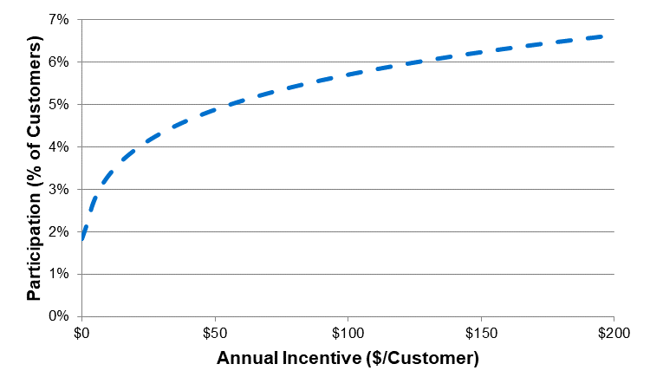
For small C&I customers, a similar approach was used to estimate participation levels. However, these customers tend to have lower enrollments than larger nonresidential customers, and were scaled accordingly. Small C&I customers tend to exhibit roughly 40% of the uptake of residential customers, based on data from historic DR program analysis, which have extensively marketed these programs.
Large C&I customers were slightly different than the other two segments. Due to the large variation in customer size, participation was estimated as the percent of load enrolled in demand response rather than the number of customers. Figure 8-6 shows the participation level of large C&I customers as a function of incentive. Although customers grow less responsive to the incentive as it increases, they continue to be much more responsive to the annual incentive as it increases. This is why for technical potential, it is assumed that if a large C&I customer is paid a high enough incentive; they will curtail their entire load. Similar to the residential participation curve, this curve can vary based on existing participation rates for a utility as well as the industries that large C&I customers belong to. To account for these differences, Nexant uses existing utility DR participation levels to calibrate its participation curve.
Figure 8-6: Large C&I Program Enrollment as a function of Incentive
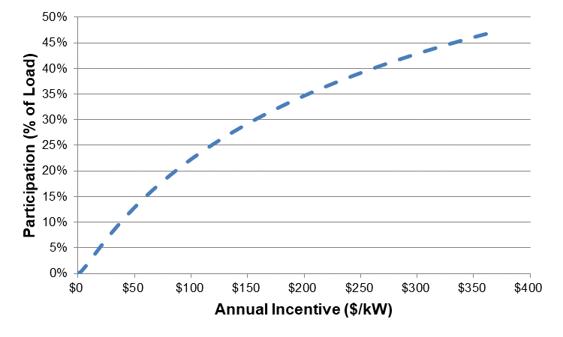

Nexant, Inc.
Headquarters
101 2nd Street, Suite 1000
San Francisco CA 94105-3651
Tel: (415) 369-1000
Fax: (415) 369-9700

nexant.com

Non-Residential results include all commercial and industrial customer segments
PV systems and CHP systems were independently analyzed for technical potential without consideration of the competition between technologies or customer preference for DSRE system.
To be eligible, customers cannot have demand less than 25 kW.
From Gulf’s 2017 Ten Year Site Plan
As the study is being used to inform 2020-2029 DSM planning, for applicable lighting technologies, the baseline lighting standard is compliant with the 2020 EISA backstop provision.
Due to the heterogeneous nature of the Industrial sector, including variations in equipment, operating schedule, process loads, and other segment-specific characteristics, the unique industrial measures encompass multiple individual equipment and technology improvements. Savings estimates for industrial measures reflect the implementation of these various individual improvements as summarized in the measure list in Appendix A.
This study did not include ground-mounted or utility-scale solar PV installations as these were determined to often not be connected to customer premise metering and therefore outside the scope of this analysis.
PVWatts estimates PV energy production and costs. Developed by the National Renewable Energy Laboratory. http://pvwatts.nrel.gov/
Utility-provided data and US Census, South Region
Single Family = RECS, South Atlantic Region; Multi-Family = US Census, South Region https://www.census.gov/construction/chars/mfu.html
Floor space = based on utility data. Average floors by building type = CBECS, South Atlantic Region
All currently enrolled DR customers are excluded
All currently enrolled DR customers are excluded
All currently enrolled DR customers are excluded
PV systems and CHP systems were independently analyzed for technical potential without consideration of the competition between technologies or customer preference for DSRE system.
Cost Effectiveness Manual for Demand Side Management and Self Service Wheeling Proposals; Florida Public Service Commission, Tallahassee, FL; adopted June 11, 1991.
Excludes current DR participants
All currently enrolled DR customers are excluded
All currently enrolled DR customers are excluded
All currently enrolled DR customers are excluded
PV systems and CHP systems were independently analyzed for technical potential without consideration of the competition between technologies or customer preference for DSRE system. Therefore results for each DSRE system should not be combined for overall DSRE potential but used as independent estimates.
Program cost estimates assumed average utility DSM program operations for mature, full-scale programs. However, actual program costs may vary by utility based on the program’s size and scale, including the number of measures offered, participation and savings targets, and specific program delivery elements.
For DR measure incentives, if the measure is currently offered by Gulf, the incentive amount that was historically used by Gulf was applied. If Gulf did not currently have a measure, the incentive was calculated as the maximum annual incentive that could be paid to a customer (or 1 kW of customer load for large C&I customers) and have the RIM cost-effectiveness ratio be 1.0
A detailed description of Nexant’s market adoption rate methodology is provided in Appendix F
The four commercial measures passing the cost-effectiveness screening for the RIM scenario are measures that are not currently offered in an existing Gulf program.
The six industrial measures passing the cost-effectiveness screening for the RIM scenario are measures that are not currently offered in an existing Gulf program.
Excludes current DR participants
All currently enrolled DR load is excluded
Bass, F. 2004. Comments on “A New Product Growth for Model Consumer Durables the Bass Model” (sic). Management Science 50 (12_supplement): 1833-1840. http://pubsonline.informs.org/doi/abs/10.1287/mnsc.1040.0300. Accessed 01/08/2016.
Buskirk, R. 2014. Estimating Energy Efficiency Technology Adoption Curve Elasticity with Respect to Government and Utility Deployment Program Indicators. LBNL Paper 6542E. Sustainable Energy Systems Group, Environmental Energy Technologies Division. Ernest Orlando Lawrence Berkeley National Laboratory. http://escholarship.org/uc/item/2vp2b7cm#page-1. Accessed 01/14/2016.
Nexant Inc. Sacramento Municipal Utility District Demand Response Potential Study. October 20, 2015.

