BEFORE THE FLORIDA PUBLIC SERVICE COMMISSION

In re: Petition for approval of transportation service agreement with Florida Public Utilities Company by Peninsula Pipeline Company, Inc. | DOCKET NO. 20190127-GU  ORDER NO. PSC-2019-0355-PAA-GU  ISSUED: August 23, 2019

The following Commissioners participated in the disposition of this matter:

ART GRAHAM, Chairman
JULIE I. BROWN
DONALD J. POLMANN
GARY F. CLARK
ANDREW GILES FAY

NOTICE OF PROPOSED AGENCY ACTION
ORDER APPROVING FIRM TRANSPORTATION SERVICE AGREEMENT

BY THE COMMISSION:

NOTICE is hereby given by the Florida Public Service Commission that the action discussed herein is preliminary in nature and will become final unless a person whose interests are substantially affected files a petition for a formal proceeding, pursuant to Rule 25-22.029, Florida Administrative Code (F.A.C.).

Background
On June 10, 2019, Peninsula Pipeline Company, Inc. (Peninsula) filed a petition seeking approval of a firm transportation service agreement (Agreement) between Peninsula and Florida Public Utilities Company (FPUC), collectively the parties. Peninsula operates as a natural gas transmission company as defined by Section 368.103(4), Florida Statutes (F.S.). FPUC is a local distribution company (LDC) subject to our jurisdiction pursuant to Chapter 366, F.S.

By Order No. PSC-07-1012-TRF-GP, Peninsula received approval of an intrastate gas pipeline tariff that allows it to construct and operate intrastate pipeline facilities and to actively pursue agreements with natural gas customers. Peninsula provides transportation service only; it does not engage in the sale of natural gas. Pursuant to Order No. PSC-07-1012-TRF-GP, Peninsula is allowed to enter into certain gas transmission agreements without prior approval. However, Peninsula is requesting our approval of this proposed Agreement as it does not fit any of the criteria enumerated in the tariff for which our approval would not be required. The parties are subsidiaries of Chesapeake Utility Corporation (Chesapeake), and pursuant to Section 368.105, F.S., and Order No. PSC-07-1012-TRF-GP, we must approve agreements between affiliated companies.

Pursuant to the proposed Agreement (Attachment A), Peninsula will construct and operate natural gas pipelines in western Palm Beach County. During the evaluation of the petition, two data requests were issued to the parties for which responses were received on July 2 and July 15, 2019. We have jurisdiction over this matter pursuant to Sections 366.05(1), 366.06, and 368.105, F.S.

Decision
FPUC provides natural gas service to residential, commercial, and industrial customers in Palm Beach County and receives deliveries of natural gas to serve these customers from the Florida Gas Transmission (FGT) interstate pipeline. The petition explains that the proposed Agreement has been necessitated by a request for service by FPUC to enable FPUC to provide service to existing and future customers in Palm Beach County, specifically the Florida Research Park and four new residential developments (Ancient Tree, Arden, Avenir, and West Lake). The four residential developments are in various stages of development. The parties estimate that the new developments will serve approximately 10,000 residential, commercial, and industrial customers. In addition, the parties explained, the proposed pipeline interconnections will enhance FPUC’s ability to provide industrial customers in the area with higher natural gas pressure.

To address the increase in customers and demand, the parties entered into the proposed Agreement. The proposed Agreement specifies an initial term of 20 years and thereafter shall be extended for additional 10-year increments, unless either party gives no less than 180 days written notification of termination. Pursuant to the proposed Agreement, Peninsula will undertake the three new projects described below and shown in Attachment B.

First, Peninsula would construct an interconnection with the Florida Southeast Connection, LLC, (FSC) along State Road 710 near the Florida Research Park in Palm Beach County. FSC is a wholly owned subsidiary of NextEra Energy, Inc., and owns and operates natural gas pipelines in central Florida. The FSC pipeline connects to the interstate Sabal Trail Pipeline and became operational in June 2017. Peninsula would then construct 4,000 feet of six inch steel pipeline to a new custody transfer point with FPUC’s distribution system to serve, among other things, the Florida Research Park.

Second, Peninsula would construct an interconnection with the FSC pipeline near the Florida Turnpike. From this interconnection point, Peninsula would build 30,000 feet of eight inch steel pipeline, 300 feet of four inch steel pipeline, and 1,000 feet of two inch steel pipeline to two new custody transfer points with FPUC’s distribution system to serve the Avenir and Ancient Tree residential developments.
Finally, Peninsula would construct an interconnection with Florida City Gas. From this interconnection, Peninsula would construct approximately 18,000 feet of 12 inch steel pipeline to a new custody transfer point with FPUC’s distribution system to serve the Arden residential development. Peninsula would also construct approximately 32,000 feet of eight inch steel pipeline and 6,000 feet of six inch polyethylene pipeline to serve the West Lake residential development.
In response to the first data request, the parties state that FPUC did not issue a Request for Proposals (RFP) to obtain bids from other entities to construct the pipeline. However, Peninsula did engage in a conversation with FSC regarding the possibility of FSC building the pipeline in south Florida. According to Peninsula, FSC declined to bid on the pipeline construction portion of the project citing the size of the laterals and the operational specifications of the project were not something they were interested in pursuing.
The parties assert that the negotiated monthly reservation charge in the proposed Agreement is consistent with a market rate since they are within the ranges of rates set forth in similar agreements as required by Section 368.105(3)(b), F.S. FPUC is proposing to recover its payments to Peninsula through the Purchased Gas Adjustment (PGA) and the swing service rider mechanisms, consistent with other gas transmission pipeline costs incurred by FPUC. The swing service rider allows FPUC to recover intrastate capacity costs from their transportation customers and is a cents per therm charge that is included in a monthly gas bill of transportation customers. FPUC provided information showing that the impact on the PGA will be minor ($0.01823 per therm for 2019). While FPUC will incur costs associated with this service expansion, any new load will help spread the costs over a larger customer base.
The benefit of Peninsula, as opposed to FPUC, constructing the new pipeline is primarily that Peninsula’s construction and ownership of the pipeline will avoid FPUC undertaking the costs and risks for the three projects, which in turn protects FPUC’s customers. Peninsula stated that engineering and permitting is currently underway with construction projected to be completed by January 2020. Approval of this petition would also allow FPUC to transport gas via the FSC and Florida City Gas pipelines, in addition to the FGT pipeline.
Based on our review of the petition and the parties’ data request responses, we find that the proposed Agreement is cost effective, reasonable, meets the requirements of Section 368.105, F.S., and benefits FPUC’s customers. Therefore, we hereby approve the proposed Agreement between the parties dated May 17, 2019.
Based on the foregoing, it is

ORDERED by the Florida Public Service Commission that Peninsula Pipeline Company’s request to approve a firm transportation service agreement dated May 17, 2019, between Peninsula Pipeline Company and Florida Public Utilities Company is hereby approved. It is further

ORDERED that the provisions of this Order, issued as proposed agency action, shall become final and effective upon the issuance of a Consummating Order unless an appropriate petition, in the form provided by Rule 28-106.201, Florida Administrative Code, is received by the Commission Clerk, 2540 Shumard Oak Boulevard, Tallahassee, Florida 32399-0850, by the close of business on the date set forth in the “Notice of Further Proceedings” attached hereto. It is further

ORDERED that, if a protest is filed within 21 days of the issuance of this Order, this docket shall remain open pending resolution of the protest. If no protest is timely filed, this docket shall be closed upon the issuance of a Consummating Order.

By ORDER of the Florida Public Service Commission this 23rd day of August, 2019.

/s/ Adam J. Teitzman
ADAM J. TEITZMAN
Commission Clerk
Florida Public Service Commission
2540 Shumard Oak Boulevard
Tallahassee, Florida 32399
(850) 413-6770
www.floridapsc.com

Copies furnished: A copy of this document is provided to the parties of record at the time of issuance and, if applicable, interested persons.

KBS

NOTICE OF FURTHER PROCEEDINGS OR JUDICIAL REVIEW

The Florida Public Service Commission is required by Section 120.569(1), Florida Statutes, to notify parties of any administrative hearing that is available under Section 120.57, Florida Statutes, as well as the procedures and time limits that apply. This notice should not be construed to mean all requests for an administrative hearing will be granted or result in the relief sought.

Mediation may be available on a case-by-case basis. If mediation is conducted, it does not affect a substantially interested person's right to a hearing.

The action proposed herein is preliminary in nature. Any person whose substantial interests are affected by the action proposed by this Order may file a petition for a formal proceeding, in the form provided by Rule 28-106.201, Florida Administrative Code. This petition must be received by the Office of Commission Clerk, 2540 Shumard Oak Boulevard, Tallahassee, Florida 32399-0850, by the close of business on September 13, 2019.

In the absence of such a petition, this Order shall become final and effective upon the issuance of a Consummating Order.

Any objection or protest filed in this docket before the issuance date of this Order is considered abandoned unless it satisfies the foregoing conditions and is renewed within the specified protest period.

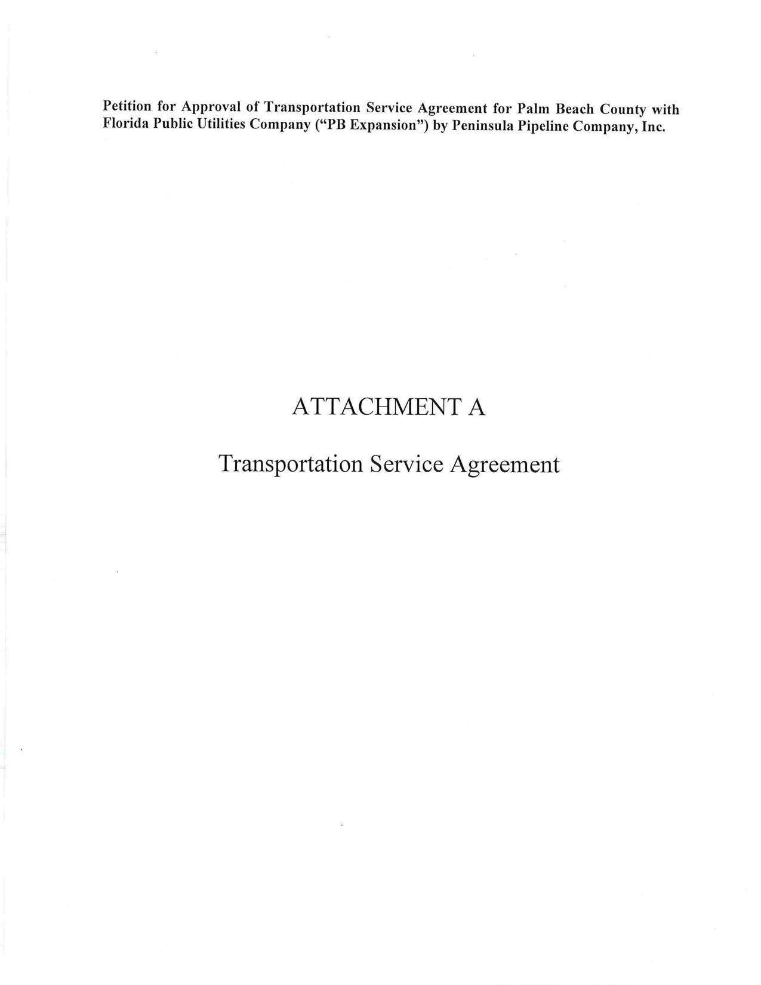

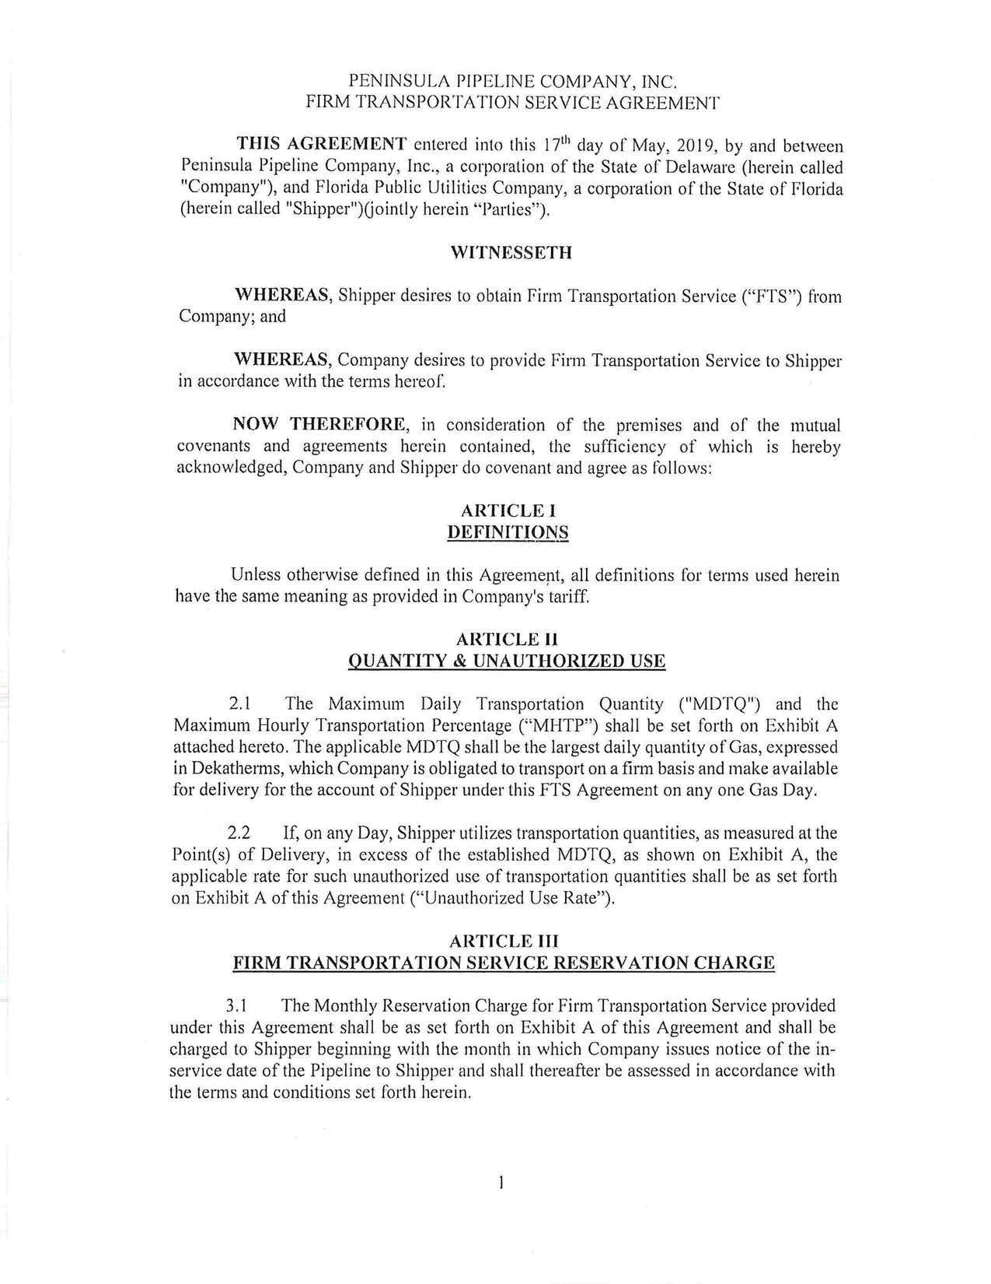
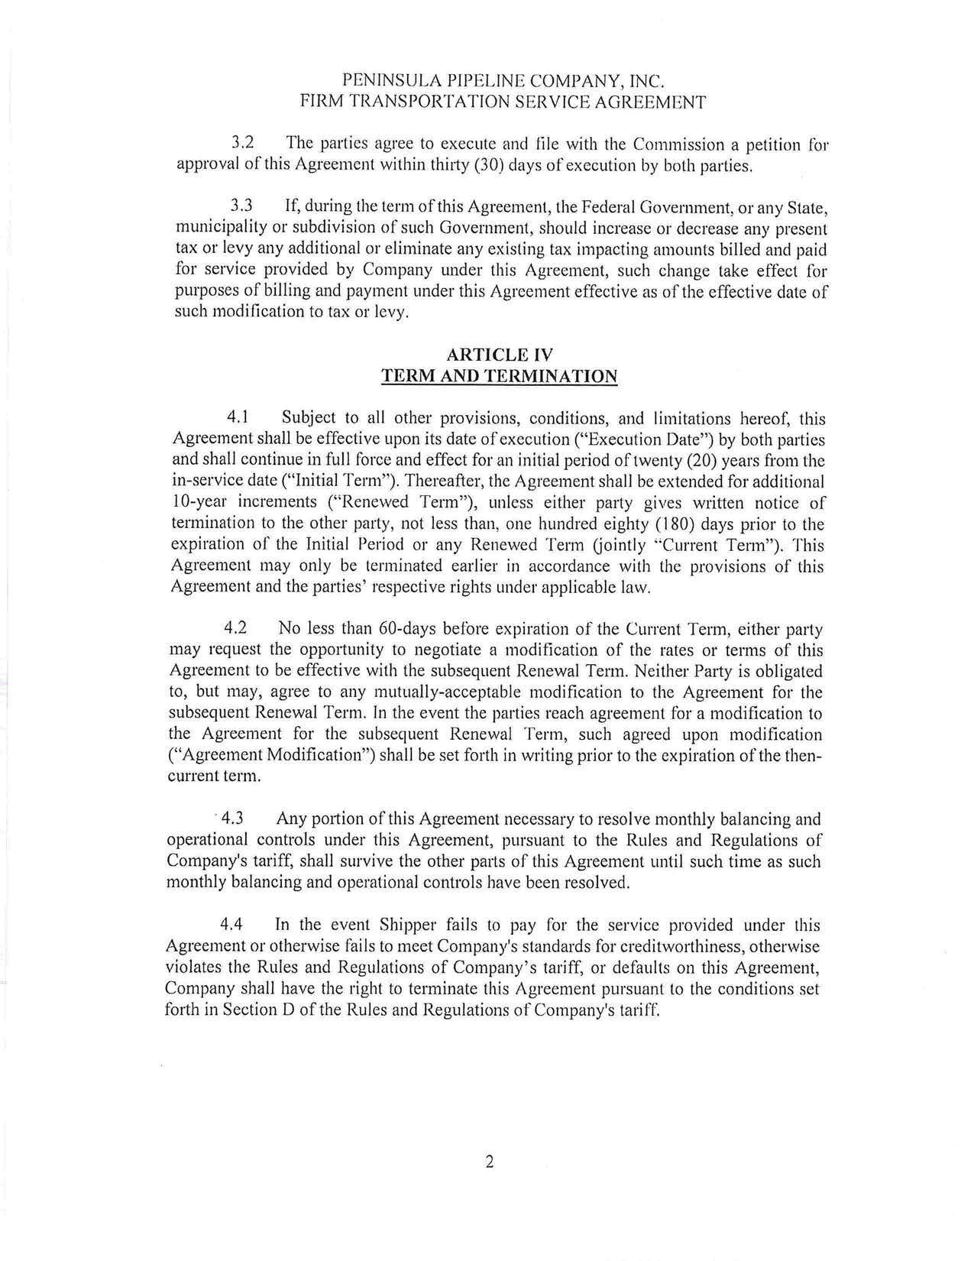

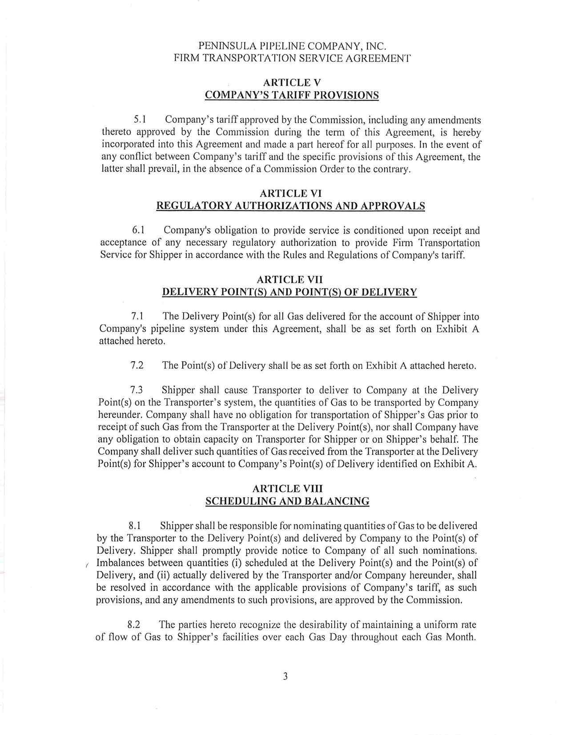

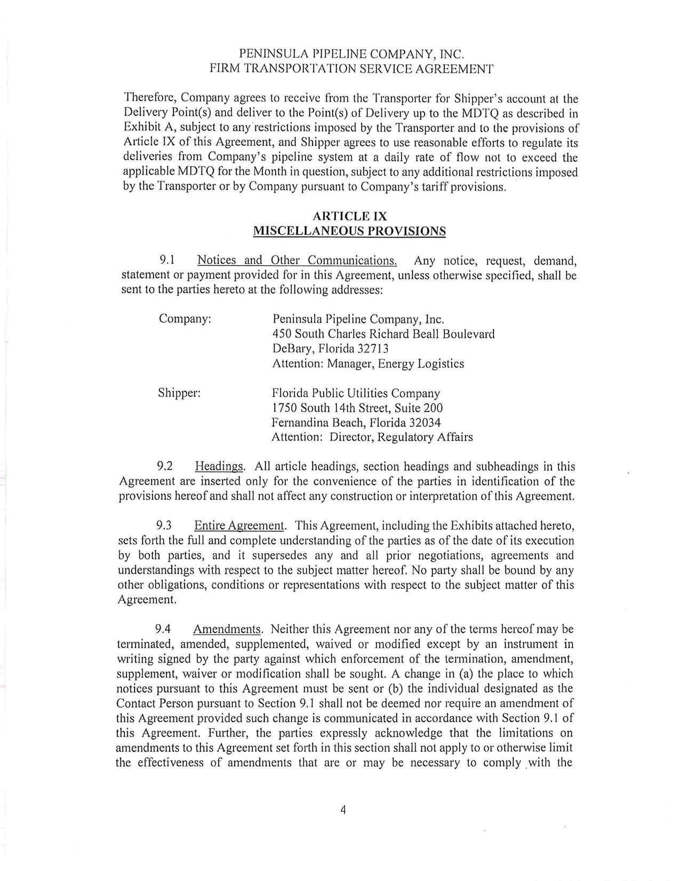
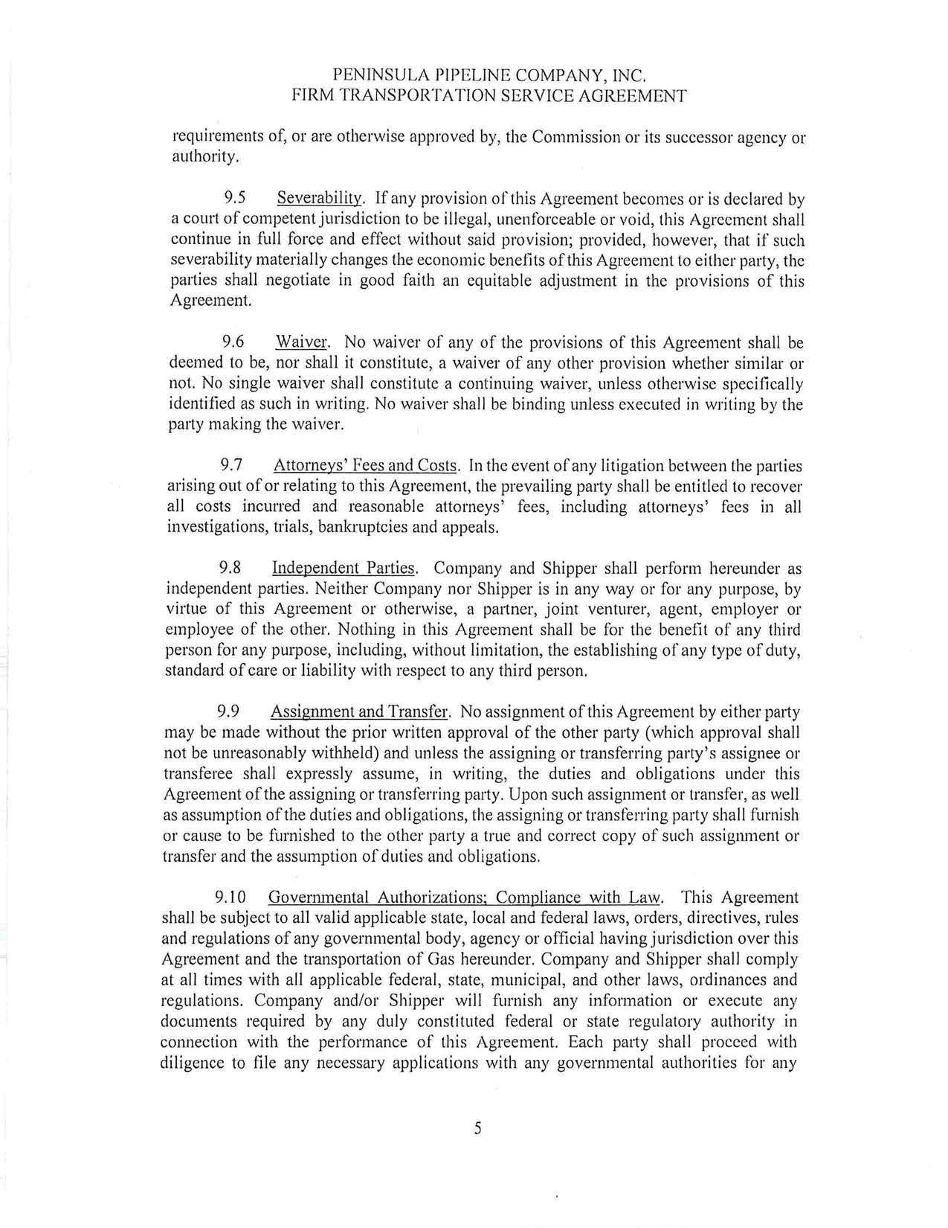

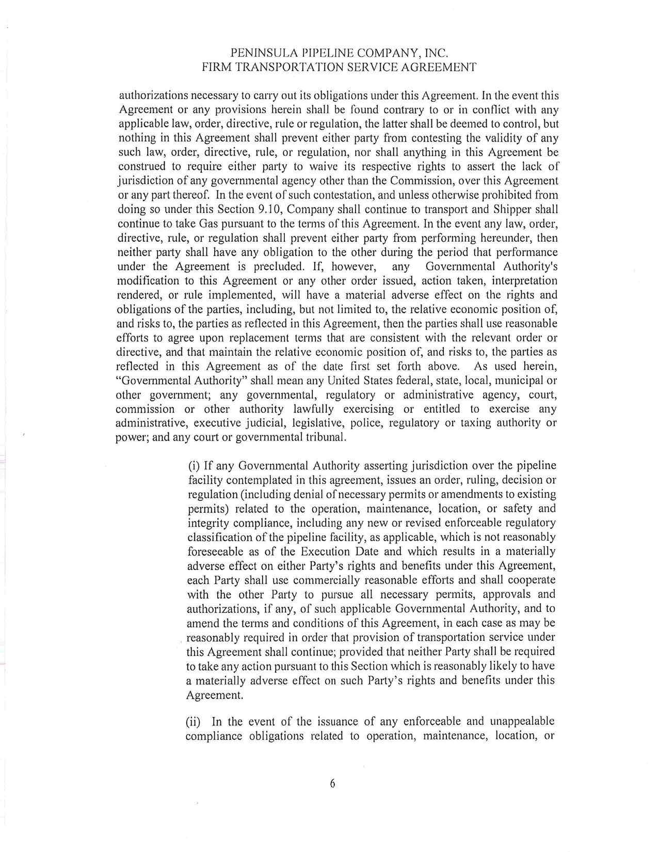
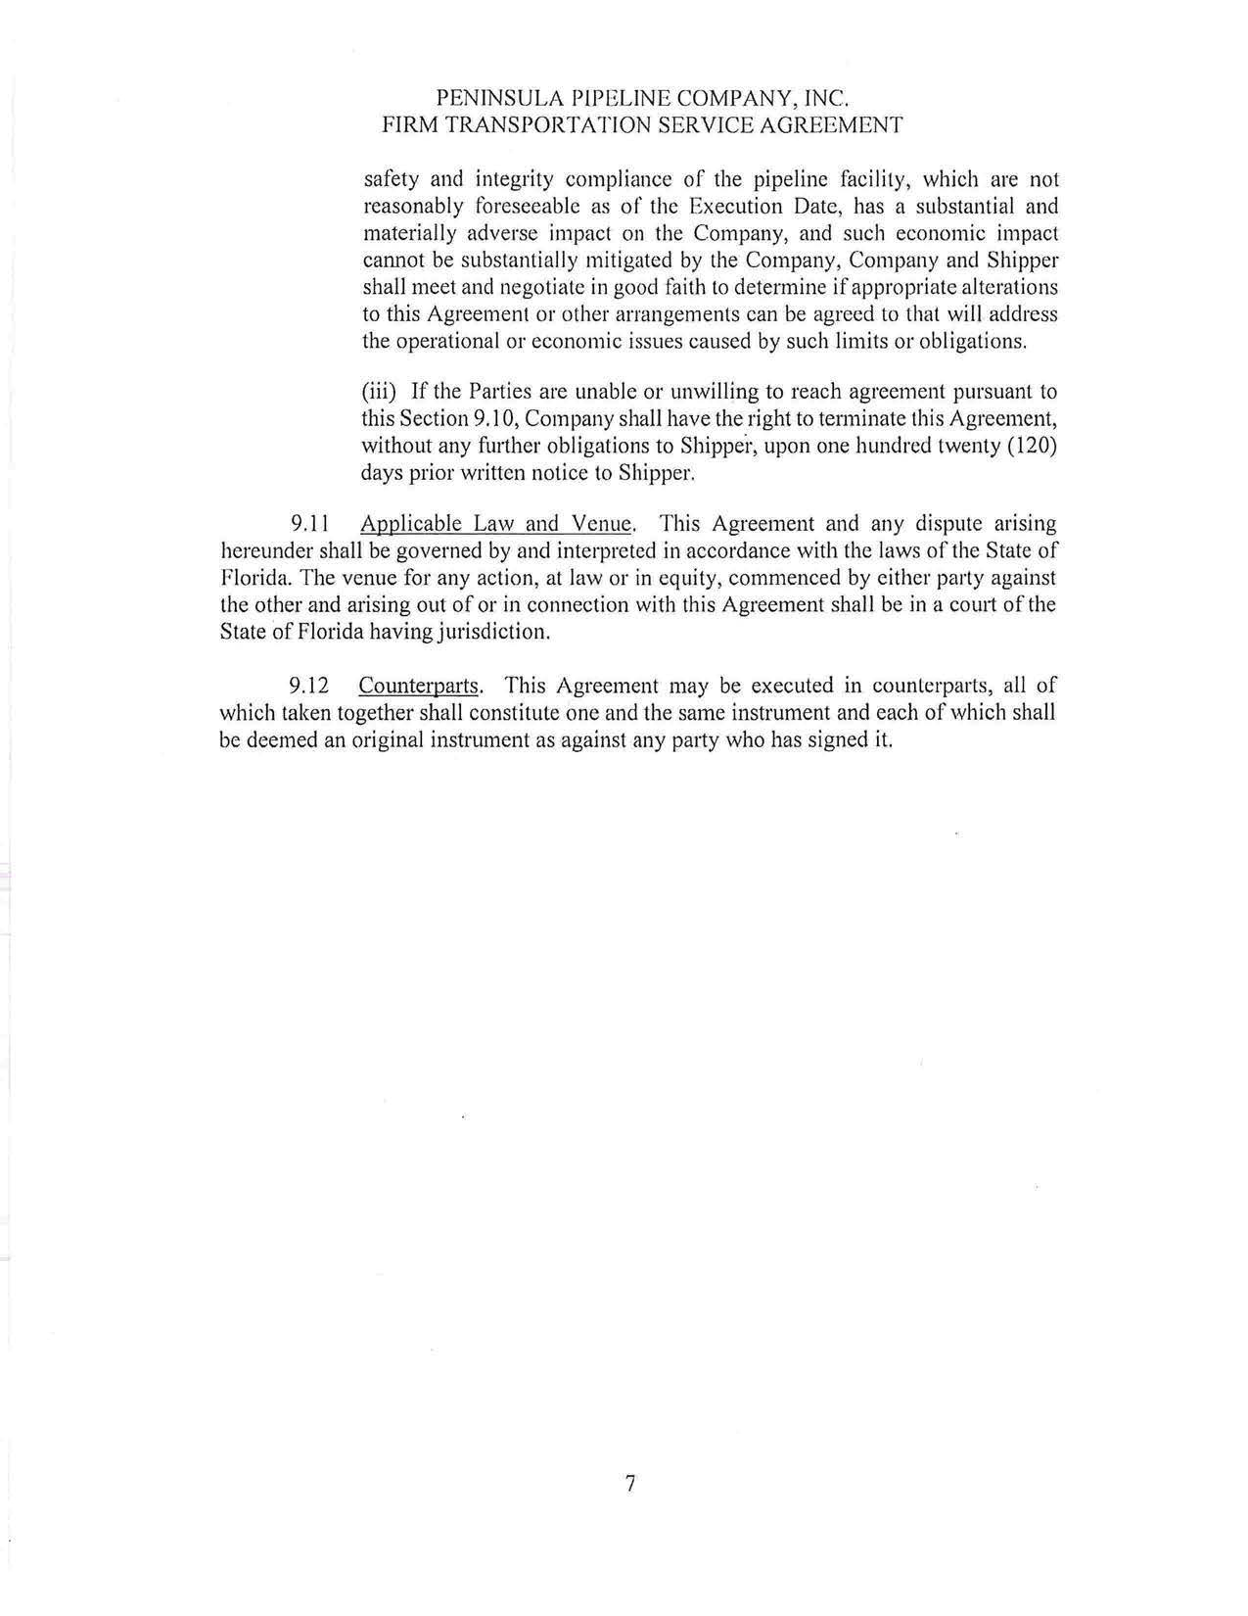

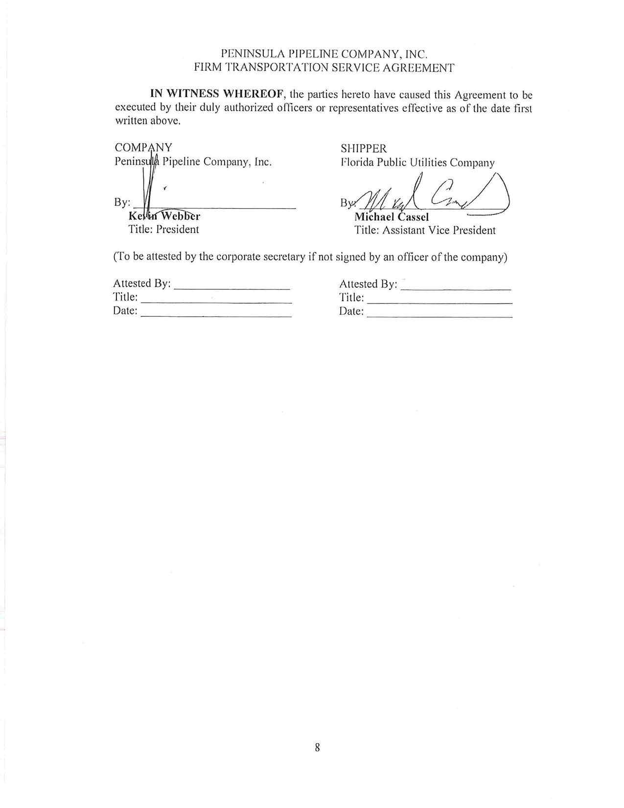
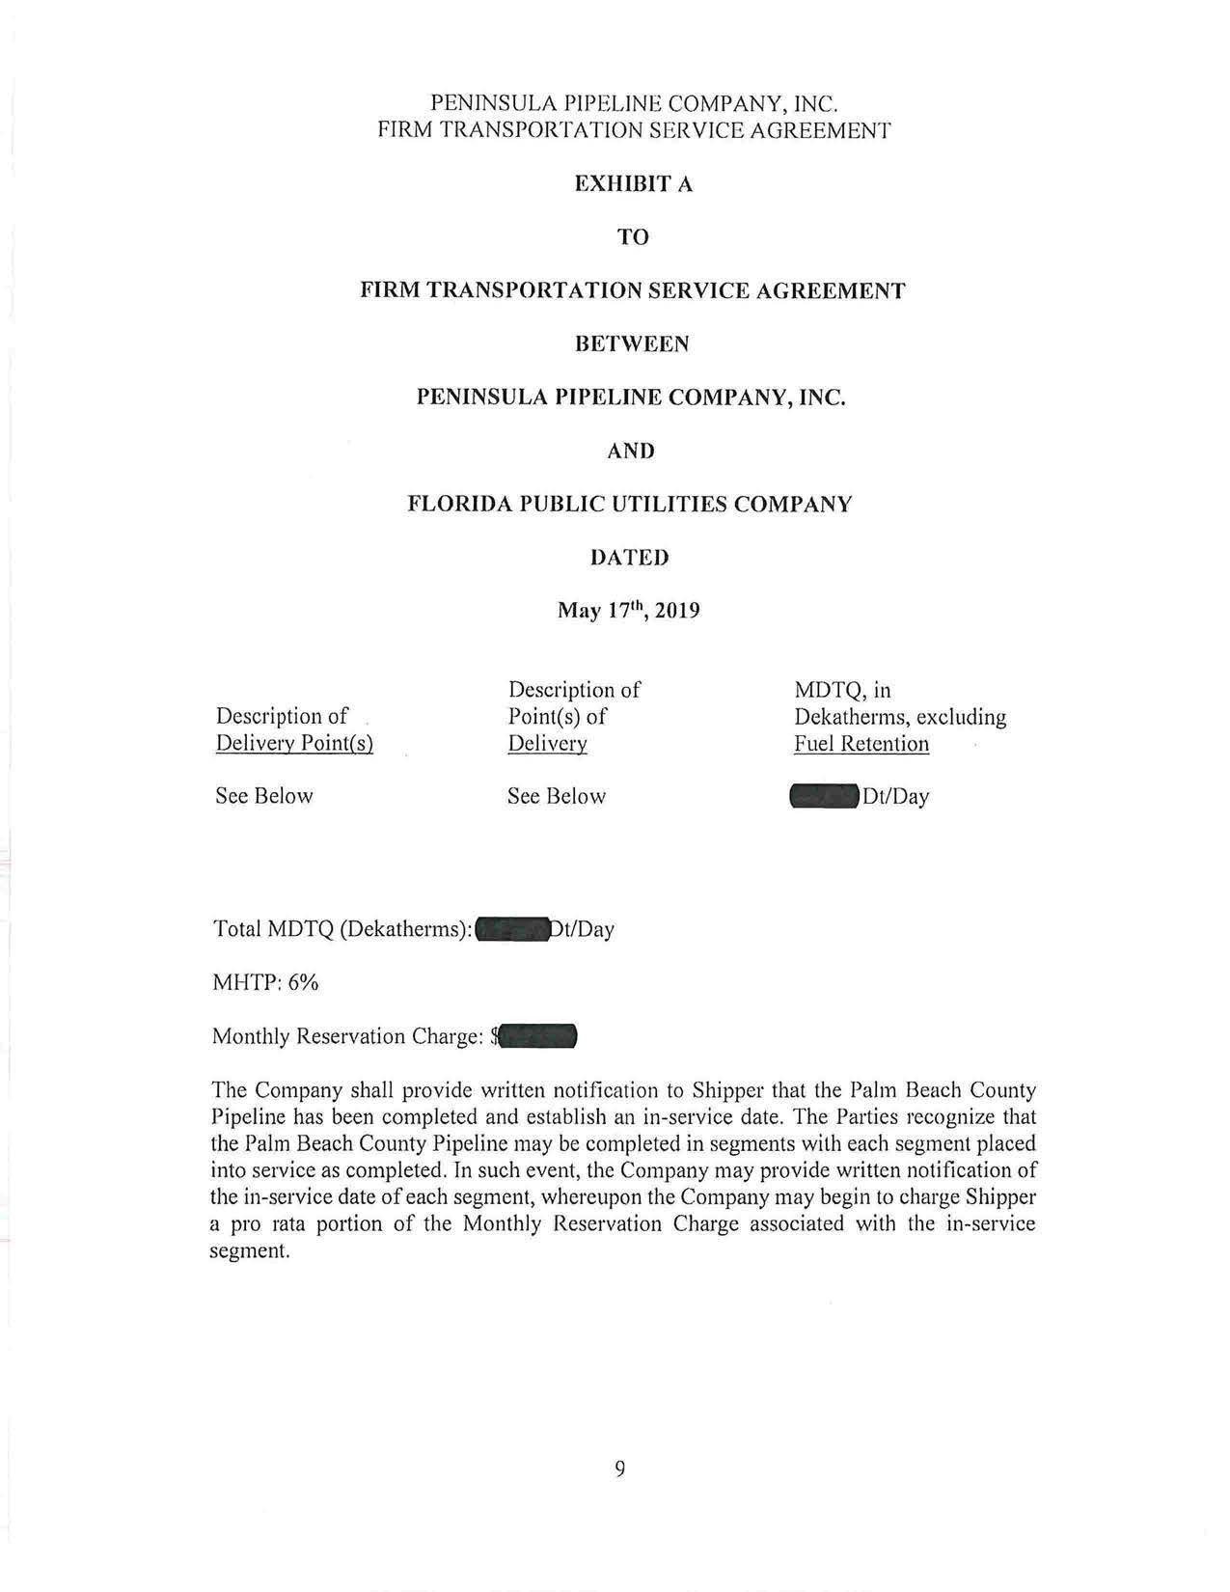

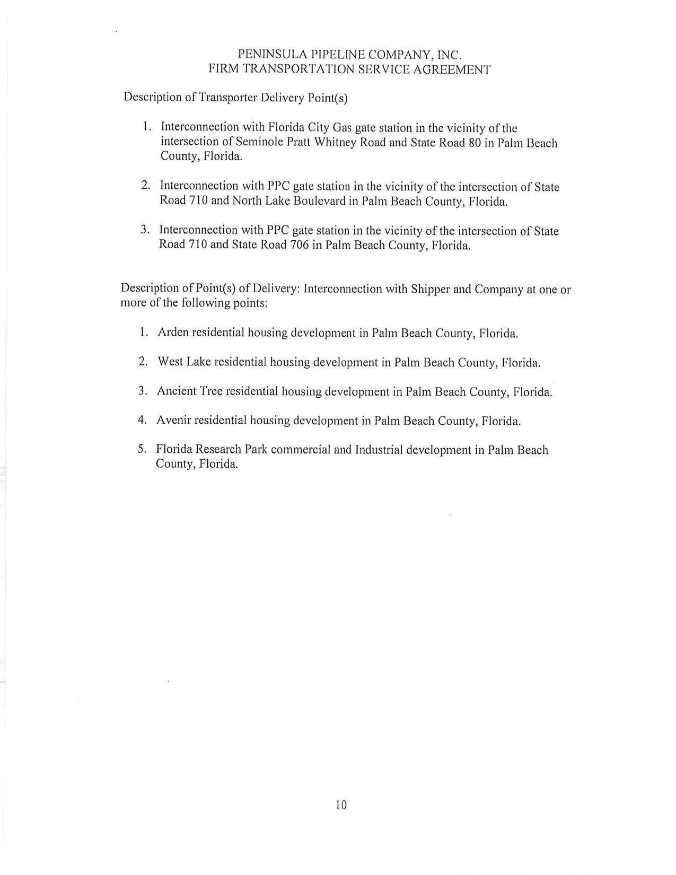
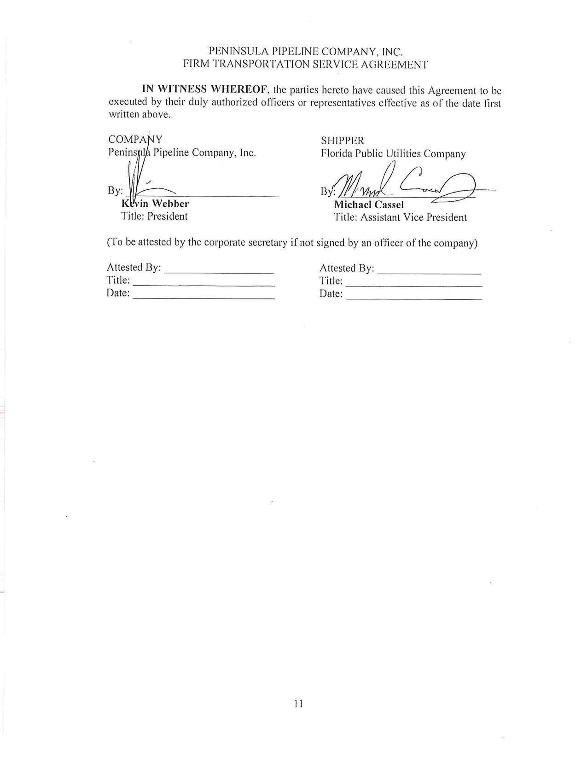
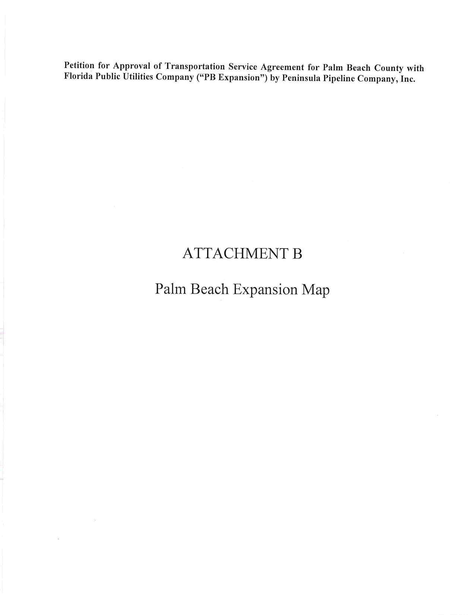
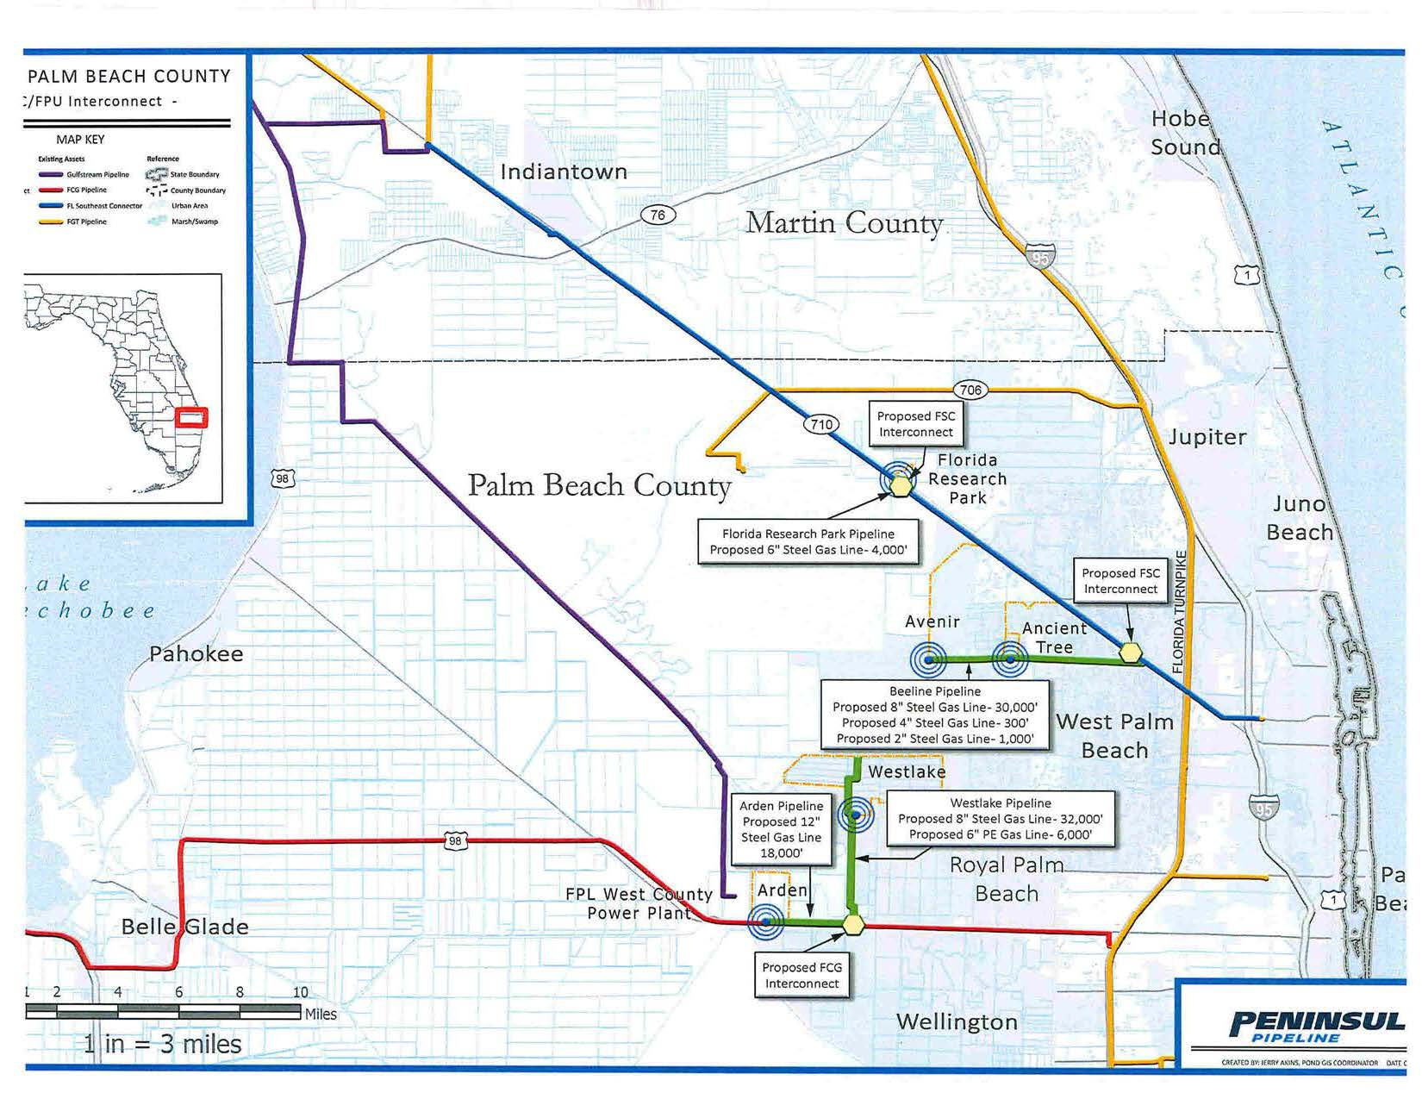

Order No. PSC-06-0023-DS-GP, issued January 9, 2006, in Docket No. 050584-GP, In re: Petition for declaratory statement by Peninsula Pipeline Company, Inc. concerning recognition as a natural gas transmission company under Section 368.101, F.S., et seq.
Order No. PSC-07-1012-TRF-GP, issued December 21, 2007, in Docket No. 070570-GP, In re: Petition for approval of natural gas transmission pipeline tariff by Peninsula Pipeline Company, Inc.
Peninsula Pipeline Company, Inc., Intrastate Pipeline Tariff, Original Vol. 1, Original Sheet No. 11, Section 3.
Peninsula Pipeline Company, Inc., Intrastate Pipeline Tariff, Original Vol. 1, Original Sheet No. 12, Section 4.
Follow up email response of July 15, 2019, from FPUC clarified that the Florida Southeast Connector referenced on page five of the petition should be Florida Southeast Connection.
This arrangement is referred to as an LDC to LDC interconnection and allows FPUC to receive natural gas deliveries to serve its customers through a pipeline owned by Florida City Gas.
Order No. PSC-2018-0557-TRF-GU, issued November 20, 2018, in Docket No. 20180158-GU, In re: Joint petition for approval of swing service rider, by Florida Public Utilities Company, Florida Public Utilities Company-Indiantown Division, Florida Public Utilities Company-Fort Meade, and Florida Division of Chesapeake Utilities Corporation.

