BEFORE THE FLORIDA PUBLIC SERVICE COMMISSION

In re: Petition by Peace River Electric Cooperative, Inc. to establish temporary tariffs for customers previously served by Duke Energy Florida, LLC. | DOCKET NO. 20190138-EC  ORDER NO. PSC-2019-0359-TRF-EC  ISSUED: August 26, 2019

The following Commissioners participated in the disposition of this matter:

ART GRAHAM, Chairman
JULIE I. BROWN
DONALD J. POLMANN
GARY F. CLARK
ANDREW GILES FAY

ORDER APPROVING TEMPORARY TARIFFS

BY THE COMMISSION:

Background
On January 28, 2019, we approved an amended territorial agreement (agreement) between Peace River Electric Cooperative (PRECO or utility) and Duke Energy Florida, LLC (DEF) in Hardee, Highlands, Polk, and Osceola Counties. Through the agreement, PRECO and DEF (the petitioners) revised the service boundaries to serve customers more reliably and economically. Under the agreement, approximately 2,750 customers in Hardee County and a small area in southern Polk County will be transferred from DEF to PRECO. The petitioners stated that transferring customers from DEF to PRECO will eliminate duplication of services, create operational efficiencies for both utilities, and ensure customers continue to receive safe and reliable service. PRECO notified its customers that the transfer of customers from DEF to PRECO is scheduled to begin on August 1, 2019.
On June 26, 2019, PRECO filed in Docket No. 20190000-OT, our undocketed matters, tariffs applicable to the customers that were previously served by DEF. The tariffs were designed to allow the transferred customers to be billed by PRECO the current DEF rates, if beneficial to the customer, for a period up to five years. Based on discussions with Commission staff, PRECO filed revised tariffs on July 12, 2019, that included a three-year transition period (instead of five years as originally proposed by PRECO). On July 23, 2019, the PRECO board of directors approved the proposed tariffs contingent on our final approval.

Our jurisdiction over rural electric cooperatives can be found in Section 366.04(2), Florida Statutes (F.S.). We do not have jurisdiction over the total revenues of a rural electric cooperative; however, we have jurisdiction over territorial agreements and rate structure. Rule 25-9.051(7), Florida Administrative Code (F.A.C.), defines rate structure as the classification system used in justifying different rates between various customer classes.

Our Administrative Procedures Manual (APM) provides guidance for administrative approval by Commission staff for filings made by rural electric cooperatives. The APM states that certain filings cannot be administratively approved by staff. Specifically, APM 2.07(C)(5)a.5. provides that a filing by a rural electric cooperative that contains new pricing concepts shall be brought before us. Typically, in territorial agreements, transferred customers start paying the rates and charges of the utility they are being transferred to with their first bill under their new provider. PRECO’s proposal to allow the transferred customers to stay on the DEF rates for a transition period constitutes a new pricing concept; therefore, the matter has come before us for our approval.

This order addresses PRECO’s proposed temporary tariffs as filed on July 12, 2019, and the tariffs are shown in Attachment A to this order. We have jurisdiction pursuant to Section 366.04(2), F.S.

Decision
The temporary tariffs are applicable to the residential and commercial customers previously served by DEF and that were transferred from DEF to PRECO pursuant to the agreement approved in Order No. PSC-2019-0048-PAA-EU. The tariffs are available for three years (August 1, 2019 through August 1, 2022). Pursuant to the temporary tariffs, the transferred customers will have the option to stay on the DEF rate, or switch to the applicable PRECO rates at any time after the transfer, if it is advantageous for them to do so. However, the customer cannot switch back to the DEF rate after electing the PRECO rate. PRECO states that based on billing data on the acquired customers, PRECO will work with the new customers to determine if they are better off on the DEF or the PRECO rates. After the three-year period, all transferred customers will take service under the PRECO rates. PRECO does not intend to adjust the rates contained in the temporary tariffs to reflect changes in DEF’s rates.

PRECO explained that it will start transferring customers on or around August 1, 2019 and continue until the process is complete in early 2020. Based on current active customer counts, PRECO expects to transfer 2,745 customers (2,353 residential and 392 commercial customers). As of July 2019, the residential 1,000 kilowatt-hour (kWh) bill for a PRECO customer is $124.06 and $125.36 for a DEF customer (calculations do not include Gross Receipts Taxes).

While the difference between PRECO and DEF customers for the residential 1,000 kWh bill is less than one percent, depending on usage, residential customers would see varying bill impacts as a result of the difference in rate design between PRECO and DEF. Specifically, DEF’s residential customer charge is $9.66, while PRECO’s residential customer charge is $26.50. The customer charge is a fixed monthly charge and does not vary based on usage. On the other hand, PRECO’s energy charge, which is billed based on kWh usage, is lower than DEF’s energy charge. Therefore, residential customers that use approximately less than 900 kWhs per month would experience lower bills under the current DEF rates; residential customers that use more than approximately 900 kWhs per month would experience lower bills under the current PRECO rates.

Regarding the commercial customers being transferred from DEF to PRECO, the utility explained that Duke’s commercial rate schedules differ with respect to applicability. For example, DEF offers a General Service Time of Use rate, while PRECO does not. PRECO explained that once it has billing information on the transferred commercial customers, the utility will be able to determine which commercial PRECO rate schedule the customer would qualify for and whether it would be advantageous for the customer to choose a PRECO rate or remain on the temporary tariff that contains the DEF rates.

To support the temporary tariffs, PRECO explained that the utility is committed to make the transfer for the acquired customers as easy as possible. PRECO further states that the temporary, or transitional, rates are of limited duration and are not unduly discriminatory under Rule 29-9.053(1)(d), F.A.C.

We recognize PRECO’s desire to help customers transition from DEF to PRECO and to reduce any rate shock. However, PRECO is cautioned if it enters into another territorial agreement where it seeks to offer temporary rates, the proposed territorial agreement should address the utility’s plans to offer temporary rates for any transferred customers.

The petition for the territorial agreement, in accordance with Rule 25-6.0440(1)(d), F.A.C., stated that the impacted customers were notified by mail of the transfer and provided a description of the differences in rates between DEF and PRECO. Additionally, PRECO stated it held an open house in Wauchula on August 14, 2018, for customers affected by the proposed transfers. However, none of the information included in the petition for approval of the territorial agreement indicated that the transferred customers would have the option to continue being billed the DEF rates for a transition period. We are also not aware of a prior Commission-approved territorial agreement that provides for transferred customers to remain on another utility’s rates.

Conclusion

Based on the information provided by PRECO, we find that the proposed temporary tariffs are designed to help transition customers and are not unduly discriminatory under Rule 29-9.053(1)(d), F.A.C; therefore, they are hereby approved. At the end of the 3-year period (August 1, 2022) PRECO shall withdraw the temporary tariffs.

Based on the foregoing, it is

ORDERED by the Florida Public Service Commission that Peace River Electric Cooperative, Inc.’s request to establish temporary tariffs for customers previously served by DEF, as shown in Attachment A, are hereby approved. At the end of the 3-year transition period (August 1, 2022), PRECO shall withdraw the temporary tariffs. It is further

ORDERED that if no protest is filed by a person whose substantial interests are affected within 21 days of the issuance of the Order, this docket shall be closed upon the issuance of a Consummating Order.

By ORDER of the Florida Public Service Commission this 26th day of August, 2019.

/s/ Adam J. Teitzman
ADAM J. TEITZMAN
Commission Clerk
Florida Public Service Commission
2540 Shumard Oak Boulevard
Tallahassee, Florida 32399
(850) 413-6770
www.floridapsc.com

Copies furnished: A copy of this document is provided to the parties of record at the time of issuance and, if applicable, interested persons.

JSC

NOTICE OF FURTHER PROCEEDINGS

The Florida Public Service Commission is required by Section 120.569(1), Florida Statutes, to notify parties of any administrative hearing or judicial review of Commission orders that is available under Sections 120.57 or 120.68, Florida Statutes, as well as the procedures and time limits that apply. This notice should not be construed to mean all requests for an administrative hearing or judicial review will be granted or result in the relief sought.

Mediation may be available on a case-by-case basis. If mediation is conducted, it does not affect a substantially interested person's right to a hearing.

The Commission's decision on this tariff is interim in nature and will become final, unless a person whose substantial interests are affected by the proposed action files a petition for a formal proceeding, in the form provided by Rule 28-106.201, Florida Administrative Code. This petition must be received by the Office of Commission Clerk, 2540 Shumard Oak Boulevard, Tallahassee, Florida 32399-0850, by the close of business on September 16, 2019.

In the absence of such a petition, this Order shall become final and effective upon the issuance of a Consummating Order.

Any objection or protest filed in this docket before the issuance date of this order is considered abandoned unless it satisfies the foregoing conditions and is renewed within the specified protest period.

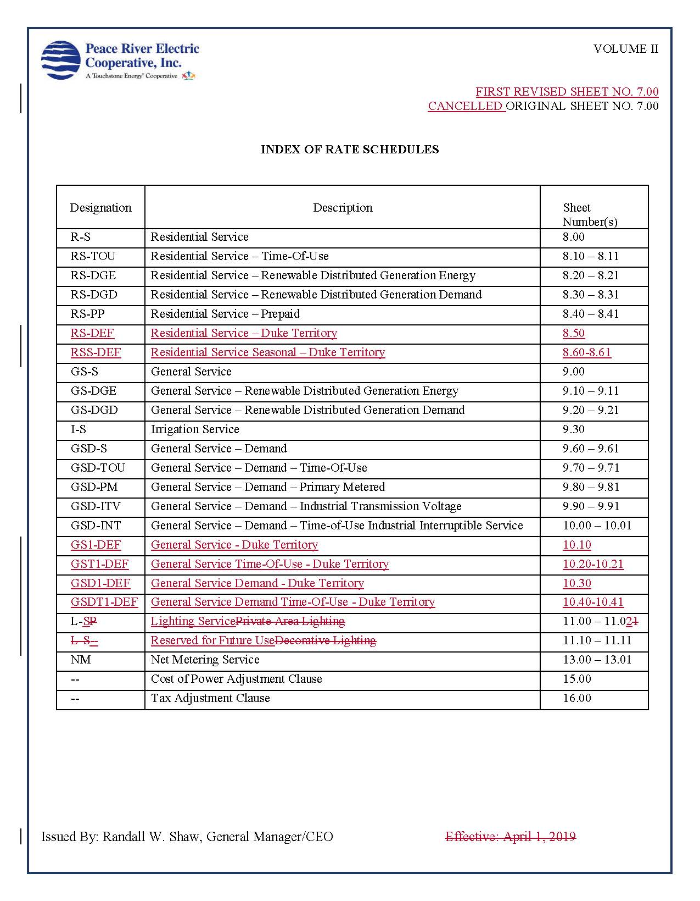

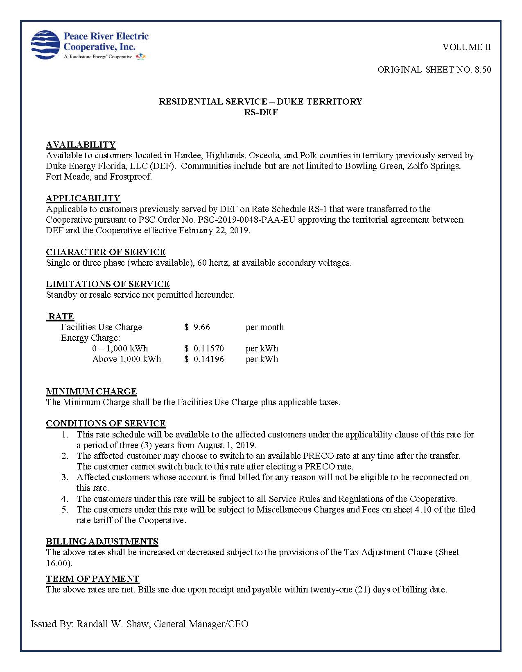
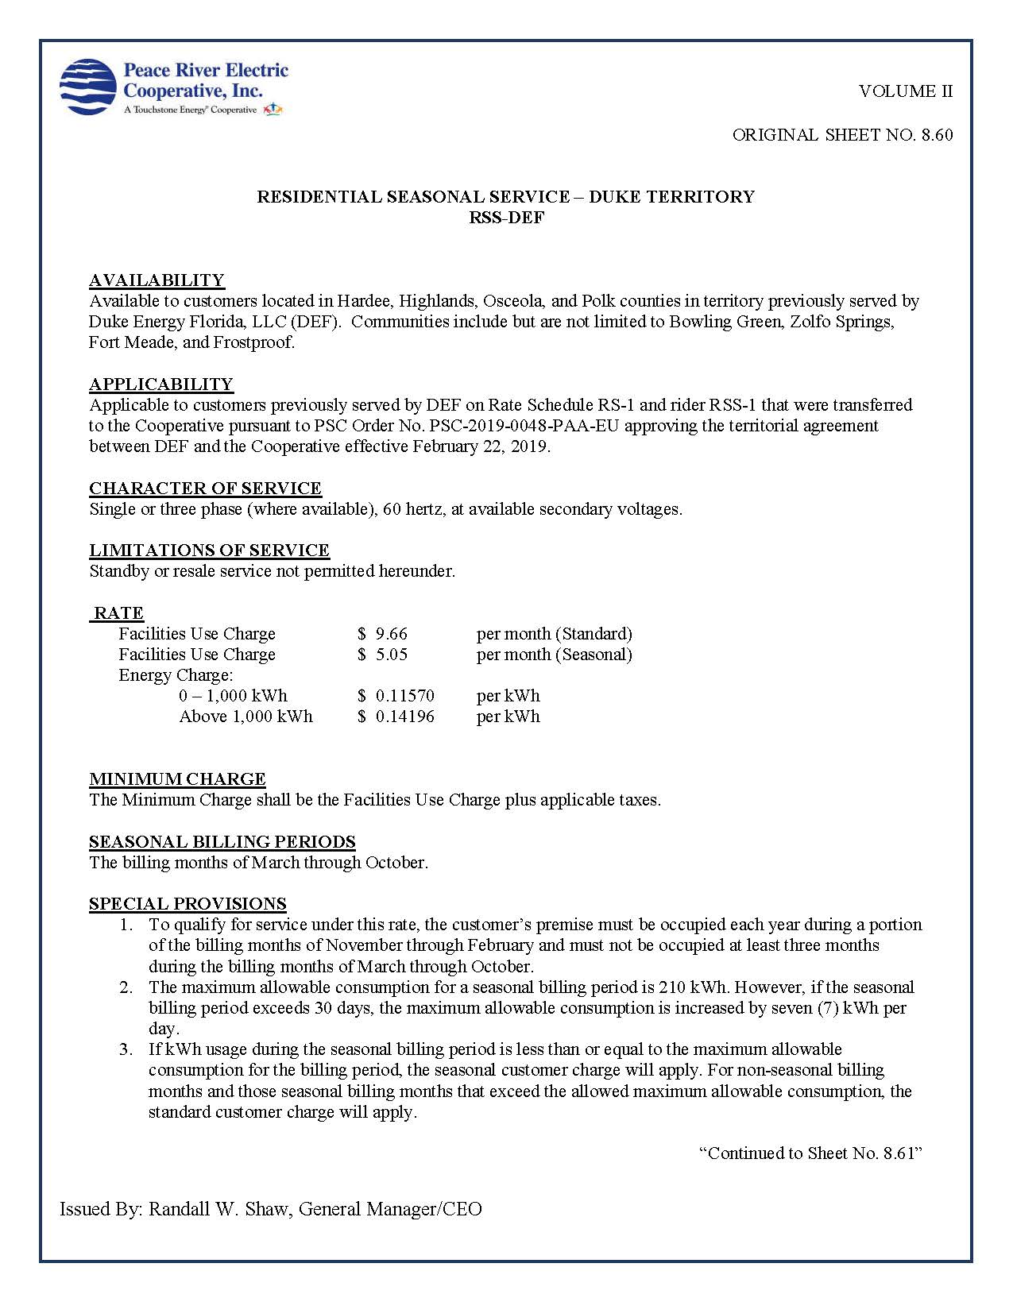

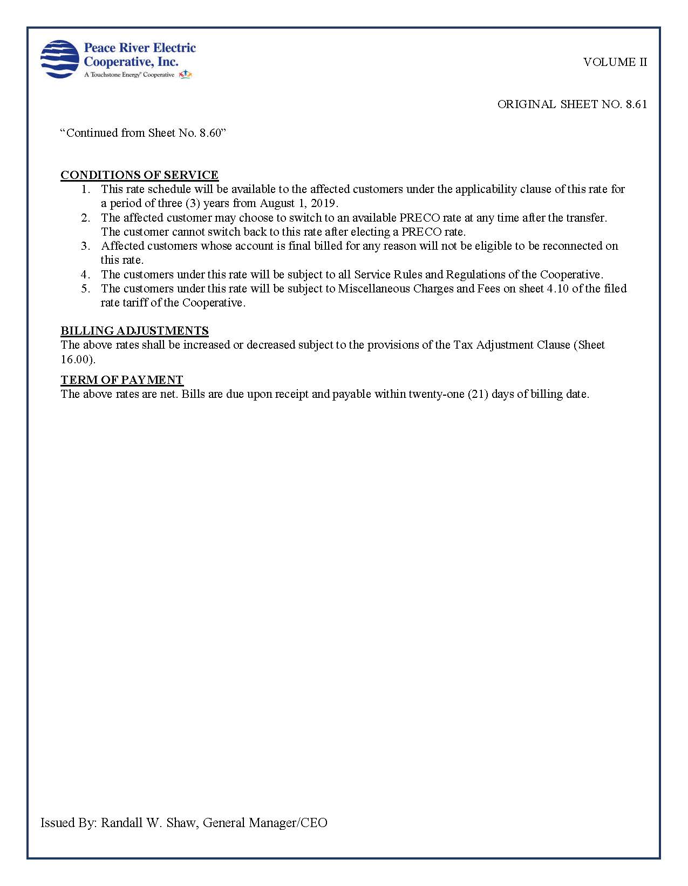
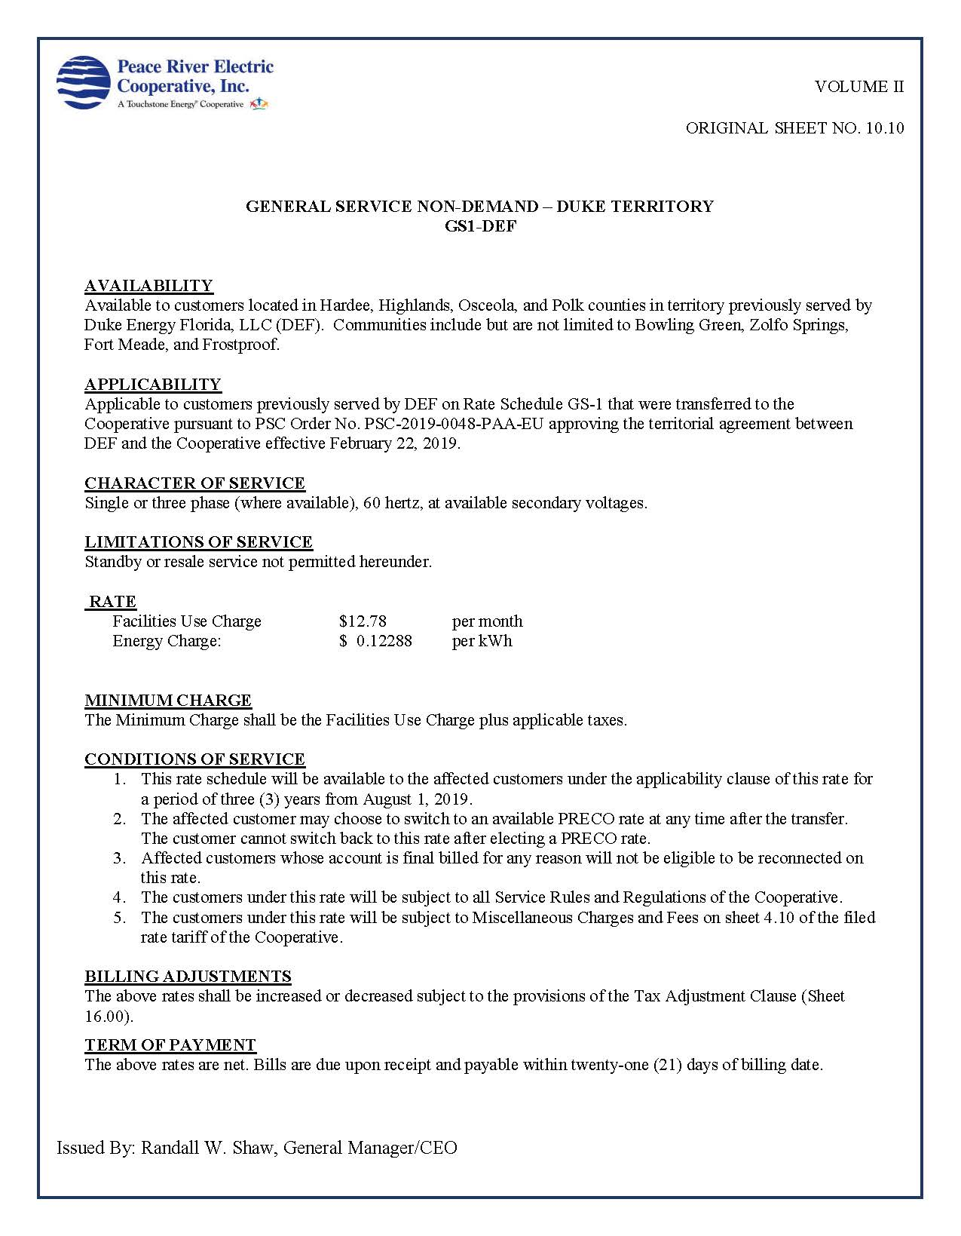

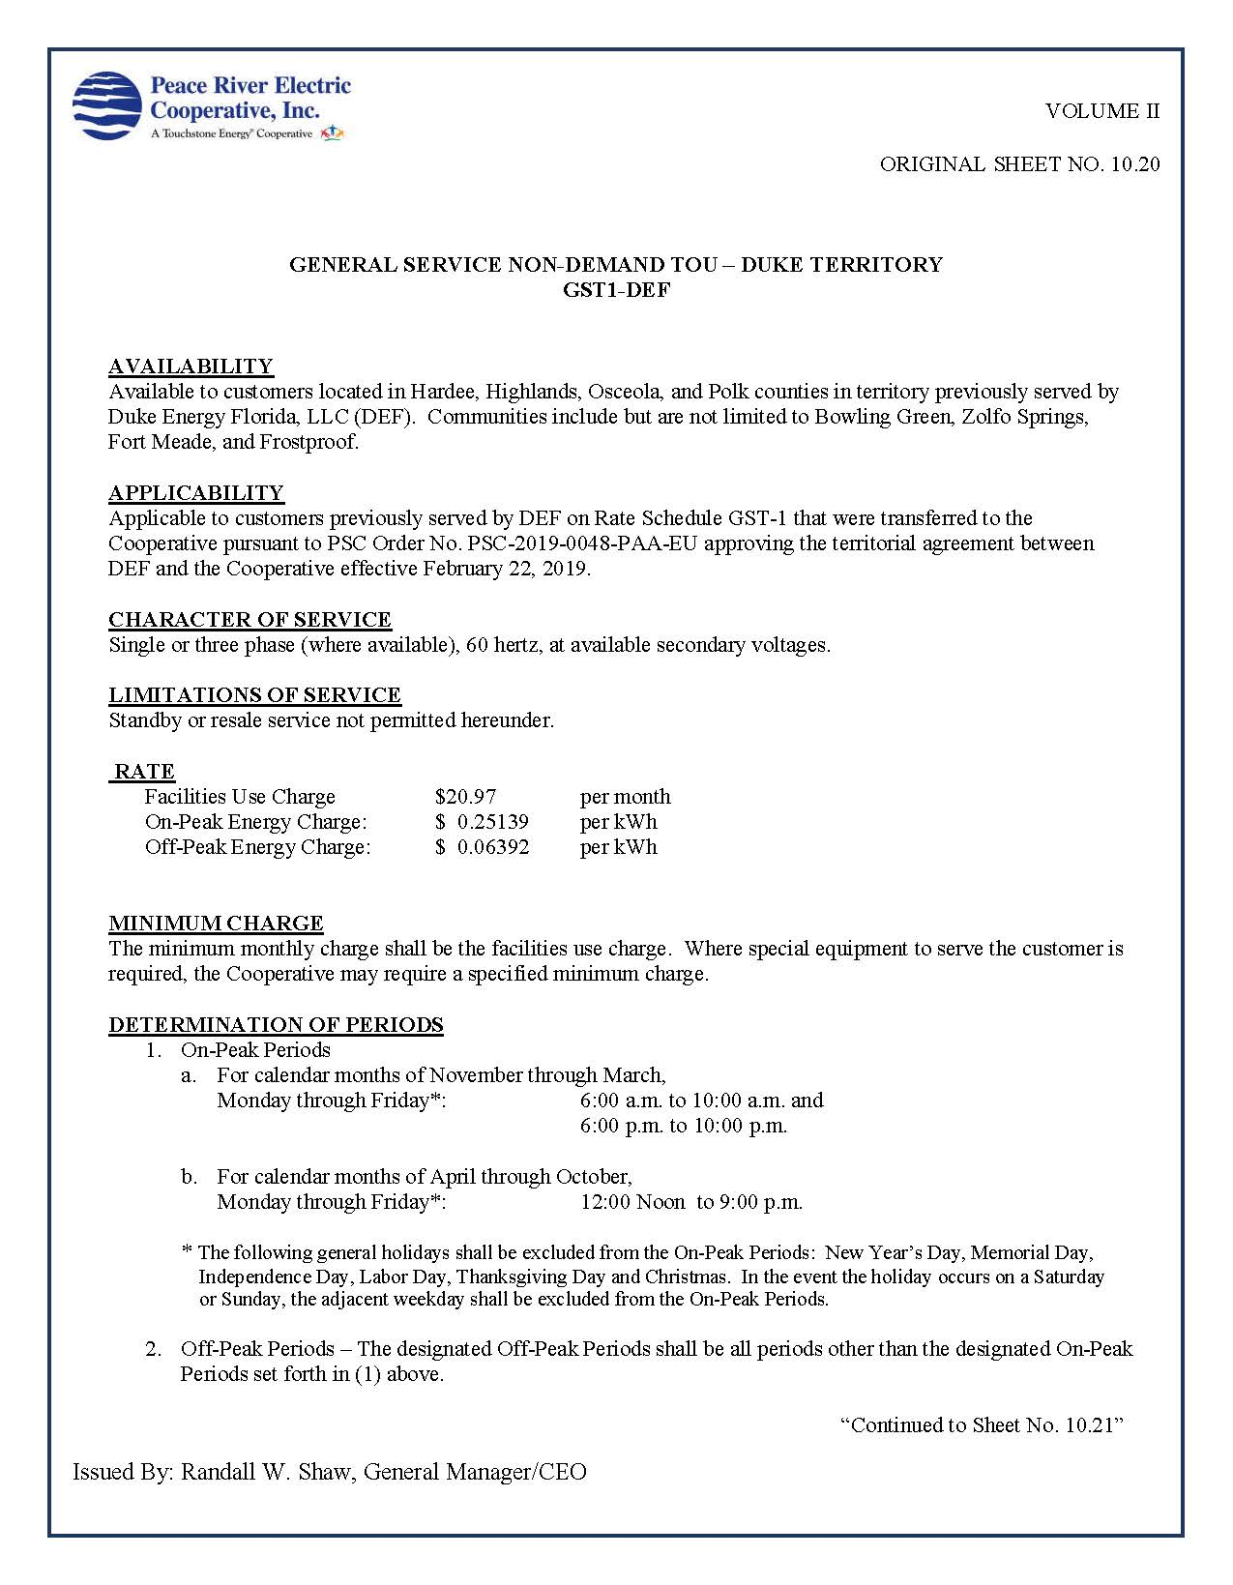
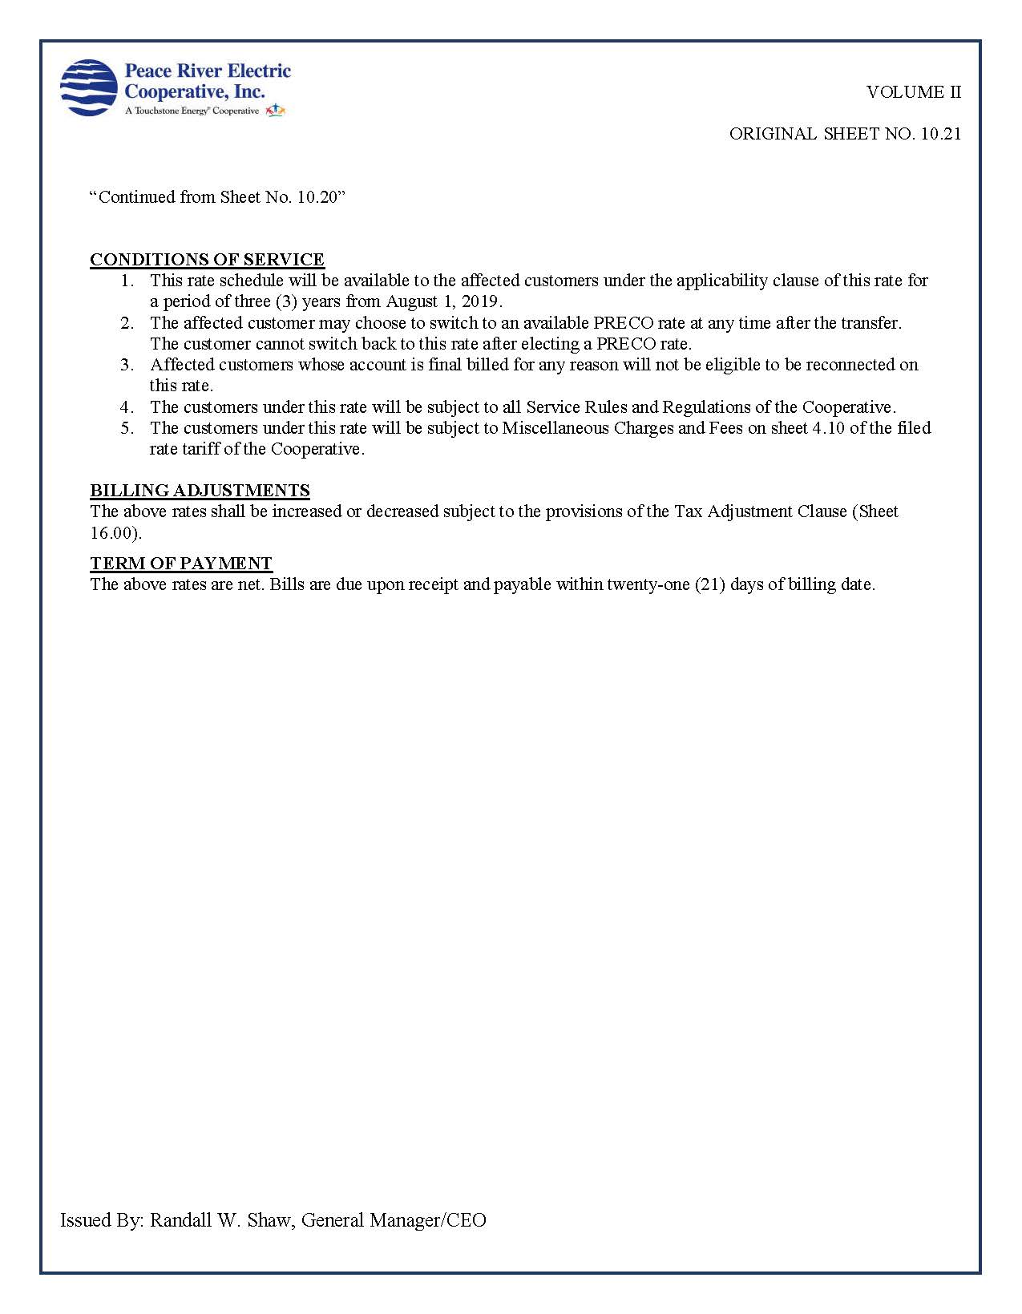

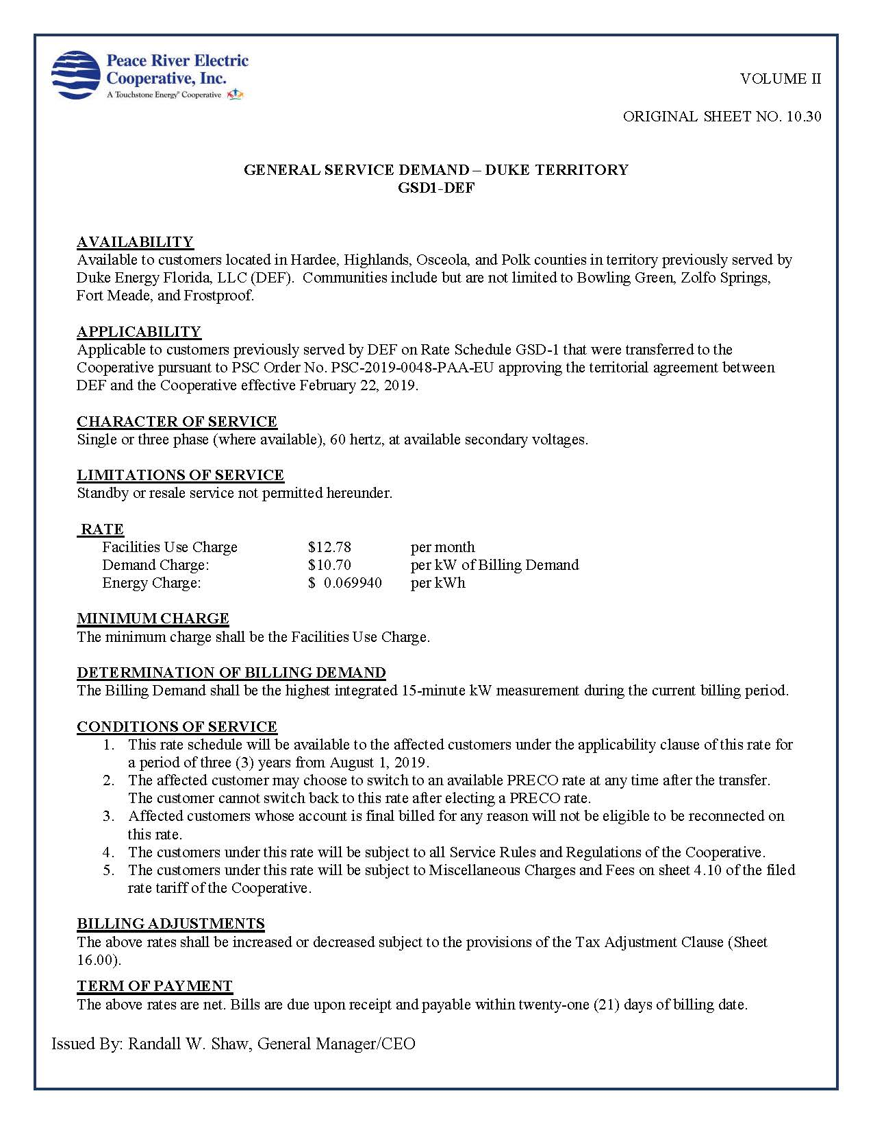
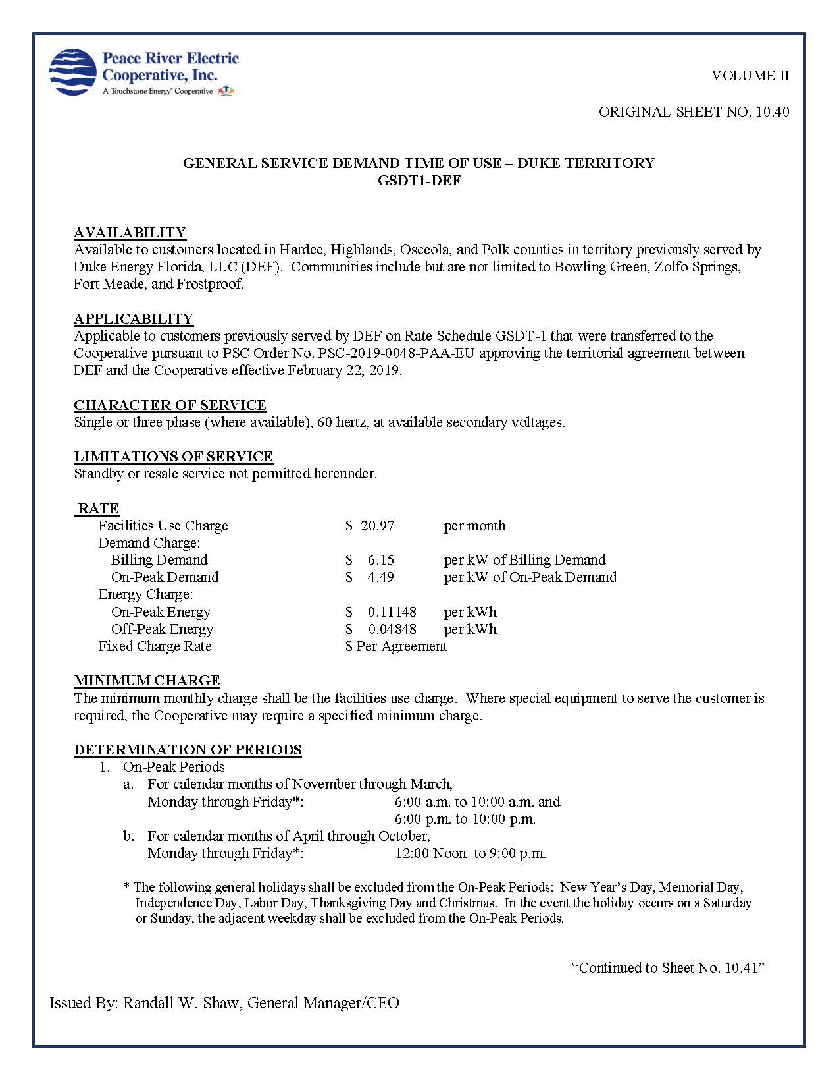

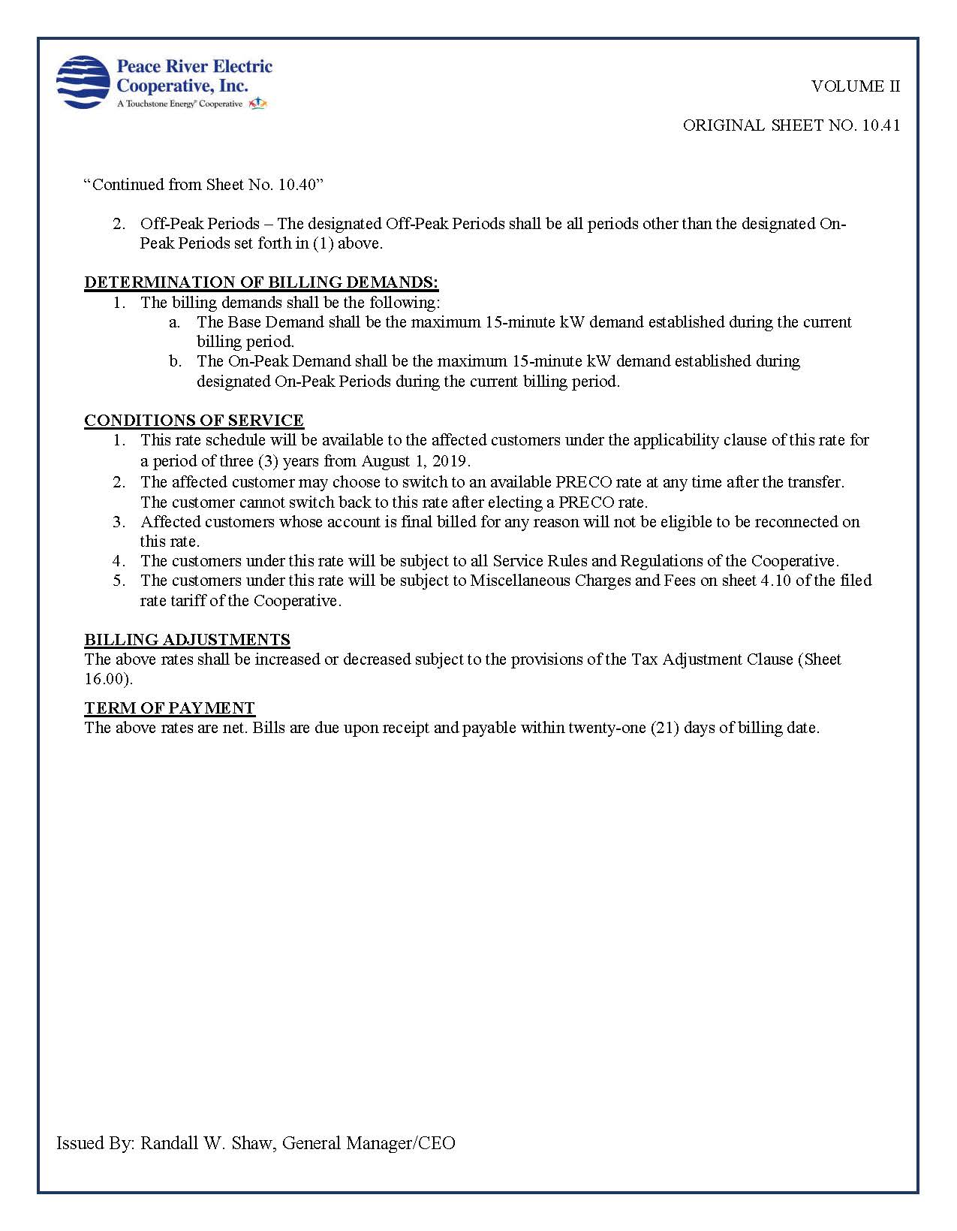

Order No. PSC-2019-0048-PAA-EU, issued January 28, 2019, in Docket No. 20180159-EU, In re: Joint Petition for approval of amendment to territorial agreement in Hardee, Highlands, Polk, and Osceola Counties, by Peace River Electric Cooperative and Duke Energy Florida, LLC.
Id. at page 3
Docket No. 20190000-OT, Document No. 05171-2019.
Exhibit F of the petition filed in Docket No. 20180159-EU.

