State of Florida |  | Public Service Commission  Capital Circle Office Center ● 2540 Shumard Oak Boulevard  Tallahassee, Florida 32399-0850  -M-E-M-O-R-A-N-D-U-M-
DATE: | September 20, 2019
TO: | Office of Commission Clerk (Teitzman)
FROM: | Division of Economics (Guffey, Coston)  Office of the General Counsel (Trierweiler)
RE: | Docket No. 20190137-EU – Joint petition for approval of territorial agreement in Marion County, by Clay Electric Cooperative, Inc. and City of Ocala.
AGENDA: | 10/03/19 – Regular Agenda – Proposed Agency Action – Interested Persons May Participate
COMMISSIONERS ASSIGNED: |  |  | All Commissioners
PREHEARING OFFICER: |  |  | Polmann
CRITICAL DATES: |  |  | None
SPECIAL INSTRUCTIONS: |  |  | None

Case Background
On July 2, 2019, Clay Electric Cooperative, Inc. (Clay) and the City of Ocala Electric Utility (Ocala), collectively the joint petitioners, filed a petition seeking Commission approval of a territorial agreement (agreement) delineating their respective modified service boundaries in Marion County. The proposed agreement, map depicting the current service territories and proposed changes, and written descriptions of the territorial boundaries are provided in Attachment A to this recommendation.
In 1986, the Commission approved a territorial agreement that established the boundaries for Clay and Ocala’s service territories in Marion County. The 1986 agreement was a 25-year agreement which was effective from January 7, 1987 to January 7, 2012. Since 2012, the parties state that they have continued to honor and operate pursuant to the terms of the 1986 agreement. Pursuant to Section 6.1, the proposed agreement will be in effect for a term of 25 years from the date of the issuance of the Commission Order.
During the review of this joint petition, staff issued a data request to Clay and Ocala on July 19, 2019, for which responses were received on August 8, 2019. The responses have been placed in the docket file. The Commission has jurisdiction over this matter pursuant to Section 366.04, Florida Statutes (F.S.).

Discussion of Issues

Issue 1:
Should the Commission approve the proposed amended territorial agreement between Clay and Ocala in Marion County?

Recommendation:
Yes, the Commission should approve the amended territorial agreement between Clay and Ocala in Marion County. The proposed territorial agreement is in the public interest and it will enable Clay and Ocala to serve their customers in an efficient manner. (Guffey)

Staff Analysis:
Pursuant to Section 366.04(2)(d), F.S., and Rule 25-6.0440, Florida Administrative Code (F.A.C.), the Commission has the jurisdiction to approve territorial agreements between and among rural electric cooperatives, municipal electric utilities, and other electric utilities. Unless the Commission determines that the agreement will cause a detriment to the public interest, the agreement should be approved.
Prior to the 1986 agreement, parts of Marion County and areas east of City of Ocala were being served by both utilities. The 1986 agreement delineated and established specific service territories in Marion County for Clay and Ocala. In the instant docket, the parties state that they have made modest modifications to their service boundaries in order to accurately reflect land development that has occurred since 1986 and to provide reliable and efficient service to the impacted customers.
Through the proposed agreement, the joint petitioners will transfer 30 (25 residential and 5 general service commercial) customers from Clay to Ocala. In addition, three residential and two general service commercial Clay customers will be transferred to Ocala. The joint petitioners explained that customer transfers will be completed within 36 months of the order approving the agreement; however, to make the process easy and simple for customers, the utilities have agreed not to immediately transfer any customers. Customer transfers will occur when a customer applies for service at a new location or when a customer changes the type of account (i.e., residential to commercial). The joint petitioners further stated that any customers not transferred as a result of a change in service or type of account will be transferred prior to the expiration of the 36 months. In response to staff’s data request, the joint petitioners stated that when the 30 CEC customers are transferred to Ocala, they will be billed pursuant to Ocala’s approved tariffs and when five Ocala customers are transferred to CEC, they will be billed pursuant to CEC’s approved tariffs. No special or temporary tariff rates are anticipated for the transferred customers of both utilities.
The amended territorial agreement also contemplates the transfer of certain secondary service distribution facilities between the parties. In response to staff’s data request, the petitioners stated these facilities have been fully depreciated due to age and condition and therefore no purchase price is assessed. Rather, the parties will exchange the facilities on a like-kind basis. The joint petitioners assert that the proposed amended territorial agreement will prevent uneconomic duplication of facilities and, if approved, shall continue and remain in effect for a period of 25 years from the date of the Commission’s Order.

Customer Notification
In accordance with Rule 25-6.0440(1)(d), F.A.C., the petitioners state that prior to the filing of this petition, the impacted customers were notified by mail of the transfer and provided a description of the differences in rates between Clay and Ocala. In response to staff’s data request, the utilities stated that they have not received any negative responses from impacted customers. The Commission has not received any objections from impacted customers either. In response to staff’s data request, the petitioners provided updated customer notification letters. As of June 2018, the bill for a Clay residential customer using 1,000 kilowatt-hours (kWh) per month was $112.90 and the bill for an Ocala residential customer using 1,000 kWh per month was $114.64.

Conclusion
After review of the petition and the petitioners’ joint responses to staff’s data request, staff believes that the proposed agreement is in the public interest and will enable Clay and Ocala to serve their current and future customers efficiently. It appears that the proposed agreement eliminates any potential uneconomic duplication of facilities and will not cause a decrease in reliability of electric service. As such, staff believes that the proposed agreement between Clay and Ocala will not cause a detriment to the public interest and recommends Commission approval.

Issue 2:
Should this docket be closed?

Recommendation:
If no protest is filed by a person whose substantial interests are affected within 21 days of the issuance of the Order, this docket should be closed upon the issuance of a Consummating Order. (Trierweiler)

Staff Analysis:
If no protest is filed by a person whose substantial interests are affected within 21 days of the issuance of the Order, this docket should be closed upon the issuance of a Consummating Order.

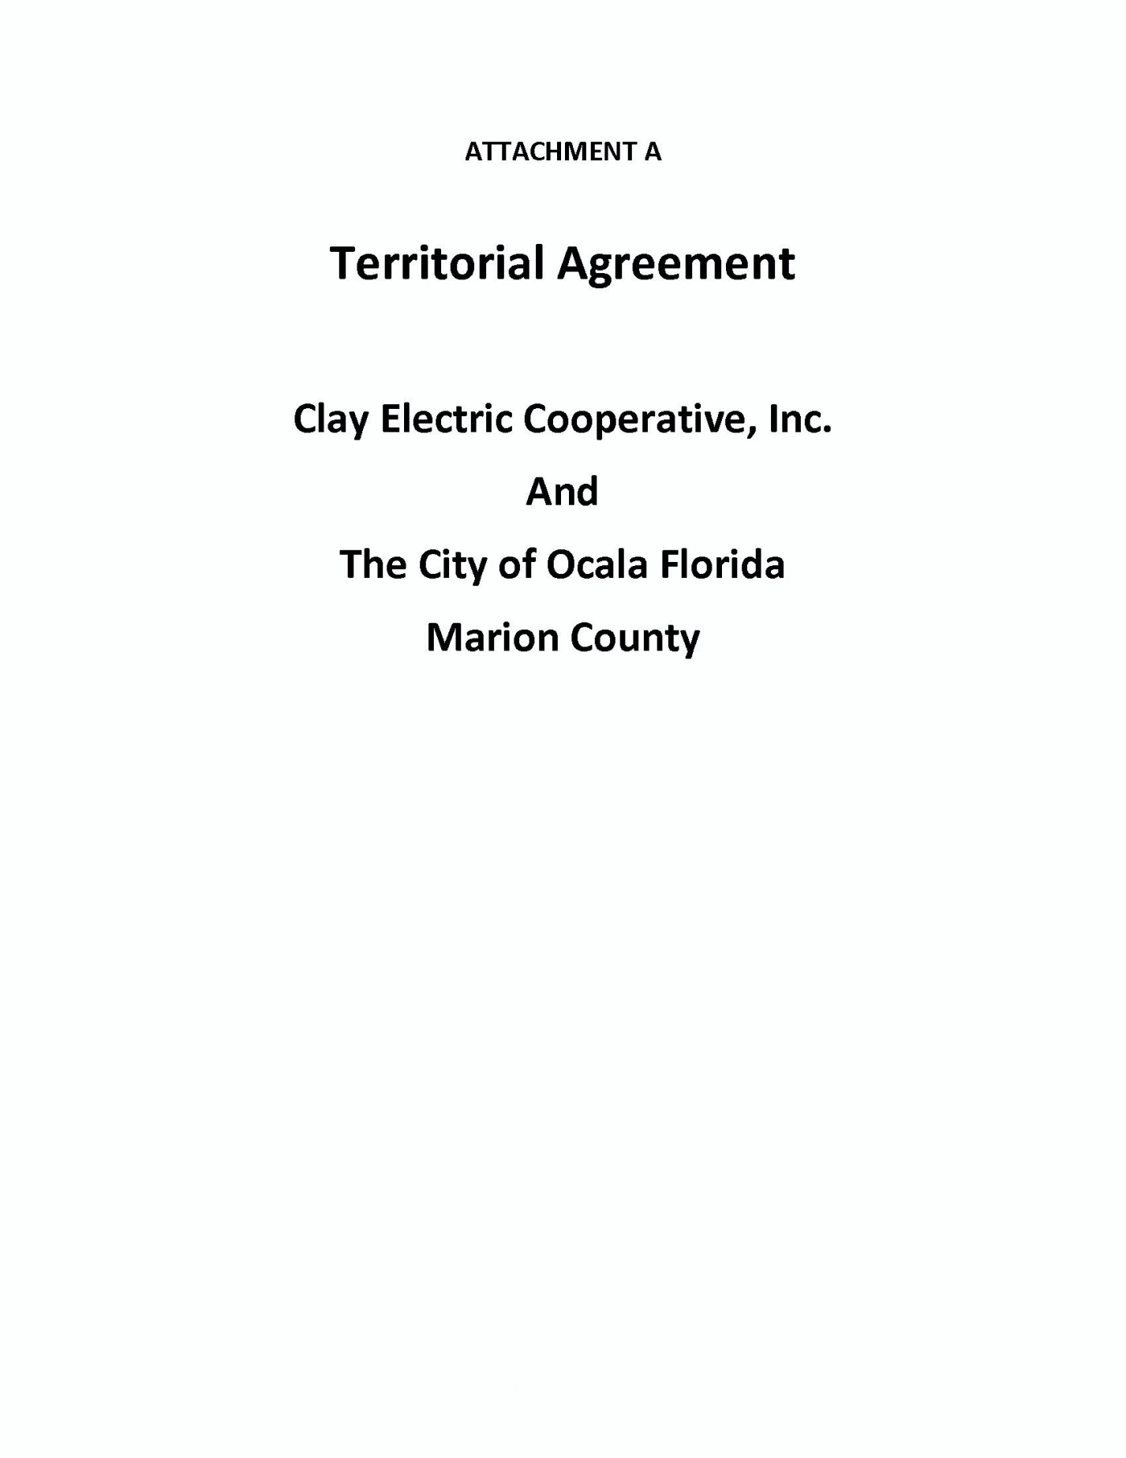

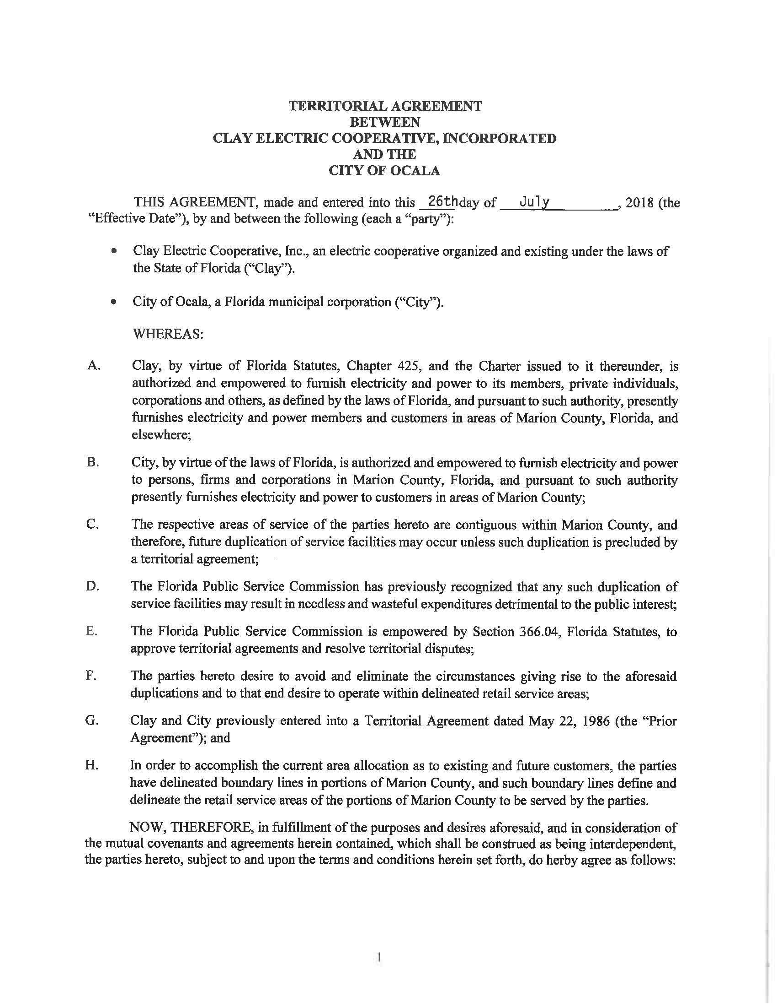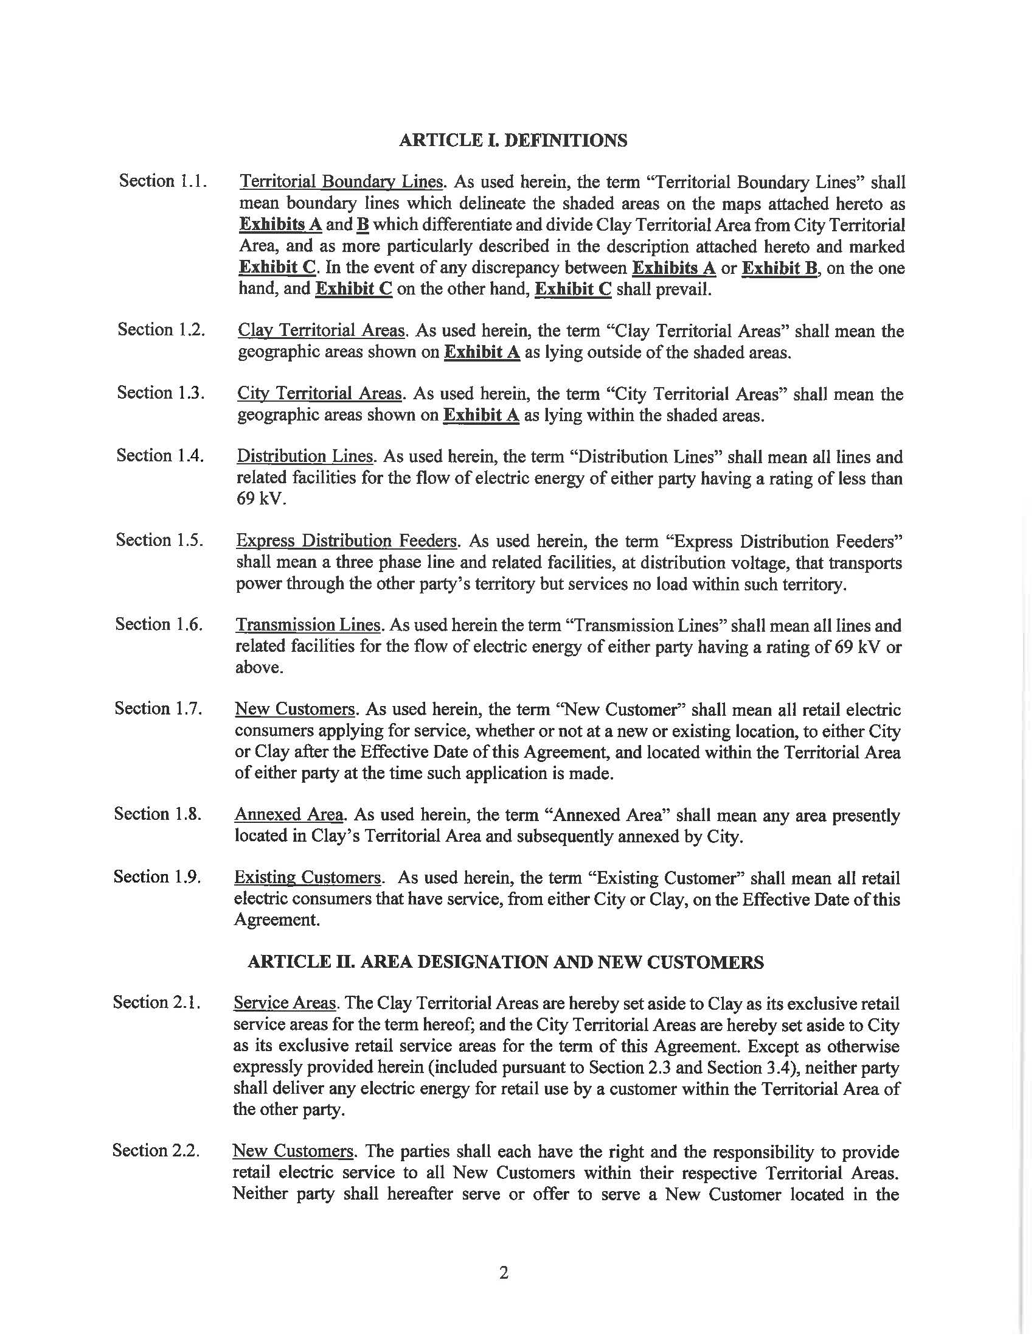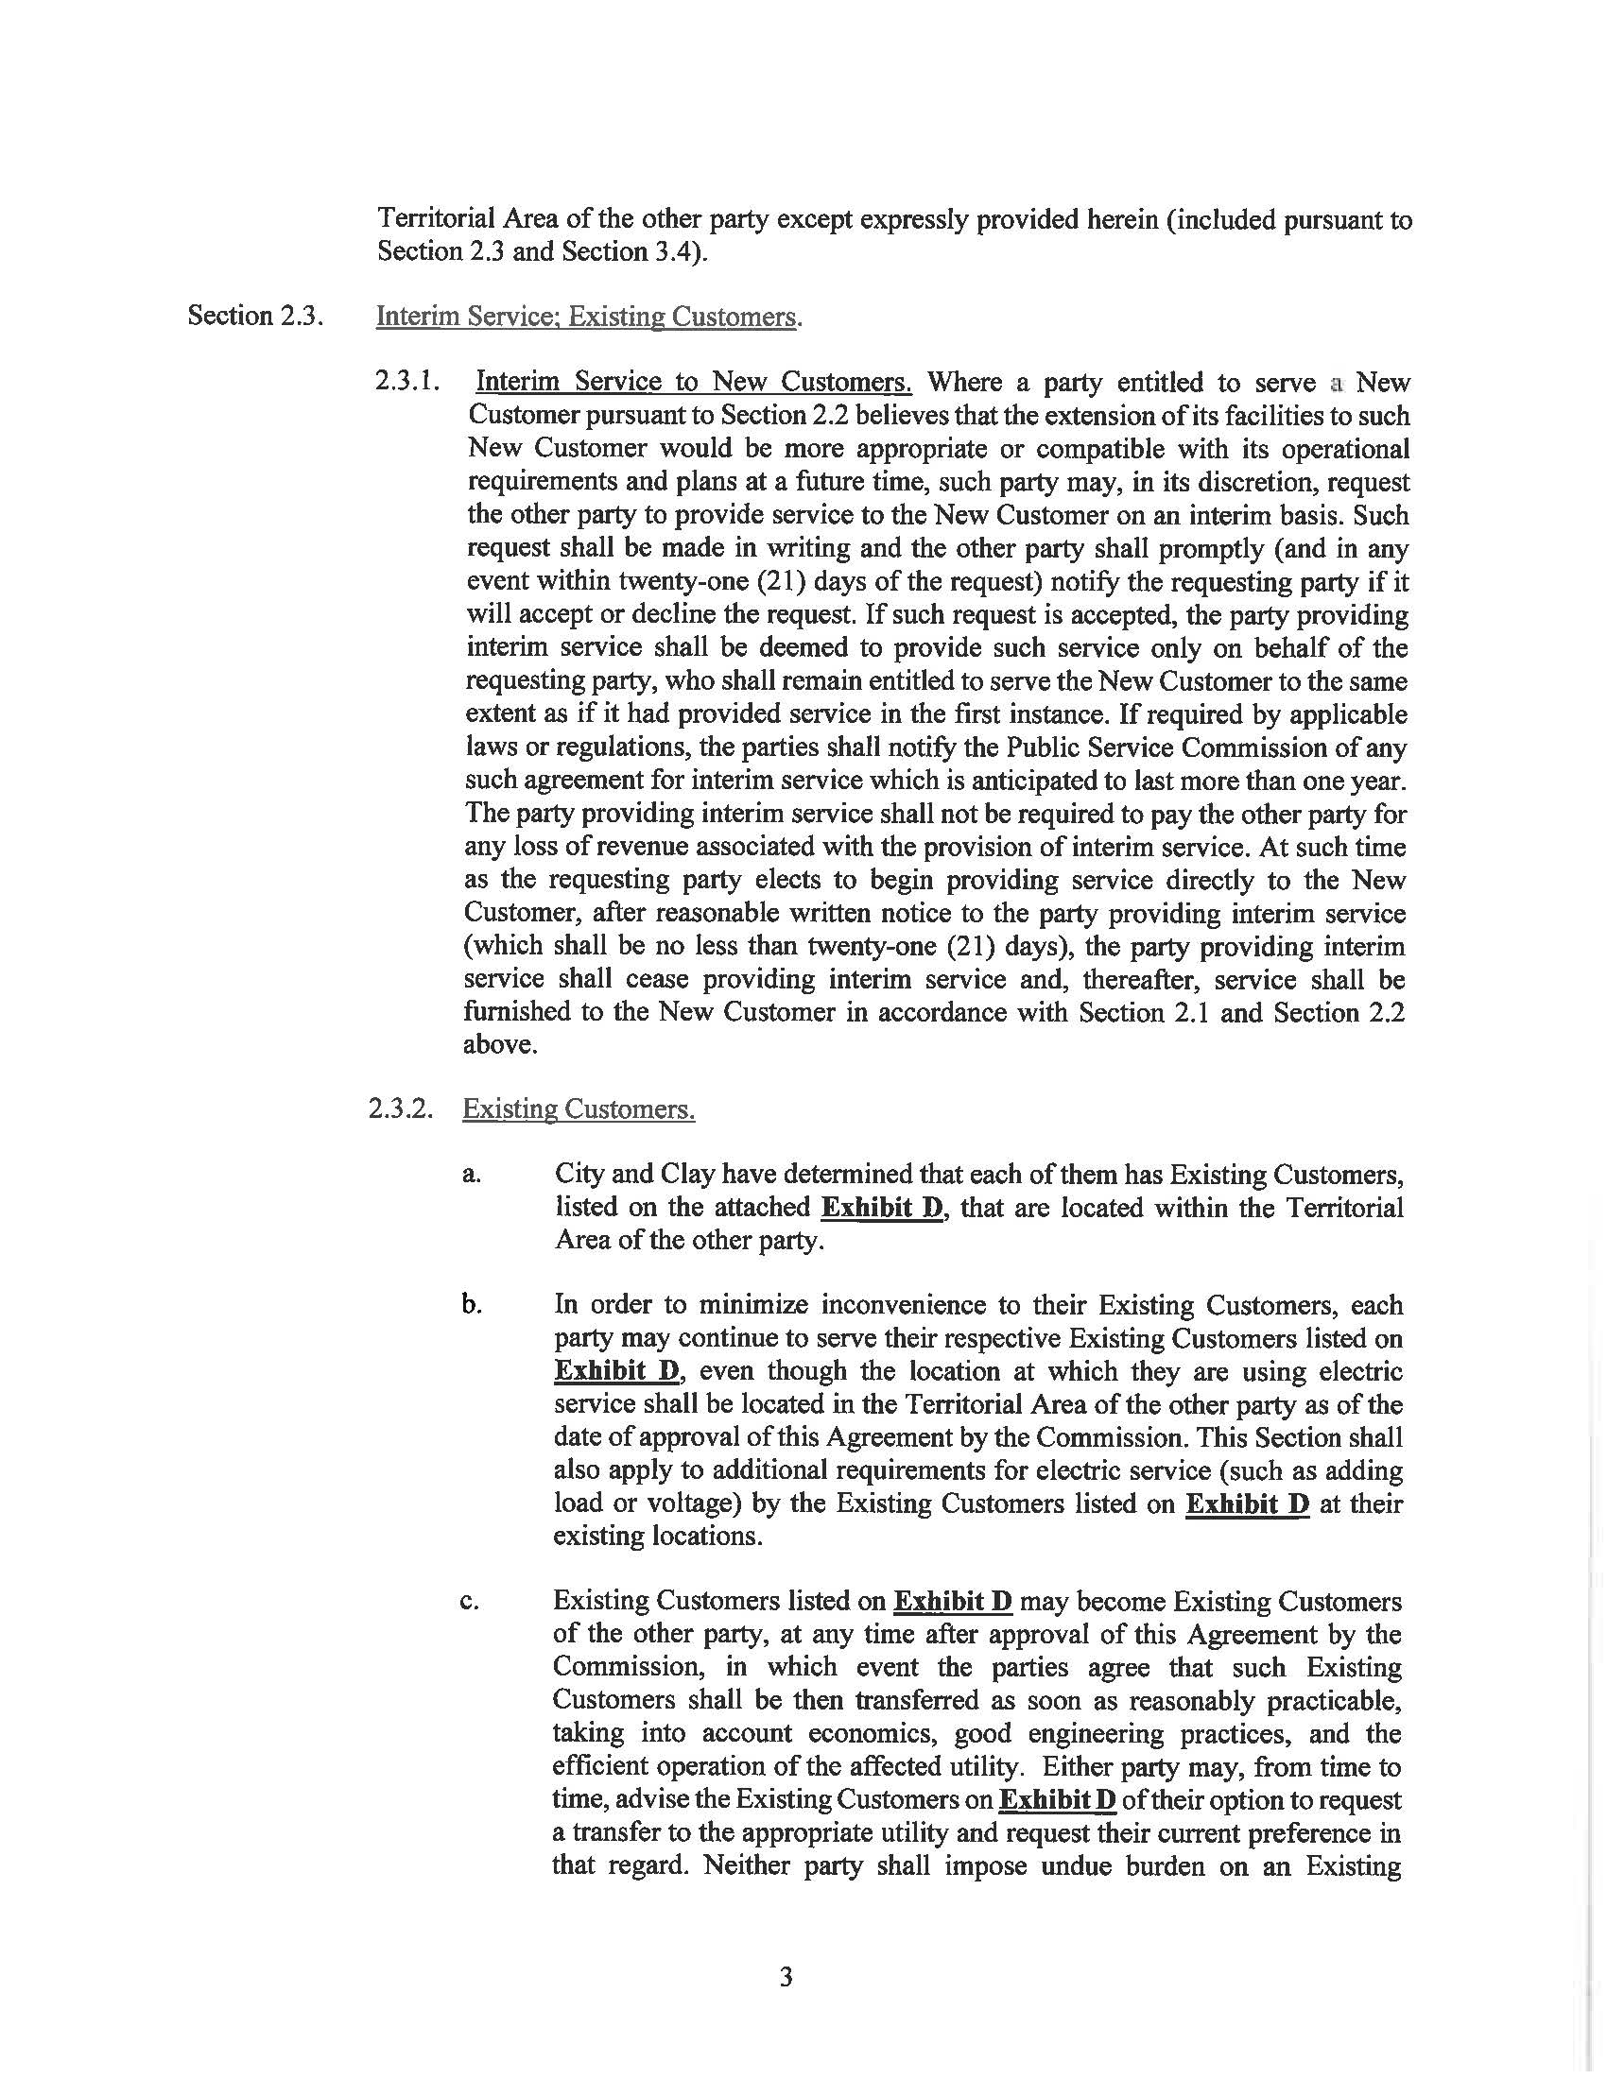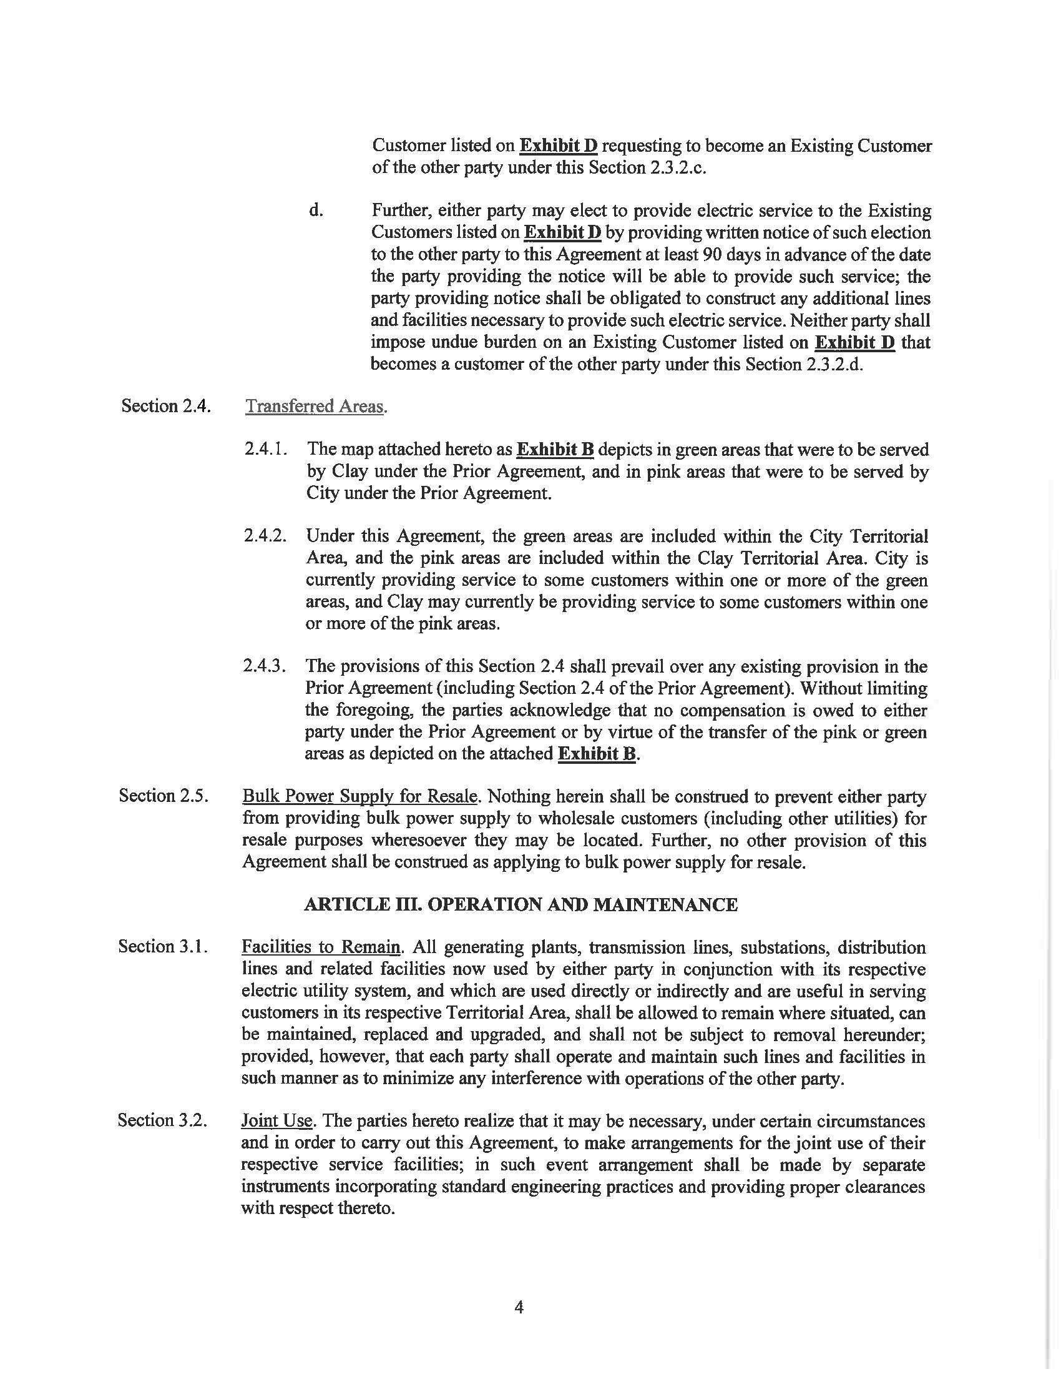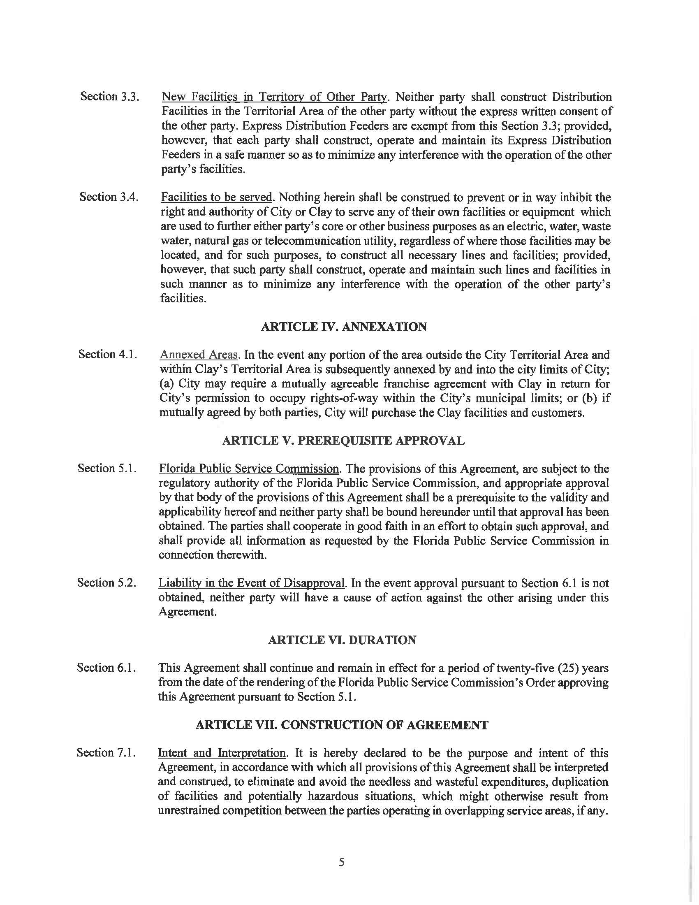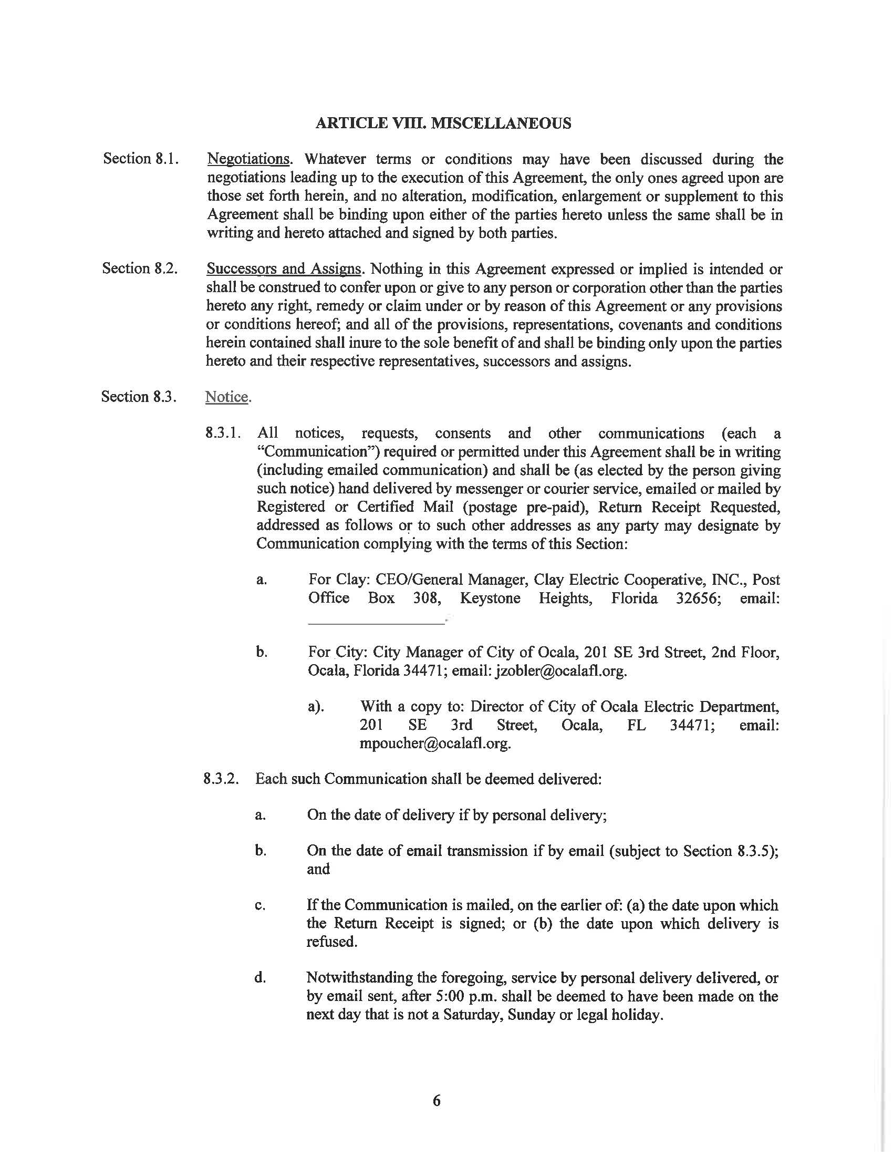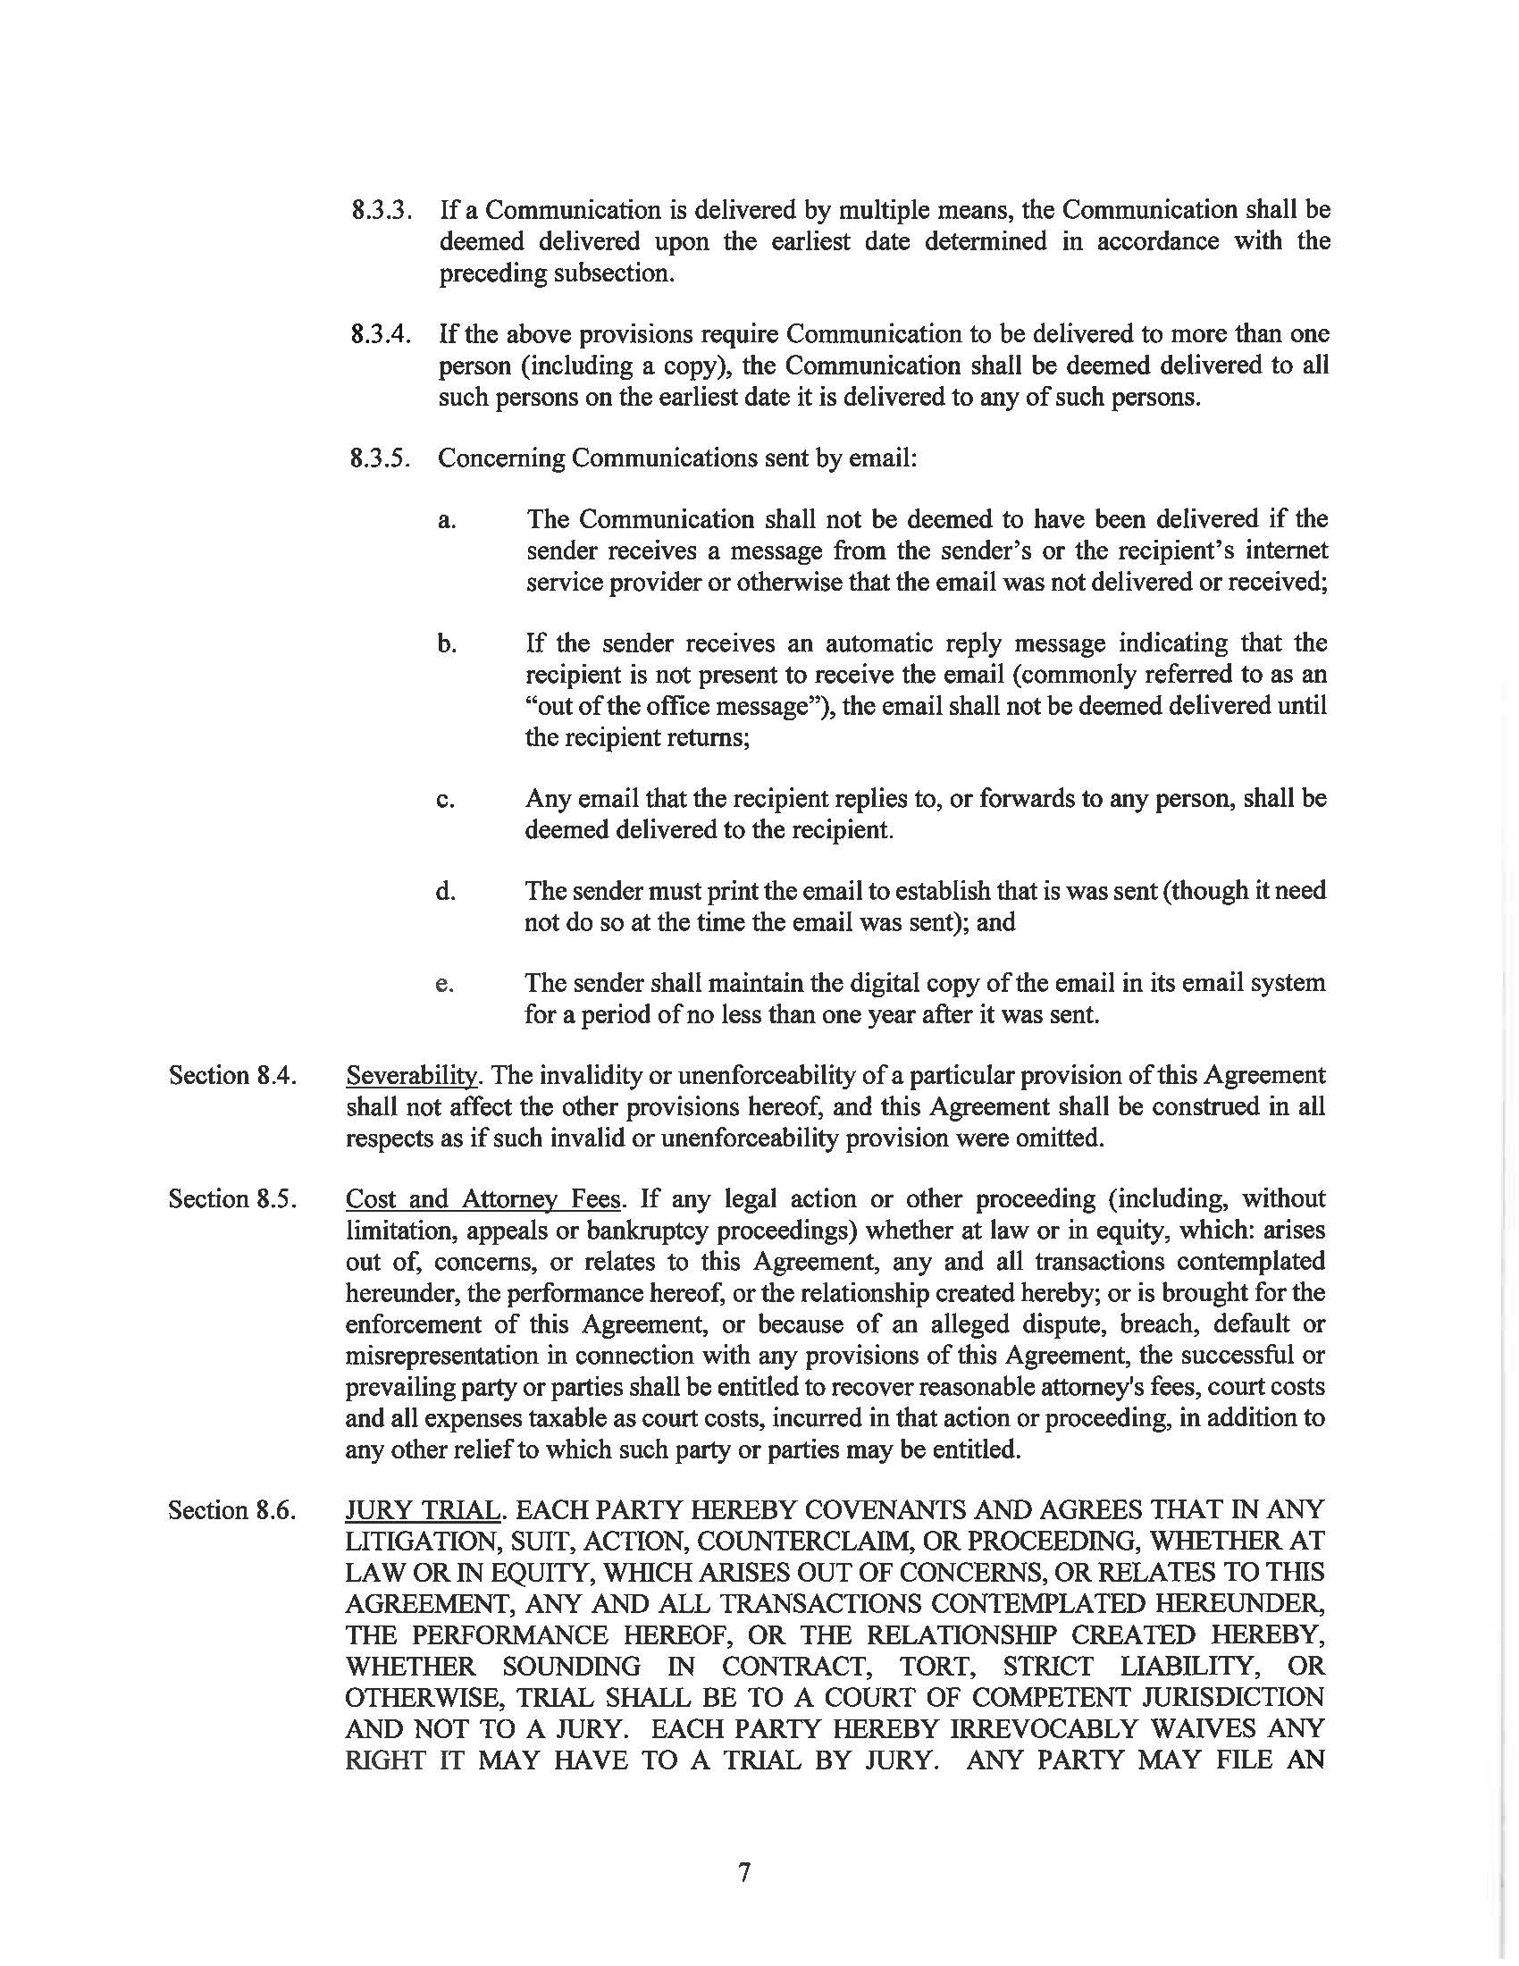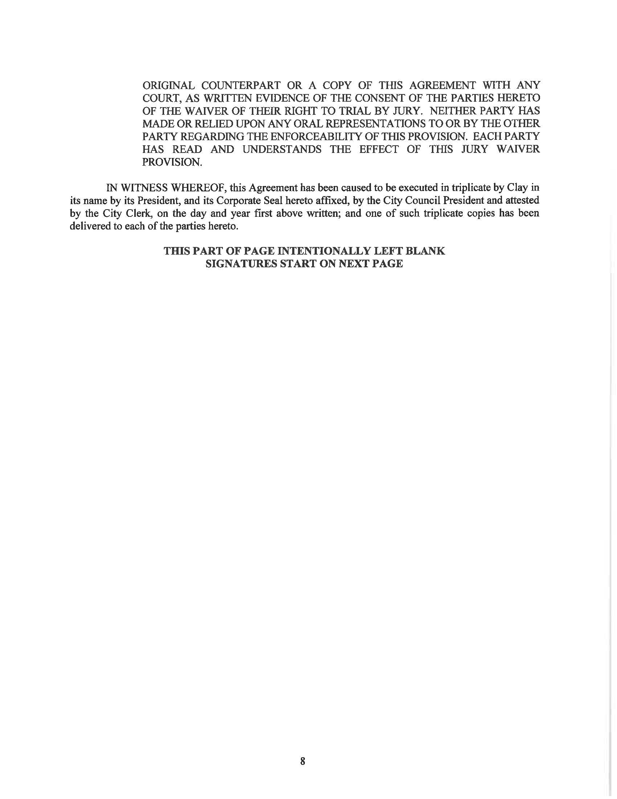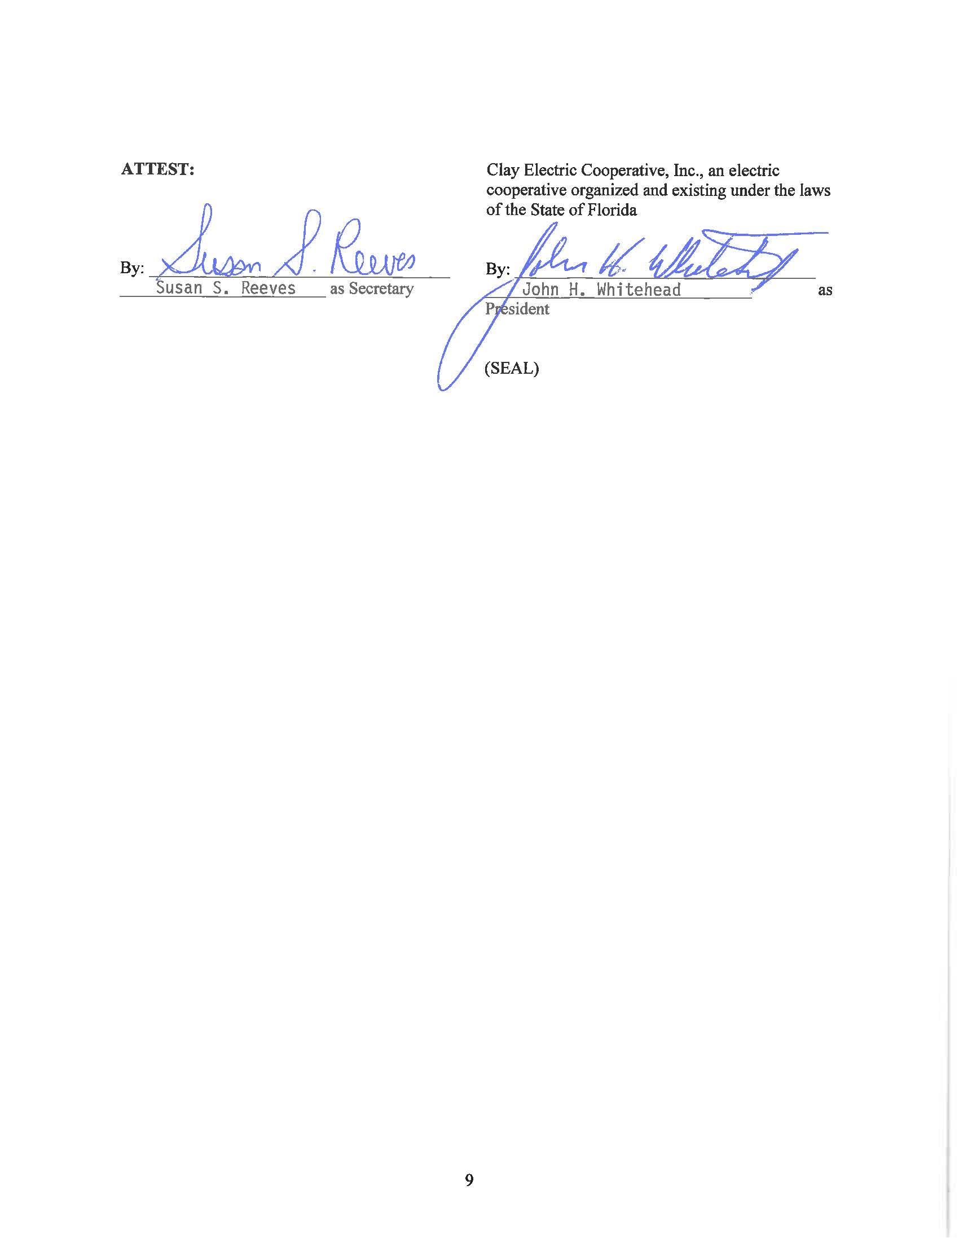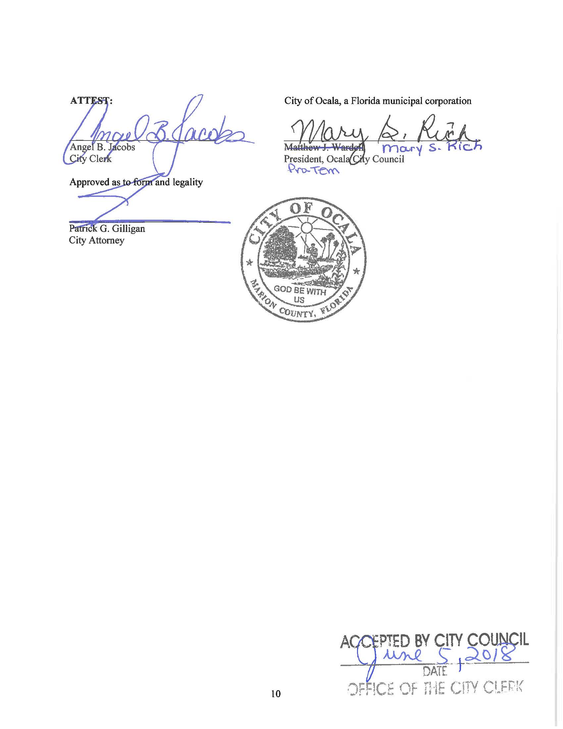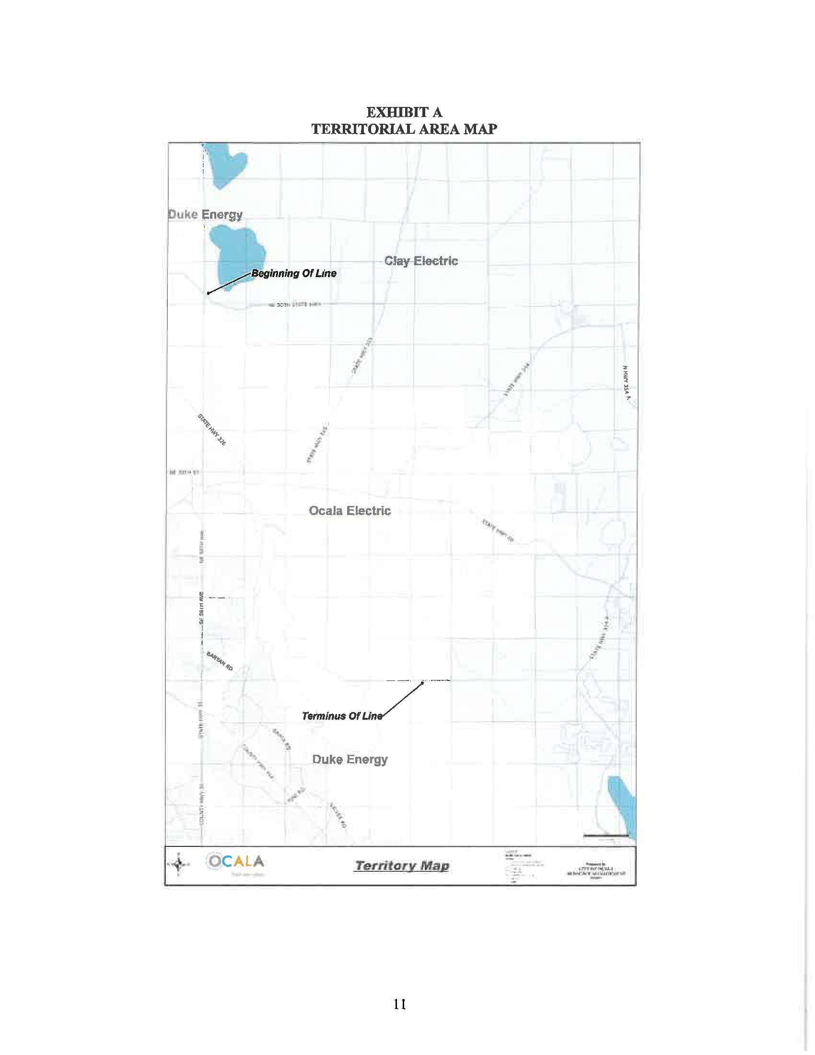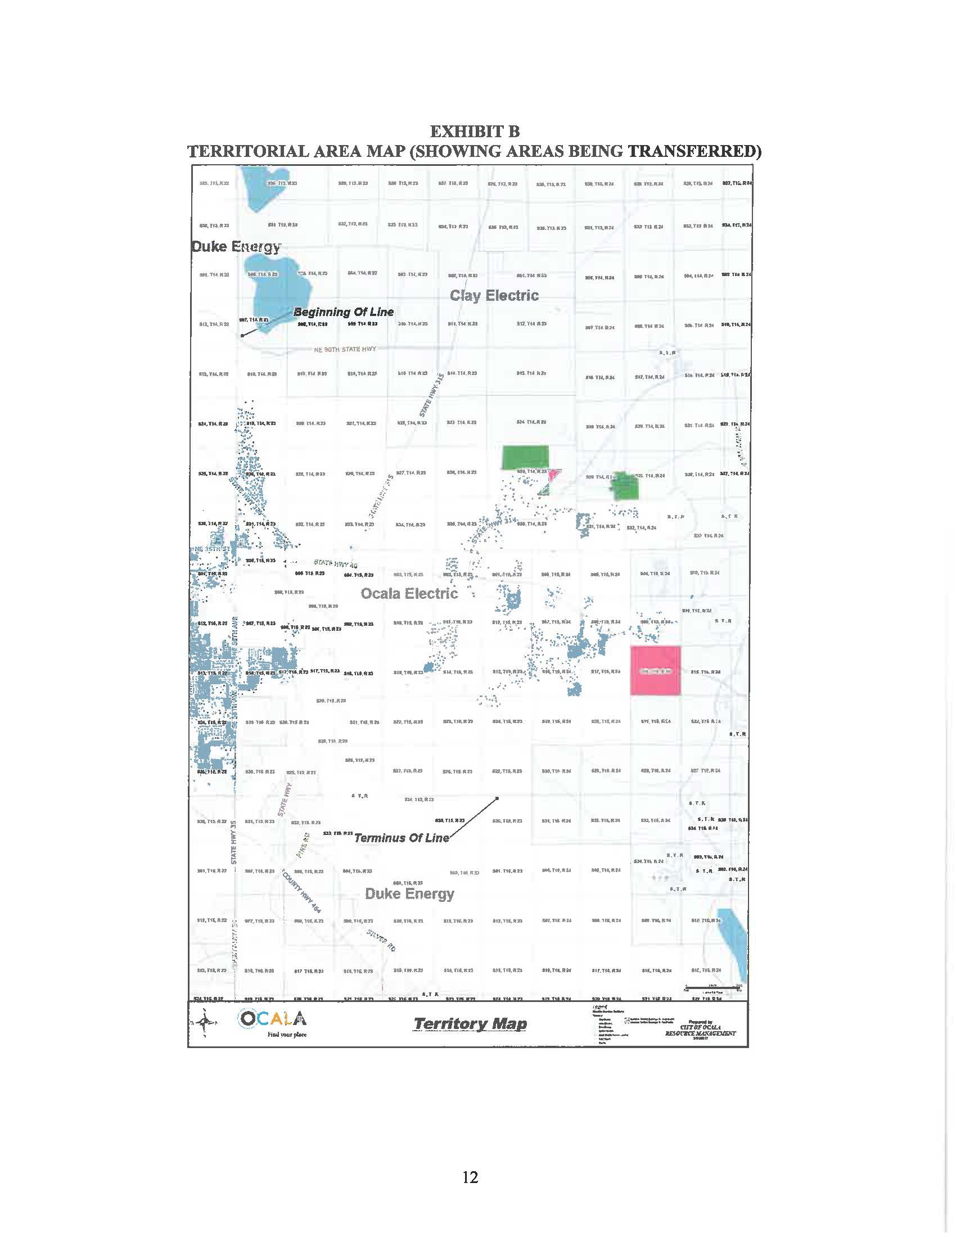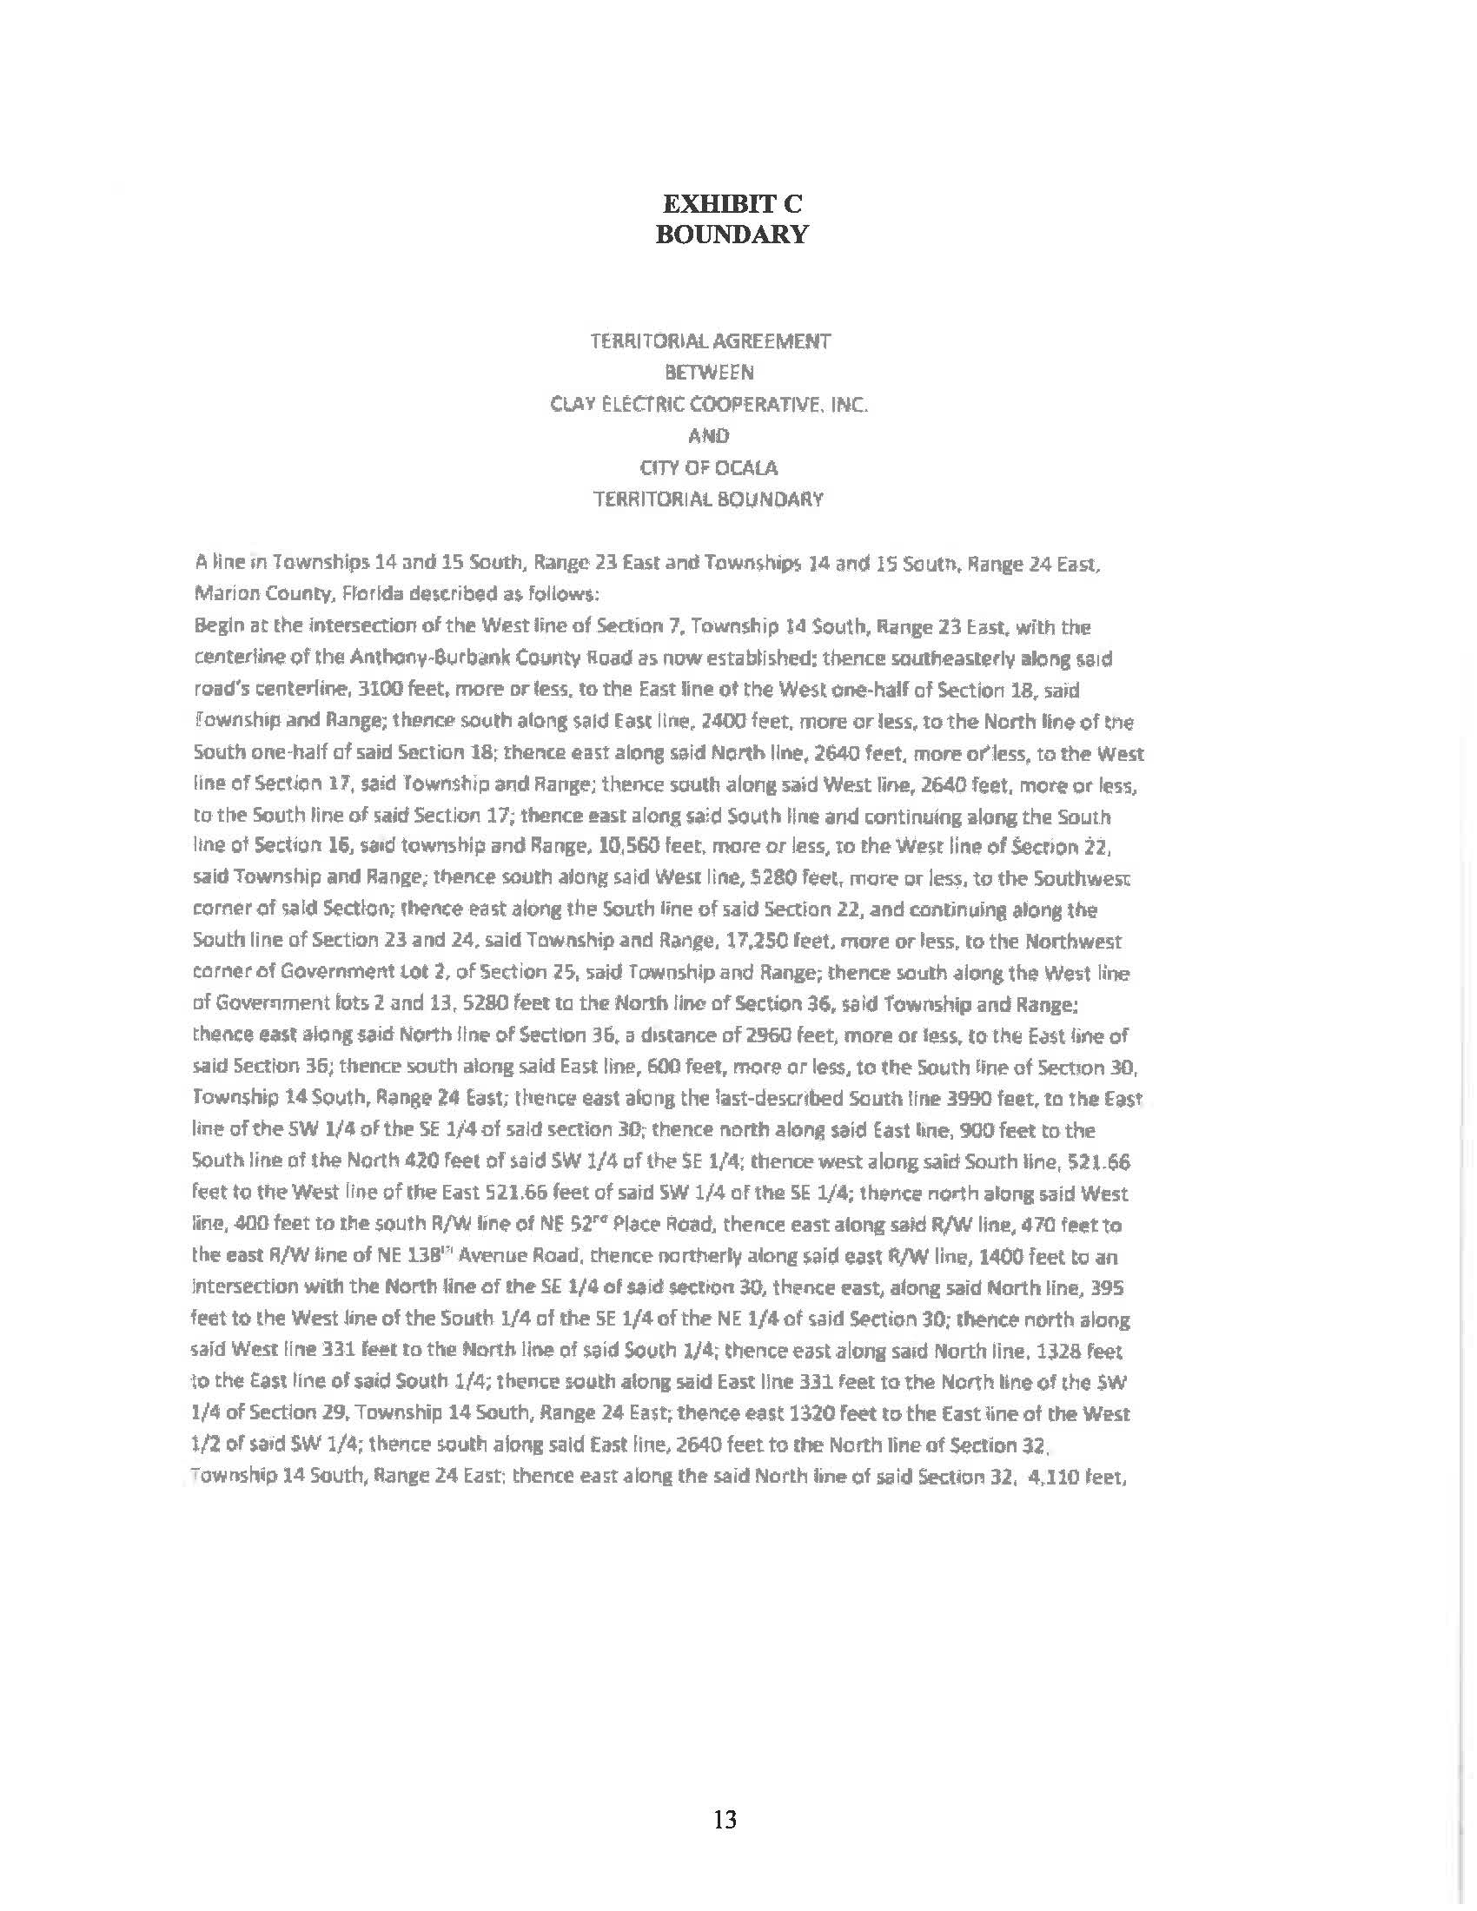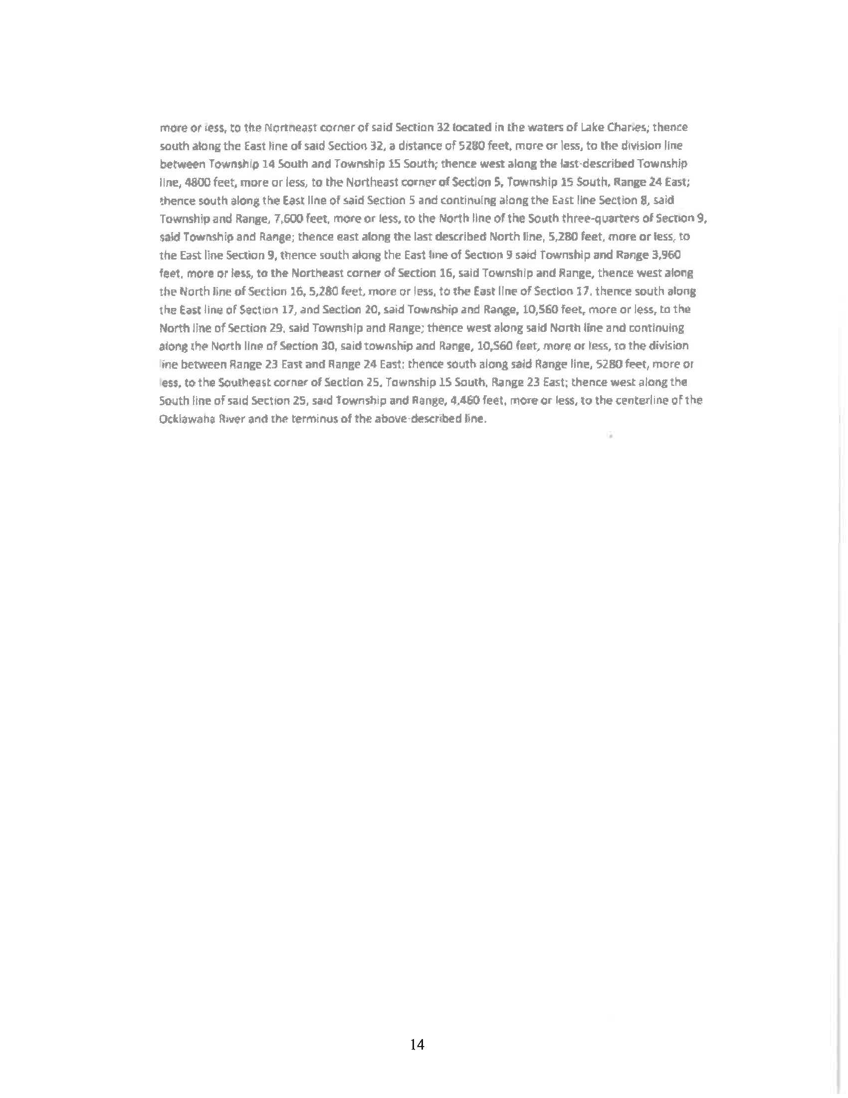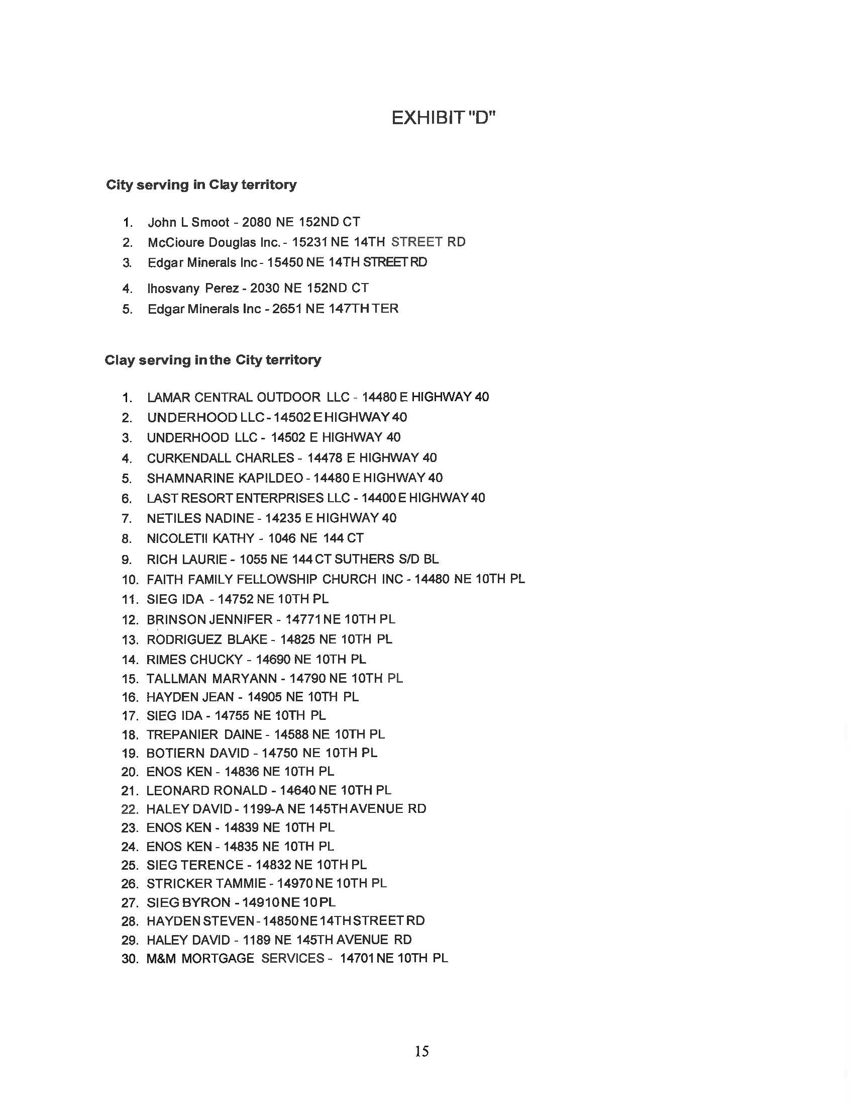

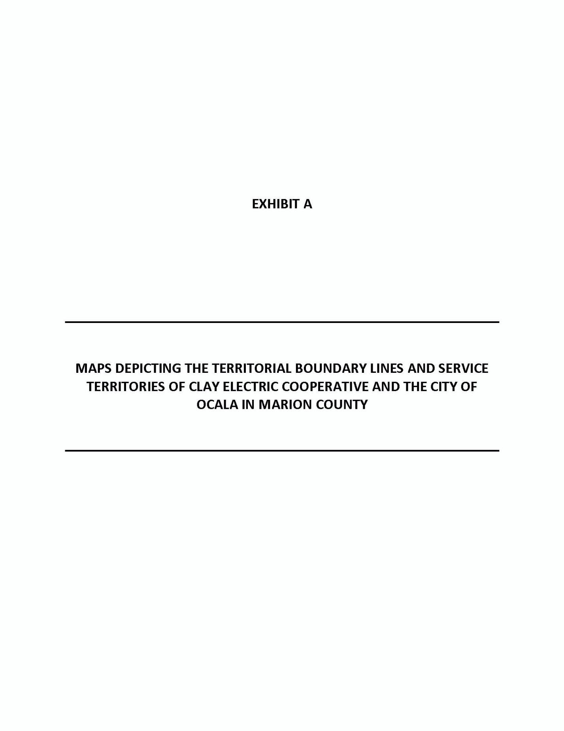

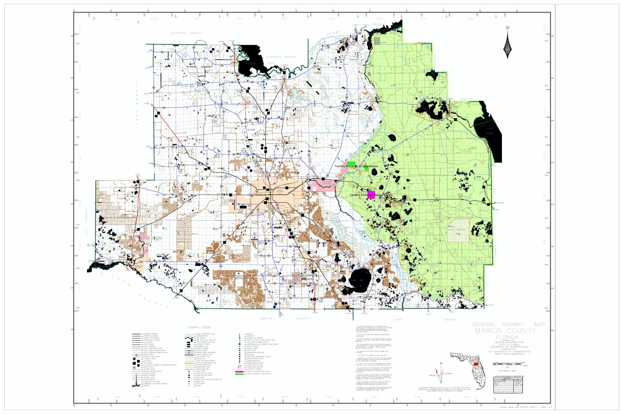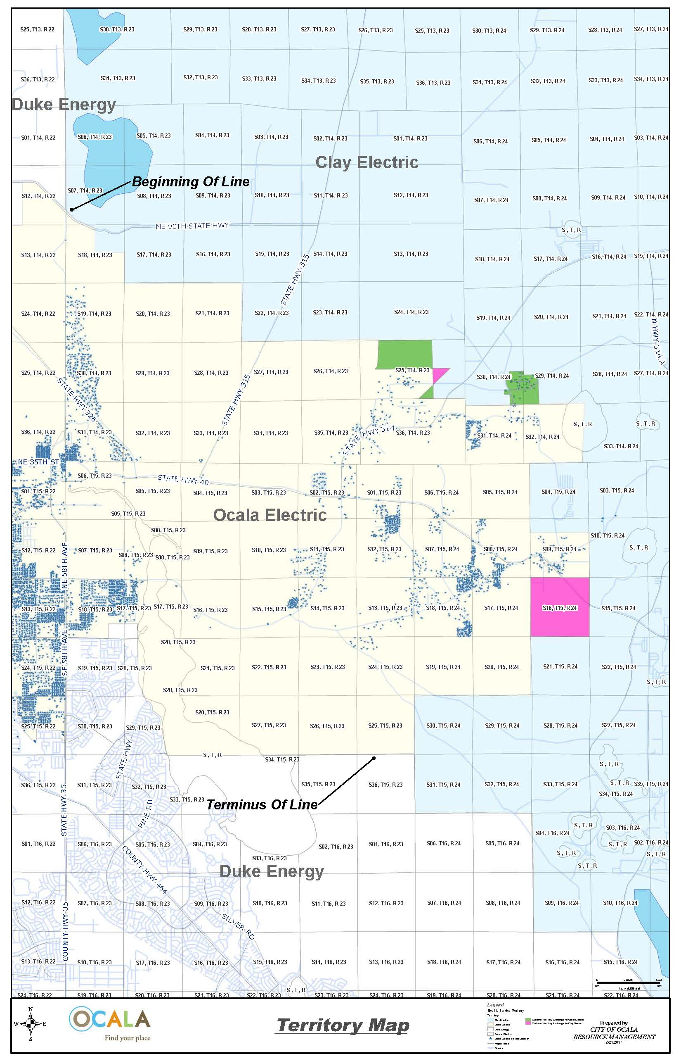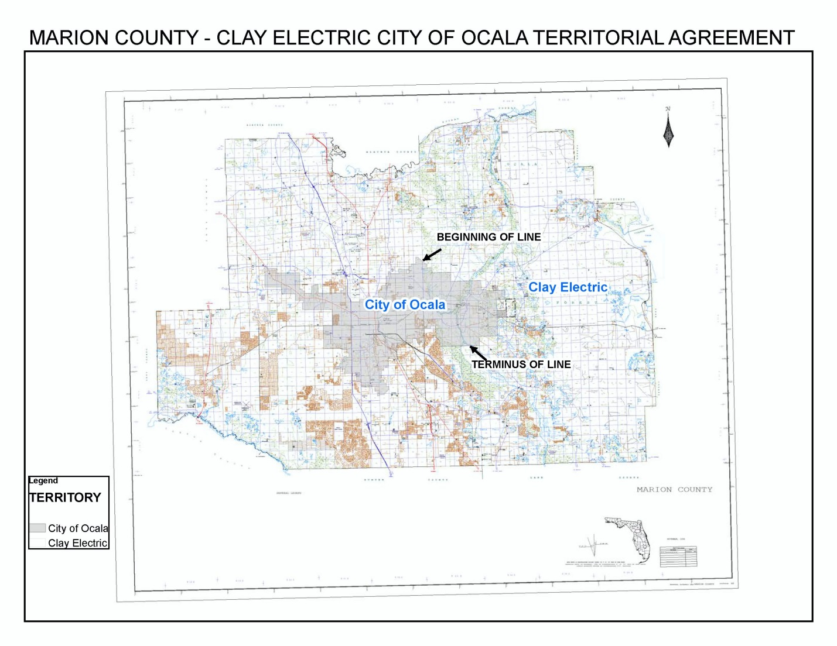

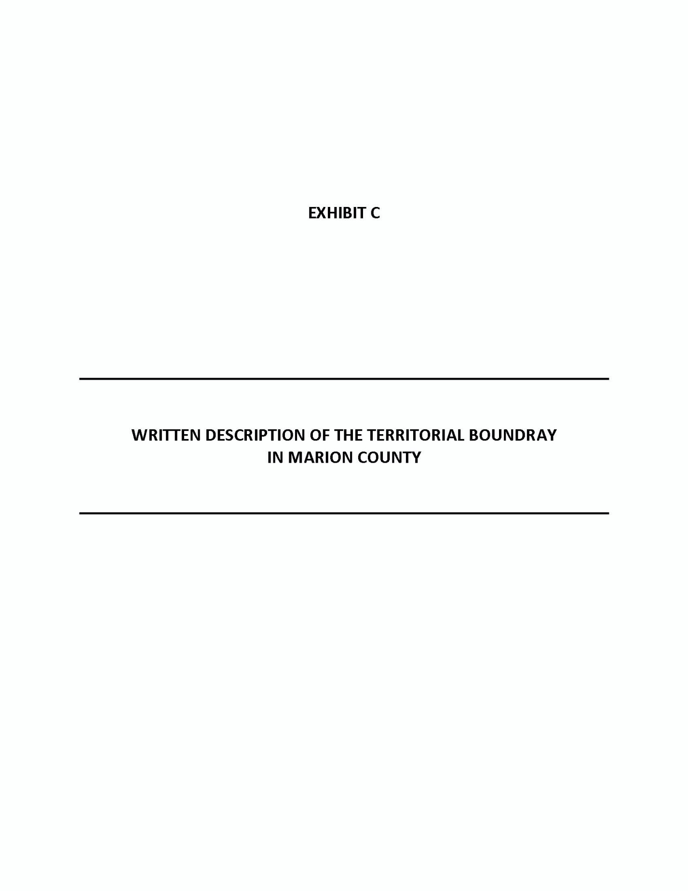

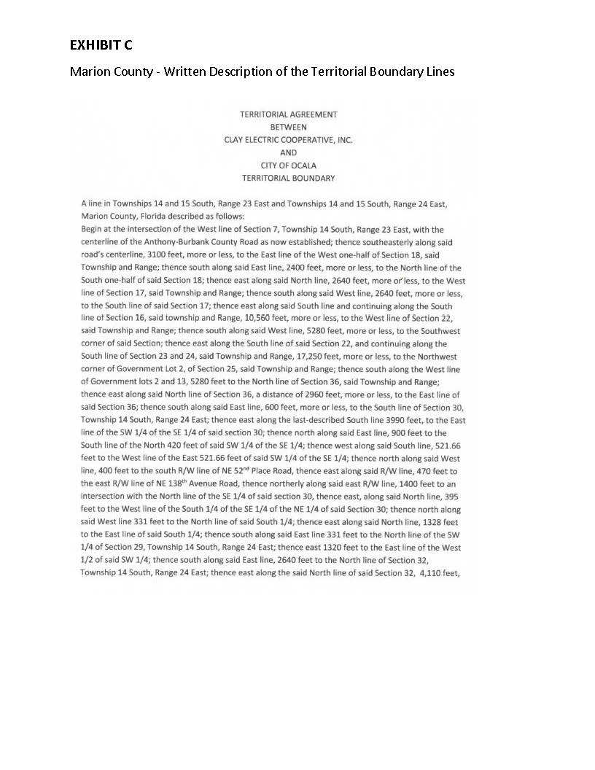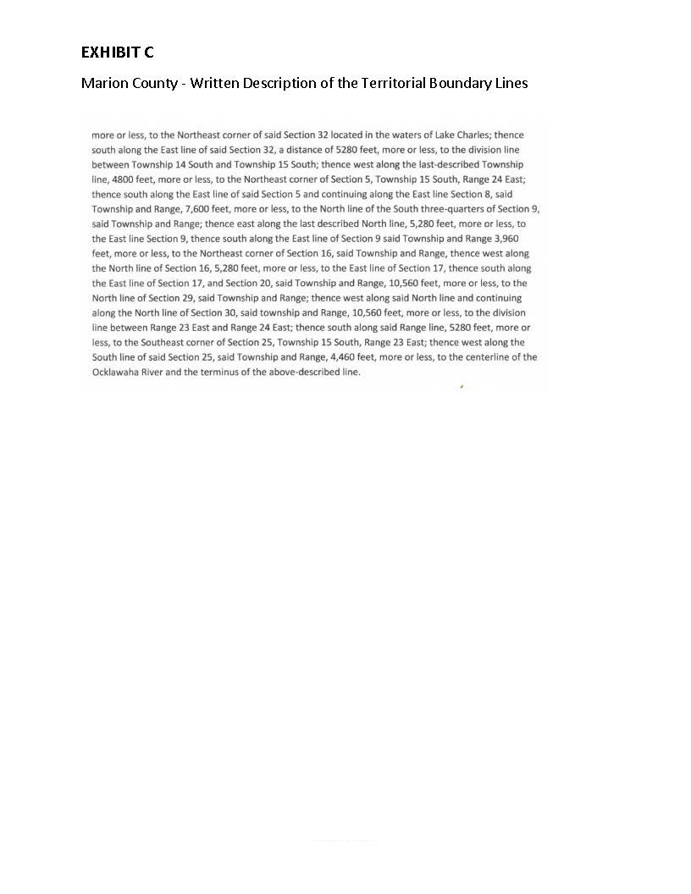

Order No. 16967, issued December 17, 1986, in Docket No. 860658-EU, In re: Joint Petition for Approval of Territorial Agreement Between the City of Ocala and Clay Electric Cooperative, Inc.
Utilities Commission of the City of New Smyrna Beach v. Florida Public Service Commission, 469 So. 2d 731 (Fla. 1985).
Order No. 16967, issued December 17, 1986, in Docket No. 860658-EU, In re: Joint Petition for Approval of Territorial Agreement Between the City of Ocala and Clay Electric Cooperative, Inc.
Response #4 in Staff’s first Data Request.
Joint response to questions 16 and 17 in Staff’s First Data Request.
Exhibit D of the petition.
Response #13 and Exhibits 2 and 3 in response #14 to Staff’s First Data Request.

