State of Florida |  | Public Service Commission  Capital Circle Office Center ● 2540 Shumard Oak Boulevard  Tallahassee, Florida 32399-0850  -M-E-M-O-R-A-N-D-U-M-
DATE: | September 20, 2019
TO: | Office of Commission Clerk (Teitzman)
FROM: | Division of Economics (Coston)  Office of the General Counsel (Trierweiler)
RE: | Docket No. 20190144-EI – Petition for expedited approval of shared solar rider tariff modification, by Tampa Electric Company.
AGENDA: | 10/03/19 – Regular Agenda – Tariff Filing – Interested Persons May Participate
COMMISSIONERS ASSIGNED: |  |  | All Commissioners
PREHEARING OFFICER: |  |  | Administrative
CRITICAL DATES: |  |  | 60-day Suspension waved until 10/03/2019
SPECIAL INSTRUCTIONS: |  |  | None

Case Background
By Order No. PSC-2019-0215-TRF-EI, the Commission approved Tampa Electric Company’s (TECO or utility) Shared Solar Tariff (SSR-1 tariff). The SSR-1 tariff provides residential and commercial customers with the option to purchase energy produced from a TECO-owned solar generation facility to replace all or a portion of their monthly energy consumption. Participants are charged a Shared Solar Charge of $0.063 per kilowatt-hour. The SSR-1 tariff became effective on June 25, 2019, after TECO completed programming its billing system to administer the SSR-1 tariff.

On July 19, 2019, TECO filed for approval of a modification to tariff Sheet No. 3.305 of the SSR-1 tariff. This recommendation addresses the proposed modification to tariff Sheet No. 3.305 as shown in Attachment A to the recommendation. On September 3, 2019, the utility waived the 60-day file and suspend provision of Section 366.06(3), Florida Statutes (F.S.), until the October 3, 2019 Agenda Conference. The Commission has jurisdiction pursuant to Section 366.06, F.S.

Discussion of Issues

Issue 1:
Should the Commission approve TECO's proposed modification to the SSR-1 tariff?

Recommendation:
Yes, the Commission should approve TECO’s proposed modification to tariff sheet No. 3.305, as shown in Attachment A, effective October 3, 2019. (Coston)

Staff Analysis:
TECO has proposed deleting language in its current SSR-1 that precludes customers in its budget billing program from participating in the voluntary SSR-1 tariff. The budget billing plan, or levelized payment plan, is an optional tariff that allows customers to make budgeted monthly payment amounts to help stabilize their monthly payments. TECO explained that at the time the utility developed the SSR-1 tariff, the billing system had limitations that were excluding customers on the budget billing plan from participating in the SSR-1 tariff. As a result of the billing system limitations, TECO included in its original petition for the SSR-1 tariff a provision which provided that customers may not take service under both the budget billing plan and the SSR-1 tariff. As of August 13, 2019, 102 customers have subscribed to TECO’s SSR-1 tariff.
TECO stated that following the Commission’s approval of the SSR-1 tariff, the utility was able to modify its billing system to allow the SSR-1 tariff to be made available to customers also taking service under the utility’s budget billing plan. Therefore, TECO proposed to modify tariff sheet No. 3.305 to allow customers that elect to participate in the budget billing program to also take service under the SSR-1 tariff. TECO states it currently has 55,602 customers that utilize the budget billing program.
The proposed removal of Special Provision No. 6 on tariff sheet No. 3.505 will make the SSR-1 tariff available to levelized payment plan customers. Staff recommends that TECO’s proposed modification to tariff sheet No. 3.305, as shown in Attachment A, is reasonable and should be approved effective October 3, 2019.

Issue 2:
Should this docket be closed?

Recommendation:
Yes. If Issue 1 is approved and a protest is filed within 21 days of the issuance of the order, the tariff should remain in effect pending resolution of the protest. If no timely protest is filed, this docket should be closed upon the issuance of a consummating order. (Trierweiler)

Staff Analysis:
If Issue 1 is approved and a protest is filed within 21 days of the issuance of the order, the tariff should remain in effect pending resolution of the protest. If no timely protest is filed, this docket should be closed upon the issuance of a consummating order.

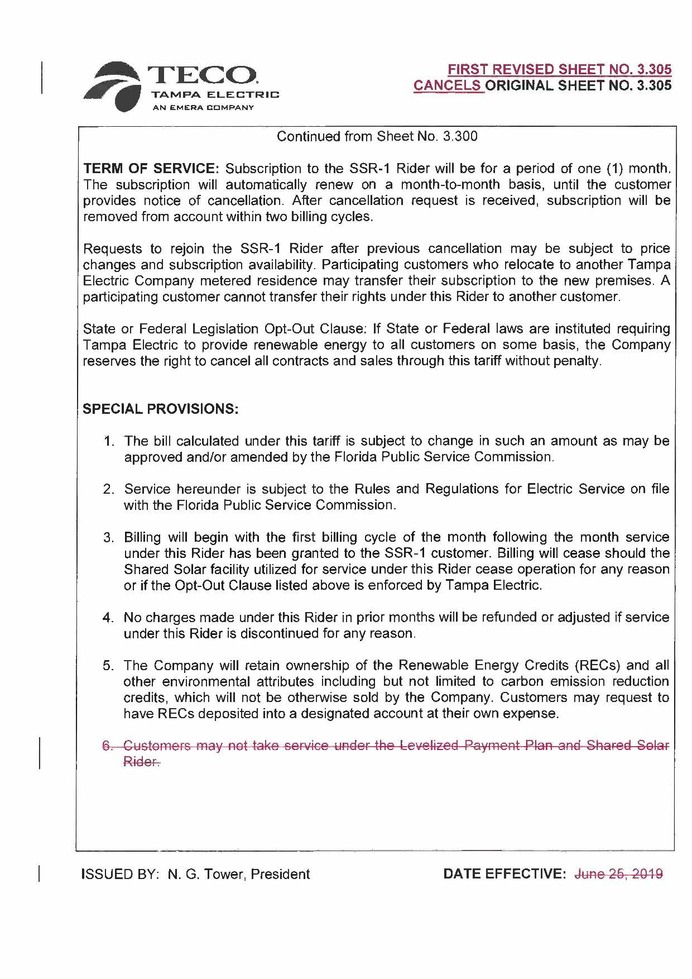

Order No. PSC-2019-0215-TRF-EI, issued June 3, 2019, in Docket No 20180204-EI, In re: Petition for approval of shared solar tariff, by Tampa Electric Company.

