State of Florida |  | Public Service Commission  Capital Circle Office Center ● 2540 Shumard Oak Boulevard  Tallahassee, Florida 32399-0850  -M-E-M-O-R-A-N-D-U-M-
DATE: | September 20, 2019
TO: | Office of Commission Clerk (Teitzman)
FROM: | Office of the General Counsel (Harper, A. King)  Division of Economics (Coston, Draper, Galloway, Guffey, McNulty)  Division of Engineering (Doehling, Graves, L. King)  Office of Industry Development and Market Analysis (Breman, Crawford, Eichler)
RE: | Docket No. 20190131-EU – Proposed adoption of Rule 25-6.030, F.A.C., Storm Protection Plan and Rule 25-6.031, F.A.C., Storm Protection Plan Cost Recovery Clause.
AGENDA: | 10/03/19 – Regular Agenda – Rule Proposal – Interested Persons May Participate
COMMISSIONERS ASSIGNED: |  |  | All Commissioners
PREHEARING OFFICER: |  |  | Fay
RULE STATUS: |  |  | Proposal May Not Be Deferred. Rules must be proposed by October 31, 2019.
SPECIAL INSTRUCTIONS: |  |  | None

Case Background
The 2019 Florida Legislature passed SB 796 to enact Section 366.96, Florida Statutes (F.S.), entitled “Storm protection plan cost recovery.” Section 366.96, F.S., requires each investor-owned electric utility (IOU) to file a transmission and distribution storm protection plan (storm protection plan) for the Commission’s review and directs the Commission to hold an annual proceeding to determine the IOU’s prudently incurred costs to implement the plan and allow recovery of those costs through a Storm Protection Plan Cost Recovery Clause (SPPCRC).
Section 366.96(3), F.S., requires the Commission to adopt rules to specify the elements that must be included in an IOU’s filing for the Commission’s review of its storm protection plan. Section 366.96(11), F.S., further requires that the Commission adopt rules to implement and administer the section and mandates that the Commission propose a rule for adoption as soon as practicable after the effective date of the act, but not later than October 31, 2019.
In furtherance of the Legislature’s directive, the Commission’s Notice of Development of Rulemaking was published in Volume 45, No. 11, of the Florida Administrative Register on June 7, 2019. The notice included two new rules: Rule 25-6.030, Florida Administrative Code (F.A.C.), which would specify the elements that must be included in an IOU’s storm protection plan; and Rule 25-6.031, F.A.C., which would establish the SPPCRC.
Staff held rule development workshops to obtain stakeholder comments on the draft rules on June 25, 2019, and August 20, 2019. Representatives from Florida Power & Light Company (FPL), Tampa Electric Company (TECO), Duke Energy Florida, LLC (DEF), Gulf Power Company (Gulf), Florida Public Utilities Company (FPUC), Florida Retail Federation (FRF), Florida Industrial Power Users Group (FIPUG), and the Office of Public Counsel (OPC) participated at the workshops and submitted post-workshop comments. Additionally, representatives from Florida Electric Cooperatives Association, Inc., (FECA) and Florida Municipal Electric Association (FMEA) submitted post-workshop comments.
The Notice of Development of Rulemaking also included a number of existing Commission rules that staff identified as potential candidates for amendment or repeal in order to fully implement the new legislation. Several stakeholders opined that it would be difficult to determine any effects on existing rules until Rules 25-6.030 and 25-6.031, F.A.C., were adopted and effective. Staff agrees. Thus, whether any other existing rules should be amended or repealed will be addressed in a future staff recommendation for the Commission’s consideration after Rules 25-6.030 and 25-6.031, F.A.C., become effective.

Storm Protection Plans
Prior to the enactment of Section 366.96, F.S., IOUs submitted storm hardening plans pursuant to Rule 25-6.0342, F.A.C., Electric Infrastructure Storm Hardening, and recovered storm hardening costs through base rate proceedings. Section 366.96, F.S., changes this process.
Section 366.96, F.S., finds that it is in the state’s interest for IOUs to protect and strengthen the state’s transmission and distribution systems in order to reduce outage times and restoration costs associated with extreme weather conditions and enhance overall reliability. In furtherance of this interest, Section 366.96(3), F.S., requires each IOU to file a storm protection plan that covers the immediate 10-year planning period and explains the systematic approach the utility will follow to reduce restoration costs and outage times associated with extreme weather events. The statute requires the Commission to adopt rules to specify the elements that must be included in each utility’s storm protection plan. The intent of Rule 25-6.030, F.A.C., Storm Protection Plan, is to meet this statutory mandate.
Section 366.96(5), F.S., requires that no later than 180 days after an IOU files a storm protection plan that contains all of the elements required by the Commission rule, the Commission must determine whether it is in the public interest to approve, approve with modification, or deny the plan. The statute requires that in reviewing the storm protection plan, the Commission must consider the following four criteria:
- The extent to which the plan is expected to reduce restoration costs and outage times associated with extreme weather events and enhance reliability, including whether the plan prioritizes areas of lower reliability performance.
- The extent to which storm protection of transmission and distribution infrastructure is feasible, reasonable, or practical in certain areas of the utility’s service territory, including, but not limited to, flood zones and rural areas.
- The estimated costs and benefits to the utility and its customers of making the improvements proposed in the plan.
- The estimated annual rate impact resulting from implementation of the plan during the first 3 years addressed in the plan.
Thus, the information required by the Commission in Rule 25-6.030, F.A.C., Storm Protection Plan, must enable the Commission to review each utility’s storm protection plan under the above criteria and ultimately determine whether the plan is in the public interest.
Staff envisions that after Rule 25-6.030, F.A.C., becomes effective, the Commission will open dockets to review each utility’s storm protection plan. The Prehearing Officer will issue an Order Establishing Procedure (OEP) to set all the controlling dates in the dockets, including the date by which the IOUs must submit their plans and the hearing dates. Although separate dockets will be opened to address each IOU’s storm protection plan, staff envisions that one hearing will be held to address all of the dockets. As mentioned above, the Commission will have 180 days after the IOU files its plan to approve, approve with modifications, or deny the plan.
Additionally, Section 366.96(6), F.S., mandates that at least every 3 years after approval of an IOU’s storm protection plan, the utility must file for Commission review an updated storm protection plan that addresses each element specified by Commission rule. The Commission must approve, modify, or deny each updated plan pursuant to the criteria used to review the initial plan. Staff envisions that the Commission will open dockets every 3 years to review each utility’s updated storm protection plan and that the Prehearing Officer will issue an Order Establishing Procedure to set all controlling dates in the dockets.
Section 366.96(10), F.S., also requires that beginning December 1 of the year after the first full year of implementation of a storm protection plan and annually thereafter, the Commission must submit a report on the status of IOUs’ storm protection activities to the Governor, the President of the Senate, and the Speaker of the House of Representatives. The report must include, but is not limited to, identification of all storm protection activities completed or planned for completion, the actual costs and rate impacts associated with completed activities as compared to the estimated costs and rate impacts for those activities, and the estimated costs and rate impacts associated with activities planned for completion. Staff is recommending requirements in Rule 25-6.030, F.A.C., to gather the information that the Commission will need to develop its report pursuant to the statute. Staff envisions that approval of this report will take place at a Commission Internal Affairs meeting.

Storm Protection Plan Cost Recovery Clause
Section 366.96(7), F.S., directs the Commission to conduct an annual proceeding, the “storm protection plan cost recovery clause,” to determine an IOU’s prudently incurred storm protection plan costs and allow the utility to recover such costs through a charge separate and apart from its base rates. Rule 25-6.031, F.A.C., is intended to establish the SPPCRC, pursuant to the statute.
Section 366.96(9), F.S., specifically includes in those recoverable costs the depreciation costs associated with eligible capital expenditures, as well as a return on the undepreciated portions of capital expenditures at the company’s weighted average cost of capital. If the Commission determines that costs were prudently incurred, those costs will not be subject to disallowance or further prudence review except for fraud, perjury, or intentional withholding of key information by the public utility. Section 366.96(8), F.S., provides that costs may be recovered through the clause only if they are not recovered through base rates.
Once Rule 25-6.031, F.A.C., becomes effective, staff envisions that the Commission will open a docket to establish the SPPCRC and that like the Commission’s other cost recovery clause dockets, the Prehearing Officer will issue an OEP to set forth all the controlling dates in the docket, including the dates by which any requests for cost recovery for the year must be filed. Staff also envisions that the SPPCRC will become a “roll-over” docket like the Commission’s other cost recovery clause dockets.
There was discussion at the workshop and in post-workshop comments from stakeholders as to when the hearing in the SPPCRC should be held. Section 366.96, F.S., does not mandate IOUs to file for cost recovery each year under the new clause, nor does the section contain any dates by which the Commission must render its decision on any requests for cost recovery. Thus, staff believes that the Commission has the discretion to determine the hearing dates for this clause proceeding, and like the other cost recovery clauses any controlling dates for the proceeding should be determined by the Prehearing Officer, in conjunction with the Chairman’s Office.
The Process for Storm Plan Approval and Cost Recovery
Staff envisions that once Rules 25-6.030 and 25-6.031, F.A.C., become effective, the Commission will open dockets simultaneously to address the plans and establish the SPPCRC. While each IOU will have a docket to address its storm protection plan, one hearing will be held to address all the plans. There will be a single docket and single hearing for the SPPCRC, which will address IOUs’ recovery of costs incurred implementing the storm protection plans. The hearing on an IOU’s petition for cost recovery will be held only after the Commission has approved the utility’s storm plan. Accordingly, staff envisions that the process will work as follows: First, an electric utility will submit to the Commission a storm protection plan; then the Commission will hold a hearing in the plan docket to determine if the utility’s storm protection plan is reasonable. If the utility’s storm protection plan is approved, the utility’s petition for cost recovery for that plan will be addressed in the hearing in the clause docket. If the utility’s petition for cost recovery is approved in the SPPCRC, factors will be set and go into effect at a date determined by the Commission. Though storm protection plan cost recovery factors will be calculated separately, they will be incorporated in the energy charge line item that includes the other clauses on customers’ bills.

This recommendation addresses whether the Commission should propose new Rules 25-6.030 and 25-6.031, F.A.C. The Commission has jurisdiction pursuant to Sections 120.54 and 366.96, F.S.

Discussion of Issues

Issue 1:
Should the Commission propose the adoption of Rule 25-6.030, F.A.C., Storm Protection Plan, and Rule 25-6.031, F.A.C., Storm Protection Plan Cost Recovery Clause?

Recommendation:
Yes. The Commission should propose the adoption of Rules 25-6.030 and 25-6.031, F.A.C., as set forth in Attachment A. The Commission should also certify Rules 25-6.030 and 25-6.031, F.A.C., as minor violation rules. (Breman, Eichler, Harper, A. King, Graves, Guffey)

Staff Analysis:
The purpose of this rulemaking is to create Rule 25-6.030. F.A.C., to specify the elements that must be included in an investor-owned utility’s storm protection plan, and Rule 25-6.031, F.A.C., to establish the SPPCRC. Staff is recommending that the Commission propose the rules as set forth in Attachment A.

Overarching Themes That Emerged During Rule Development
Staff held two rule development workshops on Rules 25-6.030 and 25-6.031, F.A.C. Three overarching themes seemed to drive the bulk of the stakeholder’s comments. The first is whether Section 366.96, F.S., permits the Commission to allow recovery of projected costs in the SPPCRC. The second is when and through what filing should IOUs provide project-level detail to the Commission. The third is what the approval of a storm protection plan means for approval of costs in the SPPCRC. Before staff discusses its recommended language for each rule, staff believes that it is important to discuss these overarching issues.

Allowing for Projected Costs vs. Actual/Incurred Costs Only
Staff envisions the SPPCRC mirroring other Commission cost recovery clauses. In the Nuclear Cost Recovery Clause (NCRC), Energy Conservation Cost Recovery Clause (ECCR), and Environmental Cost Recovery Clause (ECRC), the Commission projects the costs the utility will incur in the next year and sets a factor that will allow the company to recover those costs from customers as the costs are incurred. Because the costs and the sales used to set the factor are estimated, the amount of money the utility actually recovers may be more or less than the actual costs. During the year the costs are incurred and the year after the costs are incurred, the Commission performs a true-up of the costs and the recovered amounts so that the utility ultimately recovers only those costs actually incurred.
OPC asserts that Section 366.96, F.S., only permits IOUs to recover their prudently incurred costs through the new cost recovery clause. OPC argues that the Commission can allow IOUs to recover projected costs that are later trued-up through the NCRC and ECRC because the statutes creating those clauses specifically reference “projected” costs. According to OPC, because Section 366.96, F.S., does not specifically provide for this same mechanism, it therefore prohibits it. In support of this argument, OPC points to earlier versions of SB 796 that contained language referring to the recovery of projected costs—language that was almost identical to the language used in the ECRC statute—and notes that the specific language on projected costs was removed as the bill made its way through legislative committees.
Staff disagrees with OPC’s reading of the statute. While the terms “projected costs” and “true-up” are not in Section 366.96, F.S., the statute does not specifically bar the recovery of incurred costs through the recovery of projected costs that are later trued-up. The statute is silent on the matter; it only says that the Commission must allow the IOUs to recover their prudently incurred costs. Additionally, the fact that language explicitly providing for the recovery of projected costs was removed by the Senate proves nothing about the meaning of the final version of the bill that became law. “[O]ur legislatures speak only through statutes,” not the legislative history underlying them. Declaring the meaning of a statute based on speculation about why specific language was removed from the bill during the legislative process is improper.
The IOUs state that storm protection plan cost recovery should be based on projected costs and that OPC’s reading of Section 366.96, F.S., is unduly restrictive. FPL states that this mechanism has worked well for a wide variety of costs in other clause proceedings “because it allows IOUs to begin recovery of costs as the costs are projected to be incurred, while providing staff and intervenors with essentially three opportunities to review the costs before their recovery is finalized.” FPL also points out that the Commission has allowed recovery of projected costs subject to true-up with actual costs under Section 366.93(2), F.S., the NCRC, which provides generally for recovery of “costs incurred” and only refers to projected costs in connection with carrying costs on an IOU’s projected construction cost balance.
Staff believes Section 366.96, F.S., gives the Commission discretion to determine the mechanism by which IOUs can recover their prudently incurred costs, including allowing IOUs to recover projected costs and truing-up those projections when actual cost data becomes available. First and foremost, by using this method, IOUs would ultimately recover only their actual prudently incurred costs. This not only comports with the current procedure in the NCRC and ECRC clauses, but it is also consistent with Section 366.96(7), F.S., which directs the Commission to allow the IOUs to recover “prudently incurred . . . storm protection plan costs . . . through a charge separate and apart from its base rates.”
Second, allowing for the recovery of projected costs enables the IOUs to recover costs as they are incurred. This reduces regulatory lag and, ultimately, the costs passed on to customers, which is the purpose of cost recovery clauses. Staff believes IOUs will be entitled to recover carrying costs associated with the lag between when they incurred costs and when they recover them. Under OPC’s interpretation, an IOU would incur costs in one year but couldn’t request recovery of those costs until the next year’s SPPCRC. If the Commission approved those costs in the SPPCRC, the utility could not begin recovering the costs until the year after. This leaves customers paying carrying costs for two years. Thus, using a cost recovery mechanism that should minimize that regulatory lag, as staff is recommending in draft Rule 25-6.031, F.A.C., should also minimize the carrying costs customers have to pay.
Third, allowing for the timely recovery of costs incentivizes IOUs to undertake capital-intensive projects that will achieve the purpose of the statute: hardening the state’s electric transmission and distribution infrastructure to better withstand extreme weather conditions.
Fourth, the new statute is forward thinking as it emphasizes planning in its objective—the statute requires the IOUs to come up with a 10-year plan, not an annual one. Staff believes that consideration of projected costs would be consistent with the requirement of long-term planning to ensure infrastructure is hardened. Allowing projected costs to be included in storm plan petitions gives the Commission a comprehensive view over the IOUs’ long-term storm protection projects. This is in the public interest because it allows for transparency and review of the projects before the projects are completed and costs are incurred. Staff believes that the approval of a storm protection plan means it is reasonable for an IOU to continue to go forward with the scope of activities and to incur costs consistent with the approved plan.
Staff believes it is in the consumers’ interest for IOUs to recover their incurred costs as near in time to when they were incurred as possible. For the reasons set forth above, staff’s recommended rules provide that projected costs are eligible for cost recovery.

When and Where Project-Level Details Should be Provided
Staff’s recommended rules require IOUs to provide in their storm protection plan project-level data for each of the first three years of the plan. All of the IOUs commented that such a requirement is neither “feasible” nor “desirable.” FPL asserts that the initiation of specific projects within a program is subject to change until shortly before initiation due to a host of factors. It argues that, as a consequence, accurately projecting project-level data two or more years in the future is difficult, if not impossible. Therefore, FPL suggests that the rules should only require the storm protection plan to contain project-level data for the first year of the plan. For the second and third years, it suggests that the data required be “more general” than the data required for the first year yet still “sufficiently detailed” to develop rate-impact estimates. FPL further suggests that project-level detail should be required annually in the clause docket for the subsequent planning year.
OPC and FRF assert that detailed project and spending information is needed to ensure the prevention of double recovery by IOUs. OPC states that “[a]t a minimum, year-by-year project and cost detail should be required on a basis that allows the Commission and customers to determine what costs, activities[,] and projects are being recovered in base rates at the time recovery is sought” in the SPPCRC.
Staff believes that project-level information for each of the first three years is necessary to provide a baseline for the Commission’s review and comparison of costs sought in the SPPCRC. Additionally, without this level of detail, the Commission could not adequately address the legislative requirement of Section 366.96(4), F.S., as to rate impact, nor would it have enough information to make an informed decision to modify a plan pursuant to Section 366.96(5), F.S. For these reasons, staff’s recommended rules require project-level detail for each of the first three years. This is further discussed in the sections of this recommendation pertaining to subsection (3) of Rule 25-6.030, F.A.C., and subsections (3) and (7) of Rule 25-6.031, F.A.C.

How the Storm Rules Will Work Together
The third theme that arose from the rule development workshops was how the approval process for storm protection plans and the clause process would work together, if an IOU chooses to recover costs through the clause. In other words, what does approval of a storm protection plan actually mean in terms of cost recovery later on in the clause?
OPC raised concerns about whether it would have the opportunity to challenge the costs of a project that was part of program and plan that was previously approved by the Commission. Pursuant to Section 366.96, F.S., an electric utility may submit to the Commission a storm protection plan that includes the utility’s proposed programs, projects, and activities that are designed to meet the objectives of the statute, i.e., reducing restoration costs and outage times associated with extreme weather events and enhancing reliability. This is similar to the planning process in the ECRC. If the utility’s storm protection plan is deemed to be in the public interest and is approved, the IOUs are authorized to go forward in implementing the approved plan. Approval of the plan (and programs and projects within the plan), however, does not constitute a de facto approval of the costs. Plan approval means the Commission has deemed the utility’s plan reasonable and the utility may go forward with actions to implement the plan.
The prudence determination is made later in the clause process. As part of the cost recovery clause, an IOU seeking recovery for costs made pursuant to its approved storm protection plan would file its petition at the times directed by the Commission, pursuant to the OEP in the annual cost recovery proceeding. As part of its petition, the IOU would submit a list of projects it anticipates undertaking in the next year, including projected costs for those projects. The Commission would determine whether the anticipated projects and programmatic activity are consistent with the utility’s storm protection plan as well as the reasonableness of the projected costs for those activities. As part of its petition, the utility would also include available actual cost data for the current year’s activities as well as actual cost data for the previous year’s activities. The Commission would determine the prudence of those actual incurred costs and, using the methods already used in other clauses, set factors for the recovery of the projected costs and true-up the recovery of costs actually incurred.

Rule 25-6.030, F.A.C., Storm Protection Plan
Rule 25-6.030, F.A.C., requires each IOU to file a petition with the Commission for approval of a storm protection plan. The rule describes the information that must be included in the storm protection plan, as well as information needed for the Commission to satisfy its duty to file an annual report with the executive and legislative branches detailing the IOUs’ planned and completed storm protection projects and the related rate impacts.

Subsection (1): Application and Scope
This subsection requires each investor-owned electric utility to file a petition with the Commission for approval of a storm protection plan. It also mandates that the plan cover the utility’s immediate 10-year planning period and must be updated every 3 years.
OPC suggests that language be added to this subsection to require each utility to file its plan on the third Monday of January of each year the plan update is to be considered for Commission approval. TECO states that it plans to prepare a storm protection plan and file it with the Commission within 4 to 5 months of the storm rules being adopted, e.g., no later than March 1, 2020. TECO suggests it would be more efficient for all of the IOUs to file their plans at the same time given that the timing of the Commission’s approval must be within the 180 day limit provided by Section 366.96, F.S.
The Commission will have 180 days after the utility files its plan to approve, approve with modifications, or deny the plan; however, there is no requirement in the statute that the Commission must review the plans at a particular time of the year. Thus, staff does not recommend that the Commission include the language offered by OPC, as this language will remove some Commission discretion as to when the Commission wants to conduct its review of plans. As discussed in the Case Background, staff envisions that after Rule 25-6.030, F.A.C., becomes effective, the Commission will open a docket to review each utility’s storm protection plan. The Prehearing Officer will issue an Order Establishing Procedure to set all the controlling dates in the docket, including the date by which investor-owned electric IOUs must submit their plans and the hearing dates. Staff envisions that this same procedure will be used to review future utility storm protection plans as well.

Subsection (2): Definitions
A storm protection plan is comprised of storm protection programs. A program may include specific projects. Paragraph (2)(a) defines a program as a category, type, or group of related storm protection projects that is undertaken to enhance the utility’s existing infrastructure for the purpose of reducing restoration costs and outage times and improving overall service reliability. Paragraph (2)(b) defines a project as a specific activity designed to enhance a specified portion of existing electric transmission or distribution facilities for the purpose of reducing restoration costs and outage times, and improving overall service reliability.
Paragraph (2)(c) identifies the “Transmission and distribution facilities” that will be eligible for storm protection plans. “Transmission and distribution facilities” are defined as “all utility owned poles and fixtures, towers and fixtures, overhead conductors and devices, substations and related facilities, land and land rights, roads and trails, underground conduits, and underground conductors.”
FPL and Gulf argue that the definition of “transmission and distribution facilities” should be expanded to include additional types of assets, such as structures and improvements, station equipment, underground conductors and devices, battery storage equipment, meters and services. FPL also suggests the removal of “substations and related facilities” from the definition because these assets are included within the station equipment accounts.
TECO, DEF, and FPUC echo FPL’s suggestions to expand the definition of “transmission and distribution facilities.” FPUC argues that meters should be specifically enumerated in the definition of “transmission and distribution facilities,” and DEF specifically suggests a change that would explain the definition by including the language “and associated facilities.”
OPC comments that the definition of “transmission and distribution facilities” should be narrowed to track the Federal Energy Regulatory Commission’s Uniform System of Accounts (USOA) definitions of “transmission and distribution facilities.” OPC argues the USOA definition excludes meters, because the primary purpose of a meter is to measure electricity delivery. According to OPC, a meter is therefore incidental and ancillary to storm protection. Also, OPC argues battery storage assets should not be included as transmission and distribution facilities for purposes of storm protection because they are broadly categorized under the USOA as production plant. Thus, OPC argues storage assets are not solely for resilience against extreme weather.
Rule 25-6.030(3)(j), provides that the IOUs can submit in its plan “[a]ny other factors the utility requests the Commission to consider.” FPUC expresses concerns that this language could be narrowly construed to include only factors pertaining to programs and projects consistent with the definition of “transmission and distribution facilities.” FPUC’s concerns appear to be based on a misunderstanding of the statute. The purpose of the statute is to encourage programs and projects that protect the utility’s transmission and distribution system. It does not require that every program or project entail a physical change to the transmission and distribution system itself. Said differently, staff intends for paragraph (3)(j) to be interpreted to encompass factors pertaining to programs and projects that are designed to protect the utility’s transmission and distribution facilities as that term is defined in the rule.

Subsection (3): Contents of the Storm Protection Plan
Subsection (3) provides the specific information that must be provided in each storm protection plan, including descriptions of the utility’s service area, the areas prioritized for enhancement, and any areas where the utility has determined that enhancement of the utility’s existing transmission and distribution facilities would not be feasible, reasonable, or practical.
Subsection (3) also requires the utility to provide certain cost estimates, such as an estimate of the annual jurisdictional revenue requirements for each year of the storm protection plan and an estimate of rate impacts for each of the first three years of the storm protection plan for residential, commercial, and industrial customers. Paragraph (3)(e) requires that for each of the first three years in an IOU’s storm protection plan the utility provide a description of each proposed storm protection project that includes:
- The actual or estimated construction start and completion dates;
- A description of the affected existing facilities, including number and type(s) of customers served, historic service reliability performance during extreme weather conditions, and how this data was used to prioritize the proposed storm protection project; and
- A cost estimate including capital and operating expenses; and
- A description of the criteria used to select and prioritize proposed storm protection projects.
Paragraph (3)(f) requires the utility to provide a description of its proposed vegetation management activities. The utility’s description must include the projected frequency (trim cycle), the projected miles of affected transmission and distribution overhead facilities, the estimated annual labor and equipment costs for both utility and contractor personnel, and a description of how the vegetation management activity will reduce outage times and restoration costs due to extreme weather events.

Level of Project Detail Required in Storm Protection Plans
The IOUs take issue with the requirement for project-level information in years 2 and 3, arguing that it is not feasible or desirable for the specific projects for years 2 and 3 to be detailed in the plan. Because projects inevitably change due to a host of issues including access, customer acceptance, and changing priorities, the IOUs argue that years 2 and 3 are sufficiently detailed if the IOUs provide the type and number of projects and program costs to support the development of annual rate-impact estimates for the first 3 years. FPL suggests the following rule language in paragraph (3)(e) instead of staff’s recommended rule language:
(e) For each of the first three years in a utility’s Storm Protection Plan, the utility must provide the following information:
1. For the first year of the plan, a description of each proposed storm protection project that includes:
i. 1. The actual or estimated construction start and completion dates;
ii. 2. A description of the affected existing facilities, including the number and type(s) of customers served, historic service reliability performance during extreme weather events, and how this data was used to prioritize the proposed storm protection project; and
iii. 3. A cost estimate including capital and operating expenses, both fixed and variable; and
iv. 4. A description of the criteria used to select and prioritize proposed storm protection projects.
2. For the second and third years of the plan, project related information such as estimated number and cost of projects under a specific program, in sufficient detail, to allow the development of preliminary estimates of rate impacts as required under subsection 3(h) of this rule.

FPL suggests that project-level detail be provided annually for the current year in the actual/estimated true-up filings under Rule 25-6.031, F.A.C.
TECO also opposes project-level detail in years 2 and 3 in the plan and suggests that the Commission consider the level of cost detail found in the Demand-Side Management Plans as a benchmark for the cost detail necessary in the storm protection plans. Likewise, DEF specifically cautioned against rule language requiring project-level information in each of the first 3 years because such a requirement may result in petitions for rule waiver. According to DEF, the requirement for 3 years of project-level data would force it to either “create data that will be subject to extensive revision and [is without] business purpose—an inefficient use of resources to both create and review—or file for a rule waiver.” Moreover, all of the IOUs believe that project-level shifts within an approved program should not constitute a modification that requires Commission action.
FRF expresses support of project-level detail to ensure costs are not double recovered. FRF commented at the workshop that the rule should require extensive accounting data and more than just a description of selection and prioritization. FRF suggests IOUs should be required to demonstrate that selection and prioritization of all projects are based on objective principles and benefits to customers.
OPC states that project-level details are necessary to ensure that the costs being recovered through base rates are not also recovered through the SPPCRC. OPC further states that “[g]iven the public interest in protecting against storm damage, all IOUs should have specific plans with detailed cost-tracking that comports with representations made to the Commission and all stakeholders regarding what they have done, are continuing to do and will do to continue storm protection efforts.” It also believes that the Commission should “require each utility to submit information for the last three years detailing all storm hardening projects that have been included in the IOUs construction budgets including status completion.”
OPC suggests edits to the rule that allow for detailed information for the first 3 years of any 10-year plan. OPC states that the initial plan approval in particular should contain detailed project-by-project information for amounts slated for recovery and include detail along the same lines for the historical periods and for current and future periods covered by the approved storm hardening plans that are in effect. According to OPC, without sufficient detail in the plan and the clause filings, it will be difficult to identify and differentiate the approved storm costs the IOUs are recovering in base rates with current storm hardening plans versus the storm related costs IOUs ask for cost recovery for in the SPPCRC. OPC also suggests that detailed data is necessary to understand what costs are tied to settlement agreements and thus necessary to ensure customers do not pay twice for the same costs.
FPL takes issue with OPC’s assertion that costs projected under an IOU’s storm hardening plan that was previously approved prior to these new storm protection plan rules should be treated automatically as already recovered in base rates and thus excluded from cost recovery under the SPPCRC. FPL states that it takes no position on whether the rules need a detailed mechanism or protocol for determining a baseline to measure costs in the SPPCRC. However, costs initially projected to be incurred pursuant to an approved storm protection plan should be eligible for cost recovery under the SPPCRC.
The IOUs have the burden to prove that costs being requested through the SPPCRC are not being recovered in base rates. As such, staff believes that any petition for costs filed in the SPPCRC must evidence that the utility is not seeking double recovery and therefore OPC’s concerns are more appropriately addressed by the filing requirements in Rule 25-6.031, F.A.C., Storm Protection Plan Cost Recovery Clause, which is further discussed below.
With regards to project-level detail for all 3 years and as previously discussed in the overarching themes section of the case background, staff believes that project-level detail for years 1, 2, and 3 provides a baseline for the Commission’s review and comparison of costs sought in the SPPCRC from projects that were previously approved in a storm protection plan. This information is also relevant to comply with subsections (4) and (5) of Section 366.96, F.S. This level of detail is necessary for the Commission to adequately address the legislative requirement of Section 366.96(4), F.S. Also, without project-level detail for all 3 years, the Commission would not have enough information to make an informed decision to modify a plan pursuant to Section 366.96(5), F.S.

Whether Franchise Agreement Information Should be Included in Storm Protection Plans
OPC argues that the storm protection plan should include Franchise Agreements to ensure that programs or projects are not proposed or modified to influence renewals. In response, DEF states such a provision would be beyond the scope of Section 366.96, F.S., and would be information more appropriately sought through discovery rather than the rule.
Staff’s draft rule requires that each utility provide a description of the criteria used to select and prioritize proposed programs and projects. Staff believes that this requirement will provide sufficient information for vetting the basis of proposed programs and projects, including franchise agreements. Thus, such specific criteria in the rule are unnecessary.

Subsection (4): Annual Status Report
Subsection (4) requires that each utility submit to the Commission Clerk an annual status report on the utility’s storm protection plan programs and projects. The rule provides that the annual status report must identify all storm protection plan programs and projects completed in the prior calendar year or planned for completion, provide actual costs and rate impacts associated with completed programs and projects as compared to the estimated costs and rate impacts for those programs and projects, and provide estimated costs and rate impacts associated with programs and projects planned for completion during the next year of the storm protection plan.

Rule 25-6.031, F.A.C., Storm Protection Plan Cost Recovery Clause
Rule 25-6.031, F.A.C., addresses how an IOU may file a petition for recovery of prudently incurred costs through the SPPCRC. Specifically, the rule creates an annual clause proceeding, which consists of a true-up of the previous year’s costs, a true-up and estimation for the current year’s costs, and a projection of next year’s costs. The rule provides that costs recovered in base rates may not be recovered through the clause.

Subsection (2): Simultaneous Filings
Subsection (2) allows an IOU to file a petition for recovery of prudently incurred costs and reasonable projected costs through the SPPCRC after its storm protection plan is filed with the Commission. FPL argues that allowing a petition for cost recovery to be filed simultaneously with the storm protection plan reasonably allows for conducting the clause on an annual basis. OPC stated in the workshop that it would oppose simultaneous plan and clause filings the first time the rules are implemented because it would be too difficult to analyze base rates and incremental costs the first time. Recovery of storm protection plan costs through the SPPCRC is not required by the statute and is discretionary to the IOU.
Staff believes a simultaneous plan and clause petition would allow for administrative efficiency and reduce regulatory lag. Therefore, the rule allows an IOU to file a petition once its storm protection plan is filed with the Commission.
Subsection (2) also provides that if the Commission approves the utility’s storm protection plan with modifications, the utility has 15 business days to file an amended cost recovery petition and supporting testimony reflecting the modifications. FPL suggests rule language that requires an IOU to “promptly file an amended” clause petition in the event that the Commission approves its storm protection plan with modifications. While staff agrees in concept with allowing for prompt filings, staff believes that FPL’s language is too ambiguous. It is staff’s belief that a timeline of 15 business days conveys urgency while recognizing that some time will be needed for the utility to draft and file an amended clause petition.

Subsection (3): Annual Hearing to Determine Reasonableness of Projected Costs and Prudence of Actual Costs
Subsection (3) addresses the role of the annual cost recovery proceeding in determining the reasonableness of an IOU’s projected costs and the prudence of its actual costs to implement an approved storm protection plan. The rule provides that an annual hearing to address petitions for recovery of storm protection plan costs will be held and will be limited to determining the reasonableness of projected storm protection plan costs, the prudence of actual storm protection plan costs incurred by the utility, and to establish storm protection plan cost recovery factors consistent with the requirements of this rule.
In line with its position that storm protection plans should not require the level of detailed information for years 2 and 3 of the plans as required for year 1, FPL proposes that the actual/estimated true-up filing in the cost recovery clause include the project-level information. To accomplish this, FPL suggests that the following language be added to subsection (3) of Rule 25-6.031:
The Commission shall determine the reasonableness of the lists of projects (by applicable program) filed by the utility pursuant to section (7)(b) of this rule based on whether such projects are consistent with the program criteria for such projects approved by the Commission under the utility’s Storm Protection Plan.
Staff disagrees with FPL’s suggestion that additional language is required to clarify the standard that will be applied in the SPPCRC hearings. Subsection (3) already notes that the Commission will determine the reasonableness of projected costs of the storm protection plan, which would necessarily entail a determination that the projects generating those costs are consistent with the plan. Moreover, FPL’s suggested language seems to limit the Commission’s reasonableness determination to only one review at the actual/estimated true-up stage. The current language allows the Commission the flexibility to make reasonableness reviews when necessary throughout the cost recovery process.
In its comments, OPC expresses a “fundamental concern” about the timing of the SPPCRC hearing, advocating that the hearing take place in the first 6 months of the year. OPC suggests that language be added to subsection (3) of the rule to specify that the annual hearing under the rule will be conducted no later than July 31 of each year after the calendar year in which the first phase of the plan was approved. OPC believes that the SPPCRC must be separated out from the other cost recovery clauses due to the amount of time that OPC anticipates it will take to determine whether storm protection plan costs are included in base rates and how such costs are to be determined.
FPL notes in its comments that applying the new clause factors on a mid-year cycle could lead to customer confusion and would introduce unnecessary complexity in the billing process. Although it has no objection to leaving the procedural detail out of the rule and using an Order Establishing Procedure to set all controlling dates, FPL provides a schedule in its comments that essentially mirrors that of the NCRC, with a hearing taking place in August/September and factors going into effect on January 1.
Unlike the Commission’s determination on the utility’s storm protection plan, Section 366.96, F.S., does not include statutory deadlines for the annual SPPCRC hearing. Thus, the Commission has full discretion to determine the hearing dates for this clause proceeding. Staff recommends that hearing dates for the proceeding should be determined by the Prehearing Officer working in conjunction with the Chairman’s Office similar to the other cost recovery clauses.
As discussed in the Case Background, staff envisions that once Rule 25-6.031, F.A.C., becomes effective, the Commission will open a docket to establish the SPPCRC, and the Prehearing Officer will issue an Order Establishing Procedure to set forth all the controlling dates in the docket, including the dates by which any requests for cost recovery for the year must be filed. Staff also envisions that the SPPCRC will become a “roll-over” docket like the Commission’s other cost recovery clause dockets.

Subsection (4): Deferred Accounting Treatment
Subsection (4) of the rule provides that costs recovered through the clause will be trued-up in the clause, and the clause true-up amounts will be afforded deferred accounting treatment at the 30-day commercial paper rate. FPUC suggests that the phrase “over and under-recovery” be inserted after the phrase “cost recovery true-up.” Staff disagrees because the presence of a true-up event means either an over- or under-recovery event has occurred. Thus, staff believes keeping only the phrase “true-up” adequately addresses the occurrence of either an over- or under-recovery.
FPUC also suggests that additional language be added to subsection (4) of the rule to address the regulatory treatment of deferred capitalized expenses. Staff believes the rule does not need to address all existing types of deferred accounting events. As currently drafted, the rule requires information necessary to determine if a petition for cost recovery of prudently incurred costs is consistent with an IOU’s approved storm protection plan. The Commission must also receive enough information to ensure that the utility is not recovering costs through the clause that it will also recover through base rates. Staff believes the recommended rule language does this. Creating a specific list of deferred capitalized expenses could only confuse rather than clarify eligible expenses. Therefore, FPUC’s suggestion is not recommended.
Because OPC is opposed to any provisions in the rule which allow cost recovery for projected costs as opposed to actually incurred costs, OPC also took issue with subsection (4). OPC suggesting limiting the recovery of costs related to variances caused by sales forecasting variances or changes in the utility’s prices for services or equipment. Staff disagrees with OPC’s suggestion for the reasons discussed in the first subsection in the section discussing overarching themes.

Subsection (5): Treatment of Subaccounts
Subsection (5) of the rule requires IOUs to maintain subaccounts for costs subject to recovery to ensure separation of those costs from costs not subject to recovery through the clause.

Subsection (6): Recoverable Costs
Subsection (6) of the rule provides that an IOU’s petition for recovery of costs prudently incurred to implement its storm protection plan may include costs incurred after the filing of the utility’s storm protection plan. The utility may recover the annual depreciation expense on capitalized storm protection plan expenditures using the utility’s most recent Commission-approved depreciation rates. Subsection (6) provides that the utility may recover a return on the undepreciated balance of the costs calculated at the utility’s weighted average cost of capital using the return on equity most recently approved by the Commission. The rule requires that the utility submit its final true-up of storm protection plan revenue requirements based on actual costs for the prior year and previously filed costs and revenue requirements for such prior year along with a description of the work actually performed during such year.
DEF, TECO, and FPUC argue that subsection (6) should specifically allow for the recovery through the SPPCRC of costs incurred developing a storm protection plan. Read together, paragraph (2)(c) and subsection (7) of Section 366.96, F.S., allow for the recovery of “reasonable and prudent costs to implement an approved transmission and distribution storm protection plan.” The plain language of Section 366.96, F.S., allows an IOU to recover the costs of implementing a storm protection plan, not developing it.
Paragraph (6)(b) of the rule states that the utility is not permitted to recover costs through the SPPCRC that are included for recovery through base rates or any other cost recovery mechanism. OPC suggests adding language that states that the “utility must file detailed information consistent with Rule 25-6.030(g), F.A.C., as a part of meeting its burden of demonstrating that clause-eligible costs are not being recovered in base rates or any other cost recovery mechanism.” Staff assumes that OPC’s rule reference is for the purpose of requiring an estimate of the annual jurisdictional revenue requirements for each year of the storm protection plan. Rule 25-6.030(3)(g), F.A.C., requires an IOU to provide an estimate of the annual jurisdictional revenue requirements for each year of the storm protection plan, so it is unnecessary for Rule 25-6.031, F.A.C., to restate that requirement. Moreover, staff believes each utility’s demonstration that its costs are excluded from other recovery mechanisms will be adequately vetted through the clause hearing process pursuant to the filing requirements of Rule 25-6.031, F.A.C.
OPC also suggests that the term “mid-point” be inserted in paragraph (6)(c) after “equity” and before “most recently approved by the Commission.” Staff believes this change is not needed because the return on equity approved by the Commission is used as the midpoint of a range of reasonableness.
In addition, FPL proposes the following language as paragraph (6)(d): “The utility may request recovery of cost of removal and any remaining investment associated with retirements of Storm Protection Plan investments recovered under the clause.” Staff has two concerns about the proposed language. First, staff is unsure how FPL or other IOUs may determine remaining investment for any one asset. Under Rule 25-6.0436 Depreciation, F.A.C., and Rule 25-6.04361 Subcategorization of Electric Plant for Depreciation Studies and Rate Design, F.A.C., many assets, especially transmission and distribution assets, are grouped in mass property accounts, wherein asset age data for any single asset is unknown, thus the remaining investment in that particular asset is also unknown. Staff believes the methodology used to determine the net unrecovered investment amount for a type of asset replaced in a storm protection plan project must take into account the past recovery of both short and long lived assets relative to average service life. Ideally, such a method would be reflective of both the IOUs’ gains received and losses incurred when such assets are removed, yielding net unrecovered investment. Second, the cost of removal is reflected in current depreciation rates for all assets, so some portion of removal costs for all current assets have already been recovered in base rates. Staff is concerned that this is not reflected in FPL’s proposed rule language, which appears to allow for recovery of all removal costs through the clause. For these reasons, staff does not recommend adding FPL’s recommended language.

Subsection (7): Cost Recovery Mechanism and Filing Requirements
Subsection (7) addresses the filing requirements for the SPPCRC and describes the mechanism used to project and true-up costs incurred to implement the utility’s storm protection plan. Paragraphs (7)(a)–(c) describe the same three-step mechanism used in other clauses. The three steps are referred to in those paragraphs as the Final True-up for Previous Year, the Estimated True-up for Current Year, and the Projected Costs for Subsequent Year. In other words, the recovery of incurred costs is a moving three-year process that begins with the projection of future costs and ends with the final true-up of those projected costs. Paragraphs (7)(a)–(d) require the utility to submit data sufficient to allow the Commission to project future costs and determine incurred costs as that data becomes available. Paragraph (7)(d) also requires the utility to submit data establishing sales forecasting variances and changes in the utility’s price of service and equipment. Paragraph (7)(e) requires the utility to submit its proposed factors and effective 12-month billing period.
OPC suggests striking paragraphs (7)(a), (7)(b), and (7)(c) to remove the filing requirements that true-up projected costs to actual incurred costs as well as the associated revenue requirements on a moving three-year basis. In its comments, OPC asserted that there is a lack of statutory authority for projected cost recovery as opposed to costs that have been incurred. OPC recommends striking paragraphs (7)(a) through (c) to conform the rule to that argument. As previously discussed, staff disagrees with OPC’s premise that the rules should not allow for projected costs. Thus, staff believes there is no need to change subsection (7).
FPL suggests that paragraph (7)(b) of the rule be revised to show that this filing would include a listing of project-level information for the current year, consistent with its position that storm protection plans should not require the level of detailed information for years 2 and 3 of the plans, as required for year 1 (see staff’s discussion on subsection (3)(e) of Rule 25-6.030). However, FPL did not propose comparable language for paragraph (7)(c) addressing projections or for true-up filings in paragraph (7)(a). FPL did not state what was unique about the current year filings of paragraph (7)(b) of the rule that necessitated the added language. As previously noted in the analysis for the storm protection plan rule, staff believes each utility’s respective petitions should require a certain level of detail to support the utility’s respective requests in the petitions for cost recovery in the clause. The recommended rule language of paragraph (7)(b) adequately provides the filing requirements consistent with this belief. Thus, the suggested changes are not necessary.
OPC also suggests editing paragraph (7)(e) to make the word “factors” singular. But each utility has multiple rate classes, and each rate class has a unique factor. Therefore, multiple factors will be set for each utility. Staff therefore does not recommend incorporation of the editorial suggestion.

Subsection (8): Effect on Subsequent Rate Proceeding
Subsection (8) provides that recovery of costs under this rule does not preclude an IOU from proposing inclusion of unrecovered storm protection plan implementation costs in base rates in a subsequent rate proceeding. FPUC and FPL suggest subsection (8) should specifically identify or list for inclusion the “future revenue requirements for existing storm protection plan investments” as eligible costs for future base rate recovery. Staff disagrees. Subsections (2), (6), and (8) of the draft rule allow for recovery of costs prudently incurred to implement an IOU’s storm protection plan. The rule allows for recovery of costs prudently incurred after the filing of the utility’s plan that implement the utility’s storm protection plan and that were costs not previously approved in another proceeding. Because Rule 25-6.031, F.S., already covers all types of expenses appropriate for clause recovery, there is no need for the rule to include a specific or enumerated list of the types of costs as suggested by the IOUs. Listing types of costs could confuse rather than clarify what is permitted for recovery under the rule.

Other Issues
FRF suggests that for transparency purposes, the rules should require the storm protection plan cost recovery charges be shown as a separate line item on customers’ bills. TECO recommends that to avoid customer confusion, storm protection plan cost recovery charges be calculated separately but incorporated in the energy charge line item that includes the other clauses on customers’ bills.
Section 366.96, F.S., does not mandate that storm protection plan cost recovery charges be shown as a separate line item on customers’ bills. The statute is silent on the matter. Due to billing system reprograming, the IOUs state they would incur additional costs, which would ultimately be passed on to the customers if the Commission required that the storm protection plan charges be a separate line item. On the other hand, the IOUs say that no additional billing charges will be incurred as long as the storm protection plan charges are incorporated into the non-fuel energy charge on customers’ bills.
Staff believes each utility’s costs, and ultimately the customers’ costs, would be higher if the Commission required a separate line item on customers’ bills. The customers’ bills will include approved storm protection plan cost recovery charges whether they are reflected as line items or included in the energy charge line on the bill. Staff believes that adding additional expenses for the sake of transparency is unnecessary and would be outweighed by lower costs to the customers. Thus, staff believes the rules should not mandate that the storm protection plan cost recovery charges be shown as a separate line item on customers’ bills.
FRF also suggests adding a third rule, Rule 25-6.0301, F.A.C., which would require an IOU to seek Commission approval for changes to its storm protection plan that result in changes to the total cost of the plan of more than a certain percentage of that total. Staff does not believe that such a rule is necessary. Each utility will have to report and explain cost variances in the SPPCRC proceedings. In these proceedings, the utility will have to show cost changes and the cause of those changes. IOUs will also have to show that all of their costs were prudently incurred to implement the utility’s approved plan. In other words, requiring IOUs to seek the Commission’s approval of a storm protection plan modification solely on the basis of a cost variance is unduly duplicative of the scrutiny that will be a part of the SPPCRC.

Minor Violation Rules Certification
Pursuant to Section 120.695, F.S., beginning July 1, 2017, for each rule filed for adoption, the agency head must certify whether any part of the rule is designated as a rule the violation of which would be a minor violation. Under Section 120.695(2)(b), F.S., a violation of a rule is minor if it does not result in economic or physical harm to a person or adversely affect the public health, safety, or welfare or create a significant threat of such harm. Rule 25-6.030, F.A.C., and Rule 25-6.031, F.A.C., will be minor violation rules, as a violation of these rules will not result in economic or physical harm to a person or have an adverse effect on the public health, safety, or welfare or create a significant threat of such harm. Therefore, for the purposes of filing the rules for adoption with the Department of State, staff recommends that the Commission certify proposed Rule 25-6.030 and 25-6.031, F.A.C., as minor violation rules.

Statement of Estimated Regulatory Costs
Pursuant to Section 120.54(3)(b), F.S., agencies are encouraged to prepare a statement of estimated regulatory costs (SERC) before the adoption, amendment, or repeal of any rule. The SERC is appended as Attachment B to this recommendation. The SERC analysis also includes whether the rules are likely to have an adverse impact on growth, private sector job creation or employment, or private sector investment in excess of $1 million in the aggregate within five years after implementation.
The SERC concludes that any economic impacts that might be incurred by affected entities would be a result of the statute rather than the rules. Staff believes that the new rules will not likely directly or indirectly increase regulatory costs in excess of $200,000 in the aggregate in Florida within one year after implementation. Staff notes that the IOUs, in response to staff’s SERC data request, provided potential financial impacts resulting from specific requirements of Chapter 366.96, F.S.
Further, the SERC concludes that the rules will not likely have an adverse impact on economic growth, private-sector job creation or employment, private sector investment, business competitiveness, productivity, or innovation in excess of $1 million in the aggregate within five years of implementation. Thus, the new rules do not require legislative ratification pursuant to Section 120.541(3), F.S.
In addition, the SERC states that the rules will have no adverse impact on small businesses, small cities, or small counties. The rules will have minimal impact on state and local revenues and transactional costs. Any implementation or enforcement costs on the Commission will be offset by the additional staff positions and funding provided under the new law. No regulatory alternatives were submitted pursuant to Section 120.541(1)(a), F.S. None of the impact/cost criteria established in Section 120.541(2)(a), F.S., will be exceeded as a result of the recommended rules.

Conclusion
Based on the foregoing, staff recommends the Commission propose the adoption of Rules 25-6.030 and 25-6.031, F.A.C., as set forth in Attachment A. Staff also recommends that the Commission certify Rules 25-6.030 and 25-6.031, F.A.C., as a minor violation rules.

Issue 2:
Should this docket be closed?

Recommendation:
Yes. If no requests for hearing or comments are filed, the rules should be filed with the Department of State, and the docket should be closed. (Harper, A. King)

Staff Analysis:
If no requests for hearing or comments are filed, the rules may be filed with the Department of State and the docket closed. When these rules become effective, staff will bring a recommendation in a separate docket for the Commission’s consideration on any other existing Commission rules that need to be amended or repealed.

25-6.030 Storm Protection Plan.
(1) Application and Scope. Each utility as defined in Section 366.96(2)(a), F.S., must file a petition with the Commission for approval of a Transmission and Distribution Storm Protection Plan (Storm Protection Plan) that covers the utility’s immediate 10-year planning period. Each utility must file, for Commission approval, an updated Storm Protection Plan at least every 3 years.
(2) For the purpose of this rule, the following definitions apply:
(a) “Storm protection program” – a category, type, or group of related storm protection projects that are undertaken to enhance the utility’s existing infrastructure for the purpose of reducing restoration costs and reducing outage times associated with extreme weather conditions therefore improving overall service reliability.
(b) “Storm protection project” – a specific activity within a storm protection program designed for the enhancement of an identified portion or area of existing electric transmission or distribution facilities for the purpose of reducing restoration costs and reducing outage times associated with extreme weather conditions therefore improving overall service reliability.
(c) “Transmission and distribution facilities” – all utility owned poles and fixtures, towers and fixtures, overhead conductors and devices, substations and related facilities, land and land rights, roads and trails, underground conduits, and underground conductors.
(3) Contents of the Storm Protection Plan. For each Storm Protection Plan, the following information must be provided:
(a) A description of how implementation of the proposed Storm Protection Plan will strengthen electric utility infrastructure to withstand extreme weather conditions by promoting the overhead hardening of electrical transmission and distribution facilities, the undergrounding of certain electrical distribution lines, and vegetation management.
(b) A description of how implementation of the proposed Storm Protection Plan will reduce restoration costs and outage times associated with extreme weather conditions therefore improving overall service reliability.
(c) A description of the utility’s service area, including areas prioritized for enhancement and any areas where the utility has determined that enhancement of the utility’s existing transmission and distribution facilities would not be feasible, reasonable, or practical. Such description must include a general map, number of customers served within each area, and the utility’s reasoning for prioritizing certain areas for enhanced performance and for designating other areas of the system as not feasible, reasonable, or practical.
(d) A description of each proposed storm protection program that includes:
1. A description of how each proposed storm protection program is designed to enhance the utility’s existing transmission and distribution facilities including an estimate of the resulting reduction in outage times and restoration costs due to extreme weather conditions;
2. If applicable, the actual or estimated start and completion dates of the program;
3. A cost estimate including capital and operating expenses;
4. A comparison of the costs identified in subparagraph (3)(d)3. and the benefits identified in subparagraph (3)(d)1.; and
5. A description of the criteria used to select and prioritize proposed storm protection programs.
(e) For each of the first three years in a utility’s Storm Protection Plan, the utility must provide a description of each proposed storm protection project that includes:
1. The actual or estimated construction start and completion dates;
2. A description of the affected existing facilities, including number and type(s) of customers served, historic service reliability performance during extreme weather conditions, and how this data was used to prioritize the proposed storm protection project;
3. A cost estimate including capital and operating expenses; and
4. A description of the criteria used to select and prioritize proposed storm protection projects.
(f) For each of the first three years in a utility’s Storm Protection Plan, the utility must provide a description of its proposed vegetation management activities including:
1. The projected frequency (trim cycle);
2. The projected miles of affected transmission and distribution overhead facilities;
3. The estimated annual labor and equipment costs for both utility and contractor personnel; and
4. A description of how the vegetation management activity will reduce outage times and restoration costs due to extreme weather conditions.
(g) An estimate of the annual jurisdictional revenue requirements for each year of the Storm Protection Plan.
(h) An estimate of rate impacts for each of the first three years of the Storm Protection Plan for the utility’s typical residential, commercial, and industrial customers.
(i) A description of any implementation alternatives that could mitigate the resulting rate impact for each of the first three years of the proposed Storm Protection Plan.
(j) Any other factors the utility requests the Commission to consider.
(4) By June 1, each utility must submit to the Commission Clerk an annual status report on the utility’s Storm Protection Plan programs and projects. The annual status report shall include:
(a) Identification of all Storm Protection Plan programs and projects completed in the prior calendar year or planned for completion;
(b) Actual costs and rate impacts associated with completed activities under the Storm Protection Plan as compared to the estimated costs and rate impacts for those activities; and
(c) Estimated costs and rate impacts associated with programs and projects planned for completion during the next calendar year.
Rulemaking Authority 366.96, FS. Law Implemented 366.96, FS. History–New _____.

25-6.031 Storm Protection Plan Cost Recovery Clause.
(1) Application and Scope. This rule applies to each utility as defined in Section 366.96(2)(a), F.S.
(2) After a utility has filed its Transmission and Distribution Storm Protection Plan (Storm Protection Plan), the utility may file a petition for recovery of associated costs through the Storm Protection Plan cost recovery clause. The utility’s petition shall be supported by testimony that provides details on the annual Storm Protection Plan implementation activities and associated costs, and how those activities and costs are consistent with its Storm Protection Plan. If the Commission approves the utility’s Storm Protection Plan with modifications, the utility shall, within 15 business days, file an amended cost recovery petition and supporting testimony reflecting the modifications.
(3) An annual hearing to address petitions for recovery of Storm Protection Plan costs will be limited to determining the reasonableness of projected Storm Protection Plan costs, the prudence of actual Storm Protection Plan costs incurred by the utility, and to establish Storm Protection Plan cost recovery factors consistent with the requirements of this rule.
(4) Storm Protection Plan cost recovery clause true-up amounts shall be afforded deferred accounting treatment at the 30-day commercial paper rate.
(5) Subaccounts. To ensure separation of costs subject to recovery through the clause, the utility filing for cost recovery shall maintain subaccounts for all items consistent with the Uniform System of Accounts prescribed by this Commission, pursuant to Rule 25-6.014, F.A.C.
(6) Recoverable costs.
(a) The utility’s petition for recovery of costs associated with its Storm Protection Plan may include costs incurred after the filing of the utility’s Storm Protection Plan.
(b) Storm Protection Plan costs recoverable through the clause shall not include costs recovered through the utility’s base rates or any other cost recovery mechanism.
(c) The utility may recover the annual depreciation expense on capitalized Storm Protection Plan expenditures using the utility’s most recent Commission-approved depreciation rates. The utility may recover a return on the undepreciated balance of the costs calculated at the utility’s weighted average cost of capital using the return on equity most recently approved by the Commission.
(7) Pursuant to the order establishing procedure in the annual cost recovery proceeding, a utility shall submit the following for Commission review and approval as part of its Storm Protection Plan cost recovery filings:
(a) Final True-Up for Previous Year. The final true-up of Storm Protection Plan cost recovery for a prior year shall include revenue requirements based on a comparison of actual costs for the prior year and previously filed costs and revenue requirements for such prior year for each program and project filed in the utility’s cost recovery petition. The final true-up shall also include identification of each of the utility’s Storm Protection Plan programs and projects for which costs were incurred during the prior year, including a description of the work actually performed during such prior year, for each program and project in the utility’s cost recovery petition.
(b) Estimated True-Up for Current Year. The actual/estimated true-up of Storm Protection Plan cost recovery shall include revenue requirements based on a comparison of current year actual/estimated costs and the previously-filed projected costs and revenue requirements for such current year for each program and project filed in the utility’s cost recovery petition. The actual/estimated true-up shall also include identification of each of the utility’s Storm Protection Plan programs and projects for which costs have been and will be incurred during the current year, including a description of the work projected to be performed during such current year, for each program and project in the utility’s cost recovery petition.
(c) Projected Costs for Subsequent Year. The projected Storm Protection Plan costs recovery shall include costs and revenue requirements for the subsequent year for each program and project filed in the utility’s cost recovery petition. The projection filing shall also include identification of each of the utility’s Storm Protection Plan programs and projects for which costs will be incurred during the subsequent year, including a description of the work projected to be performed during such year, for each program and project in the utility’s cost recovery petition.
(d) True-Up of Variances. The utility shall report observed true-up variances including sales forecasting variances, changes in the utility’s prices of services and/or equipment, and changes in the scope of work relative to the estimates provided pursuant to subparagraphs (7)(b) and (7)(c). The utility shall also provide explanations for variances regarding the implementation of the approved Storm Protection Plan.
(e) Proposed Storm Protection Plan Cost Recovery Factors. The utility shall provide the calculations of its proposed factors and effective 12-month billing period.
(8) Recovery of costs under this rule does not preclude a utility from proposing inclusion of unrecovered Storm Protection Plan implementation costs in base rates in a subsequent rate proceeding.
Rulemaking Authority 366.96, FS. Law Implemented 366.96, FS. History–New _____.

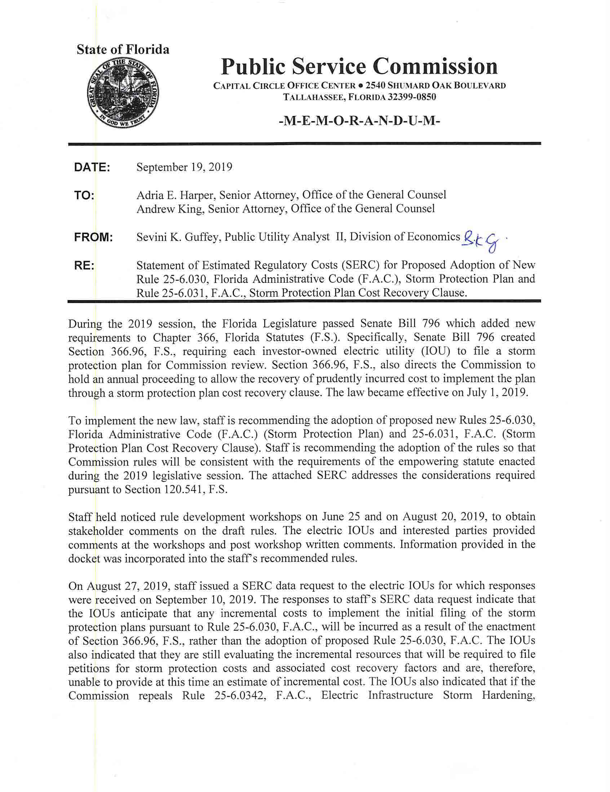

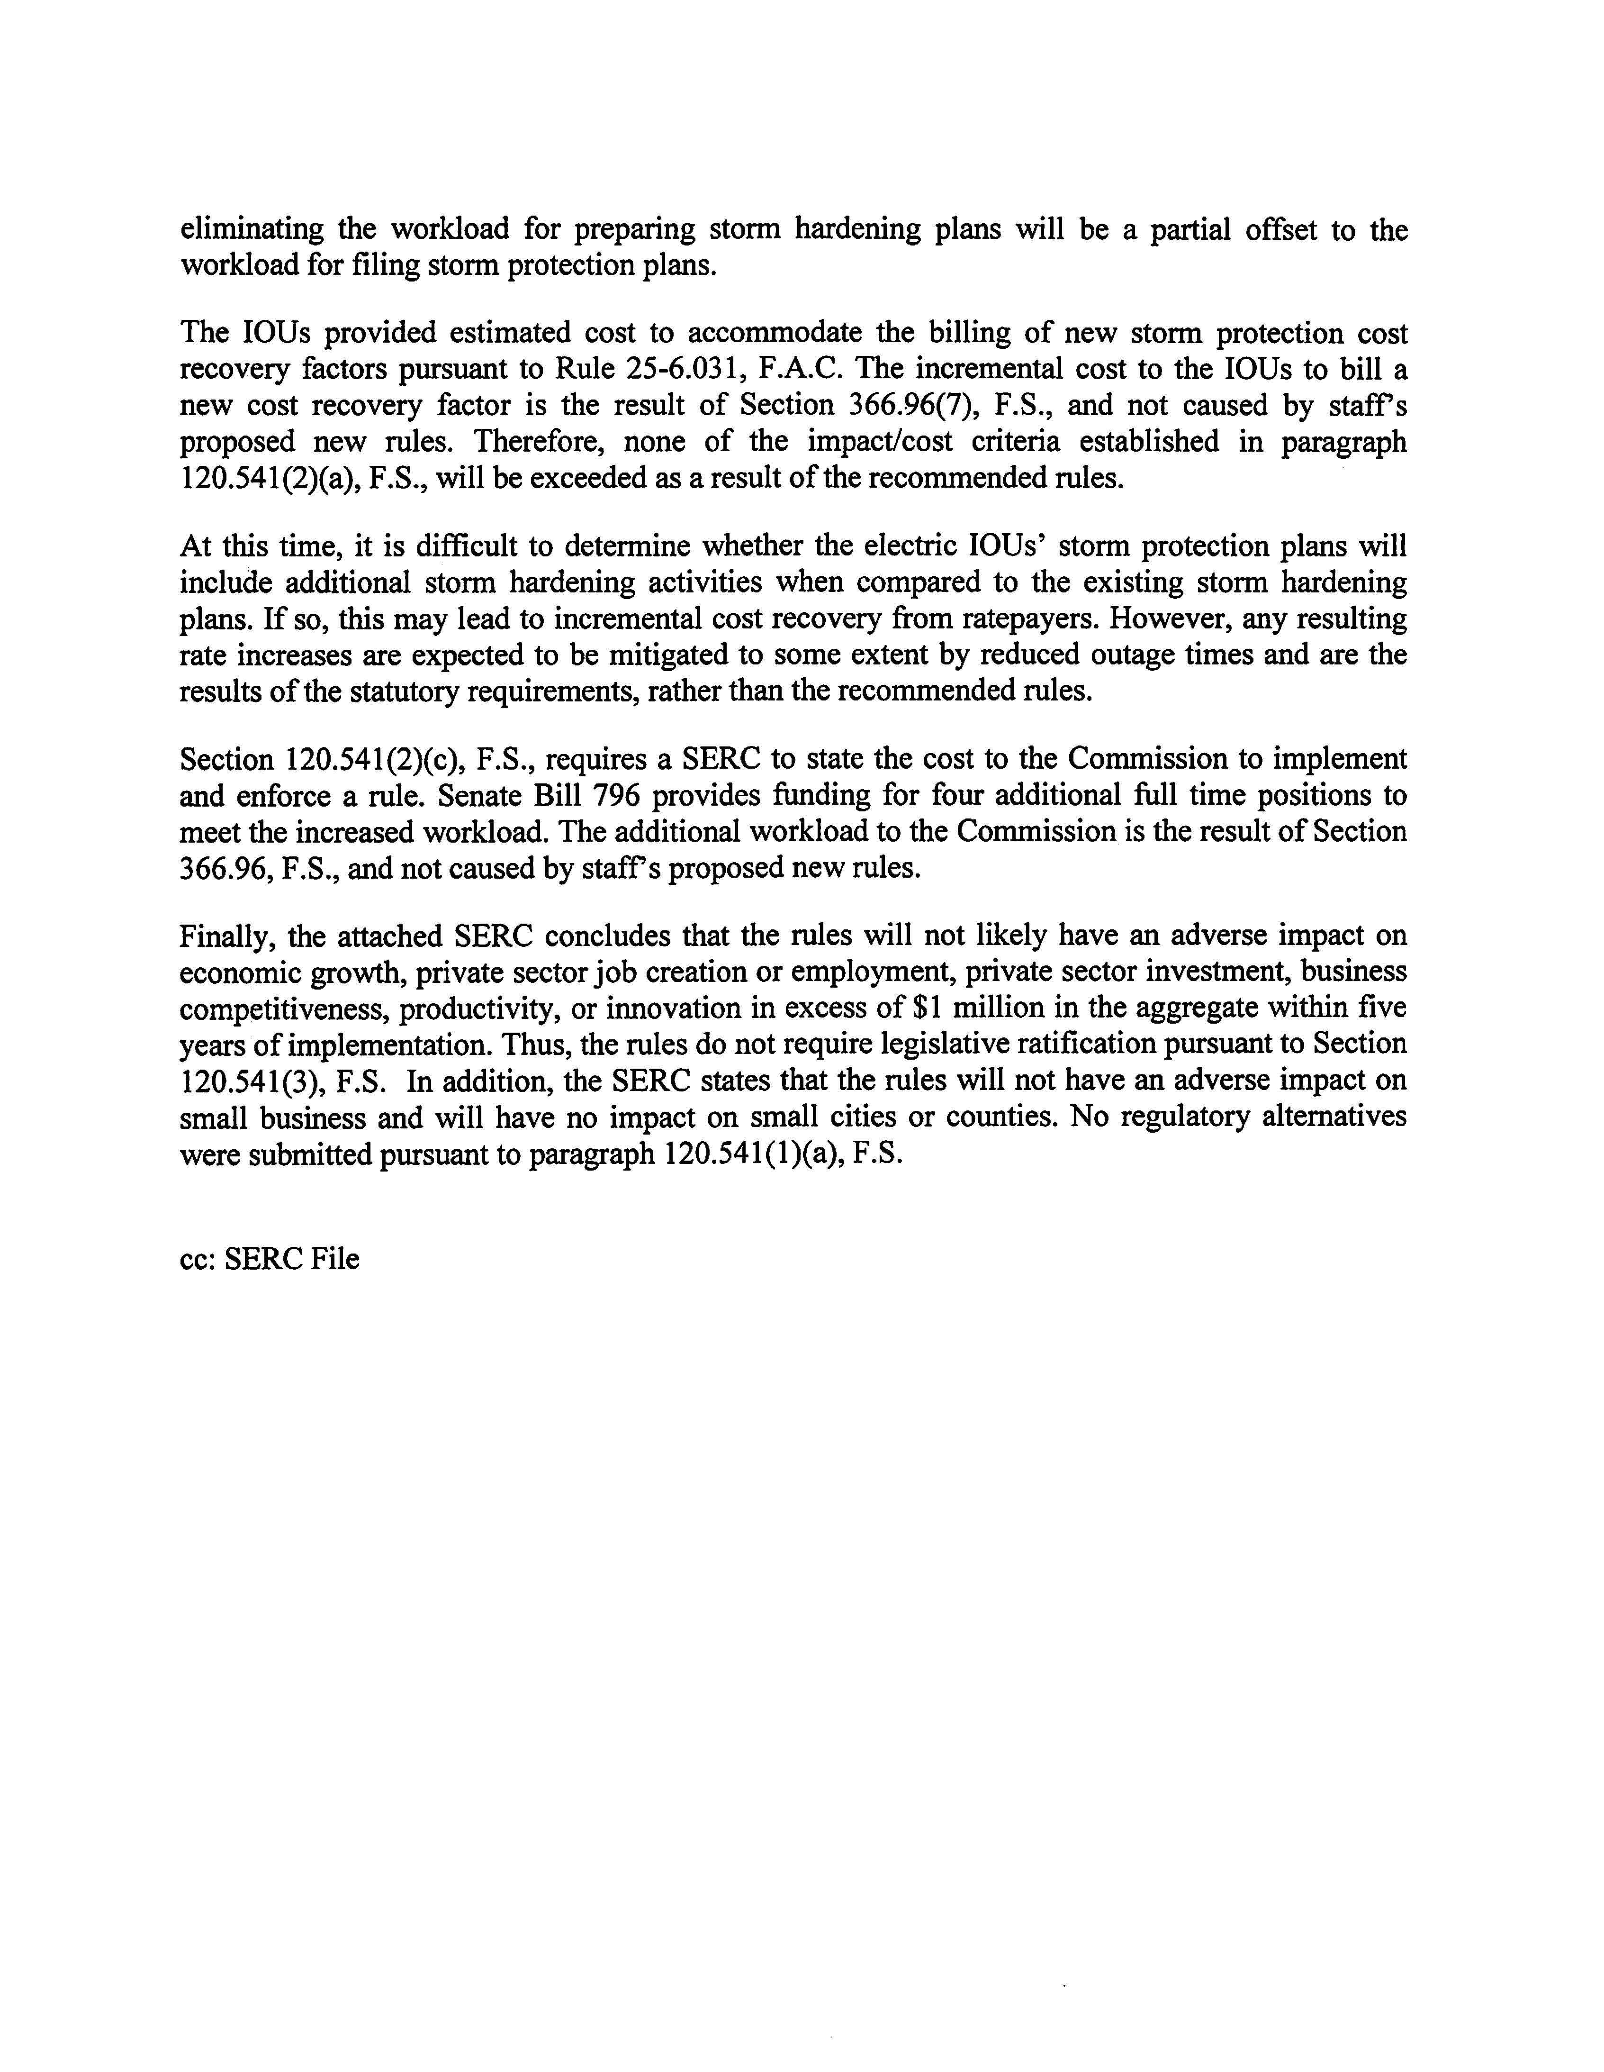

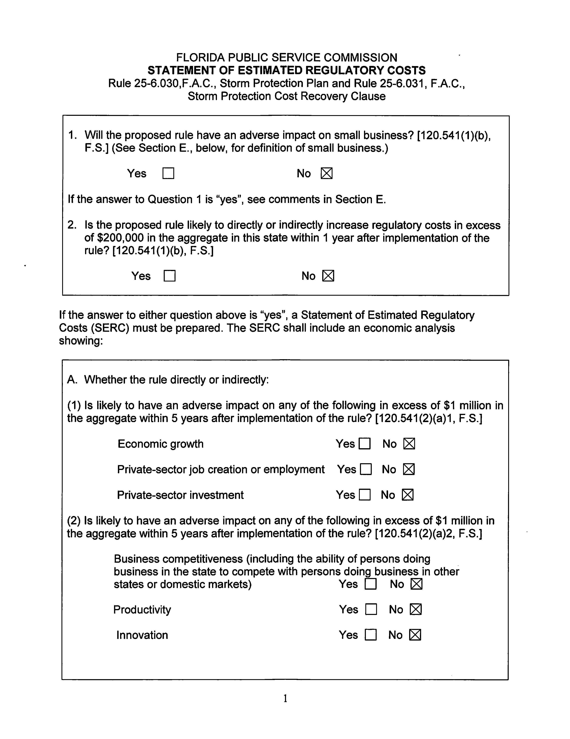

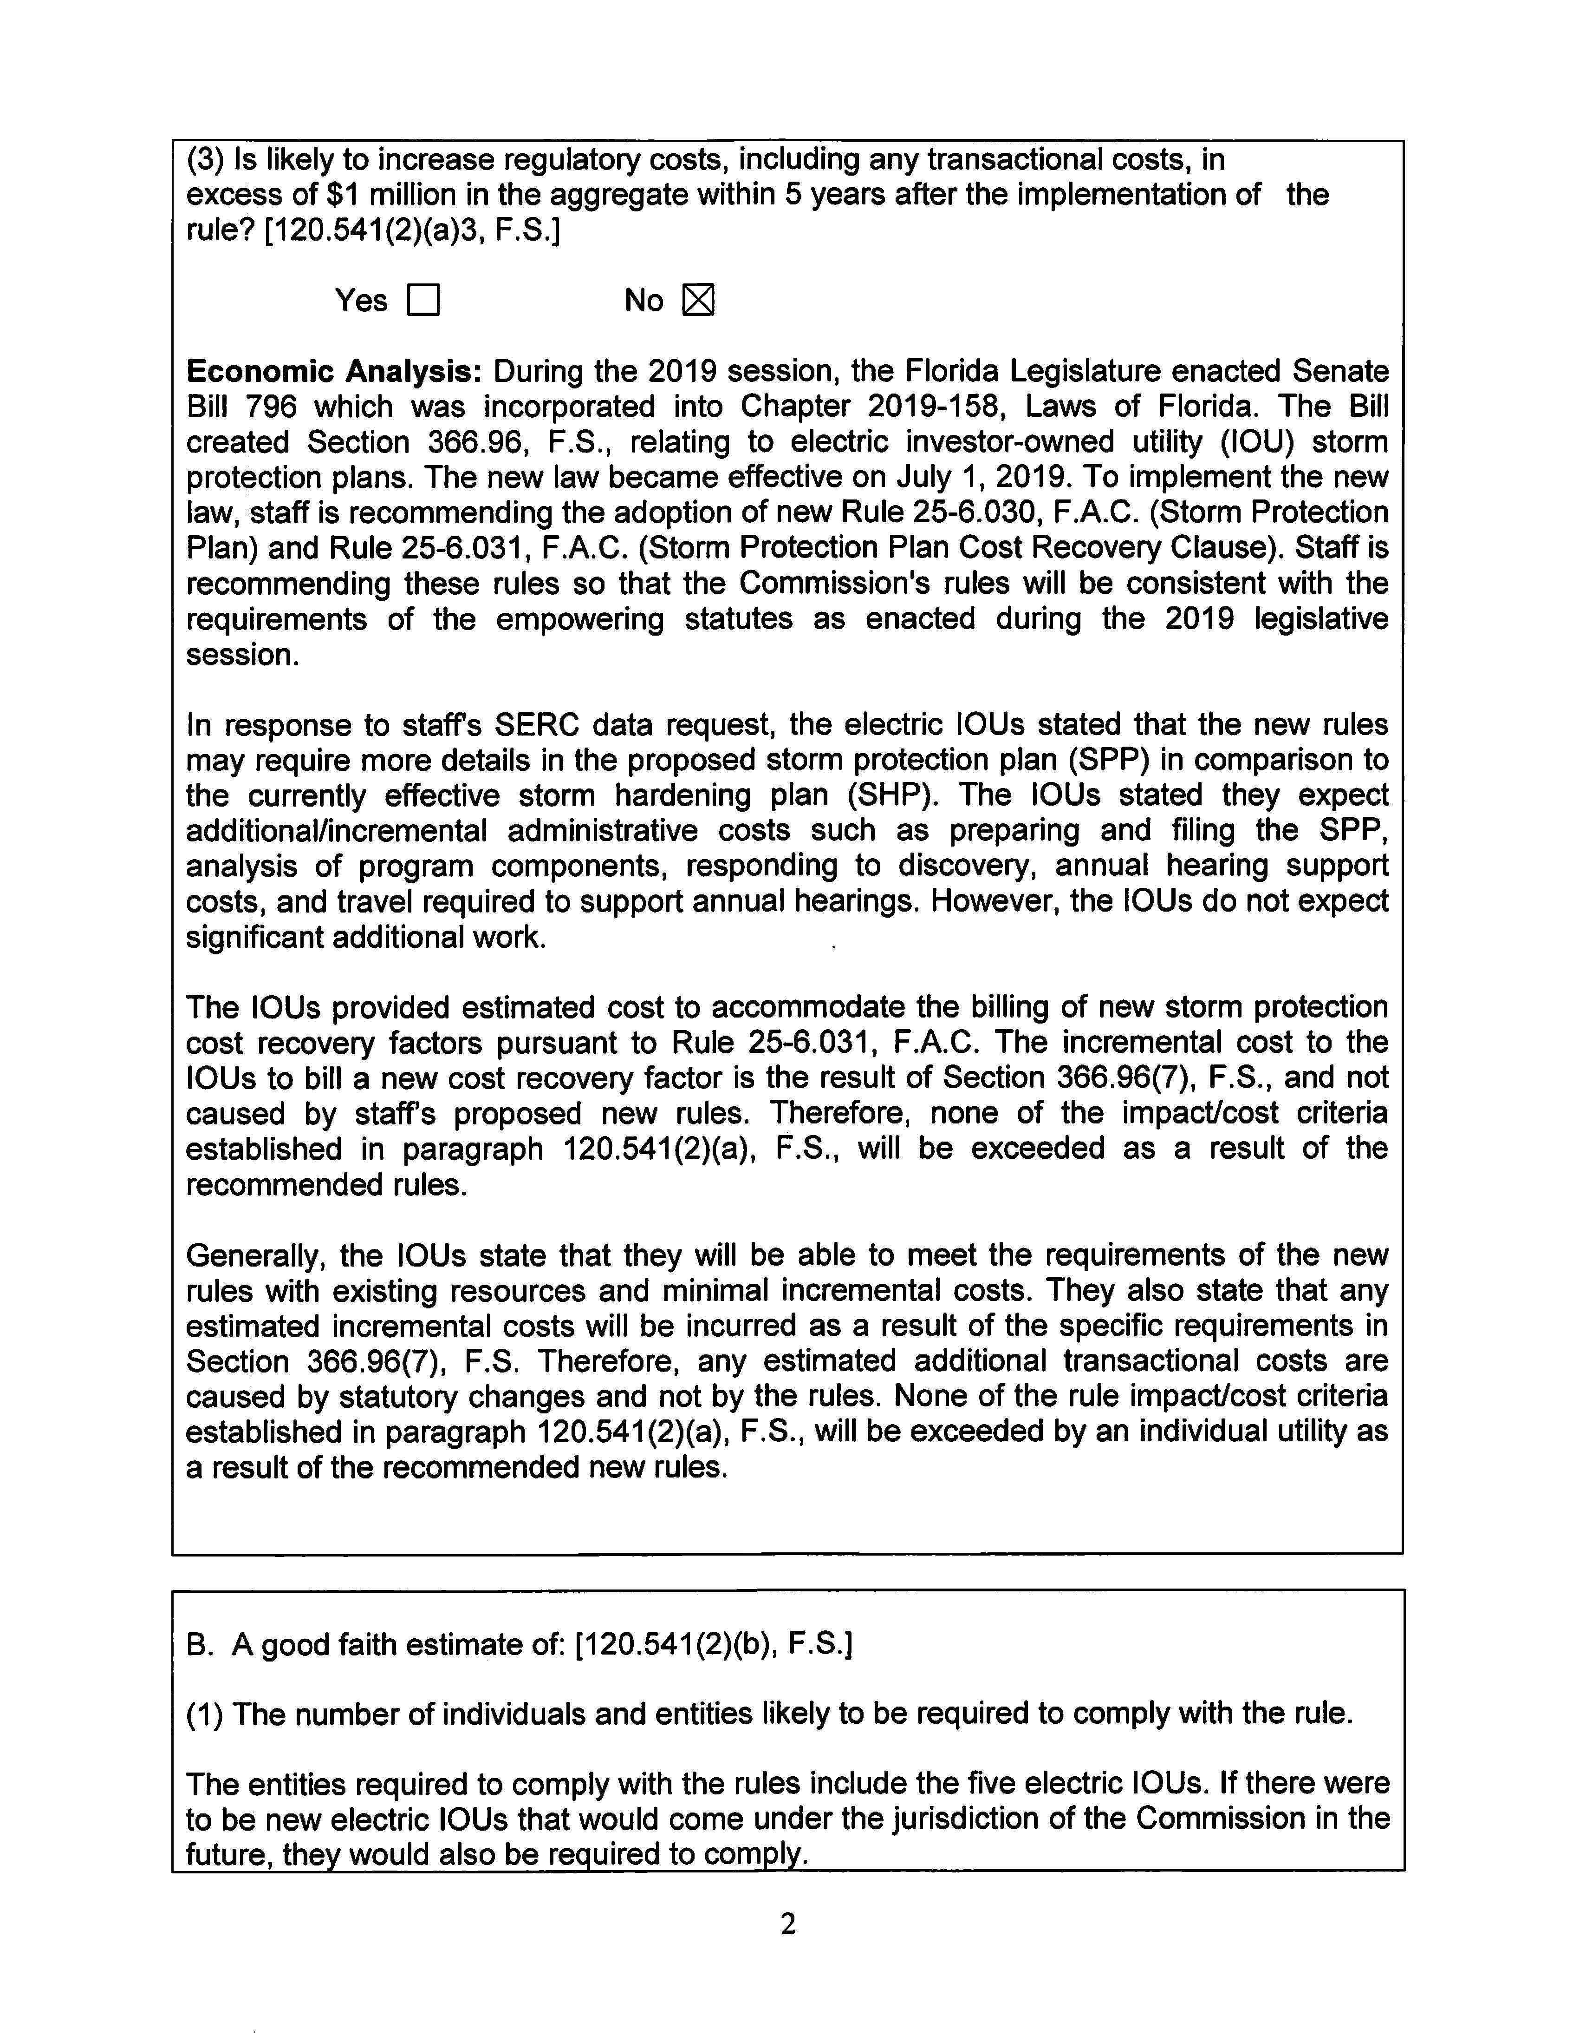

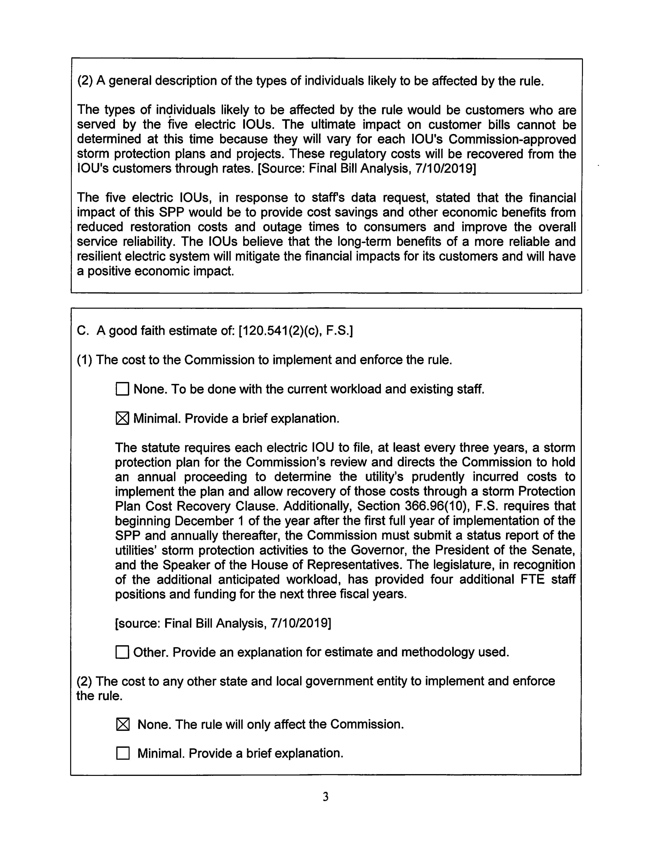

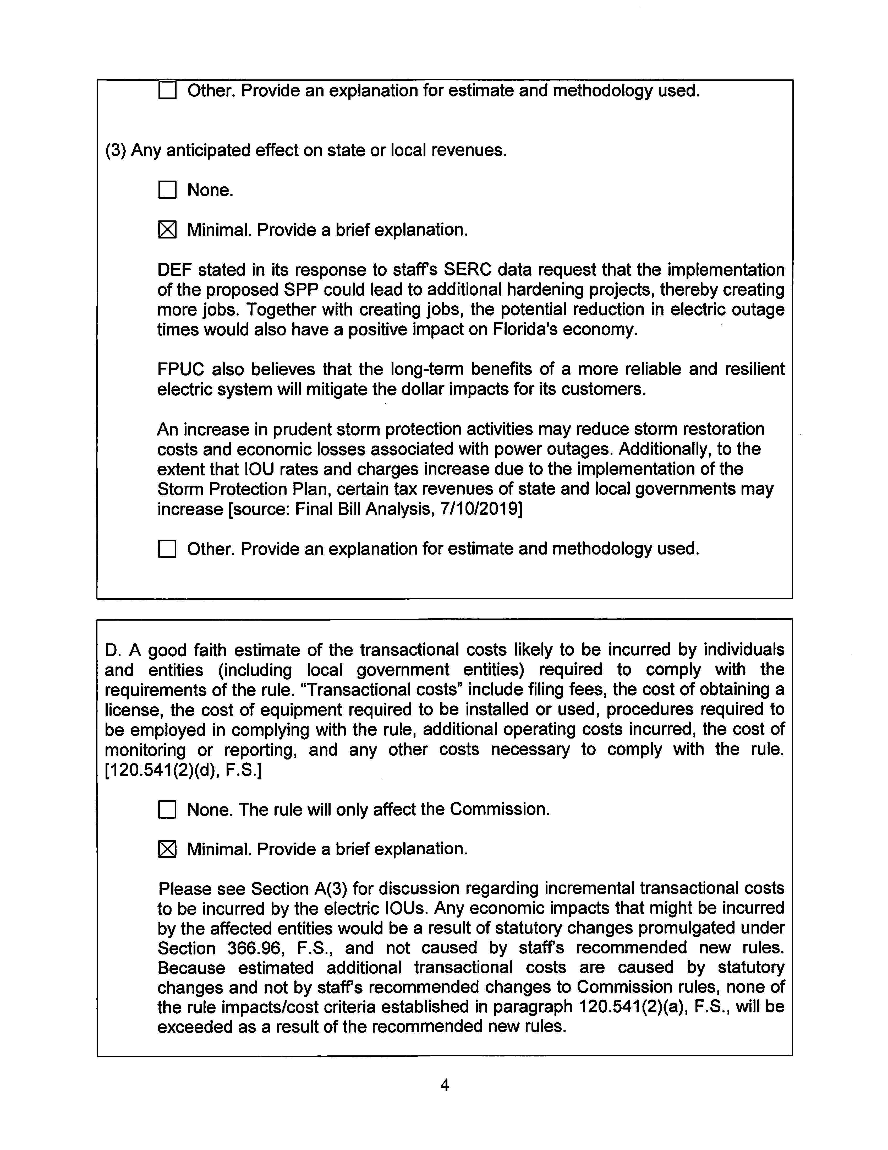

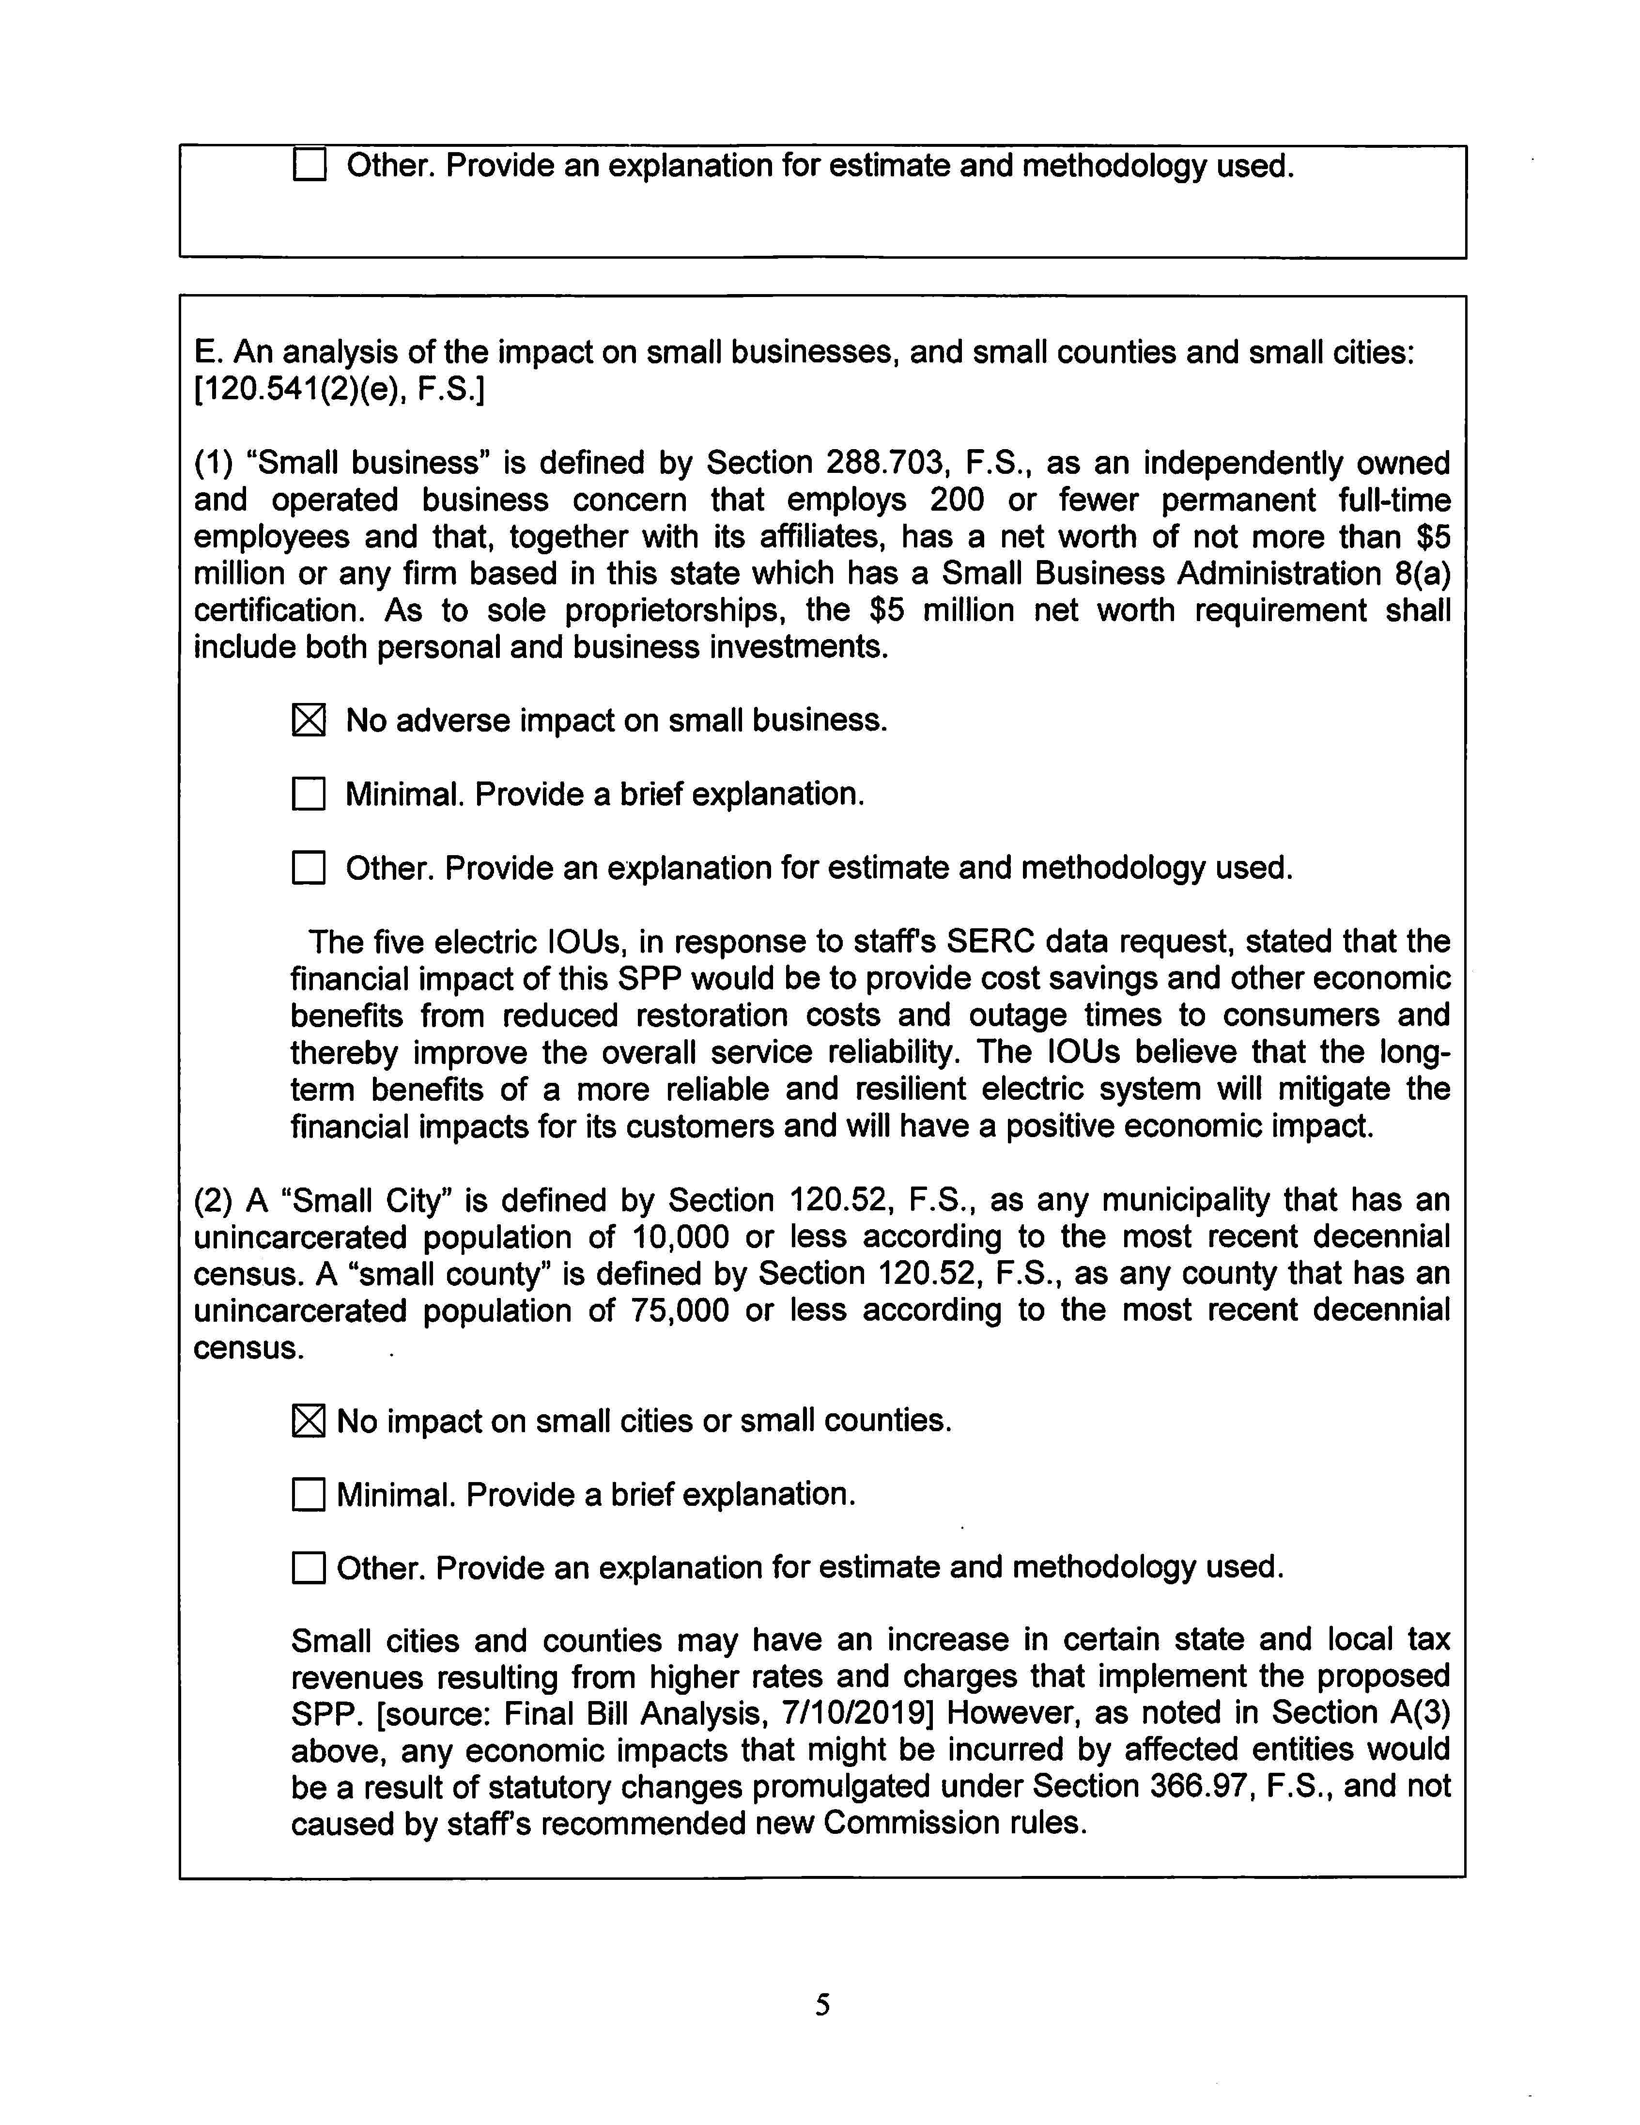

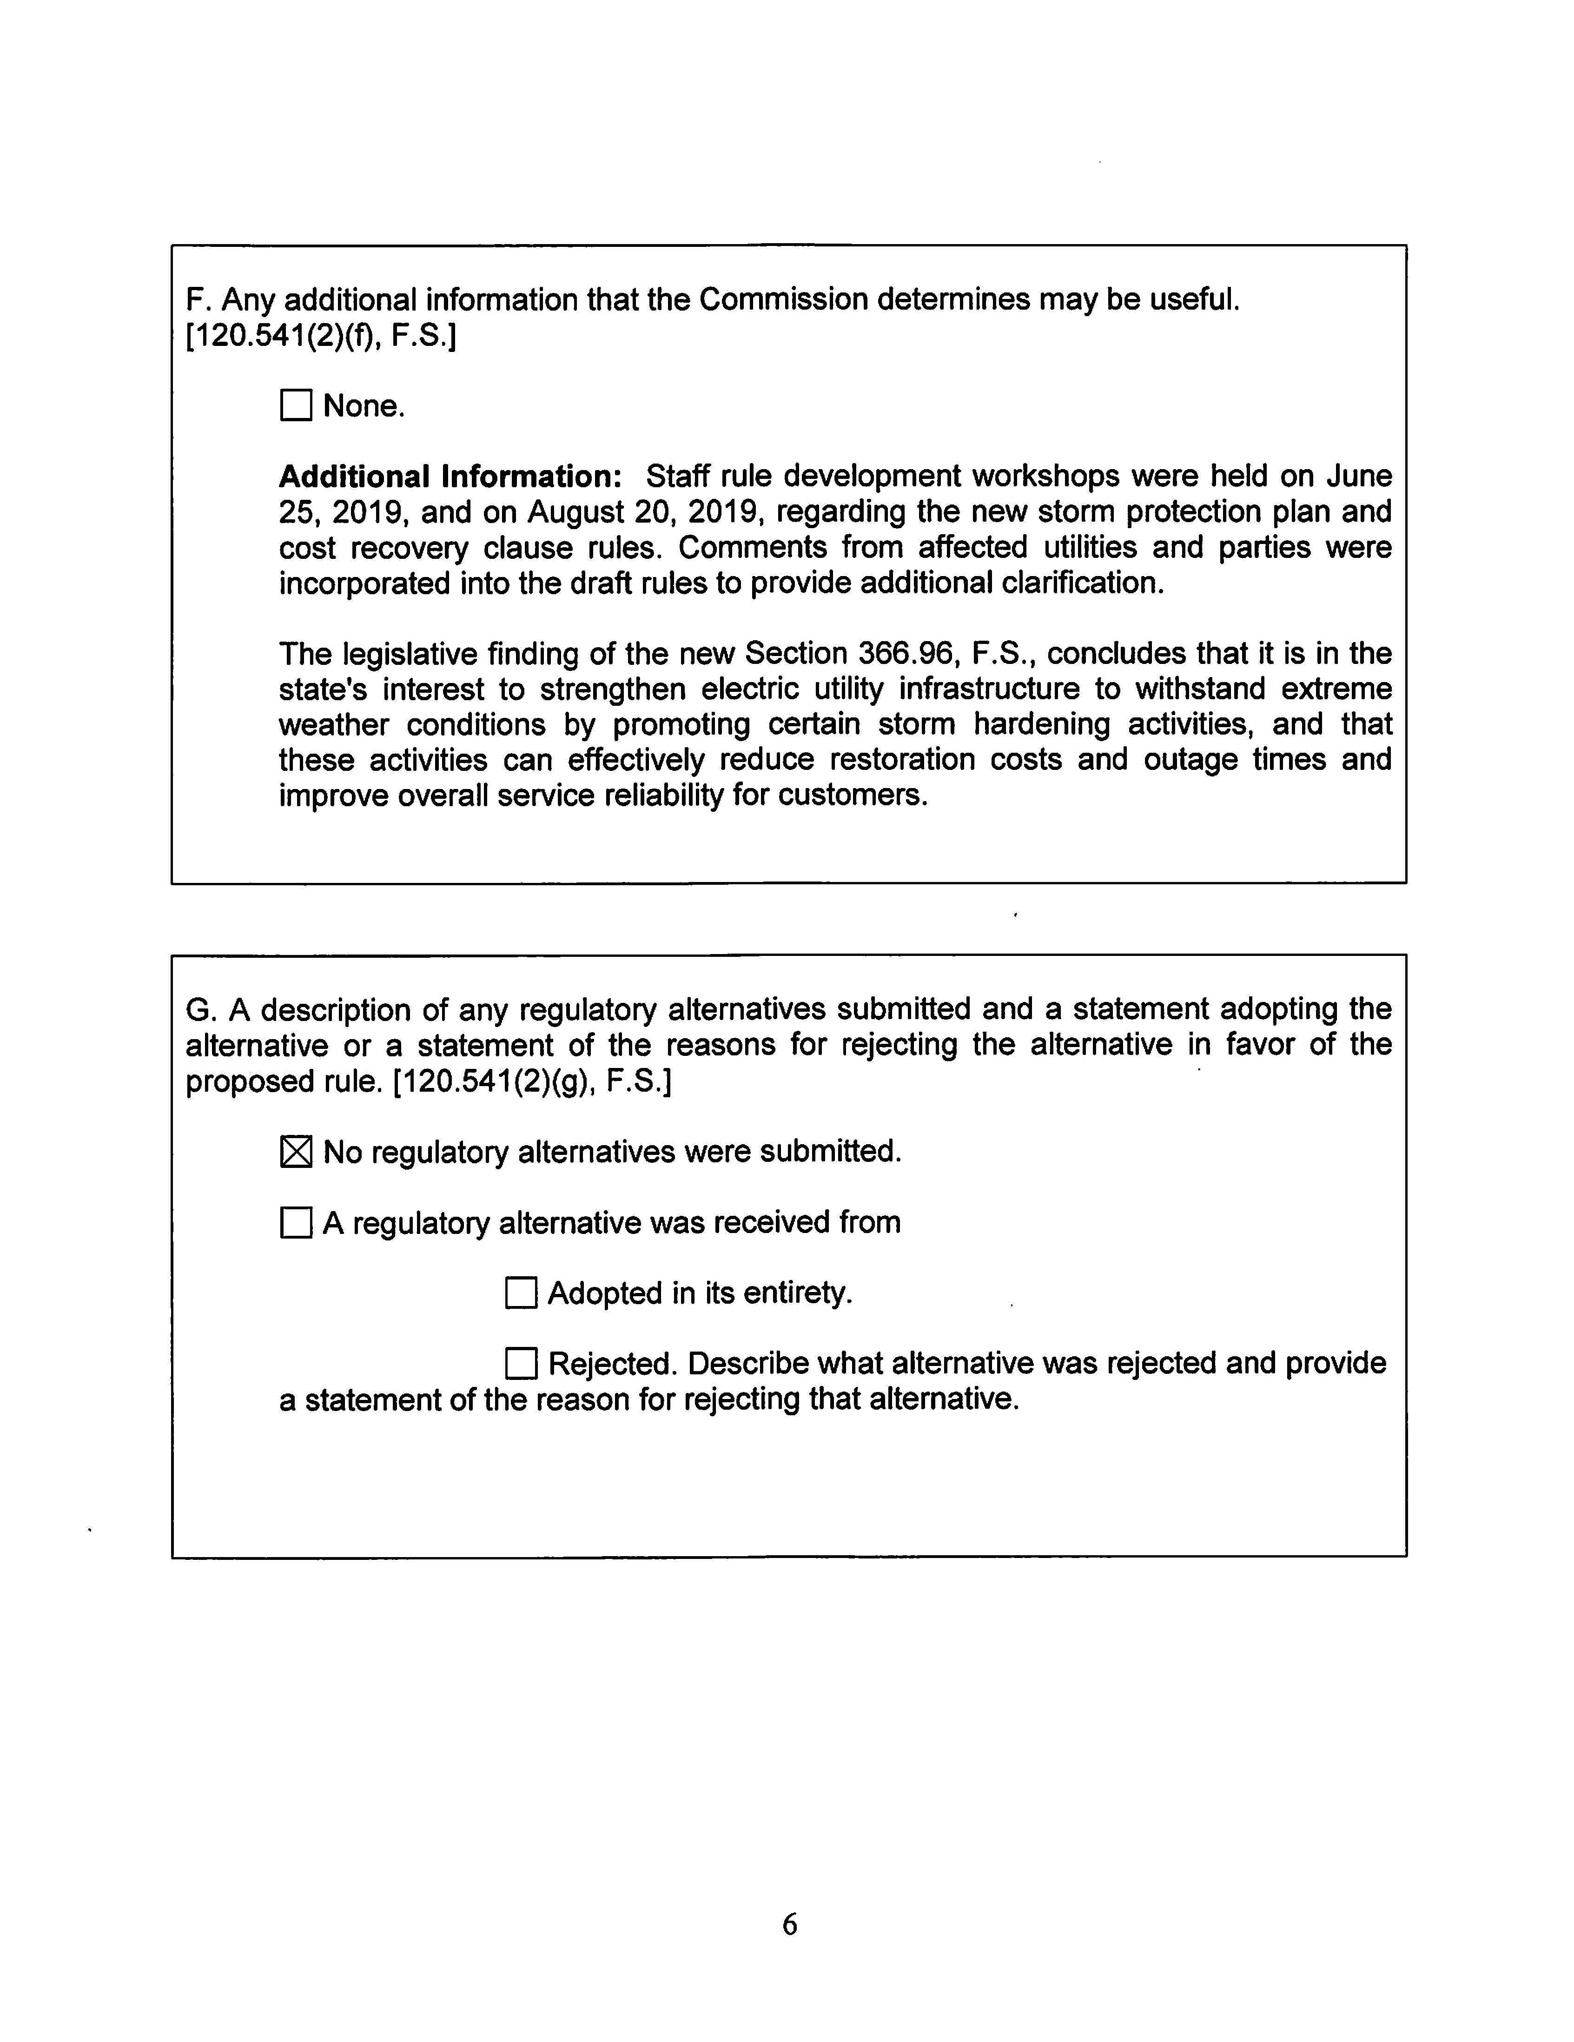

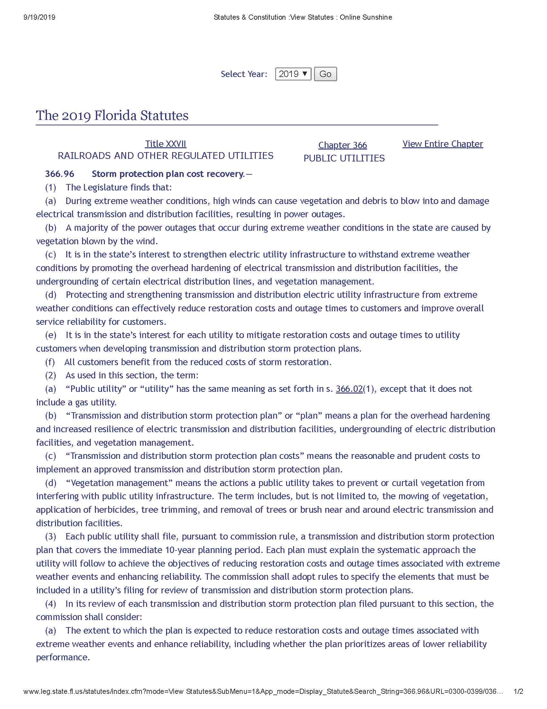

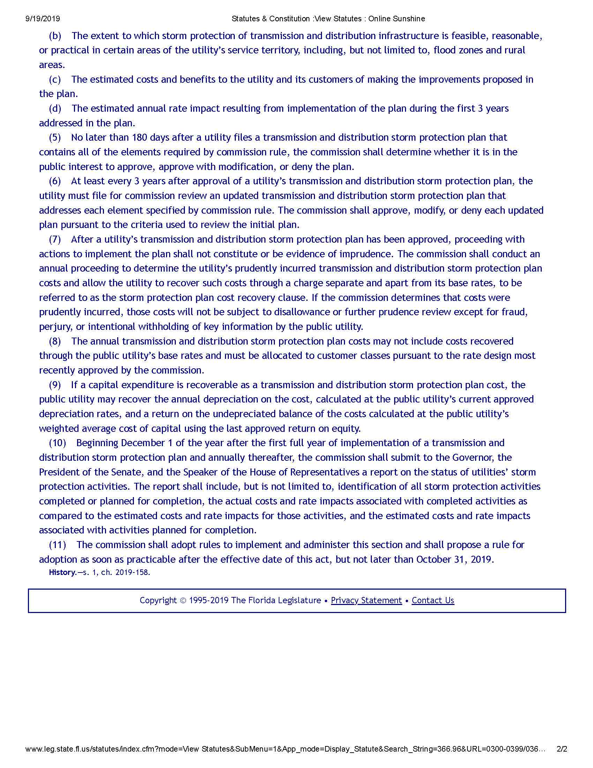

A copy of Section 366.96, F.S., is appended as Attachment C.
Section 366.96, F.S., uses the terms “public utilities” and “utility,” and defines these terms as having the same meaning as “public utility” as defined in Section 366.02(1), F.S., except that it does not include a gas utility. The Commission often refers to these types of electric utilities as “investor-owned electric utilities” or “IOUs,” and this is how staff refers to these types of utilities in this recommendation.
Antonin Scalia & Bryan A. Garner, Reading Law: The Interpretation of Legal Texts 381 (citation omitted).
Similarly, once a nuclear or environmental plan (i.e., projected activities and costs) is approved, it doesn’t necessarily mean all costs will be deemed prudent and recoverable. The clause process does not allow for an automatic determination or a finding of prudence on projected levels of expenses just by virtue of approving the initial plan. The Commission may find the plan to be in the public interest and can authorize the utility to go forward with the plan. However, the prudence of the costs is not pre-determined at that point. Rather, the costs will be reviewed and audited in the cost recovery clause hearing.
Gulf supported and adopted all of FPL’s comments. Thus, any FPL comments that are reflected in this recommendation should also be considered comments by Gulf.
See discussion supra Subsection (3): Contents of the Storm Protection Plan.
FPL anticipates modifications to its billing system. The estimated cost is $300,000 for five years. Duke stated that the company does not expect any reprogramming of its billing system as long as the factors are incorporated into the non-fuel energy charge on customer bills. TECO estimates incremental costs of $250,000 in the aggregate for the next five years to prepare the SPP, for regulatory efforts, and for additional billing system reprogramming. Gulf Power estimates no more than $200,000 in total for the entire next five-year period to reprogram its billing system to accommodate the new SPP cost recovery clause factor. FPUC stated that for the next five years, the company may incur the following incremental costs: $155,000 for preparation of the SPP, additional staff hires $440,000, system reprogramming to accommodate billing $40,000.

