State of Florida |  | Public Service Commission  Capital Circle Office Center ● 2540 Shumard Oak Boulevard  Tallahassee, Florida 32399-0850  -M-E-M-O-R-A-N-D-U-M-
DATE: | September 20, 2019
TO: | Office of Commission Clerk (Teitzman)
FROM: | Division of Economics (Guffey, Coston, Draper)  Division of Accounting and Finance (Mouring)  Office of the General Counsel (Schrader)
RE: | Docket No. 20190142-EU – Joint petition for approval of amendment to territorial agreement in Nassau County, by Florida Power & Light Company and Okefenoke Rural Electric Membership Corporation.
AGENDA: | 10/03/19 – Regular Agenda – Proposed Agency Action – Interested Persons May Participate
COMMISSIONERS ASSIGNED: |  |  | All Commissioners
PREHEARING OFFICER: |  |  | Polmann
CRITICAL DATES: |  |  | None
SPECIAL INSTRUCTIONS: |  |  | None

Case Background
On July 17, 2019, Florida Power & Light Company (FPL) and Okefenoke Rural Electric Membership Corporation (Okefenoke), collectively the joint petitioners, filed a petition seeking Commission approval of clarification and amendment (2019 amendment) to the joint petitioners’ current territorial agreement as it relates to certain boundaries in Nassau County.
In May 1992, FPL filed three petitions to resolve territorial disputes with Okefenoke in Baker and Nassau Counties. The three dockets were consolidated for hearing purposes; however, after lengthy negotiations the parties reached an agreement the Commission approved in 1995 (1995 agreement). The parties currently operate pursuant to the 1995 agreement. The proposed 2019 amendment would correct a discrepancy in the maps delineating the territorial boundaries approved in the 1995 agreement in an area known as the Crawford Diamond in Nassau County and allow FPL to provide electric service to the adjacent property. All other provisions of the 1995 agreement would remain in effect. There are no customer transfers contemplated in the 2019 amendment. The 1995 agreement is included as Exhibit A to the joint petition in the instant docket.
During the review of this petition, staff issued two data requests to the joint petitioners for which responses were received on August 27, 2019. The responses have been placed in the docket file. In response to staff’s first data request, FPL provided an updated page 1 of the 2019 amendment to indicate the date of the amendment. On September 20, 2019, the joint petitioners filed the signature page of the 2019 amendment. The 2019 amendment, dated July 13, 2019, is provided in Attachment A to this recommendation. The Commission has jurisdiction over this matter pursuant to Section 366.04, Florida Statutes (F.S.).

Discussion of Issues

Issue 1:
Should the Commission approve the proposed 2019 clarification and amendment to the 1995 territorial agreement between FPL and Okefenoke?

Recommendation:
Yes, the Commission should approve the proposed 2019 clarification and amendment to the 1995 territorial agreement between FPL and Okefenoke. The proposed amendment will resolve the boundary line discrepancy that exists in the area referred to as the Crawford Diamond in Nassau County and will enable FPL and Okefenoke to serve their customers in an efficient manner. (Guffey, Coston, Draper)

Staff Analysis:
Pursuant to Section 366.04(2)(d), F.S., and Rule 25-6.0440(2), Florida Administrative Code (F.A.C.), the Commission has the jurisdiction to approve territorial agreements between and among rural electric cooperatives, municipal electric utilities, and other electric utilities. Unless the Commission determines that the agreement will cause a detriment to the public interest, the agreement should be approved.
FPL is an investor-owned utility operating under the jurisdiction of this Commission pursuant to Chapter 366, F.S. Okefenoke is a rural electric corporation organized and existing under the laws of Georgia and registered to conduct business in Florida pursuant to Section 425.27, F.S. Both petitioners presently provide electric service in Baker and Nassau Counties and are operating pursuant to the 1995 agreement. The 1995 agreement does not specify a term; Section 4.1 of the 1995 agreement states that the agreement will continue and remain in effect until the Commission, by order, modifies or withdraws its approval after proper noticing and hearing.
Through the proposed 2019 amendment, the joint petitioners seek to clarify a discrepancy in the maps approved in the 1995 agreement and to amend the 1995 agreement to allow FPL to serve a property which is currently located within Okefenoke’s service territory. The proposed amendment involves an area called the Crawford Diamond, which is located in Nassau County. The Crawford Diamond is a 1,815 acre property which is zoned as an industrial park. The petitioners explained that the Crawford Diamond is located adjacent to railroads and road infrastructure. FPL explained to staff in response to a data request that, through its economic development team, it is promoting this location to attract new commercial and industrial customers. In addition, FPL explained to staff that it is conducting preliminary engineering and permitting to potentially construct the Nassau Solar Energy Center in the Crawford Diamond. However, there are no customers or electric service facilities in the Crawford Diamond or the adjacent property at this time. The clarification and the amendment to the 1995 agreement are discussed below.
The joint petition states that two conflicting maps approved in the 1995 agreement can be interpreted to allow both FPL and Okefenoke to serve a portion of the Crawford Diamond. The 1995 agreement includes several pages of maps (shown in Attachment A to the order approving the 1995 agreement). Specifically, the petition states that the map on page 25 of the 1995 agreement and the maps on pages 47 and 48 of the maps are not consistent. The area of discrepancy within the Crawford Diamond is shown on page 7 of 13 in Attachment A to this recommendation. The parties now seek to clarify the discrepancy and amend the territorial boundaries approved in the 1995 agreement to allow FPL to serve the area of discrepancy.
The proposed 2019 amendment also seeks Commission approval to allow FPL to serve potential future customers in a 335.86 acre property that is adjacent to the area of discrepancy discussed above. The property is currently in Okefenoke’s service territory. Page 8 of 13 in Attachment A to this recommendation indicates the revised territorial boundary lines.
In addition to the proposed 2019 amendment, FPL and Okefenoke have entered into a Memorandum of Understanding (MOU) dated November 15, 2018. The joint petitioners attached the MOU in Exhibit E of their petition in the instant docket. The joint petitioners are not seeking Commission approval of the MOU. The joint petitioners explained that the MOU represents the negotiated provisions necessary to resolve the discrepancy in the 1995 agreement maps. The MOU also includes other terms and provisions that are not generally included in territorial agreements for Commission approval. The MOU will terminate if the Commission does not issue an order approving the 2019 amendment by December 31, 2019.
Pursuant to the MOU, FPL plans to construct an FPL-owned substation and associated transmission and distribution lines in the Crawford Diamond. FPL will also build a second substation and transfer this substation to Okefenoke for $10 (Okefenoke substation). Any transmission assets installed by FPL to serve the Okefenoke substation would be retained by FPL. In response to staff’s second data request, FPL estimates the construction cost for the Okefenoke substation to be approximately $6.8 to $7.6 million. The Okefenoke substation will be constructed on FPL land which then will be transferred to Okefenoke pursuant to a special warranty deed. Exhibit A to the MOU shows that the Okefenoke substation will be built at the boundary line between FPL and Okefenoke. FPL stated that once the Okefenoke substation is completed, and the transfer of ownership of the substation and the land on which it is located has been made from FPL to Okefenoke, FPL will come back to the Commission to request further modification of the territorial agreement and indicate that the subject property has been transferred to Okefenoke and will thereafter be part of Okefenoke’s service territory.
In an email provided to staff that has been included in the docket file, FPL asserts that it is currently not seeking recovery of any costs to build the Okefenoke substation and FPL is not asking the Commission in this docket to make a prudence determination regarding FPL’s activities. FPL stated that if the Commission approves the proposed 2019 amendment and the costs to construct the Okefenoke substation are incurred, FPL may seek recovery of those costs in a future base rate filing. If such a filing is made by FPL, the Commission would be asked to review the cost and prudence associated with the Okefenoke substation and the associated transmission assets FPL would retain.

Conclusion
The joint petitioners assert that the 2019 amendment will provide certainty to future electric customers and the joint petitioners regarding the provision of electric service within the Crawford Diamond. No customers will be transferred as a result of the proposed 2019 amendment. The joint petitioner’s further state the proposed 2019 amendment represents a mutually agreeable solution to the boundary discrepancy, provides benefits to both FPL and Okefenoke, and eliminates the need for the Commission to resolve a potential future territorial dispute.
After review of the petition, the responses to staff’s data requests, and a follow-up response from FPL, staff believes that the proposed 2019 amendment is in the public interest. The proposed amendment will resolve the boundary line discrepancy that exists in the area referred to as the Crawford Diamond in Nassau County and will enable FPL and Okefenoke to serve their customers in an efficient manner. In addition, no current customers will be affected as a result of the proposed 2019 amendment. As such, staff believes that the proposed clarification and amendment to the 1995 agreement between FPL and Okefenoke will not cause a detriment to the public interest and recommends Commission approval.
However, the Commission should note that in approving the 2019 amendment, the Commission makes no finding regarding the prudence or potential recovery of the costs to construct the Okefenoke substation that will be transferred to Okefenoke. Those costs would be subject of a future, appropriate rate proceeding.
Issue 2: Should this docket be closed?

Recommendation:
If no protest is filed by a person whose substantial interests are affected within 21 days of the issuance of the Order, this docket should be closed upon the issuance of a Consummating Order. (Schrader)

Staff Analysis:
If no protest is filed by a person whose substantial interests are affected within 21 days of the issuance of the Order, this docket should be closed upon the issuance of a Consummating Order.

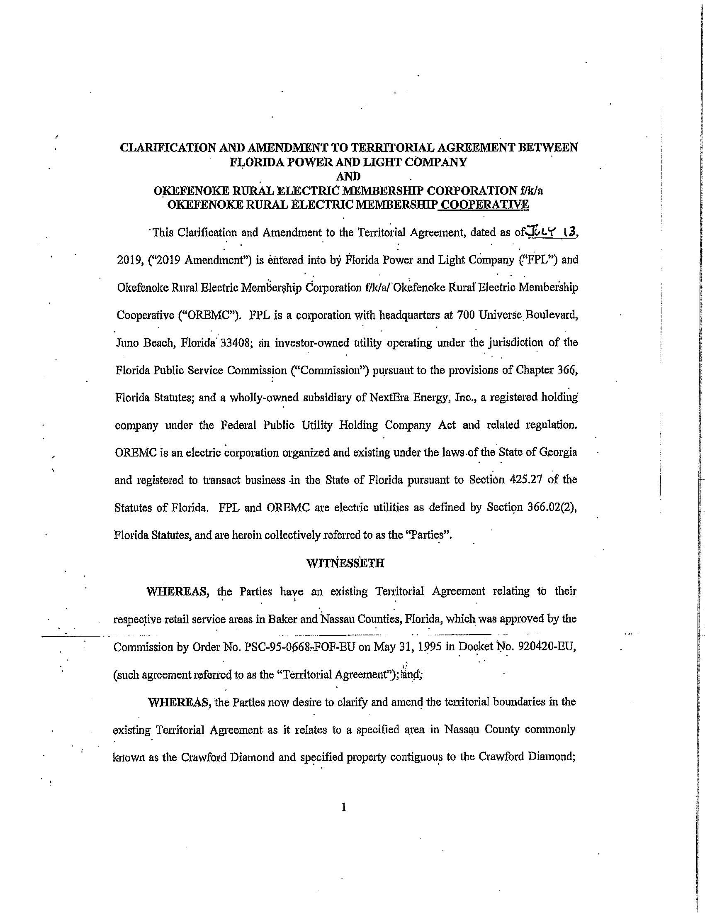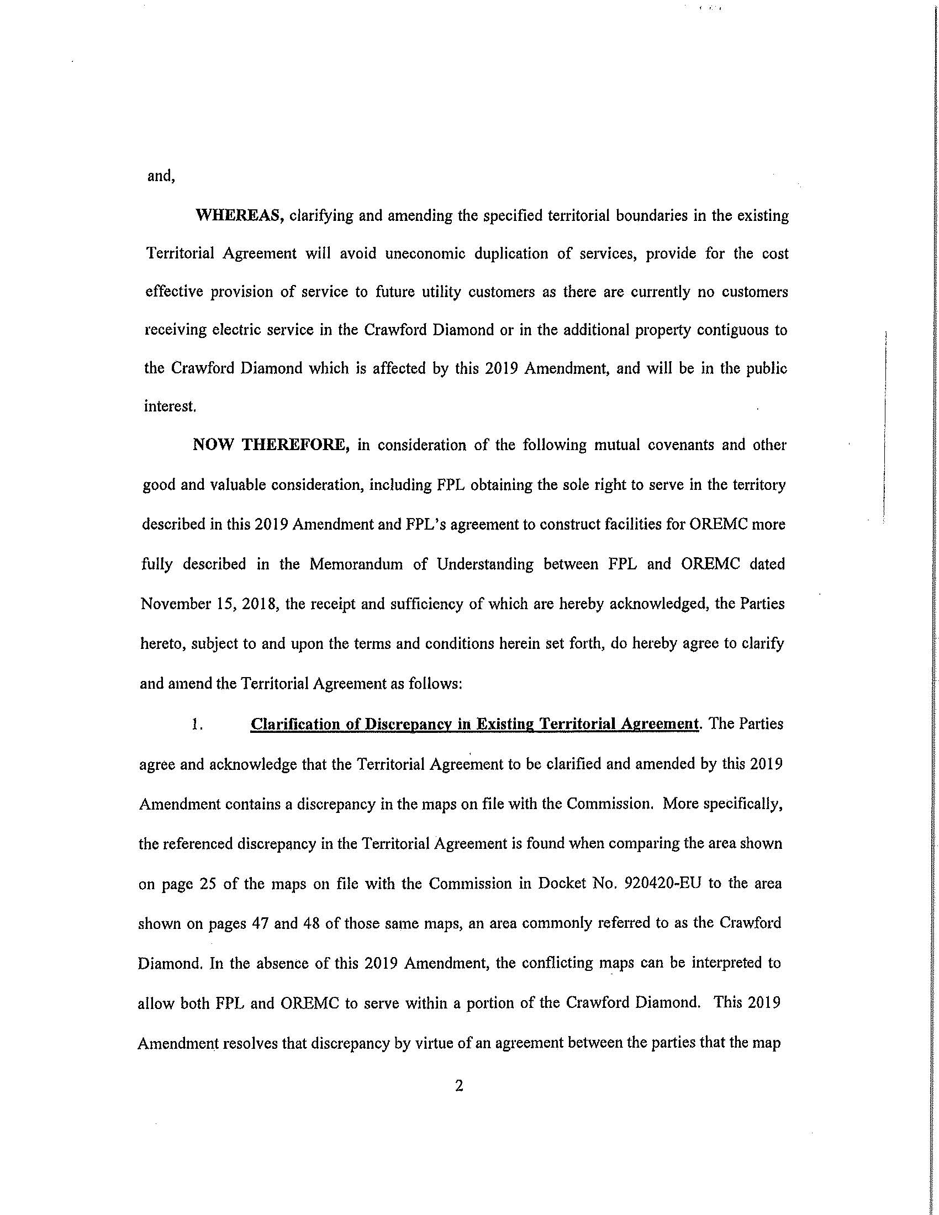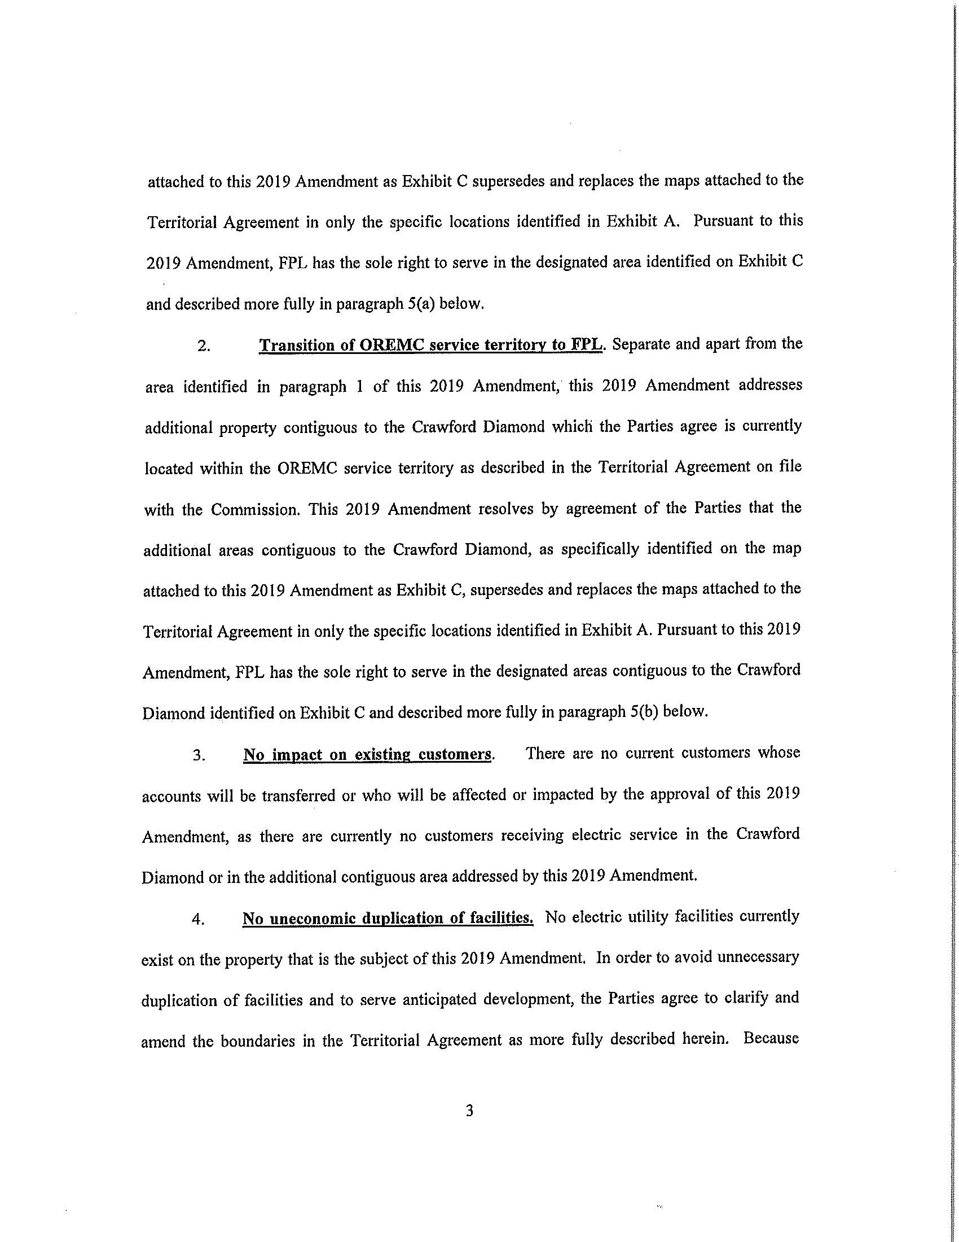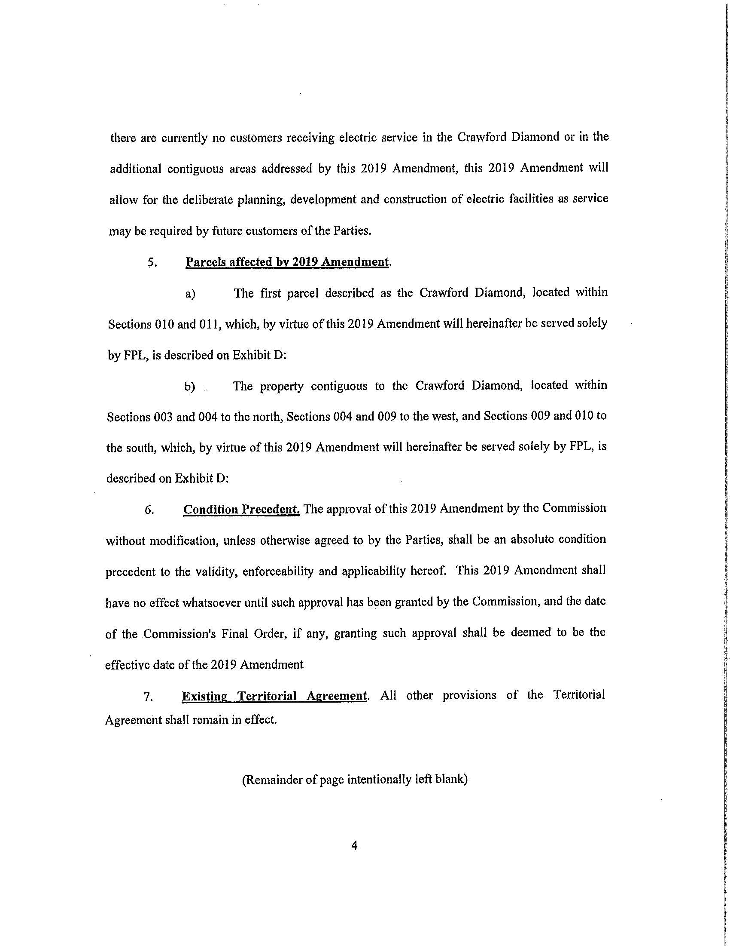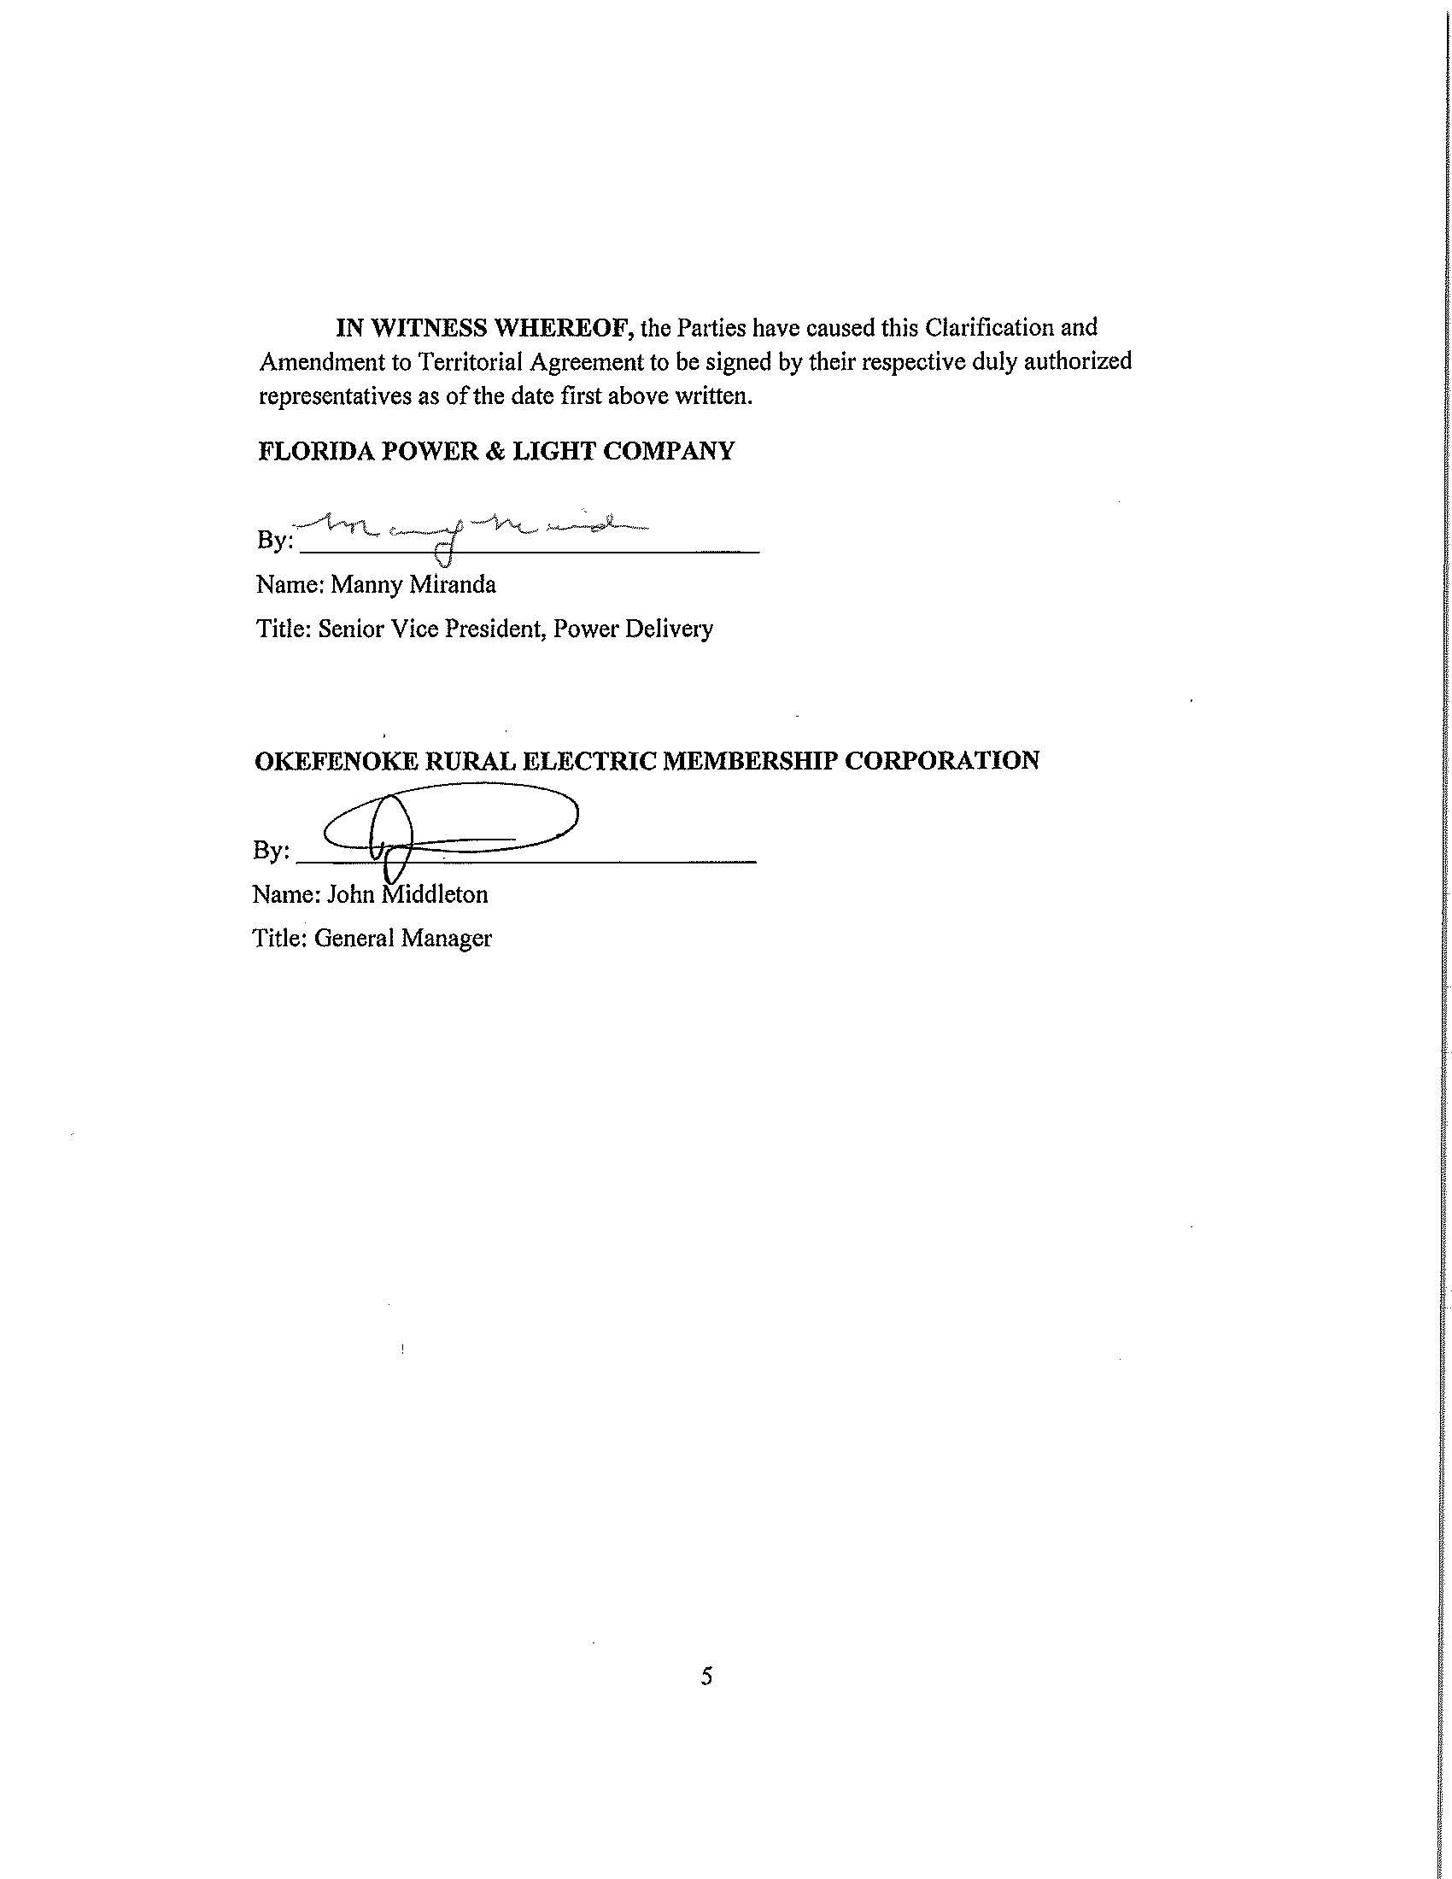

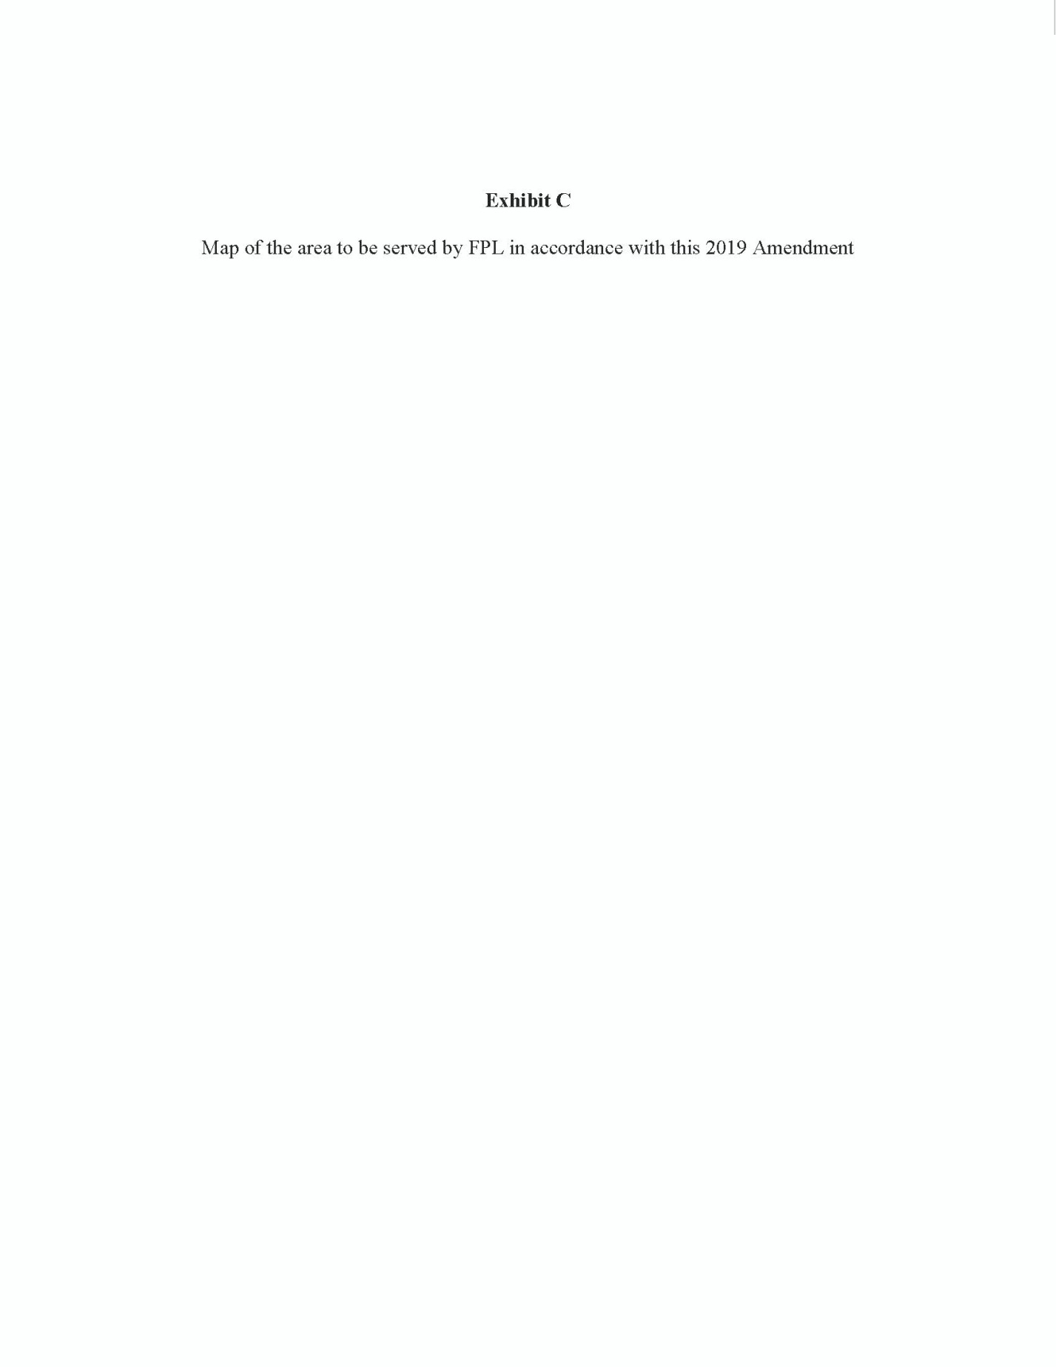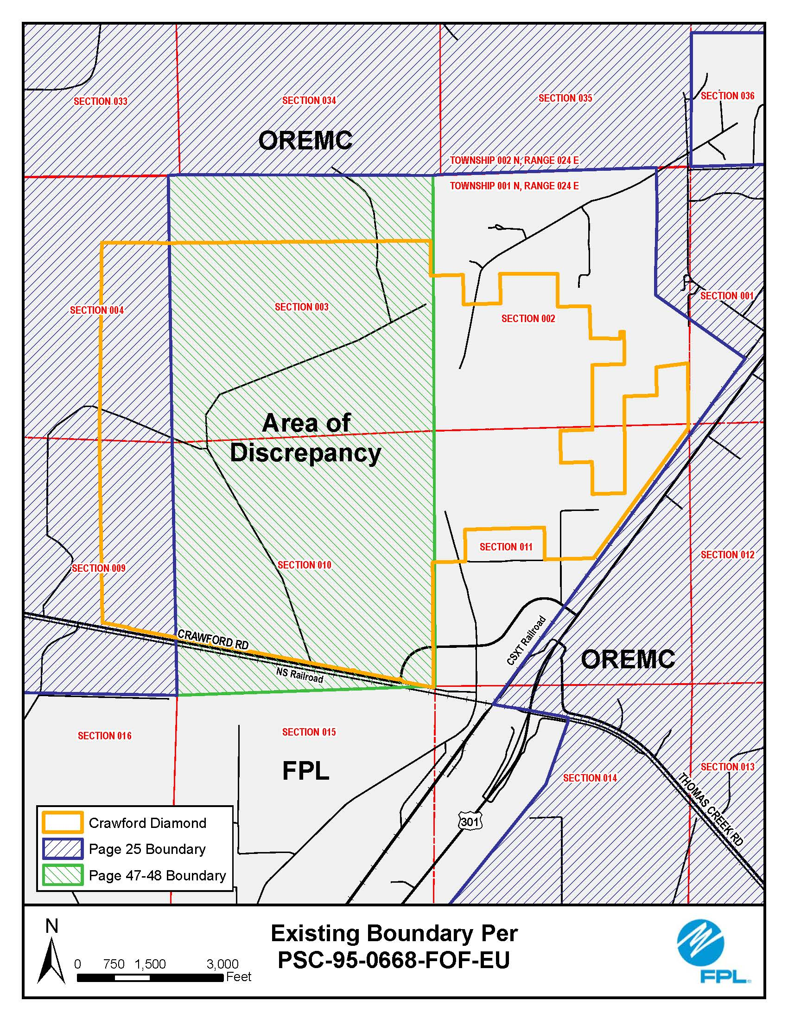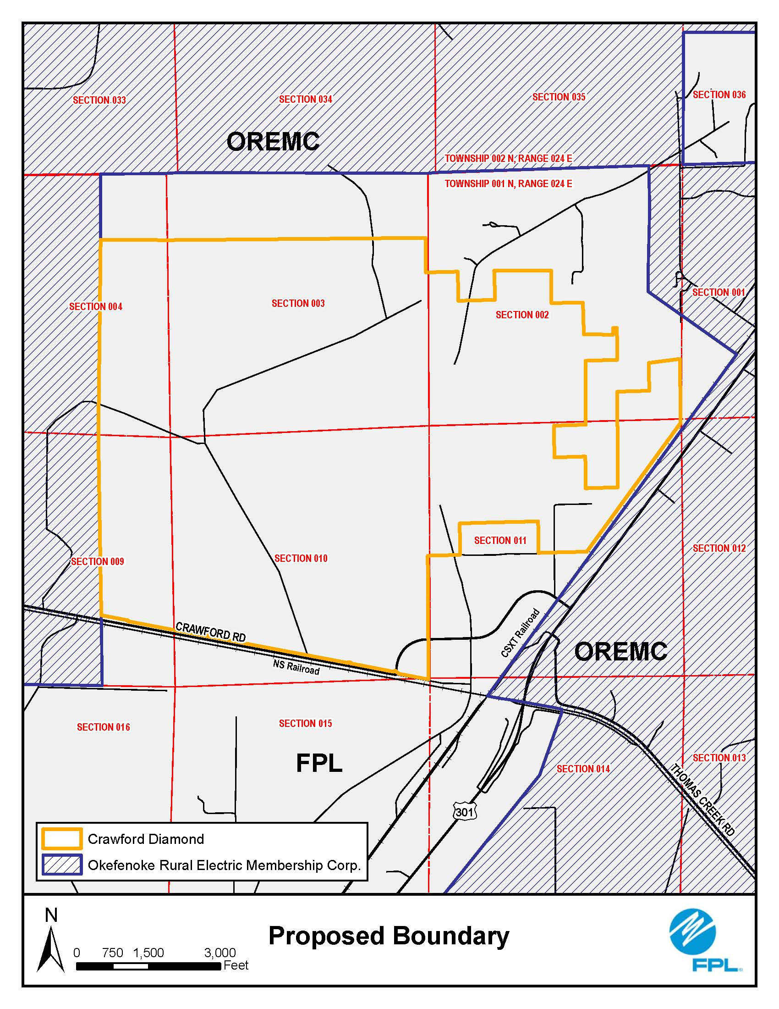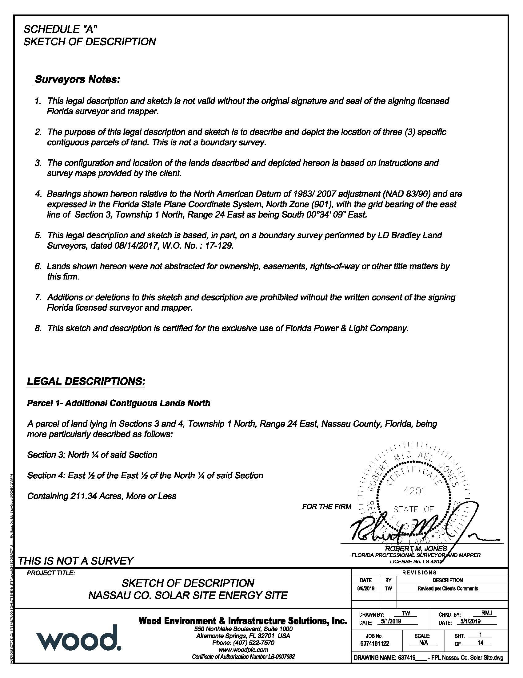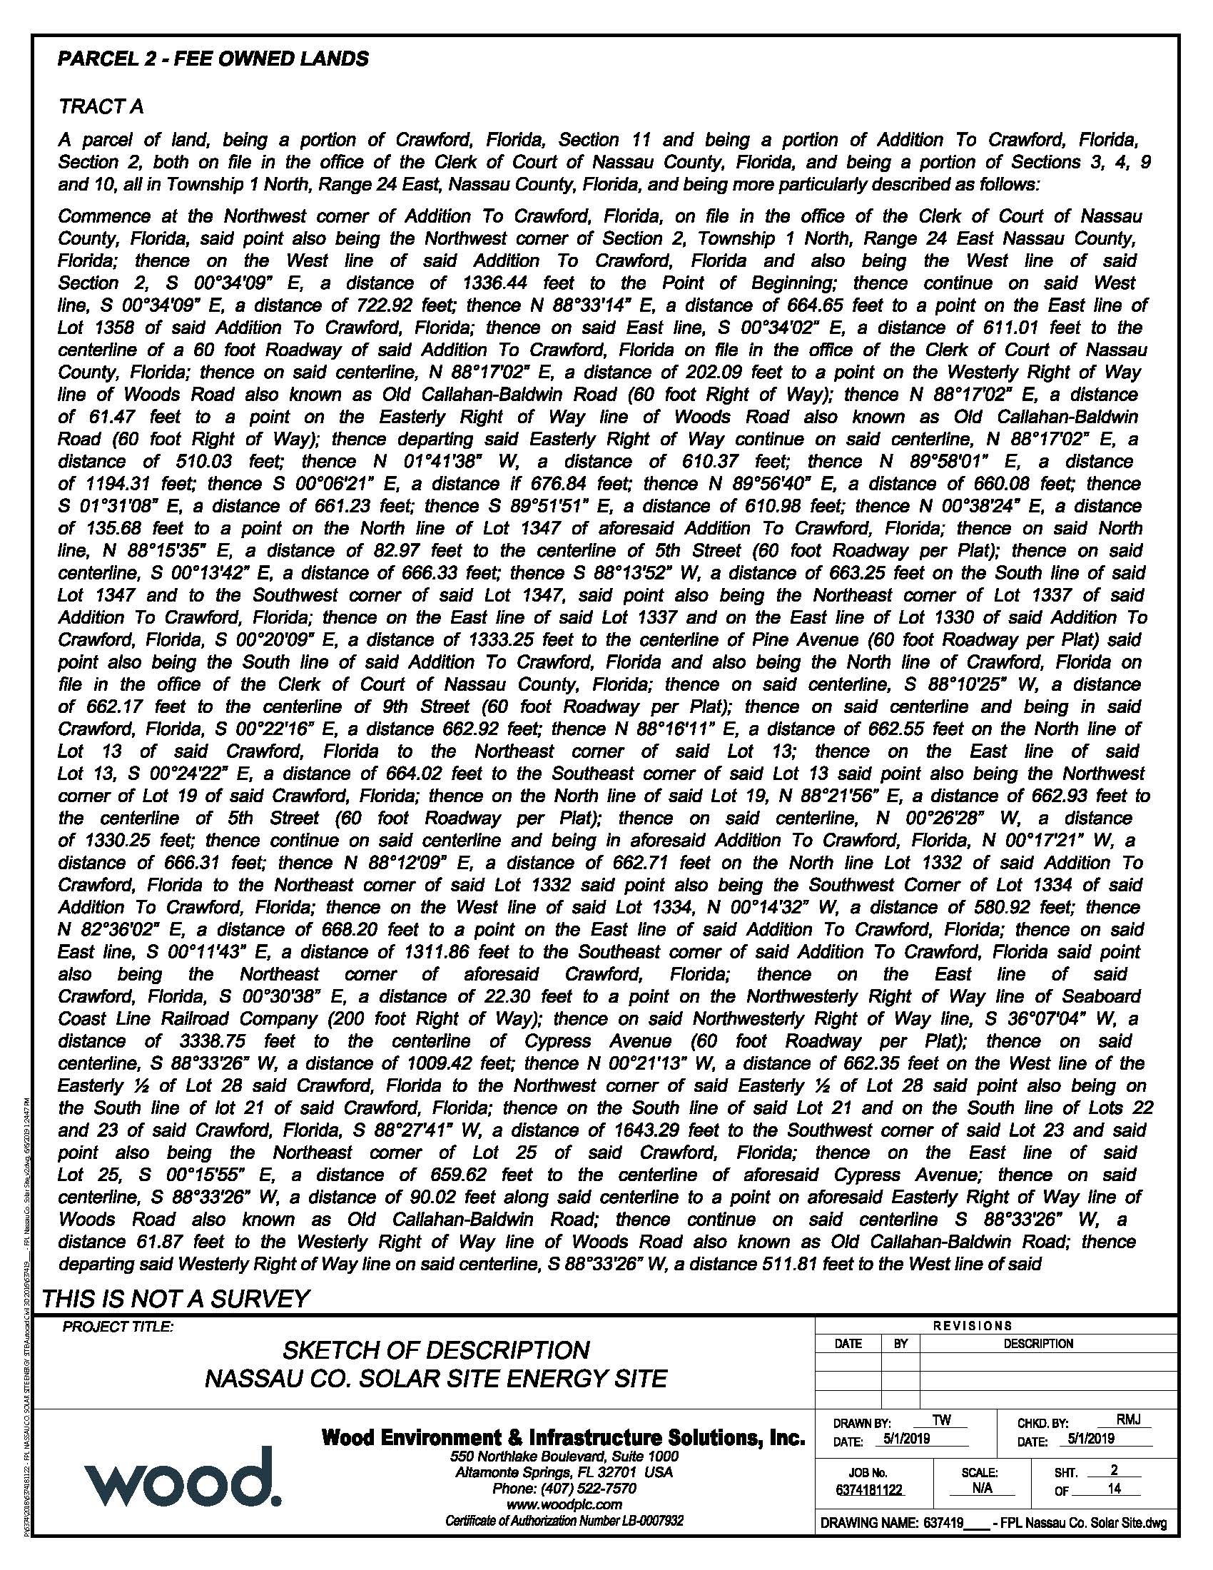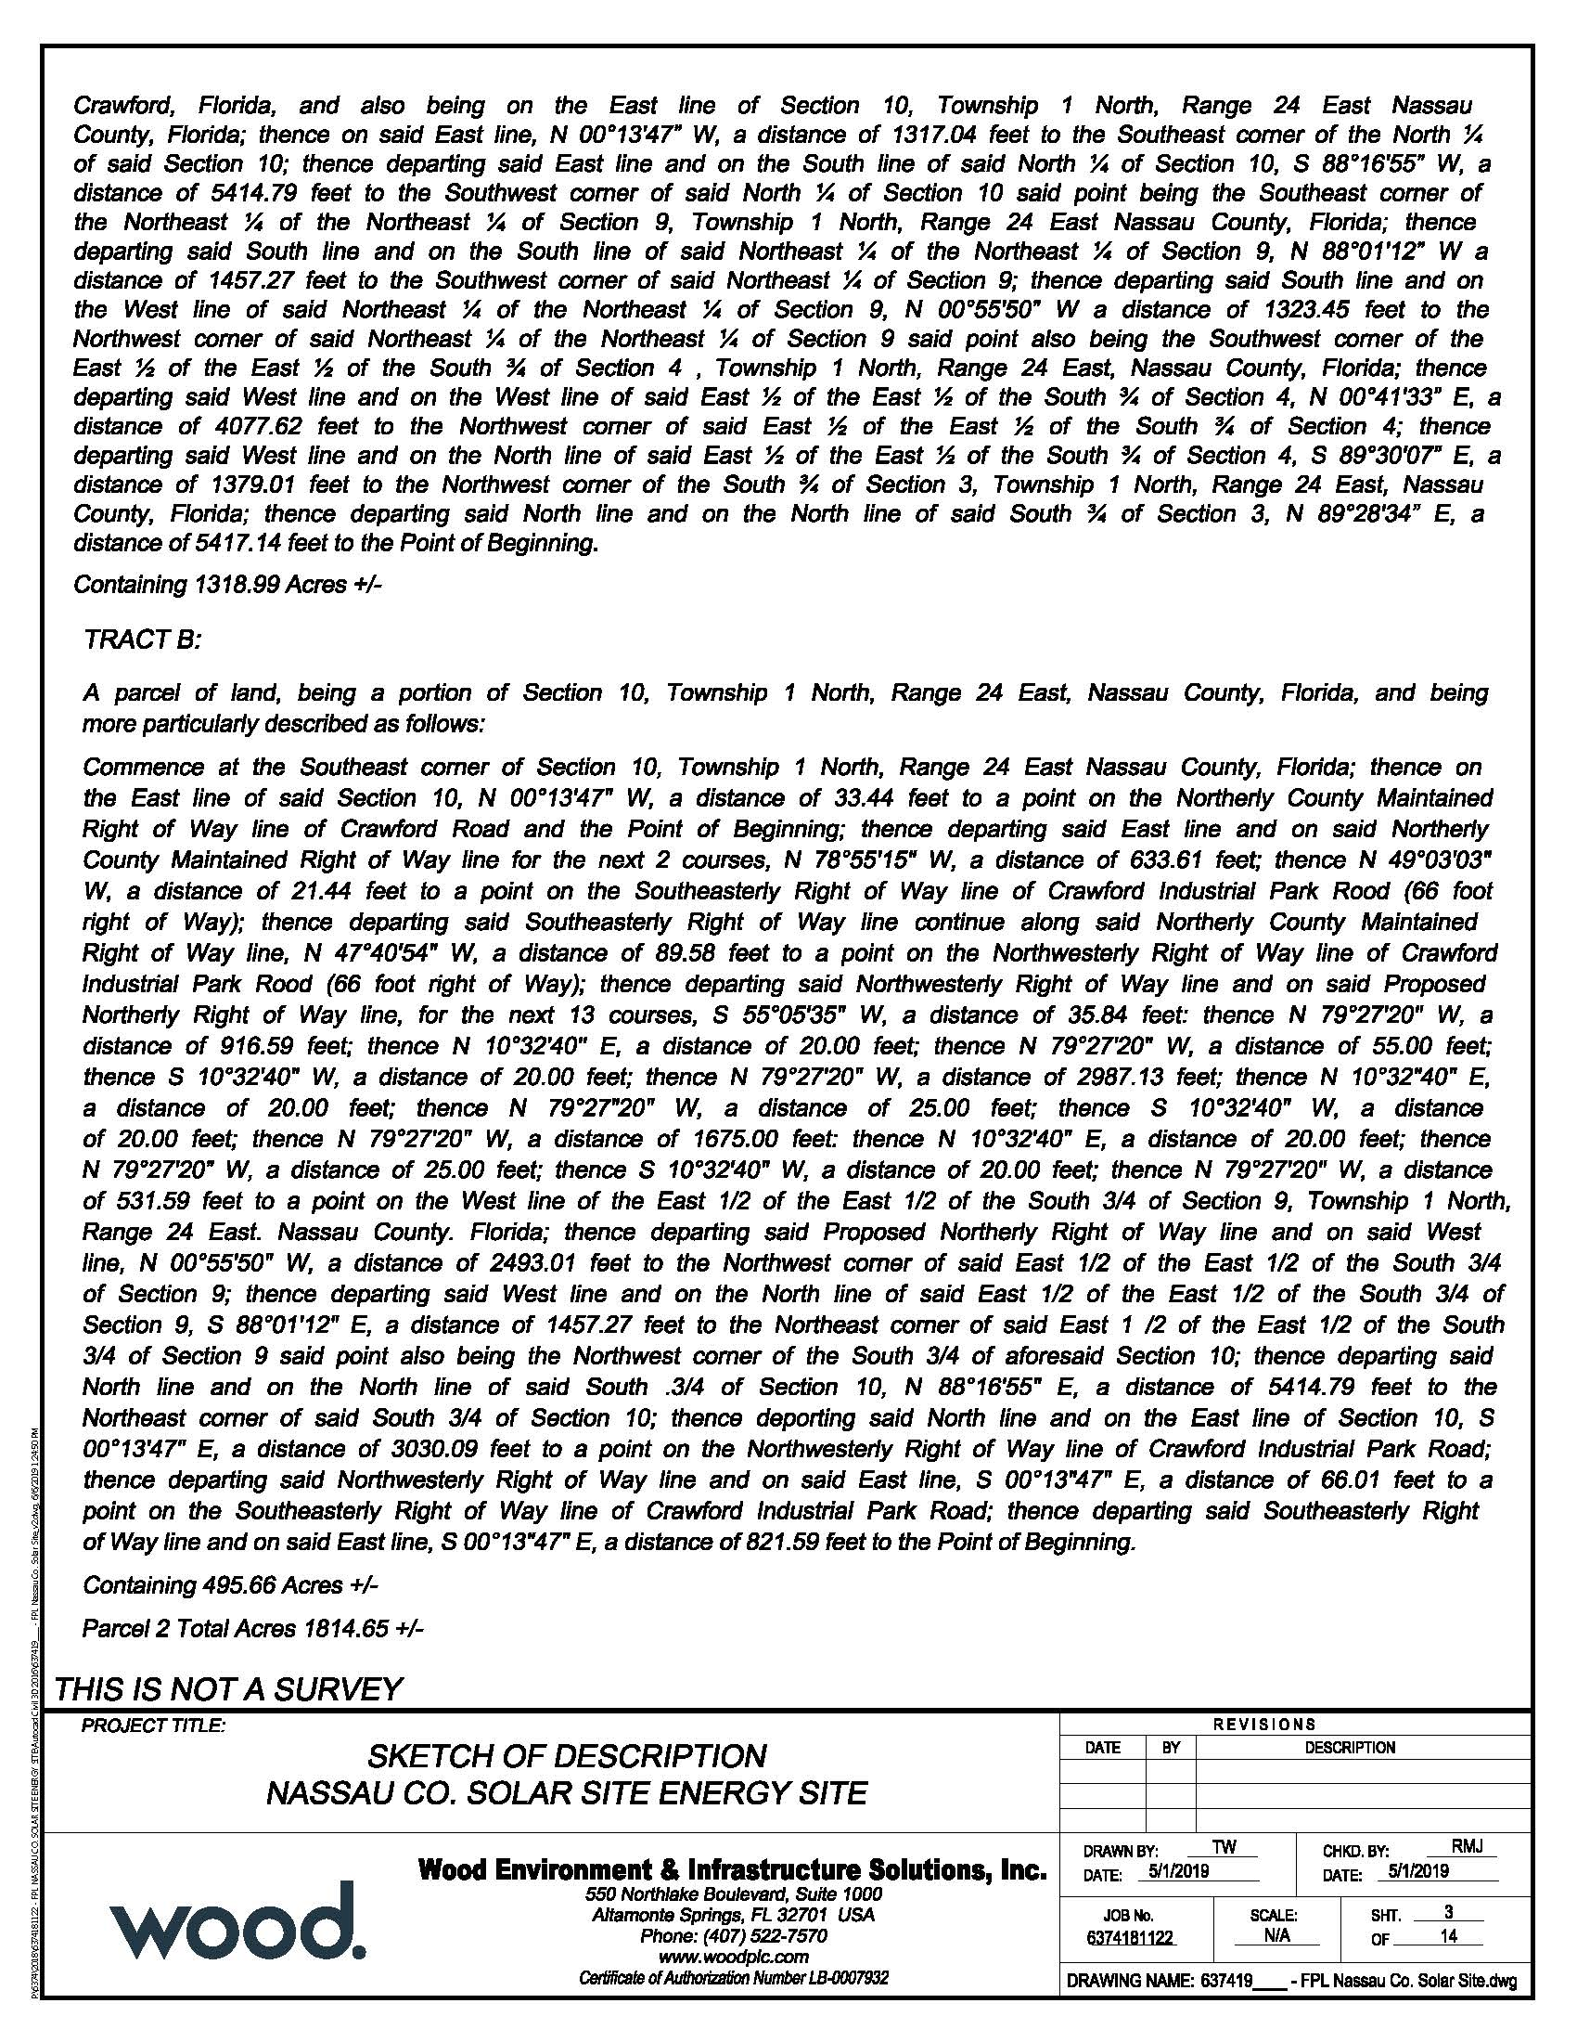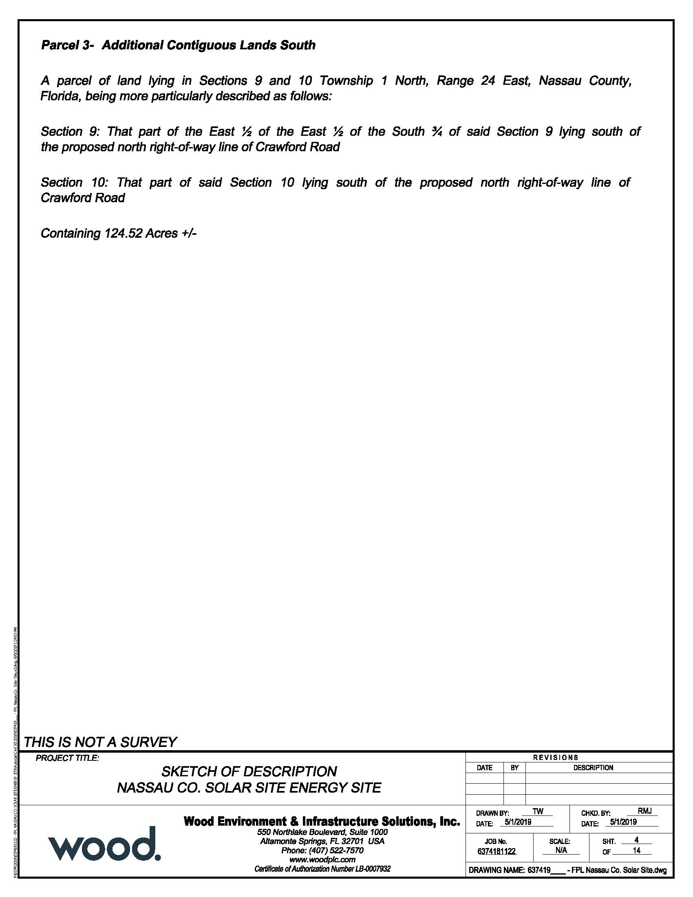

Order No. PSC-95-0668-FOF-EU, issued May 31, 1995, in Docket No. 920420-EU, In re: Petition to resolve territorial dispute in Baker County with Okefenoke Rural Electric Membership Corporation by Florida Power and Light Company.
Utilities Commission of the City of New Smyrna Beach v. Florida Public Service Commission, 469 So. 2d 731 (Fla. 1985).
See Document No. 08721-2019, filed on September 11, 2019, in Docket No. 20190142-EU.

