BEFORE THE FLORIDA PUBLIC SERVICE COMMISSION

|  |  |
| --- | --- |
| In re: Petition for authority for approval of non-firm energy pilot program and tariff by Florida Public Utilities Company. | DOCKET NO. 20190132-EI  ORDER NO. PSC-2019-0432-TRF-EI  ISSUED: October 22, 2019 |

The following Commissioners participated in the disposition of this matter:

ART GRAHAM, Chairman

JULIE I. BROWN

DONALD J. POLMANN

GARY F. CLARK

ANDREW GILES FAY

ORDER APPROVING NON-FIRM PILOT PROGRAM

BY THE COMMISSION:

BACKGROUND

On June 18, 2019, Florida Public Utilities Company (FPUC or utility) filed a petition for approval of a non-firm energy pilot program and tariff (pilot program). Under the proposed pilot program, FPUC would purchase non-firm energy from Florida Power & Light Company (FPL), pursuant to its wholesale purchased power contract with FPL, and resell the non-firm energy to qualifying industrial customers who own self-generation. The utility proposes that the pilot will end on December 31, 2020.

On July 2, 2019, FPUC waived the 60-day file and suspend provision of Section 366.06(3), Florida Statutes (F.S.), until the September 5, 2019 Agenda Conference. On July 23, 2019, FPUC responded to staff’s first data request. In its response, FPUC included corrected tariff sheets. Specifically, FPUC removed the $500 monthly administrative charge that was erroneously included in the tariffs filed with the petition and corrected a tariff sheet’s numbering. On August 22, 2019, FPUC filed certain additional minor corrections to the proposed tariffs. The revised tariff sheets, as filed on August 22, 2019 are shown in Attachment A to this recommendation. On August 30, 2019, FPUC further extended its 60-day file-and-suspend waiver until the October 3, 2019 Agenda Conference. We have jurisdiction over this matter pursuant to Sections 366.04, 366.05, and 366.06, F.S.

DECISION

FPUC does not generate electricity to serve its customers; rather, FPUC’s Northeast Division currently purchases power to serve its customers from FPL pursuant to a wholesale purchased power agreement.[1] FPUC recovers its payments to FPL from its customers through the fuel and purchased power cost recovery clause factors (fuel factors) we approve in the annual fuel hearing.

On April 10, 2017, FPUC and FPL executed a Native Load Firm All Requirements Power and Energy Agreement (agreement) that includes a provision allowing FPUC to purchase non-firm energy from FPL pursuant to FPL’s wholesale TS-1 tariff. The TS-1 tariff is an economy energy tariff under which FPL sells non-firm energy at FPL’s forecasted incremental fuel cost to wholesale customers. The TS-1 tariff has been approved by the Federal Energy Regulatory Commission (FERC).

The proposed pilot program is designed for FPUC to purchase non-firm energy from FPL pursuant to the TS-1 tariff and sell the non-firm energy to qualifying industrial customers. Specifically, to qualify for the proposed pilot program, customers must qualify for FPUC’s General Service Large Demand (GSLD), GSLD-1, or standby tariffs and own dispatchable self-generation. The proposed pilot program is limited to a maximum of three customers.

FPUC currently provides service to two industrial customers that would qualify for the proposed pilot program: Rayonier Advanced Materials (Rayonier) and WestRock. Both customers produce paper and lumber products and are operating on Amelia Island. FPUC explained that when the utility discussed with Rayonier and WestRock the option of being able to purchase non-firm energy from FPL, both customers expressed interest in a non-firm energy option to add to their generation mix.

Rayonier and WestRock have on-site generation that provides the majority of their energy and capacity requirements. FPUC explained that these two customers use coal, natural gas, or heat from burning wood by-products to generate electricity. FPUC serves as a back-up energy resource. The amount of energy Rayonier and WestRock purchase from the utility varies based on the operational status of the facilities. The utility states that the pilot program could allow the participants to purchase non-firm energy at a lower price than the cost to self-generate, which could provide a benefit to the production costs of Rayonier and WestRock.

Customers who choose to take service under the pilot program agree to a minimum of 12 months of service; service will continue thereafter until the customer submits a written notice of termination to FPUC. Pursuant to the proposed pilot program, FPL will notify FPUC each Friday morning of the hourly non-firm energy prices starting Sunday at midnight. FPUC will then notify the participating customers of the non-firm energy prices (expressed in dollars per megawatt-hour) by 10 am. The customers must submit to FPUC their non-firm energy purchases, or nominations, for the following week by 2 pm of the same day and FPUC will forward that information to FPL. Participating customers must purchase a minimum of 1,500 megawatt-hours per year.

The utility explained that Rayonier and WestRock would immediately benefit from the proposed pilot program. While the proposed pilot program would be available to three customers, FPUC explained that the utility is not aware of a third customer who currently would be interested in the pilot program.

The non-firm energy costs charged by FPL to FPUC will be directly passed by the utility to the non-firm pilot customers. The utility states it would not assess any administrative, energy, or demand surcharges under the proposed pilot program. FPUC explained that it expects its administrative cost to administer the non-firm pilot to be minimal; however, FPUC would petition the Commission to modify the pilot program tariff in the future should administrative charges be appropriate. Additionally, FPUC stated the cost to purchase non-firm energy from FPL and revenues received from customers participating in pilot program would not be included in the utility’s Purchased Power Cost Recovery filing, Docket No. 20190001-EI.

FPUC proposed to offer the non-firm tariff as a pilot in order to determine whether this energy supply option is beneficial to participating customers and the utility. FPUC states that the pilot program will be revenue neutral to the utility and the general body of ratepayers as the cost of the non-firm energy will be passed directly through to the customers participating in the pilot.

Furthermore, the utility’s overall load factor in its Northeast Division is currently impacted by the demand and energy purchases from Rayonier and WestRock. When these customers make short term purchases of electricity from FPUC, it increases FPUC’s monthly maximum demand. However, this increase in demand does not increase the total energy amount by the same percentage, which results in a negative impact on the utility’s load factor. The proposed pilot program would provide participants the incentive to purchase energy over longer periods of time resulting in a positive impact on FPUC’s load factor in the Northeast Division. FPUC’s load factor is considered by wholesale energy providers when negotiating the pricing contained in purchased power contracts. An improved load factor would benefit FPUC’s general body of ratepayers through lower fuel factors when future agreements for wholesale power are negotiated.

For these reasons, we approve FPUC’s petition for the pilot program and tariff, as shown in Attachment A, effective October 3, 2019. This pilot program will allow FPUC to assess the benefits of offering a non-firm energy program to its industrial customers with self-generation. The pilot program will be revenue-neutral to the utility and have a potential benefit to both participants and FPUC’s general body of ratepayers. We further find that if FPUC wishes to extend or make permanent the pilot program, FPUC shall be required to file a petition regarding the future of the program with this Commission prior to the December 31, 2020 expiration date.

Based on the foregoing, it is

ORDERED by the Florida Public Service Commission that Florida Public Utilities Company’s Petition for Authority for Approval of Non-Firm Energy Pilot Program and Tariff, contained in Attachment A, is hereby approved. It is further

ORDERED that the Non-Firm Pilot Program tariff shall become effective on October 3, 2019. It is further

ORDERED that if Florida Public Utilities Company wishes to extend or make permanent the pilot program, FPUC shall petition this Commission regarding the future of the pilot program prior to its December 31, 2020 expiration date. It is further

ORDERED that if a protest if filed within 21 days of the issuance of this Order, this tariff should remain in effect, with any revenues held subject to refund, pending resolution of the protest. If no timely protest is filed, this docket shall be closed upon the issuance of a consummating order.

By ORDER of the Florida Public Service Commission this 22nd day of October, 2019.

|  |  |
| --- | --- |
|  | /s/ Adam J. Teitzman |
|  | ADAM J. TEITZMAN  Commission Clerk |

Florida Public Service Commission

2540 Shumard Oak Boulevard

Tallahassee, Florida 32399

(850) 413‑6770

www.floridapsc.com

Copies furnished: A copy of this document is provided to the parties of record at the time of issuance and, if applicable, interested persons.

SBr

NOTICE OF FURTHER PROCEEDINGS

The Florida Public Service Commission is required by Section 120.569(1), Florida Statutes, to notify parties of any administrative hearing or judicial review of Commission orders that is available under Sections 120.57 or 120.68, Florida Statutes, as well as the procedures and time limits that apply. This notice should not be construed to mean all requests for an administrative hearing or judicial review will be granted or result in the relief sought.

Mediation may be available on a case-by-case basis. If mediation is conducted, it does not affect a substantially interested person's right to a hearing.

The Commission's decision on this tariff is interim in nature and will become final, unless a person whose substantial interests are affected by the proposed action files a petition for a formal proceeding, in the form provided by Rule 28-106.201, Florida Administrative Code. This petition must be received by the Office of Commission Clerk, 2540 Shumard Oak Boulevard, Tallahassee, Florida 32399-0850, by the close of business on November 12, 2019.

In the absence of such a petition, this Order shall become final and effective upon the issuance of a Consummating Order.

Any objection or protest filed in this docket before the issuance date of this order is considered abandoned unless it satisfies the foregoing conditions and is renewed within the specified protest period.

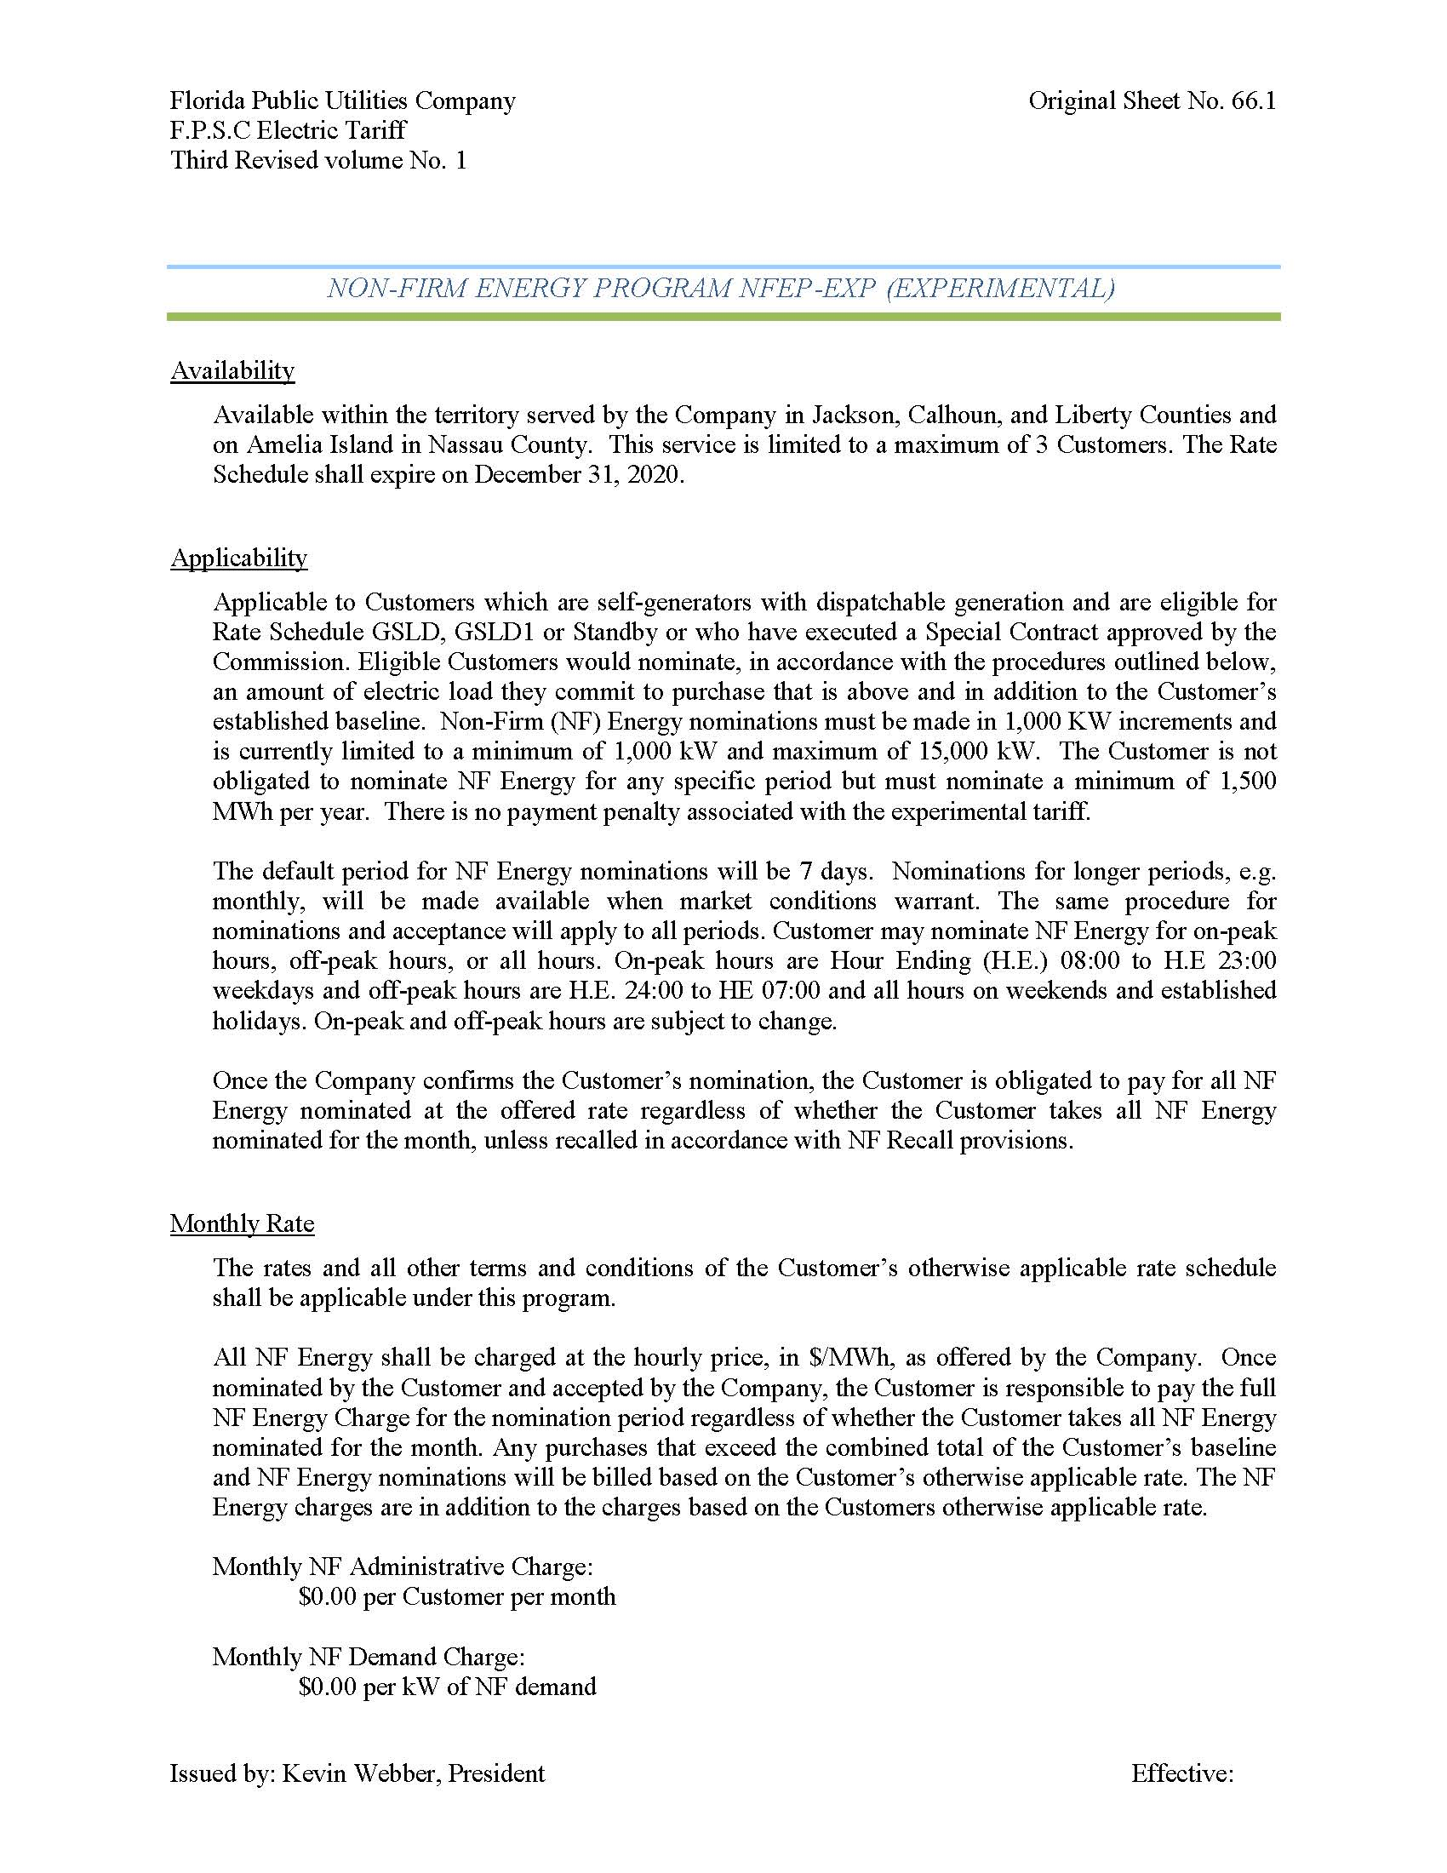

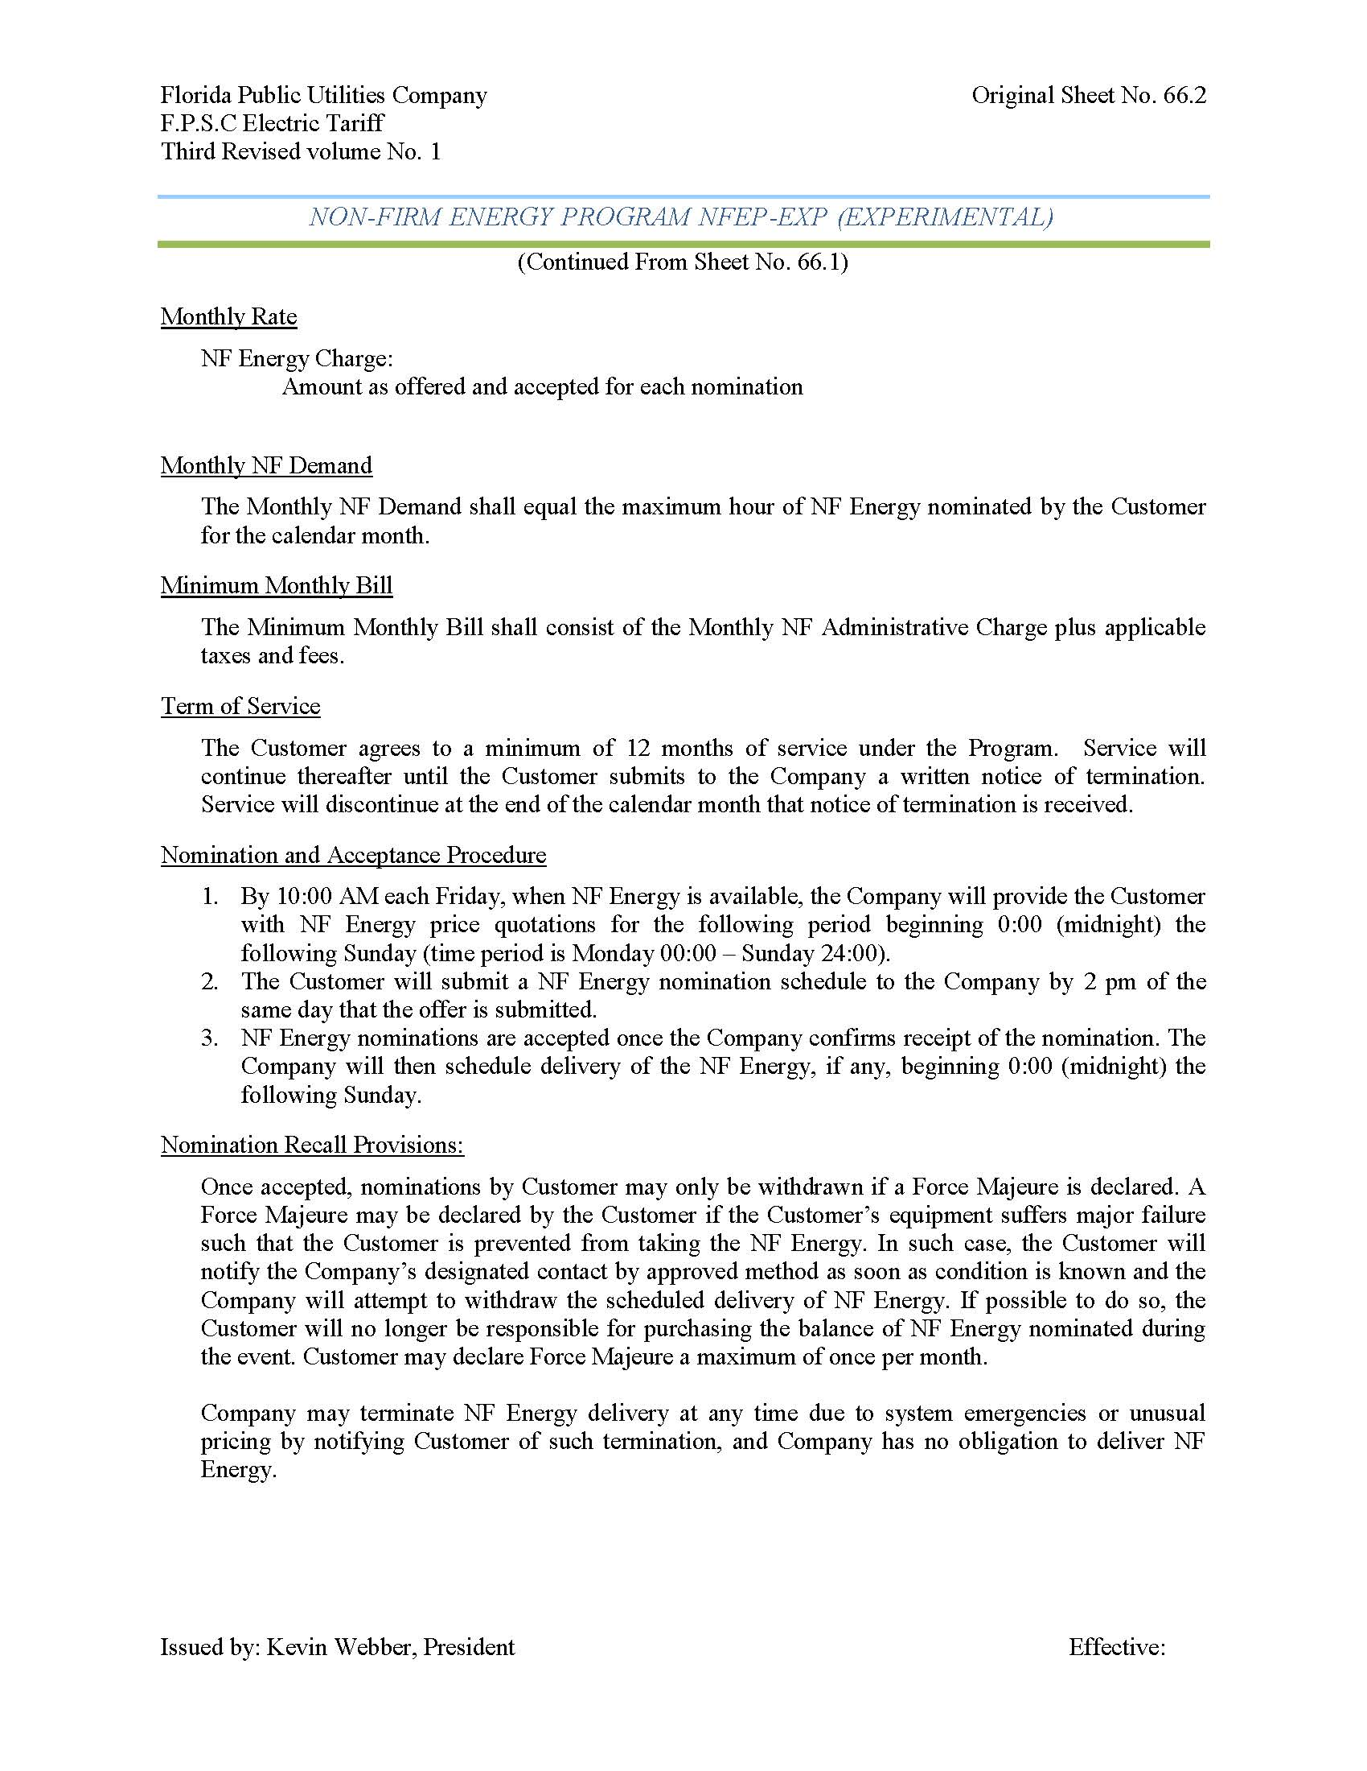

1. FPUC’s Northwest Division currently purchases power from Gulf Power Company pursuant to a wholesale purchased power agreement.