State of Florida |  | Public Service Commission  Capital Circle Office Center ● 2540 Shumard Oak Boulevard  Tallahassee, Florida 32399-0850  -M-E-M-O-R-A-N-D-U-M-
DATE: | October 24, 2019
TO: | Office of Commission Clerk (Teitzman)
FROM: | Division of Economics (Guffey, Coston)  Office of the General Counsel (Schrader)
RE: | Docket No. 20190160-GU – Joint petition for approval of swing service rider rates for January through December 2020, by Florida Public Utilities Company, Florida Public Utilities Company-Indiantown Division, Florida Public Utilities Company-Fort Meade, and Florida Division of Chesapeake Utilities Corporation.
AGENDA: | 11/05/19 – Regular Agenda – Tariff Filing – Interested Persons May Participate
COMMISSIONERS ASSIGNED: |  |  | All Commissioners
PREHEARING OFFICER: |  |  | Administrative
CRITICAL DATES: |  |  | 8-Month effective Date: 4/15/20 (60-day suspension date waived by the companies)
SPECIAL INSTRUCTIONS: |  |  | None

Case Background
On August 16, 2019, Florida Public Utilities Company, Florida Public Utilities Company – Indiantown Division, and Florida Public Utilities Company – Fort Meade (jointly, FPUC), as well as the Florida Division of Chesapeake Utilities Corporation (Chesapeake) (jointly, companies), filed a petition for approval of a revised swing service rider tariff for the period January through December 2020. FPUC is a local distribution company (LDC) subject to the regulatory jurisdiction of the Commission pursuant to Chapter 366, Florida Statutes (F.S.). FPUC is a wholly-owned subsidiary of Chesapeake Utilities Corporation, which is headquartered in Dover, Delaware. Chesapeake is also an LDC subject to the Commission’s jurisdiction under Chapter 366, F.S., and is an operating division of Chesapeake Utilities Corporation.
The Commission first approved the companies’ swing service rider tariff in Order No. PSC-16-0422-TRF-GU (swing service order) and the initial swing service rider rates were in effect for the period March through December 2017. As required in the swing service order, the companies submitted the instant petition with revised 2020 swing service rider rates for Commission approval by September 1, 2019. The swing service rider is a cents per therm charge that is included in the monthly gas bill of transportation customers. This is staff’s recommendation on the 2020 swing service rider rates.
During its evaluation of the petition, staff issued a data request to the companies for which responses were received on September 24, 2019. On August 3, 2019, the companies waived their 60-day file and suspend provision via an e-mail, which has been placed in the docket file. The proposed revised tariff sheets are shown in Attachment A to the recommendation. The Commission has jurisdiction over this matter pursuant to Sections 366.04, 366.05, and 366.06, F.S.

Discussion of Issues

Issue 1:
Should the Commission approve the companies’ revised swing service rider rates for the period January through December 2020?

Recommendation:
Yes. The Commission should approve the companies’ swing service rider rates for the period January through December 2020. The costs included are appropriate and the methodology for calculating the swing service rider rates is consistent with the swing service order. (Guffey)

Staff Analysis:
The companies incur intrastate capacity costs when they transport natural gas on intrastate pipelines (i.e., pipelines operating within Florida only). The companies have two types of natural gas customers: sales and transportation. The swing service rider allows the companies to recover the intrastate capacity costs directly from all transportation customers as intrastate pipeline projects benefit all customers.

Types of Natural Gas Customers
Sales customers are primarily residential and small commercial customers that purchase natural gas from an LDC and receive allocations of intrastate capacity costs through the Purchased Gas Adjustment (PGA) charge. Of the joint petitioners in the instant docket, only Florida Public Utilities Company and Florida Public Utilities Company – Fort Meade have sales customers.
Transportation customers receive natural gas from third party marketers, also known as shippers and, therefore, do not pay the PGA charge to the LDC. The companies’ transportation customers can be categorized as Transitional Transportation Service (TTS) or non-TTS. TTS program shippers purchase gas in aggregated customer pools for residential and small commercial customers, who do not contract directly with a shipper for their gas supply. Of the joint petitioners in the instant docket, only Florida Public Utilities Company – Indiantown Division (Indiantown) and Chesapeake have TTS customers.
TTS customers receive allocations of intrastate capacity costs through the swing service rider. Prior to the approval of the swing service rider, TTS customers received allocations of intrastate capacity cost through the Operational Balancing Account (OBA) mechanism. The OBA mechanism allowed Indiantown and Chesapeake to assign intrastate capacity costs to TTS shippers, who then passed the costs on to the TTS customers for whom they purchase gas. With the approval of the swing service rider, TTS customers are now charged directly for their allocated portion of the intrastate capacity costs (rather than Indiantown and Chesapeake charging the shippers who then passed the costs on to the TTS customers).
Non-TTS customers are primarily large commercial or industrial customers who contract directly with a shipper for their natural gas supply. Prior to the approval of the swing service rider, non-TTS customers were not paying a share of the intrastate capacity costs. The Commission approved a stepped implementation process for the swing service rider for non-TTS customers because the implementation of the swing service rider can have a significant financial impact on those customers who previously had not been allocated any portion of the intrastate capacity costs.
Specifically, the swing service order approved a five-year implementation period for non-TTS customers with a 20 percent per year stepped allocation. Accordingly, the 2019 swing service charges included a 60 percent allocation of intrastate capacity costs to the non-TTS customers; the instant petition includes an 80 percent allocation of intrastate capacity costs to the non-TTS customers.

Proposed Swing Service Rider Rates
The proposed 2020 swing service rider rates were calculated based on the same methodology approved in the swing service order. As shown in the companies’ petition, the total intrastate capacity costs for the period July 2018 through June 2019 are $12,357,380. The total intrastate capacity costs reflect payments by FPUC to intrastate pipelines for the transportation of natural gas, pursuant to Commission approved transportation agreements. In addition, the intrastate capacity costs include payments to outside contractors FPUC hired to provide expertise on the purchase of commodity and capacity.
Of these costs, $5,045,570 will be billed directly to certain large special contract customers. The remaining costs of $7,311,810 are allocated between sales and transportation customers.
The companies used actual therm usage data for the period July 2018 through June 2019 to allocate the intrastate capacity costs. Based on the usage data, the appropriate split for allocating the cost is $5,286,466 (72.3 percent) to transportation customers and $2,025,344 (27.7 percent) to sales customers. The sales customers’ share of the cost is embedded in the PGA.
The transportation customers’ share is allocated to the various transportation rate schedules in proportion with each rate schedule’s share of the companies’ total throughput. To calculate the swing service rider rates, the cost allocated to each rate schedule is divided by the rate schedule’s number of therms.
As stated earlier, TTS customers are charged an allocated portion of the intrastate capacity costs, while non-TTS customers are subject to a phased implementation. Since non-TTS customers are allocated 80 percent of the total intrastate capacity costs in 2020, the swing service revenues the companies will receive is a total of $4,328,730; the remaining $957,736 ($5,286,466 - $4,328,730) of intrastate capacity costs allocated to transportation customers will be recovered through the PGA cost recovery clause from sales customers.

Credit to the PGA
The total intrastate capacity costs are embedded in the PGA with the projected 2020 swing service rider revenues incorporated as a credit in the calculation of the 2020 PGA. The amount credited to the 2020 PGA is $4,328,730, plus $5,045,570 received from special contract customers, for a total of $9,374,300. At the end of the stepped implementation period in 2021, non-TTS customers will no longer receive a reduced allocation of the intrastate capacity cost. As a result, the credit to the PGA will increase and sales customers will no longer absorb a portion of the non-TTS intrastate capacity costs.

Conclusion
Based on its review of the information provided in the petition and in response to staff’s data requests, staff recommends that the companies’ proposed swing service rider is reasonable. Staff reviewed the total projected intrastate capacity costs and verified that the costs included are appropriate. The Commission should approve the proposed swing service rider rates for the period January through December 2020. The costs included are appropriate and the methodology for calculating the swing service rider rates is consistent with the swing service order.

Issue 2:
Should this docket be closed?

Recommendation:
Yes. If Issue 1 is approved and a protest is filed within 21 days of the issuance of the order, the tariff should remain in effect, with any revenues held subject to refund, pending resolution of the protest. If no timely protest is filed, this docket should be closed upon the issuance of a consummating order. (Schrader)

Staff Analysis:
If Issue 1 is approved and a protest is filed within 21 days of the issuance of the order, the tariff should remain in effect, with any revenues held subject to refund, pending resolution of the protest. If no timely protest is filed, this docket should be closed upon the issuance of a consummating order.

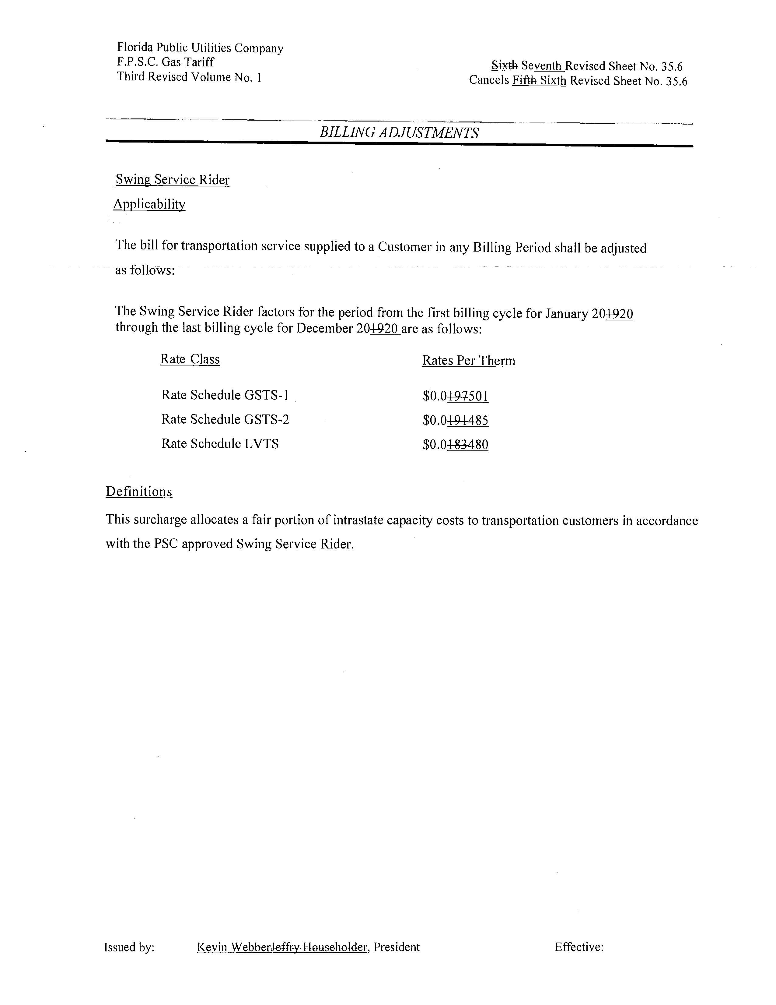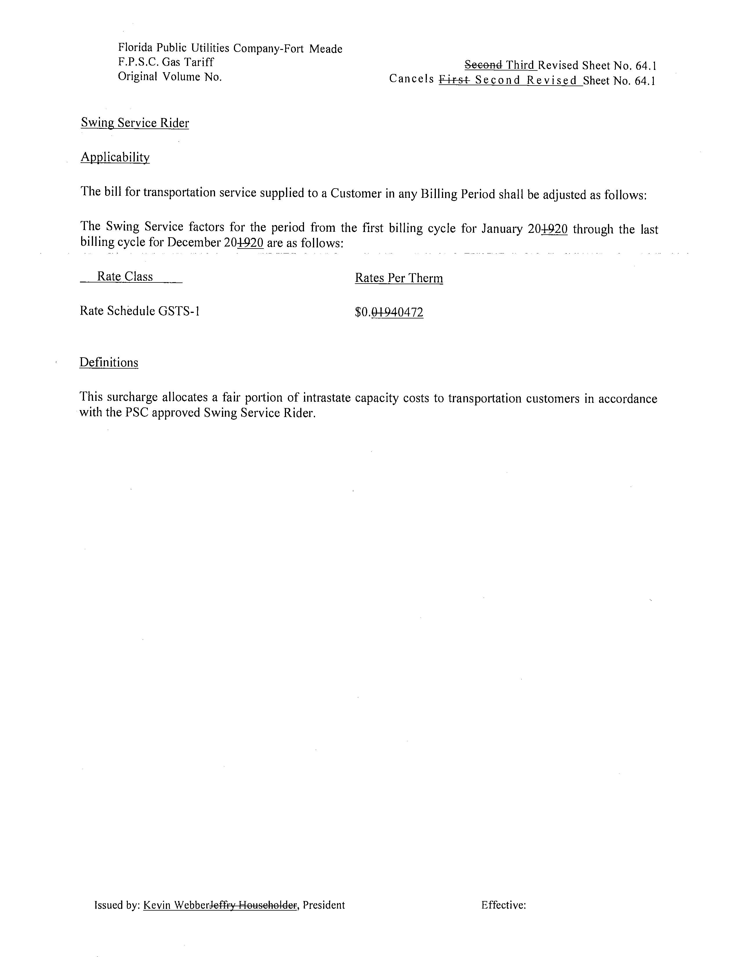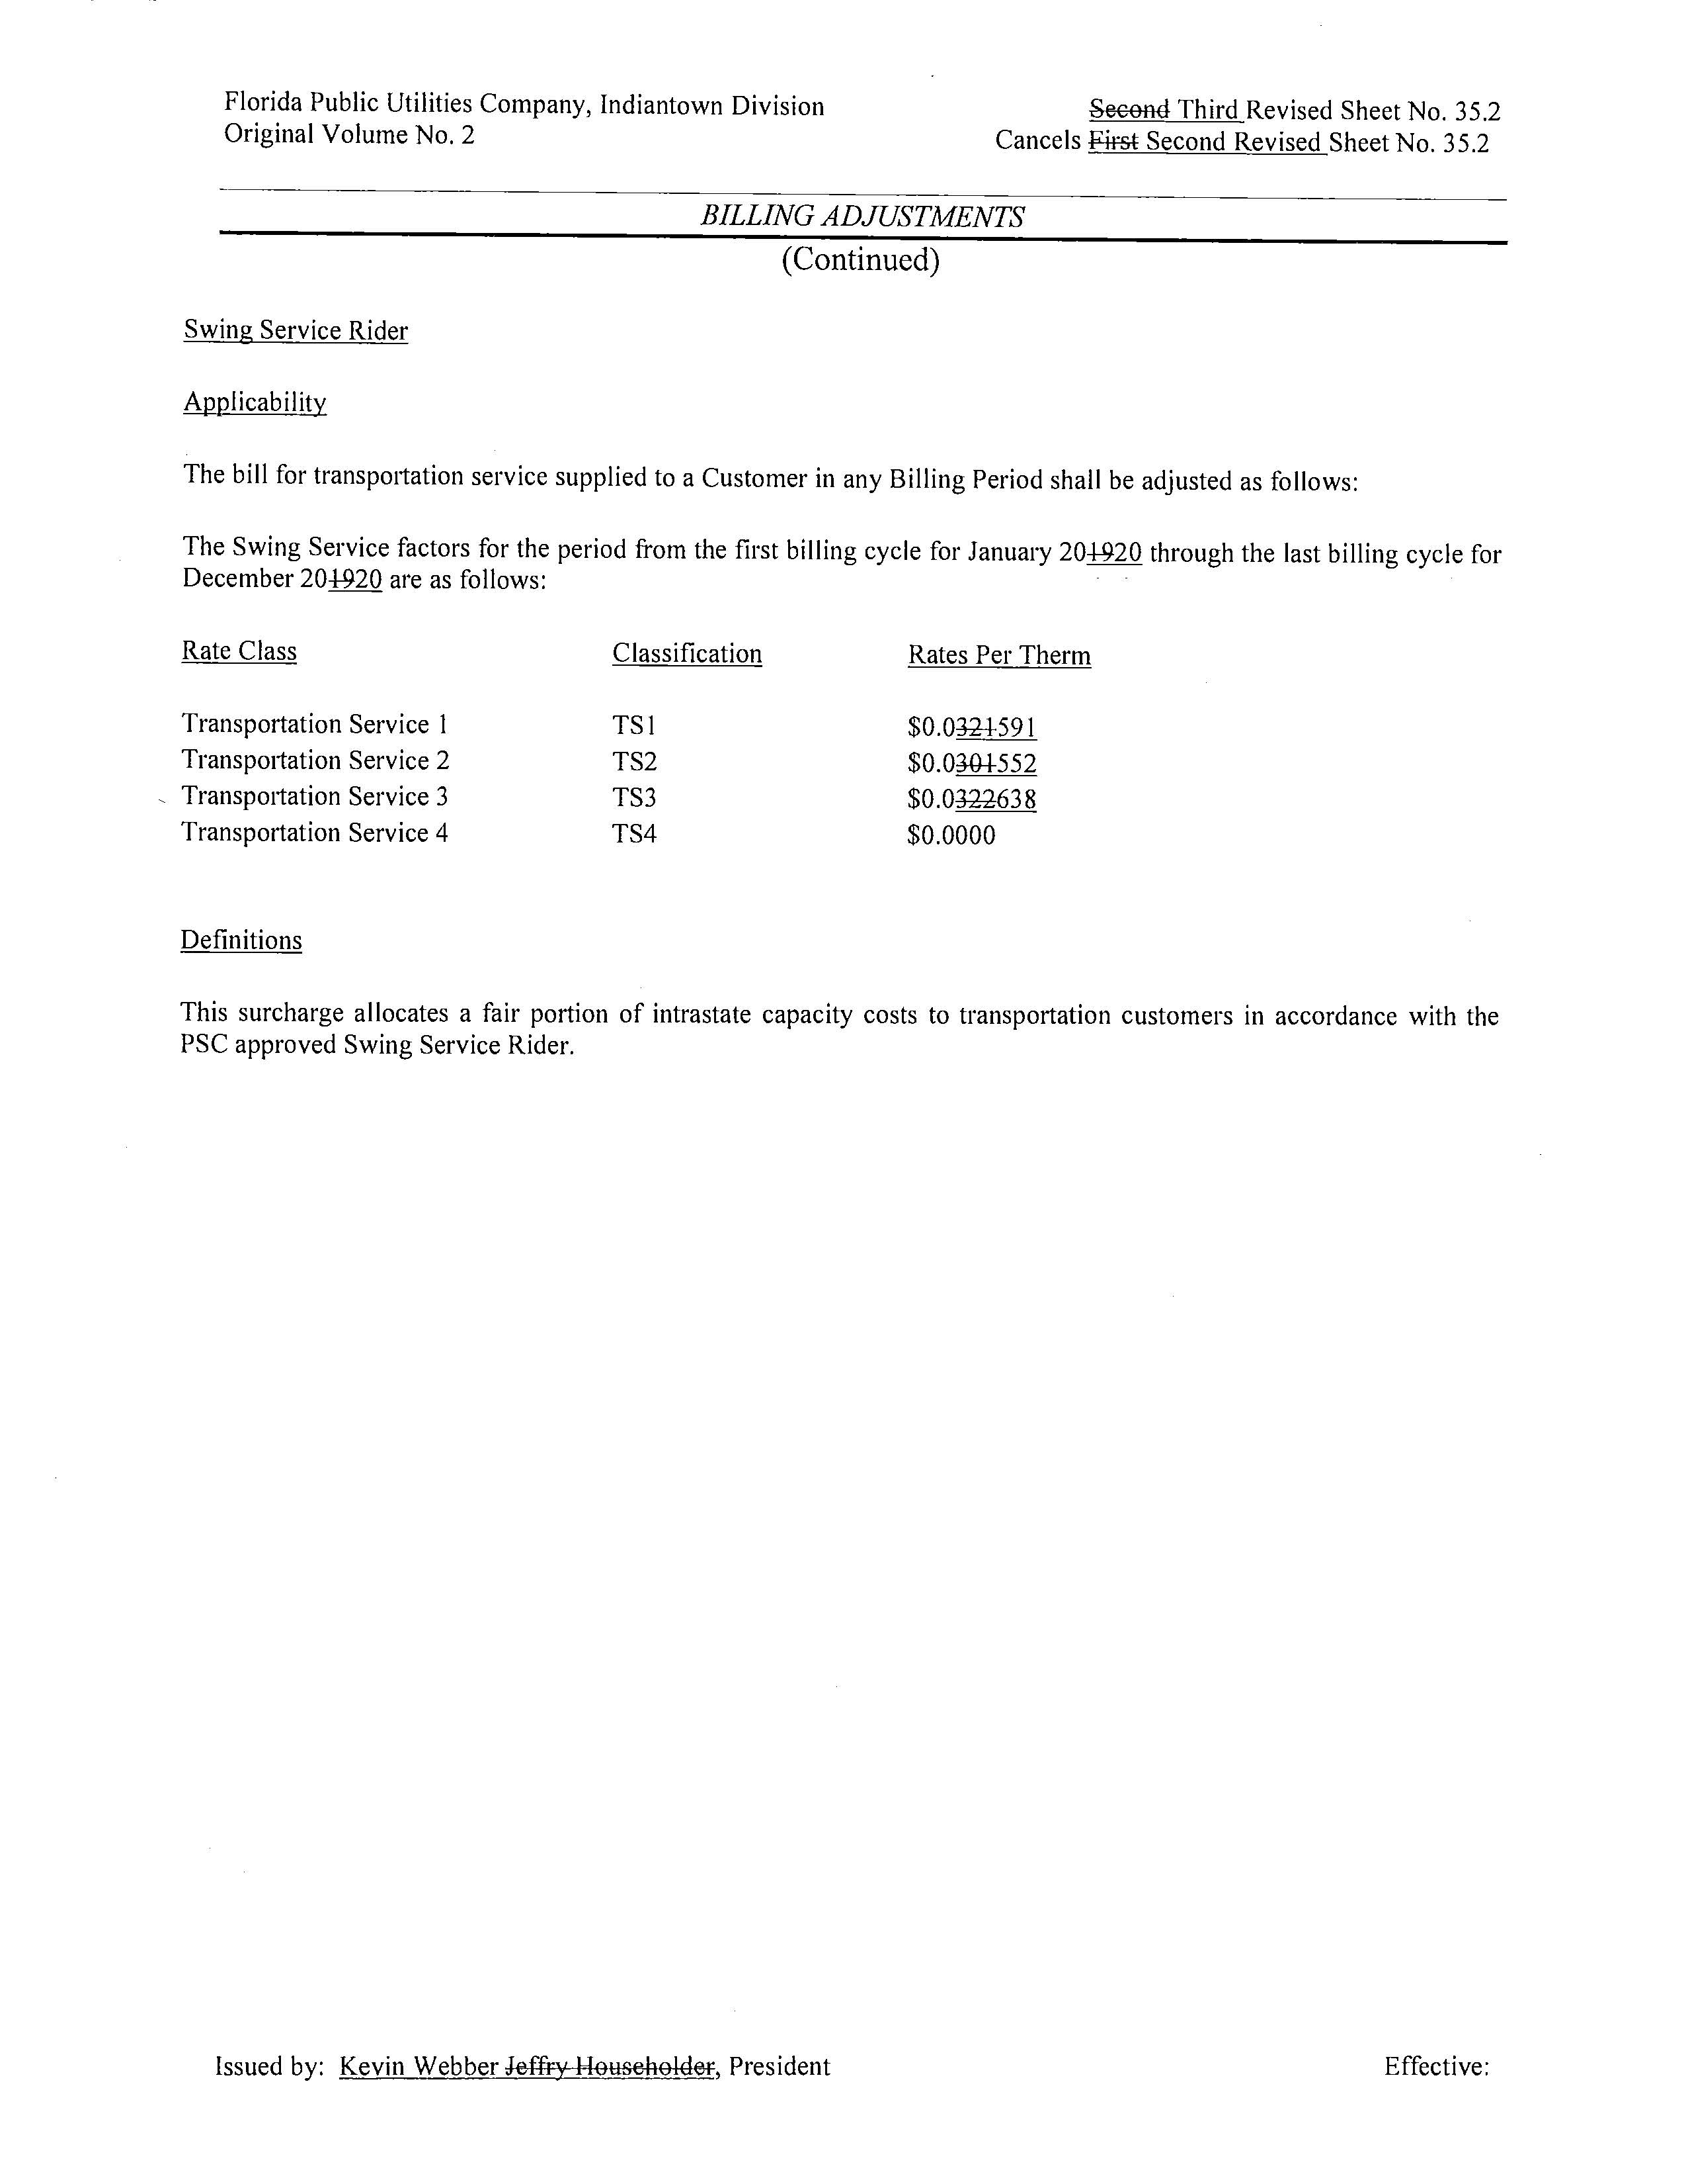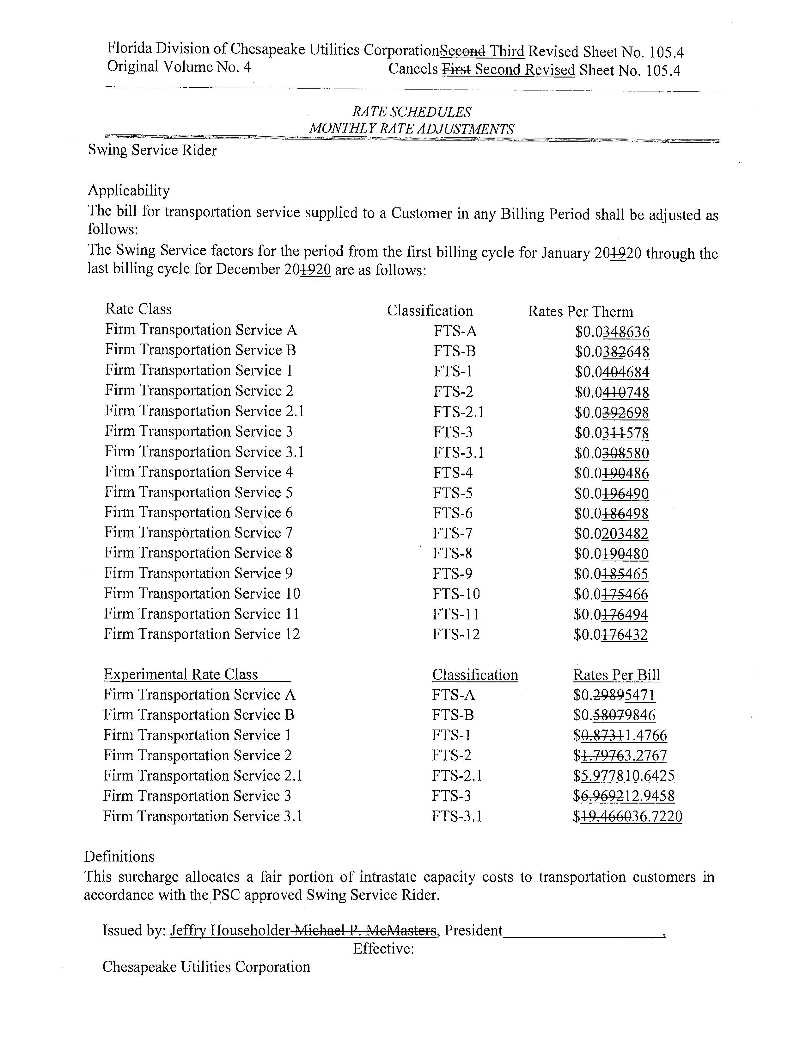

Order No. PSC-16-0422-TRF-GU, issued October 3, 2016, Docket No. 160085-GU, In re: Joint petition for approval of swing service rider, by Florida Public Utilities Company, Florida Public Utilities Company-Indiantown Division, Florida Public Utilities Company-Fort Meade, and Florida Division of Chesapeake Utilities Corporation.
The PGA charge is set by the Commission in the annual PGA cost recovery clause proceeding.
The Commission does not regulate the shippers or their charges for the gas commodity.
See direct testimony of Michelle D. Napier on behalf of FPUC, filed on August 9, 2019, Document No. 07322-2019, in Docket No. 20190003-GU, Exhibit No. MDN-1, Schedule E-1, line 8 on Page 1 of 6.

