State of Florida |  | Public Service Commission  Capital Circle Office Center ● 2540 Shumard Oak Boulevard  Tallahassee, Florida 32399-0850  -M-E-M-O-R-A-N-D-U-M-
DATE: | October 24, 2019
TO: | Office of Commission Clerk (Teitzman)
FROM: | Division of Economics (Ward, Coston)  Division of Accounting and Finance (Hightower)  Office of the General Counsel (Lherisson, Crawford)
RE: | Docket No. 20190173-GU – Joint petition for approval of GRIP cost recovery factors, by Florida Public Utilities Company, Florida Public Utilities Company-Fort Meade, and Florida Division of Chesapeake Utilities Corporation.
AGENDA: | 11/05/19 – Regular Agenda – Tariff Filing – Interested Persons May Participate
COMMISSIONERS ASSIGNED: |  |  | All Commissioners
PREHEARING OFFICER: |  |  | Administrative
CRITICAL DATES: |  |  | 60-Day suspension date waived by the utility until 11/5/2019
SPECIAL INSTRUCTIONS: |  |  | None

Case Background
On September 3, 2019, Florida Public Utilities Company (FPUC), Florida Public Utilities Company-Fort Meade (Fort Meade), and Florida Division of Chesapeake Utilities Corporation (Chesapeake), collectively the companies, filed a joint petition for approval of their gas reliability infrastructure program (GRIP or program) cost recovery factors for the period January through December 2020. The GRIP for FPUC and Chesapeake was first approved in Order No. PSC-12-0490-TRF-GU (2012 order) to recover the cost of accelerating the replacement of cast iron and bare steel distribution mains and services, including a return on investment, through a surcharge on customers’ bills. Fort Meade’s GRIP was originally approved in Order No. PSC-15-0578-TRF-GU, and allowed Fort Meade to file its annual petition for GRIP factors concurrently with FPUC and Chesapeake. The current GRIP charges for January through December 2019 were approved in Order No. PSC-2018-0547-TRF-GU.
On October 8, 2019, the companies filed responses to staff’s first data request. On October 11, 2019, the companies filed responses to staff’s second data request. In an email dated October 21, 2019, the companies waived the 60-day file and suspend provision of Section 366.06(3), Florida Statutes (F.S.), until the November 5, 2019 Agenda Conference. The proposed tariff sheets are contained in Attachment B (FPUC), Attachment C (Chesapeake), and Attachment D (Fort Meade). The Commission has jurisdiction over this matter pursuant to Sections 366.03, 366.04, 366.05, and 366.06, F.S.

Discussion of Issues

Issue 1:
Should the Commission approve FPUC's, Fort Meade's, and Chesapeake's proposed GRIP surcharges for the period January through December 2020?

Recommendation:
Yes, the Commission should approve FPUC’s, Chesapeake’s, and Fort Meade’s proposed GRIP surcharges for the period January through December 2020. Furthermore, staff recommends the Commission direct the Company to determine if the WACC complies with the normalization rules to avoid a normalization violation. Additionally, if an adjustment to the WACC is necessary, staff recommends any adjustment be made in a subsequent true-up filing. (Ward, Hightower)

Staff Analysis:
The GRIP surcharges have been in place since January 2013 for FPUC and Chesapeake, while Fort Meade’s surcharges were first implemented in January 2017. In response to staff’s data requests, the companies stated that replacement projects in Winter Haven, Lake Worth, New Smyrna Beach, West Palm Beach, Palm Beach, Fort Meade, Bartow, and Lake Wales were completed in 2019. Additional replacement projects in Lake Worth, Winter Haven, New Smyrna Beach, West Palm Beach, Palm Beach, Boynton Beach, Haines City, Lake Wales, and Lake Alfred were projected to continue into 2020. Attachment A provides an update of mains and services replaced and replacement forecasts. The companies stated that they prioritize the potential replacement projects focusing on areas of high consequence and areas more susceptible to corrosion.

FPUC’s True-ups by Year
FPUC’s calculation for the 2020 GRIP revenue requirement and surcharges include a final true-up for 2018, an actual/estimated true-up for 2019, and projected costs for 2020. FPUC was authorized to recover $747,727 of annual GRIP expenses in base rates; therefore, the $747,727 is excluded from the GRIP surcharge calculation.

Final True-up for 2018
FPUC stated that the revenues collected through the GRIP surcharges for 2018 were $10,326,269, compared to a revenue requirement of $9,994,382, resulting in an over-recovery of $331,887. The 2017 over-recovery of $2,231,264, the 2018 over-recovery of $331,887, and interest of $53,720 associated with any over- and under-recoveries results in a final 2018 true-up of $2,616,870 (over-recovery).

Actual/Estimated 2019 True-ups
FPUC provided actual revenues for January through July 2019 and estimated revenues for August through December 2019, totaling $9,166,112, compared to an actual/estimated revenue requirement for 2019 of $10,326,381, resulting in an under-recovery of $1,160,269. The 2018 over-recovery of $2,616,870, the 2019 under-recovery of $1,160,270, and interest of $56,582 results in a total 2019 over-recovery of $1,513,182.

Projected 2020 Costs
FPUC expects capital expenditures of $12,220,000 for the replacement of cast iron/bare steel infrastructure in 2020. The return on investment (which includes federal income taxes, regulatory assessment fees, and bad debt), depreciation expense, and property tax and customer notification expense associated with that investment are $12,112,394. Subtracting the revenue requirement for bare steel replacement included in base rates results in a 2020 revenue requirement of $11,364,667. After subtracting the total 2019 over-recovery of $1,513,182, the 2020 revenue requirement is $9,851,484. Table 1-1 shows FPUC’s 2020 revenue requirement calculation.
Table 1-1
FPUC 2020 Revenue Requirement Calculation
2020 Projected Expenditures | $10,000,000
Return on Investment | $7,355,418
Depreciation Expense | 2,815,901
Property Tax and Customer Notice Expense | 1,941,074
2020 Revenue Requirement | $12,112,394
Less Revenue Requirement in Base Rates | 747,727
2020 GRIP Revenue Requirement | $11,364,667
Less 2019 Over-recovery | 1,513,182
2020 Total Revenue Requirement | $9,851,484
Source: FPUC Responses to Staff’s First Data Request, Attachment 2 Schedule C-2 page 4 of 15

Chesapeake’s True-ups by Year
Chesapeake’s calculation for the 2020 GRIP revenue requirement and surcharges include a final true-up for 2018, an actual/estimated true-up for 2019, and projected costs for 2020. Chesapeake does not have a replacement recovery amount embedded in base rates.

Final True-up for 2018
Chesapeake stated that the revenues collected for 2018 were $3,602,006, compared to a revenue requirement of $3,246,851, resulting in over-recovery of $355,155. The 2017 under-recovery of $164,174, 2018 over-recovery of $355,155, and interest of $1,164 associated with any over- and under-recoveries results in a final 2018 over-recovery of $192,146.

Actual/Estimated 2019 True-up
Chesapeake provided actual GRIP revenues for January through July 2019 and estimated revenues for August through December 2019, totaling $4,381,645, compared to an actual/estimated revenue requirement of $3,883,318, resulting in an over-recovery of $498,327. The 2018 over-recovery of $192,146, 2019 over-recovery of $498,327, and interest of $11,425 associated with any over- and under-recoveries results in a total 2019 over-recovery of $701,897.

Projected 2020 Costs
Chesapeake projects capital expenditures of $2,000,000 for the replacement of cast iron/bare steel infrastructure in 2020. The return on investment, depreciation expense, and property tax and customer notification expense to be recovered in 2020 totals $4,181,223. After subtracting the total 2019 over-recovery of $701,897, the total 2020 revenue requirement is $3,479,326. Table 1-2 shows Chesapeake’s 2020 revenue requirement calculation.

Table 1-2
Chesapeake 2020 Revenue Requirement Calculation
2020 Projected Expenditures | $2,000,000
Return on Investment | $2,511,628
Depreciation Expense | 986,653
Property Tax and Customer Notice Expense | 682,942
2020 Revenue Requirement | $4,181,223
Less 2019 Over-recovery | 701,897
2020 Total Revenue Requirement | $3,479,326
Source: FPUC Responses to Staff’s First Data Request, Attachment 2 Schedule C-2 page 9 of 15

Fort Meade’s True-ups by Year
Fort Meade started its replacement program in 2016 and first implemented GRIP surcharges in January 2017. Unlike FPUC and Chesapeake, only bare steel services (and no mains) require replacement in Fort Meade. Fort Meade’s replacement program was originally scheduled to be completed in 2018. However, the companies explained that as a result of delays in contractor availability and permitting, the replacement program is expected to conclude in 2019.

Final True-up for 2018
Fort Meade stated that the revenues collected for 2018 were $7,394, compared to a revenue requirement of $24,720, resulting in an under-recovery of $17,326. Adding the 2017 over-recovery of $13,528, the 2018 under-recovery of $17,326, and $104 for interest associated with any over- and under-recoveries, the final 2018 under-recovery is $3,693.

Actual/Estimated 2019 True-up
Fort Meade provided actual GRIP revenues for January through July 2019 and estimated revenues for August through December 2019 totaling $25,087, compared to an actual/estimated revenue requirement of $25,518, resulting in an under-recovery of $431. Adding the 2018 under-recovery of $3,693, the 2019 under-recovery of $431, and interest of $64 associated with any over- and under-recoveries, the resulting total 2019 true-up is an under-recovery of $4,188.

Projected 2020 Costs
Fort Meade projects capital expenditures of $0 for the replacement of cast iron/bare steel infrastructure in 2020, as the replacement program is scheduled to be completed in 2019. Therefore, the 2020 GRIP factors are designed to only recover the remaining 2019 under-recovery of $4,188 and the revenue requirement of $25,526 associated with the 2019 year-end total investment ($4,188 + $25,526 = $29,714).

Proposed Surcharges for FPUC, Chesapeake, and Fort Meade
As established in the 2012 order approving the GRIP program, the total 2020 revenue requirement is allocated to the rate classes using the same methodology used for the allocation of mains and services in the cost of service study used in the utilities’ most recent rate case. The respective percentages were multiplied by the 2020 revenue requirements and divided by each rate class’ projected therm sales to provide the GRIP surcharge for each rate class.
The proposed 2020 GRIP surcharge for FPUC’s residential customers on the Residential Service (RS) schedule is $0.22312 per therm (compared to the current surcharge of $0.21356 per therm). The monthly bill impact is $4.46 for a residential customer using 20 therms per month. The proposed FPUC tariff page is shown in Attachment B.
The proposed 2020 GRIP surcharge for Chesapeake’s residential customers on the FTS-1 schedule is $0.10585 per therm (compared to the current surcharge of $0.13593). The monthly bill impact is $2.12 for a residential customer using 20 therms per month. The proposed Chesapeake tariff pages are contained in Attachment C.
The proposed 2020 GRIP surcharge for Fort Meade’s residential customers on the RS schedule is $0.24865 per therm (compared to the current surcharge of $0.29382). The monthly bill impact is $4.97 for a residential customer using 20 therms per month. The proposed Fort Meade tariff page is shown in Attachment D.

Accounting and Tax Considerations
The state corporate income tax rate changed from 5.5 percent to 4.458 percent beginning on January 1, 2019 through January 1, 2022. The change in tax rate was announced by the Department of Revenue’s Tax Information Publication on September 12, 2019. Therefore, the proposed 2020 factors that are addressed in this recommendation do not reflect the lower tax rate. In a noticed informal meeting on October 15, 2019, Commission staff, utility representatives, and interested persons discussed the change in the tax rate. Based on the discussions and comments made by the utilities, staff recommends that the companies address the impact of the lower tax rate in the 2019 true-up calculations provided in the surcharge petition that will be filed in September 2020 for 2021 factors.
Commission staff reviewed the companies’ weighted average cost of capital (WACC), as filed in its petition. In their response to the staff’s second data request, the companies indicated the calculation of the WACC complies with Order No. PSC-2012-0425-PAA-EU regarding IOU cost recovery clauses. However, the companies did not determine whether a proration adjustment is required. Consequently, it is unknown if the companies are in compliance with Internal Revenue Service (IRS) normalization rules, per Internal Revenue Code (IRC) §1.167(l)-1. Staff recommends the Commission direct the companies to determine if the WACC complies with the normalization rules to avoid a normalization violation. Further, if an adjustment to the WACC is necessary, staff recommends any adjustment be made in a subsequent true-up filing.

Conclusion
Staff believes the calculation of the 2020 GRIP surcharge revenue requirement and the proposed GRIP surcharges for FPUC, Chesapeake, and Fort Meade are reasonable and accurate. Staff recommends approval of FPUC’s, Chesapeake’s, and Fort Meade’s proposed GRIP surcharges for the period January through December 2020. Furthermore, staff recommends the Commission direct the Company to determine if the WACC complies with the normalization rules to avoid a normalization violation. Additionally, if an adjustment to the WACC is necessary, staff recommends any adjustment be made in a subsequent true-up filing.

Issue 2:
Should this docket be closed?

Recommendation:
Yes. If Issue 1 is approved and a protest is filed within 21 days of the issuance of the order, the tariffs should remain in effect, with any revenues held subject to refund, pending resolution of the protest. If no timely protest is filed, this docket should be closed upon the issuance of a consummating order. (Lherisson)

Staff Analysis:
If Issue 1 is approved and a protest is filed within 21 days of the issuance of the order, the tariffs should remain in effect, with any revenues held subject to refund, pending resolution of the protest. If no timely protest is filed, this docket should be closed upon the issuance of a consummating order.
FPUC, Chesapeake, and Fort Meade Pipe Replacement Program Progress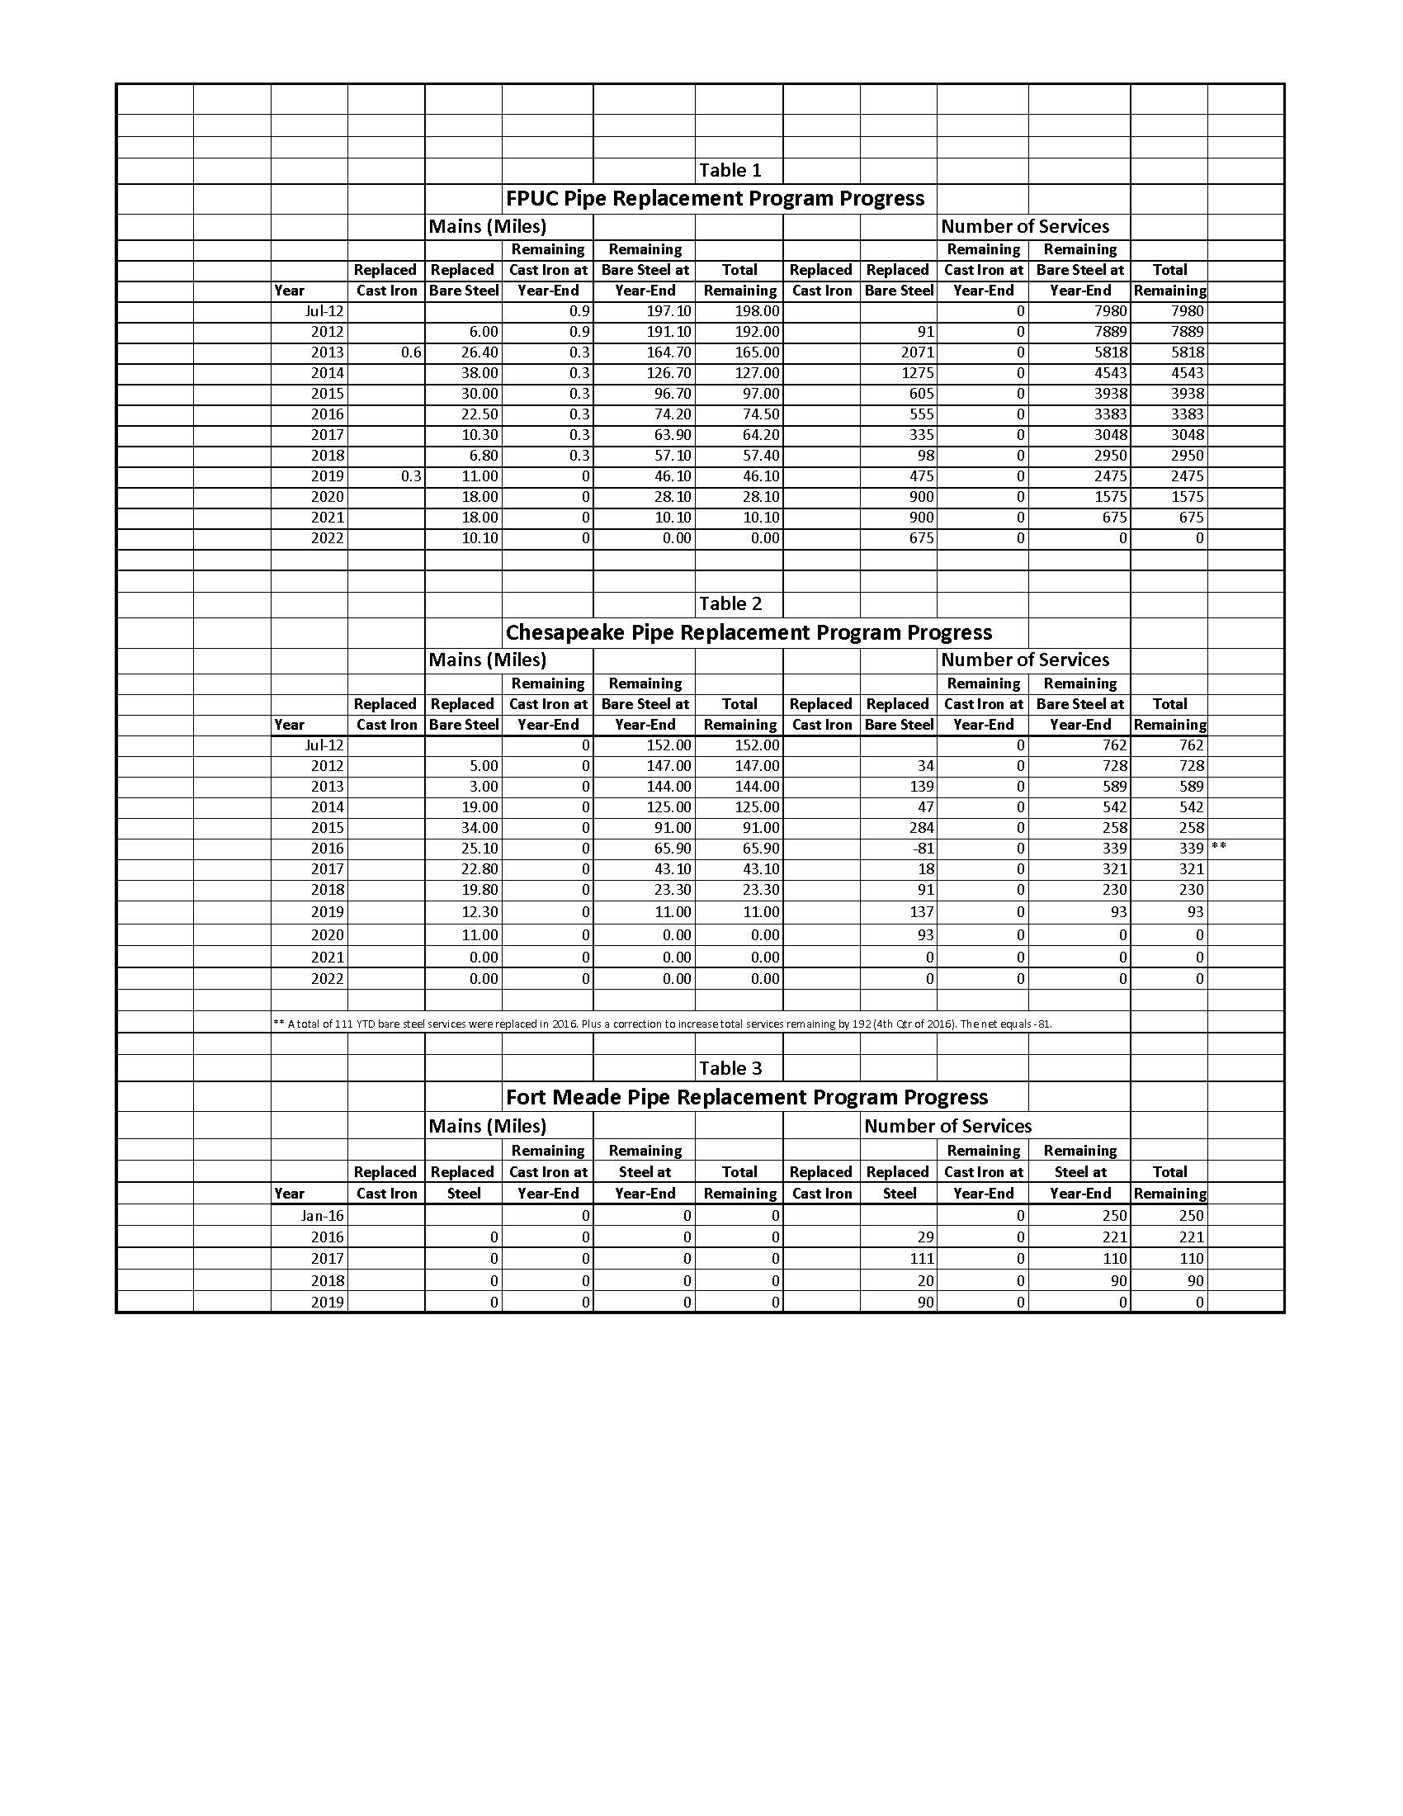
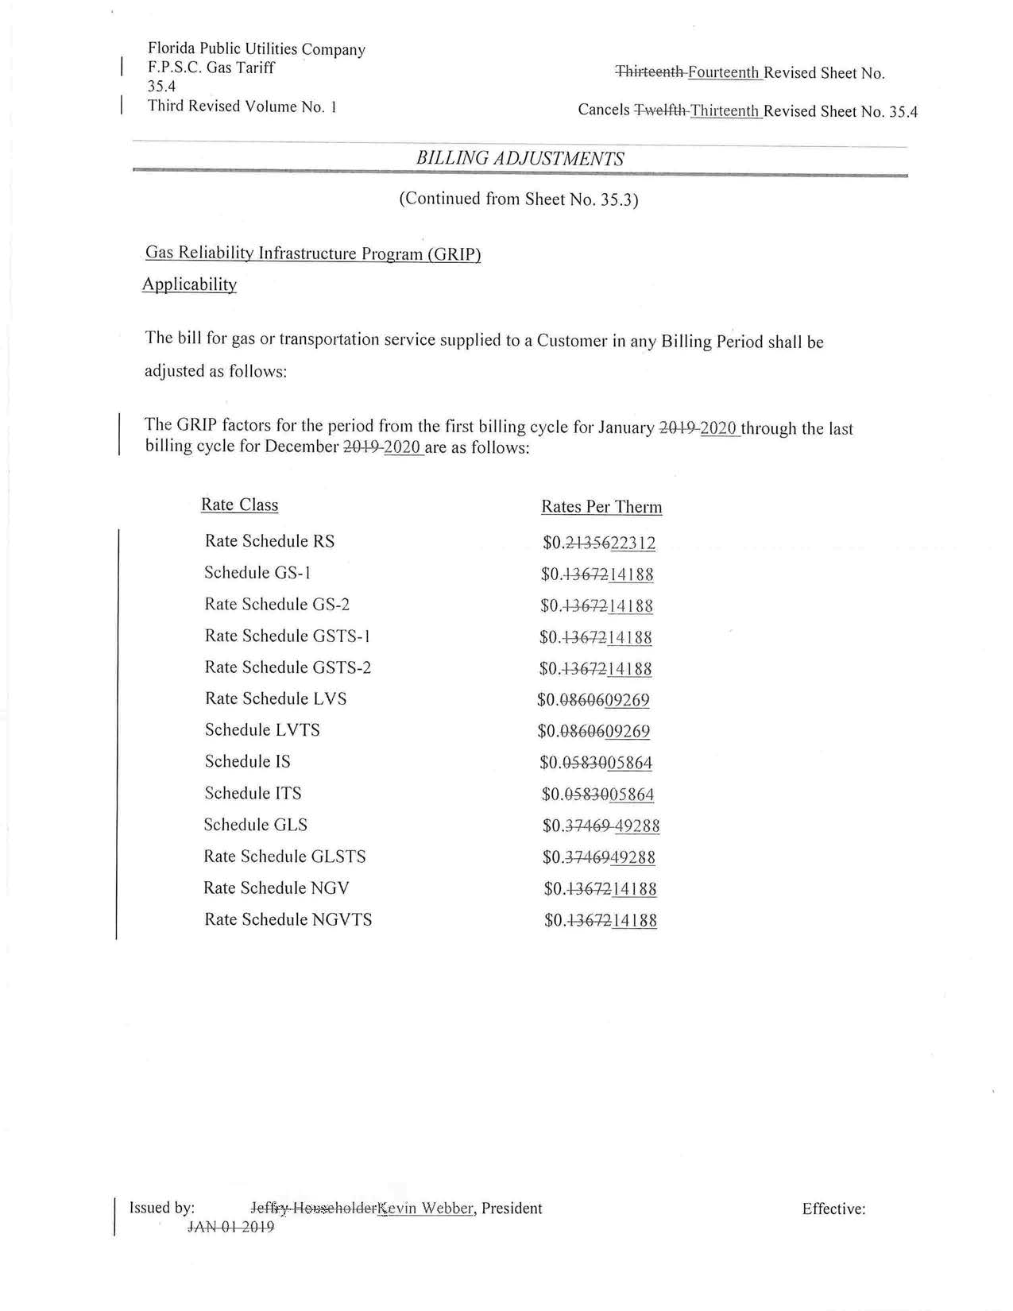
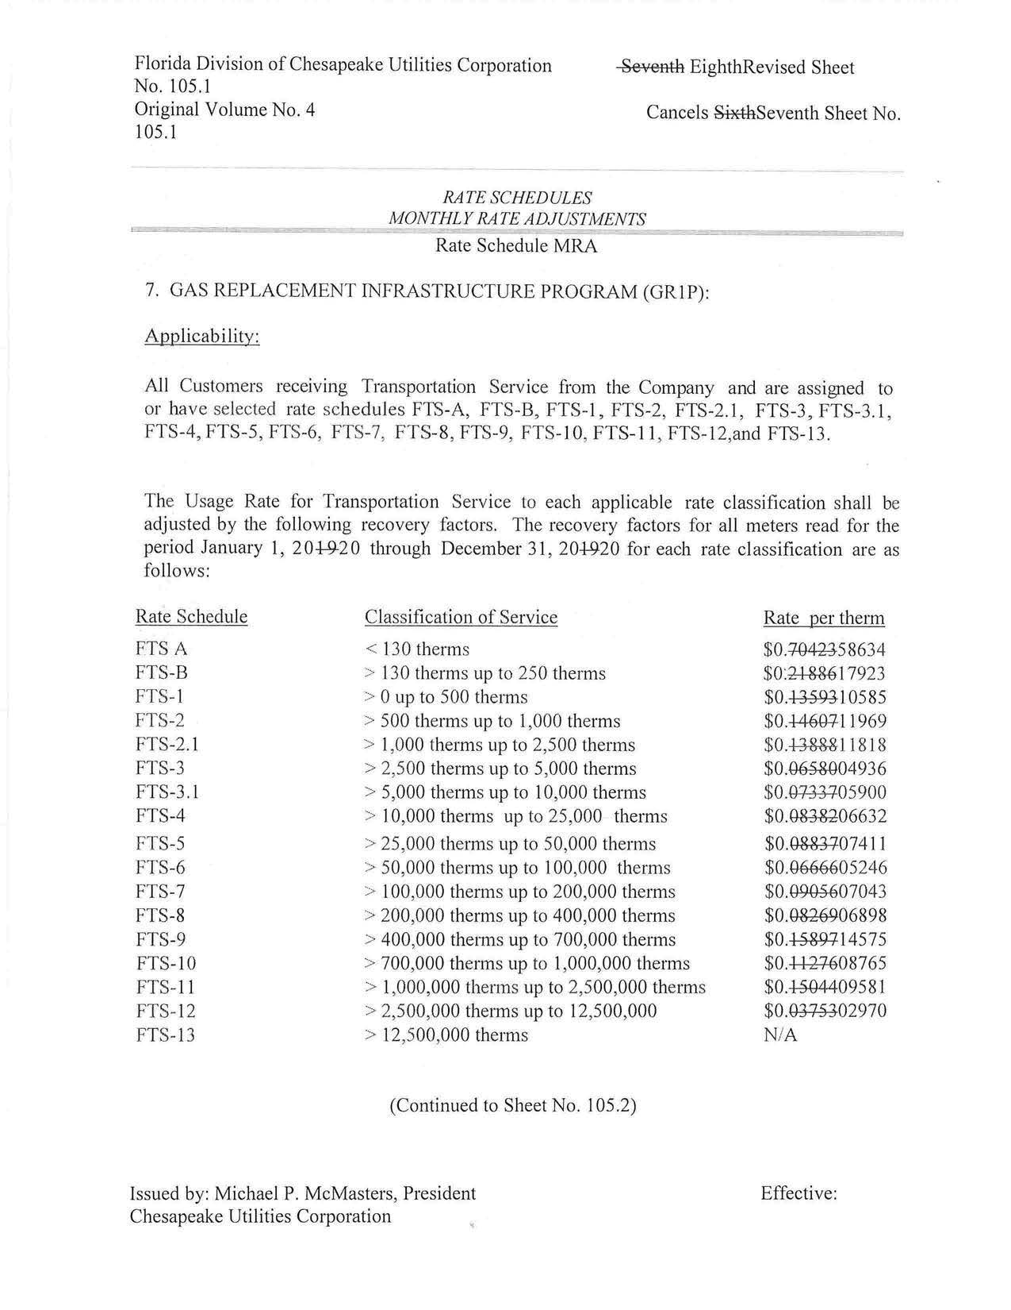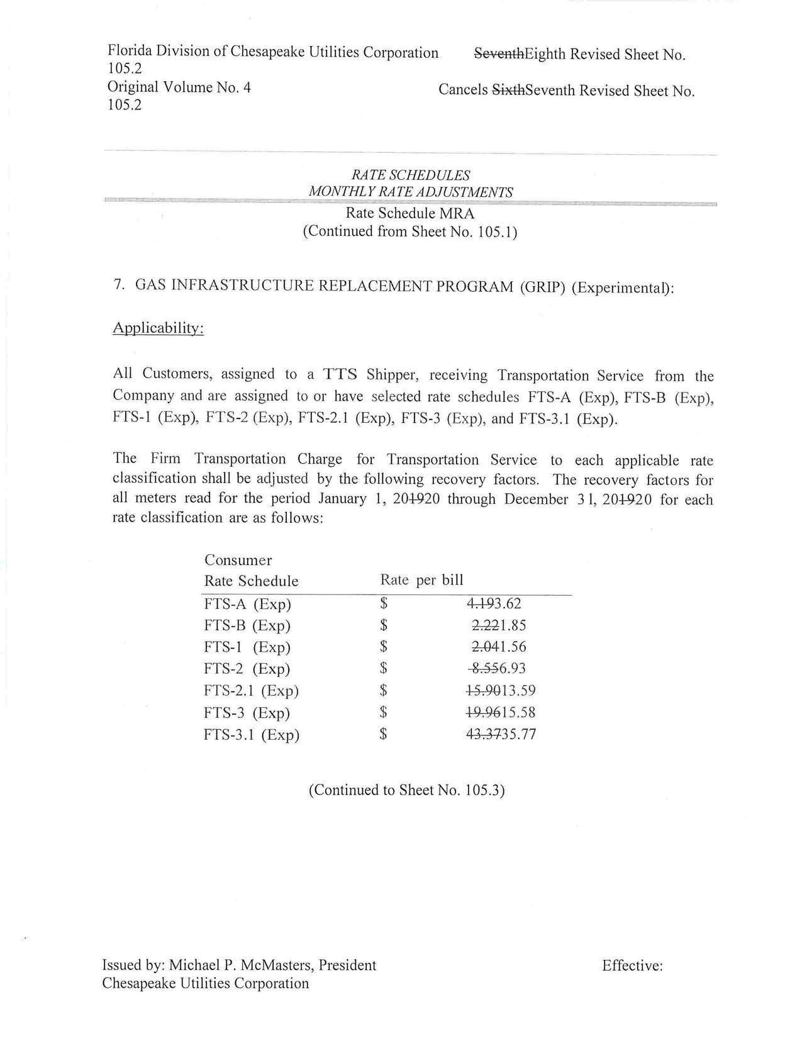
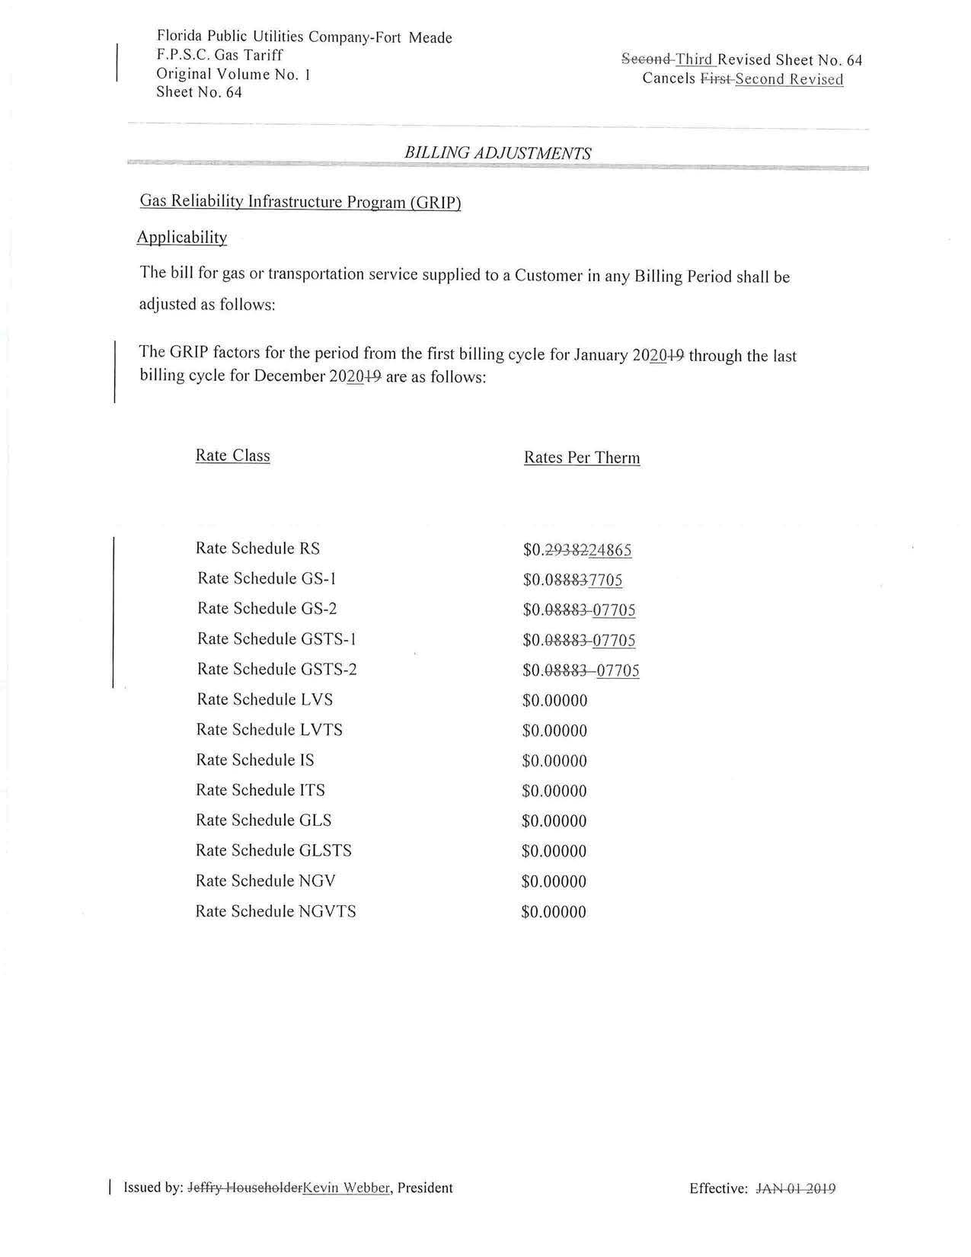

Order No. PSC-12-0490-TRF-GU, issued September 24, 2012, in Docket No. 120036-GU, In re: Joint petition for approval of Gas Reliability Infrastructure Program (GRIP) by Florida Public Utilities Company and the Florida Division of Chesapeake Utilities Corporation.
Order No. PSC-15-0578-TRF-GU, issued December 21, 2015, in Docket No. 150191-GU, In re: Joint petition for approval to implement gas reliability infrastructure program (GRIP) for Florida Public Utilities Company-Fort Meade and for approval of GRIP cost recovery factors by Florida Public Utilities Company, Florida Public Utilities Company-Fort Meade, and the Florida Division of Chesapeake Utilities Corporation.
Order No. PSC-2018-0547-TRF-GU, issued November 19, 2018, in Docket No. 20180163-GU, In re: Joint petition for approval of gas reliability infrastructure program (GRIP) cost recovery factors by Florida Public Utilities Company, Florida Public Utilities Company-Fort Meade, and Florida Division of Chesapeake Utilities Corporation.

