State of Florida |  | Public Service Commission  Capital Circle Office Center ● 2540 Shumard Oak Boulevard  Tallahassee, Florida 32399-0850  -M-E-M-O-R-A-N-D-U-M-
DATE: | October 24, 2019 November 26, 2019
TO: | Office of Commission Clerk (Teitzman)
FROM: | Division of Economics (Guffey)  Division of Accounting and Finance (Hightower)  Office of the General Counsel (Lherisson)
RE: | Docket No. 20190171-GU – Petition for approval of 2018 true-up, projected 2019 true-up, and 2020 revenue requirements and surcharges associated with cast iron/bare steel pipe replacement rider, by Peoples Gas System.
AGENDA: | 11/05/19 12/10/19 – Regular Agenda – Tariff Filing – Interested Persons May Participate
COMMISSIONERS ASSIGNED: |  |  | All Commissioners
PREHEARING OFFICER: |  |  | Administrative
CRITICAL DATES: |  |  | 8-Month Effective Date: 04/30/20 (60-day suspension date waived by the utility)
SPECIAL INSTRUCTIONS: |  |  | None

Case Background
On August 30, 2019, Peoples Gas System (Peoples or utility) filed a petition for approval of its final 2018 true-up, projected 2019 true-up, and 2020 revenue requirement and surcharges associated with the cast iron/bare steel replacement rider (Rider CI/BSR or rider). The rider was originally approved in Order No. PSC-12-0476-TRF-GU (2012 order) to recover the cost of accelerating the replacement of cast iron and bare steel distribution pipes through a surcharge on customers’ bills. Peoples’ current surcharges were approved in Order No. PSC-2018-0540-TRF-GU. In the 2012 order, the Commission found that “replacement of these types of pipelines is in the public interest to improve the safety of Florida’s natural gas infrastructure, and reduce the possibility of loss of life and destruction of property should an incident occur.”
In Order No. PSC-17-0066-AS-GU the Commission approved a comprehensive settlement agreement between Peoples and the Office of Public Counsel (OPC). The settlement agreement, in part, added problematic plastic pipe (PPP) installed in the company’s distribution system to eligible replacements under the rider. PPP was manufactured before 1983 and has significant safety concerns. In certain areas, the PPP is interspersed with, or connected to, the cast iron/bare steel pipe that is being replaced under the rider. As provided for in the settlement agreement, PPP replacements are included in the calculation of the 2020 rider surcharges.
On September 12, 2018, the Commission approved a settlement agreement between Peoples, OPC, and the Florida Industrial Power Users Group in Docket No. 20180044-GU addressing certain impacts of the Tax Cuts and Jobs Act of 2017 on Peoples. The settlement agreement provides for a reduction of Peoples’ 2019 depreciation expense of approximately $10.3 million resulting from extending the lives of certain mains and service assets, which, consequently, reduces the depreciation expense collected through the rider. Additionally, the settlement agreement provides that Peoples’ revenue requirement calculations incorporate the lower federal income tax rate effective February 6, 2018.
In its petition, the utility waived its 60-day file-and-suspend provision of Section 366.06(3), Florida Statutes (F.S.). Peoples filed its response to staff’s first data request on September 27, 2019. With the responses, the company utility filed revised tariff Sheet No. 7.806 which is contained in Attachment B to the recommendation. On October 14, 2019, Peoples filed responses to staff’s second data request. On November 4, 2019, Peoples requested the staff recommendation dated for the November 5, 2019 Agenda Conference be deferred to the December 10, 2019 Agenda Conference. The deferral was to allow the utility additional time to evaluate its calculations related to its Weighted Average Cost of Capital (WACC) and treatment of Accumulated Deferred Income Taxes (ADITs) in the instant docket. On November 12, 2019, Peoples filed its amended petition including the Ninth Revised Sheet No. 7.806 in the subject docket, which is contained in Attachment B to this recommendation. On November 18, 2019, Peoples responded to staffs’ follow-up questions by e-mail, and the e-mail has been placed in the docket file. The Commission has jurisdiction over this matter pursuant to Sections 366.03, 366.04, 366.05, and 366.06, F.S.

Discussion of Issues

Issue 1:
Should the Commission approve Peoples proposed Rider CI/BSR surcharges for the period January through December 2020?

Recommendation:
Yes, the Commission should approve Peoples’ proposed Rider CI/BSR surcharges for the period January through December 2020. (Guffey, Hightower)

Staff Analysis:
The Rider CI/BSR charges have been in effect since January 2013. Rider PPP charges have been in effect since 2017. In 2019, Peoples’ cast iron and bare steel replacement activity focused in the areas of St. Petersburg, Tampa, Miami, Jacksonville, and Sarasota, while PPP projects were in Daytona, Eustis, Pompano Beach, and Orlando. In 2020, Peoples states it will focus on replacement projects in St. Petersburg, Tampa, Orlando, Miami, Jacksonville, and Ocala. The original projected completion date for the CI/BSR replacement program was 2022 for mains and services; however, Peoples now expects to complete the mains and services replacement in 2021. The replacement of PPP is expected to continue until 2028.
Attachment A to this recommendation contains tables which display the replacement progress and forecasts for Rider CI/BSR (Table 1) and for PPP (Table 2). Additionally, Peoples provided Table 3 which consolidates actual and projected CI/BSR and PPP miles replaced investment and revenue requirements for each year of the replacement program.

True-ups by Year
Peoples’ calculation for the 2020 revenue requirement and surcharges includes a final true-up for 2018, an actual/estimated true-up for 2019, and projected costs for 2020. Pursuant to the 2012 order, the capital expenditures for 2017 through 2019 exclude the first $1 million of facility replacements each year because that amount is included in rate base. Peoples has included depreciation expense savings as discussed in the 2012 order; however, the utility has not identified any operations and maintenance savings.

Final True-up for 2018
Exhibit A of the petition shows that the revenues collected for 2018 were $10,399,354 compared to a revenue requirement of $9,359,024, resulting in an over-recovery of $1,040,330. The final 2017 under-recovery of $1,030,552, 2018 over-recovery of $1,040,330, and interest of $6,108 associated with any over- and under-recoveries results in a final 2018 over-recovery of $15,886.

Actual/Estimated 2019 True-up
In Exhibit B of the petition, Peoples provided actual revenues for January through July and forecast revenues for August through December of 2019, totaling $11,484,578, compared to an actual/estimated revenue requirement of $13,382,287, 13,641,293, resulting in an under-recovery of $1,897,709 2,156,715. The final 2018 over-recovery of $15,886, 2019 under-recovery of $1,897,709 2,156,715, and interest of $9,684 12,368 associated with any over- and under-recoveries results in a total 2019 under-recovery of $1,891,507 2,153,196.

Projected 2020 Costs
Exhibit C of the petition shows Peoples projects investment or capital expenditures of $35,013,339 for the replacement of cast iron/bare steel infrastructure and PPP in 2020. As shown in Table 3 of Attachment A of the recommendation, this consists of the CI/BSR investment of $19,328,072 and the PPP investment of $15,685,267. The return on investment (which includes federal income taxes, regulatory assessment fees, and bad debt), depreciation expense (less savings), and property tax expense associated with that investment are $17,324,344 17,840,500. After adding the total 2019 under-recovery of $1,891,507 2,153,196, the total 2020 revenue requirement is $19,215,851 19,993,696. Table 1-1 displays the 2020 revenue requirement calculation.
Table 1-1
2020 Revenue Requirement
2020 Projected Expenditures |  | $35,013,339
Return on Investment | $12,443,492 | 12,959,646
Depreciation Expense (less savings) | 2,340,490
Property Tax Expense | 2,540,364
2020 Revenue Requirement | $17,324,346 | 17,840,500
Plus 2019 Under-recovery | +1,891,507 | 2,153,196
Total 2020 Requirement | $19,215,852 | 19,993,696
Source: Page 1 of 2 in Exhibit C in amended petition (Docket No. 20190171-GU)

Proposed Surcharges
As established in the 2012 order, the total 2020 revenue requirement is allocated to rate classes using the same methodology that was used for the allocation of mains and services in the cost of service study used in Peoples’ most recent rate case. After calculating the percentage of total plant costs attributed to each rate class, the respective percentages were multiplied by the 2020 revenue requirement resulting in the revenue requirement by rate class. Dividing each rate class’s revenue requirement by projected therm sales provides the rider surcharge for each rate class.
The proposed 2020 rider surcharge for residential customers is $0.08845 0.09203 per therm (compared to the current surcharge of $0.05274). The 2020 monthly bill impact will be $1.77 1.84 for a residential customer who uses 20 therms. The proposed revised tariff page as revised on September 27, 2019, is provided in the amended petition of November 12, 2019, is Attachment B to this recommendation.

Accounting and Tax Considerations
The state corporate income tax rate changed from 5.5 percent to 4.458 percent beginning on January 1, 2019 through January 1, 2022. The change in tax rate was announced by the Department of Revenue’s Tax Information Publication on September 12, 2019. In its amended petition, Peoples proposes 2019 and 2020 factors that reflect the lower state corporate income tax rate change from 5.5 percent to 4.458 percent. Therefore, the proposed 2020 factors that are addressed in this recommendation do not reflect the lower tax rate. In a noticed informal meeting on October 15, 2019, Commission staff, utility representatives, and interested persons discussed the change in the tax rate. Based on the discussions and comments made by the utilities, staff recommends that Peoples address the impact of the lower tax rate in the 2019 true-up calculations provided in the surcharge petition that will be filed in September 2020 for 2021 factors.

Calculation of Weighted Average Cost of Capital
Peoples has determined that in calculating its WACC, it has been removing plant from rate base for recovery through the CI/BSR recovery clause without removing the associated accumulated deferred income taxes (ADITs), which may lead to a normalization violation. In its amended petition, Peoples requests to modify its weighted average cost of capital (WACC) to avoid a potential normalization violation and remain compliant with Internal Revenue Code (IRC) §167 and §168. Peoples specifically requests approval to modify its WACC to reflect that plant removed from rate base for recovery through the CI/BSR be removed from the capital structure through a specific adjustment to remove ADITs associated with the CI/BSR. The remaining plant balance is removed through a pro-rata adjustment applied to all other sources of capital.

Commission Sstaff reviewed Peoples’ WACC, as filed in its amended petition with its proposed methodology and supporting documentation and believes that the calculations are reasonable and appropriate. Staff determined Tthe utility did not make a consistency and proration adjustment to the projected ADIT balance as described in Internal Revenue Code §1.167(l)-1. In its response to staff’s second data request, Peoples stated that per Internal Revenue Service (IRS) normalization rules, prorating the ADITs is only required if a utility does not meet or exceed the limitation provision. Peoples explained that it did not make a consistency and proration adjustment to the WACC in the 2020 projection filing because the utility is currently meeting or exceeding the limitation provision and is therefore not in violation of the IRS normalization rules. If an adjustment to the WACC is necessary, staff recommends any adjustment be made in a subsequent true-up filing.

Conclusion
Staff reviewed Peoples’ filings and supporting documentation and believes that the calculations are consistent with the methodology approved in the 2012 order and are reasonable and accurate. Staff reviewed Peoples’ calculation of the 2019 true-up and 2020 projected cost calculations and verified that the calculation includes the 21 percent federal tax rate starting February 6, 2018. Staff also verified that Peoples lowered the depreciation expense effective January 2019. Therefore, staff recommends approval of Peoples’ proposed 2020 Rider CI/BSR surcharges as revised on September 27, 2019 in the amended petition of November 12, 2019, to be effective for the period January through December 2020.

Issue 2:
Should this docket be closed?

Recommendation:
Yes. If Issue 1 is approved and a protest is filed within 21 days of the issuance of the order, the tariff should remain in effect, with any revenues held subject to refund, pending resolution of the protest. If no timely protest is filed, this docket should be closed upon the issuance of a consummating order. (Lherisson)

Staff Analysis:
If Issue 1 is approved and a protest is filed within 21 days of the issuance of the order, the tariff should remain in effect, with any revenues held subject to refund, pending resolution of the protest. If no timely protest is filed, this docket should be closed upon the issuance of a consummating order.

Table 1
Peoples’ CI/BSR Replacement Program Progress
 | Main Replacements |  |  |  |  | Service Replacements
Year | Replaced Cast Iron (miles) | Replaced Bare Steel (miles) | Remaining Cast Iron at Year End (miles) | Remaining Bare Steel at Year End (miles) | Total Miles Remaining of CI/BS Mains | Replaced Number of Bare Steel Services | Total Number of Remaining Bare Steel Services
2012 |  |  | 100 | 354 | 454 |  | 14,978
2013 | 13 | 38 | 87 | 316 | 403 | 907 | 14,071
2014 | 2 | 18 | 85 | 298 | 383 | 7964 | 6,107
2015 | 26 | 60 | 59 | 238 | 297 | 1019 | 5,088
2016 | 15 | 35 | 44 | 203 | 247 | 1050 | 6,963
2017 | 15 | 36 | 29 | 178 | 207 | 1135 | 4,279
2018 | 10 | 52 | 18* | 126 | 144 | 1970 | 2,309
2019 (projected) | 7 | 59 | 11 | 67 | 78 | 1200 | 1,109
2020 | 6 | 45 | 5 | 22 | 23 | 1000 | 109
2021 | 5 | 18 | 0 | 4 | 4 | 109 | 0
2022 | 0 | 4 | 0 | 0 | 0 | 0 | 0
Source: Response to staff’s first data request

Table 2
Peoples’ PPP Replacement Program Progress
Year | PPP (miles)  Replaced | Total Remaining PPP Mains (miles) | Replaced Number of PPP Services | Total Number of Remaining PPP Services
2016 | 0 | 551 | 0 | -
2017 | 34 | 517 | 1,396 | 26,841
2018 | 56 | 461 | 3,941 | 22,958
2019 | 33 | 413 | Not yet determined | -
2020 | 50 | 364 | Not yet determined | -
2021 | 50 | 314 | Not yet determined | -
2022 | 54 | 260 | Not yet determined | -
2023 | 50 | 210 | Not yet determined | -
2024 | 50 | 160 | Not yet determined | -
2025 | 45 | 115 | Not yet determined | -
2026 | 45 | 70 | Not yet determined | -
2027 | 45 | 25 | Not yet determined | -
2028 | 25 | 0 | Not yet determined | -
Source: Response to staff’s first data request and Document No. 09441-2019

Table 3
Peoples’ CI/BSR Replacement Program Progress
Year | CI/BS Miles Replaced | PPP Miles Replaced | CI/BS Investment $ | PPP Investment $ | CI/BS Revenue Requirement $ | PPP Revenue Requirement $
2017 | 51 | * | 17,588,366 | 2,915,802 | 6,868,302 | 74,021
2018 | 62 | 56 | 27,035,678 | 15,890,424 | 8,510,823 | 848,201
2019 | 66 | 33 | 30,672,038 | 10,513,608 | 10,855,703 | 2,526,584
2020 | 51 | 50 | 19,328,072 | 15,685,267 | 13,511,689 | 3,812,655
2021 | 27 | 50 |  | 16,077,399 | 14,905,884 | 5,464,964
2022 | 0 | 54 |  | 16,479,334 | 15,298,303 | 7,158,192
2023 |  | 50 |  | 16,891,317 | 15,117,501 | 8,874,103
2024 |  | 50 |  | 17,659,872 | 14,920,474 | 10,628,394
2025 |  | 45 |  | 15,971,797 | 14,722,925 | 12,334,602
2026 |  | 45 |  | 16,371,091 | 14,525,360 | 13,931,631
2027 |  | 45 |  | 16,593,231 | 14,327,795 | 15,539,094
2028 |  | 25 |  | 16,260,325 | 14,130,227 | 17,124,548
Source: Response to staff’s first data request

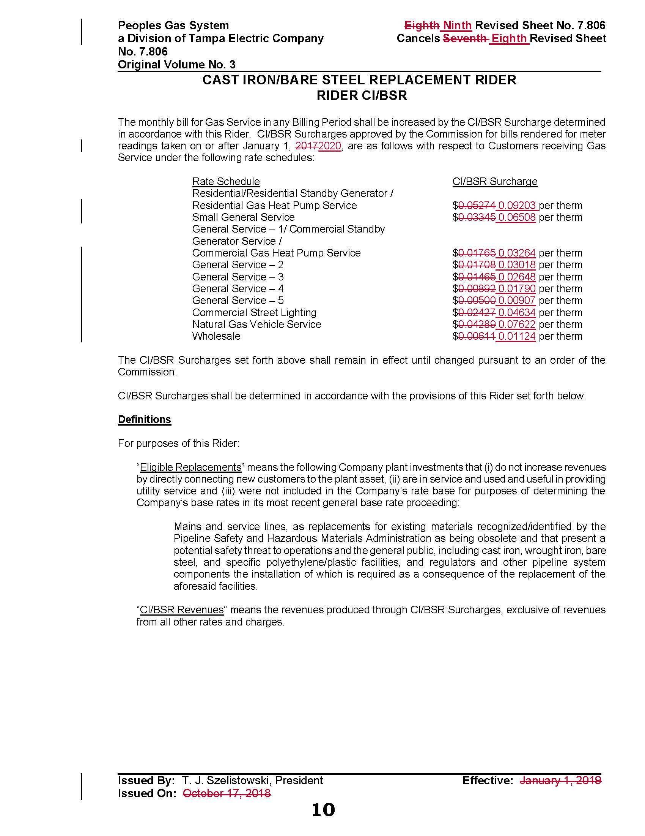

Order No. PSC-12-0476-TRF-GU, issued September 18, 2012, in Docket No. 110320-GU, In re: Petition for approval of Cast Iron/Bare Steel Pipe Replacement Rider (Rider CI/BSR), by Peoples Gas System.
Order No. PSC-2018-0540-TRF-GU, issued November 19, 2018, in Docket No. 20180173-GU, In re: Petition for approval of 2017 true-up, projected 2018 true-up, and 2019 revenue requirements and surcharges associated with cast iron/bare steel pipe replacement rider, by Peoples Gas System.
Order No. PSC-17-0066-AS-GU, issued February 28, 2017, in Docket No. 20160159-GU, In re: Petition for approval of settlement agreement pertaining to Peoples Gas System’s 2016 depreciation study, environmental reserve account, problematic plastic pipe replacement, and authorized ROE.
Order No. PSC-2018-0501-S-GU, issued October 18, 2018, in Docket No. 20180044-GU, In re: Consideration of the tax impacts associated with Tax Cuts and Jobs Act of 2017 for Peoples Gas System.

