State of Florida  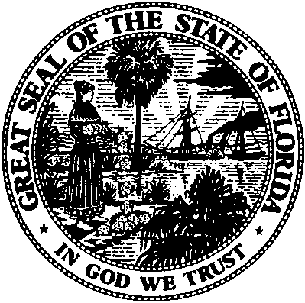 | Public Service Commission  Capital Circle Office Center ● 2540 Shumard Oak Boulevard  Tallahassee, Florida 32399-0850  -M-E-M-O-R-A-N-D-U-M-
DATE: | November 26, 2019
TO: | Office of Commission Clerk (Teitzman)
FROM: | Office of Industry Development and Market Analysis (Yglesias de Ayala, Williams, Wendel)  Office of the General Counsel (Passidomo, Murphy, Weisenfeld)
RE: | Application for Certificate of Authority to Provide Telecommunications Service
AGENDA: | 12/10/2019 - Consent Agenda - Proposed Agency Action - Interested Persons May Participate
SPECIAL INSTRUCTIONS: |  | None

Please place the following Application for Certificate of Authority to Provide Telecommunications Service on the consent agenda for approval.

DOCKET NO. | COMPANY NAME | CERT. NO.
20190180-TX | Smart Choice Communications, LLC | 8941
20190186-TX | HFA of Florida LLC | 8942
20190207-TX | Tone Communication Services llc | 8943

The Commission is vested with jurisdiction in this matter pursuant to Section 364.335, Florida Statutes. Pursuant to Section 364.336, Florida Statutes, certificate holders must pay a minimum annual Regulatory Assessment Fee if the certificate is active during any portion of the calendar year. A Regulatory Assessment Fee Return Notice will be mailed each December to the entity listed above for payment by January 30.

