BEFORE THE FLORIDA PUBLIC SERVICE COMMISSION

In re: Petition for limited proceeding to reduce base rates and charges to reflect impact of the 2019 temporary state income tax rate reduction, by Tampa Electric Company. | DOCKET NO. 20190203-EI  ORDER NO. PSC-2019-0524-PAA-EI  ISSUED: December 17, 2019

The following Commissioners participated in the disposition of this matter:

ART GRAHAM, Chairman
JULIE I. BROWN
DONALD J. POLMANN
GARY F. CLARK
ANDREW GILES FAY

NOTICE OF PROPOSED AGENCY ACTION
ORDER GRANTING PETITION TO REDUCE BASE RATES AND CHARGES

BY THE COMMISSION:

NOTICE is hereby given by the Florida Public Service Commission that the action discussed herein is preliminary in nature and will become final unless a person whose interests are substantially affected files a petition for a formal proceeding, pursuant to Rule 25-22.029, Florida Administrative Code (F.A.C.).

BACKGROUND

On September 27, 2017, Tampa Electric Company (Company), the Office of Public Counsel, the Florida Industrial Power Users Group, the Florida Retail Federation, the Federal Executive Agencies, and the WCF Hospital Utility Alliance entered into the 2017 Amended and Restated Stipulation and Settlement Agreement (2017 Agreement). The Commission approved the 2017 Agreement by Order No. PSC-2017-0456-S-El. Paragraph 9 of the 2017 Agreement addresses the procedures and principles to be followed for changes in the rate of taxation of corporate income by federal or state taxing authorities.

On September 12, 2019, the Florida Department of Revenue issued a Tax Information Publication (TIP) announcing that the Florida corporate income tax rate was reduced from 5.5 percent to 4.458 percent effective retroactive to January l, 2019, and would remain in effect through December 31, 2021 (State Tax Rate Change). The TIP indicates that the Florida corporate income tax rate will return to 5.5 percent effective January 1, 2022. It also indicates that further reductions in the tax rate are possible for calendar years 2020 and 2021. The Department of Revenue's authority to reduce the state corporate income tax rate is contained in Section 220.1105, Florida Statutes (F.S.).

The Company's petition addresses the impacts of the State Tax Rate Change on Tampa Electric as provided in the 2017 Agreement through proposed reductions to the Company's base rates and charges effective with the first billing cycle for January 2020. The proposed base rates reflect an increase of the Company's base rates in effect during 2019 and a reduction to the incremental base rates associated with the Company's Third SoBRA approved on October 17, 2019, to reflect the lower state corporate income tax rate.

We have jurisdiction in this matter pursuant to Sections 366.04, 366.05, and 366.06, F.S.

DECISION

On September 12, 2019, the Florida Department of Revenue issued a TIP announcing that the Florida corporate income tax rate was reduced from 5.5 percent to 4.458 percent effective retroactive to January 1, 2019, and would remain in effect through December 31, 2021. The TIP indicated that the Florida corporate income tax rate will return to 5.5 percent effective January l, 2022. It also indicated that further reductions in the tax rate are possible for calendar years 2020 and 2021.

Paragraph 9 of the Company's 2017 Amended and Restated Stipulation and Settlement Agreement (2017 Agreement) requires the Company, among other things, to pass along any tax savings associated with federal or state tax rate changes within 120 days of when the tax reform becomes law. Paragraph 9 also requires the Company to adjust any SoBRAs, that have not gone into effect, for any changes to federal or state tax rate changes or other tax reform. The Company believes that the 2017 Agreement requires the Company to reflect the State Tax Rate Change in its base rates and charges or otherwise address the impact of the tax rate change on or before January 10, 2020.

2019 Annual Revenue Requirement

As indicated in the Company's petition, the net annual income tax expense reduction for 2019 attributable to the State Tax Rate Change on a total company basis is $3,965,734 and the retail jurisdictional Net Operating Income impact is $3,743,288. This amount is based on the Company's calculation of excess accumulated deferred state tax reserves, the Company's 2019 forecasted earnings surveillance report, the 4.458 percent state corporate income tax rate effective January 1, 2019, and a 5-year flow-back period for the excess accumulated deferred state tax reserves. After applying the appropriate retail separation factors and the effective tax rate gross-up factor, the annual revenue requirement reduction for 2019 necessary to reflect the effect of tax reform pursuant to the 2017 Agreement is $4,959,442. Schedules showing the calculation of these amounts were included with the Company's petition.

We have reviewed the calculations included with the Company's petition and approve an annual revenue requirement reduction for 2019 of $4,959,442 to reflect the state tax rate change. Additionally, we authorize the Company to account for the revenue impact of the state tax change from January I, 2019, to December 31, 2019, through a credit of $4,959,442 through the ECCR (Environmental Capital Cost Recovery) clause as part of its true-up filing in 2020. Additionally, because the "stay out period" specified in the 2017 Agreement ends on December 31, 2021, we authorize the Company to complete the flow back of excess accumulated deferred income taxes ($4,265,315 total company net of federal offset) for 2022 and 2023 by crediting one-fifth of the associated separated, annual revenue requirement amount through the ECCR clause during those years using the true up provision in paragraph 9(b) of the 2017 Agreement.

Adjusting the Third SoBRA

Paragraph 9(b) of the 2017 Agreement requires the Company to "adjust any SoBRAs that have not yet gone into effect to specifically account for Tax Reform." As indicated in the Company's petition, the annual revenue requirement for the Third SoBRA re-calculated using the 4.458 percent state corporate income tax rate is $26,452,000, which is $144,000 lower than the amount approved in the Third SoBRA docket. The Company's petition showed the revenue requirement for the Third SoBRA using the new state rate. We have reviewed the calculations regarding the revenue requirement for the third SoBRA included with the Company's petition and approve $26,452,000 as the revised revenue requirement for the Third SoBRA.

Proposed Tariffs and Base Rates

The Company is seeking approval of proposed tariffs and associated charges that reflect the impact of the decrease of the state corporate income tax on the utility's 2019 annual revenue equirement and the revised Third So BRA revenue requirement. The Company's Third SoBRA and associated tariffs were approved by Order No. PSC-2019-0477-FOF-El, effective January 1, 2020. However, since as discussed above, the Commission-approved Third SoBRA rates did not reflect the new state income corporate tax, the Company filed revised tariffs reflecting an across-the-board reduction in base rates as approved in Order No. PSC-2019-0477-FOF-EI.

Attachment Four to the petition shows the proposed tariffs in both legislative and revised formats. The Company indicated that customers will be notified of the proposed 2020 base rates and charges, including changes to the cost recovery clauses, in December bills. The Company provided a copy of the notice to customers for review. The current 2019 base rate portion of the 1,000 kilowatt-hour (kWh) residential electric bill is $66.53. With approval of the Third SoBRA rates, the base rate portion of the 1,000 kWh bill increased from $66.53 to $68.08. With the proposed tariffs as shown in Attachment Four to the petition, the base rate portion of the 1,000 kWh bill will decrease from $68.08 to $67.76, a $0.32 decrease. The Company’s total 1,000kWh residential bill, including all cost recovery clauses, will decrease in 2020.

Future True-Ups

Further reductions in the state corporate income tax rate are possible for calendar years 2020 and 2021. Also, the Company's 2018 excess accumulated deferred state income tax reserves may require a true-up. Consequently, it is likely that future true-ups will be necessary.

Base Rate Reduction Proposed Agency Action Approach

In light of the requirement in the 2017 Agreement that base rate changes be made within 120 days, the Company has requested that this petition be given expedited treatment as a proposed agency action (PAA) and scheduled for consideration on or before the December 10, 2019 Commission Conference. In addition, even though it will need to load the 2020 proposed base rates and charges into its billing system and begin publishing notice of those changes before our final decision on this petition, the Company has requested permission to implement the reduced 2020 proposed base rates and charges effective with the first billing cycle in January 2020 and to provide notice of the proposed base rate decreases requested in this petition as "proposed" rate changes consistent with the normal 30-day customer notice requirement, i.e., before our decision on this petition.

The Company has also requested that if this petition is approved on a PAA basis on December 10, 2019, and a substantially affected party protests the order, and after a hearing, we adjust the annual revenue requirement and/or Third SoBRA impacts proposed in its petition, that any resulting revised rate be put into effect subsequent to that decision with appropriate notice to customers using the ECCR refund mechanism reflected in paragraph 9(b) of the petition to account for any resulting differences between the time the rates proposed in this petition go into effect and the date that any such revised rates are put into effect. We hereby approve the Company’s request to use the base rate reduction PAA approach as described above.

As noted previously, further reductions in the state corporate income tax rate are possible for calendar years 2020 and 2021. Additionally, the Company's 2018 excess accumulated deferred state income tax reserves may warrant a true-up. Consequently, it is likely that future true-ups will be necessary. Therefore, this docket shall remain open through 2022 to address any required true-ups.

Based on the foregoing, it is

ORDERED by the Florida Public Service Commission that Tampa Electric Company’s Limited Proceeding to Reduce Base Rates and Charges to Reflect Impact of the 2019 Temporary State Income Tax Rate of Reduction is hereby granted as set forth in the body of this Order. It is further

ORDERED that Tampa Electric Company’s attached proposed 2020 tariffs and associated base rates and charges are hereby approved and will go into effect concurrently with meter readings for the first billing cycle in January 2020. It is further

ORDERED that the annual revenue requirement reduction for 2019 is $4,959,442 to reflect the state corporate income tax rate change and the revised Third SoBRA revenue requirement is $26,452,000. It is further

ORDERED that Tampa Electric Company shall account for the revenue impact of the state tax change from January 1, 2019 to December 31, 2019, through a credit of $4,959,442 through the Environmental Capital Cost Recovery clause as part of its true-up filing in 2020 and that Tampa Electric Company shall flow back excess accumulated deferred income taxes ($4,265,315 total company net of federal offset) for 2022 and 2023 by crediting one-fifth of the associated separated, annual revenue requirement amount through the Environmental Capital Cost Recovery clause during those years. It is further

ORDERED that this docket shall remain open through 2022 to address any associated necessary true-ups.

By ORDER of the Florida Public Service Commission this 17th day of December, 2019.

ADAM J. TEITZMAN
Commission Clerk
Florida Public Service Commission
2540 Shumard Oak Boulevard
Tallahassee, Florida 32399
(850) 413-6770
www.floridapsc.com

Copies furnished: A copy of this document is provided to the parties of record at the time of issuance and, if applicable, interested persons.

SBr

NOTICE OF FURTHER PROCEEDINGS OR JUDICIAL REVIEW

The Florida Public Service Commission is required by Section 120.569(1), Florida Statutes, to notify parties of any administrative hearing that is available under Section 120.57, Florida Statutes, as well as the procedures and time limits that apply. This notice should not be construed to mean all requests for an administrative hearing will be granted or result in the relief sought.

Mediation may be available on a case-by-case basis. If mediation is conducted, it does not affect a substantially interested person's right to a hearing.

The action proposed herein is preliminary in nature. Any person whose substantial interests are affected by the action proposed by this order may file a petition for a formal proceeding, in the form provided by Rule 28-106.201, Florida Administrative Code. This petition must be received by the Office of Commission Clerk, 2540 Shumard Oak Boulevard, Tallahassee, Florida 32399-0850, by the close of business on January 7, 2020.

In the absence of such a petition, this order shall become final and effective upon the issuance of a Consummating Order.

Any objection or protest filed in this/these docket(s) before the issuance date of this order is considered abandoned unless it satisfies the foregoing conditions and is renewed within the specified protest period.

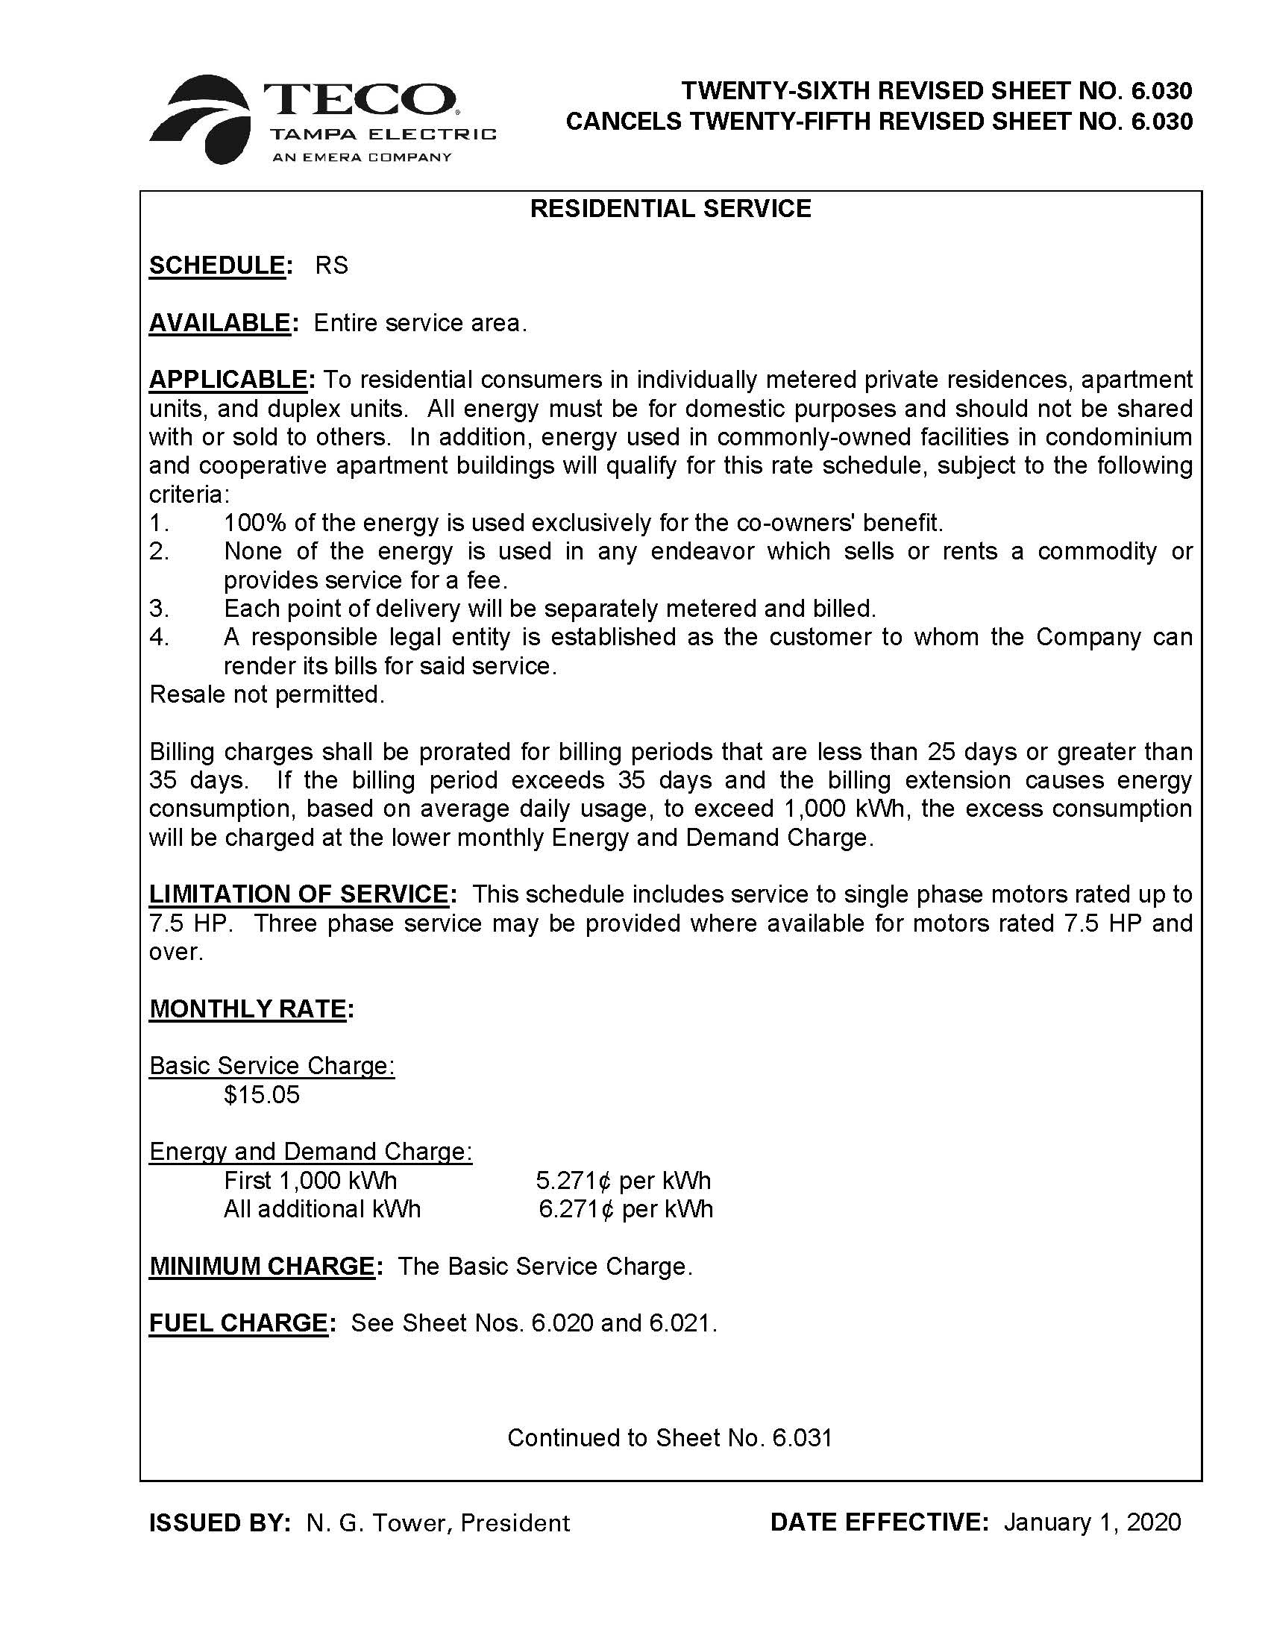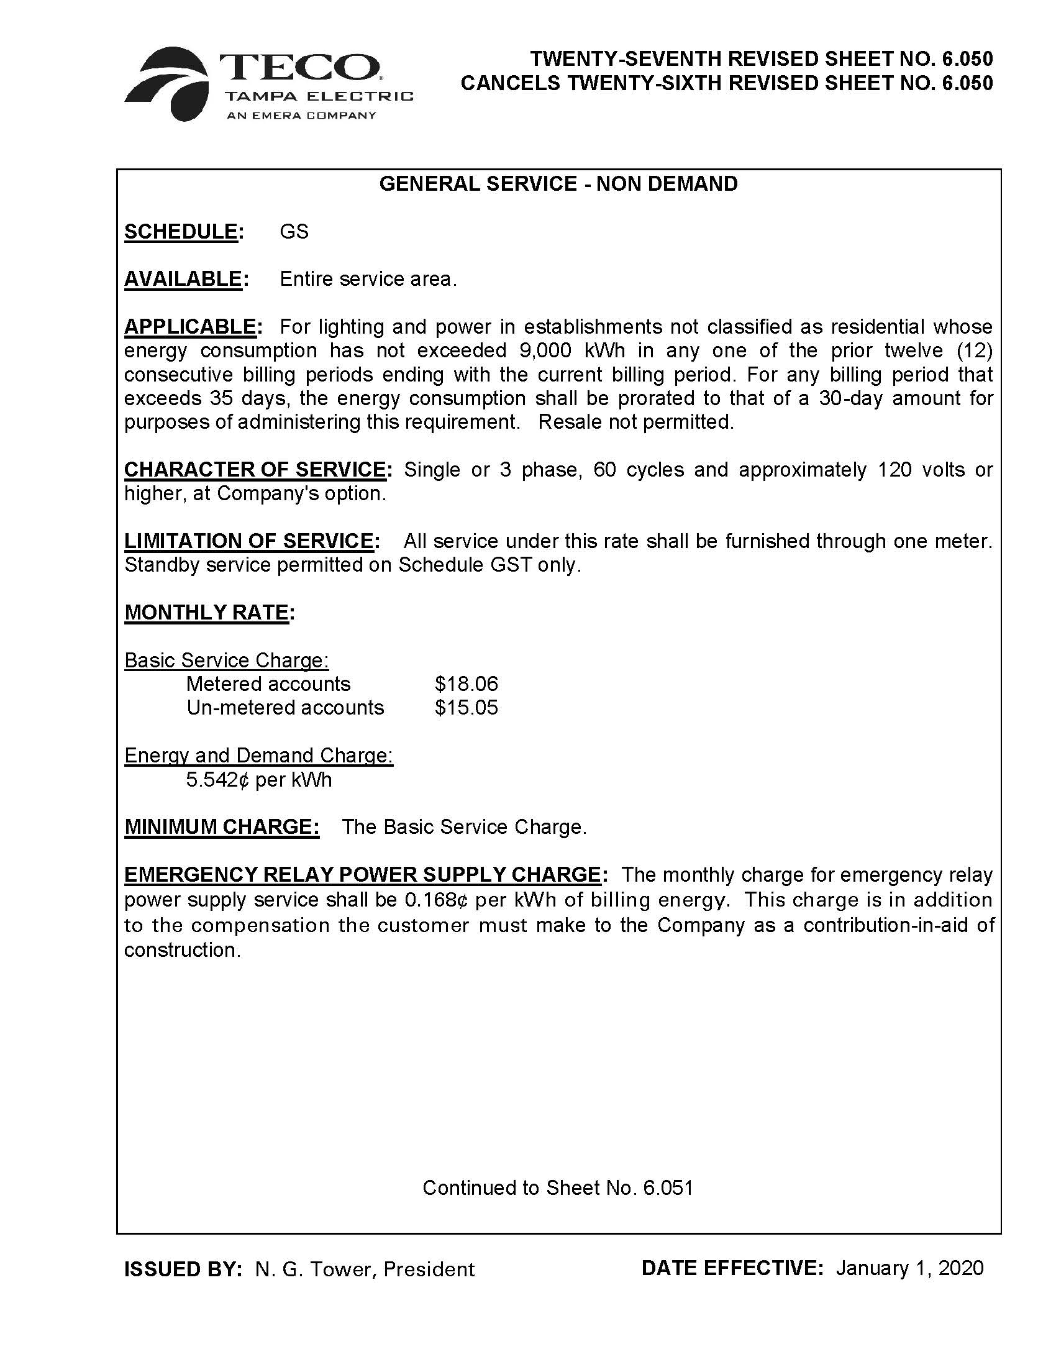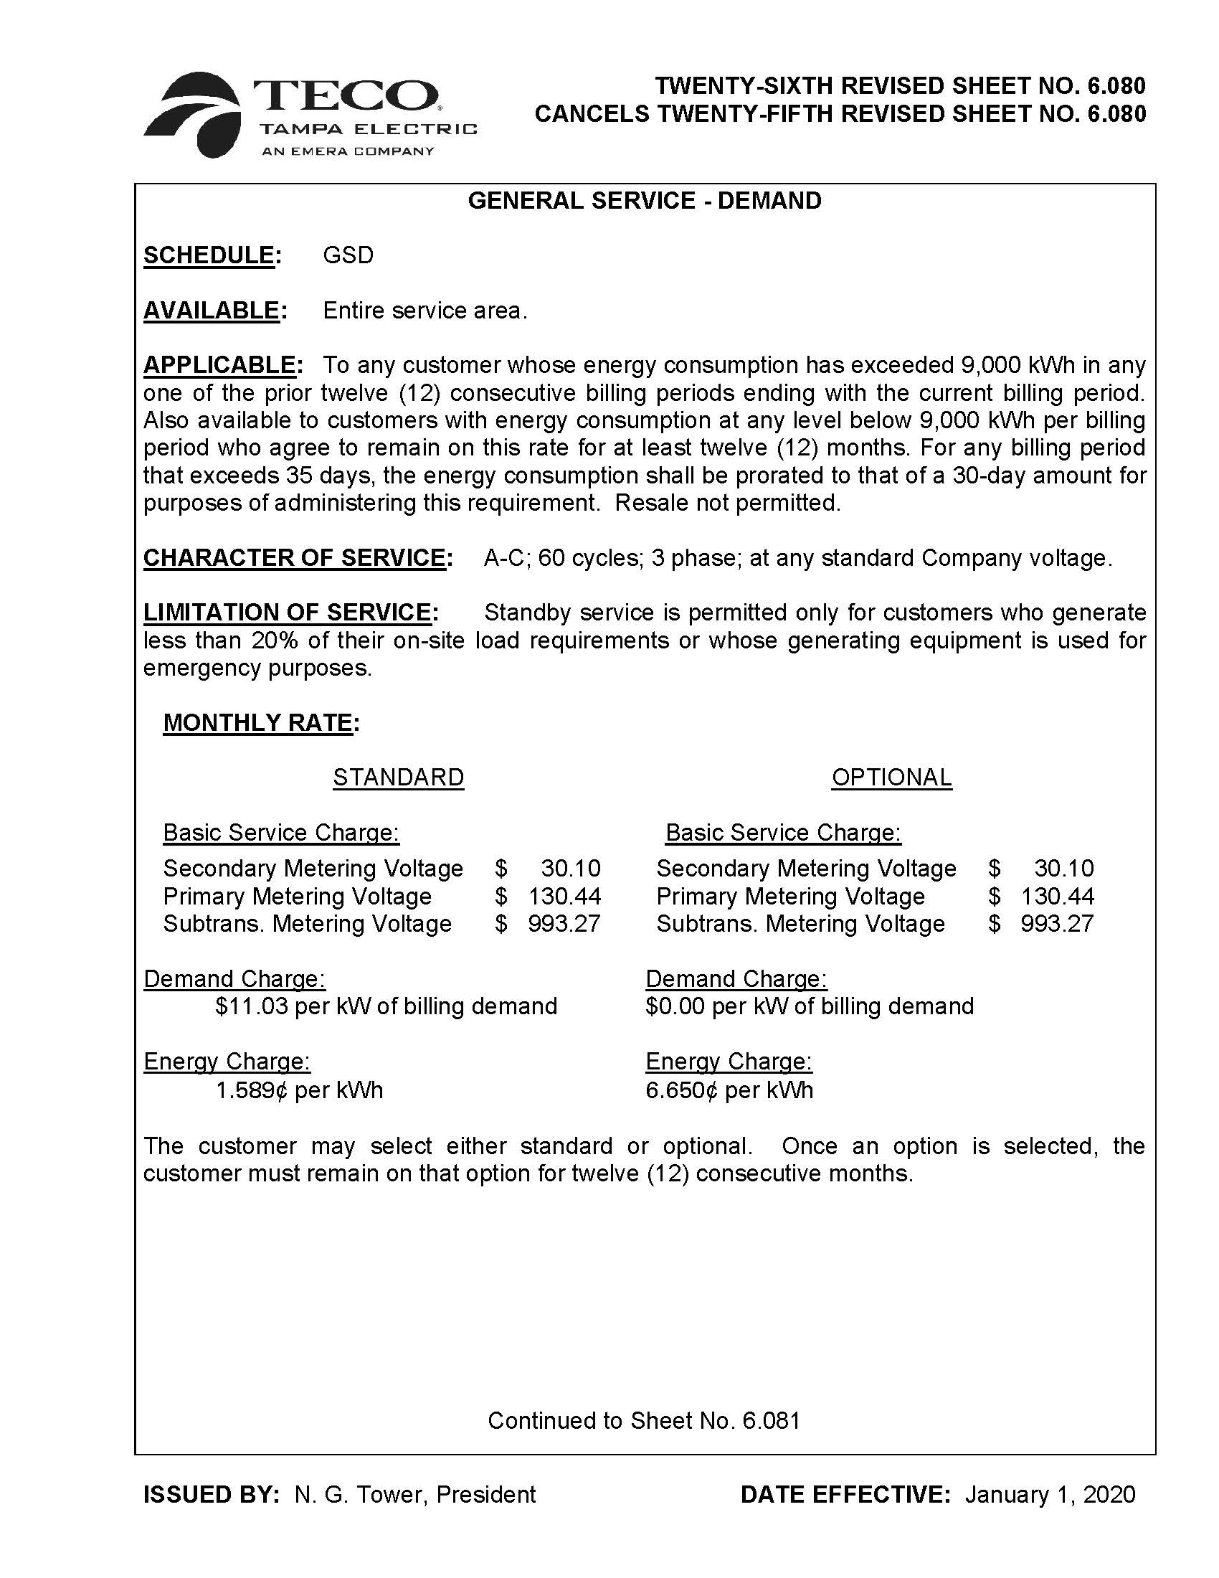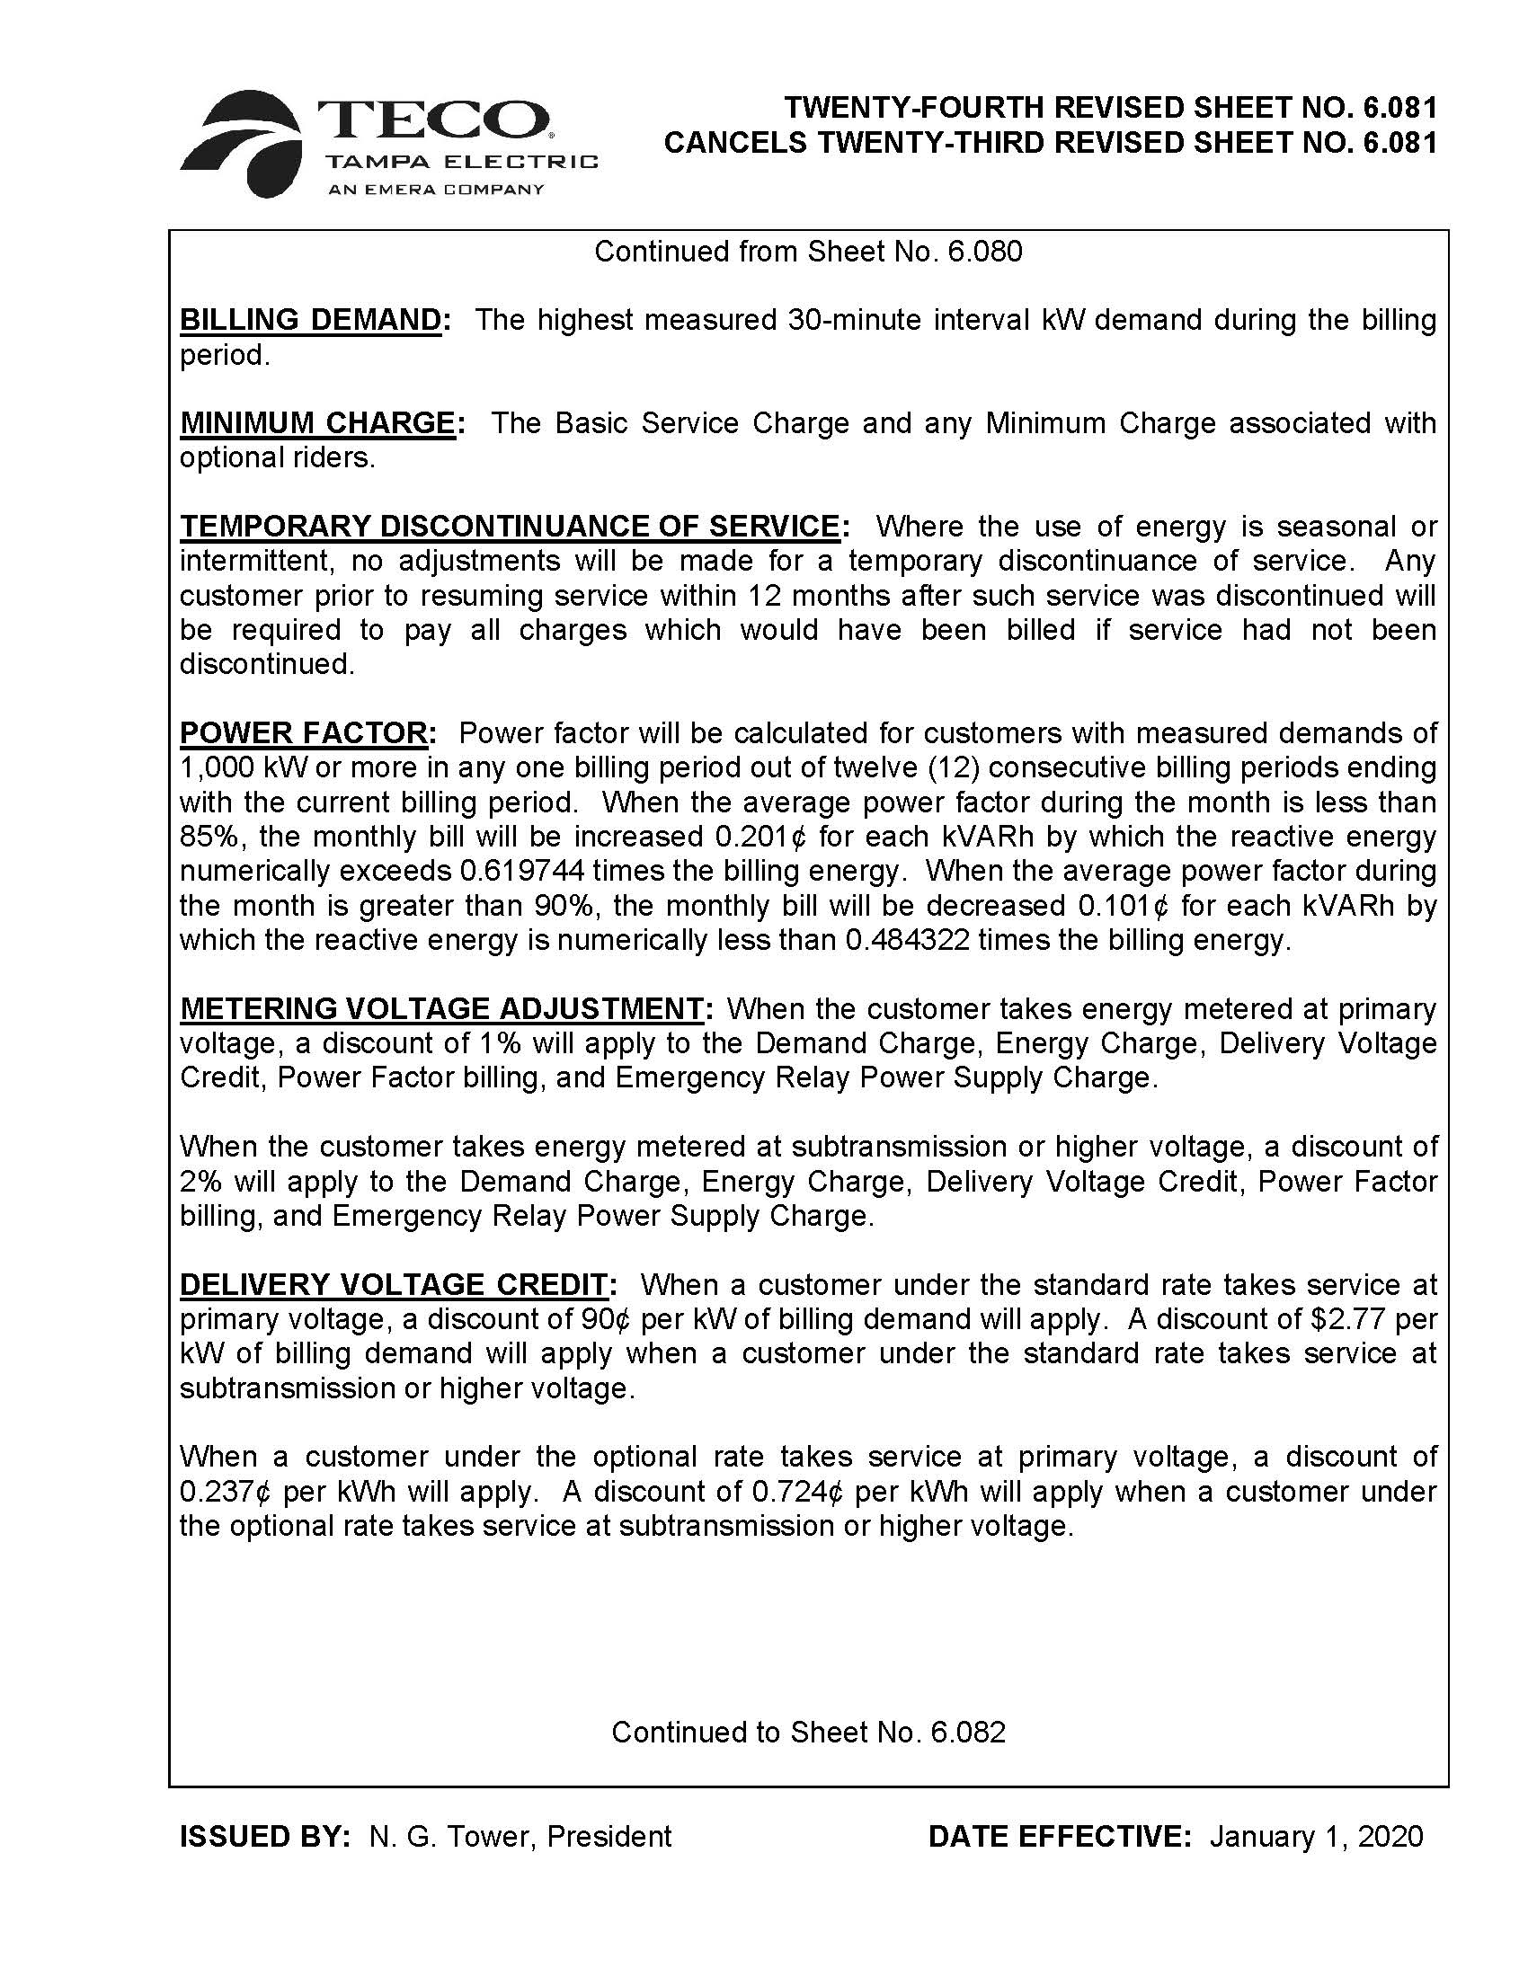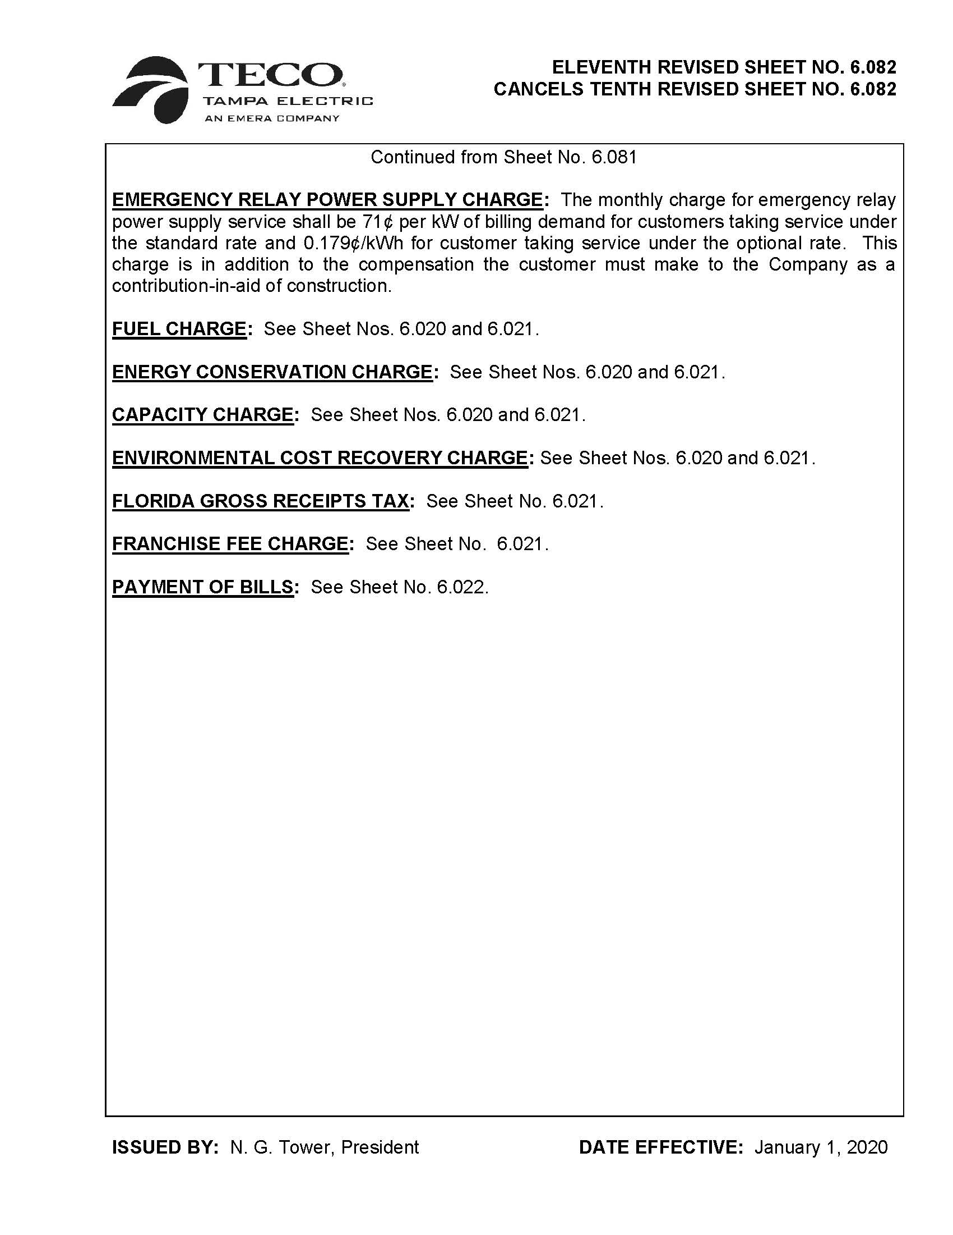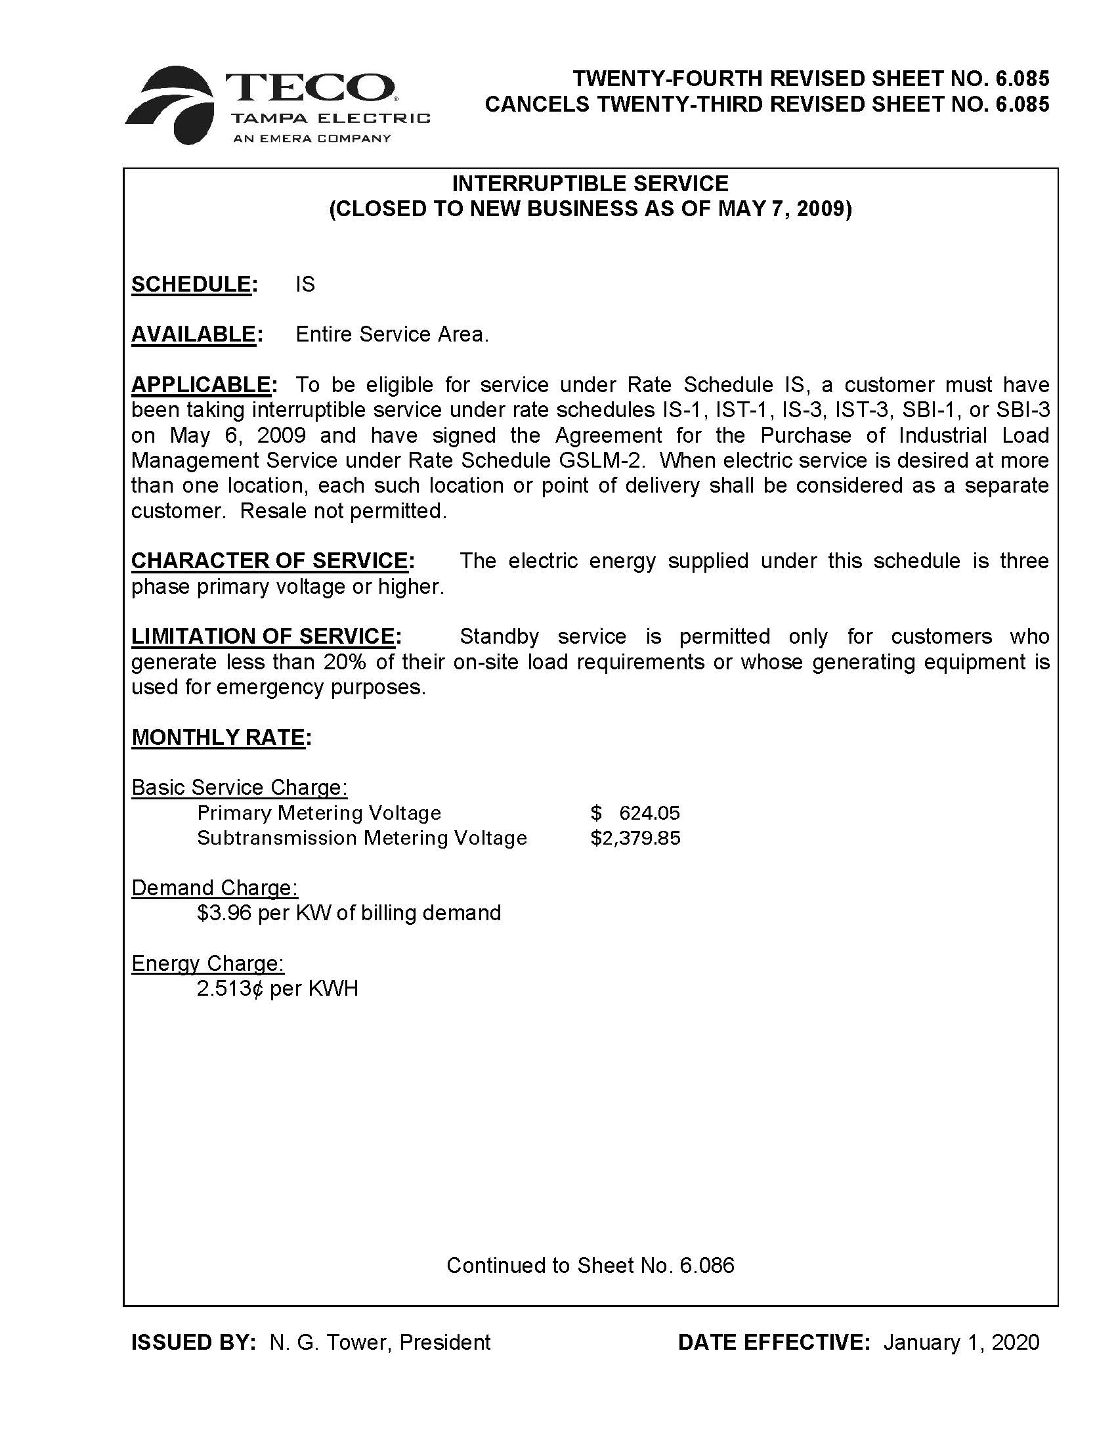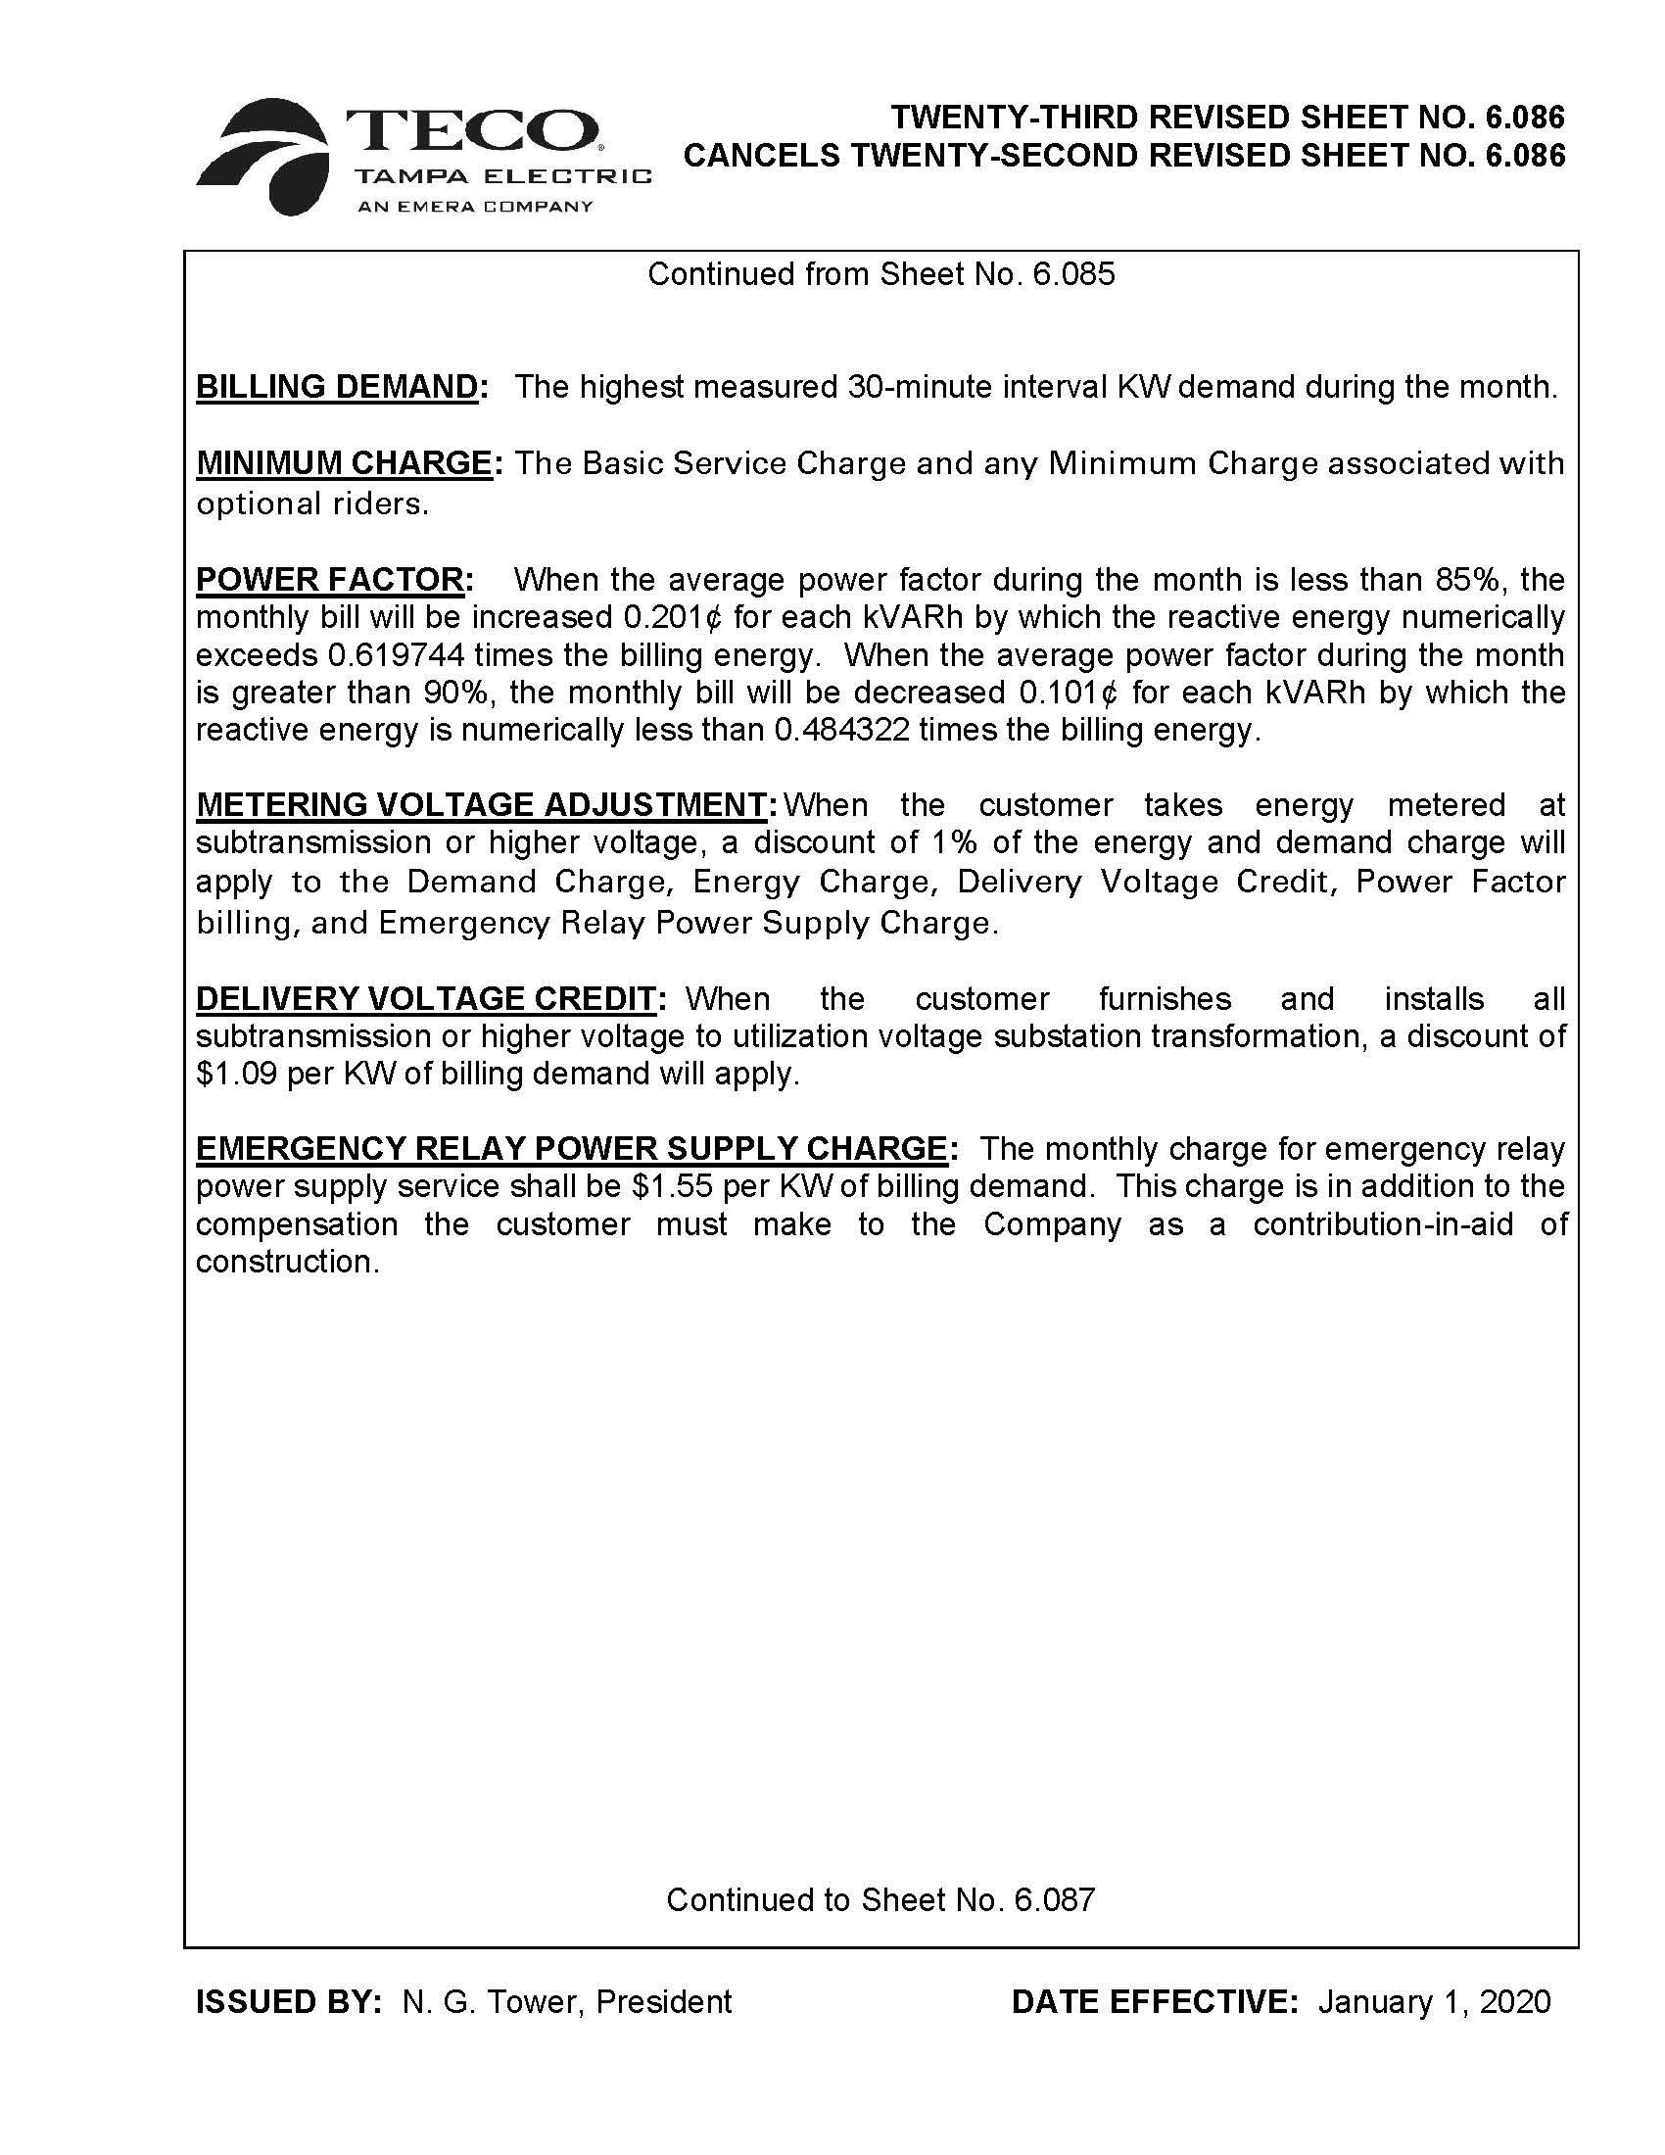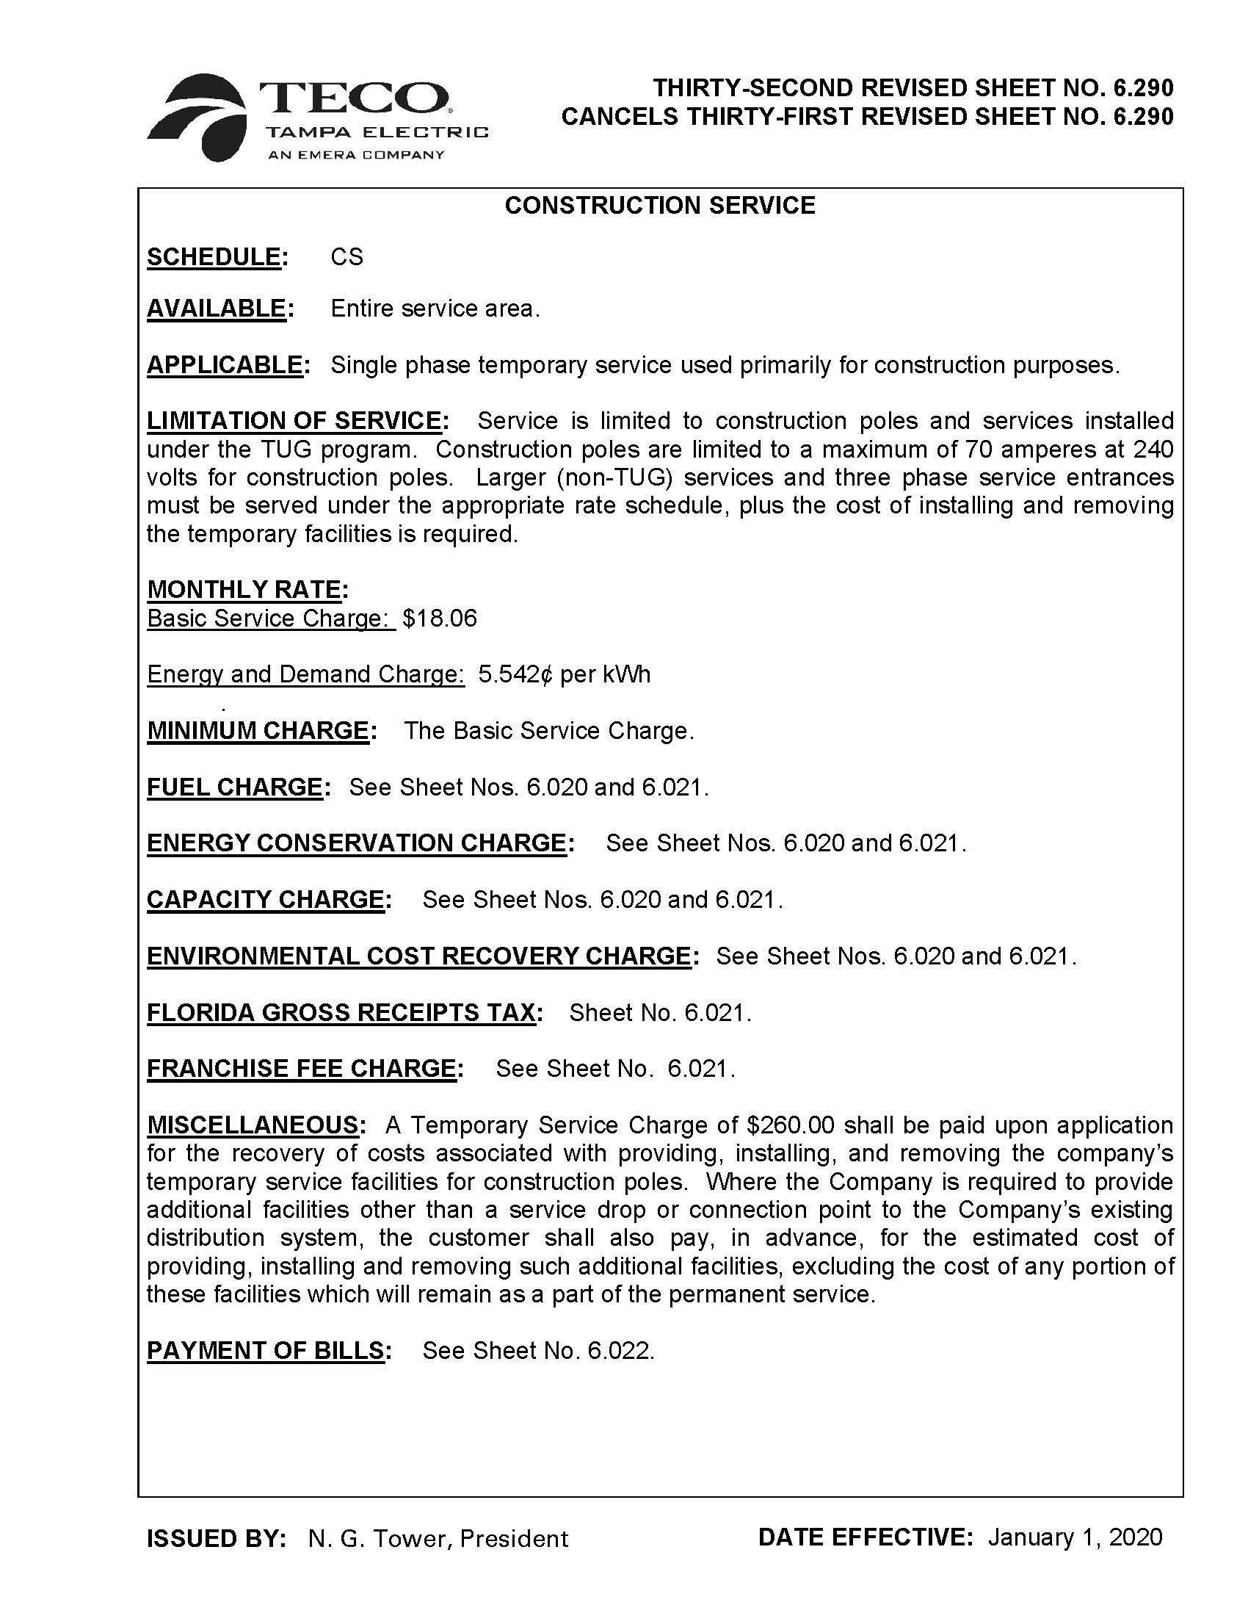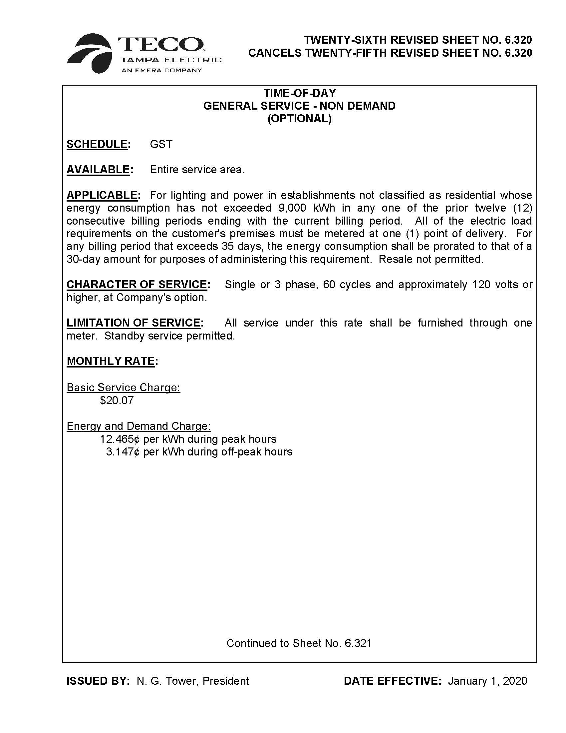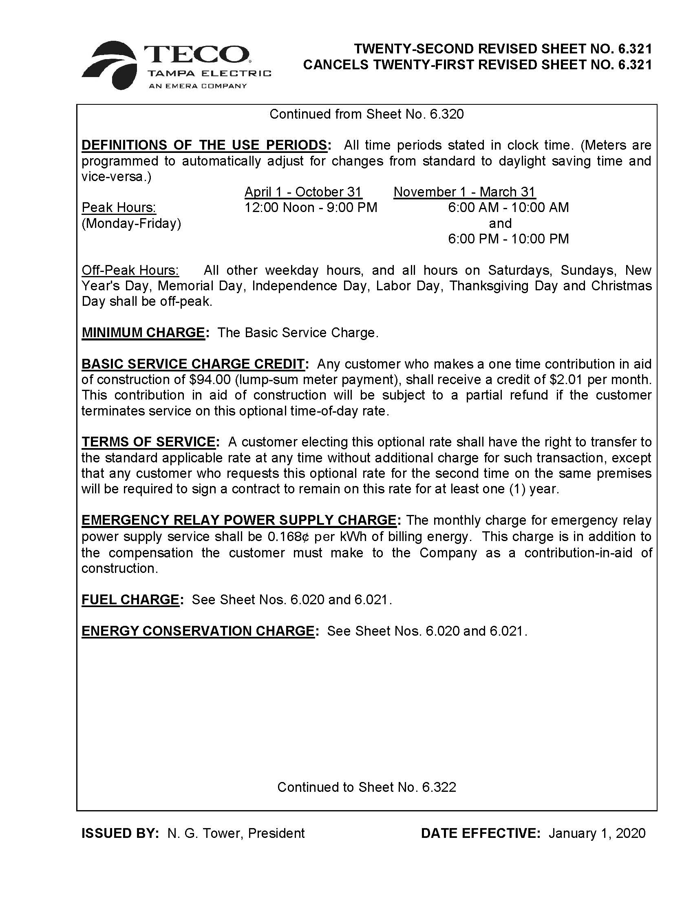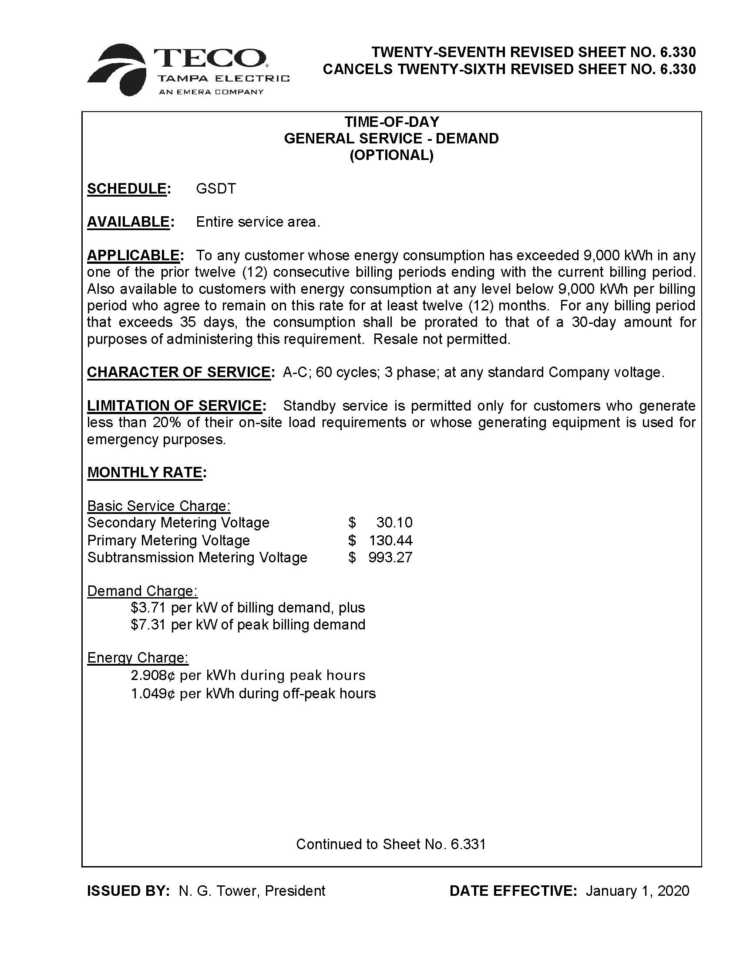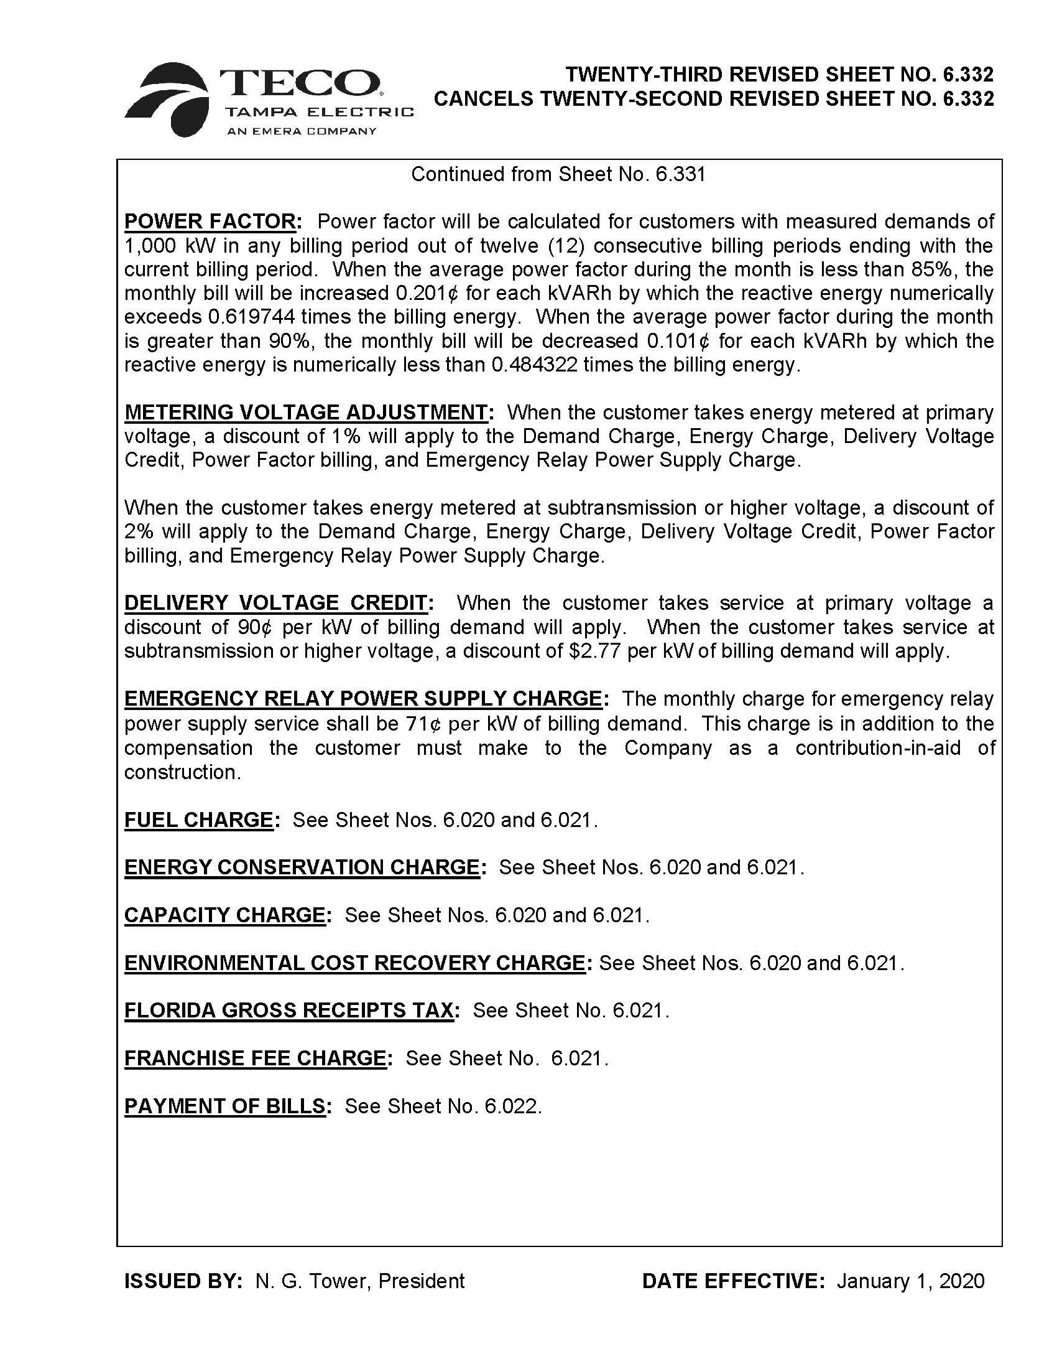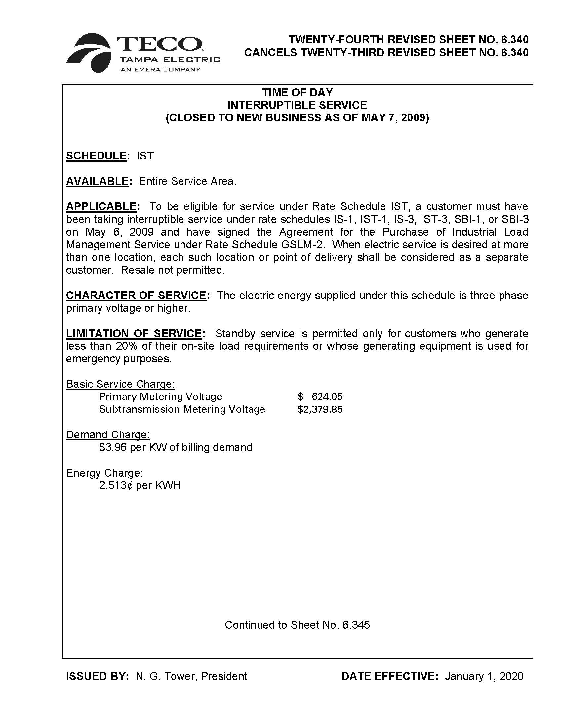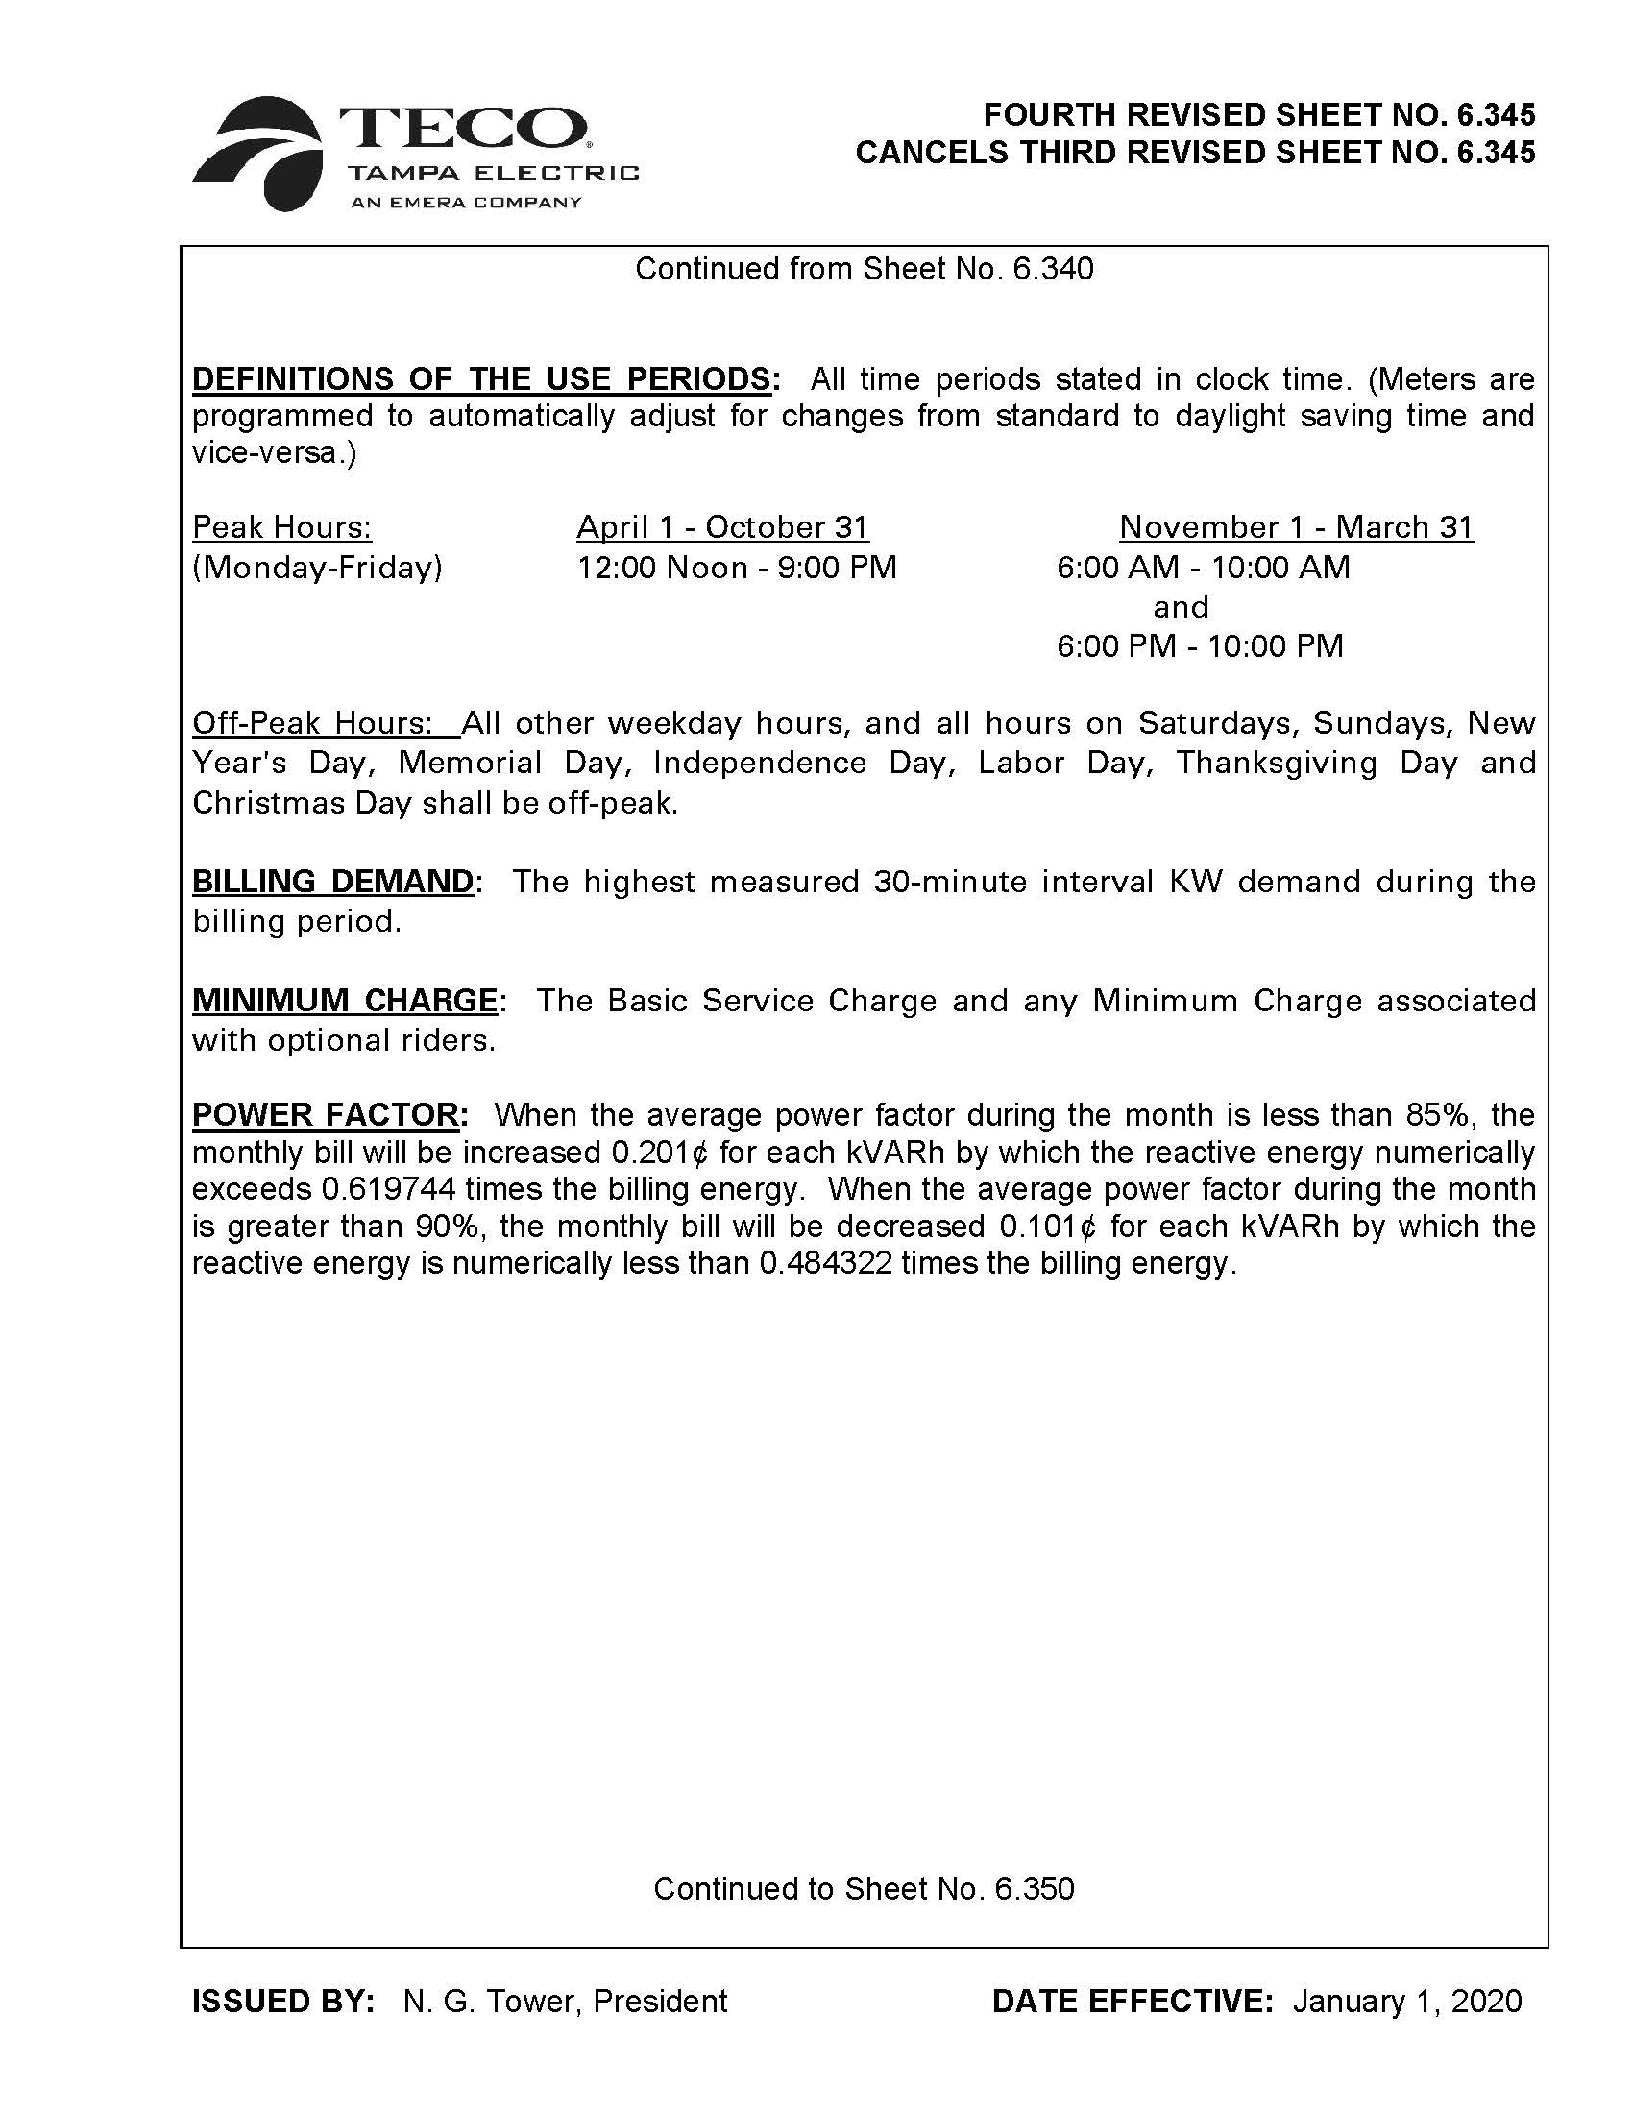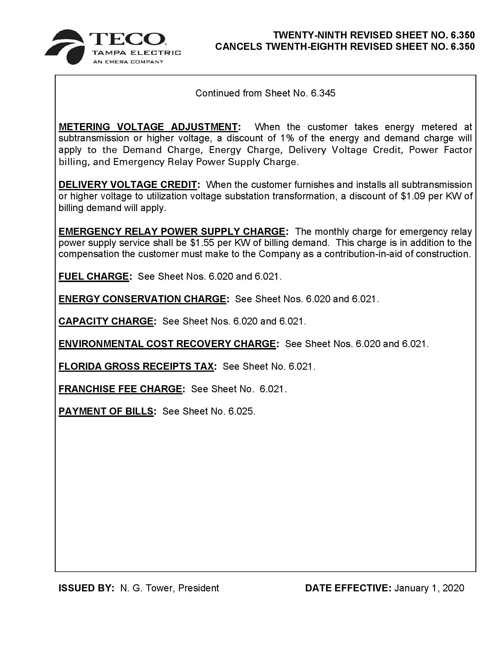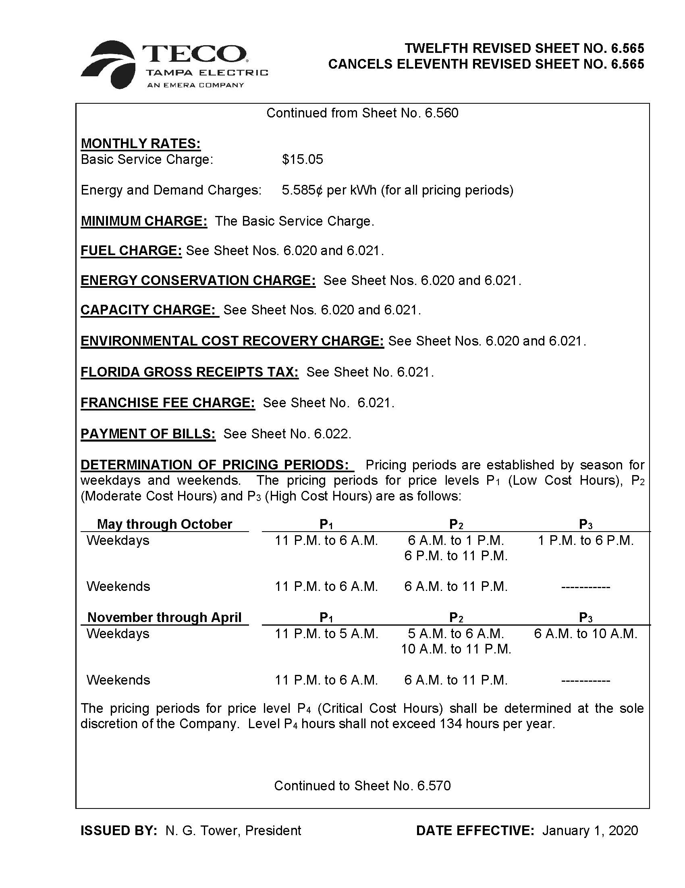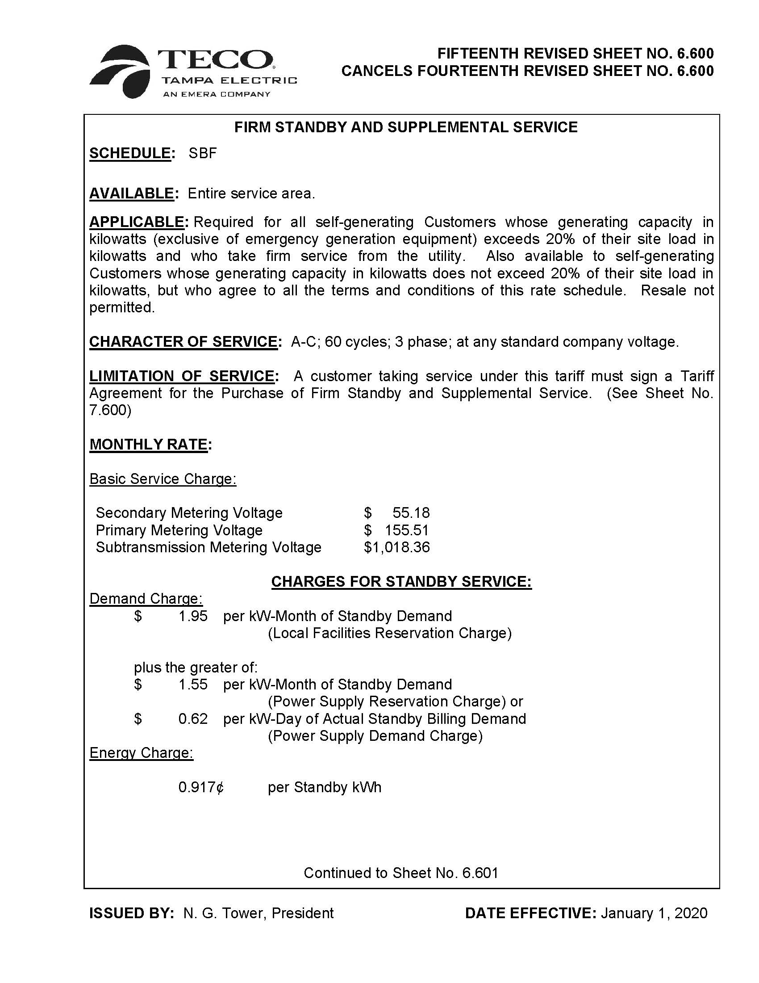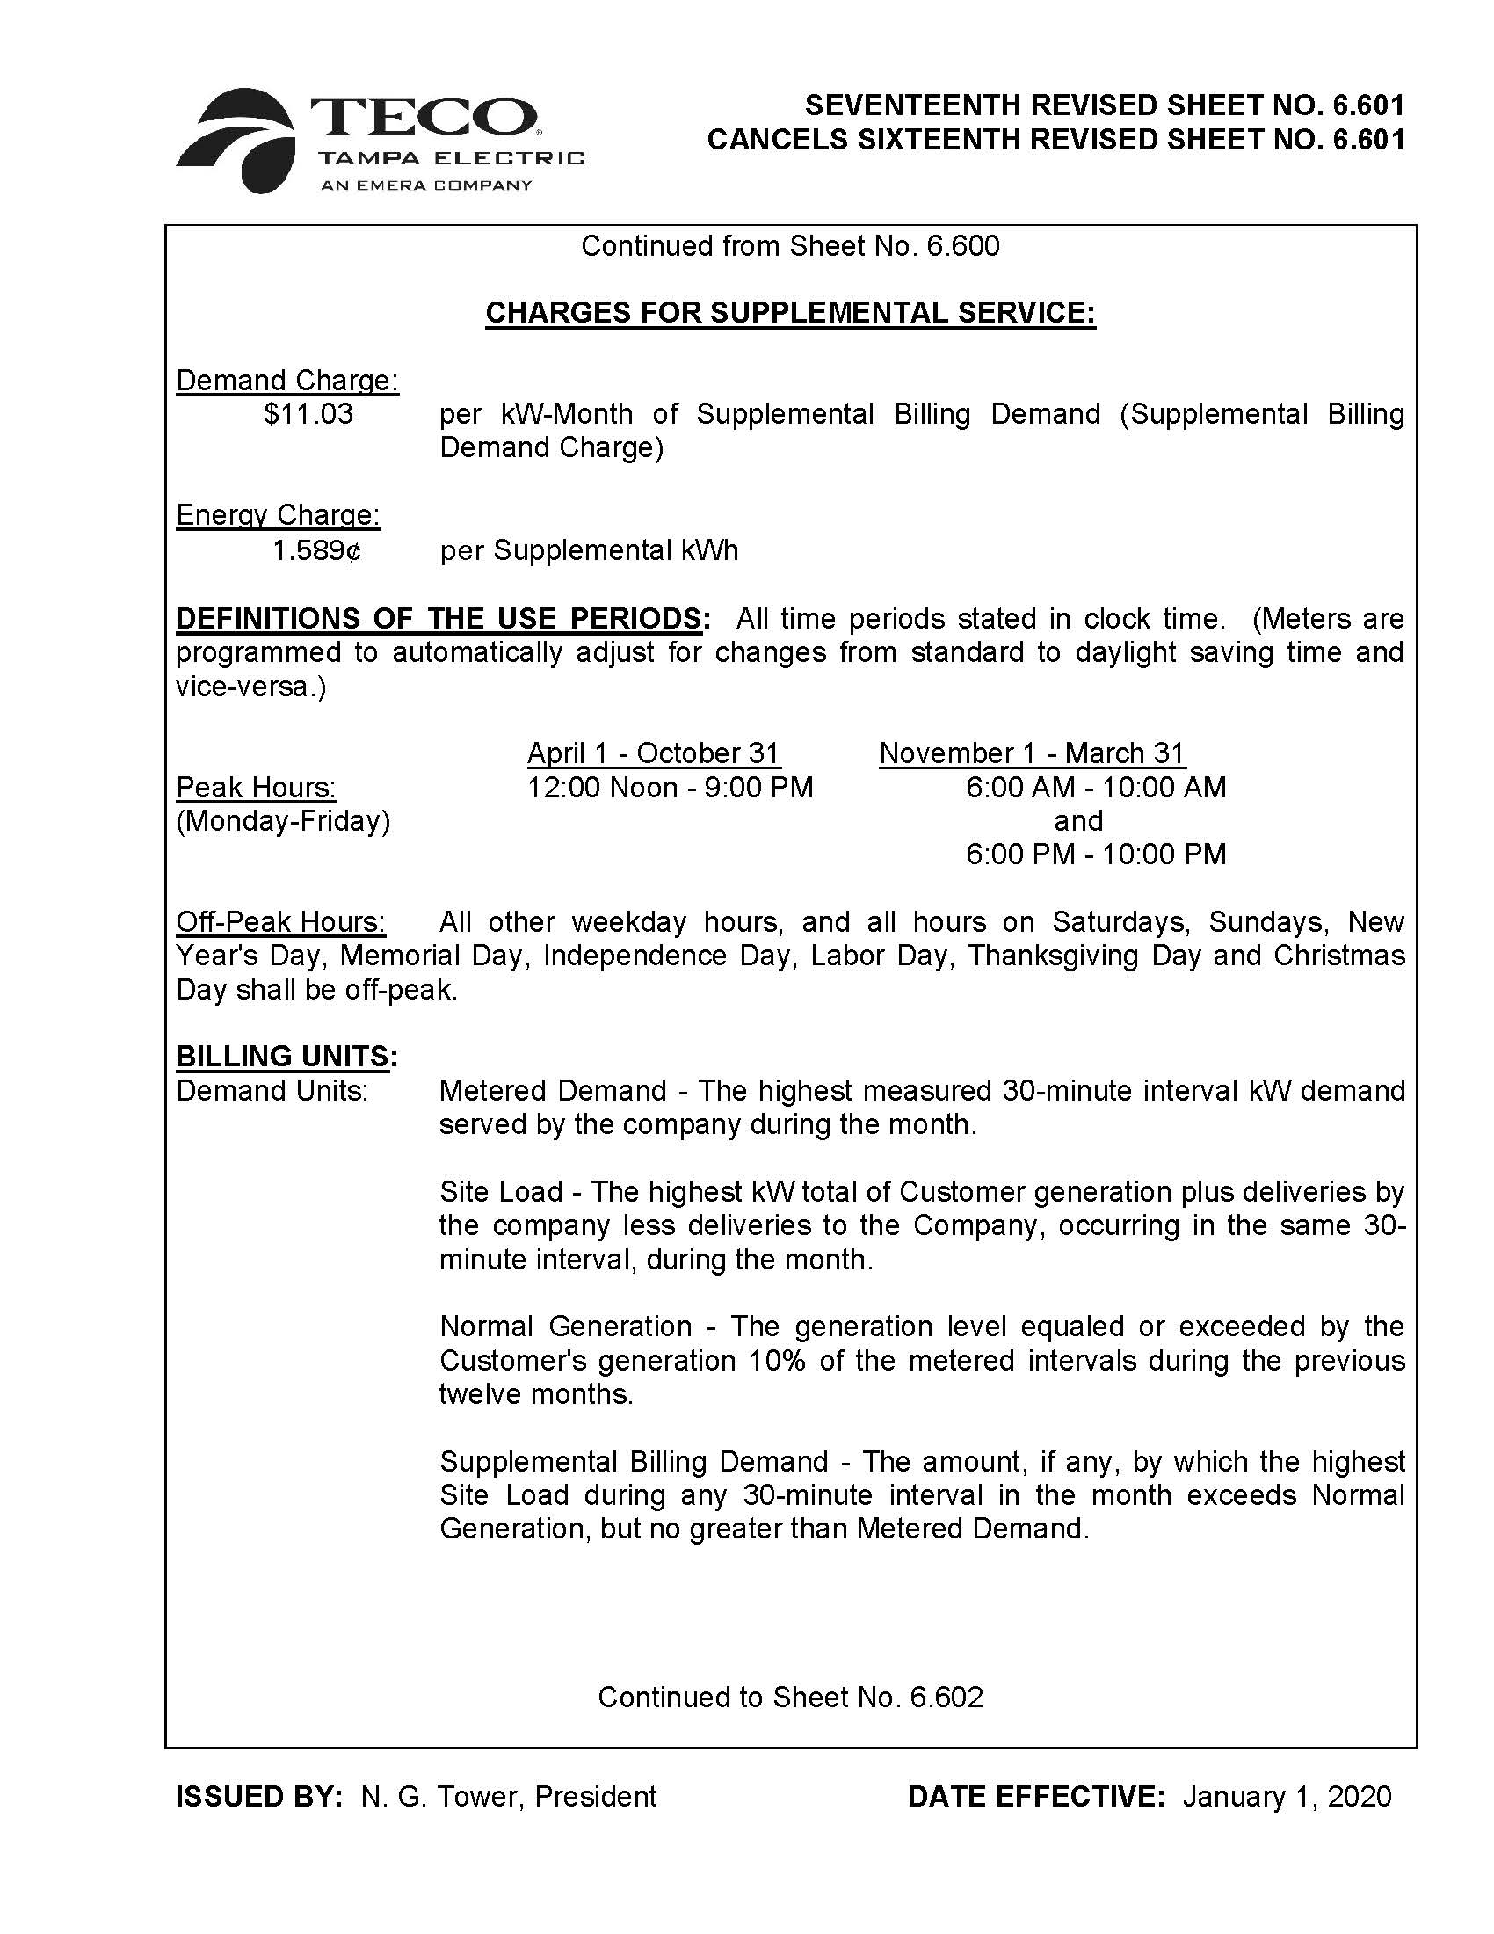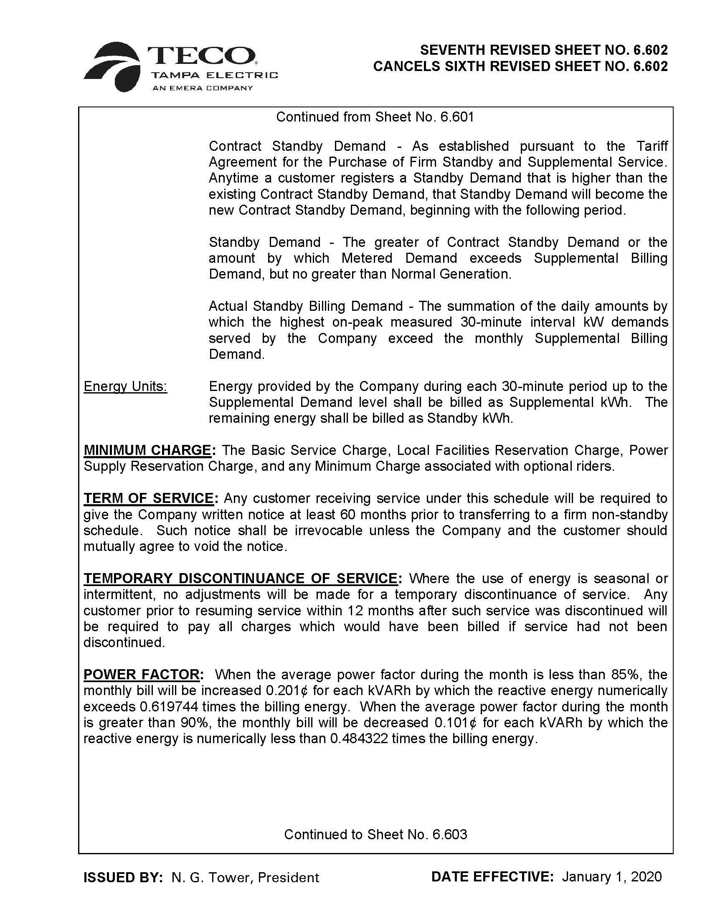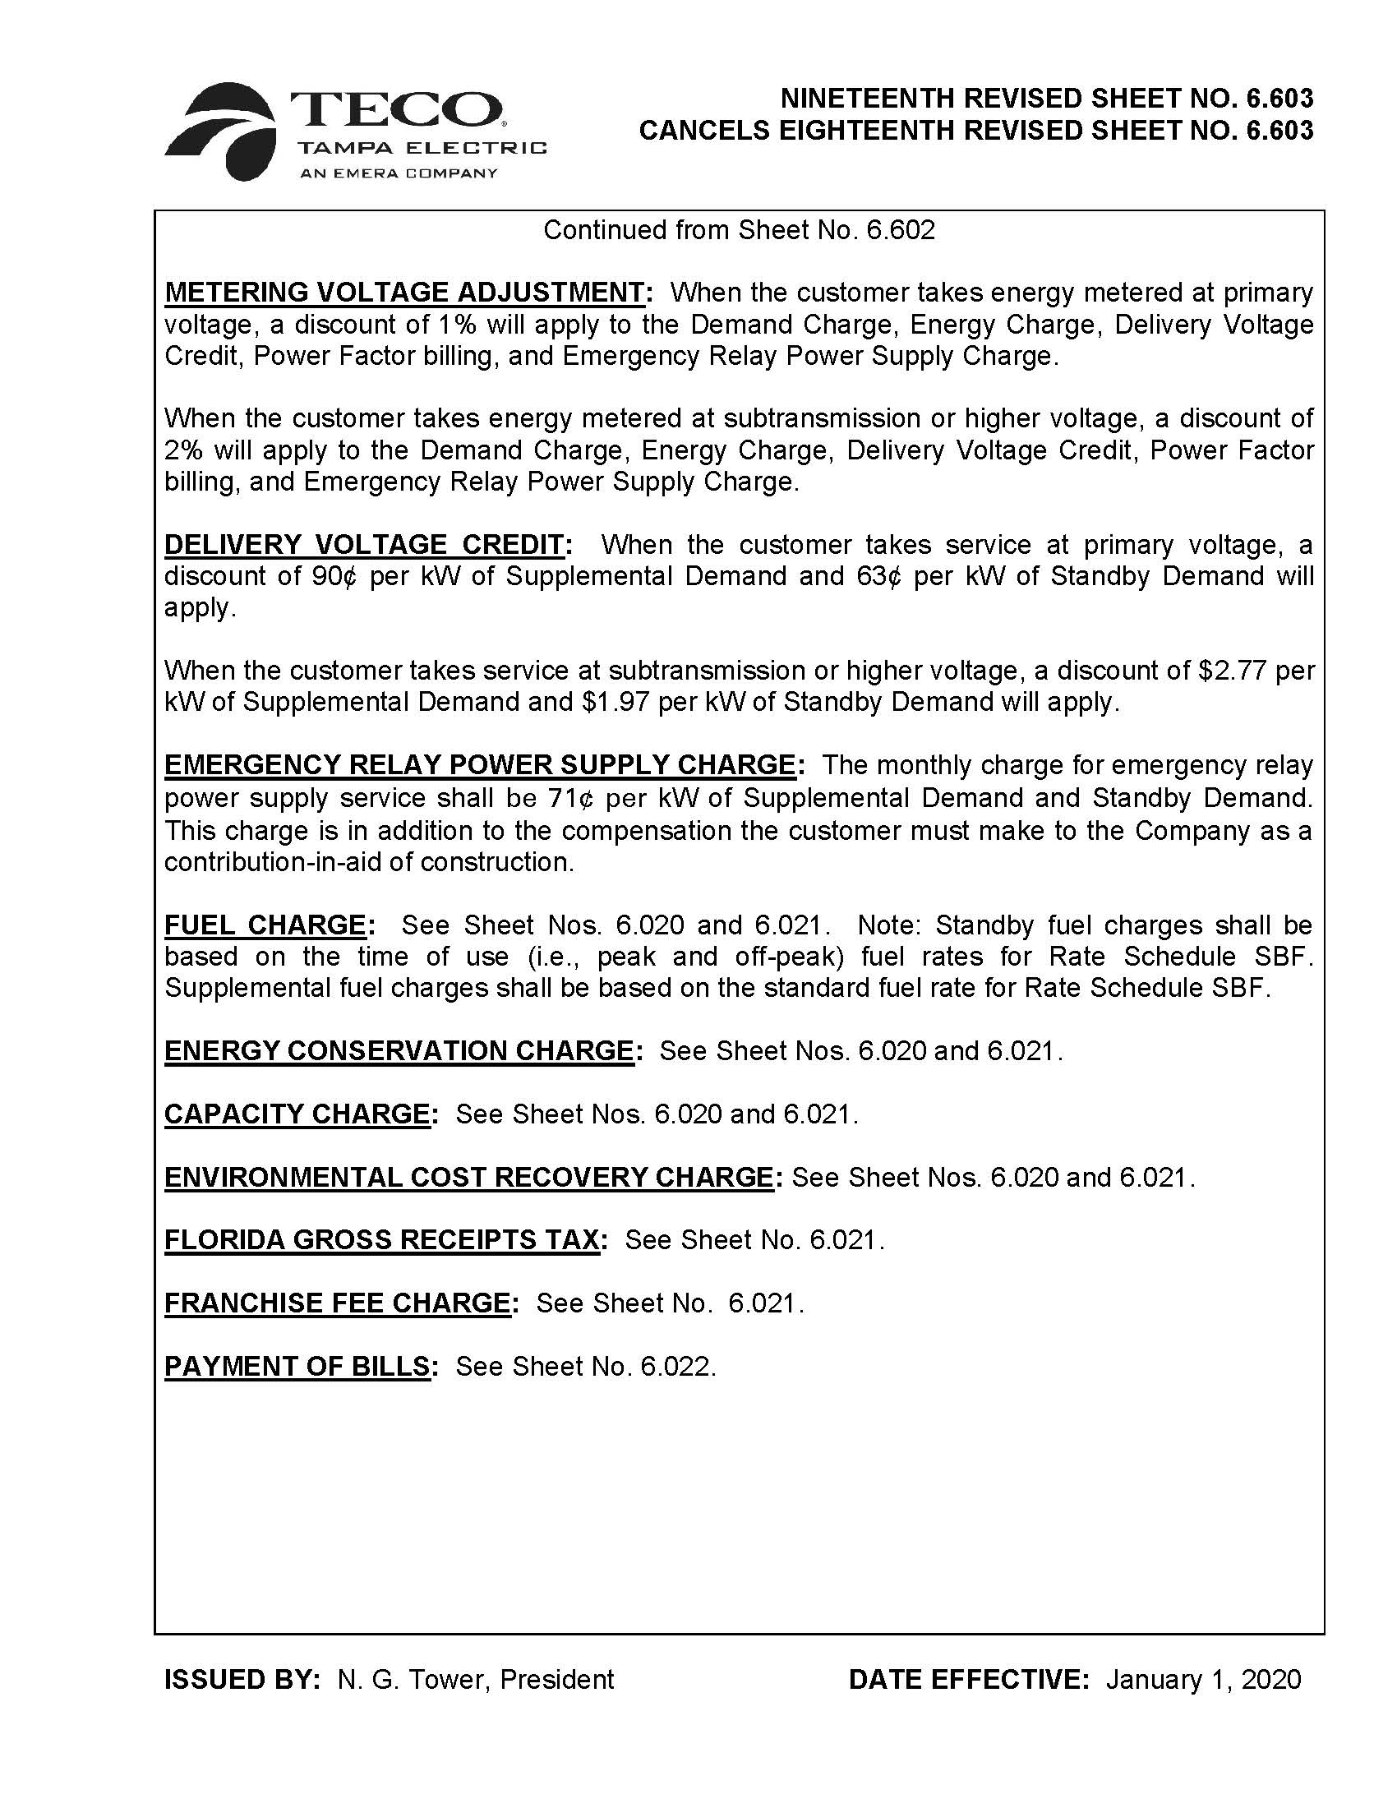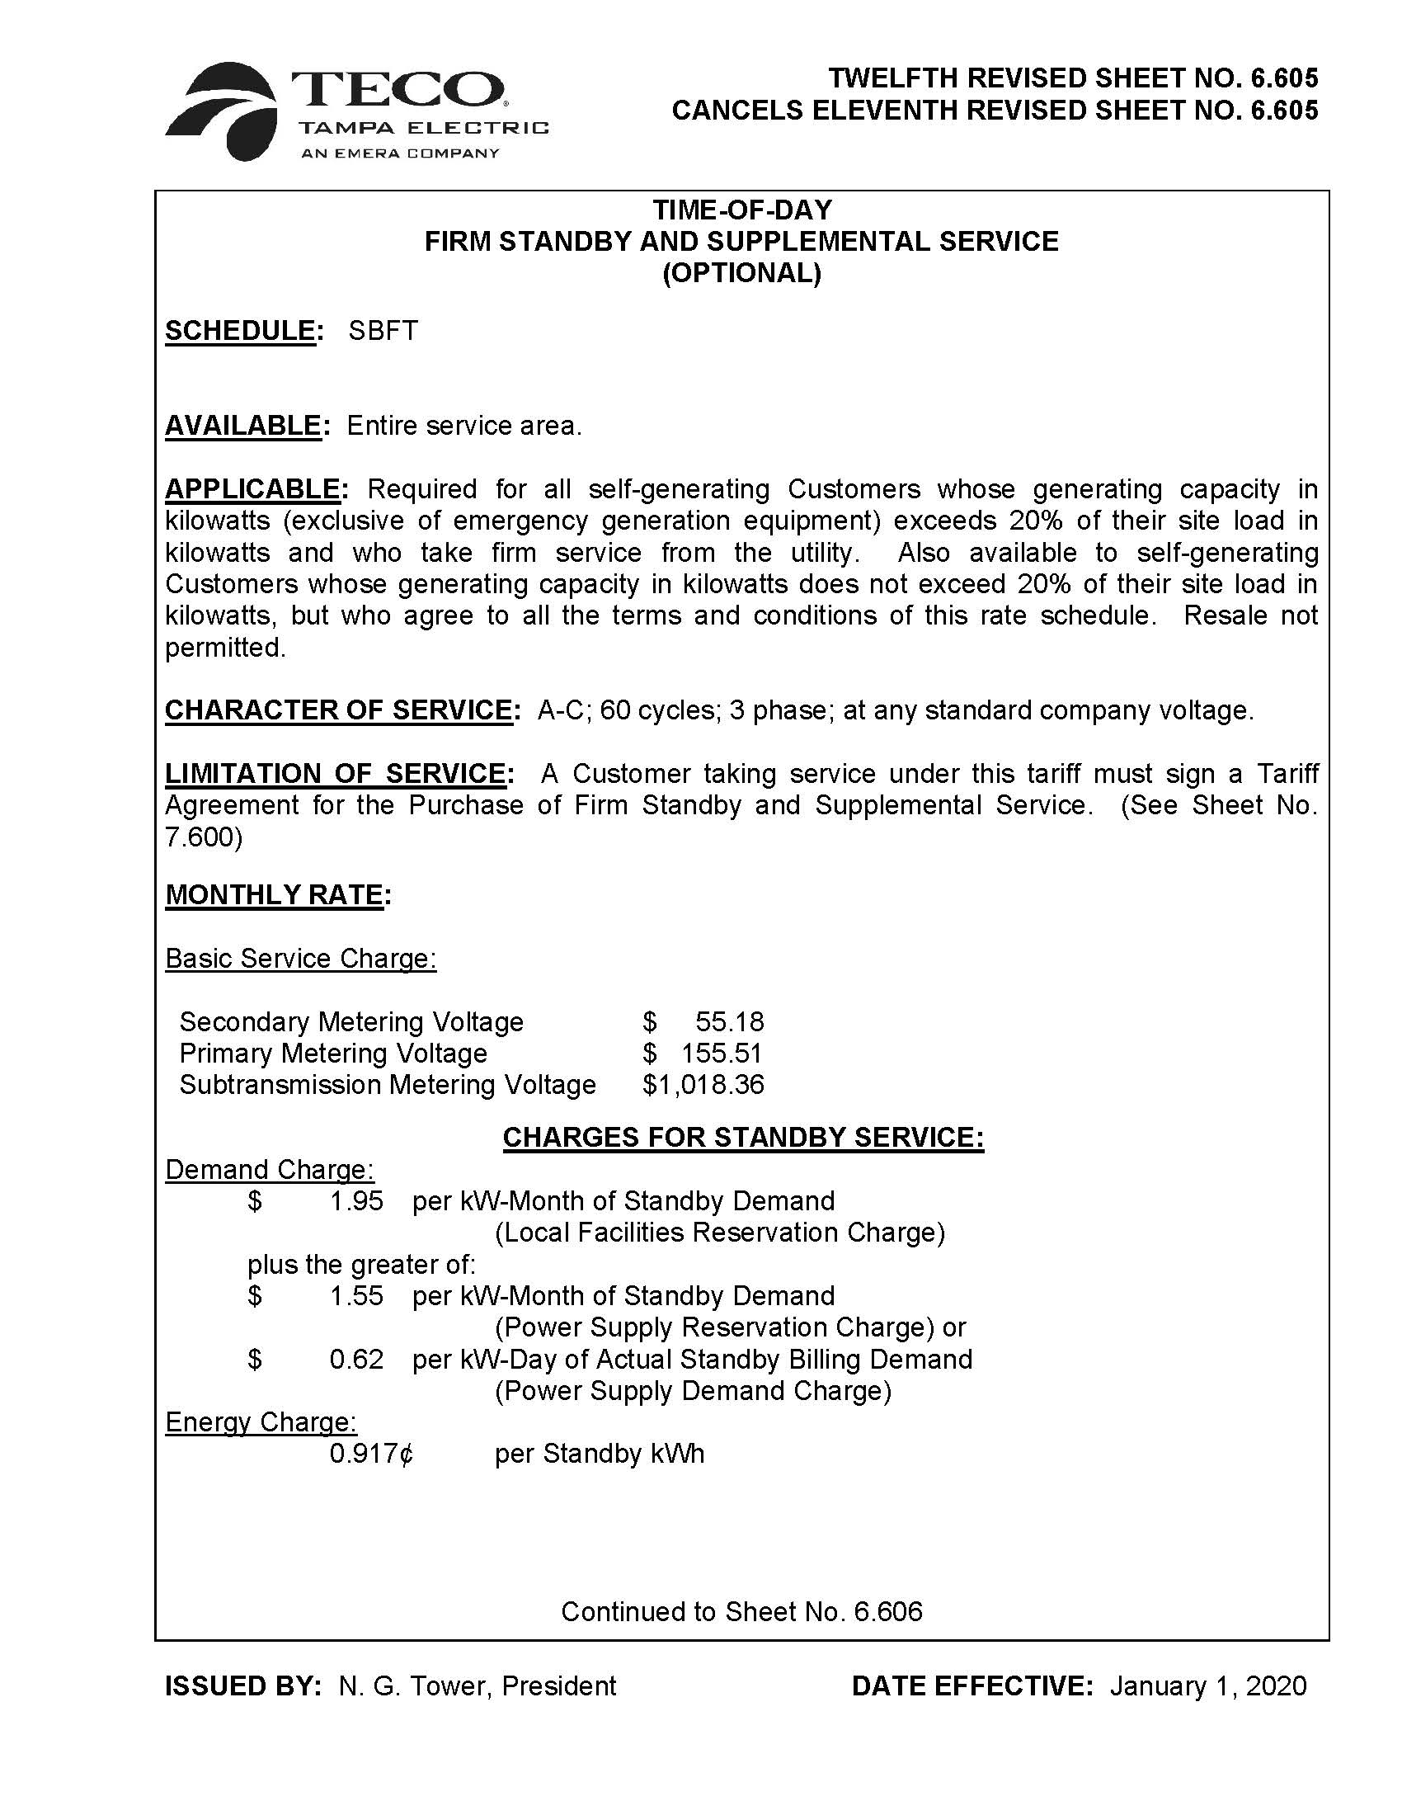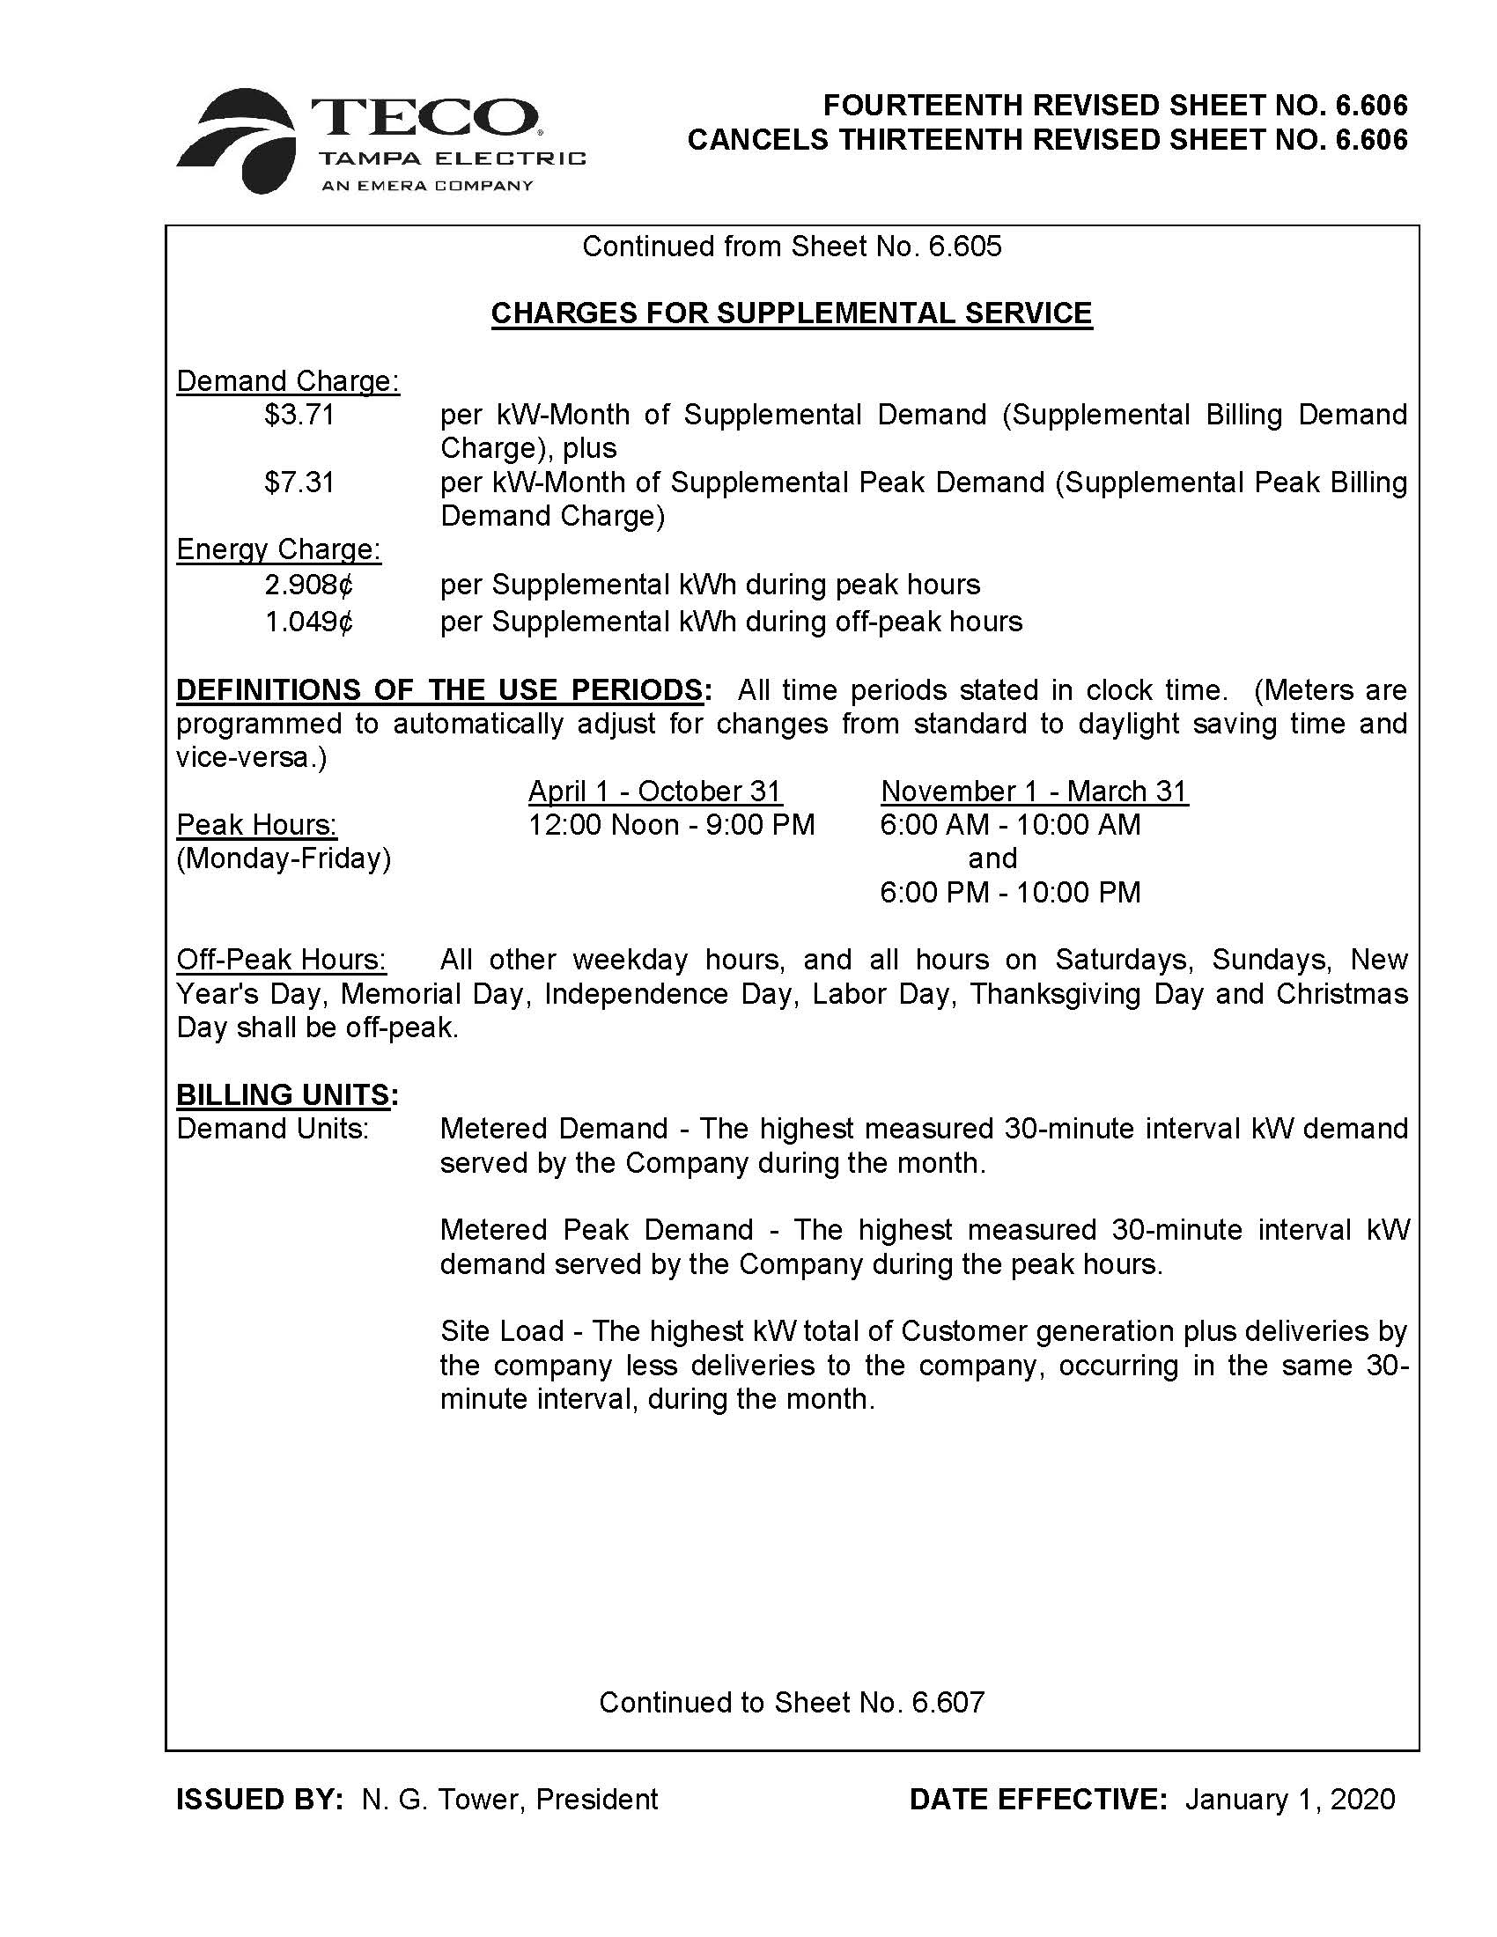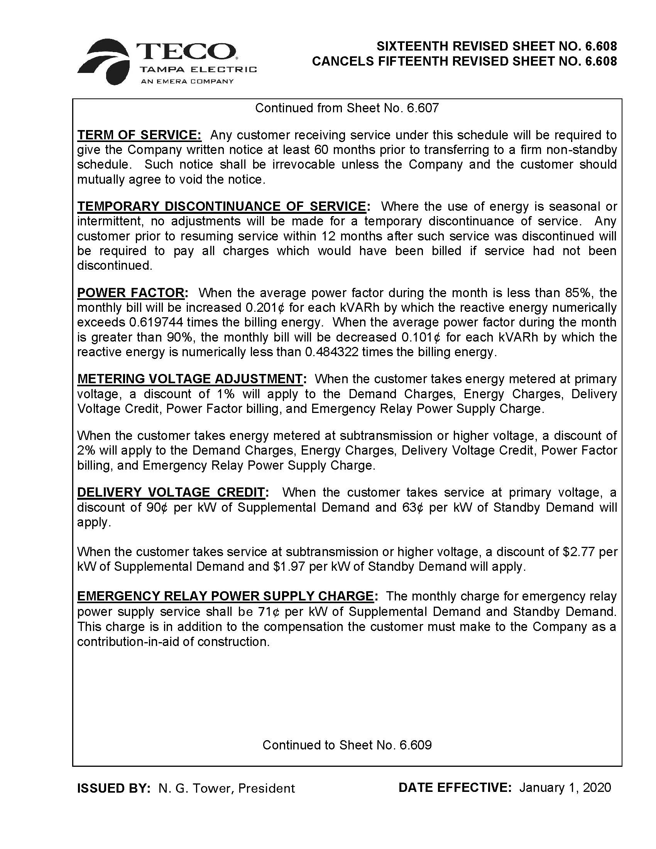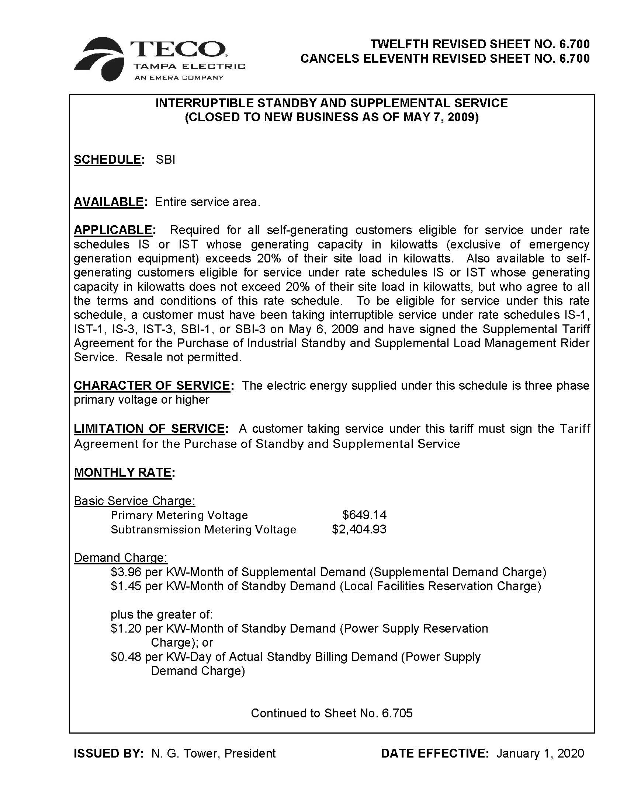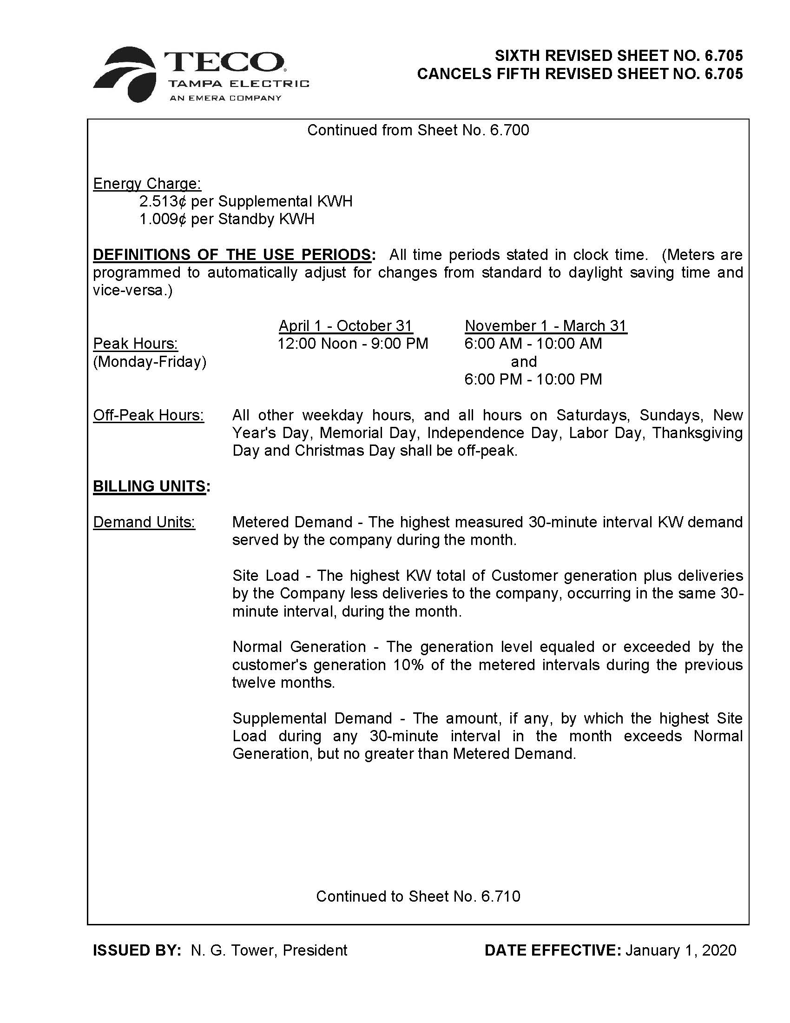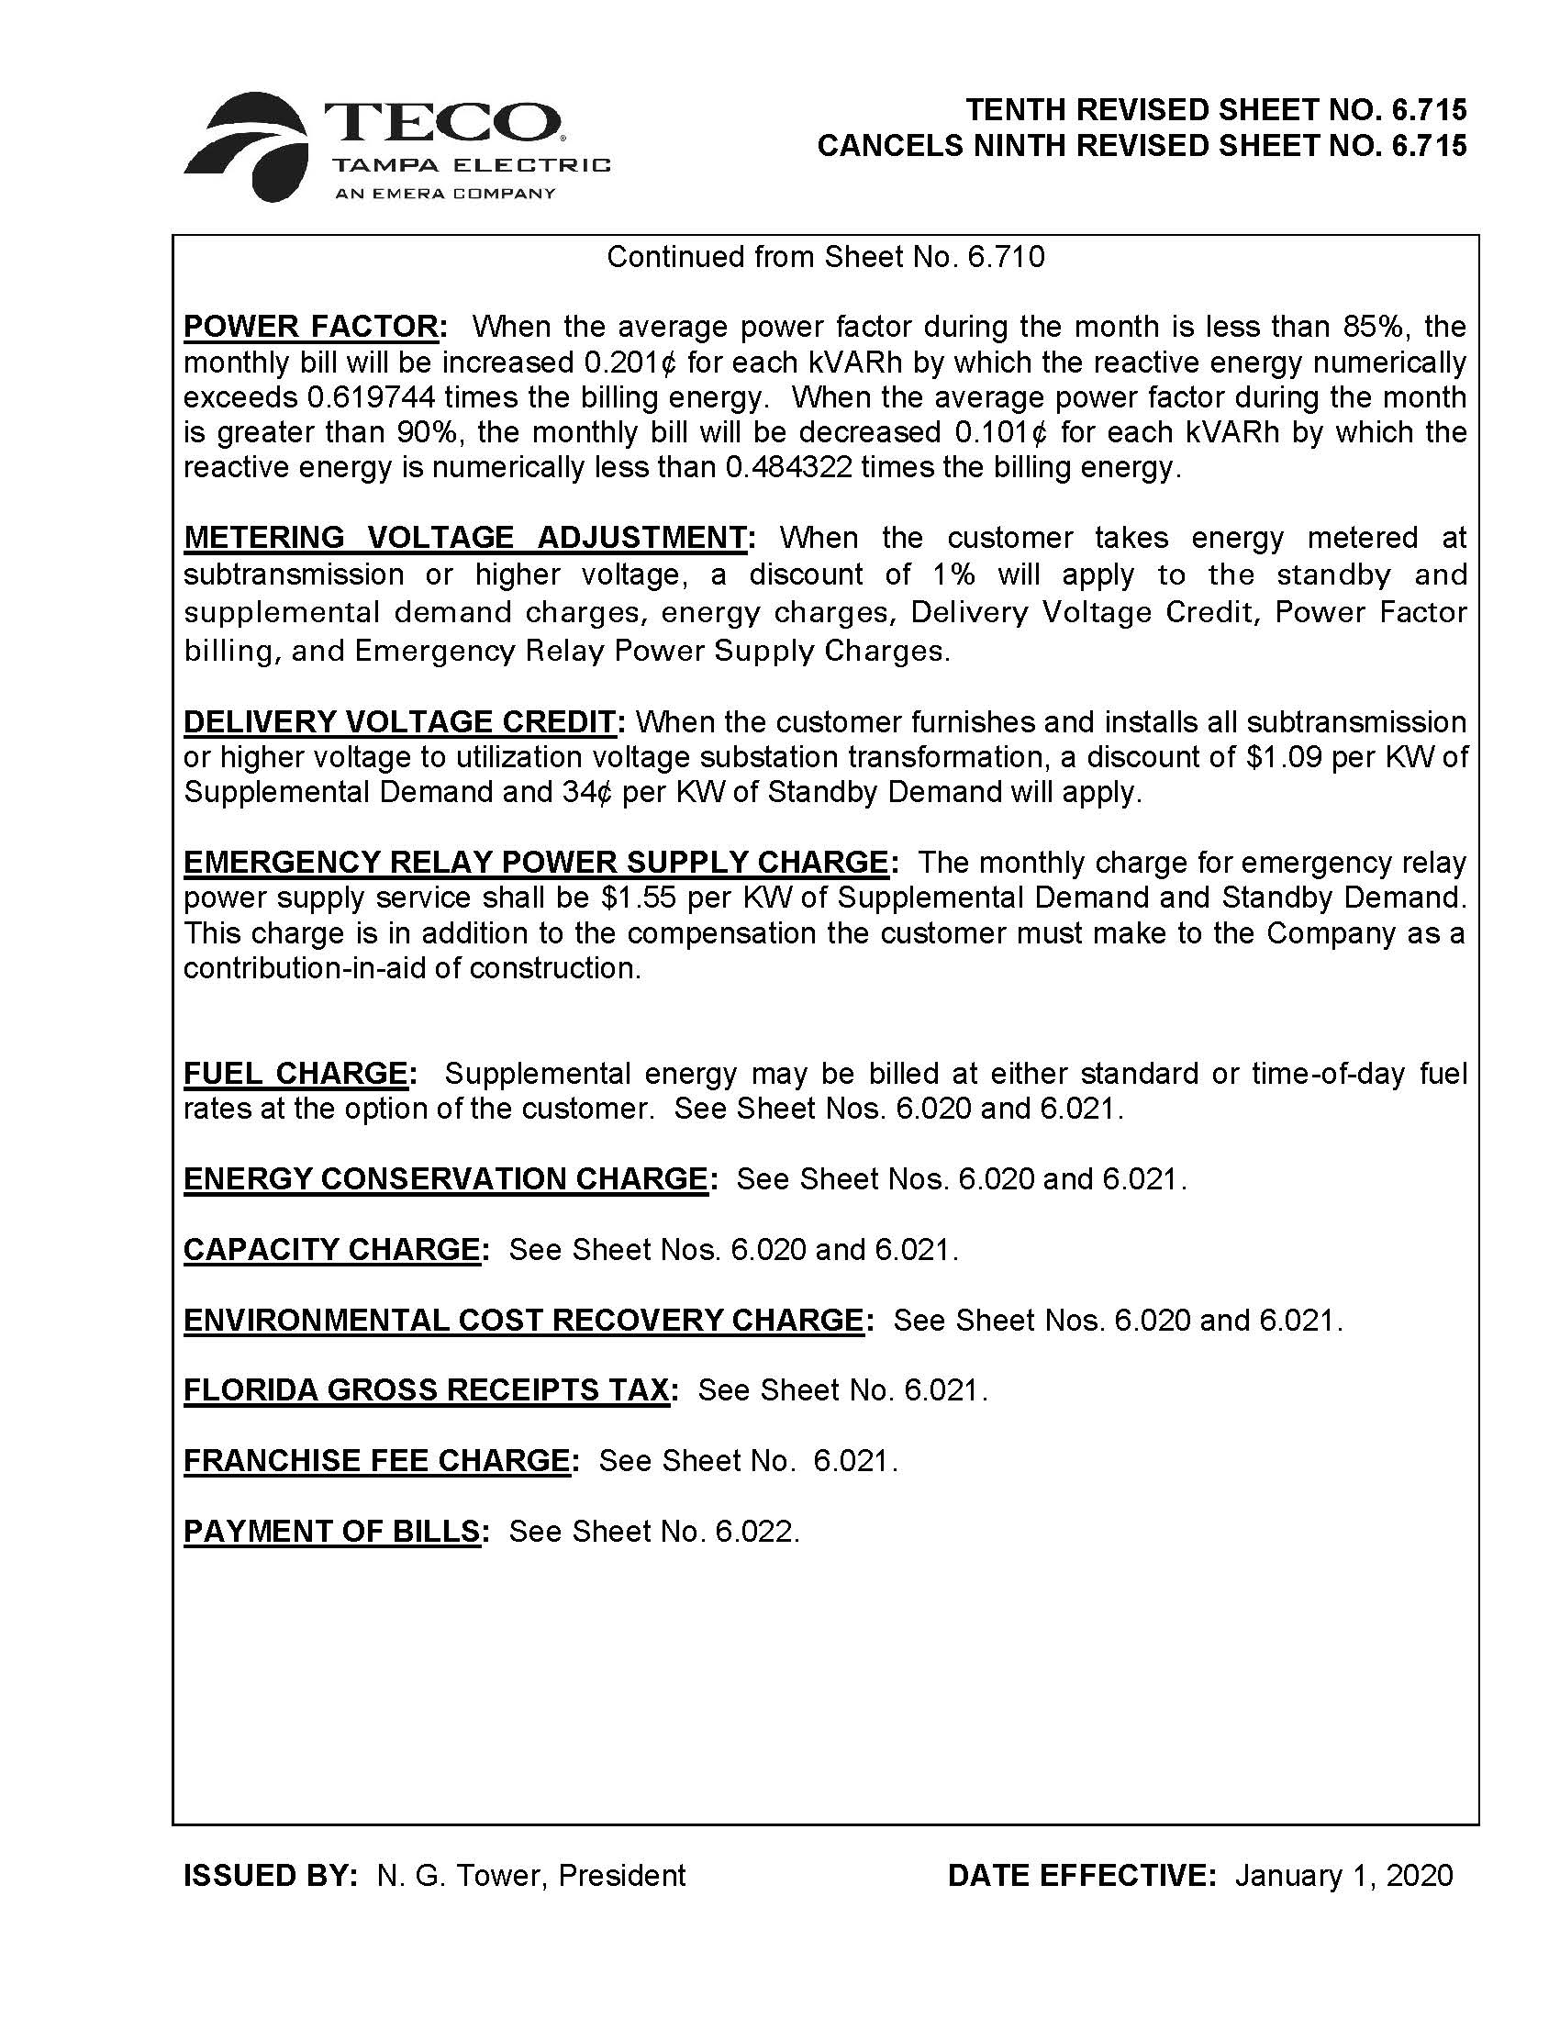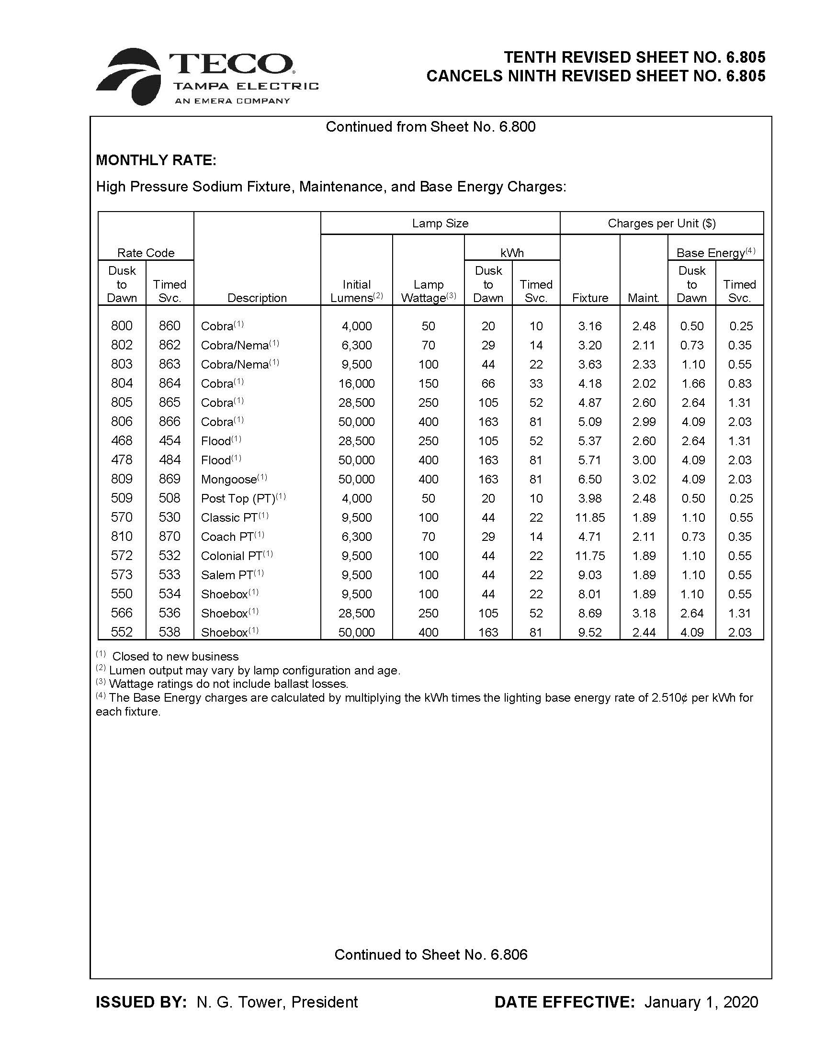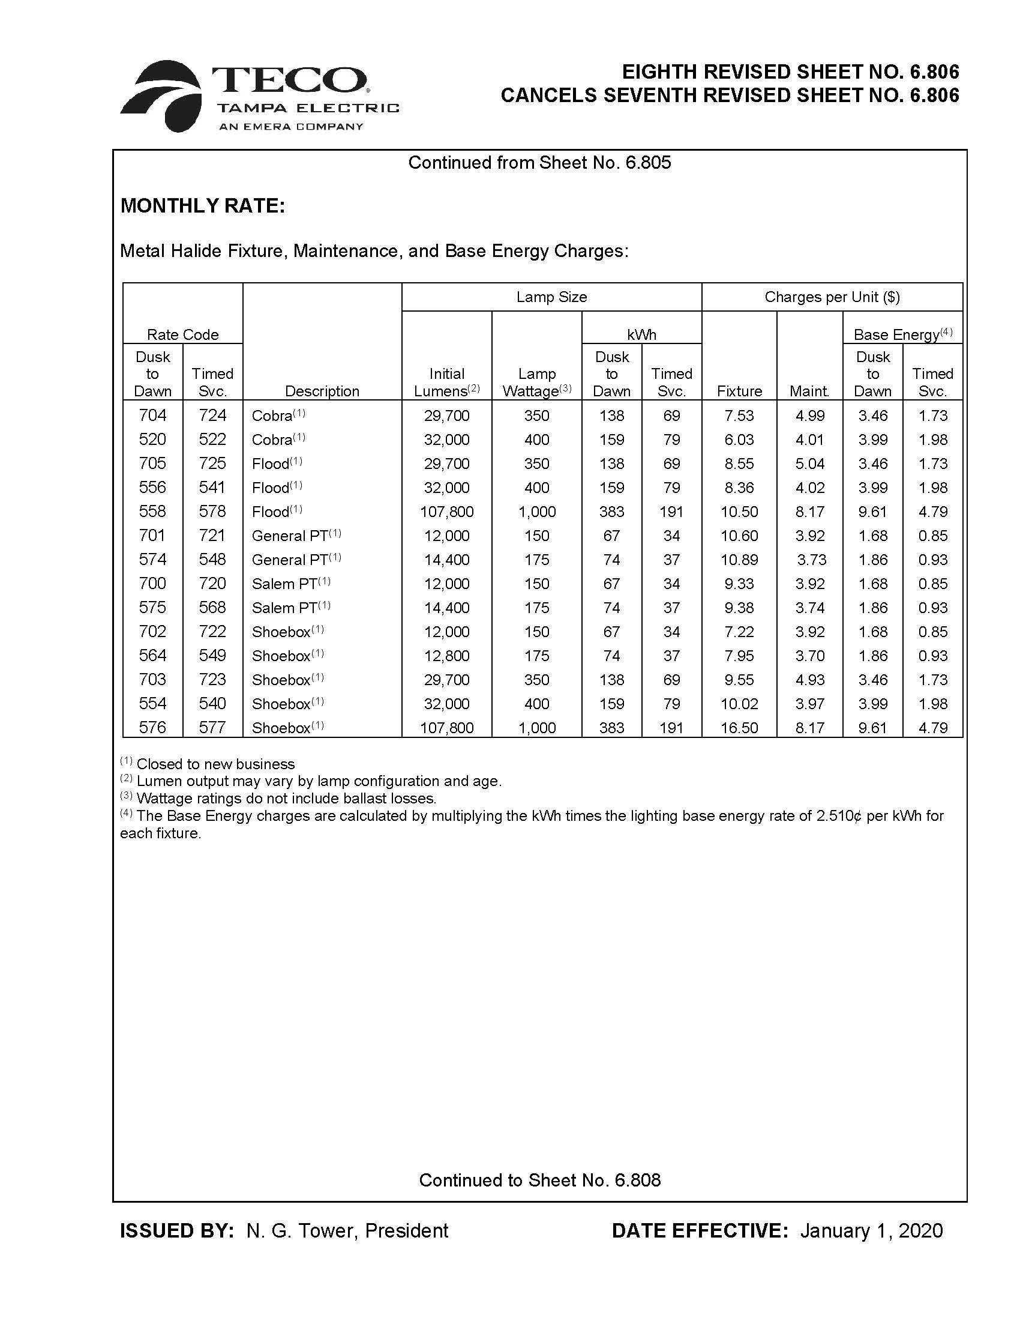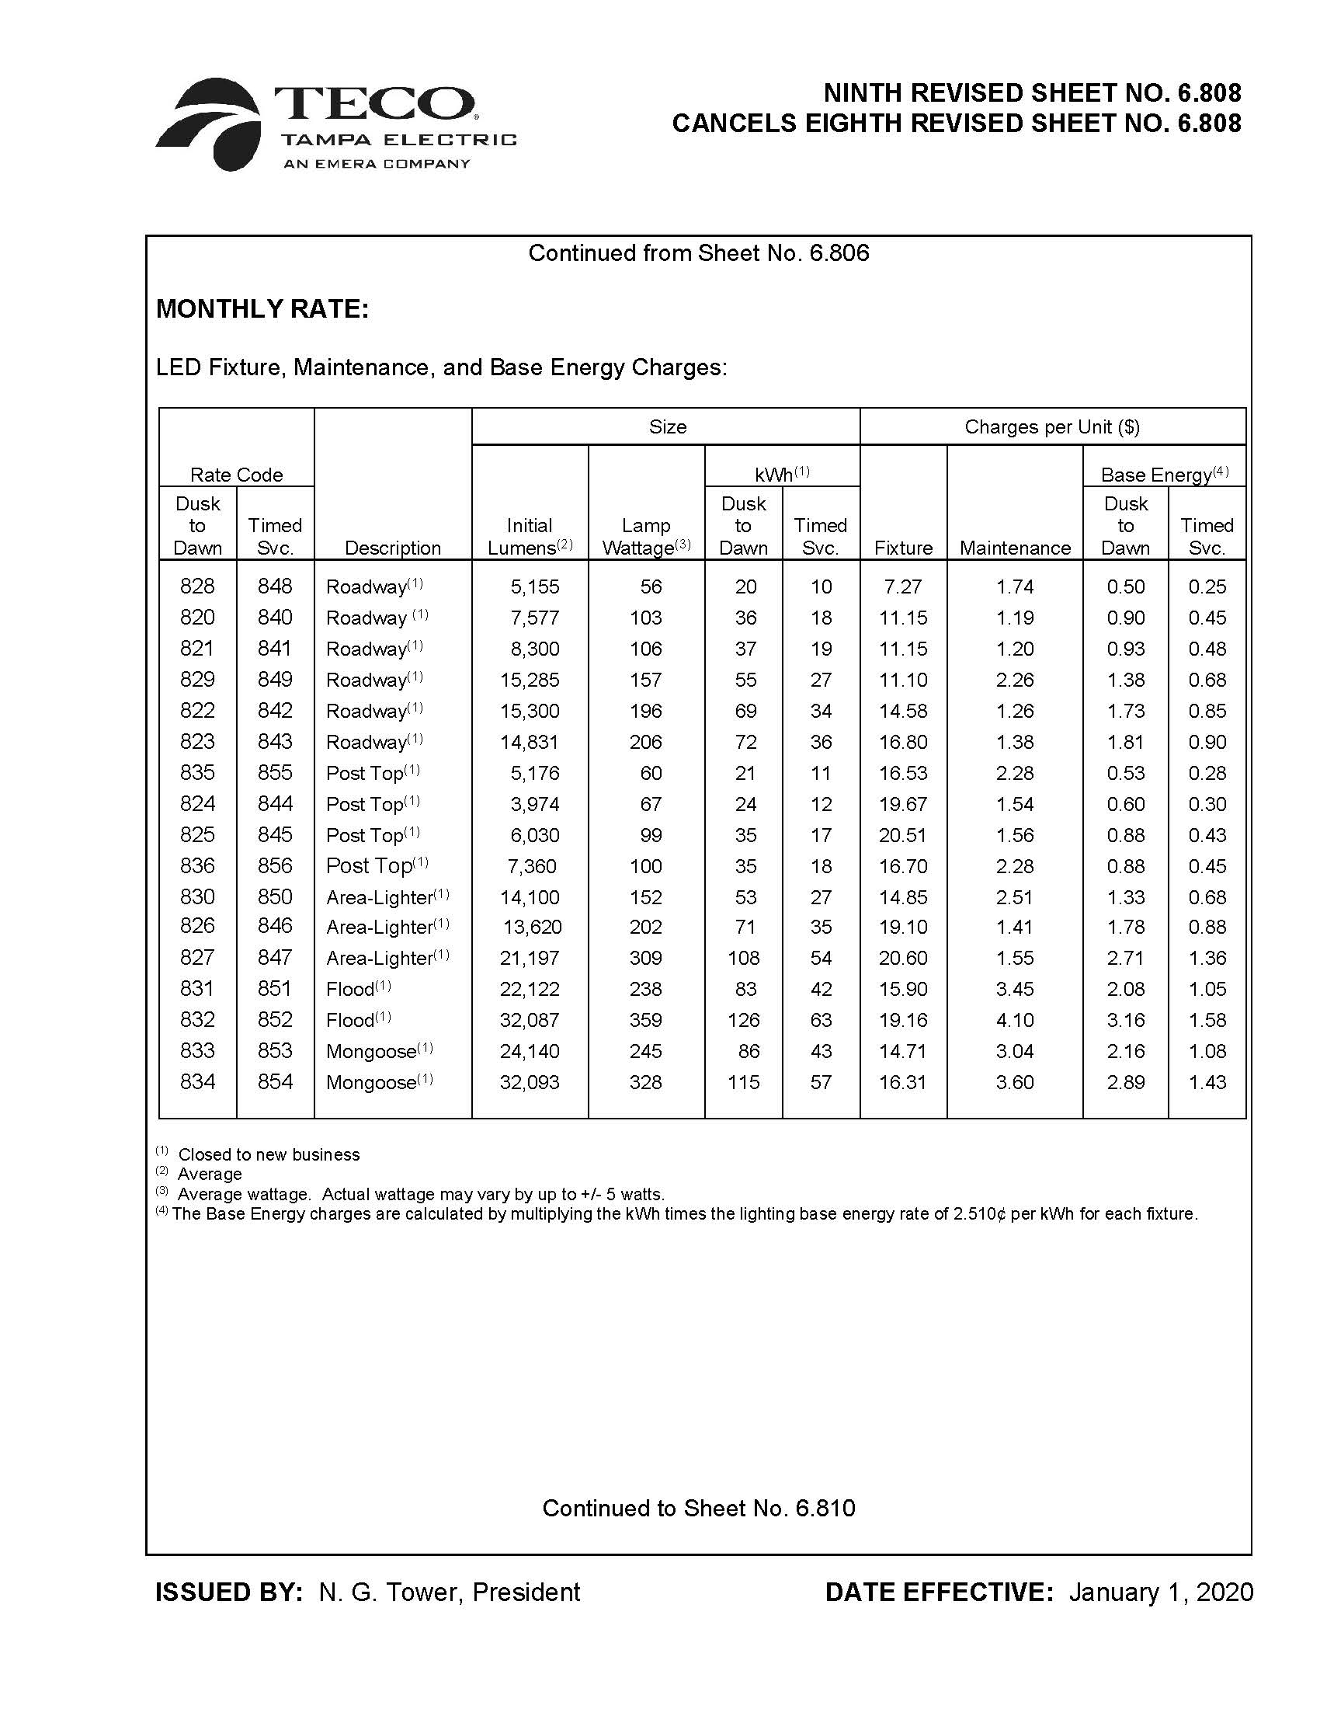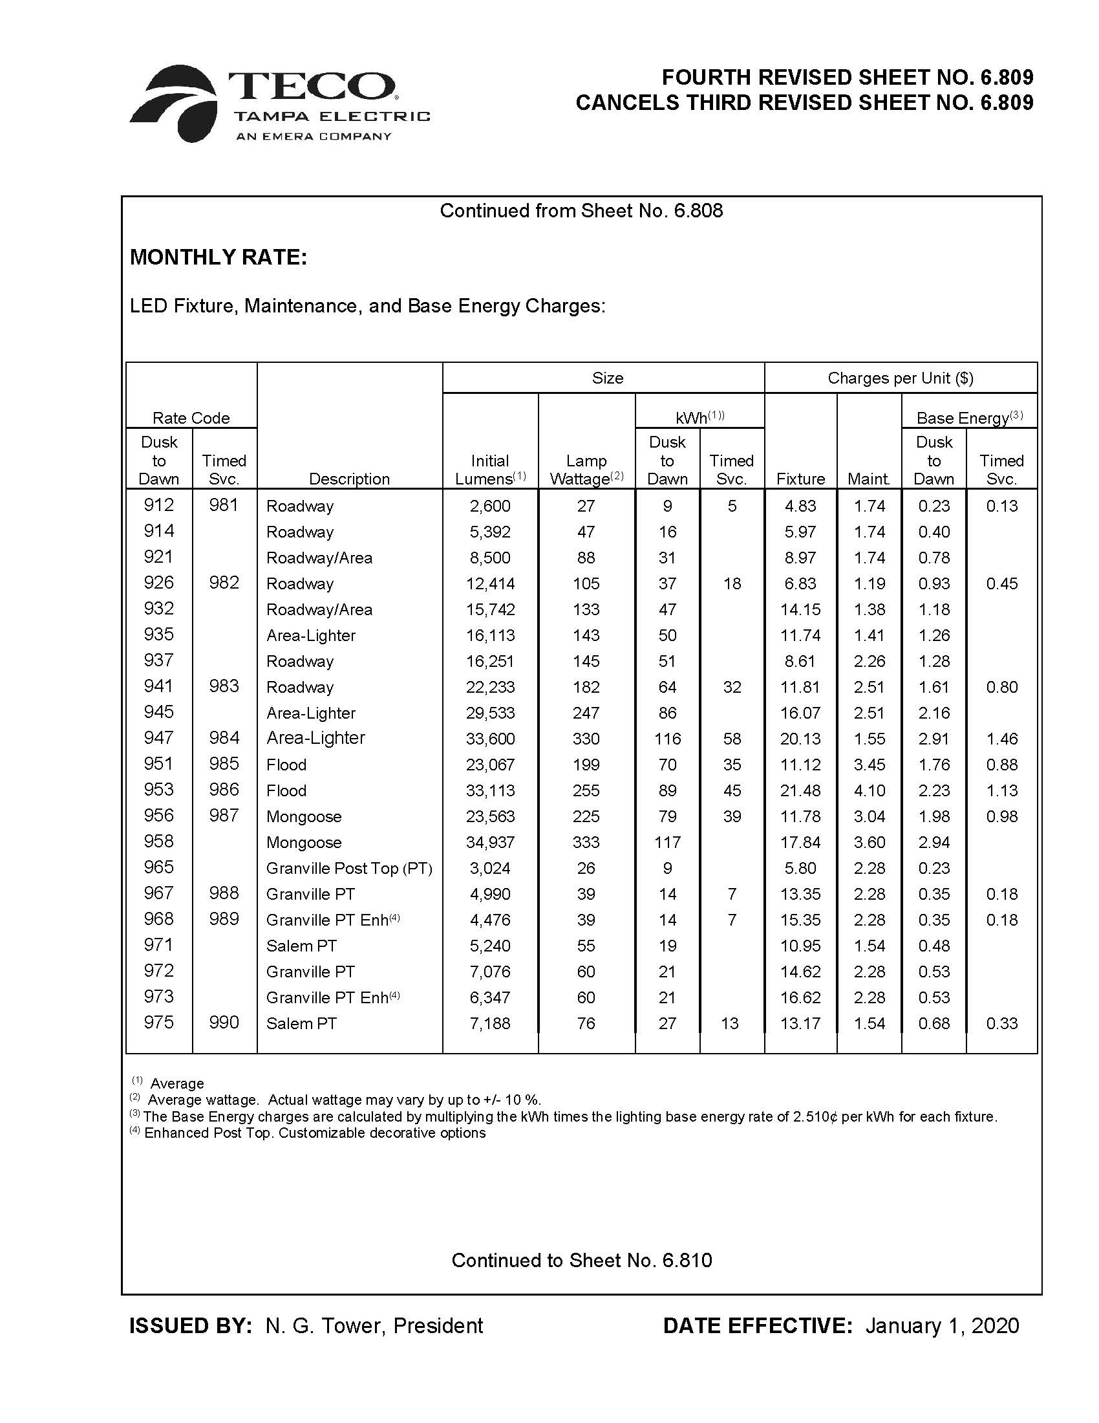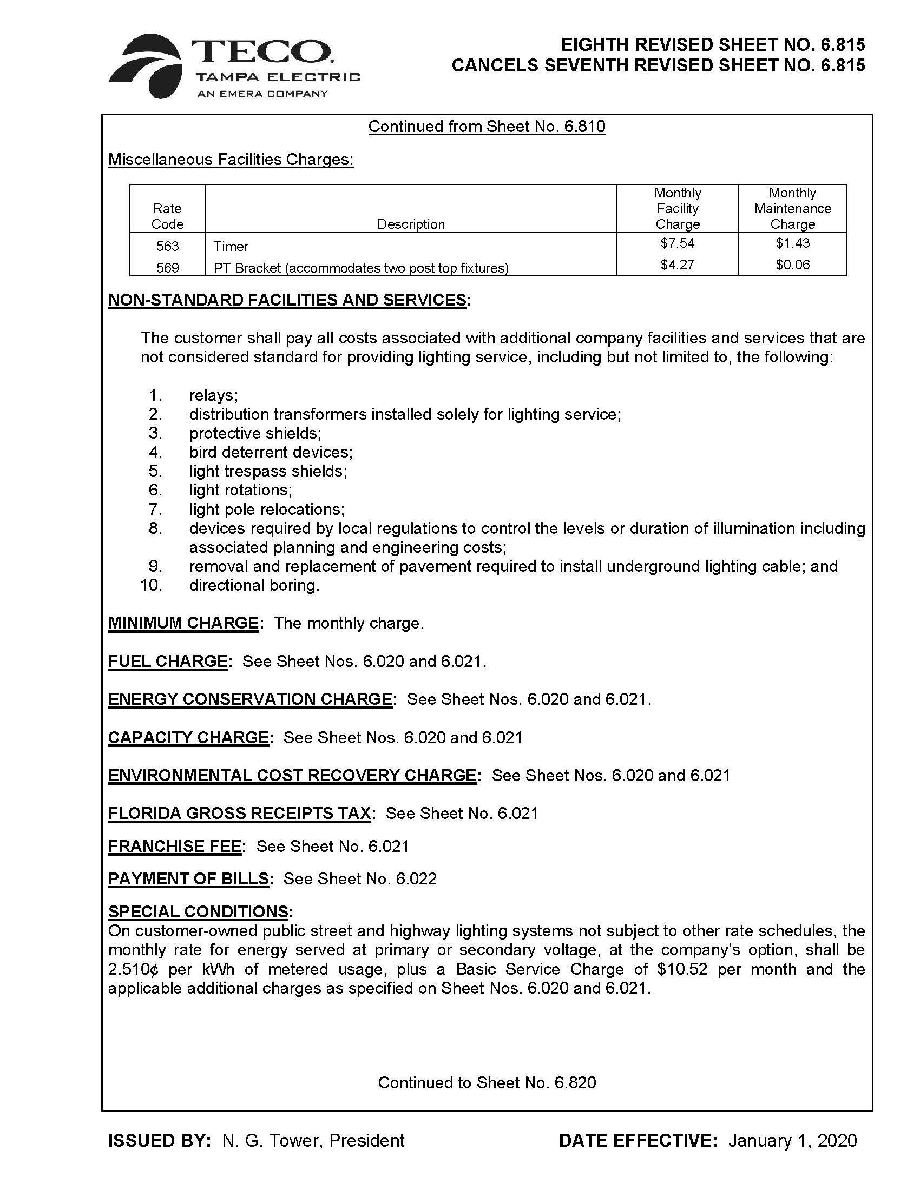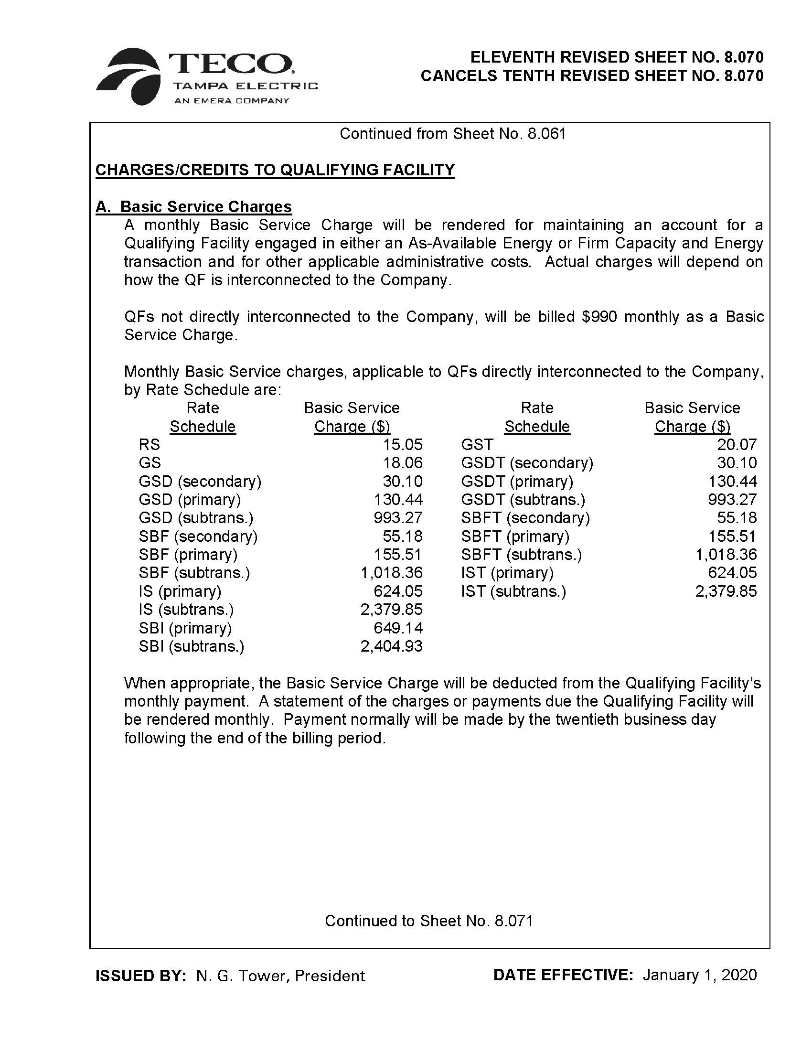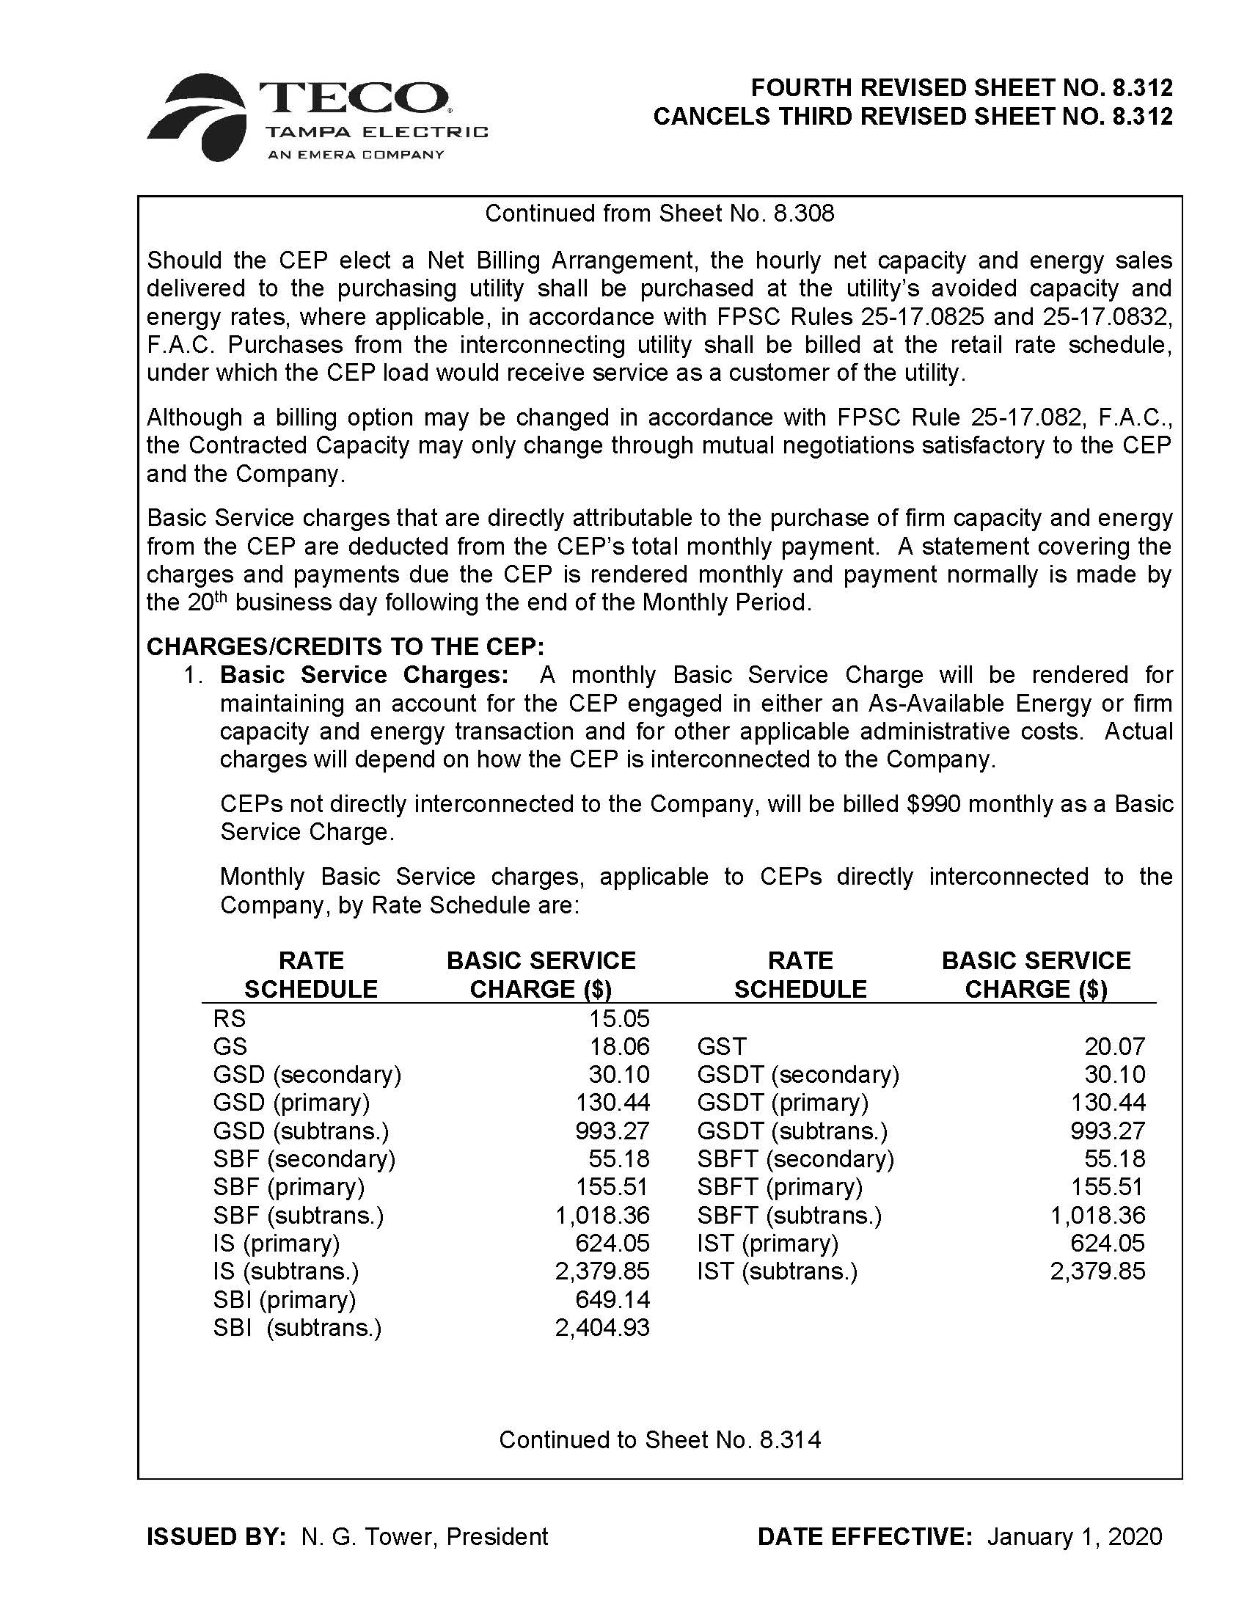

Order No. PSC-2017-0456-S-EI, issued November 27, 2017, in Docket No. 20170210-EI, In re: Petition for limited proceeding to approve 2017 amended and restated stipulation and settlement agreement, by Tampa Electric Company, and Docket No. 20160160-EI, In re: Petition for approval of energy transaction optimization mechanism, by Tampa Electric Company.
Order No. PSC-2019-0477-FOF-EI, issued November 12, 2019, in Docket No. 20190136-EI, In re: Petition for a limited proceeding to approve Third SoBRA, by Tampa Electric Company.
Typically, effective dates are set a minimum of 30 days after a Commission vote modifying changes as a result of a mid-course correction. Gulf Power Co. v. Cresse, 410 So. 2d 492 (Fla. 1982); Order No. PSC-96-0907-FOF-EI, issued on July 15, 1996, in Docket No. 960001-EI, In re: Fuel and purchased power cost recovery clause and generating performance incentive factor; Order No. 96-0908-FOF-EI, issued July 15, 1996, in Docket No. 960001-EI, In re: Fuel and purchased power cost recovery clause and generating performance incentive factor. This time limit is imposed in order to not have new rates applied to energy consumed before the effective date of our action, i.e., the date of the vote. However, we have also implemented charges in less than 30 days when circumstances warrant. Order No. PSC-15-0161-PCO-EI, issued April 30, 2015, in Docket No. 150001-EI, In re: Fuel and purchased power cost recovery clause and generating performance incentive factor (approving FPL’s petition for a mid-course correction which reduced fuel factors with less than 30 days notice.) In this case the Company has requested a reduction in rates and has given customers notice of the proposed reduction 30 days before the scheduled Commission vote. Under these circumstances we find that allowing the rate reduction to go into effect on January 1, 2020 is warranted.

