BEFORE THE FLORIDA PUBLIC SERVICE COMMISSION

In re: Annual reestablishment of price increase or decrease index of major categories of operating costs incurred by water and wastewater utilities pursuant to Section 367.081(4)(a), F.S. | DOCKET NO. 20190005-WS  ORDER NO. PSC-2019-0525-PAA-WS  ISSUED: December 17, 2019

The following Commissioners participated in the disposition of this matter:

ART GRAHAM, Chairman
JULIE I. BROWN
DONALD J. POLMANN
GARY F. CLARK
ANDREW GILES FAY

NOTICE OF PROPOSED AGENCY ACTION
ORDER ESTABLISHING 2020 PRICE INDEX FOR WATER AND WASTEWATER UTILITIES

BY THE COMMISSION:

NOTICE is hereby given by the Florida Public Service Commission that the action discussed herein is preliminary in nature and will become final unless a person whose interests are substantially affected files a petition for a formal proceeding, pursuant to Rule 25-22.029, Florida Administrative Code (F.A.C.).

Background
Since March 31, 1981, pursuant to the guidelines established by Section 367.081(4)(a), Florida Statutes (F.S.), and Rule 25-30.420, Florida Administrative Code (F.A.C.), we have established a price index increase or decrease for major categories of operating costs on or before March 31 of each year. This process allows water and wastewater utilities to adjust rates based on current specific expenses without applying for a rate case.
This Order calculates the 2020 price index by comparing the Gross Domestic Product Implicit Price Deflator Index for the fiscal year ended September 30, 2019. This same procedure has been used each year since 1995 to calculate the price index. The U.S. Department of Commerce, Bureau of Economic Analysis, released its most recent third quarter figures on October 30, 2019.
Since March 31, 1981, this Commission has received and processed approximately 3,741 index and pass through applications. We have jurisdiction over this matter pursuant to Section 367.081, F.S.

Decision
In 1993, the Gross Domestic Product Implicit Deflator (GDP) was established as the appropriate measure for determining the water and wastewater price index. At the same time, the convention of using a four quarter fiscal year comparison was also established and this practice has been used every year since then. The GDP is prepared by the U.S. Department of Commerce. Prior to that time, the Gross National Product Implicit Price Deflator Index (GNP) was used as the indexing factor for water and wastewater utilities. The Department of Commerce switched its emphasis from the GNP to the GDP as the primary measure of U.S. production.
Pursuant to Section 367.081(4)(a), F.S., this Commission, by order, shall establish a price increase or decrease index for major categories of operating costs incurred by utilities subject to its jurisdiction reflecting the percentage of increase or decrease in such costs from the most recent 12-month historical data available. Since 1995, the price index was determined by using a four quarter comparison, ending September 30, of the Implicit Price Deflator Index in order to meet the statutory deadline. The updated price index was determined by comparing the change in the GDP using the four quarter fiscal year comparison ending September 30, 2019. This method has been used consistently since 1995 to determine the price index.
In Order No. PSC-2018-0612-PAA-WS, issued December 27, 2018, in Docket No. 20180005-WS, in keeping with the practice started in 1993, we reiterated the alternatives which could be used to calculate the indexing of utility revenues. Past concerns expressed by utilities, as summarized from utility input in previous hearings, are:
1) Inflation should be a major factor in determining the index;
2) Nationally published indices should be vital to this determination;
3) Major categories of expenses are labor, chemicals, sludge-hauling, materials and supplies, maintenance, transportation, and treatment expense;
4) An area wage survey, Dodge Building Cost Index, Consumer Price Index, and the GDP should be considered;

5) A broad measure index should be used; and
6) The index procedure should be easy to administer.
Based upon these concerns, we have previously explored the following alternatives:
1) Survey of Regulated Water and Wastewater Utilities;
2) Consumer Price Index;
3) Florida Price Level Index;
4) Producer Price Index – previously the Wholesale Price Index; and
5) GDP (replacing the GNP).
Over the years, we found that the Survey of Regulated Water and Wastewater Utilities should be rejected because using the results of a survey would allow utilities to pass on to customers all cost increases, thereby reducing the incentives of promoting efficiency and productivity. We have also found that the Consumer Price Index and the Florida Price Level Index should be rejected because of their limited degree of applicability to the water and wastewater industry. Both of these price indices are based upon comparing the advance in prices of a limited number of general goods and, therefore, appear to have limited application to water and wastewater utilities.
We further found that the Producer Price Index (PPI) is a family of indices that measure the average change over time in selling prices received by domestic producers of goods and services. PPI measures price change from the perspective of the seller, not the purchaser, and therefore shall be rejected. The bases for these indices have not changed, and the conclusions reached in Order No. PSC-2018-0612-PAA-WS continue to apply in this case. Since 1993, we have found that the GDP has a greater degree of applicability to the water and wastewater industry. Therefore, we shall continue to use the GDP to calculate water and wastewater price level adjustments.
The following information provides a historical perspective of the annual price index:
Table 1
Historical Analysis of the Annual Price Index for Water and Wastewater Utilities
Year | Commission  Approved Index | Year | Commission  Approved Index
2008 | 2.39% | 2014 | 1.41%
2009 | 2.55% | 2015 | 1.57%
2010 | 0.56% | 2016 | 1.29%
2011 | 1.18% | 2017 | 1.51%
2012 | 2.41% | 2018 | 1.76%
2013 | 1.63% | 2019 | 2.36%

The table below shows the historical participation in the Index and/or Pass-Through programs:
Table 2
Percentage of Jurisdictional Water and Wastewater Utilities Filing for Indexes and
Pass-Throughs
Year | Percentage | Year | Percentage
2008 | 42% | 2014 | 39%
2009 | 53% | 2015 | 49%
2010 | 29% | 2016 | 38%
2011 | 43% | 2017 | 37%
2012 | 30% | 2018 | 42%
2013 | 41% | 2019 | 60%

Appropriate Rates for 2020 Index
The U.S. Department of Commerce, Bureau of Economic Analysis, released the most recent third quarter 2019 figures on October 30, 2019. Consistent with our establishment of the 2019 Price Index last year, we are using the third quarter 2019 amounts to calculate the 2020 Price Index. Using the third quarter amounts allows time for a hearing if there is a protest, in order for this Commission to establish the 2020 Price Index by March 31, 2020, in accordance with Section 367.081(4)(a), F.S. The percentage change in the GDP using the fiscal year comparison ending with the third quarter is 1.79 percent. This number was calculated as follows.
GDP Index for the fiscal year ended 9/30/19 | 112.627
GDP Index for the fiscal year ended 9/30/18 | 110.645
Difference | 1.98
Divided by 9/30/18 GDP Index | 110.645
2020 Price Index | 1.79%

Noticing of Indexing Requirements
The package presented in Attachment 1 shall be mailed to every regulated water and wastewater utility after the expiration of the PAA protest period, along with a copy of the finalized PAA order. The entire package will also be made available on this Commission’s website.
In an effort to increase the number of water and wastewater utilities taking advantage of the annual price index and pass-through programs, we find that the attached cover letter (Attachment 2) from the Director of the Division of Accounting and Finance shall be included with the mailing of the PAA Order in order to explain the purpose of the index and pass-through applications and to communicate that Commission staff is available to assist them.

Closure of Docket

Uniform Rule 25-22.029(1), F.A.C., contains an exception to the procedural requirements set forth in Uniform Rule 28-106.111, F.A.C., providing that “[t]he time for requesting a Section 120.569 or 120.57 hearing shall be 14 days from issuance of the notice for PAA orders establishing a price index pursuant to Section 367.081(4)(a), F.S.” We therefore require any protest to the PAA Order in this docket be filed within 14 days of the issuance of the PAA Order, and that any party filing the protest shall be required to pre-file testimony with the protest. Upon expiration of the protest period, if a timely protest is not received, the decision shall become final and effective upon the issuance of a Consummating Order. However, this docket shall remain open through the end of the year and be closed upon the establishment of the new docket on January 2, 2020.

Based on the foregoing, it is

ORDERED by the Florida Public Service Commission that the Gross Domestic Product Implicit Price Deflator Index is approved for use in calculating price level adjustments. It is further

ORDERED that the 2020 Price Index for water and wastewater utilities shall be 1.79 percent. It is further

ORDERED that pursuant to Rule 25-30.420(1), F.A.C., the Office of Commission Clerk, after the expiration of the Proposed Agency Action (PAA) protest period, shall mail each regulated water and wastewater utility a copy of the PAA order establishing the index containing the information presented in Attachment 1. A cover letter from the Director of the Division of Accounting and Finance shall be included with the mailing of the order (Attachment 2). The entire package shall also be made available on the Commission’s website. It is further

ORDERED that any substantially affected person filing a protest to this order shall do so within 14 days of the issuance of this order. It is further

ORDERED that any substantially affected person filing a protest to this order shall pre-file direct testimony with the protest. It is further

ORDERED that the provisions of this Order, issued as proposed agency action, shall become final and effective upon the issuance of a Consummating Order unless an appropriate petition, in the form provided by Rule 28-106.201, Florida Administrative Code, is received by the Commission Clerk, 2540 Shumard Oak Boulevard, Tallahassee, Florida 32399-0850, by the close of business on the date set forth in the “Notice of Further Proceedings” attached hereto. It is further

ORDERED that in the event this Order becomes final, this docket shall remain open through the end of the year and be closed upon the establishment of the new docket on January 2, 2020.

By ORDER of the Florida Public Service Commission this 17th day of December, 2019.

ADAM J. TEITZMAN
Commission Clerk
Florida Public Service Commission
2540 Shumard Oak Boulevard
Tallahassee, Florida 32399
(850) 413-6770
www.floridapsc.com

Copies furnished: A copy of this document is provided to the parties of record at the time of issuance and, if applicable, interested persons.

BYL

NOTICE OF FURTHER PROCEEDINGS OR JUDICIAL REVIEW

The Florida Public Service Commission is required by Section 120.569(1), Florida Statutes, to notify parties of any administrative hearing that is available under Section 120.57, Florida Statutes, as well as the procedures and time limits that apply. This notice should not be construed to mean all requests for an administrative hearing will be granted or result in the relief sought.

Mediation may be available on a case-by-case basis. If mediation is conducted, it does not affect a substantially interested person's right to a hearing.

The action proposed herein is preliminary in nature. Any person whose substantial interests are affected by the action proposed by this order may file a petition for a formal proceeding, in the form provided by Rule 28-106.201, Florida Administrative Code. This petition must be received by the Office of Commission Clerk, 2540 Shumard Oak Boulevard, Tallahassee, Florida 32399-0850, by the close of business on December 31, 2019.

In the absence of such a petition, this order shall become final and effective upon the issuance of a Consummating Order.

Any objection or protest filed in this/these docket(s) before the issuance date of this order is considered abandoned unless it satisfies the foregoing conditions and is renewed within the specified protest period.

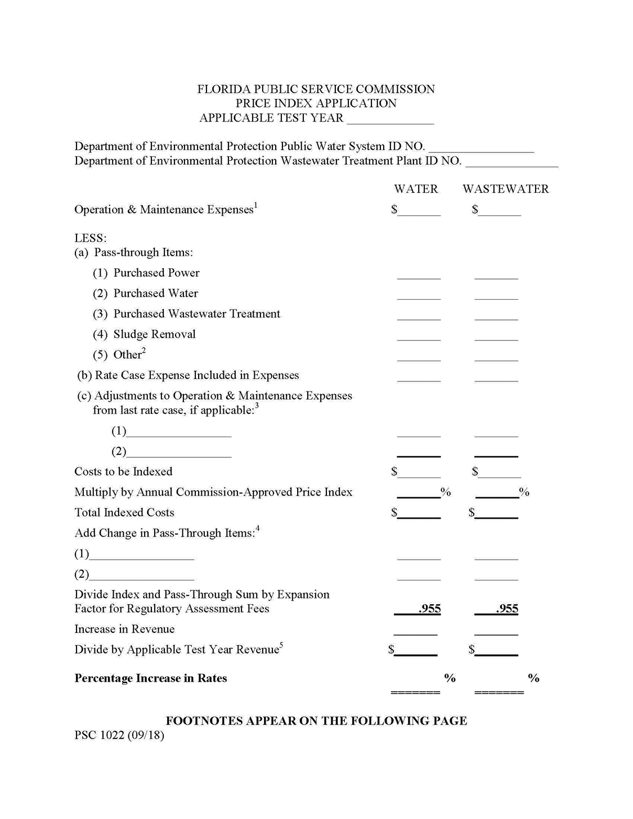

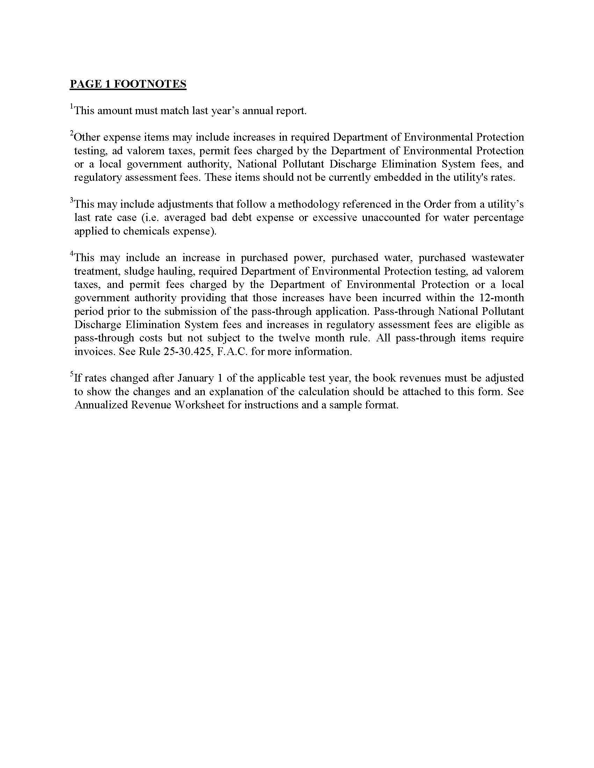

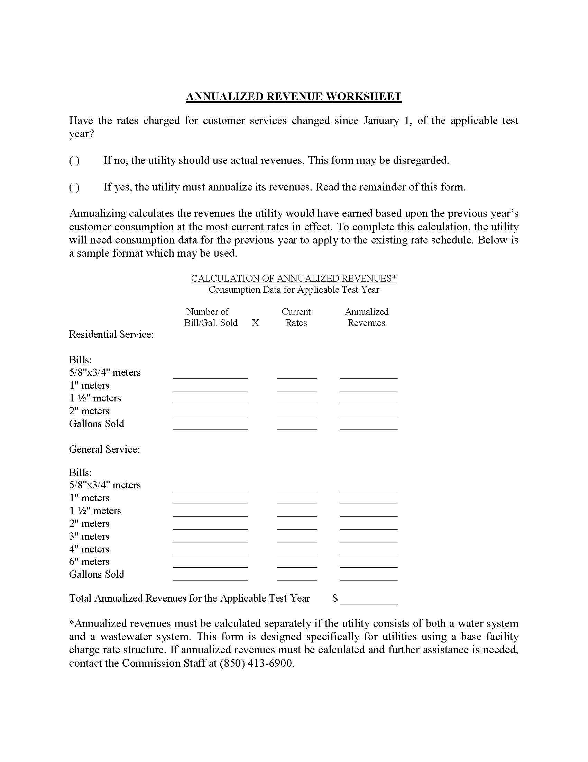

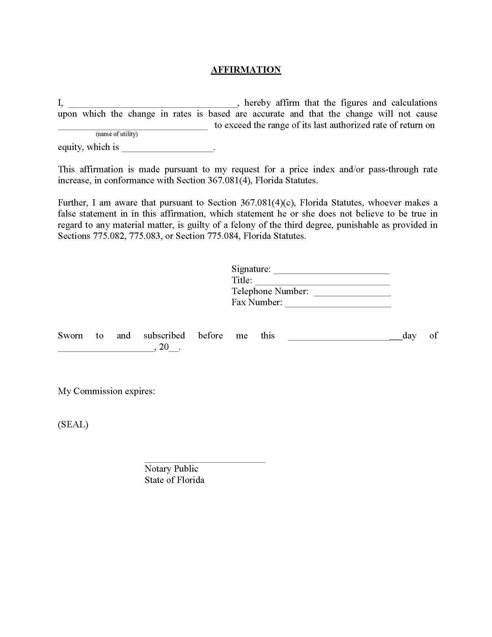

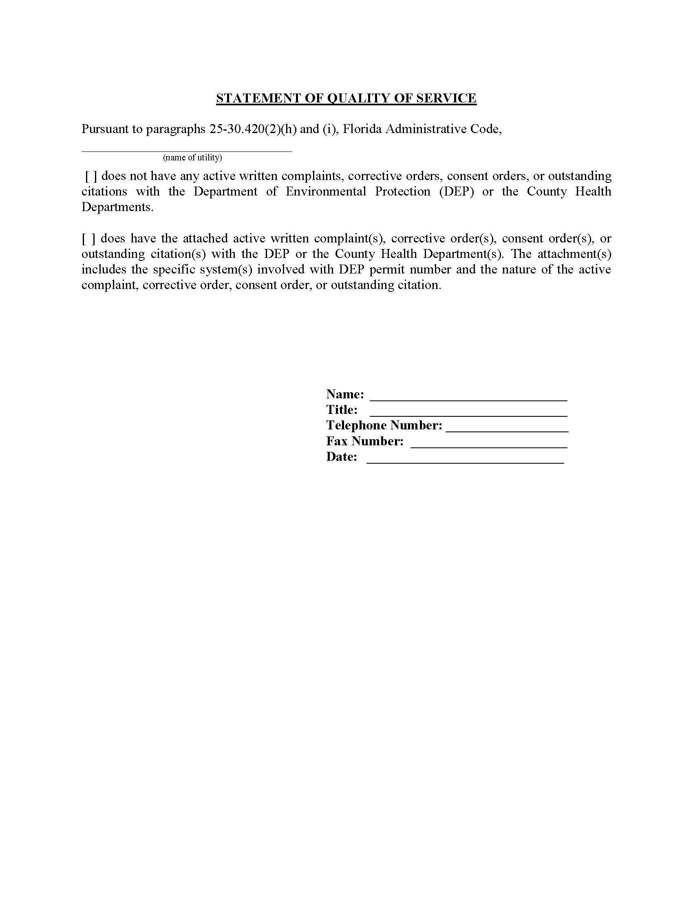

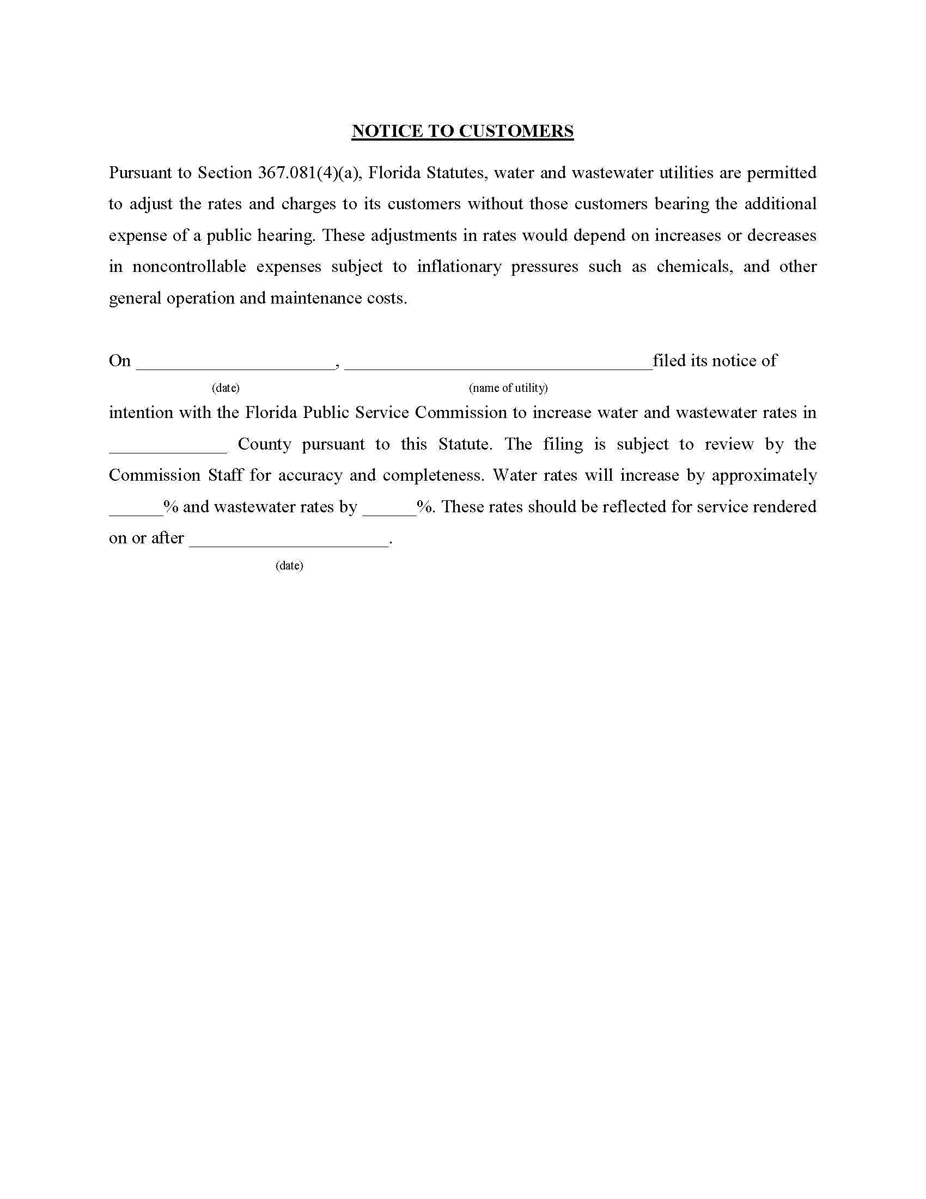

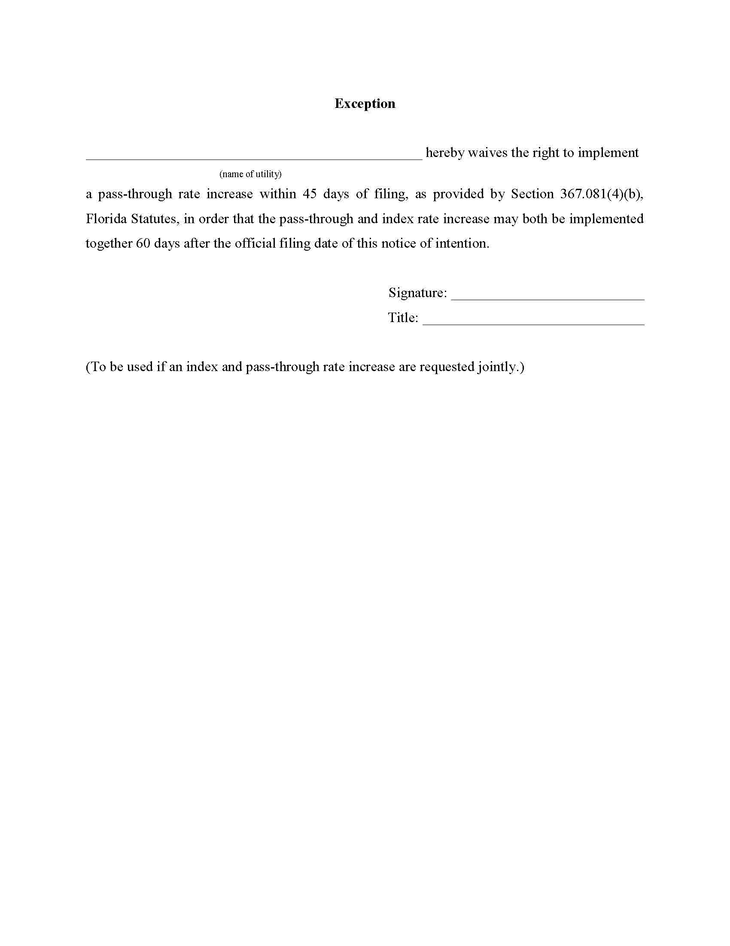

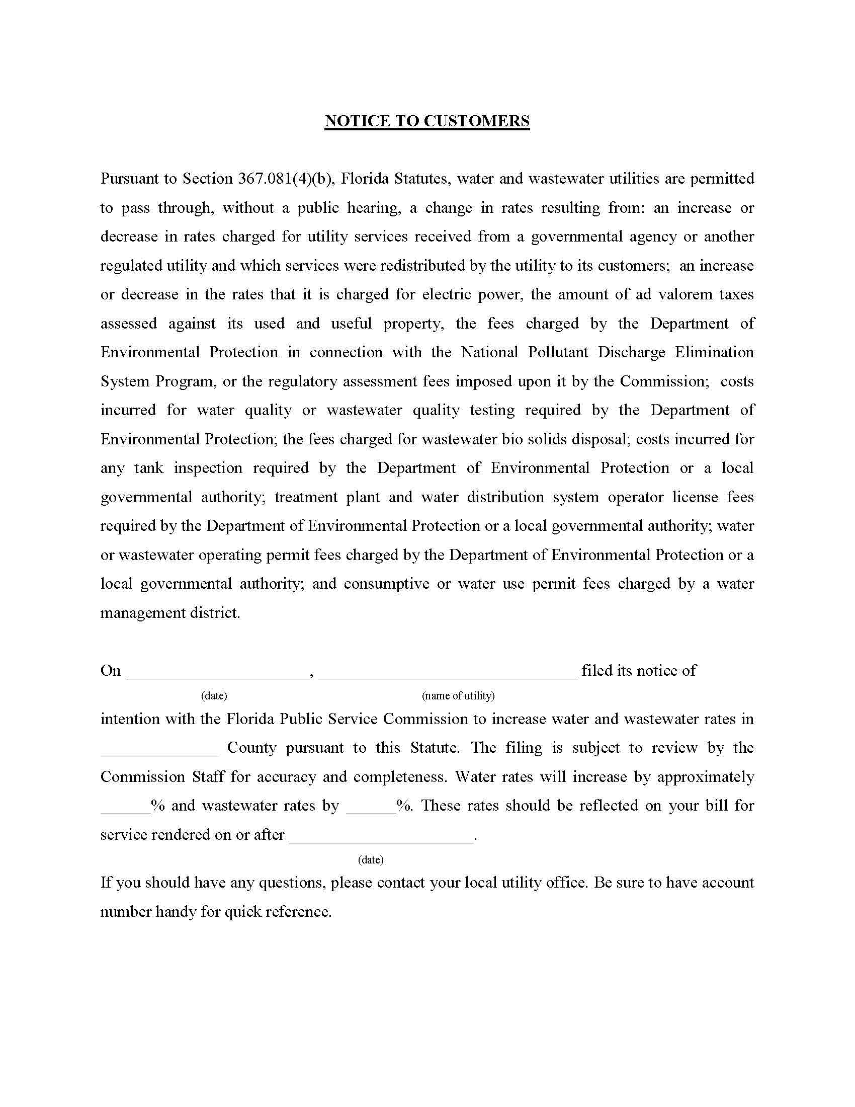
Commissioners:  Gary F. Clark, Chairman  Art graham  Julie i. brown  Donald J. Polmann  Andrew Giles Fay | State of Florida | Division of  Accounting and Finance  Andrew L. Maurey  Director  (850) 413-6900
Public Service Commission
Month Day, 2020

All Florida Public Service Commission
Regulated Water & Wastewater Utilities

Re: Docket No. 20190005-WS - 2020 Price Index

Dear Utility Owner:

Since March 31, 1981, pursuant to the guidelines established by Section 367.081(4)(a), Florida Statutes (F.S.), and Rule 25-30.420, Florida Administrative Code (F.A.C.), the Commission has established a price index increase or decrease for major categories of operating costs. This process allows water and wastewater utilities to adjust rates based on current specific expenses without applying for a rate case. The intent of this rule is to insure that inflationary pressures are not detrimental to utility owners, and that any possible deflationary pressures are not adverse to rate payers. By keeping up with index and pass-through adjustments, utility operations can be maintained at a level sufficient to insure quality of service for the rate payers.
Pursuant to Rule 25-30.420(1)(a), F.A.C., all operation and maintenance expenses shall be indexed with the exception of:
a) Pass-through items pursuant to Section 367.081(4)(b), F.S.;
b) Any amortization of rate case expense; and
c) Disallowances or adjustments made in an applicant's most recent rate proceeding.
Please note that all sludge removal expense should now be removed from operation and maintenance expenses for the purpose of indexing. Incremental increases in this category of expense may now be recovered using a pass-through request.

All Florida Public Service Commission
Regulated Water & Wastewater Utilities
Page 2
Month Day, 2020

Upon the filing of a request for an index and/or pass-through increase, staff will review the application and modify existing rates accordingly. If for no other reason than to keep up with escalating costs, utilities throughout Florida should file for this rate relief on an annual basis. Utilities may apply for a 2020 Price Index anytime between April 1, 2020, through March 31, 2021 by mail or by emailing Applications@psc.state.fl.us. The attached package will answer questions regarding what the index and pass-through rate adjustments are, how to apply for an adjustment, and what needs to be filed in order to meet the filing requirements. While this increase for any given year may be minor, (see chart below), the long-run effect of keeping current with rising costs can be substantial.
Year | Annual  Commission  Approved Index | Year | Annual  Commission  Approved Index
1995 | 1.95% | 2008 | 2.39%
1996 | 2.49% | 2009 | 2.55%
1997 | 2.13% | 2010 | 0.56%
1998 | 2.10% | 2011 | 1.18%
1999 | 1.21% | 2012 | 2.41%
2000 | 1.36% | 2013 | 1.63%
2001 | 2.50% | 2014 | 1.41%
2002 | 2.33% | 2015 | 1.57%
2003 | 1.31% | 2016 | 1.29%
2004 | 1.60% | 2017 | 1.51%
2005 | 2.17% | 2018 | 1.76%
2006 | 2.74% | 2019 | 2.36%
2007 | 3.09% | 2020 | 1.79%

Please be aware that pursuant to Section 837.06, F.S., whoever knowingly makes a false statement in writing with the intent to mislead a public servant in the performance of his or her official duty shall be guilty of a misdemeanor of the second degree.

Our staff is available at (850) 413-6900 should you need assistance with your filing. If you have any questions, please do not hesitate to call.

Sincerely,

Andrew L. Maurey
Director
Enclosures

Order No. PSC-1993-0195-FOF-WS, issued February 9, 1993, in Docket No. 19930005-WS, In re: Annual reestablishment of price increase or decrease index of major categories of operating costs incurred by water and wastewater utilities pursuant to Section 367.081(4)(a), F.S.
Order No. PSC-1995-0202-FOF-WS, issued February 10, 1995, in Docket No. 19950005-WS, In re: Annual reestablishment of price increase or decrease index of major categories of operating costs incurred by water and wastewater utilities pursuant to Section 367.081(4)(a), F.S.

