BEFORE THE FLORIDA PUBLIC SERVICE COMMISSION

In re: Petition for approval to amend tariff provisions on capacity for transportation service to be consistent with tariff filed with rate case settlement, by Florida City Gas. | DOCKET NO. 20190191-GU  ORDER NO. PSC-2019-0548-TRF-GU  ISSUED: December 30, 2019

The following Commissioners participated in the disposition of this matter:

ART GRAHAM, Chairman
JULIE I. BROWN
DONALD J. POLMANN
GARY F. CLARK
ANDREW GILES FAY

TARIFF ORDER

BY THE COMMISSION:

Background
On October 10, 2019, Florida City Gas (City Gas or utility) filed a petition for approval to amend tariff provisions to be consistent with the tariff filed with its 2017 rate case Stipulation and Settlement (settlement). In City Gas’s 2017 rate case, this Commission approved a settlement among the parties to the case. On March 26, 2018, the tariffs implementing the settlement were entered into the rate case record as Hearing Exhibit 121. On April 12, 2018, the utility resubmitted the settlement tariffs in their entirety to address minor edits and corrections identified by Commission staff on certain pages, including tariff Sheet No. 22. The tariffs as submitted on April 12, 2018, were attached to this Commission’s final order in the 2017 rate case (Order No. PSC-2018-0190-FOF-GU).
City Gas states in the instant petition that it recently came to the utility’s attention that tariff Sheet No. 22, as refiled on April 12, 2018, and attached to the order approving the settlement, does not accurately reflect the settlement terms the parties to the settlement agreed on. Therefore, City Gas filed this petition to revise tariff Sheet No. 22 to reflect the tariff that was originally included in Hearing Exhibit 121. Tariff Sheet No. 22 addresses the utility’s allocation of interstate pipeline capacity to its sales and transportation customers.
During the review process of the current petition, Commission staff issued one data request to the utility, for which responses were received on November 6, 2019. City Gas’s proposed tariff sheet, approved herein, is shown in Attachment A to this Order. The utility waived the 60-day file and suspend provision of Section 366.06(3), Florida Statutes (F.S.), until December 10, 2019. We have jurisdiction over this matter pursuant to Sections 366.03, 366.04, 366.05, and 366.06, F.S.

Decision
In City Gas’s 2017 rate case, witness Becker testified about the utility’s capacity on the interstate pipeline. Capacity is the amount of space that City Gas has reserved on the Florida Gas Transmission (FGT) interstate pipeline. The space on the interstate pipeline allows City Gas to buy natural gas and transport it to their service territory. The cost of the capacity, or the reservation fee, is paid to the interstate pipeline. City Gas has firm capacity contracts with FGT that vary by season with the highest capacity being held in the winter when customers require more natural gas.
Witness Becker further explained the difference between sales and transportation customers. Sales customers are those customers who receive their supply of natural gas from the utility. Transportation customers are those customers who only contract for the transport of natural gas on City Gas’s system, but do not get their supply of natural gas from the utility. City Gas also defines a subset of Transportation customers known as Essential Use Transportation (essential use) customers who require natural gas service for health and safety reasons. City Gas asserted in the rate case that the utility needs to hold capacity for the essential use customers as a backup supply, because their needs are critical in nature. City Gas does not hold capacity for non-essential use transportation customers as the third party gas marketer supplying these customers with the gas commodity is responsible for making capacity arrangements on FGT.
Tariff Sheet No. 22 addresses the utility’s allocation of capacity to third party suppliers. City Gas stated in the instant petition that the current tariff is not consistent with the negotiated rate case settlement and does not provide clarity for when City Gas can release capacity to third party marketers.
City Gas’s proposed tariff language is designed to clarify the process under which the utility will release capacity to third party marketers. In general, capacity releases are posted on an electronic bulletin board administered by FGT. Under the proposed tariff, City Gas may not release capacity unless and until the utility holds sufficient capacity to serve its sales and essential use customers. Once City Gas has enough capacity to serve 100 percent of the pipeline capacity necessary to serve its sales and essential use customers, the utility will be required to release capacity. City Gas states that this language is intended to ensure that essential use customers are protected if their third party supplier is unable to deliver the gas. The proposed language also ensures sales customers are not allocated additional costs as a result of additional capacity being acquired to support the utility’s transportation customers.

Conclusion
The signatories to the settlement were City Gas, the Office of Public Counsel (OPC), and the Federal Executive Agencies (FEA). The utility stated that OPC has indicated that it does not oppose the utility’s request to make this tariff correction and FEA has not responded. On November 19, 2019, Commission staff also contacted FEA in regards to the tariff correction. As of December 10, 2019, FEA has not responded to Commission staff. We have reviewed City Gas’s filings and supporting documentation and find that the revisions to Tariff Sheet No. 22 are consistent with the settlement and with the tariffs entered into the rate case record as Hearing Exhibit 121. Therefore, we hereby approve City Gas’s amended Tariff Sheet No. 22. The approved tariff shall be effective December 10, 2019.

Based on the foregoing, it is

ORDERED by the Florida Public Service Commission that Florida City Gas’s proposed changes to Tariff Sheet No. 22 are hereby approved. The tariff shall be effective December 10, 2019. It is further

ORDERED that if a protest is filed within 21 days of issuance of the Order, the tariff shall remain in effect with any charges held subject to refund pending resolution of the protest. It is further

ORDERED that if no timely protest is filed, this docket shall be closed upon the issuance of a Consummating Order.

By ORDER of the Florida Public Service Commission this 30th day of December, 2019.

ADAM J. TEITZMAN
Commission Clerk
Florida Public Service Commission
2540 Shumard Oak Boulevard
Tallahassee, Florida 32399
(850) 413-6770
www.floridapsc.com

Copies furnished: A copy of this document is provided to the parties of record at the time of issuance and, if applicable, interested persons.

BYL

NOTICE OF FURTHER PROCEEDINGS

The Florida Public Service Commission is required by Section 120.569(1), Florida Statutes, to notify parties of any administrative hearing or judicial review of Commission orders that is available under Sections 120.57 or 120.68, Florida Statutes, as well as the procedures and time limits that apply. This notice should not be construed to mean all requests for an administrative hearing or judicial review will be granted or result in the relief sought.

Mediation may be available on a case-by-case basis. If mediation is conducted, it does not affect a substantially interested person's right to a hearing.

The Commission's decision on this tariff is interim in nature and will become final, unless a person whose substantial interests are affected by the proposed action files a petition for a formal proceeding, in the form provided by Rule 28-106.201, Florida Administrative Code. This petition must be received by the Office of Commission Clerk, 2540 Shumard Oak Boulevard, Tallahassee, Florida 32399-0850, by the close of business on January 21, 2020.

In the absence of such a petition, this Order shall become final and effective upon the issuance of a Consummating Order.

Any objection or protest filed in this docket before the issuance date of this order is considered abandoned unless it satisfies the foregoing conditions and is renewed within the specified protest period.

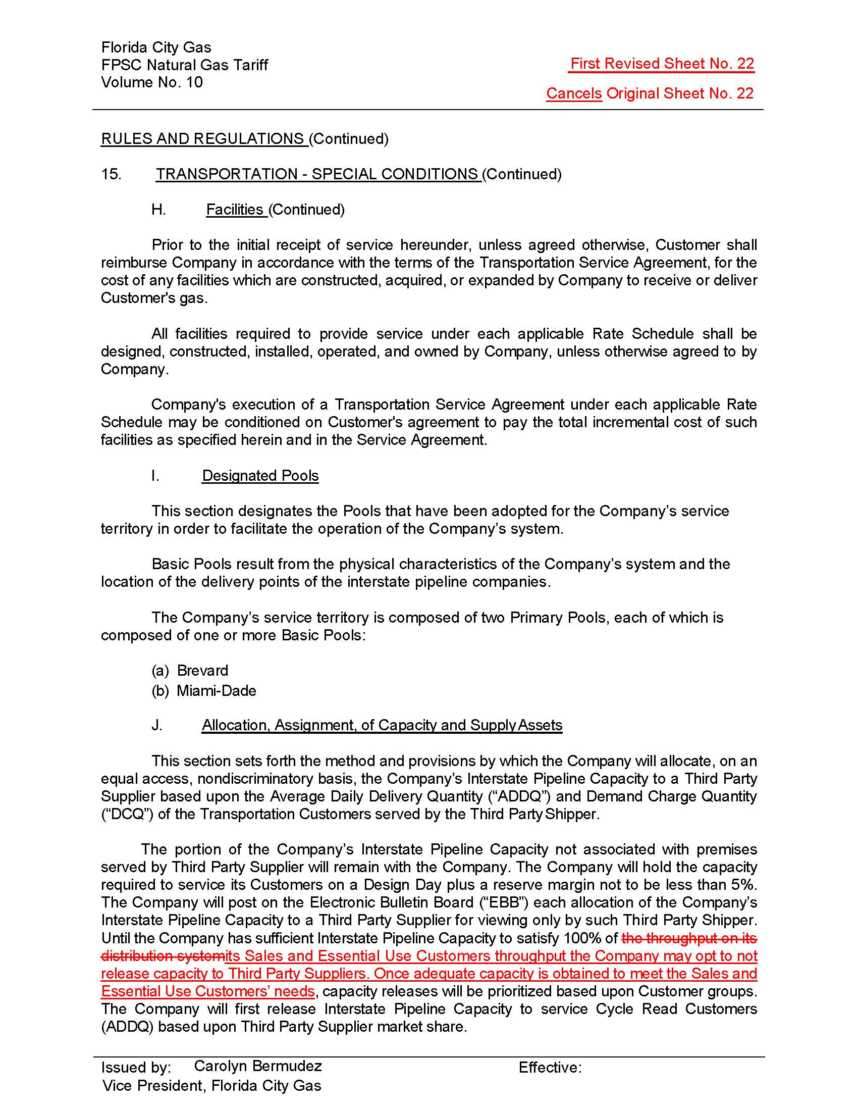

Order No. PSC-2018-0190-FOF-GU, issued April 20, 2018, in Docket No. 20170179-GU, In re: Petition for rate increase by Florida City Gas.

