State of Florida |  | Public Service Commission  Capital Circle Office Center ● 2540 Shumard Oak Boulevard  Tallahassee, Florida 32399-0850  -M-E-M-O-R-A-N-D-U-M-
DATE: | February 21, 2020
TO: | Office of Commission Clerk (Teitzman)
FROM: | Division of Engineering (Wright, Doehling, Ellis, King)  Division of Accounting and Finance (Mouring, Fletcher)  Division of Economics (Galloway, Wu)  Office of the General Counsel (Trierweiler, Simmons)
RE: | Docket No. 20190061-EI – Petition for approval of FPL SolarTogether program and tariff, by Florida Power & Light Company.
AGENDA: | 03/03/20 – Regular Agenda - Post-Hearing Decision - Participation Limited to Commissioners and Staff
COMMISSIONERS ASSIGNED: |  |  | All Commissioners
PREHEARING OFFICER: |  |  | Clark
CRITICAL DATES: |  |  | None
SPECIAL INSTRUCTIONS: |  |  | Staff recommends addressing the Issues in the following order: Issues 2, 3, 1, 4 and 6.

Case Background
On March 13, 2019, Florida Power & Light Company (FPL or Utility) filed a petition (Petition) for a new voluntary community solar program (SolarTogether Program or Program) and associated tariff. The proposed SolarTogether Program is designed to allow FPL customers to subscribe to a portion of new solar capacity built through the Program (subscription charge) and to receive a credit of a portion of the system savings produced by that solar capacity (subscription credit). Phase 1 of the Program consists of five FPL SolarTogether projects that comprise a total of 20 solar photovoltaic (PV) power plants. Each power plant is rated at 74.5 megawatts (MW) for a total of 1,490 MW that would provide electricity to all of FPL’s customers.

The Office of Public Counsel (OPC), Walmart, Inc. (Walmart), the Southern Alliance for Clean Energy (SACE), Vote Solar, and the Florida Industrial Power Users Group (FIPUG) were granted intervention in this docket. In June of 2019, Vote Solar and OPC both filed motions requesting the SolarTogether Program and tariff be set for an administrative hearing. FPL objected to both motions. After considering the arguments made by the parties, the matter was set for an administrative hearing.
FPL filed its direct testimony on July 29, 2019. Staff, SACE, Walmart, Vote Solar, and OPC filed direct testimony on September 3, 2019. FPL filed its rebuttal testimony on September 23, 2019, which included a revised tariff. On September 27, 2019, OPC filed a motion for continuance of the hearing, or in the alternative, a motion to strike portions of FPL’s rebuttal testimony, arguing that there was insufficient time and opportunity to address the tariff revisions filed with FPL’s rebuttal. FPL filed a response in opposition to OPC’s motion. In response to OPC’s motion, new controlling dates and discovery response times were established.
On October 9, 2019, FPL, SACE, Vote Solar, and Walmart (Joint Movants) filed a Joint Motion to Approve Settlement (Joint Motion), with the Joint Movants’ Stipulation and Settlement (Settlement Agreement) attached. A newly revised tariff (proposed tariff or rate Schedule STR; Attachment 1 to this recommendation) was included as Attachment I to the Settlement Agreement. OPC filed a response in opposition to the Joint Motion on October 16, 2019. In response to the new filings, the parties were allowed additional discovery and an opportunity to file additional testimony with respect to the proposed Settlement Agreement. Subsequently, both staff and OPC filed supplemental testimony on November 15, 2019, with FPL filing supplemental rebuttal testimony on November 27, 2019. On December 5, 2019, FPL filed a Notice of Superseding Proposed Tariff, stating that Attachment I of the Settlement Agreement supersedes the prior proposed tariffs in this docket.
On January 2, 2020, Duke Energy Florida, LLC (DEF) filed a motion for leave to file amicus curiae comments, with comments attached, in support of FPL’s Petition. DEF stated that the SolarTogether Program would allow customers the opportunity to support universal solar expansion which is already cost effective for all customers. DEF also stated that a voluntary option like the SolarTogether Program provides all customers with the benefits of utility-owned universal solar. DEF noted that while the Program may result in a policy shift, approving the Program would continue the Commission’s strong tradition of supporting public interest programs that utilize creative regulatory outcomes in a consistent, measured manner. OPC filed a response in opposition to DEF’s motion on January 9, 2020. The Prehearing Conference was held on January 10, 2020. By Order No. PSC-2020-0017-PHO-EI (Prehearing Order), DEF’s motion was granted.
The administrative hearing was held on January 14-15, 2020. All parties, except FIPUG, filed briefs on January 30, 2020. Because FIPUG did not file a brief, it has waived all issues pursuant to the Prehearing Order (page 20). The Florida Public Service Commission (Commission) has jurisdiction over this matter pursuant to Sections 366.03, 366.05, and 366.06, Florida Statutes (F.S.).

Settlement Agreement and Standard of Review
As mentioned previously, there is an outstanding non-unanimous Joint Motion filed by FPL, SACE, Vote Solar, and Walmart. The Joint Motion proposes that the SolarTogether Program should be approved as described in FPL’s Petition, as modified by FPL’s rebuttal testimony and exhibits, along with Paragraphs 4 and 5 within the Settlement Agreement. Paragraph 4 states that 37.5 MW, or 10% of the residential capacity for Phase 1, will be allocated to low-income customers. The subscription charge will not exceed the subscription credit in any month for these customers. These provisions for the low-income participants will begin with Project 3 with expected billing to start in February 2021. Paragraph 5 states the pricing for the subscription charge and the rate for the subscription credit for both standard and low-income customers is set forth in rate Schedule STR, Attachment 1 to this recommendation. Pursuant to paragraph 3(f) of the Settlement Agreement, participants may elect to have FPL retire on their behalf all renewable energy certificates (RECs) associated with their subscription; FPL will not utilize RECs generated by the Program.
Whether or not a settlement is under consideration, the Commission is still bound by Sections 366.01 and 366.06, F.S., which require that the Commission fix rates that are fair, just, and reasonable and determine whether the resolution of the case is in the public interest. Moreover, the Commission’s decision must be supported by competent, substantial record evidence. Sierra Club v. Brown, 243 So. 3d 903, 909-910 (Fla. 2018), citing Citizens of State v. Florida Public Service Comm'n, 146 So. 3d 1143, 1153-54, 1164, 1173 (Fla. 2014).
When considering a settlement agreement, the Commission may look at the totality of the settlement agreement to determine whether the agreement, taken as a whole, resolves all the issues; establishes rates that are fair, just, and reasonable; and is in the public interest. Florida Industrial Power Users Group v. Brown, 273 So. 3d 926, 929-930 (Fla. 2019), quoting Citizens 146 So. 3d at 1164 (Court upheld Commission’s approval of a non-unanimous settlement agreement, finding that the settlement agreement established rates that were just, reasonable, and fair, and that the agreement was in the public interest and supported by competent, substantial evidence). The Florida Supreme Court has also noted that the prudence of large capital investments is a relevant consideration in the Commission’s review of a settlement under its public interest standard, because imprudent investment of millions of dollars would likely clash with a public interest finding. Brown, 273 So. 3d at 930, quoting Sierra Club v. Brown, 243 So. 3d 903, 912 (Fla. 2018). While the Commission may consider the prudence of large capital investments under a settlement agreement, there is no affirmative requirement that the Commission must make independent specific prudence findings in a final order approving a settlement. Sierra Club, 243 So. 3d at 912. The Florida Supreme Court has also noted that although the Commission is not required by statute or case law to address each issue of disputed fact in a final order approving a settlement, it nevertheless has the discretion to do so. Citizens, 146 So. 3d at 1153. Thus, while the Commission has the authority to consider a non-unanimous settlement, it is not required to do so. The Commission may consider the issues argued in this docket.
Rather than initially taking up the Joint Motion at the outset, staff recommends that the Commission address the substantive issues as discussed below. Addressing the substantive issues in this case will effectively resolve the Joint Motion. At the conclusion of addressing all issues, the Commission may either render the Joint Motion moot or take up and rule on the Joint Motion as a fallout matter. Staff recommends this approach for the following reasons:
- The Settlement Agreement in this case, which incorporates the proposed tariff, merely represents an agreement by some of the parties to the proposed Program. Neither the Settlement Agreement nor the record developed in this case deal with issues outside of the proposed Program and tariff. There are no issues contained within staff’s recommendation that are not contained within the proposed Program and tariff. In other words, the issues and analysis reflected in staff’s recommendation essentially match up with and reflect the sum and substance of the Settlement Agreement and proposed tariff, as litigated.
- The issues addressed at the hearing, and presented in staff’s recommendation herein, were agreed upon by the parties at the Prehearing Conference, which occurred after the filing of the Settlement Agreement. Testimony and evidence were taken on these issues at the hearing. In essence, the litigation of this case was based upon the issues agreed upon by the parties, which were founded on the terms of the Settlement Agreement and the proposed tariff.
- Because the record in this case has been fully developed and litigated and the issues track the Settlement Agreement and proposed tariff as filed, taking up the issues in the staff recommendation will provide the Commission with a better framework to ensure that its decision is supported by substantial, competent evidence in the record and ultimately rendered in the public interest.
In addressing the substantive issues, staff recommends that the Commission take the issues up in the following order: Issues 2, 3, 1, 4, and 6.

Executive Summary
Florida has a regulatory framework established through statute that grants utilities specific rights and responsibilities, including the obligation to serve all customers within their service territory. The Commission regulates utilities to ensure that customers receive adequate, safe electric service at rates that are fair, just, and reasonable. The Commission has jurisdiction over the planning, development, and maintenance of a coordinated electric power grid throughout Florida. Generating electric utilities are required to annually submit to the Commission a ten-year site plan (TYSP), which estimates the future electric load requirements of customers, identifies the mix of resources to be used to serve customers, and the general location of proposed power plant sites. Underlying this process is the principle of “least-cost planning.” This principle is founded upon engineering and economic analyses whereby the least-cost option is selected in order to meet projected customer electric loads.
From the outset of this proceeding, staff’s focus has been to understand the purpose and impact of FPL’s voluntary tariff, its fundamental impact on current regulatory policies and procedures, and its impact on the development of solar generation, even as solar generation is projected to be a cost-effective alternative for all customers. In other words, staff sought to identify the incremental benefits of the SolarTogether Program and proposed tariff to the general body of ratepayers applying current statutes, rules, regulatory policies, and practices. The Commission should consider the following three policy questions when making its final determination of whether the SolarTogether Program and proposed tariff are in the public interest:
If generating facilities are built to meet the desires of certain customers, should all the benefits and costs of such facilities be allocated to those customers?
If solar generation is a cost-effective alternative for all customers, is it appropriate to allocate a majority of benefits to a small group of customers?
Does the proposed allocation of costs and benefits result in undue discrimination or an undue preference?
In the past, voluntary tariffs have been offered when the service desired (i.e., renewable energy) was not cost competitive with traditional generation. Such offerings provided a response to customer demands for a certain type of product. Voluntary contributions were designed to recover the full incremental costs of the desired service from those customers demanding the product, while most importantly, holding the general body of ratepayers harmless.
Here the proposed tariff would authorize FPL to accelerate the construction of solar facilities and to add future solar facilities based upon the Utility’s marketing efforts and the desires of a select group of customers rather than adding generating units to satisfy projected reliability or economic needs for all customers. As such, FPL’s proposed Program and associated rate Schedule STR would disregard the principles of least-cost planning and the resulting costs allocated to all customers.
Section 366.03, F.S., states in part that “[e]ach public utility shall furnish to each person applying therefore reasonably sufficient, adequate, and efficient service upon terms as required by the commission.” The Statute also states that “[n]o public utility shall make or give any undue or unreasonable preference or advantage to any person or locality, or subject the same to any undue or unreasonable prejudice or disadvantage in any respect.” Granting a preference to one group of customers or subjecting one group to disadvantage does not, per se, violate the statutory prohibition, but that preference or disadvantage must be based on relevant, significant facts explained in the Commission’s decision. Determining whether a proposed tariff grants undue preference to a certain group or subjects a group to undue prejudice is a fact-intensive inquiry.
Staff evaluated the Program and proposed tariff’s impact on the three affected entities: participants, the general body of ratepayers, and the Utility. The evidence in the record suggests that there are six areas where undue preference may exist. As discussed in Issue 2, these areas are: initial participant allocation, allocation of net benefits, low-income carve-out, costs not fully funded by participants, alternative to net metering, and subsequent participant allocation. Some examples of preference include:
- FPL allocating 75 percent (1,117.5 MW) of the Program’s capacity to the pre-registered commercial, industrial, and governmental accounts. Ten of these 206 pre-registered customers account for 50 percent of the total Program’s capacity. In contrast, FPL has not yet opened registration for the estimated 74,500 residential and small business classes of customers who are expected to subscribe.
- Only 1.5 percent of FPL’s 4.9 million customers could participate in this Program. Those participants would receive bill credits, which are essentially guaranteed, within eight years. On the other hand, 98.5 percent of FPL’s customers, the non-participants, may see benefits in the form of lower system costs, if at all, after 26 years.
- Non-participants’ bills increase immediately, whereas participants’ bills are gradually offset by a credit.
- Participating customers are not paying the full cost of the Program.

Therefore, the proposed Program and tariff appear to result in an undue preference to participants and subjects the general body of ratepayers to an undue disadvantage.

On the other hand, an incremental benefit of approving the Program appears to be the acceleration of approximately 600 MW of solar generation from 2022 to 2021. The record indicates that the acceleration of this solar generation would result in a relatively slight increase in cost; however, FPL did not provide a quantification of this cost. The acceleration of solar generation would also slightly improve FPL’s fuel diversity, reduce CO₂ emissions, and would promote the development of renewable energy consistent with the Legislative findings in Section 366.92, F.S.
If the Program is not approved, the evidence still suggests that FPL could add over 1,700 MW of future solar generation by 2022. As discussed in Issue 3, Projects 1, 2, and 3, which are approximately 900 MW, would satisfy FPL’s planning reserve margin criterion for the years 2020 - 2021 and are consistent with the Utility’s least-cost generation expansion plan, its 2019 TYSP. While FPL has demonstrated that Projects 1, 2, and 3 are cost-effective generation additions, the incremental cost of accelerating 600 MW (Projects 4 and 5), has not been quantified. As such, even if the proposed Program and tariff is not approved, it appears that constructing Projects 1, 2, and 3 would be a cost-effective addition to FPL’s system that would benefit all customers. FPL may seek cost recovery of these facilities at its next base rate proceeding under current regulatory policies and procedures.
Options to Program as Proposed
FPL argues that the proposed Program and associated tariff would be the next step forward in promoting Florida’s energy policy contained in Section 366.92, F.S., which is to promote the development of renewable energy; protect the economic viability of Florida’s existing renewable energy facilities; diversify the types of fuel used to generate electricity in Florida; encourage the development of renewable generation; improve fuel diversity; lessen Florida’s dependence on natural gas and fuel oil for the production of electricity; minimize the volatility of fuel costs; encourage investment within the state; improve environmental conditions; and, at the same time, minimize the costs of power supply to electric utilities and their customers. Staff explored various options that would achieve these same benefits for all customers but did not require the proposed tariff to be implemented. Such options would be consistent with the intent of Section 366.92, F.S., and also avoid any semblance of an undue preference. These options included classifying the solar facilities as a regulatory asset or creating a recovery mechanism similar to ones approved in recent Solar Base Rate Adjustments (SoBRAs) settlement agreements. While FPL agreed that such options could encourage the development of solar generation, it did not support such action as it would not be responsive to the primary purpose of the Program, which is to address “the needs of customers who cannot or do not want to own a net metering system, but are seeking a direct bill credit.”
Staff also considered the option of approving the tariff as filed, but recovering the participant credits as a base rate expense item rather than immediate recovery through FPL’s fuel clause. The estimated annual credits for 2020 are $31.7 million and $105.1 million for 2021. While FPL would bear the risk of these costs until its next rate case, such treatment would provide participants the same benefits as proposed by FPL, eliminate an immediate bill increase to the general body of ratepayers, and more closely reflect the current risks to the general body of ratepayers and FPL associated with traditional net metering. FPL did not support this option but admitted that participating customers would be unaffected.

Discussion of Issues

Issue 1:
Is FPL’s proposed SolarTogether Rider tariff an appropriate mechanism to seek approval for the construction of 1,490 MW of new solar generation facilities?

Recommendation:
No. FPL has not demonstrated the public benefit to be gained by changing current regulatory policies and procedures regarding the addition of generation assets. As such, approval of generation assets should not be linked to a tariff proposal as requested by FPL. (Ballinger, Simmons, Trierweiler)
Position of the Parties:
FPL: Yes. Customers are actively seeking a program like SolarTogether in order to meet sustainability and financial goals. No existing programs or tariffs fill this customer need. Moreover, approving the facilities without an associated tariff would not meet the customer need.

OPC: No.

FIPUG: FIPUG did not file a brief.

SACE: Yes. The Settlement Agreement filed in this docket on October 9, 2019 between FPL, SACE, Vote Solar, and Walmart fully resolves all matters between the referenced parties and provides numerous benefits to both participants and the general body of customers, and is therefore in the public interest. See Issue 4

VOTE
SOLAR: No position.

WALMART: Yes.

Parties’ Arguments
FPL
FPL argues that its SolarTogether proposed tariff is the appropriate mechanism to allow customers to participate voluntarily and more directly in the development of solar energy in Florida. (FPL BR 6, 22, 37) The SolarTogether tariff expands access to solar to all customers regardless of size, location, or income levels. (FPL BR 2) FPL contends that customers are actively seeking a program like SolarTogether in order to meet sustainability goals while also sharing in the financial benefits of solar. (FPL BR 5, 9) Moreover, FPL asserts that regulation should be responsive to the needs of customers and the Commission should be open to new and innovative solutions that respond to customer needs and captures benefits for all customers. FPL explains that this is particularly true and relevant for customers wanting to ensure more of their electricity needs are met by solar generation. (FPL BR 18) FPL states that no existing programs or tariffs fill this customer need; however, approving the facilities without an associated tariff would not meet the customer need. (FPL BR 37)
Regarding prudence, FPL asserts that OPC’s claim that SolarTogether violates the requirement under Section 366.06(1), F.S., that only prudent capital projects may be factored into rates and charges miscomprehends the law and the facts. (FPL BR 26) FPL contends that with respect to the law, the Florida Supreme Court has confirmed that “when presented with a settlement agreement, the Commission’s review shifts to the public interest standard.” And, that the public interest standard considers “whether the agreement—as a whole—resolved all the issues, established rates that were just, reasonable, and fair, and is in the public interest.” Citing Florida Indus. Power Users Group v. Brown, 273 So. 3d 926, 929-30 (Fla. 2019). FPL further explains that the Court found the public interest standard itself incorporates prudence considerations. OPC’s prudence challenge presumably rests on its allegation that FPL has not demonstrated a resource need. (FPL BR 26)

Last, FPL contends that for the past decade, the Commission’s constructive regulation has advanced Florida’s renewable energy policy, which states:

It is the intent of the Legislature to promote the development of renewable energy; protect the economic viability of Florida’s existing renewable energy facilities; diversify the types of fuel used to generate electricity in Florida; lessen Florida’s dependence on natural gas and fuel oil for the production of electricity; minimize the volatility of fuel costs; encourage investment within the state; improve environmental conditions; and, at the same time, minimize the costs of power supply to electric utilities and their customers. Section 366.92, F.S.
FPL asserts that SolarTogether is the next important step forward in promoting this policy. (FPL BR 21)
OPC
OPC argues that the SolarTogether proposed tariff is not the appropriate mechanism for approval of 1,490 MW of generation facilities. When the facilities are considered as a 1,490 MW whole, as FPL requests, the subject generation facilities are subject to the Power Plant Siting Act (PPSA). Therefore, the addition of 1,490 MW in generation facilities in this docket should be subjected to a need determination proceeding pursuant to the PPSA. (OPC BR 2-3)
OPC contends that FPL is proposing to change the definition of “need” in every applicable regulatory context, including the long history and usage of the term in Commission precedent. They argue the concept of need is a well-recognized term of art in the resource planning context. (OPC BR 3) OPC asserts that FPL further urges the Commission to adopt a broader, unprecedented conception of need based on not merely customer preference, but also on unquantified social and alleged economic need – “opportunities to make a difference,” allegedly lower emissions, and temporary jobs associated with construction of the solar plants. (OPC BR 3-4)
Next, OPC argues that FPL admitted SolarTogether is not a least-cost plan, and that it had not provided the Commission with an economic analysis of what it alleged was simply an acceleration of its TYSP. Still, FPL seeks a finding of prudence for $1.8 billion in generation assets without a need determination for either the 1,490 MW whole or any individual 74.5 MW block, on the basis that its customers want these particular solar assets. Moreover, FPL presented SolarTogether as an all or nothing choice to the Commission, in that the Utility repeatedly stated it does not want the facilities approved if the Program is not also approved in the exact form FPL demands. (OPC BR 5)

Last, OPC argues that whether evaluated under the PPSA or other relevant statutes related to the regulation of electric generation, an interpretation of regulatory governance which rests on approving a project based upon certain customers’ desires rather than on empirical measures directly related to ensuring the grid provides adequate electricity to the public at the lowest reasonable cost will set a precedent which calls the entire electric regulatory structure and the regulatory compact into question. (OPC BR 5-6) Taken to its logical end, contends OPC, where a customer preference for a certain type of generation determines policy-making, there is no particular need for a Public Service Commission – the job could be done by simple polling. OPC asserts that the Commission is a creature of statute, and thus lacks the authority to establish a new policy untethered to a statute or legislative grant of authority to broaden the grounds on which massive generation resources are approved. (OPC BR 6)

SACE
SACE did not specifically address whether the proposed tariff is an appropriate mechanism to seek approval of new solar generation facilities but rather argues that the Commission should approve the Settlement Agreement filed on October 9, 2019. (SACE BR 3) SACE argues that the Commission is afforded great deference to determine that a settlement agreement between parties is in the public interest and that it has been presented with substantial, competent evidence during the hearing upon which to make a public interest determination. (SACE BR 4) SACE contends that, taken as a whole, the proposed tariff and Program provisions embodied in the Settlement Agreement provide a number of benefits that are clearly in the public interest that include: expansion of renewable energy through the development of 1,490 MW of clean, renewable power; diversification of the state’s fuel mix; a cost-effective program; allocation of economic benefit to both participants and the general body of ratepayers; prioritizing the customer experience, including expanding participation to low-income families; meeting FPL’s resource needs in 2020 and 2021; meeting the enormous customer demand for solar power; and driving state economic development and local job creation. (SACE BR 4-5)

Vote Solar
Vote Solar did not take a position on this issue.
Walmart
Walmart did not provide issue-specific arguments in its brief but stated, “Walmart believes that the proposed Settlement Agreement, including the SolarTogether Settlement Tariff, is a reasonable compromise of the Settling Parties’ different positions in this case and is otherwise in the public interest.” (Walmart BR 2)
Analysis
Summary of Proposed SolarTogether Program and Associated Tariff
In its brief, FPL asserts that while many aspects of the SolarTogether Program were explored during the hearing, the driving forces behind its Petition are not debatable: “FPL is listening intently to its customers and is developing innovative solutions to satisfy their needs in a manner that benefits all.” (FPL BR 1) The proposed Program was developed to give customers the opportunity to “directly support the expansion of solar power without the need to install solar on their rooftop.” (Petition 2) FPL initially conducted outreach and marketing efforts, which included providing terms and expected pricing, to its largest energy and demand customers in order to gauge interest in such a program. (TR 62-64; Petition 2) When further describing customer desires regarding solar generation, FPL witness Valle stated “[a]lthough their reasons for being interested in community solar varied, a top driver was electric bill savings.” (TR 53) In addition to requesting approval of the Program and associated tariff, FPL is also seeking an advanced prudency determination for the costs associated with 1,490 MW of solar generation to be installed between 2020 and 2021 that would provide electricity to all of FPL’s customers. (TR 113-114; EXH 38, BSP 193)
From November 29, 2018, through January 25, 2019, FPL opened a pre-registration period for its commercial, industrial, and governmental accounts. (TR 62; EXH 39, BSP 236) During this period, 206 customers pre-registered for approximately 1,100 MW of solar capacity. (TR 130) Based on the high level of customer interest, FPL sized Phase 1 of the Program to include the construction of 20 solar PV power plants, each rated at 74.5 MW for a total of 1,490 MW. (TR 50-51, 59-60) The first six sites (447 MW) are projected to be eligible for inclusion in the Program by March 1, 2020. The next six sites (447 MW) are projected to be eligible for inclusion by February 1, 2021, and the final eight sites (596 MW) of Phase 1 are projected to be eligible for inclusion by May 1, 2021. (TR 60, 197, 221)
According to witness Valle, FPL would initially allocate 75 percent (1,117.5 MW) to the pre-registered commercial, industrial, and governmental accounts. The remaining 25 percent of the Phase 1 capacity (372.5 MW) would be allocated to residential and small business customers who would enroll through a web-based system. (TR 57-59) FPL would periodically reevaluate these allocations and adjust according to demand without Commission approval. (TR 57) Once subscription limits are met, customers would be waitlisted until an opportunity to enroll presented itself. FPL would monitor enrollment levels to determine if/when additional SolarTogether phases would be warranted. (TR 60) Witness Valle suggests that FPL is not considering a second phase at this time until customer demand has been determined. (TR 115-116)
FPL claims that the SolarTogether facilities eliminate the need to construct 300 MW of battery storage and one combustion turbine in the 2020-2023 time period. (TR 238) As such, FPL estimates that the Phase 1 SolarTogether facilities would save all customers an estimated $249 million in cumulative present value of revenue requirements (CPVRR) over the life of the units (30 years). (TR 75, 78, 87) The proposed tariff is designed to share these benefits between participants and the general body of ratepayers. (TR 76)
Participation in the Program is voluntary, would not be tied to a long-term commitment, and is portable within FPL’s service territory. (TR 61) Pursuant to the proposed tariff, participating customers would be charged a fixed subscription charge of $6.76 per kilowatt (kW) per month based on their subscription level, up to 100 percent of their previous annual usage. Participating customers would also receive a cents/kWh credit based on the actual production of the SolarTogether facilities. (Attachment 1) The credit escalates at a fixed rate of 1.7 percent annually for a period of 30 years. (TR 78) The combination of the charge and credit was designed to produce a simple payback of seven years to participating customers. (TR 310-311, 323, 340) This simple payback calculation ignores the time value of money, and using a CPVRR analysis yields an eight year payback period. (TR 502-503; EXH 64) The revenues from the subscription charge would be included as base revenues in FPL’s monthly earning surveillance reports. (TR 326) The credits would be recovered through FPL’s fuel clause. (TR 148, 328) The administrative costs for the Program, approximately $11.5 million, would be reflected as base rate recoverable costs. (TR 324; EXH 44, BSP 294) FPL will not increase base rates during the term of its existing base rate settlement but will include the SolarTogether costs and expenses in its monthly earnings surveillance report. (EXH 38, BSP 146)
In addition to the SolarTogether subscription charges and credits, participating customers can elect to have FPL retire, on their behalf, any renewable energy certificates (RECs) associated with their SolarTogether subscription. (TR 61; EXH 28) According to the Petition, RECs are defined by the U.S. Environmental Protection Agency as “a market based instrument that represents the property rights to the environmental, social, and other non-power attributes of renewable electricity.” (Petition 7)
Summary of Current Planning and Regulatory Framework
Commission witness Hinton discussed the principles of Florida’s regulatory framework and the Commission’s role. He stated:
Florida has a regulatory framework established through statute that grants utilities specific rights and responsibilities, and that establishes particular roles and responsibilities for the Commission as the economic regulatory agency….
Along with those rights, utilities have the obligation to serve all customers within their service territory, and that service must be adequate, safe, and reliable. Utilities are not permitted to build unnecessary facilities or incur costs for unnecessary services. In addition, utilities may not unduly discriminate or show preference in providing service or charging rates.
The Commission’s role is to ensure that customers receive adequate, safe electric service at rates that are fair, just, and reasonable. Those rates may only recover the cost of plant that is actually used and useful in the public service. The Commission also oversees the reliability and sufficiency of the bulk power grid and ensures that any additions to the grid are necessary and cost-effective. (TR 639-640)
Witness Hinton also stated that the proposed SolarTogether Program was a departure from traditional least-cost planning. (TR 644) The witness summarized least-cost planning as follows:
Utilities annually assess forecasts of customer load and reserve margins for a ten-year period and perform a system reliability analysis. An evaluation of existing generating resources is conducted by the utility in order to identify potential opportunities to improve generation efficiency. If a need for additional capacity is identified in a given year, the utility will develop alternative resource plans, evaluating combinations of demand-side and supply-side resources, to determine the most feasible, cost-effective approach to meet that need. The important principle underlying this process is the idea of “least cost planning.”
(TR 640)
No other witness offered an alternative view of the current regulatory framework.
Policy Implications of Proposed Program
Chapters 366 and 186.801, F.S., and the Commission’s rules implementing these Statutes, provide a solid framework for flexible utility resource planning that results in cost-effective resource additions for the benefit of all customers. The Commission fulfills its oversight and regulatory responsibilities while leaving day-to-day planning and operations to utility management. While any generation addition adds fixed costs to a utility’s rate base, the resulting addition also impacts the system’s fuel and operation and maintenance (O&M) costs. (TR 227) Under traditional least-cost planning methods, the selection of which type of generating unit to add to the system is driven by CPVRR analyses. Such analyses contain a base case and several sensitivities to determine the relative risk of the proposed addition to changes in fuel prices, loads, emissions costs, capital costs, etc. (TR 239, 506)
Evidence in the record shows that FPL’s 2019 TYSP, which includes over 1,700 MW of future solar generation by 2022, is the least-cost plan resulting in the lowest levelized system average electric rate. (EXH 39, BSP 255; EXH 45, BSP 312) However, FPL’s proposed Program and associated rate Schedule STR disregard the principles of least-cost planning regarding resource additions and resulting cost allocation. (EXH 39, BSP 253; EXH 47, BSP 344; EXH 51, BSP 371) OPC argues that FPL admitted SolarTogether is not a least-cost plan, and that it had not provided the Commission with an economic analysis of what it alleged was simply an acceleration of its TYSP. (OPC BR 5)
Instead of adding generating units to satisfy projected reliability or economic needs for all customers, approval of the proposed tariff would authorize FPL to accelerate the construction of solar facilities and to add future solar facilities based upon the Utility’s marketing efforts and the desires of a select group of customers. OPC contends that whether the generation to be added is evaluated under the PPSA or other relevant statutes related to the regulation of electric generation, an interpretation of regulatory governance which rests on approving a project based upon certain customers’ desires, rather than on empirical measures directly related to ensuring the grid provides adequate electricity to the public at the lowest reasonable cost, will set a precedent which calls the entire electric regulatory structure and the regulatory compact into question. (OPC BR 6)

Staff notes that if the proposed Program and tariff are approved, FPL is projecting its reserve margin to be above 27 percent by 2025. (EXH 39, Amended Interrogatory No. 190, Attachment 2) Even if the SolarTogether facilities are cost-effective to the general body of ratepayers, as FPL has claimed in its Petition and testimony, staff questions the public benefit to be gained by approving a voluntary tariff that fundamentally changes current regulatory policies and procedures. (Petition 4; TR 46) In the past, voluntary tariffs have been offered when the service desired (i.e., renewable energy) was not cost competitive with traditional generation. Such offerings provided a response to certain customer demands for a certain type of product. Voluntary contributions were designed to recover the full incremental costs of the desired service while, most importantly, holding the general body of ratepayers harmless. As discussed in Issue 2, staff recommends that the proposed Program and rate Schedule STR result in an undue preference to participants and subjects the general body of ratepayers to an undue disadvantage.
Conclusion

FPL has not demonstrated the public benefit to be gained by changing current regulatory policies and procedures regarding the addition of generation assets. As such, approval of generation assets should not be linked to a tariff proposal as requested by FPL.

Issue 2:
Does FPL’s proposed SolarTogether Rider tariff give any undue or unreasonable preference or advantage to any person or locality or subject the same to any undue or unreasonable prejudice or disadvantage in any respect, contrary to Section 366.03, Florida Statutes?

Recommendation:
Yes. The SolarTogether Rider tariff grants an undue preference to participants and subjects the general body of ratepayers to an undue disadvantage. (Ballinger, Simmons, Trierweiler)
Position of the Parties:

FPL: No. Undue preferences are avoided by designing rates to recover costs allocated based on customer cost responsibility. The standard is that no customer be harmed by rates charged to other customers. Under SolarTogether, the general body of customers will pay none of that cost while receiving 45% of the savings.

OPC: Yes.

FIPUG: FIPUG did not file a brief.

SACE: No. The Settlement Agreement filed in this docket on October 9, 2019 between FPL, SACE, Vote Solar, and Walmart fully resolves all matters between the referenced parties and provides numerous benefits to both participants and the general body of customers, and is therefore in the public interest. See Issue 4

VOTE
SOLAR: No. As amended, the SolarTogether tariff strikes a fair and reasonable balance in the allocation of the Program’s costs and benefits between the general body of customers, non-subscribing customers, and subscribing customers (those who are low-income and non-low-income), in consideration of the unique contributions, needs and interests of each.

WALMART: No.

Parties’ Arguments
FPL
FPL argues that undue preferences or subsidizations are avoided by designing rates to recover costs allocated to customers based on their cost responsibility. (FPL BR 19, 38) FPL contends the standard is that no customer or group of customers be harmed by the rates charged to or offerings made to other customers. (FPL BR 19, 38) Moreover, FPL states that, not only is there no harm, there are substantial benefits for all customers. (FPL BR 38) Specifically, FPL argues the Program is structured so that the participants are paying slightly more than 100 percent of the net fixed costs while receiving just over half of the benefits. (FPL BR 7) Conversely, the general body of ratepayers will not pay for any of the fixed cost of the solar centers, but is projected to receive almost half (45 percent) of the benefits. (FPL BR 7-8, 38) FPL further argues that unlike other community solar programs in the country, SolarTogether shares the program benefits with the general body of ratepayers. (FPL BR 9)

FPL states that the rate impact on the general body of ratepayers resulting from SolarTogether in the near-term is modest, short-lived and compares favorably against placing the 20 solar facilities in service without the SolarTogether Tariff. (FPL BR 34) It notes that the base portion of the bill would not change for the general body of ratepayers through at least 2021 and in the years 2020 and 2021, the fuel portion of the bill is projected to increase roughly 13 cents and 47 cents, respectively. (FPL BR 20-21) FPL disagrees with OPC’s claim that the Program is discriminatory, involuntary and subsidized. FPL explains that the SolarTogether Program is projected to be cost-effective at a reasonable cost and provide net benefits in the form of cost savings for the general body of ratepayers, including participants and non-participants, i.e., all FPL customers. (FPL BR 30)

FPL asserts that customers wishing to receive more solar generation by participating in the SolarTogether Program are not “cost causers” as that term is traditionally used. Rather, the participants are better described as “benefit facilitators” who will share an estimated $112 million with the general body of ratepayers, roughly half of which is in the form of base rate savings not subject to the volatility associated with fuel and emissions prices. (FPL BR 31-32) As such, FPL explains that the general body of ratepayers is not harmed, which is generally understood to be required before there is a finding of undue discrimination or preference. (FPL BR 32) Last, FPL clarifies that the cost of the low-income component will be borne solely by the non-low-income participants. (FPL BR 38)

OPC
OPC argues that one group of customers (non-participants) are subjected to unreasonably different levels of costs, risks, projected savings amounts, and projected savings timeframes. It asserts that FPL glosses over the fact that non-participants are treated in distinctly different, prejudicial ways by relying on generalities which focus heavily on projections based toward the end of the 30 year life of the Program, while impacts during the early years are more certain than the benefit projections (or guesses) made for later years, i.e., the 26 year range. (OPC BR 7)

OPC contends that from day one, participants are guaranteed to receive a set of bill credits and bill surcharges that are pre-scheduled in amount for the 30 year life of the Program with bill credits exceeding the pre-scheduled bill surcharges, such that participants would receive a net benefit or “payback” within eight years. (OPC BR 7) Non-participants would see an immediate bill increase as a direct result of participants’ bill credits being recovered from non-participants through the fuel clause. Moreover, argues OPC, non-participants are only projected to see some sort of payback or net savings 26 years after SolarTogether goes into service, if ever. Therefore, non-participants might get a net benefit sometime at the end of the 30 year life of the project, or they might actually receive a net loss. Participants are essentially guaranteed their payback. (OPC BR 7-9) In essence, FPL is asking non-participants to commit to carrying the costs of a $1.8 billion project for the next 30 years in the hopes of “possibly” receiving a net benefit of $112 million some 26 years in the future. OPC asserts the question to ask is whether a reasonable person would make that investment. (OPC BR 8)

OPC explains that Florida law requires that rates and charges demanded by public utilities must be “fair.” The law further prohibits public utilities from giving “any undue or unreasonable preference or advantage to any person or locality,” or subjecting them to “any undue or unreasonable prejudice or disadvantage in any respect.” OPC contends that due to the disparate and speculative charges and terms, to which non-participant customers would be subjected, the SolarTogether Program fails to comply with the law which prohibits unreasonable preferences or disadvantages for any customer as compared to another. (OPC BR 8)

OPC next explains that the general body includes both participants and non-participants, so discussing the two groups together only masks the unlawful preference, prevents meaningful comparison of the two groups, and fails to address the critical point: that the level of risk is vastly dissimilar for each group. Participants are not the ones who bear the bulk of the risk, and in fact, they bear essentially no risk, while non-participants bear the bulk of the risk. (OPC BR 9-10) OPC argues that FPL’s claims that participants pay more than 100 percent of the Program’s construction costs, or that non-participants pay none of the costs, are misleading. OPC argues that FPL is seeking recovery of the entire cost of the Program, which is forecasted to be $1.8 billion. In contrast, OPC notes that participants will only contribute $1.3 billion, a $0.5 billion shortfall that would have to be made up for by the general body of ratepayers, 97 percent of whom would be non-participants. (OPC BR 10-11) OPC argues that even FPL concedes that non-participants would pay for the Program, but that the Utility downplays the amount by describing it as “minor.” (OPC BR 10) OPC asserts that should actual costs of the Program be higher, or avoided benefits be lower, the general body of ratepayers would be required to make up the difference. (OPC BR 11) OPC argues that if FPL truly believed in its Program and projections that it would collect all costs from its participants, and not seek rate base recovery as it does in its petition, which shifts all risks to the general body of ratepayers who are ultimately responsible for the costs of the Program. (OPC BR 11)

OPC asserts the “cost causers” or “cost allocation” principle has been recognized by the Commission, the Florida Legislature, and the Florida Supreme Court. These principles ensure that entities or customers that demand and benefit from extraordinary costs will bear those costs. The SolarTogether Program does not contain elements that would justify deviation from this precedent. (OPC BR 11)

OPC next states that another element of disparate treatment built into the SolarTogether Program is that participants’ bills would contain line items to show the charges and corresponding bill credits they receive pursuant to the Program. However, OPC notes the record does not indicate non-participants would have the same level of transparency, in terms of a line item to show them how much they are involuntarily contributing to the Program by funding the net credits paid to participants. OPC contends the evidence indicates the proposed tariff does not require the customers’ bills to explicitly disclose or show the information to non-participants. Rather, the testimony is that the charges to non-participants will be hidden, without explanation, inside the fuel charge. (OPC BR 13)

Last, OPC contends that FPL reverse-engineered the Program structure to ensure that participating customers obtain a seven year simple payback; however, achieving the seven year simple payback for participants comes at the expense of non-participants. Therefore, argues OPC, FPL arbitrarily proposed rates by first deciding the terms of the Program (costs/credits/payback date) for one set of customers, then adjusting the numbers for non-participants to pay whatever is necessary to keep the participants’ terms at the pre-determined level. The Program was specifically crafted to unduly benefit one group of customers to the detriment of another, which violates the plain terms of Section 366.03, F.S. (OPC BR 13-14)

SACE
SACE did not specifically address the issue of undue preference in its brief but rather argues that the Commission should approve the Settlement Agreement filed on October 9, 2019, that resolves all issues between FPL, SACE, Vote Solar and Walmart. (SACE BR 2) SACE argues that the Commission is afforded great deference to determine that a settlement agreement between parties is in the public interest and that it has been presented with substantial, competent evidence during the hearing upon which to make a public interest determination. (SACE BR 4) SACE contends that the SolarTogether Program is cost-effective and fairly and reasonably allocates benefits to all customers. As such, SACE requests that the Commission approve the Settlement Agreement in its entirety and notes that the Commission is not precluded by statute or case law from approving nonunanimous settlements. (SACE BR 5)

Vote Solar
Vote Solar argues that the benefits flowing from the new solar resources being added to FPL’s electric grid under the SolarTogether Program will accrue to the general body of ratepayers. The SolarTogether Program and tariff, as amended, is designed to allocate 55 percent of the projected financial benefits specifically to subscribing customers, with the other 45 percent going to all customers. (Vote Solar BR 2-3) Subscribers will cover over 104.5 percent of the Program base revenue requirements through a levelized subscription rate. Vote Solar argues that the SolarTogether Program design is an improvement for the general body of customers over the typical community solar design that would isolate all of the financial benefits to subscribers. In exchange for this long-term benefit, Vote Solar contends the general body of ratepayers contributes to the subscription credit in the early years of the Program offering – with the average residential monthly electric bill expected to go up no more than 47 cents (peaking in 2021, and then decreasing after that). (Vote Solar BR 2-3)

Further, argues Vote Solar, there is a public interest need for additional clean energy capacity that lowers costs for customers suffering from high energy burdens. Low-income customers face significant barriers to accessing clean energy. The SolarTogether Program will begin to address those barriers by providing year-one savings for low-income customers, with a “hold harmless” provision to ensure that a participant’s bill will never go up in any month as a result of their enrollment. (Vote Solar BR 3-4)

Walmart
Walmart did not provide issue-specific arguments in its brief but stated, “Walmart believes that the proposed Settlement Agreement, including the SolarTogether Settlement Tariff, is a reasonable compromise of the Settling Parties’ different positions in this case and is otherwise in the public interest.” (Walmart BR 2)

Analysis

The Commission has a “long-standing regulatory philosophy . . . that tariffs are to be designed so that the end user is fairly charged for his service and that the general body of ratepayers does not unduly or unreasonably bear the costs of that service.” This philosophy implements Section 366.03, F.S., which provides that “[n]o public utility shall make or give any undue or unreasonable preference or advantage to any person or locality, or subject the same to any undue or unreasonable prejudice or disadvantage in any respect.” Some parties argue that the proposed tariff grants preferential rates to its participants, and some argue that the proposed tariff subjects the general body of ratepayers to disadvantageous rates. However, the main question is not whether the proposed tariff grants preference to some or disadvantages others, but whether that preference and/or disadvantage is “undue or unreasonable.” Several Commission orders and out-of-state court opinions provide guidance for interpreting “undue or unreasonable” in this context. The Commission has taken this language to mean that similarly situated customers must be treated similarly. The Court of Appeals for the D.C. Circuit has had occasion to interpret the similarly worded Federal Power Act, and its approach mirrors the Commission’s. The D.C. Circuit added that the reason for treating two entities differently must be “based on relevant, significant facts which are explained.” BP Energy Co. v. FERC, 828 F.3d 959, 967 (D.C. Cir. 2016) (quoting Complex Consol. Edison Co. of N.Y., Inc. v. FERC, 165 F.3d 992, 1012–13 (D.C. Cir. 1999)). Thus, the Commission must make a factual determination as to whether any preference granted by or disadvantage caused by a tariff is undue or unreasonable. See id.; Mtn. States Legal Found. v. Pub. Utils. Comm’n, 590 P.2d 495, 500 (Colo. 1979) (Carrigan, J., dissenting) (“Whether a particular classification of ratepayers is reasonable or not is essentially a fact question for the [Public Utilities Commission].”).

Section 366.03, F.S., also states “[a]ll rates and charges made, demanded, or received by any public utility for any service rendered, or to be rendered by it, and each rule and regulation of such public utility, shall be fair and reasonable.” The Florida Supreme Court made it clear that the Commission’s responsibility of making sure rates are fair and reasonable not only extends to the parties appearing before the Commission, but to the other utility customers who are not directly involved in the proceeding. Therefore, staff evaluated the proposed tariff’s impact on FPL, Program participants, and the “other utility customers,” i.e., the general body of ratepayers.

In its brief, FPL contends of its Program that “the general body of ratepayers is not harmed, which is generally understood to be required before there is a finding of undue discrimination or preference.” (FPL BR 32; citing verbatim FPL witness Deason’s testimony, TR 469). However, neither FPL nor witness Deason provided the basis for this “general understanding,” and staff can find no support in statute, rule, or precedent for it. Section 366.03, F.S., does not define what constitutes an undue or unreasonable preference. However, the statute does require that rates be fair and reasonable. Commission precedent speaks to prohibiting rates that are unduly discriminatory, and that costs associated with an optional tariff are appropriately borne by the cost causer. The Commission must make a factual determination of whether the proposed tariff in this instance gives an undue or unreasonable preference or advantage to any customers, or subjects customers to any undue or unreasonable prejudice or disadvantage. Determining whether FPL’s Program harms the general body of ratepayers may indeed be an important consideration in this case. However, it is not correct that a finding of harm to the general body of ratepayers is an established or even “generally understood” prerequisite to a finding of undue discrimination or preference.

The evidence in the record suggests that there are six areas where a preference may exist. Each area is discussed in more detail below.

Initial Participant Allocation
Through discovery, the Utility clarified that the purpose of the Program was to offer participants an alternative to installing rooftop solar (net metering) thereby allowing participants to achieve desired corporate/political goals of 100 percent renewable energy. (EXH 38, BSP 157) Also, a top driver for participation was electric bill savings. (TR 53) Staff recognizes that not all customers have the financial or physical ability to install rooftop solar and that a community solar program can help overcome these barriers. However, the proposed tariff does not require a customer to provide any information suggesting that they are physically or financially unable to install their own generation and net meter. In addition, staff recommends that a corporate or political goal of 100 percent renewable energy is self-imposed that should not be supported by other ratepayers. In its brief, OPC appears to agree and states “FPL and its allies want 98% of FPL’s customers to pay for the SolarTogether special interest project or window dressing so that 1.5% of FPL’s customers can advertise “from day one” that they obtain their energy from 100% renewable sources and meet their nation-wide, private sustainability goals, even though the overall carbon profile in FPL’s territory will not materially change and Florida’s vulnerability to what SACE describes as the climate crisis has not materially changed.” (OPC BR 5)

FPL initially conducted outreach and marketing efforts, including sample terms and estimated pricing, to its largest energy and demand customers in order to gauge interest in such a program. (EXH 38, BSP 77-111; TR 62-64; Petition 2) At the conclusion of this process, 206 customers pre-registered for approximately 1,100 MW of the Program’s capacity. (TR 130) Attachment 2 to the recommendation contains a summary of the initial participant allocation. (EXH 63) Many of these customers pre-registered for 100 percent of their annual usage and 10 of the 206 pre-registered customers account for approximately 50 percent of the total capacity. (EXH 38, BSP 179-180) In contrast, FPL has yet to open registration to the estimated 74,500 residential and small business classes of customers. (EXH 38, BSP 125, 187) Therefore, the residential and small business customers will have to wait until the Program is approved by the Commission to even try to subscribe to any capacity. (TR 59) Furthermore, in total, only 1.5 percent of FPL’s 4.9 million customers would be eligible to participate in this Program. (EXH 38, BSP 125; EXH 39, BSP 244; EXH 63) As such, the Program as proposed, by definition, cannot and will not be used by 98.5 percent of FPL’s customers. Therefore, if solar additions are now a cost-effective generation addition for all customers, it appears the “need” for a voluntary tariff is only to assist a certain small group of customers meet their self-imposed corporate or political goal.

Allocation of Net Benefits
As is common with new generation, the revenue requirements (costs) for the SolarTogether facilities, including capital, transmission, and O&M, exceed the initial system savings (benefits) for avoided generation, transmission, fuel, emissions, and other items. (EXH 50, Interrogatory No. 254, Attachment 1) Over time the benefits increase and eventually exceed the costs, producing net savings to ratepayers. The cumulative value of these costs and benefits is calculated as a CPVRR, which determines the net savings compared to an alternative. The payback period, or the amount of time the project’s cumulative benefits are forecasted to break even with the project’s cumulative costs, can also be calculated using this information. (TR 502-503) Under the Commission’s traditional regulatory framework, the SolarTogether facilities are projected to save approximately $260 million in net benefits on a CPVRR basis with a payback period of 21 years for all ratepayers. (EXH 50, Interrogatory No. 254, Attachment 1; EXH 64)

FPL’s proposed Program and associated tariff would alter the amount and allocation of net benefits in three ways. First, the Utility would seek recovery of administrative costs to operate the Program, approximately $11.5 million, which reduces the net benefits from $260 million to $249 million. (TR 137; EXH 64)

Second, FPL designed the Program and associated tariff so the credit amount paid to participants exceeds the amount participants pay in subscription charges over the 30 year life of the facilities. (TR 52, 339) Under the Program, participants would receive net benefits of approximately $137 million, and reduce their payback period from 21 years to only eight years. (TR 558; EXH 64) The general body of ratepayers, the vast majority of whom are non-participants, would decrease their share of net benefits from $260 million to $112 million, and increase their payback period from 21 to 26 years. These impacts are summarized in Attachment 3. (EXH 64)

Third, FPL designed the Program’s subscription credits to be a certain value with a fixed escalation rate, disregarding potential changes in the actual costs for fuel and emissions, thereby reducing the risk exposure for participants. (TR 118) As a result, the proposed tariff essentially guarantees net bill credits to participants. Benefits to the general body of ratepayers are speculative as these customers would bear the risk of changes in fuel and emission costs forecasts. For example, the participants’ credits include costs associated with carbon dioxide (CO₂) emissions beginning in 2026. (EXH 38, BSP 47-48) Staff notes that there is no current or pending legislation regarding the cost of CO₂ emissions at this time. In a scenario with no CO₂ related costs, under traditional regulation, the net benefits to all ratepayers would drop to $170 million with a payback period of 23 years. (TR 140; EXH 64) In that scenario, FPL designed the Program so participants still receive the same net benefit of $137 million with a payback period of eight years, but the general body of ratepayers would see its net benefits reduced to only $22 million with a payback period of 30 years. These impacts are summarized in Attachment 4. (EXH 64)

In discovery, staff requested that the Utility evaluate the impact of sensitivities for fuel and emissions costs. Under traditional ratemaking, there would be net benefits in all nine sensitivities for all ratepayers. Under the Utility’s proposed Program, as seen in Table 2-1, the participants’ charges and credits remain constant and provide a net savings of $137 million with an eight year payback regardless of sensitivity. However, net benefits to the general body of ratepayers vary, and in some sensitivities are actually net costs, with ratepayers never receiving a payback.

Table 2-1
FPL’s Nine Sensitivities
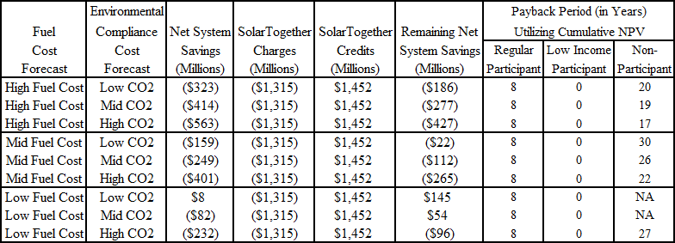
Source: (EXH 46, BSP 322)

Low-income Carve-out
Customer classes (e.g. residential, commercial, industrial, etc.) are determined by their electric usage characteristics. The proposed Program has set aside 37.5 MW for low-income customers that will begin with Project 3 (billing date of February 2021). (TR 136) The proposed tariff itself does not contain this information or any other allocation values. The proposed tariff defines a low-income participant, a sub-set of the residential customer class, as those customers whose income is at or below 200 percent of the federal poverty level. (Attachment 1; EXH 46, BSP 335) The proposed tariff also provides the low-income participant with an immediate fixed bill reduction of $0.70/kW-month. In its Petition, FPL estimates that a 5 kW subscription would equal 100 percent of an average annual residential customer’s energy usage. (EXH 38, BSP 122) Therefore, if a low-income customer subscribed for 5 kW, the estimated monthly bill reduction for the low-income participant would be $3.50 per month for the duration of their participation. The 37.5 MW allocated capacity would equate to approximately 7,500 low-income customers. (EXH 46, BSP 335) FPL witness Valle confirmed that FPL has more than 7,500 low-income customers. (TR 136) FPL has proposed that the credits paid to all participants be collected through its fuel adjustment clause. (TR 344) As such, the general body of ratepayers, including non-participating low-income customers, will be paying for this direct bill reduction.

The Commission has had little opportunity to discuss preferential treatment to low-income customers in the past, but other states have, and they have come to different conclusions, demonstrating that whether a preferential rate for low-income customers is “undue” is an open question. Compare Am. Hoechest Corp. v. Dep’t of Pub. Utils., 399 N.E.2d 1, 3–5 (Mass. 1980) (allowing preferential rates to low-income seniors on an experimental basis) with Mtn. States Legal Found., 590 P.2d at 498 (disallowing preferential rates to low-income seniors and low-income disabled customers). As discussed above, this determination is fact-intensive. Thus, the Commission must decide whether the record evidence warrants preferential rates for a small subset of FPL’s low-income ratepayers.

Costs Not Fully Funded by Participants
The evidence indicates that the proposed tariff would provide FPL with an alternative funding mechanism that accelerates the development of solar generation. As discussed above, voluntary tariffs have traditionally provided a response to certain customer demands for a certain type of product while holding the general body of ratepayers harmless. FPL’s existing SolarNow program is consistent with this policy and is designed to hold non-participating customers harmless from any increased expenses while the fuel saving benefits are realized equally among all ratepayers. Unlike prior Commission decisions regarding voluntary tariffs, the participating customers of the proposed Program would not pay the full cost of the Program. For example, the administrative costs of approximately $11.5 million would be booked as a base rate expense for FPL’s surveillance reporting. (TR 322, 324) Also, the cumulative present value of revenues to be collected from participating customers is $1.3 billion (72.9 percent) of the $1.8 billion associated with the 1,490 MW of solar generation. (EXH 42, BSP 281) FPL witness Bores explained that:

. . . We are levelizing this revenue requirement. And if you think about a revenue requirement, it normally declines over time. Right. So we -- to minimize the day-one charge and make it, quote-unquote, "economical" and encourage and meet the needs of the customers here, we have levelized that charge. So, in the short term, there will be a difference between the levelized charge to the participants and the actual revenue requirement that will sit in rate base that will turn around over the life of the project . . .

(TR 410)

The line graph below shows that in 2022 there will be a revenue deficiency of approximately $90 million paid for by the general body of ratepayers. (EXH 39, Amended Interrogatory No. 190, Attachments 4 and 5) These revenue deficiencies gradually decrease and may be addressed at each subsequent rate proceeding.

Figure 2-1
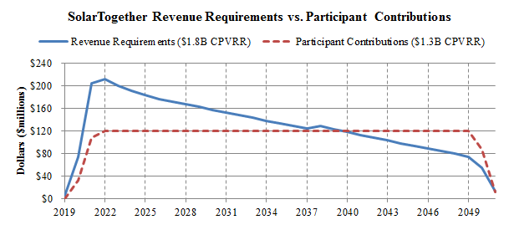
Source: (EXH 39, Amended Interrogatory No. 190, Attachments 4 and 5)

OPC contends that the participating customers of the proposed Program would not cover the full cost of the Program and that FPL’s claims that participants pay 100 percent or more of Program costs, or that non-participants pay none of the Program costs, are misleading. OPC argues that FPL is seeking recovery of the entire cost of the Program, which is forecasted to be $1.8 billion. In contrast, OPC notes that participants would only contribute $1.3 billion, a $0.5 billion shortfall that would have to be made up for by the general body of ratepayers, 97 percent of whom would be non-participants. (OPC BR 10-11)

Staff observes that such a disparity in the magnitude of savings and the relative payback shifts the majority of risk to the general body of ratepayers, which may be unduly discriminatory. To cover 100 percent of the costs associated with the solar facilities, the participating customer charge would have to be increased from $6.76/kW-month to $9.23/kW-month. (EXH 42, BSP 281; EXH 46, BSP 328) Staff recommends that such a disparity in the allocation of costs is inconsistent with the Commission’s policy to hold non-participating customers harmless when offering a voluntary tariff for a special service.

Alternative to Net Metering
FPL witness Valle discussed the Program as an alternative to net metering, especially for those customers who are unable or unwilling to do so. (TR 49) Under a traditional net metering arrangement, a customer would shoulder the full capital cost and construction risk of installing solar generation on their premise. (TR 143-144) The customer would not be able to transfer the solar facilities to another location and the payback would be affected by the performance of the solar facilities and future utility fuel and emission costs. (TR 144-145) According to witness Valle, such a traditional net metering arrangement should have a payback of between 10 to 12 years. (TR 688) Under the proposed Program and associated tariff, participants face no upfront capital or maintenance costs, and may exit the Program with one month’s notice. (TR 146-147) Furthermore, the subscription charges and credits were designed by FPL to give an essentially guaranteed payback period of eight years. (TR 323; EXH 46, BSP 322) Participants would also be eligible to transfer their participation to a new location within FPL’s service territory. (TR 61) Overall, compared to traditional net metering, the Program offers reduced risk and increased and essentially guaranteed rewards for participants. (TR 146)

The Utility is impacted by traditional net metering in that it would have lower energy and/or demand sales, producing less overall revenue. (TR 74) While the Utility’s energy costs would be offset by reduced fuel costs, base rates would not be offset. These base rate reductions would be taken into account at the Utility’s next base rate proceeding, in which the Utility’s fixed costs would have to be spread across a smaller amount of demand and energy sales resulting in an increase of base rates to the general body of ratepayers. (EXH 38, BSP 70-71) Under the proposed tariff, FPL would not see any reduction in kWh sales or revenues between rate cases. (EXH 38, BSP 71) The subscription charge would also reduce base rate risks for the Utility as it is recovered on a fixed monthly basis similar to the customer charge, rather than on an energy or demand basis for traditional generation additions.

As risks decrease for the participants and the Utility, they increase for the general body of ratepayers. As the SolarTogether facilities would be included in FPL’s rate base, the general body of ratepayers would be responsible for the capital, construction, O&M and other costs. The general body of ratepayers would also see an immediate increase in rates from the subscription credits through the fuel clause. (EXH 38, BSP 149) As the subscription credits are based on a forecast of benefits over the full life of the units, the general body of ratepayers have all fuel and emissions costs risks shifted to them from the participants. As such, the Program and proposed tariff shifts the majority of risk associated with traditional net metering to the general body of ratepayers and may be unduly discriminatory.

Subsequent Participant Allocation
In response to staff interrogatory number 65, FPL stated that approval of the Program would “include FPL’s right to reallocate capacity among customer groups…” and that over time as “customer attitudes and behaviors change, increasing the allocation to or near 100 percent may be appropriate.” Such a reallocation would not require Commission approval according to FPL. (EXH 38, BSP 126-127; EXH 38, BSP 184) Approving FPL’s request would grant the Utility complete discretion to unilaterally reallocate the Program’s capacity between residential and large commercial/industrial customers. FPL did acknowledge that it would notify the Commission in that event. (EXH 38, BSP 126) However, such a reallocation could occur hours or days after the initial web-site offering to residential and small business customers. Since the proposed tariff is in response to customer desires and not cost of service, staff recommends that allowing FPL to unilaterally reallocate Program capacity values could compound the discriminatory/preferential issues discussed above.

Summary of Joint Movants’ Alleged Program Benefits
While staff recommends that the Program and proposed tariff not be approved because there appears to be an undue preference, the Commission must determine whether the SolarTogether Program, as a whole, is in the public interest. This determination should be made by assessing whether the Program and proposed tariff provide undue or unreasonable differential treatment between participants and non-participants and that all ratepayers are fairly charged for this Program.

FPL, SACE, Vote Solar, and Walmart argue that the proposed tariff and Program are in the public interest. Some of the alleged benefits are listed below.

- The 20 solar projects result in gains in fuel diversity and less reliance on fossil fuel and decreases in system emissions, including CO₂. (TR 299, 588)
- The addition of 1,490 MW of solar-powered generation is expected to decrease FPL’s annual average use of natural gas by 21,600 million cubic feet. (TR 227-228)
- The Program’s facilities are projected to add 735 MW of firm capacity at the time of summer peak. (TR 224, 234)
- The Program is consistent with the Legislative findings in Section 366.92, F.S., that it is in the public interest to promote the development of renewable energy resources. (FPL BR 21; SACE BR 6; TR 600)
- The Program will expand customer access to clean energy. (TR 599-600, 630)
- For participants, the Program is voluntary, has no long term commitment, and is portable within FPL’s service territory. (TR 50, 61, 588, 631-632)
- Approximately 7,500 low-income customers will have access to solar with no premium and day one bill savings. (TR 136, 589-590, 599, 634)
- The Program removes the barriers associated with private rooftop solar systems. (TR 81)
- The Program provides “payback period” certainty to customers who cannot afford solar panels or do not have ownership of, or access to, a roof for the installation of panels. (TR 686, 688-89)
- Participants have the option to have the RECs associated with their subscription retired on their behalf, thus allowing them to claim the environmental attributes. (TR 61, 612, 624)

Conclusion

The Commission must weigh the record evidence and decide whether the SolarTogether tariff grants an undue preference to any group of customers or subjects any other group to an undue disadvantage. The record evidence demonstrates that the Program and tariff, as proposed, would place additional financial risks on the general body of ratepayers while insulating the Utility and participating customers from such risks. As such, staff recommends that rate schedule STR gives an undue preference to participants and subjects the general body of ratepayers to an undue disadvantage.

Issue 3: Should the Commission allow recovery of all costs and expenses associated with FPL’s proposed SolarTogether Program in the manner proposed by FPL?
Recommendation: No. The Commission should not approve any cost recovery at this time. FPL’s 2019 TYSP, which includes over 1,700 MW of future solar generation by 2022, is the least-cost plan resulting in the lowest levelized system average electric rate for all of FPL’s general body of ratepayers. Projects 1, 2, and 3, approximately 900 MW of FPL’s proposed SolarTogether Program, are consistent with FPL’s 2019 TYSP. Therefore, even if the proposed tariff is not approved, it appears that constructing Projects 1, 2, and 3 would be cost-effective additions to FPL’s system that would benefit all customers. FPL may seek cost recovery of these facilities at its next base rate proceeding under current regulatory policies and procedures.

If the Commission approves the Program and rate Schedule STR, staff recommends that the participant credits be recorded as a base rate expense. Such treatment would provide participants the same benefits as proposed by FPL, but more closely reflect the current risks to the general body of ratepayers and FPL associated with traditional net metering. (Ballinger, Simmons, Trierweiler, Mouring, Fletcher)
Position of the Parties:

FPL: Yes. The Program’s net base revenue requirements will be recovered through base rates and, over the life of the Program will be paid for by the participants. The Subscription Benefit consists of fuel and emission benefits, and therefore will be recovered through FPL’s fuel cost recovery clause.

OPC: Regardless of the ultimate decision on the SolarTogether Program, the Commission should affirmatively reject FPL’s efforts to bulk up rate base by subverting the dollar threshold of Rule 25-6.0141, F.A.C. through the use of an unauthorized bundling of discrete construction projects.

FIPUG: FIPUG did not file a brief.

SACE: Yes. The Settlement Agreement filed in this docket on October 9, 2019 between FPL, SACE, Vote Solar, and Walmart fully resolves all matters between the referenced parties and provides numerous benefits to both participants and the general body of customers, and is therefore in the public interest. See Issue 4

VOTE
SOLAR: Yes.

WALMART: Walmart believes the costs and expenses should be recovered as set forth in the proposed Settlement Agreement.

Parties’ Arguments
FPL
FPL states that its SolarTogether Program is cost-effective and projected to generate $249 million in CPVRR customer savings. (FPL BR 7) Based on the testimonies of FPL witnesses Brannen and Sim, FPL asserts that it has demonstrated that the cost for its 20 SolarTogether facilities is reasonable and the solar generation is cost-effective. (FPL BR 10) Specifically, the projected capital cost for the SolarTogether Projects is $1,202/kW, which is below the 2020 SoBRA project capital cost of $1,378/kW. (FPL BR 10-11) To ensure the reasonableness of its capital costs, FPL undertook a competitive bidding process from late 2018 through 2019 for the equipment to be installed and work to be performed at the solar facilities. (FPL BR 11-13) Moreover, asserts FPL, its economic analyses established that the resource plan with the proposed SolarTogether generation of 1,490 MW is cost-effective as compared to not constructing these solar facilities, saving customers an estimated $249 million. FPL explains that other than recognizing characteristics particular to solar generation, the cost-effectiveness analysis methodology used in this proceeding by FPL is the same methodology FPL uses in all of its resource planning analyses that it presents to the Commission. (FPL BR 9-10, 13-14)

FPL contends the net base revenue requirements would be recovered through base rates and, over the life of the Program, would be paid for by the participants. The subscription benefit consists of fuel and emission benefits, and therefore would be recovered through FPL’s fuel clause, partially offsetting system savings resulting from the addition of the Program’s facilities. Upward rate impacts will be modest and short-term. All costs would be reflected in FPL’s earnings surveillance reports. (FPL BR 9, 38)

Last, FPL disagrees with OPC’s argument that it has implemented an “unchecked effort to build rate base” by accruing Allowance for Funds Used During Construction (AFUDC) for SolarTogether Projects 1 and 2. FPL contends that it has reasonably and consistently applied the criteria in the Commission’s rule and FPL’s policy to accrue AFUDC where appropriate (i.e., SolarTogether Projects 1 and 2) and not accrue AFUDC where it is not appropriate (i.e., SolarTogether Projects 3, 4, and 5). FPL also employs criteria from its AFUDC accounting policy to determine if a project consisting of multiple sites constitutes a single project or multiple projects. The key criteria from this policy are: 1) all sites grouped as a project must have the same Engineering, Procurement, and Construction (EPC) contractor to manage the project; and 2) all sites have a defined start of construction and single scheduled in-service date. (FPL BR 36-37)

OPC
OPC argues that the Commission should reject FPL’s efforts to increase rate base and depreciable plant in service in this case and others by the use of a self-serving, internal utility-interpretation of a Commission rule. Specifically, it contends that the AFUDC Rule was designed to provide certainty and protect customers from a utility’s imposition of excessive accrual of carrying costs on future generations of customers. As a result of discovery in this docket, it became apparent that FPL has been applying – and intends to apply in the future – the concept of bundling disparate work activities that are historically and traditionally evaluated individually in order to add carrying costs to rate base. (OPC BR 14)
OPC argues that the AFUDC Rule was not intended to create opportunities to creatively stitch far-flung construction activities together to boost rate base. Moreover, FPL, which has the burden of proof to demonstrate the prudence of the costs for which it seeks recovery, failed to demonstrate that the Commission’s AFUDC Rule allows or even contemplates “bundling.” (OPC BR 16) The AFUDC Rule has two fundamental criteria – a dollar value threshold (0.05% of plant) and a duration threshold (greater than one year). OPC asserts that no utility should be allowed unfettered ability to render these criteria irrelevant by bundling. The act of bundling renders the dollar value threshold meaningless. The threshold was clearly intended to ensure that smaller projects would not be eligible for AFUDC; but instead, smaller projects would be included in the 13-month average construction work in progress (CWIP) balance. (OPC BR 16-17)

Specifically, as it relates to the SolarTogether bundling, OPC contends that FPL initially proposed that the Commission allow AFUDC to be added to rate base for the entire 20 projects included in the Program. This approach was revised to only apply to six of the 20 projects. OPC argues that these six projects were clearly bundled in groups of three because one or two on their own or combined would not meet the $243.4 million threshold. When bundled and recast as a single three-site “project,” the individual projects just barely exceed the threshold. (OPC BR 17)

Last, OPC asserts that the Commission should reject FPL’s “accounting sleight of hand” along with the Program. Moreover, the Commission should only consider this practice (bundling), if at all, in the context of a rulemaking proceeding. (OPC BR 19)

SACE
SACE did not specifically address recovery of costs for the SolarTogether Program in its brief, but rather argues that the Commission should approve the Settlement Agreement filed on October 9, 2019, that resolves all issues between FPL, SACE, Vote Solar and Walmart. SACE argues that the Commission is afforded great deference to determine that a settlement agreement between parties is in the public interest and that it has been presented with substantial, competent evidence during the hearing upon which to make a public interest determination. SACE contends that the SolarTogether Program fairly and reasonably allocates benefits to all customers. As such, SACE requests that the Commission approve the Settlement Agreement in its entirety and notes that the Commission is not precluded by statute or case law from approving nonunanimous settlements. (SACE BR 4-5)

Vote Solar
Vote Solar did not provide an argument specific to this issue. (Vote Solar BR 4)
Walmart
Walmart did not provide issue-specific arguments in its brief but stated, “Walmart believes that the proposed Settlement Agreement, including the SolarTogether Settlement Tariff, is a reasonable compromise of the Settling Parties’ different positions in this case and is otherwise in the public interest.” (Walmart BR 2)

Analysis

FPL has stated that if the Program and proposed tariff are not approved, it is still committed to constructing Projects 1 and 2. (EXH 38, BSP 162) In addition, the evidence in the record suggests that Projects 1, 2, and 3 are consistent with units identified in FPL’s 2019 TYSP and would satisfy FPL’s planning reserve margin criterion for the years 2020 and 2021. (EXH 30; EXH 39, Amended Interrogatory No. 190, Attachments 1 and 2) The evidence is also clear that the Program would result in the acceleration of approximately 600 MW of solar generation from 2022 to 2021, which are Projects 4 and 5. Staff requested an economic analysis of this acceleration through staff’s interrogatory number 241. (EXH 47, BSP 341-344) FPL filed its response to this discovery request on November 20, 2019. The first paragraph of FPL’s response states:
[T]he analysis requested in Interrogatory No. 241 consists of a new economic evaluation that cannot be performed in the time allowed for service of discovery responses. The requested new economic analysis effectively asks for a comparison of FPL’s 2019 Ten Year Site Plan (TYSP) against the SolarTogether Plan. It is important to observe that the solar additions shown in the SolarTogether Plan are essentially the same as the early year solar additions in the TYSP, except that approximately 600 MW of solar planned in early 2022 in the TYSP are built in 2021 for the purposes of SolarTogether, likely less than one year early, principally to meet broad customer interest in the participation of solar development through this unique Program. As such, FPL believes the plan is consistent with the 2019 TYSP, and notes that if the cost of PV panels or associated import tariffs were to increase, or if the labor market for solar construction continues to tighten, a delay in the decision to construct these units could result in forgone savings for participants and non-participants alike.
(EXH 47, BSP 344)

In response to staff’s interrogatory number 258, filed on December 11, 2019, FPL further clarified its response to interrogatory number 241 and states:
. . . although no actual calculation of the projected economics of such a comparison has been performed, FPL believes it would be reasonable to expect, assuming base case assumptions, that the acceleration of this solar generation would result in a relatively slight increase in CPVRR costs if construction costs remain as currently projected.

(EXH 51, BSP 371)

Acceleration of Projects 4 and 5 would increase FPL’s solar net energy for load from 4.46 percent in 2021 to 5.31 percent 2021. (EXH 68) FPL did not produce an economic analysis of this acceleration as discussed above. Therefore, staff recommends that FPL has demonstrated that Projects 1, 2, and 3 are cost-effective generation additions, but the incremental cost of accelerating Projects 4 and 5 has not been supported in the record. By continuing to adhere to the principles of least-cost planning and cost of service allocation, FPL can add approximately 900 MW of solar generation to its system for the benefit of all customers and request recovery of these costs at a subsequent base rate proceeding. If the proposed tariff is not approved, it appears that constructing Projects 1, 2, and 3 would be cost-effective additions to FPL’s system that would benefit all customers.
Allowance for Funds Used During Construction (AFUDC)
Pursuant to Rule 25-6.0141, Florida Administrative Code (F.A.C.), AFUDC is a regulatory concept that allows for the deferral and ultimate recovery of carrying costs associated with the construction of large capital additions that would not be supported by the CWIP balance included in rate base in the Utility’s last base rate case. As discussed previously, the Utility has proposed to construct 20 new solar generating facilities with a design capacity of 74.5 MW each. (TR 105) With a design capacity of less than 75 MW each, FPL argues that each of these solar generating facilities is exempt from the siting requirements of the PPSA and do not require a need determination from this Commission. (TR 406) For purposes of its filing, FPL has grouped these 20 discrete solar generating facilities into five projects. (TR 363-364; EXH 69) In the instant case, because SolarTogether Projects 1 and 2 utilize a common EPC contractor, FPL has asserted that SolarTogether Projects 1 and 2 are eligible to accrue AFUDC. (TR 379; EXH 69) The estimated annual revenue requirement impact of AFUDC for Projects 1 and 2 is $2.35 million. (TR 407; EXH 48, BSP 349)

Staff agrees with the Utility that in total, the overall capital expenditures of the six discrete solar generating facilities that make up Projects 1 and 2 do constitute large capital additions and satisfy the eligibility requirements in Rule 25-6.0141, F.A.C., to accrue AFUDC. (TR 379; EXH 69) For FPL, the current threshold of investment that is eligible to accrue AFUDC is approximately $243 million. (TR 363) However, staff does have concerns about the Utility’s policy of fragmenting large capital projects to circumvent the siting requirements of the PPSA and Commission need determinations, and the subsequent bundling of the same capital additions for AFUDC purposes. (TR 105-106, 363) The PPSA uses the term “electrical power plant” to describe new generating assets, whereas the AFUDC Rule uses the term “project” to describe large capital additions. (EXH 48, BSP 351) The PPSA defines an “electrical power plant” as “any steam or solar electrical generating facility using any process or fuel, including nuclear,” but the AFUDC Rule does not define what specifically constitutes a “project.” (Section 403.503(14), F.S.; EXH 48, BSP 351)

Staff believes that the deferral and recovery of these carrying costs, without the oversight and transparency of vetting a large capital addition through the PPSA and a Commission need determination proceeding is troublesome. Further, staff believes that it would be advisable to open rulemaking for Rule 25-6.0141, F.A.C., to address the issue of bundling projects and to define what constitutes a project for purposes of accruing AFUDC.

Options to Program as Proposed
FPL argues that the proposed Program and associated tariff would be the next step forward in promoting Florida’s energy policy contained in Section 366.92, F.S., which is to promote the development of renewable energy; protect the economic viability of Florida’s existing renewable energy facilities; diversify the types of fuel used to generate electricity in Florida; encourage the development of renewable generation; improve fuel diversity; lessen Florida’s dependence on natural gas and fuel oil for the production of electricity; minimize the volatility of fuel costs; encourage investment within the state; improve environmental conditions; and, at the same time, minimize the costs of power supply to electric utilities and their customers. (FPL BR 21) As discussed in Issue 2, staff recommends that the proposed Program and associated tariff results in an undue preference to participants, and subjects the general body of ratepayers to an undue disadvantage. However, the evidence also indicates that FPL’s customers desire additional development of solar generation. FPL witness Valle agreed that if solar generation is added to FPL’s system and recovered through traditional rate-making, all customers will receive benefits. (TR 131-132) Therefore, during cross examination, staff explored various options to encourage the development of solar generation for the benefit of all customers that did not require the proposed tariff to be implemented. Such options would be consistent with the intent of Section 366.92, F.S., and also avoid any semblance of an undue preference. These options included classifying the solar facilities as a regulatory asset or creating a recovery mechanism similar to ones approved in recent SoBRA settlement agreements. While FPL agreed that such options would encourage the development of solar generation, it did not support such action as it would not be responsive to the primary purpose of the Program, which is to address “the needs of customers who cannot or do not want to own a net metering system, but are seeking a direct bill credit.” (TR 49)

Also, as discussed in Issue 2, FPL witness Valle agreed that if a customer were to net meter, FPL would see a decline in revenues due to reduced sales. He also agreed that, in FPL’s next base rate proceeding, the impact from the reduced sales would be reviewed and rates for the general body of ratepayers would be adjusted as needed. (TR 148) Staff also explored the option of having the participant credits recorded as a base rate expense item rather than allowing immediate recovery through FPL’s fuel clause. In short, such action would approve the STR tariff as filed, but change the way FPL proposed to recover the costs. (TR 411-413) Such treatment would delay the explicit recovery of the credits until FPL’s next base rate proceeding, much like a current net metering customer, but FPL would retain the risk of interim lost revenues. The estimated annual credits for 2020 are $31.7 million and $105.1 million for 2021. FPL witness Bores agreed that participating customers would be unaffected and that FPL would bear the risk of these costs until its next rate case. (TR 413) If the Commission approves rate schedule STR as proposed, staff recommends that the participant credits associated with proposed rate schedule STR be recorded as a base rate expense. Such treatment would provide participants the same benefits as proposed by FPL but more closely reflect the current risks to the general body of ratepayers and FPL associated with traditional net metering.

Conclusion

The Commission should not approve any cost recovery at this time. FPL’s 2019 TYSP, which includes over 1,700 MW of future solar generation by 2022, is the least-cost plan resulting in the lowest levelized system average electric rate for all of FPL’s general body of ratepayers. Projects 1, 2, and 3, approximately 900 MW of FPL’s proposed SolarTogether Program, are consistent with FPL’s 2019 TYSP. Therefore, even if the proposed tariff is not approved, it appears that constructing Projects 1, 2, and 3 would be cost-effective additions to FPL’s system that would benefit all customers. FPL may seek cost recovery of these facilities at its next base rate proceeding under current regulatory policies and procedures.

If the Commission approves the Program and rate Schedule STR, staff recommends that the participant credits be recorded as a base rate expense. Such treatment would provide participants the same benefits as proposed by FPL, but more closely reflect the current risks to the general body of ratepayers and FPL associated with traditional net metering.

Issue 4:
Should the Commission approve FPL’s proposed SolarTogether Program and associated tariff, Rate Schedule STR, which is the same tariff attached as Attachment I to the Settlement Agreement filed October 9, 2019?

Recommendation:
No. See discussion in Issues 1, 2, and 3. (Ballinger, Simmons, Trierweiler)
Position of the Parties:

FPL: Yes. The Settlement represents a reasonable compromise and fully resolves all issues raised in this proceeding. Considered as a whole, the settlement is in the public interest: the Program responds to a significant customer need, is cost-effective, results in just, fair and reasonable rates, and advances Florida’s renewable energy policy.

OPC: No. OPC adopts its discussion in Issues 1, 2 and 3 above.

FIPUG: FIPUG did not file a brief.

SACE: Yes. The Settlement Agreement filed in this docket on October 9, 2019 between FPL, SACE, Vote Solar, and Walmart fully resolves all matters between the referenced parties and provides numerous benefits to participants, the general body of customers and the state, and is therefore in the public interest.

VOTE
SOLAR: Yes. The Commission should approve the tariff attached as Attachment I to the Settlement Agreement filed October 9, 2019.

WALMART: Yes. The Commission should approve the tariff attached as Attachment I to the Settlement Agreement filed October 9, 2019.

Parties’ Arguments
FPL
FPL contends the Program and the proposed tariff are in the public interest and should be approved. (FPL BR 3) In evaluating whether a settlement is in the public interest, argues FPL, the Commission should lean toward innovation and constructive regulation that is responsive to the needs of customers and open to new, innovative ways to capture benefits for all customers. The legal standard for the Commission’s determination is whether the settlement agreement is in the public interest. (FPL BR 17) FPL asserts that the Commission has broad discretion in deciding what is in the public interest, and it may consider a variety of factors in reaching its decision. (FPL BR 17)

FPL contends that with the instant Settlement Agreement, there are multiple considerations and benefits which support a finding that the SolarTogether Program as outlined and described in the Settlement Agreement is in the public interest: (1) the Program provides an innovative, voluntary community solar option that is responsive to the demands of residential and business customers who wish to or have already subscribed to the Program while bringing benefits to all FPL customers; (2) the costs of the Program have been fairly and reasonably assigned; (3) the resulting rates under the Program are fair, just and reasonable; (4) the Program makes community solar available to low-income customers; (5) the Program provides material environmental benefits through substantial carbon emission reductions; (6) the Program will provide enhanced fuel diversity which mitigates risks for all FPL customers; and (7) the Program as defined under the Settlement Agreement furthers the public interest goals of the Florida Legislature to encourage the development of renewable energy resources in the state. (FPL BR 39)

Furthermore, through the proposed tariff FPL contends that access to solar will be afforded to customers who might never have imagined they would have the financial means to participate. The Settlement Agreement signatories agreed to set aside 37.5 MW of the Program’s capacity for low-income customers, creating the opportunity to directly participate in solar for thousands of low-income households, more than any other solar program in the country. (FPL BR 22)

Last, FPL argues that contrary to OPC’s assertion that the proposed tariff violates the base rate freeze provision of the 2016 Rate Settlement, nothing in its 2016 Rate Settlement Agreement prohibits approval of the SolarTogether Program and proposed tariff. FPL contends that it repeatedly confirmed that base rates would not increase as a result of SolarTogether during the term of the Rate Settlement, currently expected to remain in place through 2021. (FPL BR 28-29)
OPC
No. OPC adopts its discussion in Issues 1, 2 and 3 above. (OPC BR 20)

SACE
SACE argues that the Commission should approve the Settlement Agreement filed on October 9, 2019. SACE contends that the Commission is afforded great deference to determine that a settlement agreement between parties is in the public interest and that it has been presented with substantial, competent evidence during the hearing upon which to make a public interest determination. (SACE BR 4)

As a threshold matter, explains SACE, Florida statute provides that “unless precluded by law, informal disposition may be made of any proceeding by stipulation, agreed settlement, or consent order.” Moreover, SACE argues the Commission is not precluded by statute or case law from approving nonunanimous settlements. The Commission’s determination of whether to approve a settlement agreement is based on the public interest, and the determination of public interest rests exclusively with the Commission. SACE argues the determination of public interest requires a case-specific analysis based on consideration of the proposed settlement taken as a whole. SACE argues that in this case, the Settlement Agreement is in the public interest based on the benefits that flow from its provisions taken as whole. (SACE BR 5-6)

SACE explains that taken as a whole, the proposed tariff and Program provisions embodied in the Settlement Agreement provide a number of benefits that are clearly in the public interest that include: expansion of renewable energy through the development of 1,490 MW of clean, renewable power; diversification of the state’s fuel mix; a cost-effective Program; allocation of economic benefit to both participants and the general body of ratepayers; prioritizing the customer experience, including expanding participation to low-income families; meeting FPL’s resource needs in 2020 and 2021; meeting the enormous customer demand for solar power; and driving state economic development and local job creation. (SACE BR 4-5)

SACE further argues that the Florida Legislature finds that it is in the public interest to promote the development of renewable energy resources. The Florida Legislature has also explicitly stated in Section 366.92(1), F.S., its intent “to promote the development of renewable energy” in order to diversify the types of fuel used to generate electricity in Florida; lessen Florida’s dependence on natural gas; minimize the volatility of fuel costs; encourage investment within the state; improve environmental conditions; and minimize the costs of power supply to electric utilities and their customers. (SACE BR 6, 12)

Vote Solar
Vote Solar argues that the Commission should approve the SolarTogether Program and proposed tariff as amended by the stipulation filed October 9, 2019, which provides a reasonable resolution of the issues raised by this filing. (Vote Solar BR 4) The SolarTogether Program and proposed tariff is projected to provide an estimated $249 million in economic benefits and commits FPL to reserve 10 percent of the Program’s residential capacity, or 37.5 MW, to low-income customers. The subscription charge for low-income customers will not exceed the subscription credit in any month, providing a critically important safeguard for these consumers. Further, Vote Solar contends that SolarTogether responds to customer demands for clean energy, which are real and immediate and that FPL must respond to these demands if it wants to continue to provide sufficient electric service that meets the evolving needs of customers. Last, the solar resources will further diversify FPL’s electric system and mitigate the fuel volatility risks to all customers due to its significant reliance on natural gas. (Vote Solar BR 4-5)

Walmart
Walmart did not provide issue-specific arguments in its brief but stated, “Walmart believes that the proposed Settlement Agreement, including the SolarTogether Settlement Tariff, is a reasonable compromise of the Settling Parties’ different positions in this case and is otherwise in the public interest.” (Walmart BR 2)

Analysis

FPL, SACE, Vote Solar, and Walmart argue that the Commission should approve the Settlement Agreement and proposed tariff, filed on October 9, 2019, because it is in the public interest. (FPL BR 3; SACE BR 4; Vote Solar BR 4; Walmart BR 2) OPC disagrees and believes the Settlement Agreement and proposed tariff should not be approved. (OPC BR 20) For the reasons discussed at length in Issues 1-3, staff recommends the Commission not approve the Program and proposed tariff, Rate Schedule STR.

Conclusion

The Commission should not approve the proposed Program and associated tariff, Rate Schedule STR, for the reasons discussed in Issues 1-3.

Issue 5:
DROPPED

Issue 6:
Should this docket be closed?

Recommendation:
The docket should be closed once the Commission has issued its final order and the time for appeal has run. (Trierweiler, Simmons)
Position of the Parties:

FPL: Yes. Upon issuance of an order approving FPL’s SolarTogether Program and Tariff, this docket should be closed.

OPC: After the Petition is denied, the docket should be closed.

FIPUG: FIPUG did not file a brief.

SACE: No position.

VOTE
SOLAR: Yes. Docket No. 20190061-EI should be closed once the Commission’s decisions on all of the issues have become final and the Commission has concluded that the docket has otherwise met the requirements for closure.

WALMART: In accordance with paragraph 8 of the Settlement Agreement, this Docket should be closed effective on the date of a Commission Order approving that the Settlement Agreement is final. Should the Commission not approve the Settlement Agreement, then Walmart takes no position as to this issue.

Parties’ Arguments

FPL, OPC, Walmart, and Vote Solar contend that the docket should be closed as set forth in their respective positions.

Conclusion

Staff recommends that the docket be closed upon issuance of the Commission’s final order and the time for filing an appeal has run.

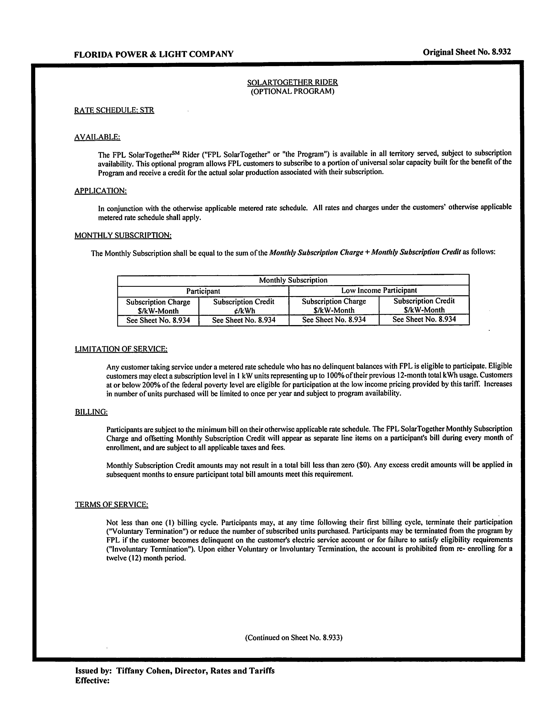
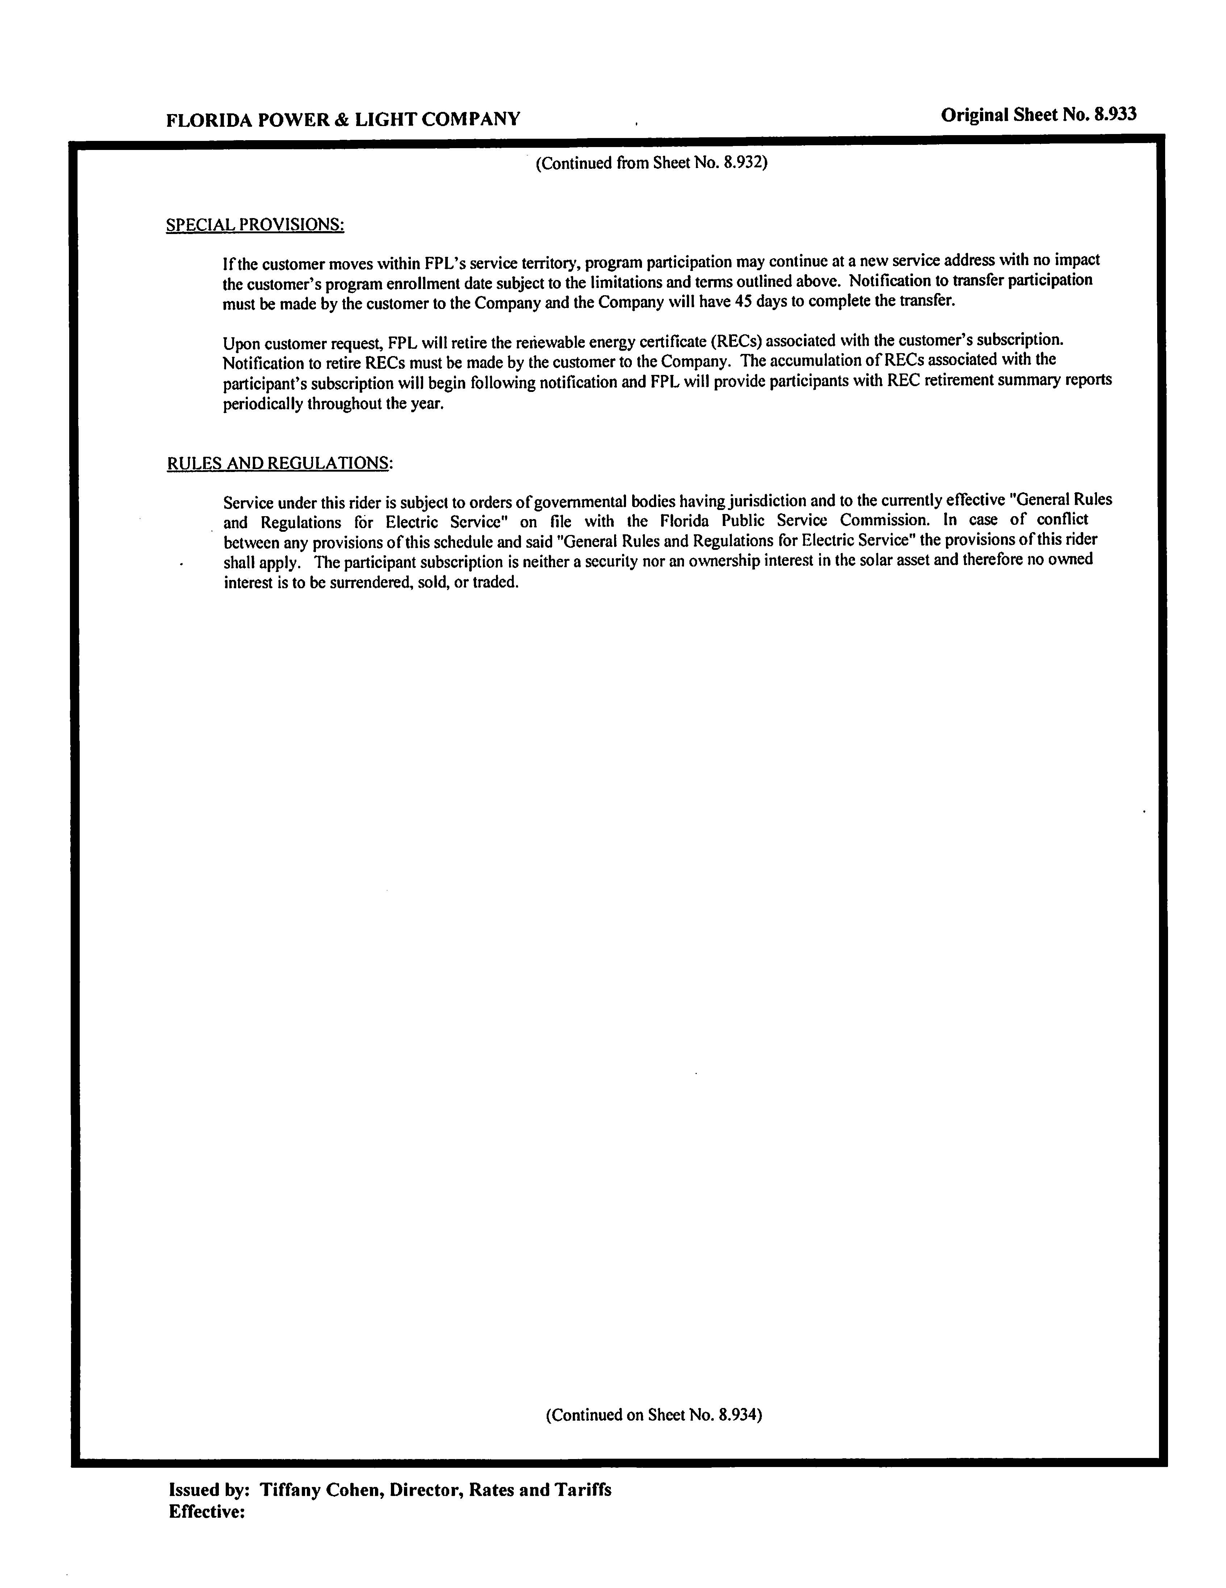

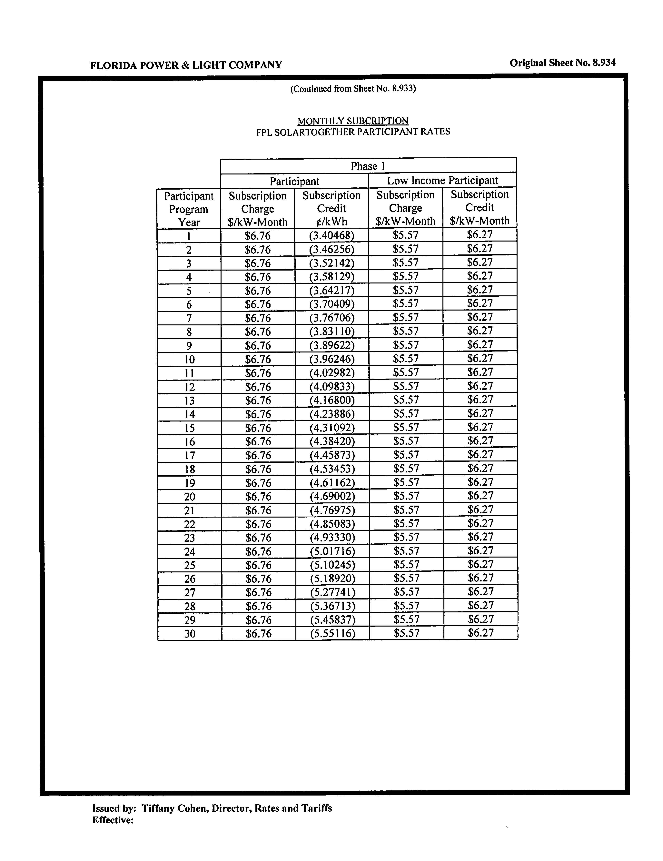

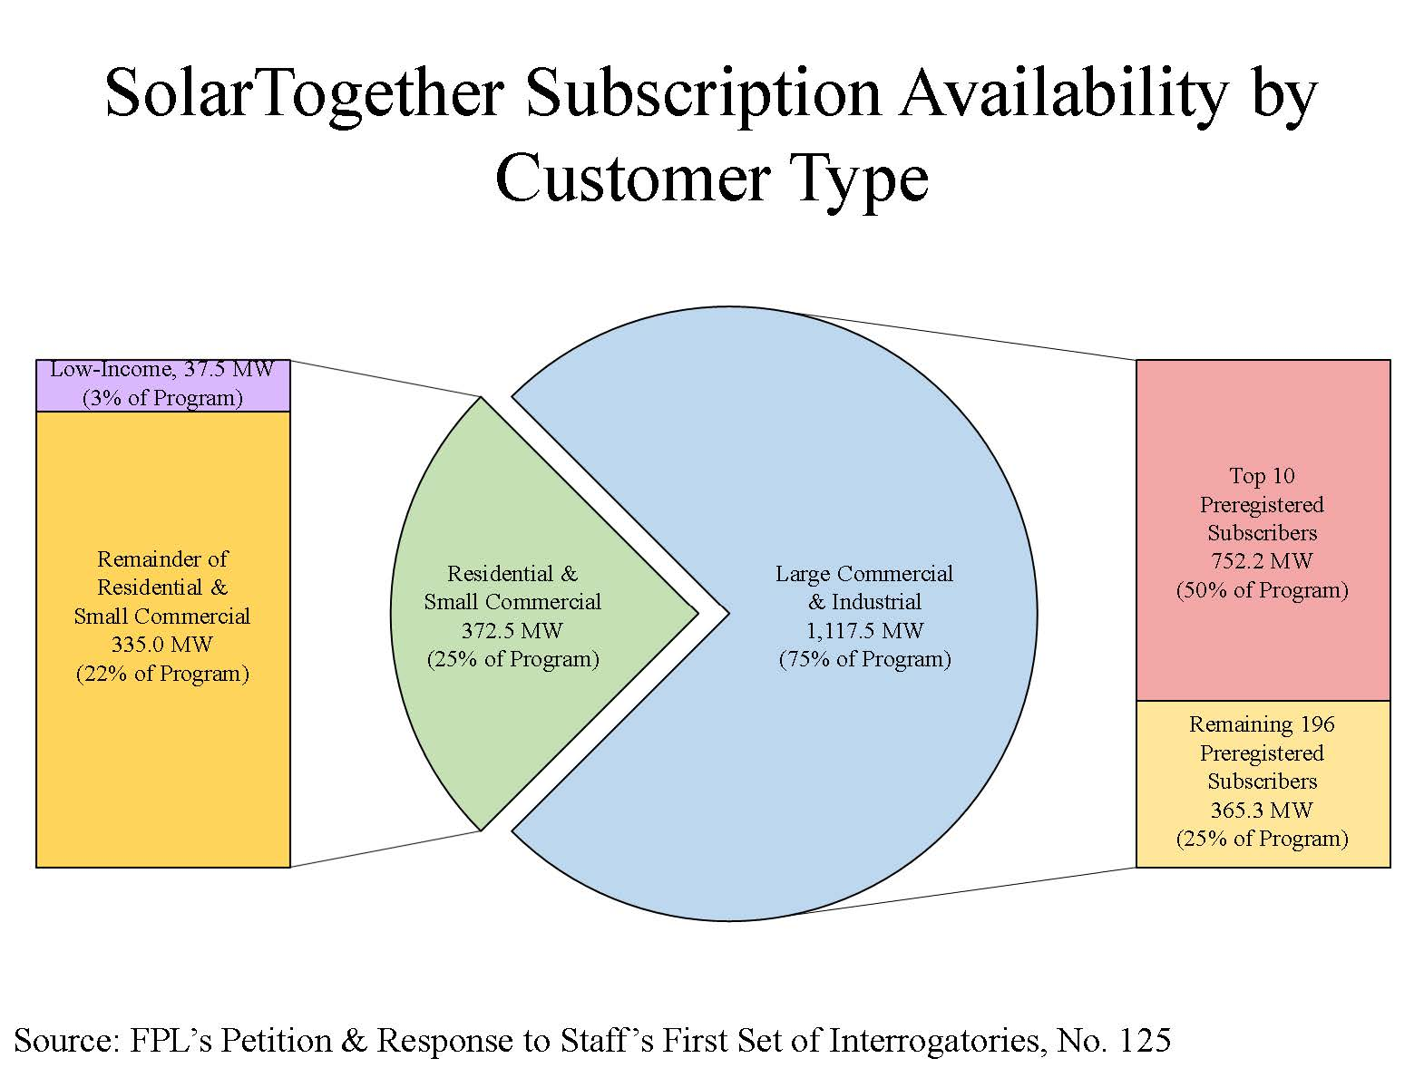
EXH 63

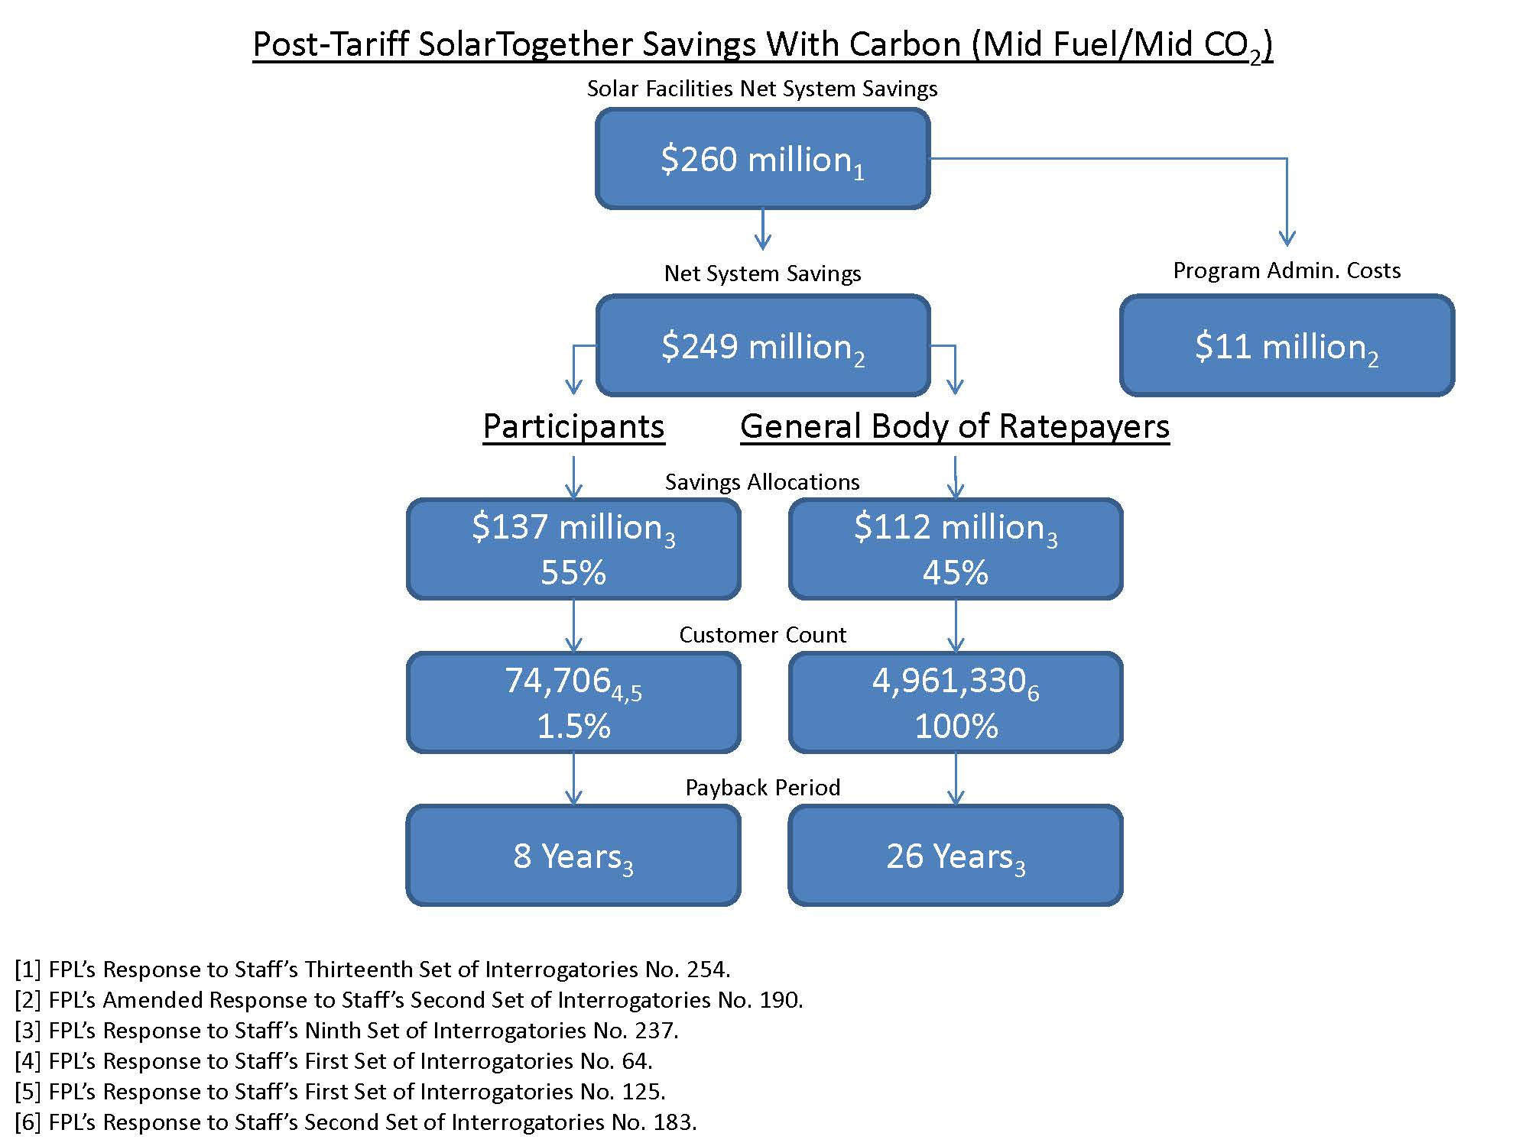
EXH 64

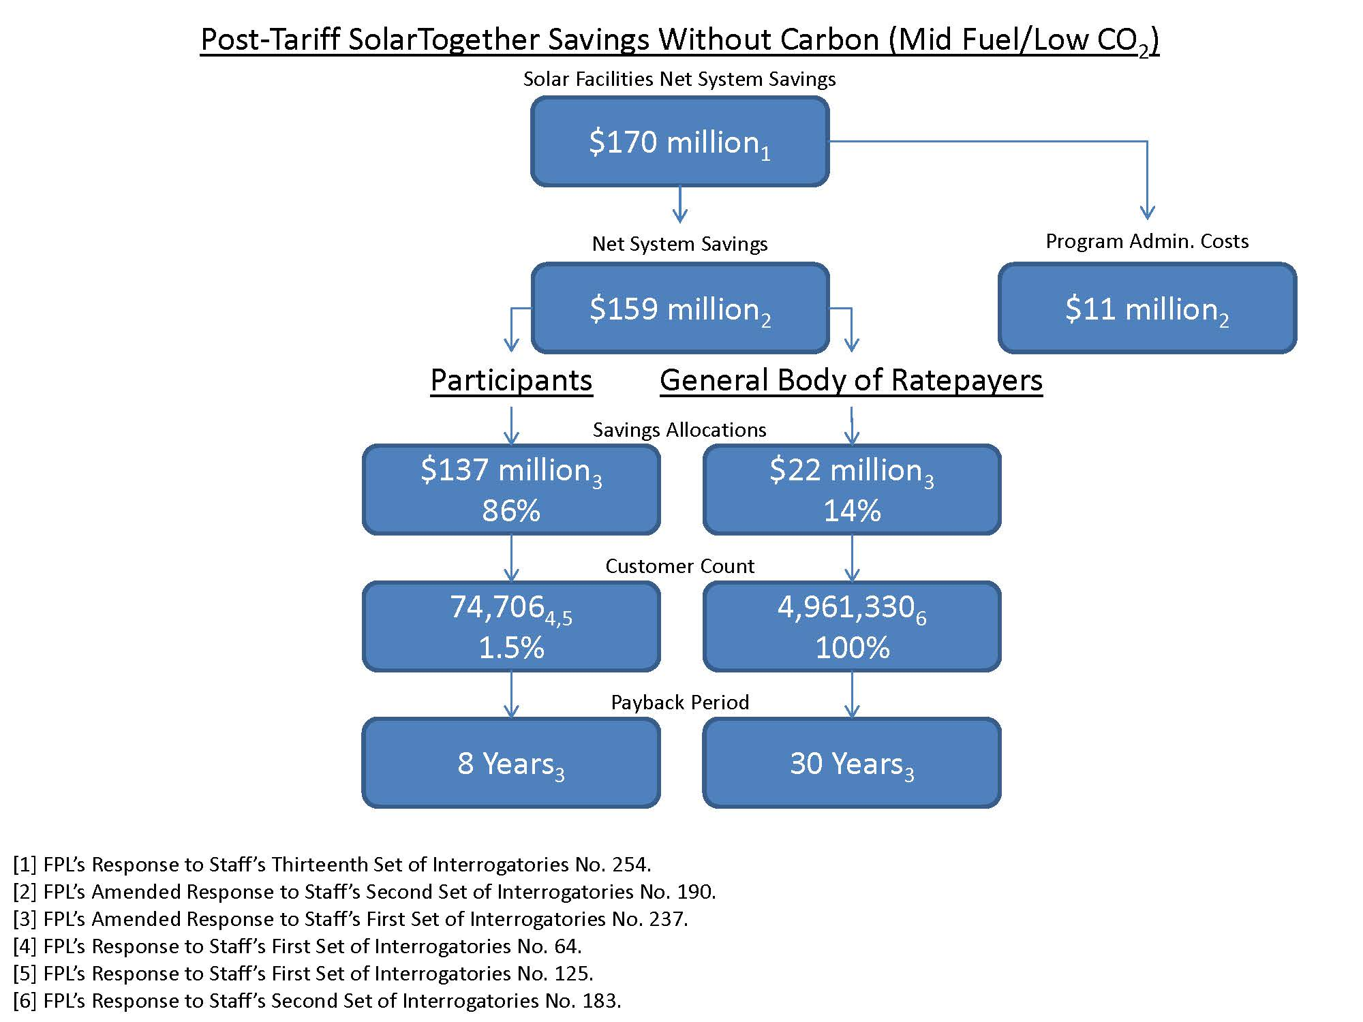
EXH 64

Sierra Club v. Brown, 243 So. 3d 903 (Fla. 2018); Citizens of State v. Florida Public Service Comm'n, 146 So. 3d 1143 (Fla. 2014); South Florida Hosp. and Healthcare Ass'n v. Jaber, 887 So. 2d 1210 (Fla. 2004).
Sections 403.501-403.518, F.S., are known as the Florida Electrical Power Plant Siting Act. The PPSA specifies that any solar or steam driven electrical power plant of 75 MW or more must obtain an affirmative determination of need from the Commission as a condition precedent before obtaining other siting approvals for construction of the proposed plant. Sections 403.506 and 403.519, F.S.
FPL’s current settlement has a termination date of December 31, 2020, unless FPL notifies the parties by March 30, 2020, that it wishes to extend its current base rates until December 31, 2021. Order No. PSC-2016-0560-AS-EI.
Order No. PSC-99-2507-S-EU, issued December 22, 1999, in Docket No. 19981890-EU, In re: Generic investigation into the aggregate electric utility reserve margins planned for Peninsular Florida. FPL, and other investor-owned utilities, voluntarily adopted a minimum reserve margin planning criterion of 20 percent.
Program bill credits less program bill surcharges. (OPC BR 13, FN 9)
Order No. PSC-08-0397-PAA-EI, issued June 16, 2008, in Docket No. 20070733-EI, In re: Complaint No. 694187E by Cutrale Citrus Juices USA, Inc. against Tampa Electric Company for refusing to provide transformer ownership discount for electrical service provided through Minute Maid substation; see, e.g., Order No. PSC-09-0283-FOF-EI, issued April 30, 2009, in Docket No. 20080317-EI, In re: Petition for rate increase by Tampa Electric Company (declining to design preferential rates for schools based on non-cost-based factors).
See Order No. 24151, issued February 25, 1991, in Docket No. 19890200-EQ, In re: Petition of Tampa Electric Company for approval of construction deferral agreement with IMC Fertilizer, Inc. (holding that Section 366.03, F.S., “prohibits only those rates which are unduly discriminatory”); see also Mo. River Energy Servs. v. FERC, 918 F.3d 954, 958 (D.C. Cir. 2019) (citations omitted) (“[A] mere difference in the treatment of two entities does not violate [the Federal Power Act]; instead, undue discrimination occurs only if the entities are ‘similarly situated,’ such that ‘there is no reason for the difference.’”).
E.g., Order No. PSC-05-0226-FOF-EI, issued February 25, 2005, in Docket No. 20030623-EI, In re: Complaints by Ocean Properties, Ltd., J.C. Penney Corp., Target Stores, Inc., and Dillard’s Department Stores Inc. against Florida Power & Light Company concerning thermal demand meter error (holding that FPL had not given certain customers any undue preference because FPL treated similarly situated customers similarly); Order No. 22197, issued November 20, 1989, in Docket No. 19891171-TI, In re: Proposed tariff filing by AT&T Communications of the Southern States, Inc. for provisional waiver of Rule 25-24.485(1)(i) and permission to provide Miami Children’s Hospital public service offering of free long distance for the period 10/30/89 through 8/28/90 (interpreting similar language in former Section 364.10, F.S., to require similarly situated customers to be treated similarly).
Compare 16 U.S.C. § 824d(b) (2018) (“No public utility shall . . . make or grant any undue preference or advantage to any person or subject any person to any undue prejudice or disadvantage”) with § 366.03 (“No public utility shall make or give any undue or unreasonable preference or advantage to any person or locality, or subject the same to any undue or unreasonable prejudice or disadvantage in any respect.”).
C.F. Industries, Inc. v. Nichols, 536 So. 2d 234 (Fla. 1988).
Order No. PSC-15-0026-FOF-EI, issued January 7, 2015, in Docket No. 20130223-EI, In re: Petition for approval of optional non-standard meter rider, by Florida Power & Light Company, p. 3 (“FPL witness Deason testified that we have a long and consistent history of setting rates based upon a regulated utility's costs. We agree. We have consistently set rates based on the cost of the service and have allocated those costs to the customer or class of customers who have caused those costs to be incurred.”)
Order No. PSC-2014-0468-TRF-EI, issued August 29, 2014, in Docket No. 20140070-EI, In re: Petition for approval of voluntary solar partnership pilot program and tariff, by Florida Power & Light Company.
See FN 2.
The Utility’s original petition, filed March 13, 2019, included the accrual of AFUDC for all five SolarTogether Projects, but was amended to exclude Projects 3, 4, and 5 in the revised petition filed September 23, 2019. Projects 3, 4, and 5 are no longer expected to utilize a common EPC contractor, and thus no longer met FPL’s internal accounting policy. (EXH 48, BSP 351)
Rule 25-6.0141, F.A.C., requires that in order for projects to be eligible to accrue AFUDC they must involve plant additions in excess of 0.5 percent of the total balances in FERC Account 101 and 106, and are expected to be completed in excess of one year after construction commences.

