State of Florida |  | Public Service Commission  Capital Circle Office Center ● 2540 Shumard Oak Boulevard  Tallahassee, Florida 32399-0850  -M-E-M-O-R-A-N-D-U-M-
DATE: | March 19, 2020
TO: | Office of Commission Clerk (Teitzman)
FROM: | Division of Accounting and Finance (Mouring, Higgins, Fletcher)  Division of Economics (Wu)  Division of Engineering (P. Buys, Doehling, Ellis, Thompson)  Office of the General Counsel (Brownless)
RE: | Docket No. 20180049-EI – Evaluation of storm restoration costs for Florida Power & Light Company related to Hurricane Irma.
AGENDA: | 03/31/20 – Regular Agenda – Proposed Agency Action – Interested Persons May Participate
COMMISSIONERS ASSIGNED: |  |  | All Commissioners
PREHEARING OFFICER: |  |  | Brown
CRITICAL DATES: |  |  | None
SPECIAL INSTRUCTIONS: |  |  | None

Case Background
On February 22, 2018, the Commission established this docket to review and evaluate Florida Power & Light Company’s (FPL or Company) storm restoration costs associated with Hurricane Irma. On August 31, 2018, the Company filed testimony and exhibits in support of the Company’s request to recover approximately $1.27 billion by charging the incremental storm damage to base O&M expenses and offsetting this amount with projected tax savings as a result of the Tax Cuts and Jobs Act (TCJA) of 2017. On June 6, 2019, a Joint Motion to Approve a Stipulation and Settlement (Storm Settlement) between the Office of Public Counsel and FPL was filed in this case. Subsequently, a hearing was held in this case on July 9, 2019, for the Commission to take final action regarding the evaluation of storm restoration costs for FPL associated with Hurricane Irma. By Order No. PSC-2019-0319-S-EI, the Commission approved the Storm Settlement.
On February 25, 2020, OPC and FPL filed a Joint Motion to Approve the Hurricane Irma Settlement Implementation Agreement (Implementation Agreement). The Implementation Agreement is attached as Attachment A. If approved, the Implementation Agreement will only impact the timing of the one-time audit provision described in paragraph 18 of the Storm Settlement. The proposed Hurricane Irma Settlement Implementation Agreement would delay the one-time audit until FPL’s smart phone application for tracking restoration crews’ time and expenses is actually deployed during a hurricane restoration. The Florida Industrial Power Users Group (FIPUG) and the Florida Retail Federation (FRF), parties to this docket, take no position on this motion. If approved by the Commission, this Implementation Agreement will take effect upon Commission approval.
The Commission should vote on whether or not to grant the Joint Motion to Approve the Hurricane Irma Settlement Implementation Agreement.

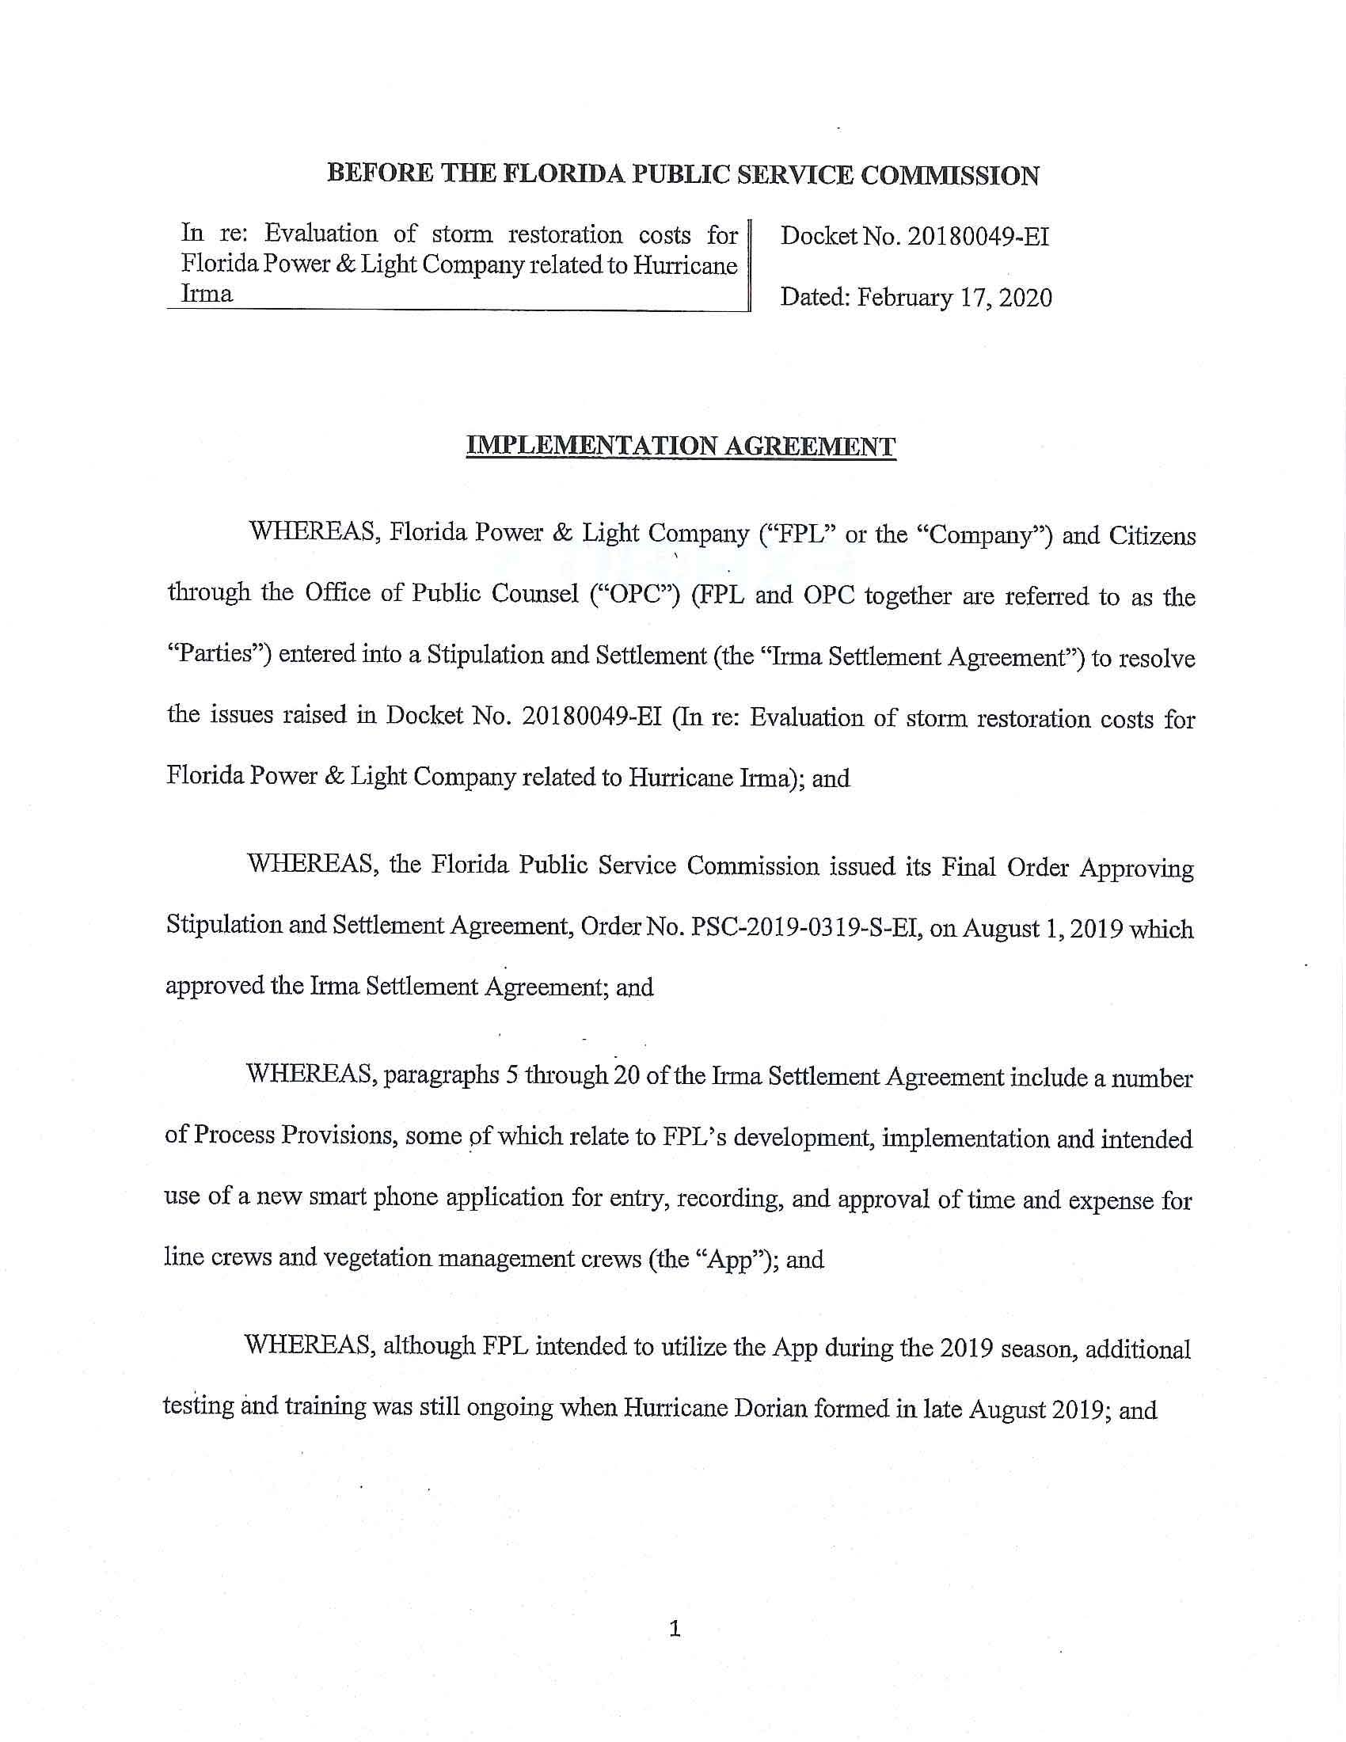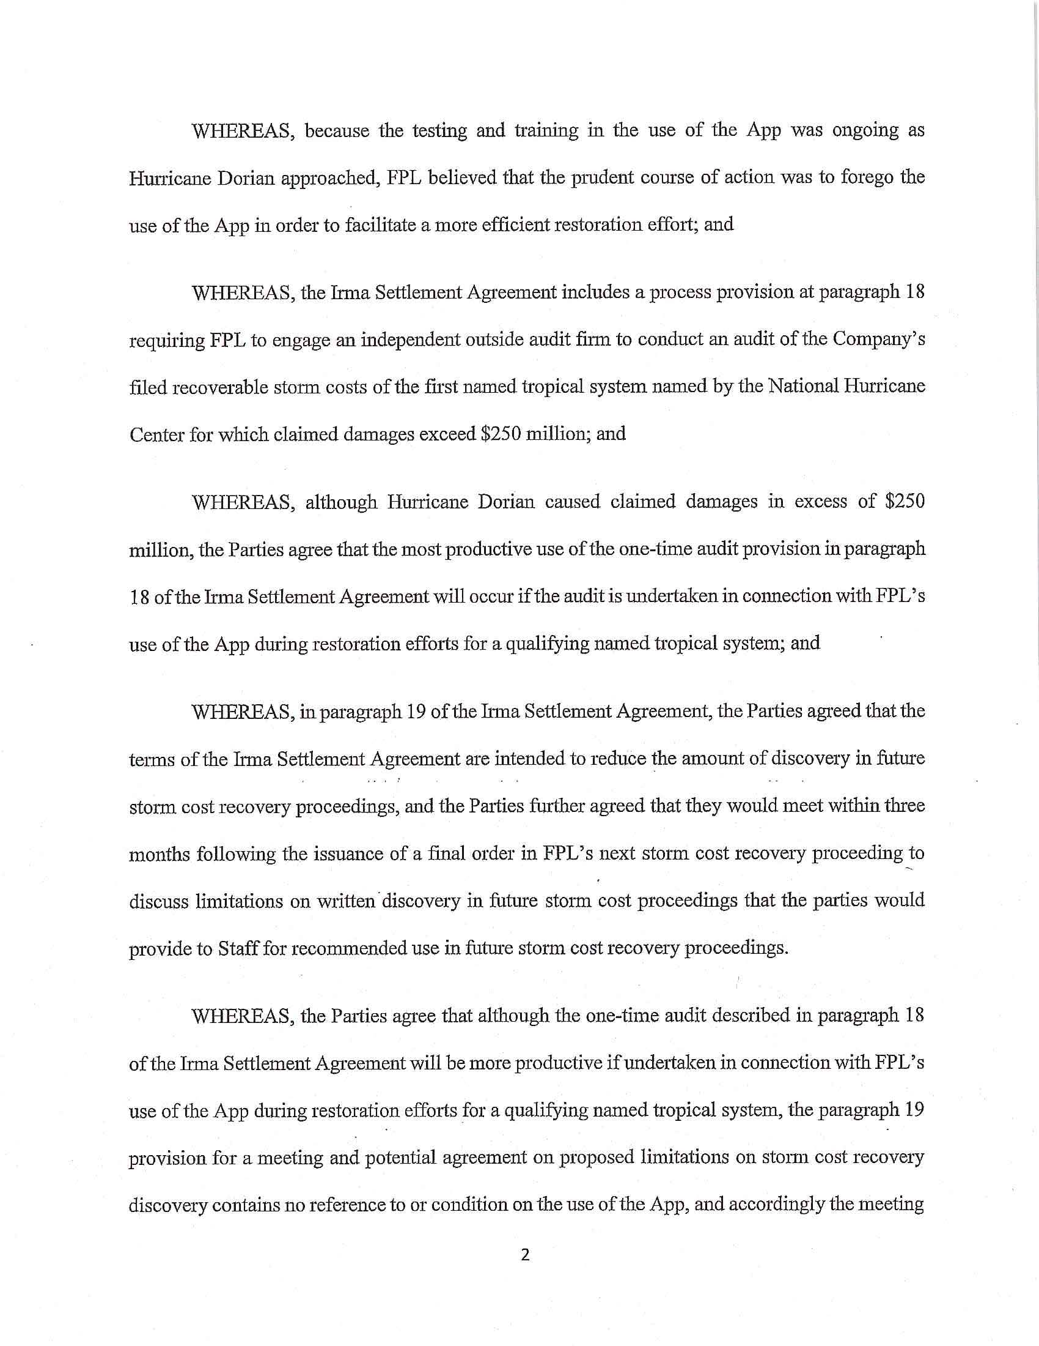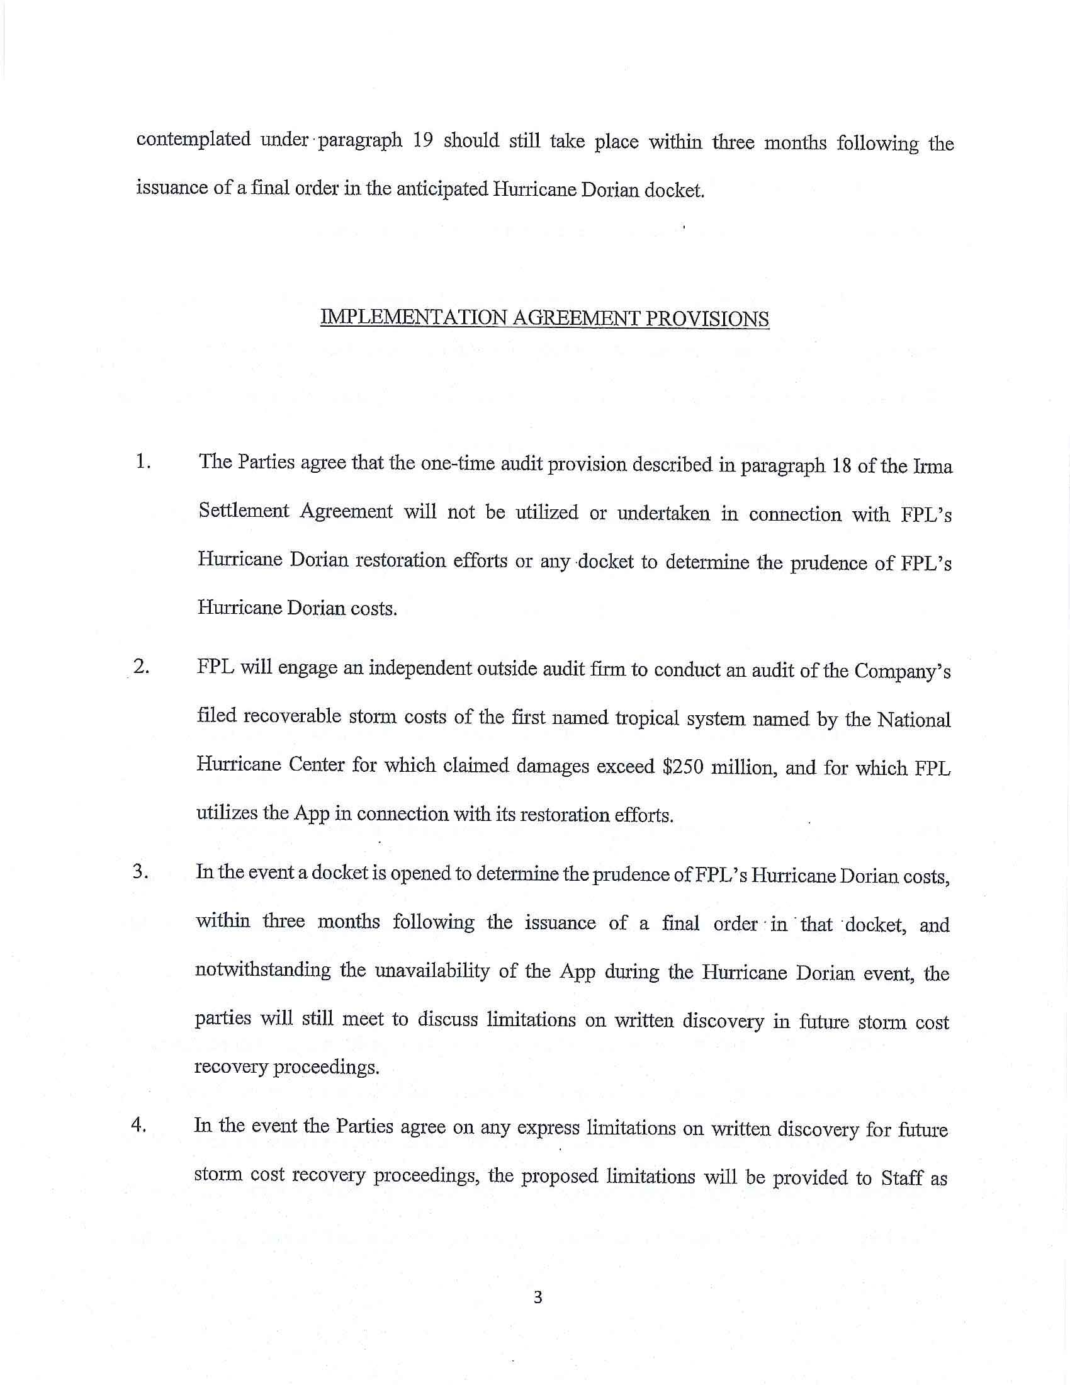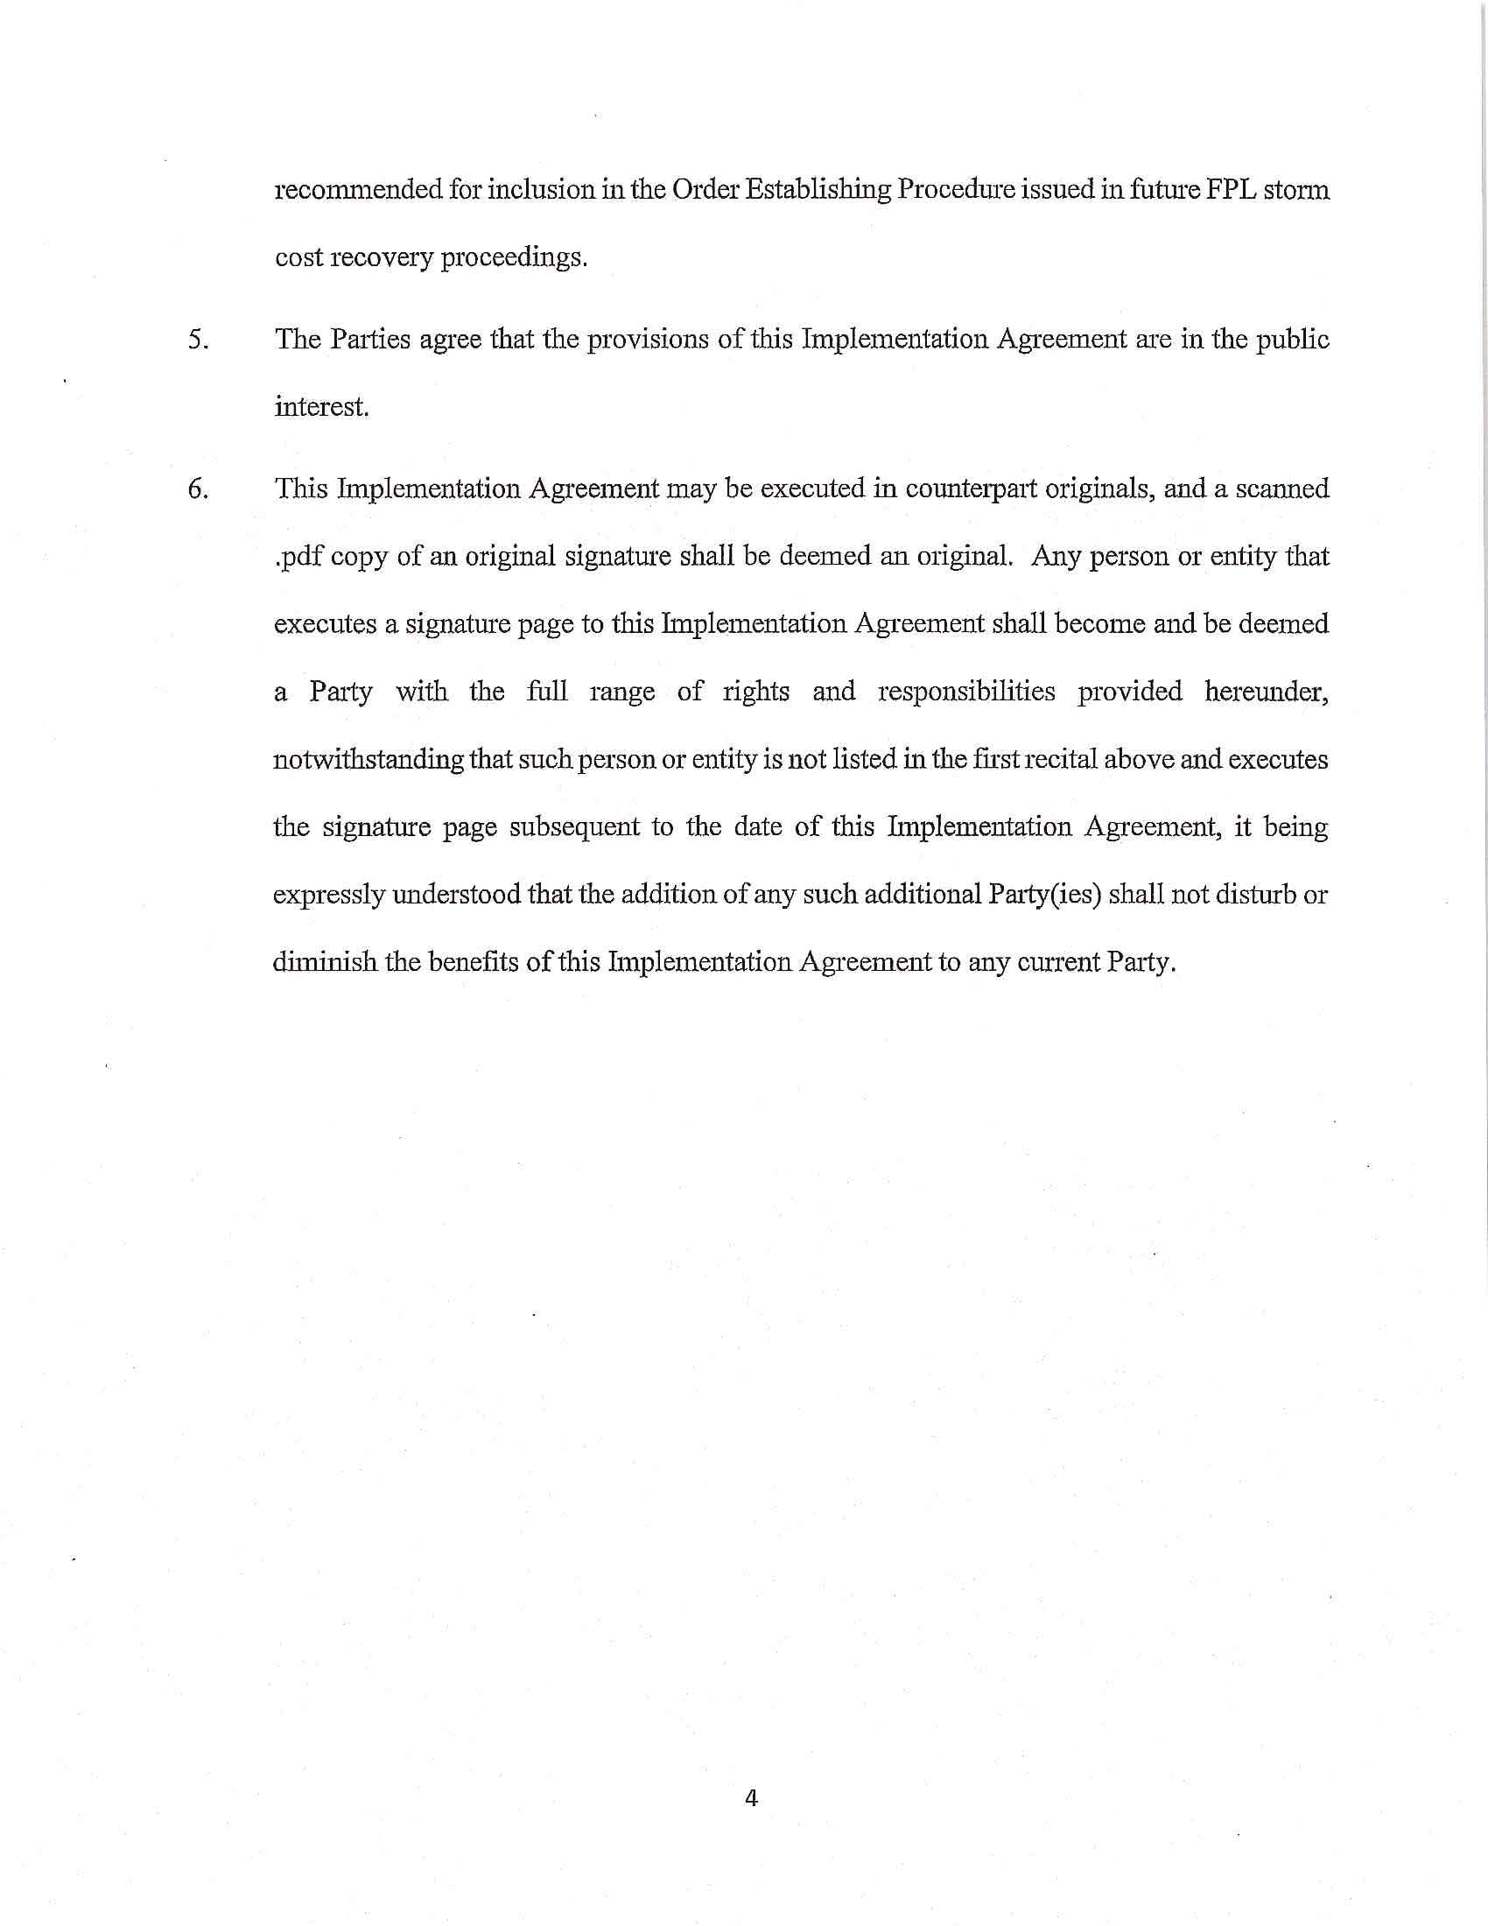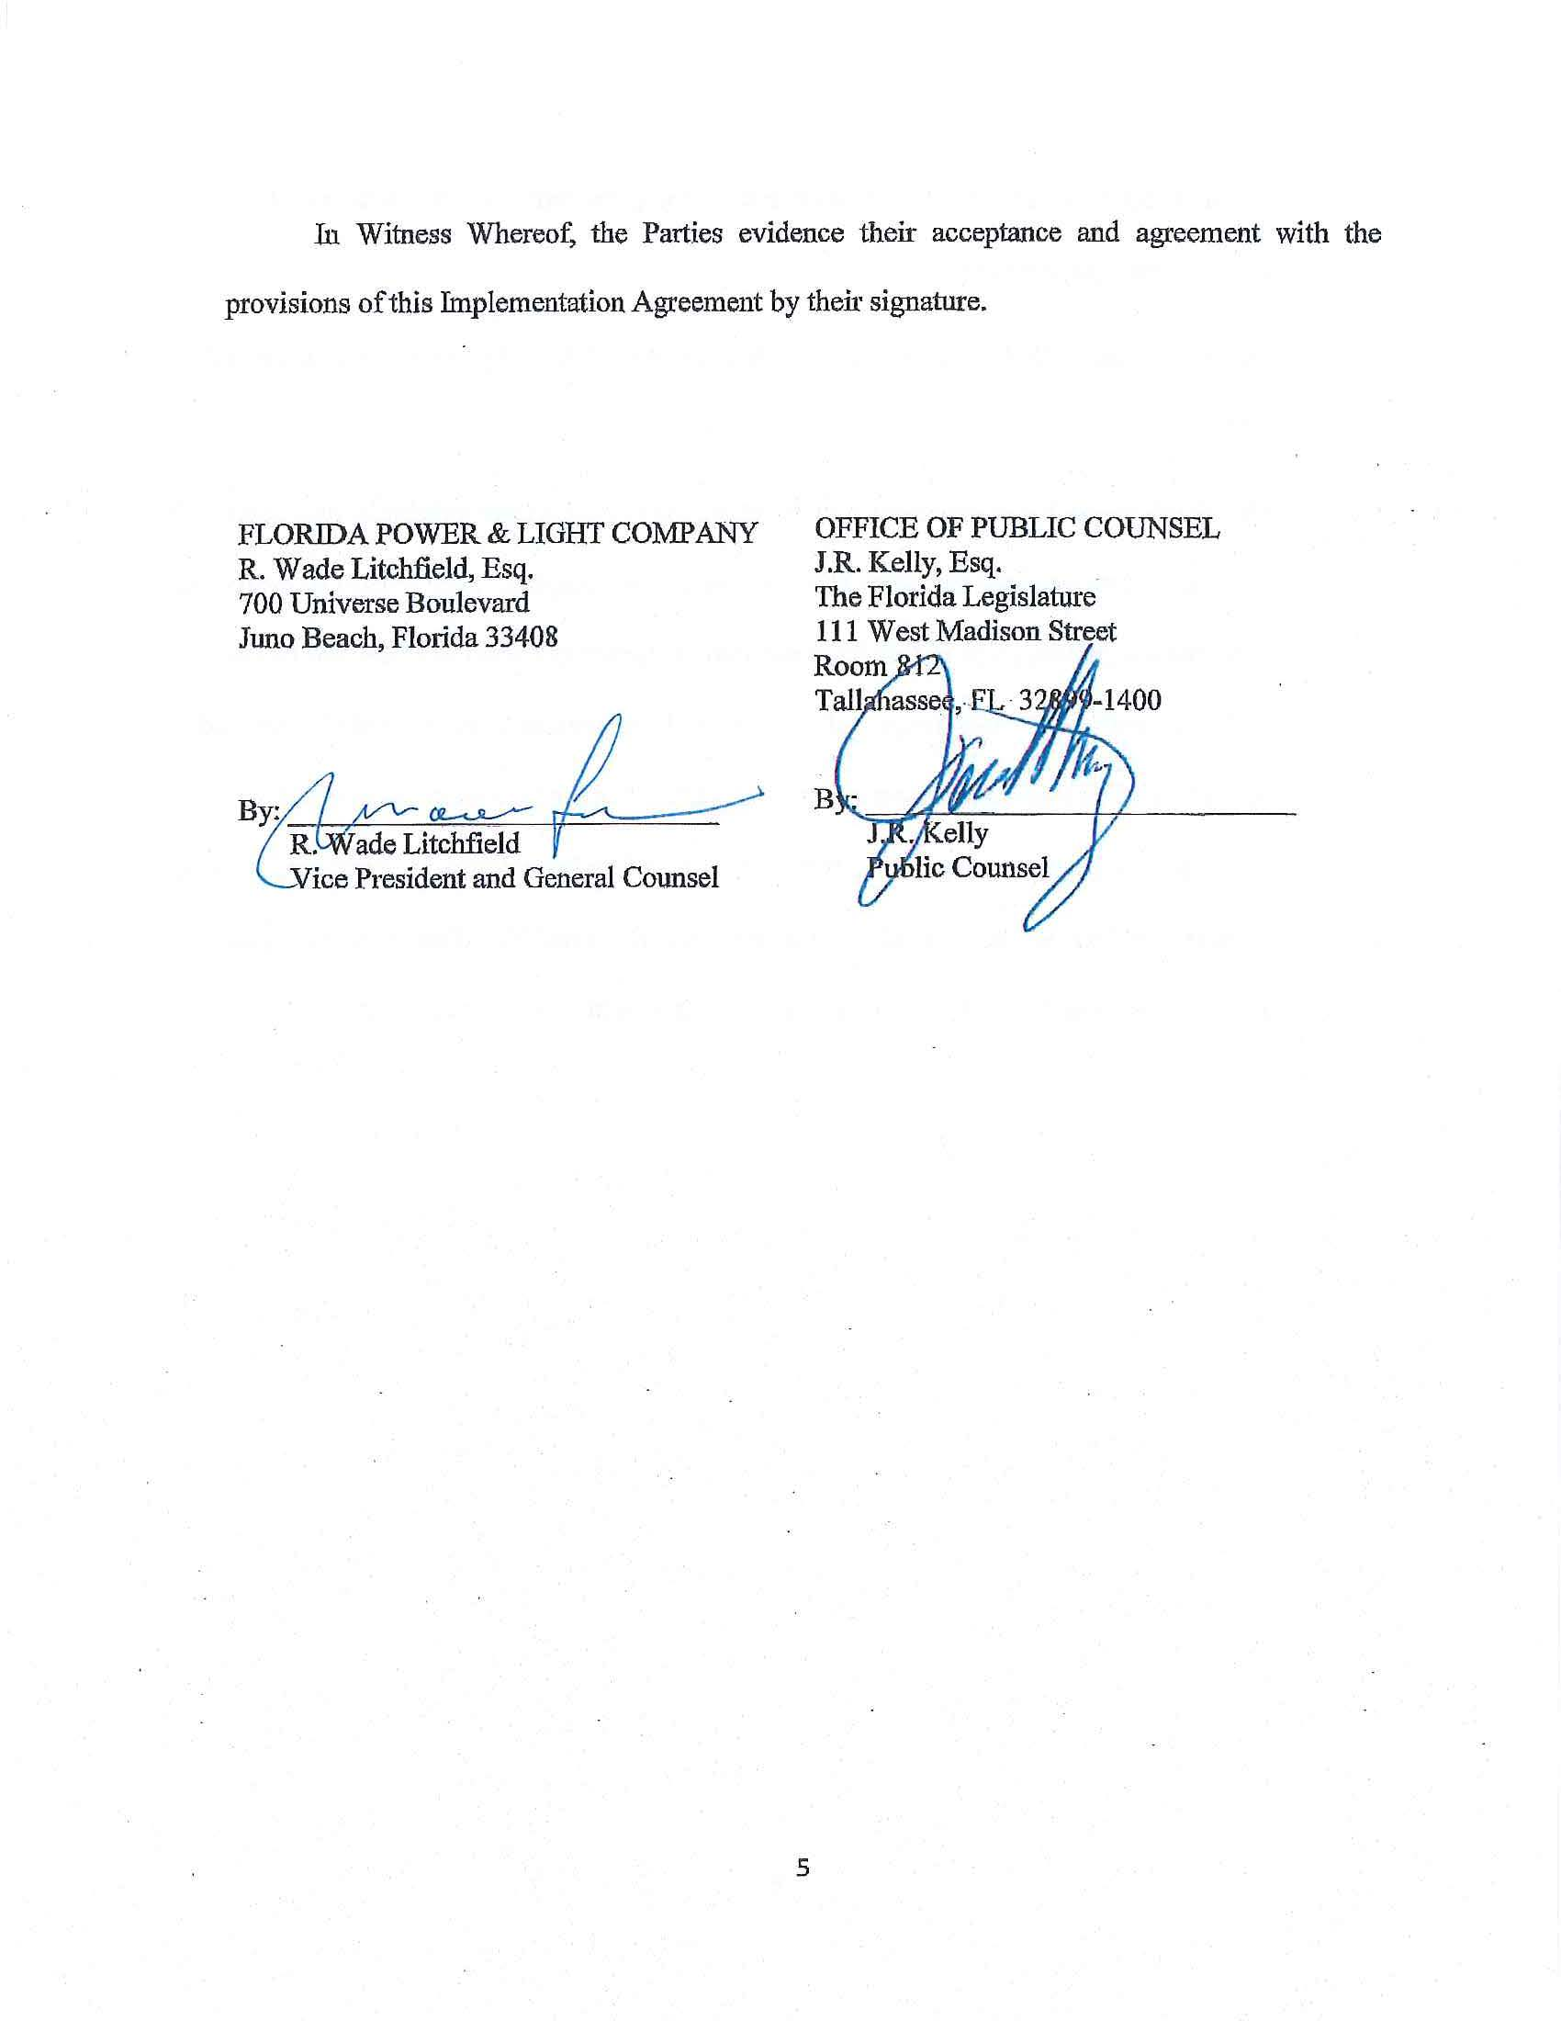

Although the Florida Industrial Power Users Group (FIPUG) was not initially a signatory to the proposed Storm Settlement, it subsequently endorsed the proposed Storm Settlement. See Document No. 04584-2019.
Order No. PSC-2019-0319-S-EI, issued August 1, 2019, in Docket No. 20180049-EI, In re: Evaluation of storm restoration costs for Florida Power & Light Company related to Hurricane Irma.

