State of Florida |  | Public Service Commission  Capital Circle Office Center ● 2540 Shumard Oak Boulevard  Tallahassee, Florida 32399-0850  -M-E-M-O-R-A-N-D-U-M-
DATE: | March 19, 2020
TO: | Office of Commission Clerk (Teitzman)
FROM: | Division of Accounting and Finance (M. Andrews, D. Buys, Mouring, Fletcher, Richards, Cicchetti)  Division of Economics (Coston, Forrest)  Office of the General Counsel (Stiller, Crawford, Schrader)
RE: | Docket No. 20200039-GU – Petition for approval to implement a temporary storm cost recovery surcharge, by St. Joe Natural Gas Company.
AGENDA: | 03/31/20 – Regular Agenda – Participation is at the Commission’s Discretion
COMMISSIONERS ASSIGNED: |  |  | All Commissioners
PREHEARING OFFICER: |  |  | Graham
CRITICAL DATES: |  |  | None
SPECIAL INSTRUCTIONS: |  |  | None

Case Background
On January 24, 2020, St. Joe Natural Gas Company (SJNG or Company) filed its petition to recover incremental storm restoration costs related to Hurricane Michael. SJNG’s service area includes Mexico Beach and Port St. Joe, and its natural gas distribution system sustained significant damage as a result of Hurricane Michael. The Company has incurred incremental costs of $321,012 and projects $60,500 in remaining costs to complete the restoration of its gas system to pre-storm condition. SJNG is requesting to recover the $381,512 over a four-year period. Currently, SJNG is not a party to any settlement agreement regarding storm restoration expenditures, nor does SJNG have a storm reserve balance. The Company requests to implement a monthly per therm surcharge for all customer classes. Residential customers will see an impact that will range from approximately $1.68 to $3.10 per month based on the level of usage.
The Office of Public Counsel’s intervention in this docket was acknowledged by Order No. PSC-2020-0066-PCO-GU, issued March 2, 2020.
The Commission has jurisdiction over this matter pursuant to Sections 366.04, 366.05, and 366.06, Florida Statutes (F.S.).

Discussion of Issues

Issue 1:
Should the Commission authorize SJNG to implement a temporary storm cost recovery surcharge?

Recommendation:
Yes, the Commission should authorize SJNG to implement a temporary storm cost recovery surcharge. Once the total actual storm costs are known, SJNG should be required to file documentation of the total storm costs for Commission review and true-up of any over/under recovery. The disposition of any over/under recovery, and associated interest, will be considered by the Commission at a later date. (M. Andrews, Mouring)

Staff Analysis:
As stated in the Case Background, SJNG filed a petition for approval of a temporary storm cost recovery surcharge to recover the incremental costs associated with Hurricane Michael. The Company’s total requested recovery amount of $381,512 includes $321,012 in actual costs that SJNG has determined to be incremental and $60,500 in projected costs. SJNG asserts that this amount was calculated in accordance with the Incremental Cost and Capitalization Approach (ICCA) methodology.

The approval of a temporary storm cost recovery surcharge is preliminary in nature and is subject to refund pending further review once the total actual storm restoration costs are known. After the actual costs are reviewed for prudence and reasonableness, and are compared to the actual amount recovered through the temporary storm cost recovery surcharge, a determination will be made whether any over/under recovery has occurred. The disposition of any over/under recovery, and associated interest, will be considered by the Commission at a later date. Under Section 366.06, F.S., the Commission has authority to allow for temporary storm cost recovery surcharges subject to refund: “[P]ursuant to the authority granted by the ‘file and suspend’ provisions of Section 366.06(3), Florida Statutes, this Commission may establish, prior to an evidentiary administrative hearing, rates subject to refund outside of full base rate proceedings.”

After reviewing the information provided by SJNG in its petition, staff recommends that the Commission authorize SJNG to implement a temporary storm cost recovery surcharge subject to refund. Once the total actual storm costs are known, SJNG should be required to file documentation of the storm costs for Commission review and true-up of any over/under recovery. Staff emphasizes that this recommendation is only for purposes of implementing temporary storm cost recovery surcharges and is not a confirmation or endorsement of the prudence of SJNG’s actual or projected costs. This recommendation only allows SJNG to begin recovery on an interim basis. This interim recovery is subject to refund following a hearing or formal proceeding where the veracity and prudence of SJNG’s actual restoration costs can be fully vetted.

Issue 2:
Should the Commission approve SJNG’s proposed Hurricane Michael temporary storm cost recovery tariff?

Recommendation:
Yes, the Commission should approve SJNG’s proposed tariff as shown in Attachment A to the recommendation, effective May 1, 2020. (Forrest)

Staff Analysis:
SJNG is seeking approval of temporary storm cost recovery surcharges as shown in the second revised tariff sheet No. 83 (Attachment A to this recommendation). The Company is requesting the temporary surcharges to remain in effect for a period of 48 months, starting May 1, 2020. Staff reviewed the surcharge factor calculation shown on page 2 of Attachment B of the petition and believes the surcharges have been calculated correctly and consistent with the methodology used to calculate the Company’s Commission-approved Energy Conservation Cost Recovery factors.

SJNG has three residential rate schedules, based on annual therm consumption. An RS-1 customer, using eight therms per month, will see a bill increase of $1.68 per month. An RS-2 customer, using 18 therms per month, will see a bill increase of $2.28 per month. Finally, a residential customer in the RS-3 class, with a monthly usage of 32 therms, will see a bill increase of $3.10 per month. SJNG will notify its customers of the proposed surcharges during the April billing cycle.

Staff recommends that the Commission approve SJNG’s proposed Hurricane Michael temporary storm cost recovery tariff, as shown in Attachment A to the recommendation, effective May 1, 2020.

Issue 3:
What is the appropriate security to guarantee the amount collected subject to refund through the temporary storm cost recovery surcharge?

Recommendation:
The appropriate security to guarantee the funds collected subject to refund is a corporate undertaking. (Cicchetti, D. Buys, Richards)

Staff Analysis:

The Company has requested a corporate undertaking to guarantee the amount collected through the temporary storm cost recovery surcharges. The criteria for a corporate undertaking include sufficient liquidity, ownership equity, profitability, and interest coverage to guarantee any potential refund. Staff reviewed SJNG’s 2016, 2017 and 2018 annual reports filed with the Commission to determine the financial condition of the Company. SJNG has experienced a decreasing Net Income over the past three years, with a reported Net Income of $68,489 in 2018. However, SJNG has $3,058,268 of equity out of a total capitalization of $3,778,268 indicating an equity ratio of 80.9 percent. Also, SJNG’s relative level of liquidity over the most recent three-year period is within acceptable parameters and the Company’s interest coverage ratio is 4.0, which demonstrates an ability to cover its interest obligations. Based on this analysis and the totality of the circumstances, staff recommends that SJNG be allowed to secure the amount collected through a corporate undertaking.

This brief financial analysis is only appropriate for deciding if the Company can support a corporate undertaking in the amount proposed and should not be considered a finding regarding staff’s position on other issues in this proceeding.
Issue 4:
Should this docket be closed?

Recommendation:
No, this docket should remain open pending final reconciliation of actual recoverable Hurricane Michael storm costs with the amount collected pursuant to the temporary storm cost recovery surcharge. The disposition of any over or under recovery, and associated interest, will be considered by the Commission at a later date. (Stiller)

Staff Analysis:
No, this docket should remain open pending final reconciliation of actual recoverable Hurricane Michael storm costs with the amount collected pursuant to the temporary storm cost recovery surcharge. The disposition of any over or under recovery, and associated interest, will be considered by the Commission at a later date.

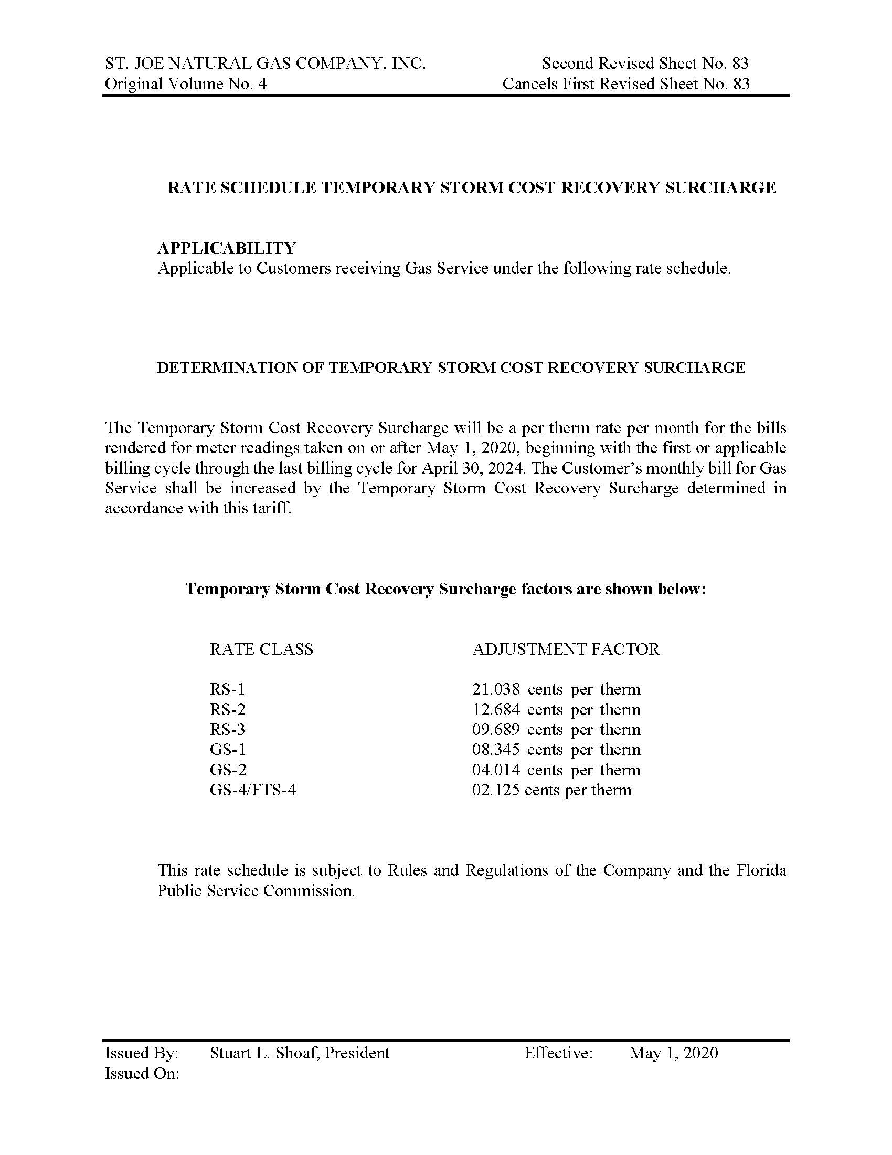

Order No. PSC-05-0187-PCO-EI, issued February 17, 2005, in Docket No. 041291-EI, In re: Petition for authority to recover prudently incurred storm restoration costs related to 2004 storm season that exceed storm reserve balance, by Florida Power & Light Company, at p.14.

