State of Florida |  | Public Service Commission  Capital Circle Office Center ● 2540 Shumard Oak Boulevard  Tallahassee, Florida 32399-0850  -M-E-M-O-R-A-N-D-U-M-
DATE: | March 19, 2020
TO: | Office of Commission Clerk (Teitzman)
FROM: | Division of Accounting and Finance (Snyder, M. Andrews, D. Buys, Mouring, Sewards)  Division of Engineering (P. Buys, King, Knoblauch, Lewis)  Office of the General Counsel (Trierweiler, Crawford, Schrader)
RE: | Docket No. 20190109-GU – Petition for recovery of costs associated with Hurricane Michael and replenishment of storm reserve, by Peoples Gas System.
AGENDA: | 03/31/20 – Regular Agenda – Proposed Agency Action – Interested Parties May Participate
COMMISSIONERS ASSIGNED: |  |  | All Commissioners
PREHEARING OFFICER: |  |  | Clark
CRITICAL DATES: |  |  | None
SPECIAL INSTRUCTIONS: |  |  | None

Case Background
On April 25, 2019, Peoples Gas System (Peoples or Company) filed a petition to recover approximately $3.4 million for the incremental restoration costs related to Hurricane Michael and to replenish the Company's storm reserve. On July 29, 2019, the Commission issued an order allowing Peoples to implement an interim storm recovery surcharge beginning with the first billing cycle of August 2019. Collections for the storm surcharge concluded in December 2019.

On February 12, 2020, Peoples and OPC (The Parties) filed a Joint Petition for Approval of Stipulation and Storm Cost Settlement Agreement (Settlement Agreement). The Settlement Agreement is attached as Attachment A. The Settlement Agreement includes adjustments to the recoverable storm amount and future process improvements for cost effective and timely storm damage recovery and service restoration.
The Settlement Agreement includes total adjustments to the storm cost recovery amount of $147,220, including $115,867 for regular payroll to be reclassified as capital and added to the Company’s Plant in Service balance. After adjustments, the revised recoverable storm amount is $3,235,482. The amount collected through the interim storm restoration recovery charge was $3,421,631. The resulting over-recovery amount of $186,149 will be credited to Peoples' Energy Conservation Cost Recovery Clause filing in 2020.
The Parties agree to a set of future storm restoration process improvements intended to allow cost-effective and timely storm damage recovery and service restoration that reasonably balances the customers' right to have service promptly restored with the customers' right not to pay excessive or improper costs to achieve that restoration. The future process improvements cover a broad range of storm cost recovery issues, including: contracting and vendor engagement, travel and work policies, cost documentation, auditing and regulatory recovery processes, and a methodology for determining incremental costs.
If approved by the Commission, the over-recovery amount of $186,149 will be credited to Peoples' Energy Conservation Cost Recovery Clause filing in 2020 and returned to customers through the trueup. The Parties will meet to evaluate the procedures and consider the need to amend them during the first quarter of 2022 and every three years thereafter.
The Settlement Agreement becomes effective after three milestones are met: the settlement agreement is approved by the Commission, a final order has been issued, and the final order becomes unappealable.
The Commission should vote on whether or not to grant the Joint Motion for Approval of Stipulation and Storm Cost Settlement Agreement at Attachment A.

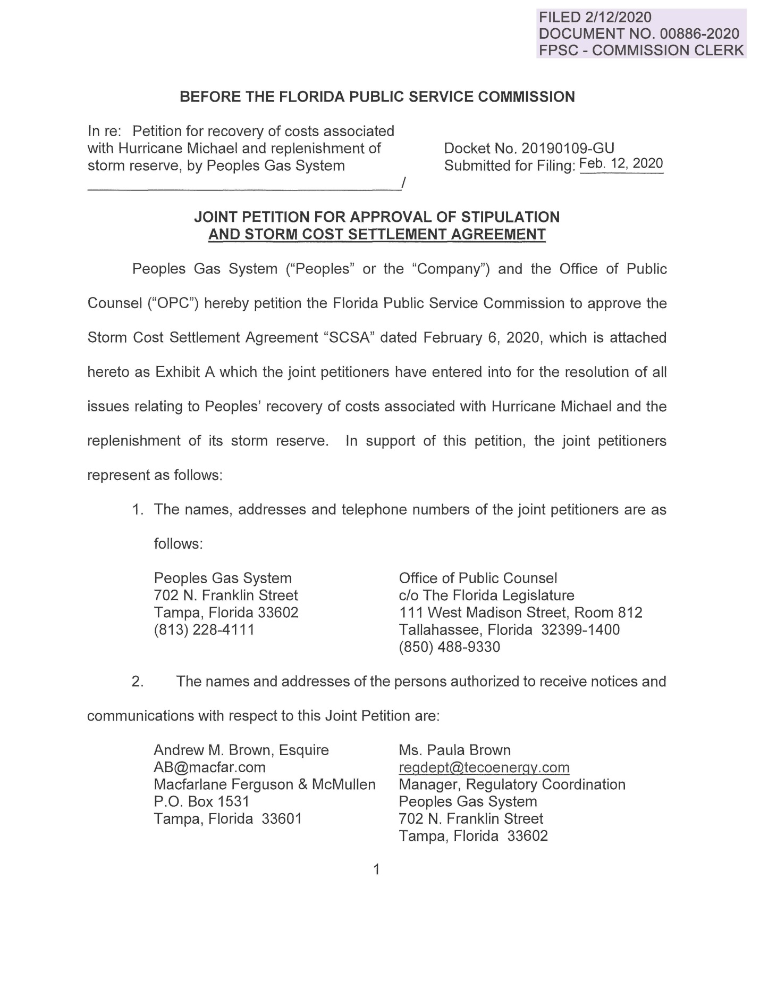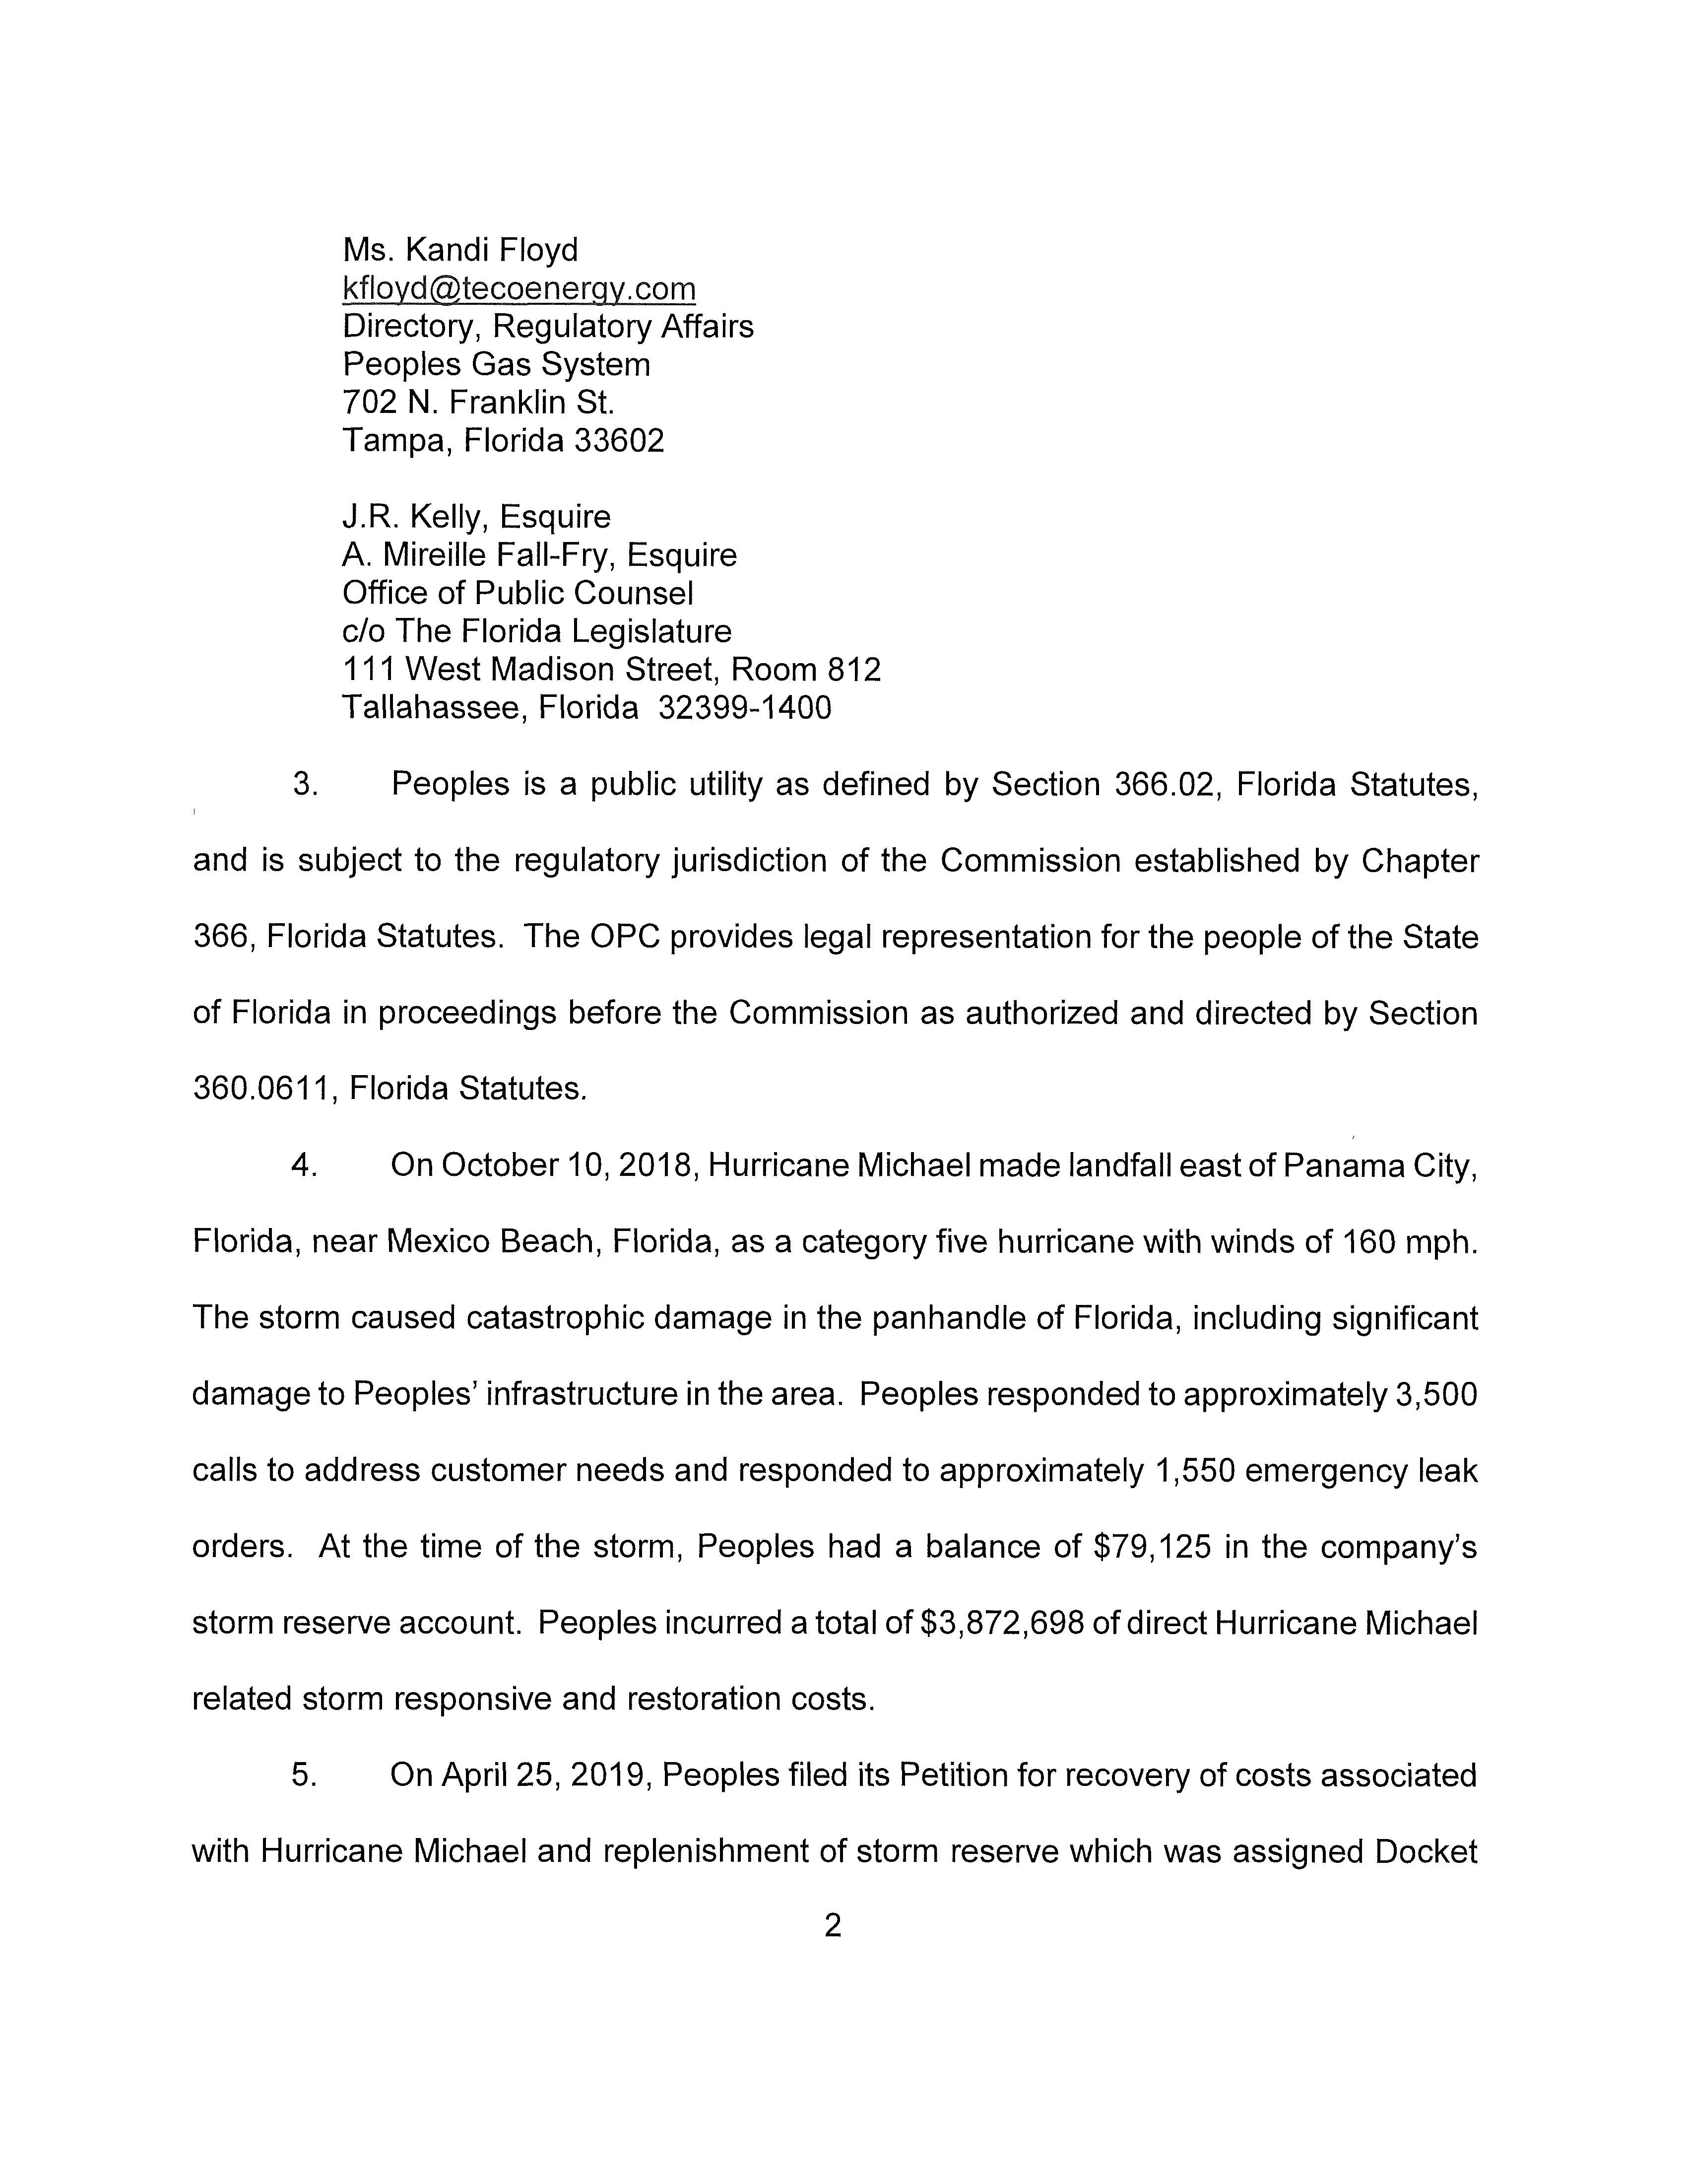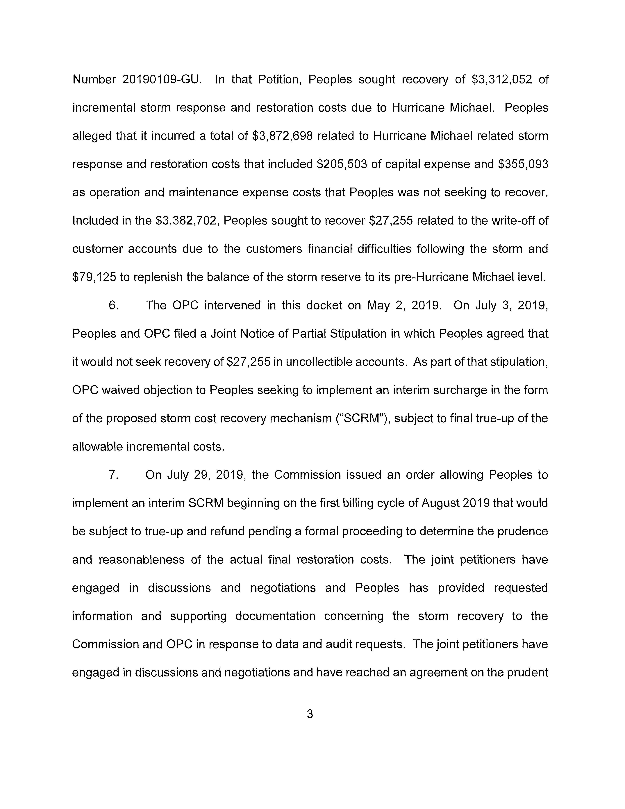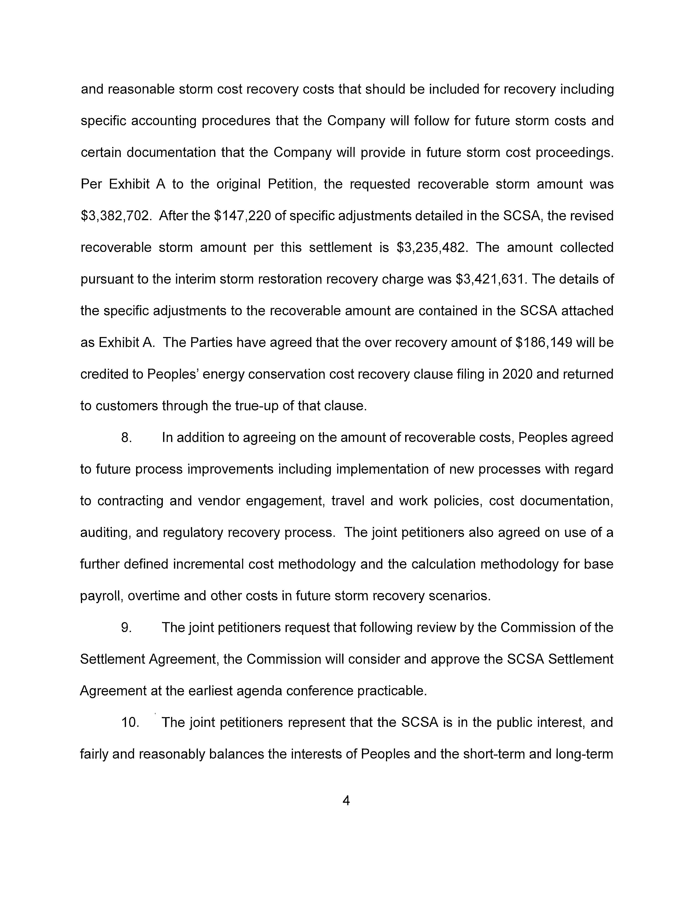

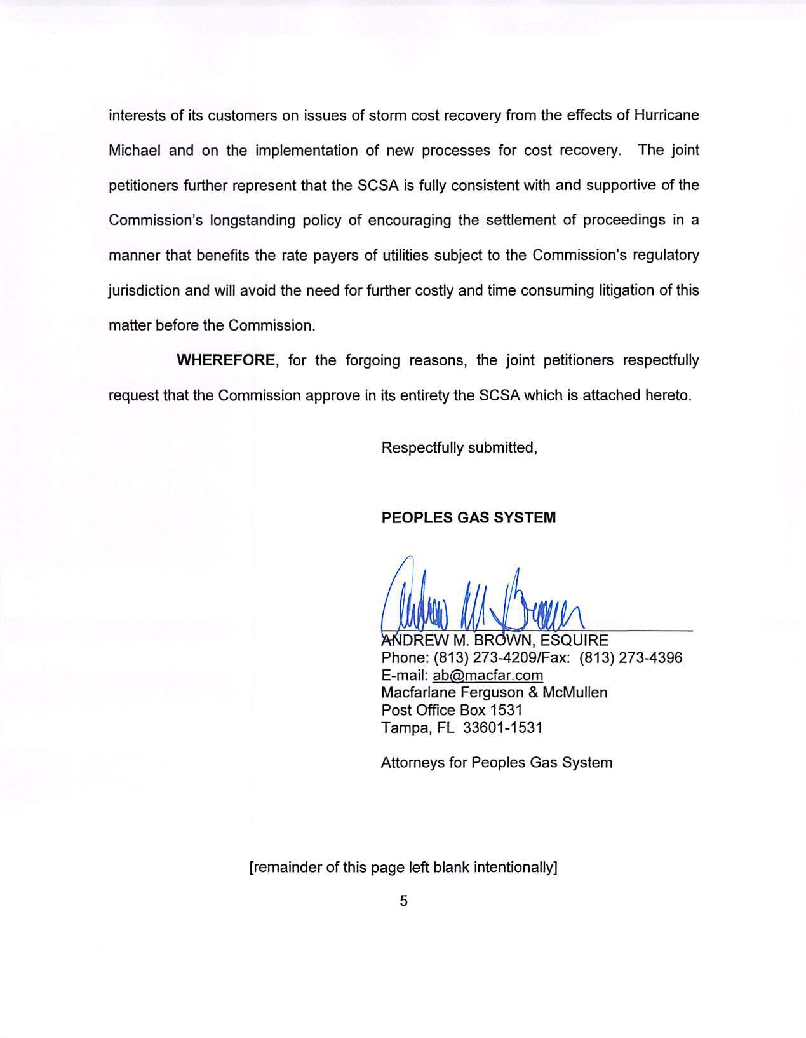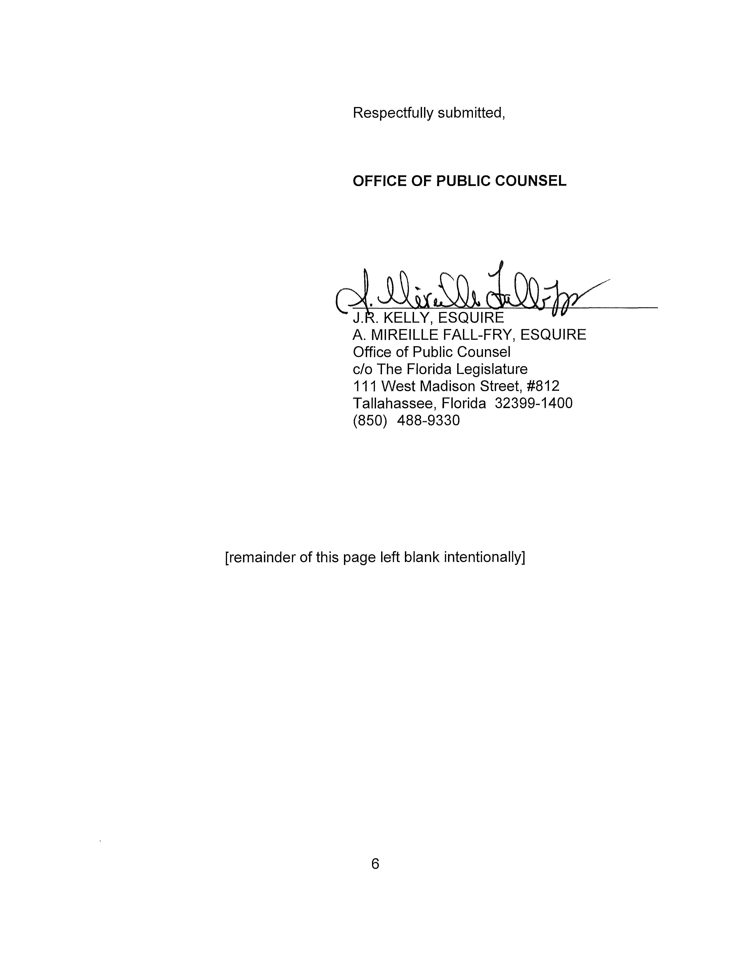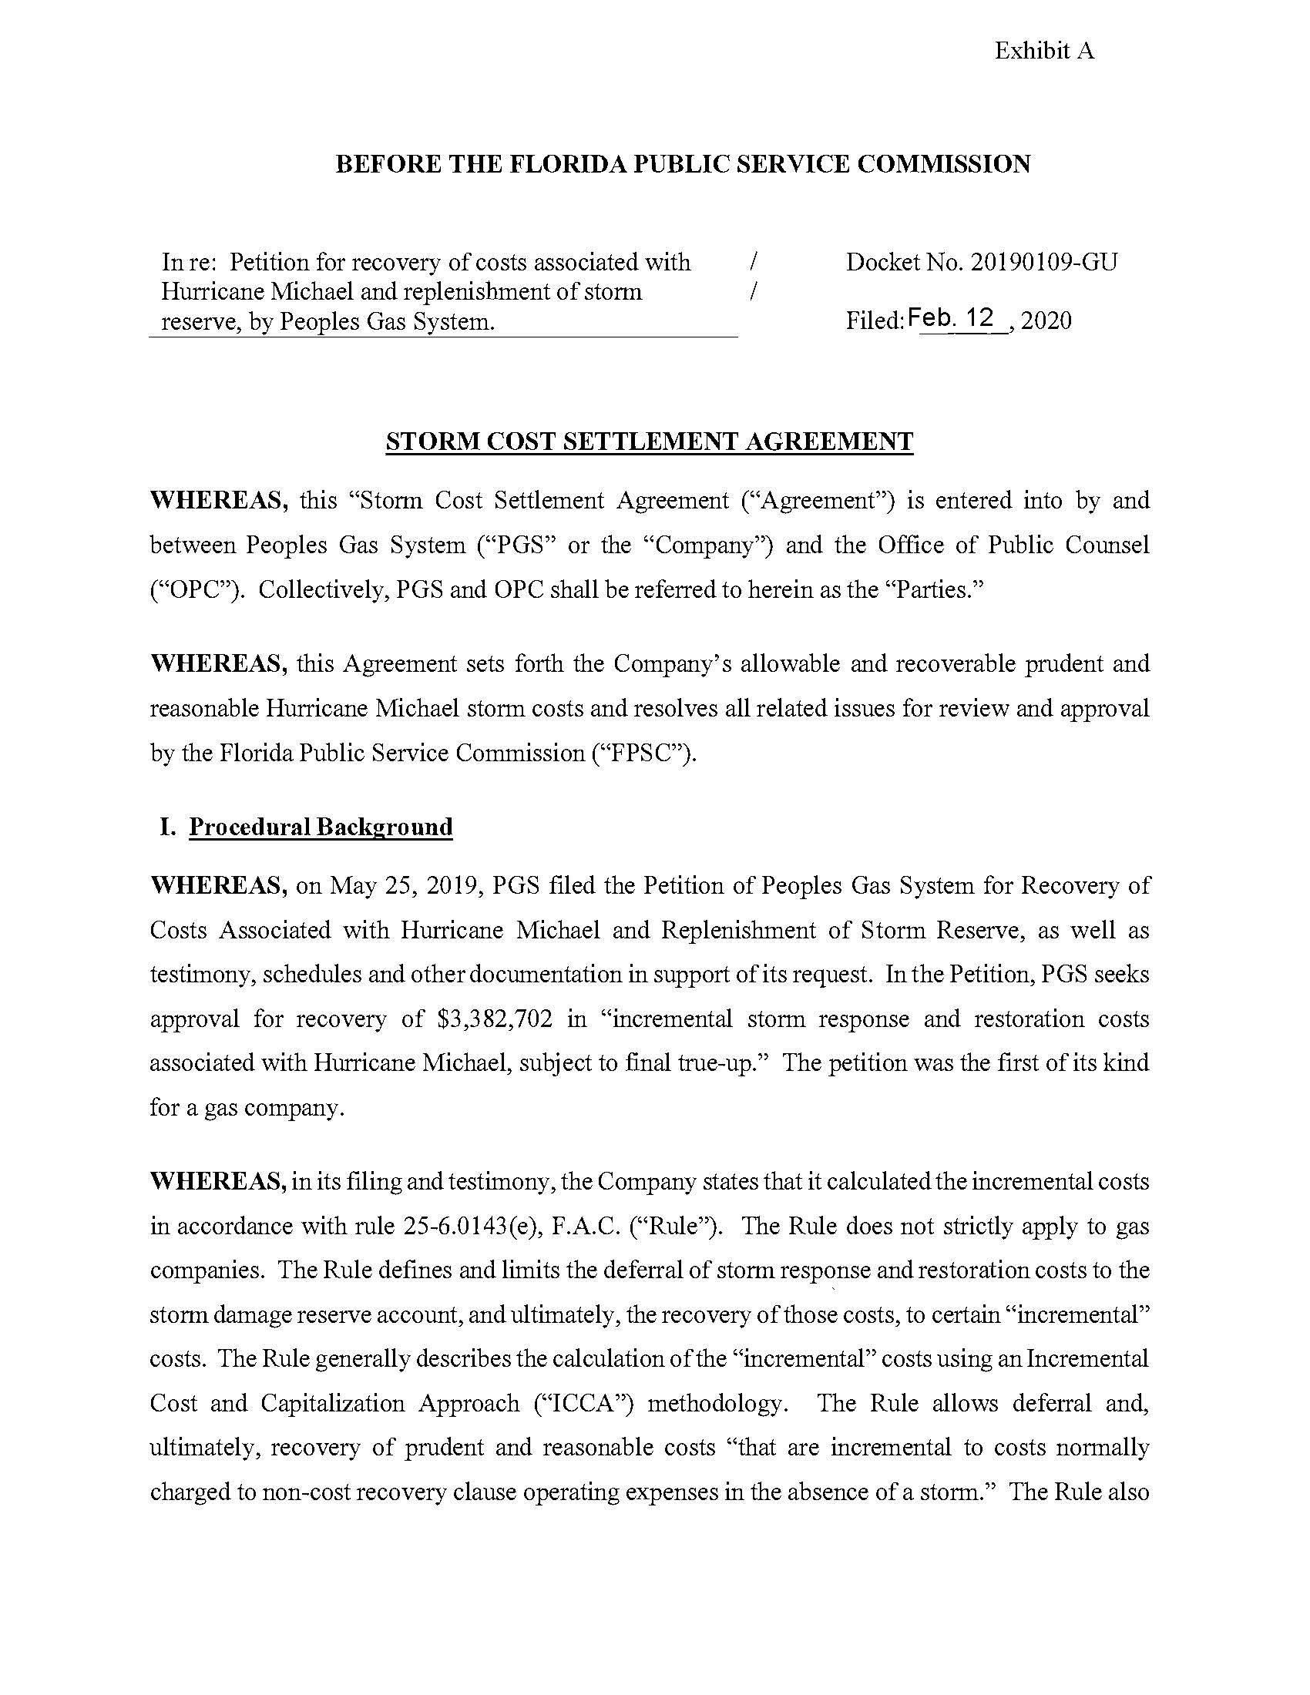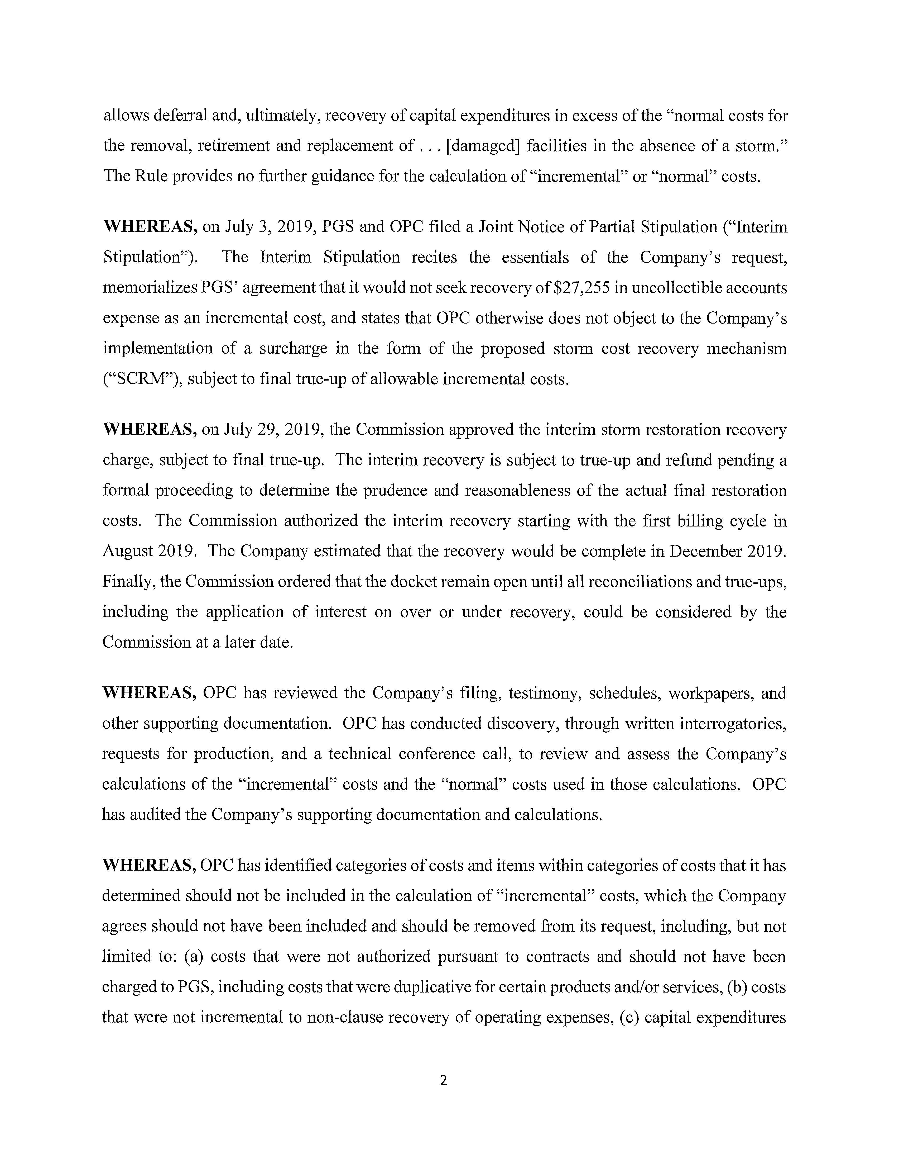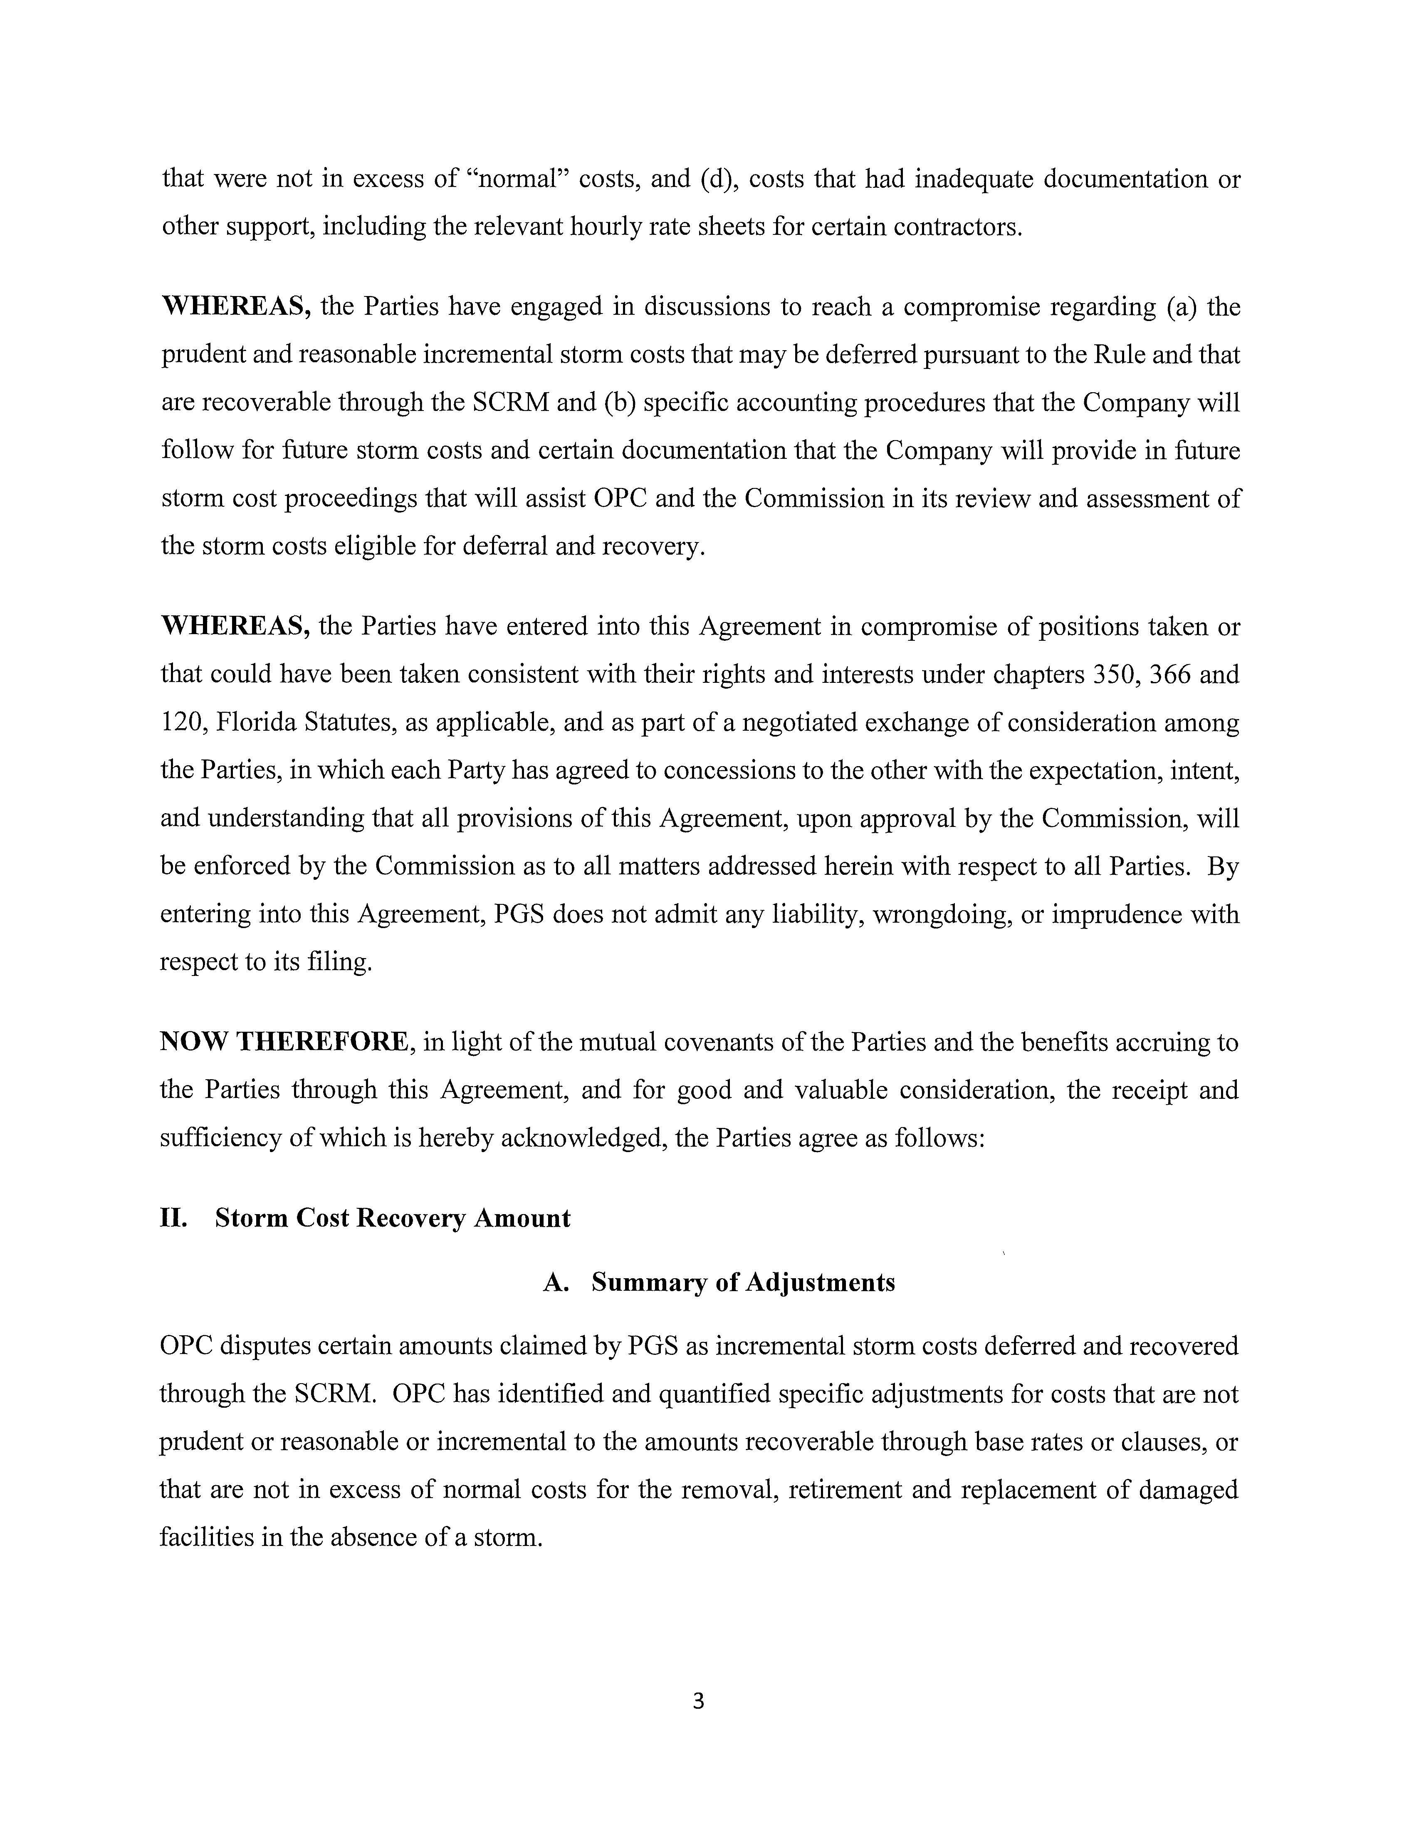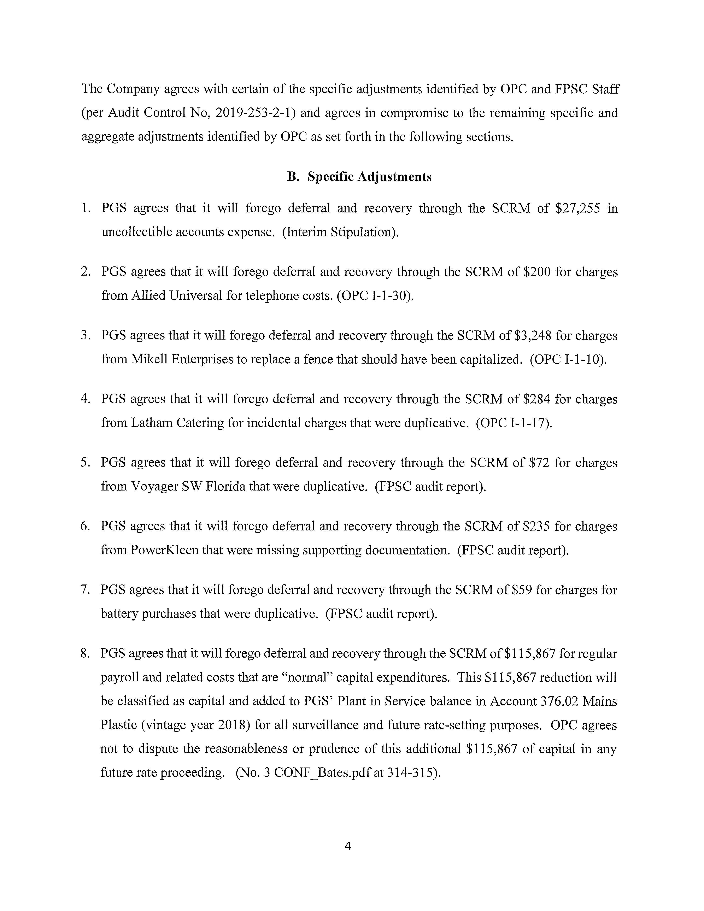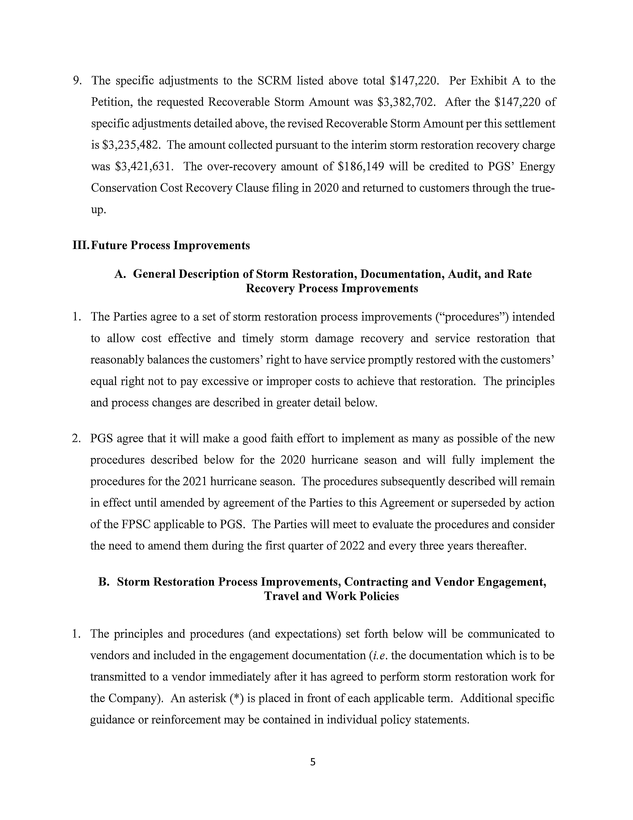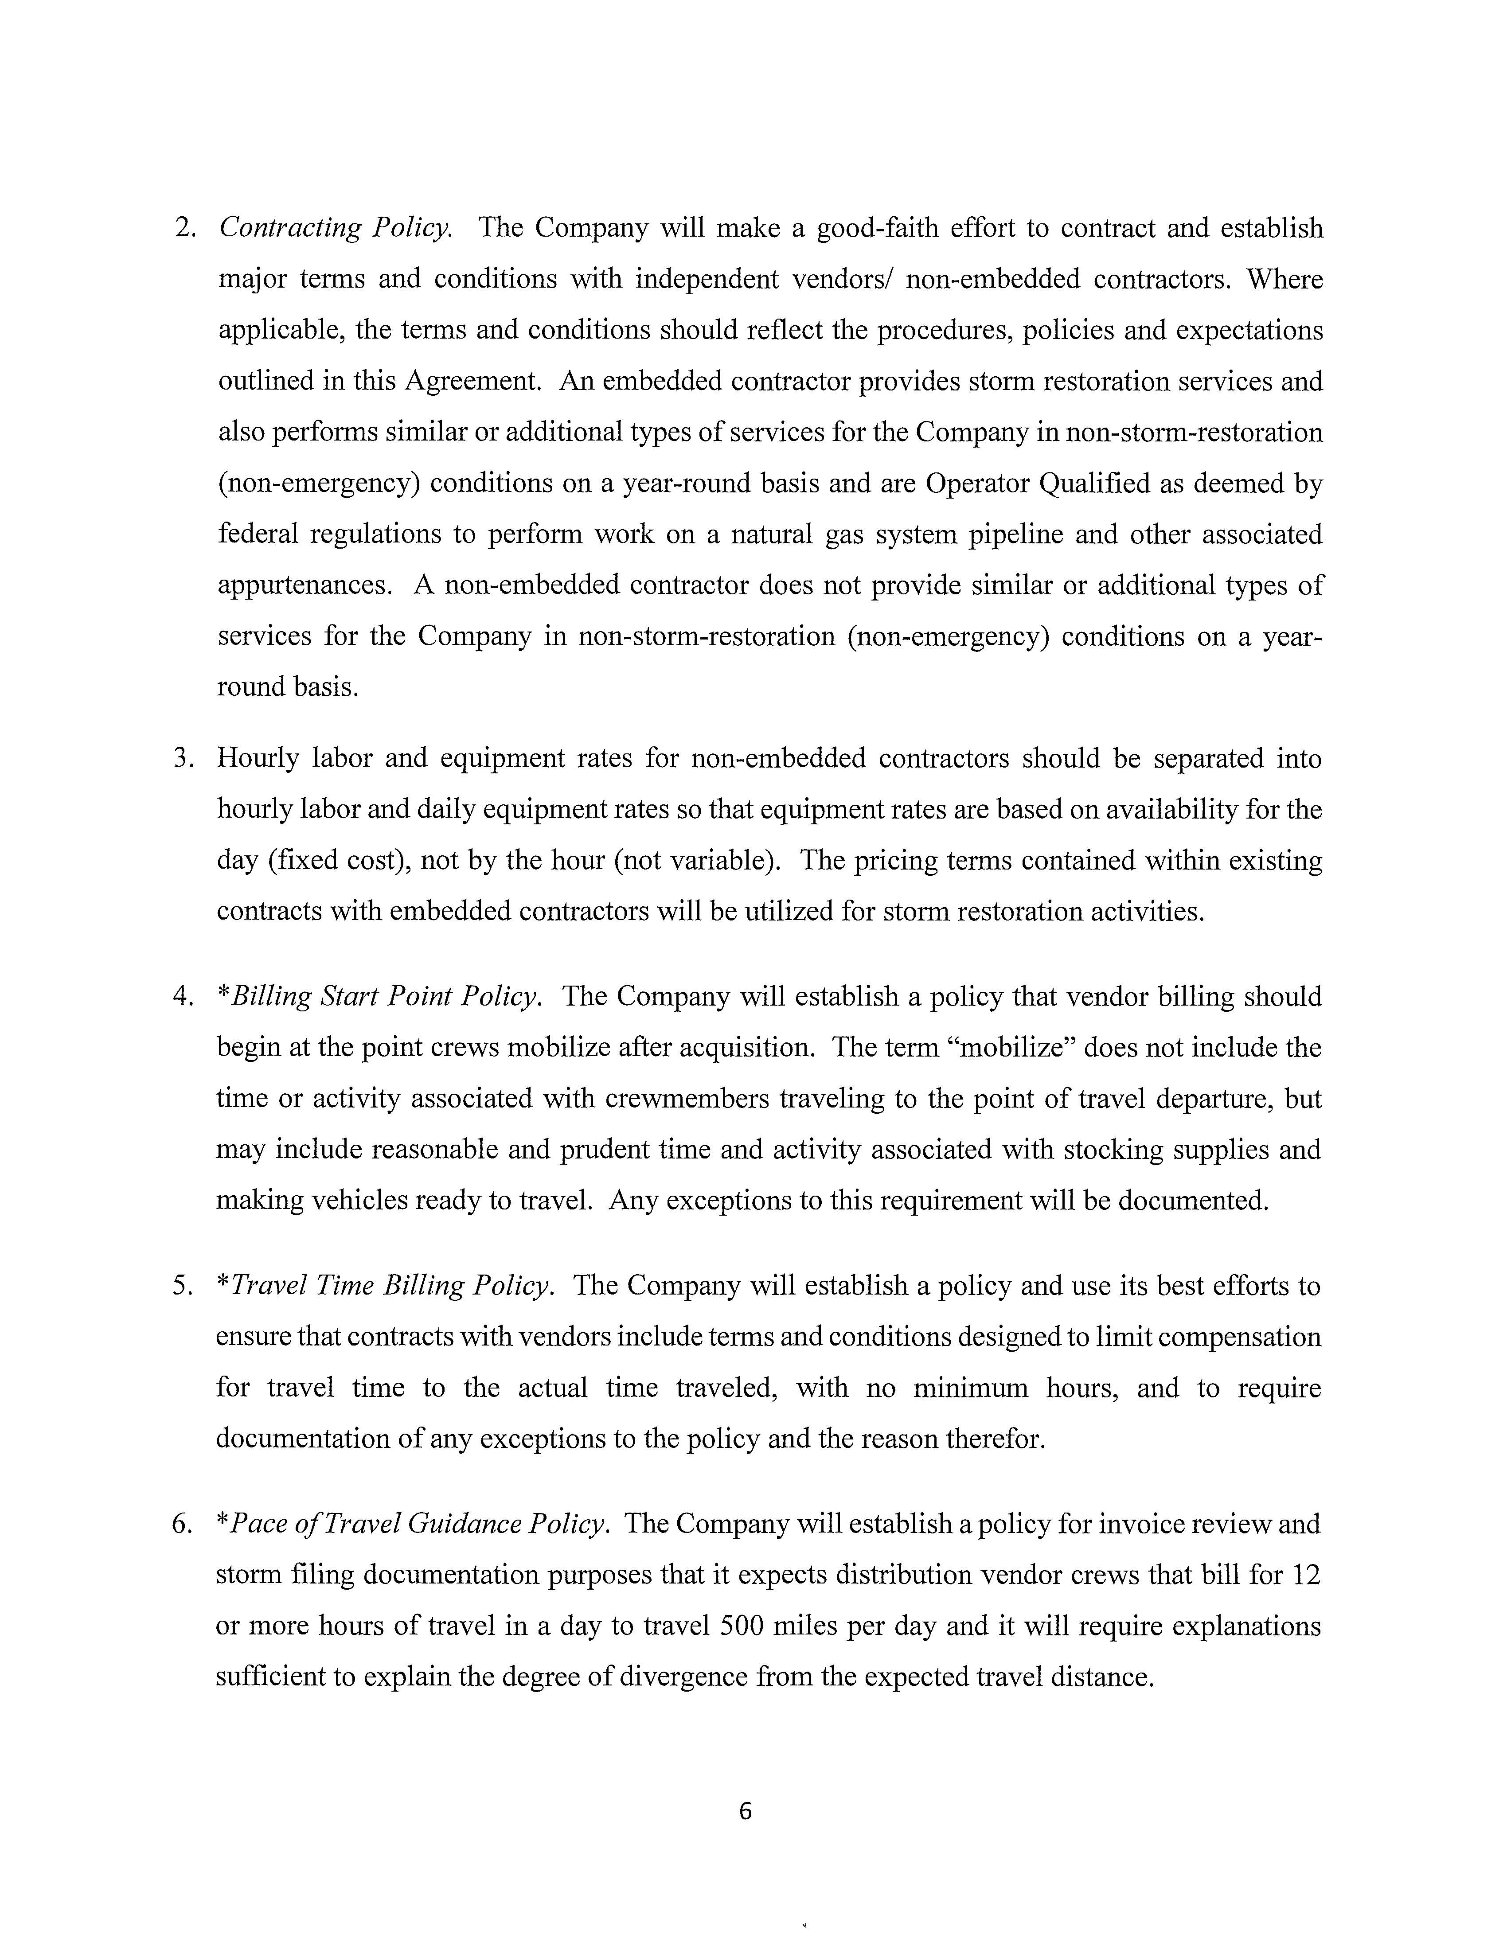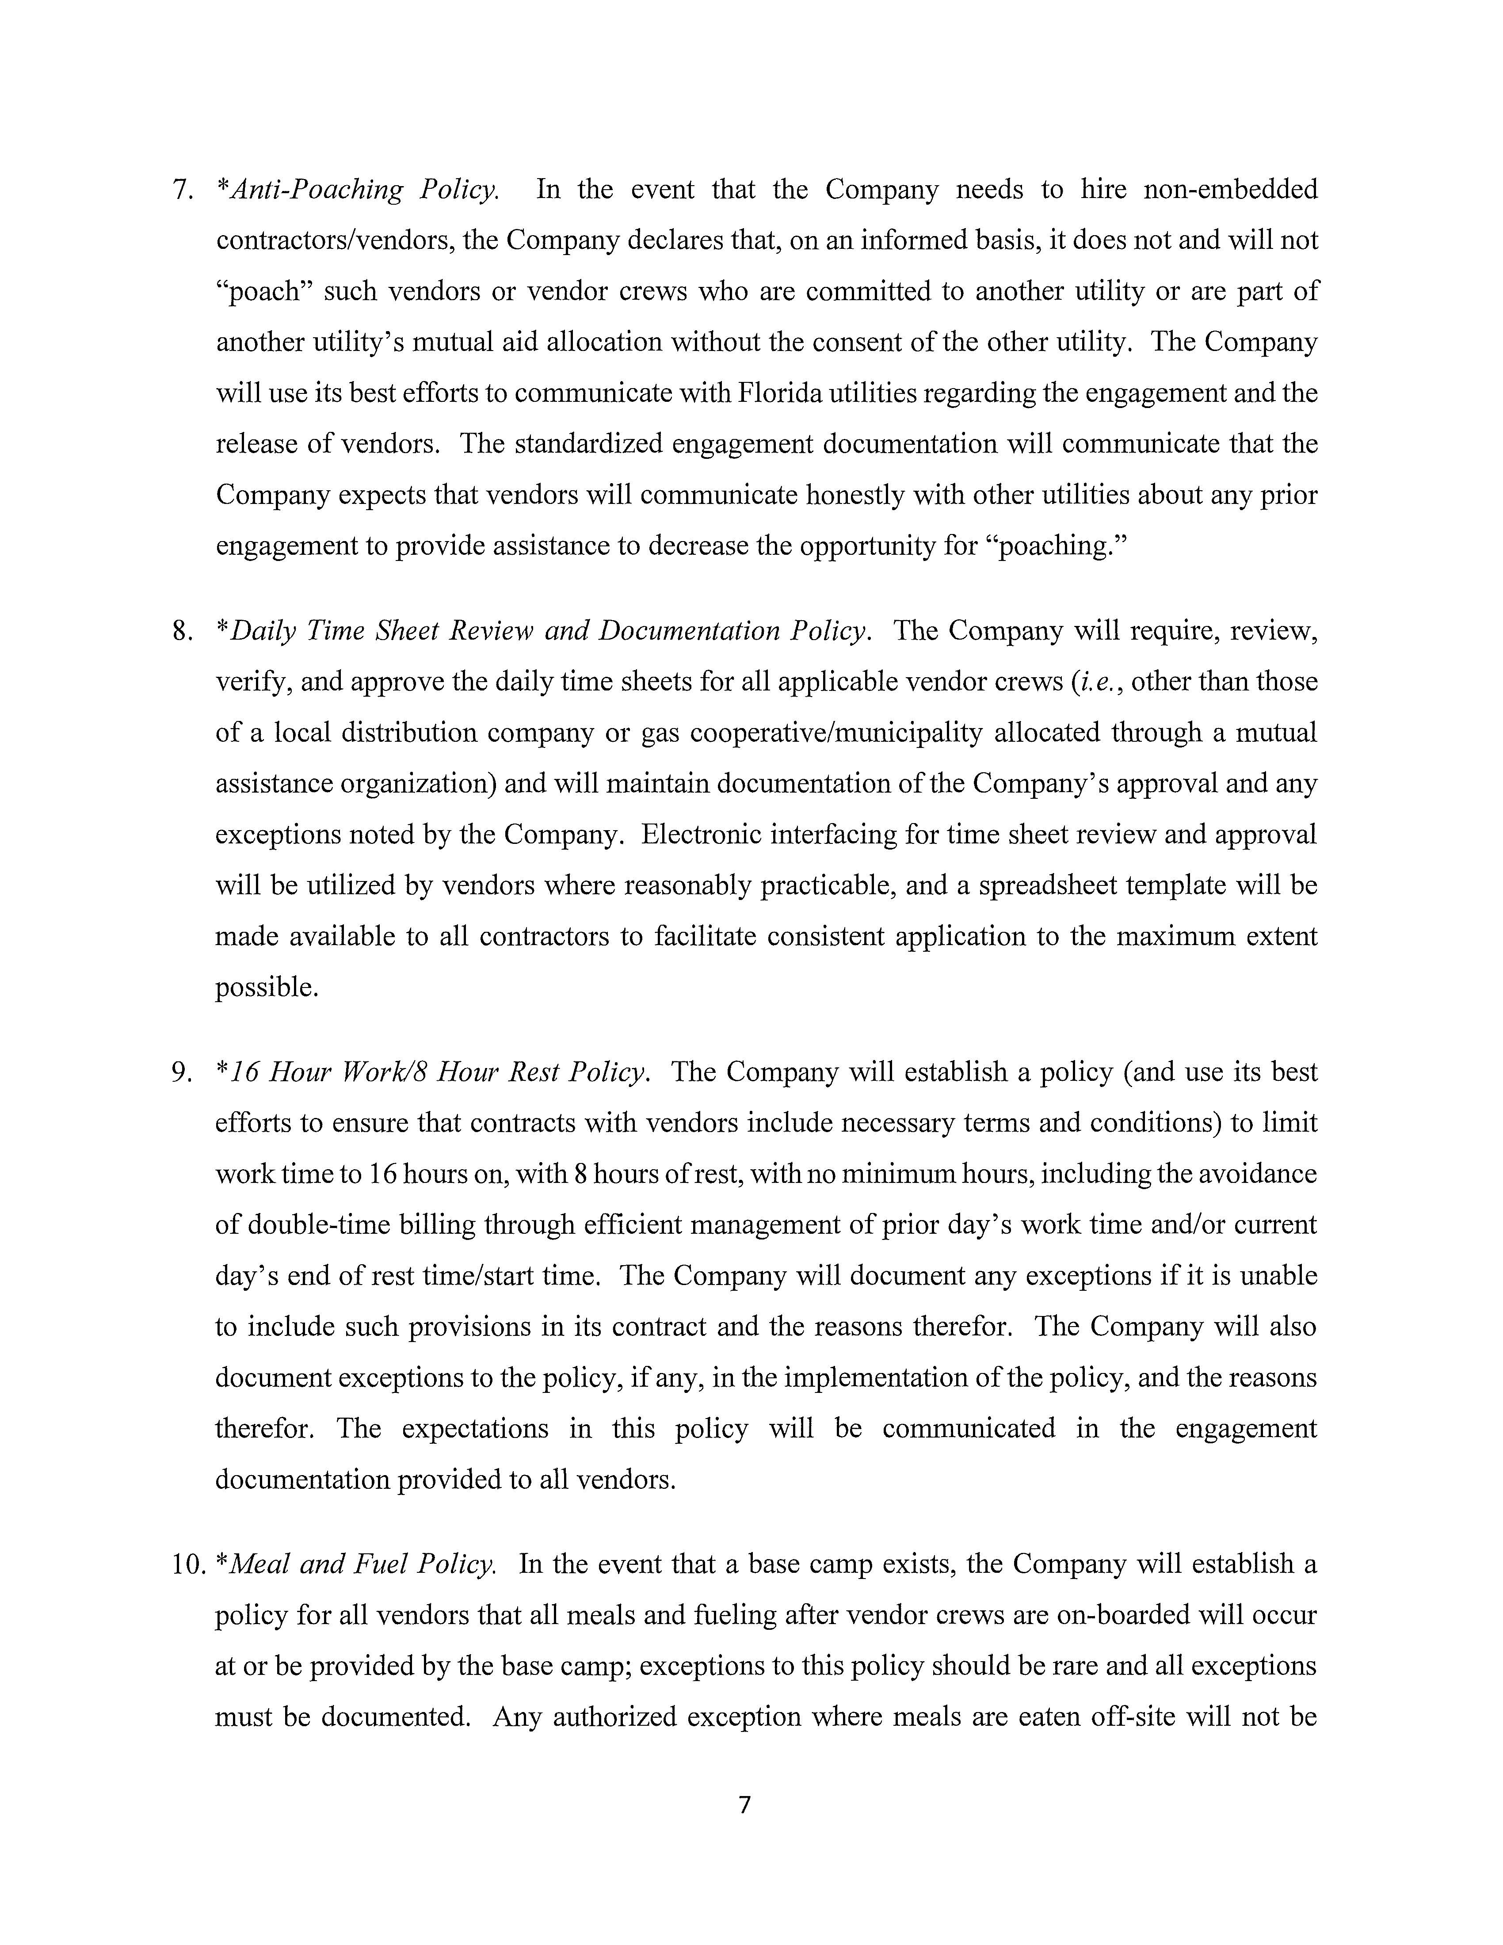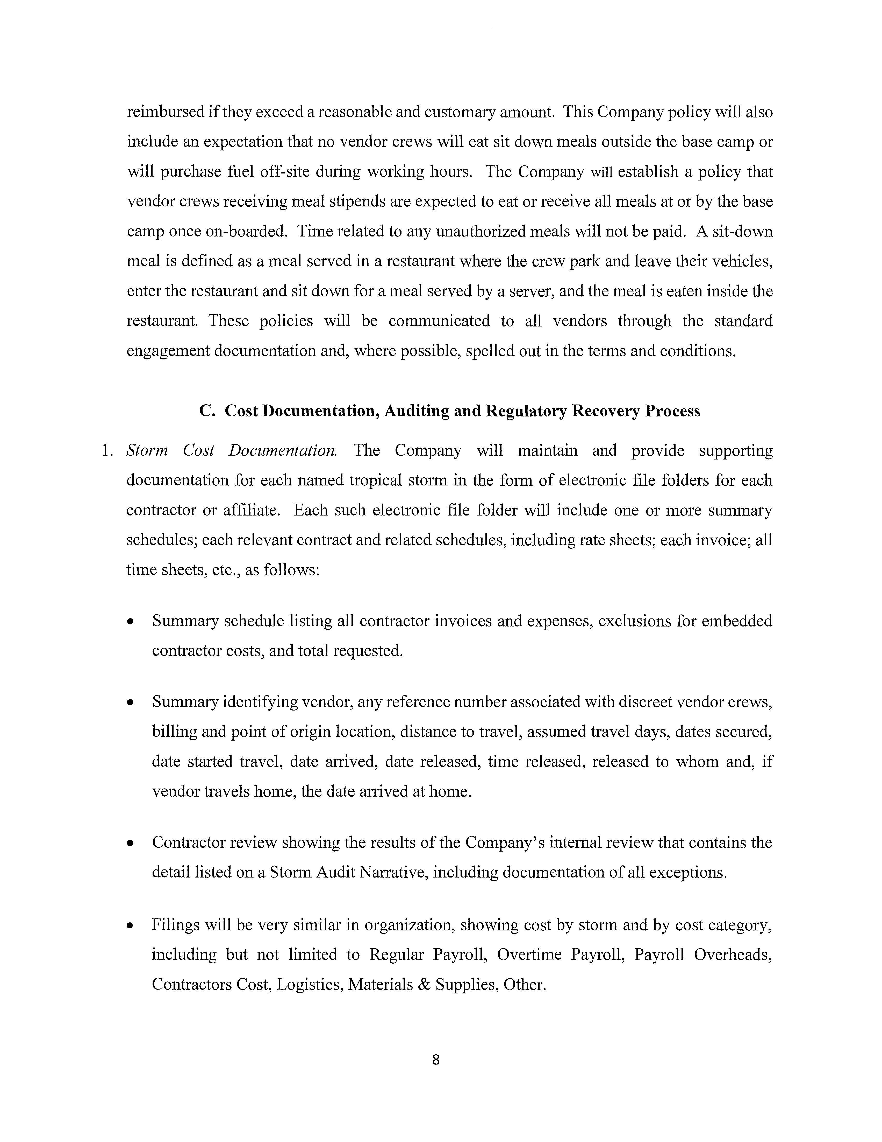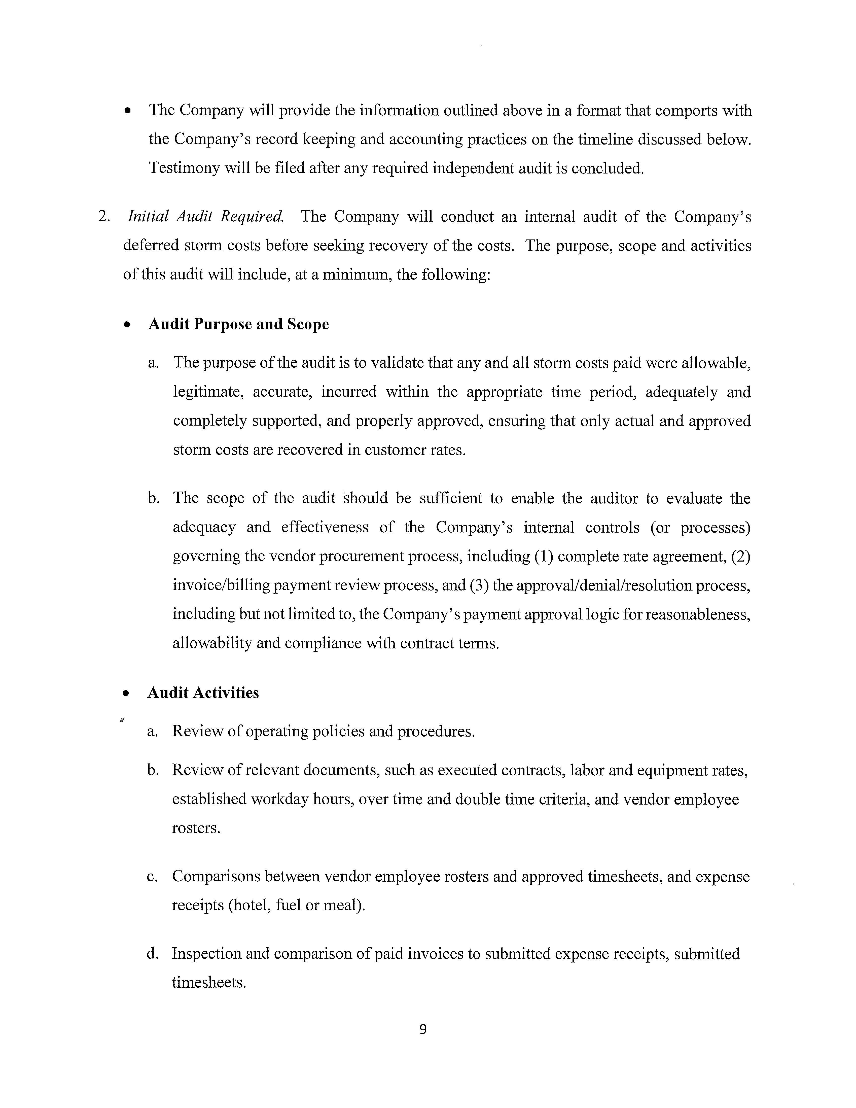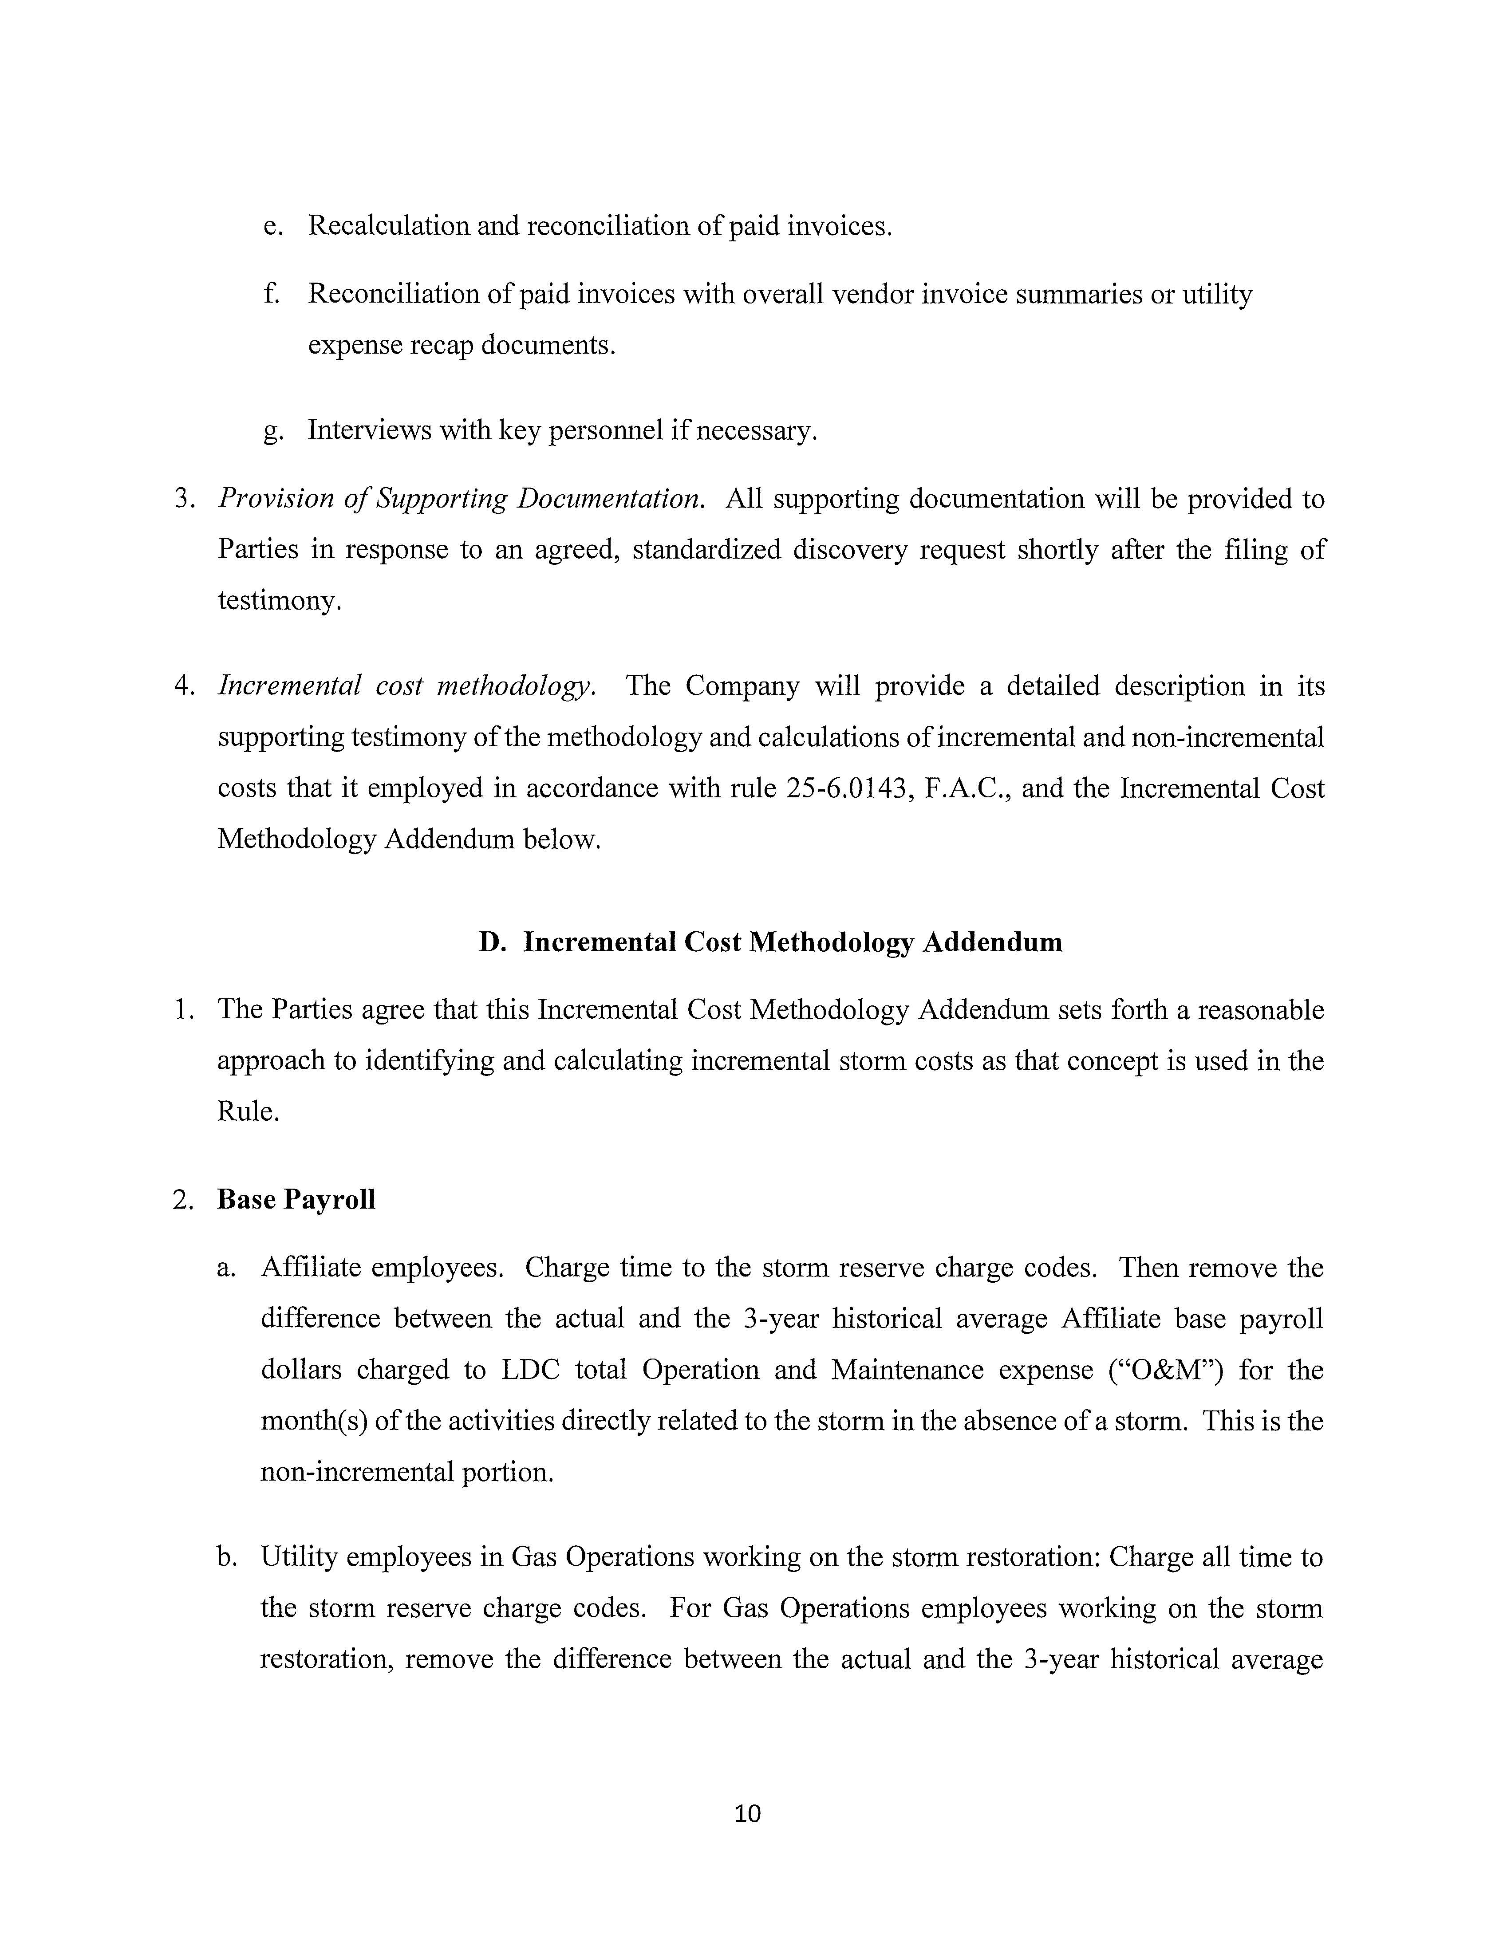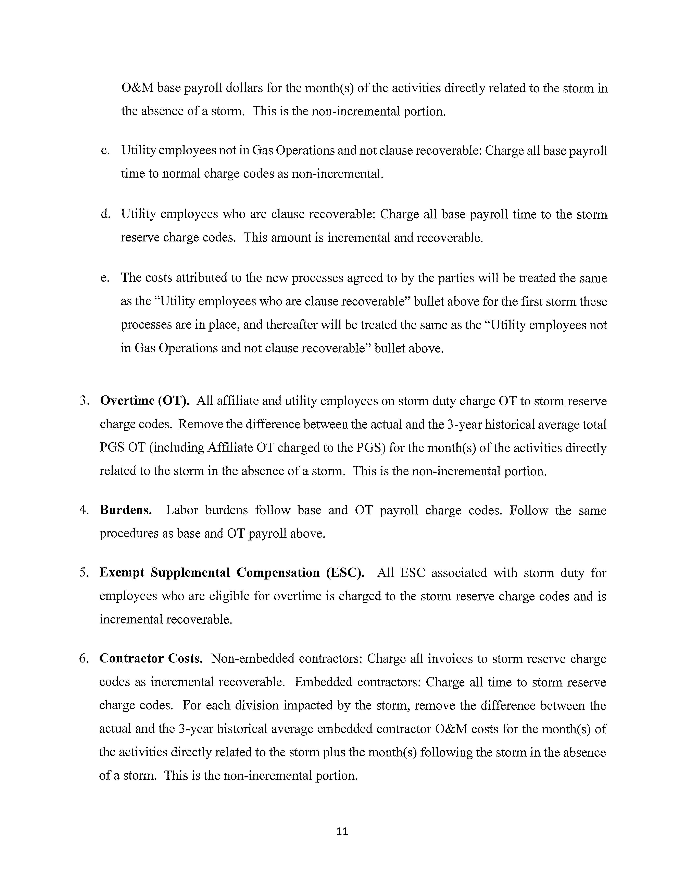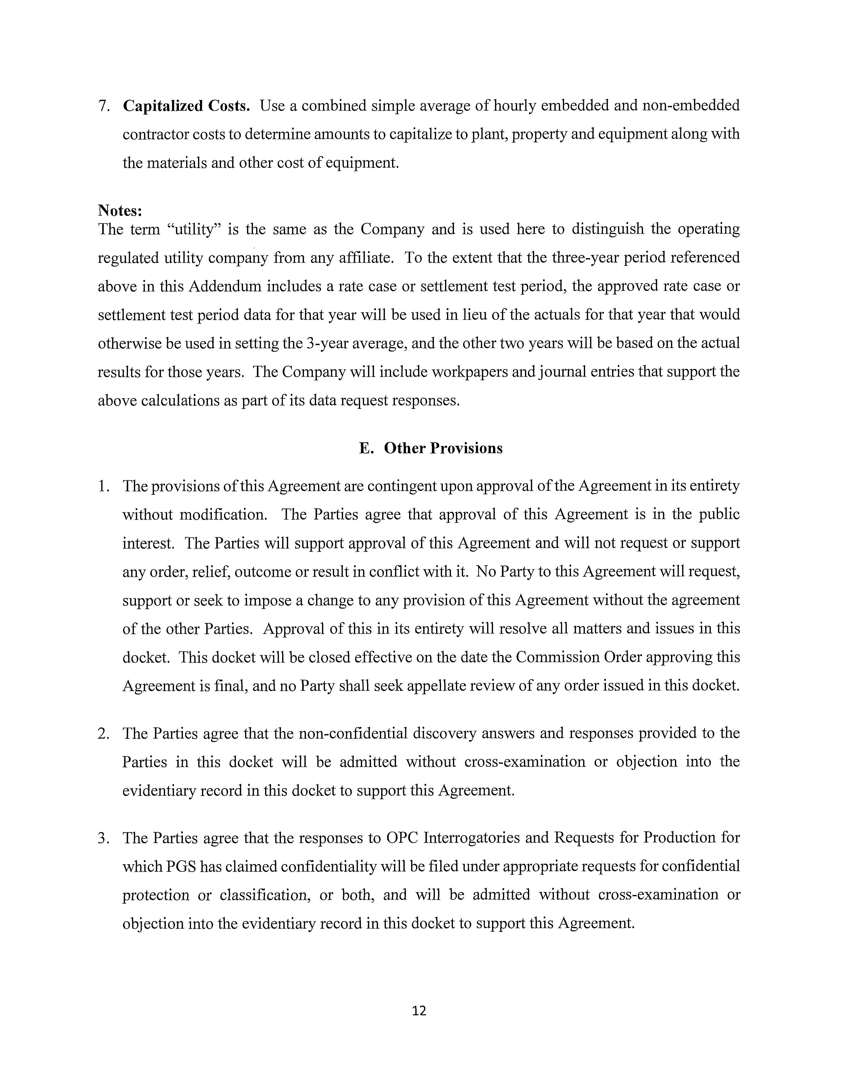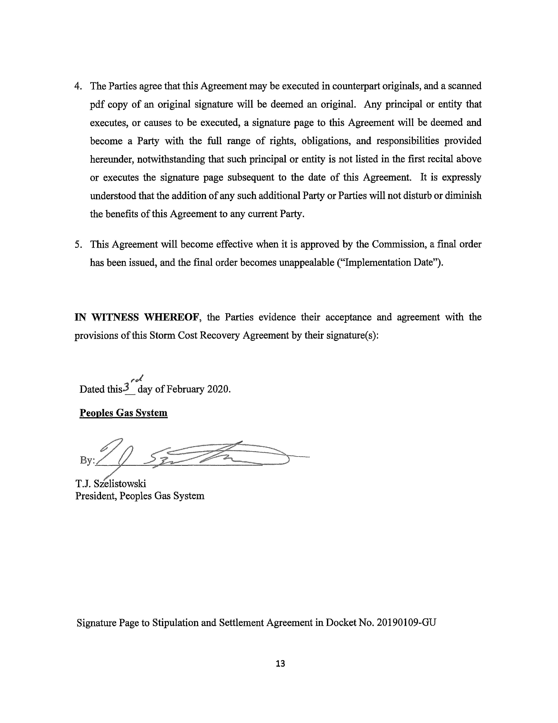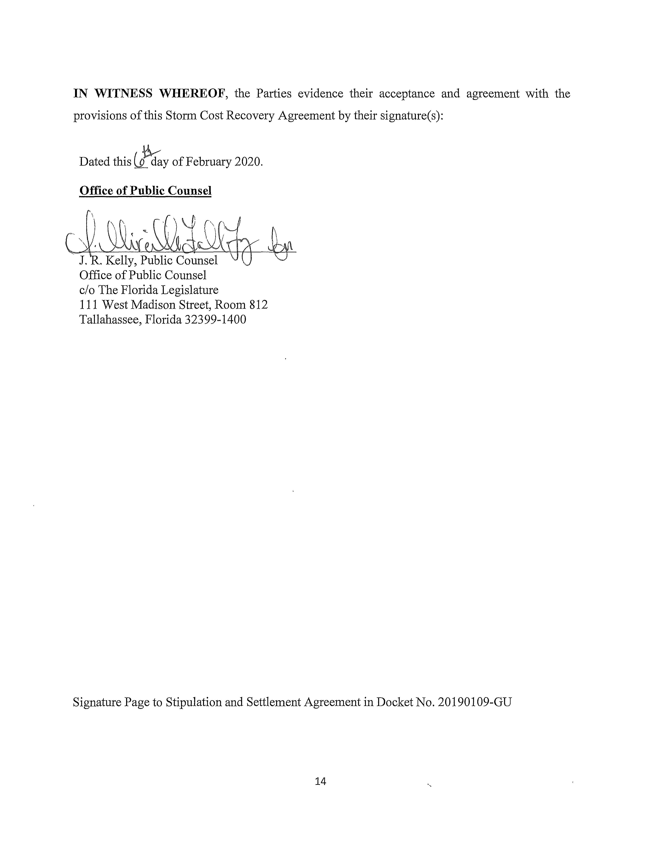

Order No. PSC-2019-0310-PCO-GU, issued July 29, 2019, in Docket No. 20190109-GU, Petition for recovery of costs associated with Hurricane Michael and replenishment of storm reserve, by Peoples Gas System.

