BEFORE THE FLORIDA PUBLIC SERVICE COMMISSION

In re: Joint motion for approval of Amendment No. 1 to stipulation and settlement, by Florida Public Utilities Company and Office of Public Counsel. | DOCKET NO. 20200033-EI  ORDER NO. PSC-2020-0083-PAA-EI  ISSUED: March 20, 2020

The following Commissioners participated in the disposition of this matter:

GARY F. CLARK, Chairman
ART GRAHAM
JULIE I. BROWN
DONALD J. POLMANN
ANDREW GILES FAY

NOTICE OF PROPOSED AGENCY ACTION
ORDER APPROVING AMENDMENT NO. 1 TO
2017 STIPULATION AND SETTLEMENT

BY THE COMMISSION:

NOTICE is hereby given by the Florida Public Service Commission that the action discussed herein is preliminary in nature and will become final unless a person whose interests are substantially affected files a petition for a formal proceeding, pursuant to Rule 25-22.029, Florida Administrative Code (F.A.C.).

CASE BACKGROUND

On July 3, 2017, Florida Public Utilities Company (FPUC or Company) petitioned the Commission to include $15,241,515 in capital projects in its rate base and increase its rates and charges by the amount necessary to recover the revenue requirement of $1,823,869 on those projects. These projects fell into three categories: (1) grid modernization and safety; (2) storm hardening; and (3) an interconnection with Florida Power & Light Company (FPL). The Office of Public Counsel (OPC) intervened on September 21, 2017, and the parties entered into a Stipulation and Settlement (2017 Settlement) resolving all issues which was approved by Order No. PSC-2017-0488-PAA-EI.

Article VII of the 2017 Settlement addresses changes in the federal or state corporate income tax rates and requires that federal or state corporate tax savings be addressed through a base rate reduction within 120 days of the effective date of such change.

On September 12, 2019, the Florida Department of Revenue issued a Tax Information Publication (TIP) announcing that the Florida corporate income tax rate was reduced from 5.500 percent to 4.458 percent effective retroactively to January 1, 2019, and continuing through December 31, 2021. The TIP indicates that the Florida corporate income tax rate will return to 5.50 percent effective January 1, 2022.

On January 22, 2020, to address this Florida tax change, FPUC and OPC filed a Joint Motion for Approval of Amendment No. 1 to Stipulation and [2017] Settlement (Joint Motion). Amendment No. 1 is Attachment A to this order. Both OPC and FPUC agree that the impact of the State Tax Rate change on FPUC’s NOI associated with base rates is approximately $35,000 annually for years 2019 through 2021. Acknowledging the tax savings amounts are based upon FPUC’s best estimates, FPUC calculated the actual amount of the tax benefit to be flowed-through to customers. For calendar year 2019, the NOI annual tax savings impact of $35,825 will be applied to the Company’s existing fuel and purchased power cost recovery balance with interest, which will serve to reduce FPUC’s Fuel Cost Recovery factors for 2021. The savings for calendar years 2020 and 2021 will be trued-up to actual and applied to the Company’s existing fuel and purchased power cost recovery balances in 2020 and 2021 with interest, thereby reducing FPUC’s Fuel Cost Recovery factors for 2022 and 2023. If approved by this Commission, this State Tax Amendment will take effect upon our approval and expire on December 31, 2023, unless otherwise modified by our order.

We have jurisdiction over this request under Sections 366.03, 366.04, 366.05, and 366.06, Florida Statutes (F.S.).

DECISION

The standard for approval of a settlement agreement is whether it is in the public interest. A determination of public interest requires a case-specific analysis based on consideration of the proposed settlement taken as a whole.

It is significant that OPC, the statutory representative for all Florida ratepayers, negotiated and is a signatory to Amendment No. 1. The intent of the 2017 Settlement was to timely pass on any reductions in state or federal corporate taxes to the ratepayers via a reduction in base rates. This state corporate tax reduction, unlike the 2017 federal corporate tax reduction, is not permanent but will only be in effect from January 1, 2019 until December 31, 2021. Under these circumstances, both OPC and FPUC have concluded that crediting FPUC’s fuel and purchased power cost recovery balance with the annual tax savings generated by the decrease in state corporate income tax plus interest for the years 2020 and 2021 is the most efficient method to give ratepayers the benefit of the tax decrease. Further, this method stabilizes base rates for the immediate future. Based on these factors, we find that taken as a whole Amendment No. 1 to the 2017 Settlement is a reasonable treatment of the tax savings associated with the temporary reduction in state corporate income taxes and we hereby approve it.

Based on the foregoing, it is

ORDERED by the Florida Public Service Commission that the Joint Motion for Approval of Amendment No. 1 to Stipulation and Settlement is hereby granted and Amendment No. 1, as stated on Attachment A, is hereby approved. It is further

ORDERED that Amendment No. 1 will take effect on March 3, 2020, and will expire on December 31, 2023, unless otherwise modified by this Commission. It is further

ORDERED that the provisions of this order, issued as proposed agency action, shall become final and effective upon the issuance of a Consummating Order unless an appropriate petition, in the form provided by Rule 28-106.201, F.A.C., is received by the Office of the Commission Clerk, 2540 Shumard Oak Boulevard, Tallahassee, Florida 32399-0850, by the close of business on the date set forth in the “Notice of Further Proceedings” attached hereto. It is further

ORDERED that, if a protest if filed within 21 days of the issuance of this order, Amendment No. 1 shall remain in effect, subject to true-up, pending resolution of the protest. If no timely protest is filed, this docket shall be closed upon the issuance of a Consummating Order.

By ORDER of the Florida Public Service Commission this 20th day of March, 2020.

/s/ Adam J. Teitzman
ADAM J. TEITZMAN
Commission Clerk
Florida Public Service Commission
2540 Shumard Oak Boulevard
Tallahassee, Florida 32399
(850) 413-6770
www.floridapsc.com

Copies furnished: A copy of this document is provided to the parties of record at the time of issuance and, if applicable, interested persons.
SBr

NOTICE OF FURTHER PROCEEDINGS OR JUDICIAL REVIEW

The Florida Public Service Commission is required by Section 120.569(1), Florida Statutes, to notify parties of any administrative hearing that is available under Section 120.57, Florida Statutes, as well as the procedures and time limits that apply. This notice should not be construed to mean all requests for an administrative hearing will be granted or result in the relief sought.

Mediation may be available on a case-by-case basis. If mediation is conducted, it does not affect a substantially interested person's right to a hearing.

The action proposed herein is preliminary in nature. Any person whose substantial interests are affected by the action proposed by this order may file a petition for a formal proceeding, in the form provided by Rule 28-106.201, Florida Administrative Code. This petition must be received by the Office of Commission Clerk, 2540 Shumard Oak Boulevard, Tallahassee, Florida 32399-0850, by the close of business on April 10, 2020.

In the absence of such a petition, this order shall become final and effective upon the issuance of a Consummating Order.

Any objection or protest filed in this/these docket(s) before the issuance date of this order is considered abandoned unless it satisfies the foregoing conditions and is renewed within the specified protest period.

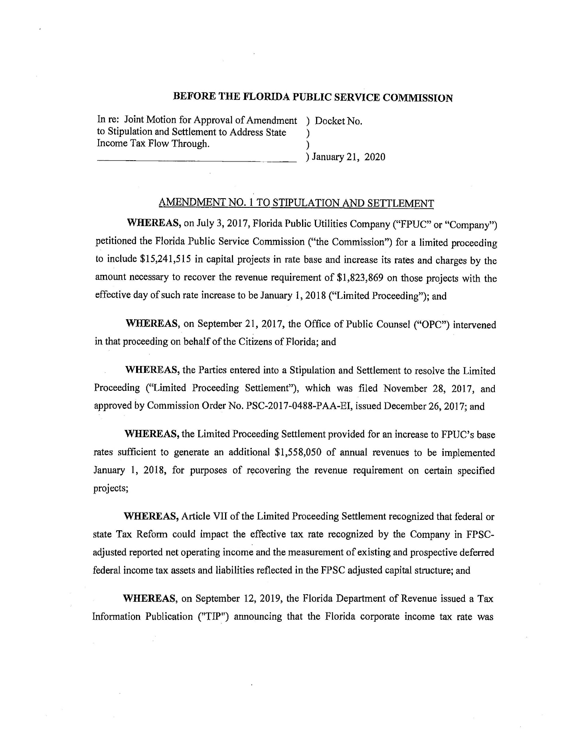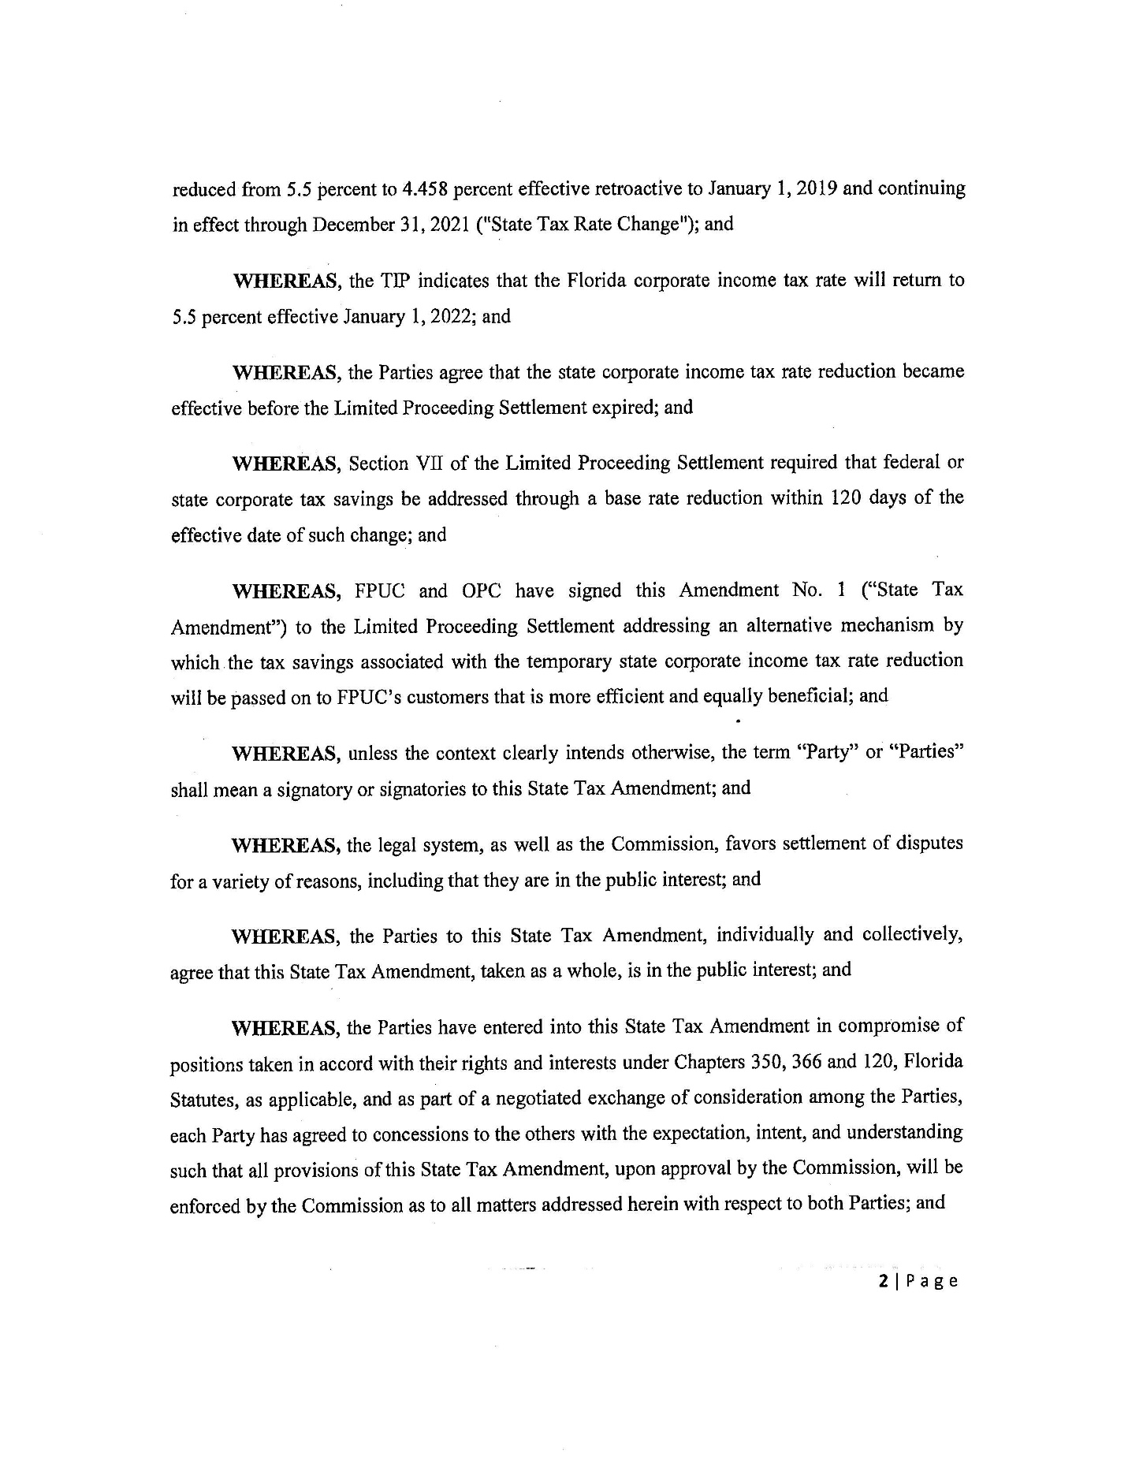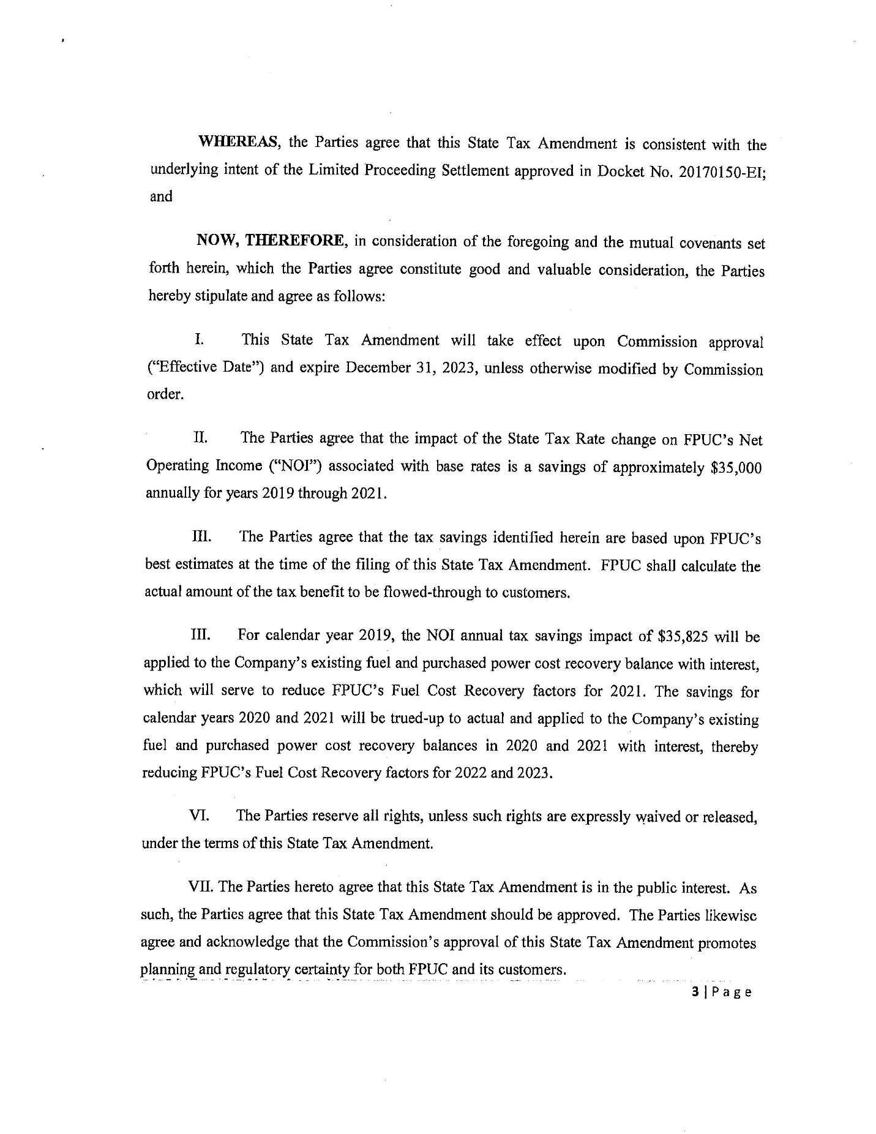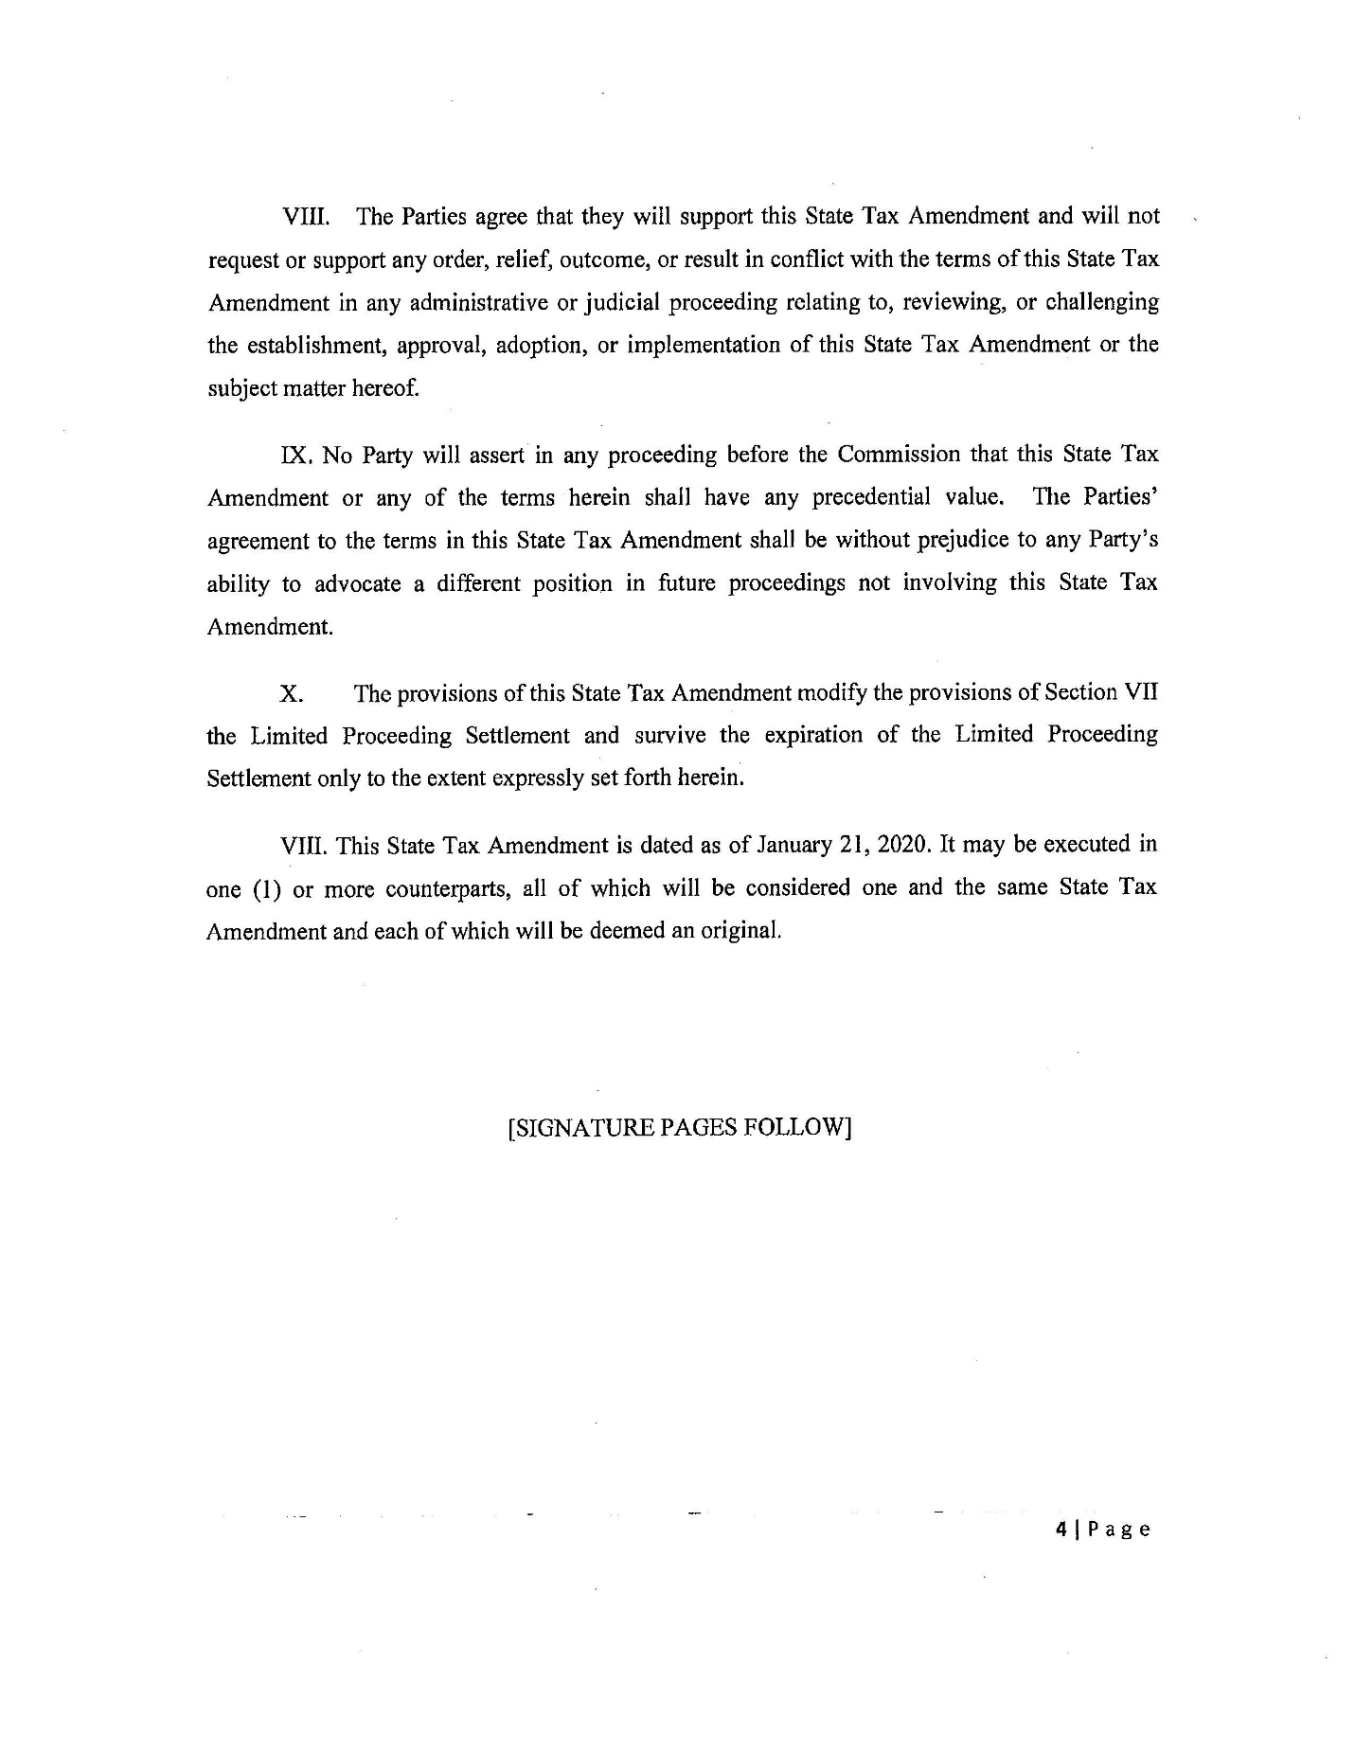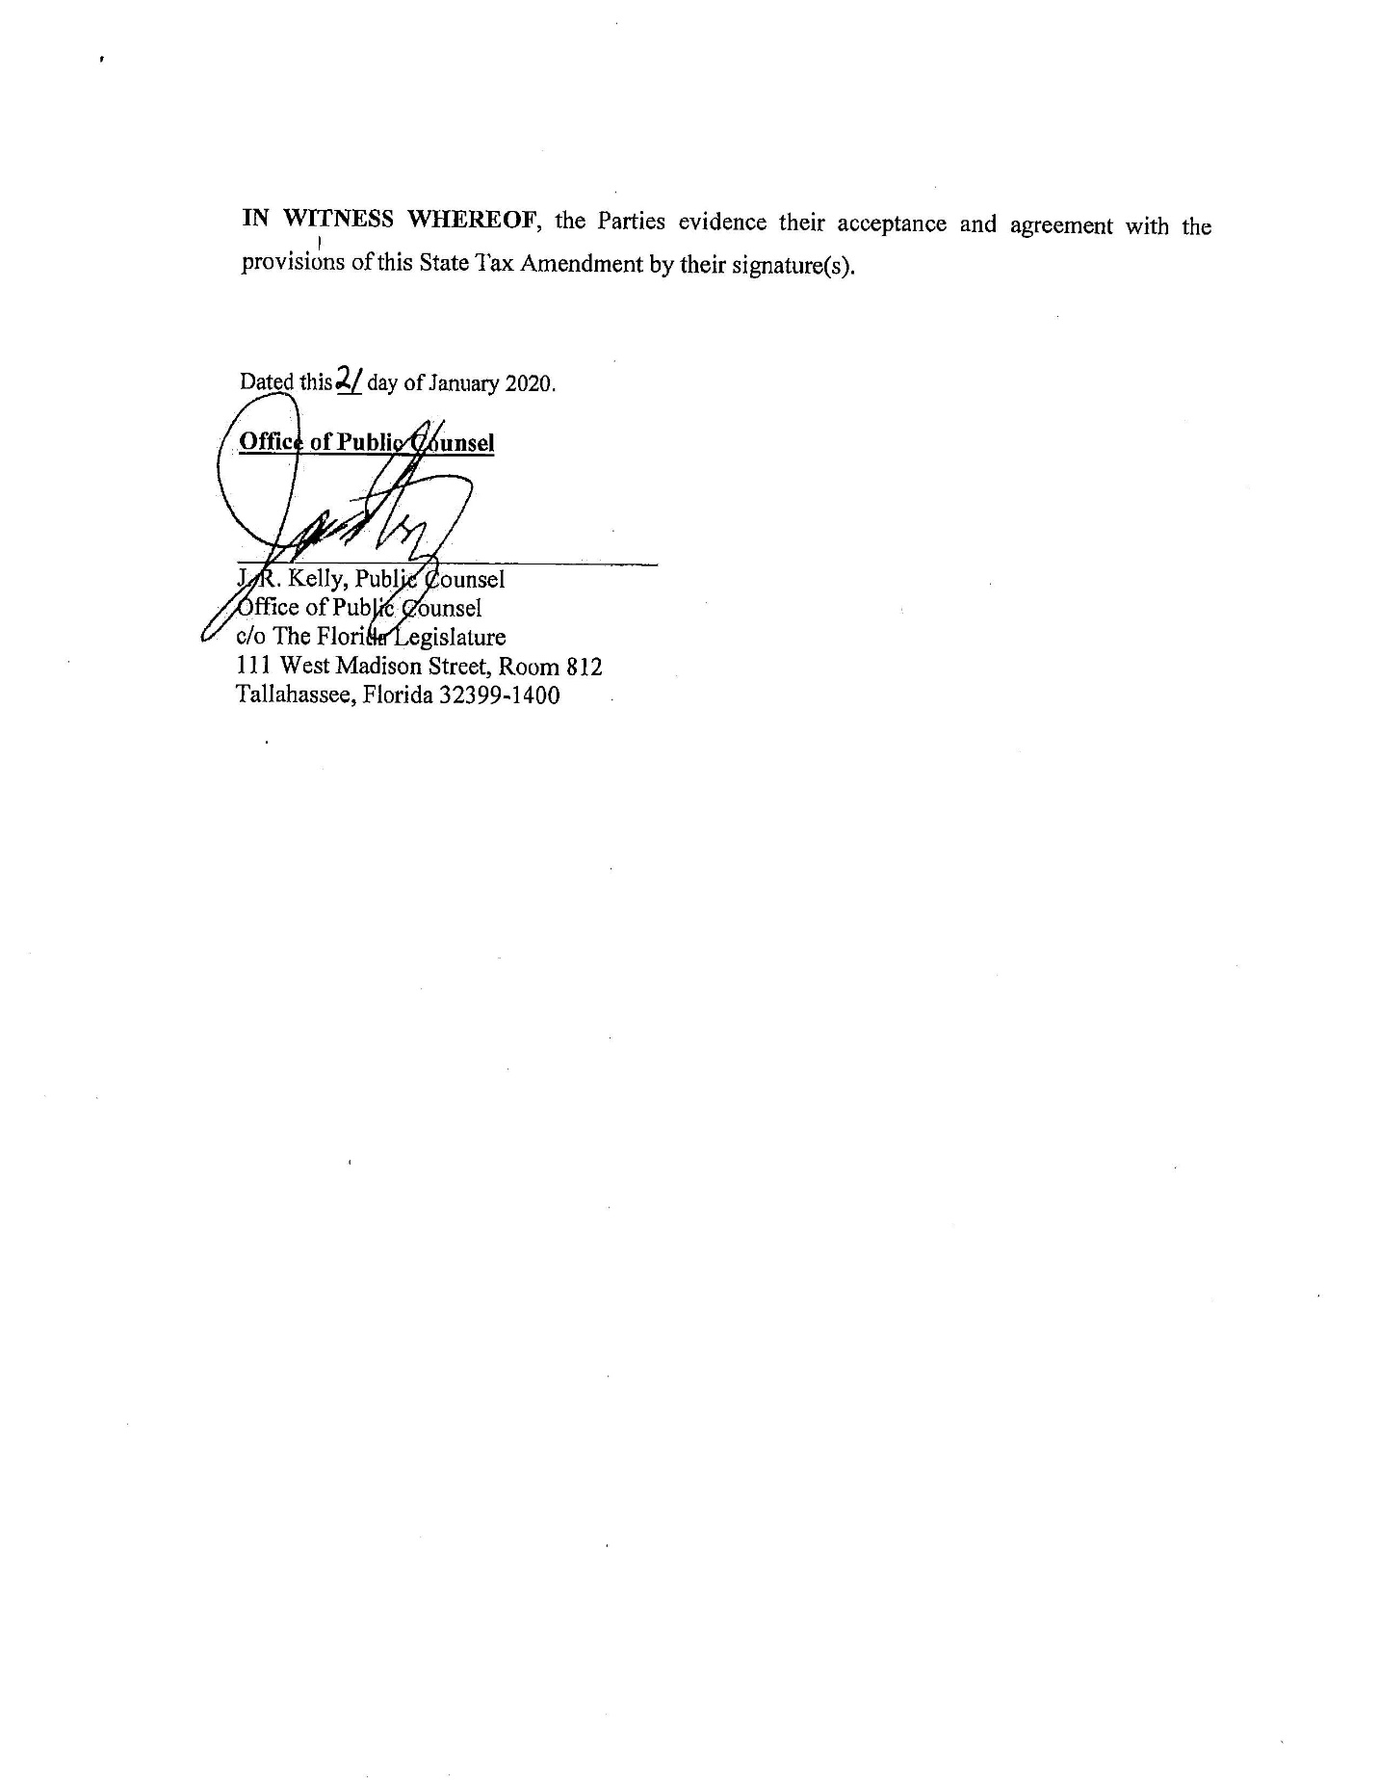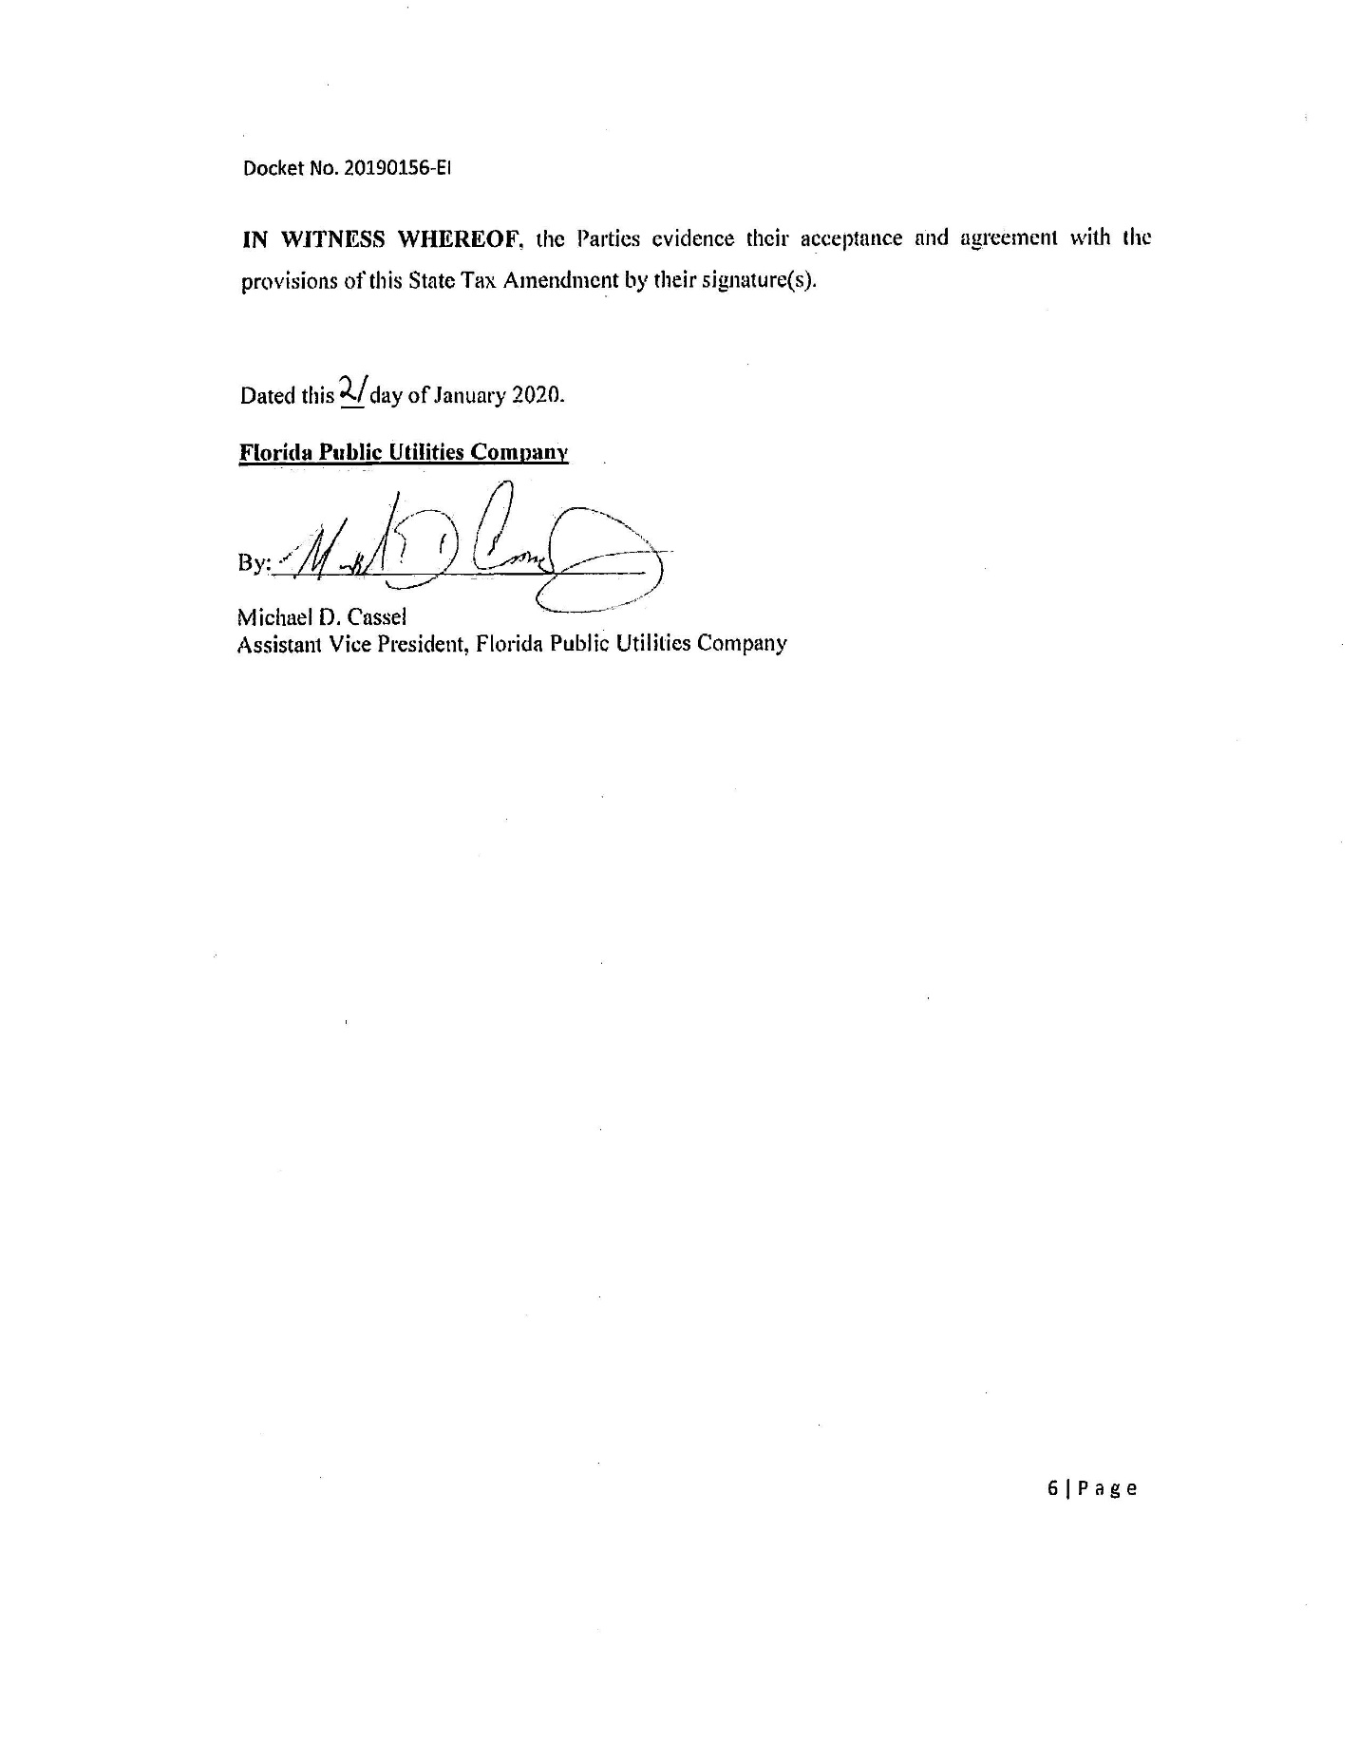

Order No. PSC-2017-0488-PAA-EI, issued December 26, 2017, in Docket No. 20170150-EI, In re: Petition for limited proceeding to include reliability and modernization projects in rate base, by Florida Public Utilities Company.
Order No. PSC-2017-0488-PAA-EI, issued on December 26, 2017, in Docket No. 20170150-EI, In re: Petition for limited proceeding to include reliability and modernization projects in rate base, by Florida Public Utilities Company; Order No. PSC-13-0023-S-EI, issued on January 14, 2013, in Docket No. 120015-EI, In re: Petition for increase in rates by Florida Power & Light Company; Order No. PSC-11-0089-S-EI, issued February 1, 2011, in Docket Nos. 080677 and 090130, In re: Petition for increase in rates by Florida Power & Light Company and In re: 2009 depreciation and dismantlement study by Florida Power & Light Company; Order No. PSC-13-0023-S-EIPSC-10-0398-S-EI, issued June 18, 2010, in Docket Nos. 090079-EI, 090144-EI, 090145-EI, 100136-EI, In re: Petition for increase in rates by Progress Energy Florida, Inc., In re: Petition for limited proceeding to include Bartow repowering project in base rates, by Progress Energy Florida, Inc., In re: Petition for expedited approval of the deferral of pension expenses, authorization to charge storm hardening expenses to the storm damage reserve, and variance from or waiver of Rule 25-6.0143(1)(c), (d), and (f), F.A.C., by Progress Energy Florida, Inc., and In re: Petition for approval of an accounting order to record a depreciation expense credit, by Progress Energy Florida, Inc.; Order No. PSC-05-0945-S-EI, issued September 28, 2005, in Docket No. 050078-EI, In re: Petition for rate increase by Progress Energy Florida, Inc.
Order No. PSC-13-0023-S-EI, at p. 7.

