BEFORE THE FLORIDA PUBLIC SERVICE COMMISSION

In re: Petition of North American Numbering Plan Administrator on behalf of the Florida telecommunications industry, for approval of consensus decision to recommend to the Commission an all-services overlay as the form of relief for the 813 numbering plan area. | DOCKET NO. 20190196-TP  ORDER NO. PSC-2020-0098-PAA-TP  ISSUED: April 10, 2020

The following Commissioners participated in the disposition of this matter:

GARY F. CLARK, Chairman
ART GRAHAM
JULIE I. BROWN
DONALD J. POLMANN
ANDREW GILES FAY

NOTICE OF PROPOSED AGENCY ACTION
ORDER APPROVING AN ALL-SERVICES DISTRIBUTED OVERLAY
AS THE AREA CODE RELIEF PLAN FOR THE 813 AREA CODE

BY THE COMMISSION:

NOTICE is hereby given by the Florida Public Service Commission (Commission) that the action discussed herein is preliminary in nature and will become final unless a person whose interests are substantially affected files a petition for a formal proceeding, pursuant to Rule 25-22.029, Florida Administrative Code (F.A.C.).

Case Background Error! Bookmark not defined.
On October 28, 2019, the North American Numbering Plan Administrator (NANPA), on behalf of Florida’s telecommunications industry (Industry) filed a petition with this Commission for approval of its area code relief plan for the 813 Numbering Plan Area (NPA). The Industry reached a consensus decision to recommend an all-services distributed overlay as the form of relief for the 813 NPA. NANPA projects that the supply of central office codes in the 813 NPA will exhaust during the third quarter of 2022. Consequently, NANPA is also requesting that we approve the recommended 13-month implementation schedule.
NANPA is the neutral third-party administrator of the North American Numbering Plan, which is the area code system shared by the United States, Canada, Bermuda, and 17 Caribbean countries. NANPA’s responsibilities include assigning area codes and prefixes, and tracking numbering usage to ensure effective and efficient utilization. NANPA is also responsible for forecasting the exhaust of geographic area codes and area code relief planning. NANPA publishes its forecasted exhaust of all area codes on a semi-annual basis. This forecast is used to determine when to start the area code relief process. The area served by NANPA is divided into NPAs, which are each identified by a three-digit NPA code, commonly called an area code.
The 813 area code was introduced in 1953 when the 305 area code needed relief due to substantial growth in demand for telephone numbers. It was the second area code assigned in Florida. Originally, the 813 area code was assigned to 16 counties stretching from Pasco county to the inland portion of Monroe county. Prior to the implementation of number conservation methods in 2002, the area served by the 813 area code was split twice, which created the 941 and 727 area codes. Currently, the 813 area code serves all of Hillsborough county, the City of Oldsmar in Pinellas county, and the central and southeastern portions of Pasco county.

In April 2019, NANPA forecasted a need for area code relief for the 813 area code. Subsequently, pursuant to the area code Relief Planning Guidelines, NANPA began the planning process by announcing the need for relief and distributing an initial planning document to the Industry. NANPA then hosted an Industry meeting on September 16, 2019, to discuss possible relief alternatives for the 813 area code. During the meeting, the Industry reviewed five relief options and reached a consensus to recommend the all-services distributed overlay plan to this Commission as the preferred method of relief for the 813 area code.

On October 28, 2019, NANPA filed a petition with us on behalf of the Industry requesting approval of the consensus decision. We have jurisdiction to address this issue pursuant to Section 364.16(7) and 120.80(13)(d), Florida Statutes (F.S.), and 47 Code of Federal Regulations (C.F.R.) § 52.19.

Analysis and Decision

Area code relief responsibilities have been delegated to the states by the Federal Communication Commission (FCC) pursuant to 47 C.F.R. § 52.19. In Florida, we are responsible for determining the appropriate form of area code relief when telephone numbers exhaust within an area code. There are several methods available to address area code exhaust issues; however, the two most commonly used methods are a geographic split or an overlay.

Geographic Split

The geographic split method divides the exhausting NPA into two, leaving the existing area code to serve one NPA and assigning a new area code to serve the other NPA. This method generally acknowledges jurisdictional or natural boundaries, but for technical reasons and number optimization considerations, the actual boundaries must conform to existing rate center boundaries. Under this method, customers on both sides of the split would retain seven digit dialing; however, it would require one half of the customers to change their area code. The last split implemented in Florida was 18 years ago. Industry guidelines specify that in the case of a geographic split, the difference in area code life expectancies between the split areas should be 10 years or less. According to NANPA, a geographic split in the 813 area code would result in an exhaust life that exceeds this 10-year limit between the two areas. Therefore, no split alternative was included in NANPA’s petition.

Overlay

The overlay method adds a new area code to the same geographic area served by the area code requiring relief. This results in the assignment of more than one area code to the same NPA. Current customers keep their existing area code and number; however, new customers or customers adding additional lines would receive the new area code. Once an overlay is implemented, the FCC requires 10-digit dialing for all local calls within the NPA. There are four potential implementation strategies for an overlay, which are as follows:

a) All-Services Distributed Overlay - The distributed overlay strategy may be considered in situations when growth in telephone numbers is expected to be more or less evenly distributed throughout the existing NPA. The new area code is added to the same geographic area as the code requiring relief and shares exactly the same geographic boundaries.

b) Concentrated Growth Overlay - A concentrated growth overlay may be considered in situations when the majority of need for the new telephone numbers is expected to be concentrated in one section of the existing NPA. For example, a fast-growing metropolitan area and a sparsely populated rural area could exist within the same NPA. The overlay area code would be assigned initially to the section of the NPA experiencing the fastest growth, and new phone numbers in that section would be assigned from the new area code. As more relief is required, the geographic area served by multiple area codes could expand to the rest of the NPA.

c) Boundary Elimination Overlay - With a boundary elimination overlay, the NPA requiring relief is adjacent to an NPA with available numbering resources. The boundary between these NPAs is eliminated, and spare telephone numbers from the adjacent area code are assigned within the NPA boundary where relief is required.

d) Multiple Overlay - The multiple overlay strategy may be considered where relief is required in an NPA served by two or more area codes. The new area code would be assigned to overlay the multiple existing area codes serving the entire geographic area. This essentially functions the same as an all-services distributed overlay.
During the September 16, 2019 Industry meeting hosted by NANPA, the following five relief plans were considered.

Alternative No. 1 - All-Services Distributed Overlay (see map in Attachment A)

A new area code would be assigned to the same geographic area occupied by the existing 813 area code. Customers would retain their current telephone numbers; however, 10-digit dialing would be required by all customers within the NPA. At the exhaust of the 813 area code, all future assignments will be made from the new area code. The projected life of this method would be approximately 37 years.

Alternative No. 2 - NPA Boundary Elimination Overlay (see map in Attachment B)

The boundary between the existing 813 and 727 area codes would be eliminated and both area codes would be assigned to the combined geographic area. This alternative would allow customers assigned the 813 and 727 area codes to retain their telephone numbers and would eliminate the need for a new area code. However, it would require 10-digit dialing for all customers within the combined NPA. The projected life of this method would be approximately 11 years.

Alternative No. 3 - NPA Boundary Elimination Overlay (see map in Attachment C)

The boundary between the existing 813 and 863 area codes would be eliminated and both area codes would be assigned to the combined geographic area. This alternative would allow customers assigned the 813 and 863 area codes to retain their telephone numbers and would eliminate the need for a new area code. However, it would require 10-digit dialing for all customers within the combined NPA. The projected life of this method would be approximately 17 years.

Alternative No. 4 - NPA Boundary Elimination Overlay (see map in Attachment D)

The boundary between the existing 813 and 941 area codes would be eliminated and both area codes would be assigned to the combined geographic area. This alternative would allow customers assigned the 813 and 941 area codes to retain their telephone numbers and would eliminate the need for a new area code. However, it would require 10-digit dialing for all customers within the combined NPA. The projected life of this method would be approximately 16 years.

Alternative No. 5 - Overlay of a New Area Code Over the Boundary Elimination (see map in Attachment E)

The boundary between the 813 and 727 area codes would be eliminated and a new area code would be assigned to the combined geographic area. This alternative would allow customers assigned the 813 and 727 area codes to retain their telephone numbers. However, it would require 10-digit dialing for all customers within the NPA. At the exhaust of the 813 and 727 area codes all future assignments would be made from the new area code. The projected life of this method would be approximately 41 years.

Industry Consensus

After review of the five alternatives the Industry reached a consensus recommending alternative No. 1, an all-services distributed overlay, as the recommended form of relief for the 813 NPA. The Industry decided against the boundary elimination overlay alternatives because they would impact a larger quantity of customers with 10-digit dialing than the all-services overlay. In addition, the Industry asserted that the boundary elimination alternatives would involve a more complex customer education process and lead to increased customer confusion.

Proposed Dialing Plan

If an all-services overlay is approved by us, the Industry recommends the dialing plan be set forth as follows:

- Local Calls 10-digit dialing (as required by the FCC)
- Toll Calls 1 + 10-digit dialing
- Operator Calls 0 + 10-digit dialing

Proposed Implementation Schedule

The Industry has recommended a 13-month implementation schedule. This schedule includes six months for network preparation, followed by a six-month permissive 10-digit dialing and customer education period. New codes are not activated until one month after the mandatory 10-digit dialing period. However, the Industry notes that the new area code would not be assigned until all assignable prefixes in the 813 area code have been assigned. During the permissive dialing period, calls within the 813 area code can be completed using either 7-digits or 10-digits. The purpose of the permissive dialing period is to facilitate transition from 7-digit to 10-digit dialing by educating customers on the impending changes without impacting the calls. Following the six-month permissive dialing period, mandatory 10-digit dialing will be required. If the required 10-digits are not dialed, the caller will receive a recorded message advising them that the area code is required to complete the call. This schedule will allow the Industry sufficient time to implement the new area code prior to the exhaustion of 813.

Staff Workshops

In an effort to educate and receive customer input, we held customer workshops on February 6, 2020, in Tampa, FL, and February 7, 2020, in St. Petersburg, FL. During these workshops, our staff and a representative from NANPA explained the area code relief process, the relief options being considered, and the customer impact. Our staff also allotted time for customers to ask questions or give comments. There were no customers nor customer comments at either workshop; however, since that time, we have received one customer comment favoring alternative No. 1.
Conclusion

We reviewed the petition and analyzed all the alternatives. We considered which alternative would provide the longest length of time before needing relief, and the impact on customers. Alternative No. 5 provides the longest projected exhaust date; however, we note that all the alternatives being considered share the same impact on customers. Customers would be required to dial 10-digits for all local calls. All things considered, alternative No. 5 provides the longest projected length of time, but would also negatively impact more customers by imposing 10-digit dialing for customers who otherwise would not be affected for another 28 years or more.
We agree with the Industry that the more favorable approach is to minimize the number of customers that would be impacted by 10-digit dialing. Therefore, we hereby approve the Industry’s proposed all-services distributed overlay as the form of relief for the 813 area code. Additionally, we hereby approve the proposed 13-month implementation schedule that includes a six-month customer permissive dialing period. Finally, we find that central office codes in the new area code shall be available only when all assignable prefixes in the 813 area code have been assigned.

Based on the foregoing, it is

ORDERED by the Florida Public Service Commission that the Industry’s consensus recommendation of an all-services distributed overlay as the area code relief plan for the 813 area code is approved. It is further

ORDERED that the proposed 13-month implementation schedule, which includes a six-month permissive dialing period, is approved. It is further

ORDERED that telephone numbers, specifically central office codes in the new area code, shall be available for assignment only when all assignable prefixes in the 813 area code have been assigned. It is further

ORDERED that the provisions of this Order, issued as proposed agency action, shall become final and effective upon the issuance of a Consummating Order unless an appropriate petition, in the form provided by Rule 28-106.201, Florida Administrative Code, is received by the Commission Clerk, 2540 Shumard Oak Boulevard, Tallahassee, Florida 32399-0850, by the close of business on the date set forth in the “Notice of Further Proceedings” attached hereto. It is further

ORDERED that in the event this Order becomes final, this docket shall be closed.

By ORDER of the Florida Public Service Commission this 10th day of April, 2020.

/s/ Adam J. Teitzman
ADAM J. TEITZMAN
Commission Clerk
Florida Public Service Commission
2540 Shumard Oak Boulevard
Tallahassee, Florida 32399
(850) 413-6770
www.floridapsc.com

Copies furnished: A copy of this document is provided to the parties of record at the time of issuance and, if applicable, interested persons.

GAP

NOTICE OF FURTHER PROCEEDINGS OR JUDICIAL REVIEW

The Florida Public Service Commission is required by Section 120.569(1), Florida Statutes, to notify parties of any administrative hearing that is available under Section 120.57, Florida Statutes, as well as the procedures and time limits that apply. This notice should not be construed to mean all requests for an administrative hearing will be granted or result in the relief sought.

Mediation may be available on a case-by-case basis. If mediation is conducted, it does not affect a substantially interested person's right to a hearing.

The action proposed herein is preliminary in nature. Any person whose substantial interests are affected by the action proposed by this order may file a petition for a formal proceeding, in the form provided by Rule 28-106.201, Florida Administrative Code. This petition must be received by the Office of Commission Clerk, 2540 Shumard Oak Boulevard, Tallahassee, Florida 32399-0850, by the close of business on May 1, 2020.

In the absence of such a petition, this Order shall become final and effective upon the issuance of a Consummating Order.

Any objection or protest filed in this/these docket(s) before the issuance date of this order is considered abandoned unless it satisfies the foregoing conditions and is renewed within the specified protest period.

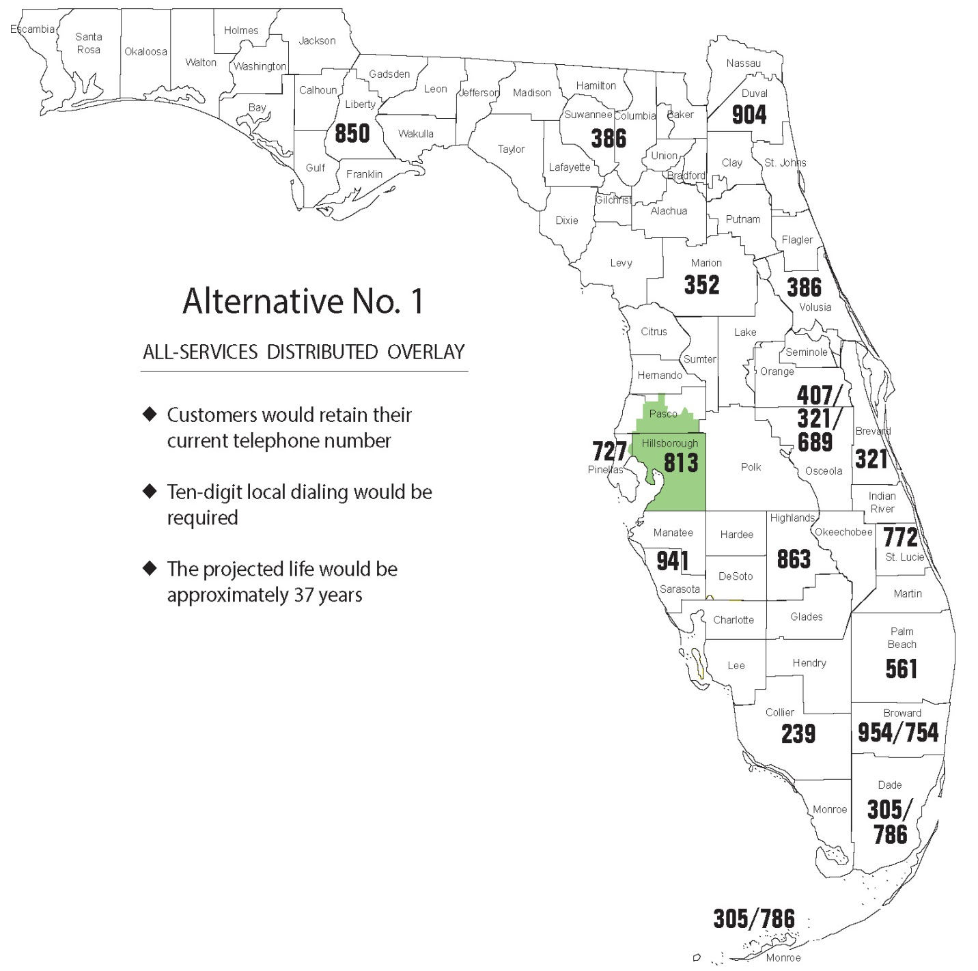

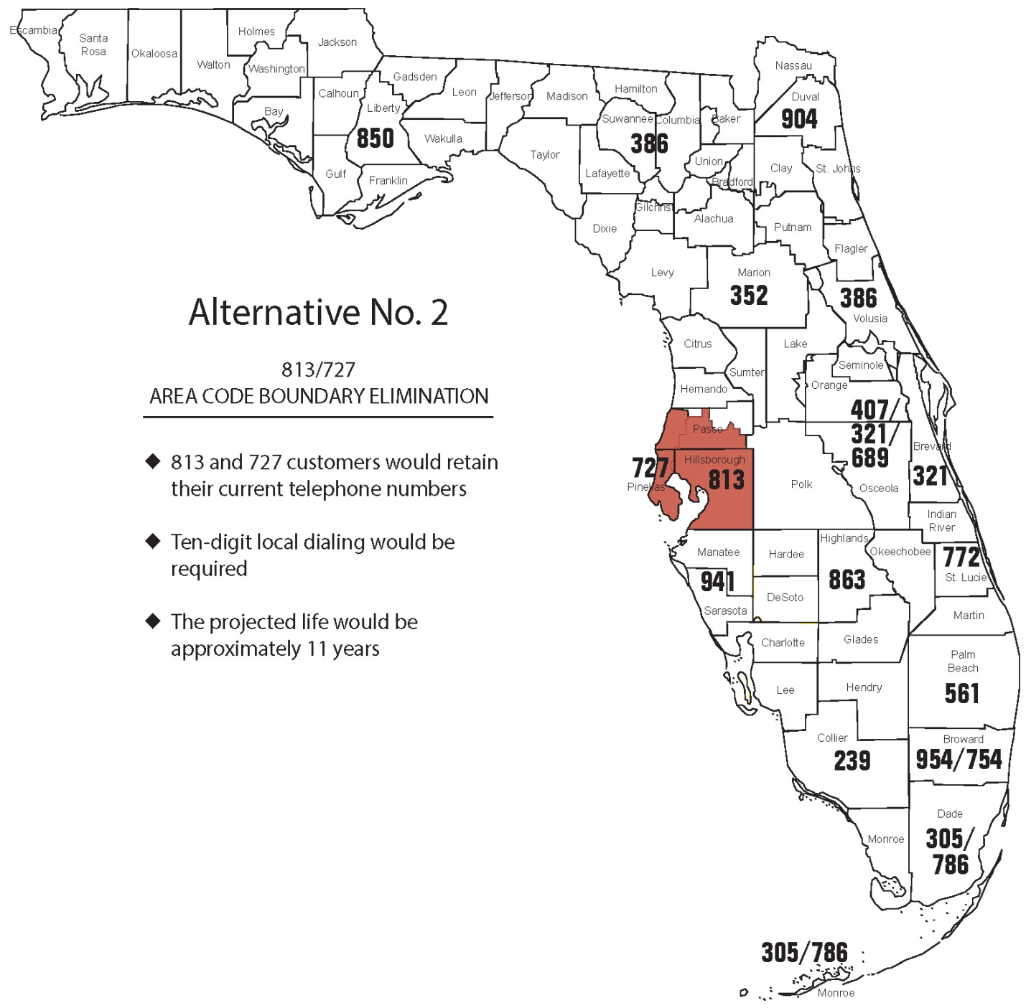

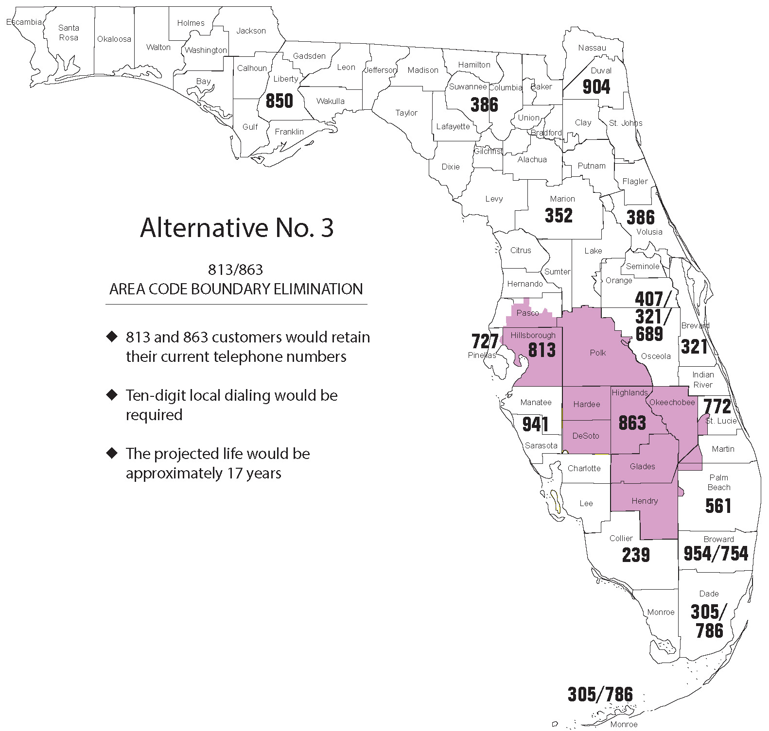

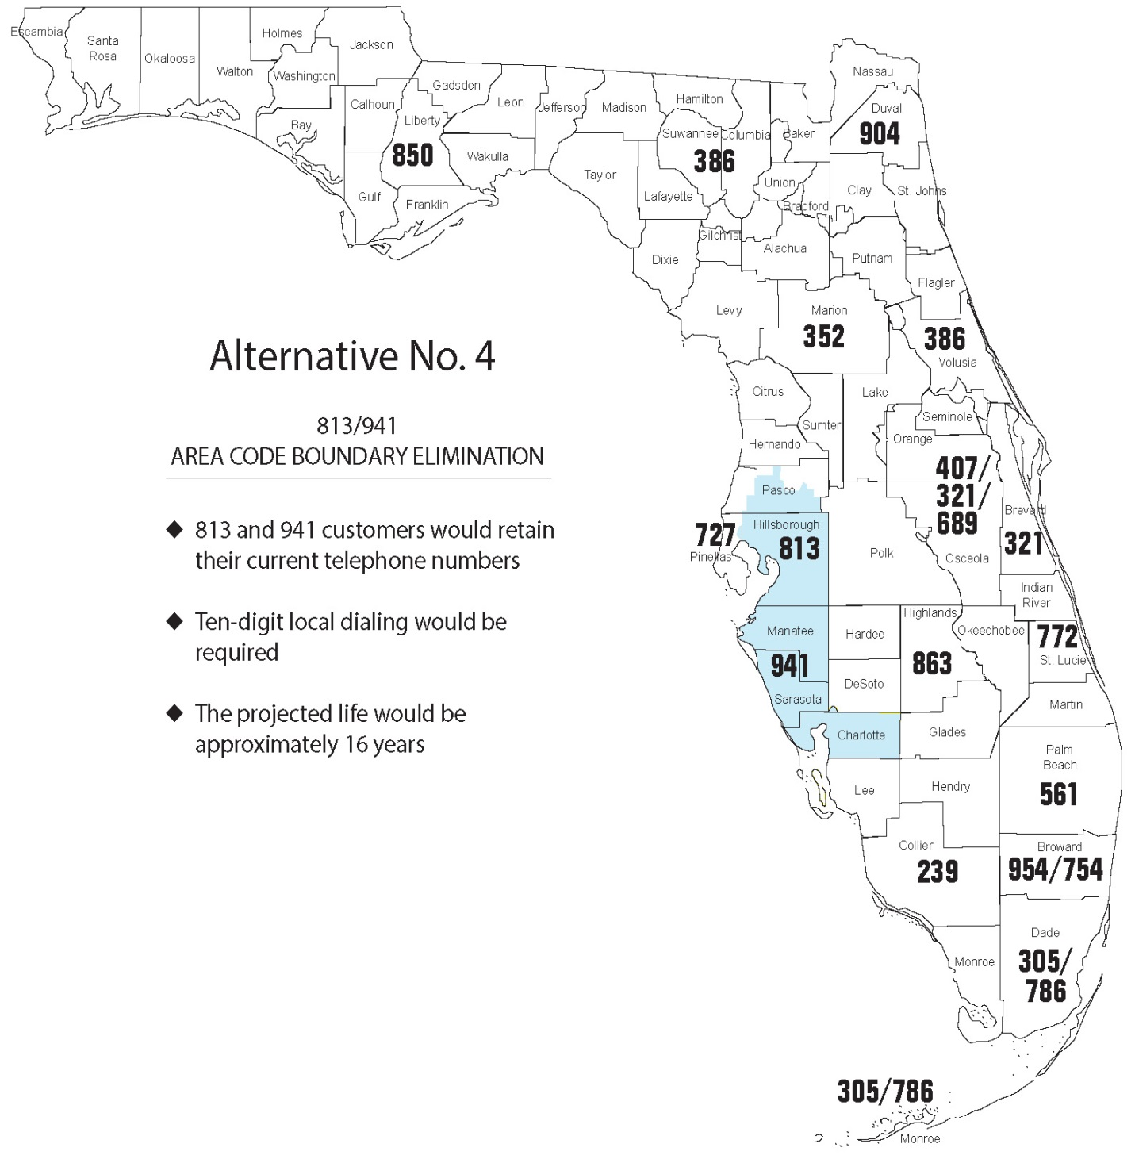

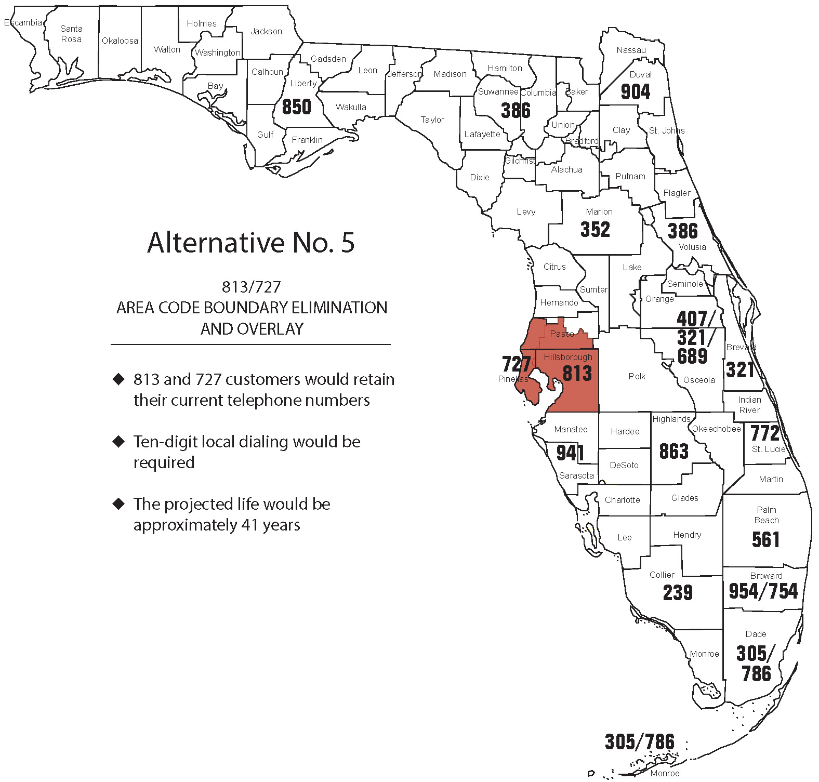

Originally, telephone numbers were assigned to carriers in number blocks of 10,000. However, in an effort to conserve numbering resources, the thousand-block number pooling system was implemented. The thousand-block number pooling system allocates telephone numbers to carriers in blocks of 1,000 instead of the historical 10,000. Under this system, an unused 1,000 number block can be reclaimed and returned to inventory if it is not activated within six months of being assigned, unless the carrier can provide us with a valid reason for needing an extension.
This document included descriptions, maps, general facts and assumptions, and the projected life of four area code relief alternatives. A geographic split in the 813 area code did not meet the NPA code relief planning guidelines; therefore, NANPA did not recommend a geographic split for consideration. The Industry also proposed one additional alternative.
NPA Code Relief Planning & Notification Guidelines ATIS-0300061 - Section 5.0 (g).

