BEFORE THE FLORIDA PUBLIC SERVICE COMMISSION

In re: Application for quick-take amendment of Certificate Nos. 278-W and 225-S to add territory in Seminole County, by Utilities, Inc. of Florida. | DOCKET NO. 20190199-WS  ORDER NO. PSC-2020-0100-FOF-WS  ISSUED: April 13, 2020

ORDER APPROVING APPLICATION FOR QUICK-TAKE AMENDMENT OF CERTIFICATE NOS. 278-W AND 225-S BY UTILITIES, INC. OF FLORIDA

BY THE COMMISSION:

On November 4, 2019, Utilities, Inc. of Florida (UIF or Utility) filed an application to amend Certificate Nos. 278-W and 225-S in Seminole County, pursuant to Rule 25-30.036(3), Florida Administrative Code (F.A.C.). The UIF water and wastewater system that is subject to this amendment, Sanlando, currently provides water service to approximately 10,407 customers and wastewater service to approximately 10,186 customers. The requested territory addition is contiguous to the Utility’s existing service territory and is limited to an area occupied by 24 single family connections currently located outside of its certificated territory. On November 5, 2019, UIF filed a petition for partial variance or waiver of Rule 25-30.030(5)(b), F.A.C., which was approved on February 24, 2020, in Order No. PSC-2020-0054-PAA-WS. The Commission has jurisdiction pursuant to Section 367.045, Florida Statutes (F.S.).

As outlined in Rule 25-30.036(3), F.A.C., what is commonly known as a “quick take” amendment, is designed to provide water and/or wastewater service quickly to areas with less than 25 Equivalent Residential Connections. The request for service territory expansion and amendment of an existing certificate is considered approved when the utility complies with Rule 25-30.036(3), F.A.C., and no protest is timely filed to the notice of application. The application contains proof of compliance with the noticing provisions set forth in Rule 25-30.030, F.A.C., and no protest has been timely filed. The application also complies with the governing statute, Section 367.045(2), F.S. The Utility has provided an adequate territory description and service territory maps as prescribed by Rule 25-30.036(2)(f) and (h), F.A.C. The territory description is appended to this Order as Attachment A. The Utility has submitted an affidavit, consistent with Section 367.045(2)(d), F.S., that it has tariffs and annual reports on file with the Commission. We find that the rates and charges approved by the Commission for UIF’s service area shall be applied to the customers in the new service territory.

Based on the above, the application is in compliance with Section 367.045(2), F.S., and the Utility has satisfied all of the conditions required by Rule 25-30.036(3), F.A.C. No protests have been filed in this docket, and the time for doing so has expired. The application to expand the service territory in Seminole County by UIF is hereby approved.

Based on the foregoing, it is

ORDERED by the Florida Public Service Commission that Utilities, Inc. of Florida’s application for quick-take amendment of Certificate Nos. 278-W and 225-S to add territory in Seminole County as described in Attachment A to this Order is hereby approved. It is further

ORDERED that this Order shall serve as Utilities, Inc. of Florida’s amended certificates and it shall be retained by the Utility. It is further

ORDERED that this docket shall be closed.

By ORDER of the Florida Public Service Commission this 13th day of April, 2020.

/s/ Adam J. Teitzman
ADAM J. TEITZMAN
Commission Clerk
Florida Public Service Commission
2540 Shumard Oak Boulevard
Tallahassee, Florida 32399
(850) 413-6770
www.floridapsc.com

Copies furnished: A copy of this document is provided to the parties of record at the time of issuance and, if applicable, interested persons.

BYL

NOTICE OF FURTHER PROCEEDINGS OR JUDICIAL REVIEW

The Florida Public Service Commission is required by Section 120.569(1), Florida Statutes, to notify parties of any administrative hearing or judicial review of Commission orders that is available under Sections 120.57 or 120.68, Florida Statutes, as well as the procedures and time limits that apply. This notice should not be construed to mean all requests for an administrative hearing or judicial review will be granted or result in the relief sought.

Any party adversely affected by the Commission's final action in this matter may request: 1) reconsideration of the decision by filing a motion for reconsideration with the Office of Commission Clerk, 2540 Shumard Oak Boulevard, Tallahassee, Florida 32399-0850, within fifteen (15) days of the issuance of this order in the form prescribed by Rule 25-22.060, Florida Administrative Code; or 2) judicial review by the Florida Supreme Court in the case of an electric, gas or telephone utility or the First District Court of Appeal in the case of a water and/or wastewater utility by filing a notice of appeal with the Office of Commission Clerk, and filing a copy of the notice of appeal and the filing fee with the appropriate court. This filing must be completed within thirty (30) days after the issuance of this order, pursuant to Rule 9.110, Florida Rules of Appellate Procedure. The notice of appeal must be in the form specified in Rule 9.900(a), Florida Rules of Appellate Procedure.

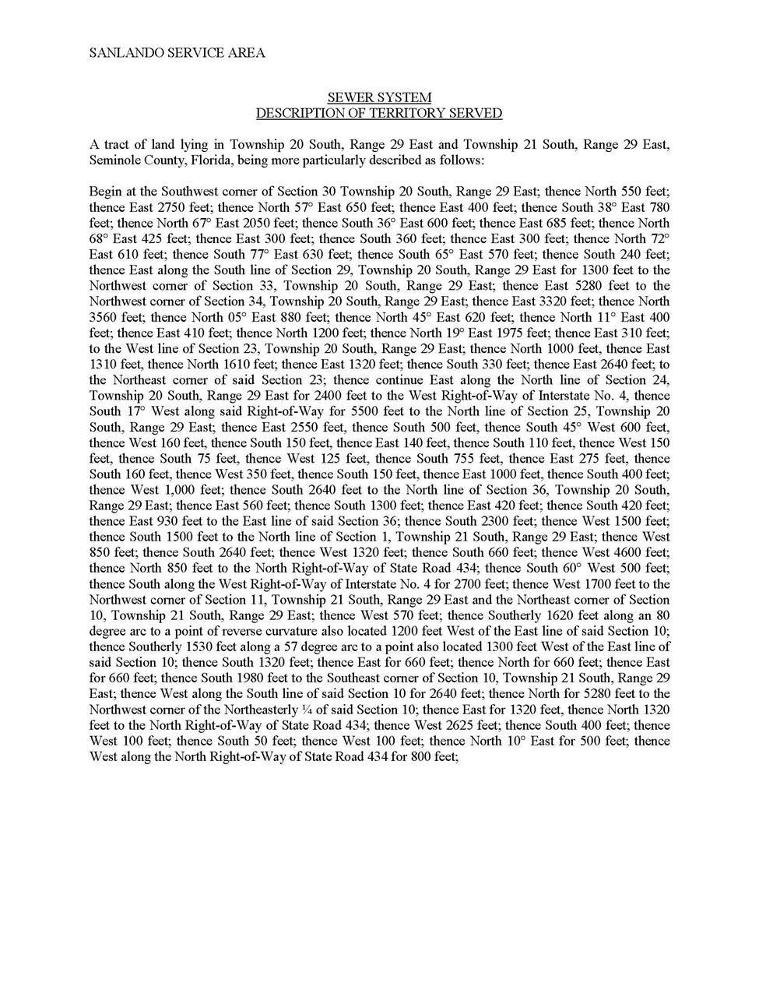

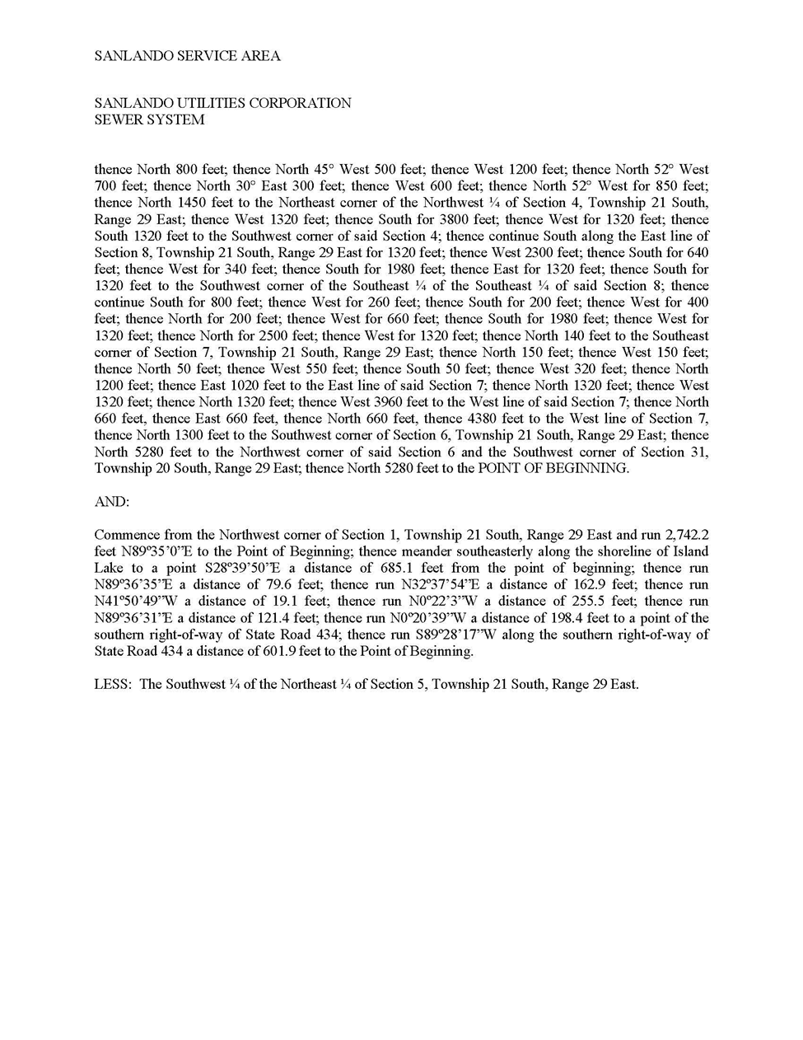

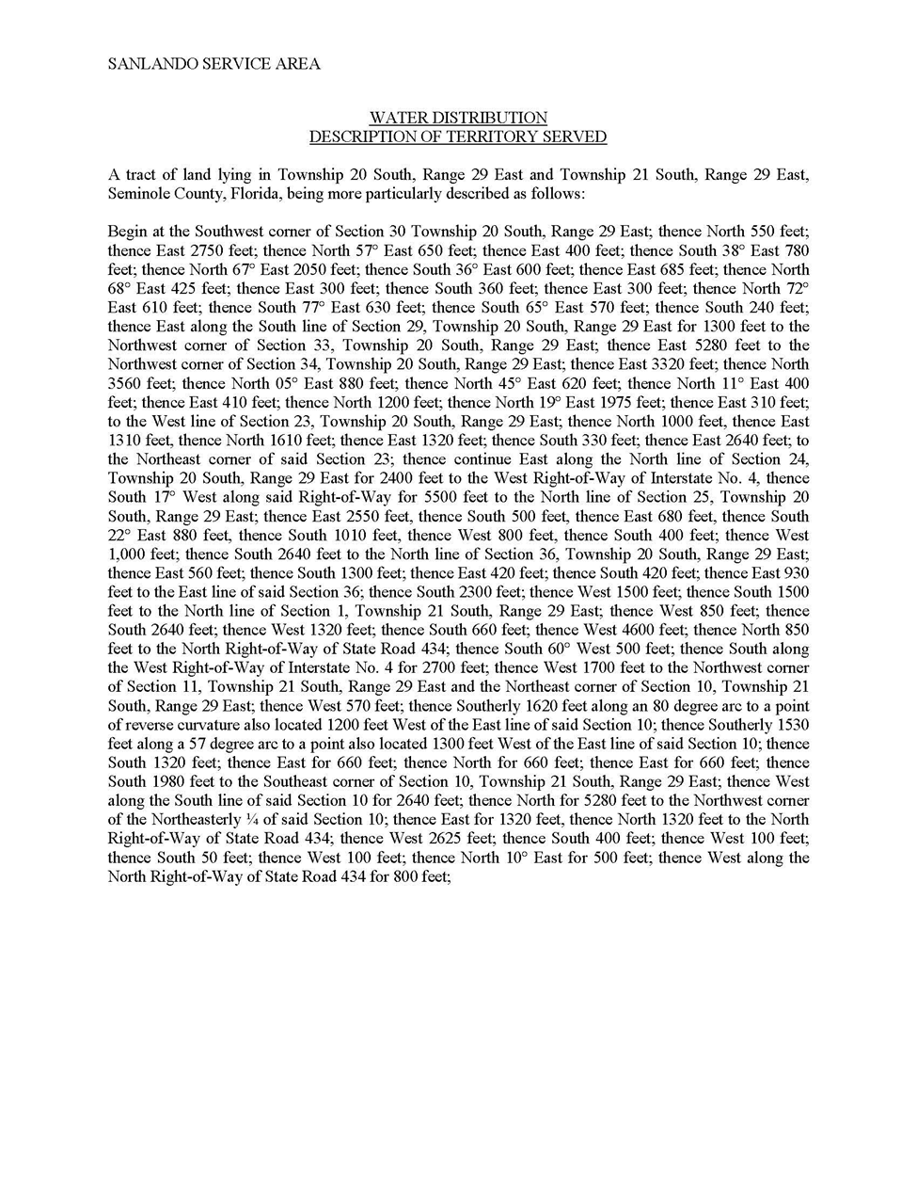

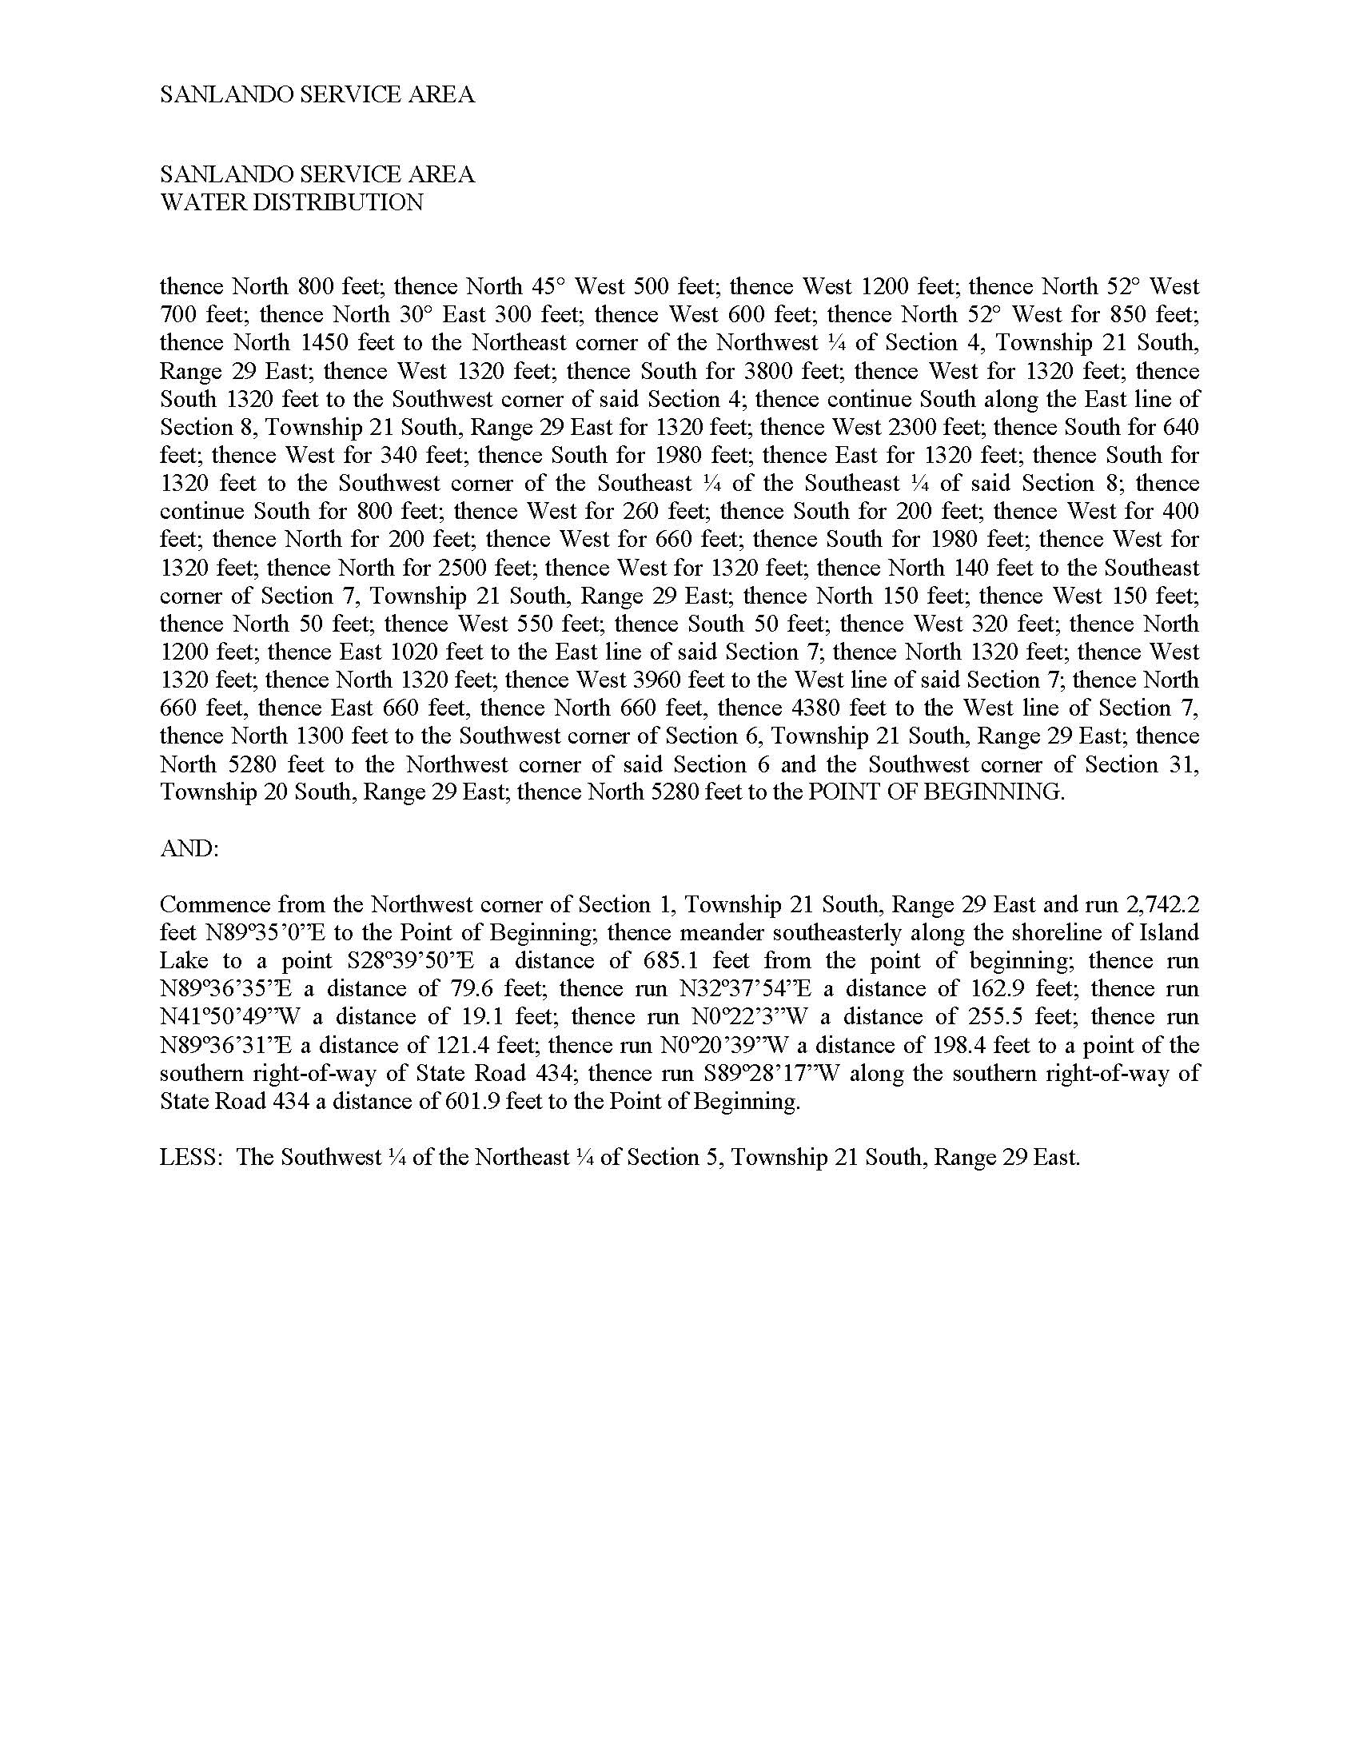

FLORIDA PUBLIC SERVICE COMMISSION
authorizes
Utilities, Inc. of Florida
pursuant to
Certificate Number 225-S

to provide wastewater service in Seminole County in accordance with the provisions of Chapter 367, Florida Statutes, and the Rules, Regulations, and Orders of this Commission in the territory described by the Orders of this Commission. This authorization shall remain in force and effect until superseded, suspended, cancelled or revoked by Order of this Commission.

Order Number | Date Issued | Docket Number | Filing Type
7128 | 02/26/1976 | 750737-WS | Original Certificate
7562 | 12/27/1976 | 760421-WS | Original Certificate
7715 | 03/28/1977 | 760144-S | Grandfather Certificate
9843 | 03/03/1981 | 780813-WS | Territory Deletion
9846 | 03/03/1981 | 800643-WS | Amendment
10061 | 06/12/1981 | 810169-S | Amendment
10084 | 06/19/1981 | 810179-WS | Amendment
10326 | 10/07/1981 | 810362-WS | Amendment
10643 | 03/04/1982 | 810389-WS | Amendment and Regional Connection
12567 | 09/30/1983 | 830237-WS | Amendment
14180 | 03/14/1985 | 840436-WS | Amendment
15331 | 11/04/1985 | 850551-WS | Amendment
15750 | 02/26/1986 | 860066-WS | Amendment
PSC-96-0448-FOF-SU | 03/29/1996 | 950959-SU | Transfer of Certificate
PSC-99-0152-FOF-WS | 01/25/1999 | 980957-WS | Transfer of Majority Control
PSC-99-2372-FOF-WS | 12/06/1999 | 991288-WS | Partial Transfer to Government
PSC-01-2316-FOF-WS | 11/27/2001 | 010887-WS | Transfer of Majority Org. Control
PSC-03-1103-FOF-SU | 10/06/2003 | 030485-WS | Amendment
PSC-04-0532-AS-WS | 05/25/2004 | 030667-WS | Territory Deletion
PSC-04-0782-FOF-WS | 08/10/2004 | 030667-WS | Reconsideration and Clarification
PSC-06-0094-FOF-WS | 02/09/2006 | 050499-WS | Transfer of Majority Org. Control
PSC-06-0752-FOF-WS | 09/05/2006 | 040384-WS | Amendment
PSC-07-0905-FOF-WS | 11/08/2007 | 070360-WS | Amendment
PSC-11-0100-FOF-SU | 02/02/2011 | 100423-SU | Amendment/Territory Deletion
PSC-11-0100A-FOF-SU | 02/04/2011 | 100423-SU | Correction
PSC-12-0497-FOF-WS | 09/27/2012 | 120084-WS | Transfer of Majority Org. Control
PSC-16-0143-FOF-WS  * | 04/12/2016  * | 150235-WS  20190199-WS | Reorganization/Name Change  Quick Take Amendment

*Order Number and date to be provided at time of issuance

FLORIDA PUBLIC SERVICE COMMISSION
authorizes
Utilities, Inc. of Florida
pursuant to
Certificate Number 278-W

to provide water service in Seminole County in accordance with the provisions of Chapter 367, Florida Statutes, and the Rules, Regulations, and Orders of this Commission in the territory described by the Orders of this Commission. This authorization shall remain in force and effect until superseded, suspended, cancelled or revoked by Order of this Commission.

Order Number | Date Issued | Docket Number | Filing Type
7128 | 02/26/1976 | 750737-WS | Original Certificate
7562 | 12/27/1976 | 760421-WS | Original Certificate
8354 | 06/12/1978 | 780097-W | Amendment
9317 | 04/04/1980 | 790969-W | Amendment
9843 | 03/03/1981 | 780727-W | Territory Deletion
 |  | 780813-WS | Territory Deletion
 |  | 780952-W | Territory Deletion
9846 | 03/03/1981 | 800643-WS | Amendment
10084 | 06/19/1981 | 810179-WS | Amendment
10326 | 10/07/1981 | 810362-WS | Amendment
10643 | 03/04/1982 | 810389-WS | Amendment
12567 | 09/30/1983 | 830237-WS | Amendment
14180 | 03/14/1985 | 840436-WS | Amendment
15331 | 11/04/1985 | 850551-WS | Amendment
15750 | 02/26/1986 | 860066-WS | Amendment
16748 | 10/20/1986 | 861178-WU | Amendment
17445 | 04/22/1987 | 870306-WU | Amendment
17445-A | 05/04/1987 | 870306-WU | Correction
18508 | 12/08/1987 | 870057-WU | Deletion of Territory
PSC-99-0152-FOF-WS | 01/25/1999 | 980957-WS | Transfer of Majority Control
PSC-99-2171-FOF-WU | 11/08/1999 | 981589-WU | Partial Transfer to Government

FLORIDA PUBLIC SERVICE COMMISSION
authorizes
Utilities, Inc. of Florida
pursuant to
Certificate Number 278-W
(Page 2)

to provide water service in Seminole County in accordance with the provisions of Chapter 367, Florida Statutes, and the Rules, Regulations, and Orders of this Commission in the territory described by the Orders of this Commission. This authorization shall remain in force and effect until superseded, suspended, cancelled or revoked by Order of this Commission.

Order Number | Date Issued | Docket Number | Filing Type
PSC-99-2372-FOF-WS | 12/06/1999 | 991288-WS | Partial Transfer to Government
PSC-01-2316-FOF-WS | 11/27/2001 | 010887-WS | Transfer of Majority Control
PSC-04-0078-FOF-WU | 01/26/2004 | 030958-WU | Amendment
PSC-04-0532-AS-WS | 05/25/2004 | 030667-WS | Territory Amendment and Deletion
PSC-04-0782-FOF-WS | 08/10/2004 | 030667-WS | Reconsideration and Clarification
PSC-06-0094-FOF-WS | 02/09/2006 | 050499-WS | Transfer of Majority Control
PSC-06-0752-FOF-WS | 09/05/2006 | 040384-WS | Amendment
PSC-07-0905-FOF-WS | 11/08/2007 | 070325-WU | Quick-Take Amendment
PSC-07-0905-FOF-WS | 11/08/2007 | 070360-WS | Amendment
PSC-09-0093-FOF-WU | 02/13/2009 | 080644-WU | Amendment
PSC-11-0408-FOF-WU | 09/23/2011 | 110142-WU | Quick-Take Amendment
PSC-12-0497-FOF-WS | 09/27/2012 | 120084-WS | Transfer of Majority Org. Control
PSC-16-0107-PAA-WU | 03/15/2016 | 150230-WU | Amendment
PSC-16-0143-FOF-WS  * | 04/12/2016  * | 150235-WS  20190199-WS | Reorganization/Name Change  Quick Take Amendment

*Order Number and date to be provided at time of issuance

Document No. 10737-2019.
Order No. PSC-2020-0054-PAA-WS, issued February 24, 2020, in Docket No. 20190199-WS, In re: Application for quick-take amendment of Certificate Nos. 278-W and 225-S to add territory in Seminole County, by Utilities, Inc. of Florida.
Order No. PSC-2019-0363-PAA-WS, issued August 27, 2019, in Docket No. 20160101-WS, In re: Application for increase in water and wastewater rates in Charlotte, Highlands, Lake, Lee, Marion, Orange, Pasco, Pinellas, Polk, and Seminole Counties by Utilities, Inc. of Florida.

