BEFORE THE FLORIDA PUBLIC SERVICE COMMISSION

In re: Petition for recovery of costs associated with Hurricane Michael and replenishment of storm reserve, by Peoples Gas System. | DOCKET NO. 20190109-GU  ORDER NO. PSC-2020-0103-PAA-GU  ISSUED: April 14, 2020

The following Commissioners participated in the disposition of this matter:

GARY F. CLARK, Chairman
ART GRAHAM
JULIE I. BROWN
DONALD J. POLMANN
ANDREW GILES FAY

NOTICE OF PROPOSED AGENCY ACTION
ORDER APPROVING STIPULATION AND STORM COST SETTLEMENT

BY THE COMMISSION:

NOTICE is hereby given by the Florida Public Service Commission that the action discussed herein is preliminary in nature and will become final unless a person whose interests are substantially affected files a petition for a formal proceeding, pursuant to Rule 25-22.029, Florida Administrative Code (F.A.C.).

Background
On April 25, 2019, Peoples Gas System (Peoples or Company) filed a petition to recover approximately $3.4 million for the incremental restoration costs related to Hurricane Michael and to replenish the Company's storm reserve. On July 29, 2019, we issued an order allowing Peoples to implement an interim storm recovery surcharge beginning with the first billing cycle of August 2019. Collections for the storm surcharge concluded in December 2019.

On February 12, 2020, Peoples and OPC (the Parties) filed a Joint Petition for Approval of Stipulation and Storm Cost Settlement Agreement (Settlement Agreement). The Settlement Agreement is attached as Attachment A. The Settlement Agreement includes adjustments to the recoverable storm amount and future process improvements for cost effective and timely storm damage recovery and service restoration.
The Settlement Agreement includes total adjustments to the storm cost recovery amount of $147,220, including $115,867 for regular payroll to be reclassified as capital and added to the Company’s Plant in Service balance. After adjustments, the revised recoverable storm amount is $3,235,482. The amount collected through the interim storm restoration recovery charge was $3,421,631. The resulting over-recovery amount of $186,149 will be credited to Peoples' Energy Conservation Cost Recovery Clause filing in 2020.
The Parties agree to a set of future storm restoration process improvements intended to allow cost-effective and timely storm damage recovery and service restoration that reasonably balances the customers' right to have service promptly restored with the customers' right not to pay excessive or improper costs to achieve that restoration. The future process improvements cover a broad range of storm cost recovery issues, including: contracting and vendor engagement, travel and work policies, cost documentation, auditing and regulatory recovery processes, and a methodology for determining incremental costs.
The Settlement Agreement calls for an over-recovery amount of $186,149 to be credited to Peoples' Energy Conservation Cost Recovery Clause filing in 2020 and returned to customers through the true-up. The Parties also propose that they will meet to evaluate the procedures and consider the need to amend them during the first quarter of 2022 and every three years thereafter. The Parties have also specified that their Settlement Agreement will only become effective after three milestones are met: we approve the settlement agreement, we issue a final order, and the final order is no longer appealable.
We have jurisdiction over this request pursuant to Sections 366.03, 366.04, 366.05, and 366.06, Florida Statutes (F.S.).

Decision

The standard for approval of a settlement agreement is whether it is in the public interest. A determination of public interest requires a case-specific analysis based on consideration of the proposed settlement taken as a whole.

During the Agenda Conference on March 31, 2020, the Parties provided comment on reasons to support the Settlement Agreement as in public interest. Both Parties highlighted the extreme vetting of Peoples’ storm costs by OPC and Commission staff, and that as a result of that process, approximately $186,000 of the requested costs were determined not to be recoverable as part of this settlement. Peoples agreed that the full amount of those costs will be returned to customers via a credit through the Energy Conservation Cost Recovery Clause charge in Peoples' tariff. The Settlement Agreement also encompasses many future process improvements designed to increase financial accountability in future storm recovery dockets. These process improvement initiatives identified specific accounting procedures, including the implementation of new processes with regard to contractors and vendor engagement, travel and work policies, cost documentation, auditing, and regulatory recovery processes that Peoples will provide in future storm cost proceedings. Peoples acknowledged that while its top priority is still going to be safe and timely restoration of services during and after a storm, these new procedures are directed at streamlining the cost recovery process and increase financial accountability.

At the hearing, OPC assured the Commission that Peoples was not being criticized for any of its former procedures, but agreed that the new procedures contained within the Settlement Agreement will be beneficial for future storm cost recovery determinations, and are in the public interest.

Therefore, based upon the People’s application, its subsequent filings, our review of the Settlement Agreement, evidence and testimony on the record, and the statements provided by the Parties at the hearing, we find that the Settlement Agreement, when taken as a whole, is in the public interest and is approved. The Settlement Agreement resolves all of the issues in this docket.

Based on the foregoing, it is

ORDERED by the Florida Public Service Commission that the Joint Motion for Approval of the Stipulation and Settlement Agreement, as stated in Attachment A, is hereby approved. It is further

ORDERED that the over-recovery amount of $186,149 shall be credited to Peoples' Energy Conservation Cost Recovery Clause filing in 2020 and returned to customers through the true-up. It is further

ORDERED that the Parties shall meet to evaluate the future process improvement procedures and consider the need to amend them during the first quarter of 2022 and every three years thereafter. It is further

ORDERED that the provisions of this order, issued as proposed agency action, shall become final and effective upon the issuance of a Consummating Order unless an appropriate petition, in the form provided by Rule 28-106.201, F.A.C., is received by the Office of the Commission Clerk, 2540 Shumard Oak Boulevard, Tallahassee, Florida 32399-0850, by the close of business on the date set forth in the “Notice of Further Proceedings” attached hereto. It is further

ORDERED that in the event this Order becomes final, this docket shall be closed.

By ORDER of the Florida Public Service Commission this 14th day of April, 2020.

/s/ Adam J. Teitzman
ADAM J. TEITZMAN
Commission Clerk
Florida Public Service Commission
2540 Shumard Oak Boulevard
Tallahassee, Florida 32399
(850) 413-6770
www.floridapsc.com

Copies furnished: A copy of this document is provided to the parties of record at the time of issuance and, if applicable, interested persons.

WLT

NOTICE OF FURTHER PROCEEDINGS OR JUDICIAL REVIEW

The Florida Public Service Commission is required by Section 120.569(1), Florida Statutes, to notify parties of any administrative hearing that is available under Section 120.57, Florida Statutes, as well as the procedures and time limits that apply. This notice should not be construed to mean all requests for an administrative hearing will be granted or result in the relief sought.

Mediation may be available on a case-by-case basis. If mediation is conducted, it does not affect a substantially interested person's right to a hearing.

The action proposed herein is preliminary in nature. Any person whose substantial interests are affected by the action proposed by this order may file a petition for a formal proceeding, in the form provided by Rule 28-106.201, Florida Administrative Code. This petition must be received by the Office of Commission Clerk, 2540 Shumard Oak Boulevard, Tallahassee, Florida 32399-0850, by the close of business on May 5, 2020.

In the absence of such a petition, this order shall become final and effective upon the issuance of a Consummating Order.

Any objection or protest filed in this/these docket(s) before the issuance date of this order is considered abandoned unless it satisfies the foregoing conditions and is renewed within the specified protest period.

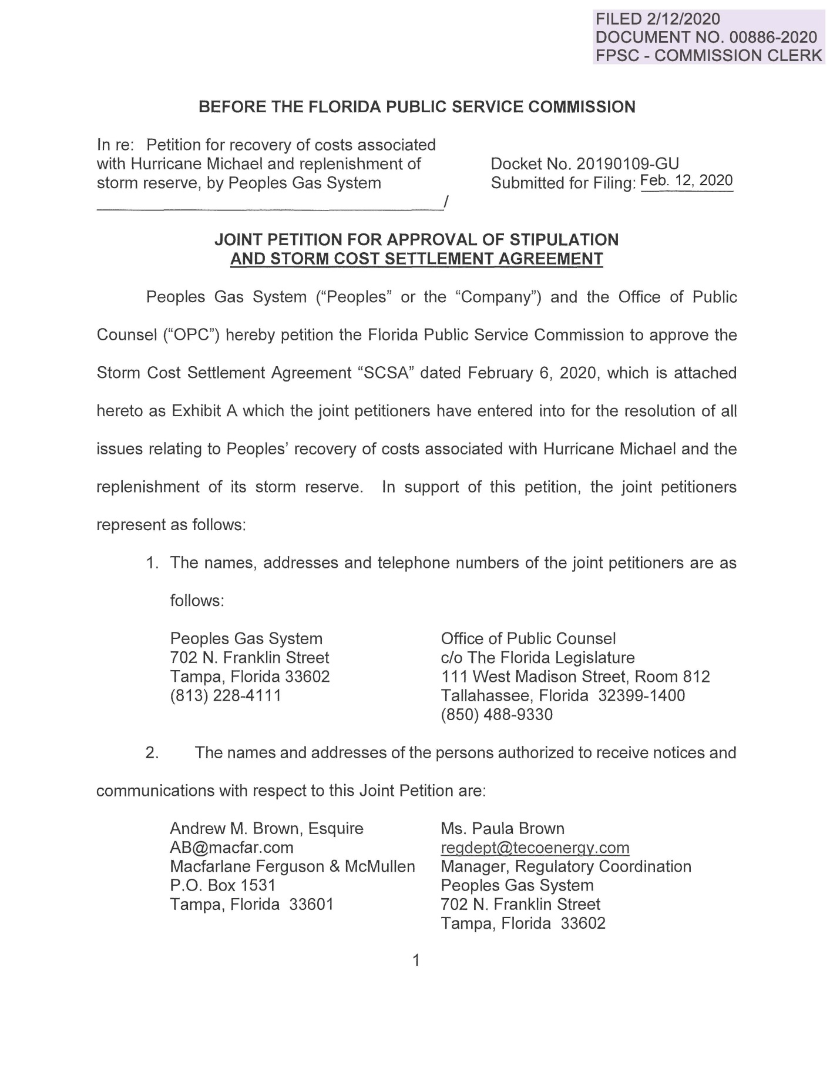

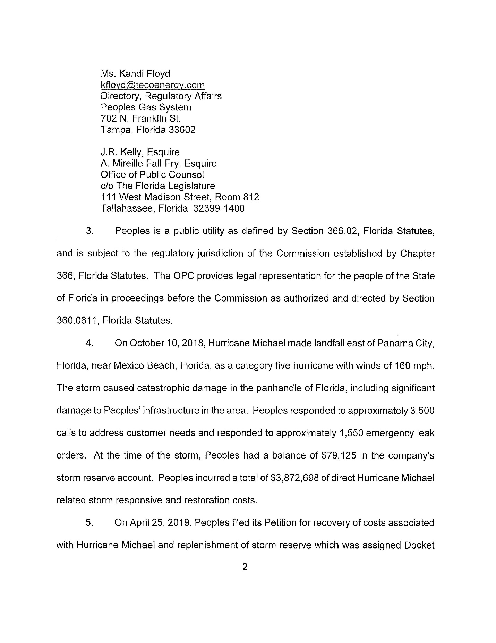

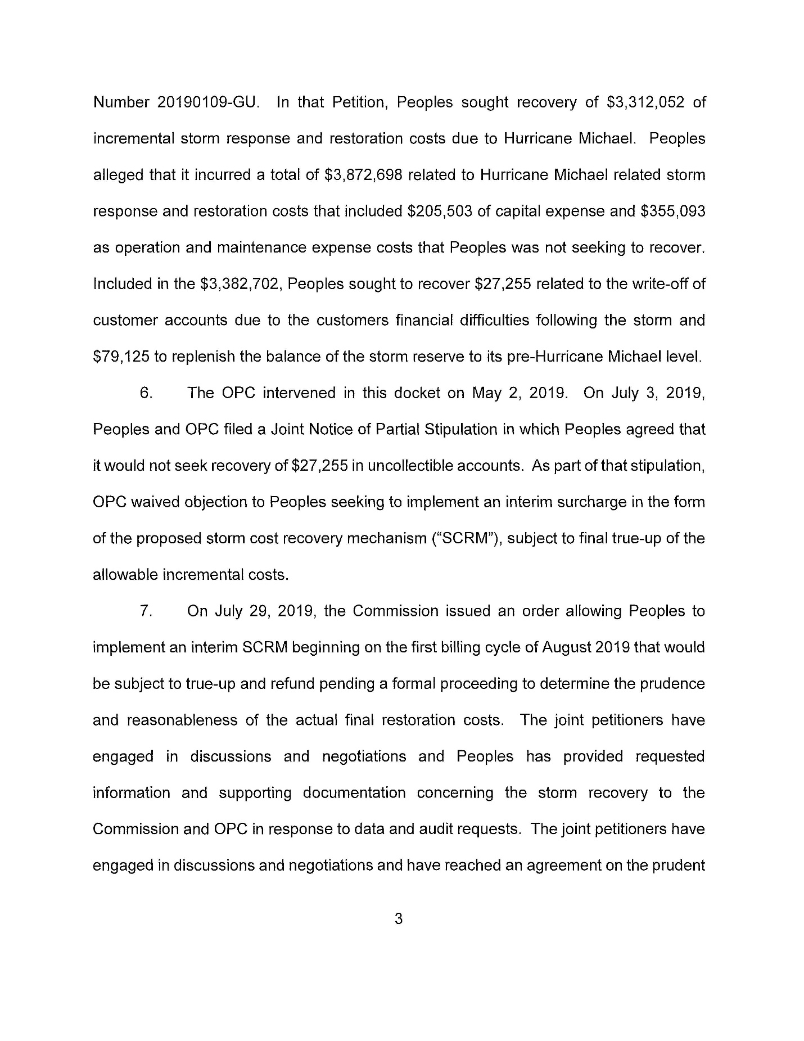

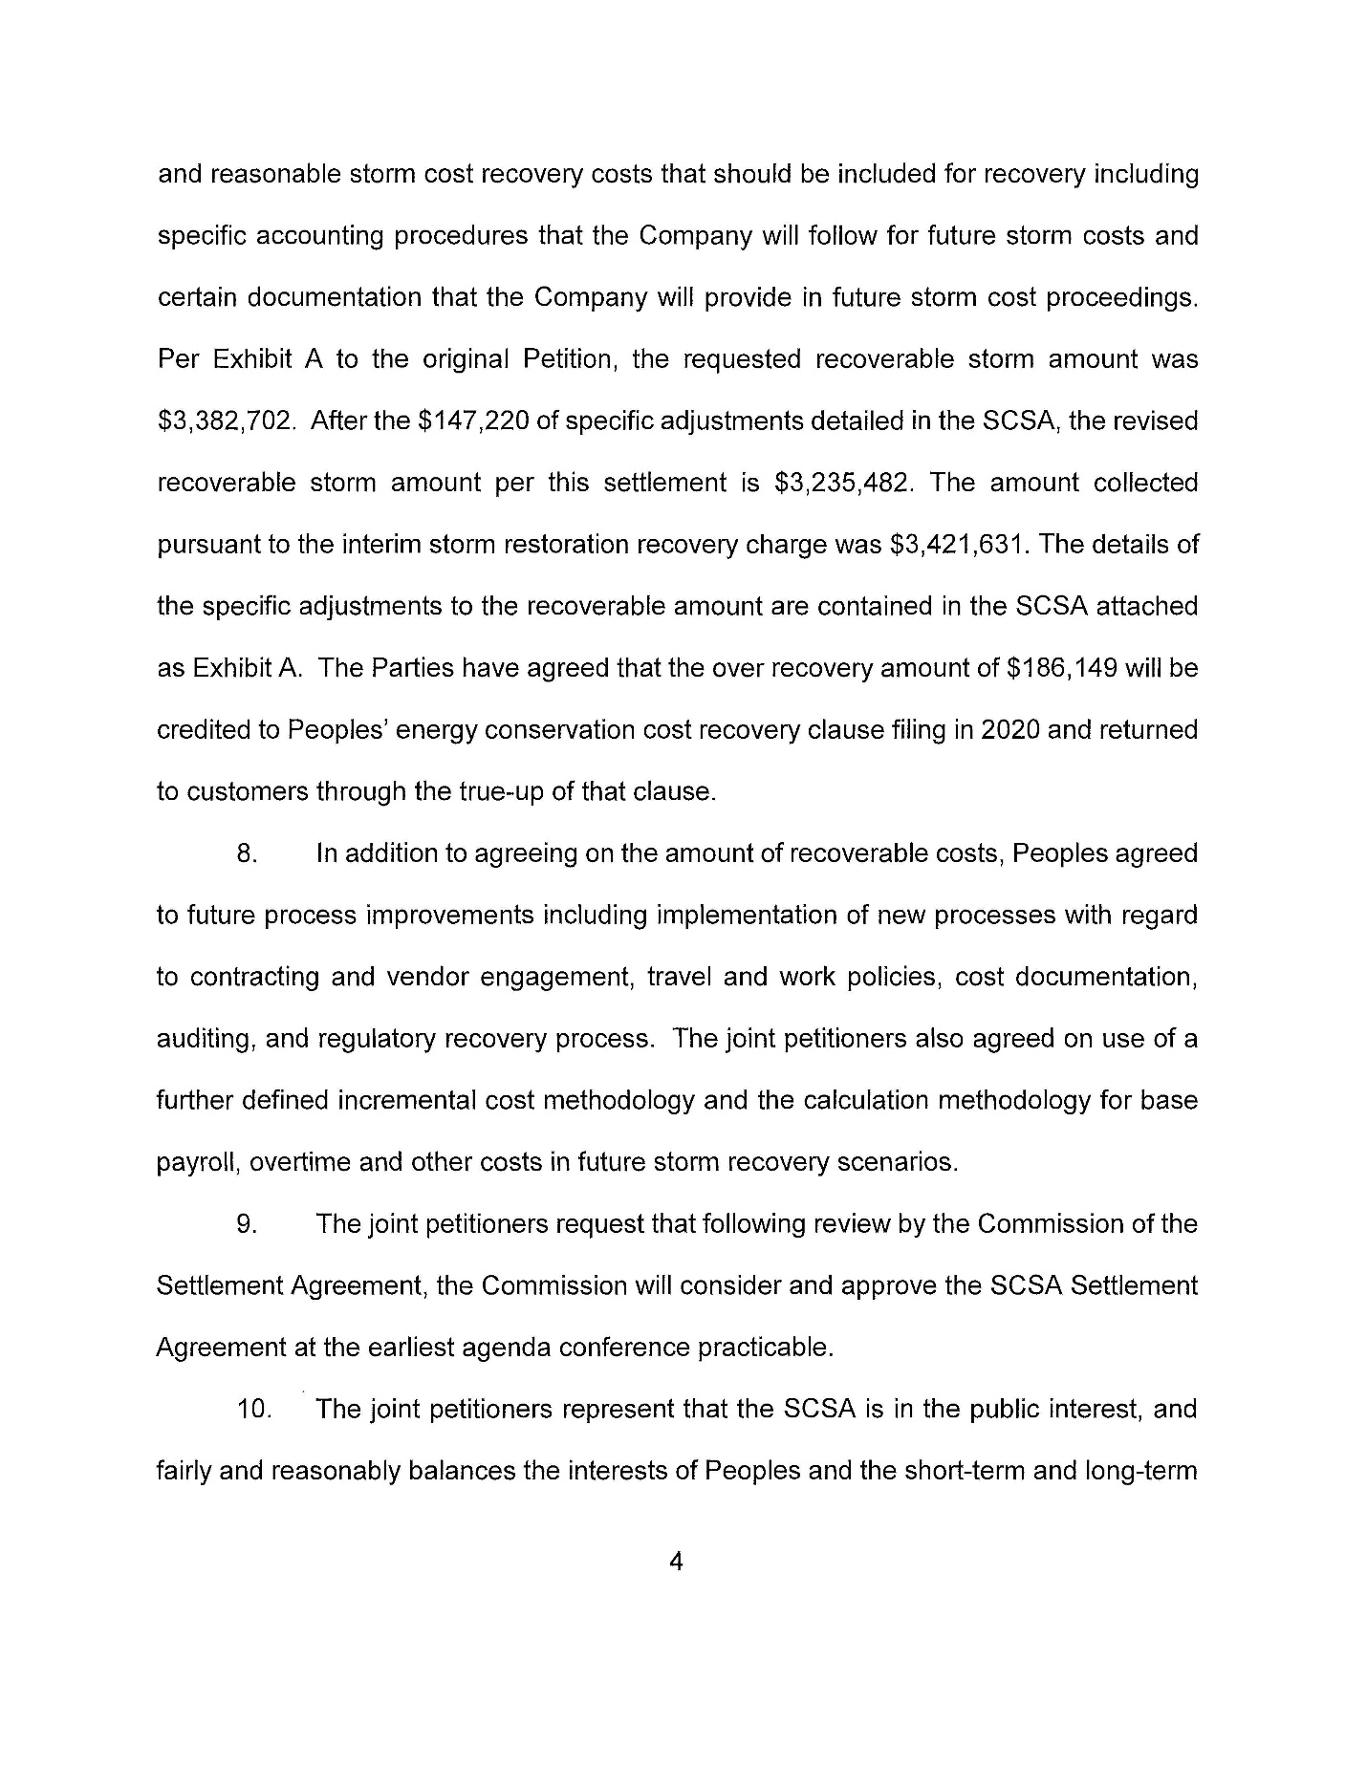

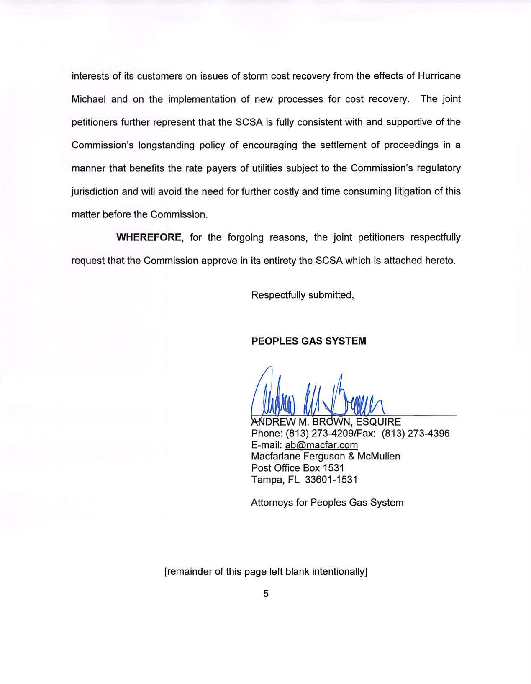

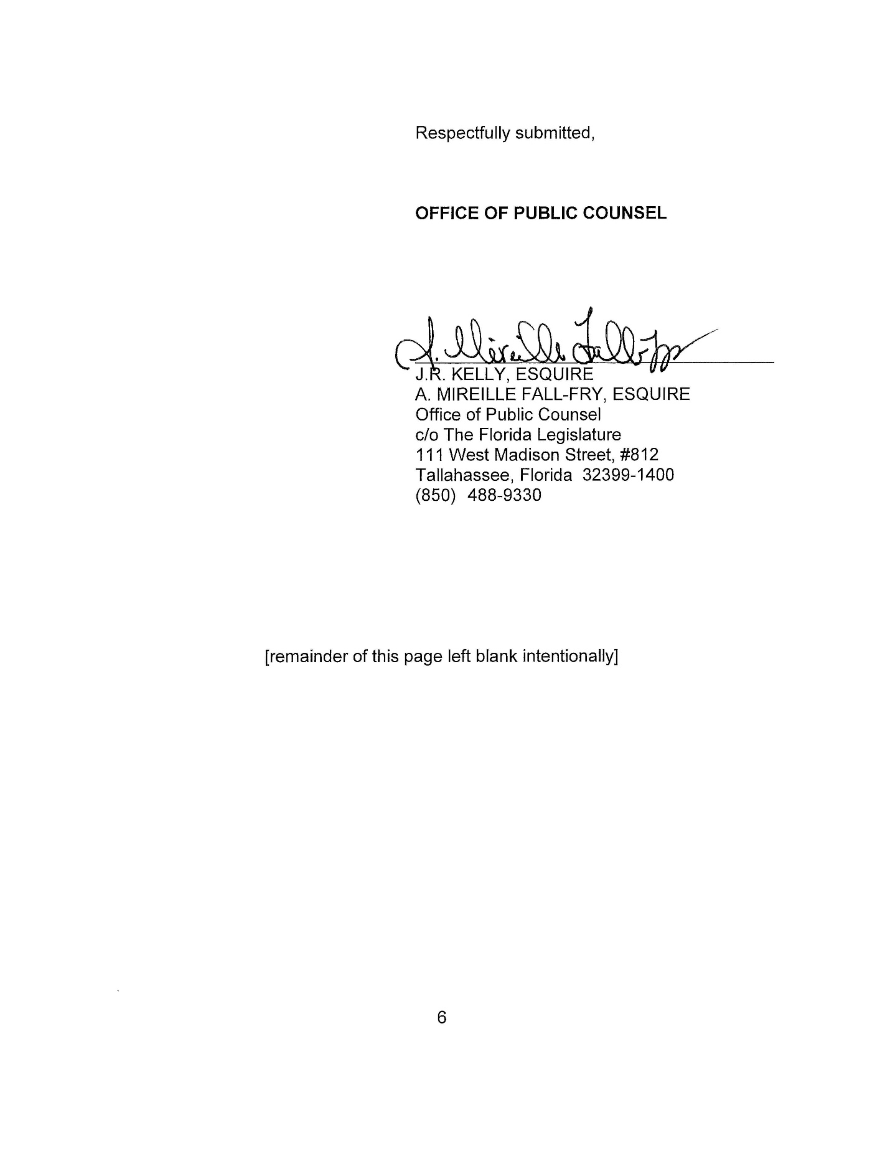

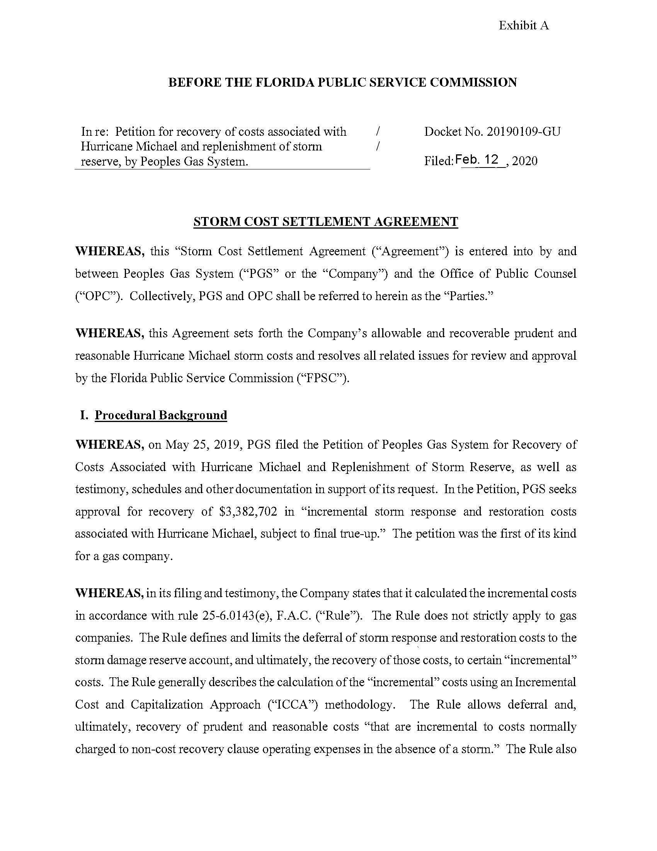

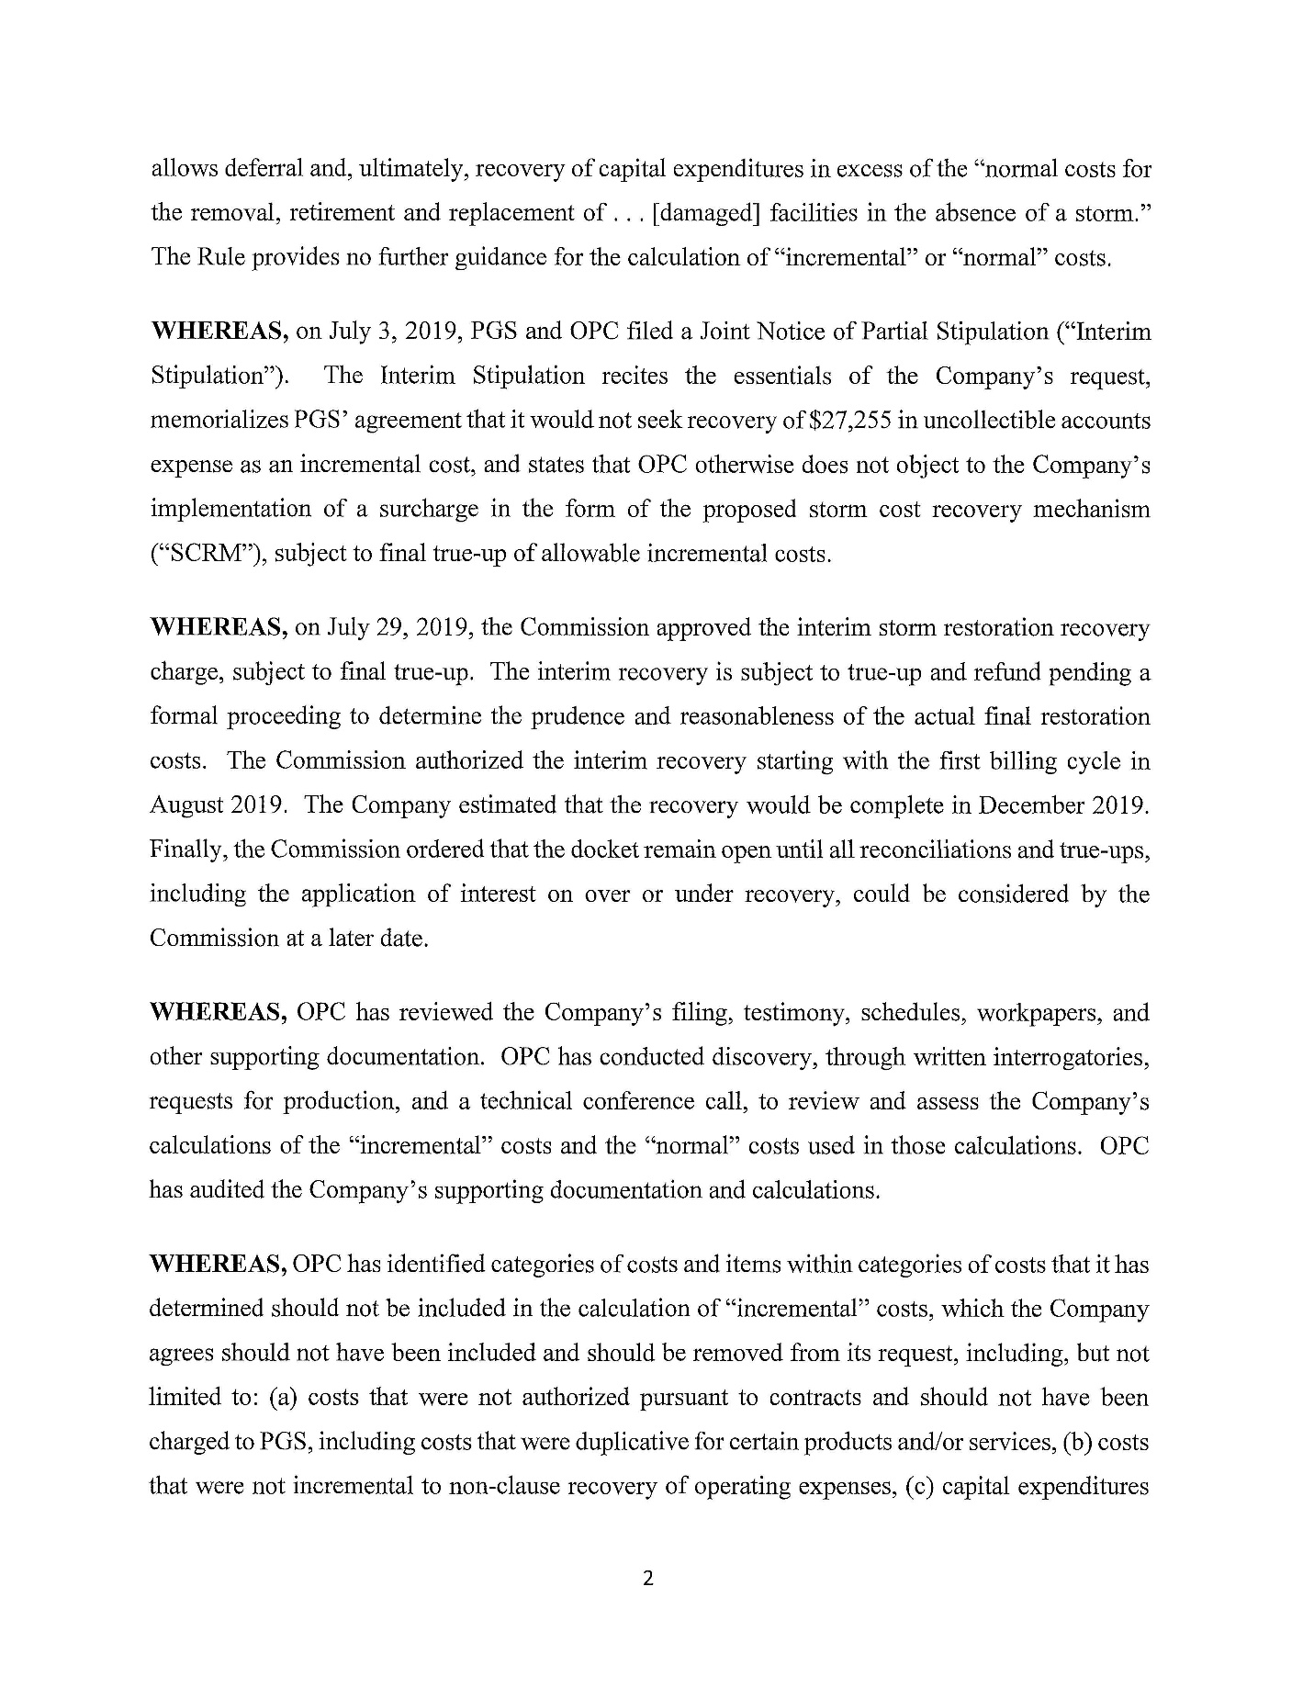

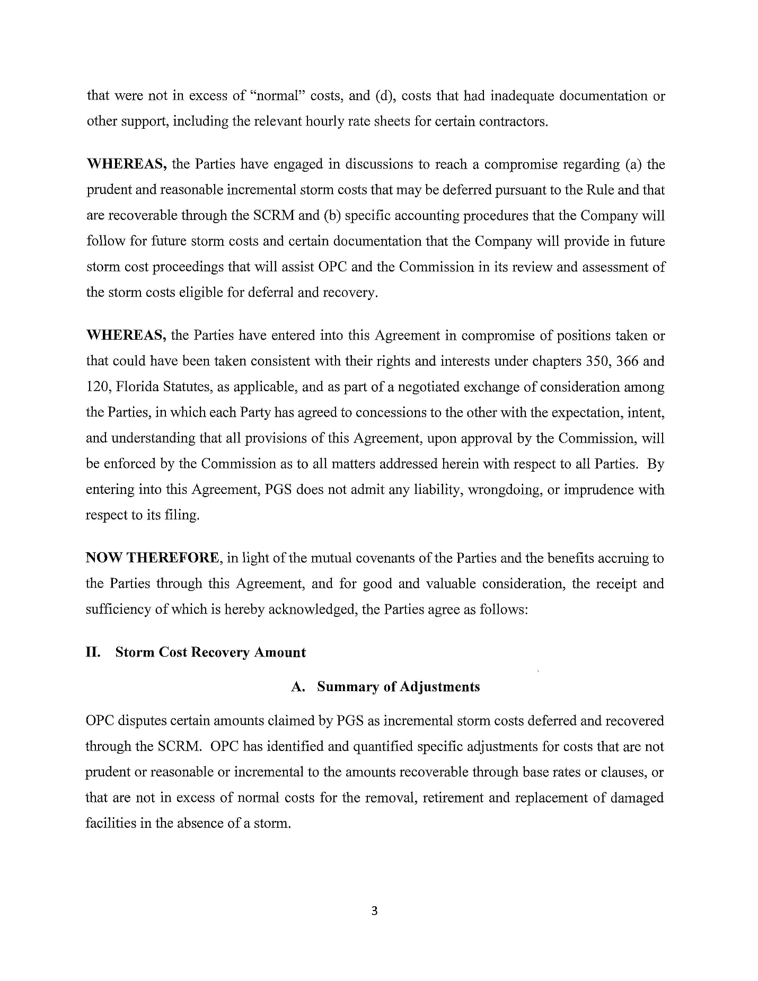

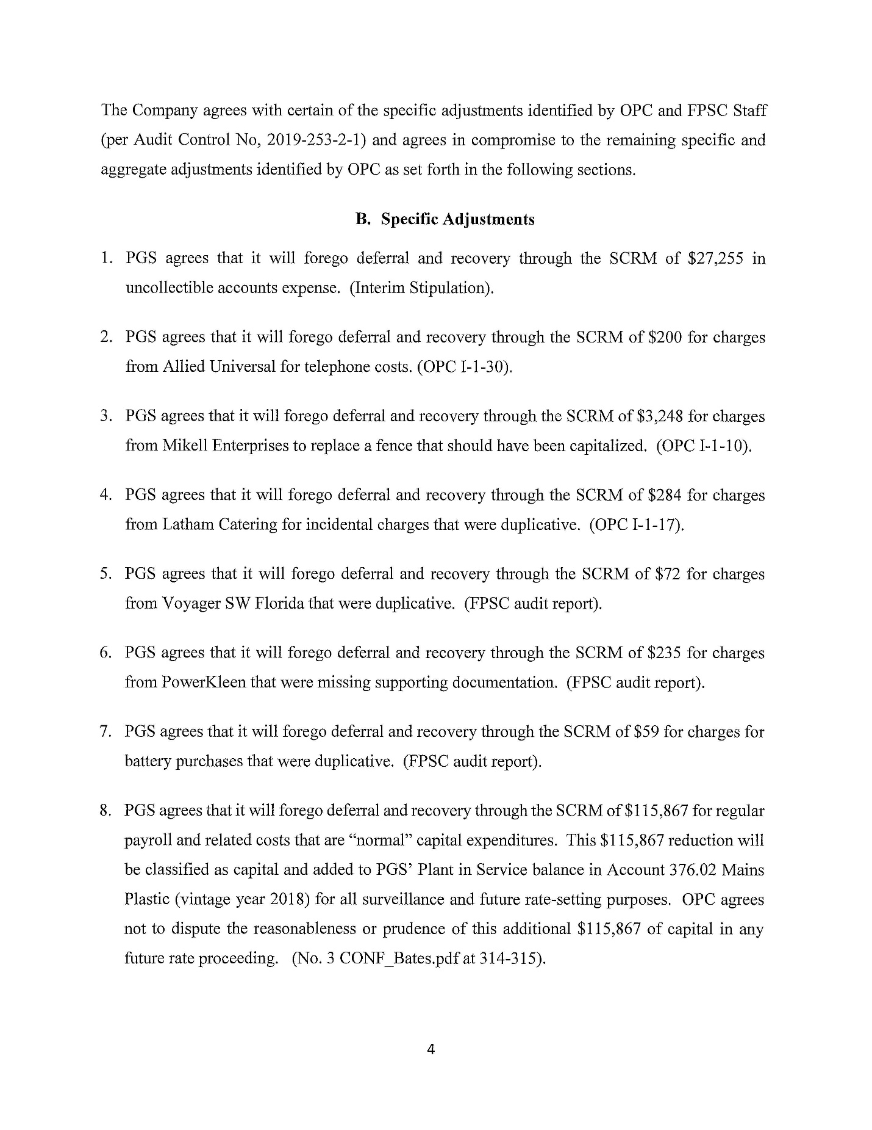

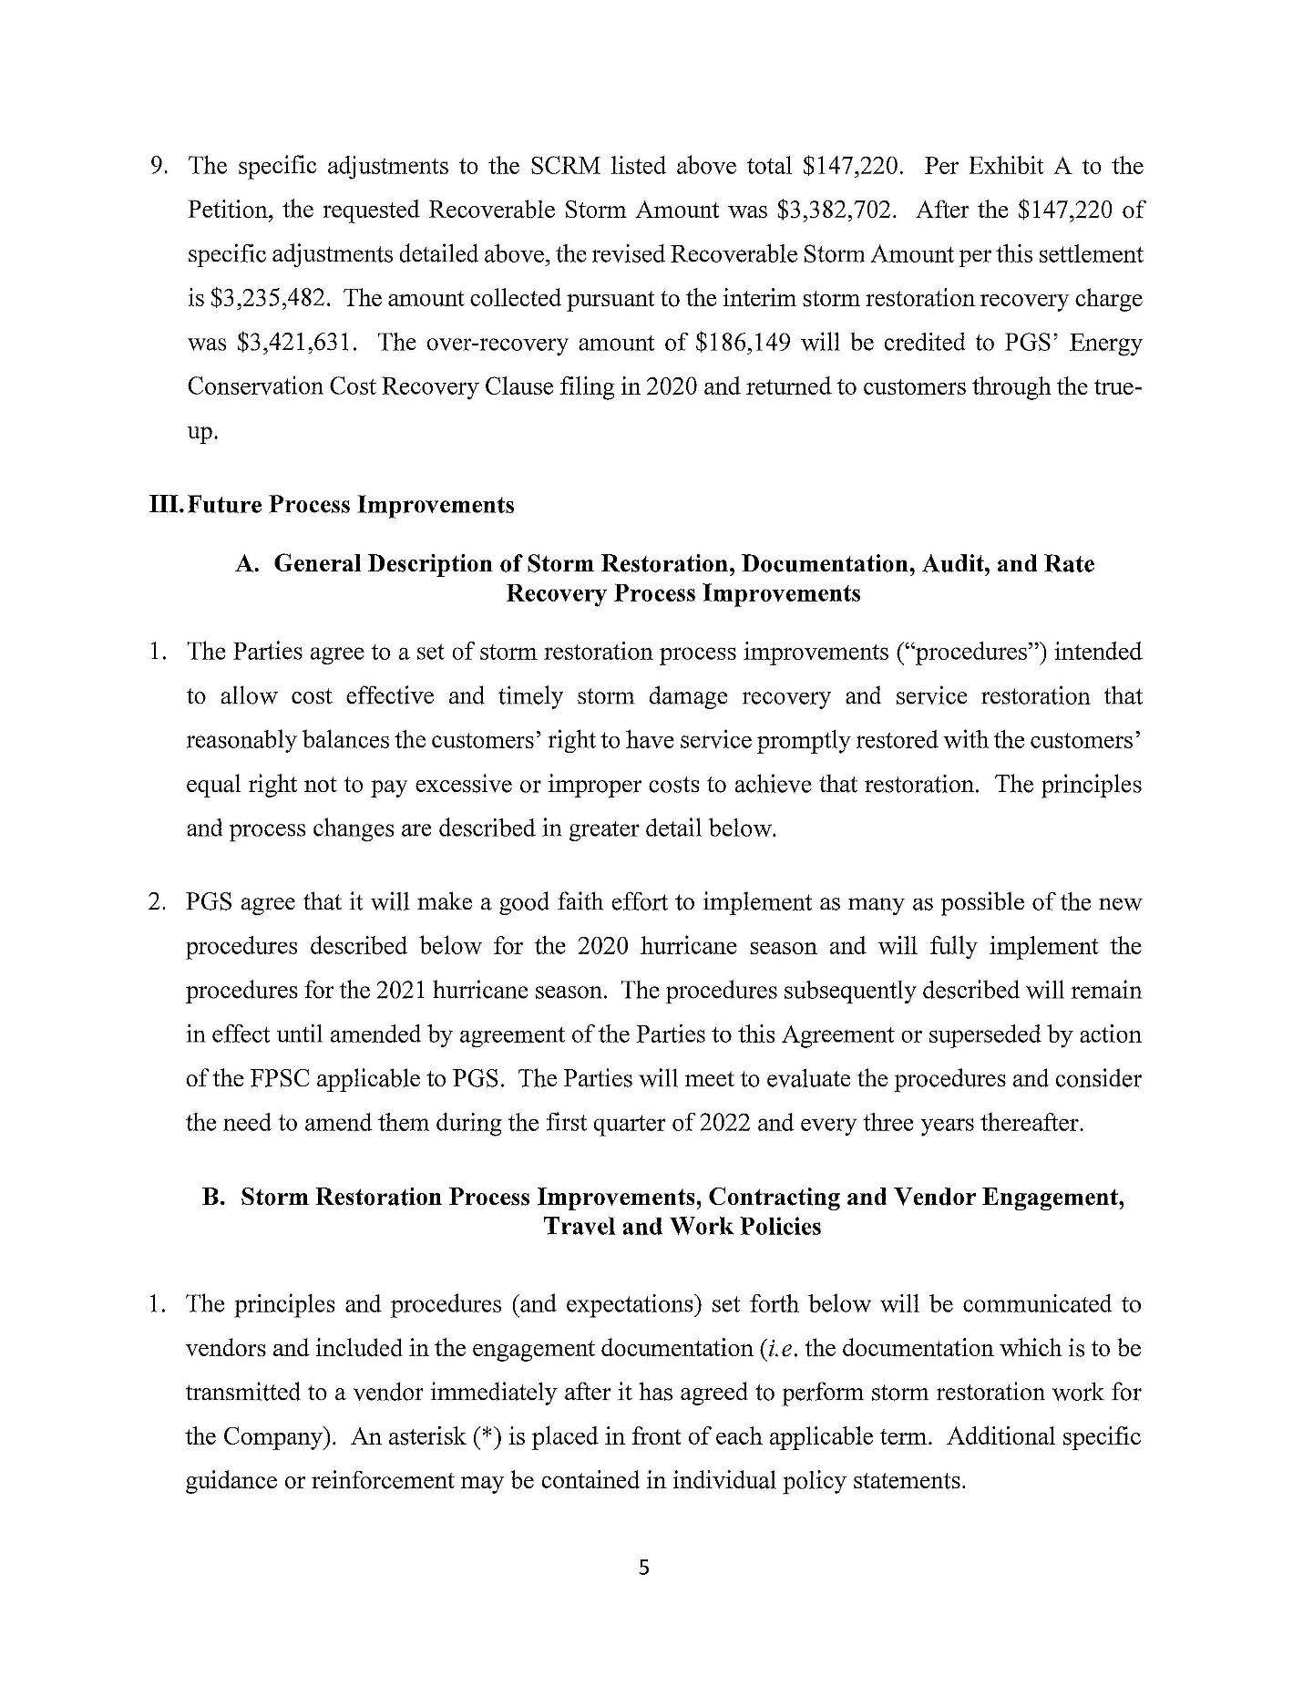

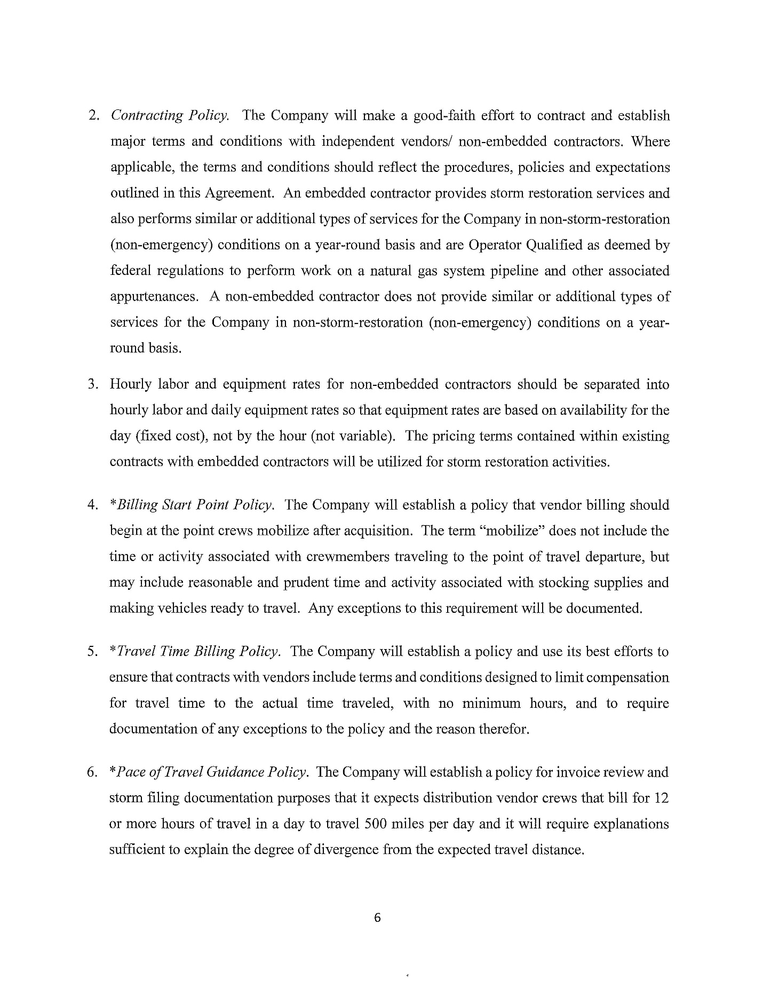

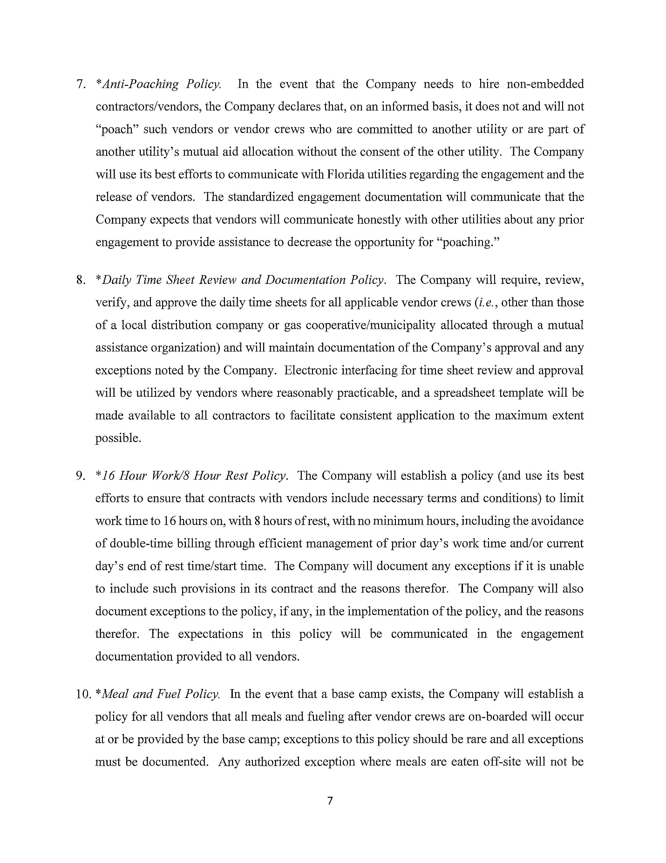

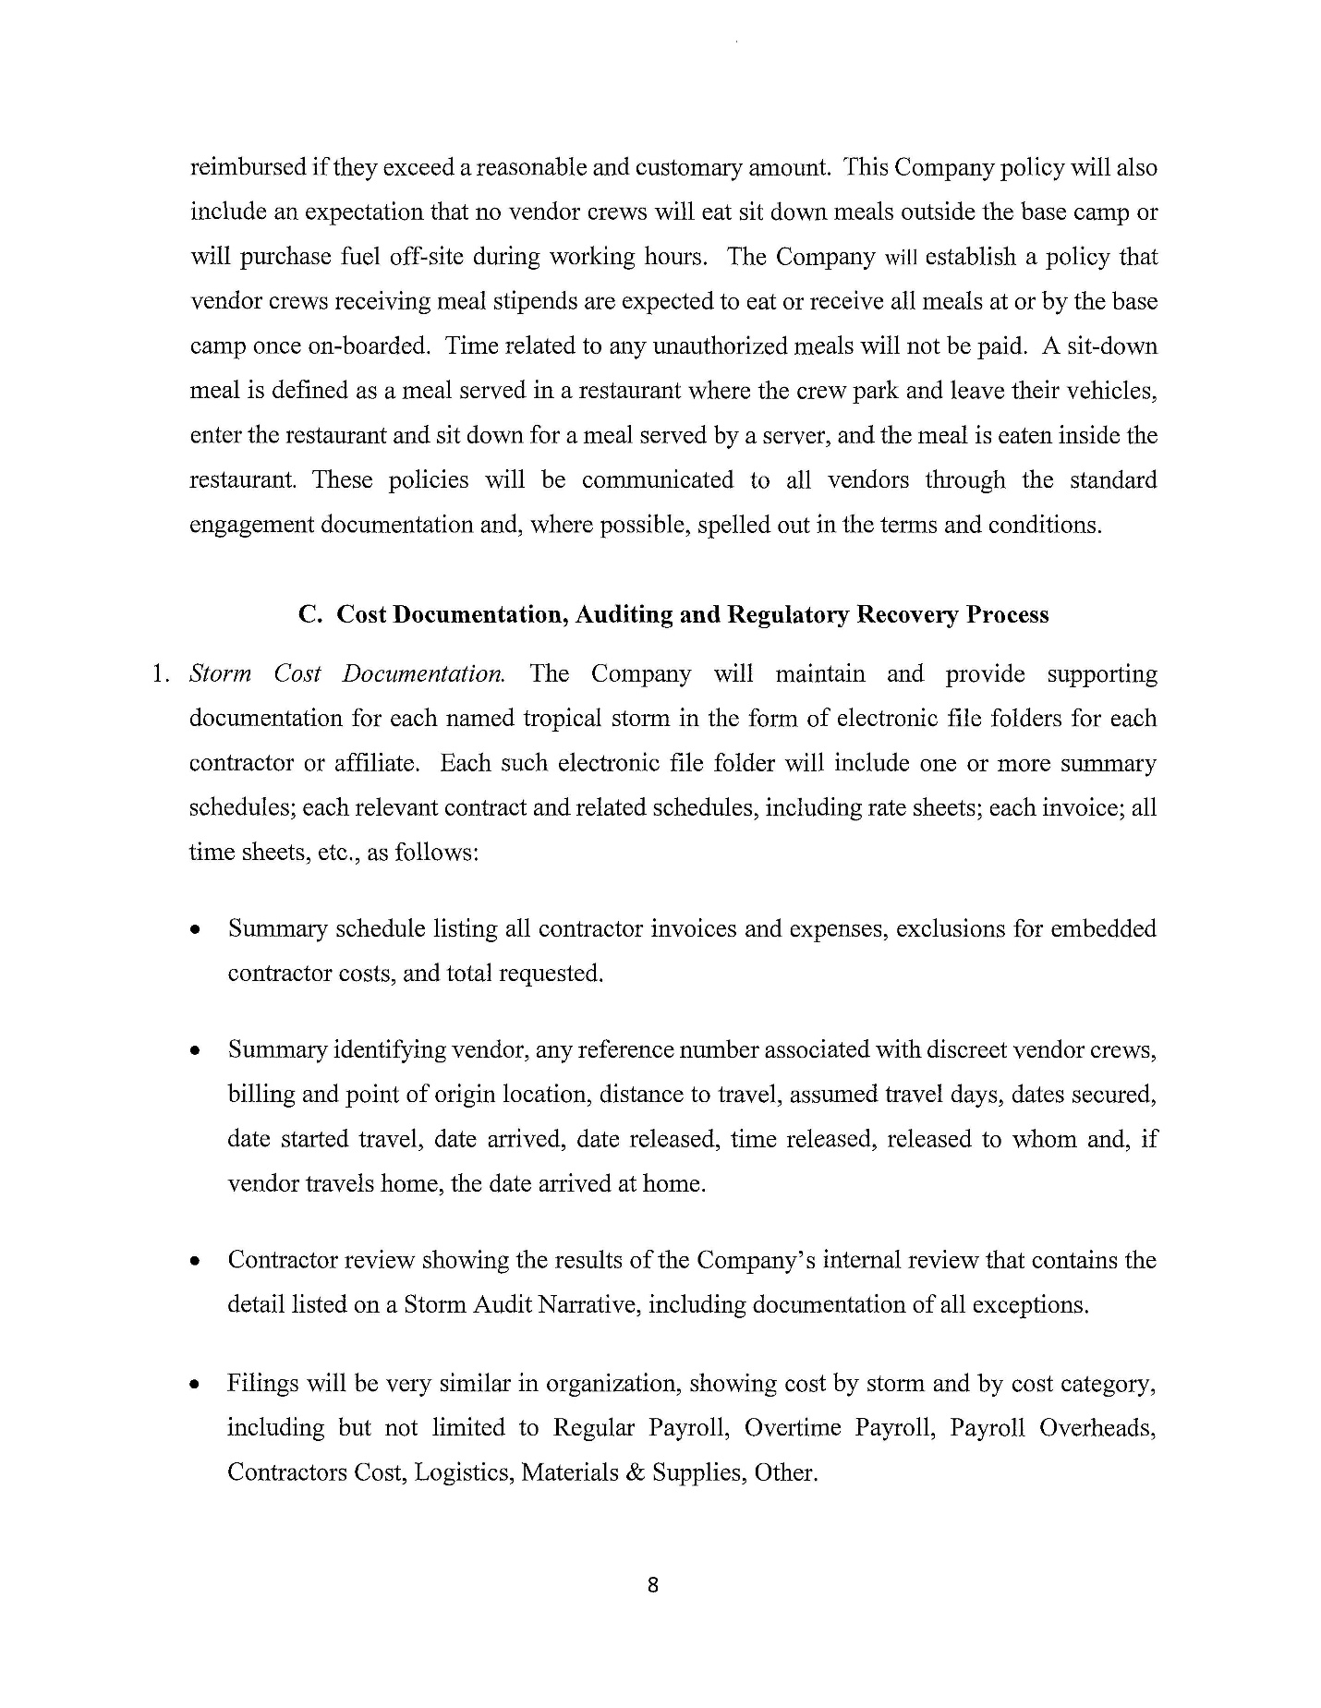

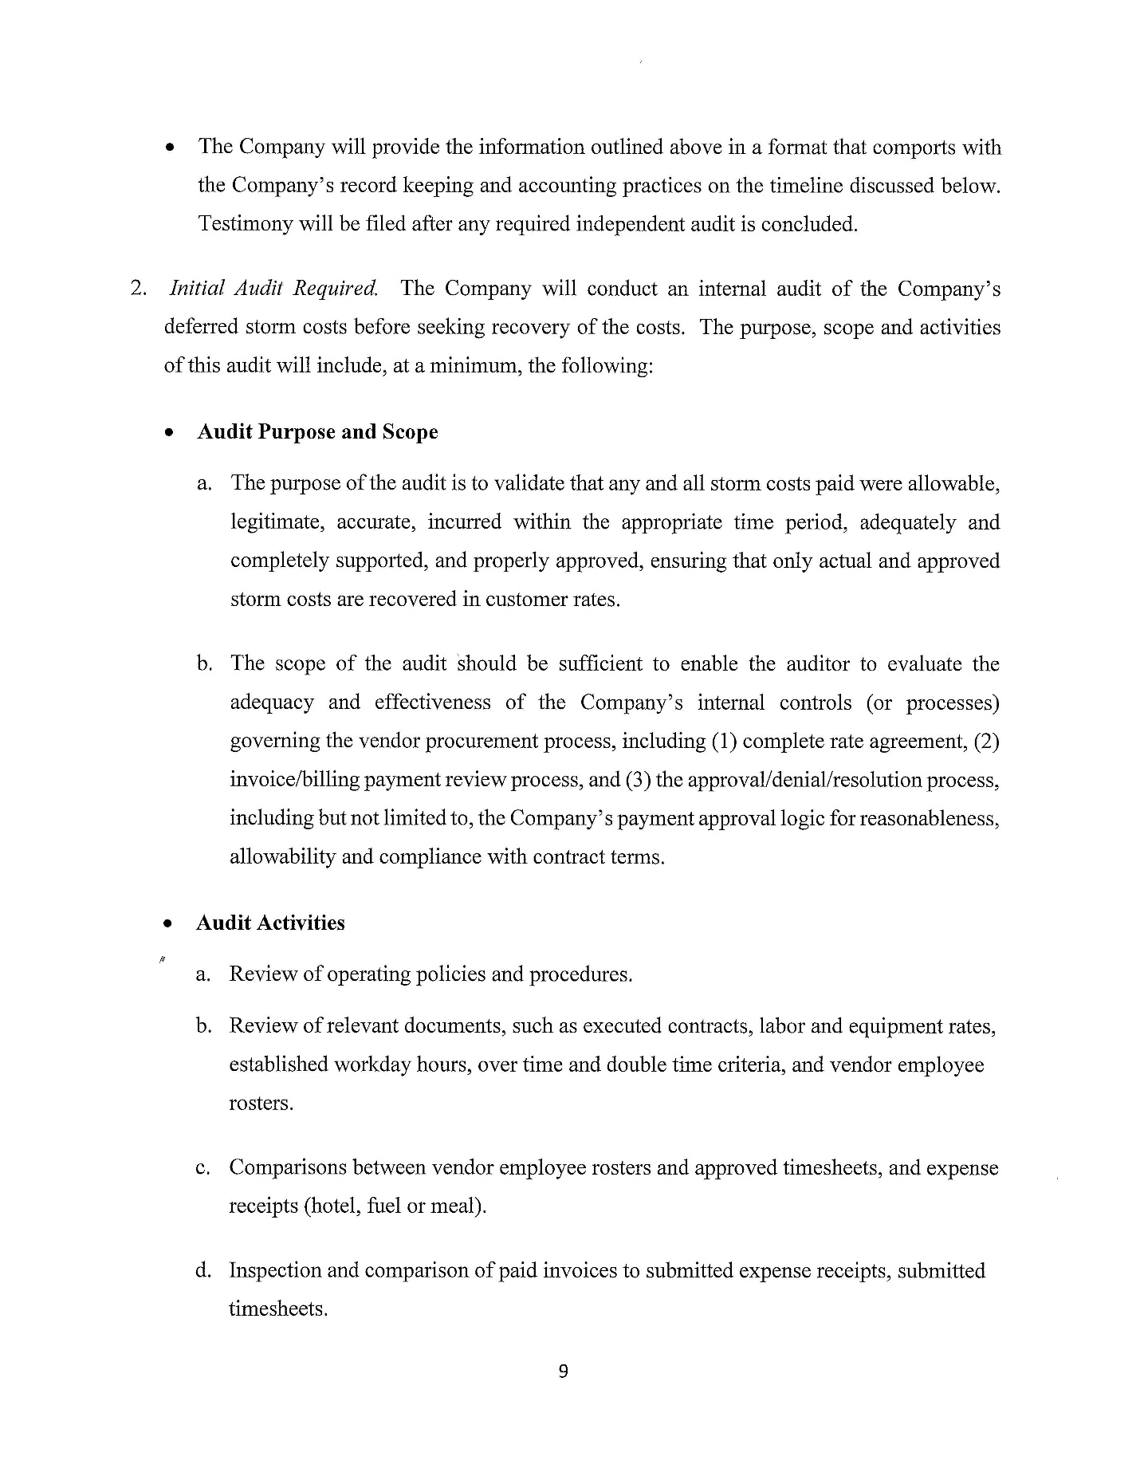

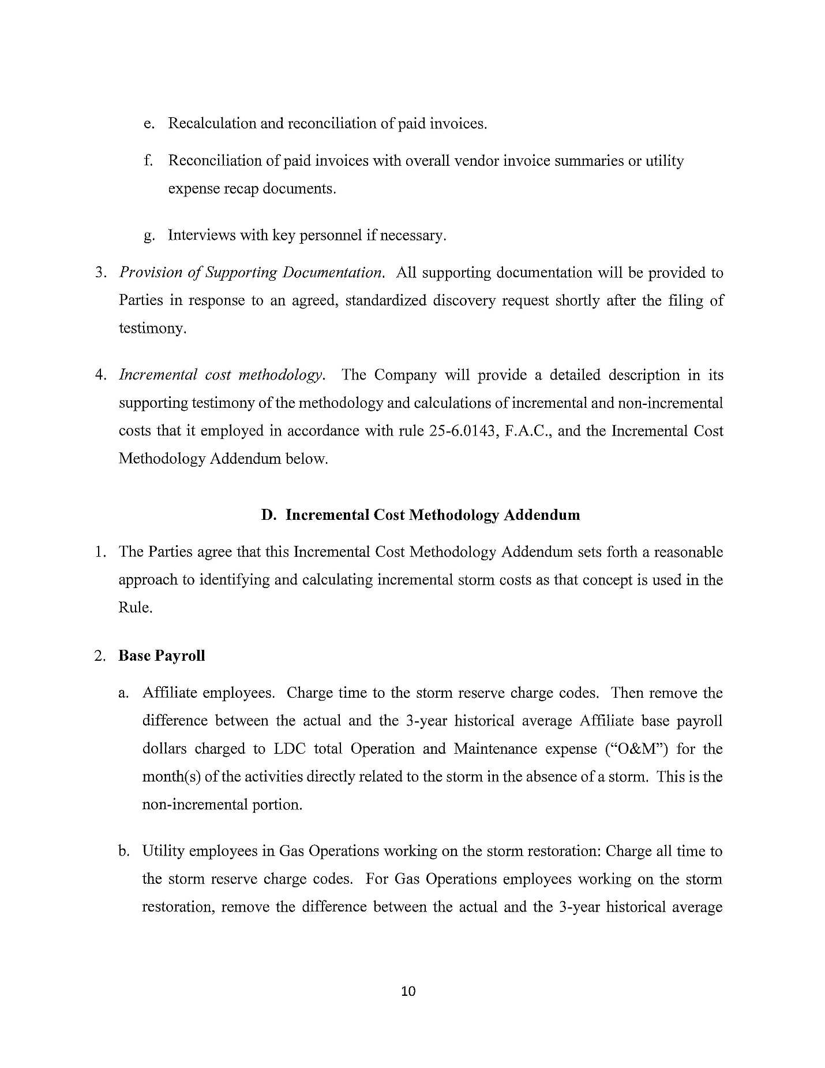

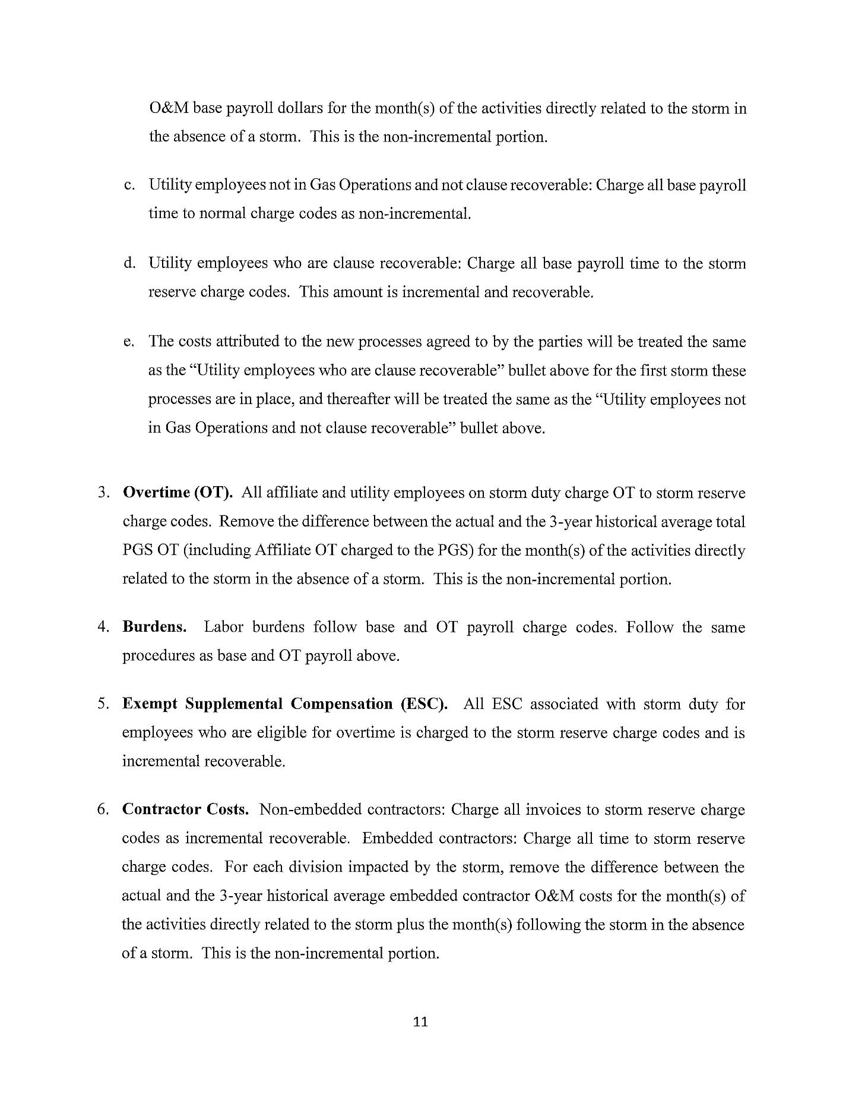

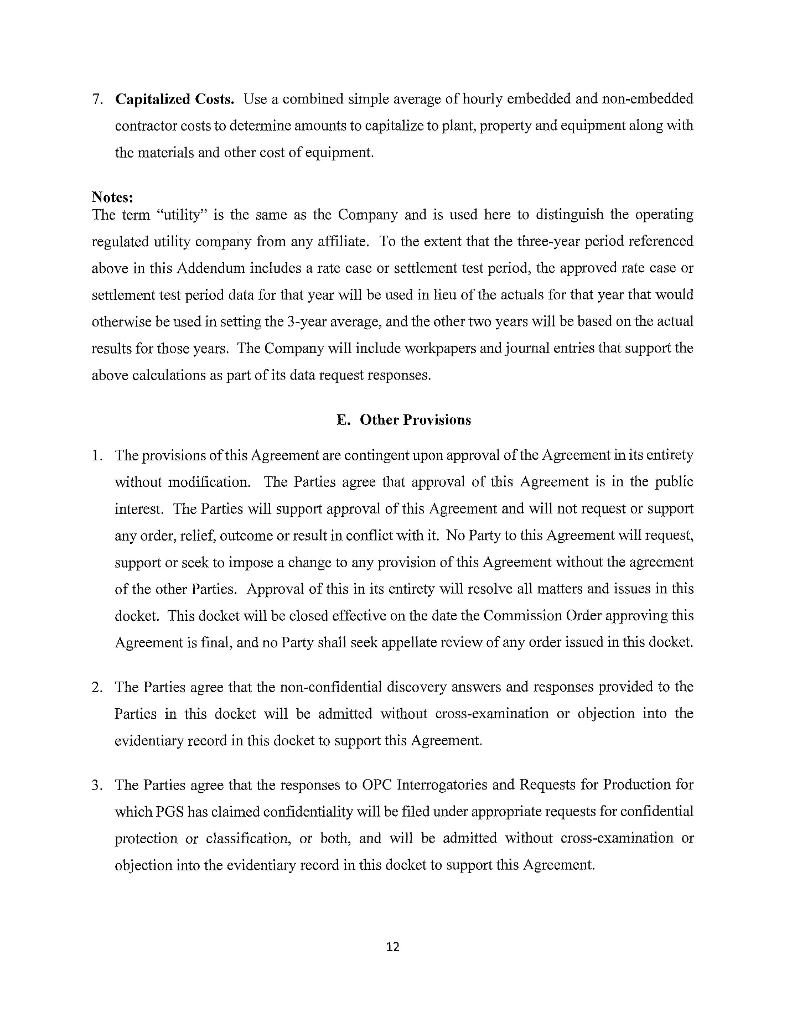

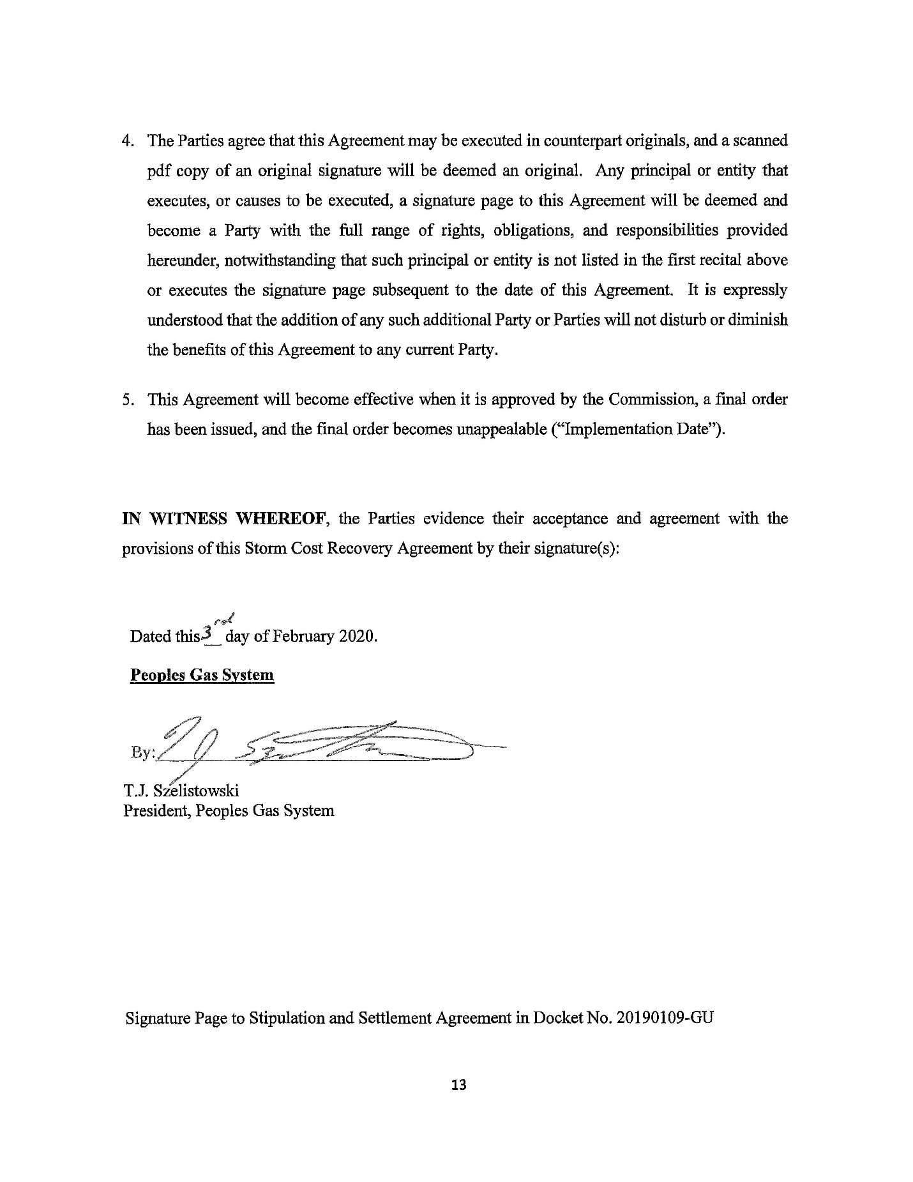

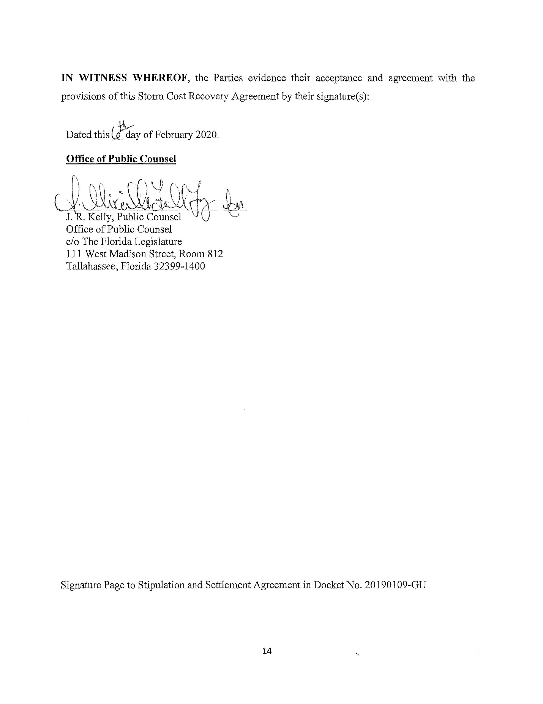

Order No. PSC-2019-0310-PCO-GU, issued July 29, 2019, in Docket No. 20190109-GU, Petition for recovery of costs associated with Hurricane Michael and replenishment of storm reserve, by Peoples Gas System.
Order No. PSC-2017-0488-PAA-EI, issued on December 26, 2017, in Docket No. 20170150-EI, In re: Petition for limited proceeding to include reliability and modernization projects in rate base, by Florida Public Utilities Company; Order No. PSC-13-0023-S-EI, issued on January 14, 2013, in Docket No. 120015-EI, In re: Petition for increase in rates by Florida Power & Light Company
Order No. PSC-13-0023-S-EI, at p. 7.

