BEFORE THE FLORIDA PUBLIC SERVICE COMMISSION

In re: Petition to revise tariffs for Florida Public Utilities Company, Florida Public Utilities Company - Indiantown Division, Florida Public Utilities Company - Fort Meade, Florida Division of Chesapeake Utilities Corporation, and Peninsula Pipeline Company to update the description of gas quality and character of service. | DOCKET NO. 20200046-GU  ORDER NO. PSC-2020-0113-TRF-GU  ISSUED: April 20, 2020

The following Commissioners participated in the disposition of this matter:

GARY F. CLARK, Chairman
ART GRAHAM
JULIE I. BROWN
DONALD J. POLMANN
ANDREW GILES FAY

ORDER APPROVING TARIFF REVISIONS TO UPDATE THE DESCRIPTION
OF GAS QUALITY AND CHARACTER OF SERVICE

BY THE COMMISSION:

Background
On January 16, 2020, Florida Public Utilities Company (FPUC), Florida Public Utilities Company - Indiantown Division (Indiantown), Florida Public Utilities Company - Fort Meade (Fort Meade), Florida Division of Chesapeake Utilities Corporation (Chesapeake), and Peninsula Pipeline Company (Peninsula) (jointly, Companies), filed proposed tariff revisions related to the description of gas quality and character of service. The purpose of the proposed tariff revisions is to require the quality of natural gas entering the system to be consistent with the standards used by interstate pipelines. The revisions do not impact rates, rate structure, or terms and conditions of service; nor do they preclude the receipt of renewable natural gas. The Companies’ revised tariff sheets are found in Attachments 1 through 5 to this Order.
The Companies initially requested that the revised tariffs be approved administratively by Commission staff. Staff determined that some revised tariffs did not meet the requirements for administrative approval and, on February 3, 2020, established this docket for Commission review.
Commission staff issued one data request to the Companies on February 10, 2020, to which responses were filed on February 24, 2020.

We have jurisdiction over this matter pursuant to Sections 366.05, 366.06, and 368.05, 368.104, Florida Statutes (F.S.).

Decision

The Proposed Revised Tariffs
FPUC, Indiantown, Fort Meade, and Chesapeake are local distribution companies (LDCs) which own and operate natural gas distribution facilities to serve retail customers and are subject to our regulatory jurisdiction under Chapter 366, F.S. Peninsula operates as an intrastate natural gas transmission company as defined in Section 368.103, F.S., and only transports natural gas. The Companies are affiliates or subsidiaries of Chesapeake Utilities Corporation.
Currently, the Companies accept natural gas that conforms to the quality standards set by the specific pipeline companies which deliver gas to the Companies’ system. Under these revisions, natural gas that is delivered from an interconnected pipeline will continue to be accepted at the standards set by that specific pipeline. In addition, the Companies have now proposed to establish gas quality standards, in each of their own tariffs, for any gas entering the Companies’ system that does not come from an interconnected pipeline.
The primary purpose of this change is to allow for the receipt of a broader range of natural gas, while maintaining the integrity of the distribution system and acceptable standards for customers. The proposed Quality of Gas section includes a list of standards for gas that is not delivered by interconnected pipelines, allowing the Companies to diversify their natural gas supply mix. Gas not delivered by interconnected pipelines can come from various sources, such as compressed, liquid, or renewable natural gas. The same standards have been proposed for each Company to ensure consistency.
The proposed Quality of Gas chart specifies the maximum allowable amount of various containments that could possibly be found in natural gas. The chart also defines ranges for specific natural gas properties, such as heating value. Finally, there is an additional requirement that gas should be commercially free of hazardous waste, solid or liquid matter, dust, gums, or any other substance that may impact the merchantability of the gas or impact any facilities the gas flows through.
The proposed Quality of Gas section is comparable to the standards set by interstate pipelines transporting gas to Florida, such as Florida Gas Transmission and Southern Natural Gas Company. Additionally, these standards are similar to what is currently contained in Peoples Gas System’s tariff.
In addition to the revisions discussed above, the LDC’s have also requested to revise certain Character of Service sections. These revisions are designed to reference the newly proposed Quality of Gas tariffs and include a definition for transportation service. These revisions do not alter service, but seek to reorganize and clarify the tariffs.

Conclusion

Based on the above, we find the proposed tariff revisions to be reasonable. The revisions do not impact customer rates, rate structure, or the terms and conditions of service. We also find the quality of gas standards requested by the Companies to be reasonable. Those standards are comparable to standards previously approved by this Commission. Therefore, we approve the proposed tariff revisions, effective March 31, 2020.

Based on the foregoing, it is

ORDERED by the Florida Public Service Commission that the revised tariffs proposed by Florida Public Utilities Company, Florida Public Utilities Company - Indiantown Division, Florida Public Utilities Company - Fort Meade, Florida Division of Chesapeake Utilities Corporation, and Peninsula Pipeline Company, as shown on Attachments 1 through 5 of this Order are approved. The proposed tariffs are effective March 31, 2020.

ORDERED that if a protest is filed within 21 days of issuance of the Order, the tariff shall remain in effect with any charges held subject to refund pending resolution of the protest. It is further

ORDERED that if no timely protest is filed, this docket shall be closed upon the issuance of a Consummating Order.

By ORDER of the Florida Public Service Commission this 20th day of April, 2020.

/s/ Adam J. Teitzman
ADAM J. TEITZMAN
Commission Clerk
Florida Public Service Commission
2540 Shumard Oak Boulevard
Tallahassee, Florida 32399
(850) 413-6770
www.floridapsc.com

Copies furnished: A copy of this document is provided to the parties of record at the time of issuance and, if applicable, interested persons.

SPS

NOTICE OF FURTHER PROCEEDINGS

The Florida Public Service Commission is required by Section 120.569(1), Florida Statutes, to notify parties of any administrative hearing or judicial review of Commission orders that is available under Sections 120.57 or 120.68, Florida Statutes, as well as the procedures and time limits that apply. This notice should not be construed to mean all requests for an administrative hearing or judicial review will be granted or result in the relief sought.

Mediation may be available on a case-by-case basis. If mediation is conducted, it does not affect a substantially interested person's right to a hearing.

The Commission's decision on this tariff is interim in nature and will become final, unless a person whose substantial interests are affected by the proposed action files a petition for a formal proceeding, in the form provided by Rule 28-106.201, Florida Administrative Code. This petition must be received by the Office of Commission Clerk, 2540 Shumard Oak Boulevard, Tallahassee, Florida 32399-0850, by the close of business on May 11, 2020.

In the absence of such a petition, this Order shall become final and effective upon the issuance of a Consummating Order.

Any objection or protest filed in this docket before the issuance date of this order is considered abandoned unless it satisfies the foregoing conditions and is renewed within the specified protest period.

Attachment 1: Florida Public Utilities Company
Fourth Revised Sheet No. 11
Original Sheet No. 22.4
Nineteenth Revised Sheet No. 24
Sixth Revised Sheet No. 24.1
Fourteenth Revised Sheet No. 25
Twenty-first Revised Sheet No. 26
Seventh Revised Sheet No. 26.1
Nineteenth Revised Sheet No. 28
Twenty-second Revised Sheet No. 29
Eighteenth Revised Sheet No. 31
First Revised Sheet No. 33.3

Attachment 2: Florida Public Utilities Company- Fort Meade
First Revised Sheet No. 9
First Revised Sheet No. 31
First Revised Sheet No. 34
First Revised Sheet No. 35
First Revised Sheet No. 39
Second Revised Sheet No.45
Second Revised Sheet No. 53

Attachment 3: Florida Public Utilities- Indiantown Division
Third Revised Sheet No. 21
Third Revised Sheet No. 22
Third Revised Sheet No. 23
Third Revised Sheet No. 25
Second Revised Sheet No. 37
Second Revised Sheet No. 53
Original Sheet No. 53.1

Attachment 4: Florida Division of Chesapeake Utilities Corporation
Second Revised Sheet No. 15
Second Revised Sheet No. 61
Original Sheet No. 61.1
Second Revised Sheet No. 71
Second Revised Sheet No. 72
Second Revised Sheet No. 73
Second Revised Sheet No. 74
Second Revised Sheet No. 75
Second Revised Sheet No. 76
First Revised Sheet No. 77
Second Revised Sheet No. 78
First Revised Sheet No. 78.1
First Revised Sheet No. 78.2
Second Revised Sheet No. 79
Second Revised Sheet No. 80
First Revised Sheet No. 80.1
First Revised Sheet No. 80.2
Second Revised Sheet No. 81
Second Revised Sheet No. 82
Second Revised Sheet No. 83
Second Revised Sheet No. 84
Third Revised Sheet No. 85
Third Revised Sheet No. 86
Third Revised Sheet No. 87
Third Revised Sheet No. 88
Third Revised Sheet No. 89
Second Revised Sheet No. 90.1

Attachment 5: Peninsula Pipeline Company
First Revised Sheet No. 9
First Revised Sheet No. 18
Original Sheet No. 18.1

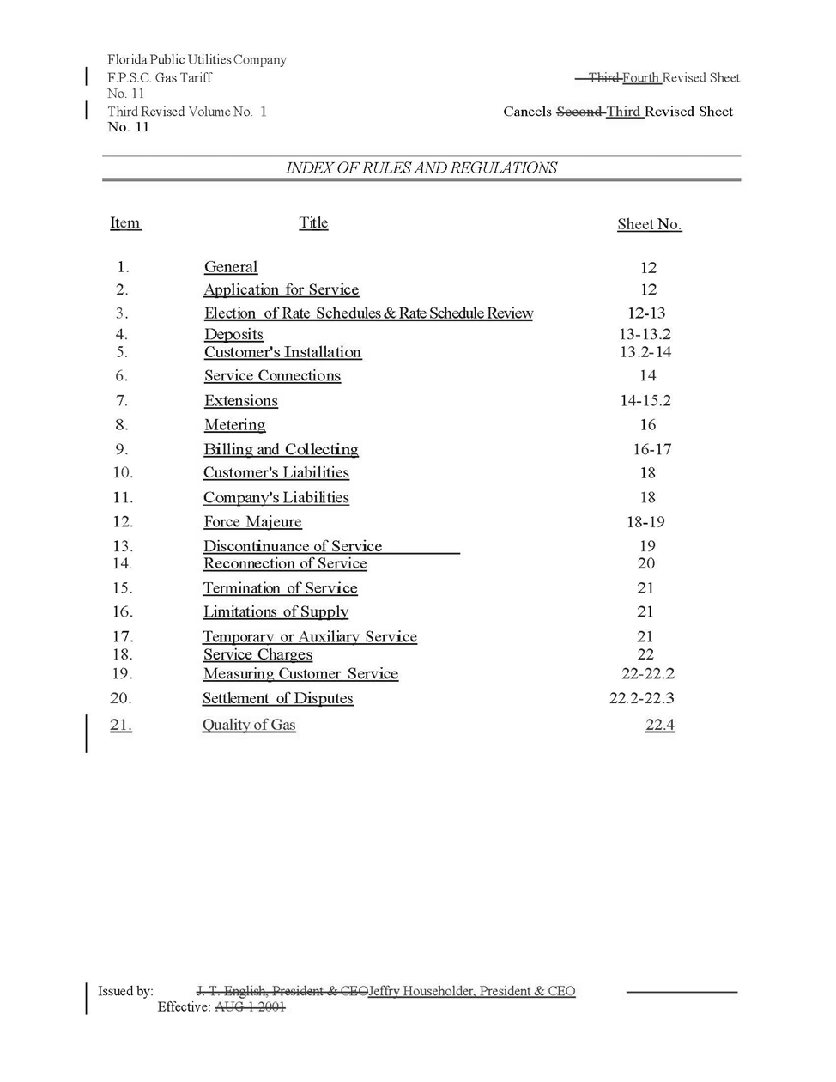

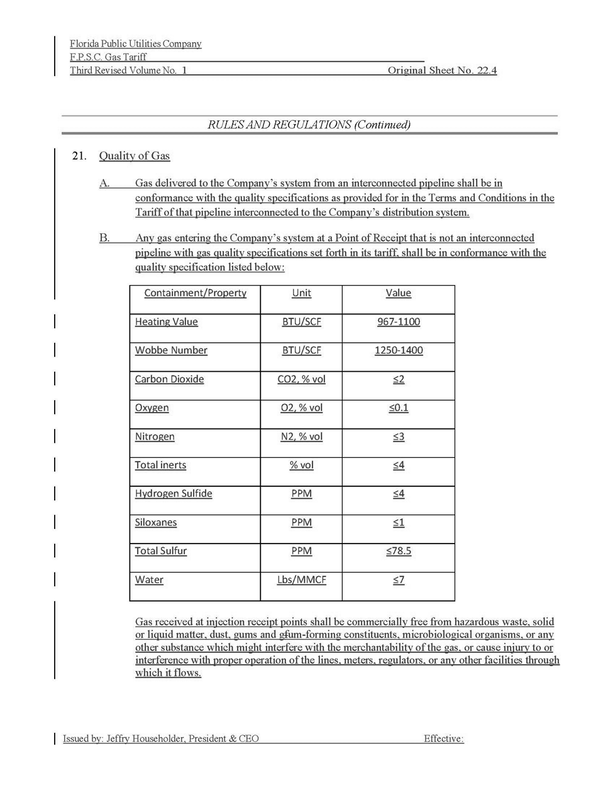

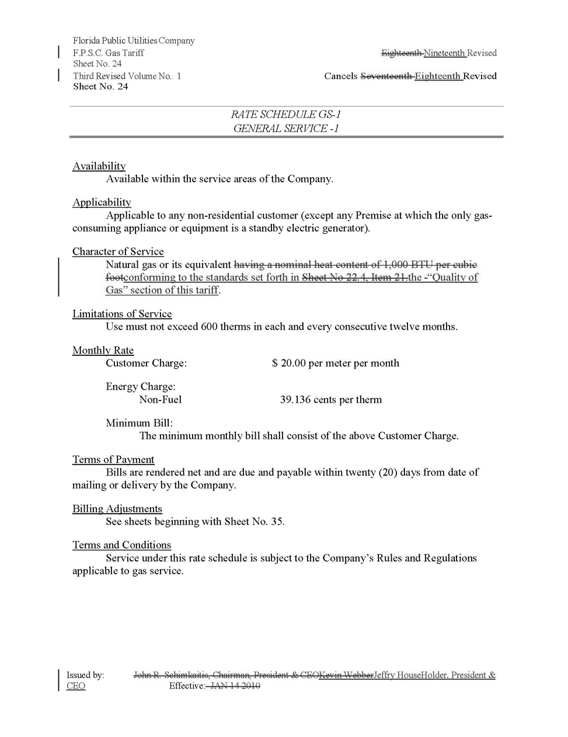

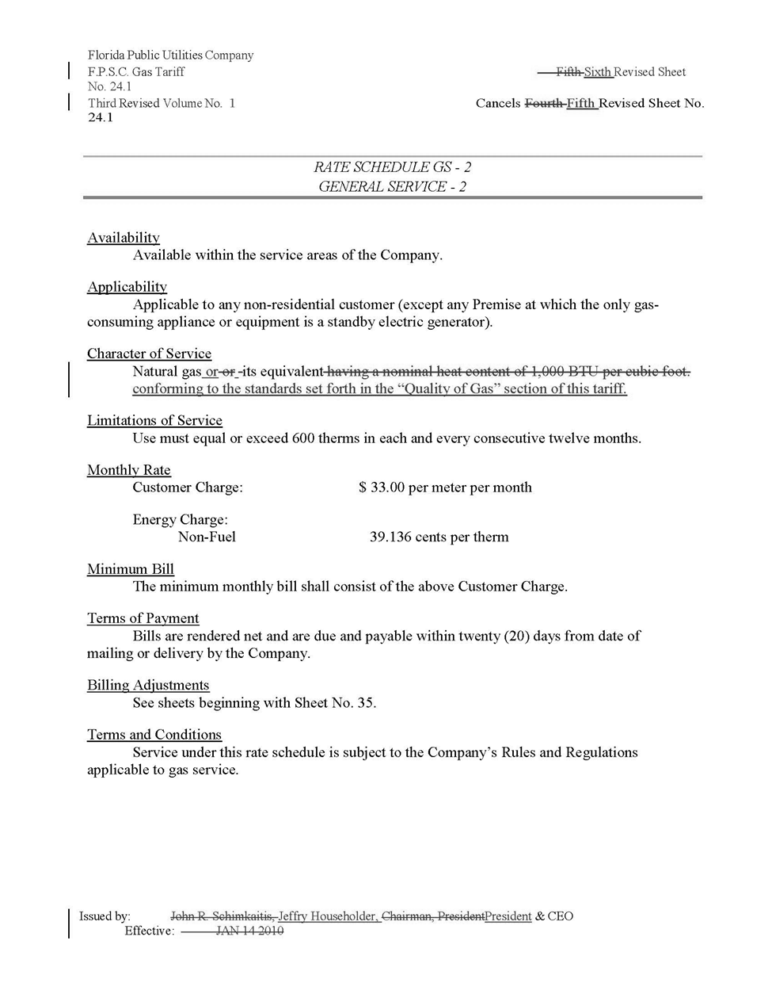

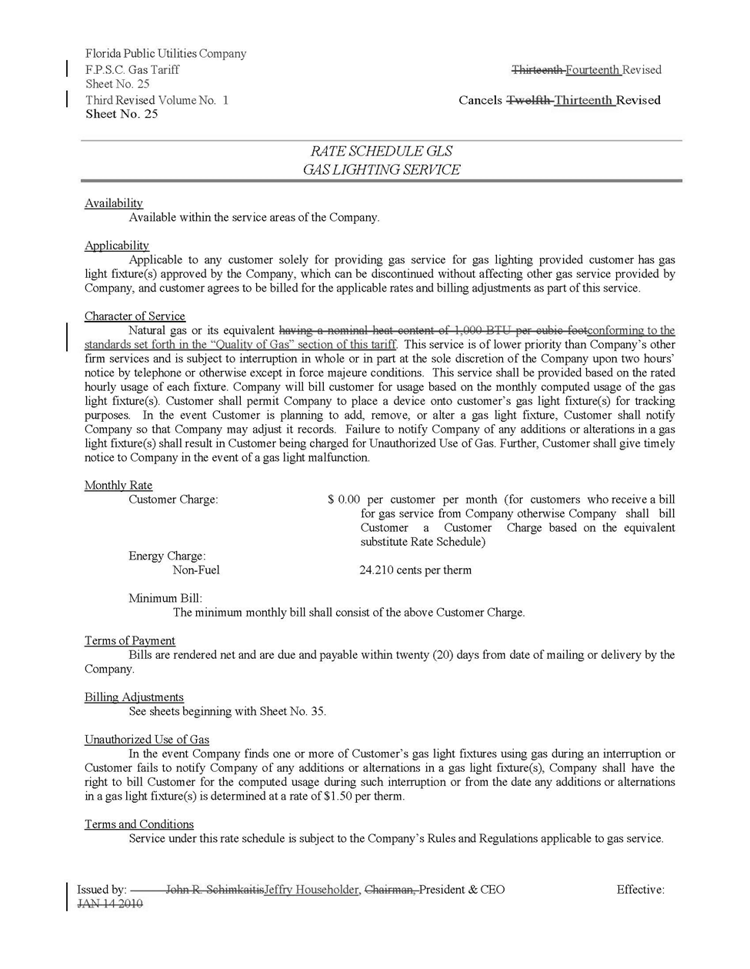

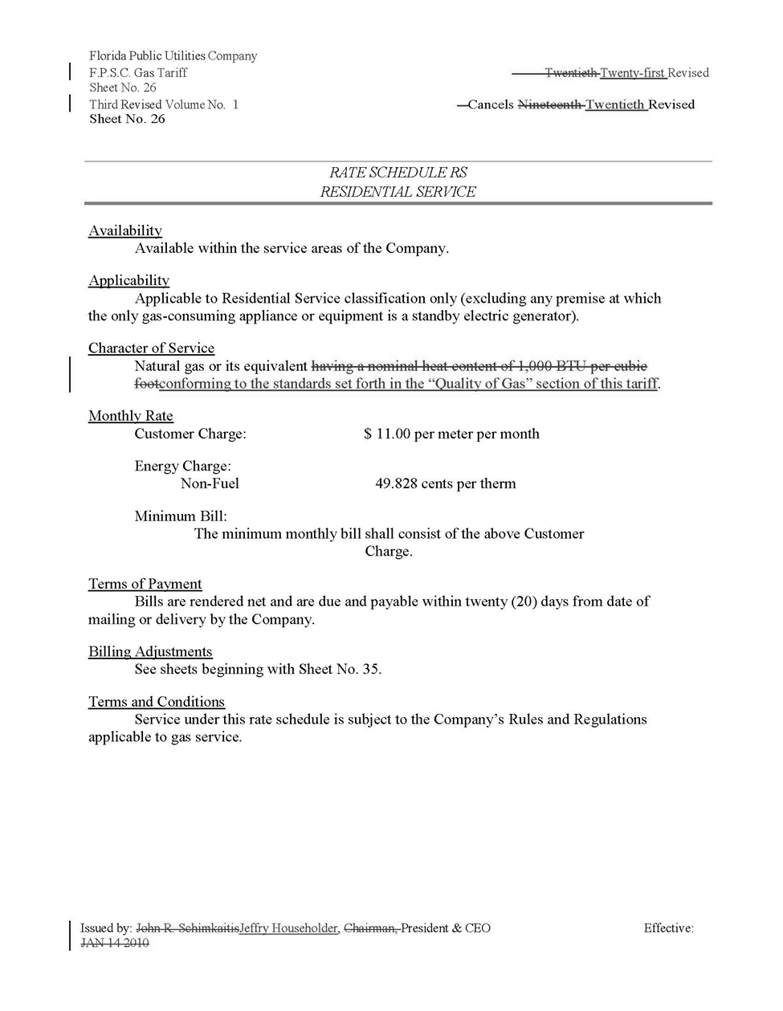

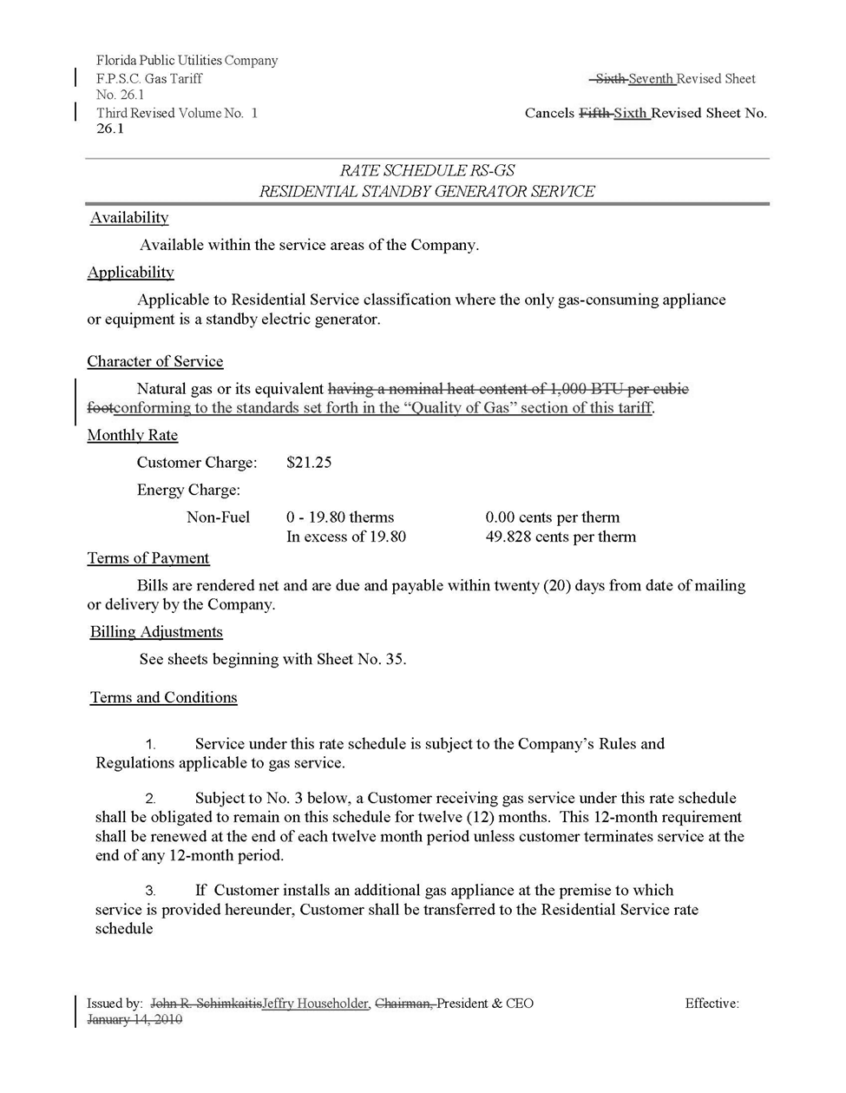

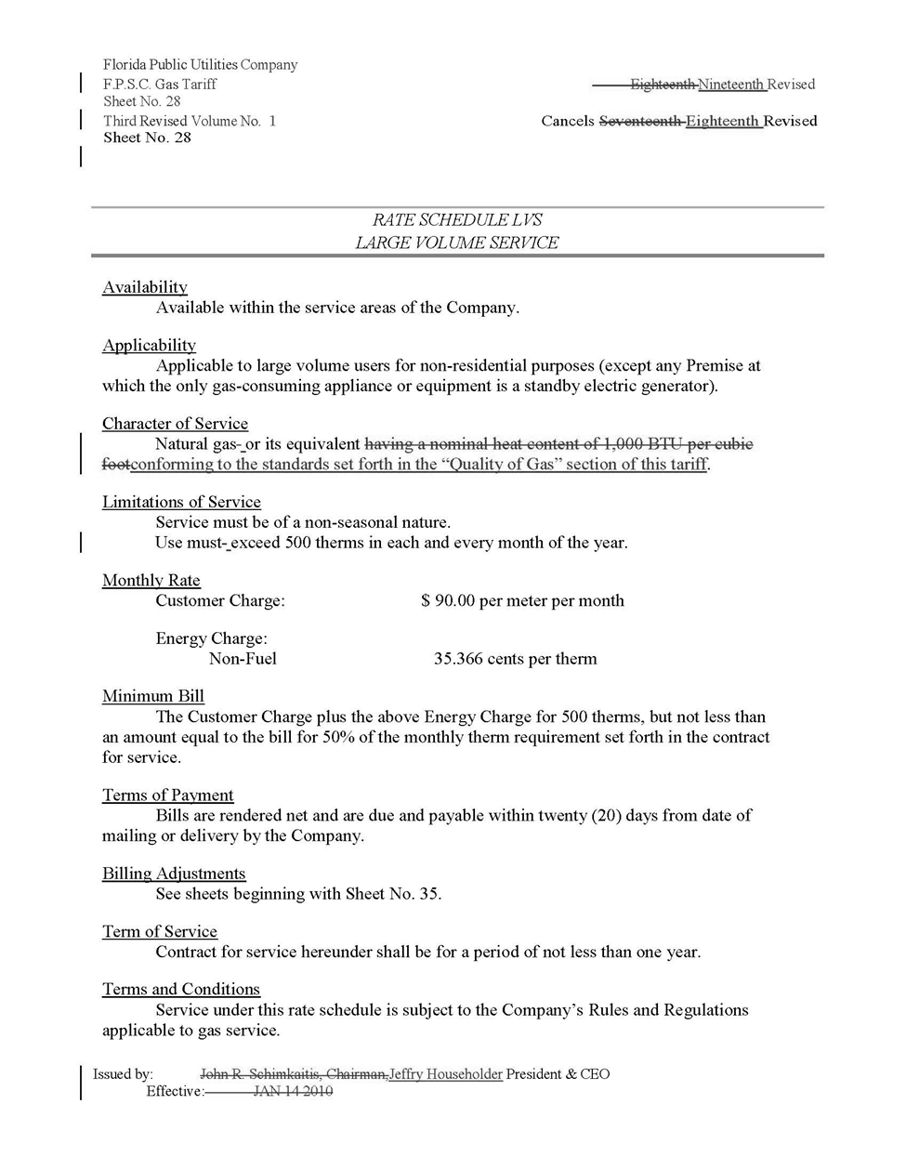

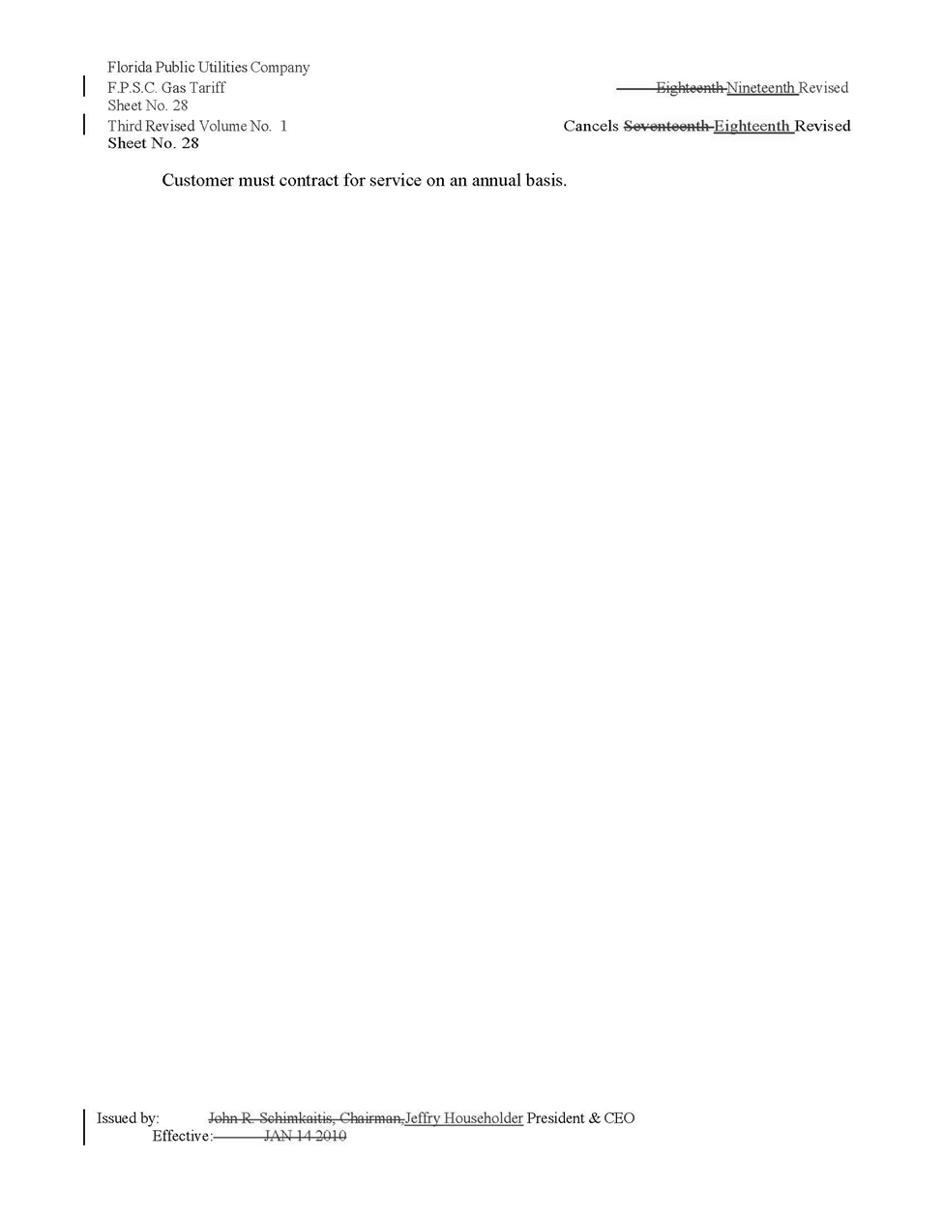

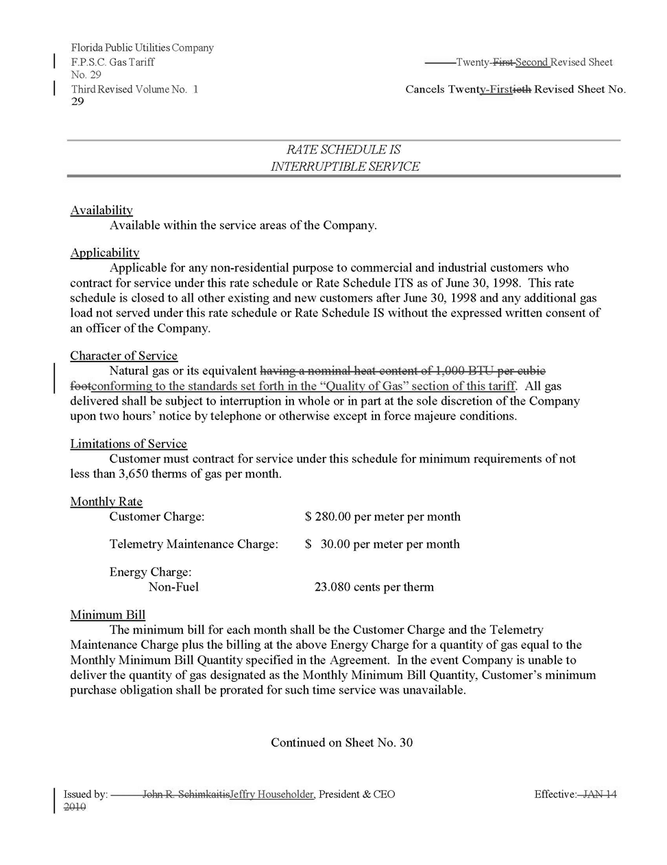

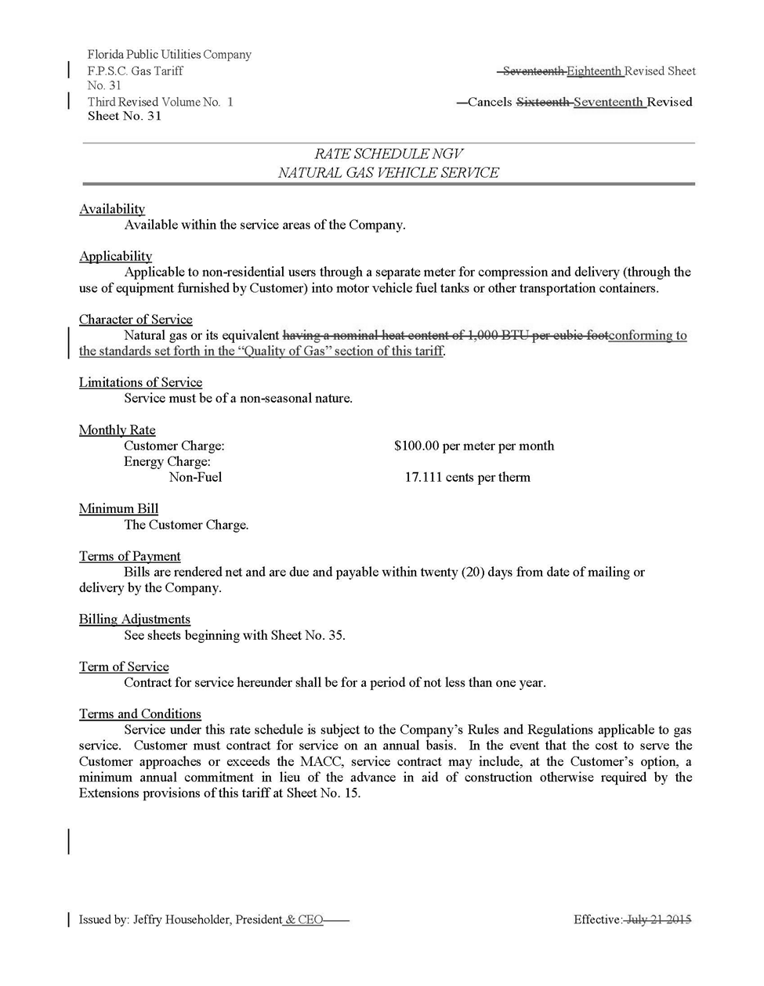

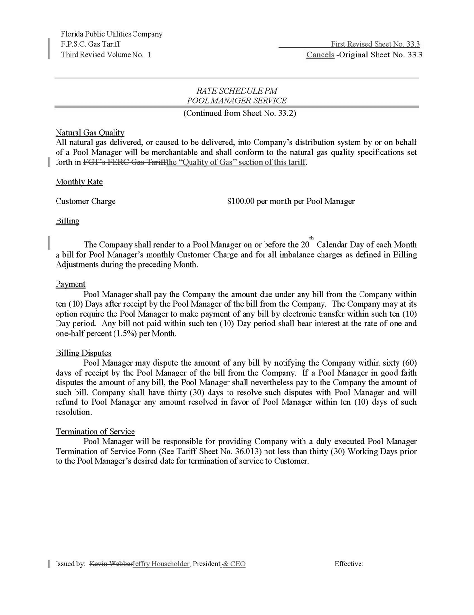

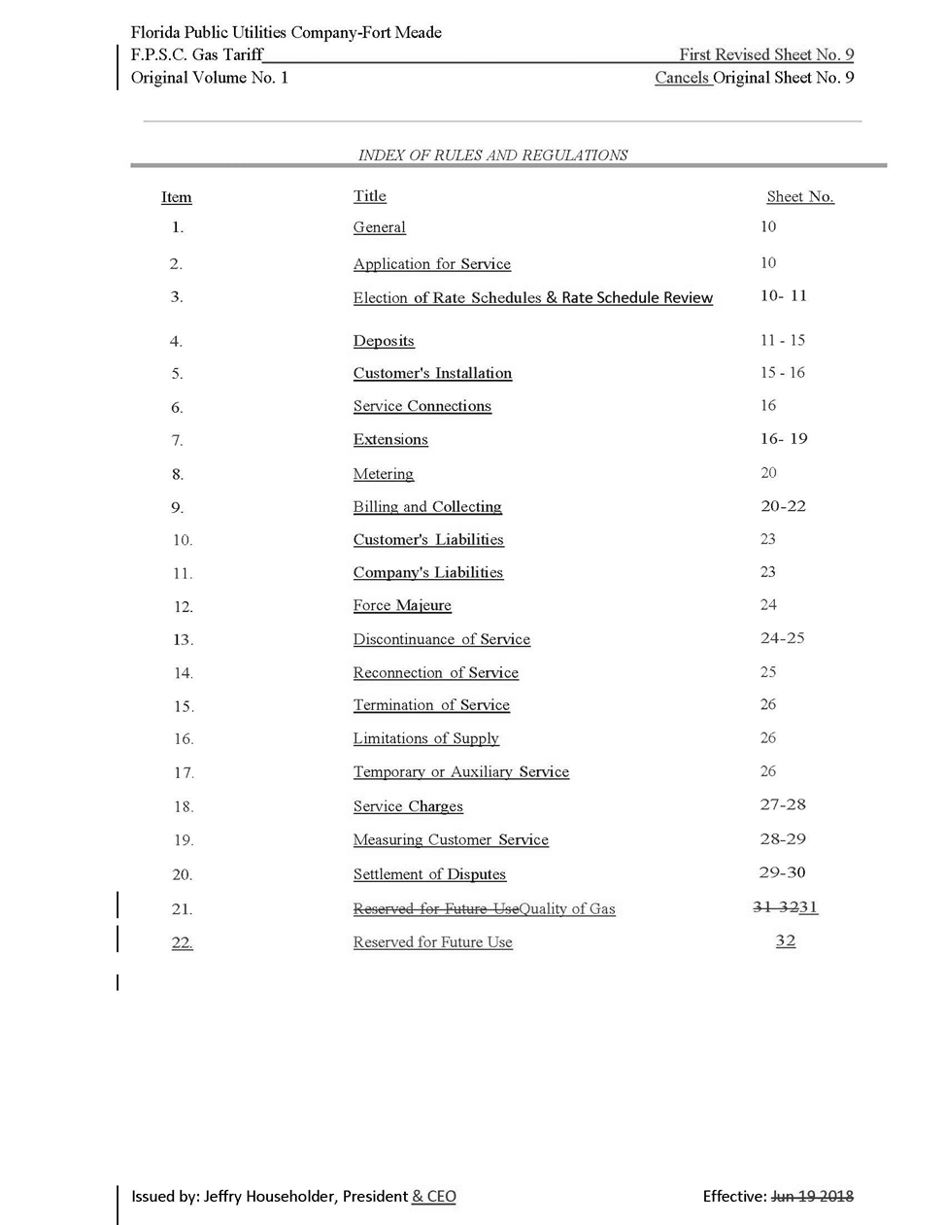

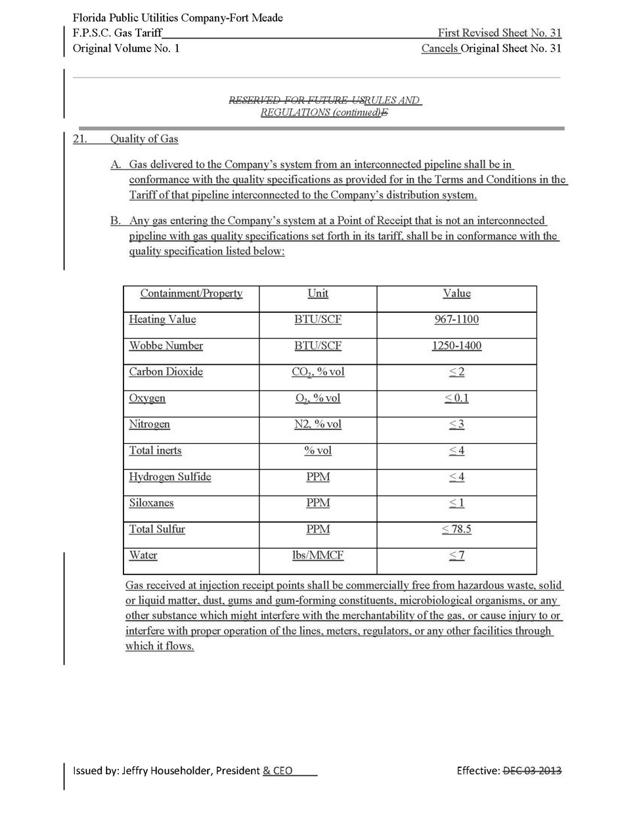

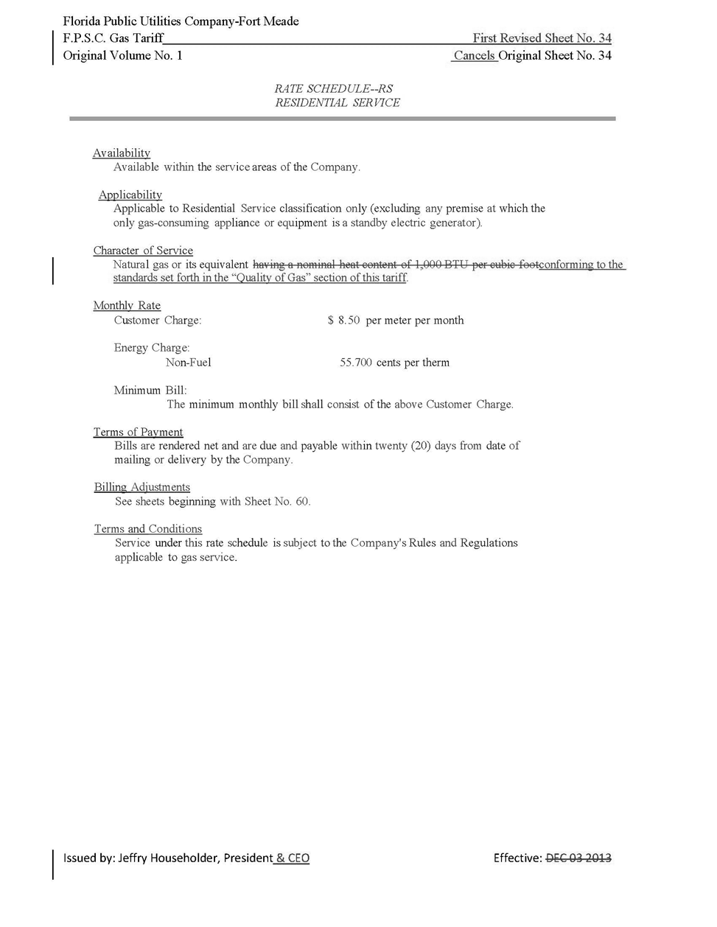

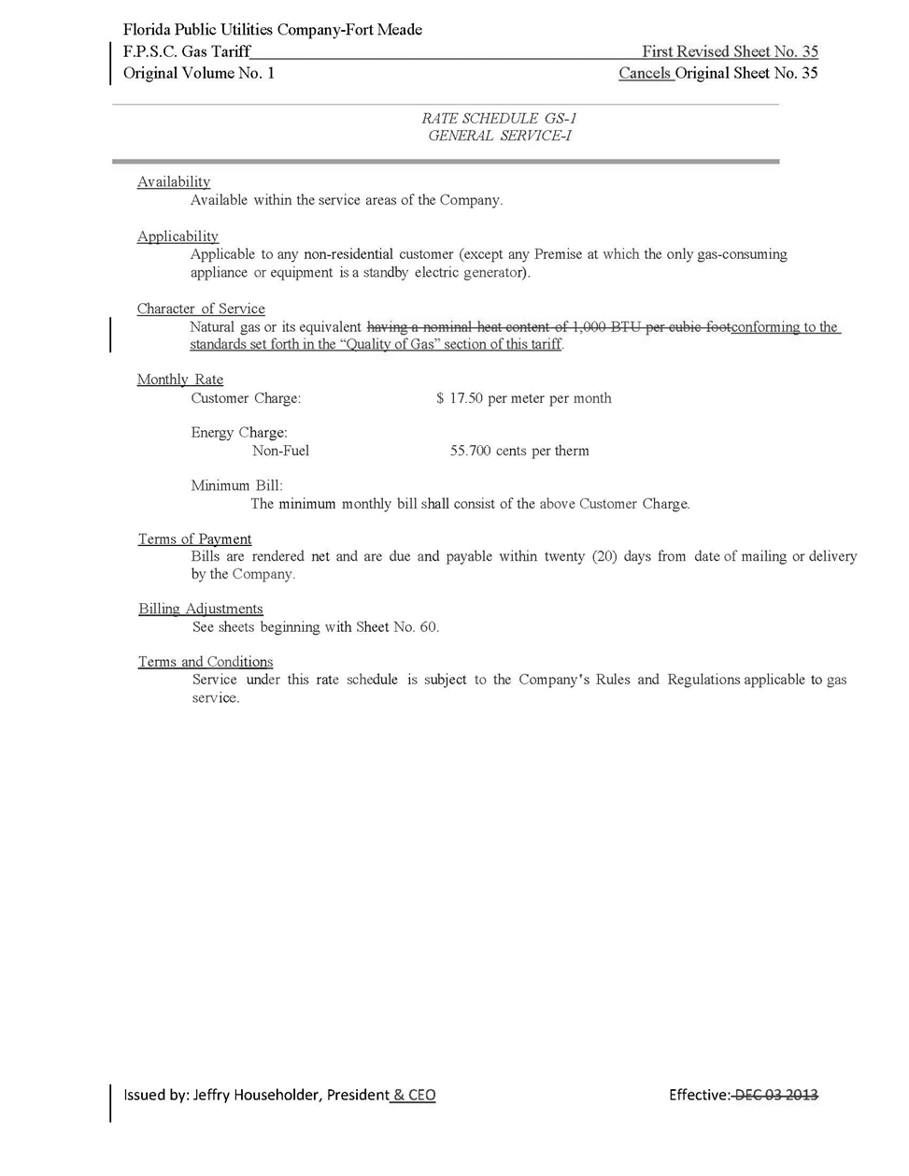

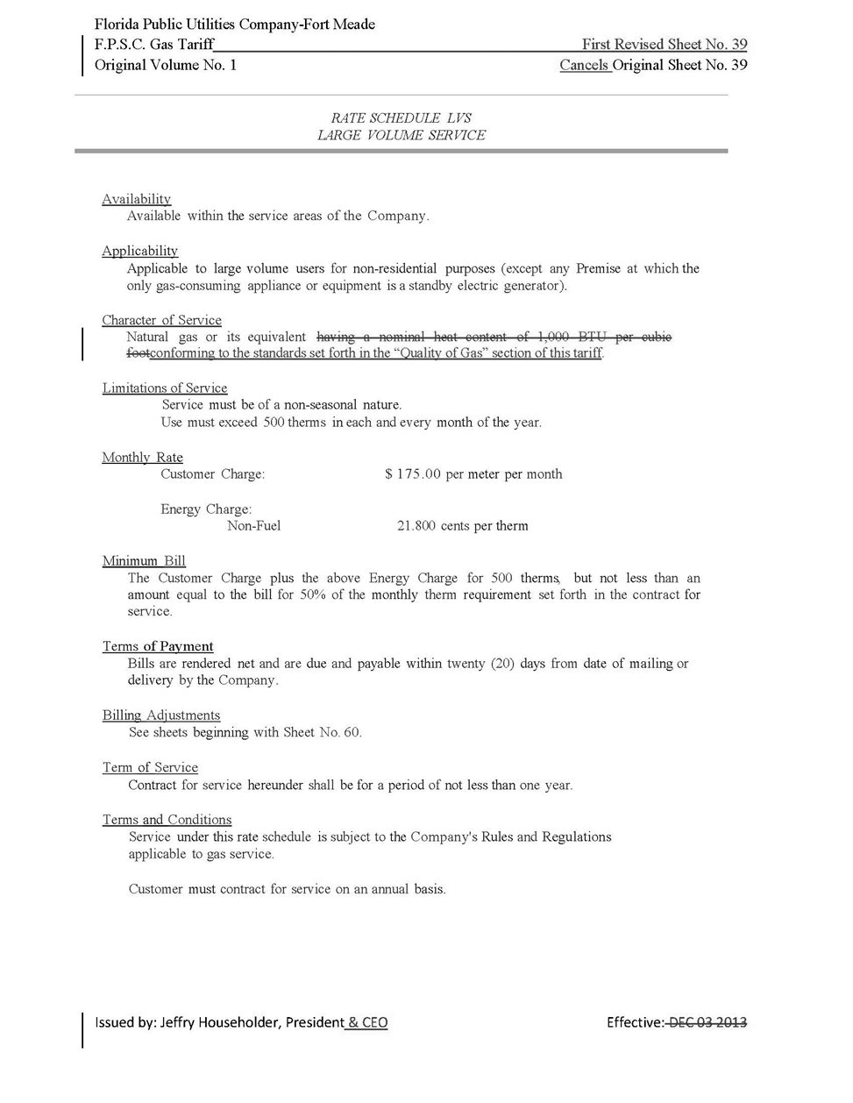

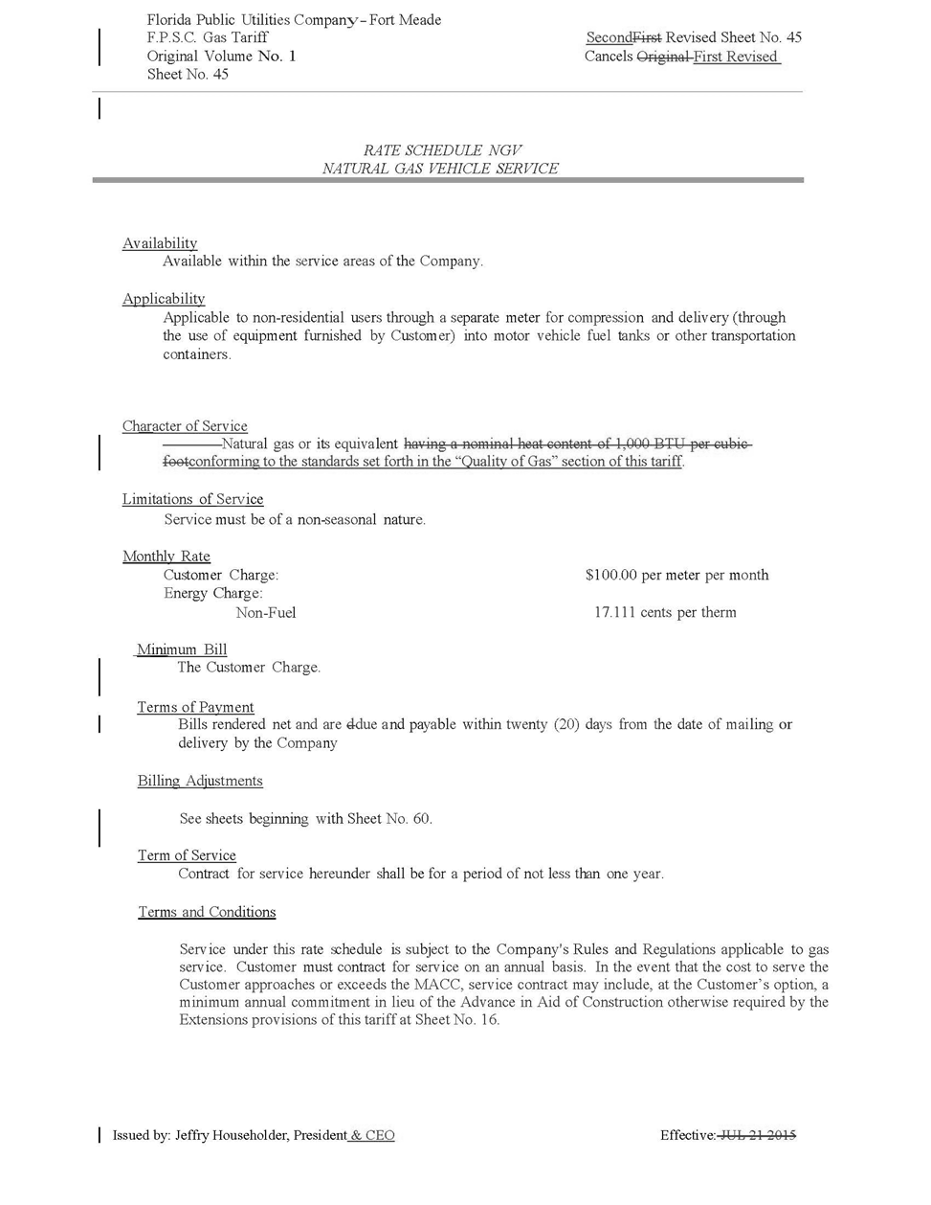

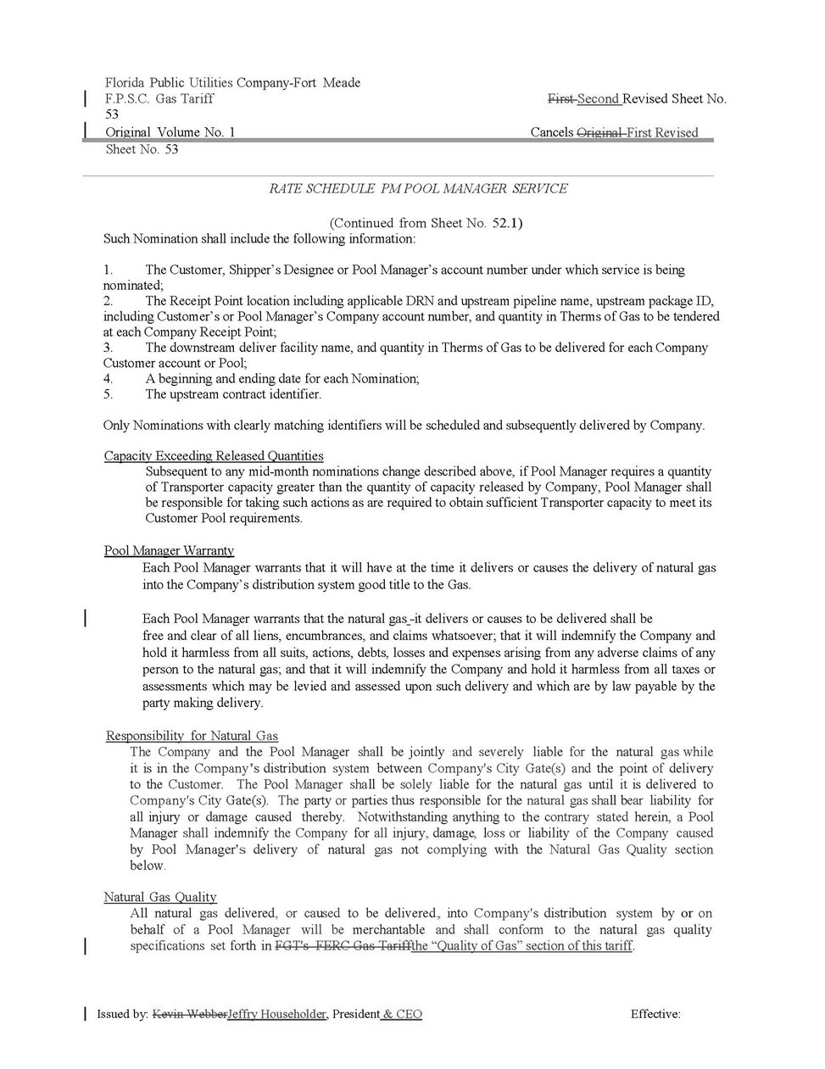

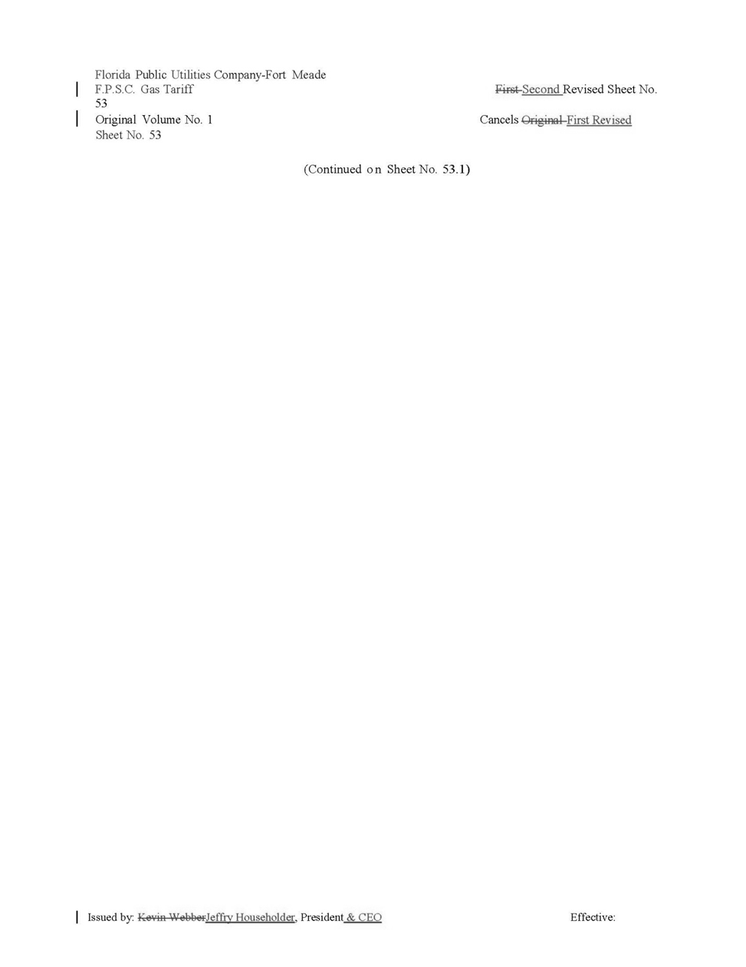

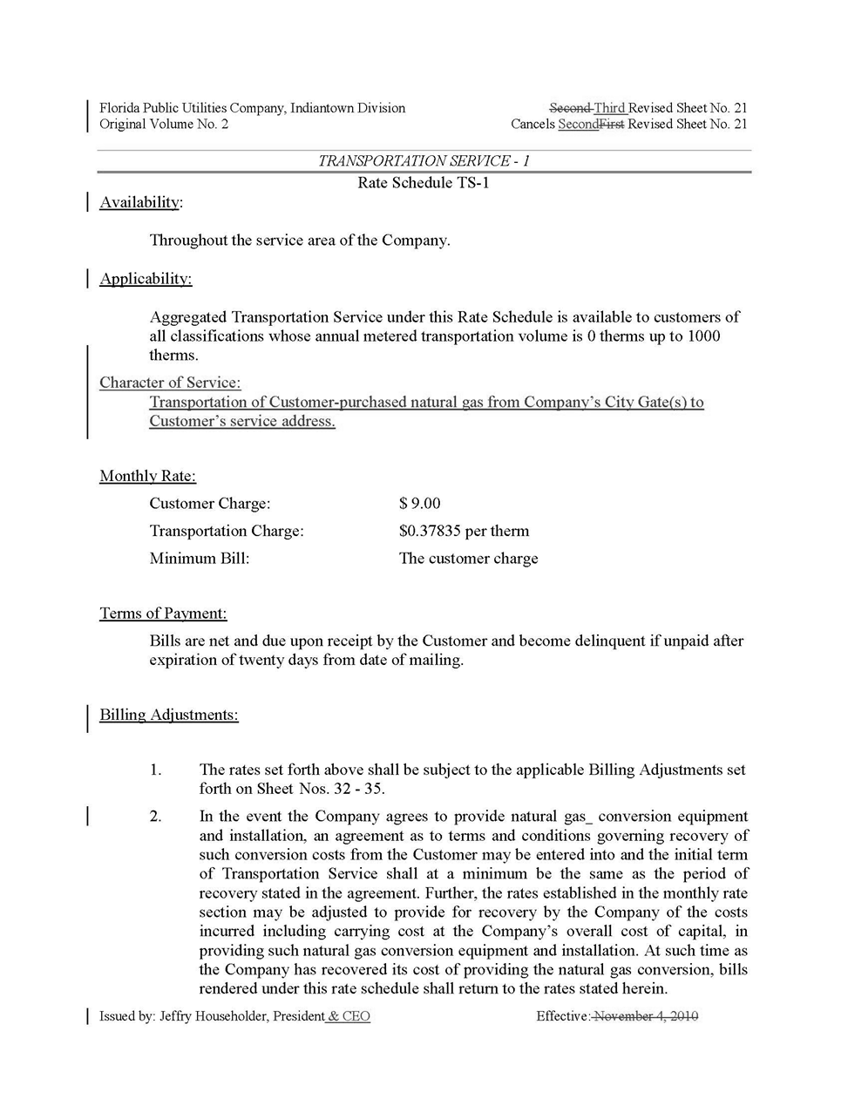

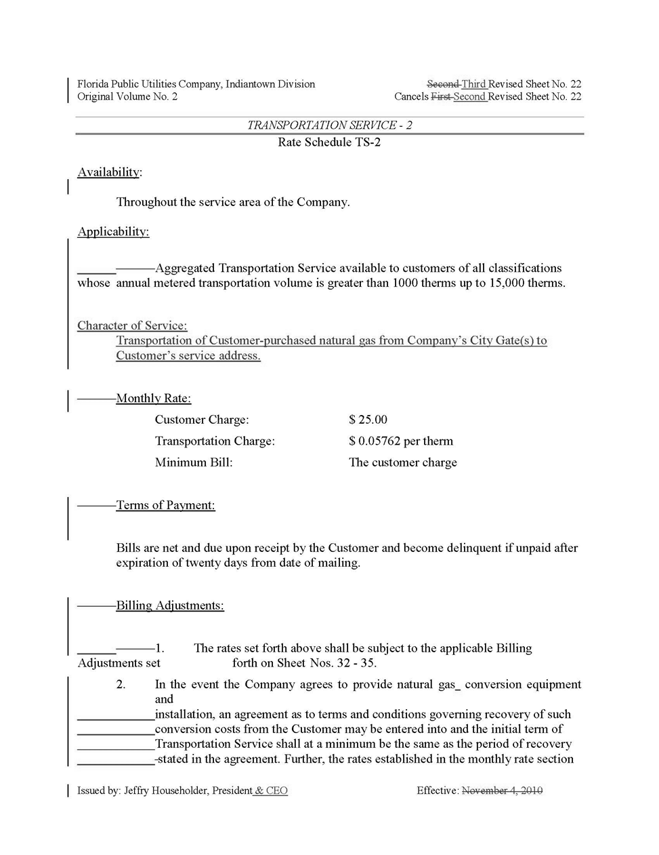

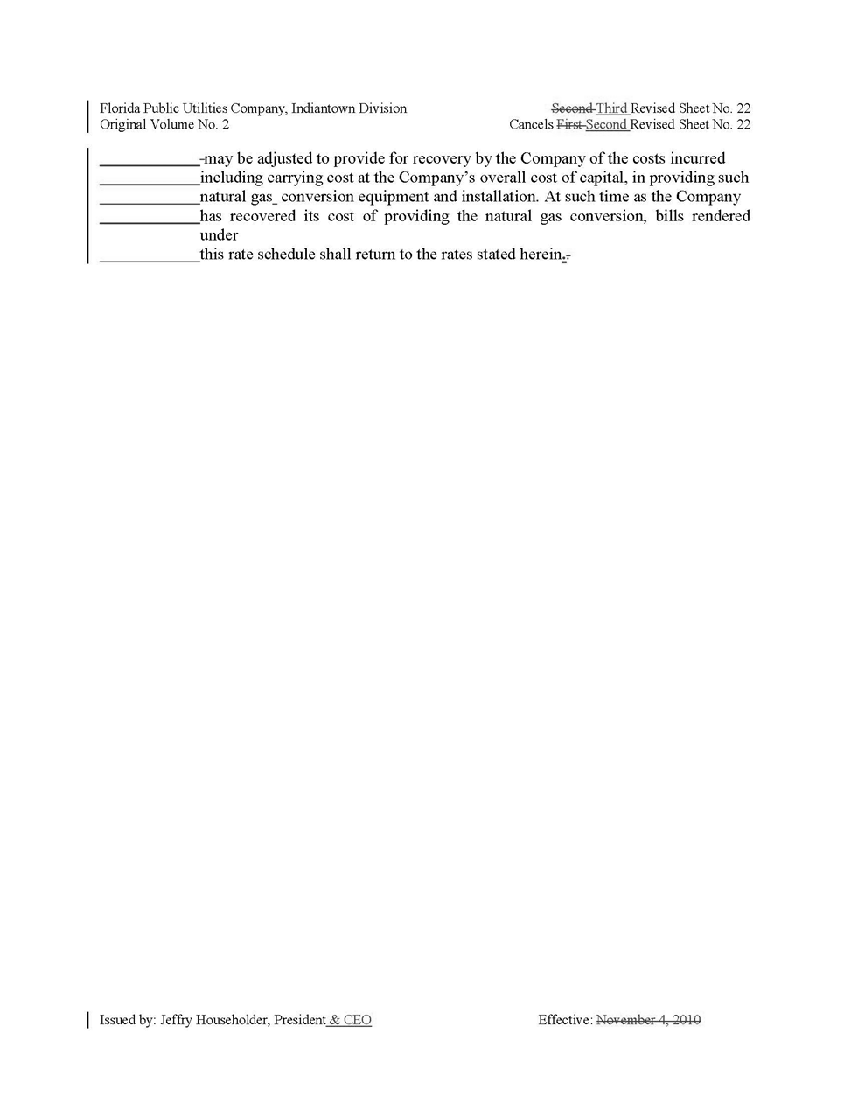

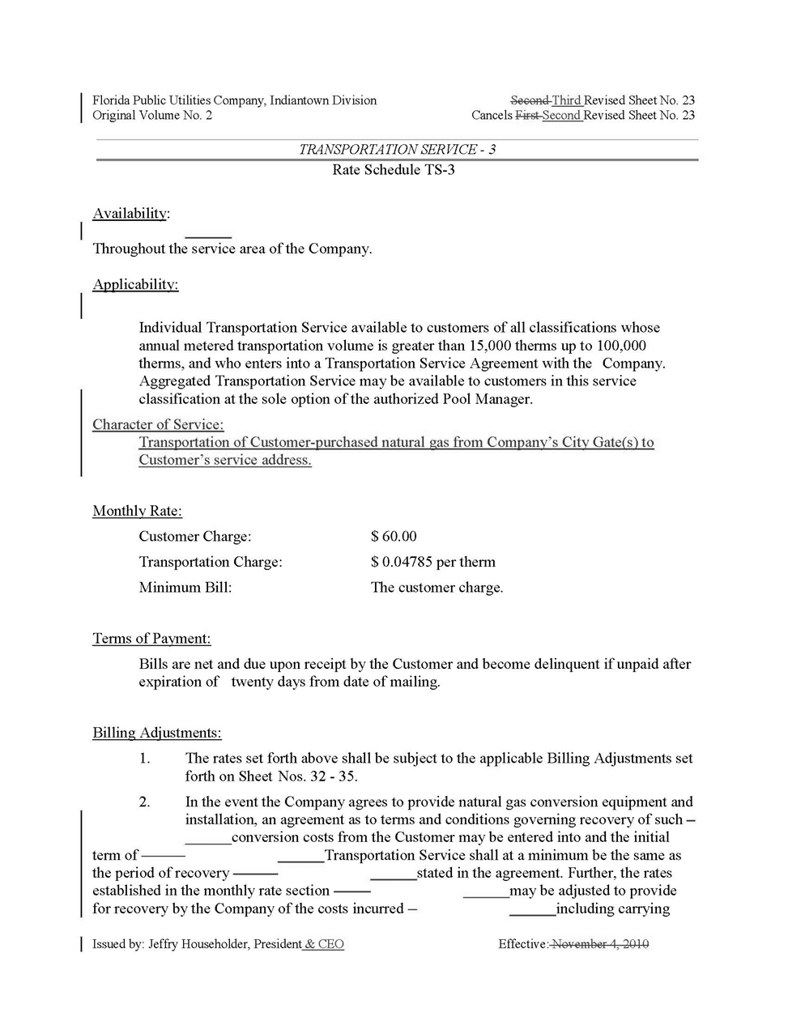

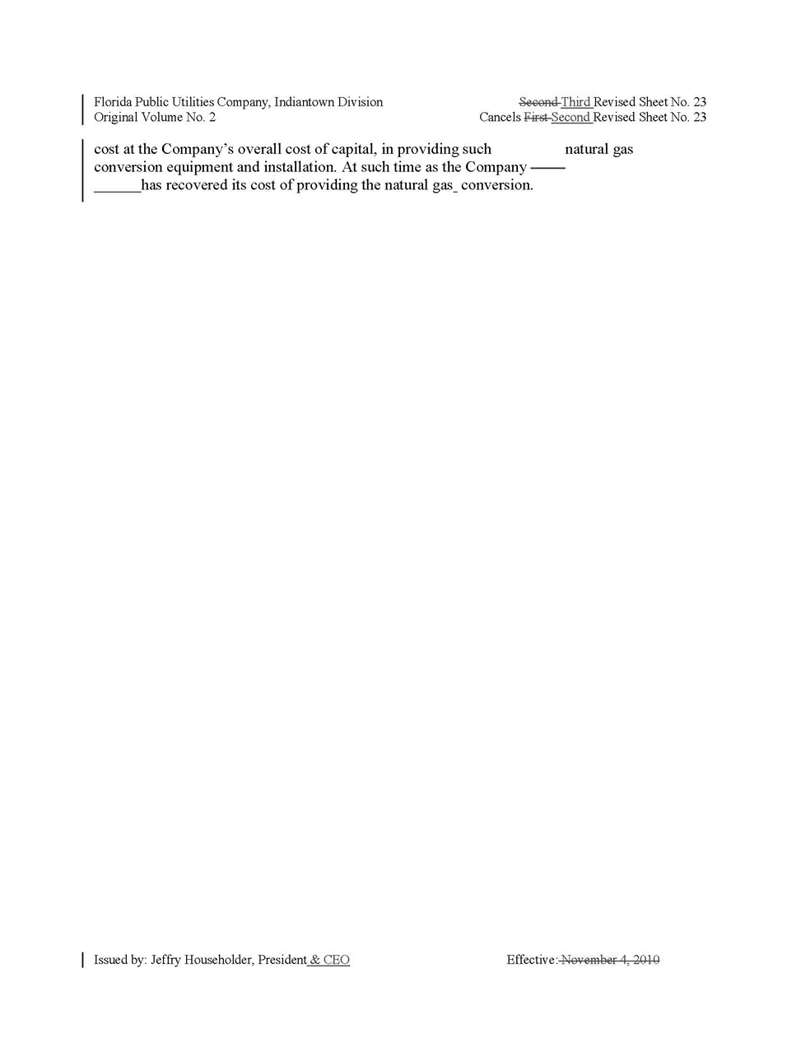

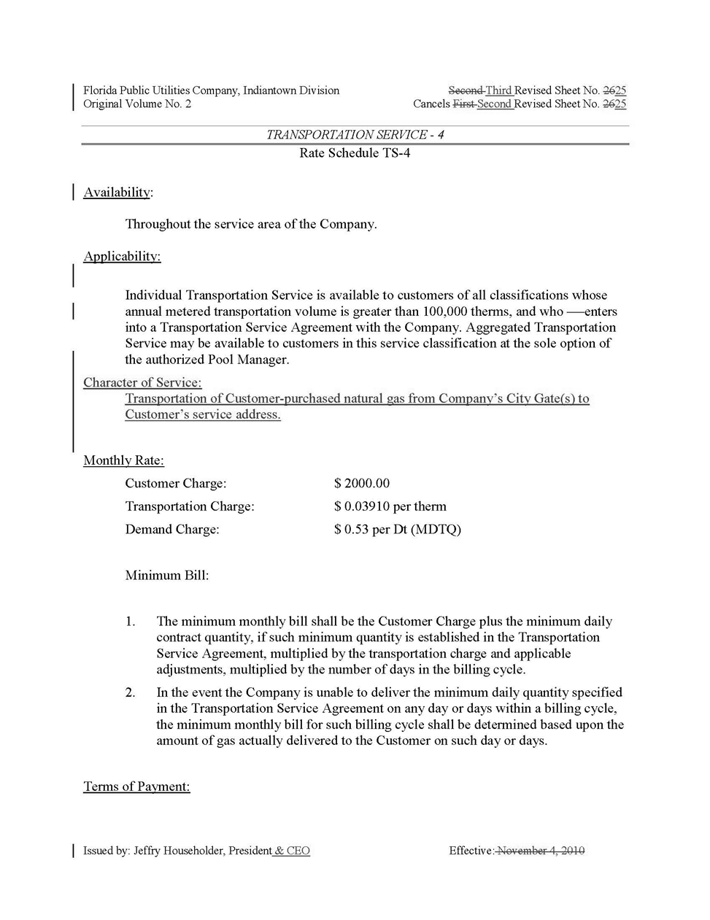

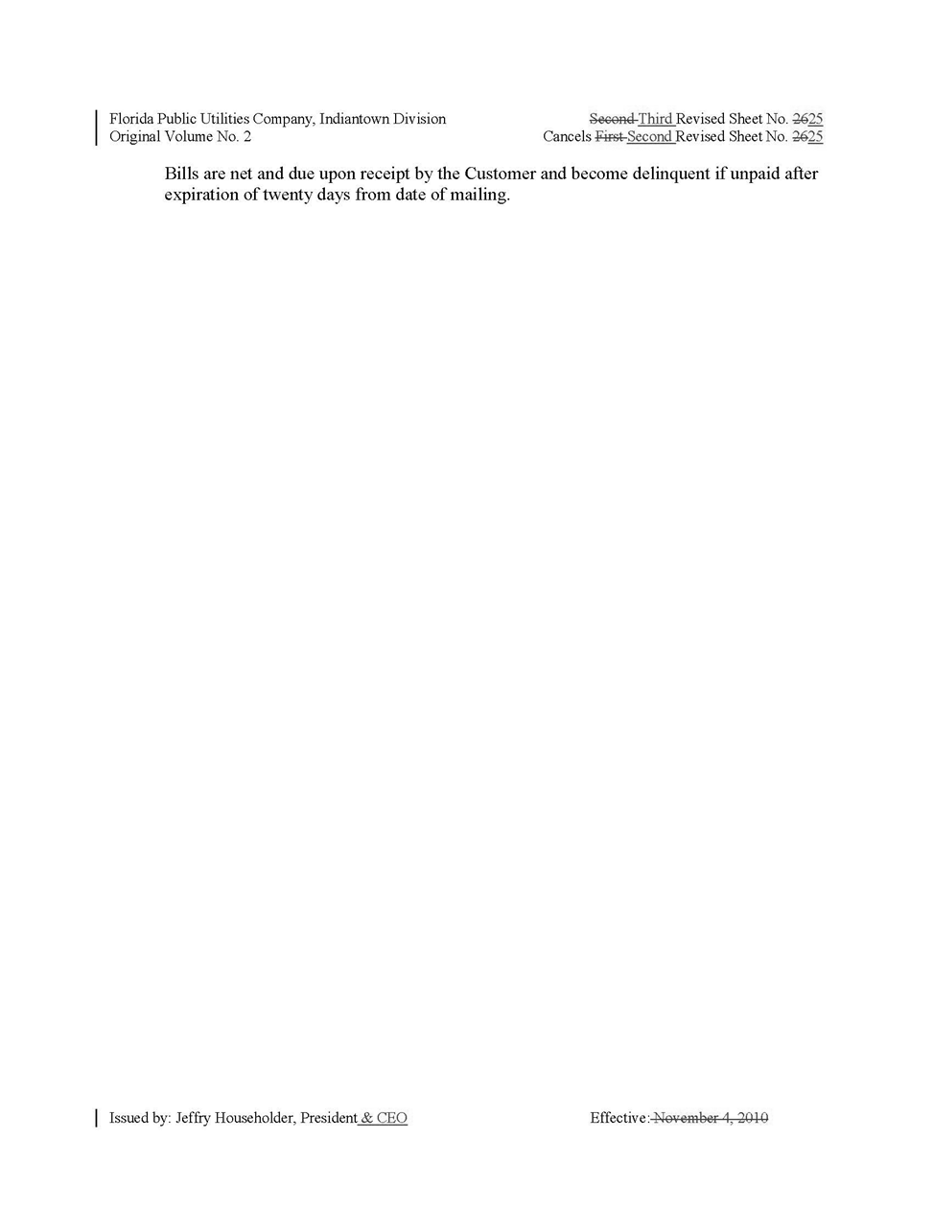

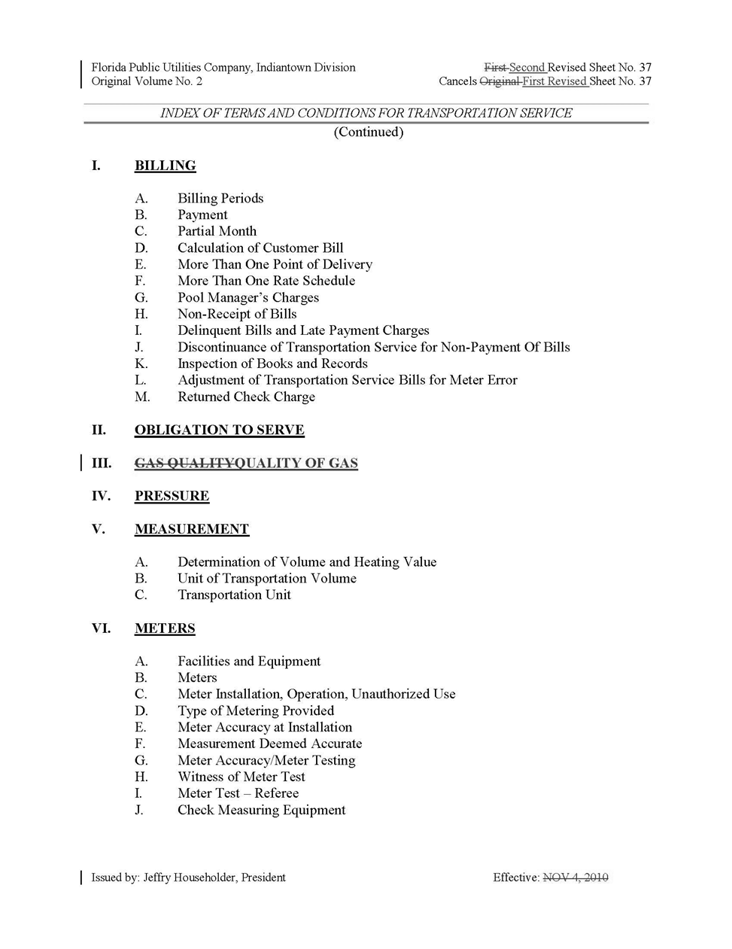

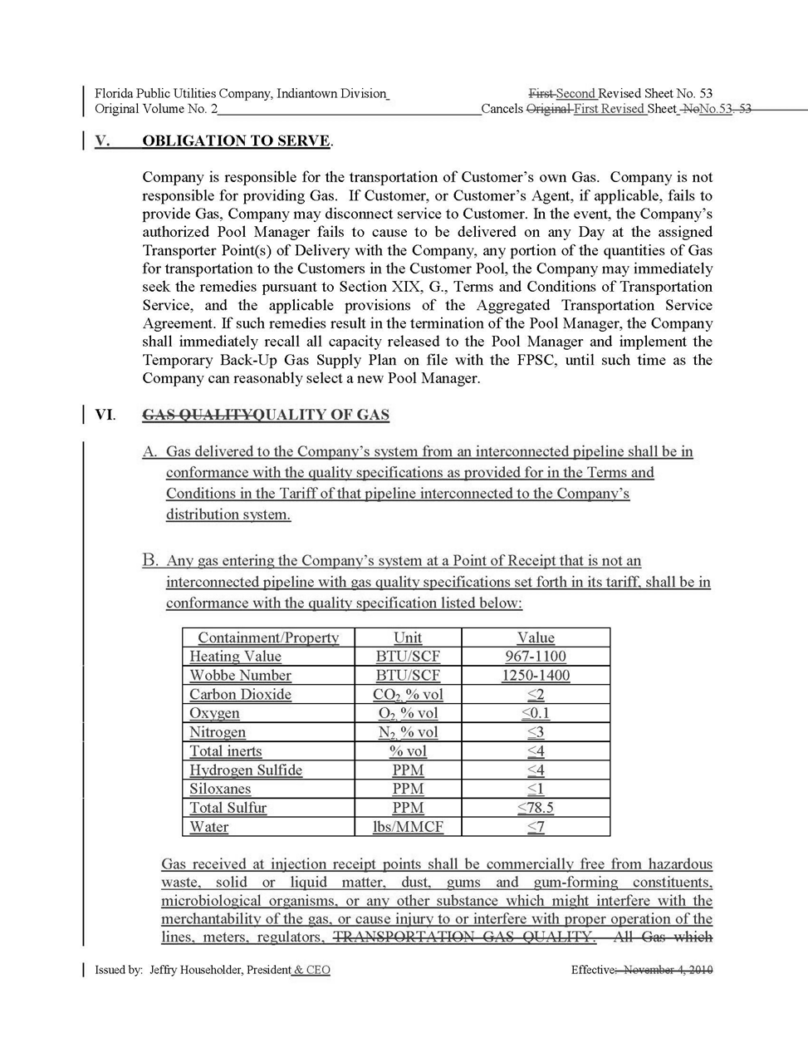

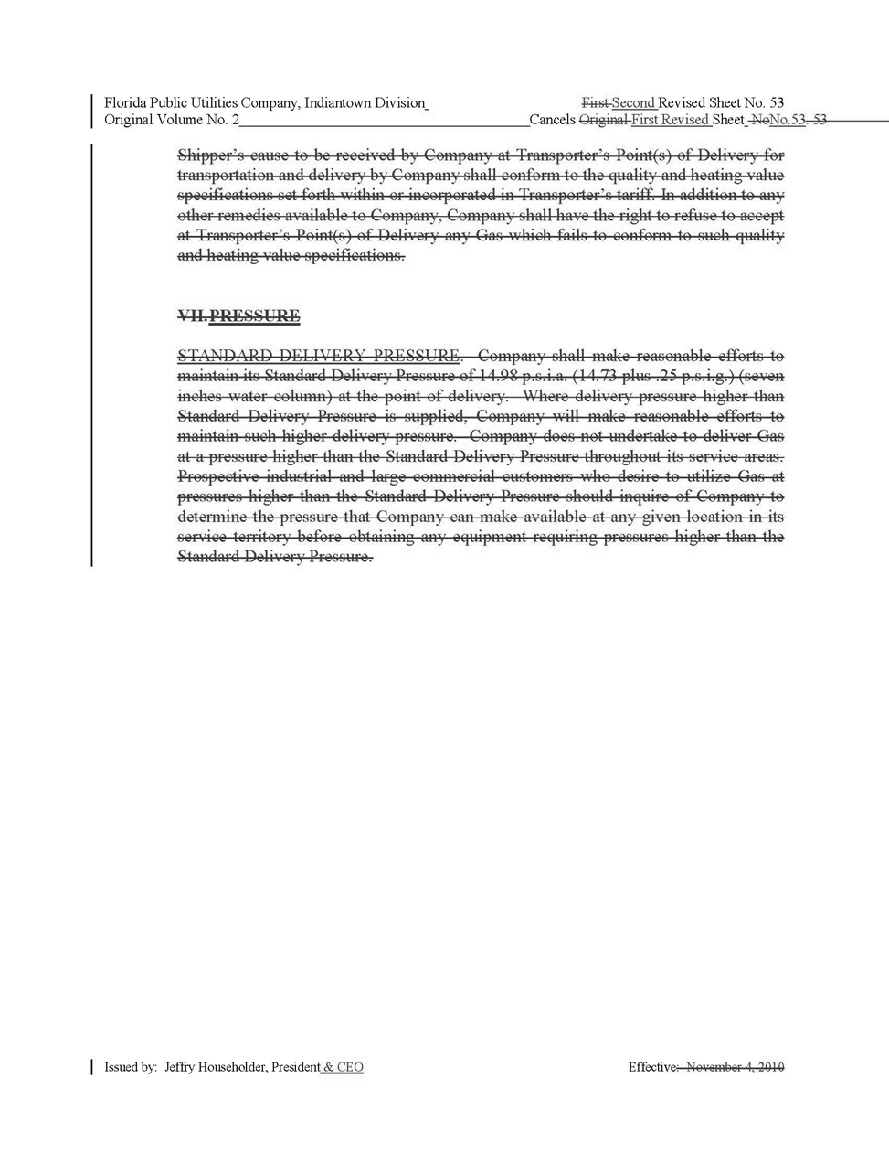

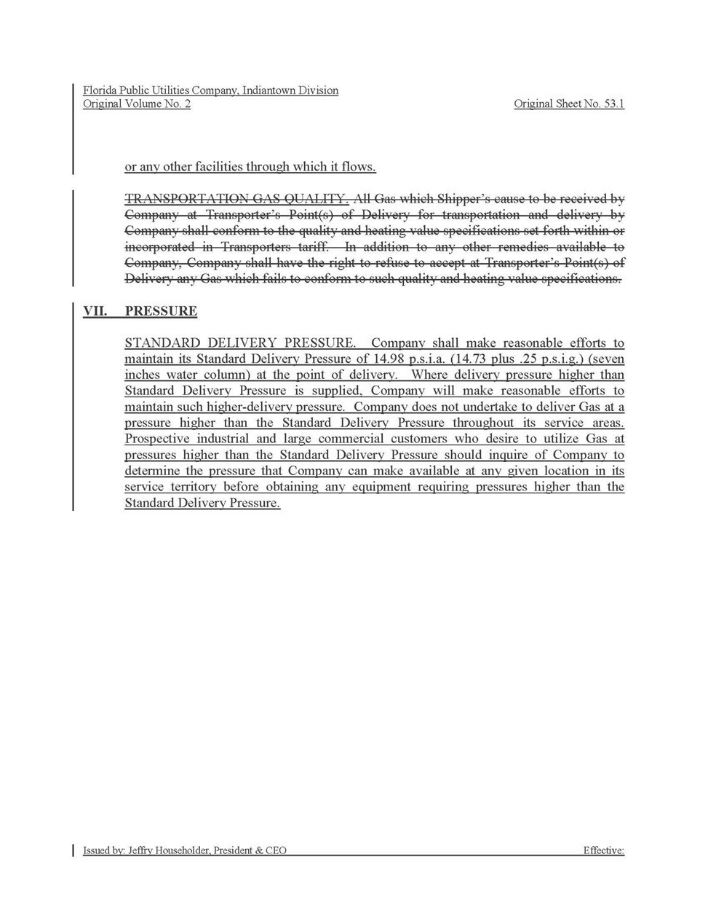

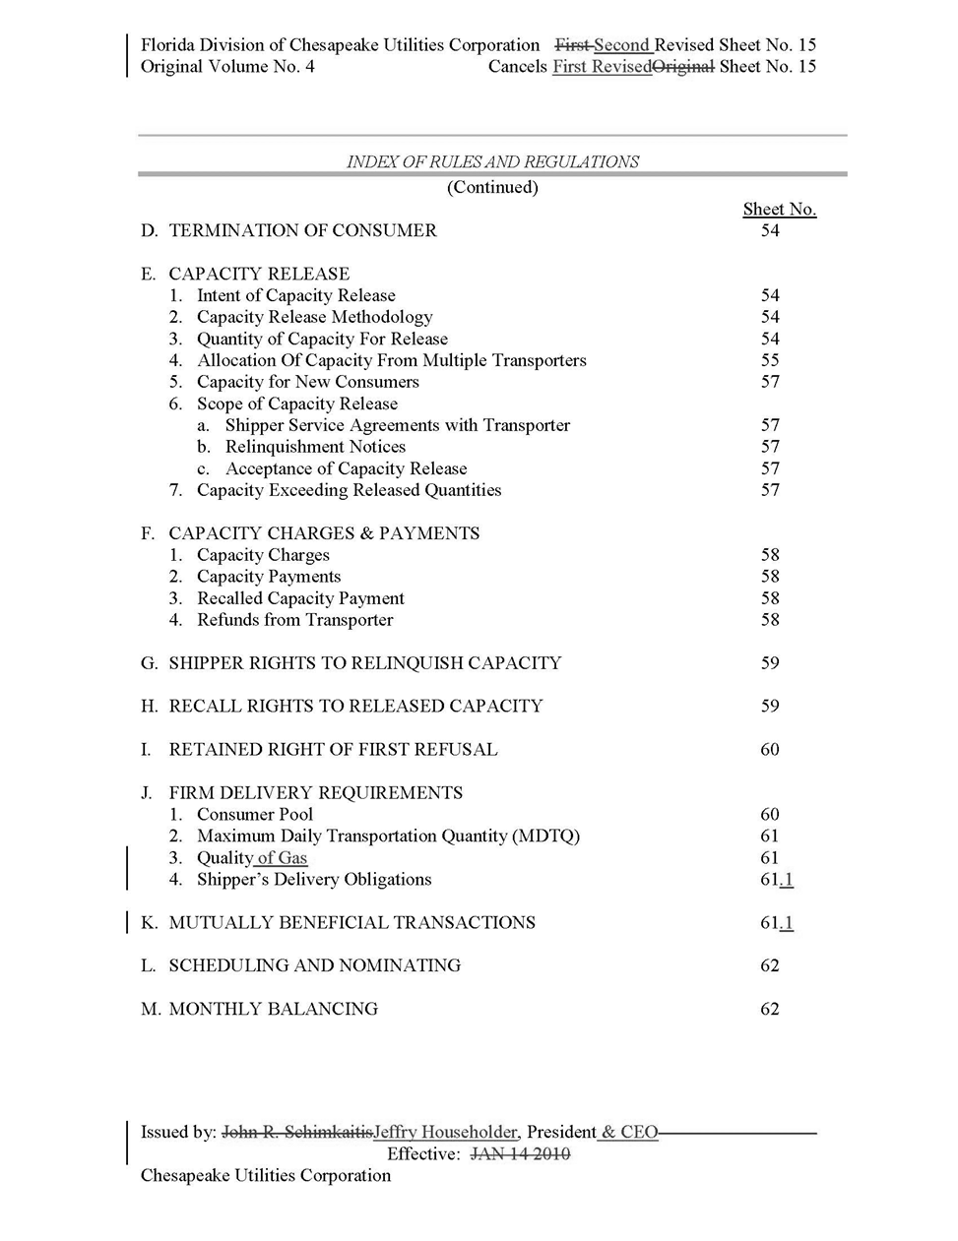

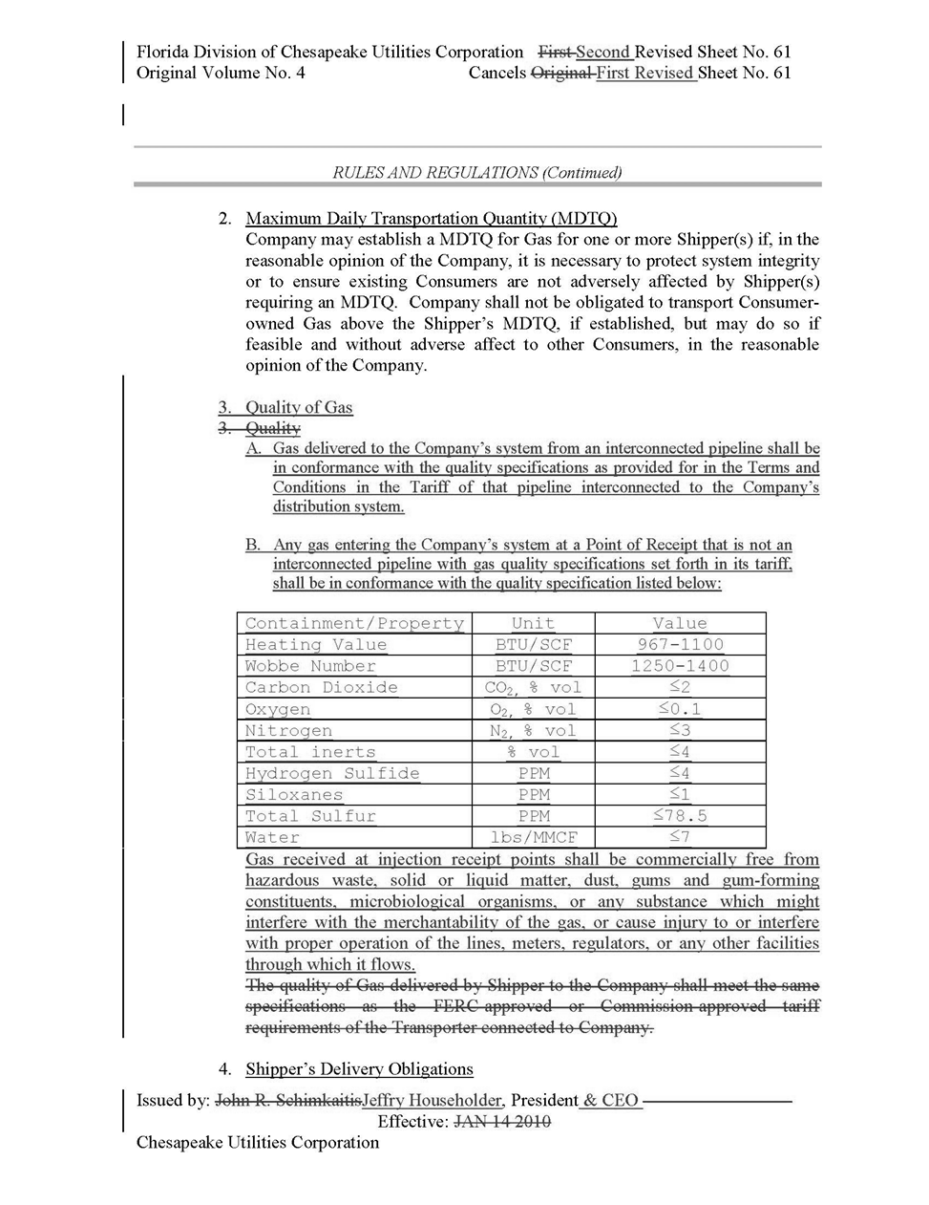

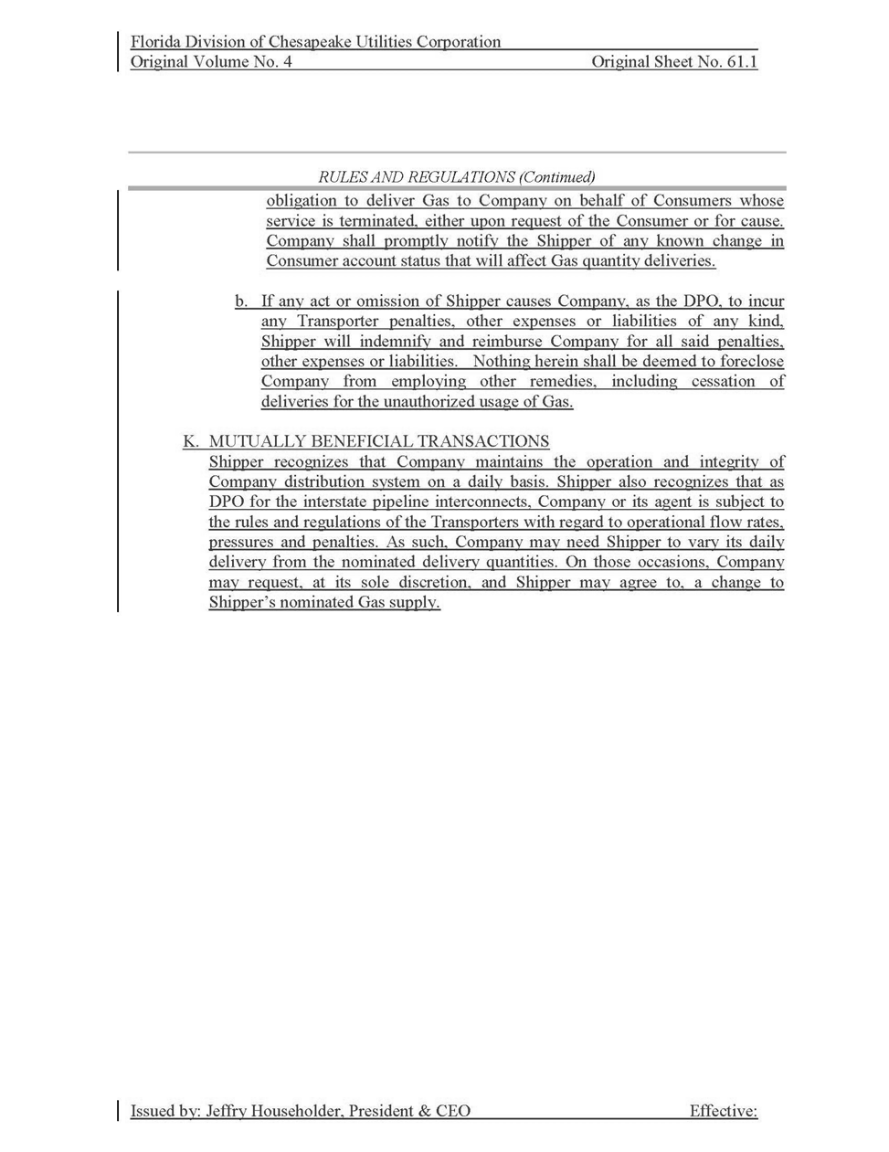

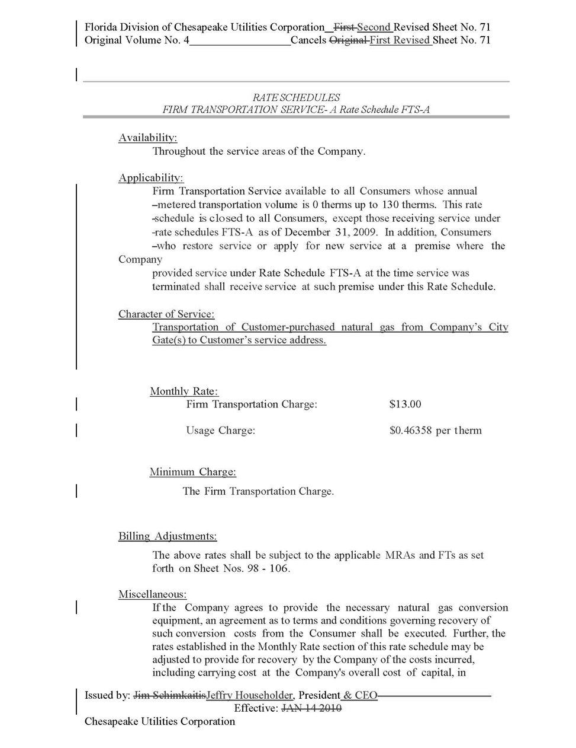

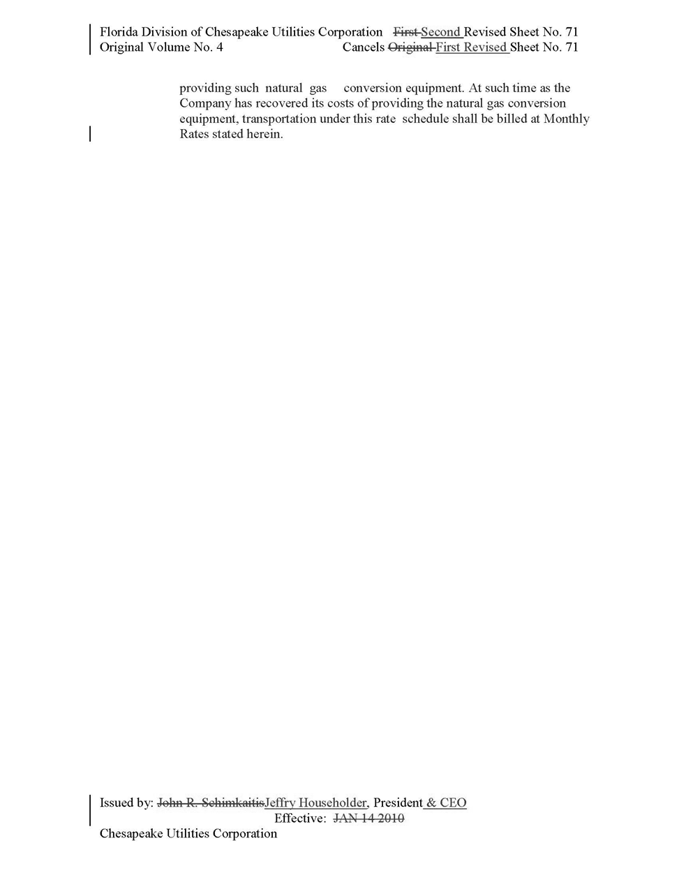

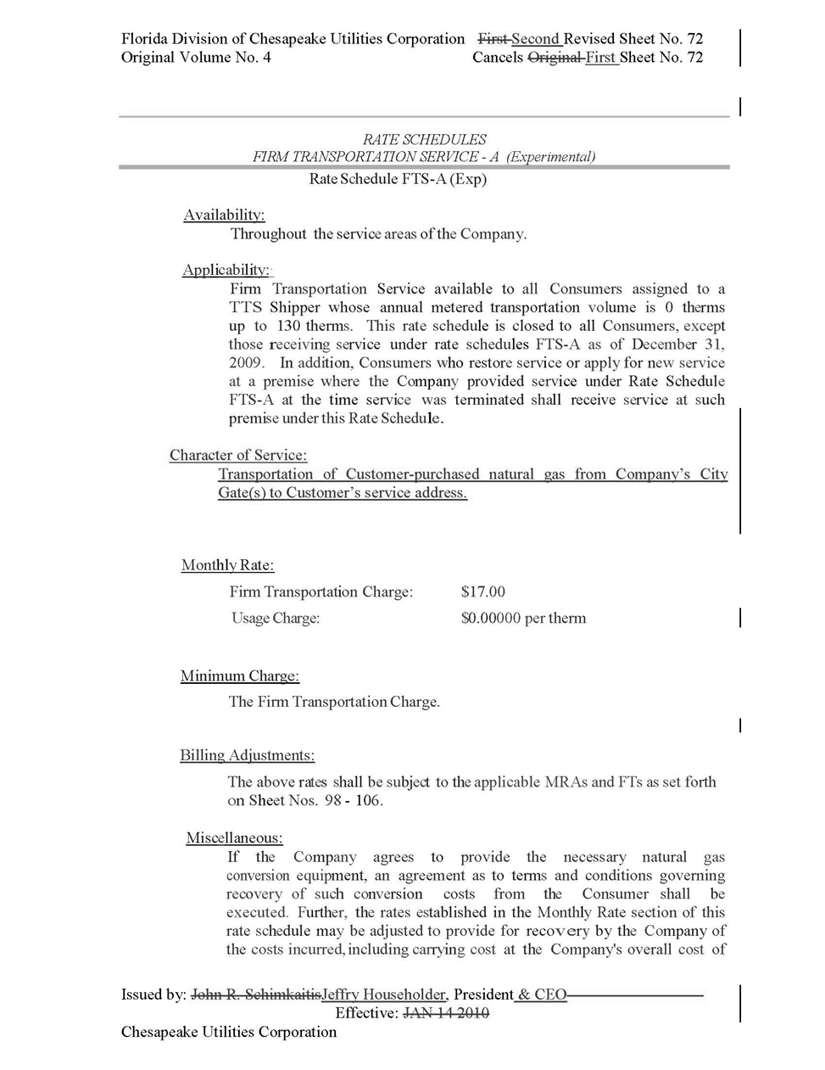

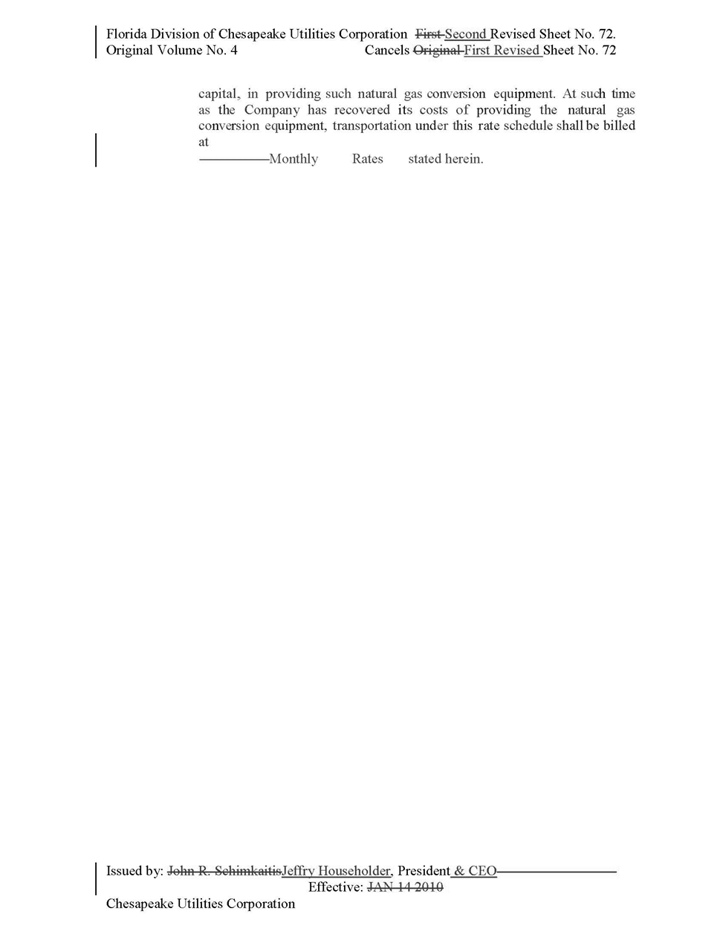

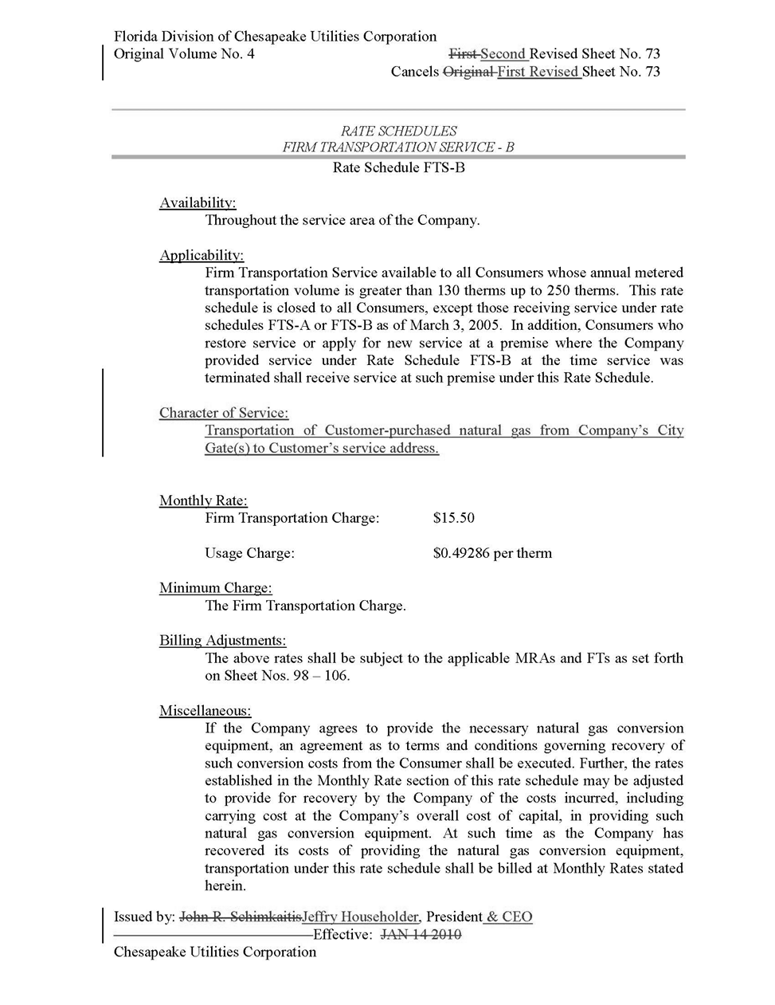

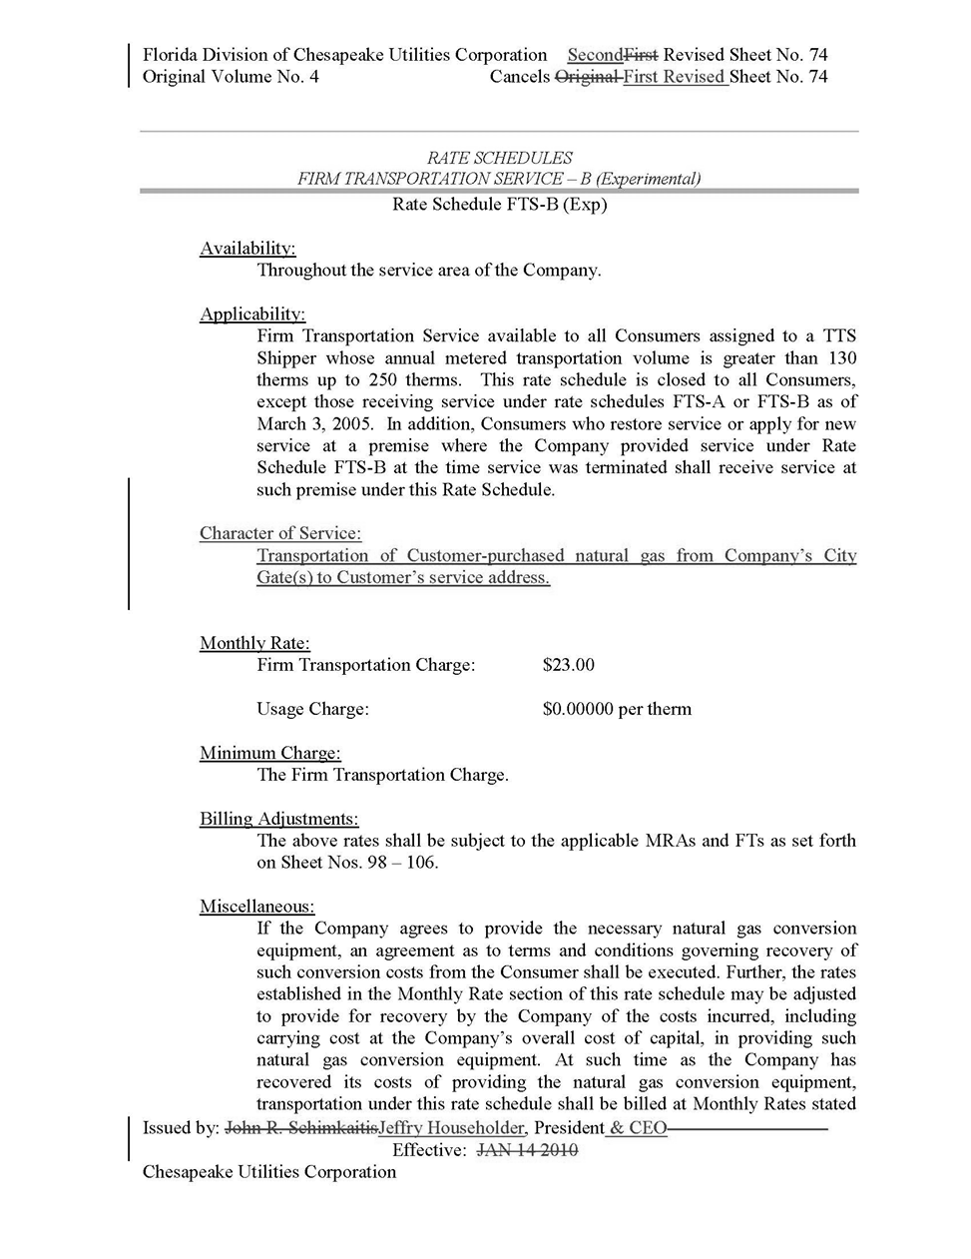.

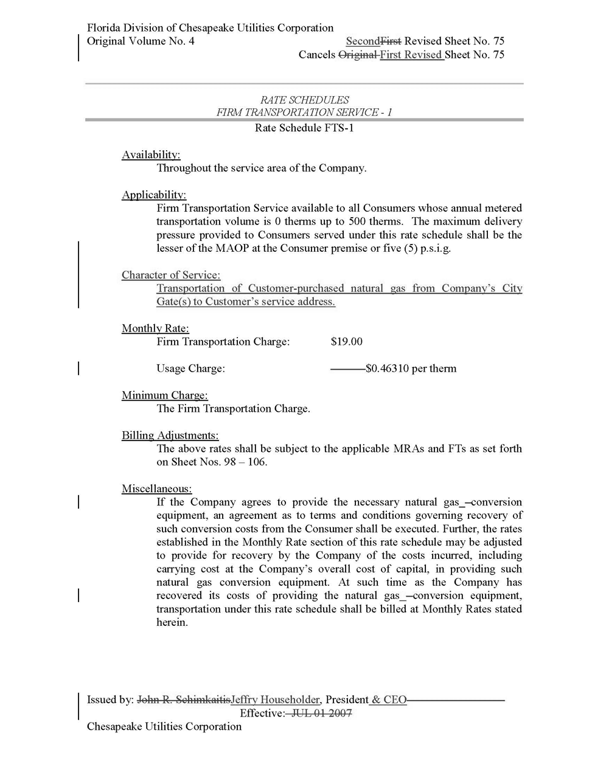

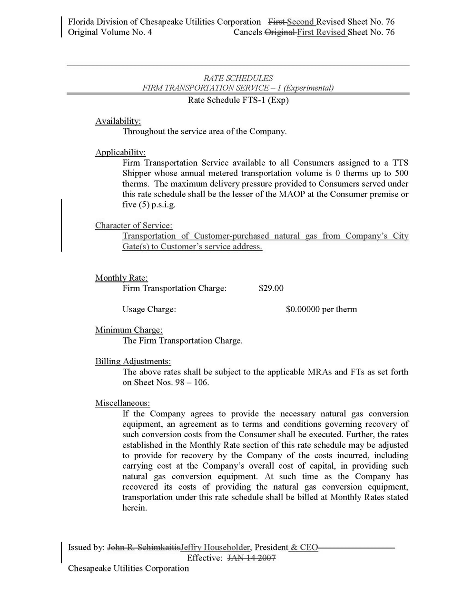
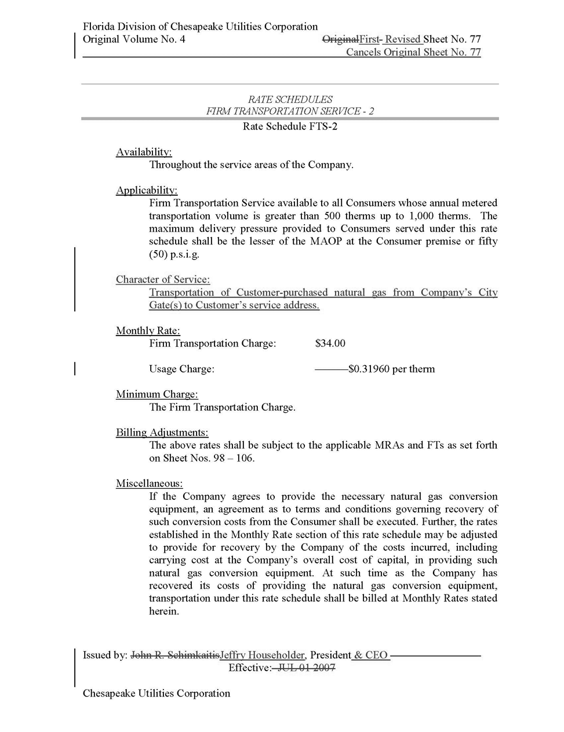

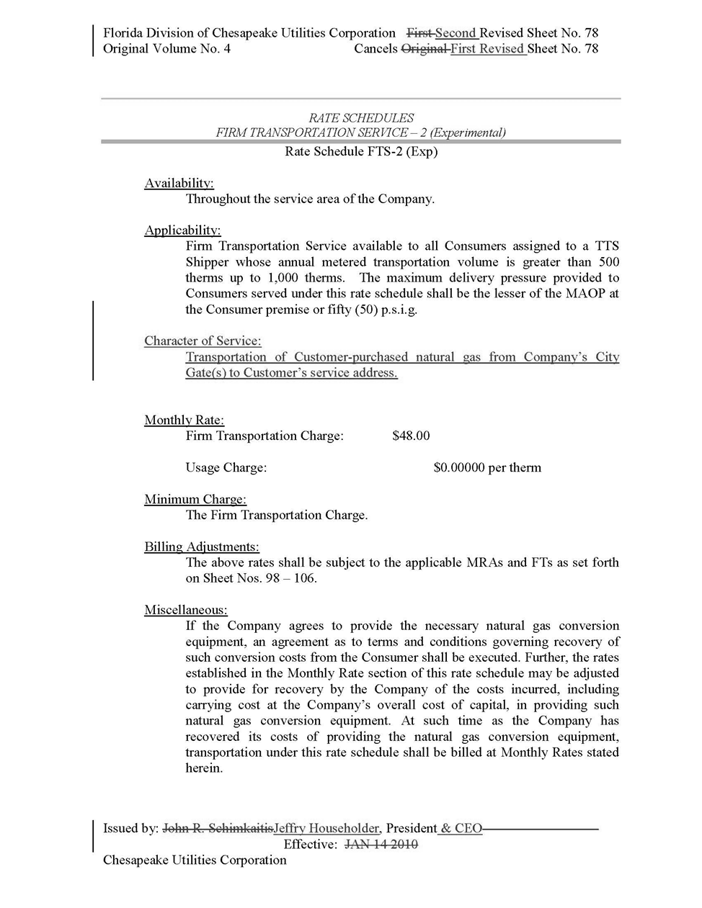

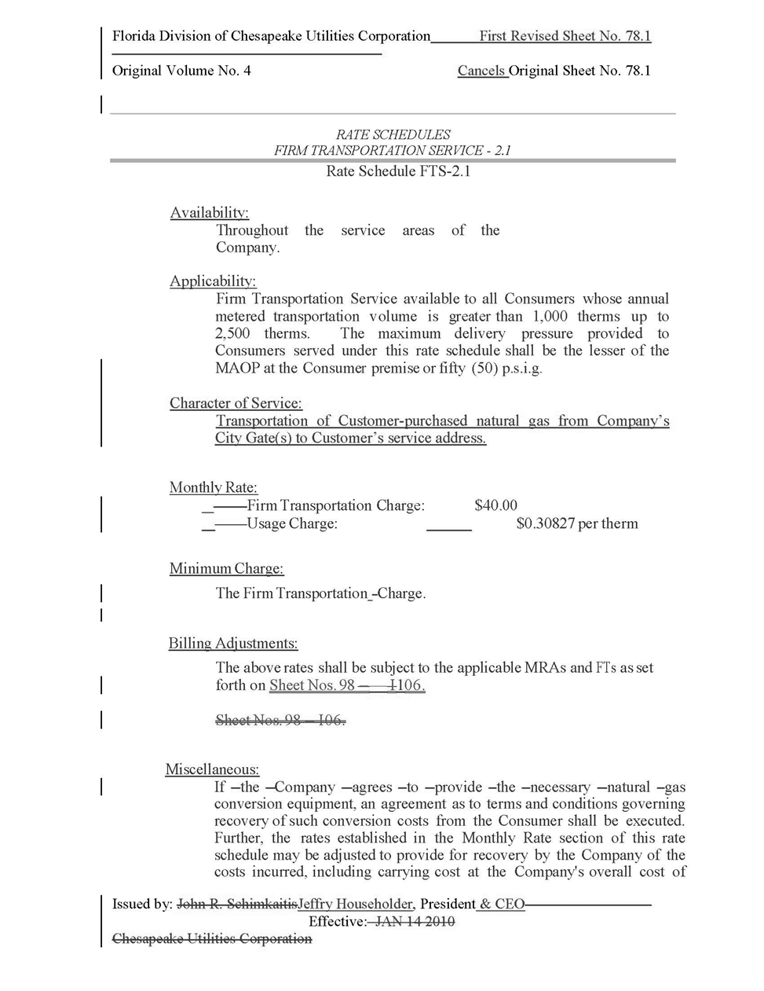

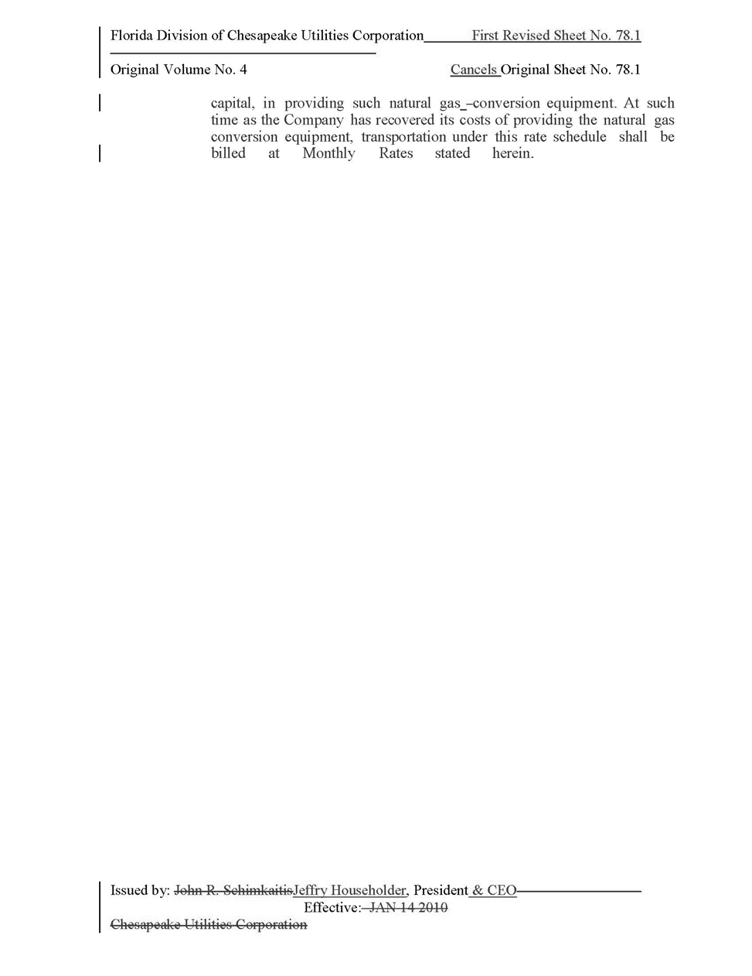

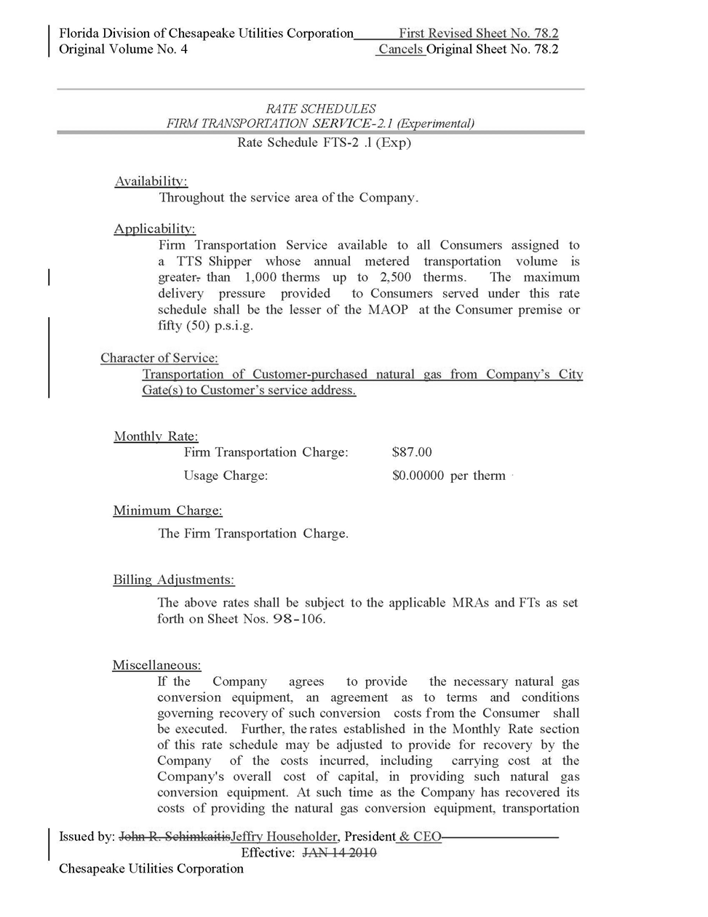

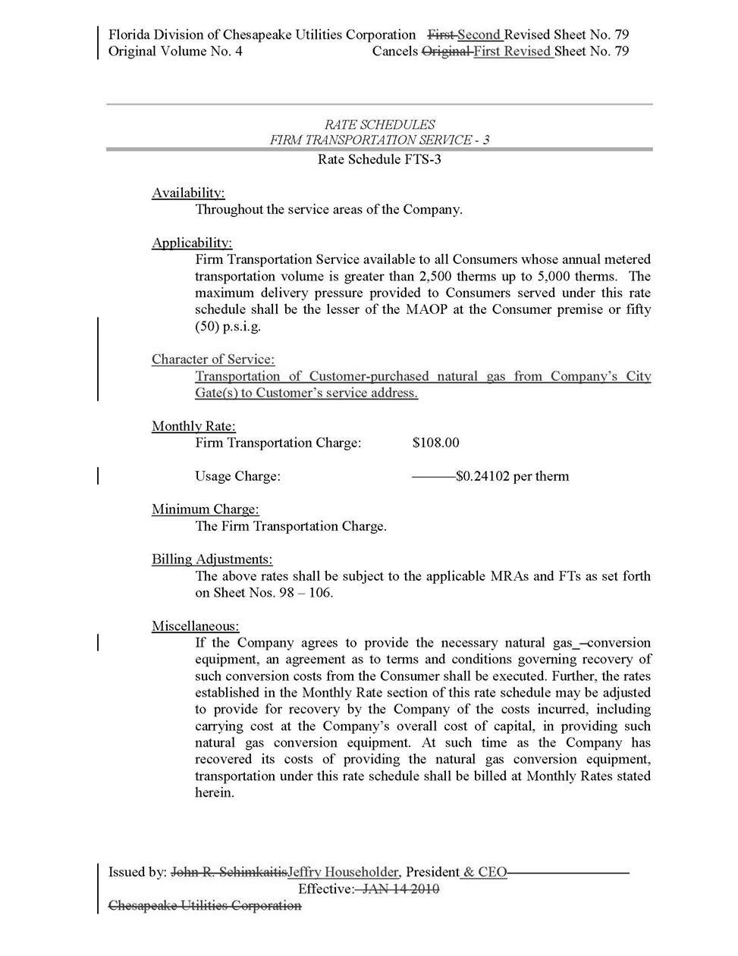

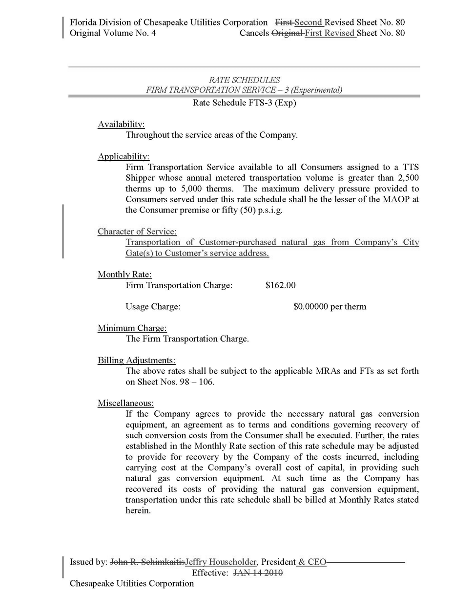

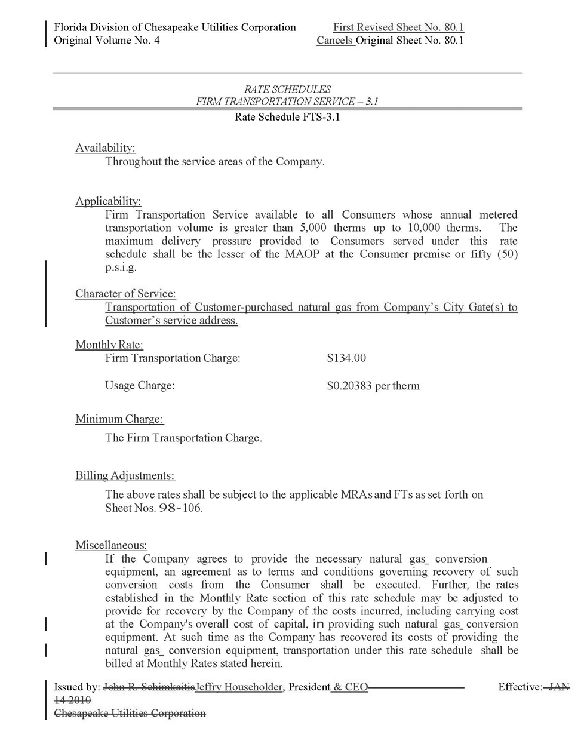

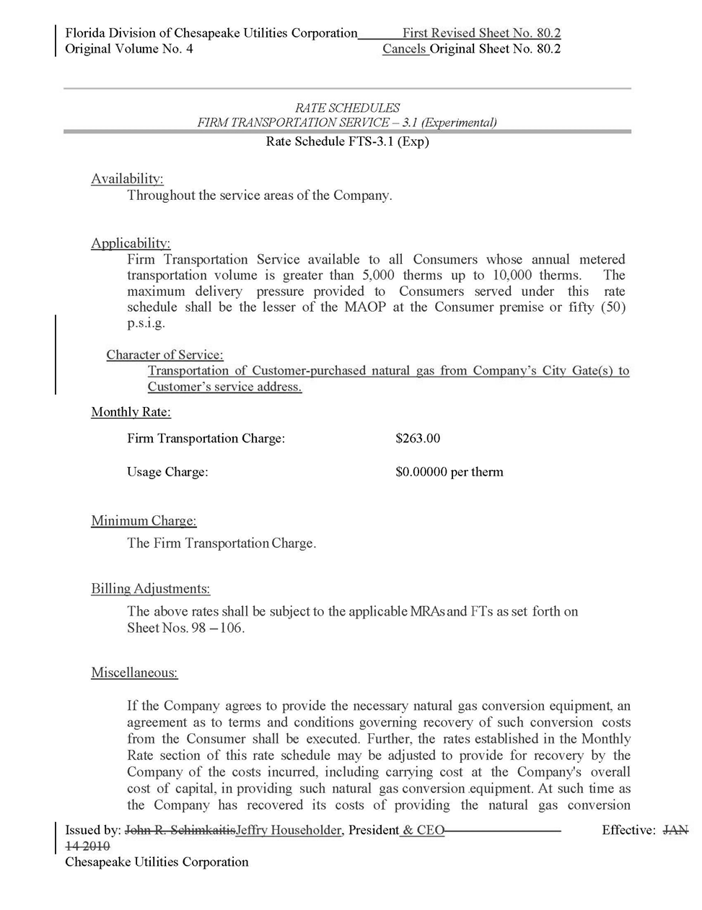

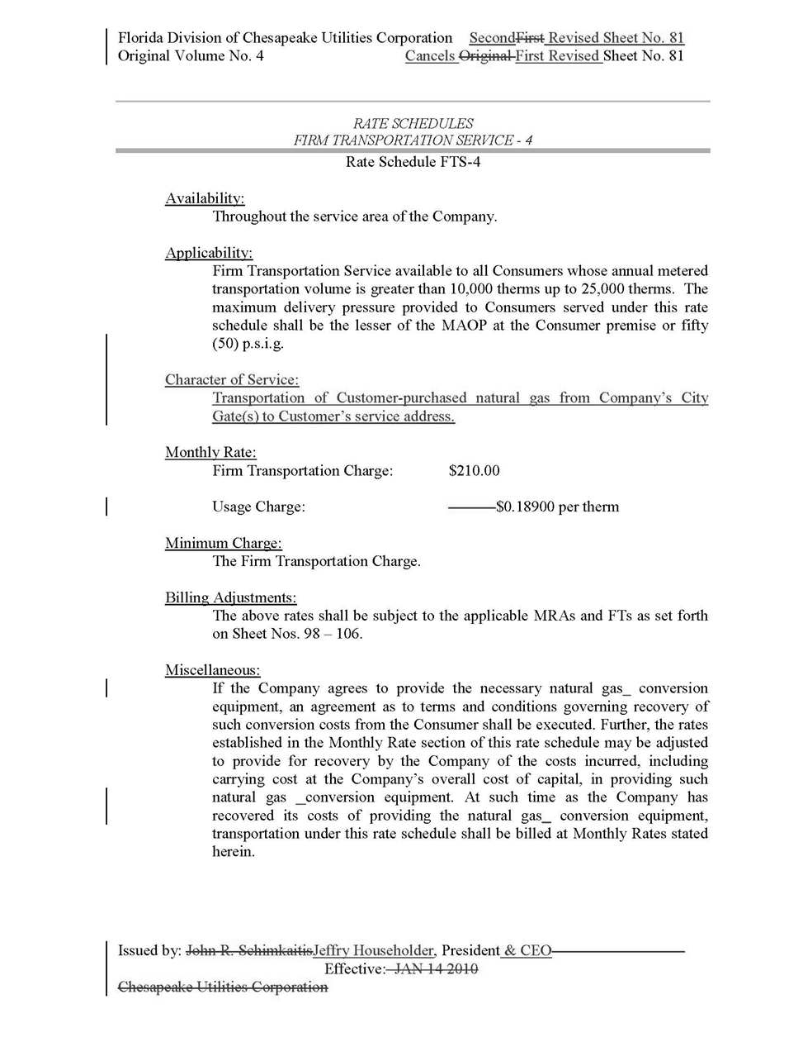

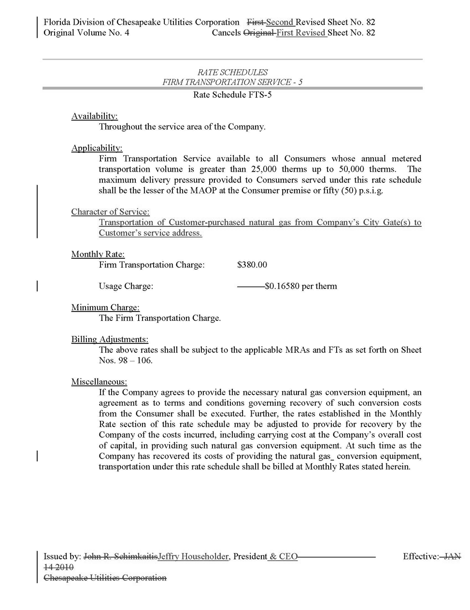

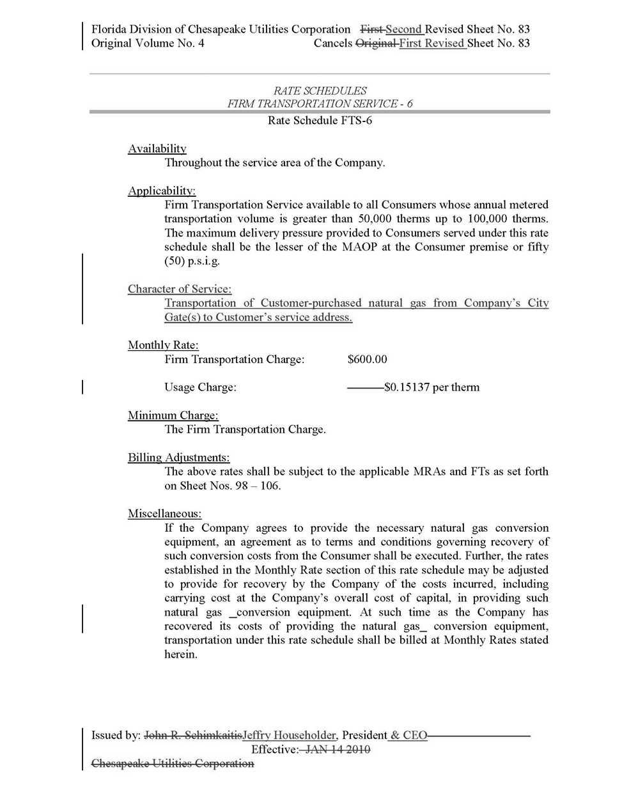

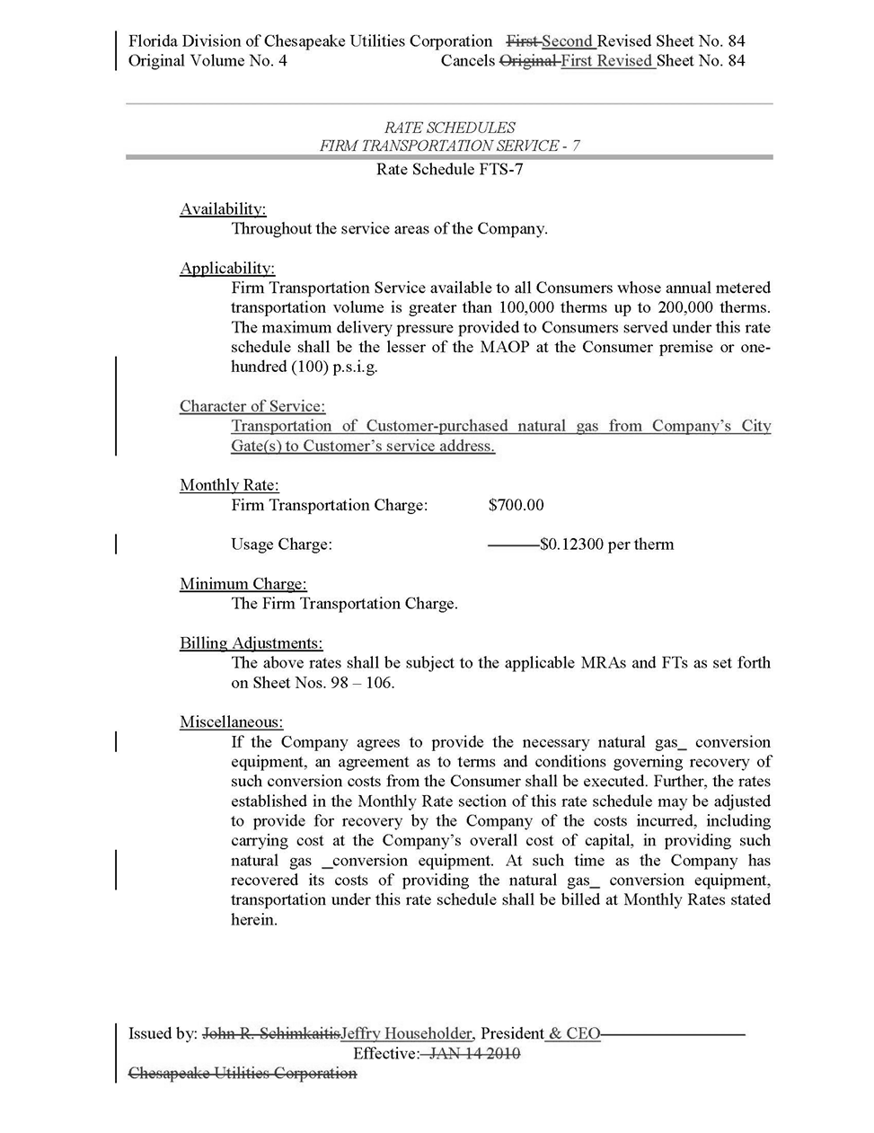

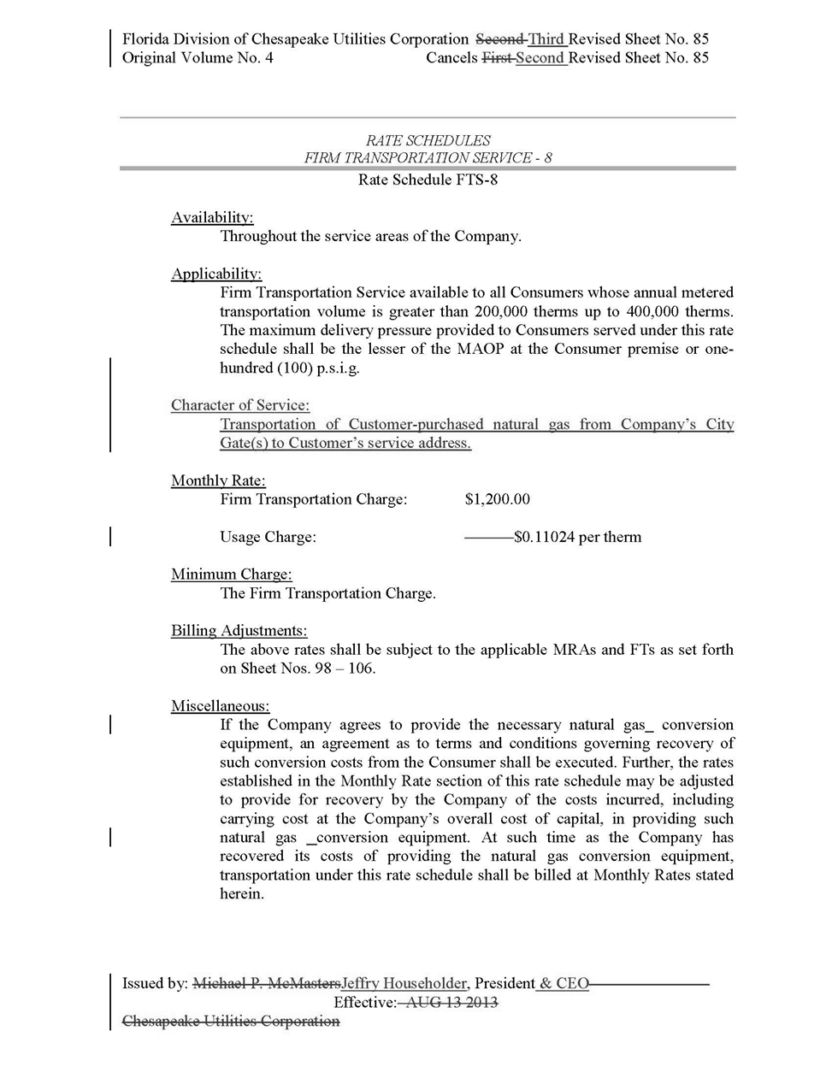

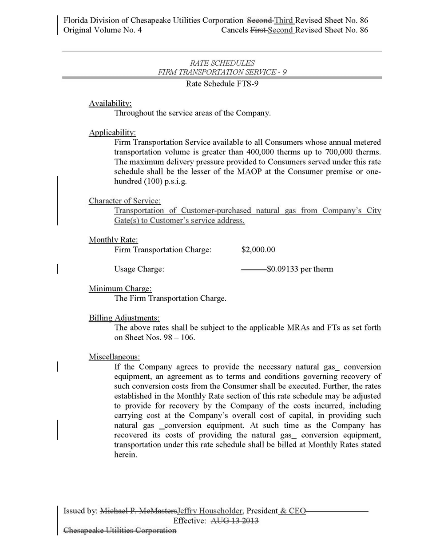

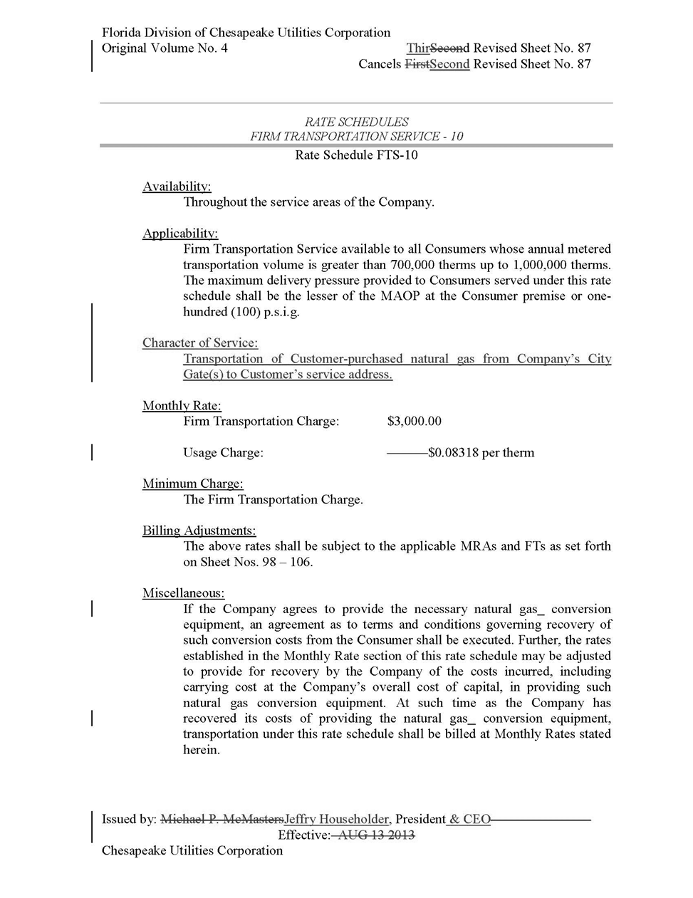

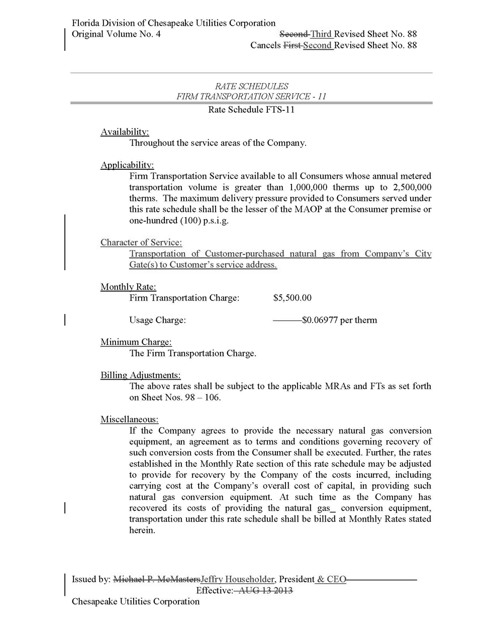

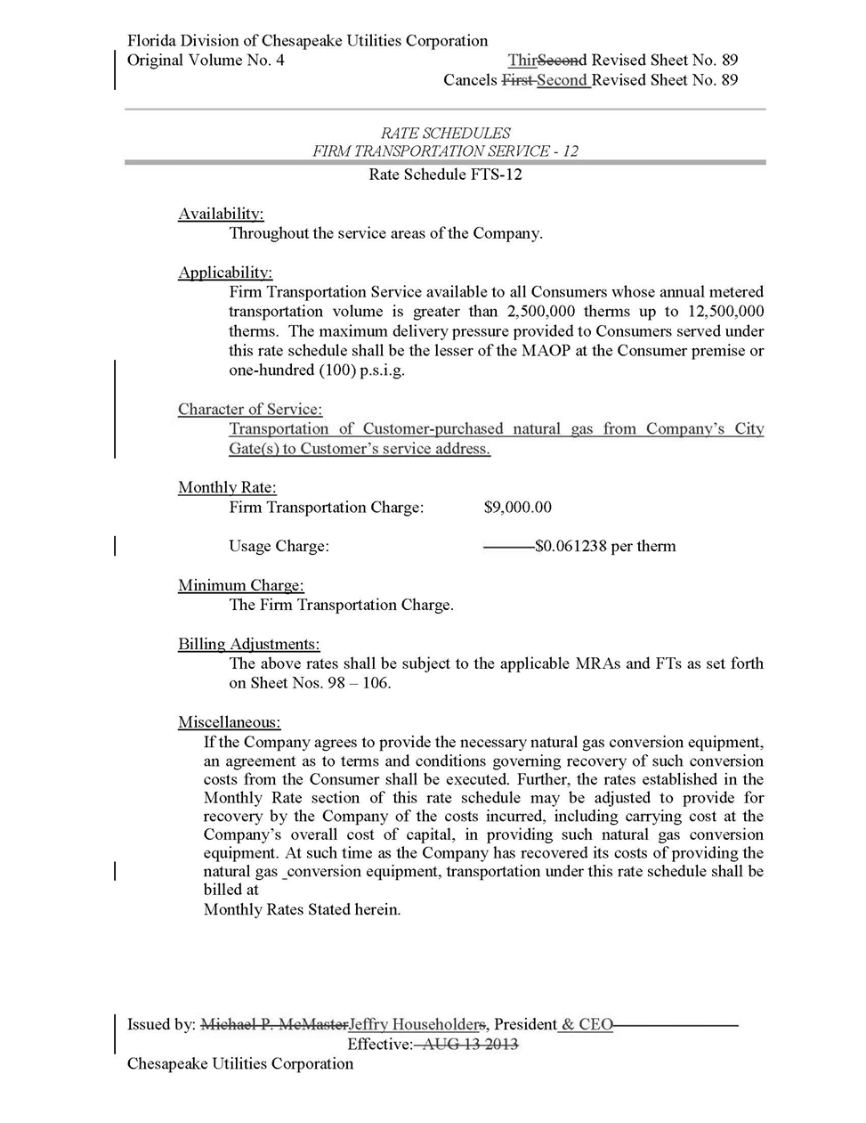

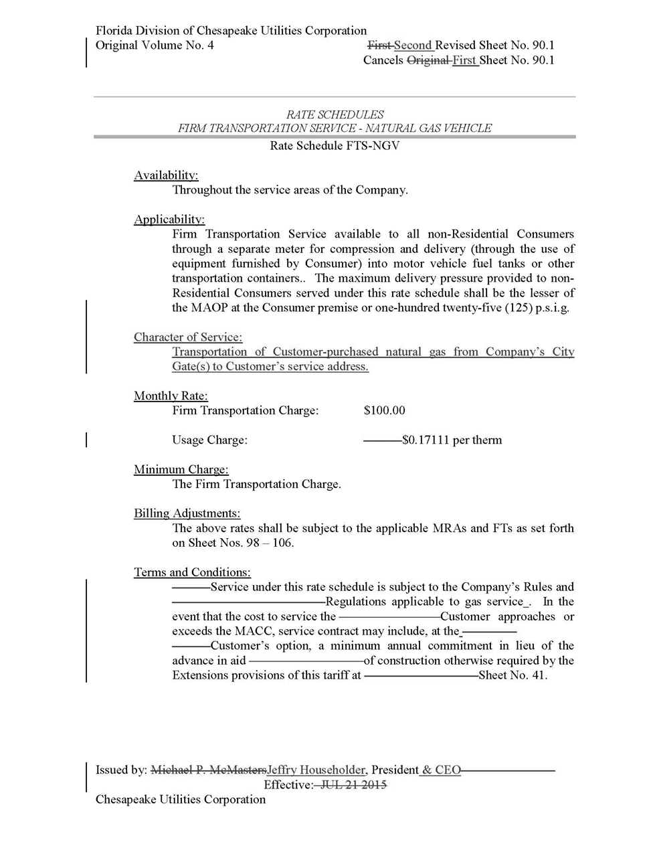

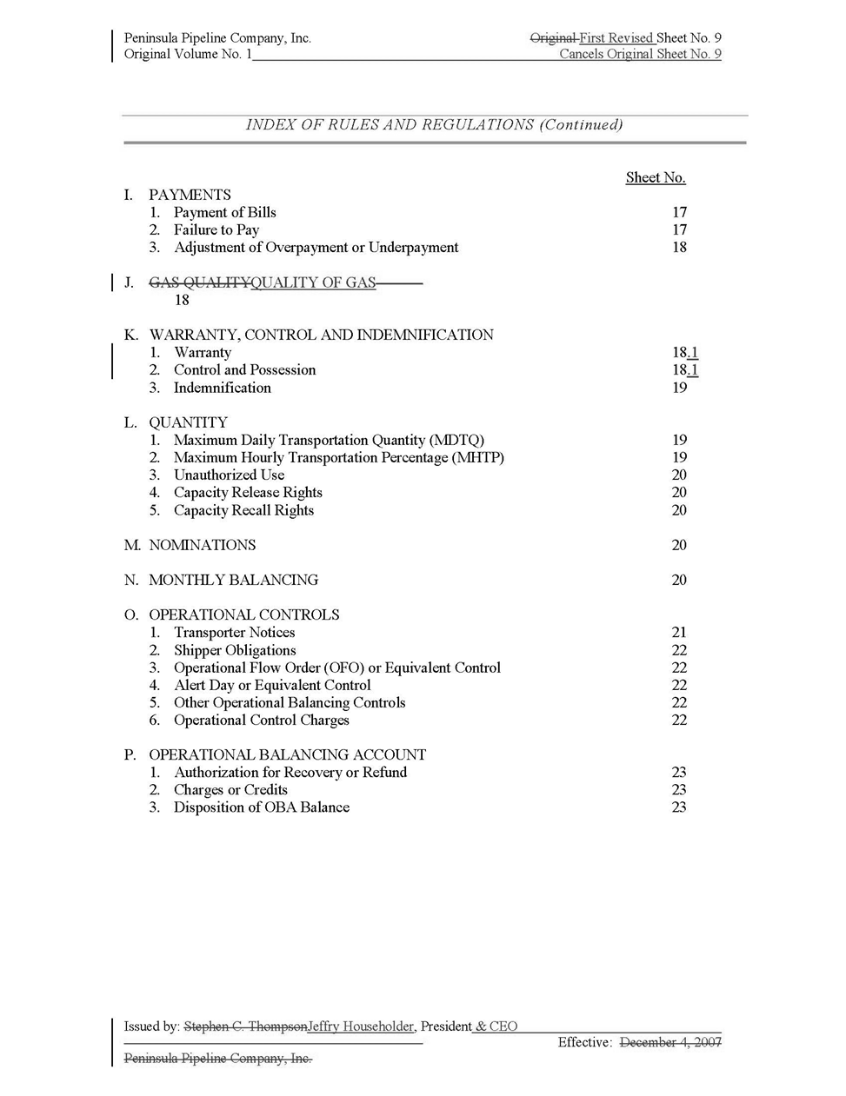

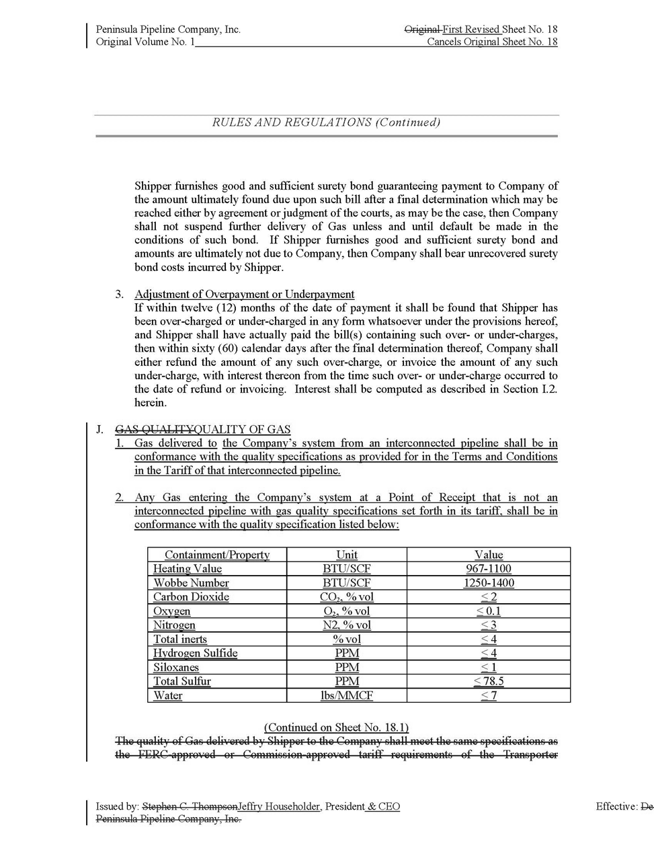

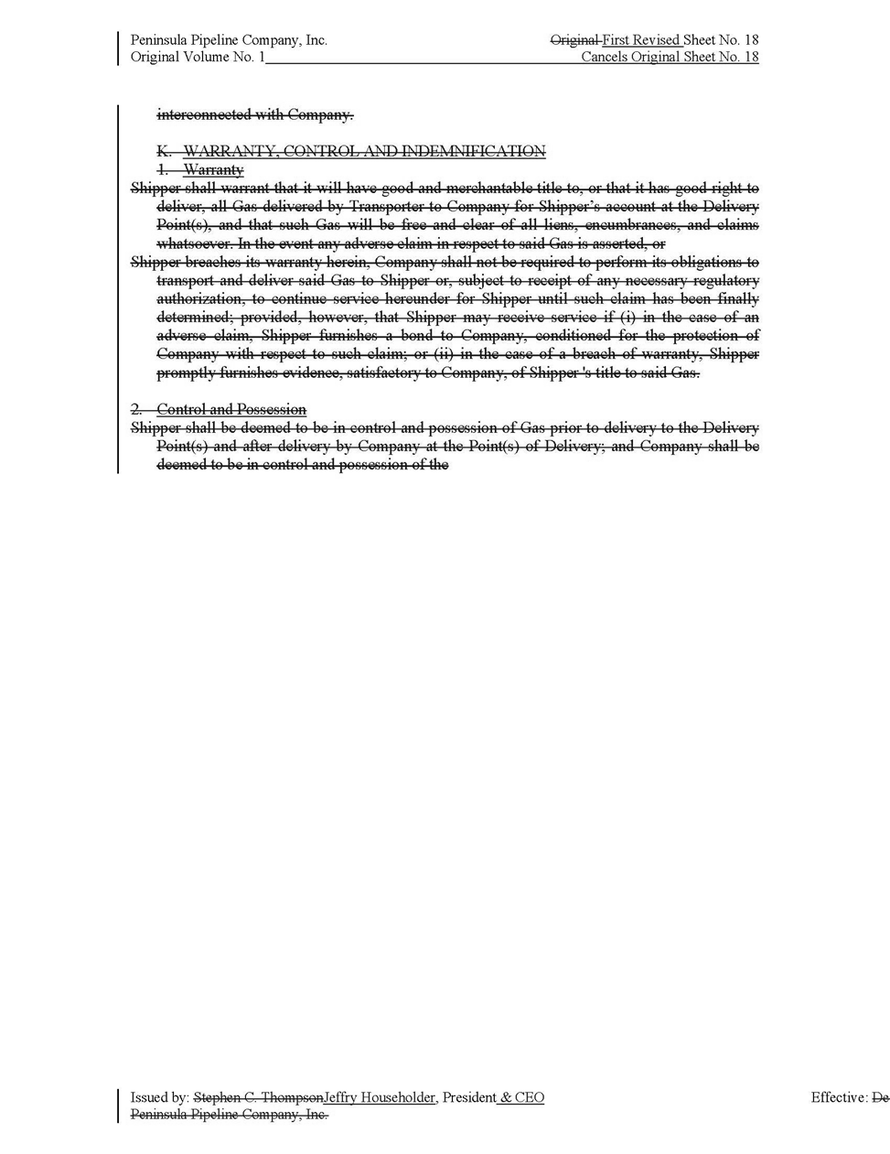

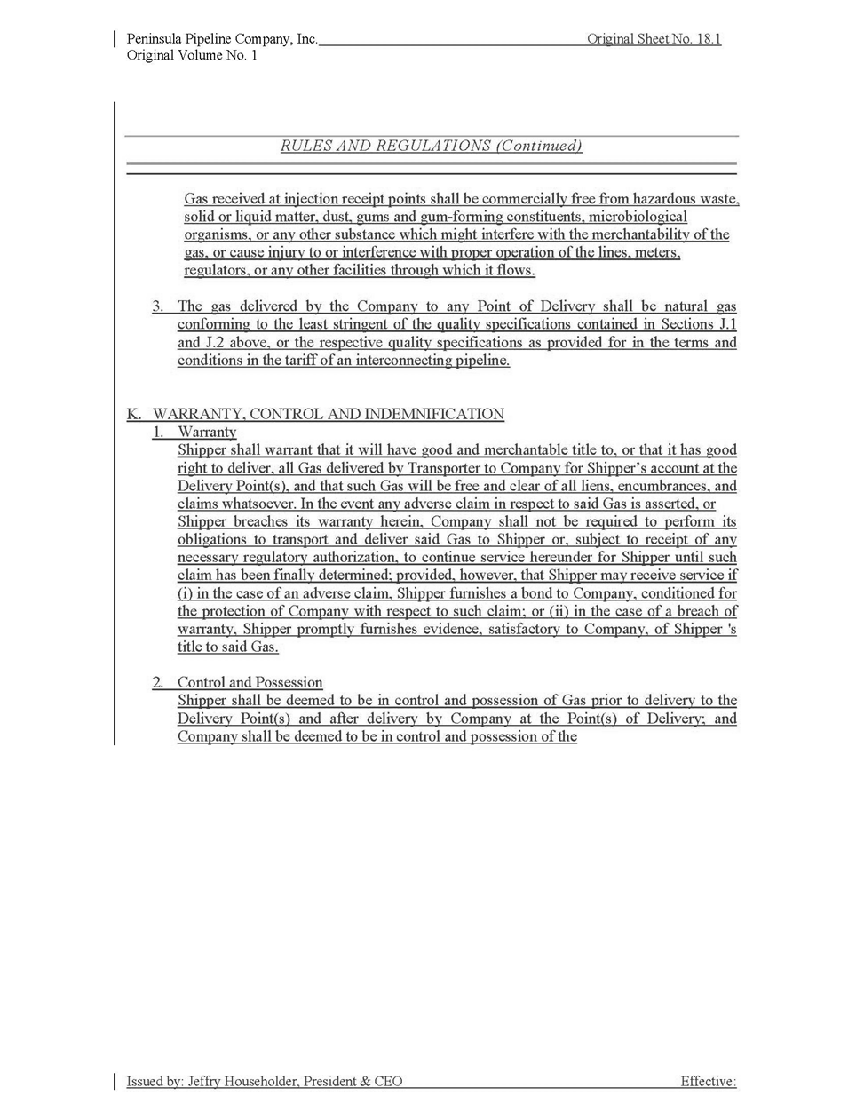

Specifically, Section 2.07(C)(5)a. of the Commission’s Administrative Procedures Manual does not provide for administrative approval of tariffs filed by intrastate natural gas transmission companies, such as Peninsula.
Document No. 00853-2020
The term “containments” is used by the Companies to describe the carbon dioxide, oxygen, nitrogen, inert gases, hydrogen sulfide, siloxanes, total sulfur, and water, which can be found in natural gas.
Tariff Sheet Nos. 5.501-3 and 5.501-4
The added definition states: “Transportation of Customer-purchased natural gas from Company’s City Gate(s) to Customer’s service address.”

