BEFORE THE FLORIDA PUBLIC SERVICE COMMISSION

In re: Petition for approval to implement a temporary storm cost recovery surcharge, by St. Joe Natural Gas Company. | DOCKET NO. 20200039-GU  ORDER NO. PSC-2020-0117-PCO-GU  ISSUED: April 20, 2020

The following Commissioners participated in the disposition of this matter:

GARY F. CLARK, Chairman
ART GRAHAM
JULIE I. BROWN
DONALD J. POLMANN
ANDREW GILES FAY

ORDER APPROVING INTERIM STORM RECOVERY CHARGE
FOR ST. JOE NATURAL GAS COMPANY

BY THE COMMISSION:

Background
On January 24, 2020, St. Joe Natural Gas Company (SJNG or Company) filed its petition to recover incremental storm restoration costs related to Hurricane Michael. SJNG’s service area includes Mexico Beach and Port St. Joe, and its natural gas distribution system sustained significant damage as a result of Hurricane Michael. The Company represents that it has incurred incremental costs of $321,012 and projects $60,500 in remaining costs to complete the restoration of its gas system to pre-storm condition. SJNG is requesting to recover the $381,512 over a four-year period. Currently, SJNG is not a party to any settlement agreement regarding storm restoration expenditures, nor does SJNG have a storm reserve balance. The Company requests to implement a monthly per therm surcharge for all customer classes. Residential customers will see an impact that will range from approximately $1.68 to $3.10 per month based on the level of usage.
The Office of Public Counsel’s intervention in this docket was acknowledged by Order No. PSC-2020-0066-PCO-GU, issued March 2, 2020.
We have jurisdiction over this matter pursuant to Sections 366.04, 366.05, and 366.06, Florida Statutes (F.S.).

Decision
Approval to Implement a Temporary Storm Cost Recovery Charge
SJNG filed a petition for approval of a temporary storm cost recovery surcharge to recover the incremental costs associated with Hurricane Michael. The Company’s total requested recovery amount of $381,512 includes $321,012 in actual costs that SJNG has determined to be incremental and $60,500 in projected costs. SJNG asserts that this amount was calculated in accordance with the Incremental Cost and Capitalization Approach (ICCA) methodology.

The approval of a temporary storm cost recovery surcharge is preliminary in nature and is subject to refund pending further review once the total actual storm restoration costs are known. After the actual costs are reviewed for prudence and reasonableness, and are compared to the actual amount recovered through the temporary storm cost recovery surcharge, a determination will be made whether any over/under recovery has occurred. The disposition of any over/under recovery, and associated interest, will be considered by us at a later date. Under Section 366.06, F.S., we have authority to allow for temporary storm cost recovery surcharges subject to refund: “[P]ursuant to the authority granted by the ‘file and suspend’ provisions of Section 366.06(3), Florida Statutes, this Commission may establish, prior to an evidentiary administrative hearing, rates subject to refund outside of full base rate proceedings.”

After reviewing the information provided by SJNG in its petition, we approve the request by SJNG to implement a temporary storm cost recovery surcharge subject to refund. Once the total actual storm costs are known, SJNG shall be required to file documentation of the storm costs for our review and true-up of any over/under recovery. Our approval is only for purposes of implementing temporary storm cost recovery surcharges and is not a confirmation or endorsement of the prudence of SJNG’s actual or projected costs. Our approval only allows SJNG to begin recovery on an interim basis. This interim recovery is subject to refund following a hearing or formal proceeding where the veracity and prudence of SJNG’s actual restoration costs can be fully vetted.

Approval of Temporary Storm Cost Recovery Tariff

SJNG is seeking approval of temporary storm cost recovery surcharges as shown in the second revised tariff sheet No. 83 (Attachment A). The Company is requesting the temporary surcharges to remain in effect for a period of 48 months, starting May 1, 2020. We reviewed the surcharge factor calculation shown on page 2 of Attachment B of the petition and find that the surcharges have been calculated correctly and consistent with the methodology used to calculate the Company’s Commission-approved Energy Conservation Cost Recovery factors.

SJNG has three residential rate schedules, based on annual therm consumption. An RS-1 customer, using eight therms per month, will see a bill increase of $1.68 per month. An RS-2 customer, using 18 therms per month, will see a bill increase of $2.28 per month. Finally, a residential customer in the RS-3 class, with a monthly usage of 32 therms, will see a bill increase of $3.10 per month. SJNG will notify its customers of the proposed surcharges during the April billing cycle.

Based on the above, we approve SJNG’s proposed Hurricane Michael temporary storm cost recovery tariff, as shown in Attachment A to the this Order, effective May 1, 2020.

Approval of Security Subject to Refund
The Company has requested a corporate undertaking to guarantee the amount collected through the temporary storm cost recovery surcharges. The criteria for a corporate undertaking include sufficient liquidity, ownership equity, profitability, and interest coverage to guarantee any potential refund. We have reviewed SJNG’s 2016, 2017 and 2018 annual reports to determine the financial condition of the Company. SJNG has experienced a decreasing Net Income over the past three years, with a reported Net Income of $68,489 in 2018. However, SJNG has $3,058,268 of equity out of a total capitalization of $3,778,268 indicating an equity ratio of 80.9 percent. Also, SJNG’s relative level of liquidity over the most recent three-year period is within acceptable parameters and the Company’s interest coverage ratio is 4.0, which demonstrates an ability to cover its interest obligations. Based on this analysis and the totality of the circumstances, we authorize SJNG to secure the amount collected through a corporate undertaking.

This brief financial analysis is only appropriate for deciding if the Company can support a corporate undertaking in the amount proposed and should not be considered a finding regarding our position on other issues in this proceeding.

Based on the foregoing, it is

ORDERED by the Florida Public Service Commission that St. Joe Natural Gas Company is authorized to implement a temporary storm cost recovery surcharge. Once the total actual storm costs are known, SJNG shall be required to file documentation of the total storm costs for Commission review and true-up of any over/under recovery. We will consider the disposition of any over/under recovery, and associated interest, at a later date. It is further

ORDERED that SJNG’s proposed tariff as shown in Attachment A to this Order is approved, effective May 1, 2020. It is further

ORDERED that the appropriate security to guarantee the funds collected subject to refund is a corporate undertaking. It is further

ORDERED that this docket shall remain open pending final reconciliation of actual recoverable Hurricane Michael storm costs with the amount collected pursuant to the temporary storm cost recovery surcharge. We will consider the disposition of any over or under recovery, and associated interest, at a later date.

By ORDER of the Florida Public Service Commission this 20th day of April, 2020.

/s/ Adam J. Teitzman
ADAM J. TEITZMAN
Commission Clerk
Florida Public Service Commission
2540 Shumard Oak Boulevard
Tallahassee, Florida 32399
(850) 413-6770
www.floridapsc.com

Copies furnished: A copy of this document is provided to the parties of record at the time of issuance and, if applicable, interested persons.
SPS

NOTICE OF FURTHER PROCEEDINGS OR JUDICIAL REVIEW

The Florida Public Service Commission is required by Section 120.569(1), Florida Statutes, to notify parties of any administrative hearing that is available under Section 120.57, Florida Statutes, as well as the procedures and time limits that apply. This notice should not be construed to mean all requests for an administrative hearing will be granted or result in the relief sought.

Mediation may be available on a case-by-case basis. If mediation is conducted, it does not affect a substantially interested person's right to a hearing.

Any party adversely affected by this order, which is preliminary, procedural or intermediate in nature, may request: (1) reconsideration within 10 days pursuant to Rule 25-22.0376, Florida Administrative Code; or (2) judicial review by the Florida Supreme Court, in the case of an electric, gas or telephone utility, or the First District Court of Appeal, in the case of a water or wastewater utility. A motion for reconsideration s hall be filed with the Office of Commission Clerk, in the form prescribed by Rule 25-22.0376, Florida Administrative Code. Judicial review of a preliminary, procedural or intermediate ruling or order is available if review of the final action will not provide an adequate remedy. Such review may be requested from the appropriate court. as described above, pursuant to Rule 9.1 00, Florida Rules of Appellate

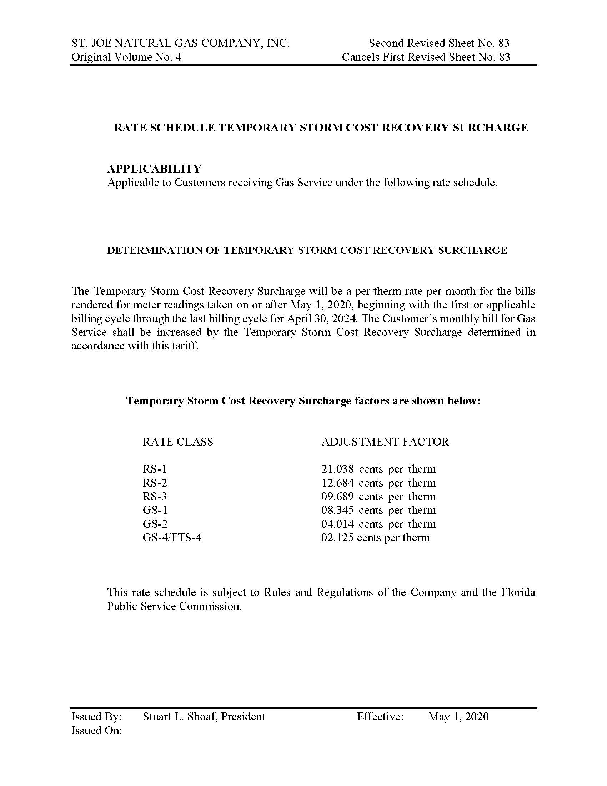

Order No. PSC-05-0187-PCO-EI, issued February 17, 2005, in Docket No. 041291-EI, In re: Petition for authority to recover prudently incurred storm restoration costs related to 2004 storm season that exceed storm reserve balance, by Florida Power & Light Company, at p.14.

