BEFORE THE FLORIDA PUBLIC SERVICE COMMISSION

In re: Fuel and purchased power cost recovery clause with generating performance incentive factor. | DOCKET NO. 20200001-EI  ORDER NO. PSC-2020-0154-PCO-EI  ISSUED: May 14, 2020

The following Commissioners participated in the disposition of this matter:

GARY F. CLARK, Chairman
ART GRAHAM
JULIE I. BROWN
DONALD J. POLMANN
ANDREW GILES FAY

ORDER GRANTING TAMPA ELECTRIC COMPANY’S, DUKE ENERGY
FLORIDA, LLC’S, FLORIDA POWER & LIGHT COMPANY’S AND GULF POWER COMPANY’S PETITIONS FOR MID-COURSE CORRECTIONS

BY THE COMMISSION:

From March 25, 2020, through April 2, 2020, the four investor-owned utilities (IOUs) in the State of Florida that generate their own electricity filed for mid-course corrections of their currently-approved fuel costs/factors. These mid-course correction petitions were filed and are being addressed as part of our annual fuel and purchased power cost recovery (fuel clause) docket.

BACKGROUND

Mid-Course Corrections

Mid-course corrections are part of the fuel clause proceeding, and such corrections are used by this Commission between fuel clause hearings whenever costs deviate from revenues by a significant margin. Petitions for mid-course corrections to fuel factors are addressed by Rule 25-6.0424, Florida Administrative Code (F.A.C.). Under this rule, a utility must notify this Commission whenever it expects to experience an under-recovery or over-recovery greater than 10 percent. Pursuant to Rule 25-6.0424, F.A.C., the mid-course percentage is the estimated end-of-period total net true-up amount divided by the current period’s total actual and estimated jurisdictional fuel revenue applicable to period amount.

Mid-course corrections are considered preliminary procedural decisions, and any over-recoveries or under-recoveries caused by or resulting from Commission-approved adjusted fuel factors may be included in the following year’s fuel factors. In this instance, the proposed revisions to current fuel cost recovery levels are being driven by a significant decline in the market-based price for natural gas. Rule 25-6.0424(2), F.A.C., does not require an under-recovery or over-recovery of 10 percent for our approval of a mid-course correction.

The monthly natural gas price at the time 2020 projections were filed in September 2019 was $2.56 per Million British thermal units (MMBtu). Four months later in January 2020, or in the first month when new rates of the 2020 clause cycle became effective, the monthly spot price was down 21 percent, falling to $2.02 per MMBtu. The forward prices currently being quoted on The New York Mercantile Exchange (NYMEX) for all months through the end of the third-quarter 2020, remain below $2.20 per MMBtu (at Henry Hub) as of April l0, 2020. These quoted spot market prices are lower than the utility-specific figures discussed below due to the addition of transportation and other costs to the utility figures.

In this proceeding, we are being asked to reduce the expected fuel and capacity costs to customers. Specific treatment of the projected fuel mid-course correction over-recoveries further described below varies by utility; however, all are requesting approval of an accelerated method for flowing back the projected over-recoveries of fuel and capacity charges to their respective customers. The “lump sum” approach of flowing back the projected over-recoveries is meant to aid in counteracting the adverse economic conditions resulting from the Coronavirus Disease 2019 (COVID-19) global pandemic. Throughout this order, we may refer to the mid-course correction dollars being flowed back to customers in a non-levelized manner as a “bill credit.” However, the proposed approaches simply effectuate flowing back all or a majority of the mid-course correction amounts in one- or three-month timeframes, rather than the standard approach of spreading the total amount over all remaining months in a period. In this instance, the standard approach, including normal noticing timeframes, would be to flow back the total mid-course correction amount ratably over the June through December time period.

Petitions

On March 25, 2020, Tampa Electric Company (Tampa Electric) filed its Petition for Mid-Course Correction of its Fuel Cost Recovery Factors and Capacity Cost Recovery Factors (Tampa Electric Petition). Through its petition, Tampa Electric is seeking authorization to lower its currently-approved 2020 fuel and capacity cost recovery factors from June through December 2020, as well as issue line item bill credits in the months of June, July, and August 2020.

On April 1, 2020, Florida Power & Light Company (FPL) filed its Mid-Course Correction Petition (FPL Petition). FPL is seeking authorization to lower its currently-approved 2020 fuel cost recovery factors for the month of May 2020. FPL’s current level of actual and projected fuel cost recovery has not breached the 10 percent threshold; thus, the filing was not prompted by the noticing requirement pursuant to Rule 25-6.0424(2), F.A.C. However,
FPL indicated that its proposed action is primarily intended to help mitigate the adverse economic impacts of the COVID-19 pandemic.

On April 2, 2020, Gulf Power Company (Gulf) filed its Mid-Course Correction Petition (Gulf Petition). Gulf is seeking authorization to issue a line item bill credit for the month of May 2020.

On April 2, 2020, Duke Energy Florida, LLC (DEF) filed its Emergency Petition for a Temporary Mid-Course Correction (DEF Petition). DEF is seeking authorization to lower its currently-approved fuel cost recovery factors for the month of May 2020. DEF’s current level of actual and projected fuel cost recovery has not breached the 10 percent threshold; thus, its filing was not prompted by the noticing requirement pursuant to Rule 25-6.0424(2), F.A.C. As with FPL, DEF indicated in its filing that the proposed action is in response to the adverse economic impacts of the COVID-19 pandemic.

Effective Dates and Noticing Requirement

FPL, Gulf, and DEF have requested that the revised tariffs become effective to essentially produce a one-time bill reduction in the month of May 2020. This matter was voted on at our April 28, 2020 Special Agenda Conference. Typically, effective dates are set a minimum of 30 days after a vote modifying charges. This time limit is imposed in order to avoid having new rates applied to energy consumed before the effective date of our action, i.e., the date of the vote. However, we have implemented charges as a result of mid-course corrections in less than 30 days when circumstances warrant. Further, the Florida Supreme Court has recognized that the fuel clause proceeding “is a continuous proceeding and operates to a utility’s benefit by eliminating regulatory lag.” In this instance, there can be no prejudice to the customers because their total rate would be decreasing, not increasing. Further, by implementing the modifications at this time customers will receive the benefit of reduced fuel rates as quickly as administratively possible.

We have jurisdiction in this matter pursuant to Sections 366.04, 366.05, and 366.06, Florida Statutes (F.S.).

DECISION

Tampa Electric Company

On an annual basis, Tampa Electric and other electric IOUs in Florida participate in a technical hearing in this docket for the purposes of evaluating actual and projected fuel, purchased power, and capacity-related costs of service. The most-recent hearing took place on November 5, 2019. The Fuel Order issued from the 2019 hearing set forth the fuel, purchased power, and capacity cost recovery factors that were implemented by all IOUs in Florida effective with the first billing cycle of January 2020. Tampa Electric’s petition includes both fuel and capacity mid-course correction requests.

Tampa Electric has proposed to flow the total mid-course correction amount through the combination of a fuel credit for the months June through August 2020 (as shown in Attachment A, Tariff Sheet No. 6.023, attached) and a reduction to the currently-approved fuel and capacity factors for the period June through December 2020 (as shown in Attachment A, Tariff Sheet No. 6.020). The fuel credit will be shown as a separate line item on the bill. For a residential customer using 1,000 kWh per month, the proposed 3-month fuel credit is $18.40. The residential fuel rate reduction associated with the remainder of the mid-course correction is $4.17 per 1,000 kWh (7 months, June through December). As proposed, the mid-course correction amount related to capacity will be distributed normally over the remaining 7-month period for a residential rate reduction of $0.22 per 1,000 kWh.

Mid-Course Correction – Fuel

With respect to the components of the mid-course correction calculation, which in this case returns the total dollar amount used to calculate the proposed rate reductions, Tampa Electric combined its final 2019 fuel over-recovery of $35,821,098, with its 2020 actual and estimated fuel over-recovery of $94,867,488, resulting in an estimated total over-recovery of $130,688,586. This is the total amount requested be returned to customers in 2020. The fuel mid-course correction position following the calculation methodology in Rule 25-6.0424(1)(a), F.A.C., is 22.3 percent.

The projected 2020 over-recovery of fuel charges is specifically associated with a decline in actual and re-projected fuel costs. Tampa Electric’s original estimation of natural gas costs for 2020 were formulated based on May 2019 futures data. At that time, Tampa Electric projected the average delivered cost of natural gas to be $3.68 per MMBtu. Tampa Electric now projects, based on March 2020 data, the average 2020 cost of natural gas will be $3.16 per MMBtu (reduction of 14 percent).

Mid-Course Correction – Capacity

As part of its request, Tampa Electric is proposing to reduce its 2020 capacity cost recovery factors by a projected 2020 over-recovery of $2,885,599. Tampa Electric’s capacity mid-course correction position following the calculation methodology in Rule 25-6.0424(1)(a), F.A.C., is 182 percent. Tampa Electric stated the projected over-recovery was caused by the inclusion of two Solar Base Rate Adjustment (SoBRA) true ups and additional firm power purchase agreements (netted against the SoBRA true ups) in its revised capacity cost estimate for 2020.

Tampa Electric, unlike with its fuel reduction, did not incorporate a final 2019 capacity over-recovery of $111,228 in the mid-course adjustment as it believes the amount is “de minimus” to the overall request. Tampa Electric claimed it will return the $111,228 to customers in 2021, or through the normal course of action during this fuel clause cycle. As proposed, the mid-course correction related to capacity will be distributed over the June through December time period. We agree with this assessment concerning the relative size of the 2019 capacity over-recovery as compared to the total mid-course adjustment and find that Tampa Electric’s proposed treatment is reasonable.

Bill Impacts

Table 1 below displays the bill impact to a residential customer using 1,000 kilowatt-hours (kWh) of electricity a month and further discusses the effects of Tampa Electric’s request.

Table 1
Monthly Residential Billing Detail at 1,000 kWh
Invoice Component | Currently-Approved 2020 Charges | Proposed Charges June-Aug. 2020 | Approved to Proposed  Difference | Approved Charges Sept.-Dec. 2020
Base Charge | $67.76 | $67.76 | $0.00 | $67.76
Fuel Charge | 27.02 | 22.85 | (4.17) | 22.85
Fuel Credit | 0.00 | (18.40) | (18.40) | 0.00
Conservation Charge | 2.32 | 2.32 | 0.00 | 2.32
Capacity Charge | 0.10 | (0.12) | (0.22) | (0.12)
Environmental Charge | 2.44 | 2.44 | 0.00 | 2.44
Gross Receipts Tax | 2.55 | 1.97 | (0.58) | 2.44
Total | $102.19 | $78.82 | ($23.37) | $97.69
Source: Tampa Electric Petition, Schedule E-10.

Tampa Electric’s current total residential charge for 1,000 kWh of usage is $102.19. Effective with the June 2020 billing cycle and continuing through August, the proposed charge will be $78.82, or a decrease of $23.37 (22.9 percent). The proposed June through August line item bill credit is $18.40. Effective with the September 2020 billing cycle and continuing through December, the bill will be $97.69. The June through December portion (i.e., amount not included in the monthly credits) of the fuel mid-course correction reflects a reduction of $4.17 per 1,000 kWh. Non-residential classes, commercial, and industrial customers can expect a reduction of 14 to 20 percent, depending on usage. Tampa Electric stated that it will provide customers notice of the changes with its June bills and on its website. The Company also filed the tariff (First Revised 6.023) for after the credit concludes post-August 2020. Commission staff has requested administrative authority to approve this First Revised Tariff Sheet No. 6.023, effective September 2020 should we approve Tampa Electric’s proposed modification. Further, Tampa Electric has represented that it has consulted with the Office of Public Counsel (OPC) about its primary proposal (factors shown on Attachment A) and that OPC is in support of the proposal.

For the reasons stated above, we hereby grant Tampa Electric’s petition to reduce its currently-approved 2020 fuel and capacity cost recovery factors for purposes of flowing back to customers a projected over-recovery of fuel and capacity charges during the period of June through December 2020, and issuing fuel-related bill credits in the months of June, July, and August 2020. Further, we approve the tariffs as shown on Attachment A effective June 1, 2020. Finally, we hereby give Commission staff administrative authority to approve the First Revised Tariff Sheet No. 6.023, effective September 2020.

Florida Power & Light Company

FPL participated in the Commission’s most-recent fuel hearing which took place on November 5, 2019. The Fuel Order issued from the 2019 hearing set forth FPL’s fuel, purchased power, and capacity-related cost recovery factors effective with the first billing cycle of January 2020.

Mid-Course Correction

FPL has proposed to address a projected 2020 fuel over-recovery of $206,083,515 by reducing its fuel factors in the month of May 2020. The projected 2020 over-recovery of fuel charges is specifically associated with a decline in projected fuel costs. FPL’s fuel mid-course correction position following the calculation methodology in Rule 25-6.0424(1)(a), F.A.C., is 6.3 percent, which is under the 10 percent threshold prompting a noticing requirement pursuant to the same rule. FPL’s original projection of natural gas costs for 2020 was formulated near the end of July 2019. At that time, FPL projected the average delivered cost of natural gas to be $4.06 per MMBtu. FPL now projects, based on March 2020 data, the average 2020 cost of natural gas will be $3.53 per MMBtu (reduction of 13 percent).

FPL’s re-projection of 2020 fuel costs returns an estimated over-recovery of $206.1 million. Typically, at this point in a fuel clause cycle a utility would incorporate any over- or under-recovery from the prior period (prior calendar year) into its mid-course correction request. However, FPL has proposed to address its final prior period true up amount, which is a net under-recovery of $51.6 million, as part of its 2021 fuel cost recovery request. In support of the requested treatment, FPL contends that by excluding the 2019 true up amount, it is maximizing the effect of the May 2020 rate reduction. FPL’s requested approach is, in principle, similar to Tampa Electric’s proposal relating to its 2019 capacity cost over-recovery, i.e., not incorporating a prior period true up amount. Further, FPL has cited Order No. PSC-2019-0109-PCO-EI as precedent where we authorized an electric utility to implement a mid-course correction that excluded the prior year’s under-recovery amount.

As part of the mid-course correction filing, FPL updated its projections for purchased power, qualifying facilities, and economy purchases due to the updated fuel pricing and input assumptions. Regarding capacity cost recovery, FPL did not propose any changes to its currently-approved factors.

Bill Impacts

Table 2 below displays the bill impact to a residential customer using 1,000 kWh of electricity a month and further discusses the effects of FPL’s request.

Table 2
Monthly Residential Billing Detail at 1,000 kWh
Invoice Component | Currently-Approved Charges for April 2020 | Currently-Approved Charges for May 2020 | Proposed Charges for May 2020 | Approved to Proposed May 2020 Difference | Approved Charges June-Dec. 2020
Base Charge | $69.43 | $69.94 | $69.94 | $0.00 | $69.94
Fuel Charge | 18.97 | 18.84 | (3.65) | (22.49) | 18.84
Conservation Charge | 1.39 | 1.39 | 1.39 | 0.00 | 1.39
Capacity Charge | 2.30 | 2.30 | 2.30 | 0.00 | 2.30
Environmental Charge | 1.55 | 1.55 | 1.55 | 0.00 | 1.55
Gross Receipts Tax | 2.40 | 2.41 | 1.83 | (0.58) | 2.41
Total | $96.04 | $96.43 | $73.36 | ($23.07) | $96.43
Source: FPL Petition, Schedule E-10.

FPL’s current total residential charge for 1,000 kWh of usage for January through April 2020 is $96.04. Effective May 2020, we approved by Order No. PSC-2019-0484-FOF-EI, FPL’s 2020 SoBRA, which would have increased the 1,000 kWh bill to $96.43. Applying the proposed one-time fuel credit decreases the $96.43 bill to $73.36, or a reduction of $23.07 in May (23.9 percent).

FPL has requested that it be allowed to return to the fuel adjustment factors approved by Order No. PSC-2019-0484-FOF-EI following the one-time May reduction. If approved, effective with the June 2020 billing cycle, the residential charge for 1,000 kWh will return to $96.43. Concerning non-residential customers, typical bill reductions will range from approximately 24 to 30 percent for commercial customers, and approximately 53 percent for industrial customers.

FPL’s proposed tariff is contained in Attachment B, attached. FPL has provided notice of its request for a mid-course correction with its April customer bills, subject to our approval.

For the reasons stated above, we hereby approve FPL’s petition to reduce, for one month, its currently-approved 2020 fuel cost recovery factors for purposes of flowing back to customers a projected over-recovery of fuel charges during the month of May 2020. The tariffs shown on Attachment B are hereby approved effective May 1, 2020. Finally, Commission staff is hereby given administrative authority to approve tariffs effective June 1, 2020, reflecting the fuel factors approved in Order No. PSC-2019-0484-FOF-EI.

Gulf Power Company

Gulf participated in our most-recent fuel hearing which took place on November 5, 2019. The Fuel Order issued from the 2019 hearing set forth Gulf’s fuel, purchased power, and capacity-related cost recovery factors effective with the first billing cycle of 2020.

Mid-Course Correction

With respect to the components of the mid-course correction calculation, which returns the total dollar amount used to calculate the proposed reduction, Gulf combined its final 2019 over-recovery of $8,868,596 with its estimated 2020 over-recovery of $42,404,427, resulting in a total estimated 2020 over-recovery of $51,273,023, or the total mid-course correction amount proposed to be flowed to customers. Gulf’s fuel mid-course correction position following the calculation methodology in Rule 25-6.0424, F.A.C., is 14.7 percent.

The projected 2020 over-recovery of fuel charges is specifically associated with a decline in projected fuel costs. Gulf’s original projection of 2020 natural gas costs was formulated near the end of July 2019. At that time, Gulf projected the average cost of natural gas to be $3.39 per MMBtu. Gulf now projects, based on March 2020 data, the average 2020 cost of natural gas will be $2.57 per MMBtu (reduction of 24.2 percent).

Gulf has proposed to flow its projected 2020 over-recovery of $51.3 million to customers through a bill credit in the month of May 2020. As part of the mid-course correction filing, Gulf updated its projections for purchased power and economy purchases due to the updated fuel pricing and input assumptions. Regarding capacity cost recovery, Gulf did not propose any changes to its currently-approved factors.

Bill Impacts

Table 3 below displays the bill impact to a residential customer using 1,000 kWh of electricity a month and further discusses the effects of Gulf’s request.

Table 3
Monthly Residential Billing Detail at 1,000 kWh
Invoice Component | Currently-Approved 2020 Charges | Proposed Charges for May 2020 | Approved to Proposed May 2020 Difference | Approved Charges June-Dec. 2020
Base Charge | $68.06 | $68.06 | $0.00 | $68.06
Fuel Charge | 32.62 | 32.62 | 0.00 | 32.62
Fuel Credit | 0.00 | (54.98) | (54.98) | 0.00
Conservation Charge | 0.60 | 0.60 | 0.00 | 0.60
Capacity Charge | 8.78 | 8.78 | 0.00 | 8.78
Environmental Charge | 18.86 | 18.86 | 0.00 | 18.86
Storm Charge | 8.00 | 8.00 | 0.00 | 8.00
Gross Receipts Tax | 3.51 | 2.10 | (1.41) | 3.51
Total | $140.43 | $84.04 | ($56.39) | $140.43
Source: Gulf Petition, Schedule E-10.

Gulf’s current total residential charge for 1,000 kWh of usage is $140.43. By applying the proposed one-month fuel credit, the total bill lowers to $84.04, or a reduction of $56.39 (40.2 percent) for the month of May 2020. The proposed fuel credit is shown in Attachment C, Original Sheet No. 6.34a, which is effective for the May 2020 billing cycle. Gulf also filed its First Revised Tariff Sheet No. 6.34a for after the credit concludes post May 2020. Commission staff has requested administrative authority to approve the First Revised Tariff Sheet No. 6.34a effective June 2020. Concerning non-residential customers, typical bill reductions will range from approximately 40 to 54 percent for small commercial customers, approximately 53 percent for medium commercial customers, and approximately 56 percent for large commercial customers. Gulf’s tariff is shown on Attachment C, attached to this order. Gulf has provided notice of this request for a mid-course correction with its April customer bills, subject to our approval.

Based on the reasons stated above, we hereby approve Gulf's petition to provide customers a fuel-related bill credit during the month of May 2020 for purposes of flowing back to customers a projected over-recovery of fuel costs. The tariff showing the fuel credit contained in Attachment C is hereby approved effective May 1, 2020. Finally, Commission staff is hereby given administrative authority to approve the First Revised Tariff Sheet No. 6.34a effective June 1, 2020.

Duke Energy Florida, LLC

DEF participated in our most-recent fuel hearing which took place on November 5, 2019. The Fuel Order issued from the 2019 hearing set forth DEF’s initial 2020 fuel, purchased power, and capacity-related cost recovery factors effective with the first billing cycle of 2020. DEF implemented a previously-approved rate change effective April 2020. The April rate adjustment is associated with the Columbia solar project going into service. Although the April 2020 rates differ from the March rates shown on Schedule E-10 of the DEF Petition, we discuss its rate recommendation from the April 2020 levels.

Mid-Course Correction

With respect to the components of the mid-course correction calculation, which in this case returns the total dollar amount used to calculate the proposed rate reductions, DEF combined its total 2019 fuel under-recovery of $21,535,230, with its estimated 2020 fuel over-recovery of $99,767,015, resulting in a net mid-course correction amount of $78,231,785. This is the total amount proposed to be flowed back to customers. DEF’s fuel mid-course correction position following the calculation methodology in Rule 25-6.0424(1)(a) F.A.C., is 6.1 percent, which is under the 10 percent threshold prompting a noticing requirement pursuant to the same rule.

The projected 2020 over-recovery of fuel charges is specifically associated with a decline in projected fuel costs. DEF’s original projection of its 2020 natural gas cost was formulated in June 2019. At that time, DEF projected the average cost of natural gas to be $4.06 per MMBtu. DEF now projects the average 2020 cost of natural gas will be $3.68 per MMBtu (or reduction of 9.4 percent).

DEF has proposed to address its 2020 mid-course amount of approximately $78.2 million through reduced fuel cost recovery factors for the month of May 2020. DEF did not revise any of its planned power purchases but “will continue to utilize power purchases when needed to economically and reliably support the needs of the system.” Further, DEF did not propose any changes to its currently-approved Capacity Cost Recovery factors.

Bill Impacts

Table 4 below displays the rate impact to a residential customer using 1,000 kWh of electricity a month and further discusses the effects of DEF’s request.

Table 4
Monthly Residential Billing Detail at 1,000 kWh
Invoice Component | Currently-Approved Charges for April 2020 | Proposed Charges for May 2020 | Approved to Proposed May 2020 Difference | Approved Charges June-Dec. 2020
Base Charge | $71.96 | $71.96 | $0.00 | $71.96
Fuel Charge | 30.67 | 4.50 | (26.17) | 30.67
Conservation Charge | 3.39 | 3.39 | 0.00 | 3.39
Capacity Charge | 12.00 | 12.00 | 0.00 | 12.00
Environmental Charge | 0.79 | 0.79 | 0.00 | 0.79
Storm Charge | 5.34 | 5.34 | 0.00 | 5.34
Asset Securitization Charge | 2.35 | 2.35 | 0.00 | 2.35
Gross Receipts Tax | 3.24 | 2.57 | (0.67) | 3.24
Total | $129.74 | $102.90 | ($26.84) | $129.74
Source: DEF Petition, Schedule E-10 and Order No. PSC-2019-0292-FOF-EI.

DEF’s current total residential charge for 1,000 kWh of usage is $129.74. By applying the proposed one-month fuel rate decrease, the total charge lowers to $102.90, or a reduction of $26.84 (20.7 percent) for the month of May 2020. DEF requested that it be allowed to return to the rates approved by Order No. PSC-2019-0484-FOF-EI following the one-time May reduction (from June through December 2020). Concerning non-residential customers, typical bill reductions will range from approximately 20 to 32 percent for commercial customers, and approximately 25 to 45 percent for industrial customers. DEF’s proposed tariff is shown on Attachment D, attached to this order. DEF will provide notice of the changes with the May billing statement and on its website.

For the reasons stated above, we hereby approve DEF’s petition to reduce, for one month, its currently-approved 2020 fuel cost recovery factors for purposes of flowing to customers a projected over-recovery of fuel charges in the month of May 2020. The tariffs as shown on Attachment D are hereby approved effective May 1, 2020. Finally, Commission staff is hereby given administrative authority to approve tariffs effective June 1, 2020, that reflect the fuel factors approved in Order No. PSC-2019-0484-FOF-EI.

Based on the foregoing, it is

ORDERED by the Florida Public Service Commission that Tampa Electric Company’s Petition for Mid-Course Correction of its Fuel Cost Recovery Factors and Capacity Cost Recovery Factors is hereby granted. It is further

ORDERED that Tampa Electric Company shall reduce its currently-approved 2020 fuel and capacity cost recovery factors for purposes of flowing back to customers a projected over-recovery of fuel and capacity charges during the period of June through December 2020, and shall issue fuel-related bill credits in the months of June, July, and August 2020, as detailed in the body of this order. It is further

ORDERED that the Seventy-Ninth Revised Sheet No. 6.020, contained in Attachment A, is hereby approved effective June 1, 2020. It is further

ORDERED that Commission staff shall have administrative authority to approve the First Revised Tariff Sheet No. 6.023, contained in Attachment A, effective September 2020. It is further

ORDERED that Florida Power & Light Company’s Mid-Course Correction Petition is hereby granted. It is further

ORDERED that Florida Power & Light Company shall reduce, for one month, its currently-approved 2020 fuel cost recovery factors for purposes of flowing back to its customers a projected over-recovery of 2020 fuel charges in the month of May 2020. It is further

ORDERED that the tariffs as shown on Attachment B shall be approved effective May 1, 2020. It is further

ORDERED that Commission staff shall have administrative authority to approve tariffs effective June 1, 2020, that reflect the fuel factors approved in Order No. PSC-2019-0484-FOF-EI. It is further

ORDERED that Gulf Power Company’s Mid-Course Correction Petition is hereby granted. It is further

ORDERED that Gulf Power Company shall provide customers a fuel-related bill credit during the month of May 2020 for purposes of flowing back to customers a projected over-recovery of fuel costs. It is further

ORDERED that Gulf Power Company’s tariff for the fuel credit shown on Attachment C is hereby approved effective May 1, 2020. It is further

ORDERED that Commission staff shall have administrative authority to approve the First Revised Tariff Sheet No. 6.34a effective June 1, 2020. It is further

ORDERED that Duke Energy Florida, LLC’s Emergency Petition for a Temporary Mid-Course Correction is hereby granted. It is further

ORDERED that Duke Energy Florida, LLC shall reduce, for one month, its currently-approved 2020 fuel cost recovery factors for purposes of flowing to customers a projected over-recovery of fuel charges during the month May 2020. It is further

ORDERED that the tariffs contained in Attachment D are approved effective May 1, 2020. It is further

ORDERED that Commission staff shall have administrative authority to approve tariffs effective June 1, 2020, that reflect the fuel factors approved in Order No. PSC-2019-0484-FOF-EI. It is further

ORDERED that the 20200001-EI fuel clause docket is an on-going proceeding and shall remain open.

By ORDER of the Florida Public Service Commission this 14th day of May, 2020.

/s/ Adam J. Teitzman
ADAM J. TEITZMAN
Commission Clerk
Florida Public Service Commission
2540 Shumard Oak Boulevard
Tallahassee, Florida 32399
(850) 413-6770
www.floridapsc.com

Copies furnished: A copy of this document is provided to the parties of record at the time of issuance and, if applicable, interested persons.

SBr

NOTICE OF FURTHER PROCEEDINGS OR JUDICIAL REVIEW

The Florida Public Service Commission is required by Section 120.569(1), Florida Statutes, to notify parties of any administrative hearing or judicial review of Commission orders that is available under Sections 120.57 or 120.68, Florida Statutes, as well as the procedures and time limits that apply. This notice should not be construed to mean all requests for an administrative hearing or judicial review will be granted or result in the relief sought.

Mediation may be available on a case-by-case basis. If mediation is conducted, it does not affect a substantially interested person's right to a hearing.

Any party adversely affected by this order, which is preliminary, procedural or intermediate in nature, may request: (1) reconsideration within 10 days pursuant to Rule 25-22.0376, Florida Administrative Code; or (2) judicial review by the Florida Supreme Court, in the case of an electric, gas or telephone utility, or the First District Court of Appeal, in the case of a water or wastewater utility. A motion for reconsideration shall be filed with the Office of Commission Clerk, in the form prescribed by Rule 25-22.0376, Florida Administrative Code. Judicial review of a preliminary, procedural or intermediate ruling or order is available if review of the final action will not provide an adequate remedy. Such review may be requested from the appropriate court, as described above, pursuant to Rule 9.100, Florida Rules of Appellate Procedure.

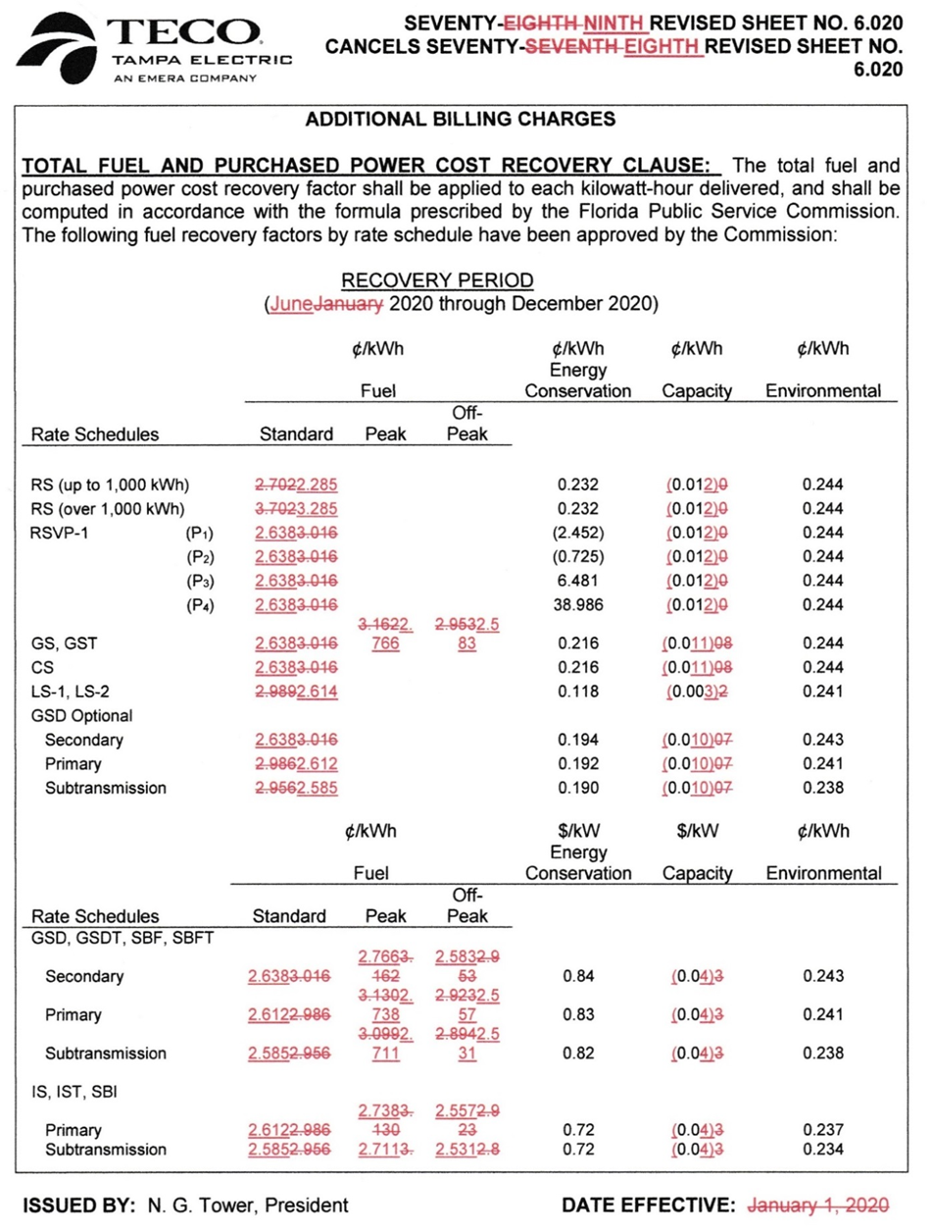
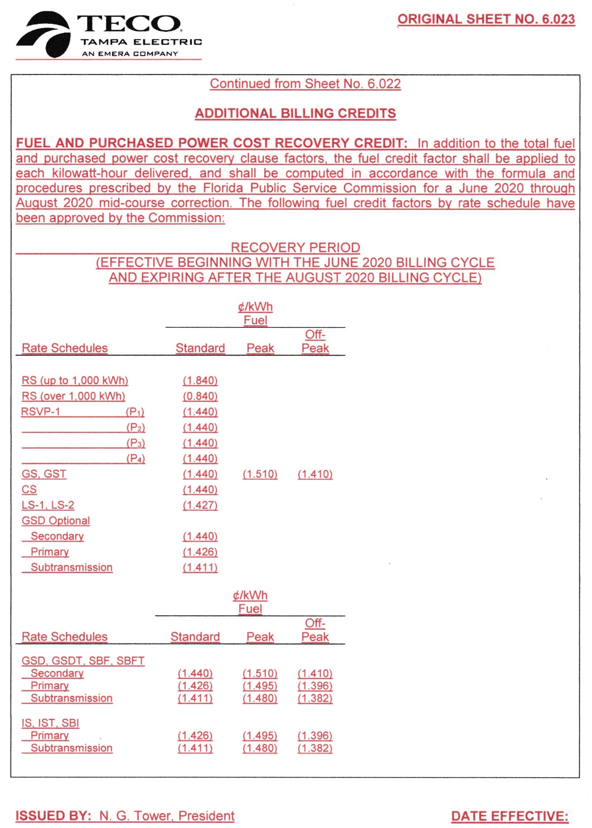
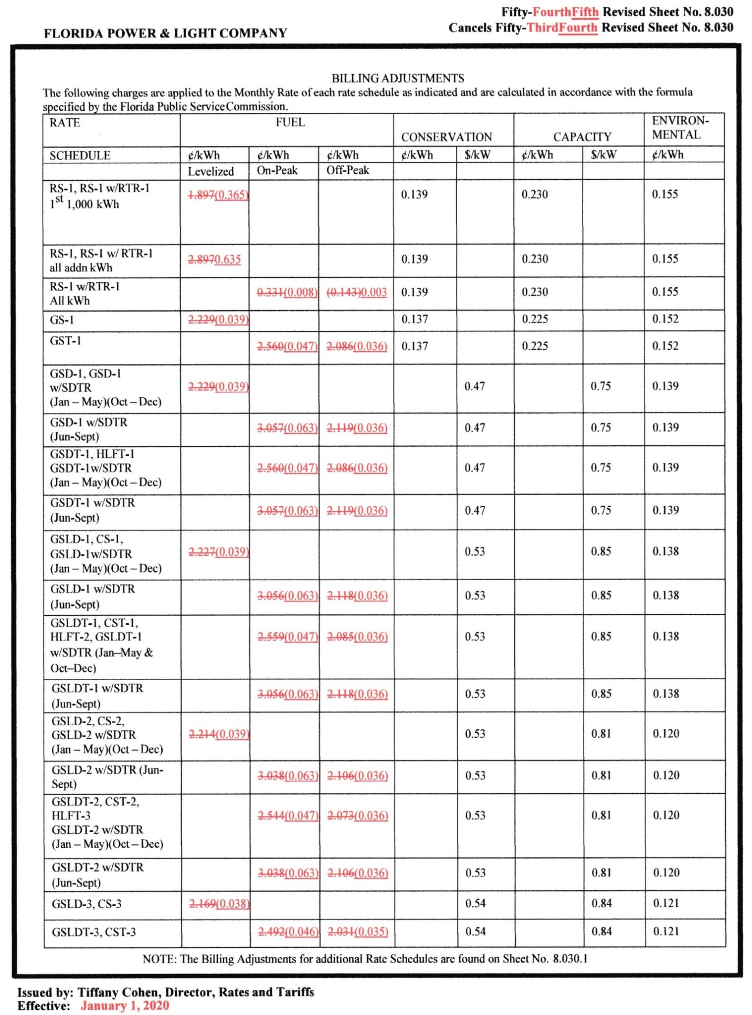

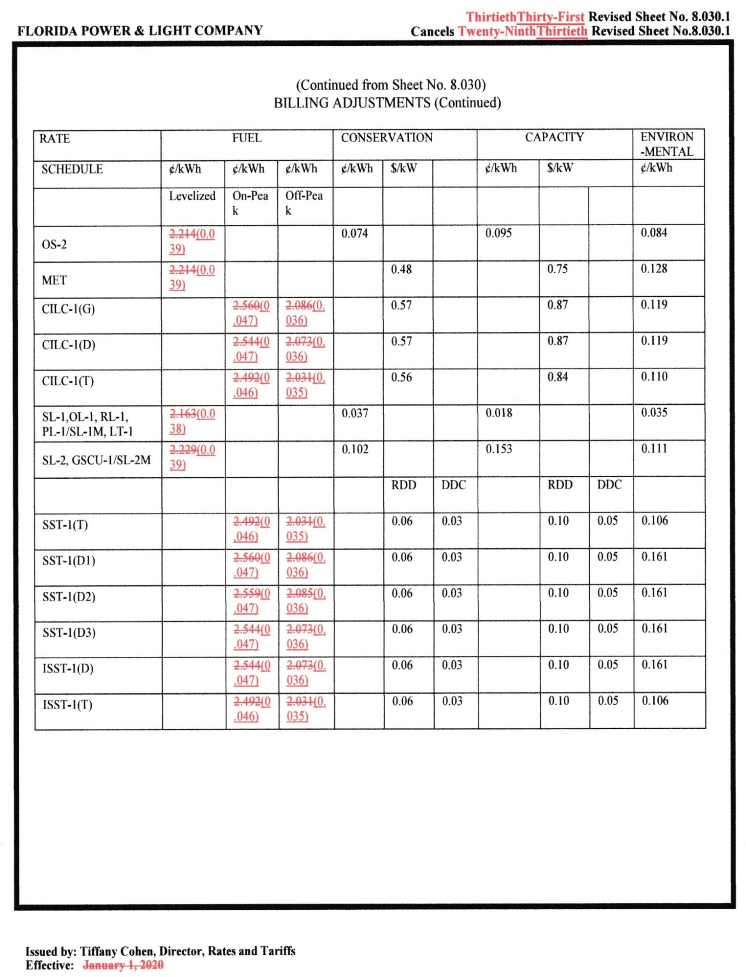

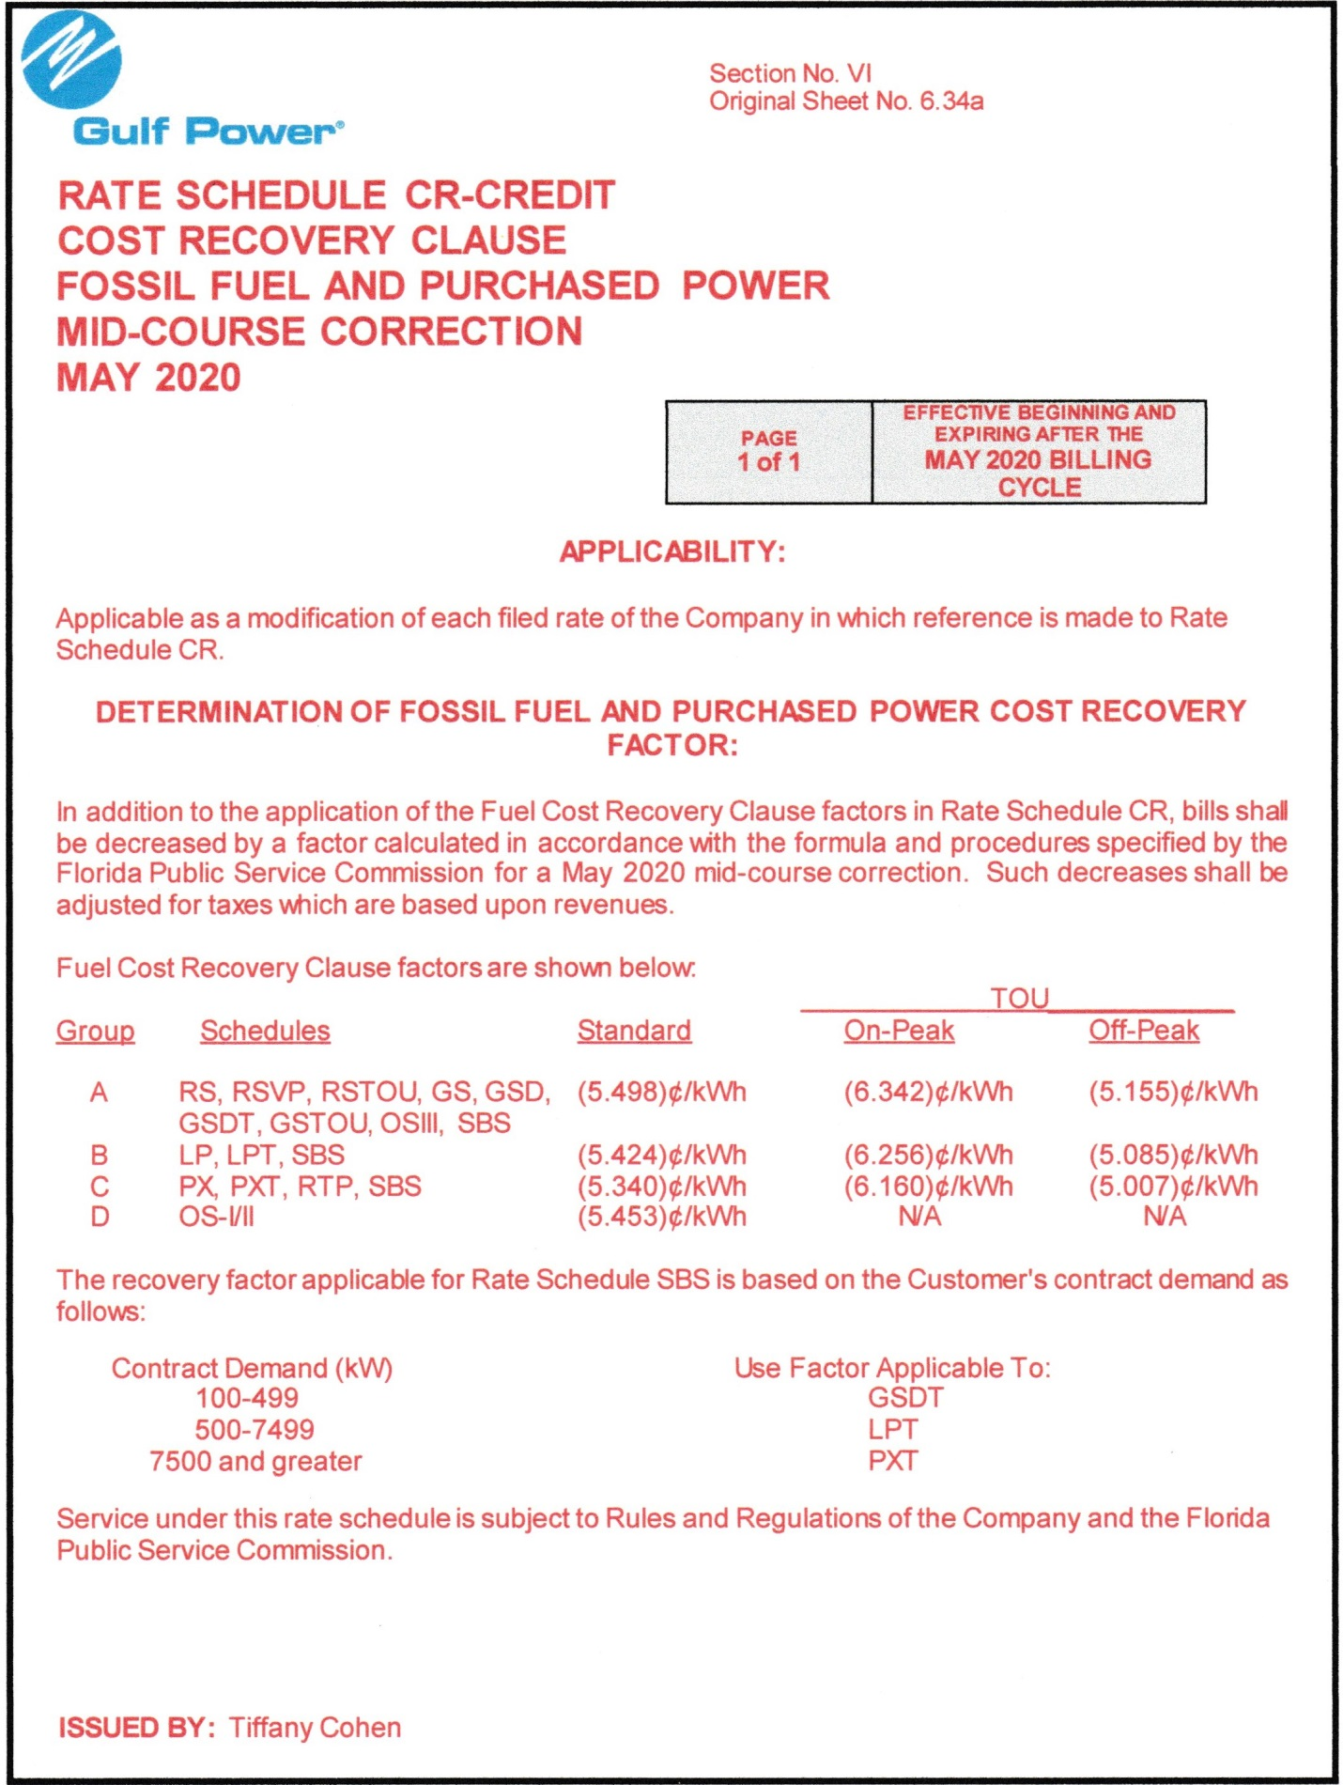
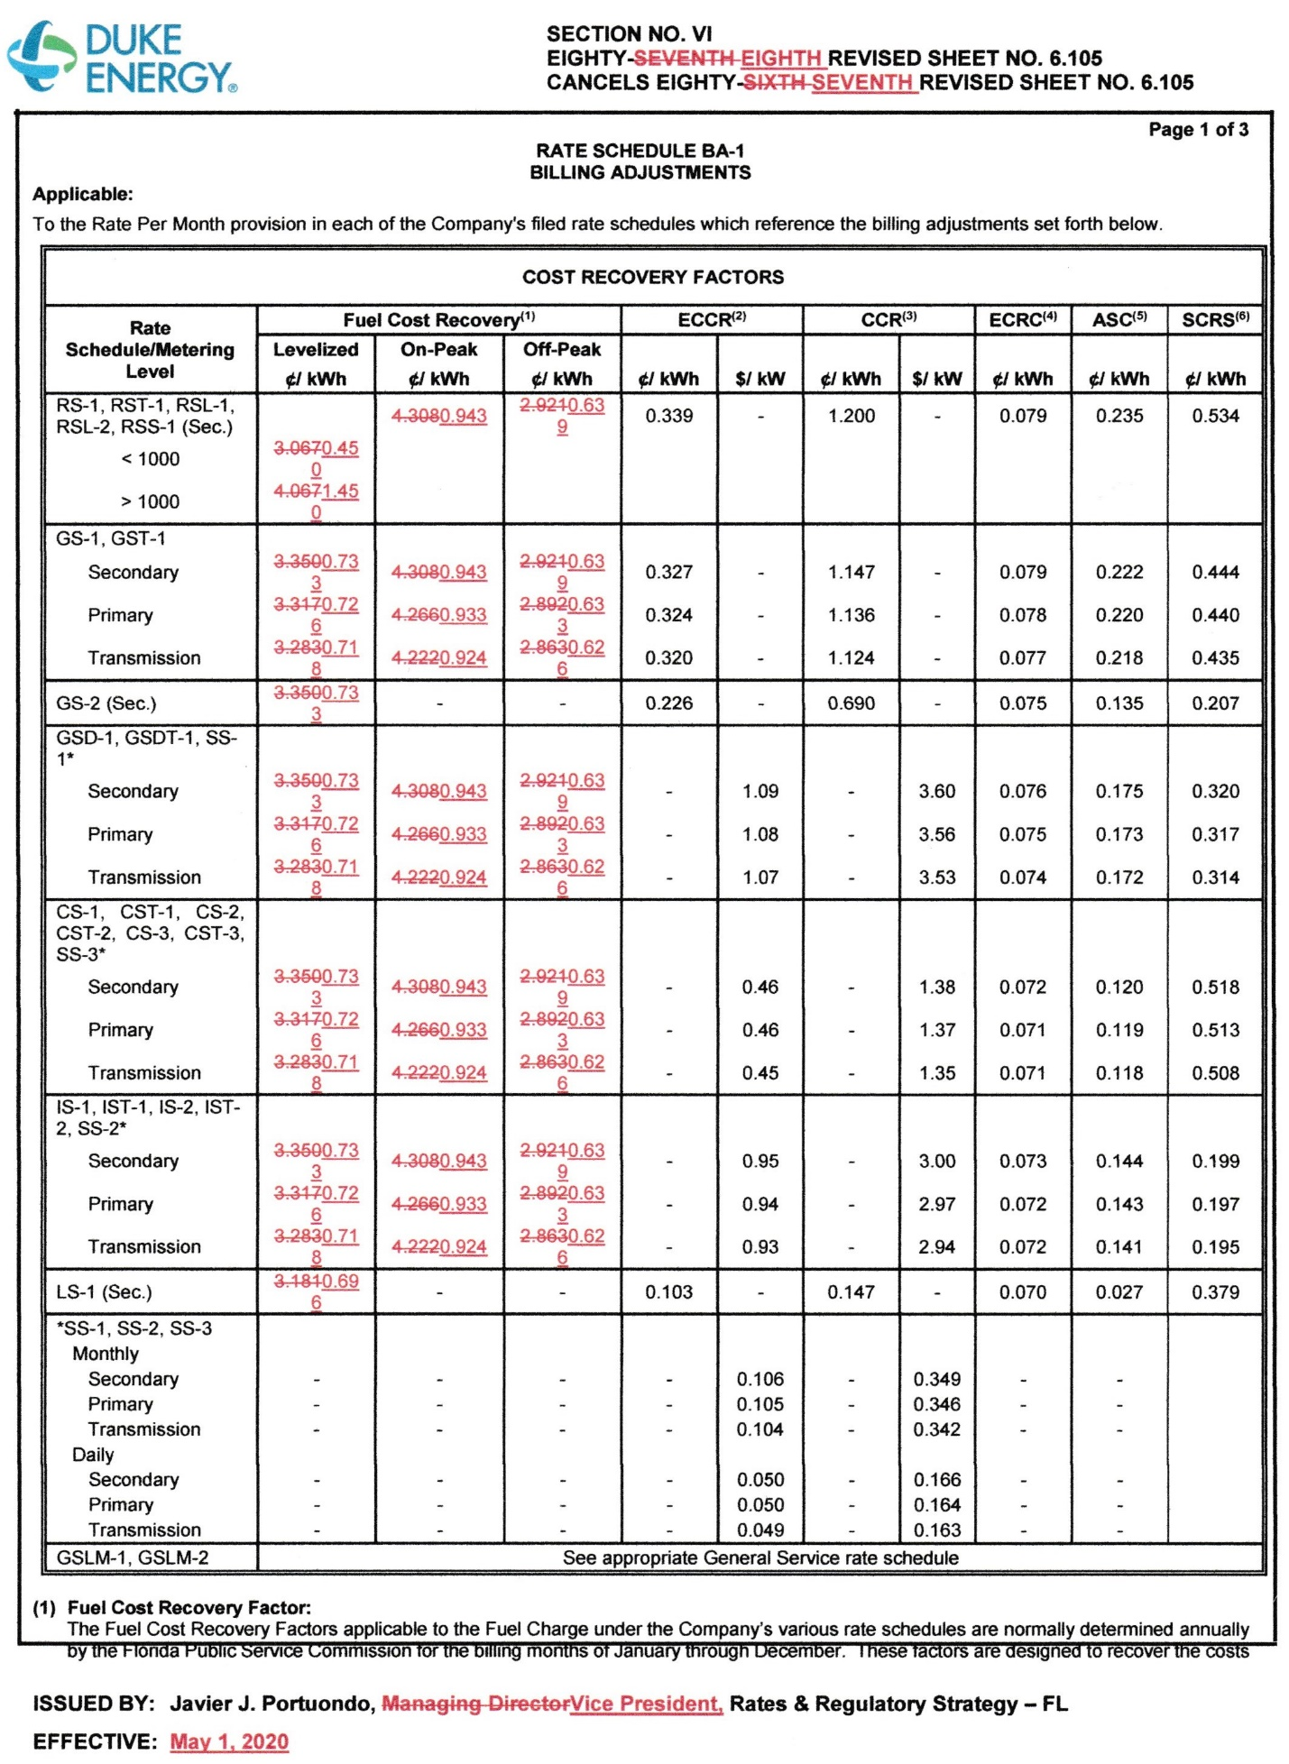

Order No. PSC-2019-0484-FOF-EI, issued November 18, 2019, in Docket No. 20190001-EI, In re: Fuel and purchased power cost recovery clause with generating performance incentive factor.
The spot price in this case is the current market price for natural gas that can be bought or sold for immediate delivery, quoted for Henry Hub. The historical prices reported herein were sourced from The U.S. Energy Information Administration, and can be located at: https://www.eia.gov/dnav/ng/hist/rngwhhdm.htm
The New York Mercantile Exchange is a commodity futures exchange owned and operated by CME Group of Chicago.
COVID-19 is a respiratory illness that can spread from person to person. For further information, please refer to The Florida Department of Health, at: http://www.floridahealth.gov/.
Document No. 01597-2020.
Document No. 01718-2020.
Document No. 01730-2020.
Document No. 01736-2020.
Order No. PSC-15-0161-PCO-EI, issued April 30, 2015, in Docket No. 150001-EI, In re: Fuel and purchased power cost recovery clause and generating performance incentive factor (rates reduced 15 days before billing cycle began.)
Gulf Power Company v. Florida Public Service Commission, 487 So. 2d. 1036, 1038 (Fla. 1986).
Order No. PSC-2019-0484-FOF-EI.
Document No. 01597-2020.
Order No. PSC-2019-0484-FOF-EI.
Order No. PSC-2019-0484-FOF-EI.
Order No. PSC-2019-0109-PCO-EI, issued March 22, 2019, in Docket 20190001-EI, In re: Fuel and purchased power cost recovery clause with generating performance incentive factor.
Order No. PSC-2019-0484-FOF-EI.
Id.
Document No. 01868-2020.
Order No. PSC-2019-0484-FOF-EI.
Id.
Document No. 01854-2020.
Order No. PSC-2019-0484-FOF-EI.
Order No. PSC-2019-0292-FOF-EI, Docket No. 20190072-EI, Issued July 22, 2019, In re: Petition for a limited proceeding to approve second solar base rate adjustment, by Duke Energy Florida, LLC.
Document No. 01736-2020.
Document No. 01828-2020.
Order No. PSC-2019-0292-FOF-EI.
Document No. 01828-2020.

