State of Florida |  | Public Service Commission  Capital Circle Office Center ● 2540 Shumard Oak Boulevard  Tallahassee, Florida 32399-0850  -M-E-M-O-R-A-N-D-U-M-
DATE: | June 24, 2020
TO: | Office of Commission Clerk (Teitzman)
FROM: | Division of Economics (Guffey)  Office of the General Counsel (Stiller)
RE: | Docket No. 20200138-EU – Joint petition for approval of territorial agreement in Sumter County, by Sumter Electric Cooperative, Inc. and City of Bushnell.
AGENDA: | 07/07/20 – Regular Agenda – Proposed Agency Action -- Interested Persons May Participate
COMMISSIONERS ASSIGNED: |  |  | All Commissioners
PREHEARING OFFICER: |  |  | Fay
CRITICAL DATES: |  |  | None
SPECIAL INSTRUCTIONS: |  |  | None

Case Background
On April 17, 2020, Sumter Electric Cooperative, Inc. (SECO) and the City of Bushnell (City or Bushnell) filed a joint petition seeking approval of a territorial agreement in Sumter County (2020 Territorial Agreement). The 2020 Territorial Agreement implements the terms of a 1981 Franchise Agreement, a 2017 Arbitration Award, and a 2019 Transfer Agreement between the utilities which transferred 623 customers and associated facilities from SECO to Bushnell. The 2020 Territorial Agreement and map depicting the new territorial boundaries are included in this recommendation as Attachment A.
In September 1981, the City and SECO entered into a Territorial Agreement (1981 Territorial Agreement) and an electric service franchise agreement (1981 Franchise Agreement) pursuant to which the City granted SECO an exclusive 30-year franchise to provide electric service to a portion of the City. The Commission approved the 1981 Territorial Agreement in 1982. In February 1999, the City and SECO amended the 1981 Territorial Agreement to establish new territorial boundary lines (1999 Territorial Agreement), which was approved by the Commission that same year. The 1999 Territorial Agreement expired on March 29, 2012. The termination of the 1981 Franchise Agreement coincided with the termination of the 1999 Territorial Agreement.
The 1981 Franchise Agreement contained an option for the City to purchase SECO’s electric utility assets located within the City limits at or after the expiration of the 30-year franchise. The parties explained that, prior to the expiration of the 1981 Franchise Agreement, they attempted to negotiate a new franchise agreement, a new territorial agreement, and Bushnell’s contractual right to purchase SECO facilities and customers per the 1981 Franchise Agreement. In early 2015, an impasse developed in the parties’ negotiations. In 2016, the City initiated arbitration before a panel of three retired Judges to determine the value of the electric assets within the City limits. The arbitrators rendered the final decision in 2017, which allowed the City to purchase the SECO system and transfer the customers, if it elected to do so. Subsequently, the parties negotiated and received City approval to transfer and purchase the SECO assets via the 2019 Transfer Agreement. As a result of the 2017 Arbitration Award, the 2019 Transfer Agreement, and the New Franchise Agreement, the joint petitioners negotiated the 2020 Territorial Agreement which delineates SECO’s and Bushnell’s respective service boundaries. Pursuant to Rule 25-6.0440(1)(f), Florida Administrative Code (F.A.C.), the petitioners provided a map identifying the geographical areas to be served by SECO and Bushnell (see map in Attachment A).
The 2020 Territorial Agreement establishes the new territorial boundaries reflecting the assets and customers transferred from SECO to Bushnell. During the review process, staff issued a data request to the joint petitioners to which responses were received on May 27, 2020. The Commission has jurisdiction over this matter pursuant to Section 366.04, Florida Statutes (F.S.).

Discussion of Issues

Issue 1:
Should the Commission approve the 2020 Territorial Agreement between SECO and Bushnell?

Recommendation:
Yes, the Commission should approve the 2020 Territorial Agreement between SECO and Bushnell. The approval of the 2020 Territorial Agreement will not be a detriment to the public interest and it will enable SECO and Bushnell to avoid duplication of facilities and serve their customers in an efficient manner. SECO and Bushnell should be put on notice that any modification or termination of SECO and Bushnell’s territorial boundaries must first be made by the Commission. (Guffey, Stiller)

Staff Analysis:
Pursuant to Section 366.04(2)(d), F.S., and Rule 25-6.0440(2), F.A.C., the Commission has the jurisdiction to approve territorial agreements between and among rural electric cooperatives, municipal electric utilities, and other electric utilities. Unless the Commission determines that the agreement will cause a detriment to the public interest, the agreement should be approved.

The 2020 Territorial Agreement
SECO and Bushnell executed the 2020 Territorial Agreement on September 24, 2019, to replace the 1999 Territorial Agreement which expired in March 2012. Upon its approval by the Commission, and pursuant to Section 5.3, the 2020 Territorial Agreement will supersede the 1999 Territorial Agreement and all other prior agreements between the parties. Through the 2020 Territorial Agreement, the joint petitioners seek to gain operational efficiencies and customer service improvements in their respective retail service territories in Sumter County and eliminate circumstances leading to uneconomic duplication of service facilities and hazardous situations.
The 2020 Territorial Agreement will remain in effect for 30 years from the date the Commission issues its order approving the agreement in its entirety and it is no longer subject to judicial review. Pursuant to Section 6.1 of the 2020 Territorial Agreement, upon the expiration of the initial 30-year term, the agreement will automatically renew for successive one-year terms. Either party may terminate this agreement after the initial 30-year term, by providing no less than 12 months of prior written notification to the effective date of the termination in accordance with Section 8.3 of the 2020 Territorial Agreement. Pursuant to Article V of the 2020 Territorial Agreement, any modifications to this agreement will be submitted to the Commission for approval.

Customer and Facilities Transfer
The parties completed the transfer of facilities and customers from SECO to Bushnell in the fall of 2019. In response to staff’s data request, the parties state that 623 SECO customers and facilities were transferred to Bushnell at a cost of $5,874,030. According to the Arbitration Award, transfer value was based upon the new reproduction cost less depreciation method. The three-judge panel rejected the use of the income approach and the market approach, rejected the inclusion of stranded costs, and included a going concern value. Rule 25-6.0440(2)(a), F.A.C., provides that in approving territorial agreements, the Commission may consider the reasonableness of the purchase price of any facilities being transferred. The determination of the transfer value through arbitration in this instance appears reasonable to staff. The customer and facility transfers were finalized by the 2019 Transfer Agreement negotiated by the parties and approved by the Bushnell City Council. The Transfer Agreement provided timelines for Bushnell to construct facilities that were necessary to integrate SECO facilities, provided timelines for SECO to separate and integrate its system after the exchange/transfer, and provided for true-up amounts for any construction by SECO that would be subject to exchange but completed after the agreed valuation date of December 31, 2015.

Staff recognizes that the joint petitioners completed the transfer of facilities and customers prior to Commission approval of the 2020 Territorial Agreement pursuant to the provisions contained in the 1981 Franchise Agreement and the 2019 Transfer Agreement. However, Section 366.04(2)(d), F.S., provides that in the exercise of its jurisdiction, the Commission has power over electric utilities to approve territorial agreements between and among rural electric cooperatives, municipal electric utilities, and other electric utilities under its jurisdiction. The Commission has the exclusive and superior statutory jurisdiction to determine electric utility service areas. Board of County Commissioners Indian River County v. Graham, 191 So. 3d 890, 892 (Fla. 2016). Without the Commission’s active supervision over territorial agreements, such agreements between utilities run afoul of anticompetitive and antitrust law and “can have no validity without the approval of this Commission.” Order No. 3051, issued November 9, 1960, in Docket No. 6231-GU, In re. Territorial Agreement Between Peoples Gas Sys. and City Gas Co., at p. 1. As stated by the Florida Supreme Court in City of Homestead v. Beard, 600 So. 2d 450, 452 (Fla. 1992):

In City Gas Co. v. Peoples Gas System Inc., 182 So. 2d 429, 433 (Fla.1965), this Court held that territorial agreements between public utilities were not violative of antitrust law based on the premise that “the public welfare does not need Ch. 542 for protection against this kind of agreement....because the public interest is adequately protected by an alternative arrangement under F.S. Ch. 366, F.S.A.” We further concluded that the “agreement could result in monopolistic control over price, production, or quality of service only by the sufferance of the commission” and that its “statutory powers are more than sufficient to prevent any such outcome if properly employed.” Id. at 435. In Storey,[] which upheld the PSC's approval of the instant agreement, this Court “recognized the importance of the regulatory function as a substitute for unrestrained competition” and commented that “a regulated or measurably controlled monopoly is in the public interest.” 217 So. 2d at 307. Therefore, our decisions exempting territorial agreements from antitrust legislation have been premised on the existence of a statutory system of regulations governing the public utilities that is sufficient to prevent any abuses arising from the monopoly power created by the agreements.

SECO and Bushnell should be put on notice that any modification or termination of their territorial boundaries, as addressed by the Commission’s orders, must first be made by the Commission.

Customer Notification
Pursuant to Rule 25-6.0440(1)(d), F.A.C., in September 2019, SECO notified its 623 customers of their transfer to Bushnell and in August 2019, Bushnell informed the former SECO customers of the transfer and requirements. In response to staff’s data request, the joint petitioners provided a copy of Bushnell’s customer notification which states that if the customer has an existing account with the City for water, wastewater, or garbage collection, the electric service will be added to the same account; no additional deposit is required of those customers. If the transferred customer did not have an existing account with Bushnell for water, wastewater, or garbage collection, those customers were required to open a new utility account with Bushnell, with a deposit of $150 or an amount equivalent to two months average electric bill. The City holds the deposit until final settlement of the customer account, at which time the deposit will be applied towards the bill and any remaining balance will be refunded to the customer and account closed pursuant to the utility’s Seventh Revised Tariff Sheet No. 4.0.

Conclusion
After review of the petition and the 2020 Territorial Agreement, and evaluation of responses to staff’s data request, staff believes that the 2020 Territorial Agreement will not be a detriment to the public interest and will enable SECO and Bushnell to serve their current and future customers in an efficient manner. It appears that the agreement will eliminate any potential uneconomic duplication of facilities and will not cause a decrease in the reliability of electric service. As such, staff believes that the 2020 Territorial Agreement between SECO and Bushnell will not cause a detriment to the public interest. Upon approval, this agreement will supersede the prior territorial agreements between SECO and Bushnell.
Staff recommends that the 2020 Territorial Agreement between SECO and Bushnell be approved. Staff believes that the agreement will not be a detriment to the public interest and should become effective on the date the Commission order approving the 2020 Territorial Agreement becomes final. SECO and Bushnell should be put on notice that any modification or termination of their territorial boundaries, as addressed by the Commission’s orders, must first be made by the Commission.

Issue 2:
Should this docket be closed?

Recommendation:
If no protest is filed by a person whose substantial interests are affected within 21 days of the issuance of the Order, this docket should be closed upon the issuance of a Consummating Order. (Stiller)

Staff Analysis:
If no protest is filed by a person whose substantial interests are affected within 21 days of the issuance of the Order, this docket should be closed upon the issuance of a Consummating Order.

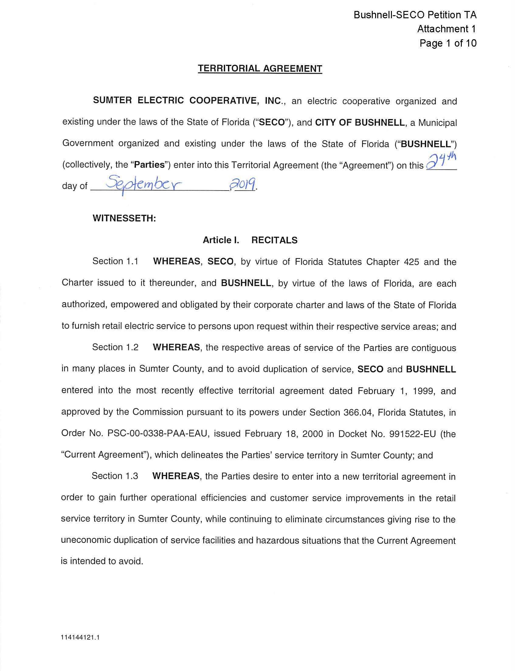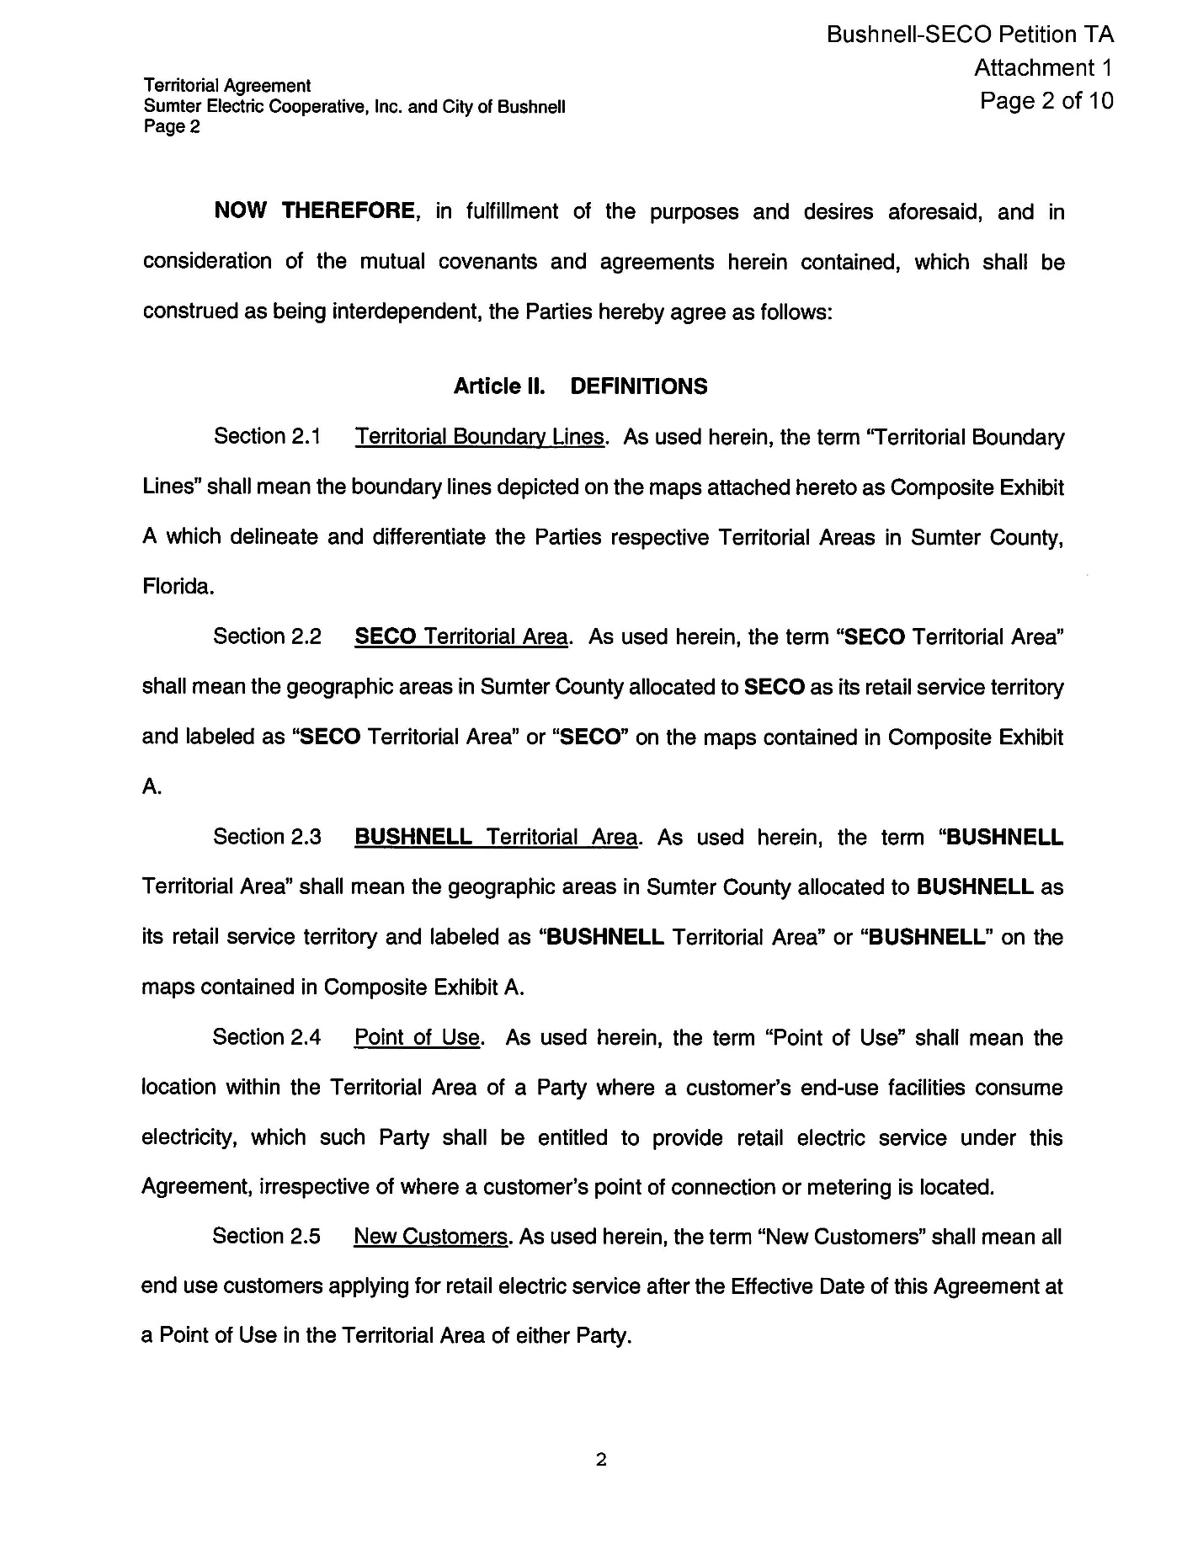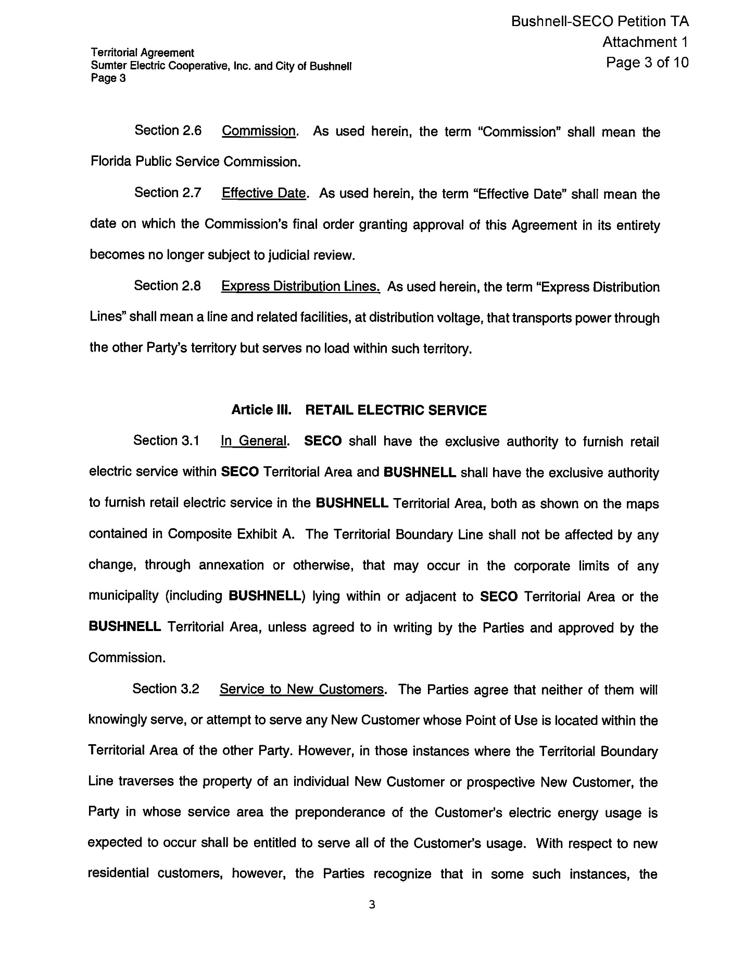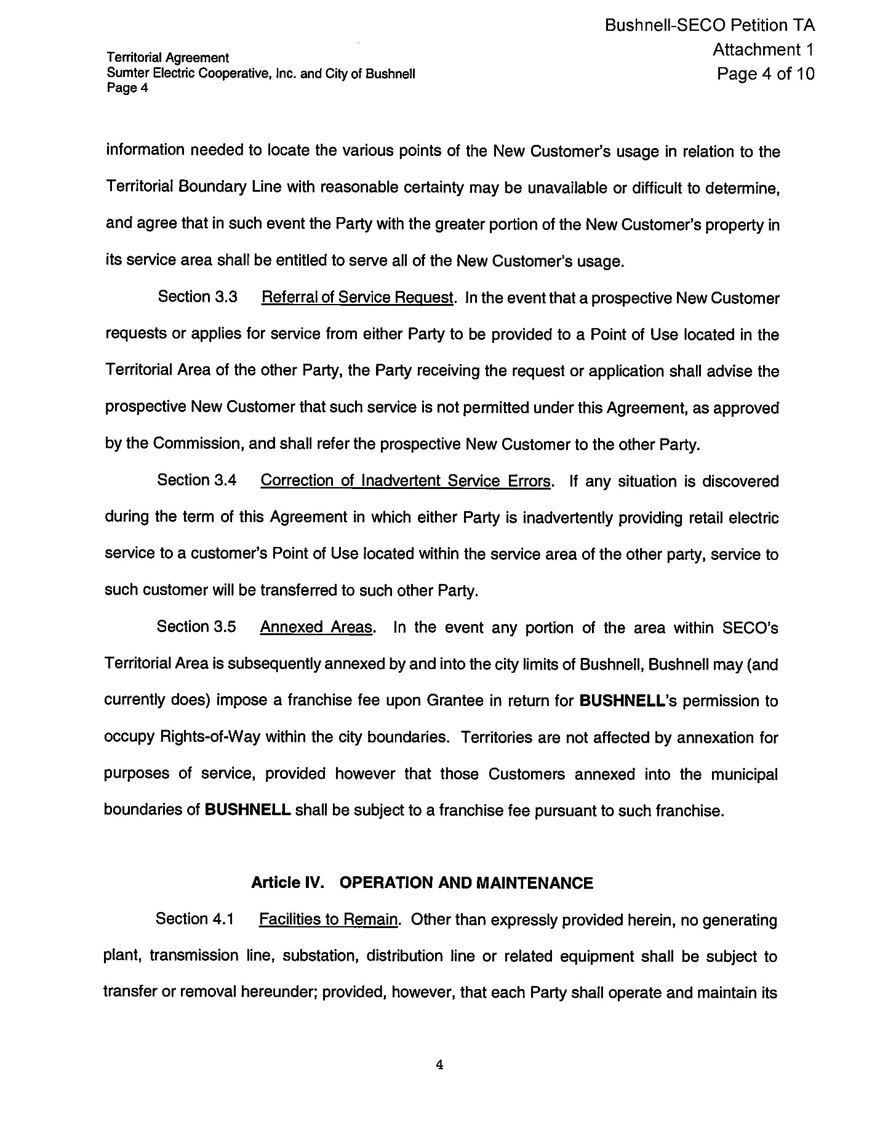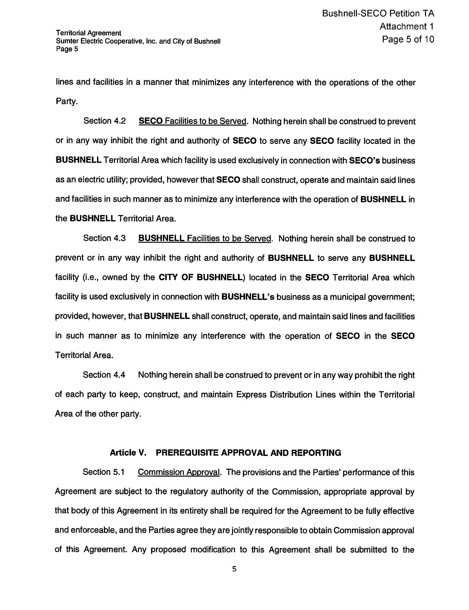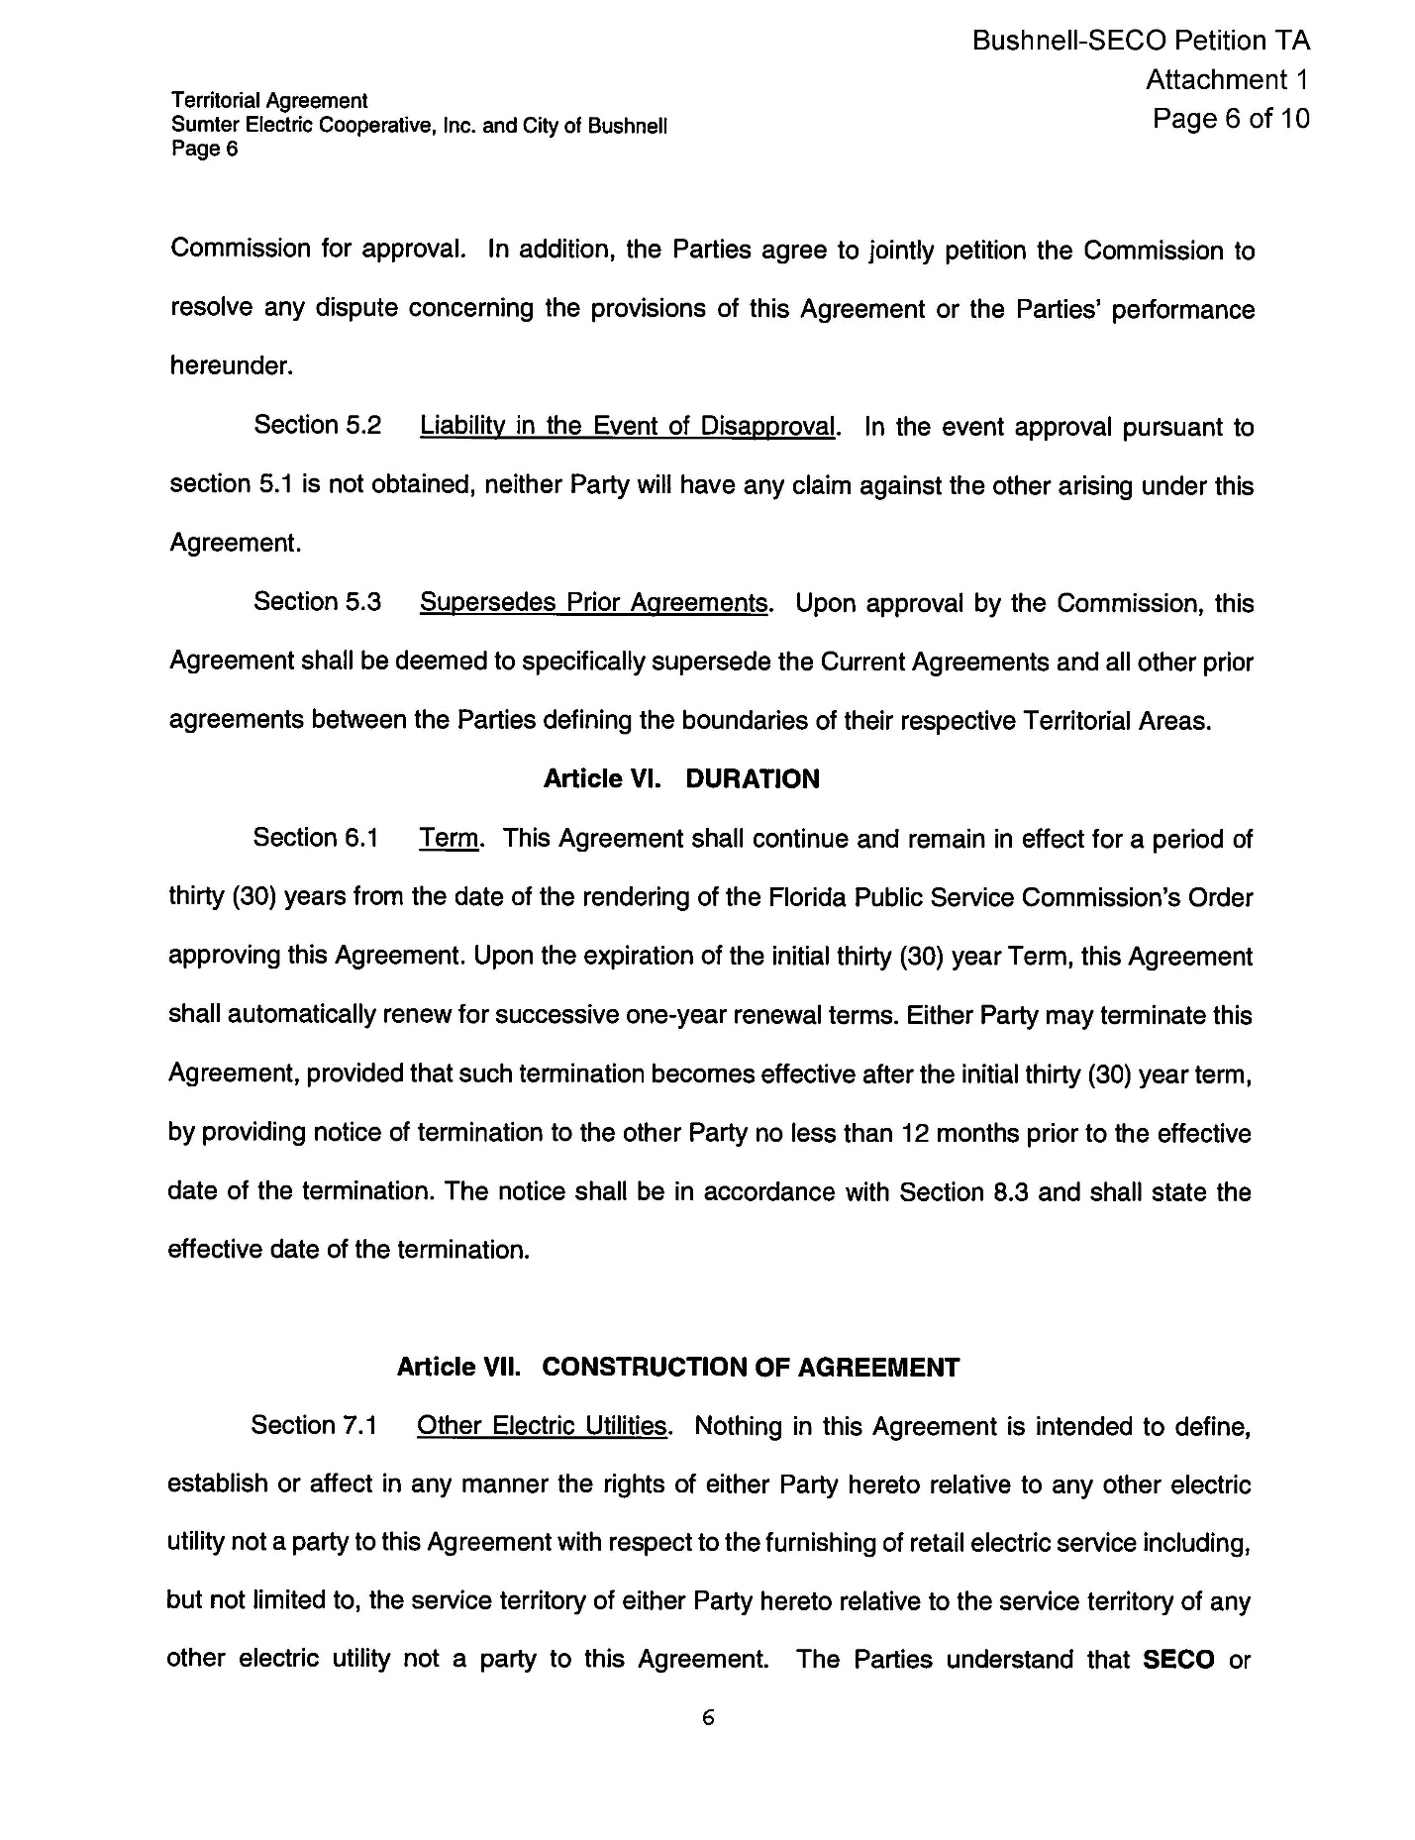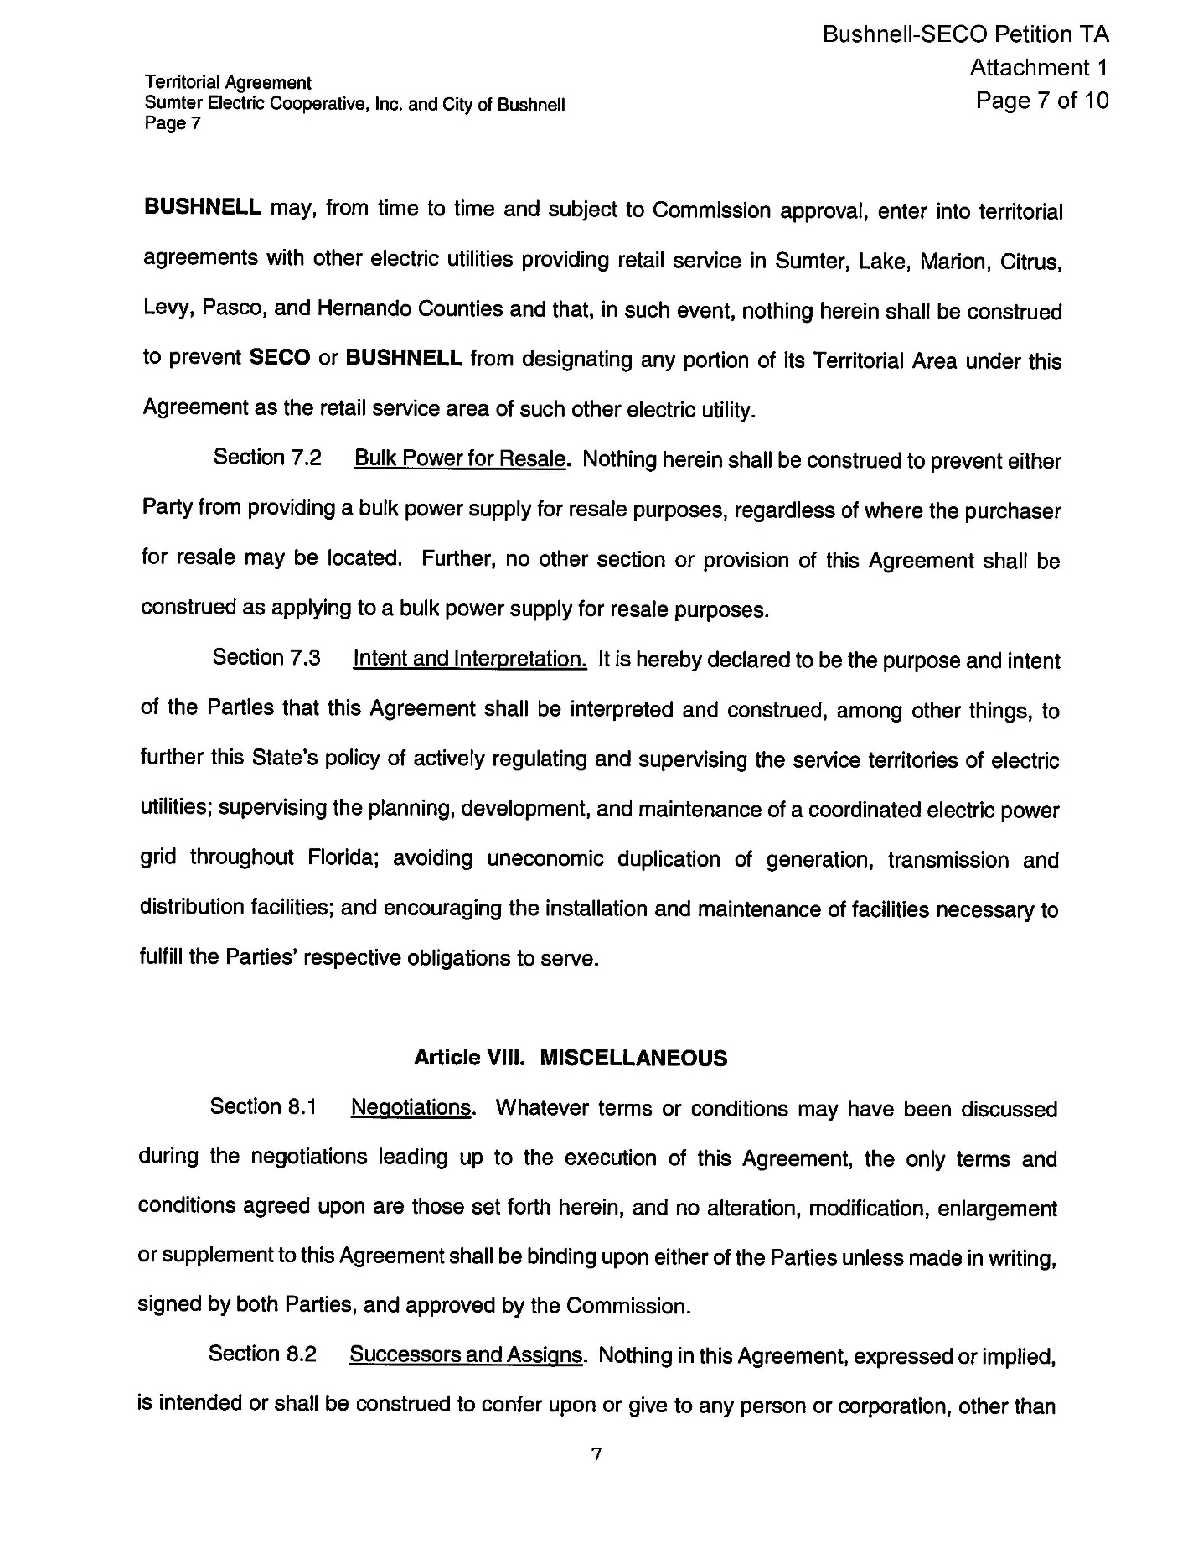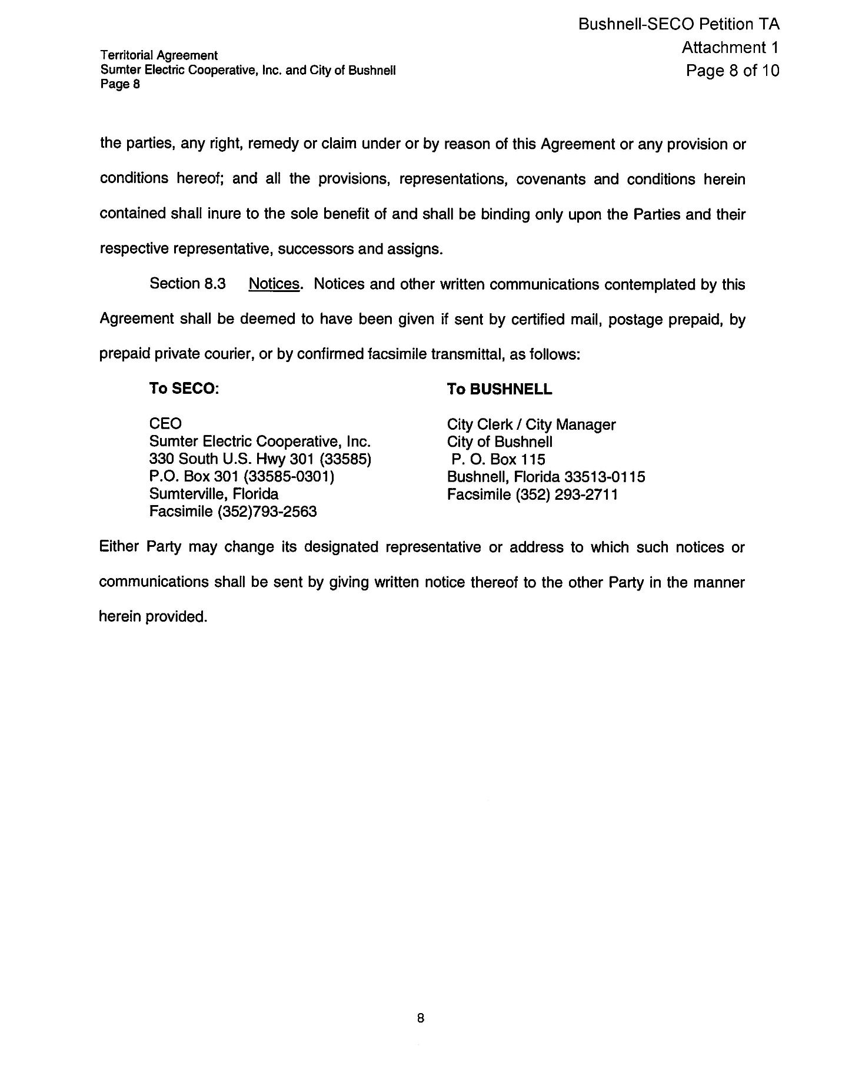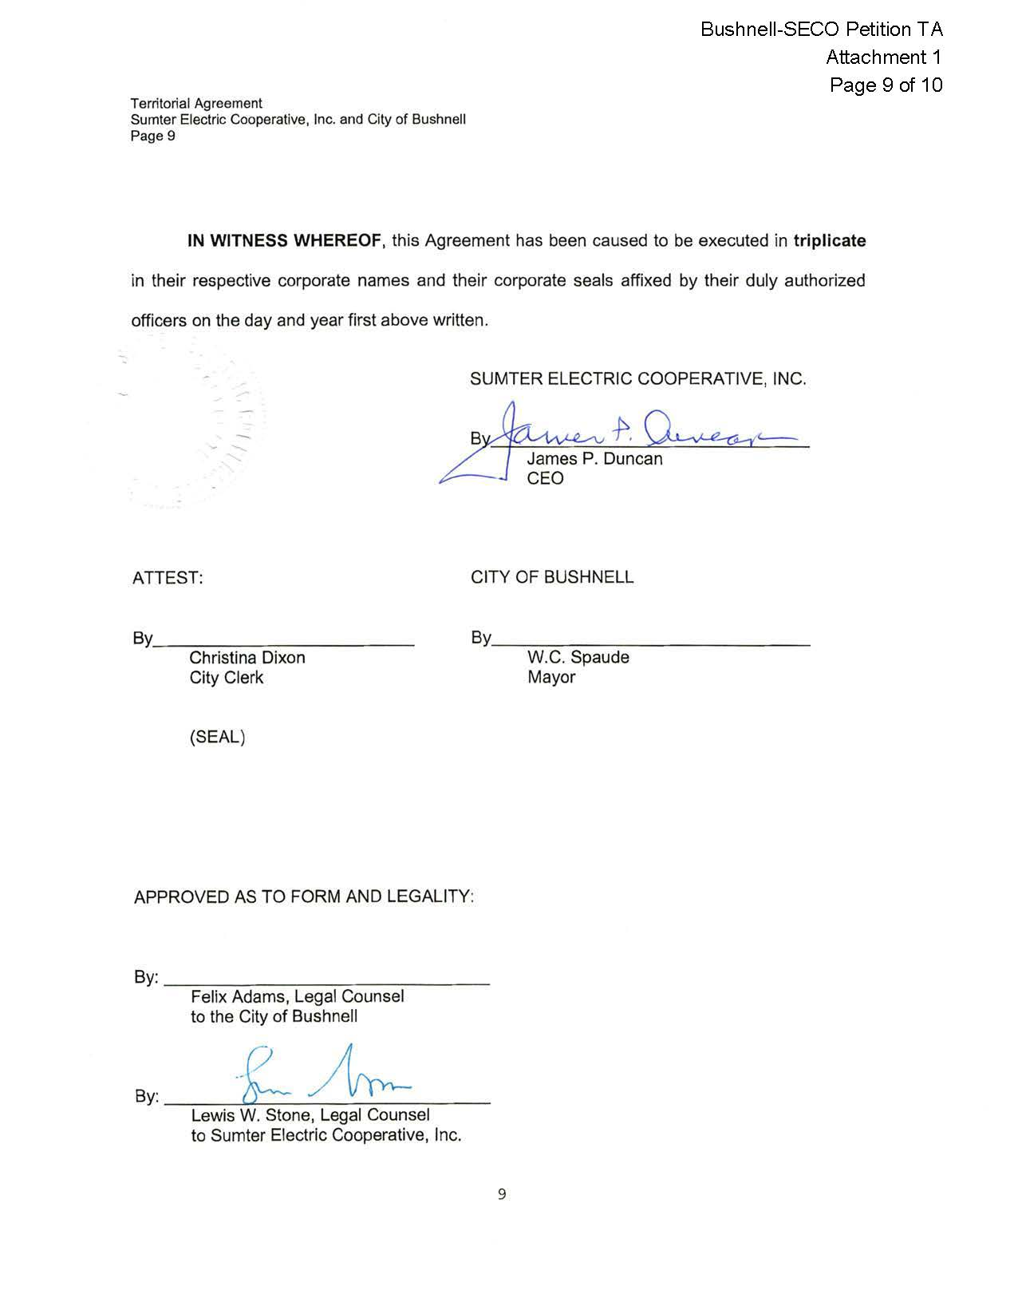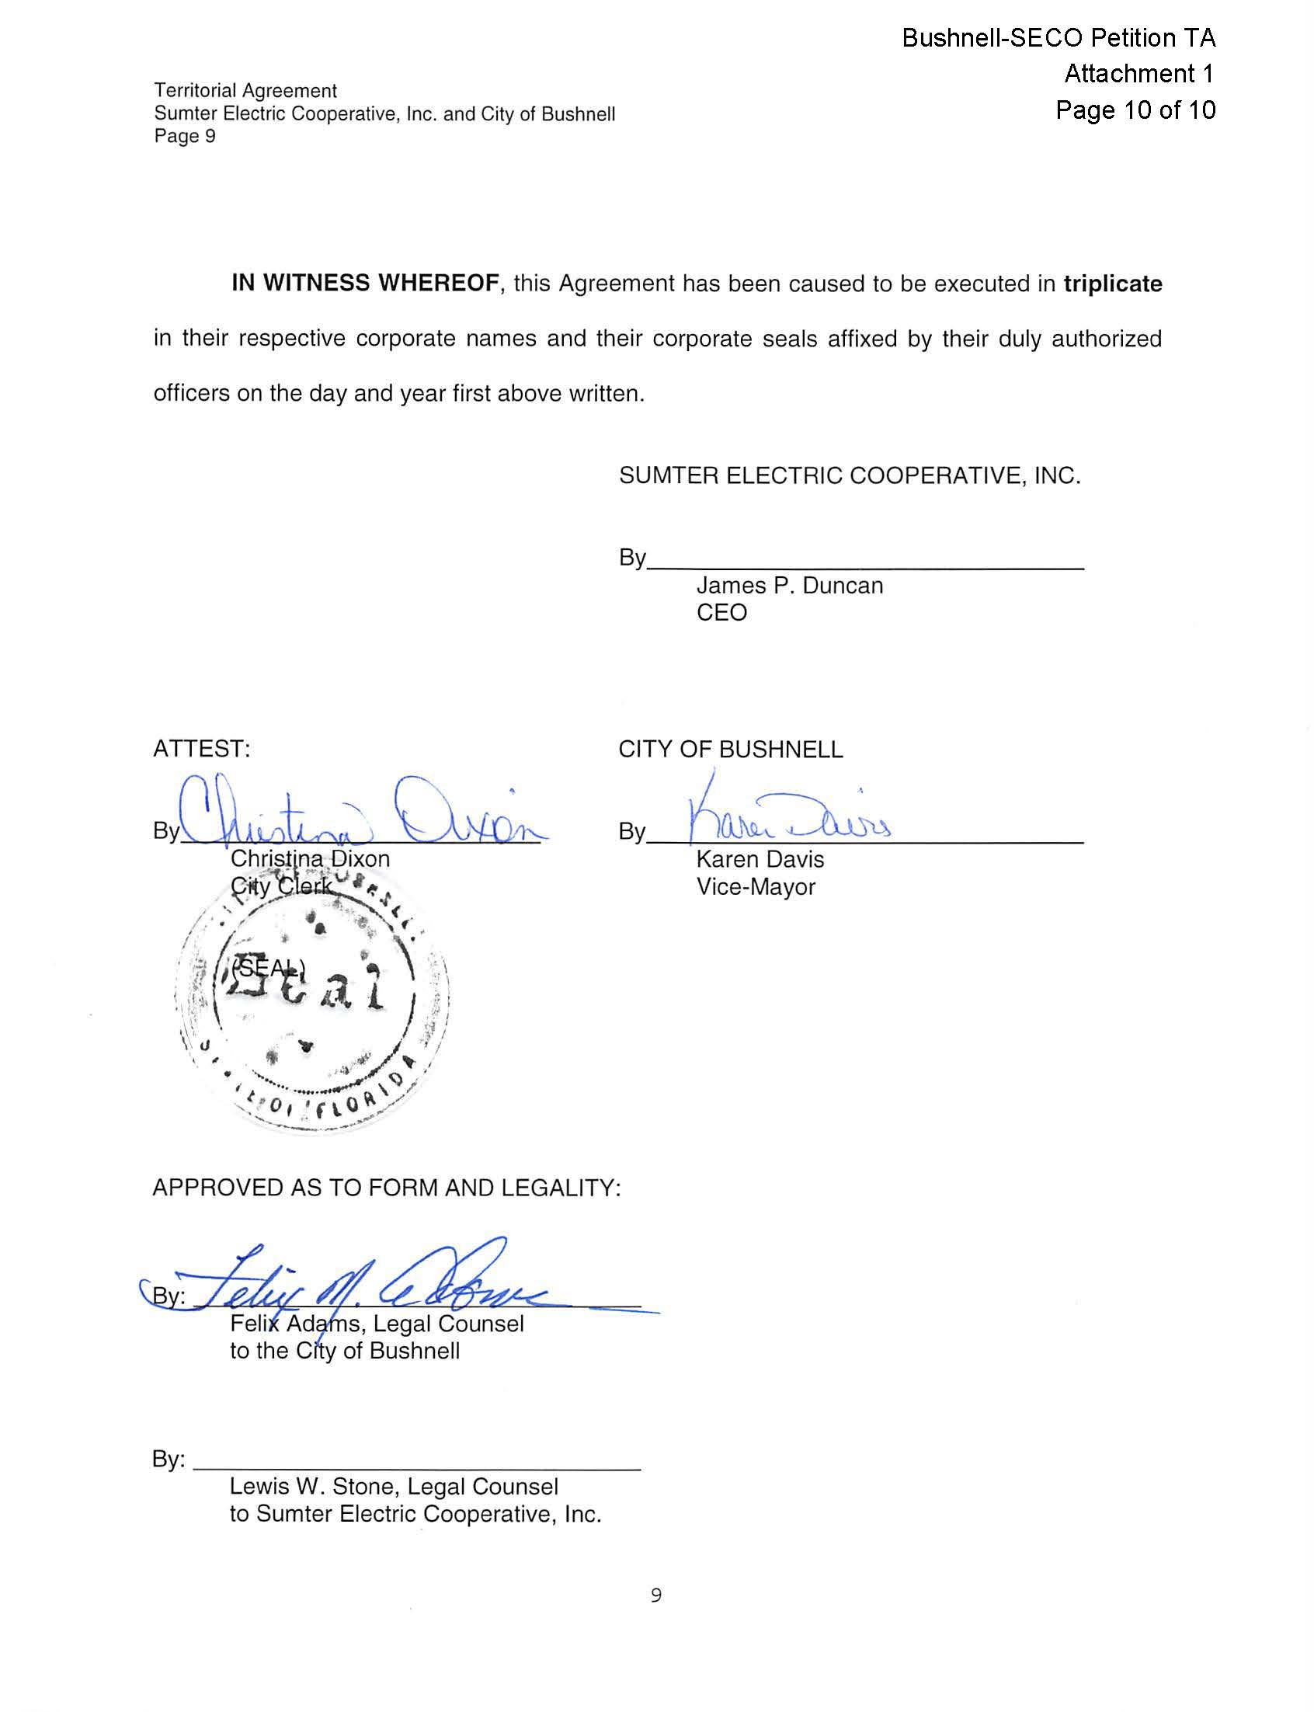

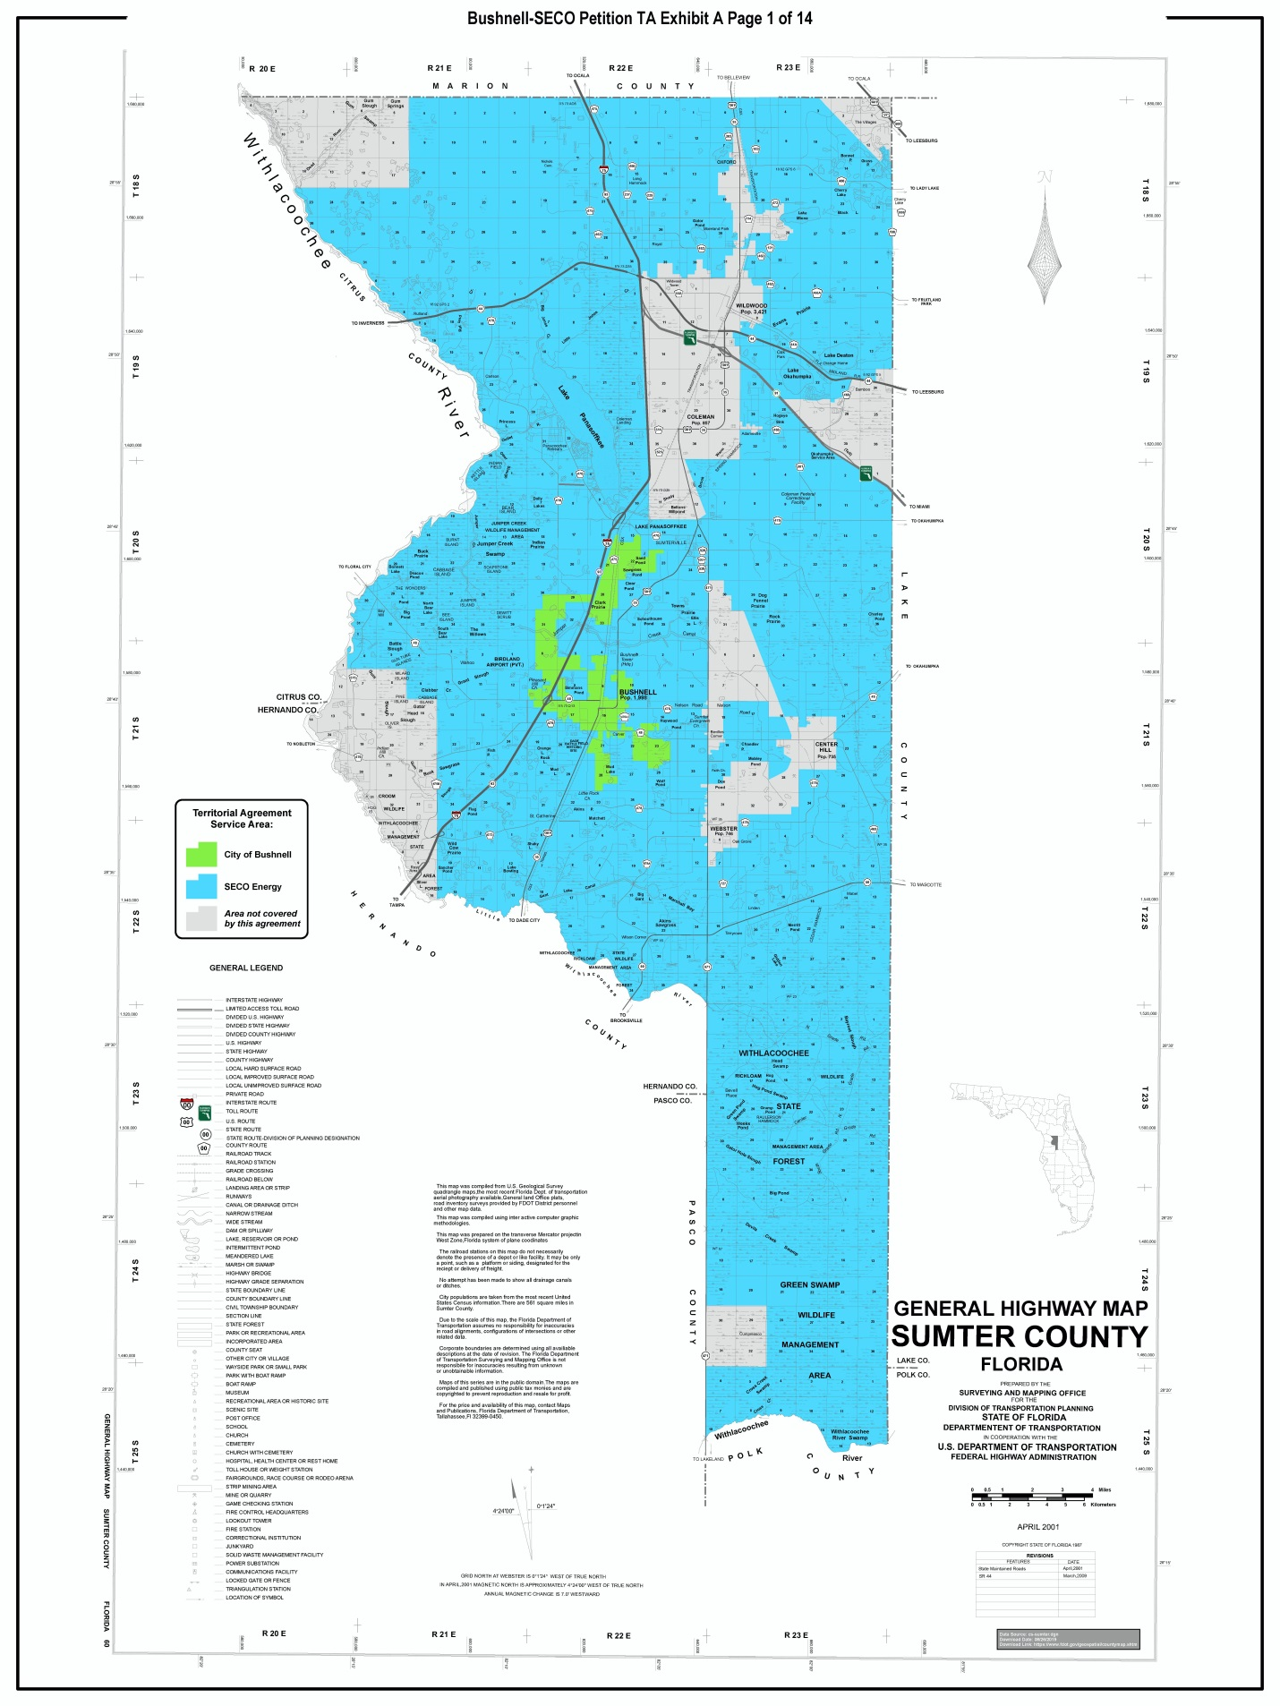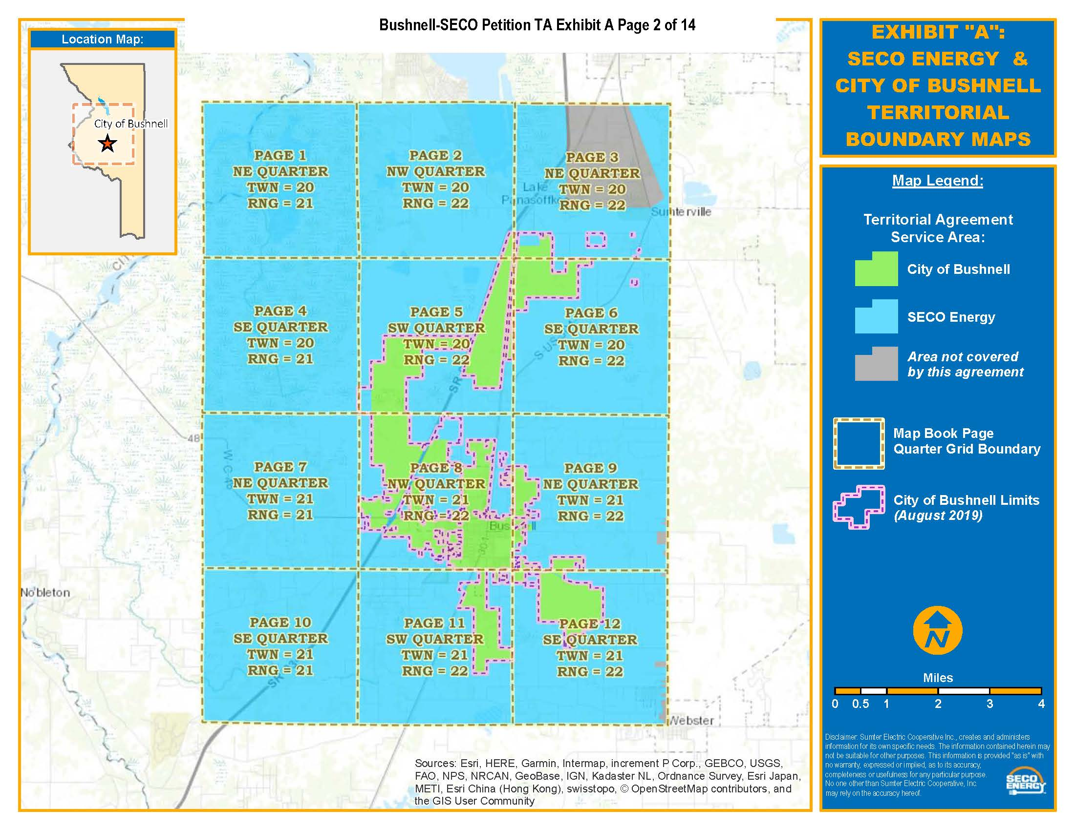

City of Bushnell Ordinance No. 81-13. Attachment No.1 in Joint Response 4 to staff’s data request (Document No. 02801-2020).
Order No. 10676, issued March 30, 1982, in Docket No. 810367-EU, In re: Joint Stipulation and Petition for Approval of Territorial Agreement between Sumter electric Cooperative, Inc. and the City of Bushnell.
Order No. PSC-00-0338-PAA-EU, issued February 18, 2000, in Docket No. 991522-EU, In re: Joint petition for approval of territorial agreement between City of Bushnell and Sumter Electric Cooperative, Inc.
Joint Response 1 to staff’s first data request (Document No. 02801-2020).
Utilities Commission of the City of New Smyrna Beach v. Florida Public Service Commission, 469 So. 2d 731 (Fla. 1985).
Joint Responses 2 and 6 to staff’s first data request (Document No. 02801-2020).
Joint Response 1 to staff’s first data request (Document No. 02801-2020).
See also Public Service Commission v. Fuller, 551 So. 2d 1210, 1212 (Fla. 1989); City Gas Co. v. Peoples Gas System, Inc., 182 So. 2d 429, 436 (Fla. 1965).
Storey v. Mayo, 217 So. 2d 304 (Fla.1968), cert. denied, 395 U.S. 909, 89 S.Ct. 1751, 23 L.Ed.2d 222 (1969).
Fuller, 551 So. 2d at 1212.

