State of Florida |  | Public Service Commission  Capital Circle Office Center ● 2540 Shumard Oak Boulevard  Tallahassee, Florida 32399-0850  -M-E-M-O-R-A-N-D-U-M-
DATE: | June 24, 2020
TO: | Office of Commission Clerk (Teitzman)
FROM: | Division of Economics (Hampson, Guffey)  Office of the General Counsel (Trierweiler)
RE: | Docket No. 20200106-EU – Joint petition to approve territorial agreement in Sumter, Lake, Marion, Levy, and Citrus Counties, by Sumter Electric Cooperative, Inc. and Duke Energy Florida, LLC.
AGENDA: | 07/07/20 – Regular Agenda – Proposed Agency Action – Interested Persons May Participate
COMMISSIONERS ASSIGNED: |  |  | All Commissioners
PREHEARING OFFICER: |  |  | Fay
CRITICAL DATES: |  |  | None
SPECIAL INSTRUCTIONS: |  |  | None

Case Background
On March 27, 2020, Sumter Electric Cooperative, Inc. (SECO) and Duke Energy Florida, LLC (DEF), collectively the joint petitioners, filed a petition seeking Commission approval of a Territorial Agreement (Agreement) delineating their respective service boundaries in Sumter, Lake, Marion, Levy, and Citrus counties. The proposed Agreement is shown in Attachment A and composite maps depicting the proposed service territories in Sumter, Lake, Marion, Levy, and Citrus counties are shown in Attachment B to this recommendation. The detailed, complete set of maps delineating the service territories and the written descriptions are contained in the joint petition as Exhibits A and B, respectively. Due to their voluminous nature, the detailed maps and written descriptions are not attached to this recommendation.

In April 2009, the Commission approved the current territorial agreement by Order No. PSC-09-0276-PAA-EU. In the instant docket, the joint petitioners seek to gain further operational efficiencies and customer improvements in their respective retail service territories by requesting to replace the current territorial agreement with an amended Agreement dated March 27, 2020. The proposed Agreement includes the transfer of 546 DEF customers to SECO and 49 SECO customers to DEF.

During the review of this joint petition, staff issued one data request to the joint petitioners on April 21, 2020, for which responses were received on May 5, 2020. The Commission has jurisdiction over this matter pursuant to Section 366.04, Florida Statutes (F.S.).

Discussion of Issues

Issue 1:
Should the Commission approve the proposed Territorial Agreement between SECO and DEF in Sumter, Lake, Marion, Levy, and Citrus counties?

Recommendation:
Yes, the Commission should approve the proposed Territorial Agreement between SECO and DEF in Sumter, Lake, Marion, Levy, and Citrus counties. The proposed Territorial Agreement will not cause a detriment to the public interest and will enable SECO and DEF to avoid duplication of facilities and to serve their customers in an efficient manner. (Hampson, Guffey)

Staff Analysis:
Pursuant to Section 366.04(2)(d), F.S., and Rule 25-6.0440, Florida Administrative Code (F.A.C.), the Commission has the jurisdiction to approve territorial agreements between and among rural electric cooperatives, municipal electric utilities, and other electric utilities. Unless the Commission determines that the agreement will cause a detriment to the public interest, the agreement should be approved.

Proposed 2020 Territorial Agreement
The joint petitioners stated they have agreed to replace the current territorial agreement with the proposed Agreement executed on March 27, 2020. The intent of the proposed Agreement is to further prevent duplication of facilities, correct encroachments, and have one service provider in residential developments when feasible. The joint petitioners stated that avoiding duplication of services enhances aesthetics, safety and reliability, and reduces restoration times and safety concerns during storm events. As such, the joint petitioners believe that these changes will allow for further operational efficiencies and customer service improvements in their respective retail service territories in Sumter, Lake, Marion, Levy, and Citrus counties.

Pursuant to Section 6.1 of the proposed Agreement, the term of the Agreement is 20 years from the effective date. After the expiration of the first 20-year term, the Agreement will remain in effect unless either party provides written notice of termination at least 12 months prior to the termination of the agreement. The effective date of the Agreement would be the date on which the Commission issues a final order granting approval of this proposed Agreement in its entirety and it is no longer subject to judicial review. In addition, any modification to the proposed Agreement would be submitted to the Commission for approval.

Customer and Asset Transfer
Paragraph 5 of the petition states that 546 DEF customers (443 residential and 103 commercial) will be transferred to SECO; and 49 SECO customers (20 residential, 28 commercial, and 1 industrial) will be transferred to DEF. In response to staff’s first data request, the joint petitioners stated that 379 of the residential accounts to be transferred from DEF to SECO are in an apartment complex and are expected to be transferred in the first year after the Agreement is approved by the Commission. SECO intends to transfer all other remaining customers within three years and DEF will transfer the 49 customers in six phases within 36 months. Pursuant to Sections 3.1 and 3.5 of the proposed Agreement, the joint petitioners will file, annually in March, a written report with the Commission on the status of the transfer of customers.

The joint petitioners agree that no lost revenue or going concern value shall be paid for the transfer of customers. Upon the transfer of customers between the utilities, the receiving utility may elect to purchase the facilities of the transferring utility that relate to providing electric service to the impacted customers. If service facilities are transferred, the proposed Territorial Agreement contains provisions for the value of the facilities based upon the replacement cost (new), less depreciation. The joint petitioners intend to undertake a valuation process of facilities using a common engineering cost estimation methodology such as the Handy-Whitman Index. The joint petitioners stated that valuing the facilities is time-consuming and often takes at least one year to complete. If there are facilities of one utility located in the service area of the other utility which are not subject to transfer or removal as a result of the proposed agreement, those facilities shall be operated and maintained in such a manner as to minimize any interference with the operations of the other utility.

Customer Notification
Pursuant to Rule 25-6.0440(1)(d), F.A.C., both SECO and DEF provided written notification to customers that will be transferred pursuant to the proposed Territorial Agreement. These letters included sample rate comparisons between SECO and DEF, as well as information regarding refunds of deposits. As of February 2020, the rate comparison for customers using 1,000 kilowatt-hours was $123.99 for DEF and $119.89 for SECO. The customer notifications are included as Exhibit E to the joint petition.

The joint petition stated that two SECO customers object to being transferred to DEF and that these customers communicated to the joint petitioners that they would contact the Commission directly after the petition was filed. As of the filing of the recommendation, the Commission received correspondence from one SECO customer objecting to the transfer to DEF. Based on information provided by neighbors, the SECO customer expressed concerns about DEF’s vegetation management practices and the poor maintenance of overhead facilities. The customer included pictures of DEF power lines in trees. The customer also stated that they currently have an underground service drop, that they paid for, and do not wish additional overhead poles to receive power. Staff inquired in its data request regarding DEF’s tree trimming practices in the area identified by the customer. The joint response stated that the overhead facilities identified by the customer are owned by DEF and that the facilities are scheduled for trimming in the second quarter of 2020. In addition, DEF confirmed the customer, when transferred, would continue to be served through their current underground service drop. Staff provided a written response to the customer and filed a copy in the instant docket.

Conclusion
The joint petitioners state that they have worked collaboratively to structure the proposed amendments to their territorial agreement and that it furthers the goals of avoiding duplication of service and enables each to achieve operational efficiency. After review of the joint petition, the proposed Territorial Agreement, and the petitioners’ joint responses to staff’s data request, staff believes the amended Territorial Agreement will not cause a detriment to the public interest, will eliminate any potential uneconomic duplication of facilities and will not cause a decrease in reliability of electric service to the customer.
Staff recommends that the Commission approve the proposed Territorial Agreement between SECO and DEF in Sumter, Lake, Marion, Levy, and Citrus counties. The proposed Territorial Agreement will not cause a detriment to the public interest and will enable SECO and DEF to avoid duplication of facilities and to serve their customers in an efficient manner.

Issue 2:

Should this docket be closed?

Recommendation:
If no protest is filed by a person whose substantial interests are affected within 21 days of the issuance of the Order, this docket should be closed upon the issuance of the Consummating Order. (Trierweiler)

Staff Analysis:
If no protest is filed by a person whose substantial interests are affected within 21 days of the issuance of the Order, this docket should be closed upon the issuance of the Consummating Order.
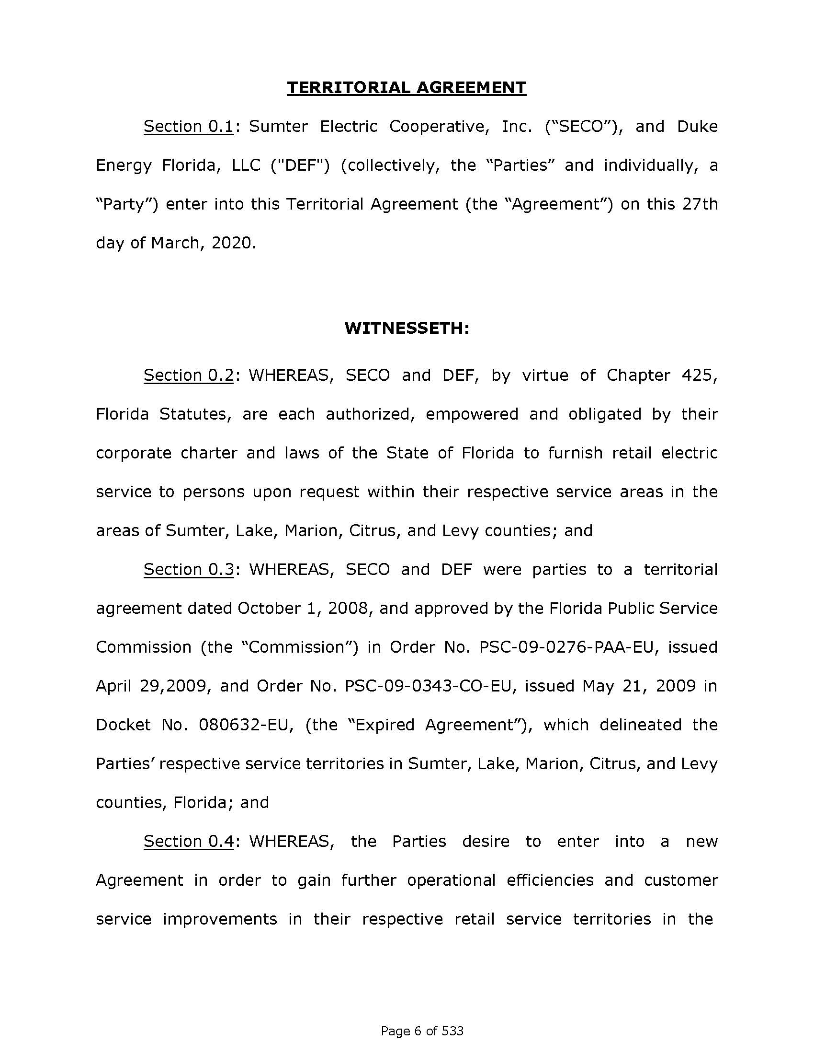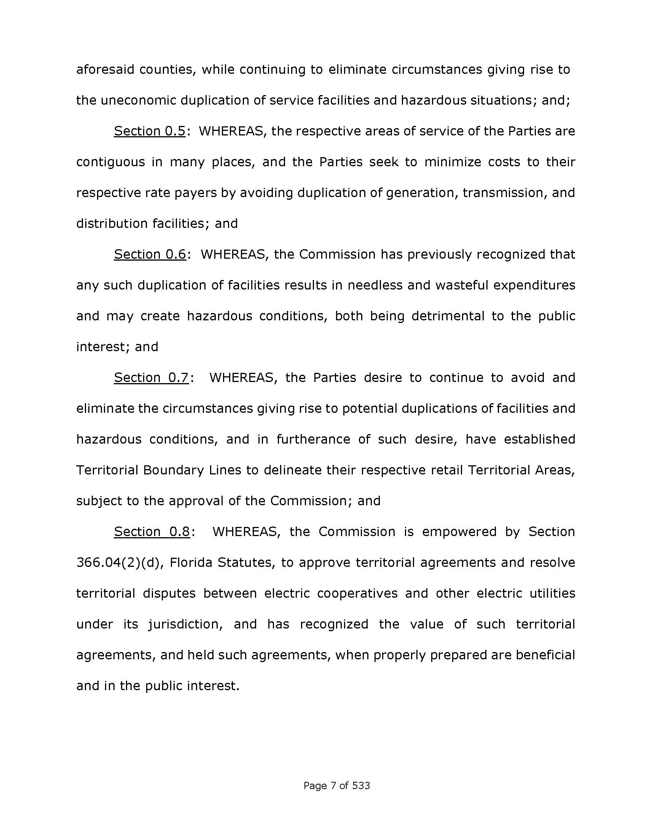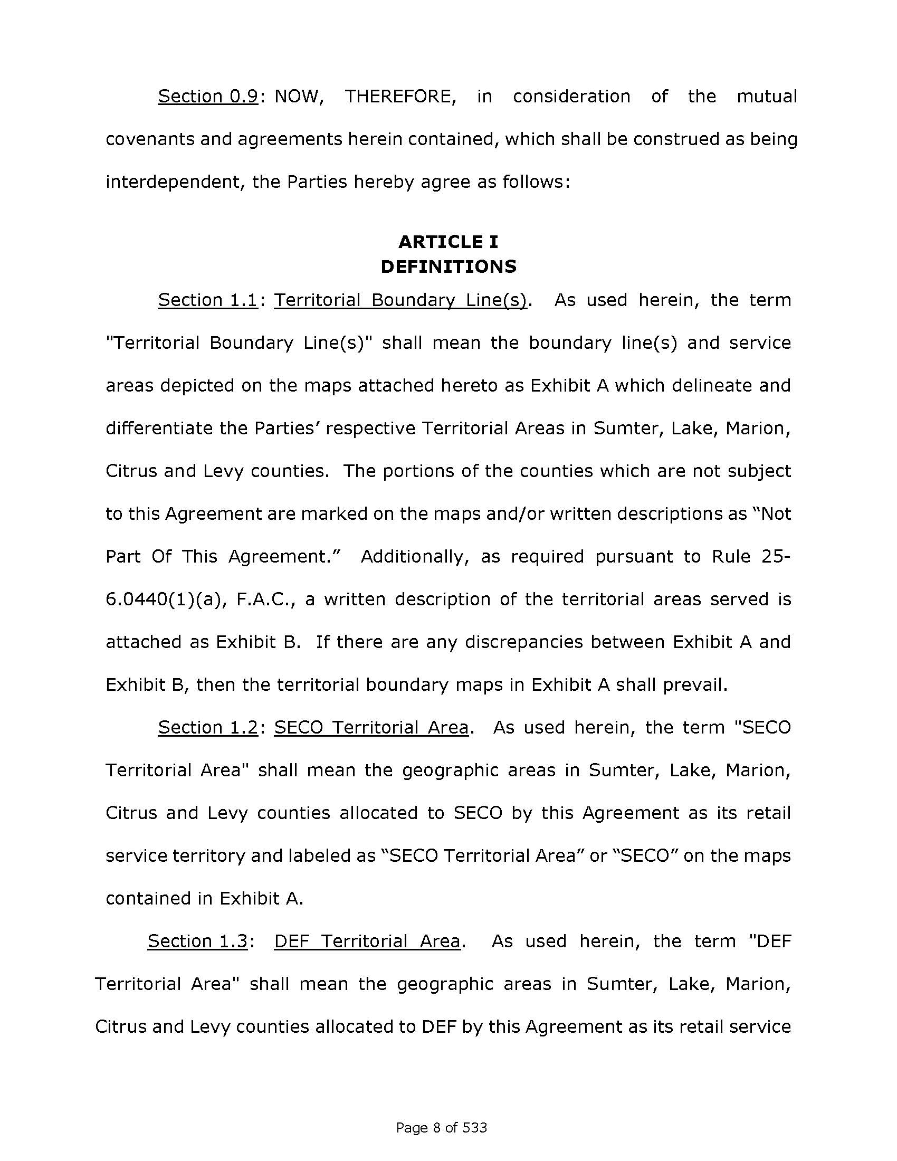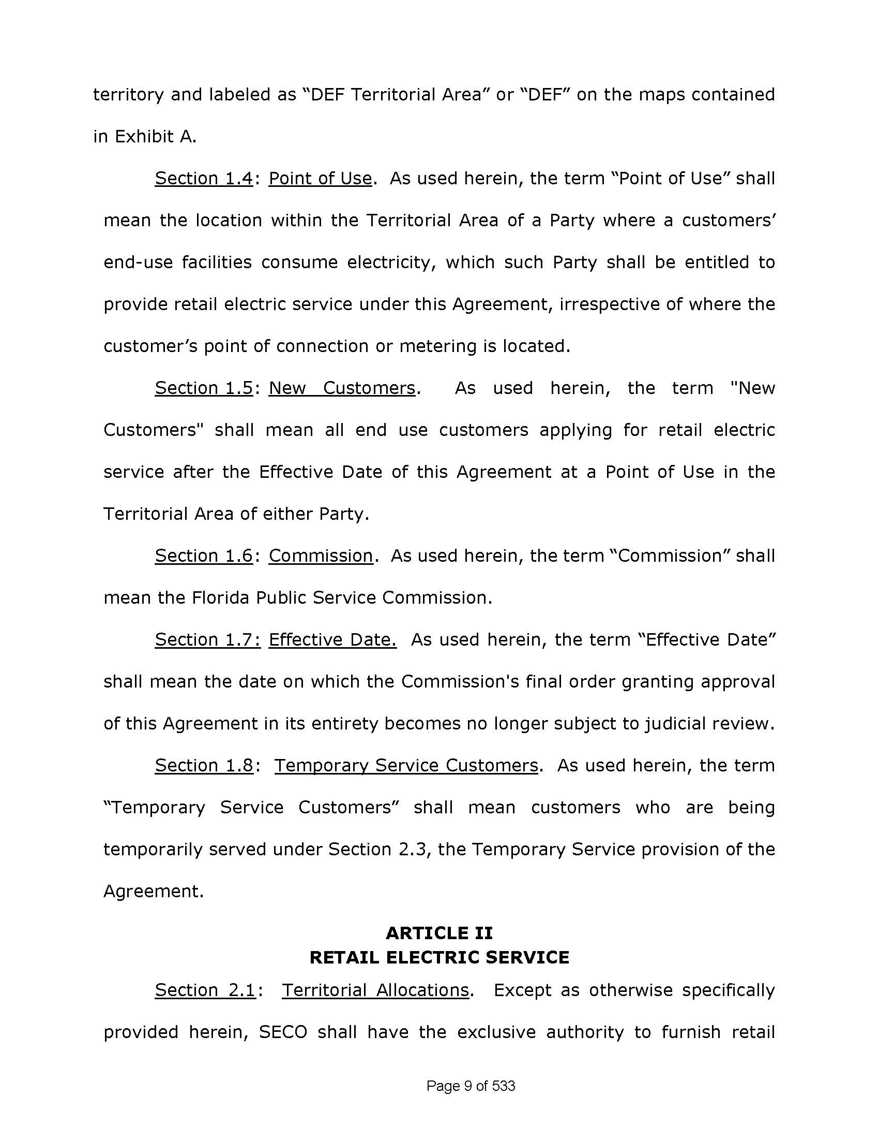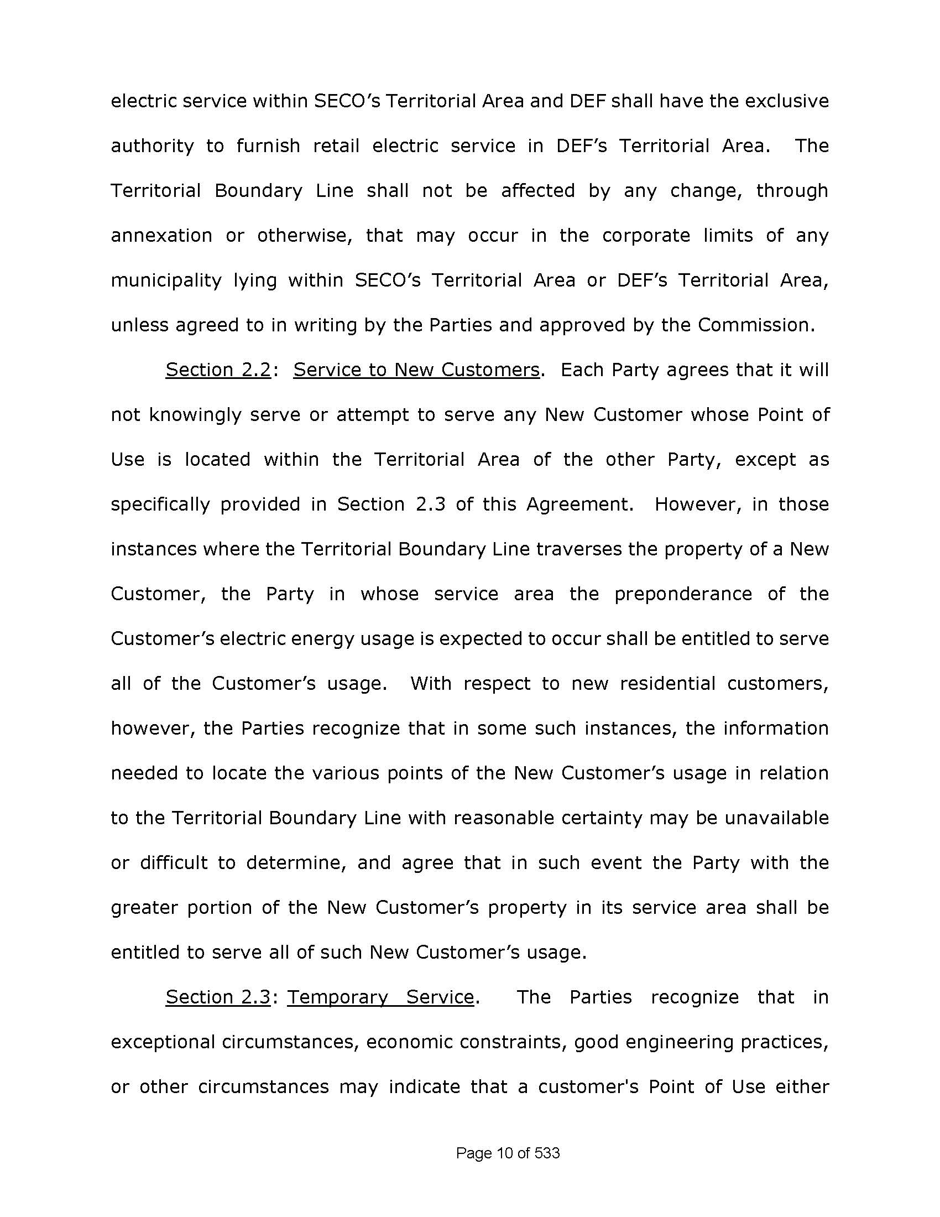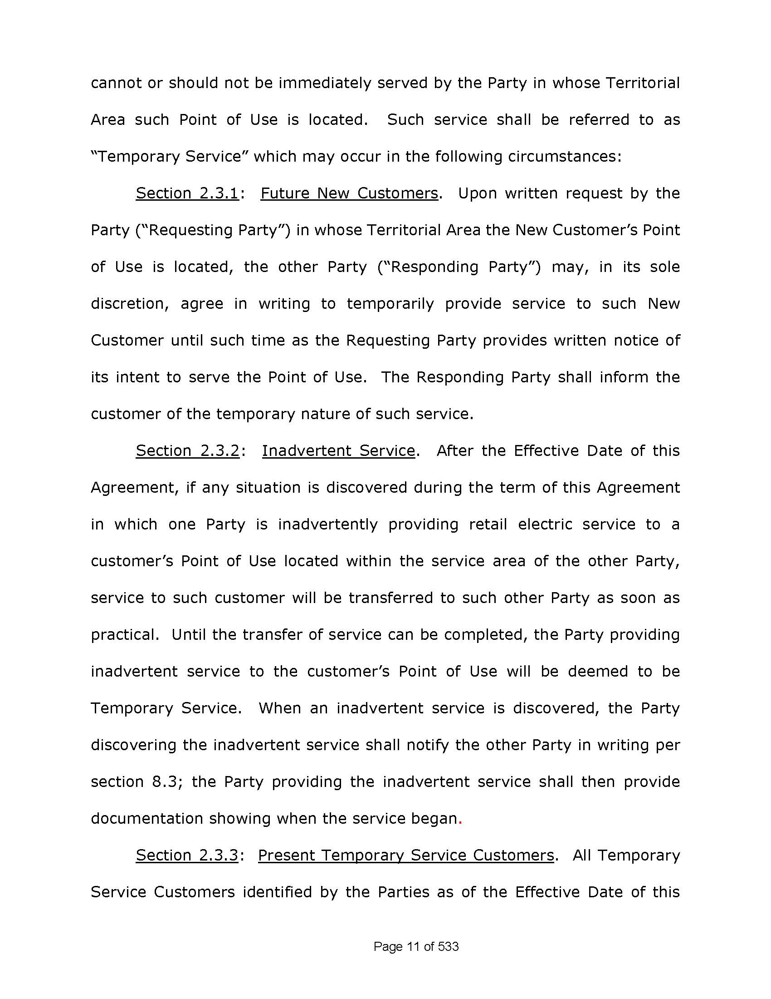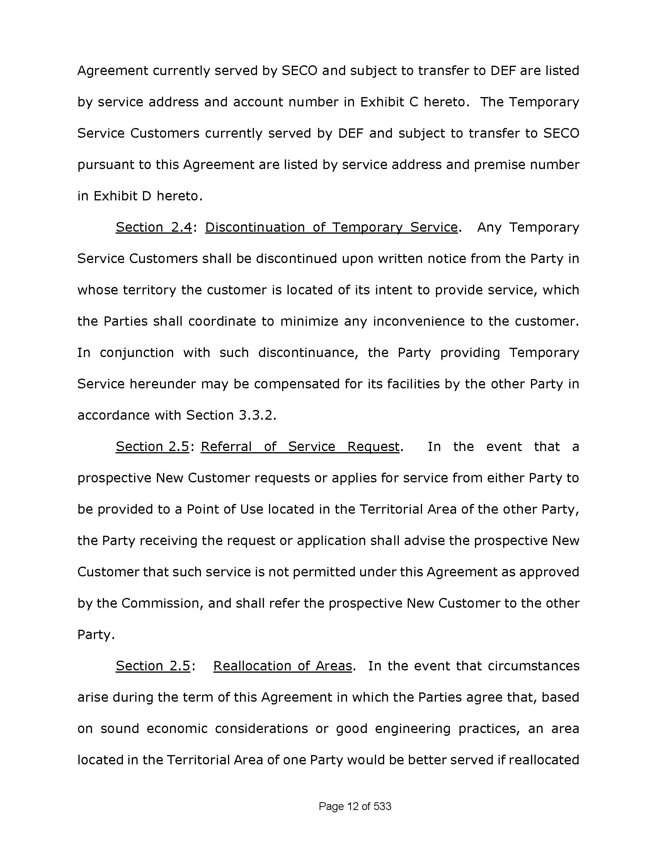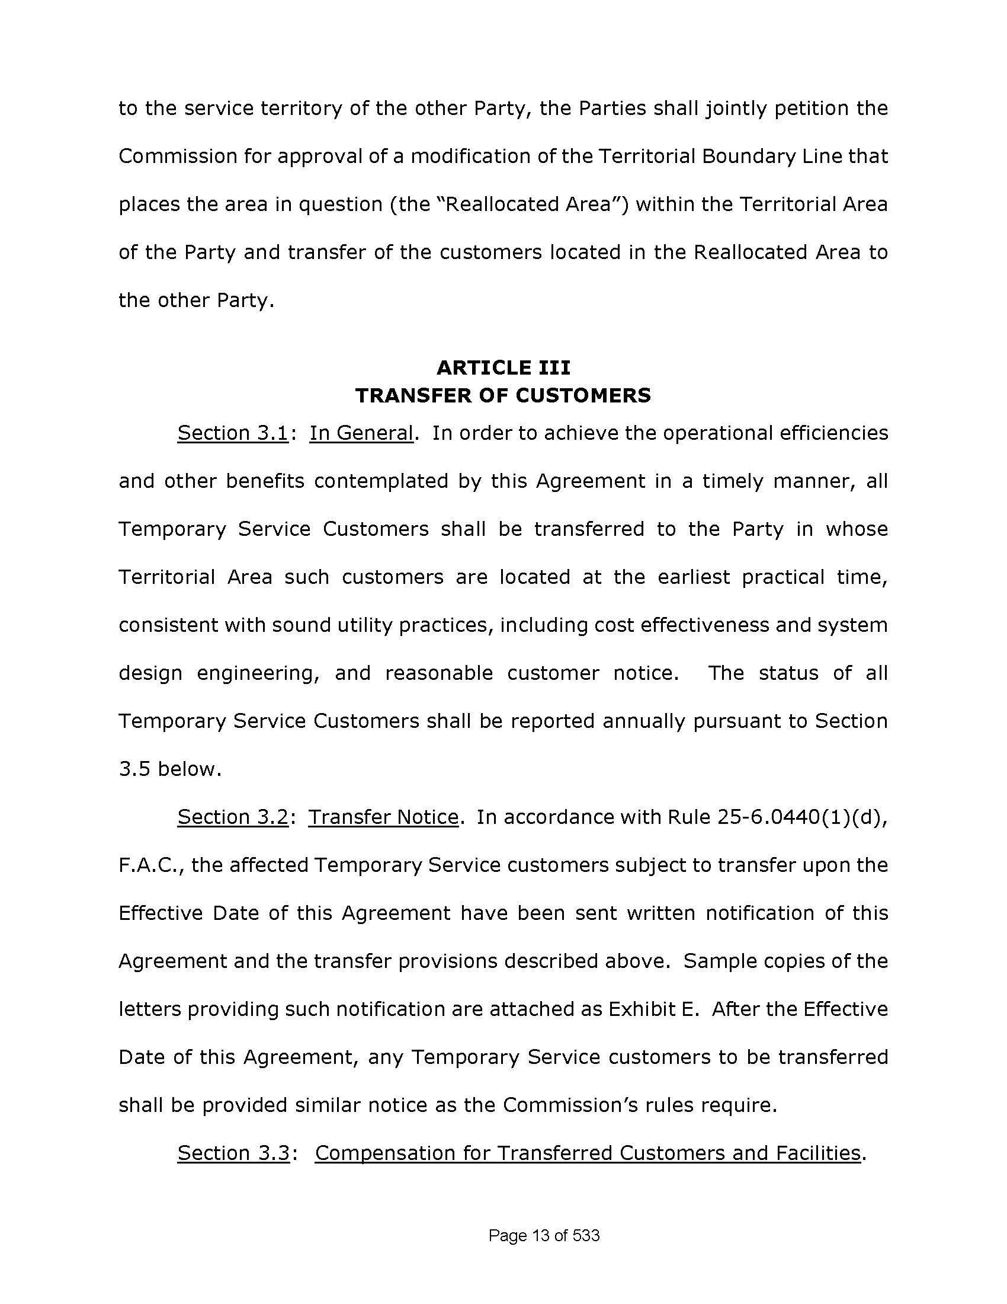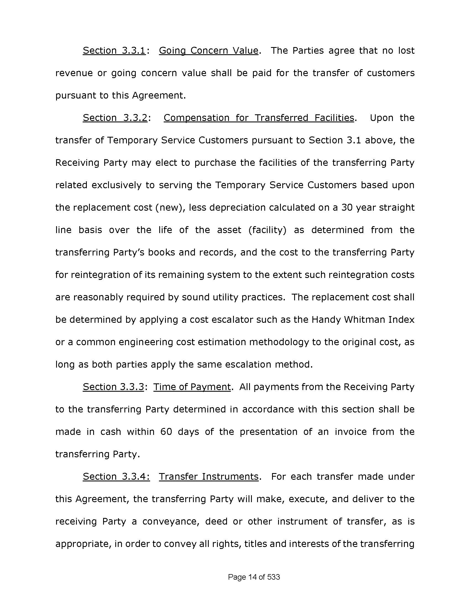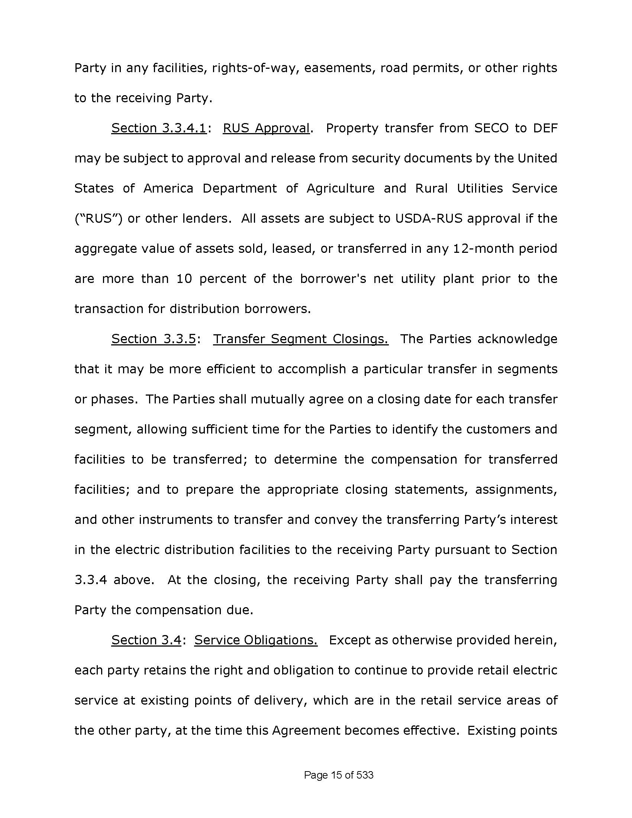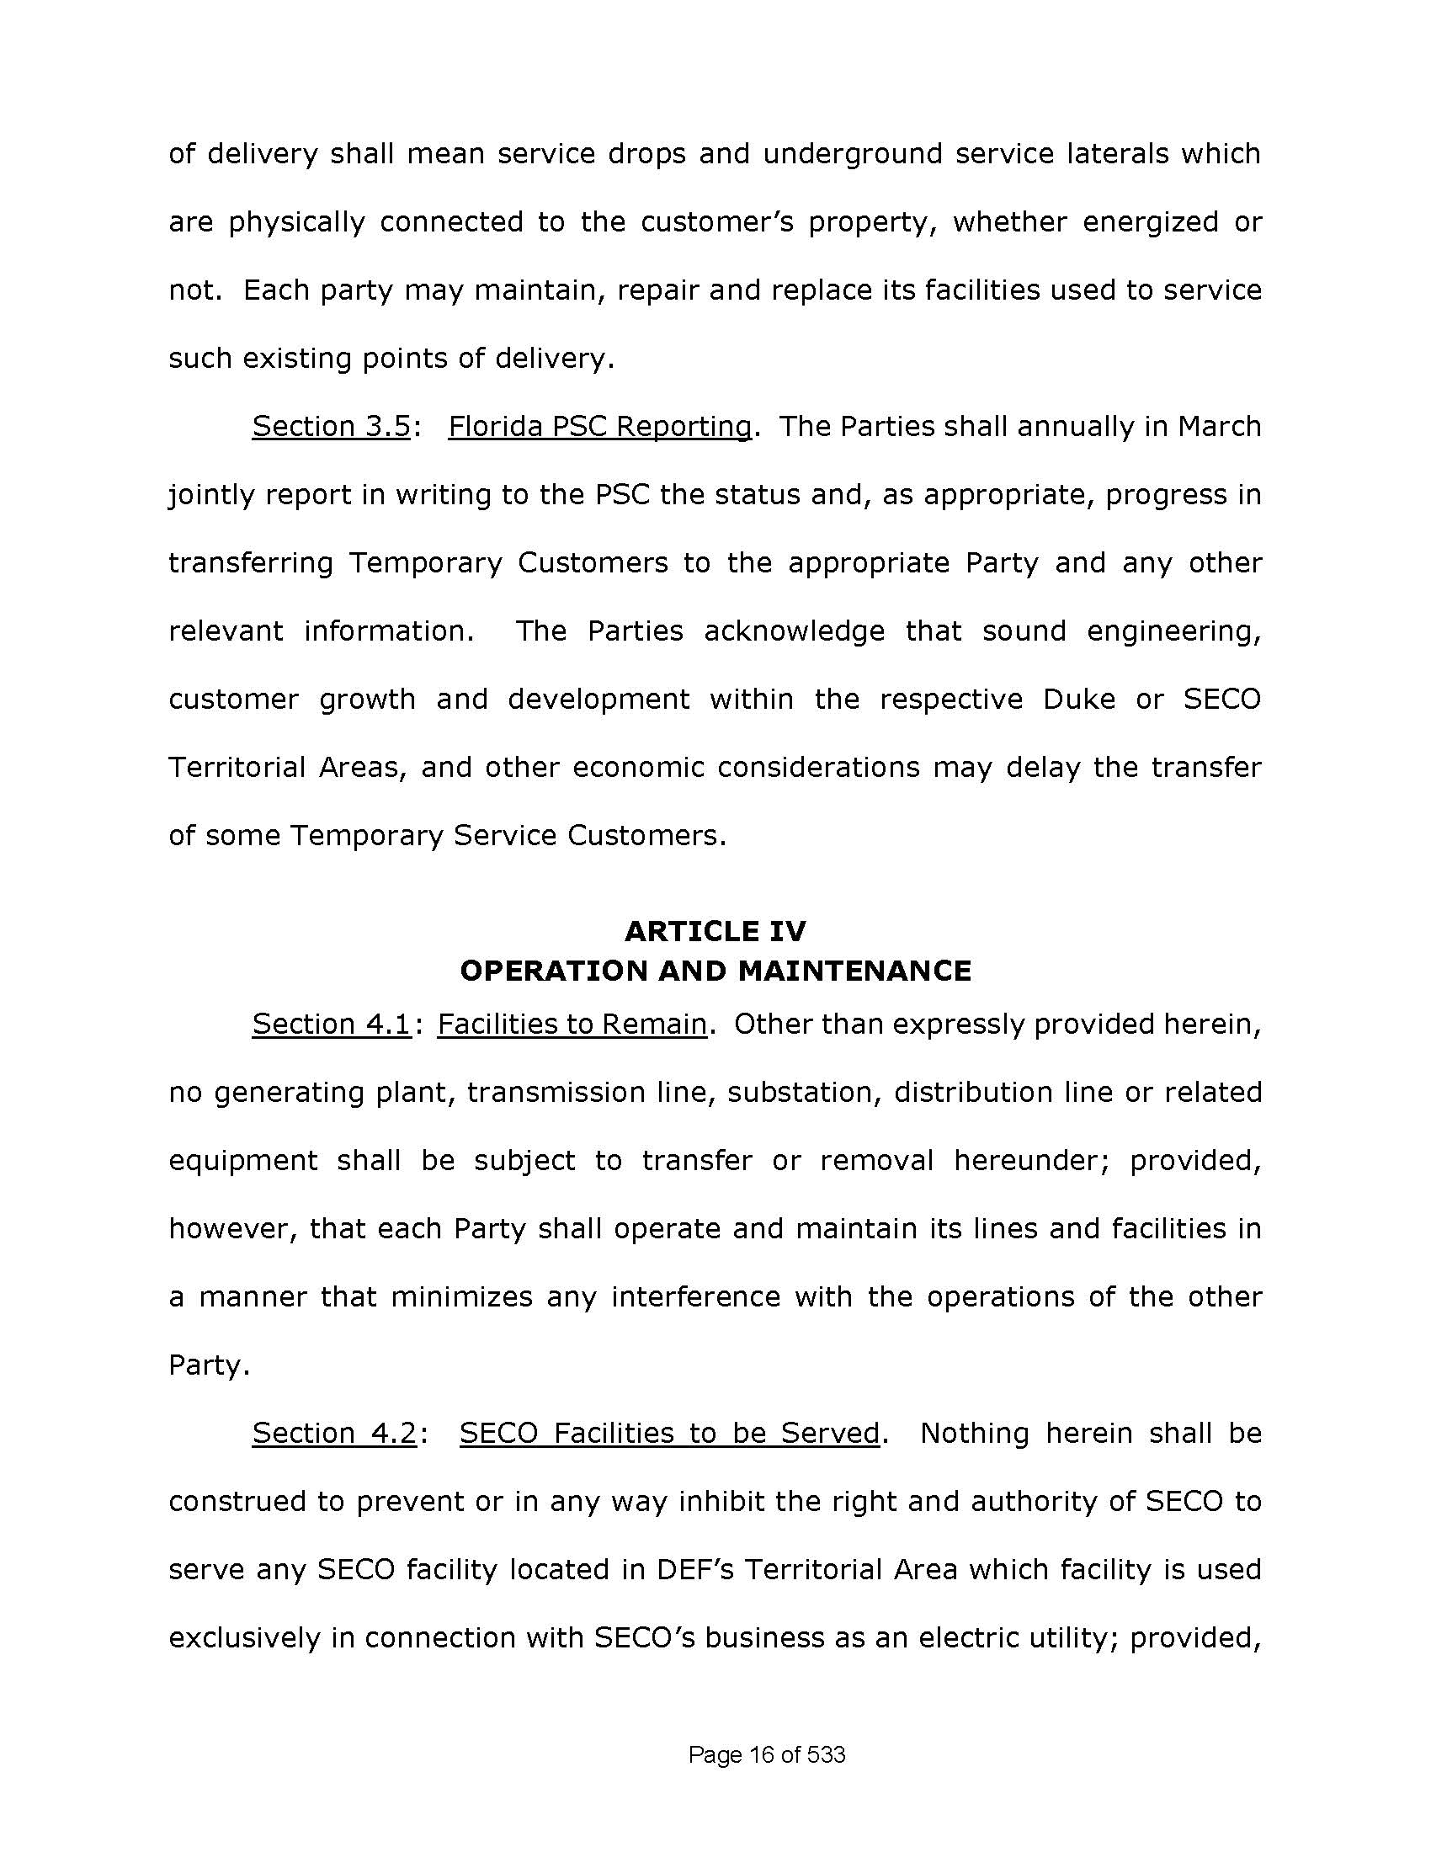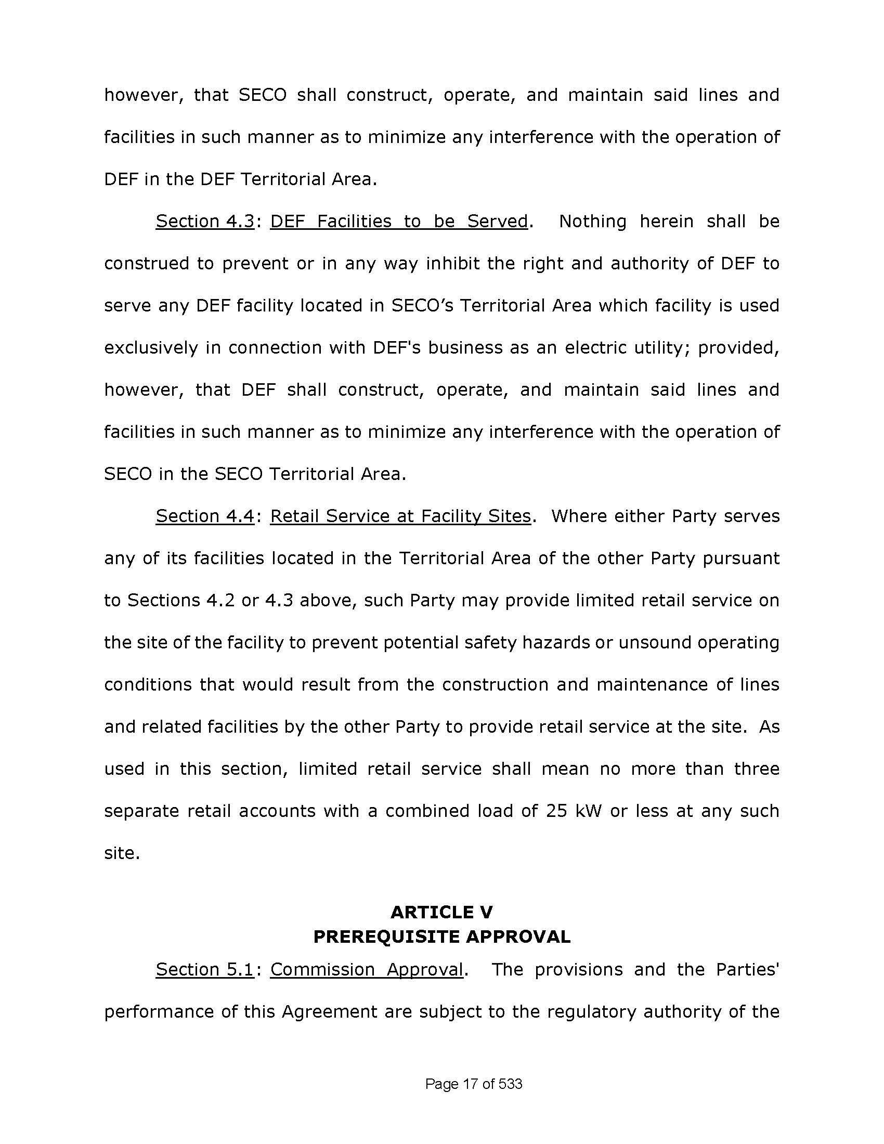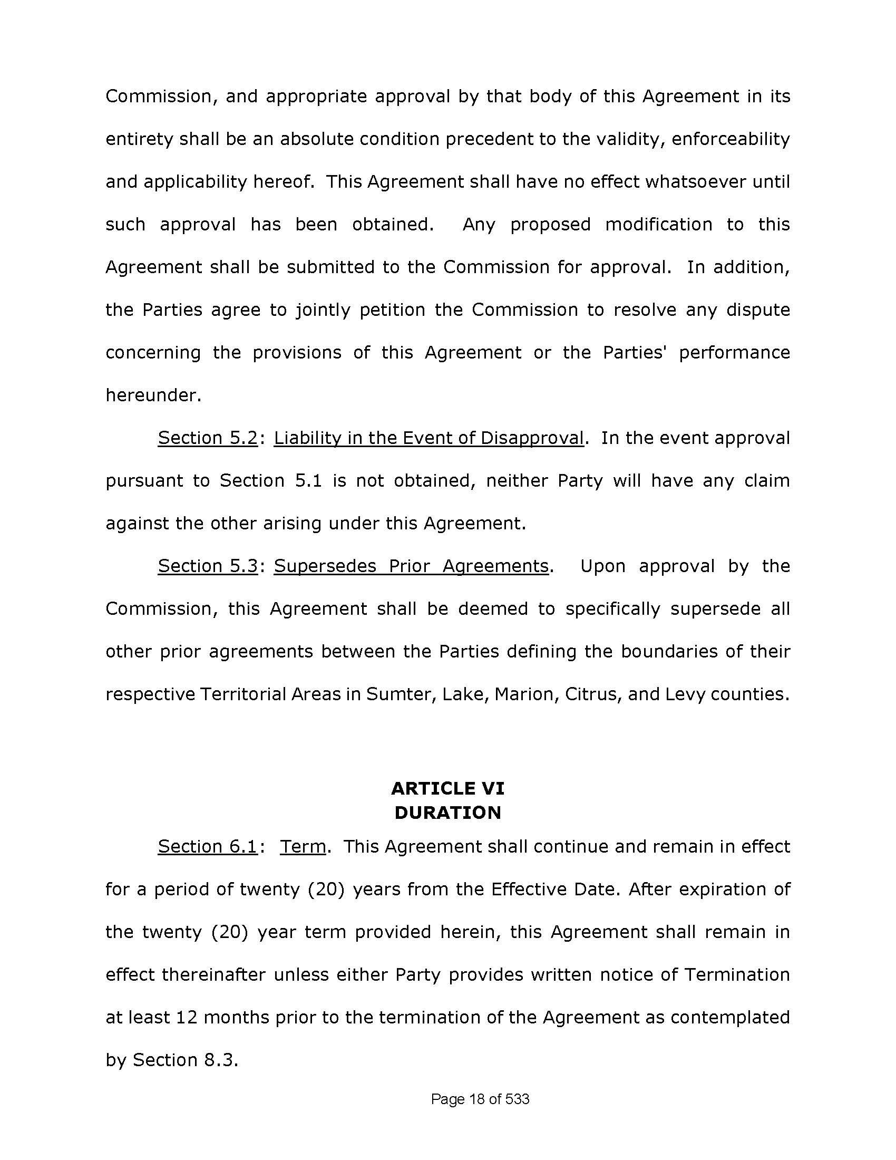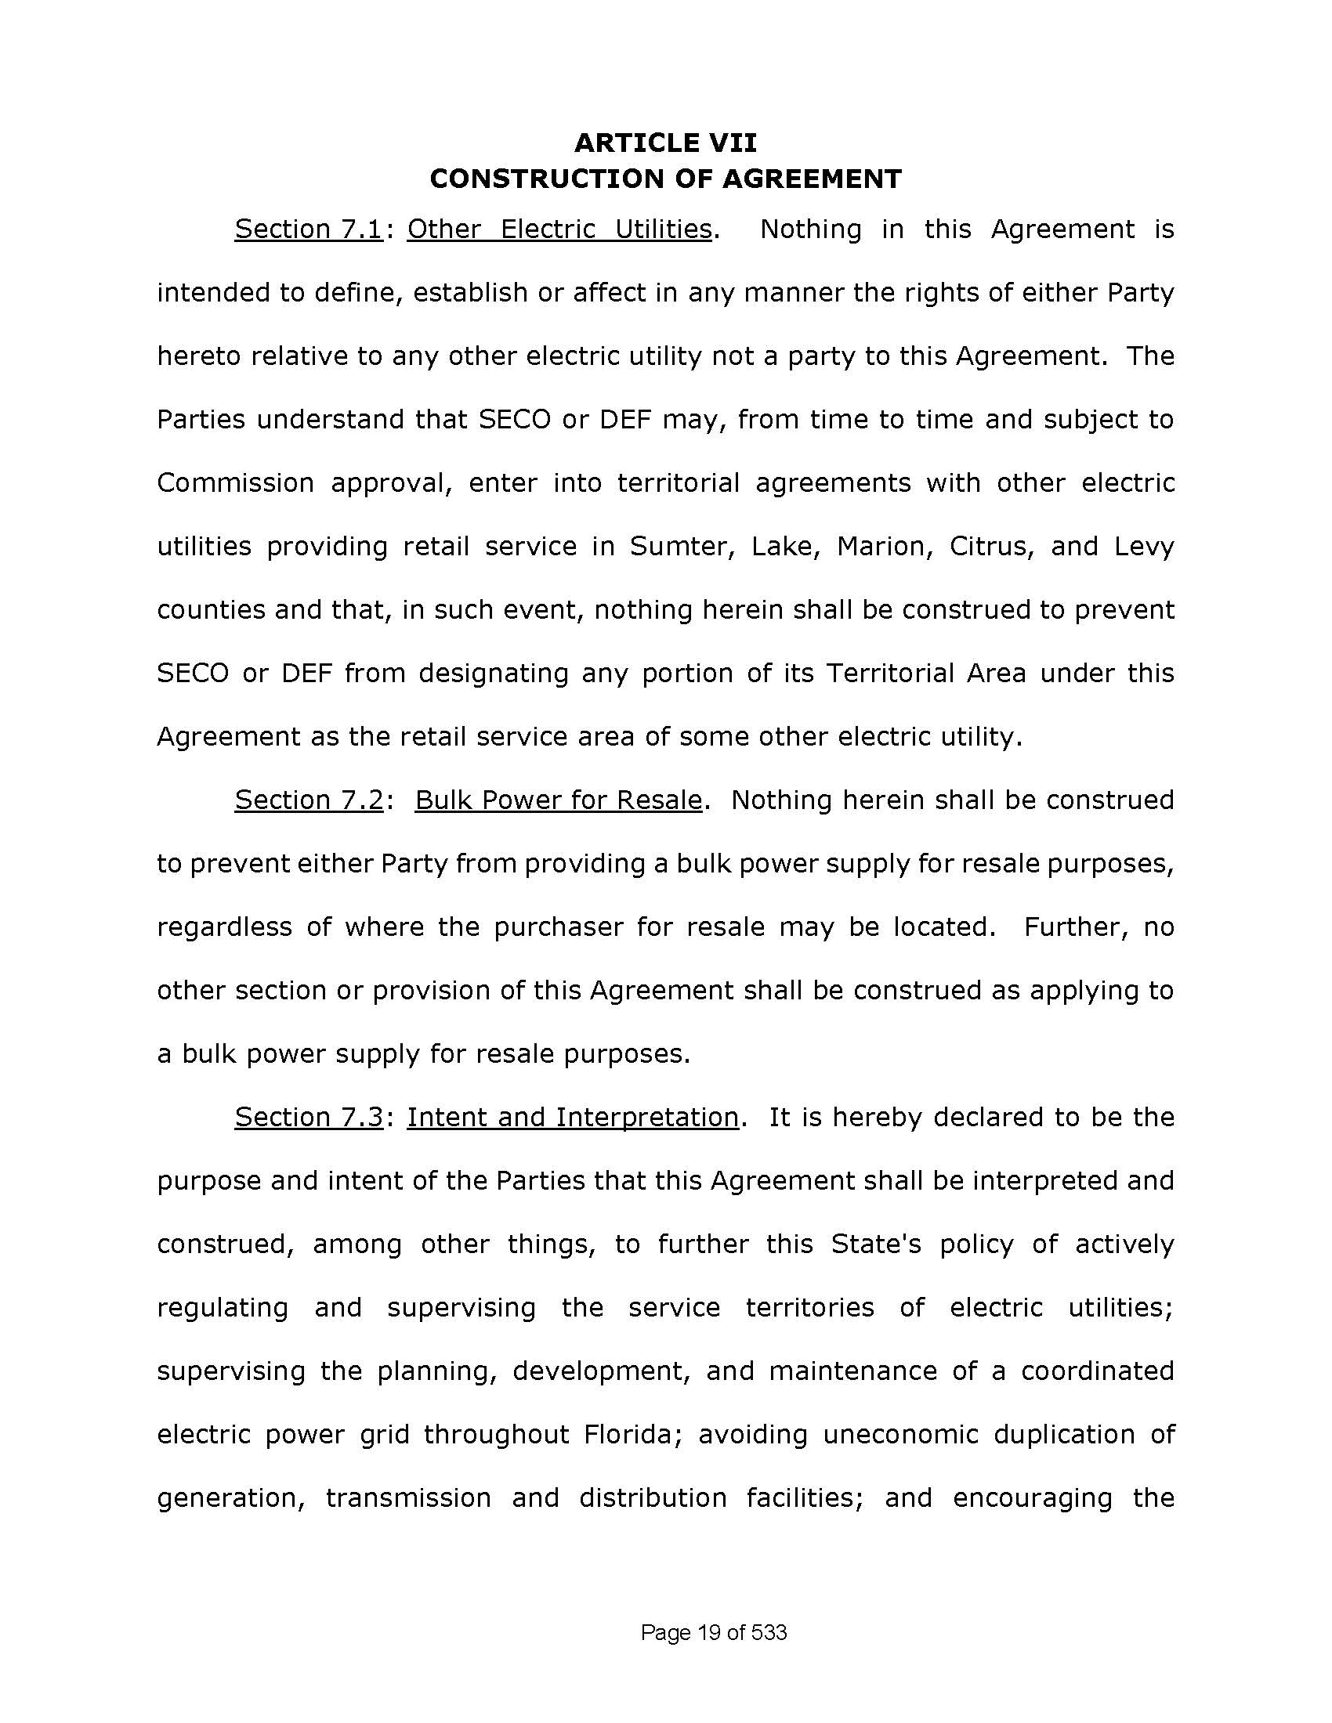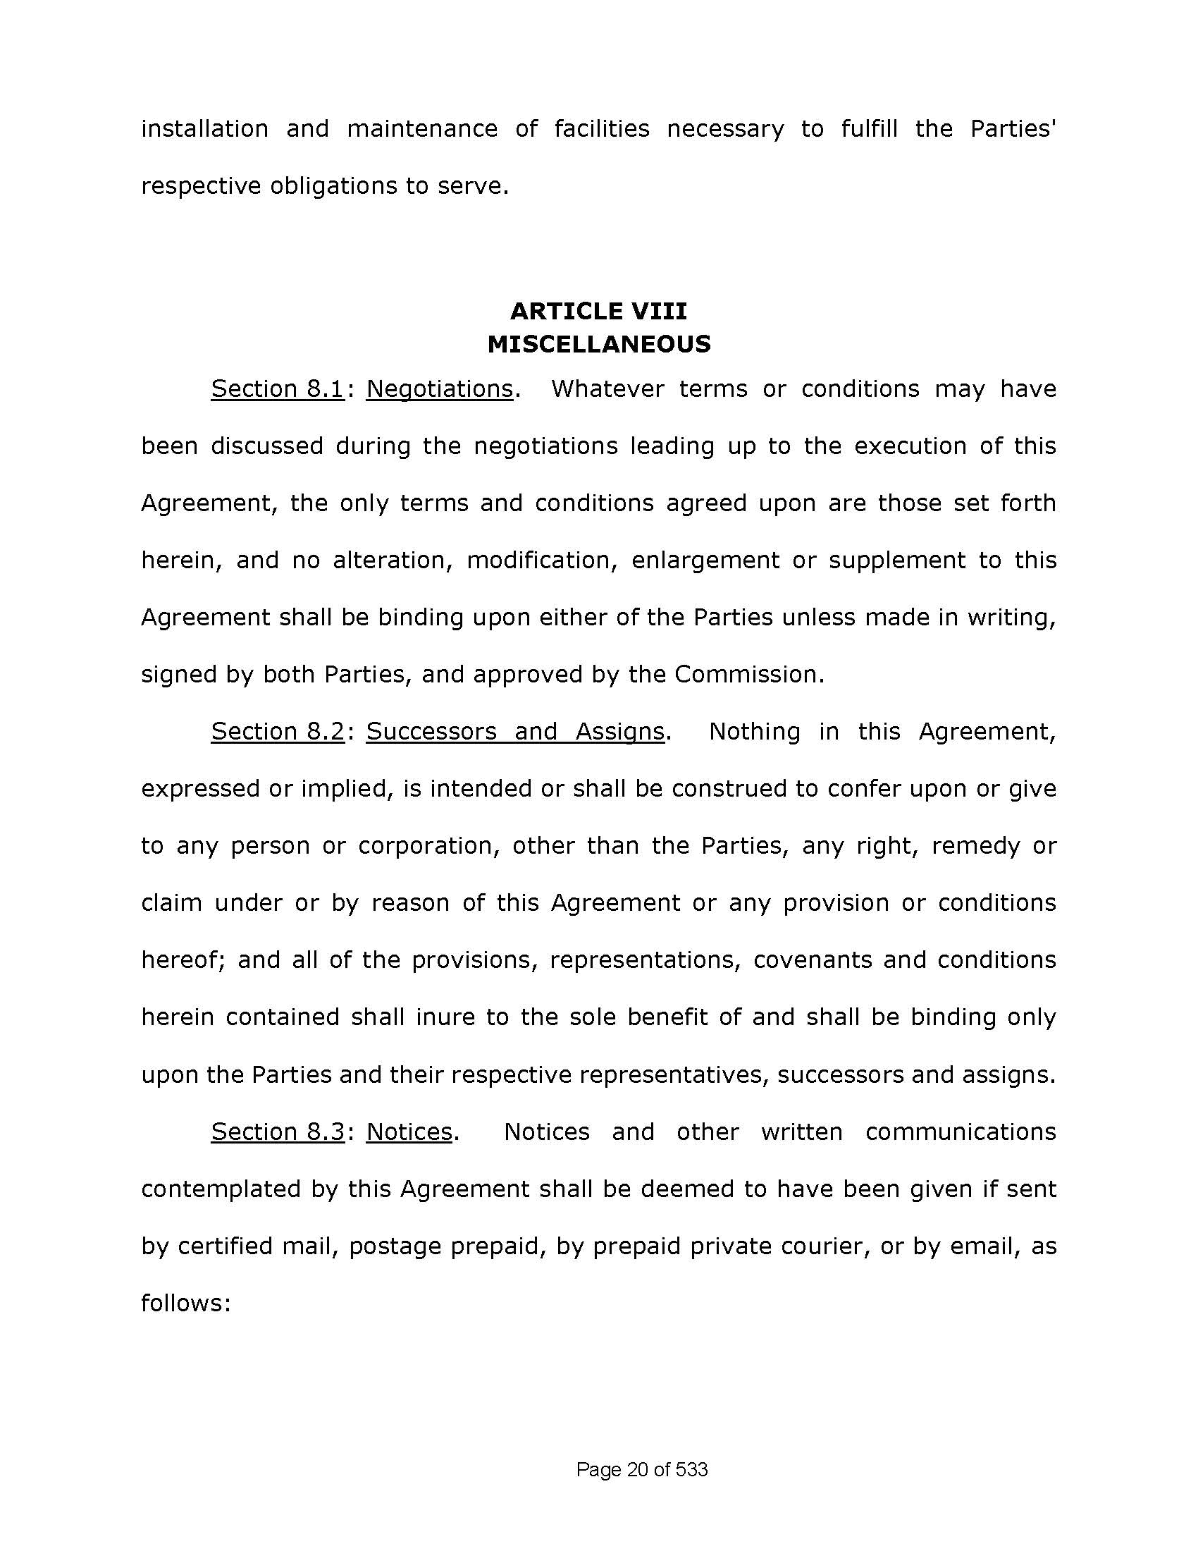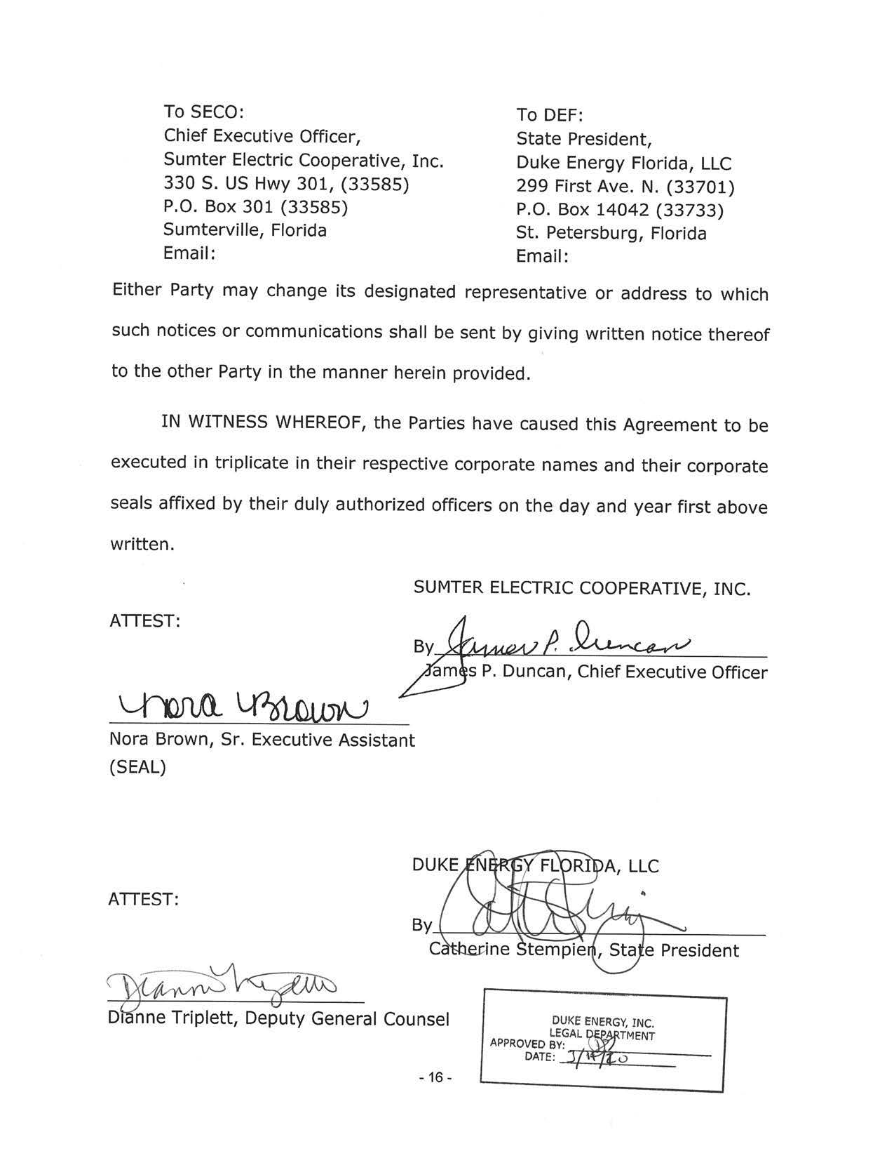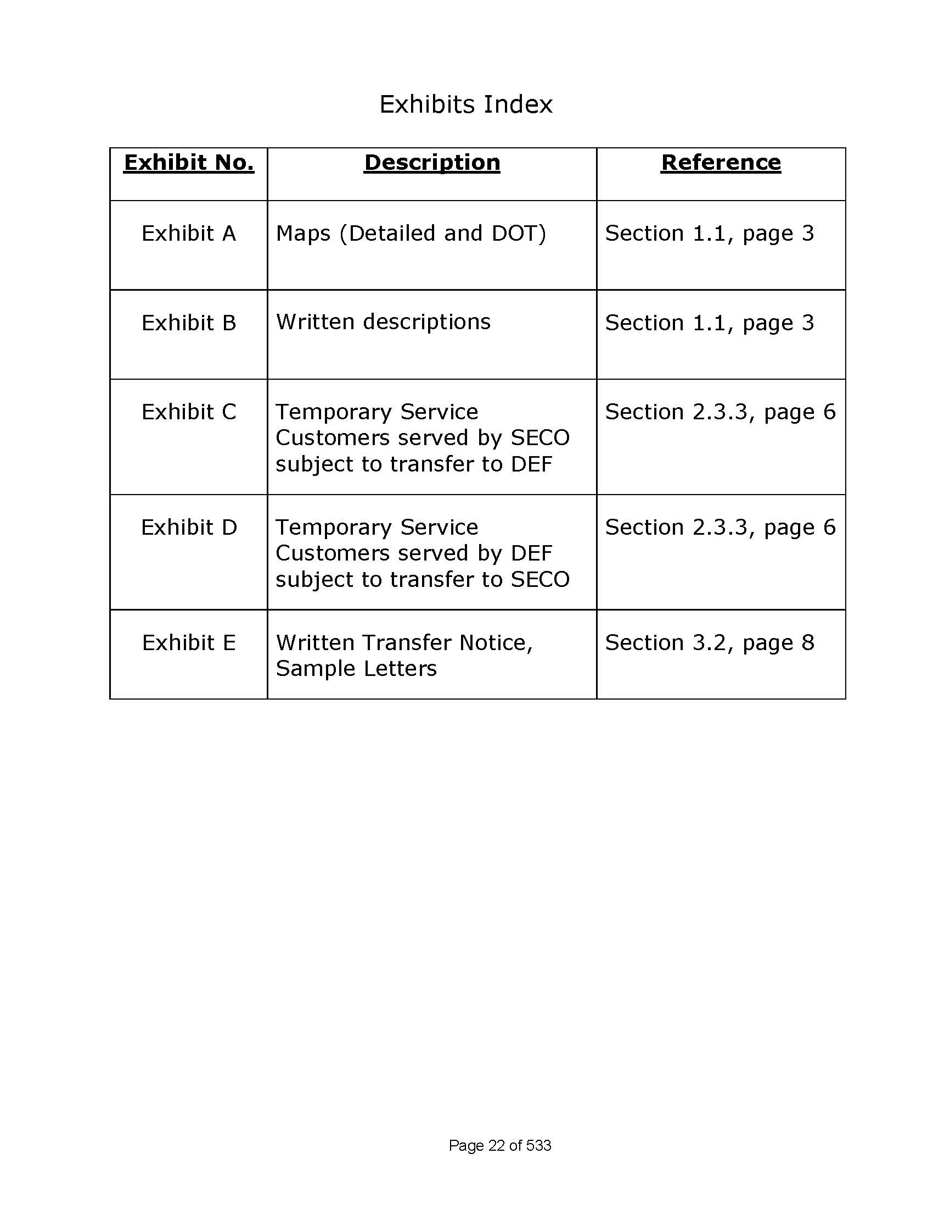
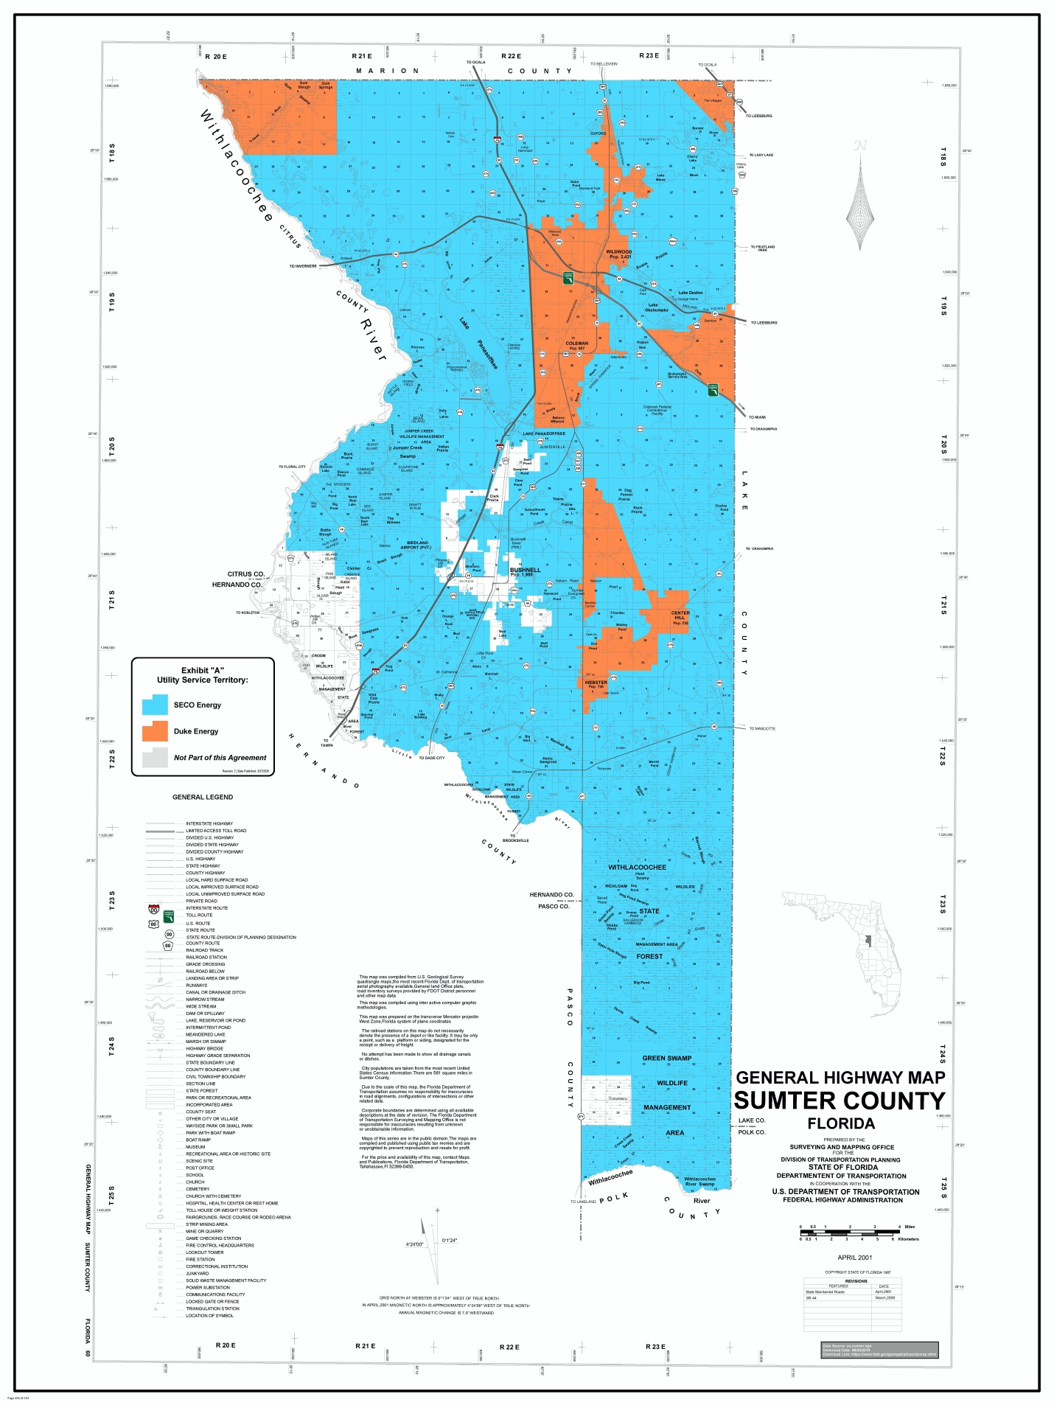
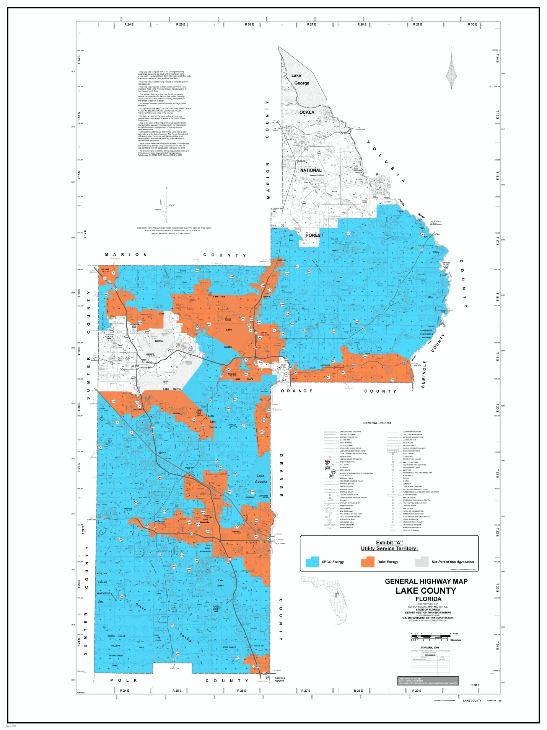
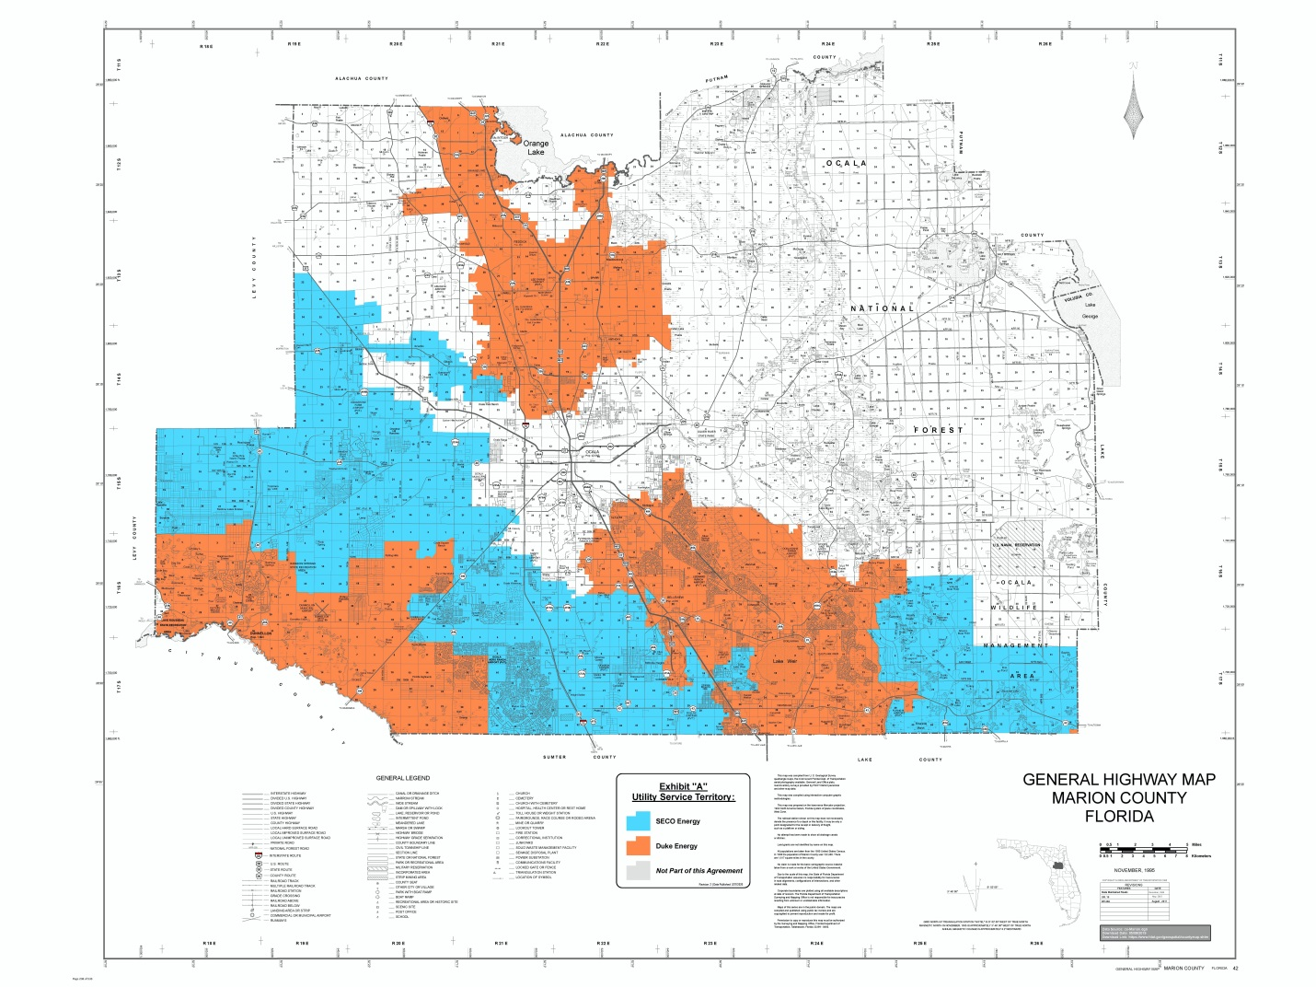

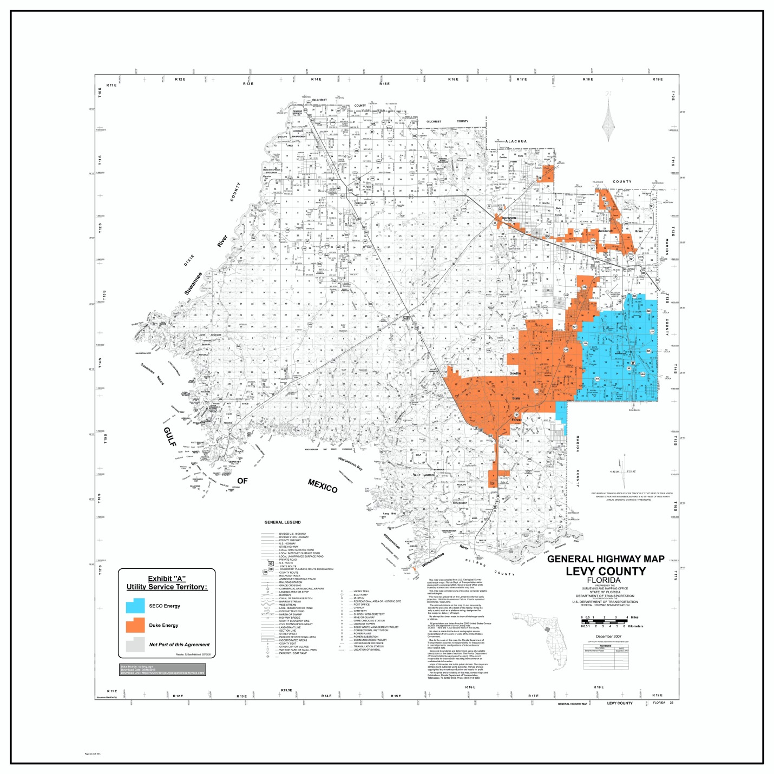

Order No. PSC-09-0276-PAA-EU, issued April 29, 2009, in Docket No. 20080632-EU, In re: Joint petition for approval of amended territorial agreement in Sumter, Lake, Marion, Citrus, and Levy Counties by Sumter Electric Cooperative, Inc. and Progress Energy Florida, Inc.
Utilities Commission of the City of New Smyrna Beach v. Florida Public Service Commission, 469 So. 2d 731 (Fla. 1985).
Response No. 2 to Staff’s First Data Request (Document No. 02398-2020).
Response Nos. 3 and 4 to Staff’s First Data Request (Document No. 02398-2020).
Consumer Correspondence (Document No. 01969-2020).
Response Nos. 11-13 to Staff’s First Data Request (Document No. 02398-2020).
Consumer Correspondence (Document No. 03194-2020).

