State of Florida |  | Public Service Commission  Capital Circle Office Center ● 2540 Shumard Oak Boulevard  Tallahassee, Florida 32399-0850  -M-E-M-O-R-A-N-D-U-M-
DATE: | June 24, 2020
TO: | Office of Commission Clerk (Teitzman)
FROM: | Division of Economics (Forrest, Coston)  Office of the General Counsel (Trierweiler)
RE: | Docket No. 20200110-EI – Petition for approval of revised underground residential distribution tariffs, by Duke Energy Florida, Inc.
AGENDA: | 07/07/20 – Regular Agenda – Interested Persons May Participate
COMMISSIONERS ASSIGNED: |  |  | All Commissioners
PREHEARING OFFICER: |  |  | Administrative
CRITICAL DATES: |  |  | 12/01/20 (8-Month Effective Date)
SPECIAL INSTRUCTIONS: |  |  | None

Case Background
On April 1, 2020, Duke Energy Florida, LLC (Duke or utility) filed a petition for approval of revisions to its underground residential distribution (URD) tariffs. The URD tariffs apply to new residential subdivisions and represent the additional costs, if any, Duke incurs to provide underground distribution service in place of overhead service. The proposed (legislative version) URD tariffs are contained in Attachment A to the recommendation.
Duke’s current URD charges were approved by Order No. PSC-2019-0443-TRF-EI. Duke waived the 60-day file and suspend provision pursuant to Section 366.06(3), Florida Statutes (F.S.), in an email dated April 8, 2020. On May 22, 2020, Duke responded to staff’s first data request. The Commission has jurisdiction over this matter pursuant to Sections 366.03, 366.04, 366.05, and 366.06, F.S.

Discussion of Issues

Issue 1:
Should the Commission approve Duke's proposed URD tariffs and associated charges?

Recommendation:
Yes, the Commission should approve Duke’s proposed URD tariffs and associated charges as shown in Attachment A, effective July 7, 2020. (Forrest)

Staff Analysis:
Rule 25-6.078, Florida Administrative Code (F.A.C.), defines investor-owned utilities’ (IOU) responsibilities for filing updated URD tariffs. Duke has filed the instant petition pursuant to subsection (3) of the rule, which requires IOUs to file supporting data and analyses for updated URD tariffs if the cost differential, using current labor and material costs, varies from the Commission-approved differential by more than ten percent. On October 15, 2019, pursuant to Rule 25-6.078, F.A.C., Duke informed the Commission that its differential for the low density subdivision would change by more than 10 percent from the differential approved in the 2019 order, requiring Duke to file the instant petition.
The URD tariffs provide charges for underground service in new residential subdivisions and represent the additional costs, if any, the utility incurs to provide underground service in place of overhead service. The cost of standard overhead construction is recovered through base rates from all ratepayers. In lieu of overhead construction, customers have the option of requesting underground facilities. Any additional cost is paid by the customer as a contribution-in-aid-of-construction (CIAC). Typically, the URD customer is the developer of a subdivision.
Traditionally, three standard model subdivision designs have been the basis upon which each IOU submits URD tariff changes for Commission approval: low density, high density, and a high density subdivision where dwelling units take service at ganged meter pedestals (groups of meters at the same physical location). While actual construction may differ from the model subdivisions, the model subdivisions are designed to reflect average overhead and underground subdivisions.
Costs for underground construction have historically been higher than costs for standard overhead construction and the additional cost is paid by the customer as a CIAC. However, as shown on Table 1-1, Duke’s proposed URD differential charges remain $0 per lot for the low density and ganged meter subdivisions. For the high density subdivision, the proposed differential decreased from the current $34 to $0 per lot. The decrease in the differentials is primarily attributable to changes in Duke’s labor, material, and operational costs.
Table 1-1 shows the current and proposed URD differentials for the low density, high density, and ganged meter subdivisions. The charges shown are per-lot charges.

Table 1-1
Comparison of URD Differential per Lot
Types of Subdivision | Current URD Differential | Proposed URD Differential
Low Density | $0 | $0
High Density | $34 | $0
Ganged Meter | $0 | $0
Source: Order PSC-2019-0443-TRF-EI and Duke’s 2020 Petition
The calculations of the proposed URD charges include (1) updated labor and material costs along with the associated loading factors and (2) operational costs. The costs are discussed below.

Labor and Material Costs
The installation costs of both overhead and underground facilities include the labor and material costs to provide primary, secondary, and service distribution lines, as well as transformers. The costs of poles are specific to overhead service while the costs of trenching and backfilling are specific to underground service. The utilities are required by Rule 25-6.078 (5), F.A.C., to use current labor and material costs.
Duke’s labor costs for overhead and underground construction are comprised of costs associated with work performed by both in-house employees and outside contractors. Duke’s in-house labor rates are based upon actual labor costs negotiated in bargaining unit contracts and labor rates with contractors are negotiated. Table 1-2 compares total 2019 and 2020 labor and material costs for the three subdivision models.
Table 1-2
Duke Trench and Install Conduit
Labor and Material Costs per Lot
 | 2019 Costs | 2020 Costs | Difference
Low Density
Underground Labor/Material costs | $1,620 | $2,263 | $643
Overhead Labor/Material costs | $1,323 | $2,343 | $1,020
Per lot Differential | $297 | $(80) | $(377)
High Density
Underground Labor/Material Costs | $1,484 | $1,978 | $494
Overhead Labor/Material Costs | $1,009 | $1,642 | $633
Per Lot Differential | $475 | $336 | $(139)
Ganged Meter
Underground Labor/Material Costs | $581 | $774 | $193
Overhead Labor/Material Costs | $750 | $1,295 | $545
Per lot Differential | $(169) | $(521) | $(352)
Source: 2019 Order and Duke’s 2020 filing.
As Table 1-2 shows, the majority of overhead and underground total labor and material costs increased since the 2019 petition. The utility stated that it identified an error in its cost estimating tool which did not allow the system to sufficiently account for the actual costs paid for overhead contract labor, specifically in the area of setting poles and overhead transformers. As such, after adjusting for these changes, the cost of pole setting increased from $164 to $644 and single-phase transformers increased from $90 to $643. The correction of these costs contribute to the majority of increased labor costs in this petition. Duke explained in response to staff’s data request that the utility will continue to monitor the labor cost data to ensure their accuracy. Duke stated that material costs have fluctuated minimally since 2019.

Operational Costs
Rule 25-6.078(4), F.A.C., requires that the differences in net present value (NPV) of operational costs between overhead and underground systems, including average historical storm restoration costs over the life of the facilities, be included in the URD charge. The inclusion of the operational cost is intended to capture longer term costs and benefits of undergrounding.
Operational costs include operations and maintenance costs along with capital costs and represent the cost differential between maintaining and operating an underground versus an overhead system over the life of the facilities. The inclusion of the storm restoration cost in the URD calculations lowers the differential, since an underground distribution system generally incurs less damage than an overhead system as a result of a storm, and therefore, less restoration costs when compared to an overhead system.
The utility used a 5-year average of historical operational costs (2015-2019) for its calculations in this docket. The methodology used by Duke in this filing for calculating the NPV of operational costs was approved in Order No. PSC-12-0348-TRF-EI. Staff notes that operational costs may vary among IOUs due to multiple factors, including differences in size of service territory, miles of coastline, regions subject to extreme winds, age of the distribution system, or construction standards.
Table 1-3
NPV of Operational Costs Differential per Lot
Type of Subdivision | Pre-Operational Costs  (A) | Non-Storm Operational  Costs  (B) | Avoided Storm Costs  (C) | Proposed URD Differentials  (A)+(B)+(C)
Low Density | $(80) | $60 | $(960) | $0
High Density | $336 | $64 | ($547) | $0
Ganged Meter | ($521) | ($69) | ($418) | $0
Source: 2020 Filing.
Table 1-3 presents the pre-operational, non-storm operational, and the avoided storm restoration cost differentials between overhead and underground systems. The proposed differential is $0 when the calculation results in a negative number.
Duke stated in its response to staff’s data request that the average non-storm operational costs did not change significantly from 2019 to 2020. However, the data show that avoided storm restoration costs increased when compared to the 2019 petition. Duke’s 2019 petition included the 5-year average of historical operational costs for 2014 to 2018, while this petition includes operational costs for 2015 to 2019.

Additional Customer Options
In October 2019, the utility adopted a “cable in conduit” approach, similar to other utilities in Florida. This change required that all cable be included in conduit at installation, rather than cable being pulled through separately installed conduit. The utility believed this approach would reduce outages, as well as reduce repair and replacement times when failures occur. Under the “cable in conduit” approach, the utility removed certain costs associated with cable installation, splicing and pulling boxes. However, as a result of this change, the utility is proposing additional undergrounding construction options to developers in this petition, which could impact the overall cost of installing underground facilities. The two additional options are discussed below:
- Customer Mainline-Duke Services: Customer supply and install conduit for primary, secondary and street lights. This option allows the developer to purchase and install primary and secondary conduit in the subdivision; therefore, the material and labor costs associated with the installation of primary and secondary conduit, including trenching, have been excluded from the differential calculation. Duke continues to install services and transformers. The developer-purchased conduit will have to be installed meeting Duke guidelines.
- Customer Trench, Provide and Install Conduit: Customer supply and install conduit for primary, secondary and street lights. This option allows the developer to purchase and install services, primary, and secondary conduit. Therefore, the associated costs have been excluded from the differential calculation. Duke continues to install the transformers.
The utility notes that while the current NPV operational costs, including avoided storm restoration, result in a $0 URD differential for these new options, Duke recognizes that a shift in the operational costs could allow the differential costs for these two new line costs to differ from the traditional Duke Trench and Install Conduit tariff, under which Duke performs the full installation.

Conclusion
Staff has reviewed Duke’s proposed URD tariffs and associated charges, its accompanying work papers, and its responses to staff’s data request. Staff believes the proposed URD tariffs and associated charges are reasonable. Staff recommends the Commission approve Duke’s proposed URD tariffs and associated charges as shown in Attachment A, effective July 7, 2020.
Issue 2:
Should this docket be closed?

Recommendation:
If Issue 1 is approved and a protest is filed within 21 days of the issuance of the order, the tariffs should remain in effect, with any revenues held subject to refund, pending resolution of the protest. If no timely protest is filed, this docket should be closed upon the issuance of a consummating order. (Trierweiler)

Staff Analysis:
If Issue 1 is approved and a protest is filed within 21 days of the issuance of the order, the tariffs should remain in effect, with any revenues held subject to refund, pending resolution of the protest. If no timely protest is filed, this docket should be closed upon the issuance of a consummating order.

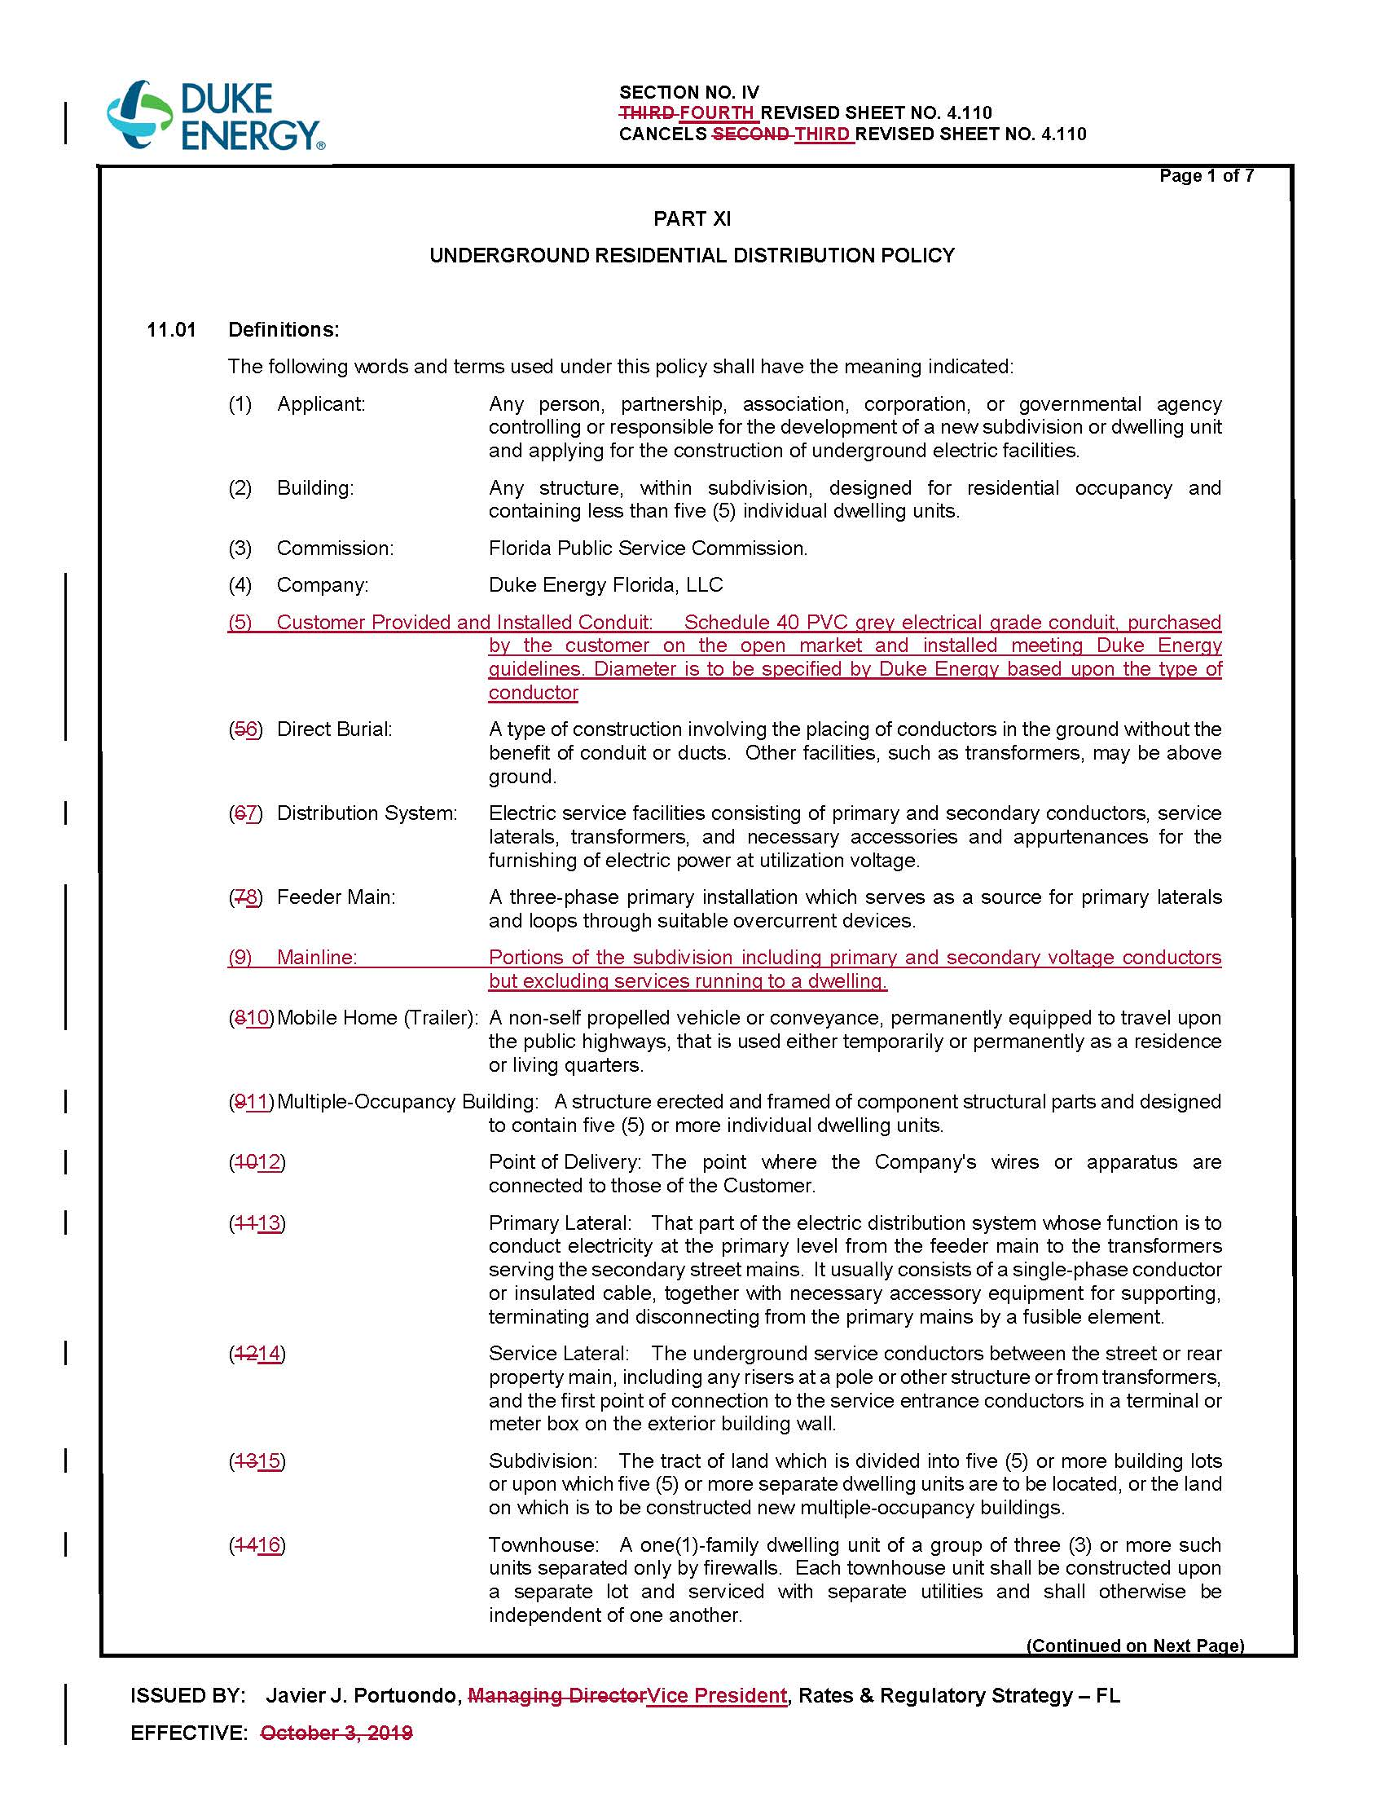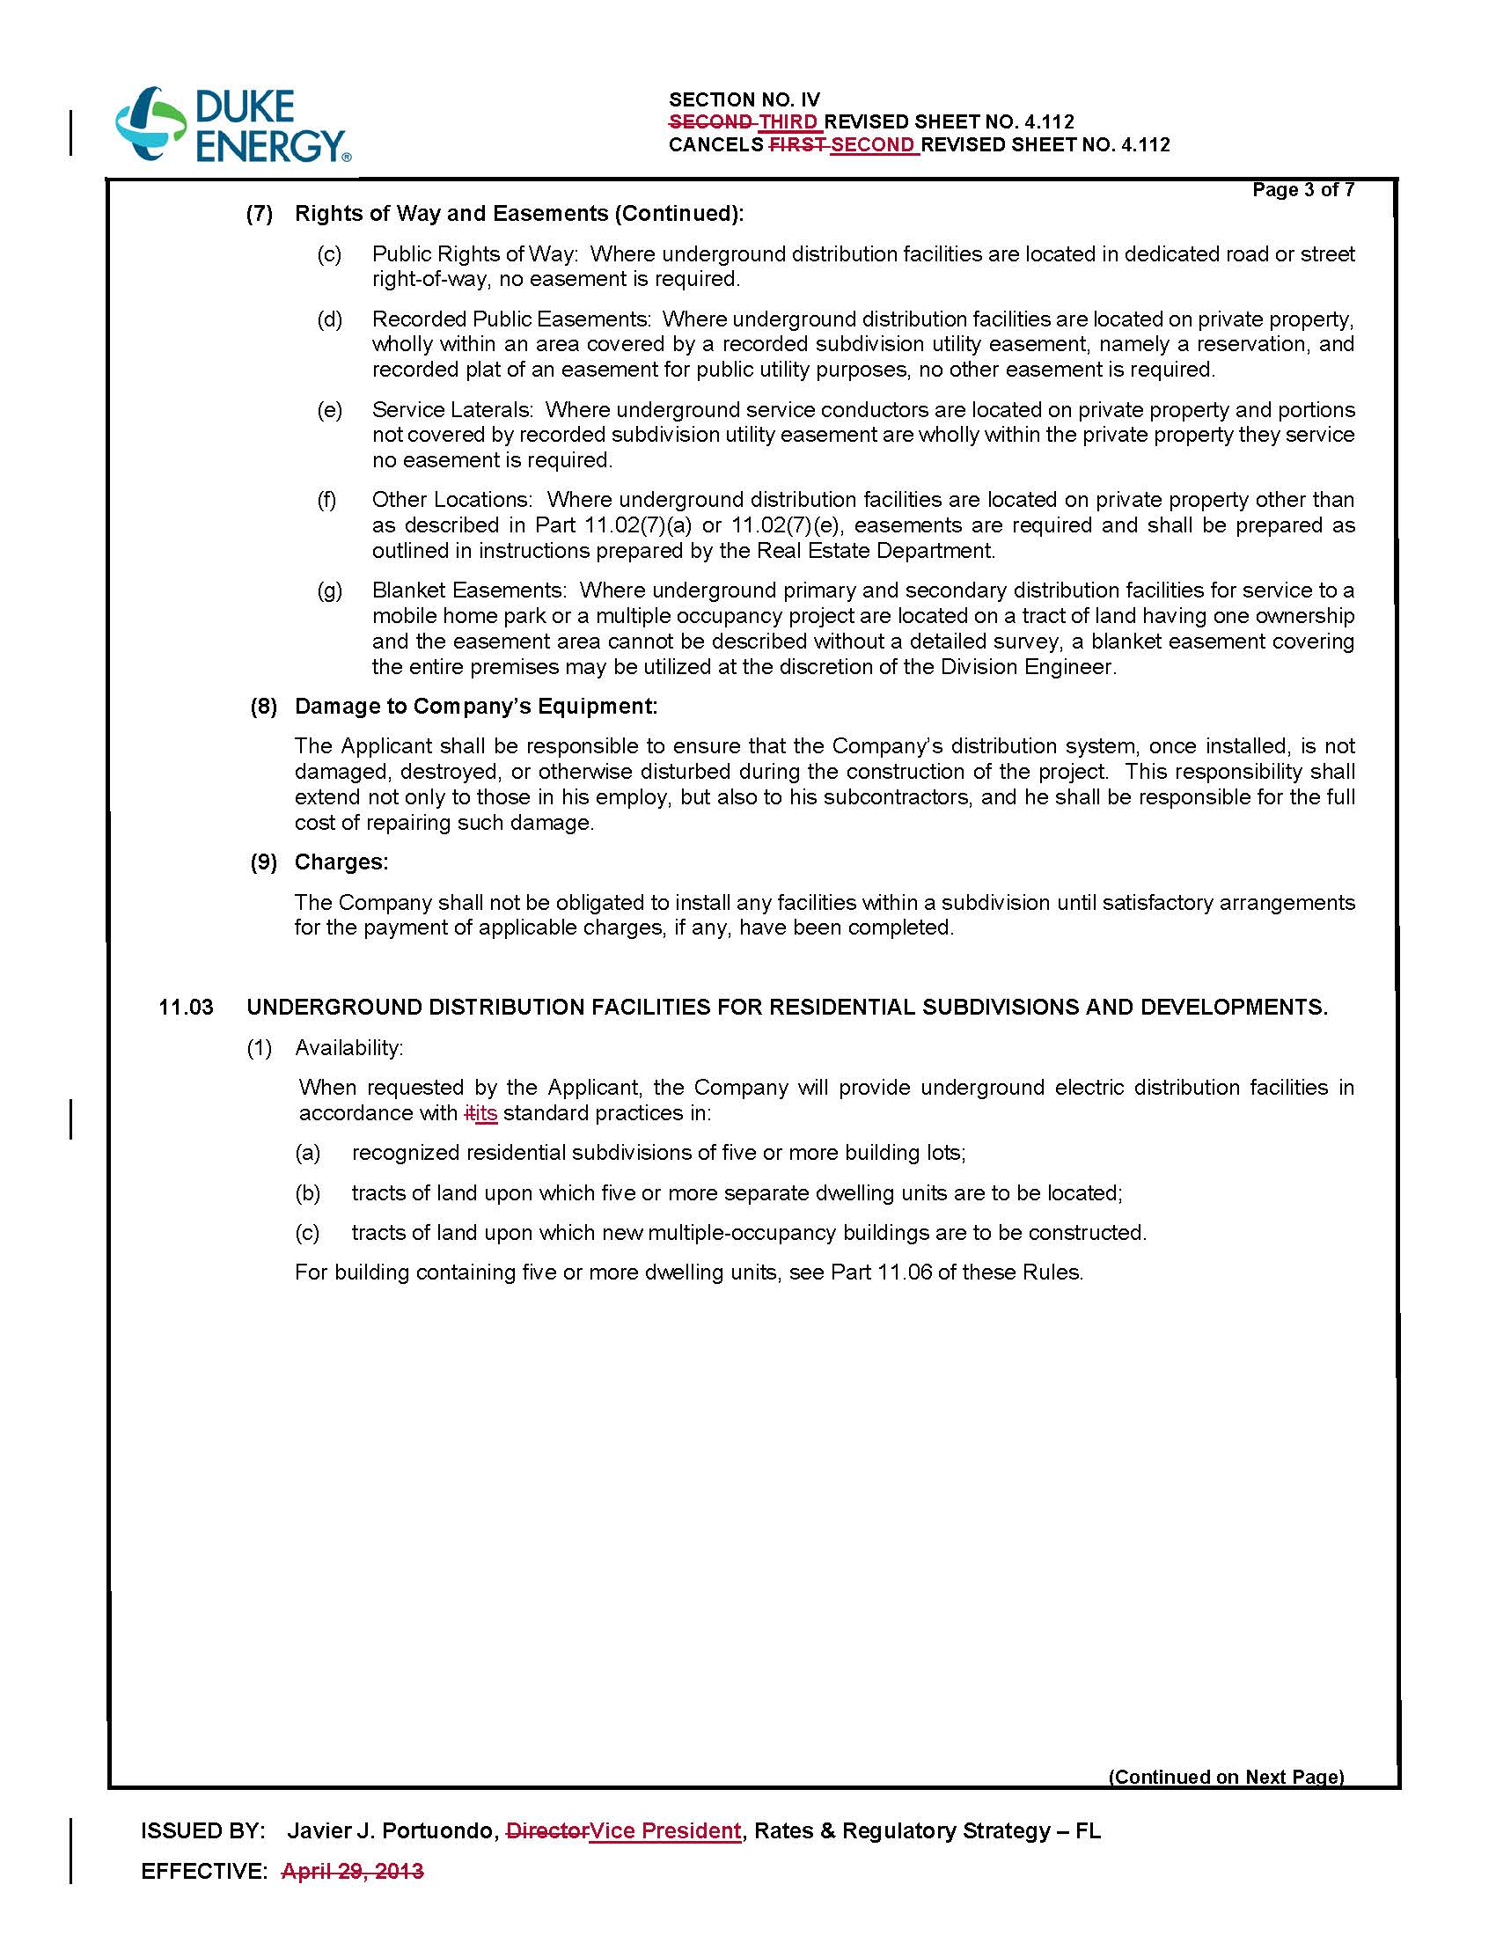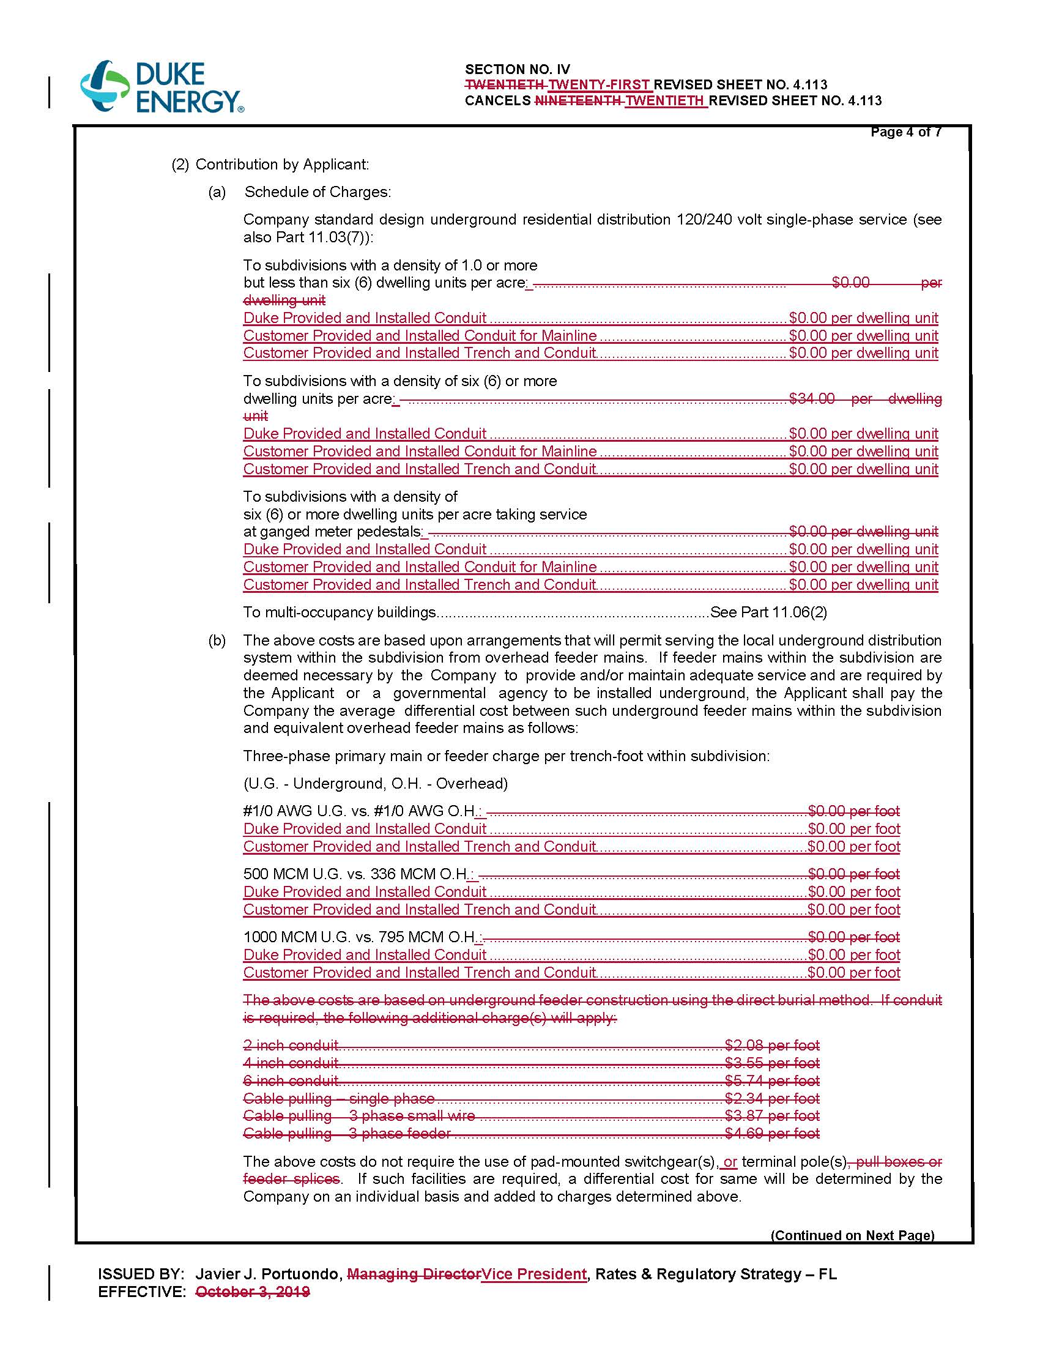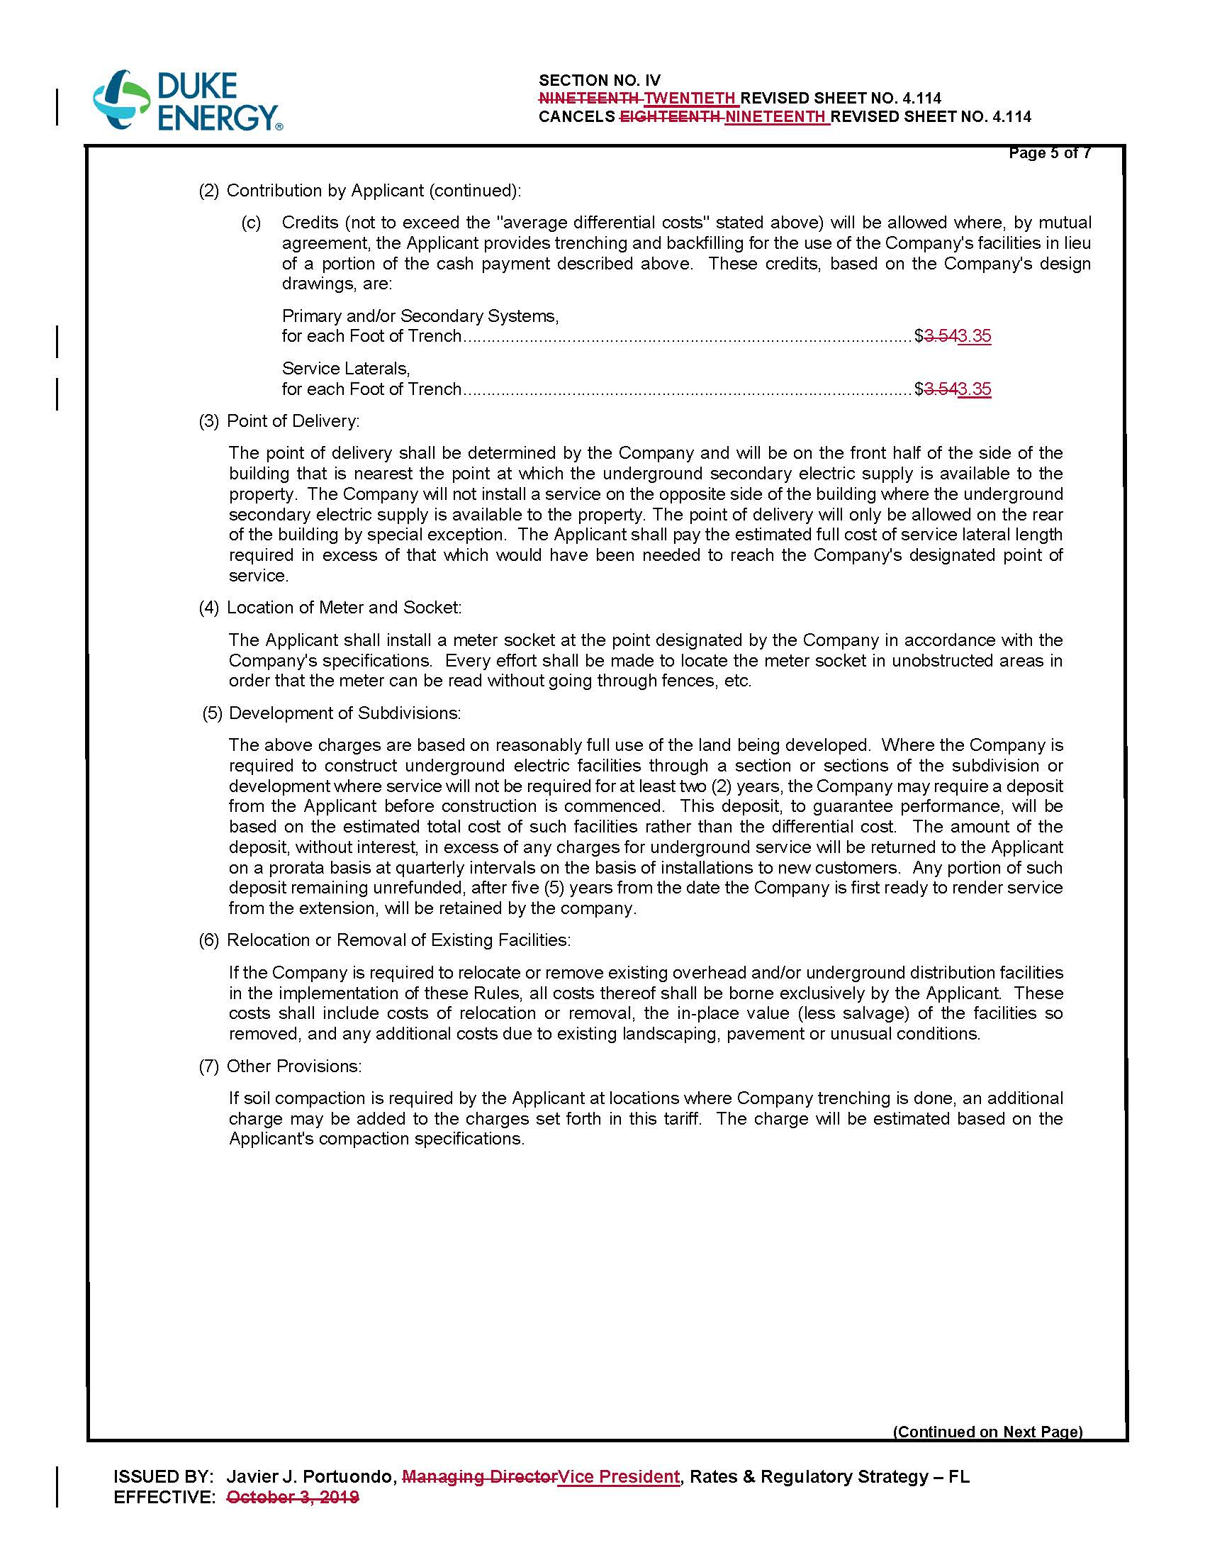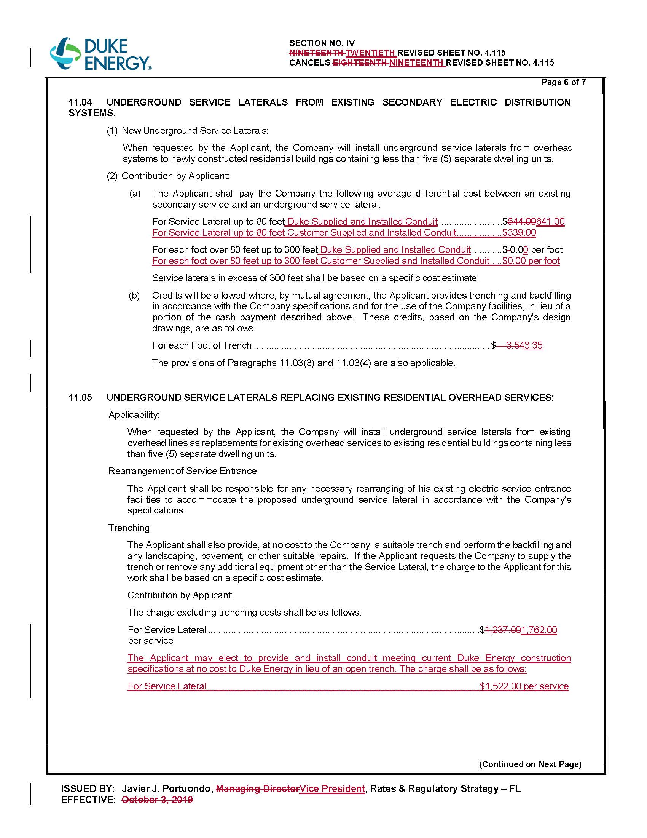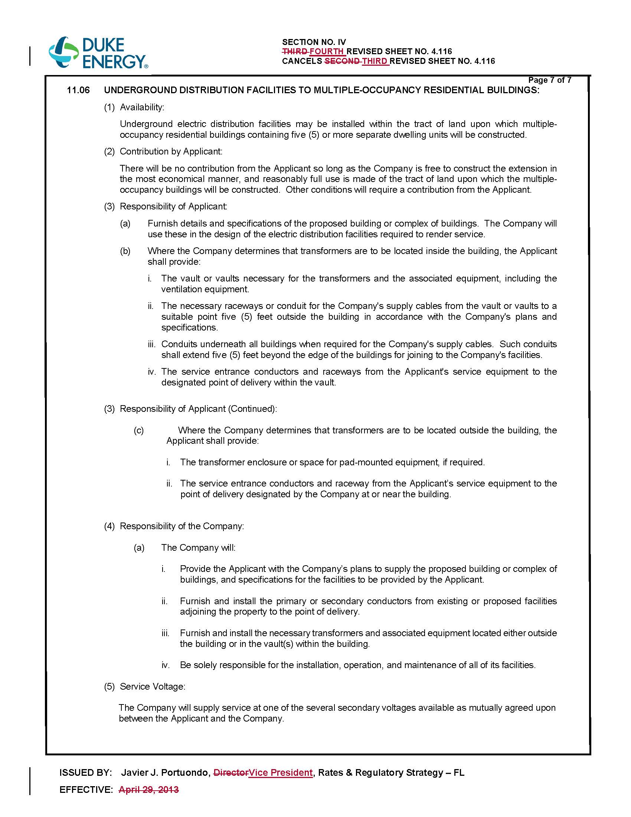

Order No. PSC-2019-0443-TRF-EI, issued November 19, 2019, in Docket 20190076-EI, In re: Petition for approval of revised underground residential distribution tariffs, by Duke Energy Florida, LLC.
Document No. 01824-2020.
Operational capital costs are the costs associated with replacement equipment needed during the lifespan of the facilities.
Order No. PSC-12-0348-TRF-EI, issued July 5, 2012, in Docket No. 110293-EI, In re: Petition for approval of revised underground residential distribution tariffs, by Progress Energy Florida, Inc.

