State of Florida |  | Public Service Commission  Capital Circle Office Center ● 2540 Shumard Oak Boulevard  Tallahassee, Florida 32399-0850  -M-E-M-O-R-A-N-D-U-M-
DATE: | June 24, 2020
TO: | Office of Commission Clerk (Teitzman)
FROM: | Division of Engineering (M. Watts, K. Johnson, Ramos)  Division of Accounting and Finance (Norris, Sewards)  Division of Economics (Bethea, Hudson)  Office of the General Counsel (Lherisson)
RE: | Docket No. 20190185-WS – Application for authority to transfer assets of exempt entity in Sumter County by the City of Wildwood to South Sumter Utility Company, LLC.
AGENDA: | 07/07/20 – Regular Agenda – Proposed Agency Action for Issues 2, 3 and 4 - Interested Persons May Participate
COMMISSIONERS ASSIGNED: |  |  | All Commissioners
PREHEARING OFFICER: |  |  | Administrative
CRITICAL DATES: |  |  | None
SPECIAL INSTRUCTIONS: |  |  | None

Case Background
On September 25, 2019, South Sumter Utility Company, LLC (SSU, Utility, or Buyer) filed an application with the Florida Public Service Commission (Commission) for authority to transfer assets of an exempt entity in Sumter County from the City of Wildwood (City) to SSU, and to amend the Buyer’s Water Certificate No. 669-W and Wastewater Certificate No. 571-S. The City currently provides water and wastewater service to 2,431 equivalent residential connections (ERCs) in two communities in the territory known as the Village of Fenney and the Village of DeSoto. The developer of this property, RP Fenney LLC, did not convey the water distribution system or the wastewater collection system to the City. Instead, the developer held this infrastructure to be conveyed to SSU as contribution-in-aid-of-construction (CIAC). Thus, SSU’s transaction with the City only included the provision of water and wastewater service to the Village of Fenney and the Village of DeSoto. SSU is a Class C water and wastewater utility currently serving approximately 1,854 water and wastewater ERCs. SSU’s rates and charges were last approved by the Commission in Docket No. 20160220-WS.

This recommendation addresses the amendment of Certificate Nos. 571-S and 669-W, and the transfer of the water and wastewater service from the City to SSU. The Commission has jurisdiction pursuant to Sections 367.045 and 367.071, Florida Statutes (F.S.).

Discussion of Issues

Issue 1:
Should the Commission approve the transfer of the water and wastewater facilities from the City of Wildwood, an exempt entity in Sumter County, to South Sumter Utility Company, LLC, and the amendment of South Sumter Utility Company, LLC’s Certificate Nos. 571-S and 669-W?

Recommendation:
Yes. The transfer of the water and wastewater service facilities from the City and the amendment of Certificate Nos. 571-S and 669-W, to include the territory as described in Attachment A, are in the public interest and should be approved, effective the date of the Commission’s vote. The resultant order should serve as SSU’s amended certificate and should be retained by the Buyer. SSU should be responsible for filing all future annual reports and Regulatory Assessment Fees (RAFs) subsequent to the date of closing. (M. Watts, K. Johnson, Sewards, Bethea)

Staff Analysis: On September 25, 2019, SSU filed an application for transfer of water and wastewater facilities and territory served by the City to SSU, and amendment of Certificate Nos. 571-S and 669-W in Sumter County. The application is in compliance with Sections 367.071, and 367.045, F.S., and Rules 25-30.036, and 25-30.037, Florida Administrative Code (F.A.C.). The application contains proof of compliance with the noticing provisions set forth in Rule 25-30.030(5)(b), F.A.C. Adequate service territory maps and territory descriptions have been provided. The application contains a description of the water and wastewater service territory of the currently exempt Utility which is appended to this recommendation as Attachment A.

Noticing, Territory, and Land Ownership
SSU provided notice of the application pursuant to Section 367.071, F.S., and Rule 25-30.030(5)(b), F.A.C. The notice provided 30 days for customers to file an objection to the transfer. No objections were received and the time for filing objections has expired.
The application contains a description of the water and wastewater service territory, which is appended to this recommendation as Attachment A. The application contains a copy of a warranty deed that was executed on September 18, 2019, as evidence that SSU owns or has rights to long-term use of the land upon which the water treatment facilities are located pursuant to Rule 25-30.037(2)(s), F.A.C.

Purchase Agreement and Financing
Pursuant to Rules 25-30.037(2)(i) and (j), F.A.C., the application contains a statement regarding financing and a copy of the purchase agreement, which includes the purchase price, terms of payment, and a list of the assets purchased. There are no customer deposits, guaranteed revenue contracts, developer agreements, customer advances, leases, or debt of the City that must be disposed of regarding the transfer. According to the purchase agreement, there was no monetary exchange between SSU and the City for the transfer of the service territory, with the exception of capacity and connection fee credits transferred from the City to SSU totaling approximately $2.9 million. According to the Buyer, the closing date will take place within 30 days after the date of the consummating order for this docket. The consummating order is scheduled to be filed on August 20, 2020. Therefore, the closing date will be September 19, 2020, subject to Commission approval, pursuant to Section 367.071(1), F.S.

Facility Description and Compliance
The SSU water treatment system that will service the Village of Fenney and the Village of DeSoto consists of two wells, a pre-stressed concrete ground storage tank with a storage capacity of 1.5 million gallons, a liquid hypochlorination system used for disinfection, a packed-storage system for sulfide removal, a pH adjustment system, and a water distribution system. The water treatment system has a maximum-day design capacity of 4.99 million gallons per day (MGD). The last Florida Department of Environmental Protection (DEP) sanitary survey was conducted on June 21, 2019. There were no deficiencies noted. Therefore, the system appears to be in compliance with the DEP rules.
Wastewater service will be provided through a wastewater collection system and a bulk wastewater treatment purchase agreement with the City of Leesburg. The agreement reserves a capacity of 3.0 MGD annual average daily flow (AADF) of wastewater treatment capacity in the Leesburg wastewater treatment plant. The total anticipated build-out demand of both the existing and proposed service area is 1.59 MGD AADF.

Financial and Technical Ability
Pursuant to Rules 25-30.037(2)(l) and (m), F.A.C., as incorporated by Rule 25-30.037(3)(c), F.A.C., the application contains statements describing the technical and financial ability of SSU to provide service to the proposed service area. In its application, the Utility provided a letter from Holding Company of the Villages, Inc. (The Villages), an affiliate company through common ownership, stating The Villages has the ability to provide financial support for SSU. Staff has reviewed the financial statements of SSU and The Villages. Based on our review, staff believes The Villages has demonstrated the ability to provide financial support for SSU.
The Villages has experience with operating multiple water and wastewater utilities, which provide service to approximately 120,000 residents. These systems are in good standing with the DEP. The Utility has retained the operation and maintenance (O&M) contractor that provides service to its other water and wastewater utilities in The Villages to provide O&M service to SSU as well.
Based on the above, staff recommends that SSU has demonstrated the financial and technical ability to provide service to the proposed service territory.

Regulatory Assessment Fees and Annual Reports
As the Buyer is acquiring non-regulated assets, there are no annual reports or RAFs on file. The Buyer will be responsible for filing annual reports and paying RAFs for all future years.

Conclusion
Staff recommends the transfer of the water and wastewater facilities from the City and the amendment of Certificate Nos. 571-S and 669-W, to include the territory as described in Attachment A, are in the public interest and should be approved, effective the date of the Commission’s vote. The resultant order should serve as SSU’s amended certificate and should be retained by the Buyer. SSU should be responsible for filing all future annual reports and RAFs subsequent to the date of closing.

Issue 2:
What is the appropriate net book value for the assets acquired by South Sumter for transfer purposes, and should an acquisition adjustment be approved?

Recommendation:
The net book value (NBV) of the assets for transfer purposes is $0 for the water system and $0 for the wastewater system as of September 19, 2020. An acquisition adjustment should not be included in rate base. Within 90 days of the date of the final order, SSU should be required to notify the Commission in writing that it has adjusted its books in accordance with the Commission’s decision. The adjustments should be reflected in SSU’s 2020 Annual Report when filed. (Sewards)

Staff Analysis:
Rate base has not previously been established for the Utility. The purpose of establishing NBV for transfers is to determine whether an acquisition adjustment should be approved. The NBV does not include normal ratemaking adjustments for used and useful plant or working capital. The NBV of the assets has been updated to reflect balances as of September 19, 2020. Staff’s recommended NBV, as described below, is shown on Schedule Nos. 1-A, 1-B, and 1-C, which are appended to this recommendation.

Utility Plant in Service (UPIS)
The assets being acquired were installed by the developer, RP Fenney, LLC (RP). The assets were not donated to the City. The Utility explained that the assets were not donated to the City because they were installed with the understanding that SSU would be serving the development once it had the ability to do so. The Utility’s application reflected a UPIS balance of $3,219,195 for the water system assets and $5,640,775 for the wastewater system assets. The developer is a non-regulated entity; as such, it does not maintain its books and records according to the National Association of Regulatory Utility Commissioners uniform system of accounts (NARUC USOA). On March 30, 2020, SSU provided specifications and contract documents detailing the components of the infrastructure to support the original cost of the assets obtained from RP. The Utility provided a UPIS balance of $3,694,229 for the water system assets, and $6,355,516 for the wastewater system assets. Staff reviewed all original cost documentation and verified the correct NARUC USOA accounts were used.
Staff analyzed the documentation and has verified the Utility’s calculation of a UPIS balance of $3,694,229 for the water system assets, and $6,355,516 for the wastewater system assets. As such, staff recommends that UPIS should be increased by $475,034 for water and $714,741 for wastewater to reflect UPIS balances of $3,694,229 for water and $6,355,516 for wastewater, as of September 19, 2020.

Land
The Utility’s application reflects a land balance of $0, as of December 10, 2018. Therefore, staff recommends a balance of $0 for land, as of September 19, 2020.

Accumulated Depreciation
The Utility’s application did not reflect an accumulated depreciation balance for the assets. However, in response to staff’s second data request, SSU provided accumulated depreciation balances as of March 31, 2020, of $165,240 and $358,491 for the water and wastewater system assets, respectively. Staff recalculated accumulated depreciation pursuant to Rule 25-30.140, F.A.C., to reflect the appropriate balances as of September 19, 2020. Staff calculated the appropriate accumulated depreciation balances to be $204,582 and $443,846 for the water and wastewater system assets, respectively. As a result, accumulated depreciation should be increased by $39,343 and $85,355 to reflect balances of $204,582 and $443,846, for the water and wastewater system assets, respectively, as of September 19, 2020.

Contributions-in-Aid-of-Construction (CIAC) and Accumulated Amortization of CIAC
As mentioned above, the City is a non-regulated entity and thus does not maintain its books and records in accordance to the NARUC USOA. As such, no CIAC was recorded. In response to staff’s second data request, the Utility stated that its intention is to record the full cost of the assets acquired as CIAC. Given the unique nature of the agreement between the City and developer as discussed in the UPIS section, staff believes it is appropriate to record the assets acquired as CIAC. Therefore, staff recommends CIAC balances of $3,694,229 and $6,355,516 for the water and wastewater system assets, respectively. Additionally, staff has calculated accumulated amortization of CIAC balances of $204,582 and $443,846 for the water and wastewater system assets, respectively.

Net Book Value
Based on the adjustments described above, staff recommends NBVs of $0 for the water system assets and $0 for the wastewater system assets, as of September 19, 2020. Staff’s recommended NBV and the NARUC USOA balances for UPIS and accumulated depreciation are shown on Schedule Nos. 1-A, 1-B, and 1-C.

Acquisition Adjustment
An acquisition adjustment occurs when the purchase price differs from the NBV of the assets at the time of the acquisition. Pursuant to Rule 25-30.0371, F.A.C., a positive acquisition adjustment may be appropriate when the purchase price is greater than the NBV, and a negative acquisition adjustment may be appropriate when the purchase price is less than the NBV. As mentioned above, staff recommends that the appropriate NBV for the water and wastewater assets is $0. Additionally, as the Utility intends to record the cost of the assets as CIAC, staff believes no acquisition adjustment is warranted. As such, staff recommends that no acquisition adjustment be approved.

Conclusion
Based on the above, staff recommends that the NBV of the assets for transfer purposes is $0 for both the water and wastewater systems as of September 19, 2020. No acquisition adjustment should be included in rate base. Within 90 days of the final order, the Buyer should be required to notify the Commission, in writing, that it has adjusted its books in accordance with the Commission’s decision. The adjustments should be reflected in SSU’s 2020 Annual Report when filed.

Issue 3:
What are the appropriate rates and charges for the Village of Fenney and the Village of DeSoto?

Recommendation:
The appropriate rates and charges for the Village of Fenney and the Village of DeSoto are the existing service rates of the City and the existing charges of SSU, as shown on Schedule Nos. 2-A and 2-B, which are appended to this recommendation. These rates and charges should remain in effect until a change is authorized by the Commission in a subsequent proceeding. The approved rates and charges should be effective for services rendered after the order becomes final, the closing on the agreement, and the customers of Village of Feeney and the Village of DeSoto have received notice pursuant to Rule 25-30.475, F.A.C. The Utility should provide proof of noticing within 10 days of rendering its approved notice. (Bethea, Hudson)

Staff Analysis:
The Village of Fenney and the Village of DeSoto are currently subject to the service rates and charges of the City. To minimize disturbance to the existing residents, SSU is requesting that all developed areas of the service area being transferred remain at the City of Wildwood’s established service rates. Rule 25-9.044(1), F.A.C, provides that:

In case of change of ownership or control of a utility which places the operation under a different or new utility, or when its name is changed, the company which will thereafter operate the utility business must adopt and use the rates, classification and regulations of the former operating company (unless authorized to change by the commission) . . . .

SSU will maintain the existing City service rates in the Village of Fenney and the Village of DeSoto. The Utility indicated that it may revisit adjusting the rates to the SSU rates at a future time if the lower City rates affect the overall profitability of the Utility. SSU stated that any areas developed after the transfer will utilize SSU service rates in existence at the time of development.

In addition, SSU is seeking to implement its existing miscellaneous service, service availability, and other charges to the Village of Fenney and the Village of DeSoto. SSU’s water service availability charges consist of a main extension and meter installation charge. SSU’s wastewater service availability charges consist of main extension and plant capacity charges. The Village of Fenney and the Village of DeSoto’s existing infrastructure has been donated to SSU by the developer. Therefore, the main extension and plant capacity charges will not be applicable to the developed area. In the event there is a need to replace a meter at the customer’s expense, SSU’s existing meter installation charge is reasonable and appropriate for the Village of Fenney and the Village of DeSoto. Only new development after the transfer should be subject to all of SSU’s service availability charges in existence at the time of development or connection of the customer.

The appropriate rates and charges for the Village of Fenney and the Village of DeSoto are the existing service rates of the City and the existing charges of SSU, as shown on Schedule Nos. 2-A and 2-B. These rates and charges should remain in effect until a change is authorized by the Commission in a subsequent proceeding. The approved rates and charges should be effective for services rendered after the order becomes final, the closing on the agreement, and the customers of Village of Fenney and the Village of DeSoto have received notice pursuant to Rule 25-30.475, F.A.C. The Utility should provide proof of noticing within 10 days of rendering its approved notice.

Issue 4:
Should this docket be closed?

Recommendation:
Yes. If no protest to the proposed agency action issue is filed by a substantially affected person within 21 days of the date of the order, a consummating order should be issued and the docket closed administratively upon Commission staff’s verification that the revised tariff sheets have been filed, the Buyer has provided proof of noticing, and the Buyer has notified the Commission in writing that it has adjusted its books and records in accordance with the Commission’s decision. (Lherisson)

Staff Analysis: If no protest to the proposed agency action issue is filed by a substantially affected person within 21 days of the date of the order, a consummating order should be issued and the docket closed administratively upon Commission staff’s verification that the revised tariff sheets have been filed, the Buyer has provided proof of noticing, and the Buyer has notified the Commission in writing that it has adjusted its books and records in accordance with the Commission’s decision.

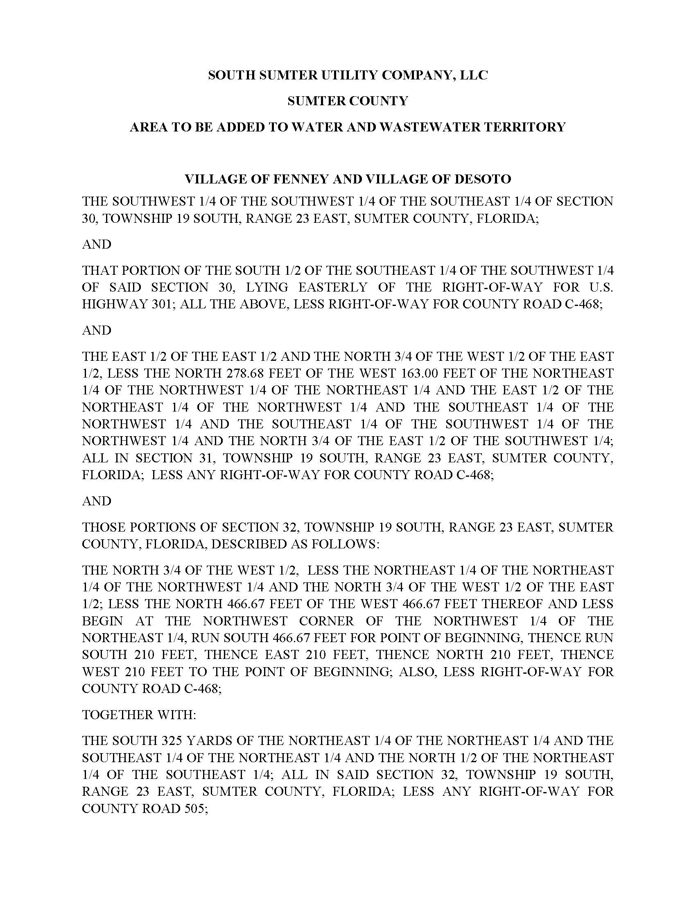
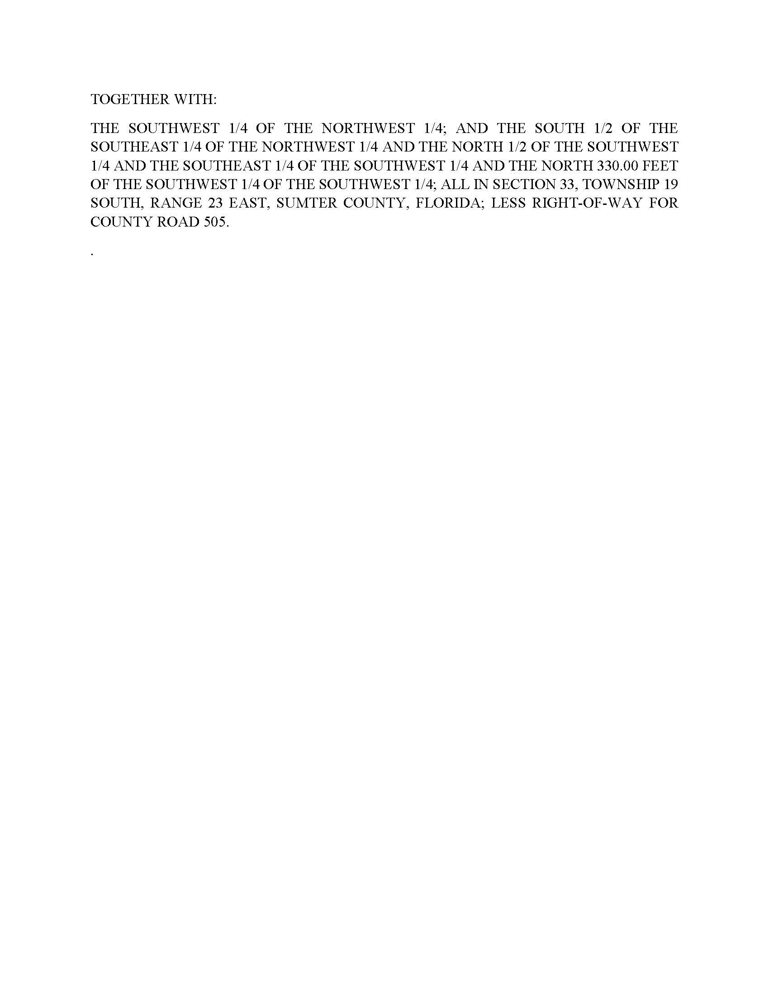
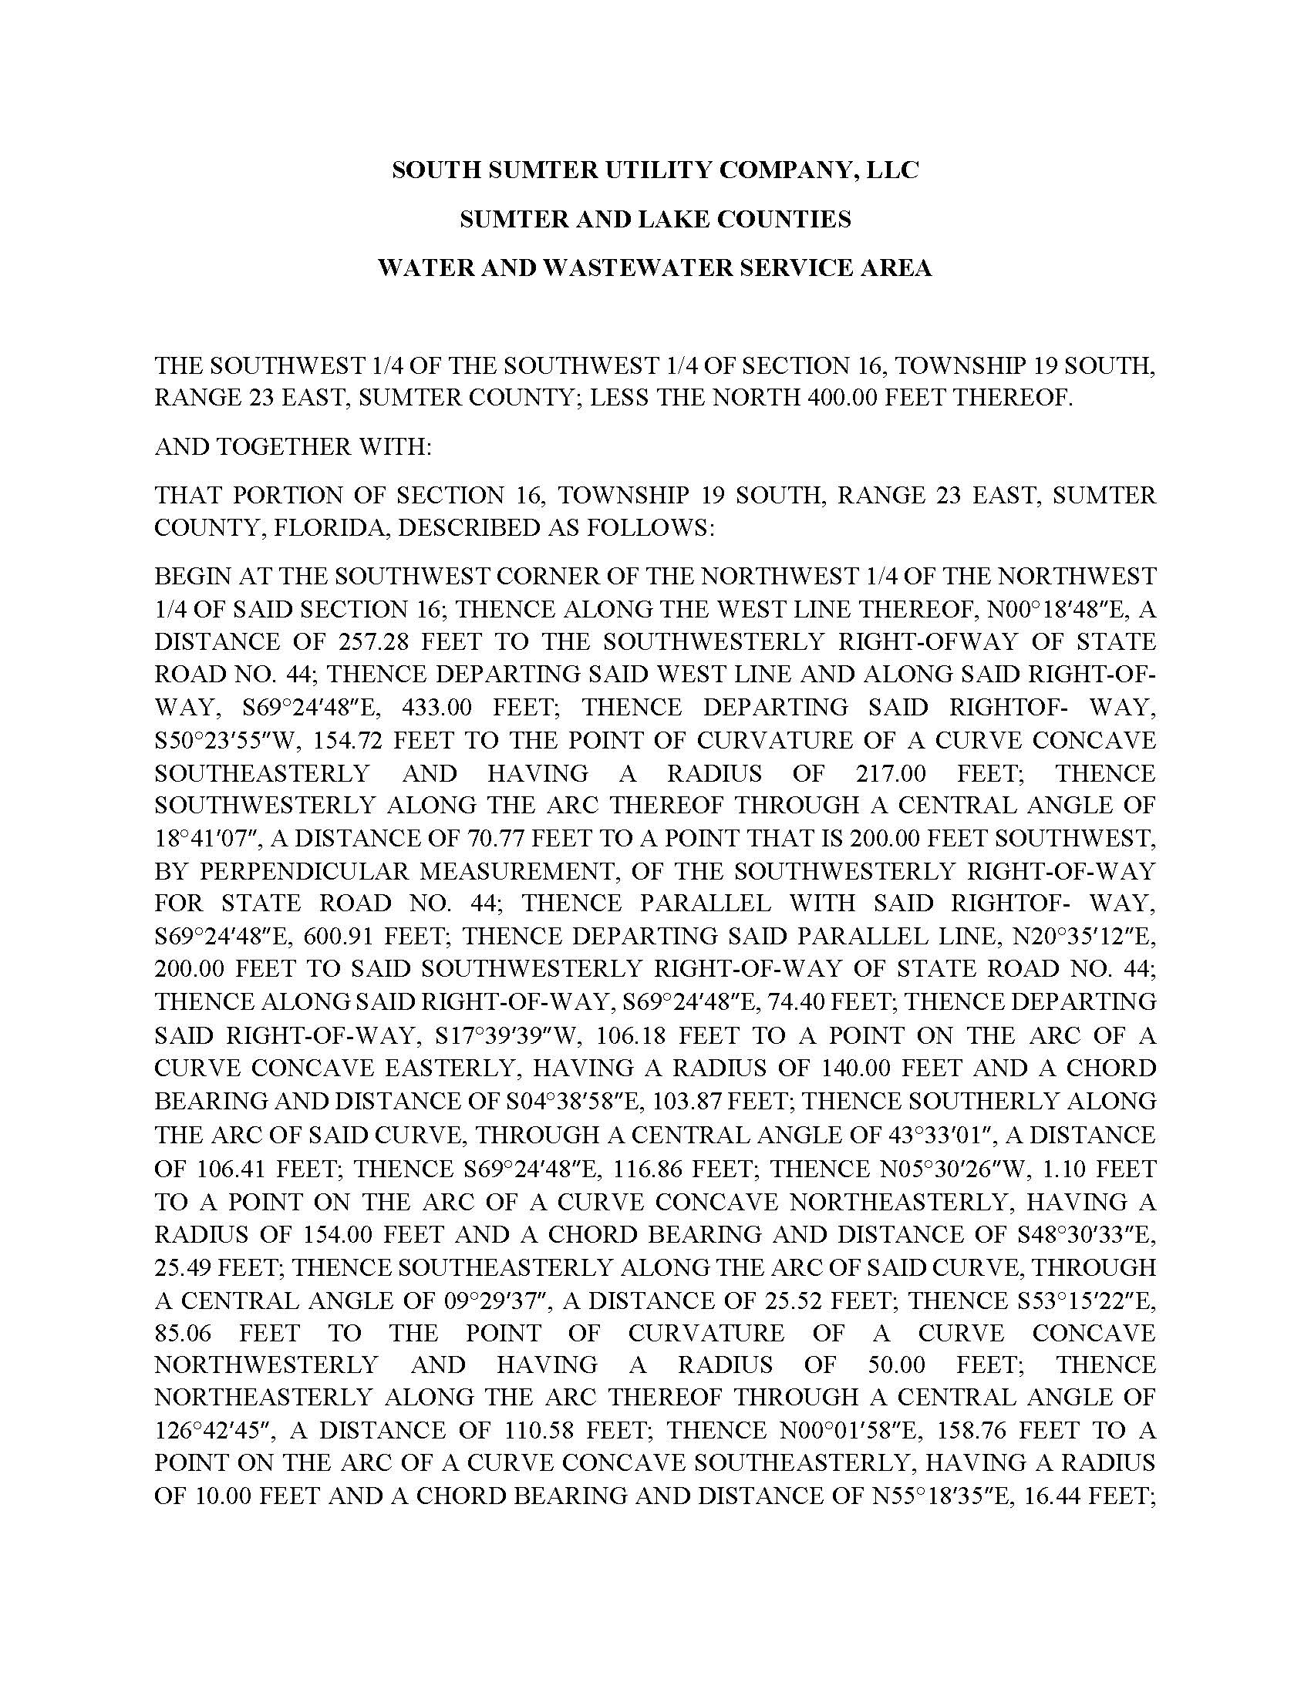

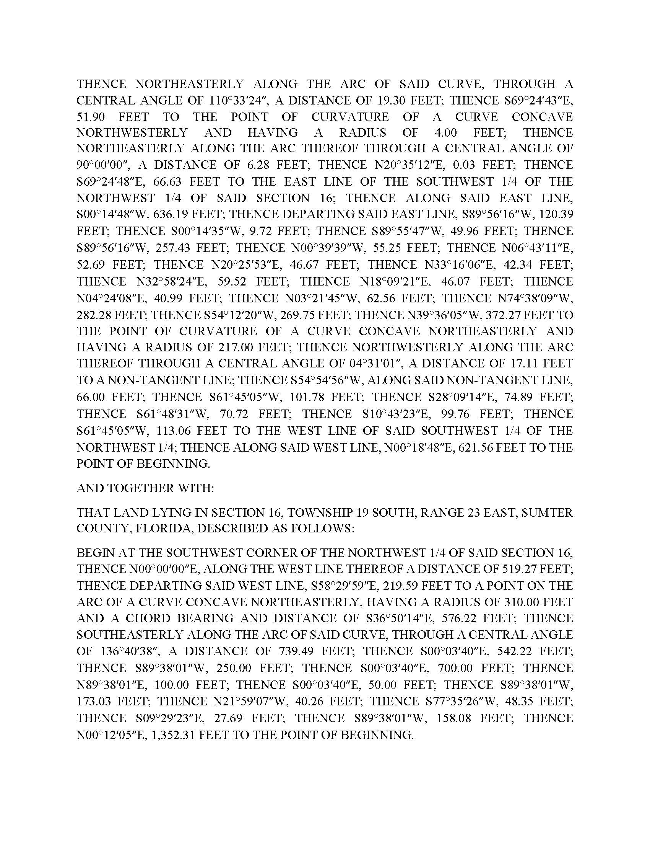

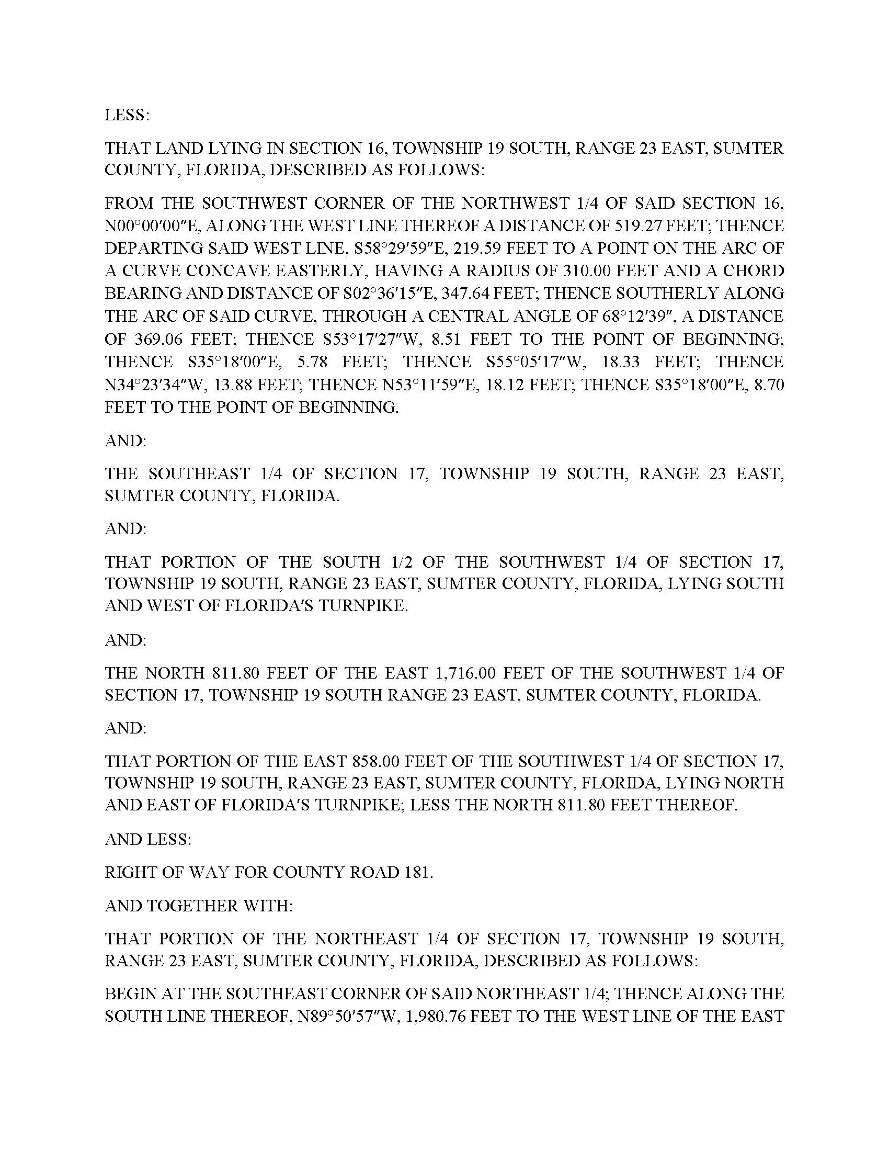

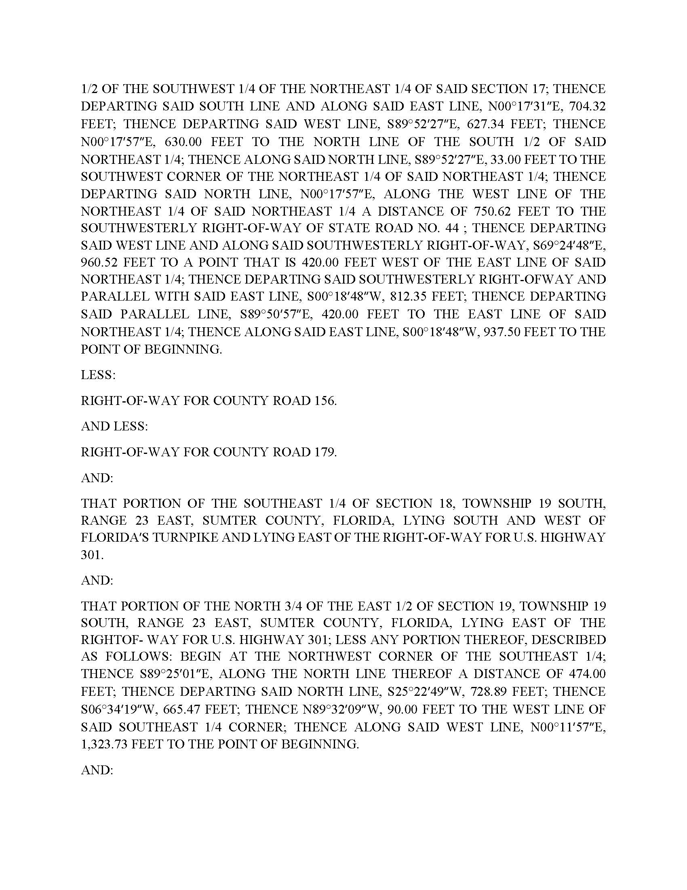

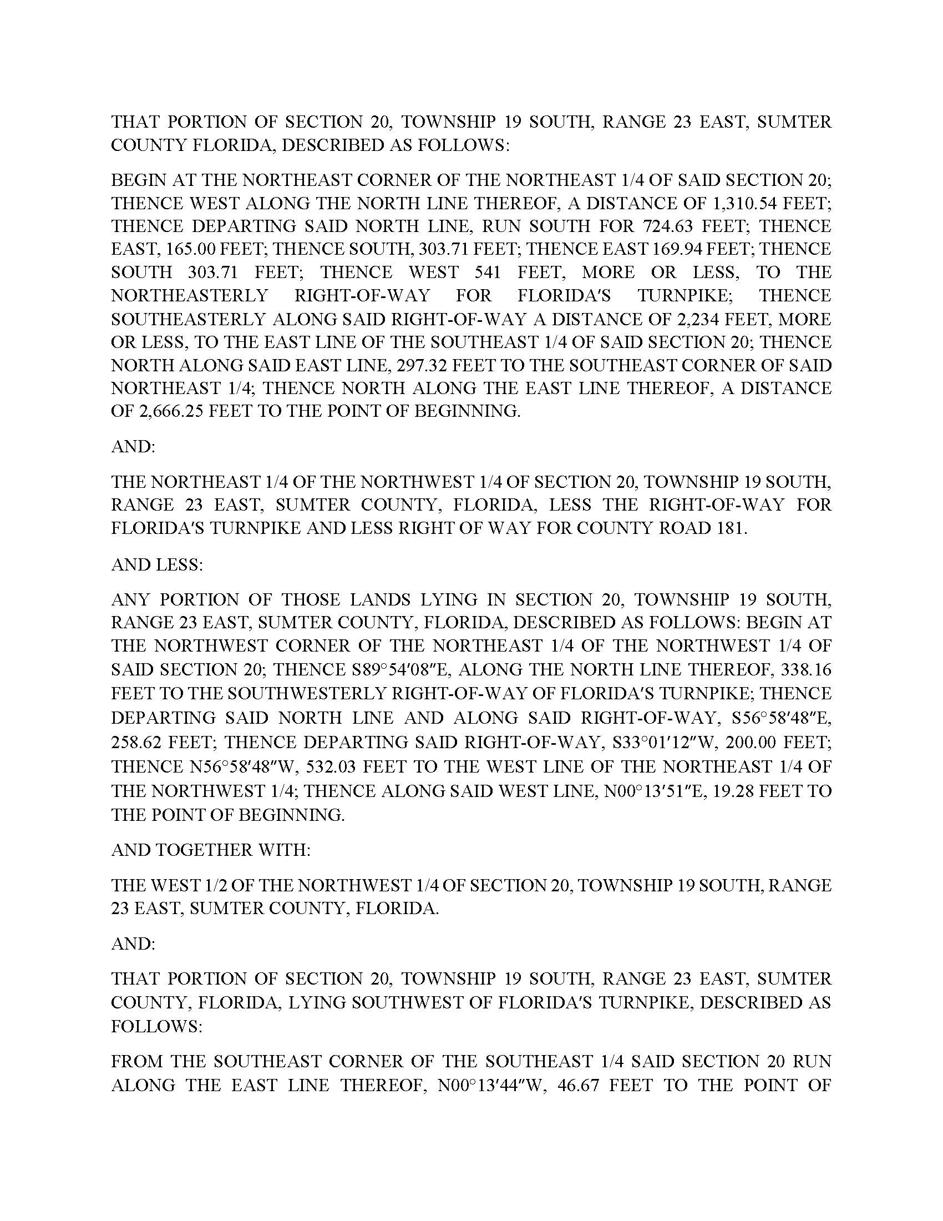

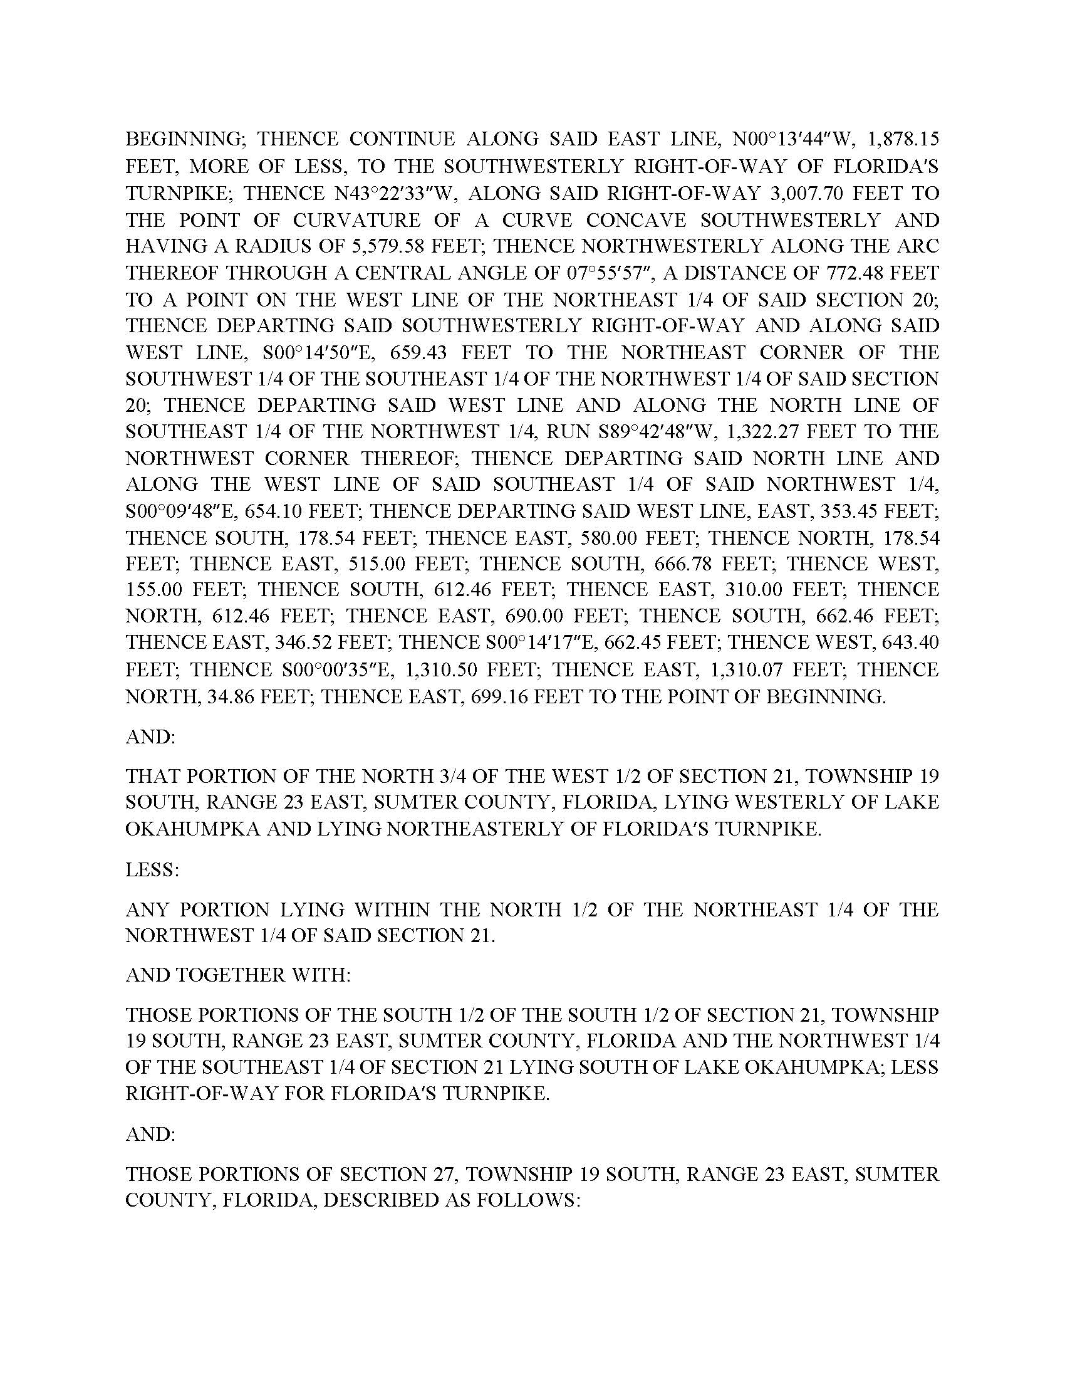

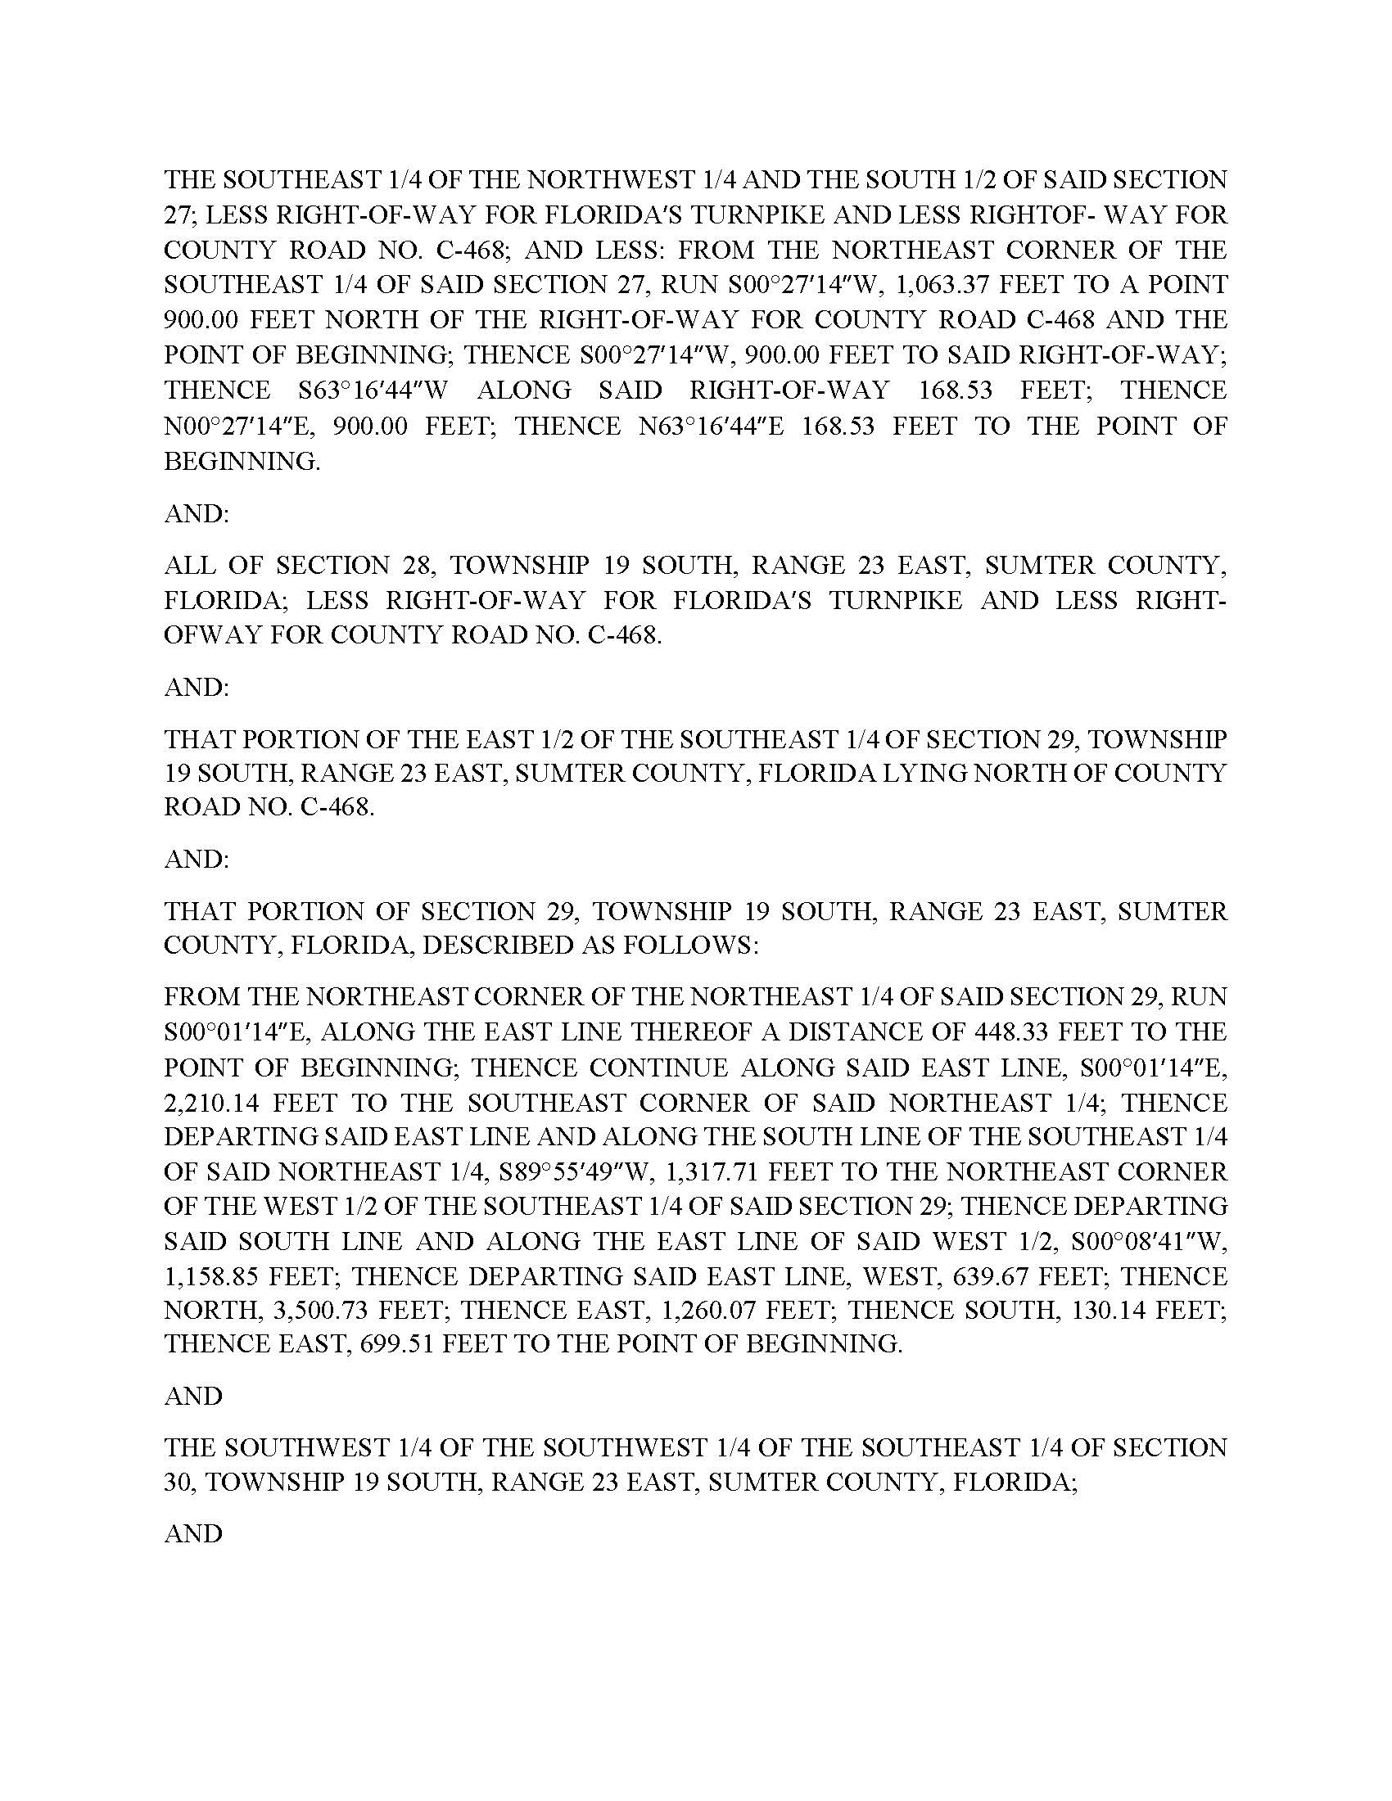

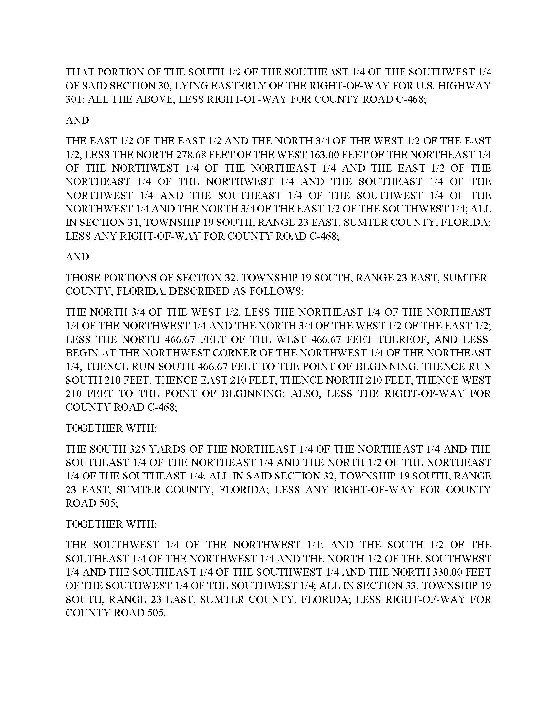

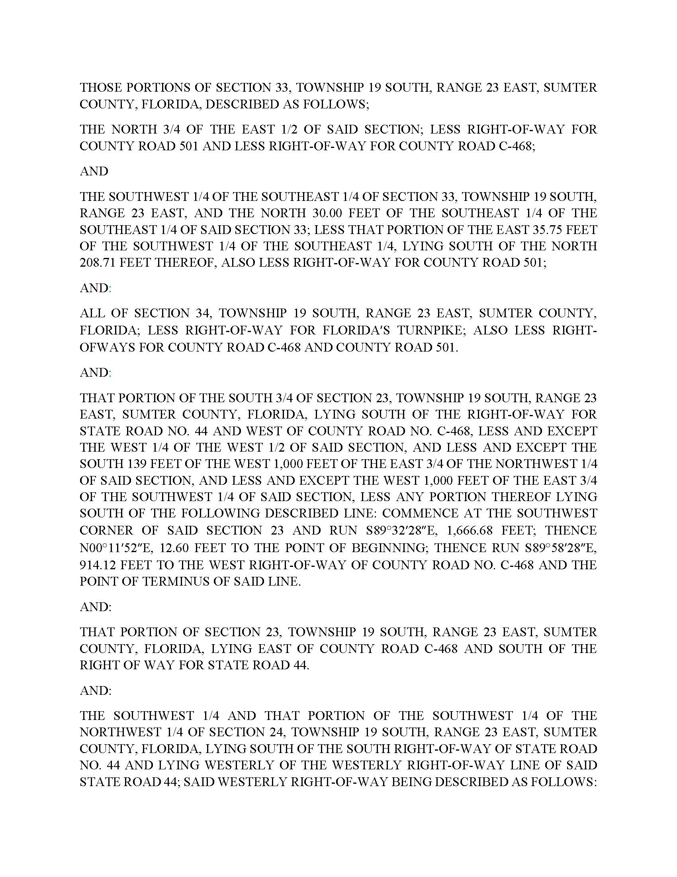

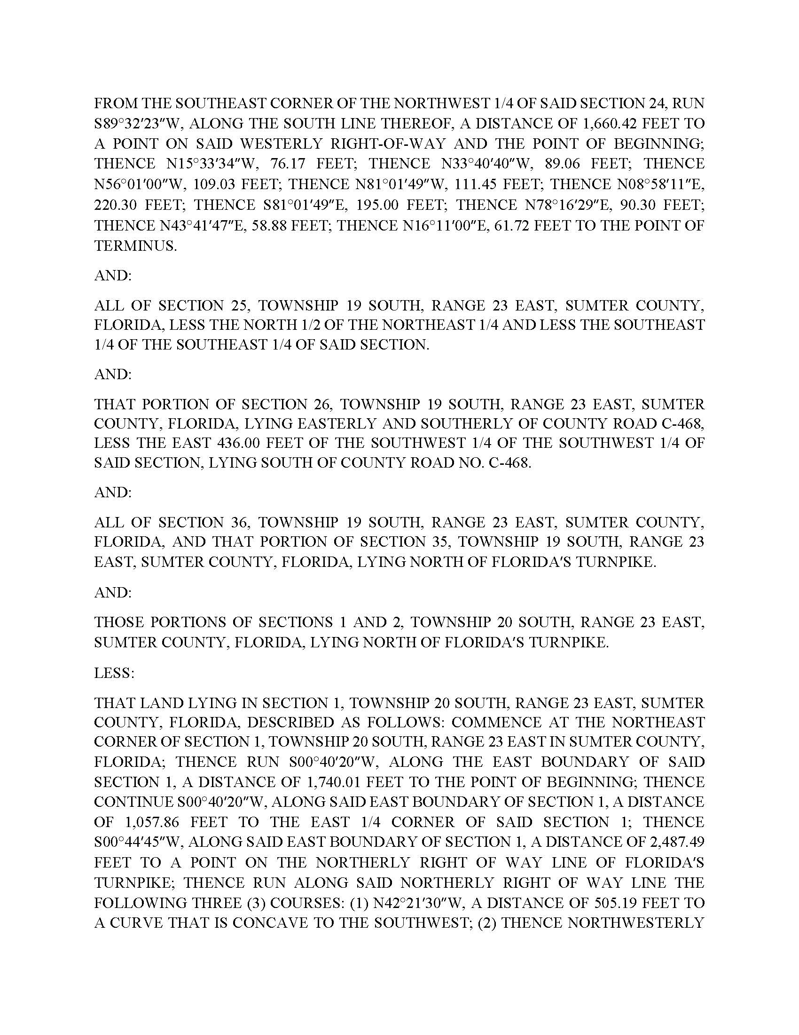

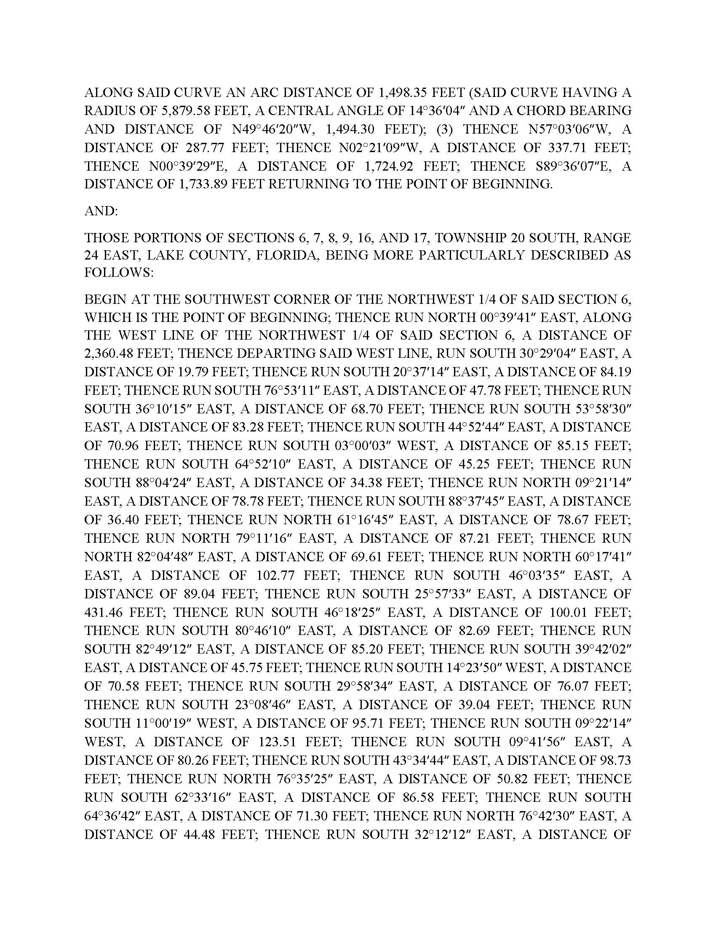

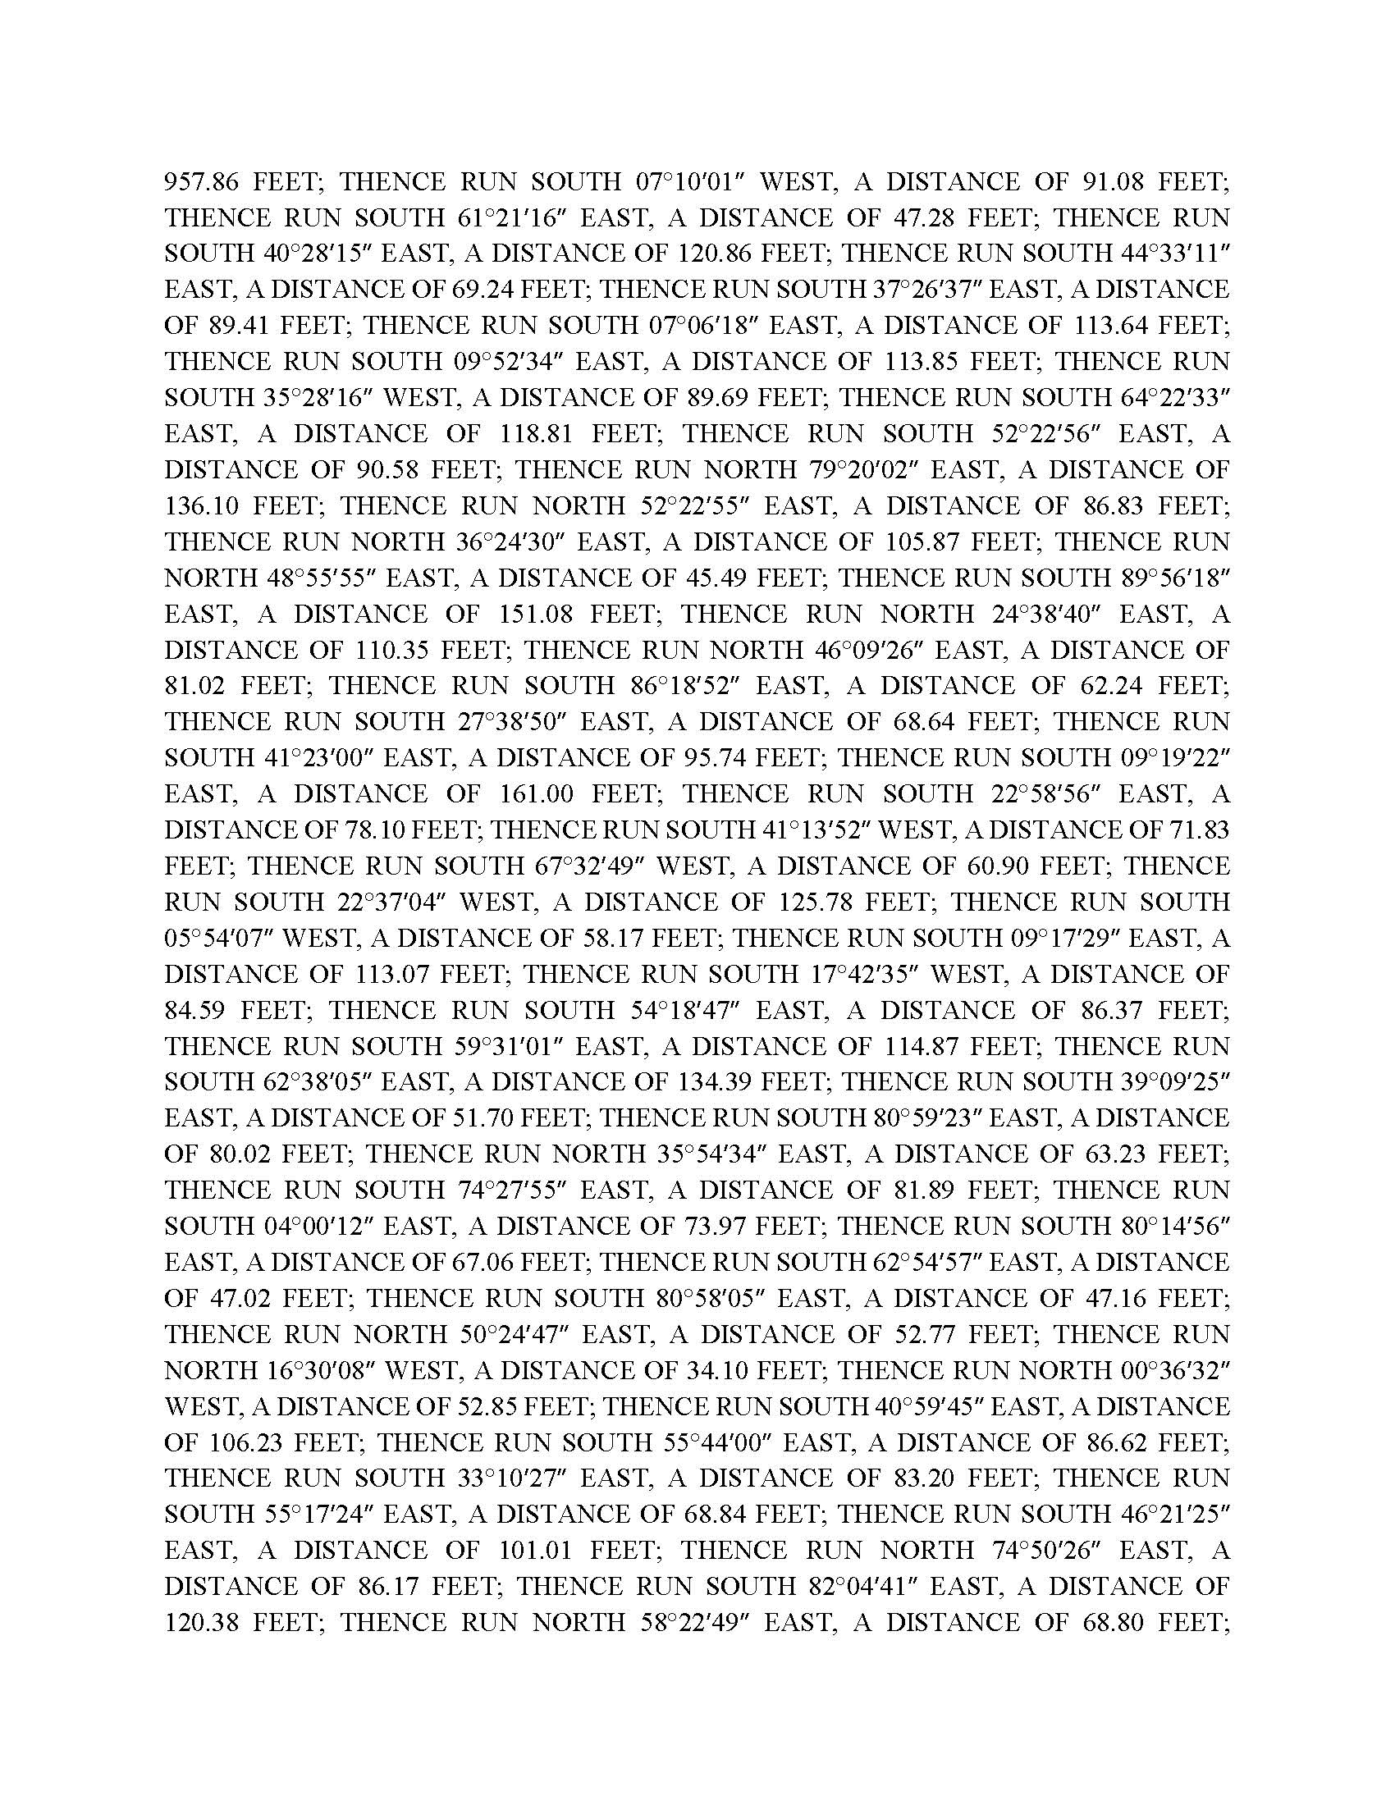

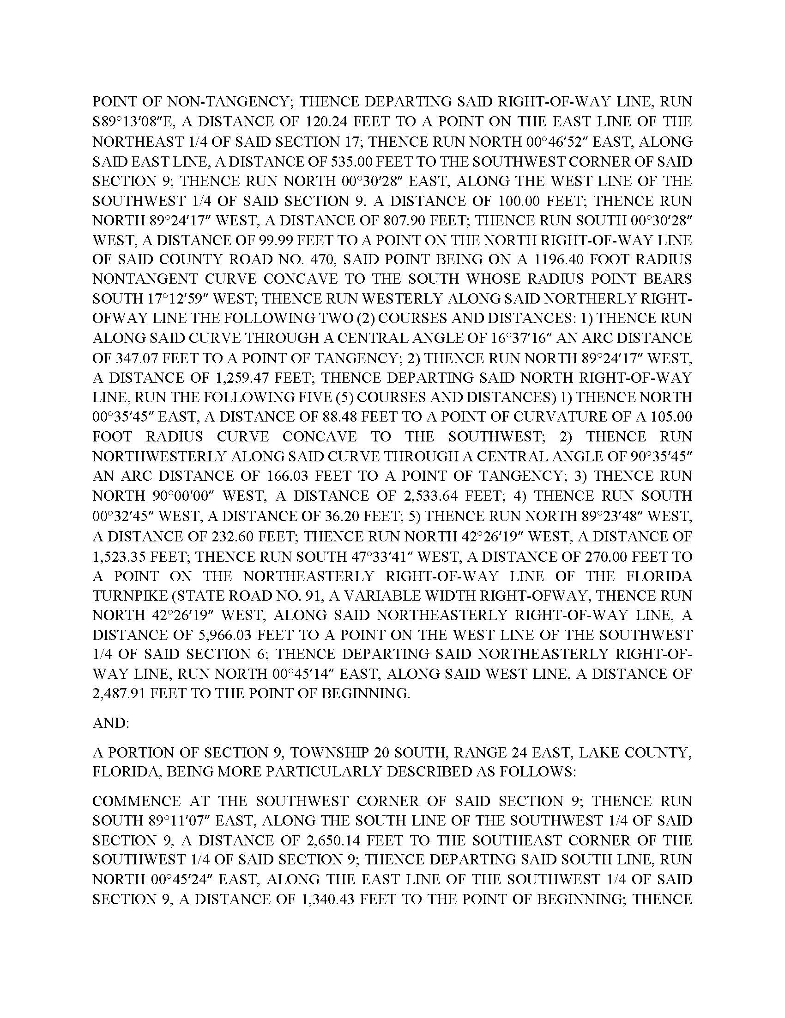

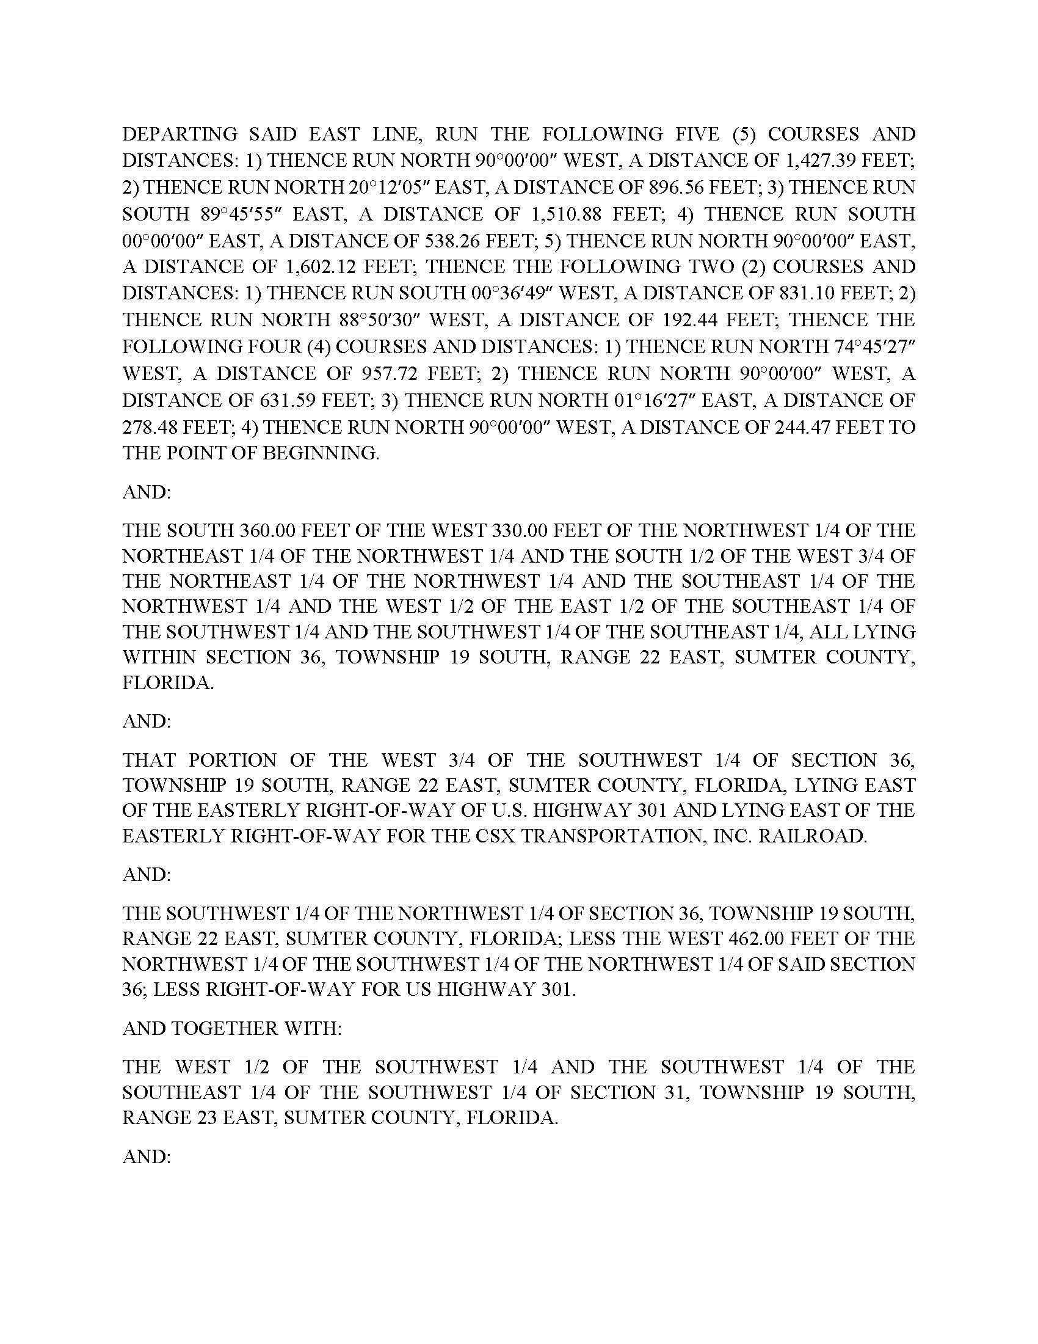

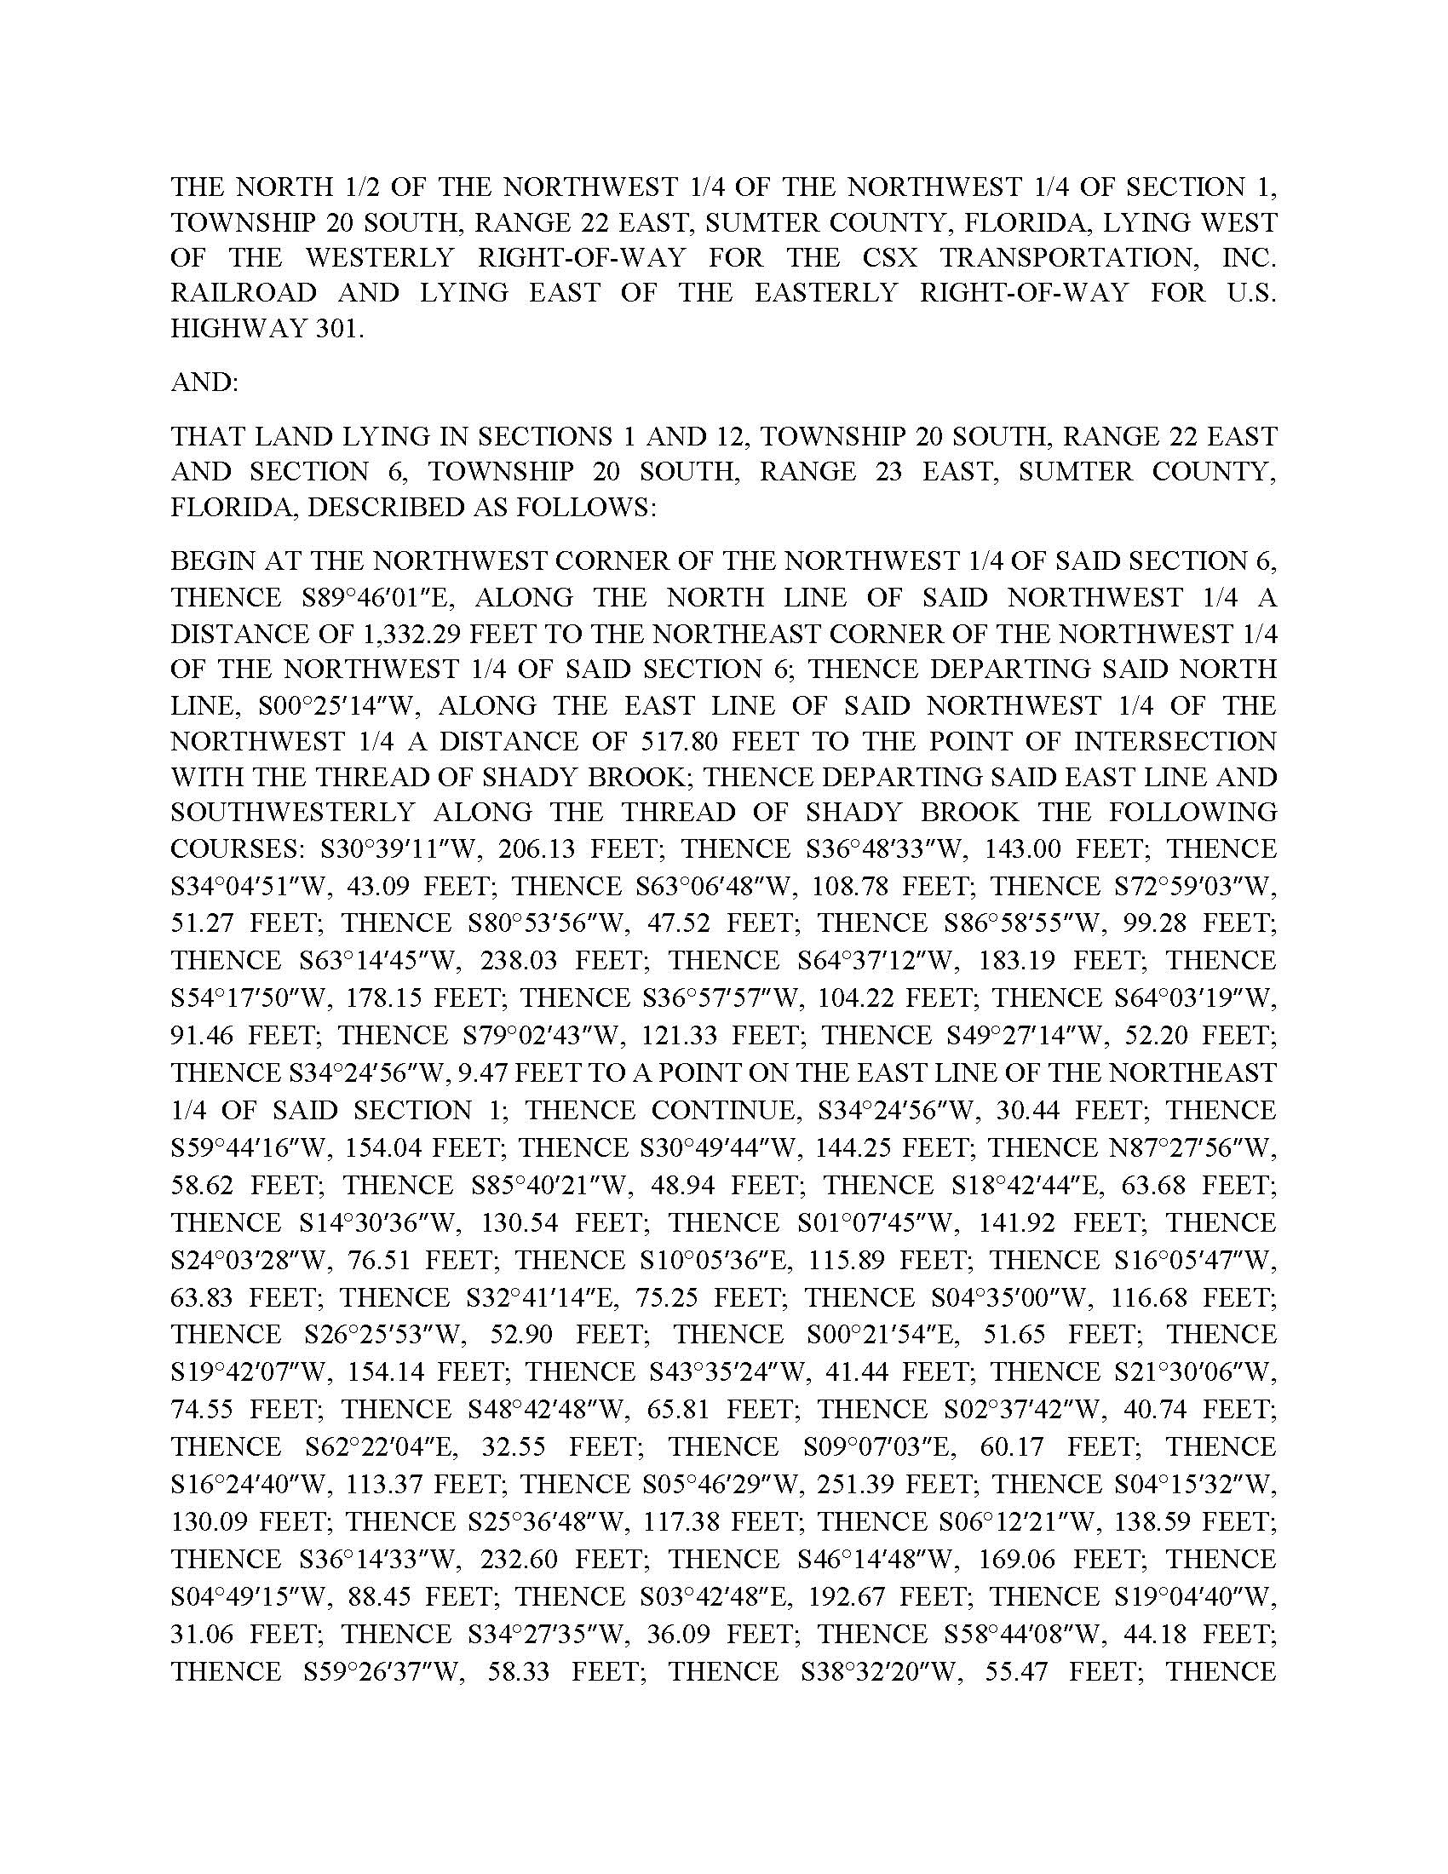

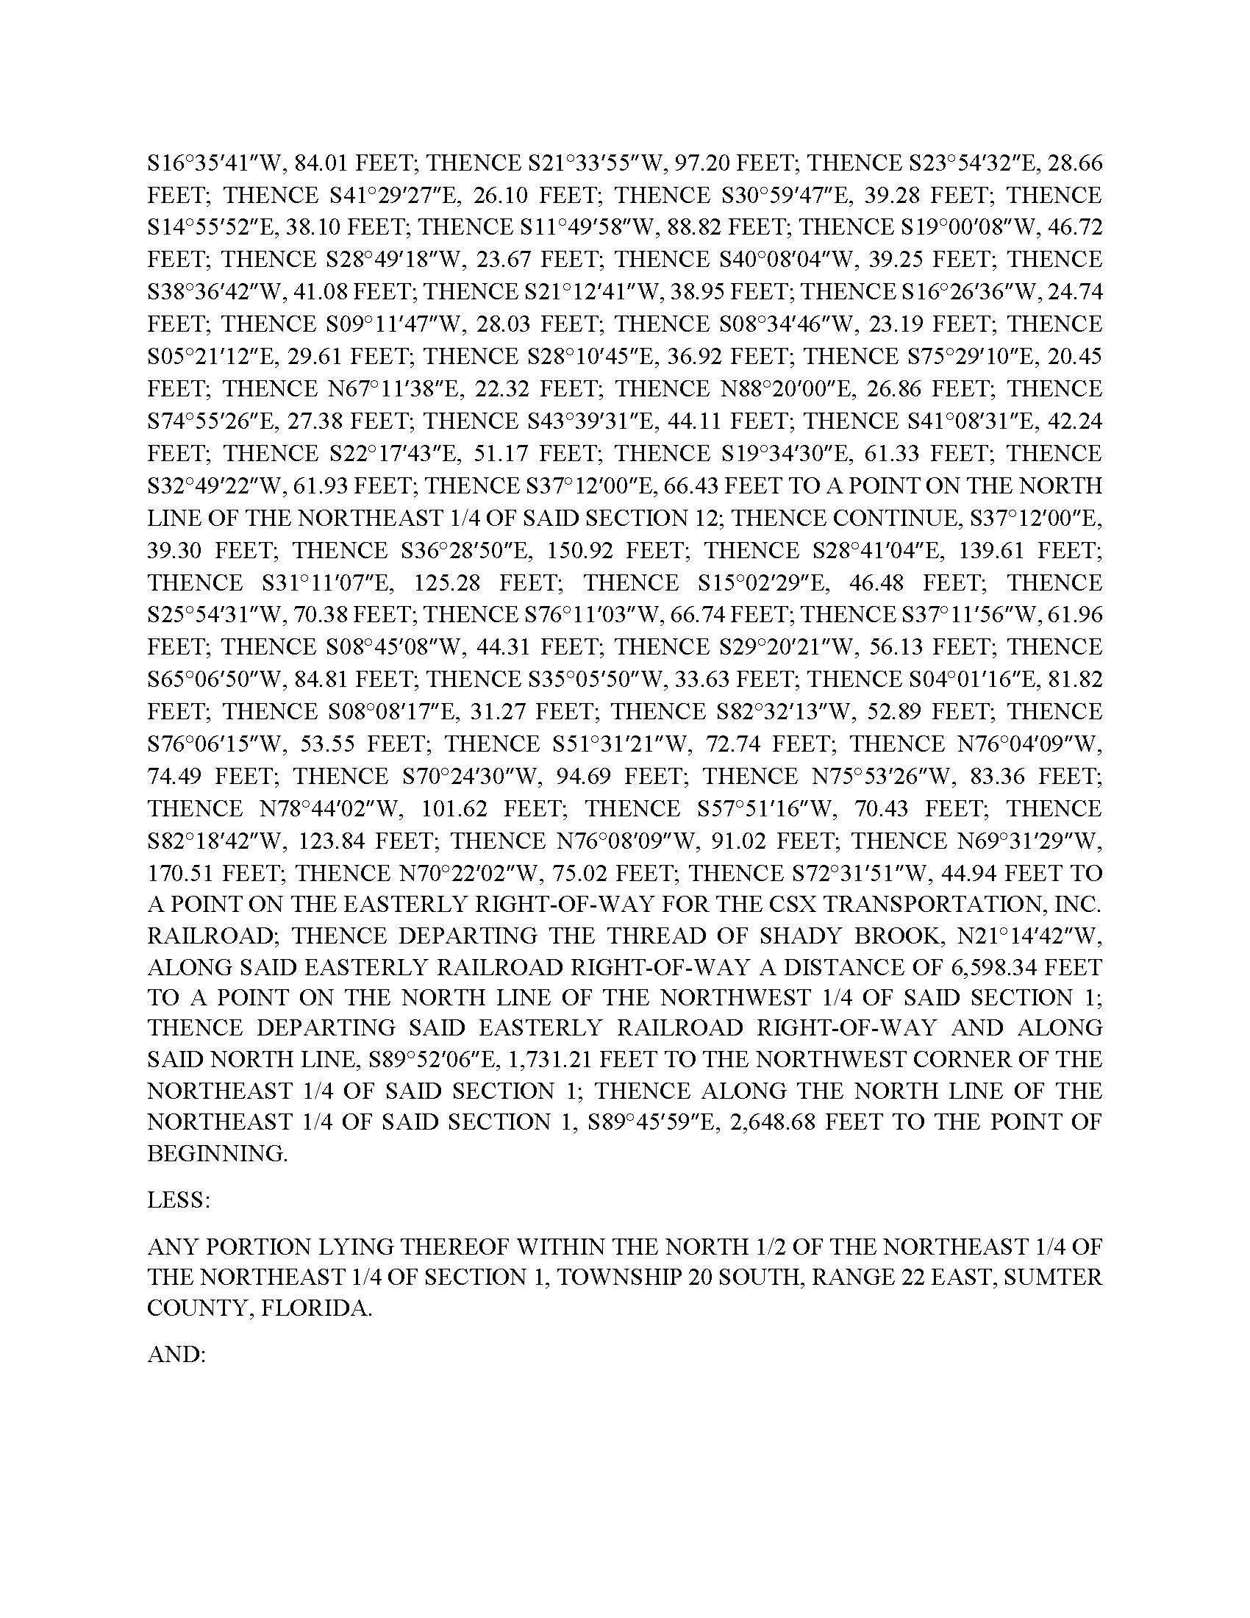

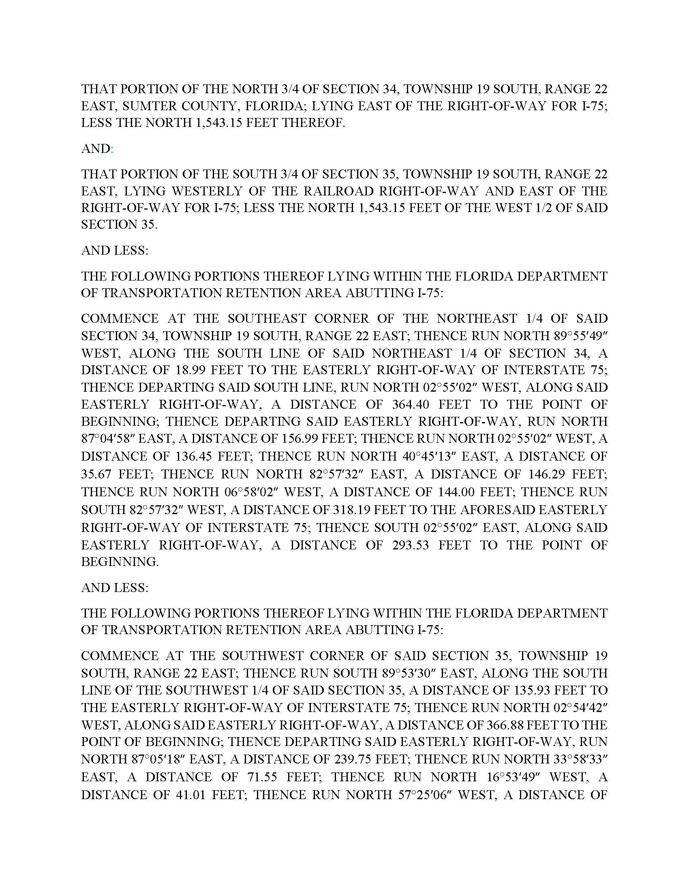

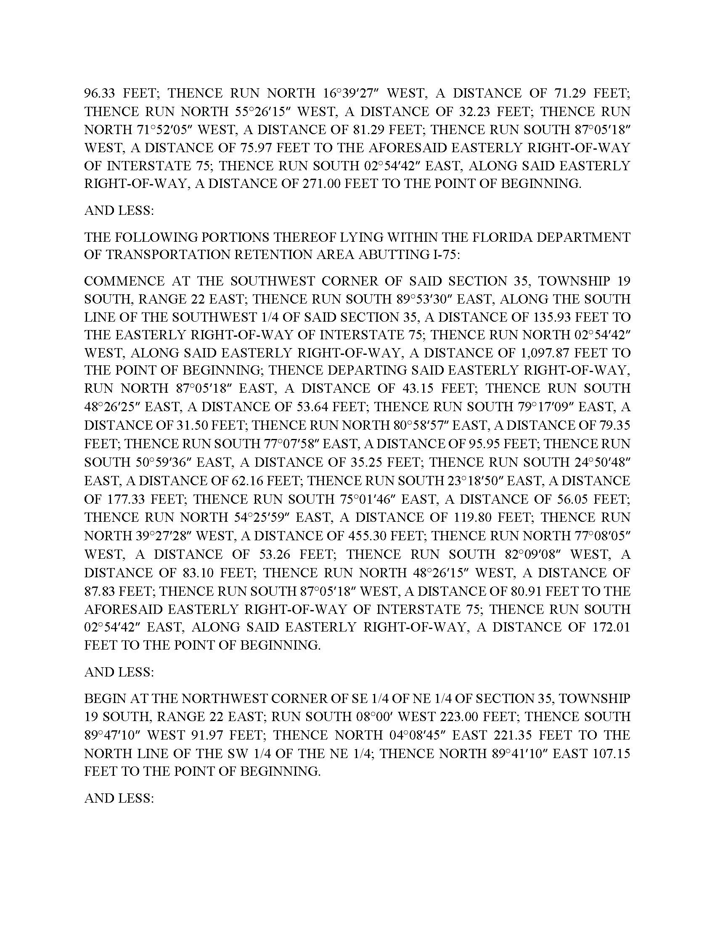

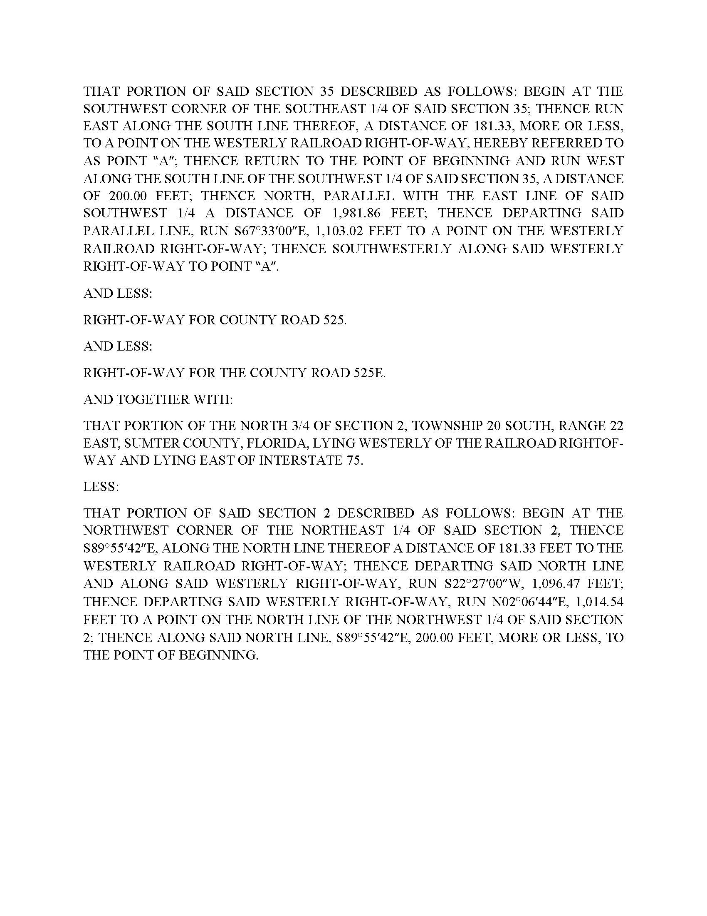

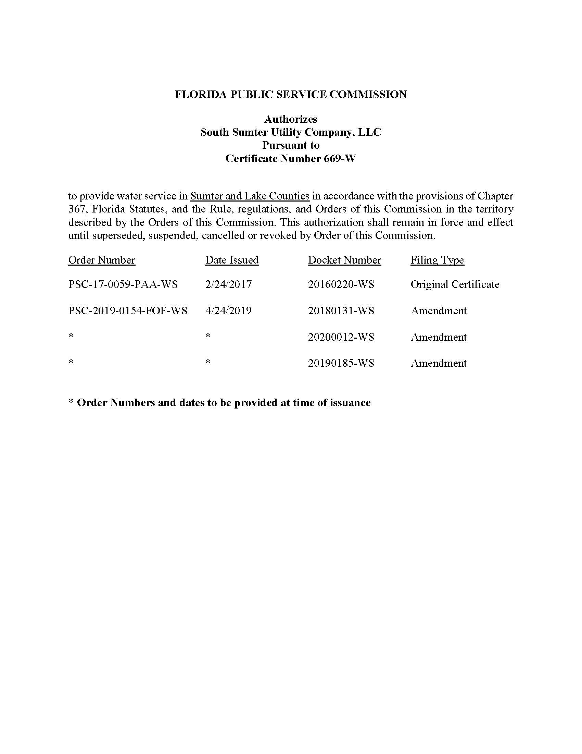

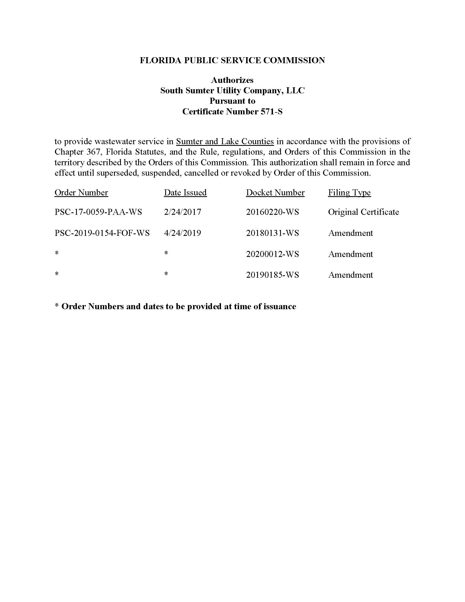
Water System Assets
Schedule of Net Book Value as of September 19, 2020
Description | Balance Per Utility | Adjustments | Staff Recommended
Utility Plant in Service | $3,694,229 | $0 | $3,694,229
Land & Land Rights | 0 | 0 | 0
Accumulated Depreciation | (165,240) | (39,343) | (204,582)
CIAC | (3,694,229) | 0 | (3,694,229)
Amortization of CIAC | 165,240 | 39,343 | 204,582
Total | $0 | $0 | $0

Wastewater System Assets
Schedule of Net Book Value as of September 19, 2020
Description | Balance Per Utility | Adjustments | Staff Recommended
Utility Plant in Service | $6,355,516 | $0 | $6,355,516
Land & Land Rights | 0 | 0 | 0
Accumulated Depreciation | (358,491) | (85,355) | (443,846)
CIAC | (6,355,516) | 0 | (6,355,516)
Amortization of CIAC | 358,491 | 85,355 | 443,846
Total | $0 | $0 | $0

Explanation of Staff’s Recommended
Adjustments to Net Book Value as of September 19, 2020
Water System Assets
Accumulated Depreciation
To reflect the appropriate amount of accumulated depreciation. | ($39,343)
Accumulated Amortization of CIAC
To reflect the appropriate amount of accumulated amortization of CIAC. | $39,343
Total adjustment to Net Book Value as of September 19, 2020. | $0

Explanation of Staff’s Recommended
Adjustments to Net Book Value as of September 19, 2020
Wastewater System Assets
Accumulated Depreciation
To reflect the appropriate amount of accumulated depreciation. | ($85,355)
Accumulated Amortization of CIAC
To reflect the appropriate amount of accumulated amortization of CIAC. | $85,355
Total adjustment to Net Book Value as of September 19, 2020. | $0

South Sumter Utility Company, LLC.
Water System Assets
Schedule of Staff’s Recommended Account Balances as of September 19, 2020
Account No. | Description | UPIS | Accumulated Depreciation
331 | Transmission and Distribution | $2,319,285 | ($116,863)
333 | Services | 1,130,459 | (61,233)
334 | Meters and Meter Installation | 244,485 | (26,486)
 | Total | $3,694,229 | ($204,582)

South Sumter Utility Company, LLC.
Wastewater System Assets
Schedule of Staff’s Recommended Account Balances as of September 19, 2020
Account No. | Description | UPIS | Accumulated Depreciation
360 | Collection Sewers – Force | $642,516 | ($46,404)
361 | Collection Sewers – Gravity | 2,967,490 | (142,879)
363 | Services | 1,198,299 | (68,324)
371 | Pumping Equipment | 1,547,211 | (186,238)
 | Total | $6,355,516 | ($443,846)

South Sumter Utility Company, LLC.
Village of Fenney and Village of DeSoto
Existing City of Wildwood Monthly Water Rates
Residential and General Service
Base Facility Charge by Meter Size
5/8" x 3/4" |  | $9.56
1" |  | $12.24
1 1/2" |  | $20.36
2" |  | $37.85
3" |  | $77.44
4" |  | $141.63
6" |  | $273.64
8” |  | $480.47
10” |  | $815.72
Charge of Per 1,000 gallons – Residential Service
0 – 6,000 gallons |  | $1.66
Over 6,000 gallons |  | $2.51
Charge of Per 1,000 gallons – General Service |  | $2.23

Existing South Sumter Miscellaneous Service and Other Charges
Initial Connection Charge |  |  | $35.13
Normal Reconnection Charge |  |  | $35.13
Violation Reconnection Charge |  |  | $35.13
Premises Visit Charge (in lieu of disconnection) |  |  | $35.13
Late Payment Charge |  |  | $5.50
Non-Sufficient Funds Charge (NSF) |  |  | Pursuant to Section 68.065, F.S.
Meter Tampering Charge |  |  | Actual Cost
Investigation of Meter Tampering |  |  | $35.13
Backflow Prevention Assembly Testing Charge |  |  | Actual Cost

Existing South Sumter Meter Installation Charge
5/8” x 3/4" |  |  | $402.00
All Other Meter Sizes |  |  | Actual Cost

South Sumter Utility Company, LLC.
Village of Fenney and Village of DeSoto
Existing City of Wildwood Monthly Wastewater Rates
Residential and General Service
Base Facility Charge by Meter Size
5/8" x 3/4" |  | $16.99
1" |  | $21.24
1 1/2" |  | $33.96
2" |  | $61.72
3" |  | $124.50
4" |  | $226.42
6" |  | $435.84
8" |  | $764.15
10” |  | $1,296.20
Charge of Per 1,000 gallons (Rate should be multiplied by 90% of water used) |  | $4.54

Existing South Sumter Miscellaneous Service and Other Charges
Initial Connection Charge |  |  | $35.13
Normal Reconnection Charge |  |  | $35.13
Violation Reconnection Charge |  |  | Actual Cost
Premises Visit Charge (in lieu of disconnection) |  |  | $35.13
Late Payment Charge |  |  | $5.50
Non-Sufficient Funds Charge (NSF) |  |  | Pursuant to Section 68.065, F.S.
Collection Device Cleaning Charge |  |  | Actual Cost

Document No. 09030-2019.
Order No. PSC-2018-0271-PAA-WS, issued on May 30, 2018, in Docket No. 20160220-WS, In re: Application for original water and wastewater certificates in Sumter County, by South Sumter Utility Company, LLC., amended by Order NO. PSC-2018-0271A-PAA-WS, issued on August 20, 2018, in Docket No. 20160220-WS, In re: Application for original water and wastewater certificates in Sumter County, by South Sumter Utility Company, LLC.

