BEFORE THE FLORIDA PUBLIC SERVICE COMMISSION

In re: Petition for approval of revised customer specified lighting tariff, by Tampa Electric Company. | DOCKET NO. 20200121-EI  ORDER NO. PSC-2020-0207-TRF-EI  ISSUED: June 25, 2020

The following Commissioners participated in the disposition of this matter:

GARY F. CLARK, Chairman
ART GRAHAM
JULIE I. BROWN
DONALD J. POLMANN
ANDREW GILES FAY

ORDER GRANTING TAMPA ELECTRIC COMPANY’S PETITION FOR
APPROVAL OF CUSTOMER SPECIFIED LIGHTING TARIFF

BY THE COMMISSION:

Background
On April 13, 2020, Tampa Electric Company (TECO or utility) filed a Petition for Approval of Revised Customer Specified Lighting Tariff (LS-2 tariff). TECO proposes to revise Tariff Sheet No. 6.830 to enable the utility to offer metered service to its LS-2 customers. Currently, the LS-2 tariff is only available as a non-metered lighting service. We previously approved the LS-2 tariff by Order No. PSC-2019-0063-TRF.
During the review of this petition, Commission staff issued a data request to TECO to which responses were received on May 5, 2020. On May 8, 2020, TECO filed a revision to Tariff Sheet No. 6.830 to correct a scrivener’s error. The approved Tariff Sheet No. 6.830 in legislative format is included in Attachment A. We have jurisdiction over this matter pursuant to Sections 366.03, 366.04, 366.05, and 366.06, Florida Statutes (F.S.).

Decision
TECO offers two outdoor lighting service tariffs: the LS-1 tariff and the LS-2 tariff. Under the LS-1 tariff, customers have the option of unmetered lighting service for TECO-owned fixtures or of metered lighting service for customer-owned fixtures. The LS-1 tariff lists the TECO-owned fixtures available for the unmetered option and the energy is billed based on the estimated usage of the fixture. Under the customer-owned option, TECO provides the energy only and the customer is responsible for maintaining the fixtures. The customer may own fixtures that are not offered by TECO. TECO explained that the majority of LS-1 customers take service under the unmetered utility-owned fixtures option; however, approximately 200 customers own the lighting facilities and use the energy-only rate offering under the LS-1 tariff.
The LS-2 tariff allows TECO to offer service for utility-owned specific fixtures or poles that are not available under the LS-1 tariff. If a customer requests a special or unique fixture, TECO purchases and installs the lighting facilities and bills the customer for the fixture and maintenance cost based on the in-place value of the facilities. Under the current LS-2 tariff, service is unmetered and the energy is billed based on the estimated usage of the fixture.
TECO explained that while the LS-1 tariff provides a metered service option, the current LS-2 tariff does not offer a metered service option. The proposed revision in the LS-2 tariff adds a section titled Special Conditions which outlines pricing for metered service. The proposed charges for metered service are the same as the currently approved LS-1 metered energy charge of 2.510 cents per kilowatt-hour (kWh) and basic service charge of $10.52 per month. Other charges such as energy conservation, capacity, and environmental charges will also be applicable.
TECO explained that the petition was filed in response to LS-1 customers who own metered lighting systems and expressed an interest to transfer ownership and maintenance of the fixtures to TECO. If the fixtures the customer owns are not offered by the utility under the LS-1 tariff, service would have to be transferred to the LS-2 tariff to allow TECO to take ownership of the lighting facilities. In response to Commission staff’s data request, TECO stated that an advantage to a customer transferring from LS-1 to LS-2 would be the maintenance, repair, and replacement of their lighting system would be the responsibility of TECO.
Customers taking service under the LS-2 tariff are required to sign a Bright Choices Outdoor Lighting Agreement (agreement) with a minimum 20 year initial term and successive one year terms continuing thereafter until either party provides the other party a 90 day written notice of termination. In response to staff’s data request, TECO stated that if an LS-1 customer transferred to LS-2 and later desires to transfer back to LS-1, an early termination penalty would be applicable, per the agreement.
TECO stated that it currently does not have any customers taking service under the LS-2 tariff, but approximately six LS-1 customers have expressed some interest in transferring to the LS-2 tariff to allow TECO to take ownership of the facilities. TECO explained that any compensation to the customer for the transferred lighting facilities would be negotiated between the customer and TECO and the negotiated amount would be specified in the agreement. The utility states the types of customers who would be interested in transferring are municipal lighting systems, parking lot lighting systems, and lighting in car lots/business spaces. TECO explained that if a customer requests their metered lighting system to be taken over by TECO, the utility would evaluate the existing condition and type of lighting equipment and upgrades needed to the equipment.

Conclusion
We have reviewed TECO’s petition and response to Commission staff’s data request and find the proposed revision to the LS-2 tariff to allow for metered service, as currently is available under the LS-1 tariff, to be reasonable and appropriate. TECO’s LS-2 tariff is hereby approved, effective June 9, 2020, the date of our vote on this matter.
Based on the foregoing, it is

ORDERED by the Florida Public Service Commission that Tampa Electric Company’s proposed revision to its LS-2 tariff, as shown in Attachment A, is approved effective June 9, 2020. It is further

ORDERED that if a protest is filed within 21 days of issuance of the Order, the tariff shall remain in effect with any charges held subject to refund pending resolution of the protest. It is further

ORDERED that if no timely protest is filed, this docket shall be closed upon the issuance of a Consummating Order.

By ORDER of the Florida Public Service Commission this 25th day of June, 2020.

/s/ Adam J. Teitzman
ADAM J. TEITZMAN
Commission Clerk
Florida Public Service Commission
2540 Shumard Oak Boulevard
Tallahassee, Florida 32399
(850) 413-6770
www.floridapsc.com

Copies furnished: A copy of this document is provided to the parties of record at the time of issuance and, if applicable, interested persons.
SPS

NOTICE OF FURTHER PROCEEDINGS

The Florida Public Service Commission is required by Section 120.569(1), Florida Statutes, to notify parties of any administrative hearing or judicial review of Commission orders that is available under Sections 120.57 or 120.68, Florida Statutes, as well as the procedures and time limits that apply. This notice should not be construed to mean all requests for an administrative hearing or judicial review will be granted or result in the relief sought.

Mediation may be available on a case-by-case basis. If mediation is conducted, it does not affect a substantially interested person's right to a hearing.

The Commission's decision on this tariff is interim in nature and will become final, unless a person whose substantial interests are affected by the proposed action files a petition for a formal proceeding, in the form provided by Rule 28-106.201, Florida Administrative Code. This petition must be received by the Office of Commission Clerk, 2540 Shumard Oak Boulevard, Tallahassee, Florida 32399-0850, by the close of business on July 16, 2020.

In the absence of such a petition, this Order shall become final and effective upon the issuance of a Consummating Order.

Any objection or protest filed in this docket before the issuance date of this order is considered abandoned unless it satisfies the foregoing conditions and is renewed within the specified protest period.

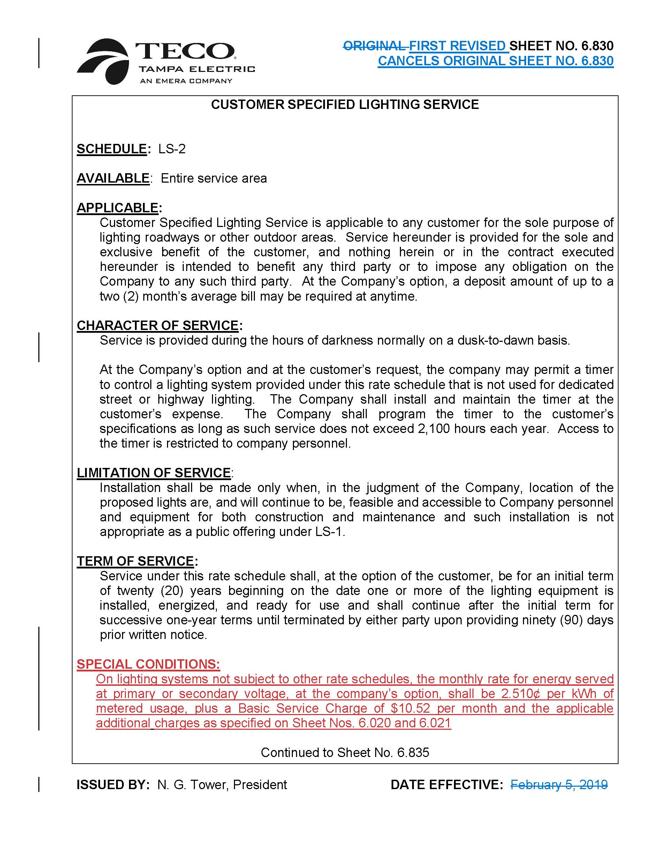

Order No. PSC-2019-0063-TRF-EI, issued February 18, 2019, in Docket No. 20180222-EI, In re: Petition for approval of customer specified lighting tariff by Tampa Electric Company.

