BEFORE THE FLORIDA PUBLIC SERVICE COMMISSION

In re: Petition for approval of renewable energy tariff and standard offer contract, by Florida Power & Light Company. | DOCKET NO. 20200114-EQ  ORDER NO. PSC-2020-0212-PAA-EQ  ISSUED: June 26, 2020

The following Commissioners participated in the disposition of this matter:

GARY F. CLARK, Chairman
ART GRAHAM
JULIE I. BROWN
DONALD J. POLMANN
ANDREW GILES FAY

NOTICE OF PROPOSED AGENCY ACTION
ORDER APPROVING FLORIDA POWER AND LIGHT COMPANY’S
STANDARD OFFER CONTRACT AND RATE SCHEDULE QS-2

BY THE COMMISSION:

NOTICE is hereby given by the Florida Public Service Commission (Commission) that the action discussed herein is preliminary in nature and will become final unless a person whose interests are substantially affected files a petition for a formal proceeding, pursuant to Rule 25-22.029, Florida Administrative Code (F.A.C.).

Background

Section 366.91(3), Florida Statutes (F.S.), requires each investor-owned utility (IOU) to continuously offer to purchase capacity and energy from renewable generating facilities and small qualifying facilities. Rules 25-17.200 through 25-17.310, F.A.C., implement the statute and require each IOU to file with this Commission, by April 1 of each year, a revised standard offer contract based on the next avoidable fossil fueled generating unit of each technology type identified in the utility’s current Ten-Year Site Plan. On April l, 2020, Florida Power & Light Company (FPL) filed a petition for approval of its revised standard offer contract, based on its 2020 Ten-Year Site Plan. Since its initial filing, FPL has filed two revisions to its petition to correct typographical and calculation errors. We have jurisdiction over this standard offer contract pursuant to Sections 366.04 through 366.055, and 366.91, F.S.

Review
Section 366.91(3), F.S., and Rule 25-17.250, F.A.C., require that FPL, an IOU, continuously make available a standard offer contract for the purchase of firm capacity and energy from renewable generating facilities (RF) and small qualifying facilities (QF) with design capacities of 100 kilowatts (kW) or less. Pursuant to Rules 25-17.250(1) and (3), F.A.C., the standard offer contract must provide a term of at least 10 years, and the payment terms must be based on the utility’s next avoidable fossil-fueled generating unit identified in its most recent Ten-Year Site Plan, or if no avoided unit is identified, its next avoidable planned purchase.
FPL’s submitted 2020 Ten-Year Site Plan does not feature an avoidable fossil-fueled generating unit or planned purchases that could be deferred during the planning period, FPL could opt to offer only a standard contract for energy payments based on its as-available energy cost. However, to encourage renewable generation, FPL has identified a 1,991 megawatt (MW) natural gas-fired combined cycle unit (CC) as the next planned generating unit. The projected in-service date of the unit is June 1, 2030. We have approved using a unit outside of the Ten-Year Site Plan planning period previously.
Under FPL’s standard offer contract, the RF/QF operator commits to certain minimum performance requirements based on the identified avoided unit, such as being operational and delivering an agreed upon amount of capacity by the in-service date of the avoided unit, and thereby becomes eligible for capacity payments in addition to payments received for energy. The standard offer contract may also serve as a starting point for negotiation of contract terms by providing payment information to an RF/QF operator, in a situation where one or both parties desire particular contract terms other than those established in the standard offer.
In order to promote renewable generation, we require the IOU to offer multiple options for capacity payments, including the options to receive early or levelized payments. If the RF/QF operator elects to receive capacity payments under the normal or levelized contract options, it will receive as-available energy payments only until the in-service date of the avoided unit (in this case June 1, 2030), and thereafter, begin receiving capacity payments in addition to the energy payments. If either the early or early levelized option is selected, then the operator will begin receiving capacity payments earlier than the in-service date of the avoided unit. However, payments made under the early capacity payment options tend to be lower in the later years of the contract term because the net present value (NPV) of the total payments must remain equal for all contract payment options.
Table 1 contains FPL’s estimates of the annual payments for each payment option available under the revised standard offer contract to an operator with a 50 MW facility operating at a capacity factor of 94 percent, which is the minimum capacity factor required under the contract to qualify for full capacity payments. Normal and levelized capacity payments begin with the projected in-service date of the avoided unit (June 1, 2030), while early and early levelized capacity payments begin in 2026 for this example.

Table 1 - Estimated Annual Payments to a 50 MW Renewable Facility
(94% Capacity Factor)
Year | Energy Payment | Capacity Payment (By Type)
 |  | Normal | Levelized | Early | Early Levelized
 | $(000) | $(000) | $(000) | $(000) | $(000)
2021 | 6,908 | - | - | ‐ | ‐
2022 | 6,933 | - | - | ‐ | ‐
2023 | 8,038 | - | - | ‐ | ‐
2024 | 8,709 | - | - | ‐ | ‐
2025 | 9,648 | - | - | ‐ | ‐
2026 | 10,212 | - | - | 1,975 | 2,217
2027 | 10,639 | - | - | 2,014 | 2,217
2028 | 11,517 | - | - | 2,054 | 2,217
2029 | 11,540 | - | - | 2,095 | 2,217
2030 | 11,625 | 3,263 | 3,574 | 2,137 | 2,217
2031 | 11,910 | 3,332 | 3,574 | 2,180 | 2,217
2032 | 12,556 | 3,402 | 3,574 | 2,223 | 2,217
2033 | 12,862 | 3,473 | 3,574 | 2,268 | 2,217
2034 | 13,404 | 3,546 | 3,574 | 2,313 | 2,217
2035 | 13,035 | 3,620 | 3,574 | 2,359 | 2,217
2036 | 13,102 | 3,696 | 3,574 | 2,407 | 2,217
2037 | 12,370 | 3,774 | 3,574 | 2,455 | 2,217
2038 | 12,076 | 3,853 | 3,574 | 2,504 | 2,217
2039 | 13,828 | 3,934 | 3,574 | 2,554 | 2,217
2040 | 13,613 | 4,016 | 3,574 | 2,605 | 2,217
Total | 224,525 | 39,908 | 39,316 | 34,143 | 33,253
Total (NPV) | 105,773 | 13,601 | 13,601 | 13,601 | 13,601

Source: FPL’s Amended Response to Our Staff’s First Data Request

FPL’s standard offer contract, in type-and-strike format, is included as Attachment A to this Order. The changes made to FPL’s tariff sheets are consistent with the updated avoided unit. Revisions include updates to calendar dates and payment information which reflect the current economic and financial assumptions for the avoided unit.

Decision

We hereby approve FPL’s revised standard offer contract and associated rate schedule QS-2 as filed. The provisions of FPL’s revised standard offer contract conform to all requirements of Rules 25-17.200 through 25-17.310, F.A.C. The revised standard offer contract provides flexibility in the arrangements for payments so that a developer of renewable generation may select the payment stream best suited to its financial needs.
Based on the foregoing, it is

ORDERED by the Florida Public Service Commission that Florida Power and Light Company’s revised standard offer contract and associated rate schedule QS-2 are approved. It is further

ORDERED that the provisions of this Order, issued as proposed agency action, shall become final and effective upon the issuance of a Consummating Order unless an appropriate petition, in the form provided by Rule 28-106.201, Florida Administrative Code, is received by the Commission Clerk, 2540 Shumard Oak Boulevard, Tallahassee, Florida 32399-0850, by the close of business on the date set forth in the “Notice of Further Proceedings” attached hereto. Potential signatories should be aware that, if a timely protest is filed, Florida Power and Light Company’s standard offer contract may subsequently be revised. It is further

ORDERED that in the event this Order becomes final, this docket shall be closed.

By ORDER of the Florida Public Service Commission this 26th day of June, 2020.

/s/ Adam J. Teitzman
ADAM J. TEITZMAN
Commission Clerk
Florida Public Service Commission
2540 Shumard Oak Boulevard
Tallahassee, Florida 32399
(850) 413-6770
www.floridapsc.com

Copies furnished: A copy of this document is provided to the parties of record at the time of issuance and, if applicable, interested persons.

AJW

NOTICE OF FURTHER PROCEEDINGS OR JUDICIAL REVIEW

The Florida Public Service Commission is required by Section 120.569(1), Florida Statutes, to notify parties of any administrative hearing that is available under Section 120.57, Florida Statutes, as well as the procedures and time limits that apply. This notice should not be construed to mean all requests for an administrative hearing will be granted or result in the relief sought.

Mediation may be available on a case-by-case basis. If mediation is conducted, it does not affect a substantially interested person's right to a hearing.

The action proposed herein is preliminary in nature. Any person whose substantial interests are affected by the action proposed by this order may file a petition for a formal proceeding, in the form provided by Rule 28-106.201, Florida Administrative Code. This petition must be received by the Office of Commission Clerk, 2540 Shumard Oak Boulevard, Tallahassee, Florida 32399-0850, by the close of business on July 17, 2020.

In the absence of such a petition, this order shall become final and effective upon the issuance of a Consummating Order.

Any objection or protest filed in this/these docket(s) before the issuance date of this order is considered abandoned unless it satisfies the foregoing conditions and is renewed within the specified protest period.

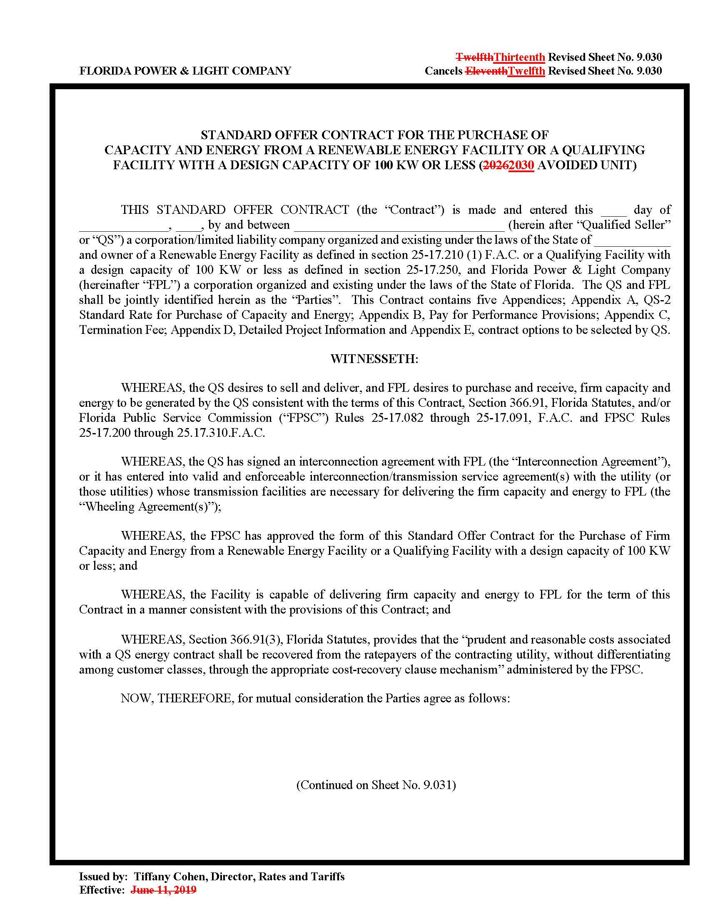

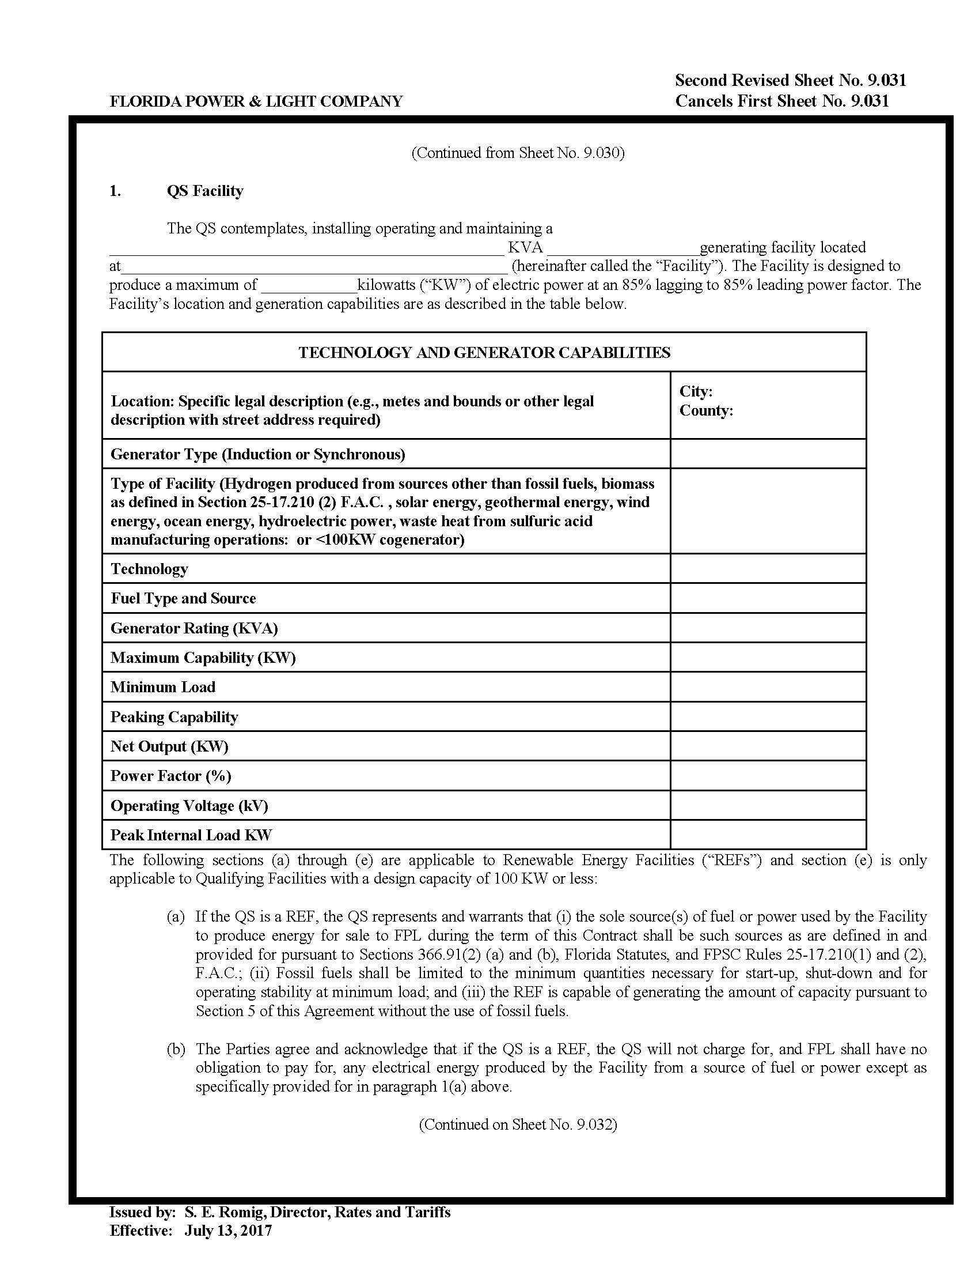

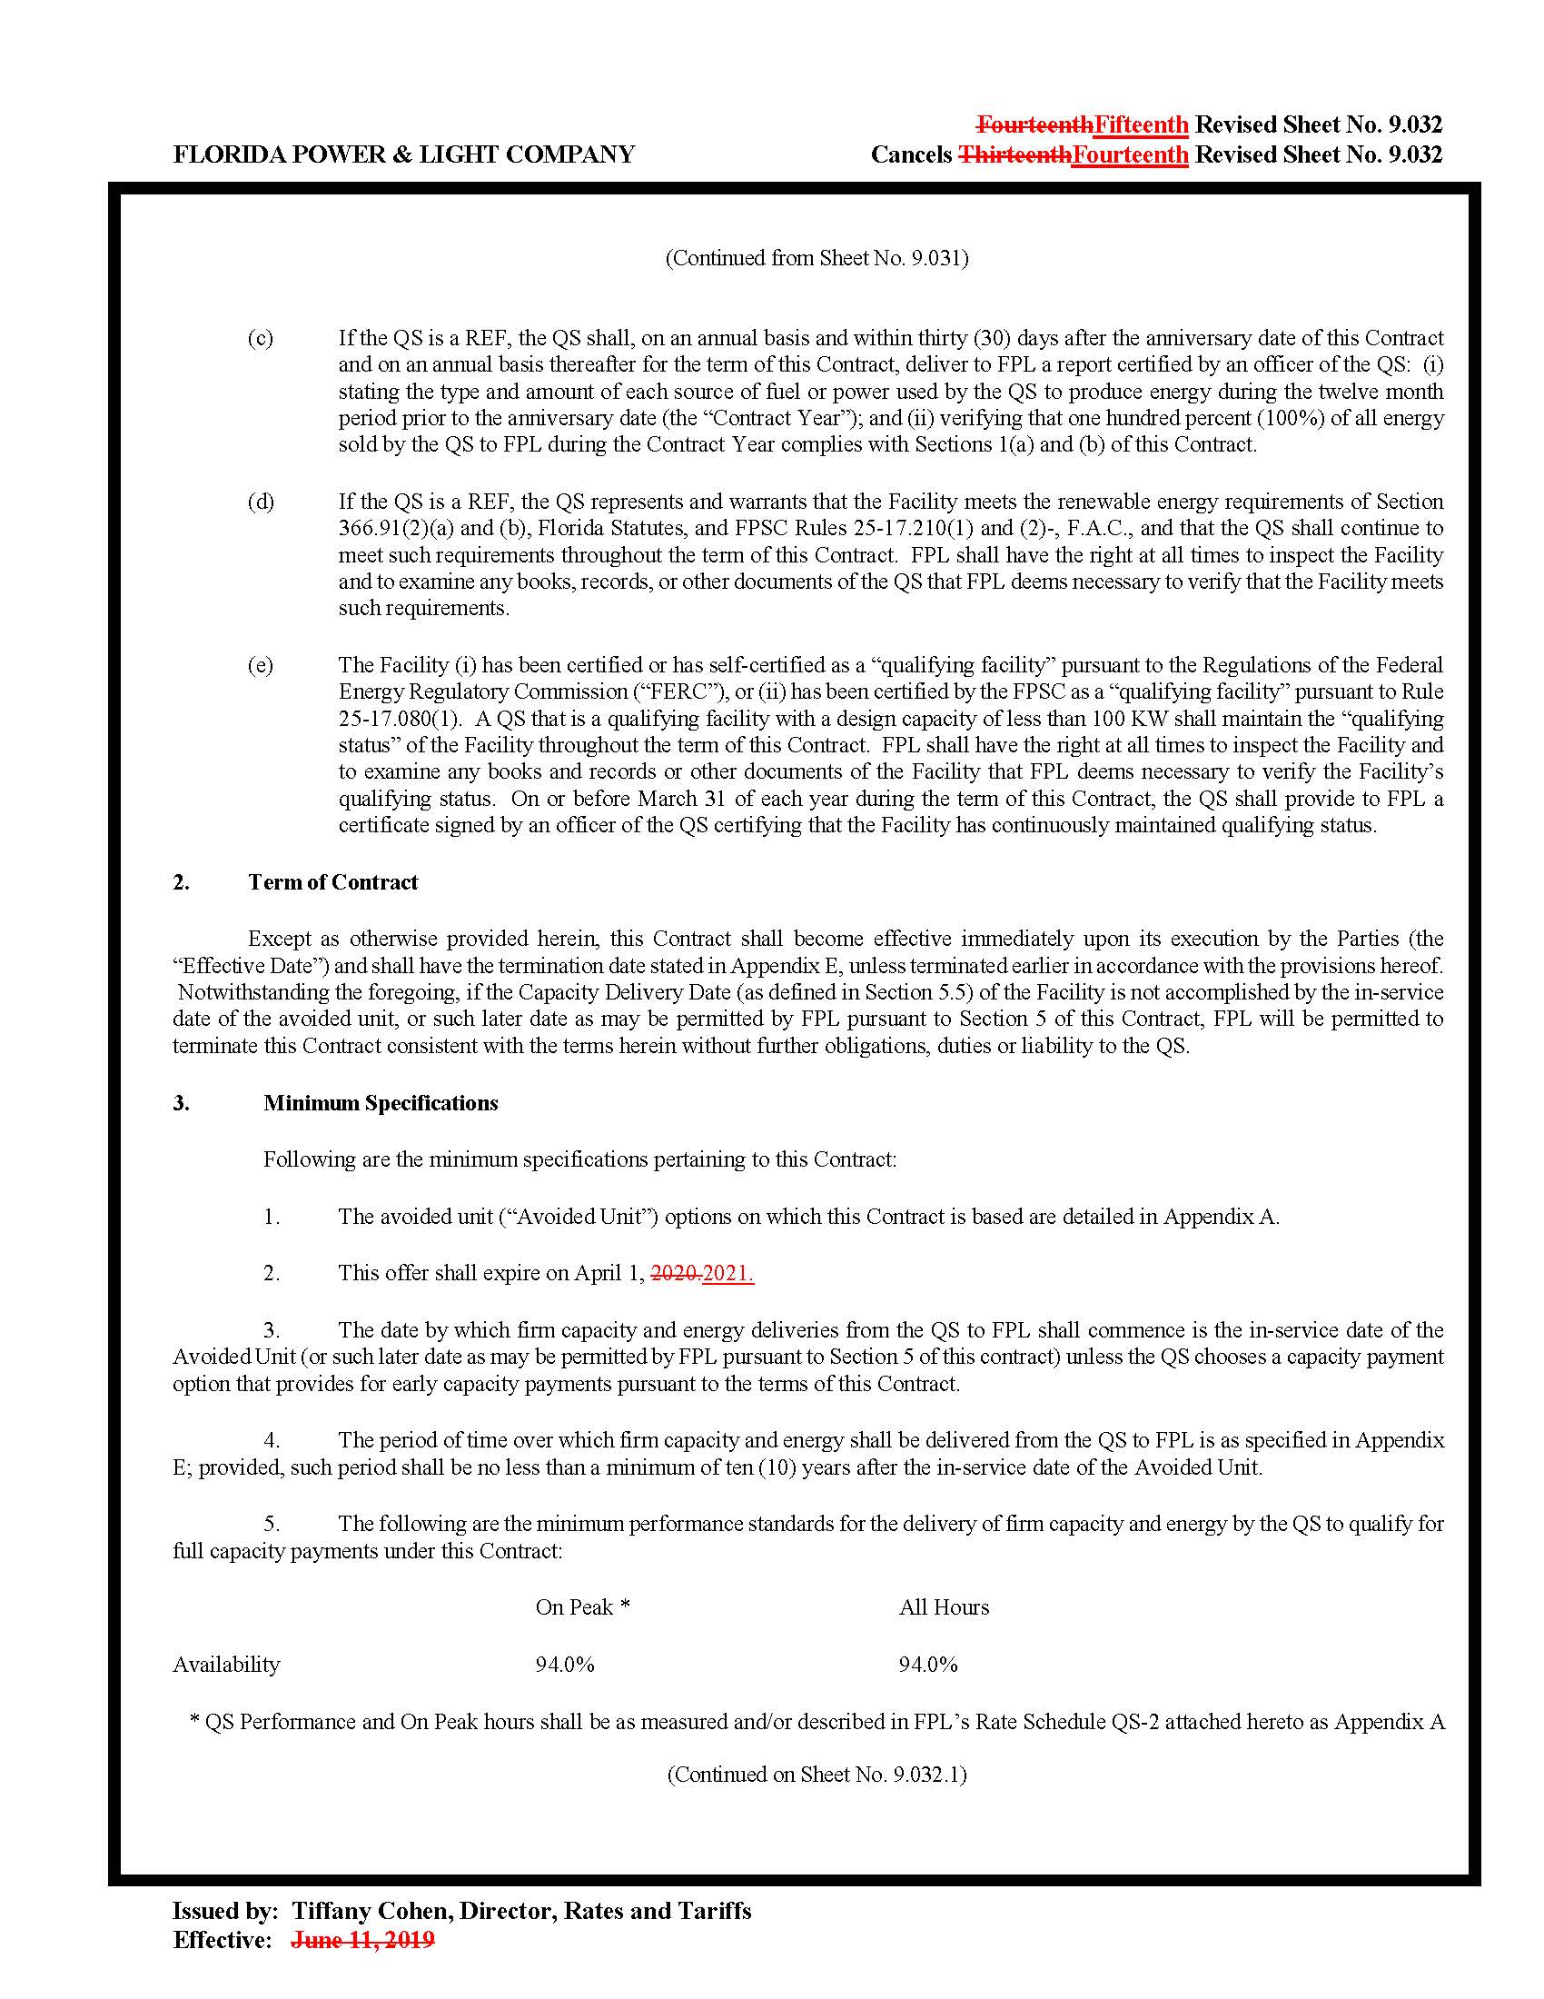

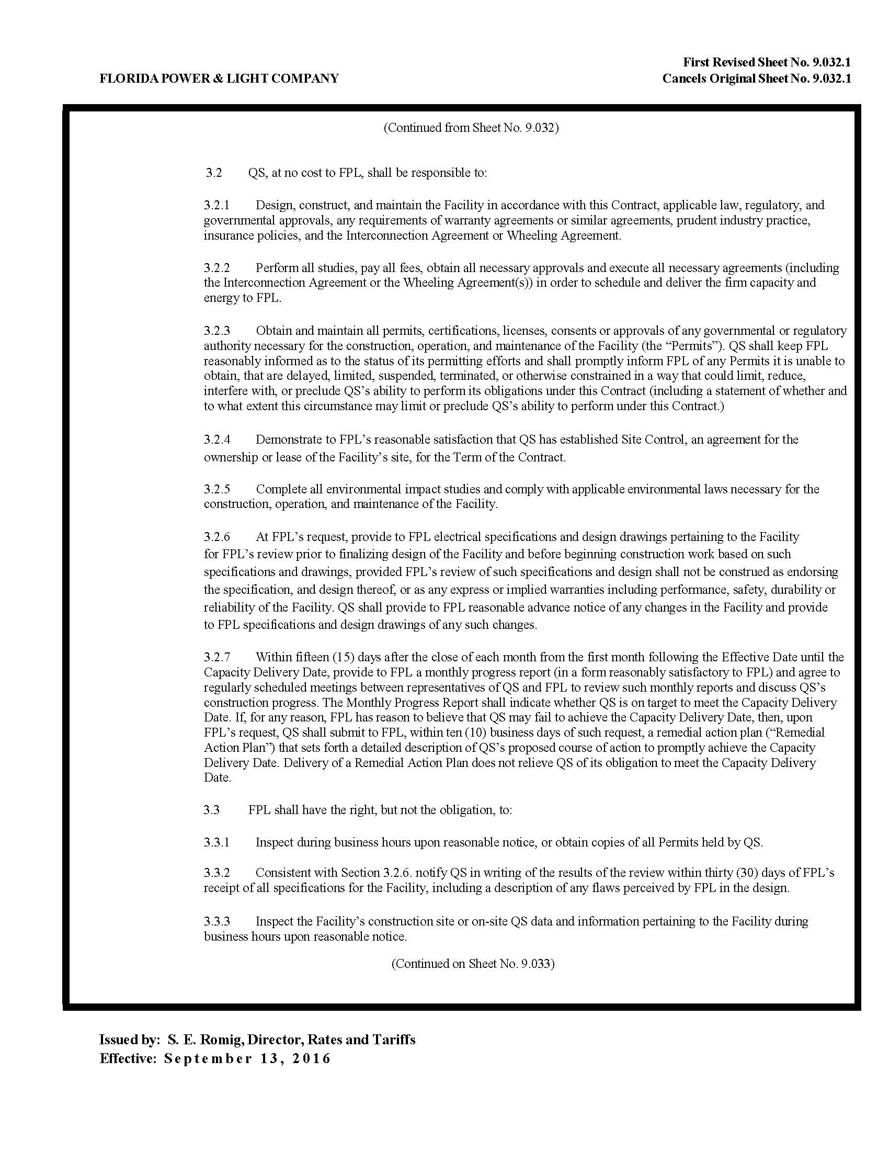

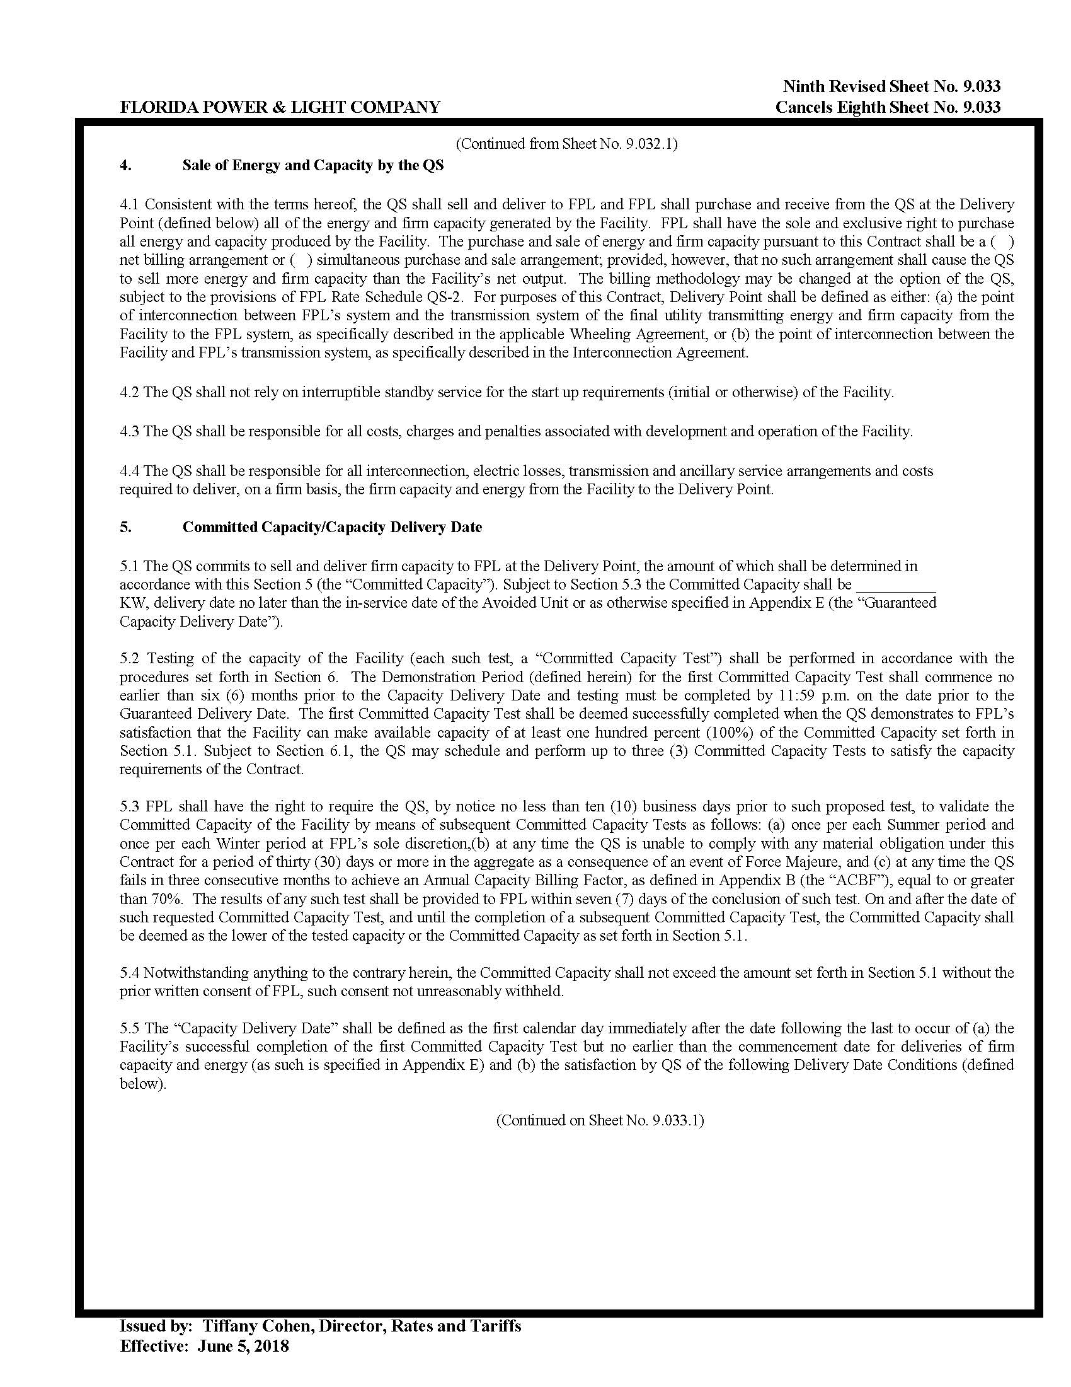

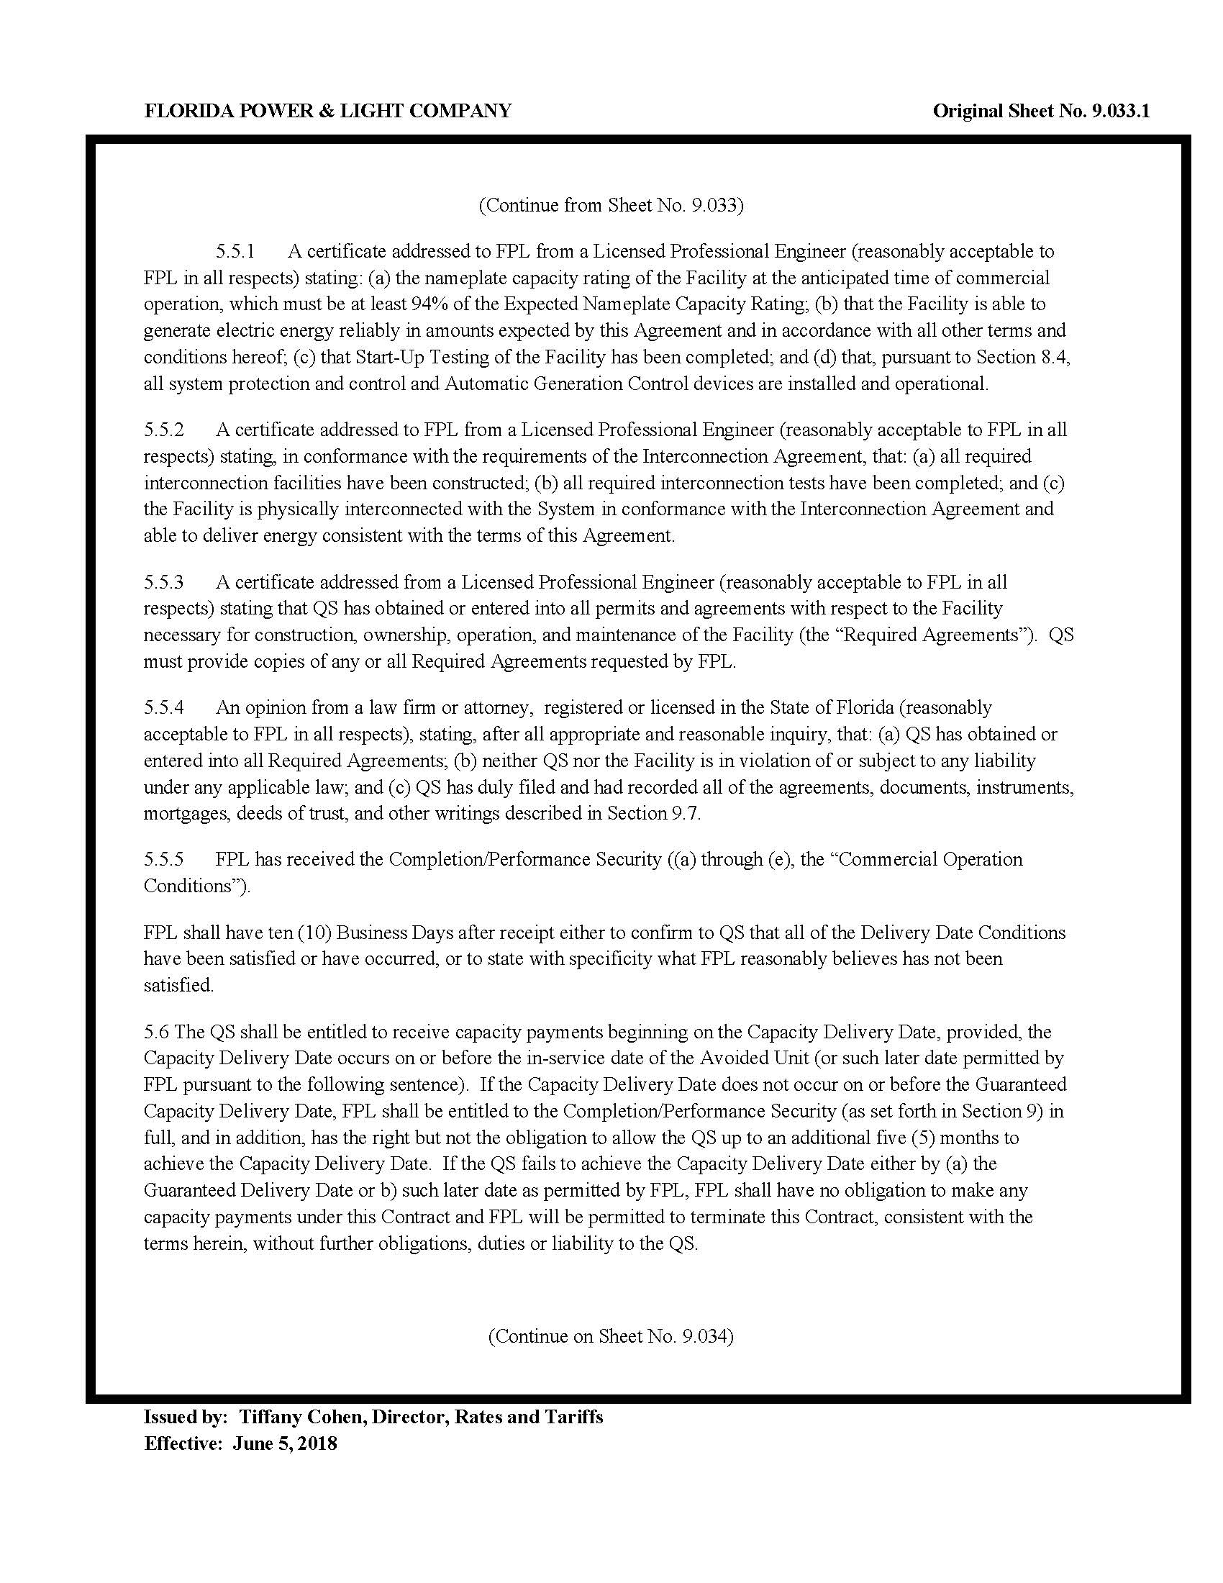

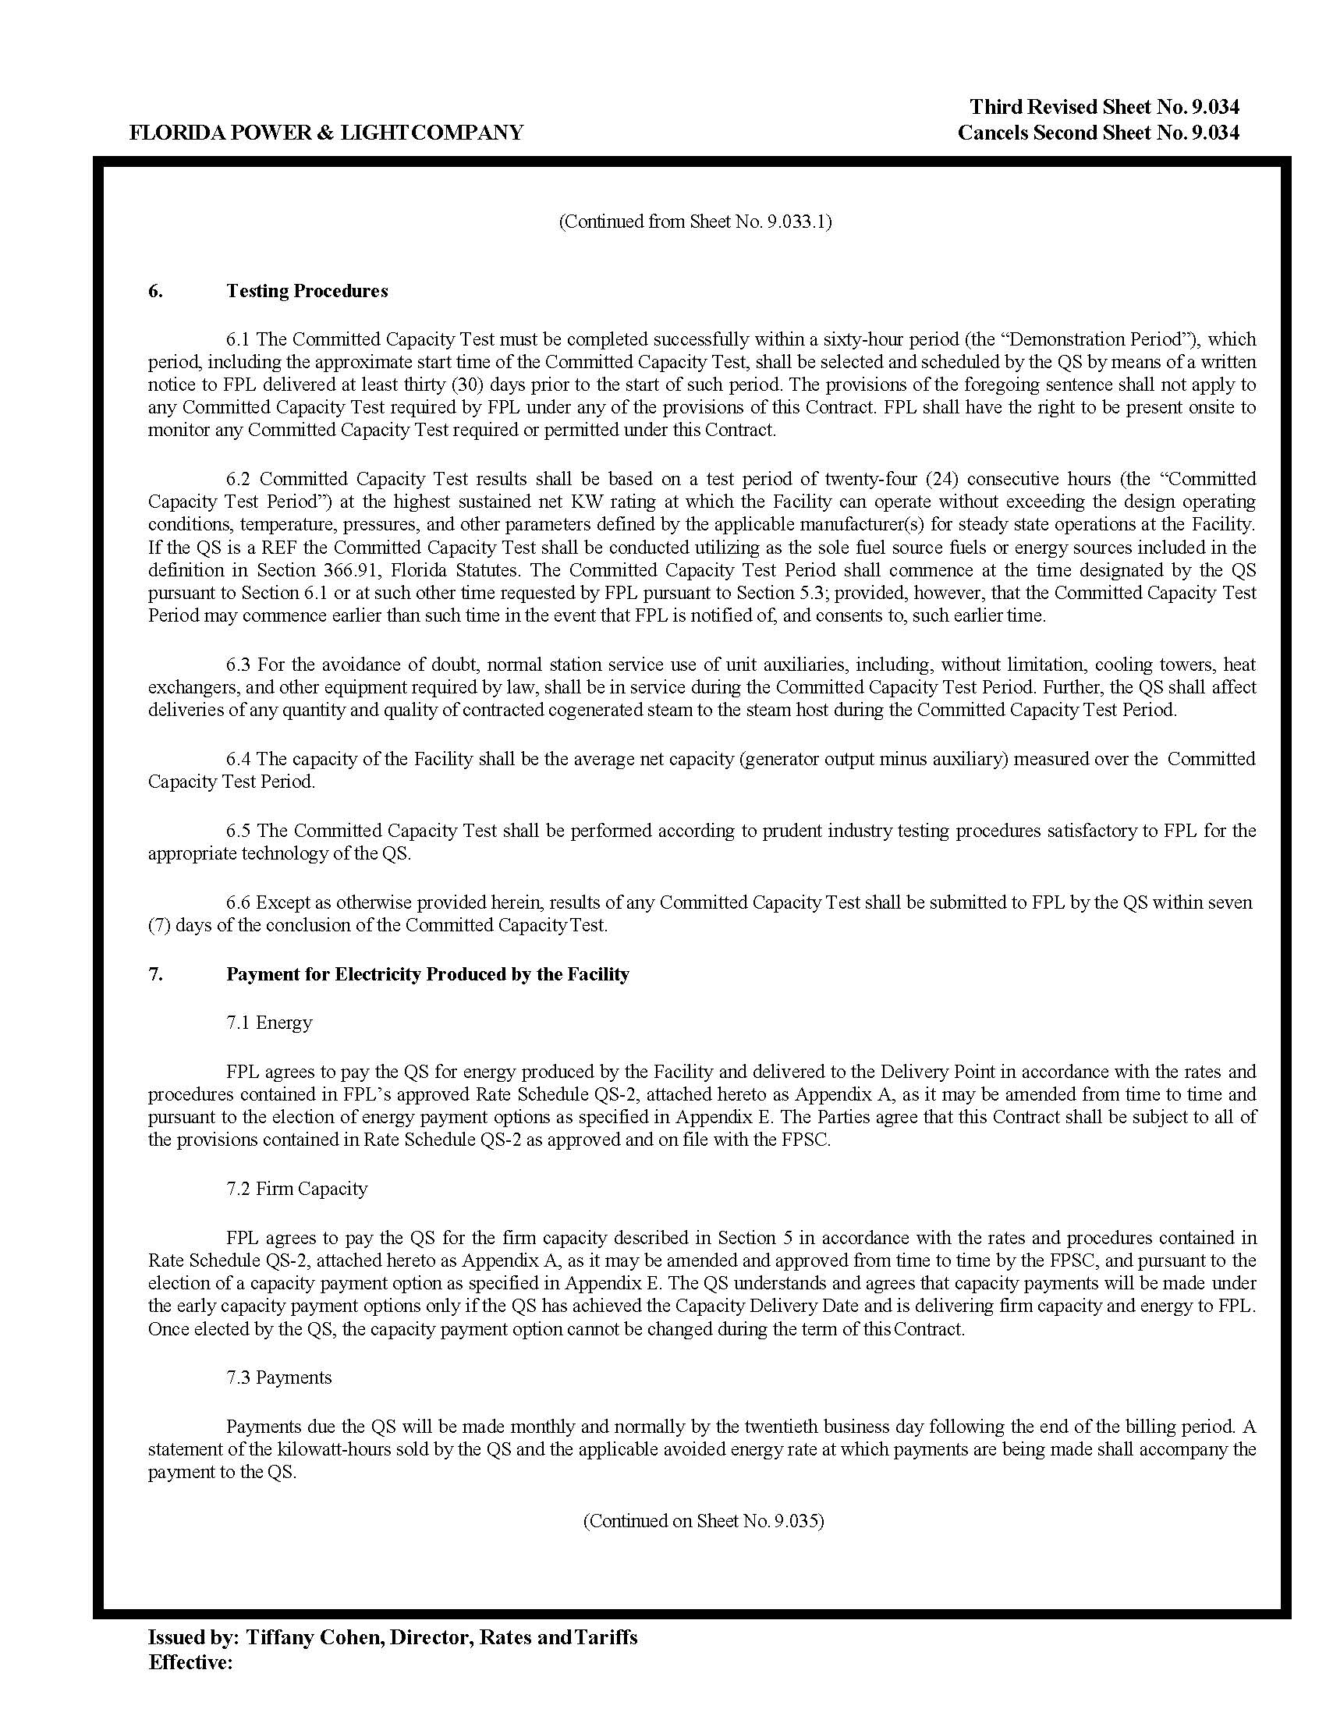

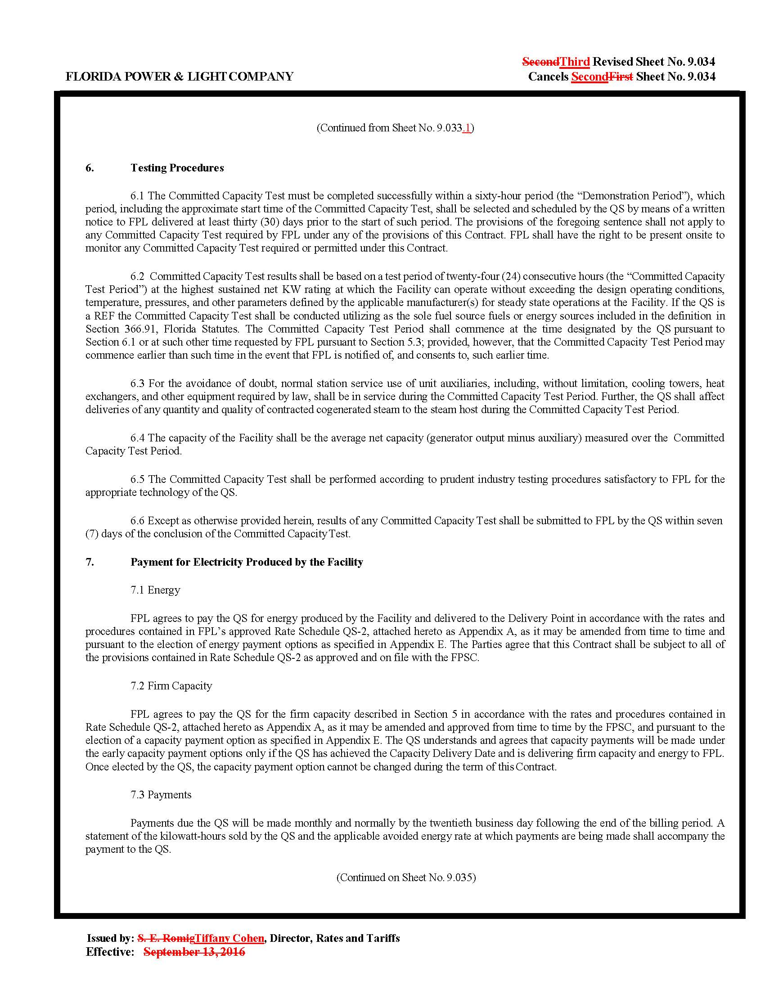

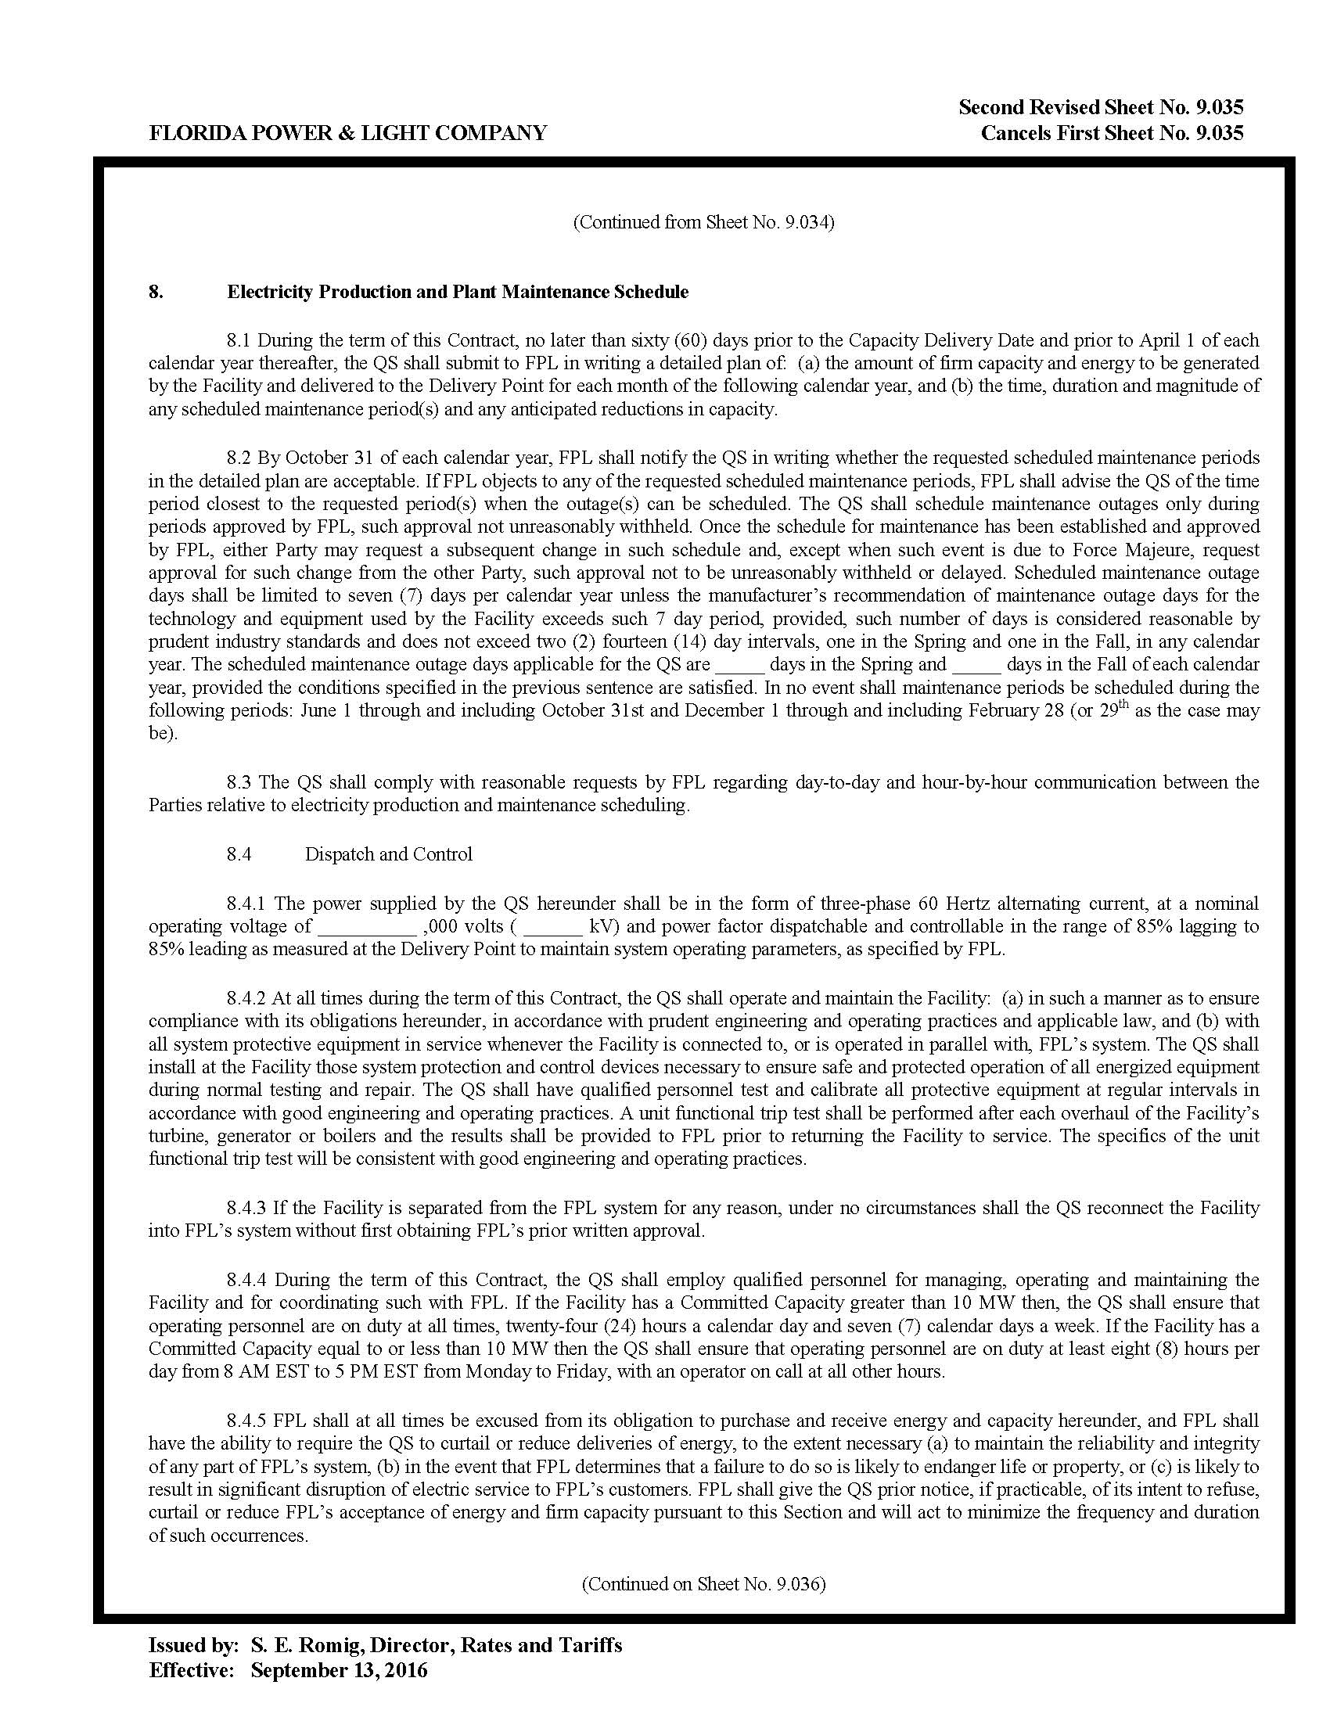

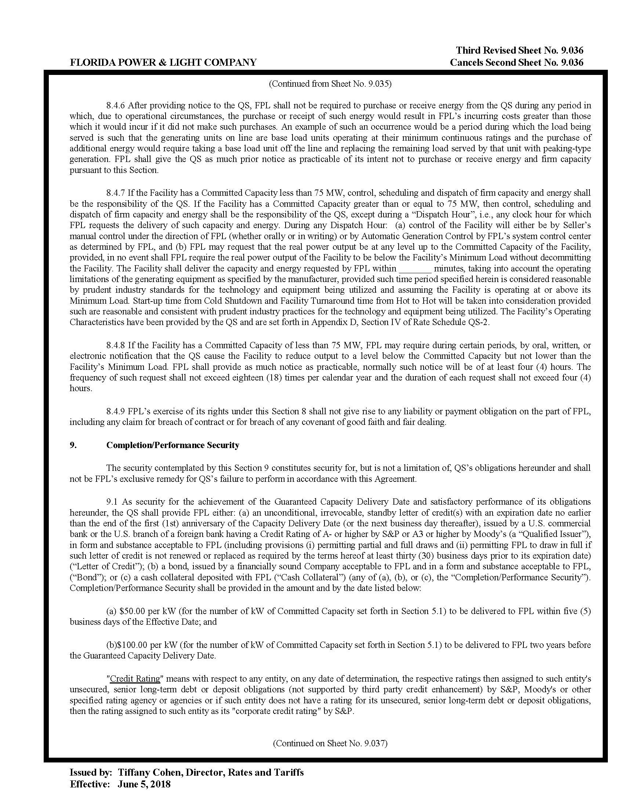

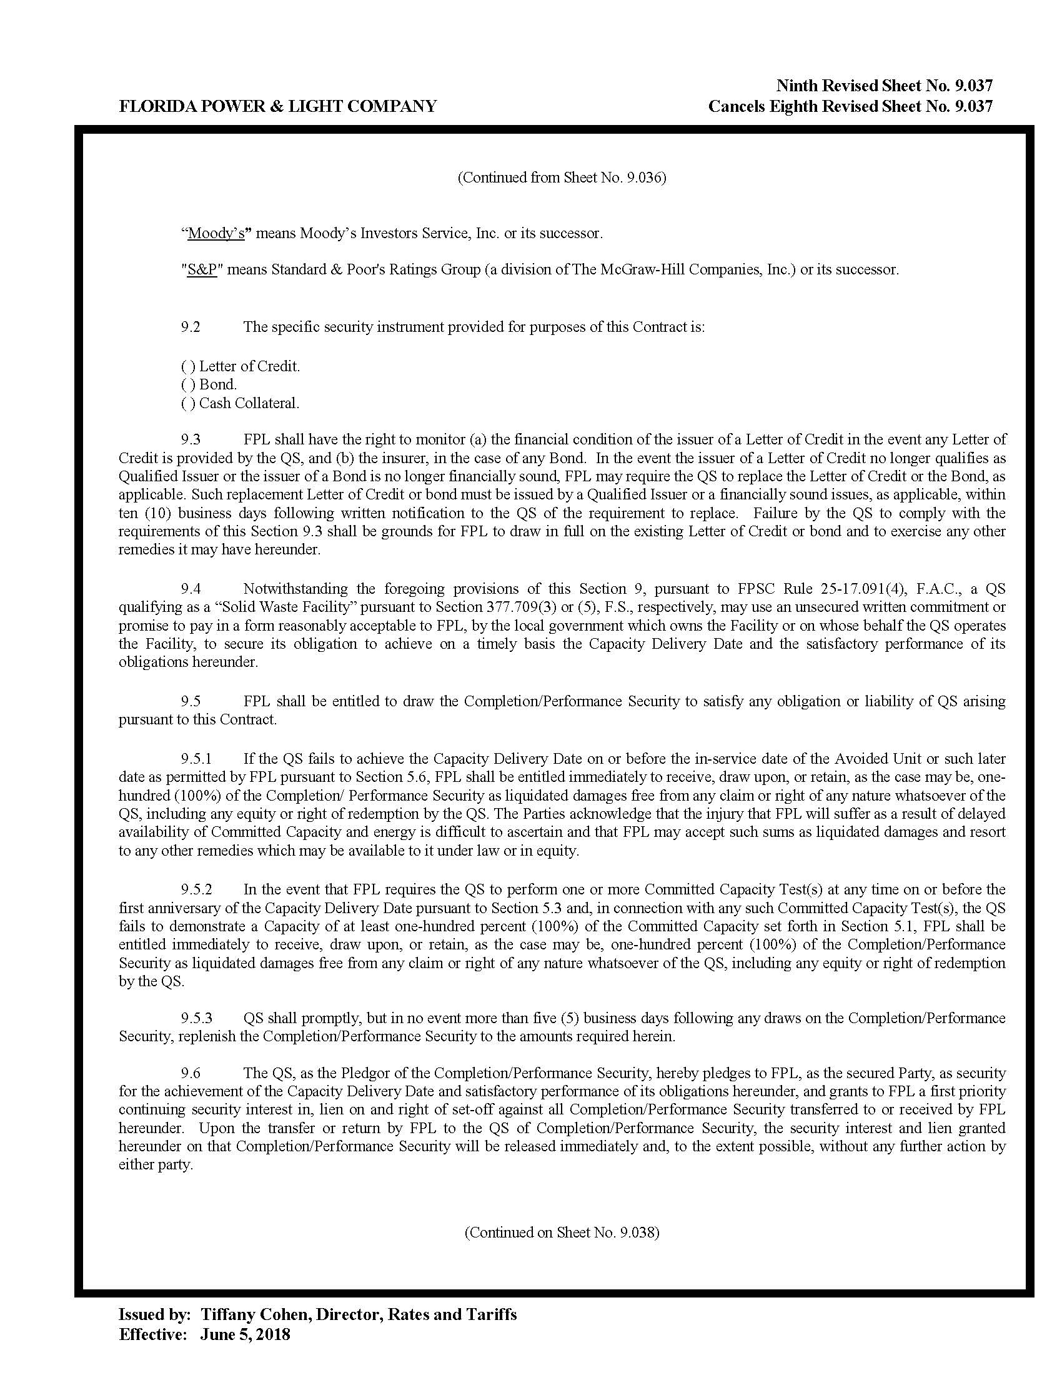

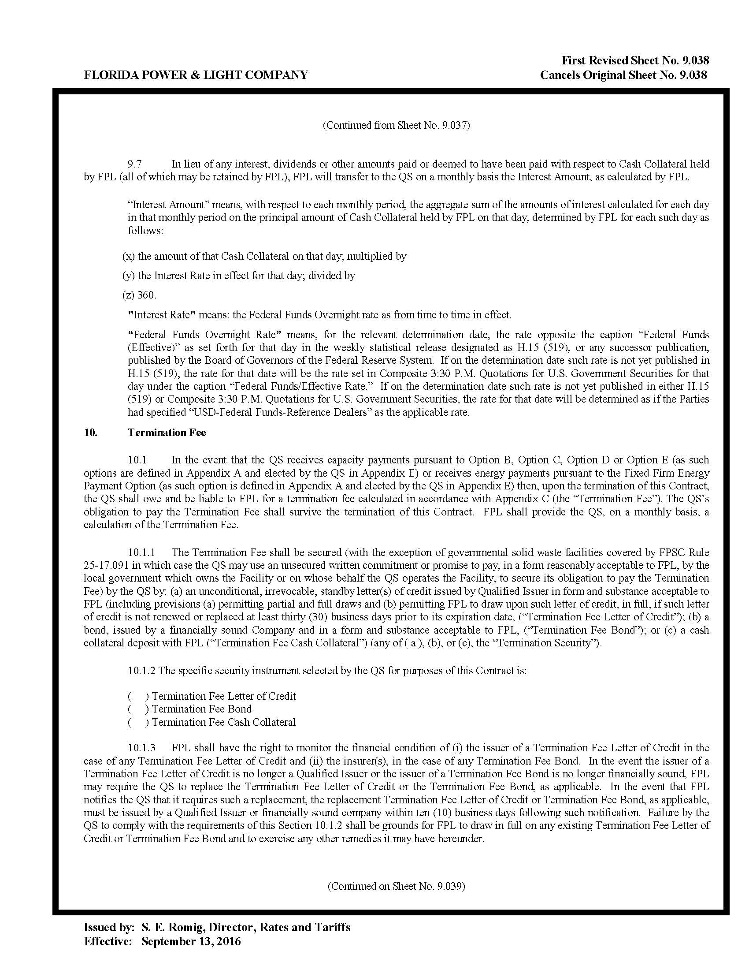

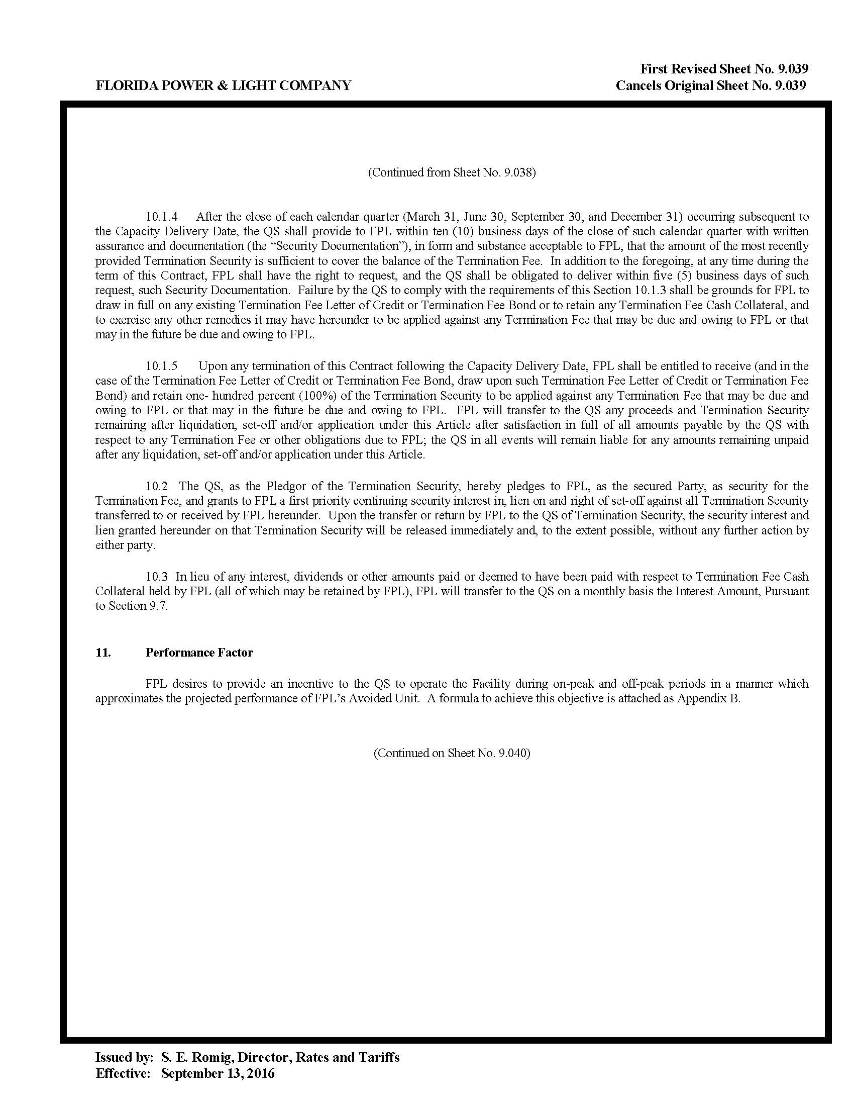

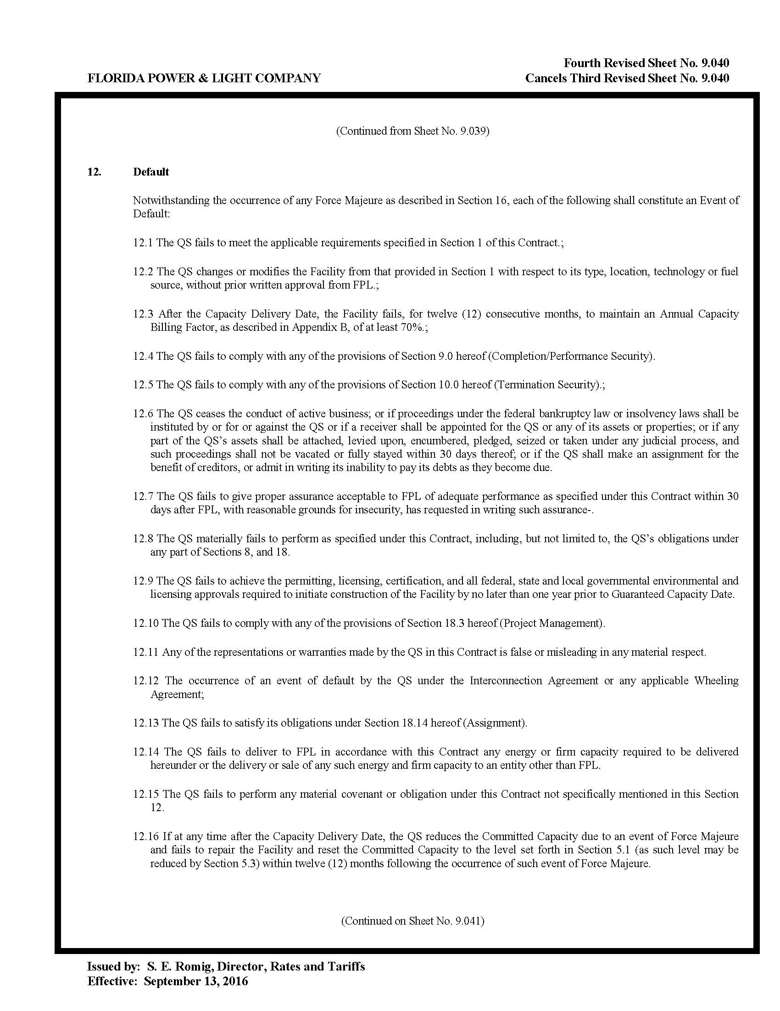

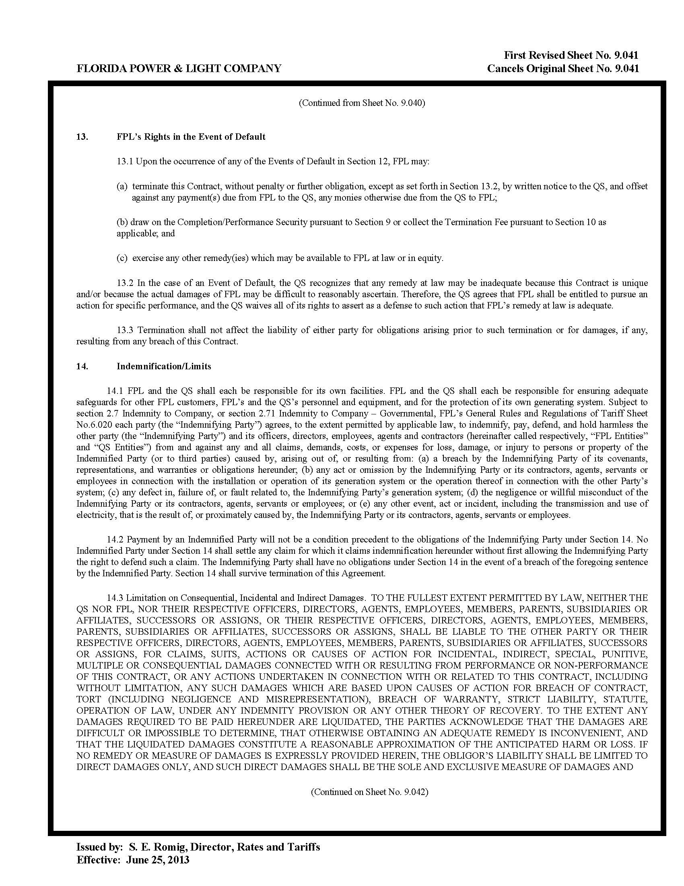

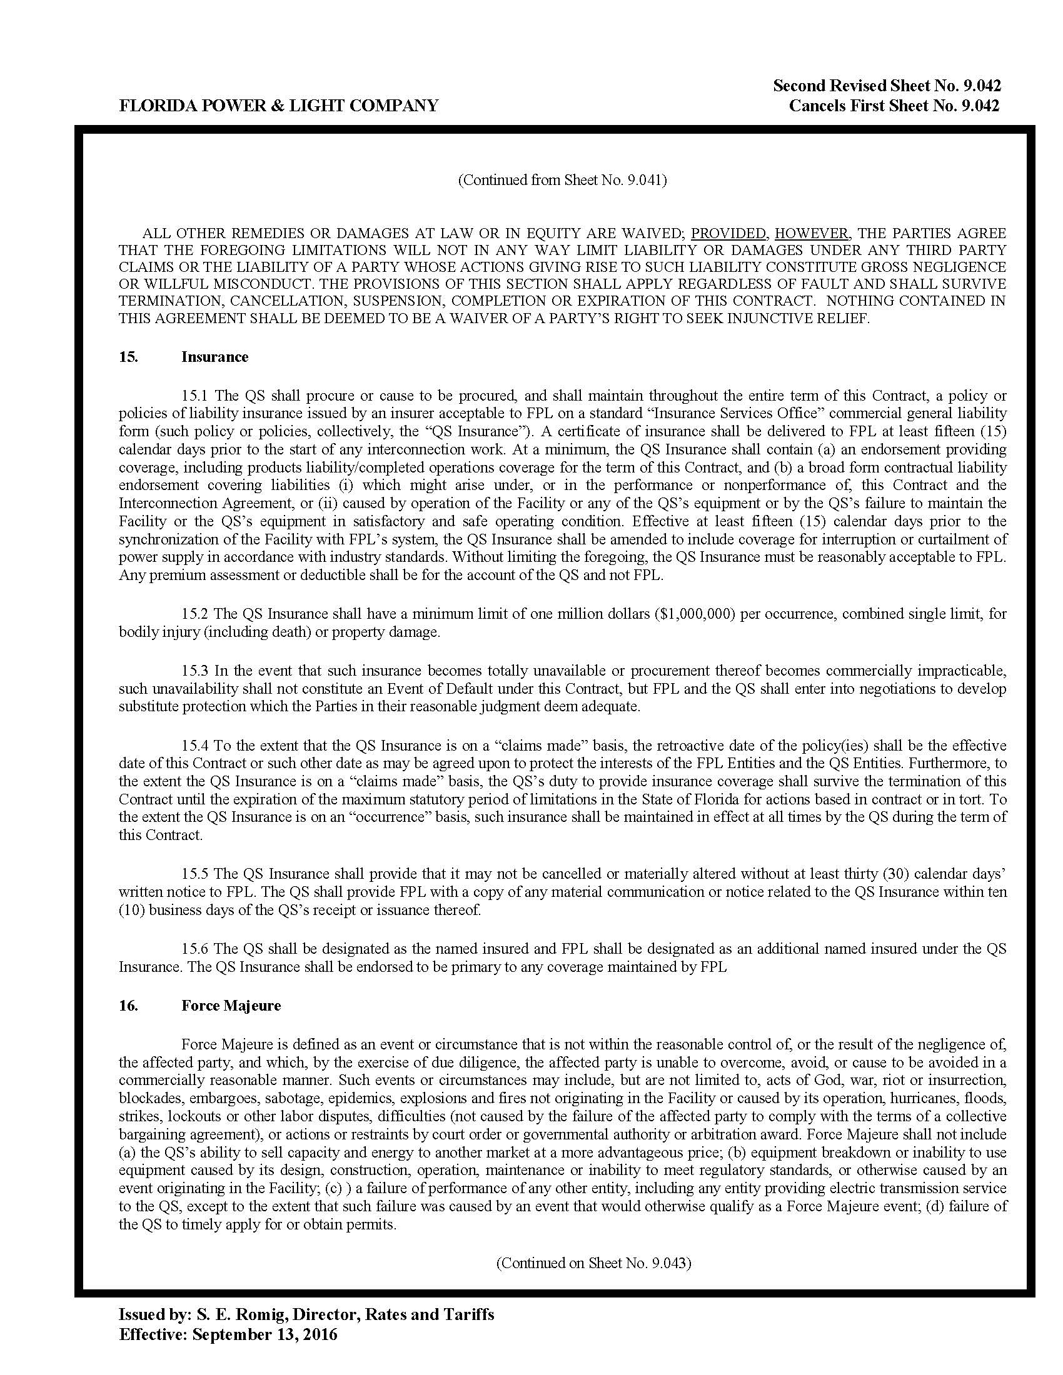

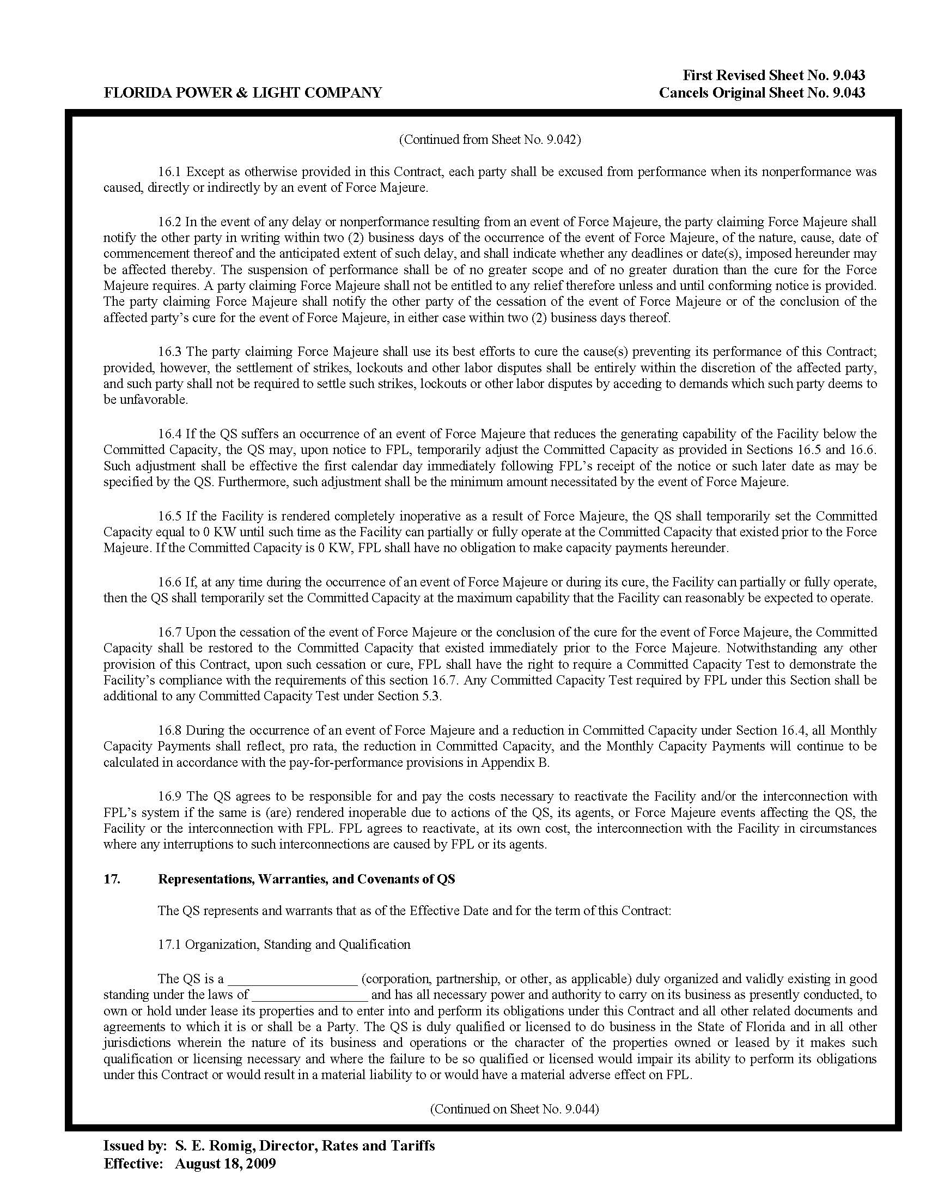

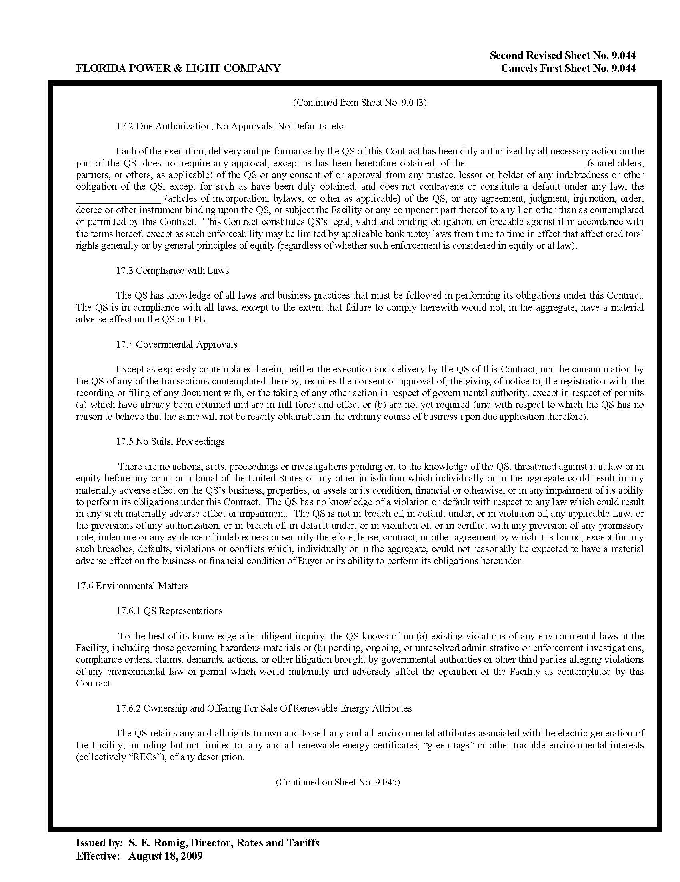

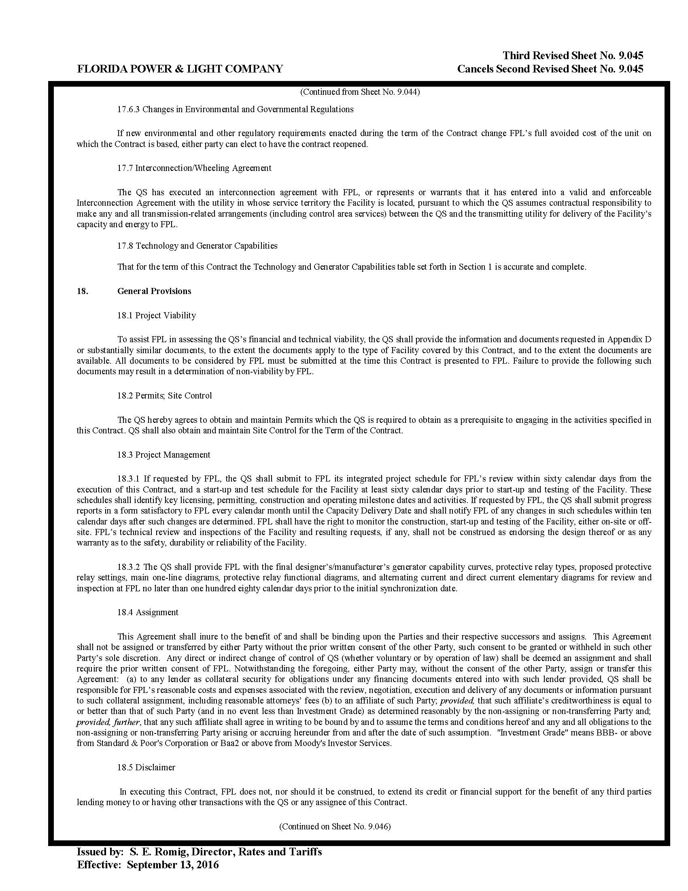

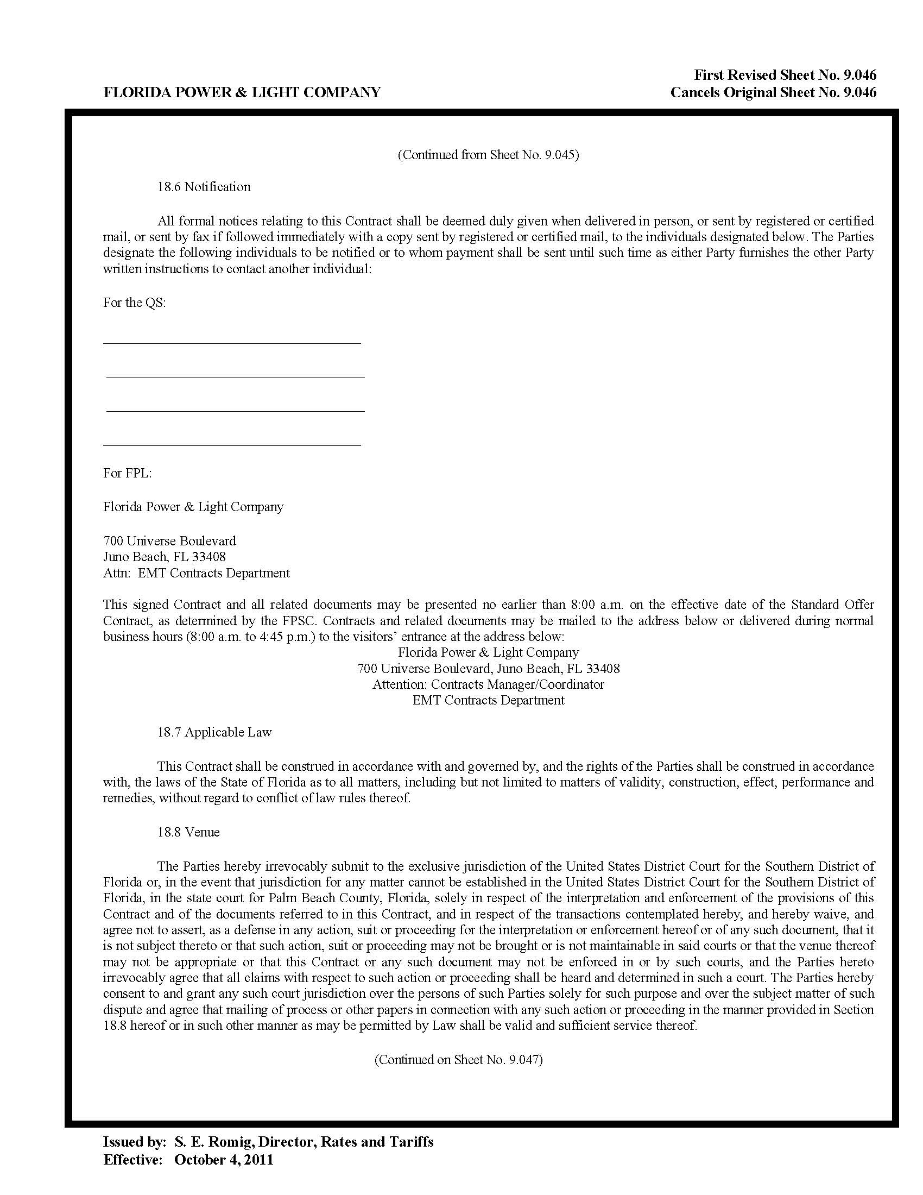

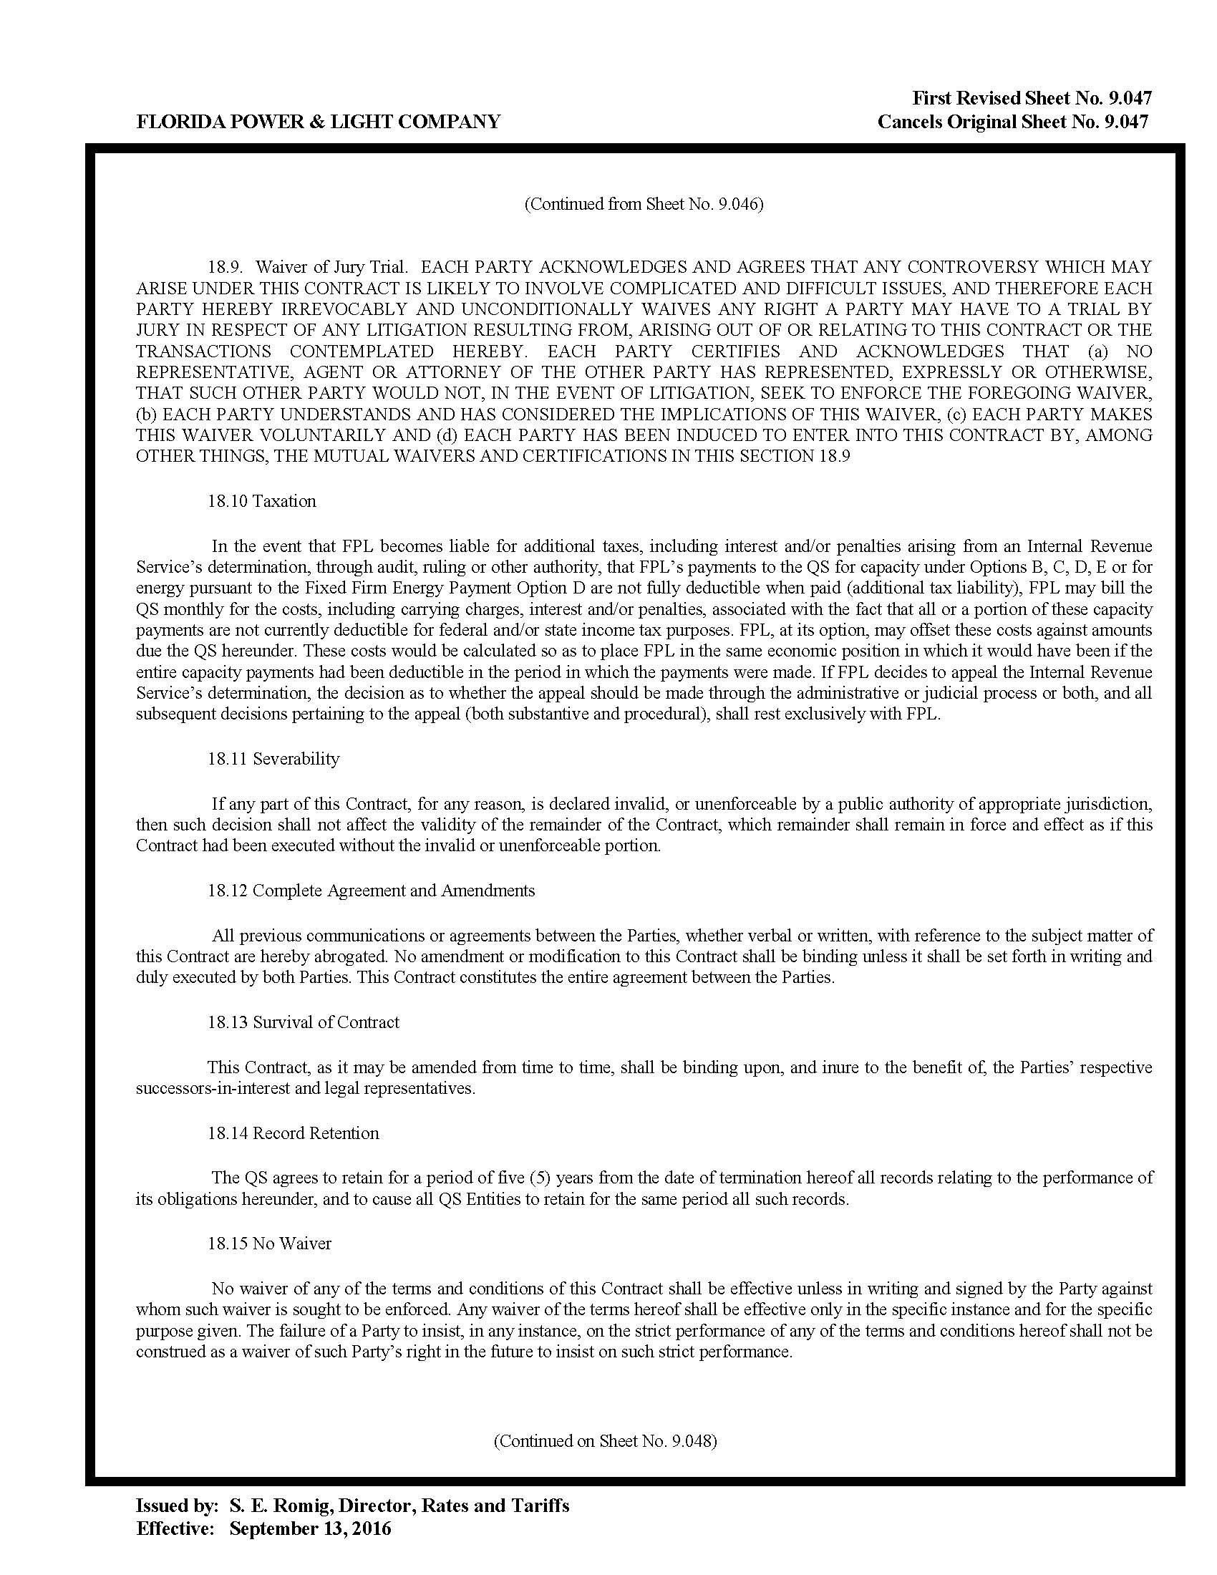

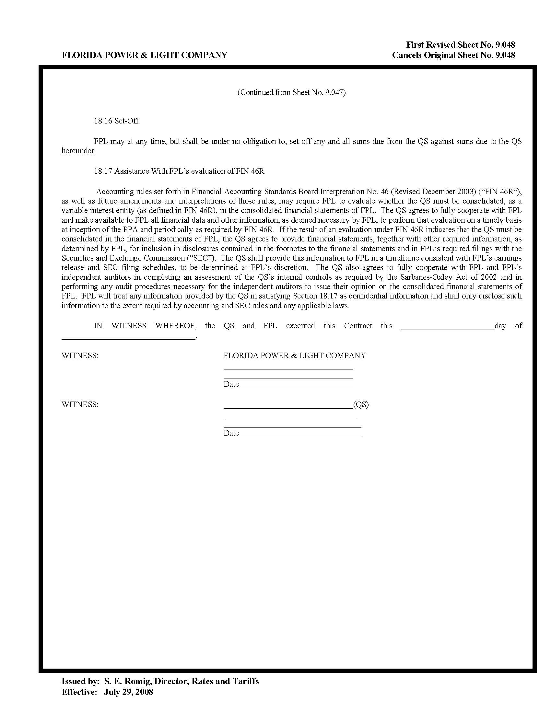

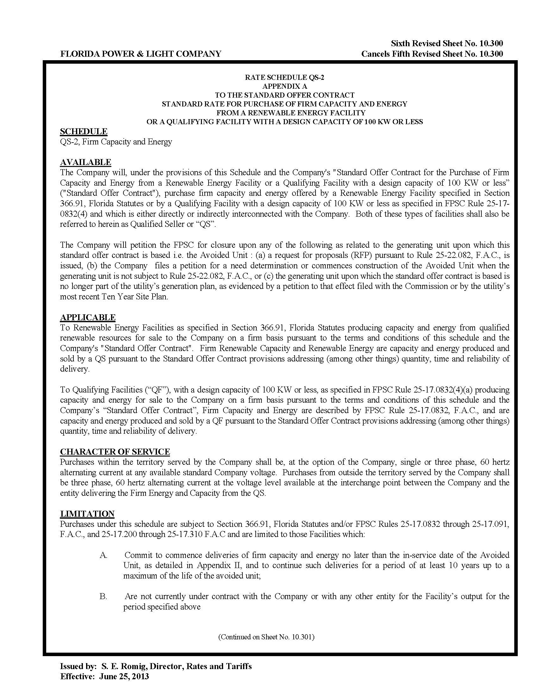

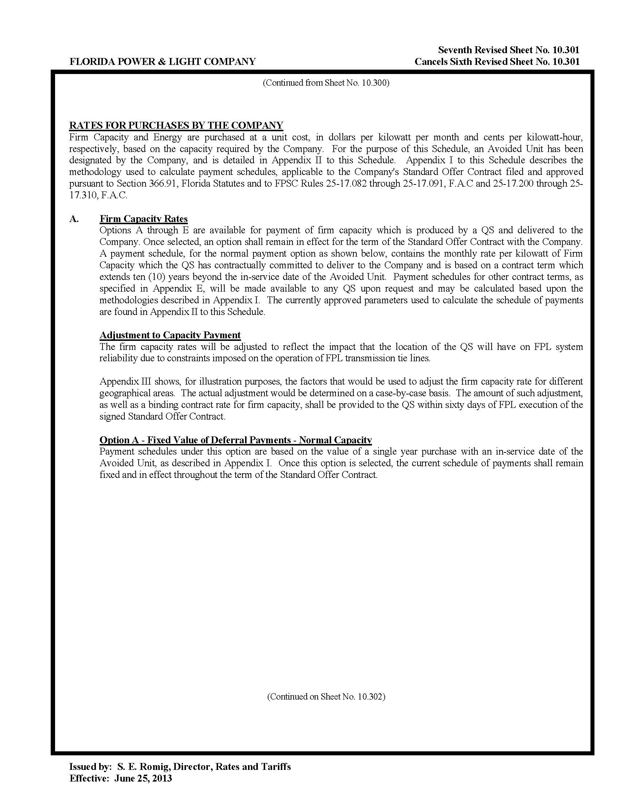

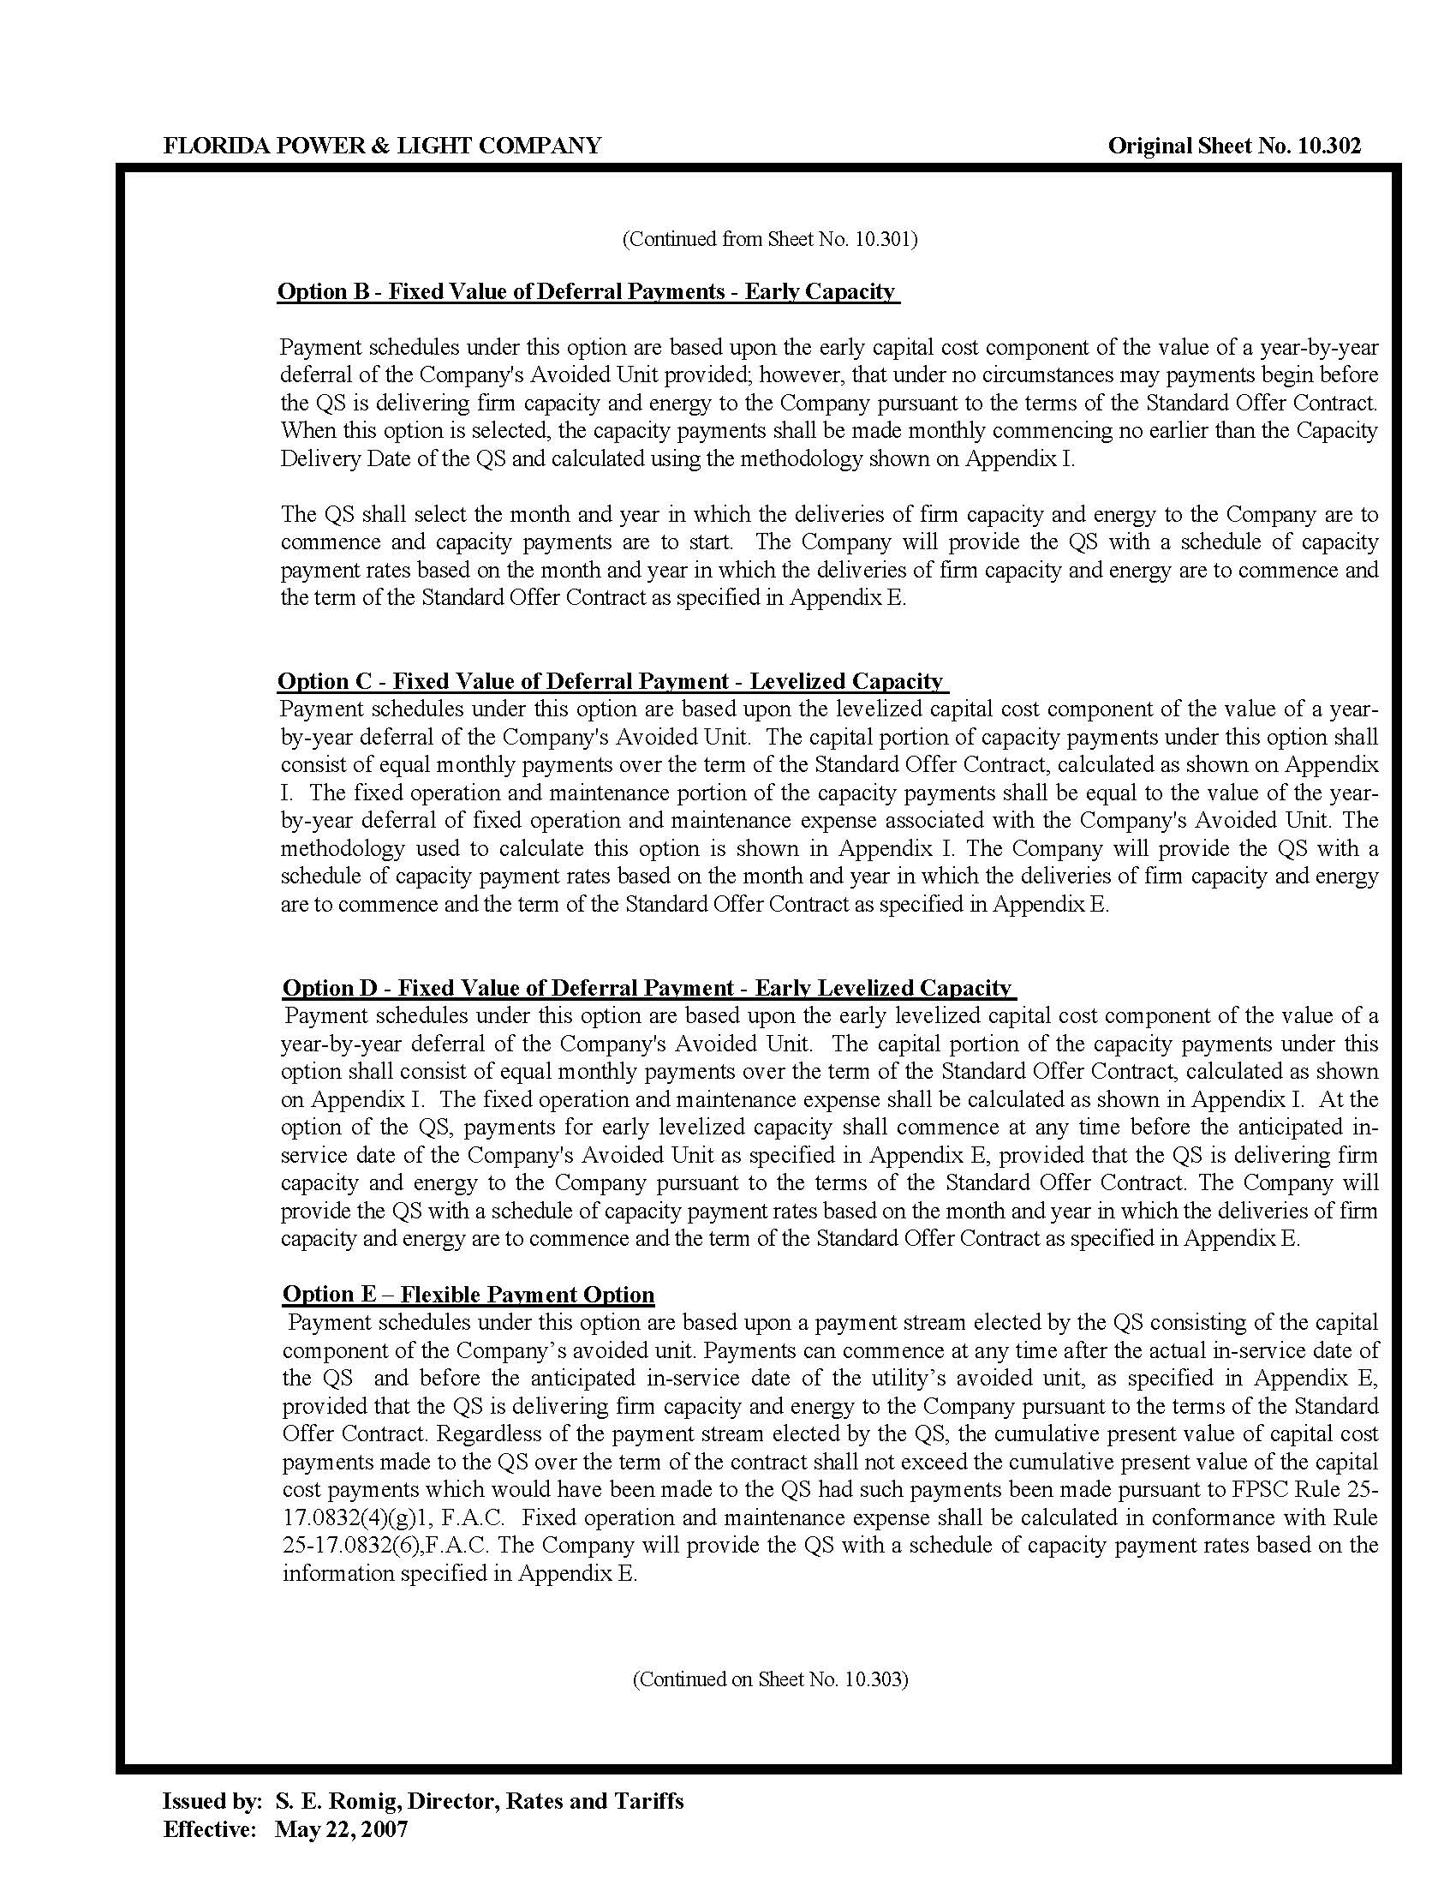

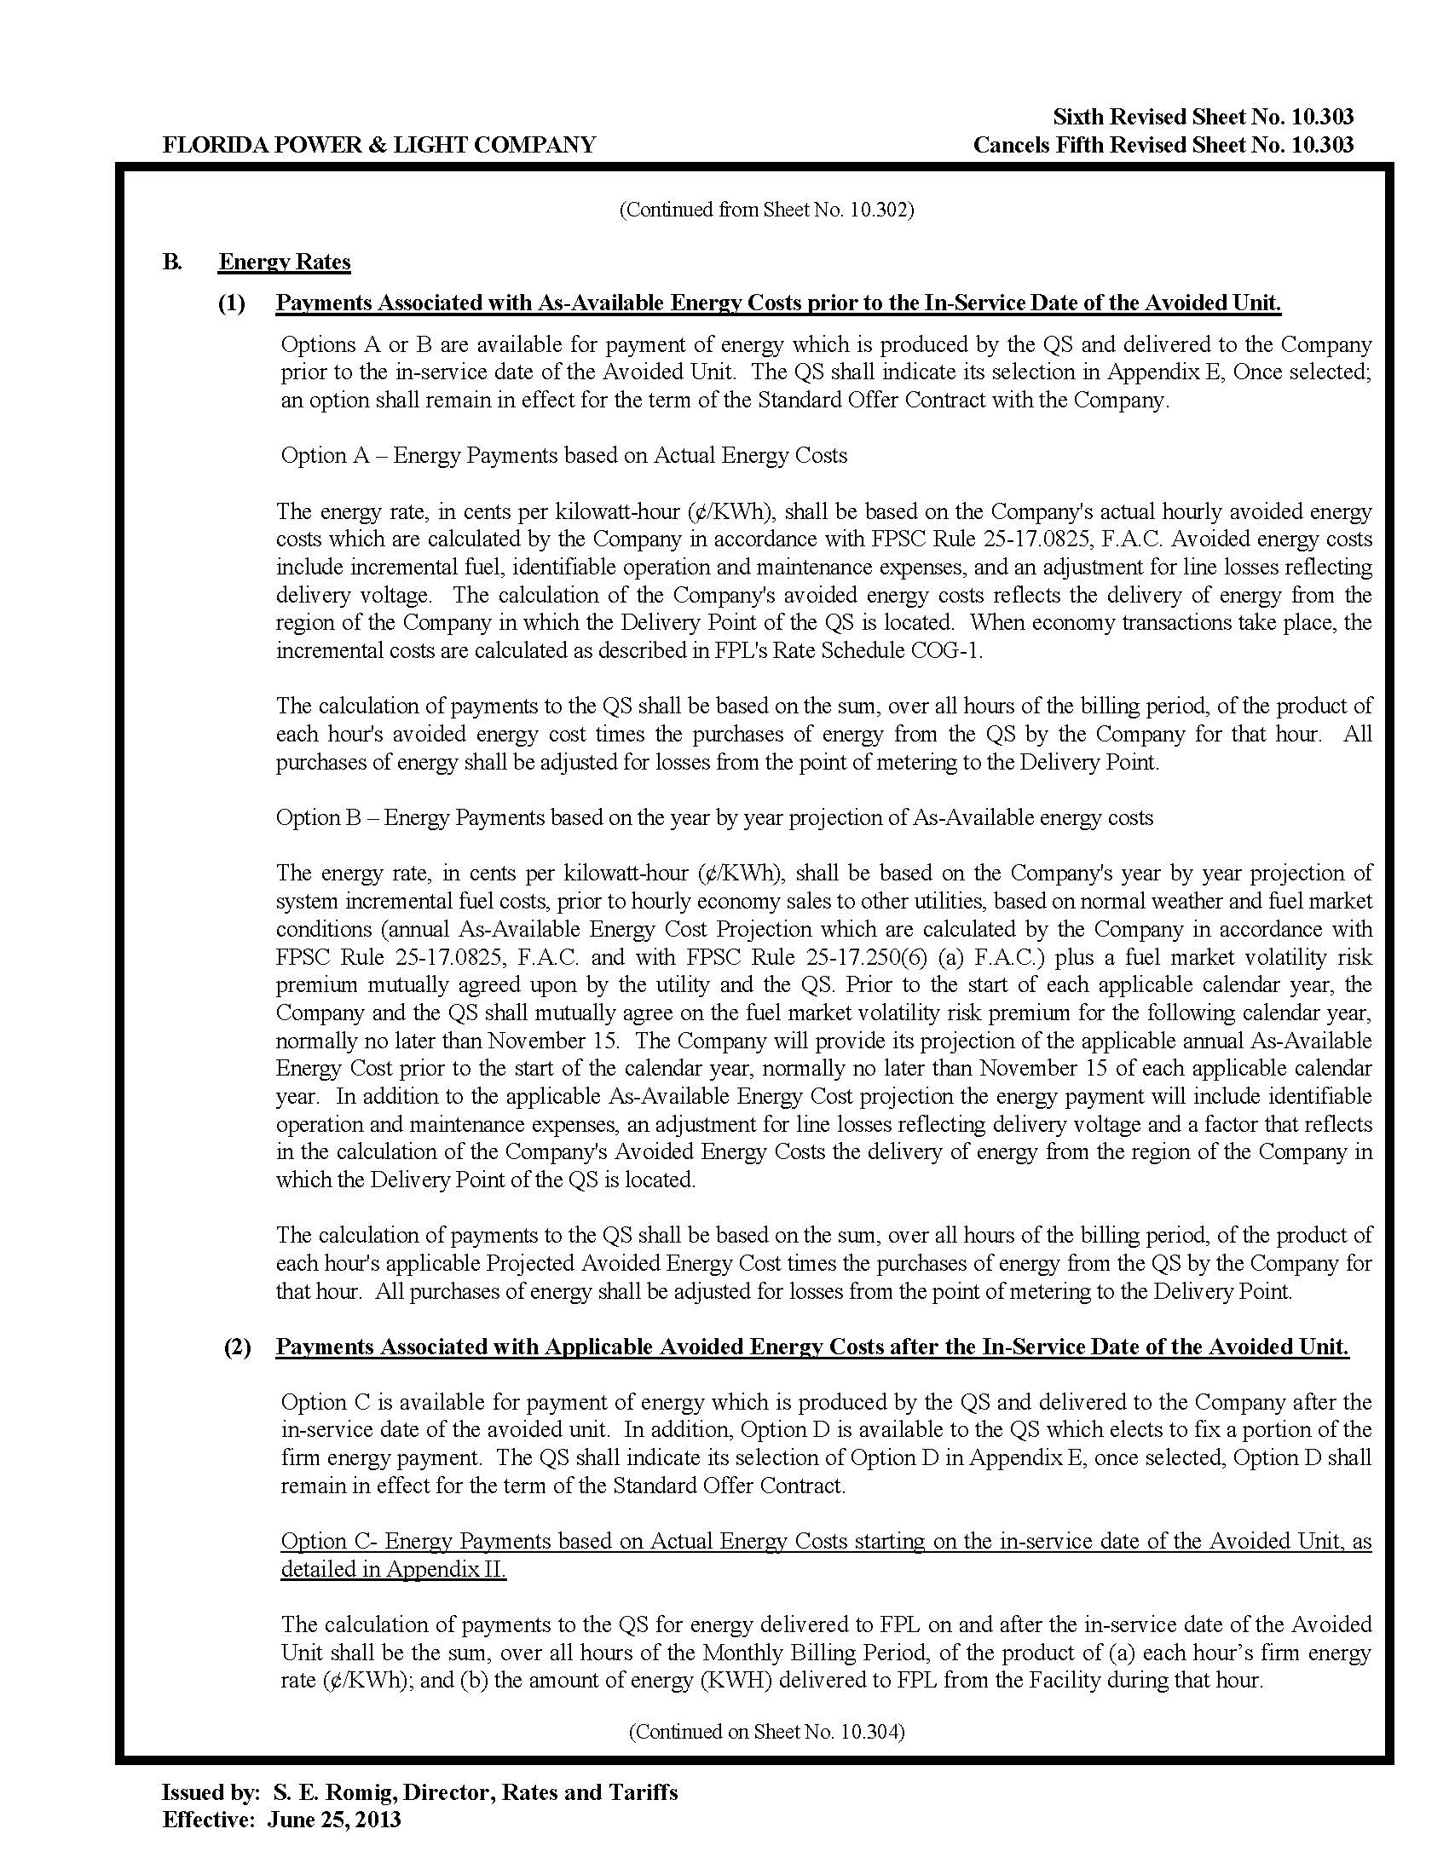

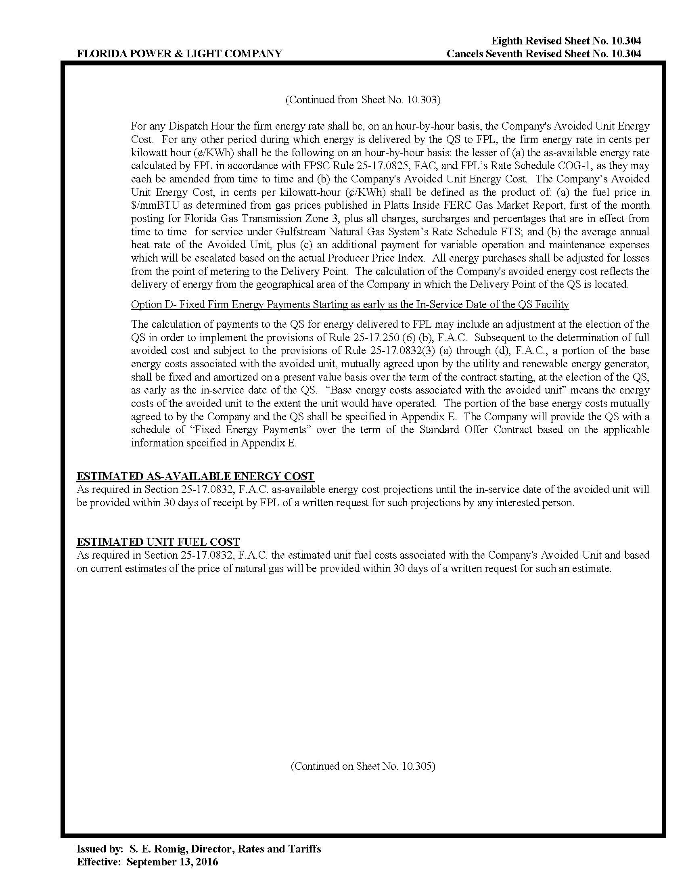

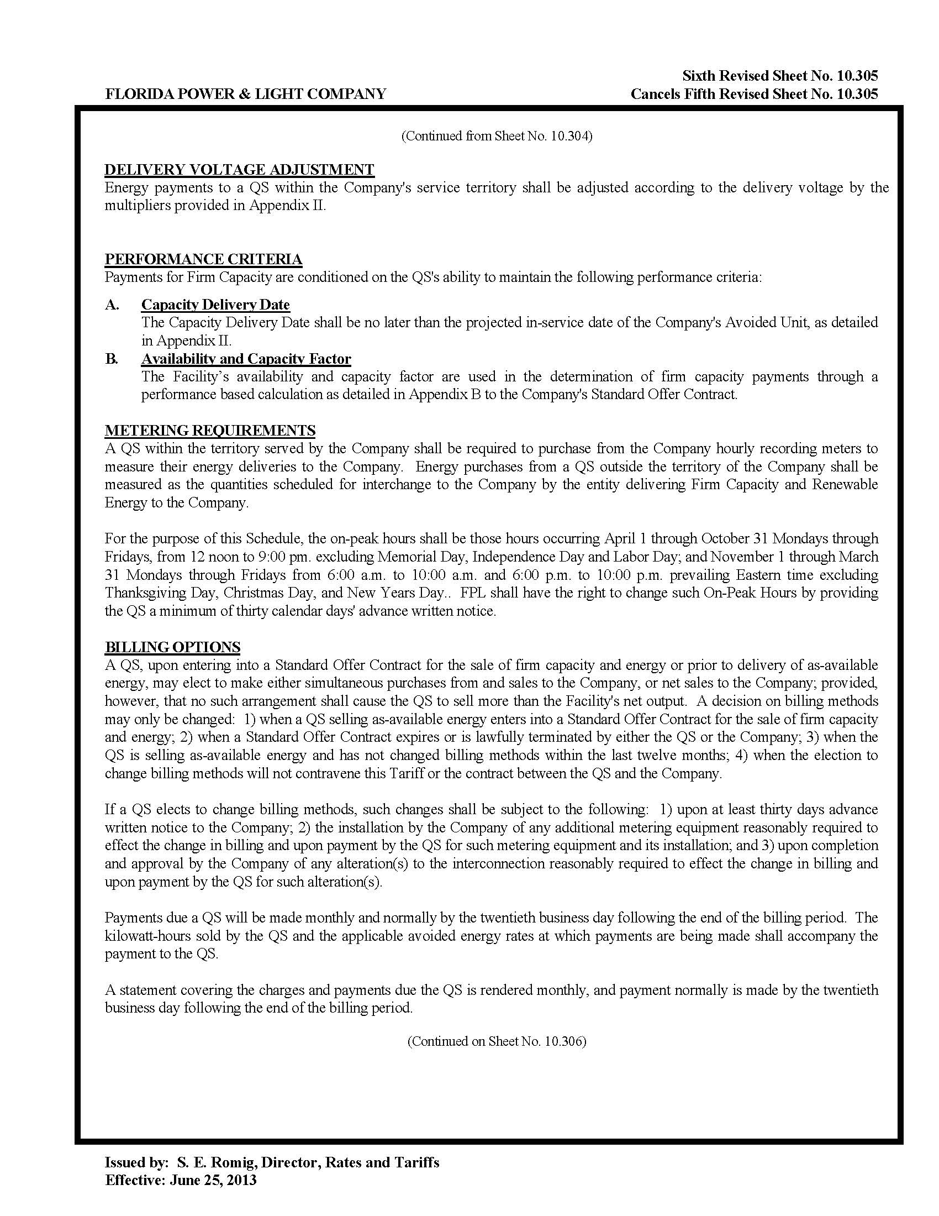

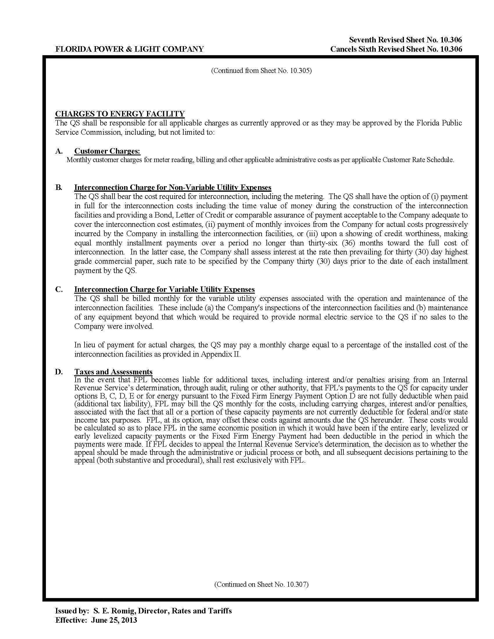

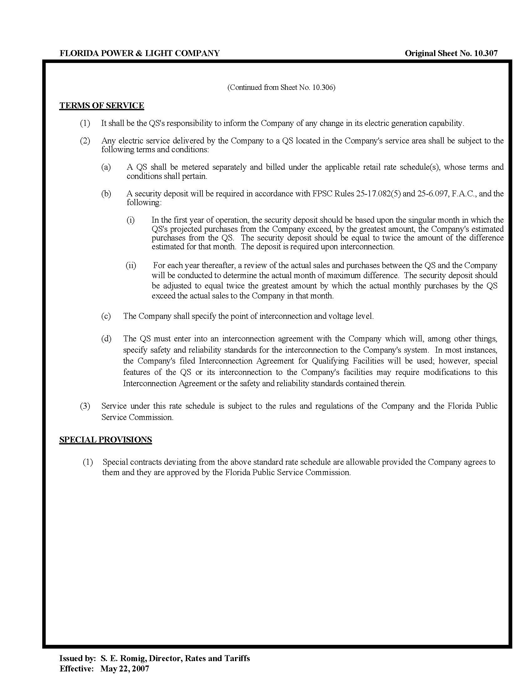

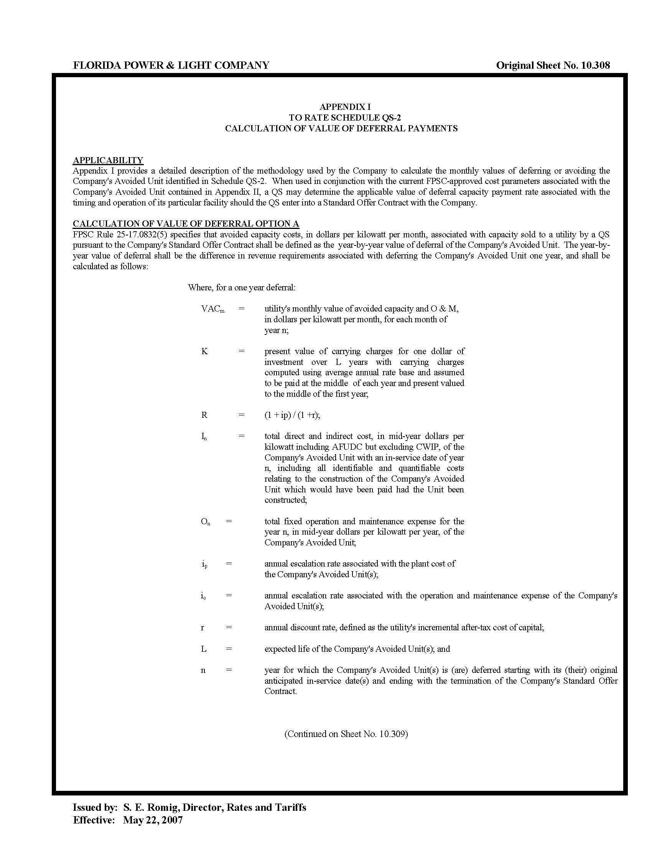

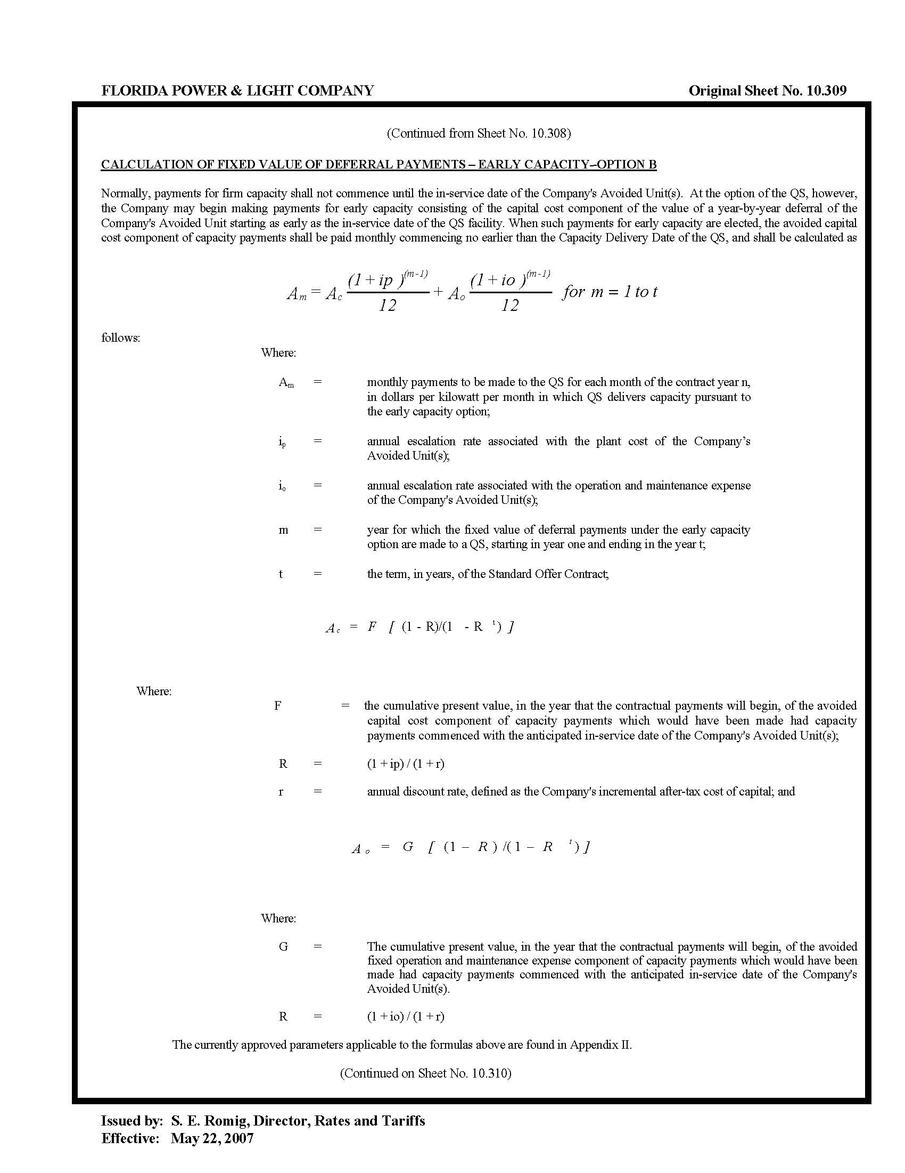

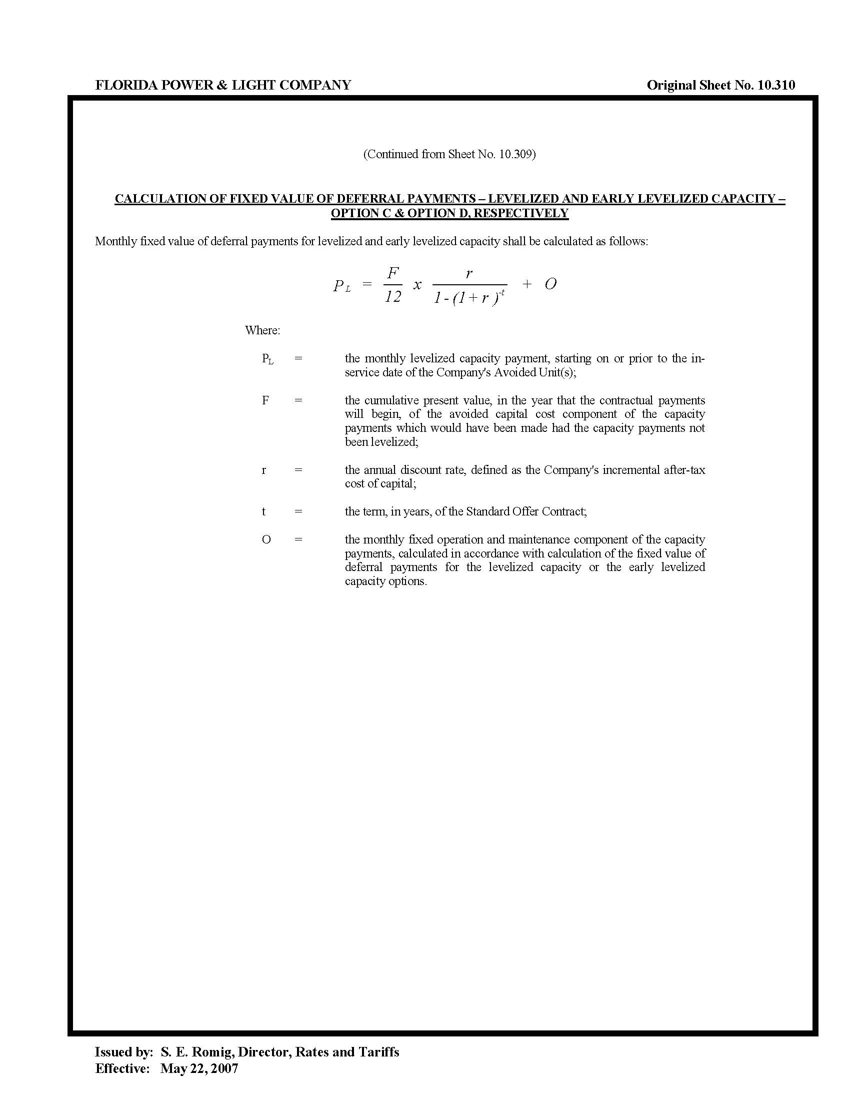

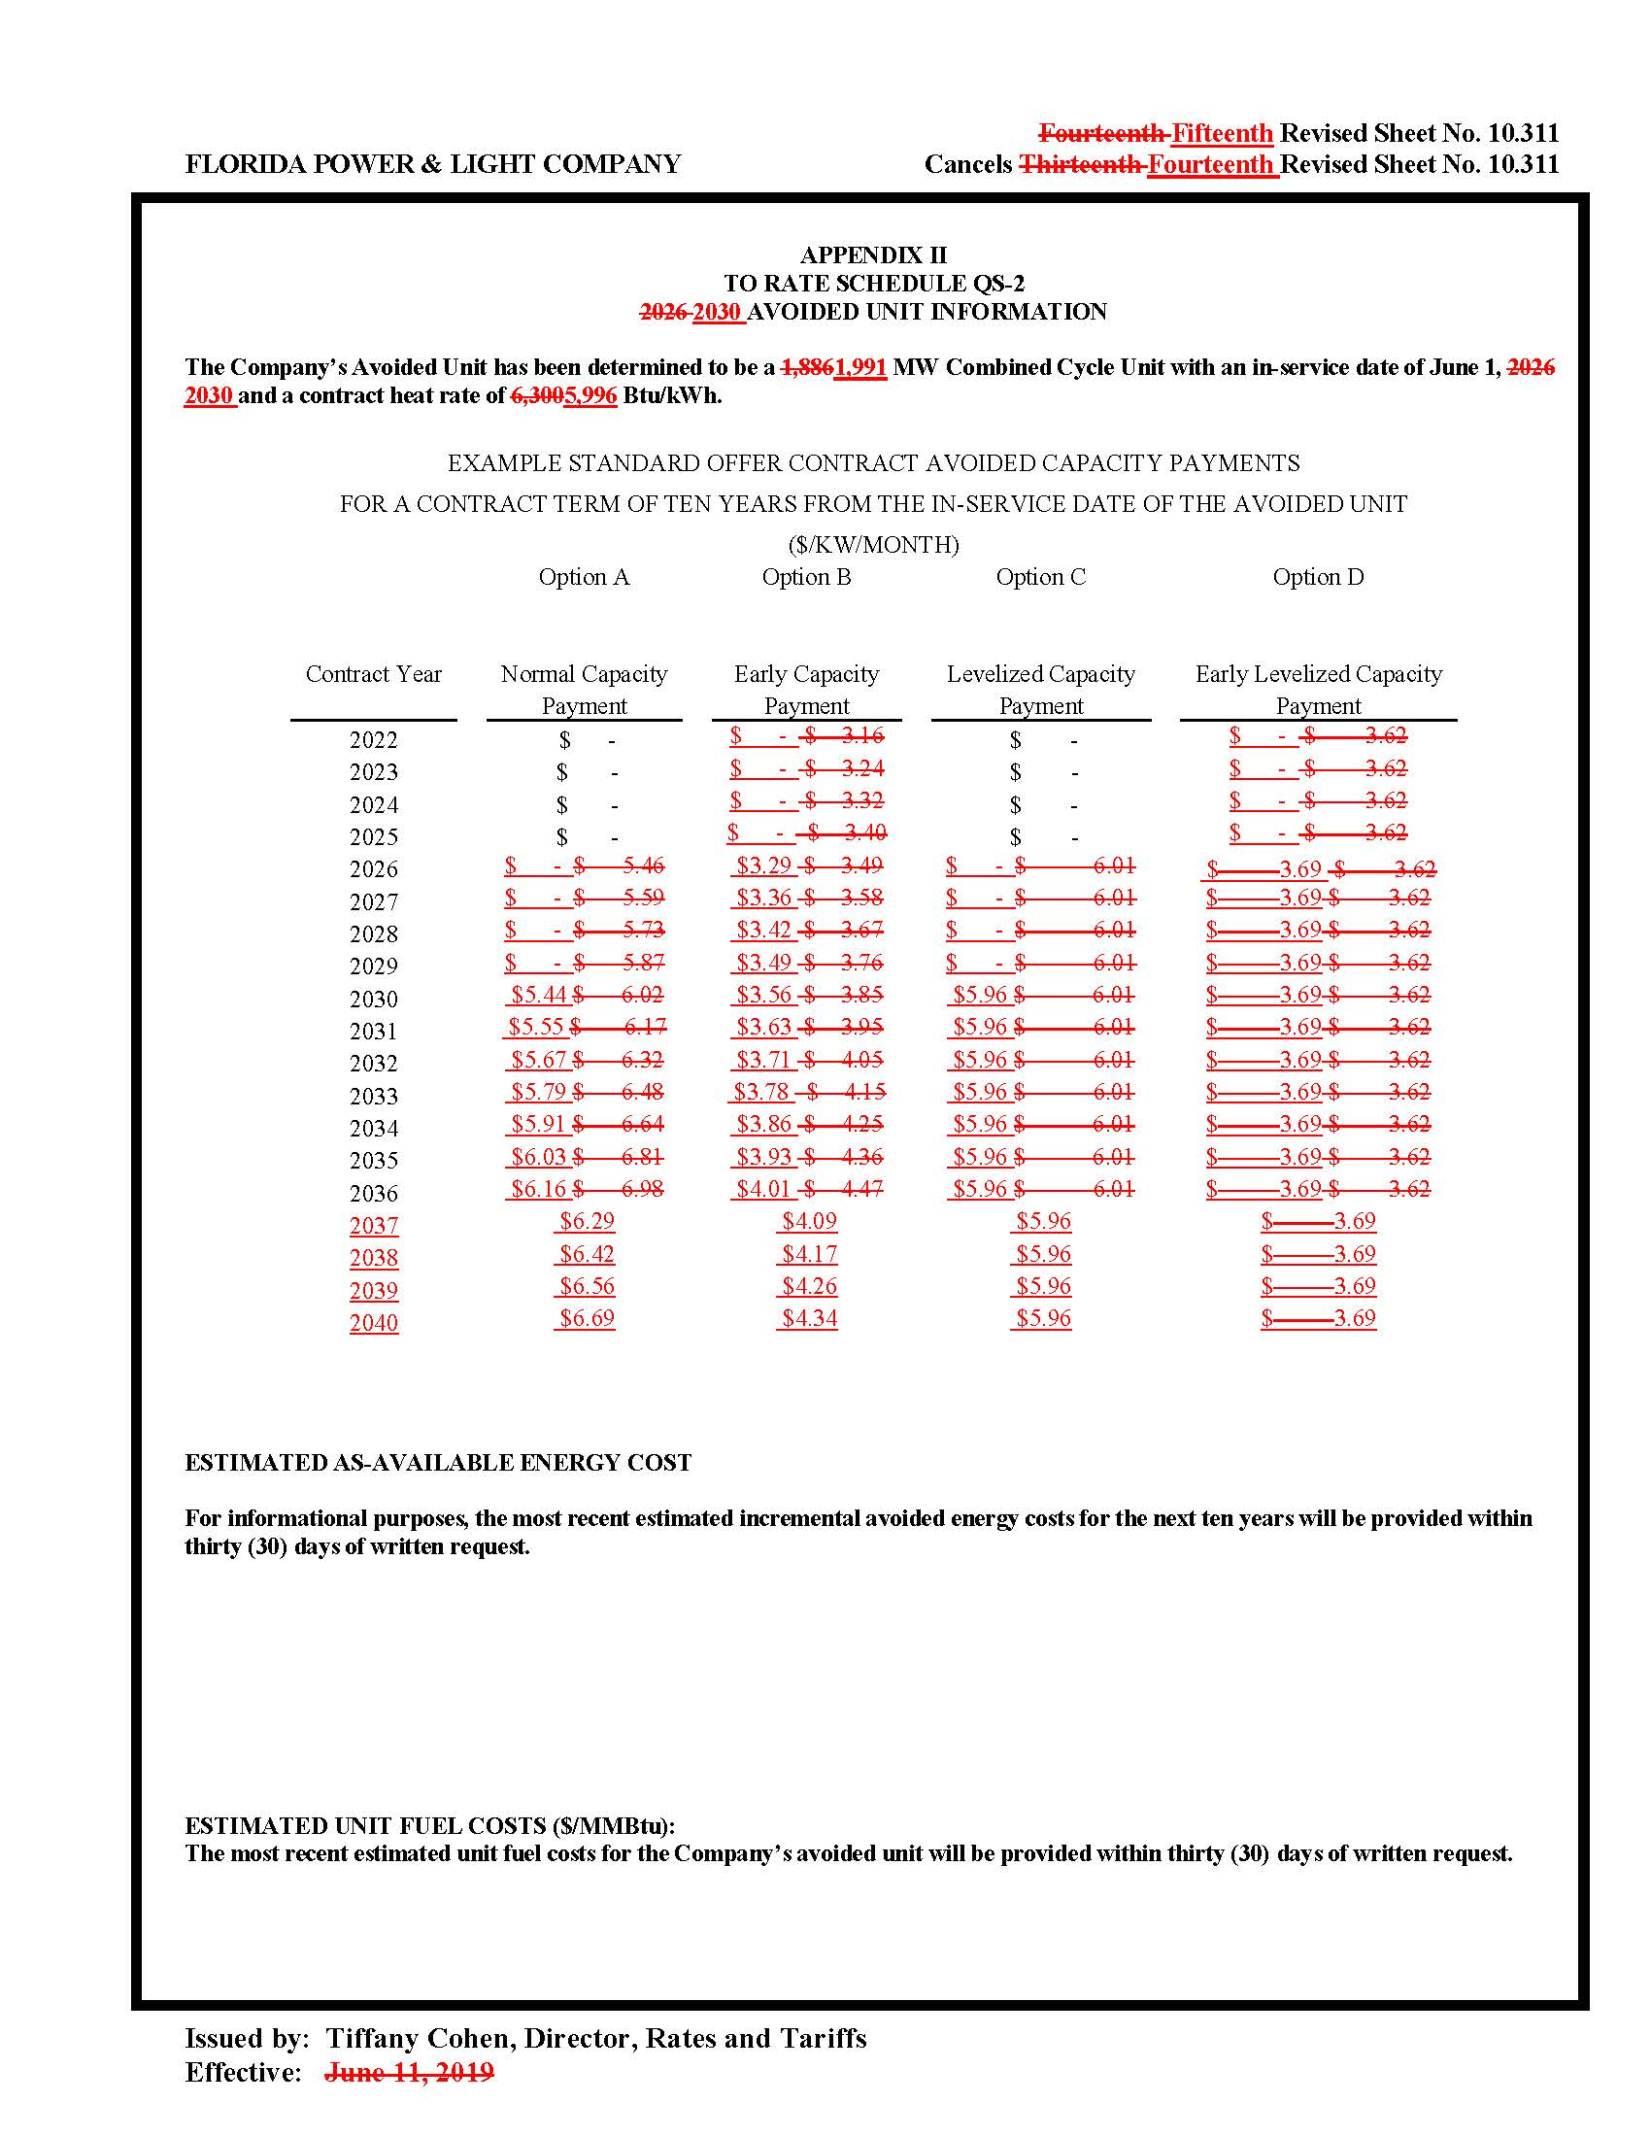

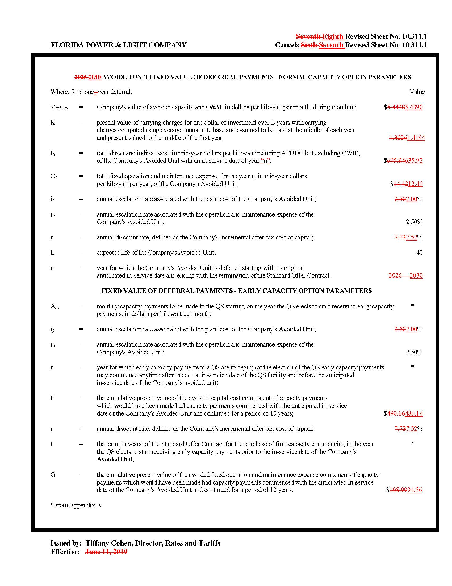

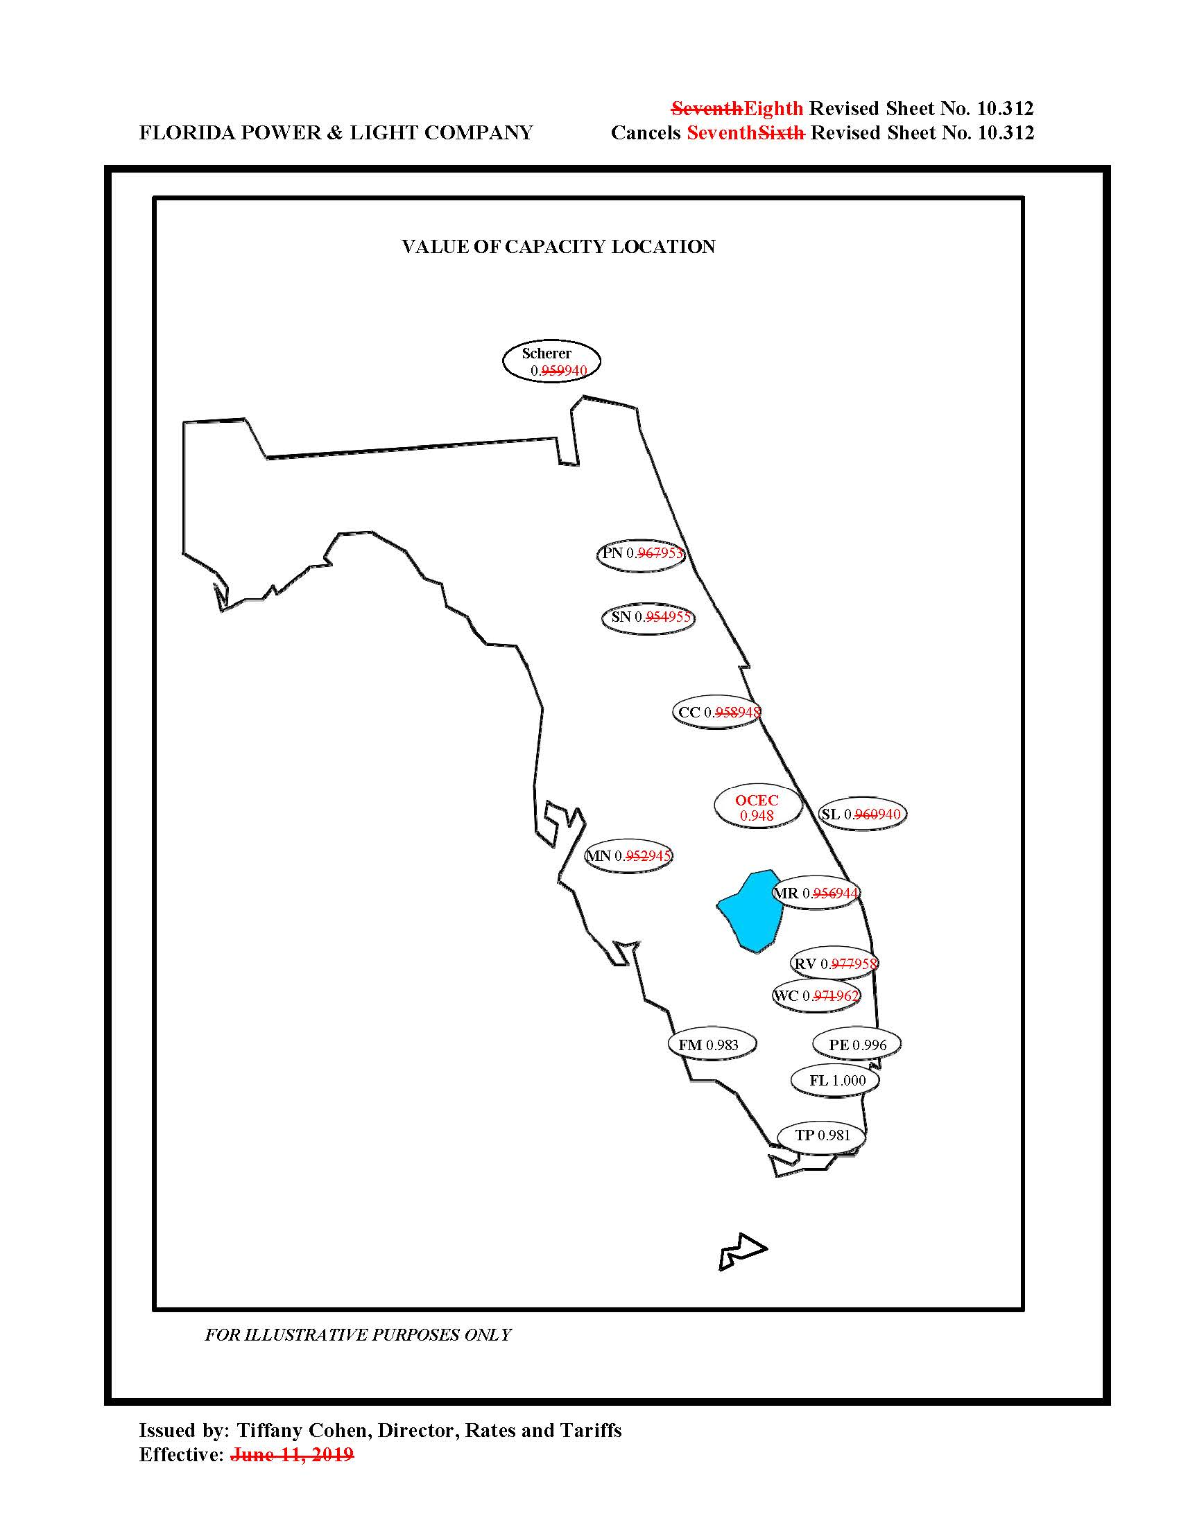

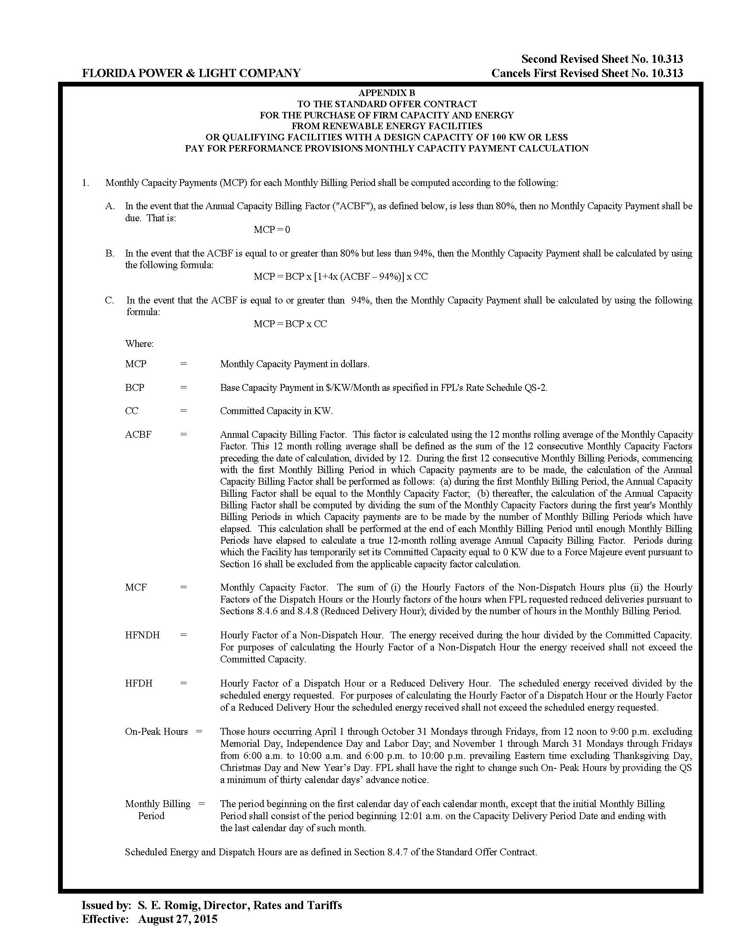

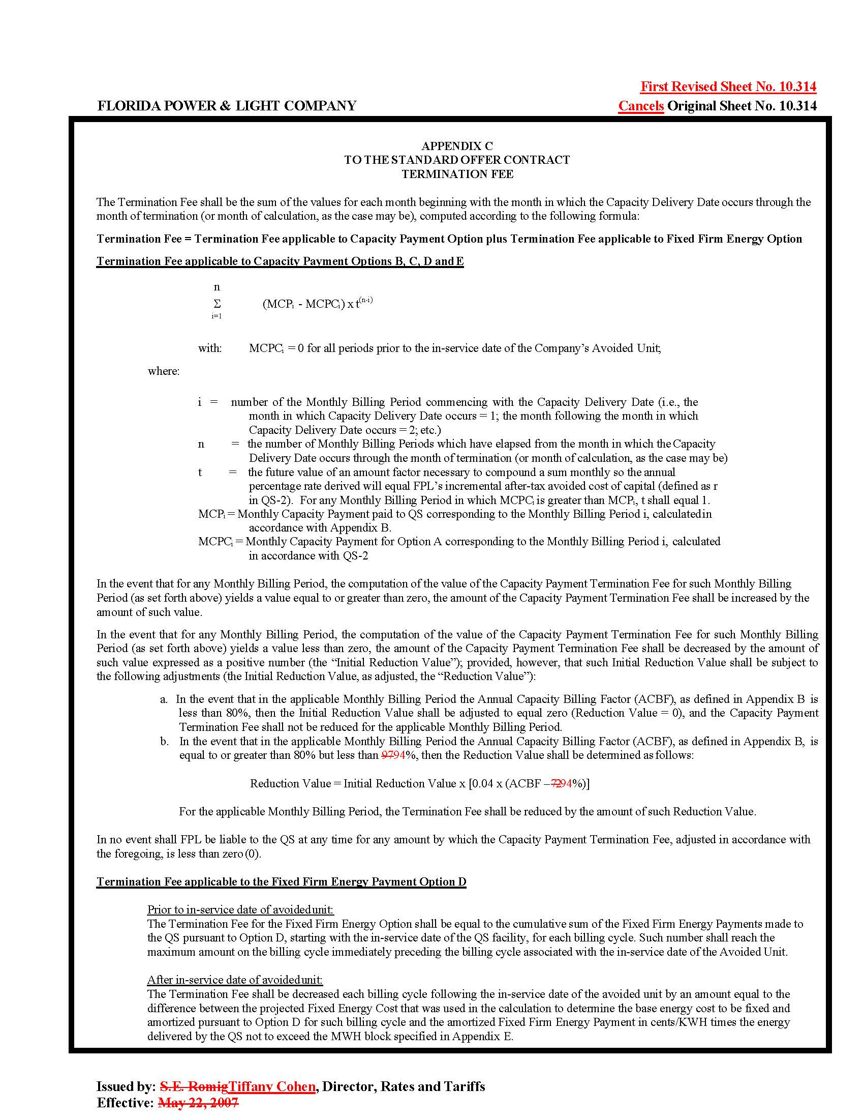

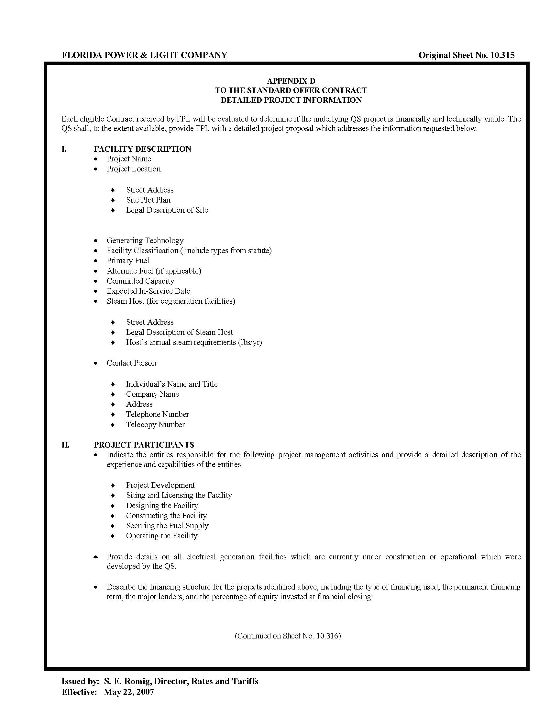

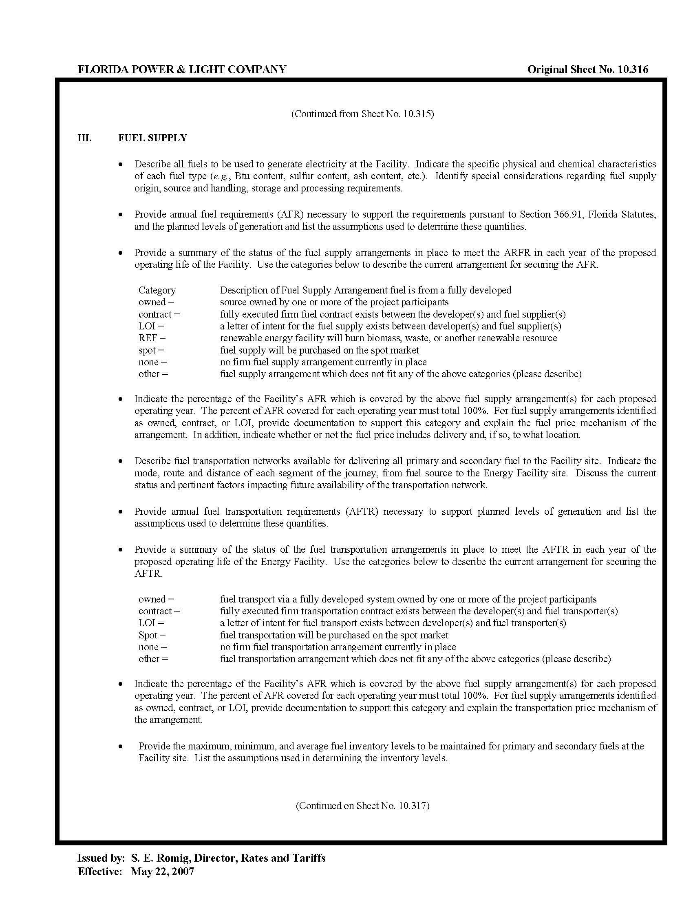

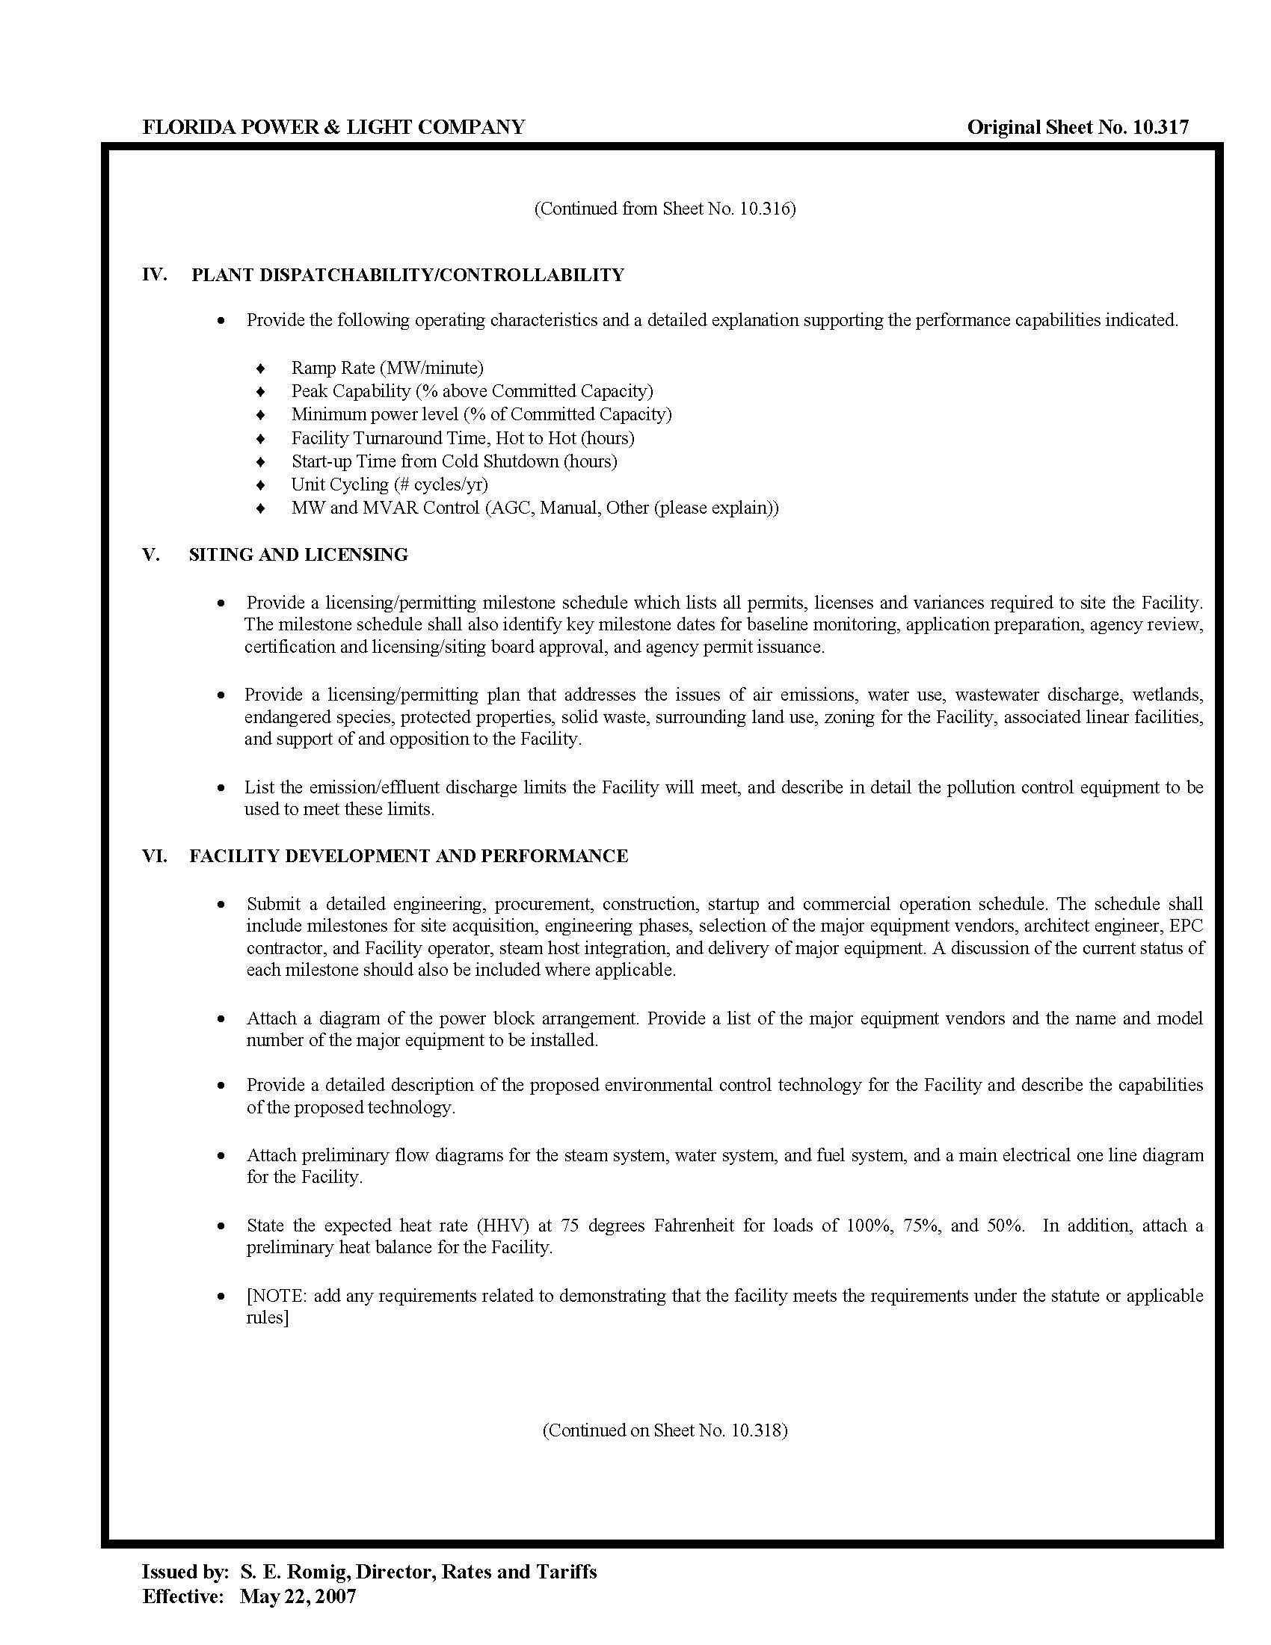

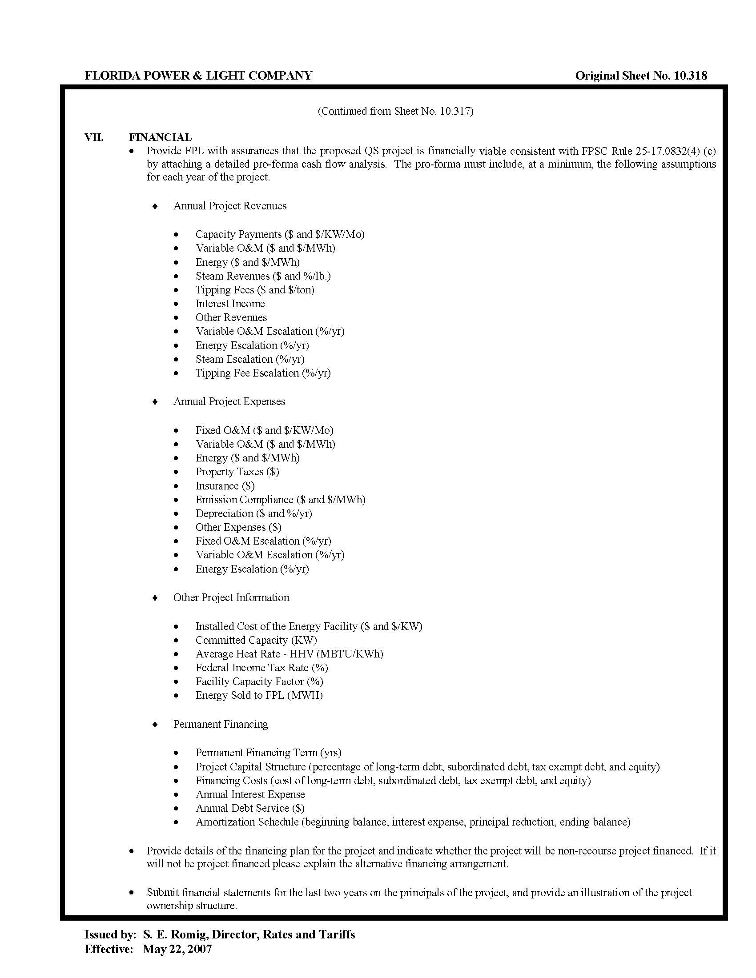

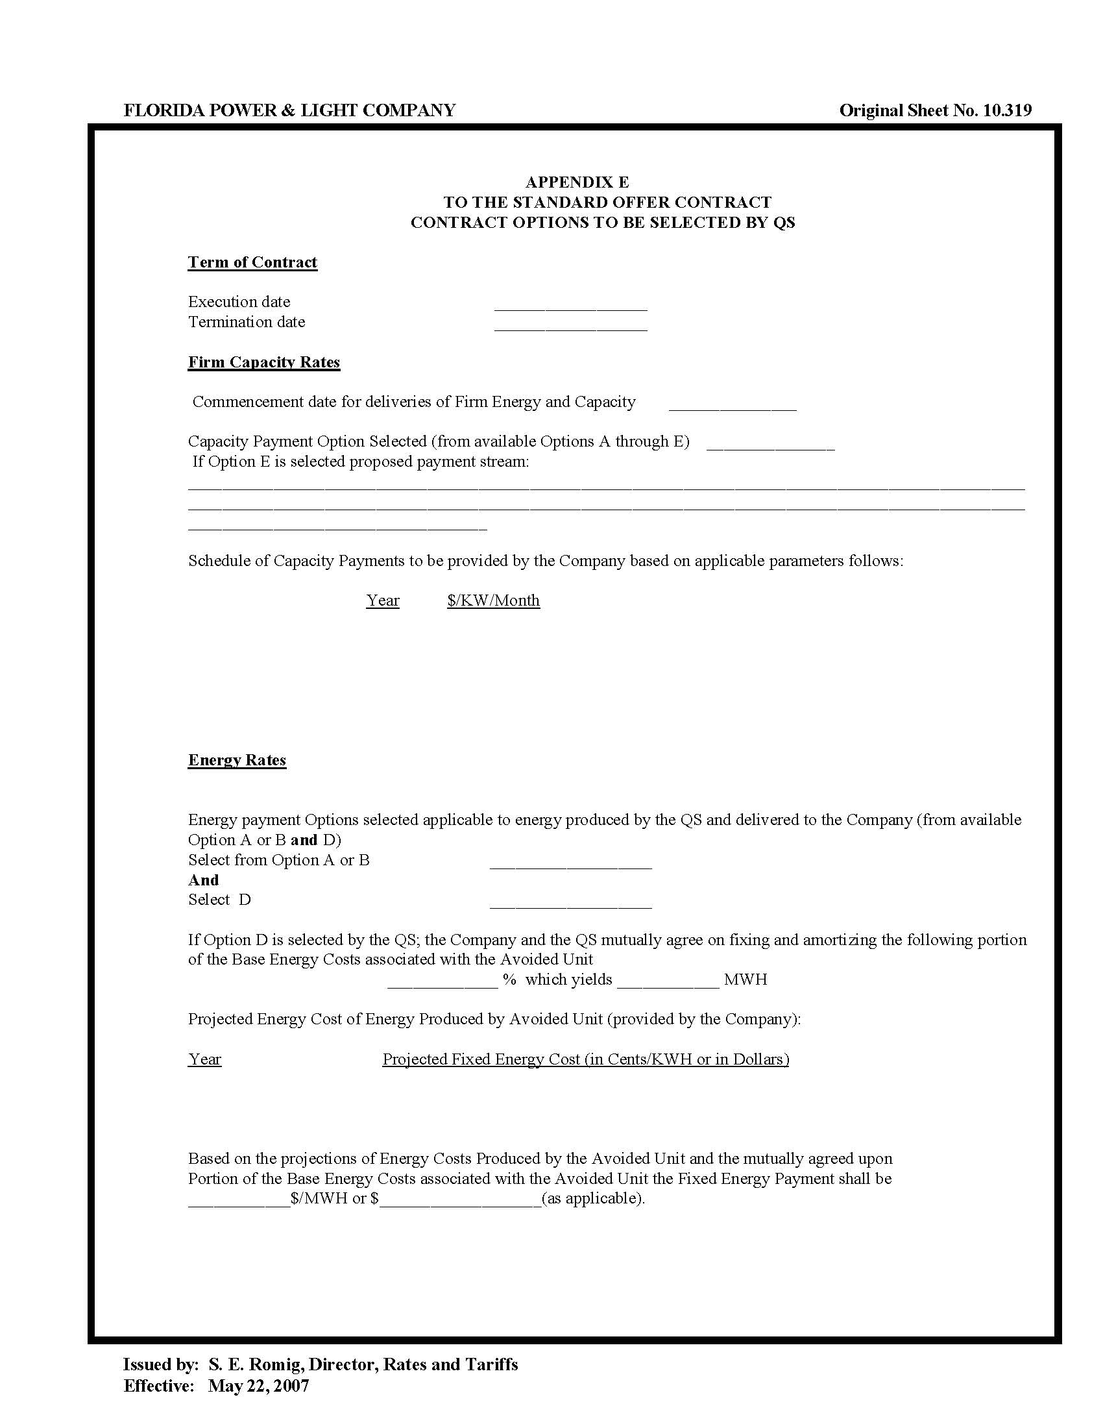

See Document Nos. 02341-2020 and 02557-2020 in Docket No. 20200114-EQ.
See Order No. PSC-2018-0316-PAA-EQ, issued June 20, 2018, in Docket No. 20180083-EQ, In re: Petition for approval of renewable energy tariff and standard offer contract, by Florida Power & Light Company.
Document No. 02342-2020, filed May 1, 2020, in Docket No. 20200114-EQ.

