BEFORE THE FLORIDA PUBLIC SERVICE COMMISSION

In re: Application for amendment of Certificates 669-W and 571-S to delete territory in Sumter County, by South Sumter Utility Company, LLC. | DOCKET NO. 20200012-WS  ORDER NO. PSC-2020-0218-FOF-WS  ISSUED: June 29, 2020

The following Commissioners participated in the disposition of this matter:

GARY F. CLARK, Chairman
ART GRAHAM
JULIE I. BROWN
DONALD J. POLMANN
ANDREW GILES FAY

ORDER APPROVING SOUTH SUMTER UTILITY COMPANY, LLC’S
APPLICATION TO AMEND CERTIFICATE NOS. 669-W AND 571-S

BY THE COMMISSION:

Background

South Sumter Utility Company, LLC (SSU or Utility) is a Class C utility which provides service in Sumter County to approximately 1,854 water and wastewater customers. The Utility is in the Southwest Florida Management District and is not in a water use caution area. In its 2018 Annual Report, the Utility reported operating revenues of $3,220 for water and $4,136 for wastewater, and a net operating loss of $218,749 for water and $226,407 for wastewater.

On January 8, 2020, pursuant to Section 367.045, Florida Statutes (F.S.), the Utility applied for an amendment to delete part of its service territory from Certificate Nos. 669-W and 571-S. The Utility does not currently provide water or wastewater service to this area. The Utility requested this territory be deleted from the service area because of the separation by the Florida Turnpike and the related difficulty in extending service to the area. For these reasons, SSU believes it is not the best alternative for water and wastewater service to the area. We have jurisdiction pursuant to Section 367.045, F.S.

Decision

On January 8, 2020, SSU applied for an amendment to delete a portion of its certificated area. The area proposed to be deleted (deletion area) is currently undeveloped.
The deletion area is planned to be developed to serve approximately 1,161 equivalent residential connections. However, the deletion area is separated from adjacent SSU territory by Florida’s Turnpike. SSU stated in its application that the reason for the proposed deletion is the difficulty in extending service across Florida’s Turnpike. In response to Commission staff’s first data request, SSU stated that a newly created water and wastewater service provider, Gibson Place Utility Company, LLC (Gibson), is the best alternative to provide water and wastewater service to the deletion area. We have been advised that Gibson, which is affiliated with the Villages, plans to file an application for original water and wastewater certificates to serve territory that will include the territory being deleted from SSU’s certificated territory.

An adequate service territory map and a territory description have been provided as prescribed by Rule 25-30.036(4)(e) and (g), Florida Administrative Code (F.A.C.). A description of the territory requested to be deleted by the Utility is appended to this Order as Attachment A. The Utility submitted an affidavit with its January 8, 2020, application consistent with Rule 25-30.036(4)(k), F.A.C., stating that it has tariffs and annual reports on file with this Commission. Within its application, the Utility indicated it had filed its 2018 Annual Report. The Utility has requested an additional extension through June 1, 2020, to file its 2019 Annual Report. In addition, the application contains proof of compliance with the noticing provisions set forth in Rule 25-30.030, F.A.C. No objections to the application have been received and the time for filing such has expired.
We hereby find that it is in the public interest to approve the application filed by SSU to amend its water certificate to delete the territory shown on Attachment A from its certificated service area. This Order shall serve as SSU’s amended certificate and shall be retained by the Utility.
Based on the foregoing, it is

ORDERED by the Florida Public Service Commission that South Sumter Utility Company, LLC’s Certificate Nos. 669-W and 571-S shall be amended to delete territory reflected in Attachment A. It is further

ORDERED that this Order shall serve as South Sumter Utility Company, LLC’s amended certificate and shall be retained by the Utility

ORDERED that this docket shall be closed.

By ORDER of the Florida Public Service Commission this 1st day of July, 2020.

/s/ Adam J. Teitzman
ADAM J. TEITZMAN
Commission Clerk
Florida Public Service Commission
2540 Shumard Oak Boulevard
Tallahassee, Florida 32399
(850) 413-6770
www.floridapsc.com

Copies furnished: A copy of this document is provided to the parties of record at the time of issuance and, if applicable, interested persons

BYL

NOTICE OF FURTHER PROCEEDINGS OR JUDICIAL REVIEW

The Florida Public Service Commission is required by Section 120.569(1), Florida Statutes, to notify parties of any administrative hearing or judicial review of Commission orders that is available under Sections 120.57 or 120.68, Florida Statutes, as well as the procedures and time limits that apply. This notice should not be construed to mean all requests for an administrative hearing or judicial review will be granted or result in the relief sought.

Any party adversely affected by the Commission's final action in this matter may request: 1) reconsideration of the decision by filing a motion for reconsideration with the Office of Commission Clerk, 2540 Shumard Oak Boulevard, Tallahassee, Florida 32399-0850, within fifteen (15) days of the issuance of this order in the form prescribed by Rule 25-22.060, Florida Administrative Code; or 2) judicial review by the Florida Supreme Court in the case of an electric, gas or telephone utility or the First District Court of Appeal in the case of a water and/or wastewater utility by filing a notice of appeal with the Office of Commission Clerk, and filing a copy of the notice of appeal and the filing fee with the appropriate court. This filing must be completed within thirty (30) days after the issuance of this order, pursuant to Rule 9.110, Florida Rules of Appellate Procedure. The notice of appeal must be in the form specified in Rule 9.900(a), Florida Rules of Appellate Procedure.

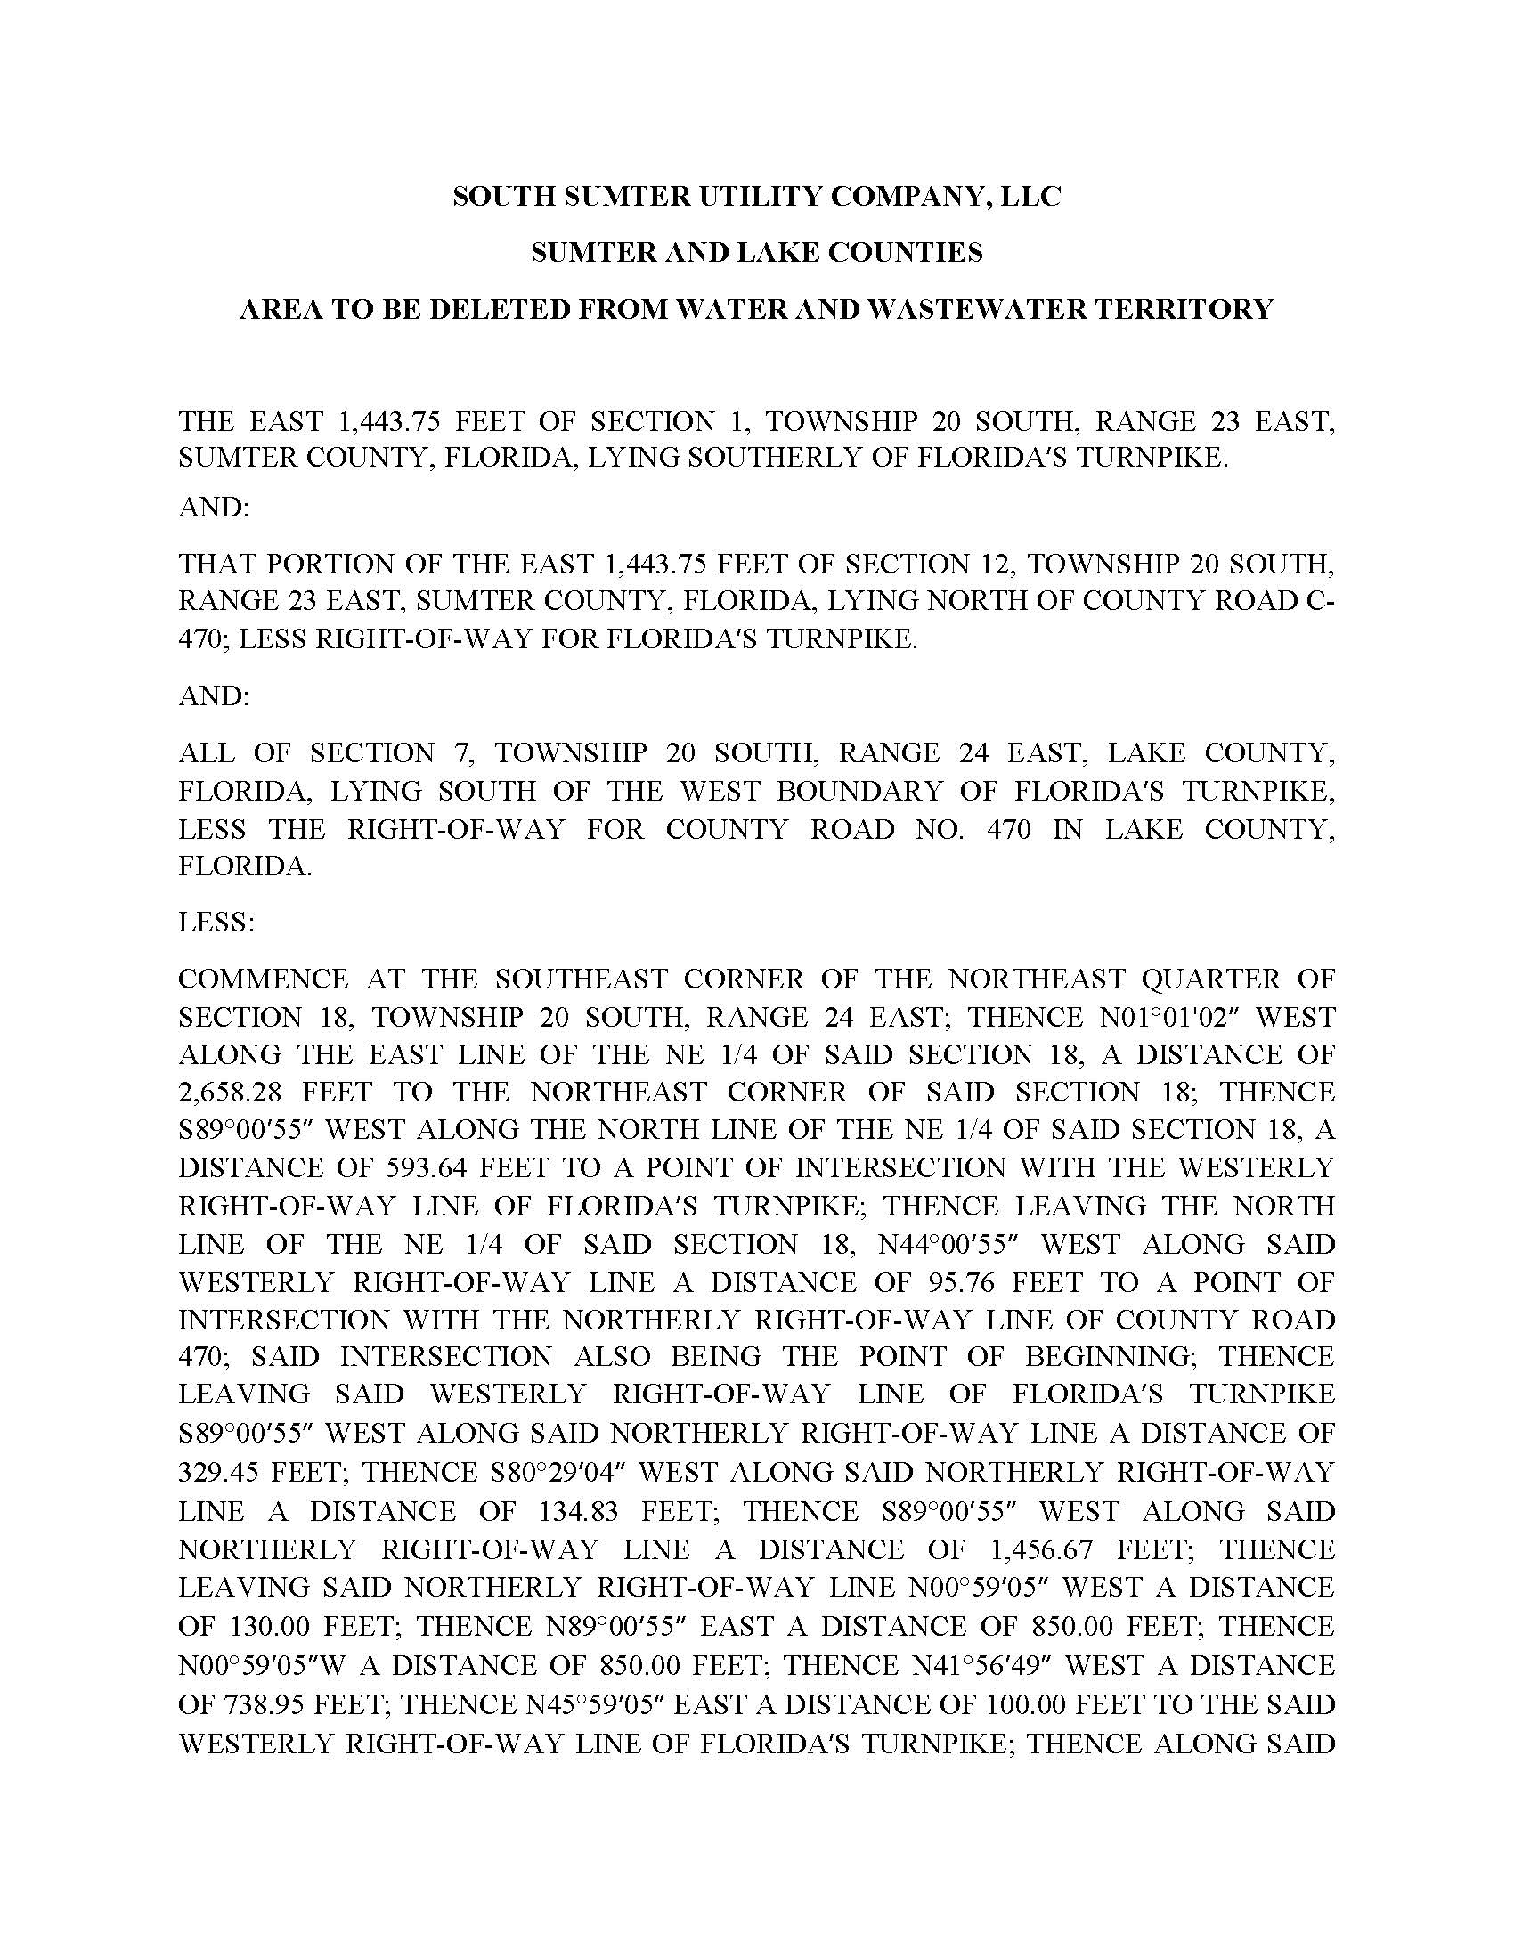

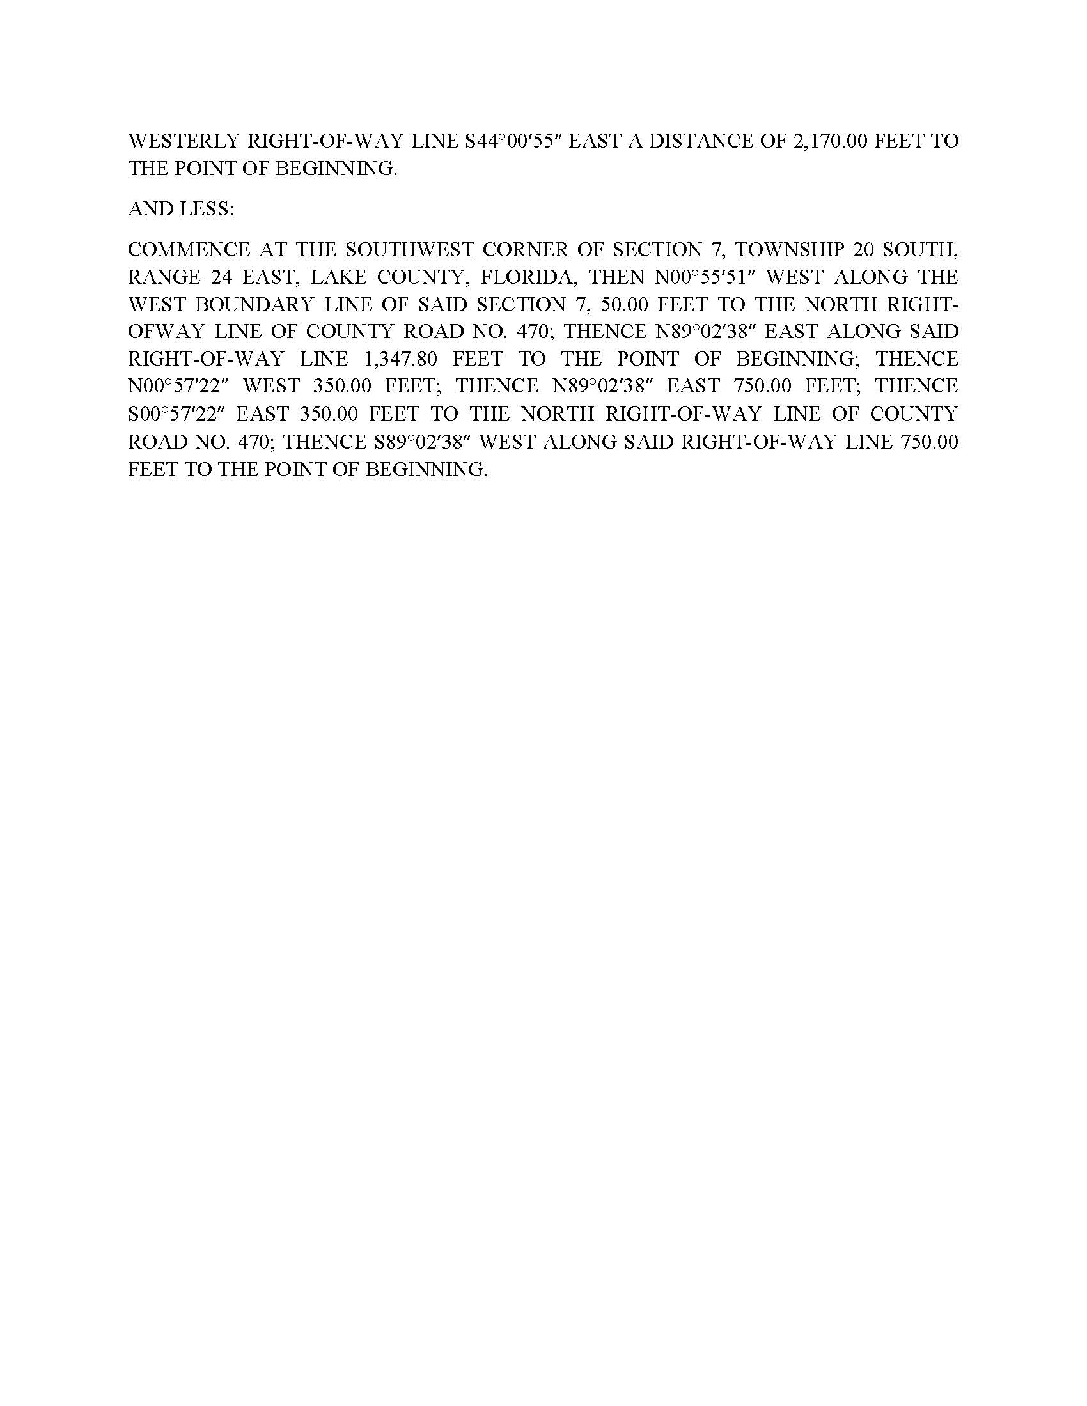

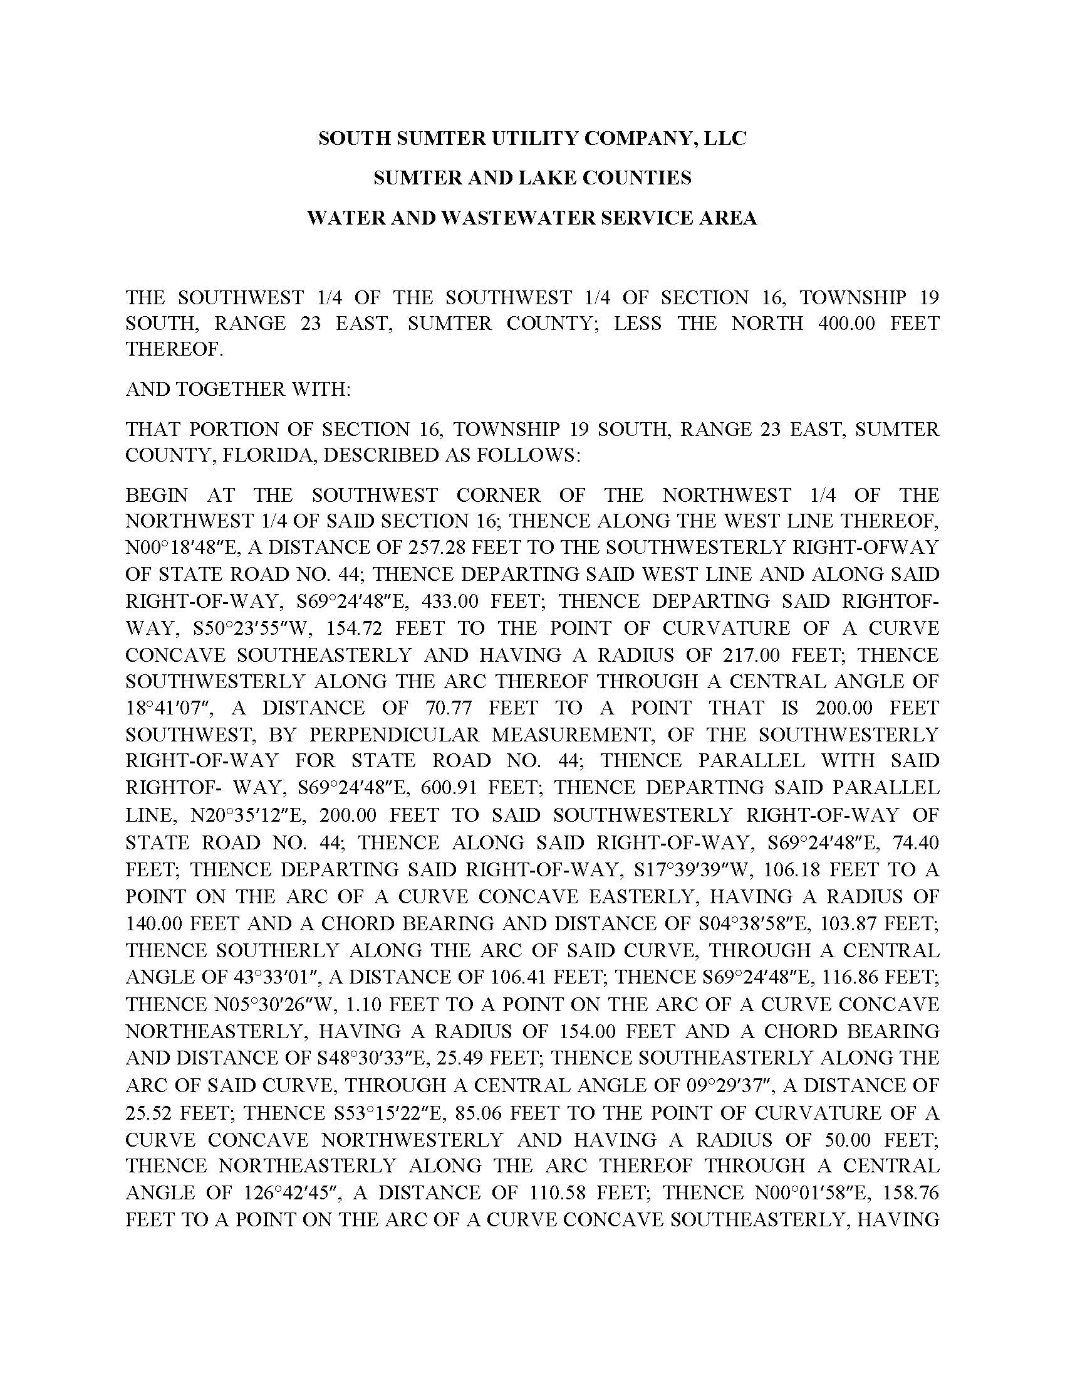

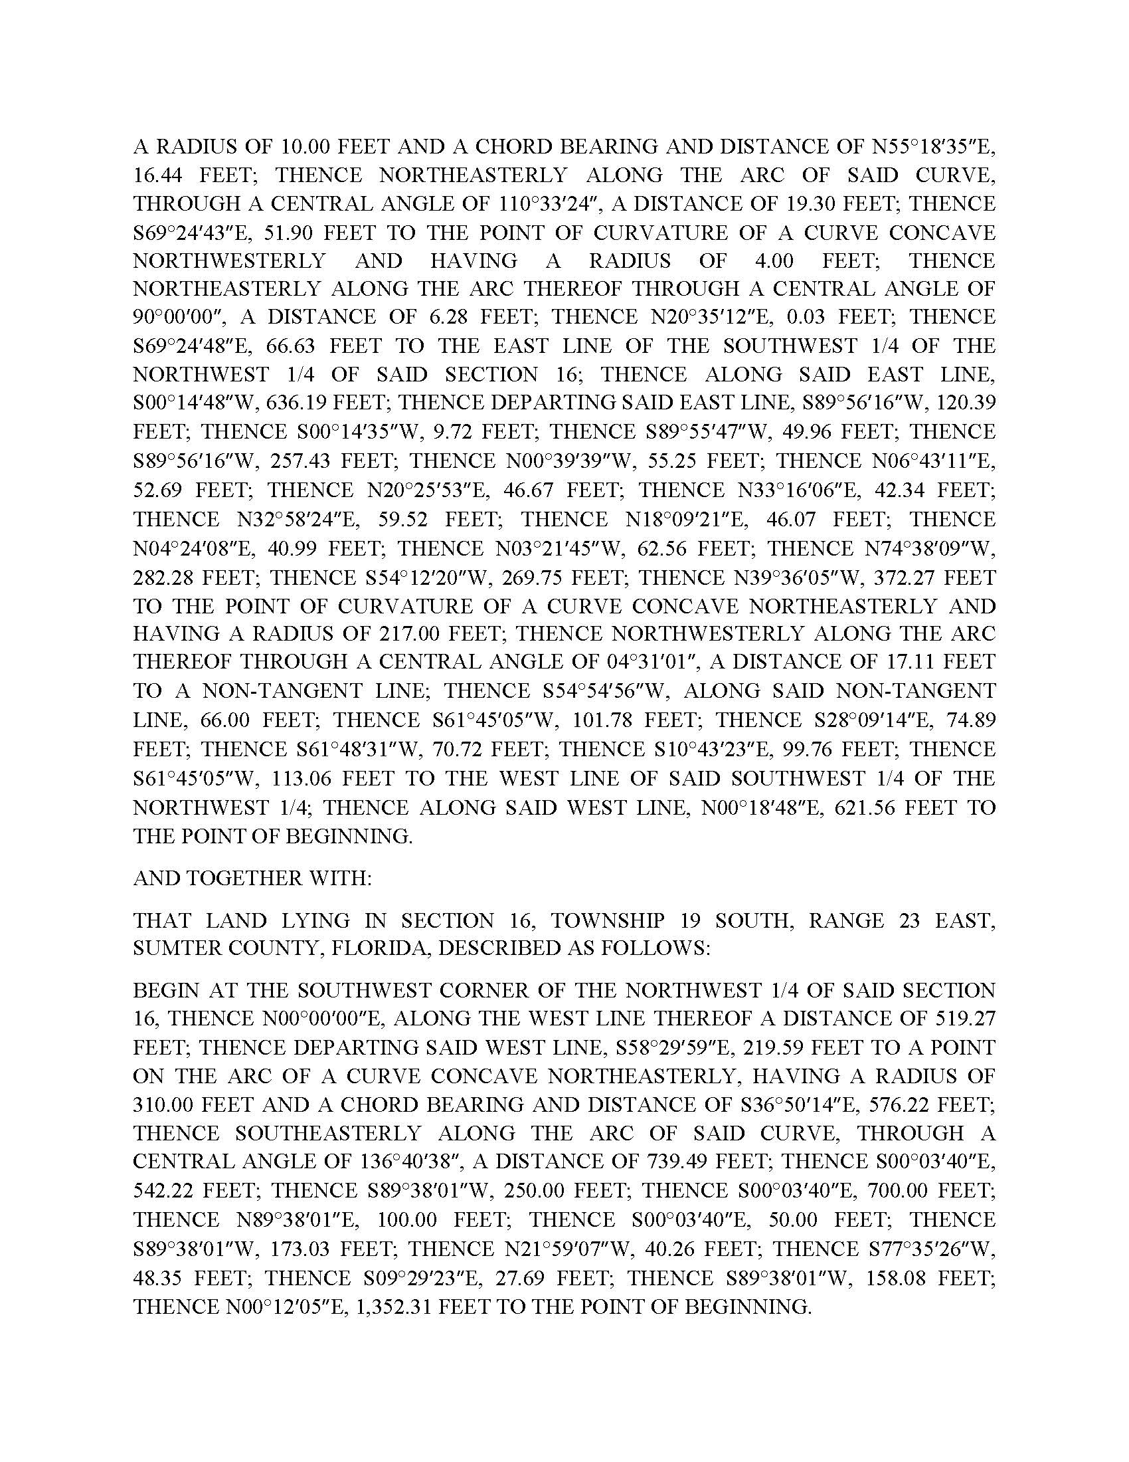

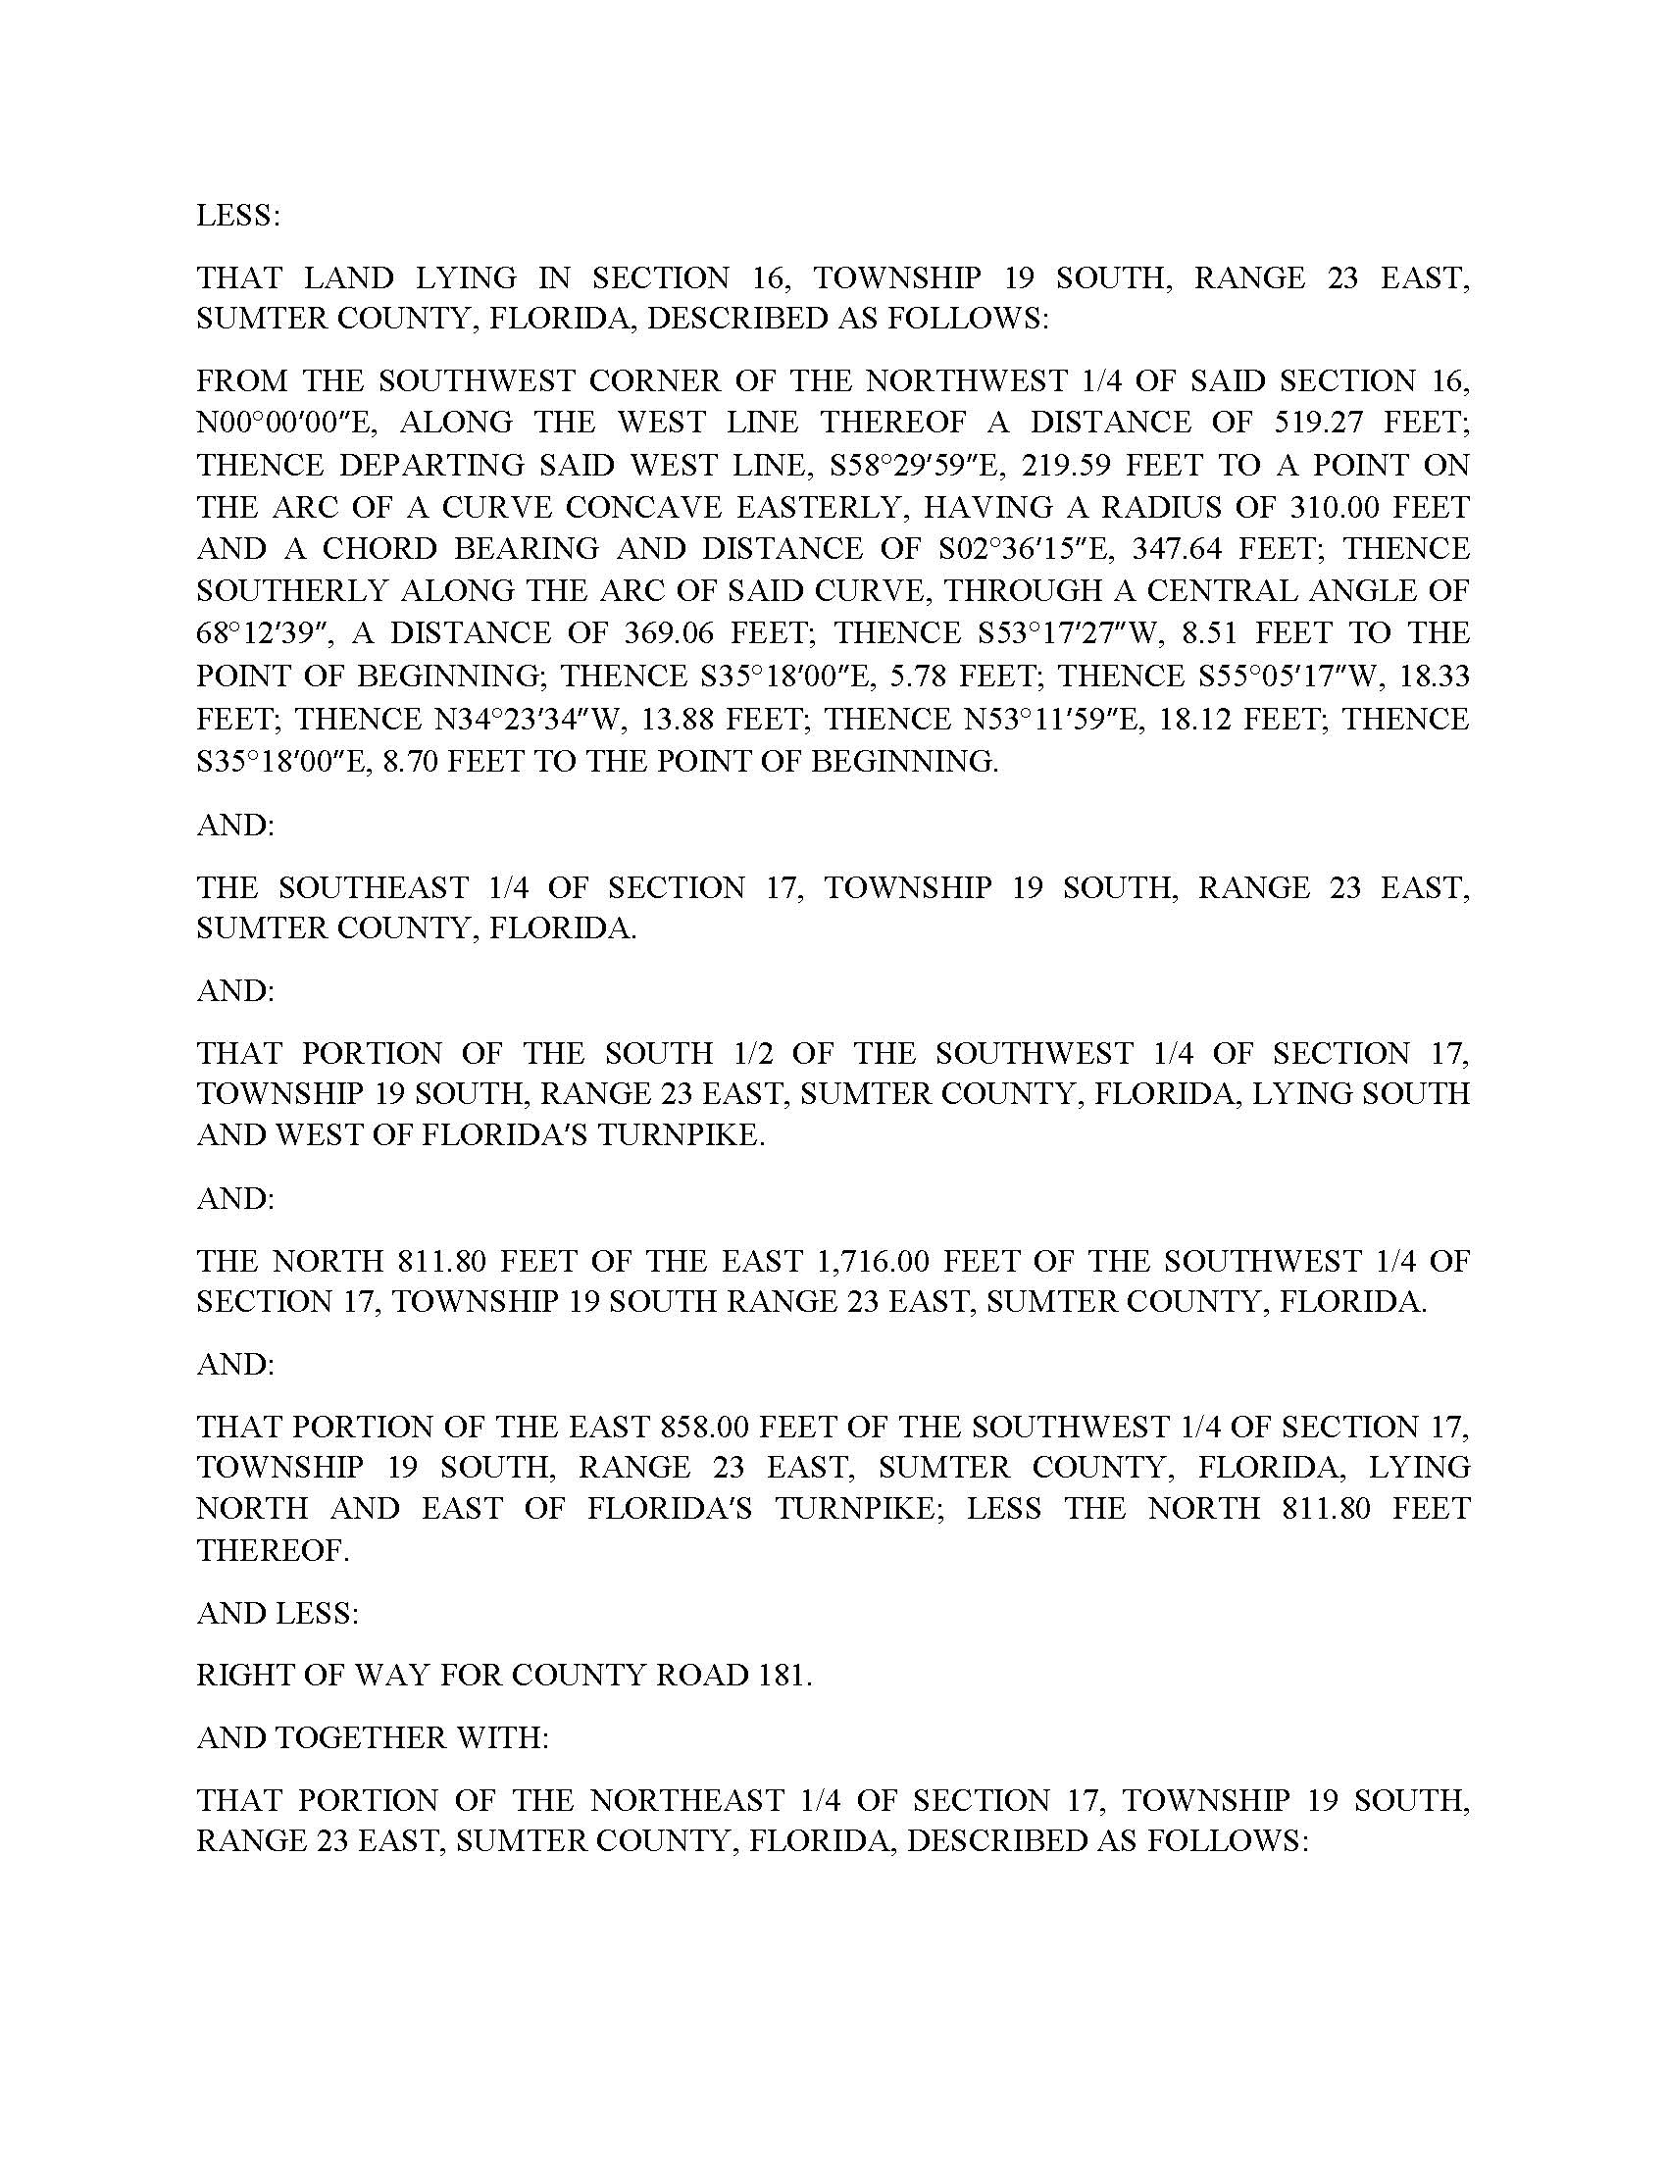

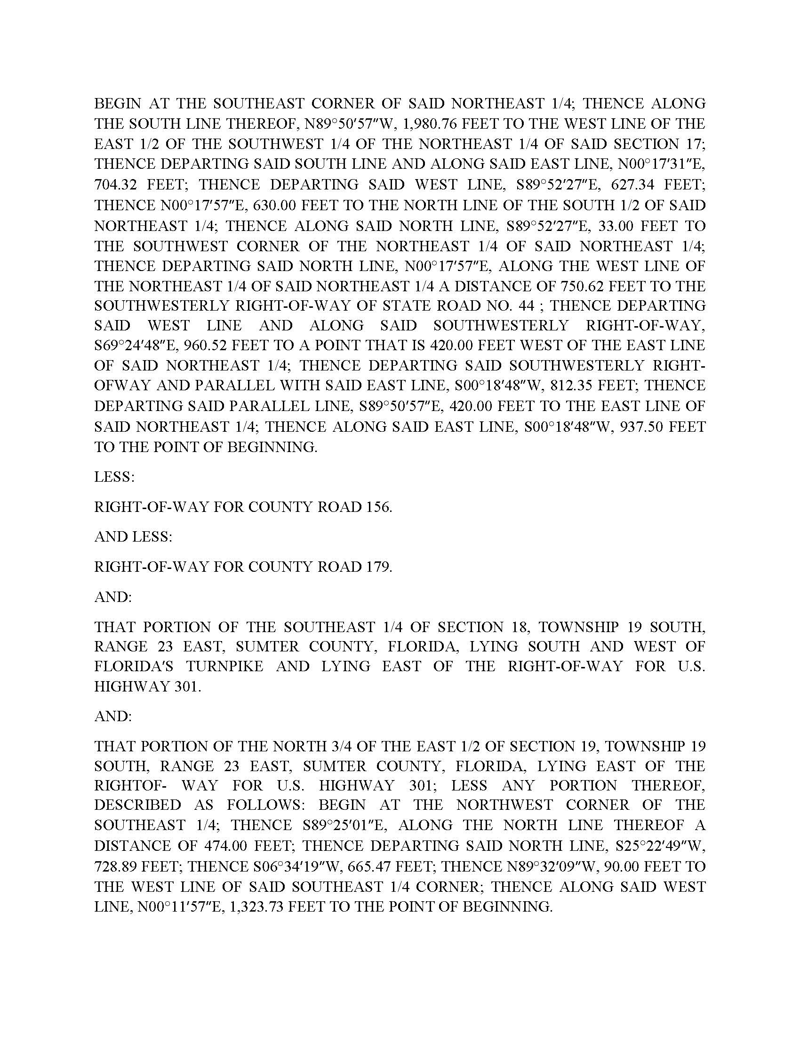

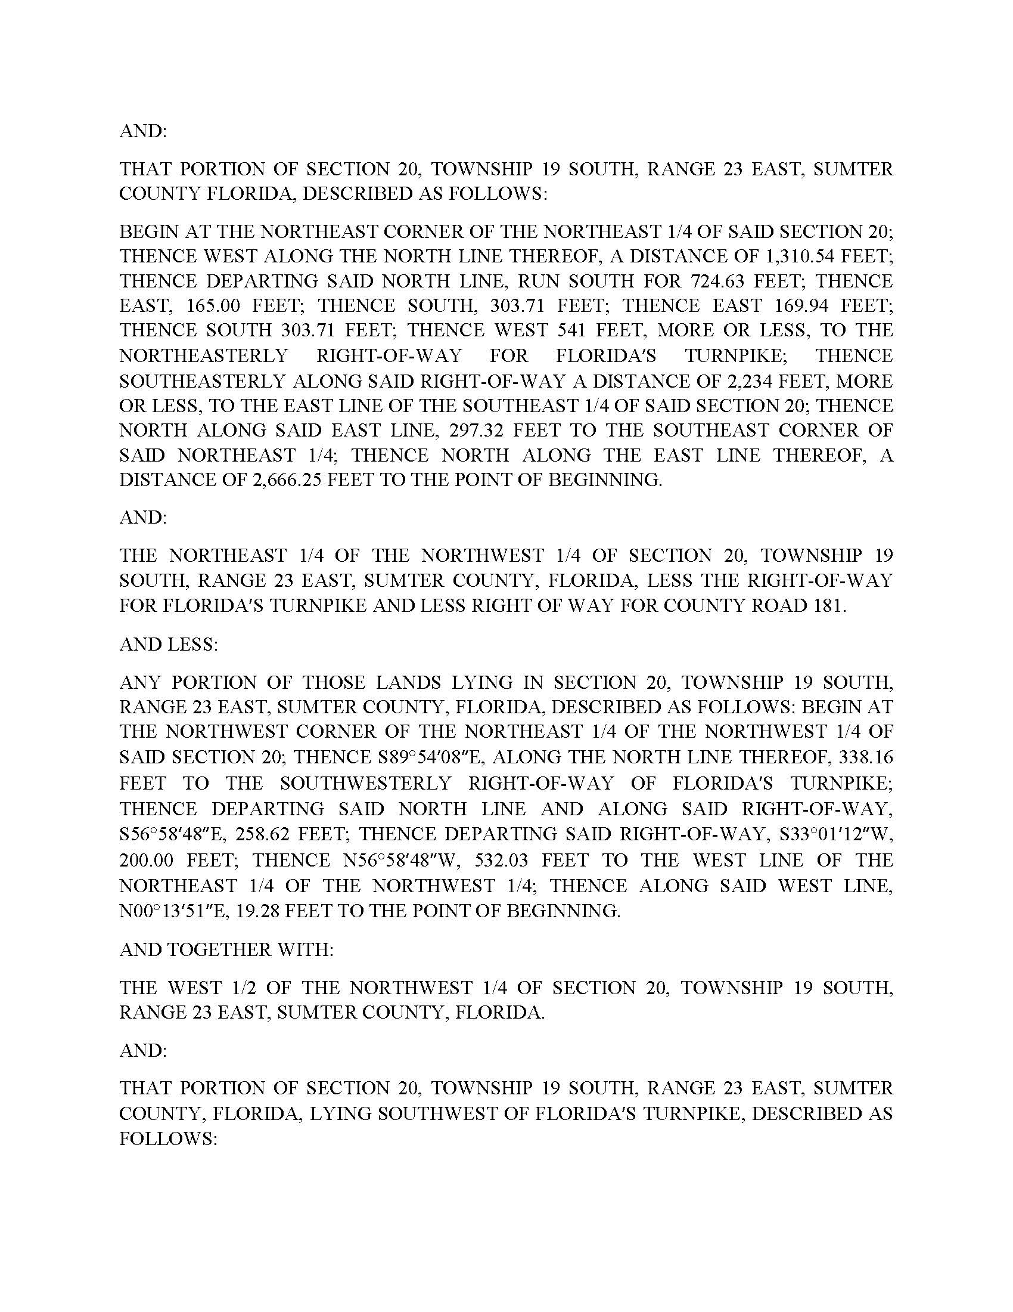

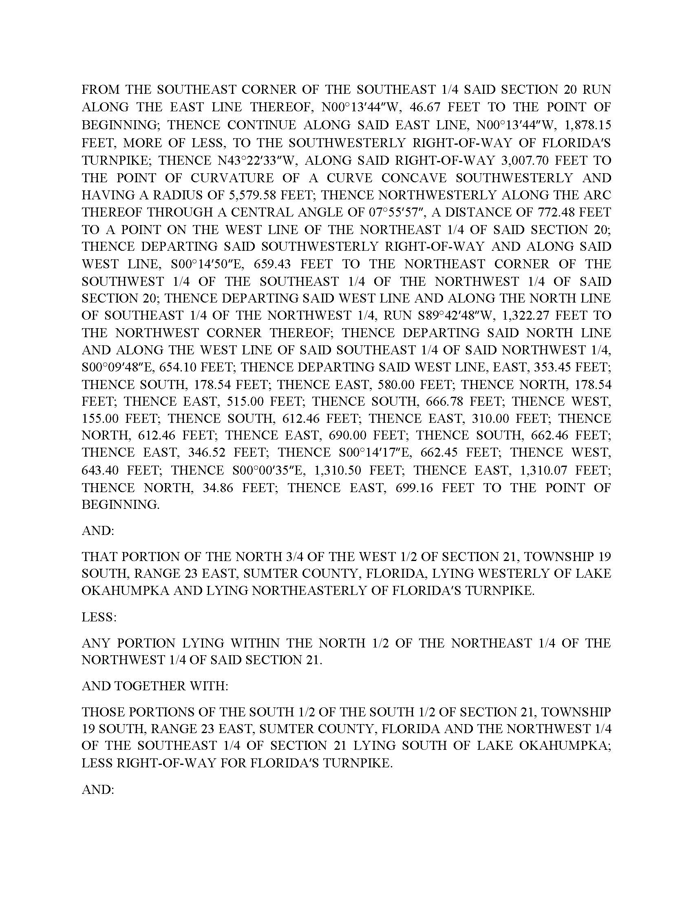

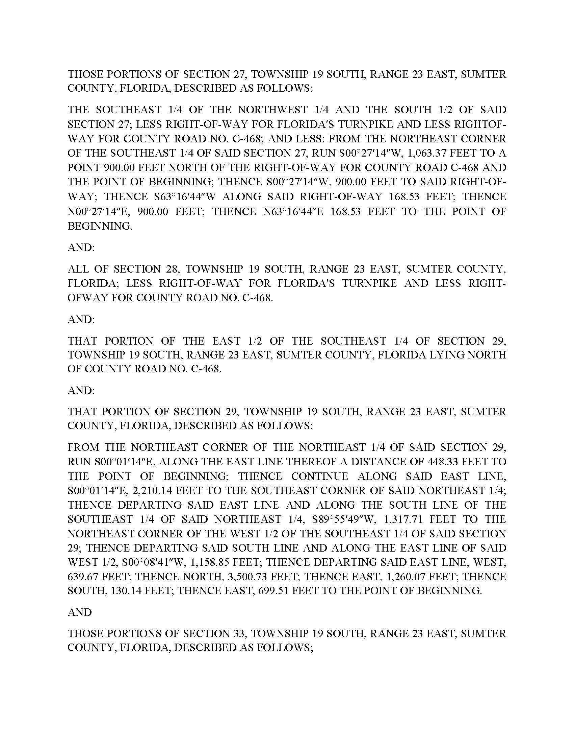

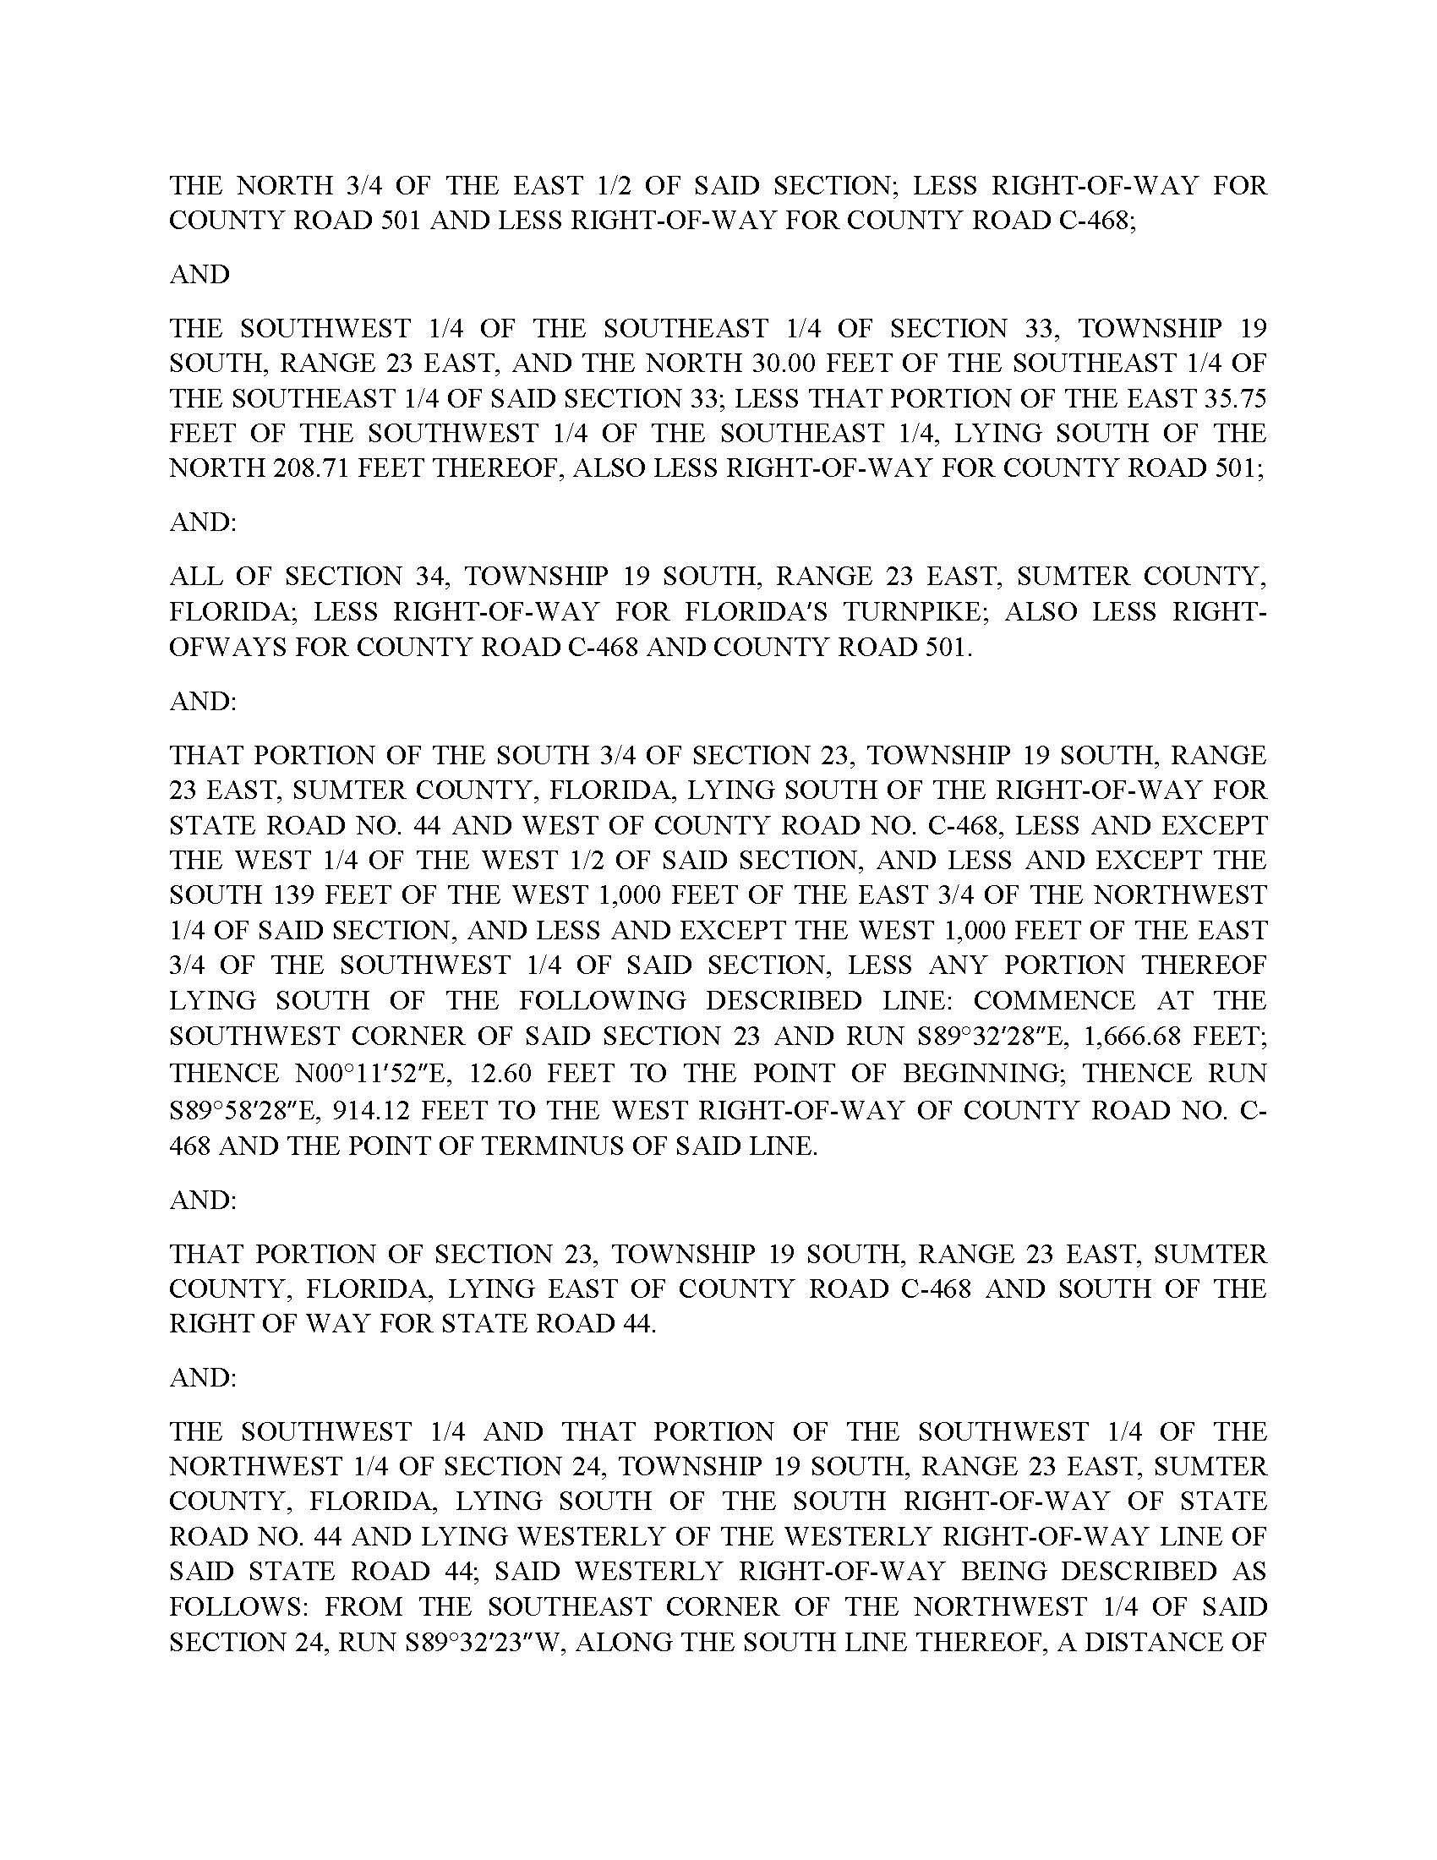

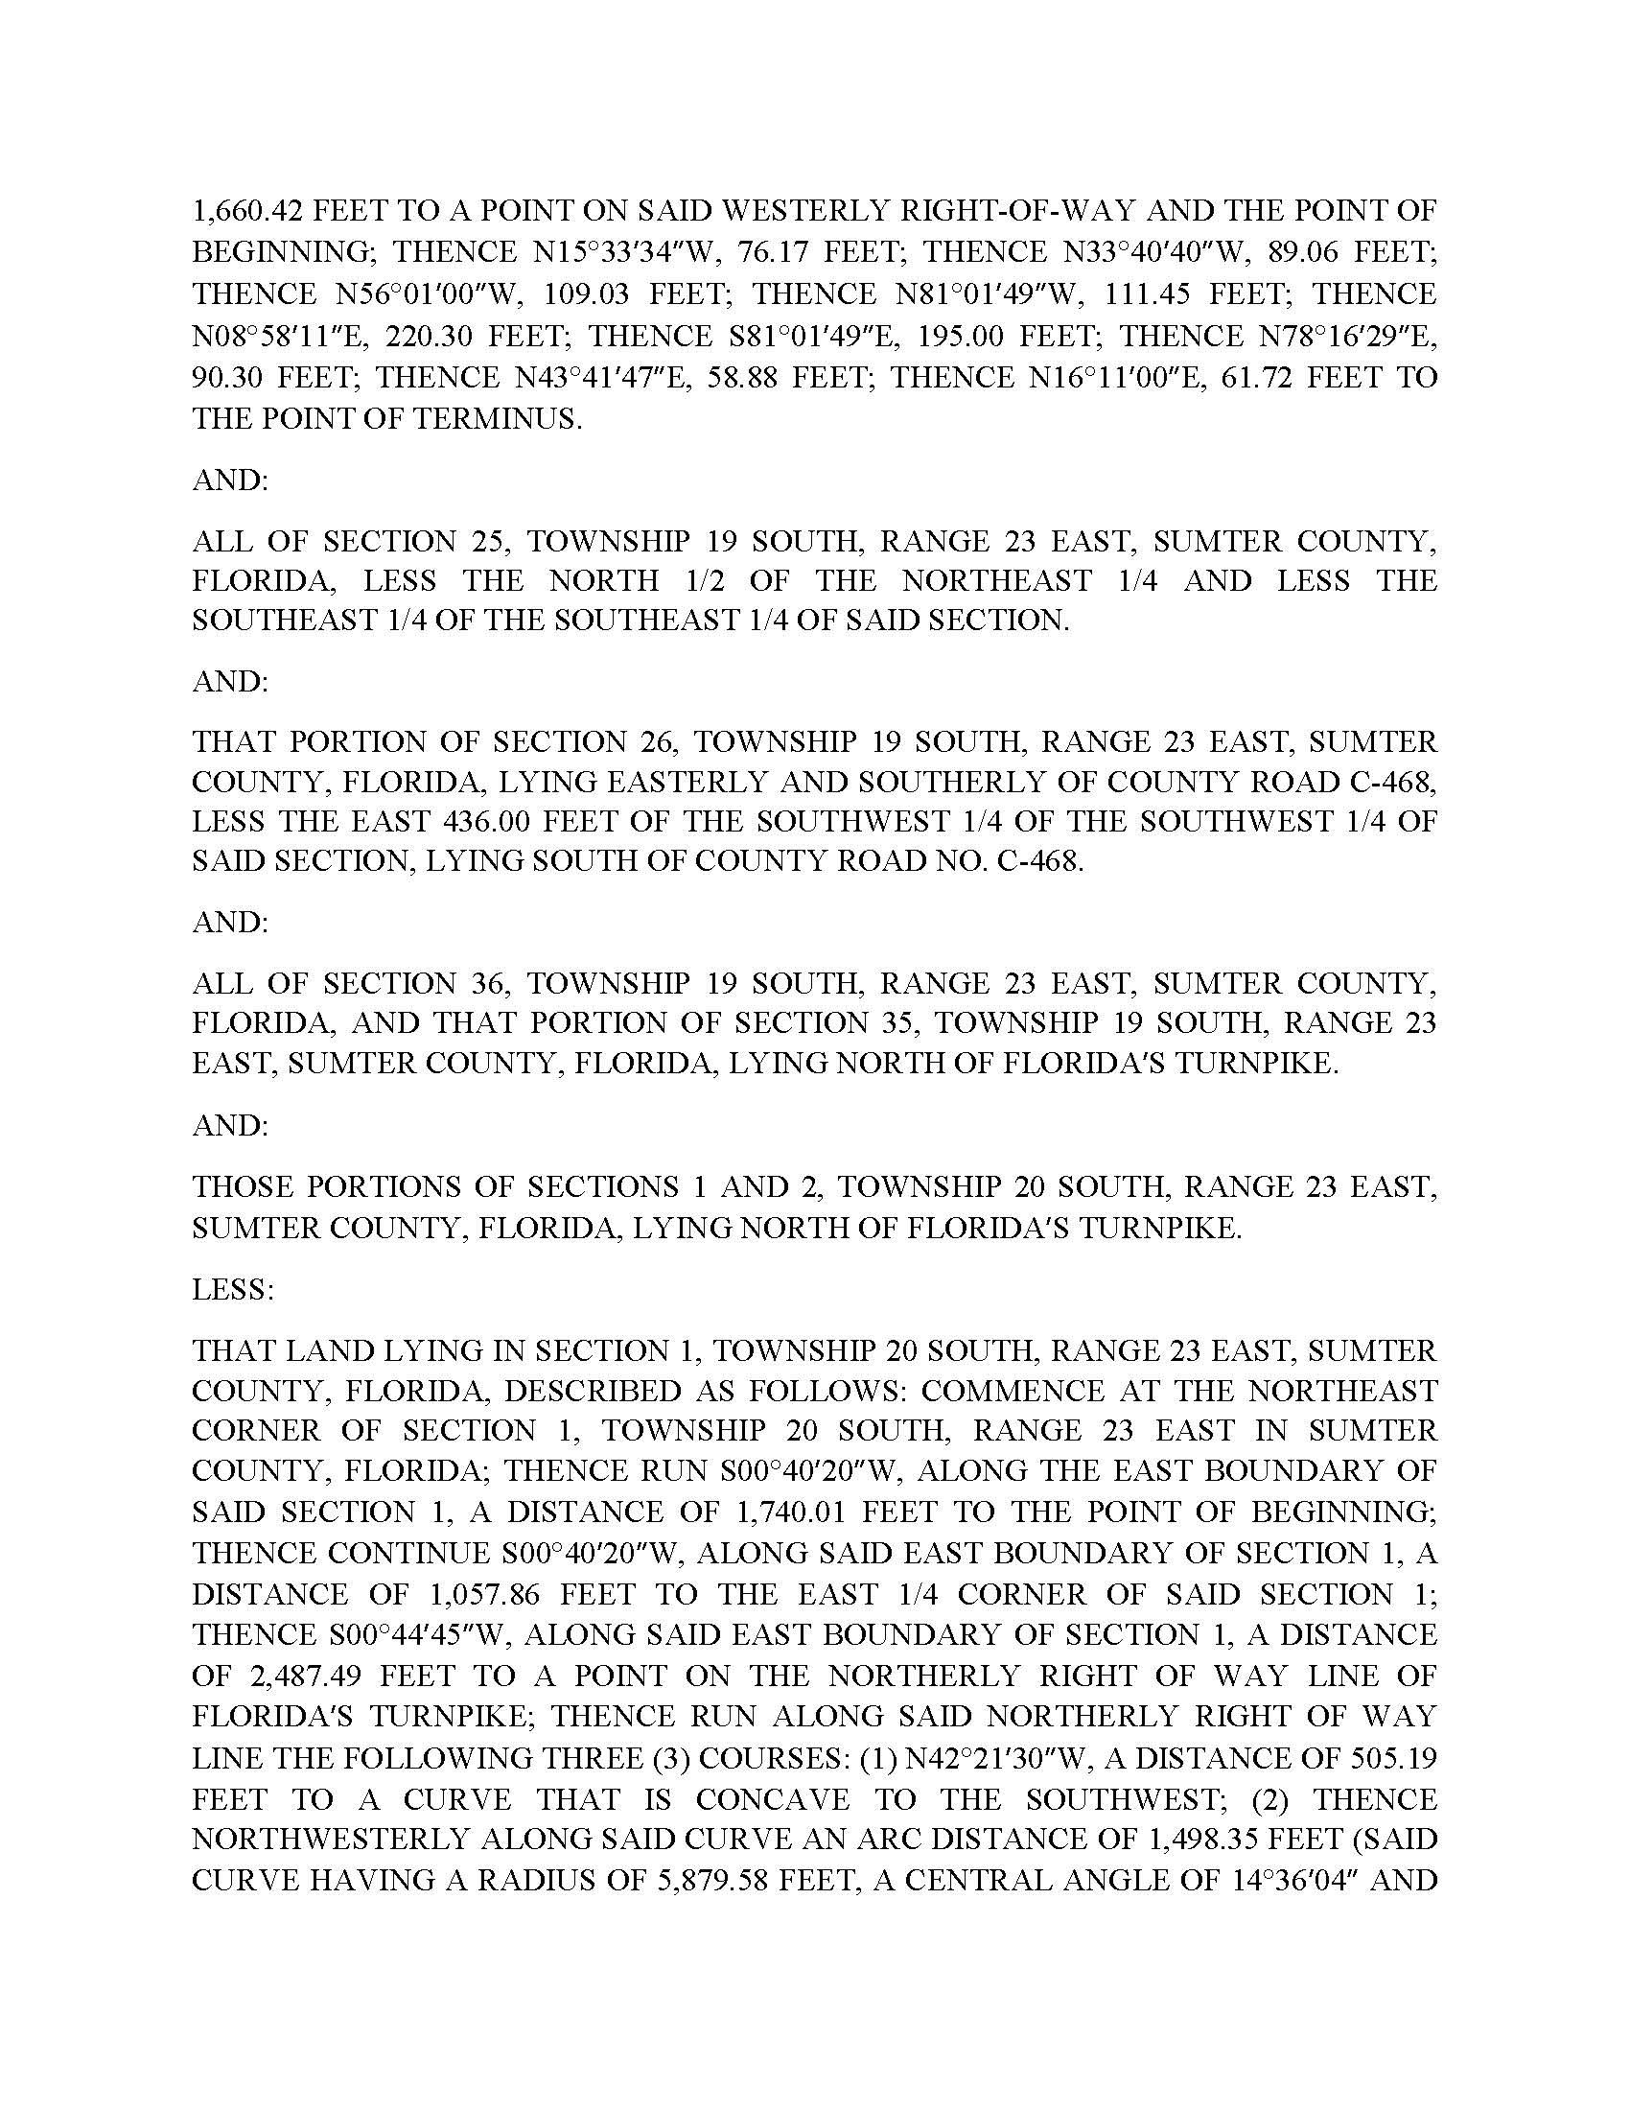

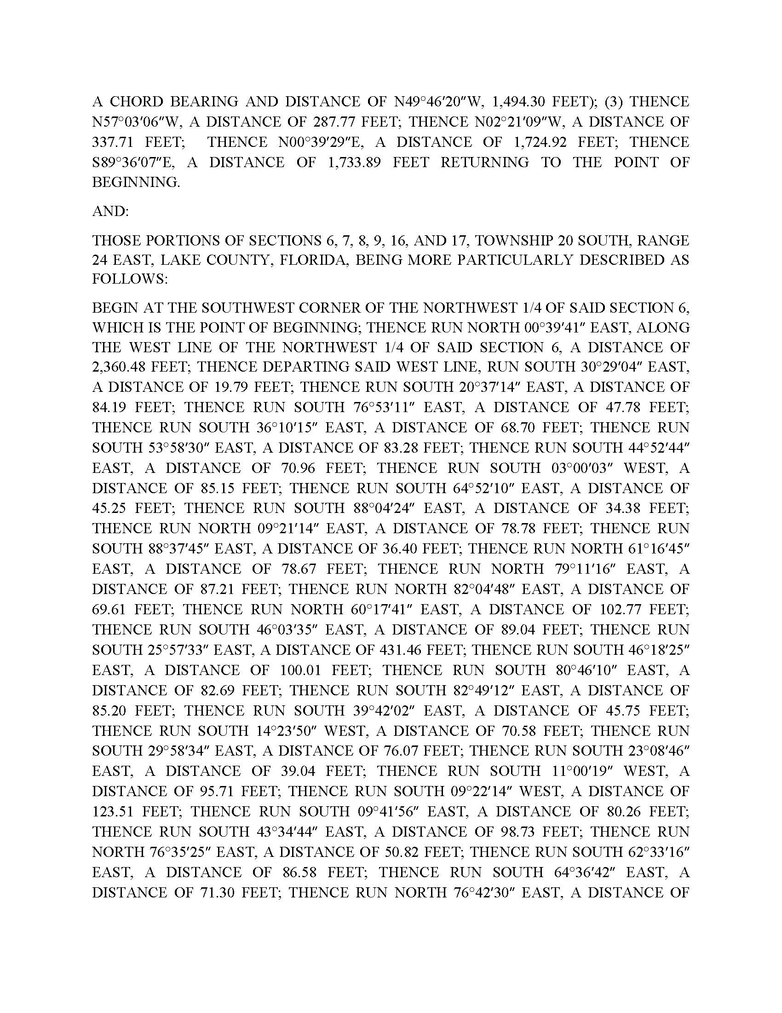

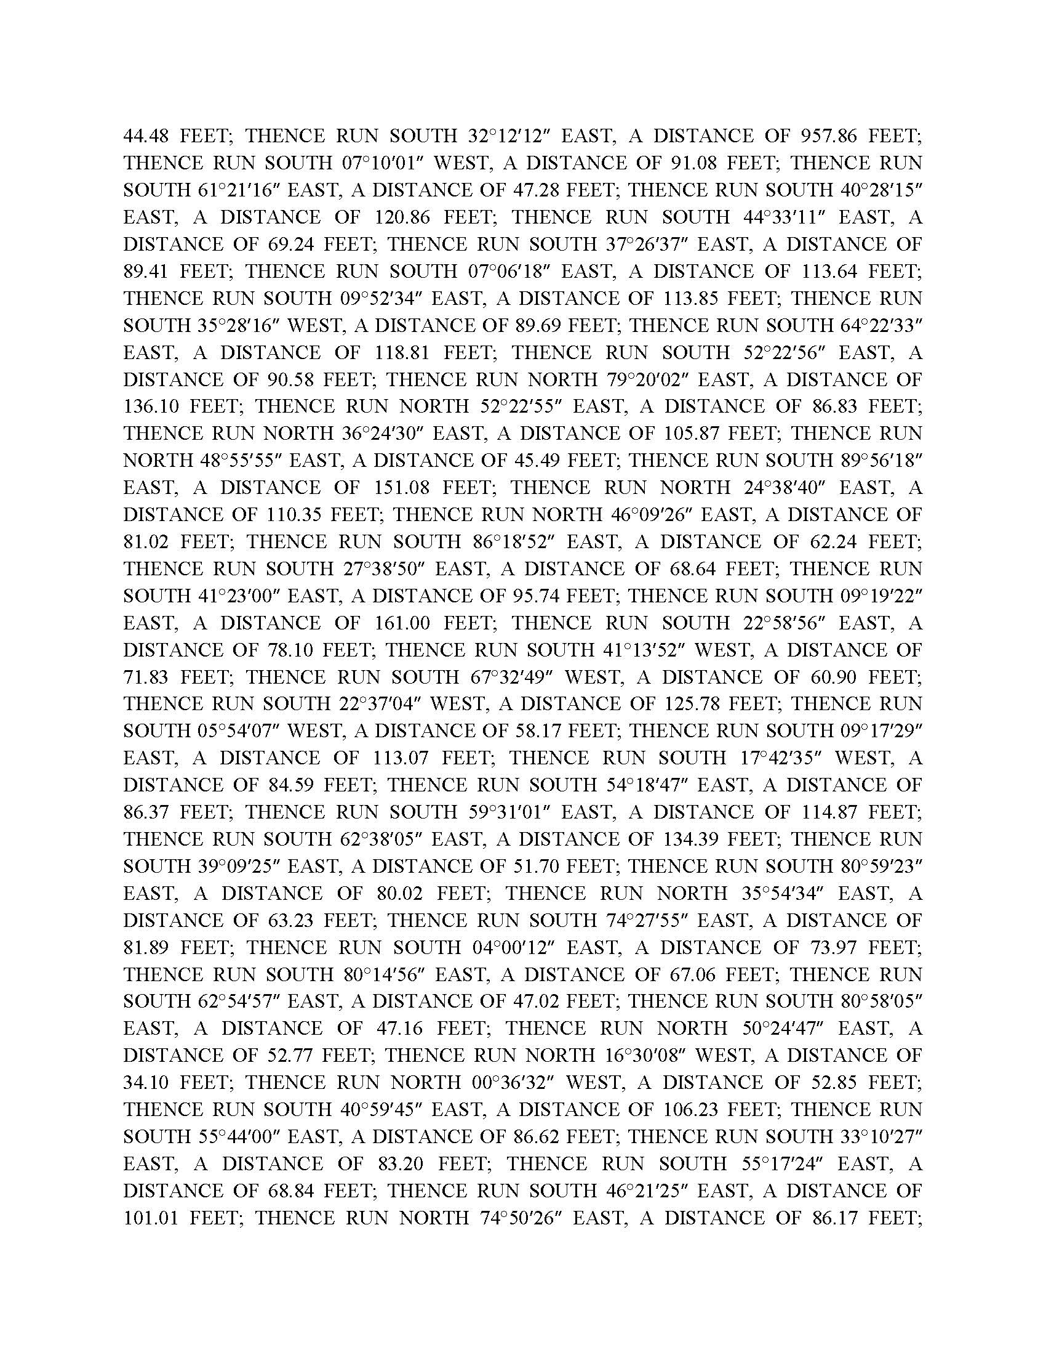

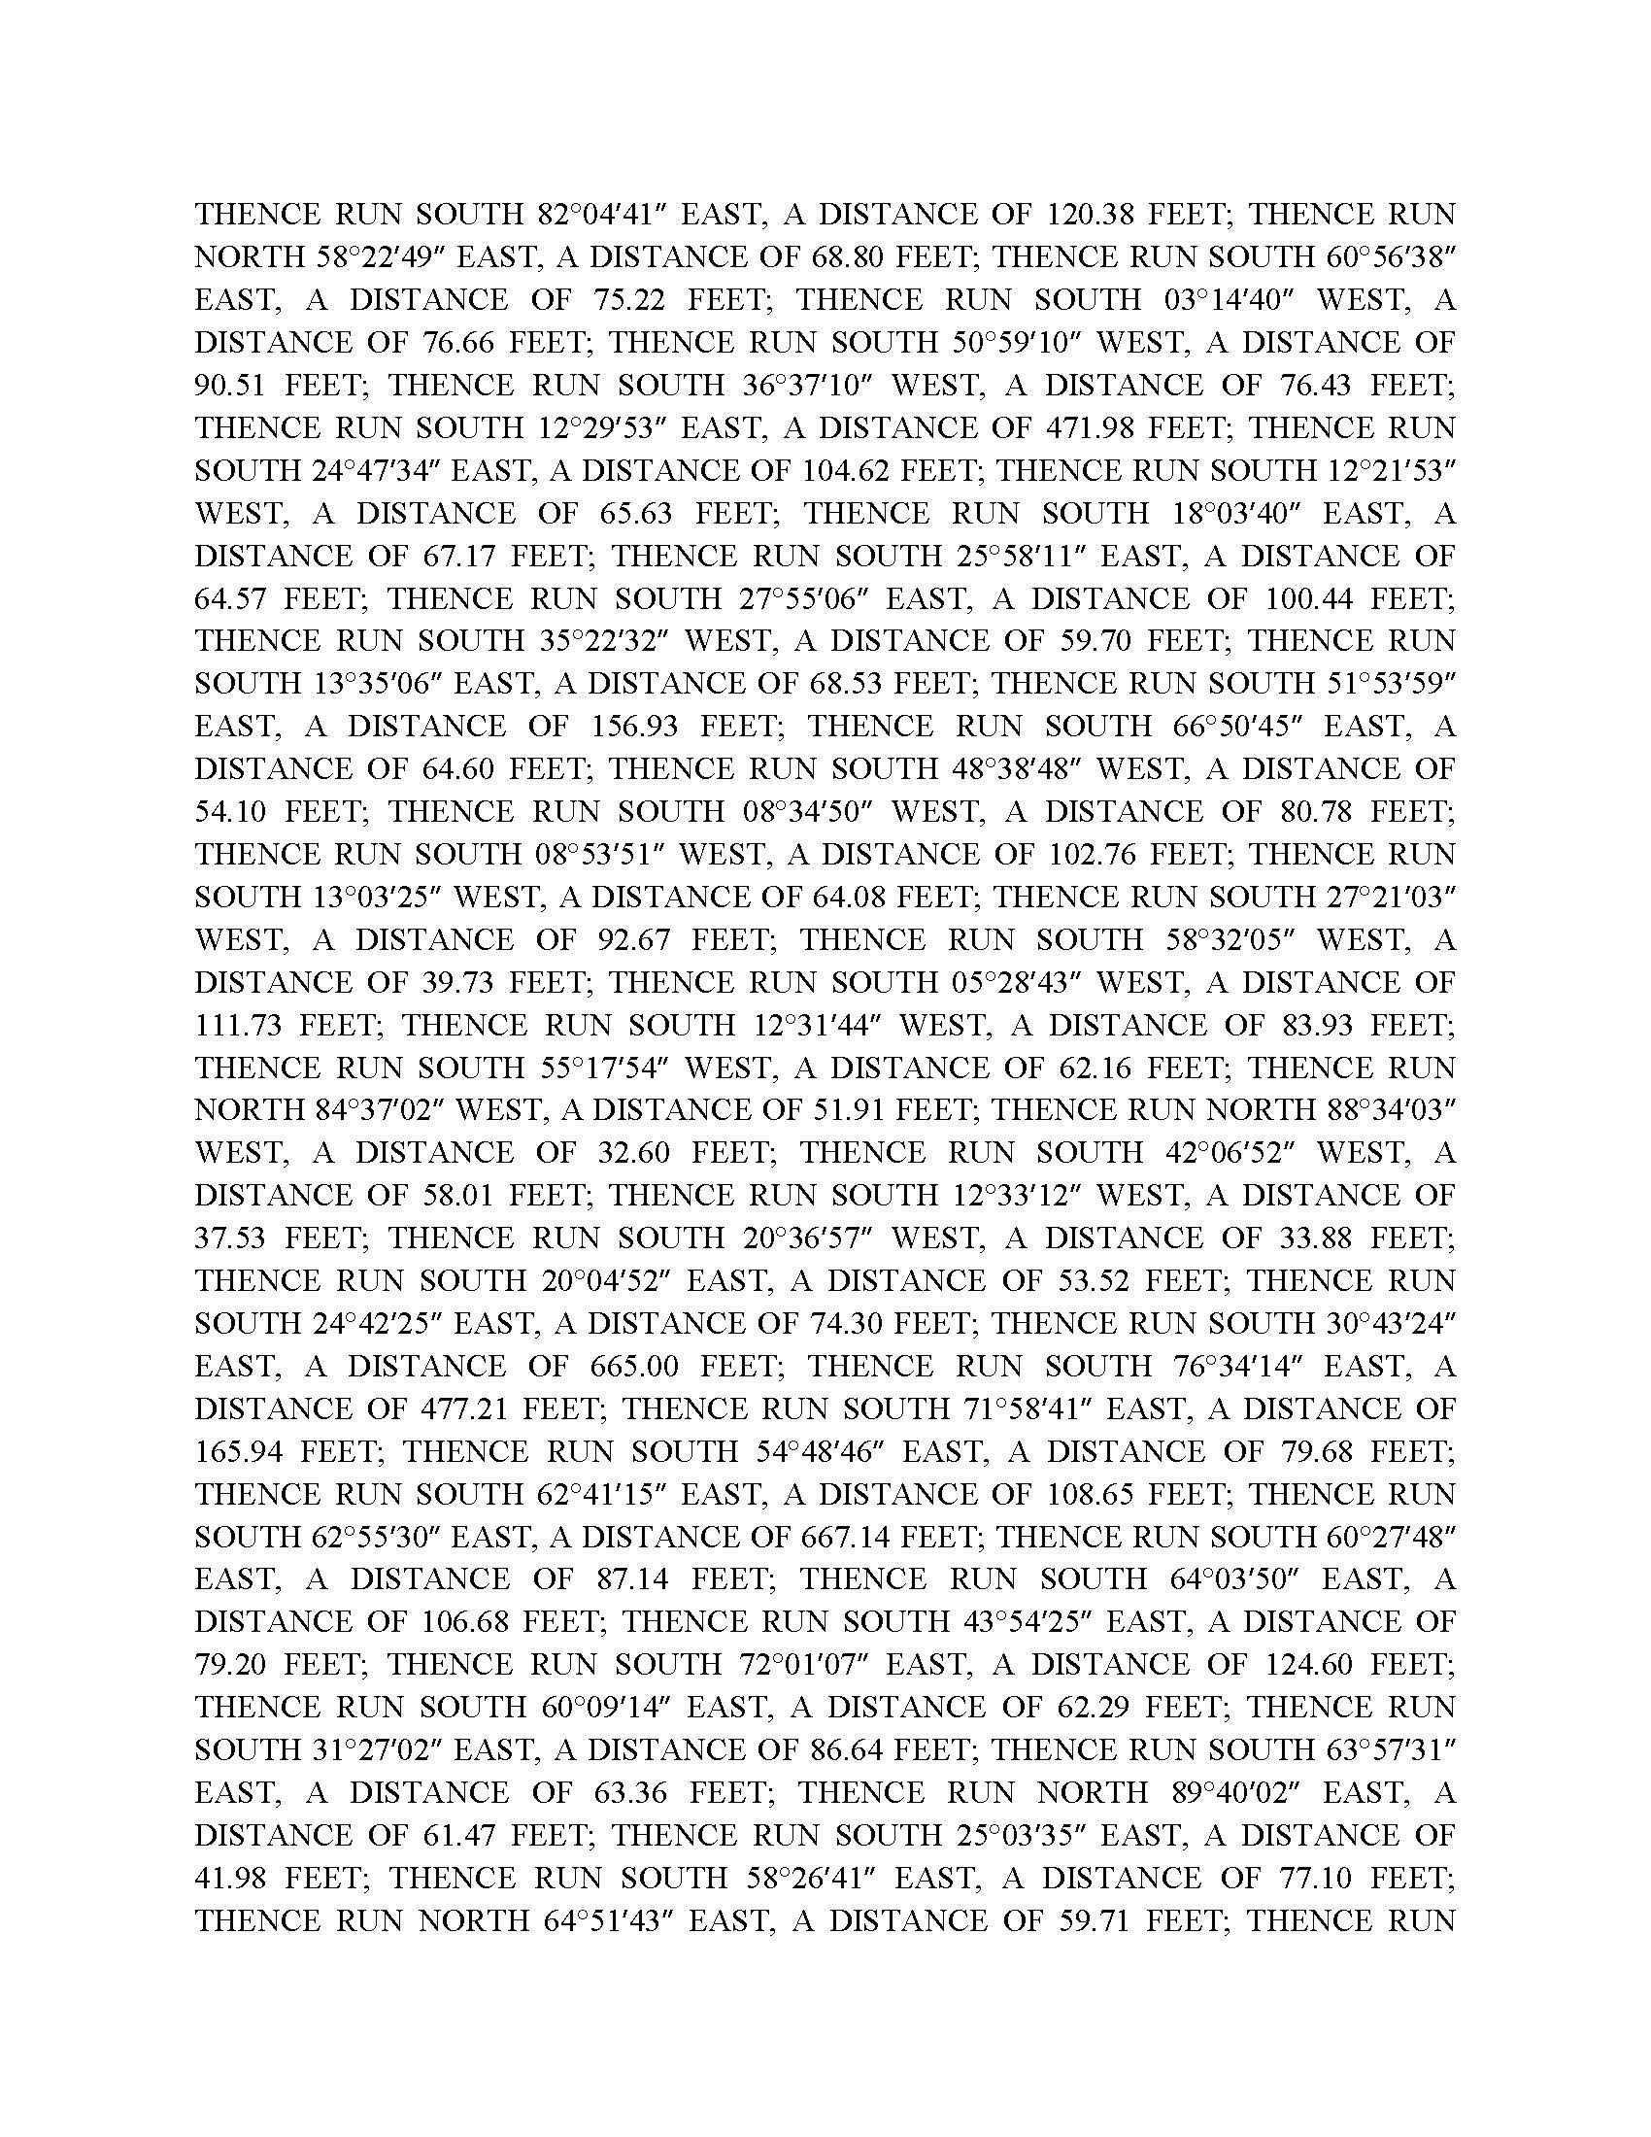

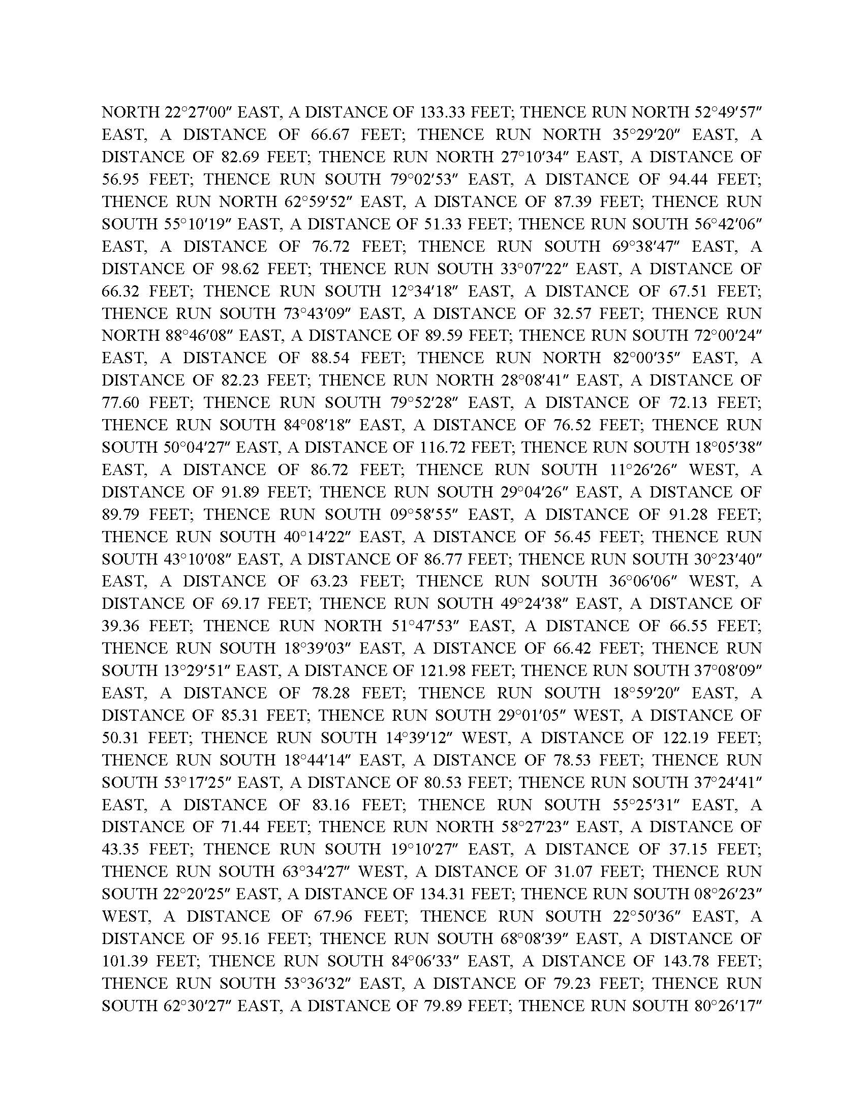
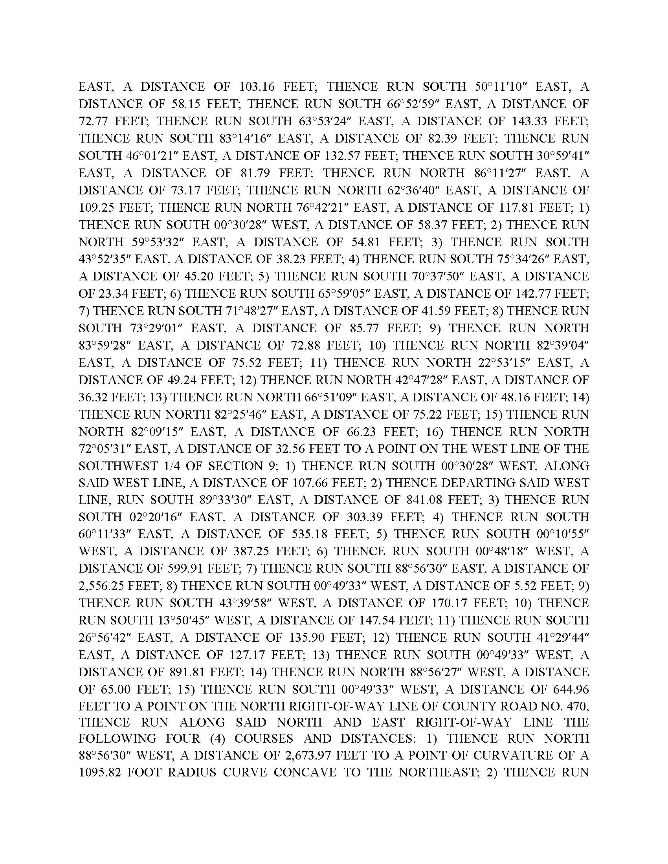

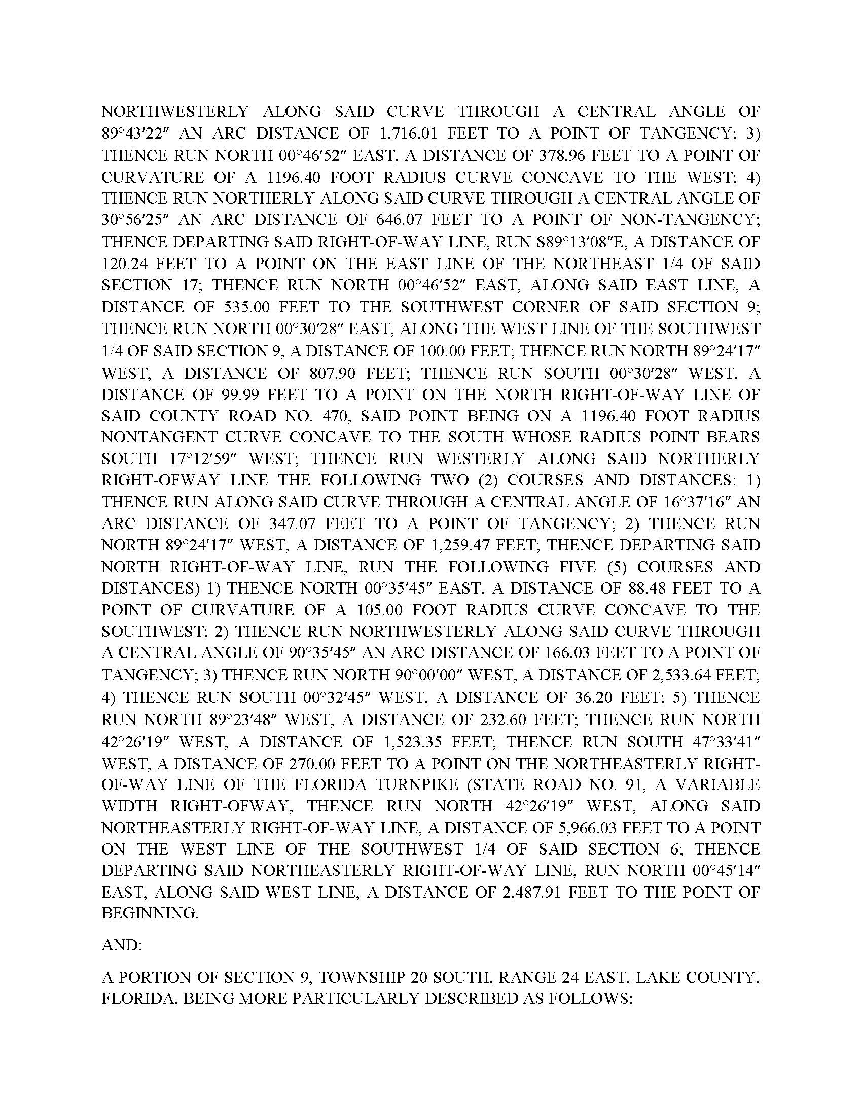

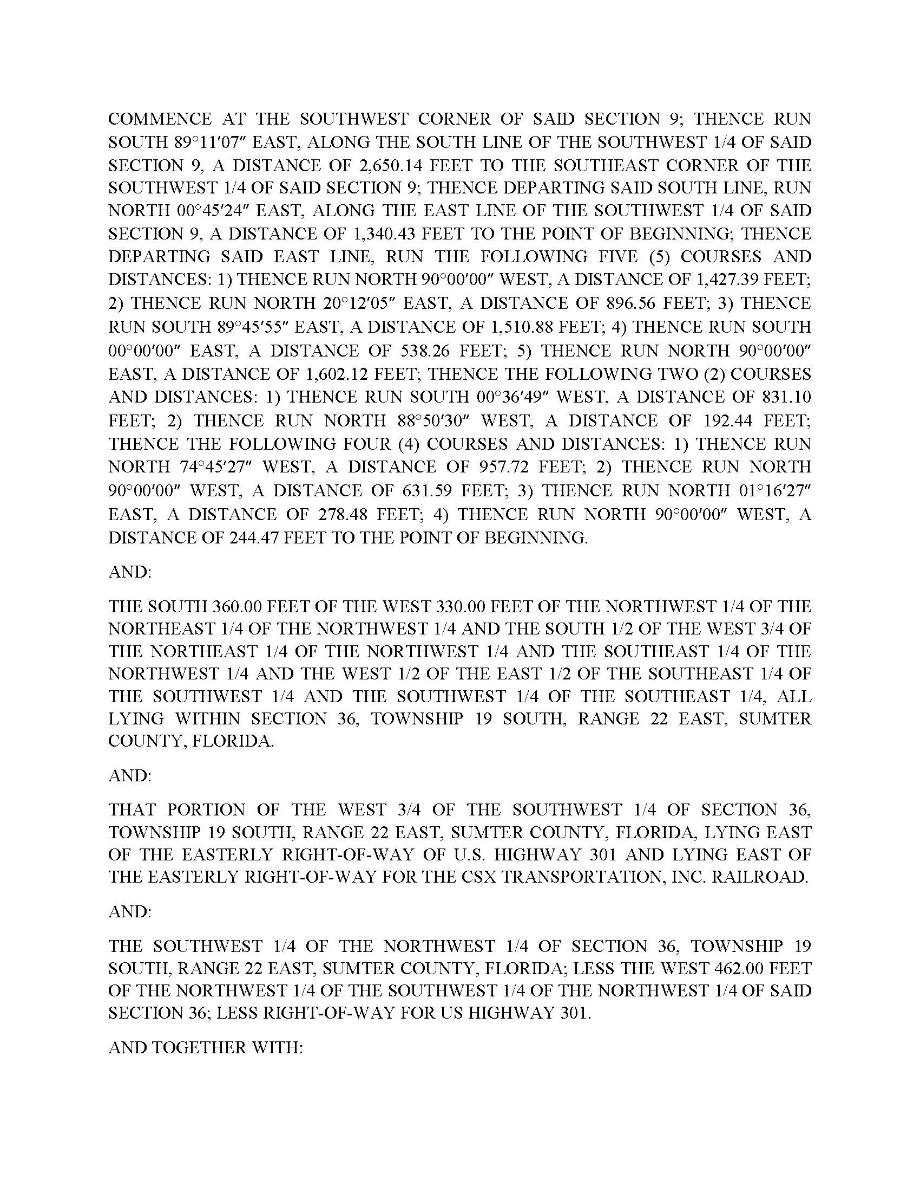

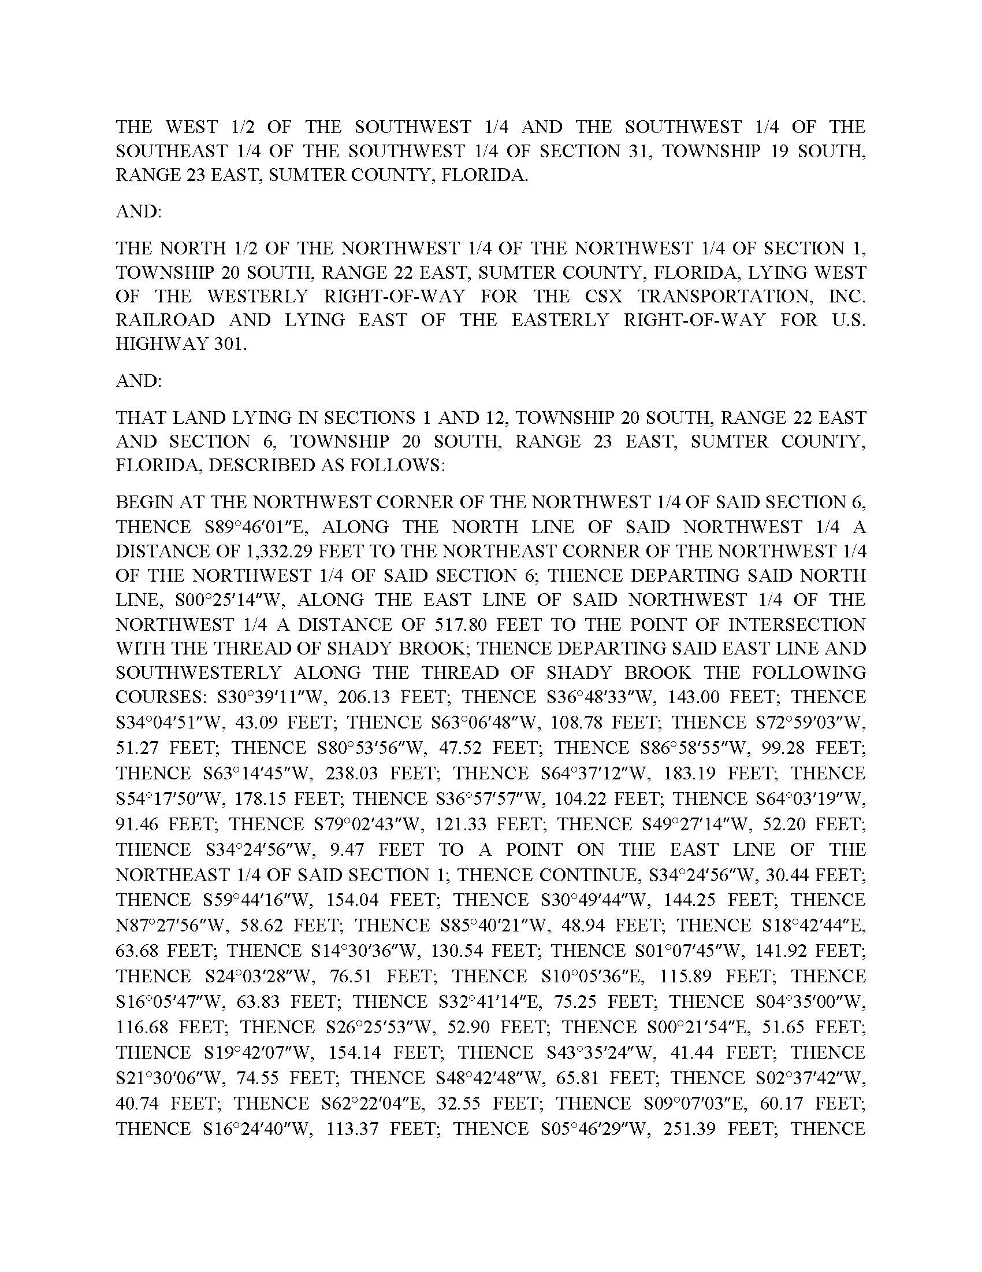

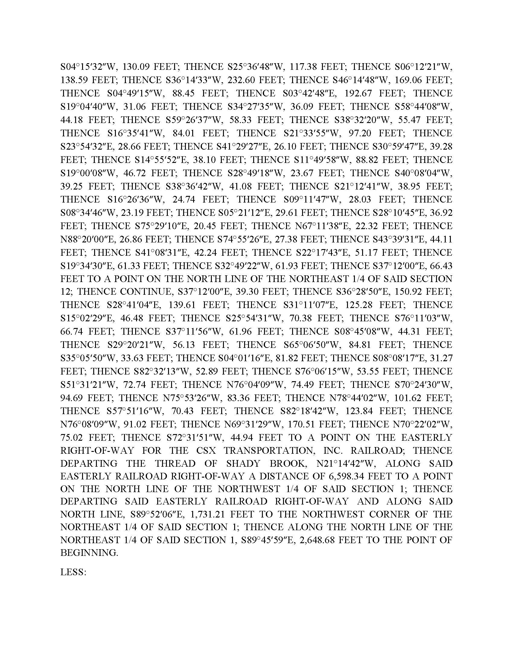

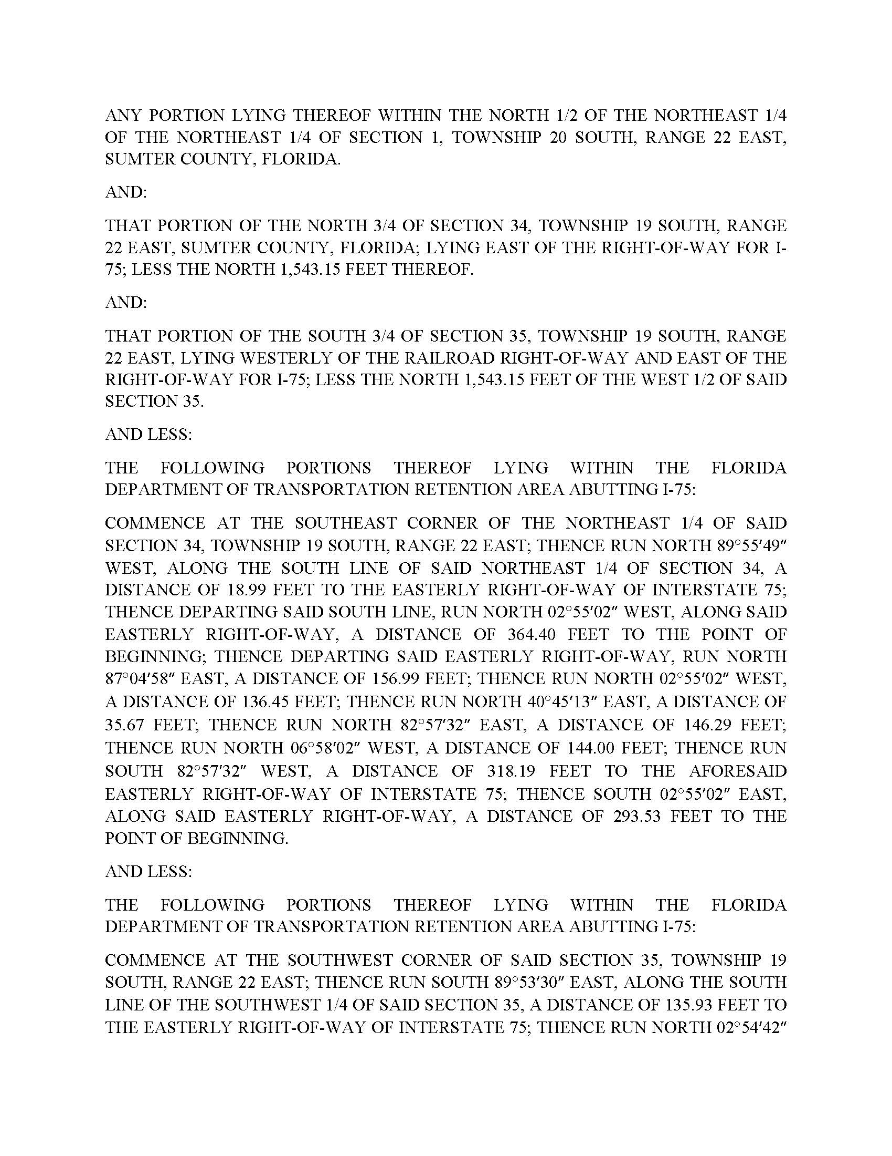

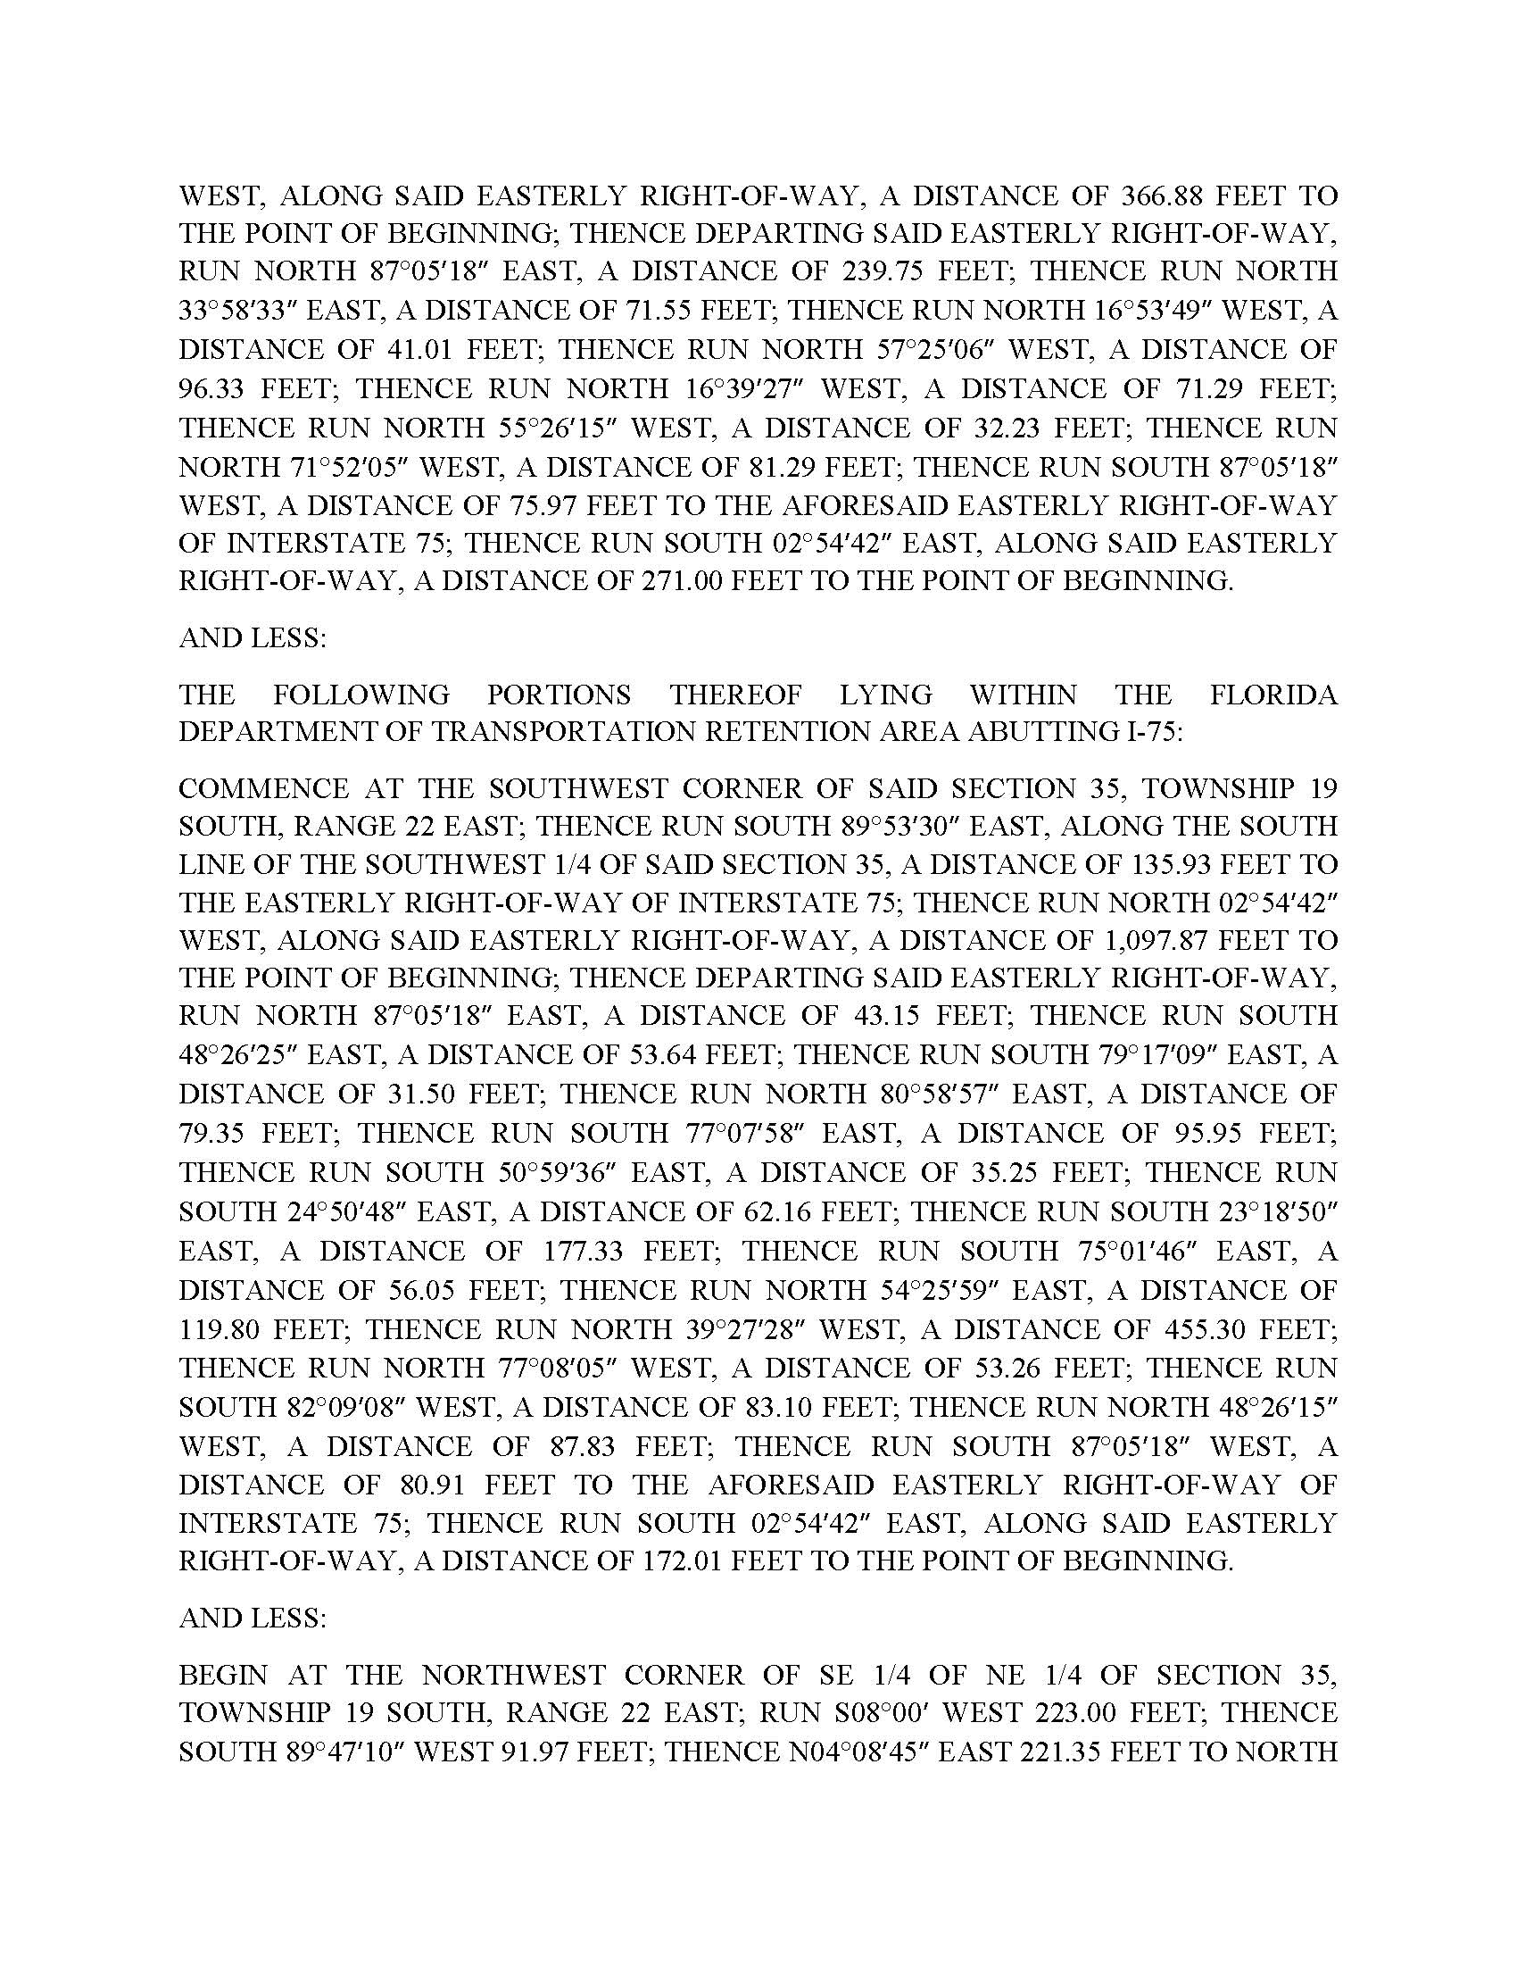

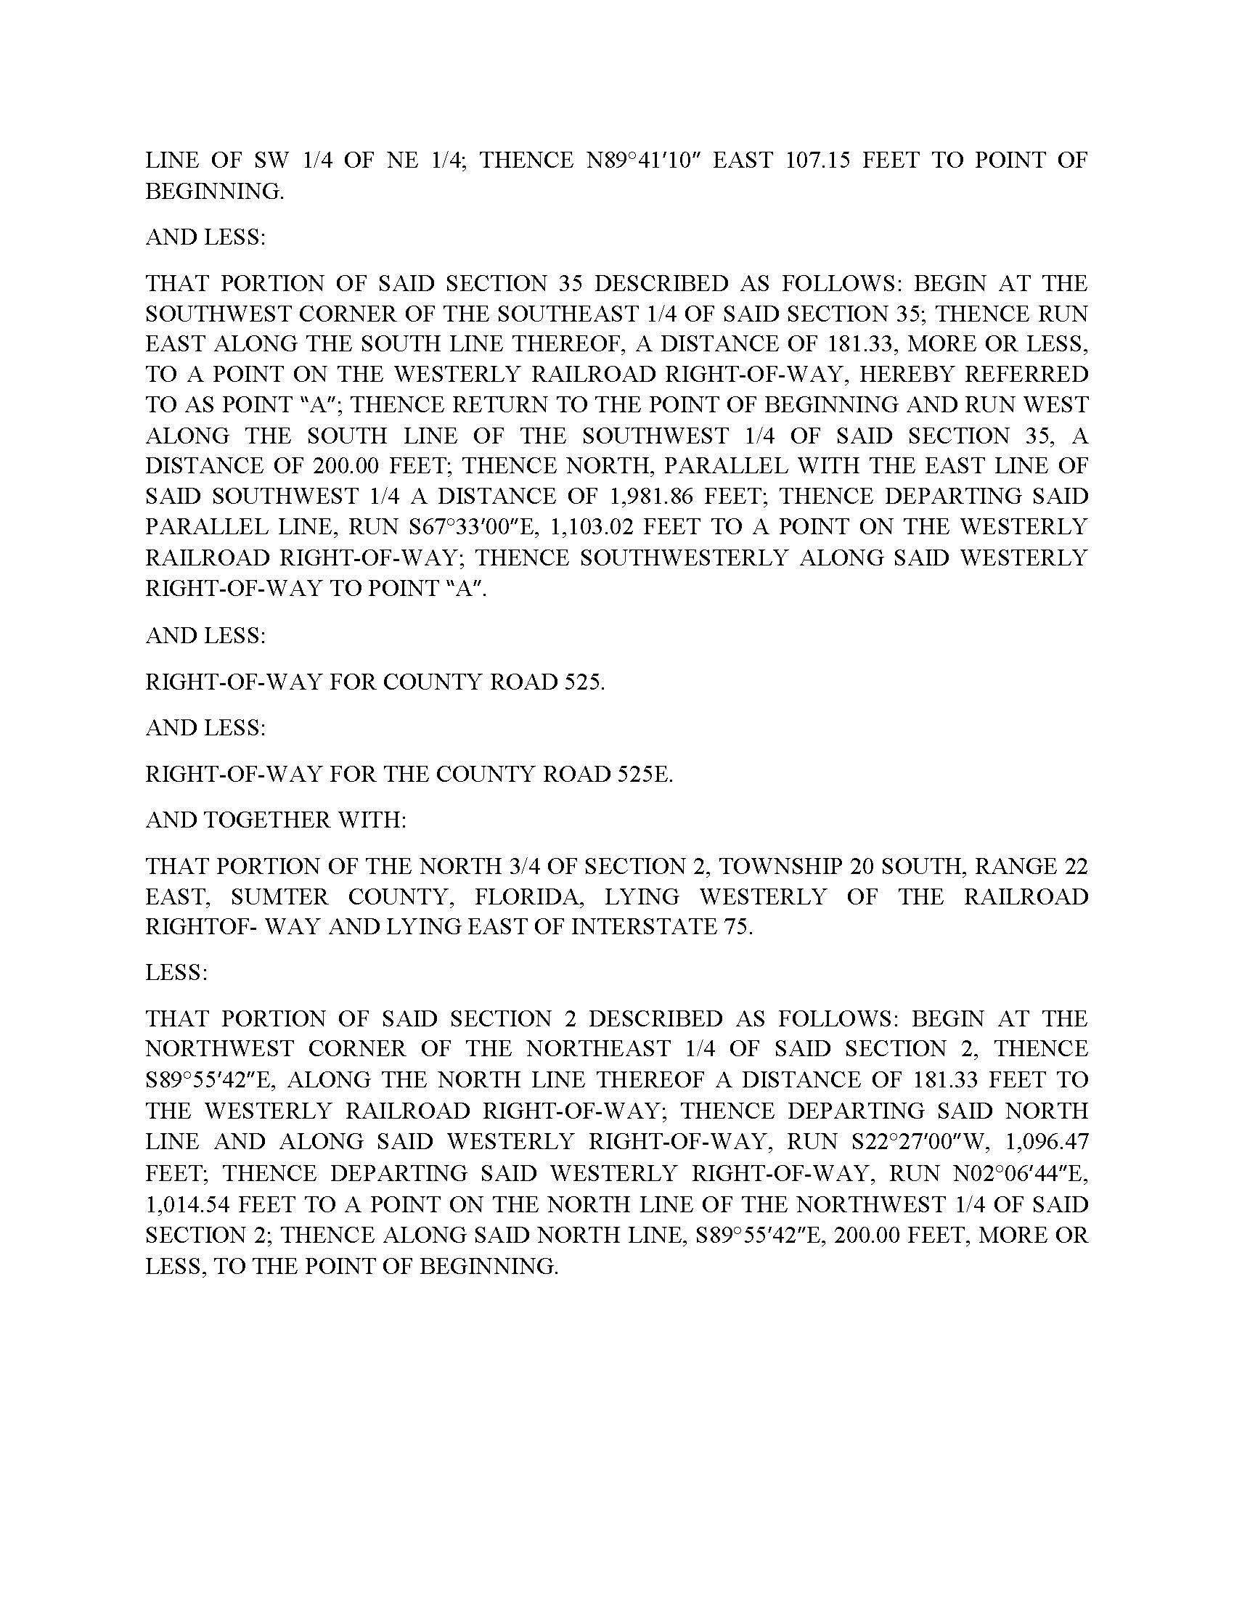

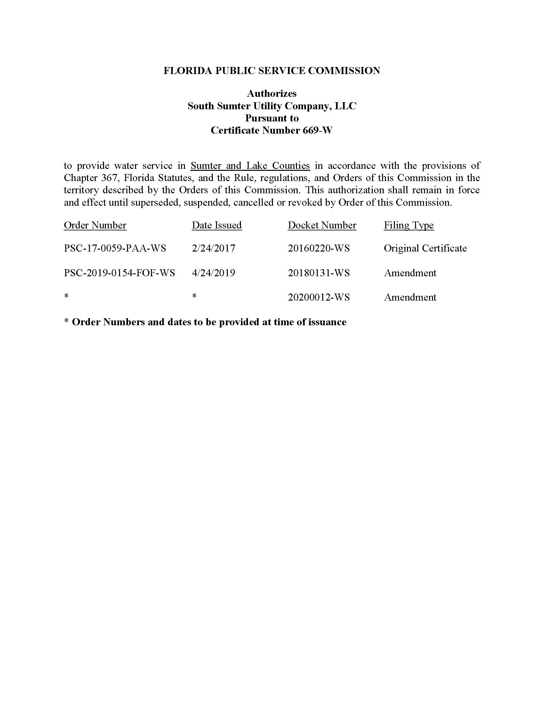

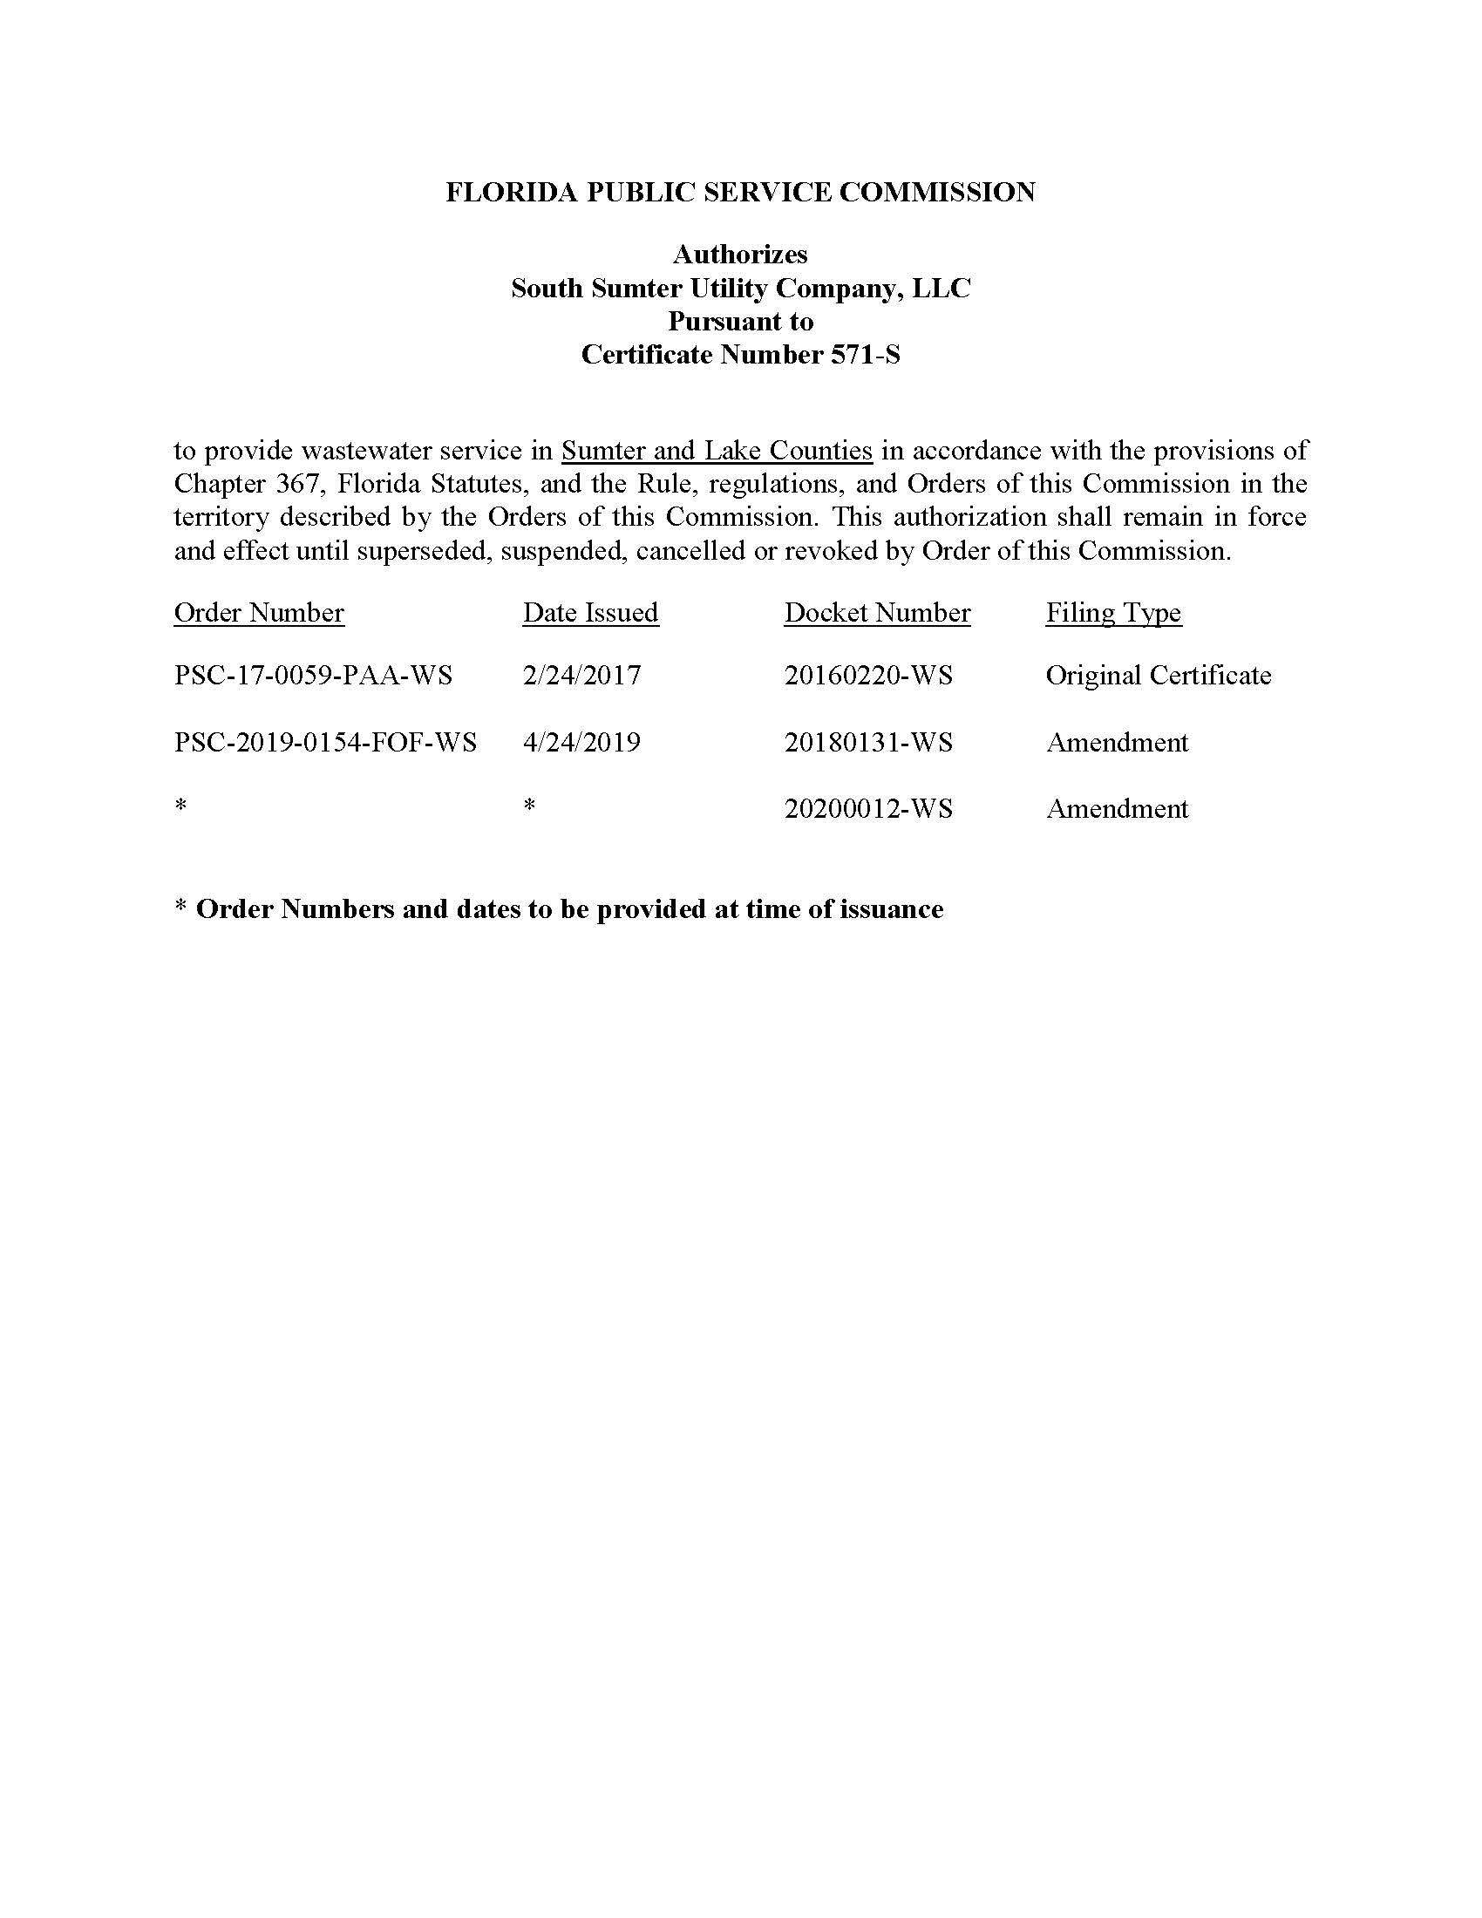

The Utility has requested an extension to file its 2019 Annual Report.
Document No. 00752-2020, filed February 3, 2020.

