BEFORE THE FLORIDA PUBLIC SERVICE COMMISSION

In re: Joint Petition for approval of territorial agreement in Sumter County by Peoples Gas System, The City of Leesburg and South Sumter Gas Company. | DOCKET NO. 20200085-GU  ORDER NO. PSC-2020-0221-PAA-GU  ISSUED: June 29, 2020

The following Commissioners participated in the disposition of this matter:

GARY F. CLARK, Chairman
ART GRAHAM
JULIE I. BROWN
DONALD J. POLMANN
ANDREW GILES FAY

PROPOSED AGENCY ACTION
ORDER APPROVING JOINT TERRITORIAL AGREEMENT

BY THE COMMISSION:

NOTICE is hereby given by the Florida Public Service Commission that the action discussed herein is preliminary in nature and will become final unless a person whose interests are substantially affected files a petition for a formal proceeding, pursuant to Rule 25-22.029, Florida Administrative Code (F.A.C.).

Background
On March 11, 2020, Peoples Gas System (Peoples) and the City of Leesburg (Leesburg), collectively the joint petitioners, filed a petition seeking our approval of a Territorial Agreement delineating their respective service boundaries in Sumter County, Florida. We note that South Sumter Gas Company, LLC, although listed in the title of the petition, is not a party to the proposed Territorial Agreement. The proposed Territorial Agreement and a map depicting the current service territories and proposed changes, and boundary areas to be served by Peoples and Leesburg are provided in Attachment A to this Order.

On February 23, 2018, Peoples filed a petition in Docket No. 20180055-GU, requesting that we resolve a territorial dispute between Peoples and Leesburg and/or South Sumter Gas Company, LLC. The Petition alleged that Peoples and Leesburg and/or South Sumter Gas Company, LLC were in a dispute as to the rights of each to provide natural gas services to the customers in Sumter County, including The Villages. The area in dispute is characterized by residential areas of varying density, interspersed with commercial support areas, and is referred to as Bigham North, Bigham West, Bigham East (Bigham developments).

On August 21, 2018, we referred the dispute to the Division of Administrative Hearings (DOAH). DOAH assigned an Administrative Law Judge (ALJ) for the purpose of conducting an administrative hearing and issuing a Recommended Order on the territorial dispute. The administrative hearing was held from June 24 to 27, 2019, and a Recommended Order was issued on September 30, 2019. In that Order, the ALJ awarded Peoples the disputed territory encompassing the Bigham North, Bigham East, and Bigham West developments in the Villages in Sumter County. The ALJ’s Order did not award any other territory to any of the parties. At the January 14, 2020 Commission Conference, we adopted the ALJ’s Recommended Order without modification by final Order No. PSC-2020-0052-FOF-GU.

The proposed Territorial Agreement in the instant docket incorporates our decision in Order No. PSC-2020-0052-FOF-GU, a separate Settlement Agreement between the parties addressing the transfer of infrastructure from Leesburg to Peoples, and establishes new service boundary lines between the joint petitioners for the remaining portions of the county. The referenced Settlement Agreement is not subject to our approval, and hence was provided for informational purposes only. The joint petitioners believe the Territorial Agreement will avoid future litigation and territorial disputes in Sumter County and enhance natural gas service for customers.

We have jurisdiction over this matter pursuant to Section 366.04, Florida Statutes (F.S.).

Decision
Pursuant to Section 366.04(2)(d), F.S., and Rule 25-6.0440, F.A.C., we have jurisdiction over territorial agreements between and among rural electric cooperatives, municipal electric utilities, and other electric utilities. Unless we determine that the agreement will cause a detriment to the public interest, the agreement should be approved.

Peoples and Leesburg Territorial Agreement
The proposed Territorial Agreement between Peoples and Leesburg was executed on March 9, 2020, and would continue to be in effect until modification by mutual agreement by the parties and approved by us or until termination or modification mandated by court order, as stated in Section 1.1 of the territorial agreement.
As a result of Order No. PSC-2020-0052-FOF-GU, 3,625 (includes 3,615 residential and 10 commercial customers) Leesburg service customers in Bigham North, Bigham West, and Bigham East were transferred to Peoples, effective June 1, 2020. Pursuant to the proposed Territorial Agreement in the instant docket, the joint petitioners will also transfer three additional customers (fire station, a district building, and The Villages Grown–a hydroponic and aeroponic farm) located adjacent to Bailey West Development to Peoples. Section 2.1 of the proposed Territorial Agreement also includes additional areas in Sumter County to be served by Peoples in the future. The joint petitioners stated that any new customers taking service within the areas contained in Article II – Boundary Provisions of the proposed Territorial Agreement will be served by either Peoples or Leesburg according to the future service areas identified in the map in Attachment A.

During the pendency of Docket No. 20180055-GU, Leesburg filed a territorial dispute petition in Docket No. 20180185-GU against Peoples regarding its natural gas service to Suwannee American Cement Company, LLC in Sumter County. This petition was still pending before us; however, pursuant to Section 2.1 of the proposed Territorial Agreement and pursuant to the Settlement Agreement, the Suwannee American Cement Company, LLC, will continue to be served by Peoples. The joint petitioners stated that the unresolved issues in Docket No. 20180185-GU will be resolved by our action to approve the proposed Territorial Agreement and Leesburg’s petition in Docket No. 20180185-GU will be voluntarily dismissed.

Transfer of Assets
The joint petitioners, in paragraph 10 of the petition and in paragraph 9 of the Territorial Agreement, stated their intention to provide an orderly transfer of assets in the Bigham developments without the need for further litigation. Rule 25-7.0471(2)(a), F.A.C., requires us to consider the reasonableness of the purchase price of any facilities being transferred.

In accordance with the Territorial Agreement, the joint petitioners stated that Peoples will be paying for the infrastructure for the approximately 3,625 Bigham development customers transferred to Peoples. South Sumter Gas Company, LLC was retained by Leesburg to serve as the construction company for the infrastructure necessary to serve the Bigham developments. Peoples will pay $5,000,000 to South Sumter Gas Company, LLC, with $500,000 to be to be retained by Peoples to pay for warranty claims. The balance will be paid to South Sumter Gas Company, LLC, in one year less claims for warranty issues related to the infrastructure being transferred. This payment amount results in a per customer amount ranging between $1,241 to $1,379 depending on the reduction for warranty expenses. Through our adoption of the ALJ’s Recommended Order, we concluded in Order No. PSC-2020-0052-FOF-GU that “the cost-per-home for Leesburg and SSGC to provide service in Bigham is $1,800. In addition, Leesburg will be installing automated meters at a cost of $72.80 per home. The preponderance of evidence indicates that PGS cost-per-home is $1,579.”

The per customer purchase price stated above is less than the cost determined by Order No. PSC-2020-0052-FOF-GU. The joint petitioners also stated that no purchase price has been affixed to Leesburg’s transfer of its Bigham development infrastructure, as Leesburg did not incur significant costs in installing infrastructure in the Bigham developments. We find the negotiated infrastructure transfer cost is reasonable and approximates the cost established in Order No. PSC-2020-0052-FOF-GU.

Customer Deposits and Notification
Leesburg notified its affected natural gas customers via a letter dated April 1, 2020, which stated that their customer deposit will be applied towards the final bill or outstanding balance, and any remaining deposit amount will be directly refunded to the customer by check within 30 to 45 days of the date of transfer (June 1, 2020). Of the 3,625 Leesburg customers to be transferred to Peoples, per Order PSC-2020-0052-FOF-GU, 1,909 customers have a deposit on file with Leesburg. Leesburg’s customer deposit is $50.

Peoples proposed a $50 deposit for Leesburg customers transferred to Peoples. After 12 months of service, Peoples will reassess the deposit amount in accordance with 366.05(1), F.S. According to Peoples’ proposed customer notification, it will collect the deposit in its first bill in July 2020 and return the deposit with interest after 23 months of continuous service and no more than one late payment. Peoples’ tariff allows transferred customers to request a credit check to evaluate if the customer would qualify to have the deposit waived. Peoples included information in its proposed customer notification on how customers can request the credit check to determine if the deposit can be waived.

Pursuant to the proposed Territorial Agreement, three additional commercial customers will be transferred to Peoples. These three customers currently are being served by Leesburg and are located outside of the area ordered to be transferred to Peoples in Order No. PSC-2020-0052-FOF-GU. The parties have agreed to transfer these customers to Peoples in the proposed Territorial Agreement. Peoples stated that it will contact the three additional customers individually to discuss the transfer and applicable billing rates.

Conclusion
Through the proposed Territorial Agreement, the joint petitioners will be able to serve customers within clearly defined service areas, comport with the requirements of Order No. PSC-2020-0052-FOF-GU, resolve the dispute in Docket No. 20180185-GU, avoid future litigation, eliminate any potential uneconomic duplication of facilities, and serve current and future customers without service disruption.

After review of the joint petition and the petitioners’ joint responses to Commission staff’s data requests, we find that the proposed Territorial Agreement is in the public interest and will enable Peoples and Leesburg to serve their current and future customers efficiently. It appears that the proposed Territorial Agreement eliminates any potential uneconomic duplication of facilities and will not cause a decrease in reliability of natural gas service. Pursuant to the joint petition, approval of this Territorial Agreement will establish definitive service boundaries and avoid future litigation. Additionally, Leesburg will withdraw its counter-petition in Docket No. 20180185-GU to resolve the territorial dispute related to the Suwannee American Cement, following our approval of this Territorial Agreement. Therefore, we find that the proposed Territorial Agreement between Peoples and Leesburg will not cause a detriment to the public interest and hereby approve the Territorial Agreement.
Based on the foregoing, it is

ORDERED by the Florida Public Service Commission the proposed Territorial Agreement between Peoples Gas Company and the City of Leesburg in Sumter County (Attachment A hereto) is approved. It is further
ORDERED that the provisions of this Order, issued as proposed agency action, shall become final and effective upon the issuance of a Consummating Order unless an appropriate petition, in the form provided by Rule 28-106.201, Florida Administrative Code, is received by the Commission Clerk, 2540 Shumard Oak Boulevard, Tallahassee, Florida 32399-0850, by the close of business on the date set forth in the “Notice of Further Proceedings” attached hereto. It is further

ORDERED that if no protest is filed by a person whose substantial interests are affected within 21 days of the issuance of the Order, this docket should be closed upon the issuance of a Consummating Order.

By ORDER of the Florida Public Service Commission this 29th day of June, 2020.

/s/ Adam J. Teitzman
ADAM J. TEITZMAN
Commission Clerk
Florida Public Service Commission
2540 Shumard Oak Boulevard
Tallahassee, Florida 32399
(850) 413-6770
www.floridapsc.com

Copies furnished: A copy of this document is provided to the parties of record at the time of issuance and, if applicable, interested persons.

WLT

NOTICE OF FURTHER PROCEEDINGS OR JUDICIAL REVIEW

The Florida Public Service Commission is required by Section 120.569(1), Florida Statutes, to notify parties of any administrative hearing that is available under Section 120.57, Florida Statutes, as well as the procedures and time limits that apply. This notice should not be construed to mean all requests for an administrative hearing will be granted or result in the relief sought.

Mediation may be available on a case-by-case basis. If mediation is conducted, it does not affect a substantially interested person's right to a hearing.

The action proposed herein is preliminary in nature. Any person whose substantial interests are affected by the action proposed by this order may file a petition for a formal proceeding, in the form provided by Rule 28-106.201, Florida Administrative Code. This petition must be received by the Office of Commission Clerk, 2540 Shumard Oak Boulevard, Tallahassee, Florida 32399-0850, by the close of business on July 20, 2020.

In the absence of such a petition, this order shall become final and effective upon the issuance of a Consummating Order.

Any objection or protest filed in this/these docket(s) before the issuance date of this order is considered abandoned unless it satisfies the foregoing conditions and is renewed within the specified protest period.

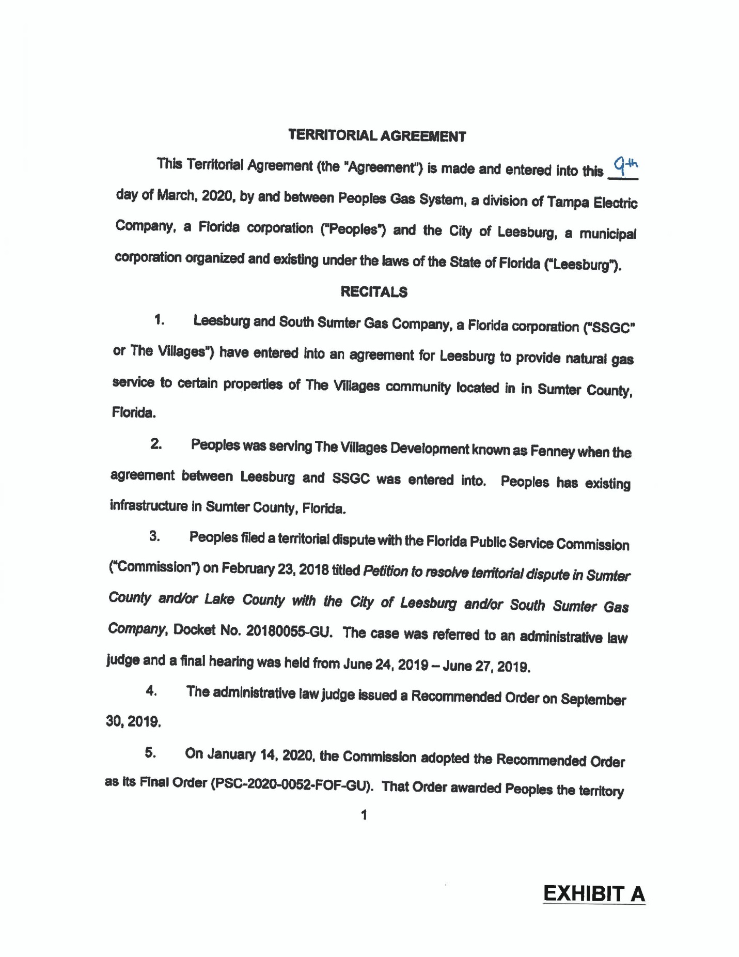

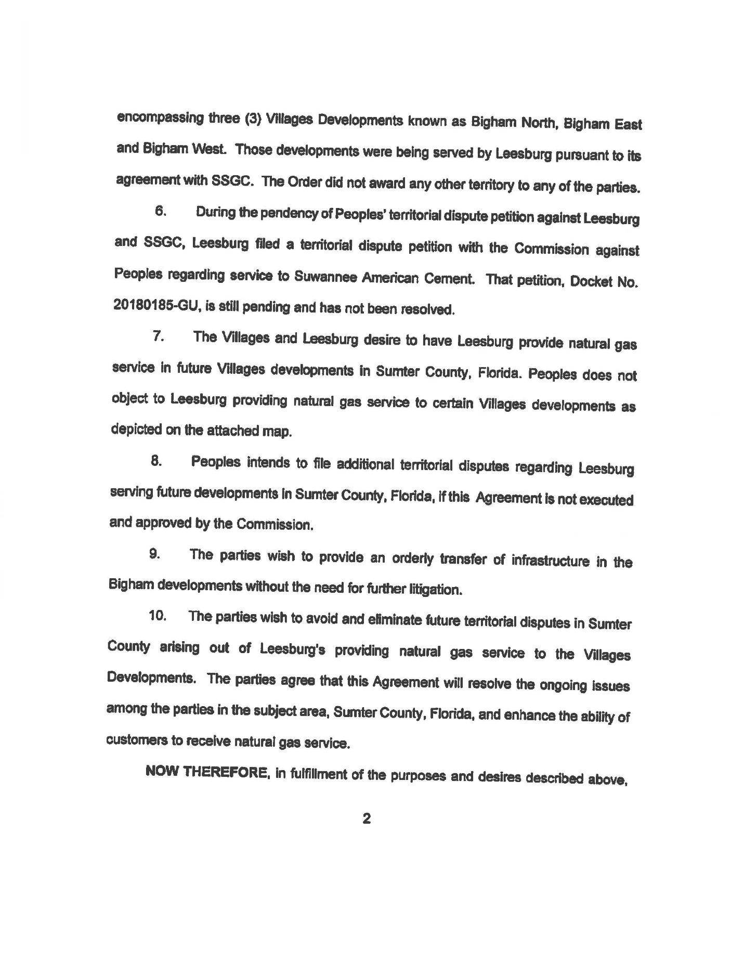

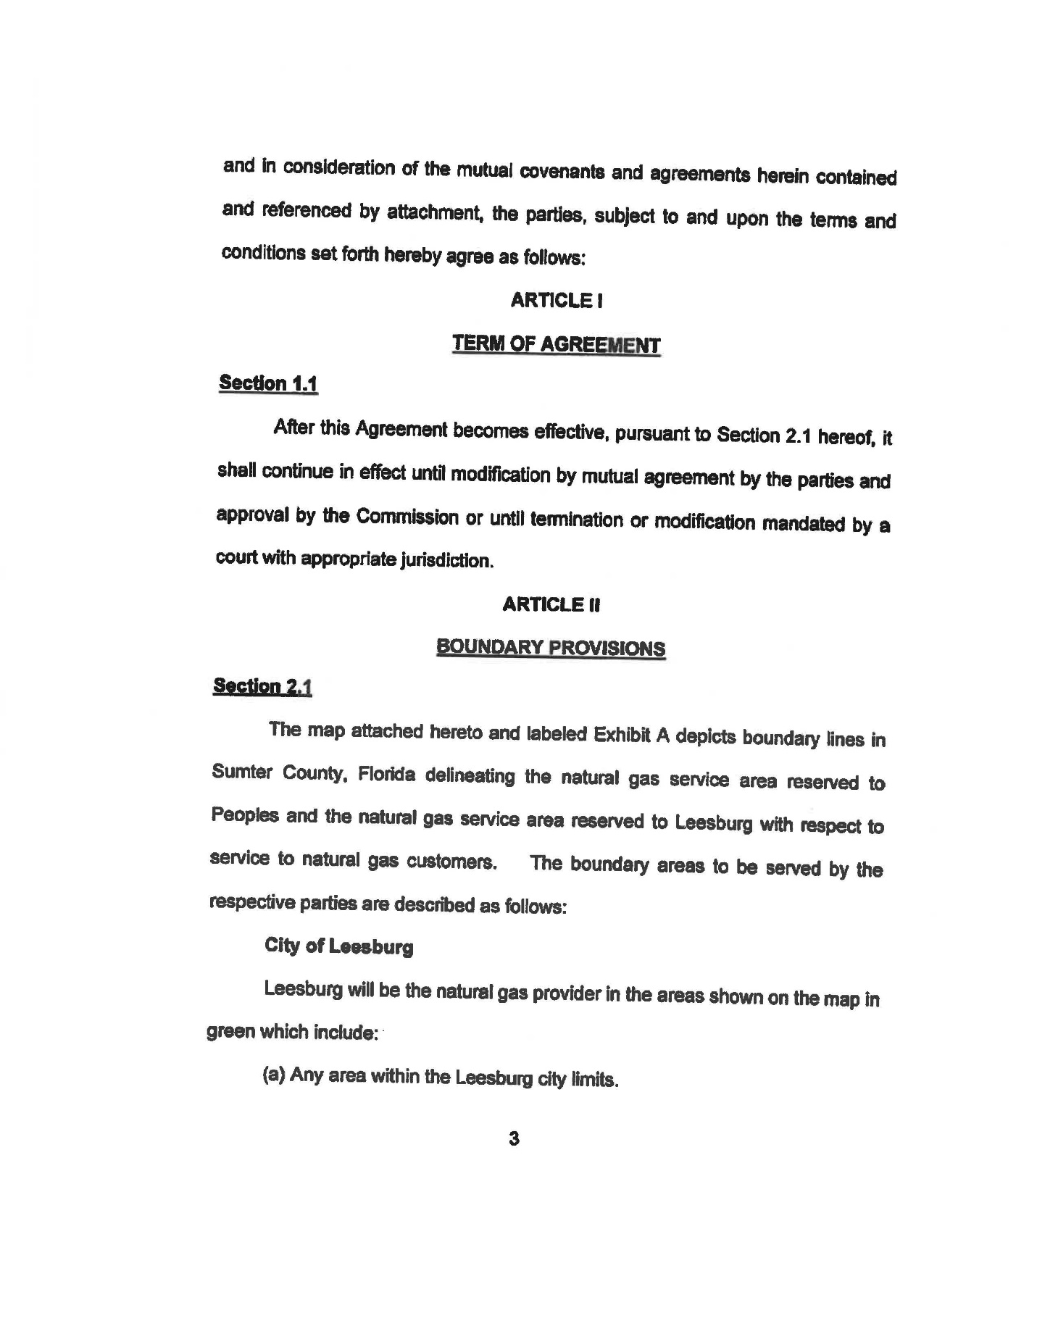

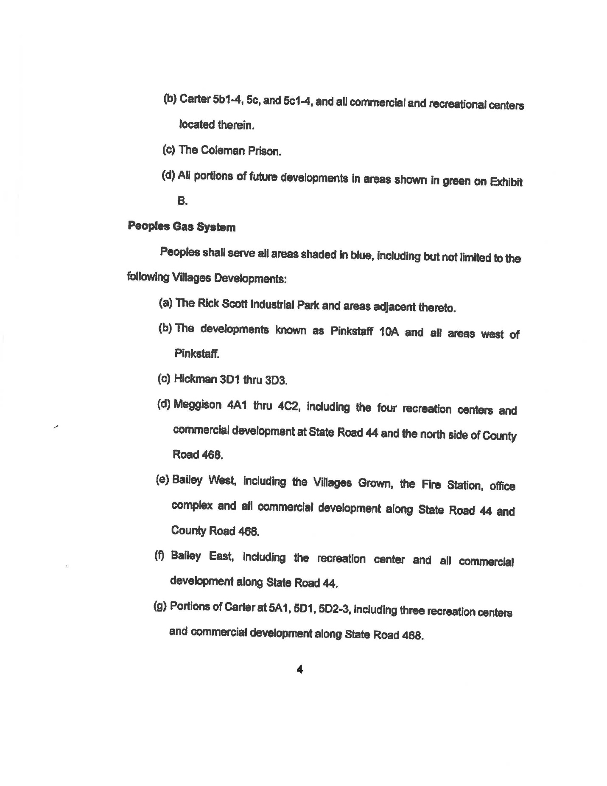

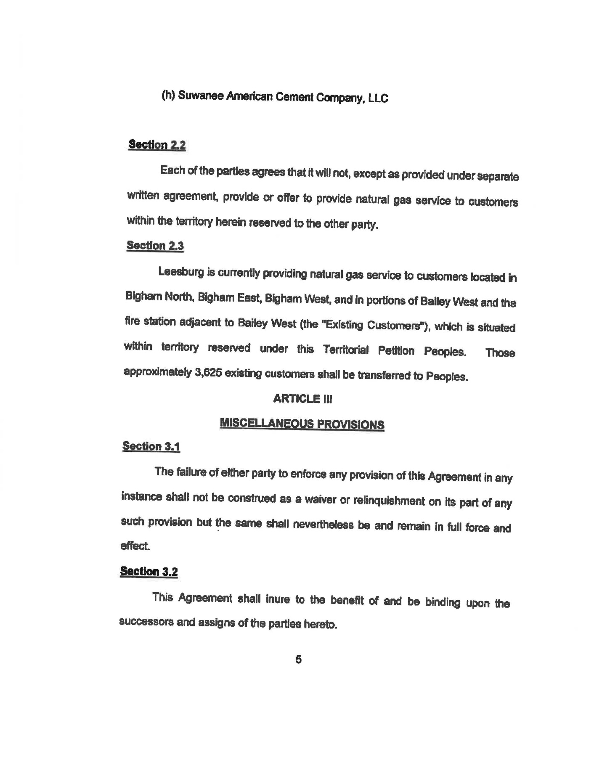

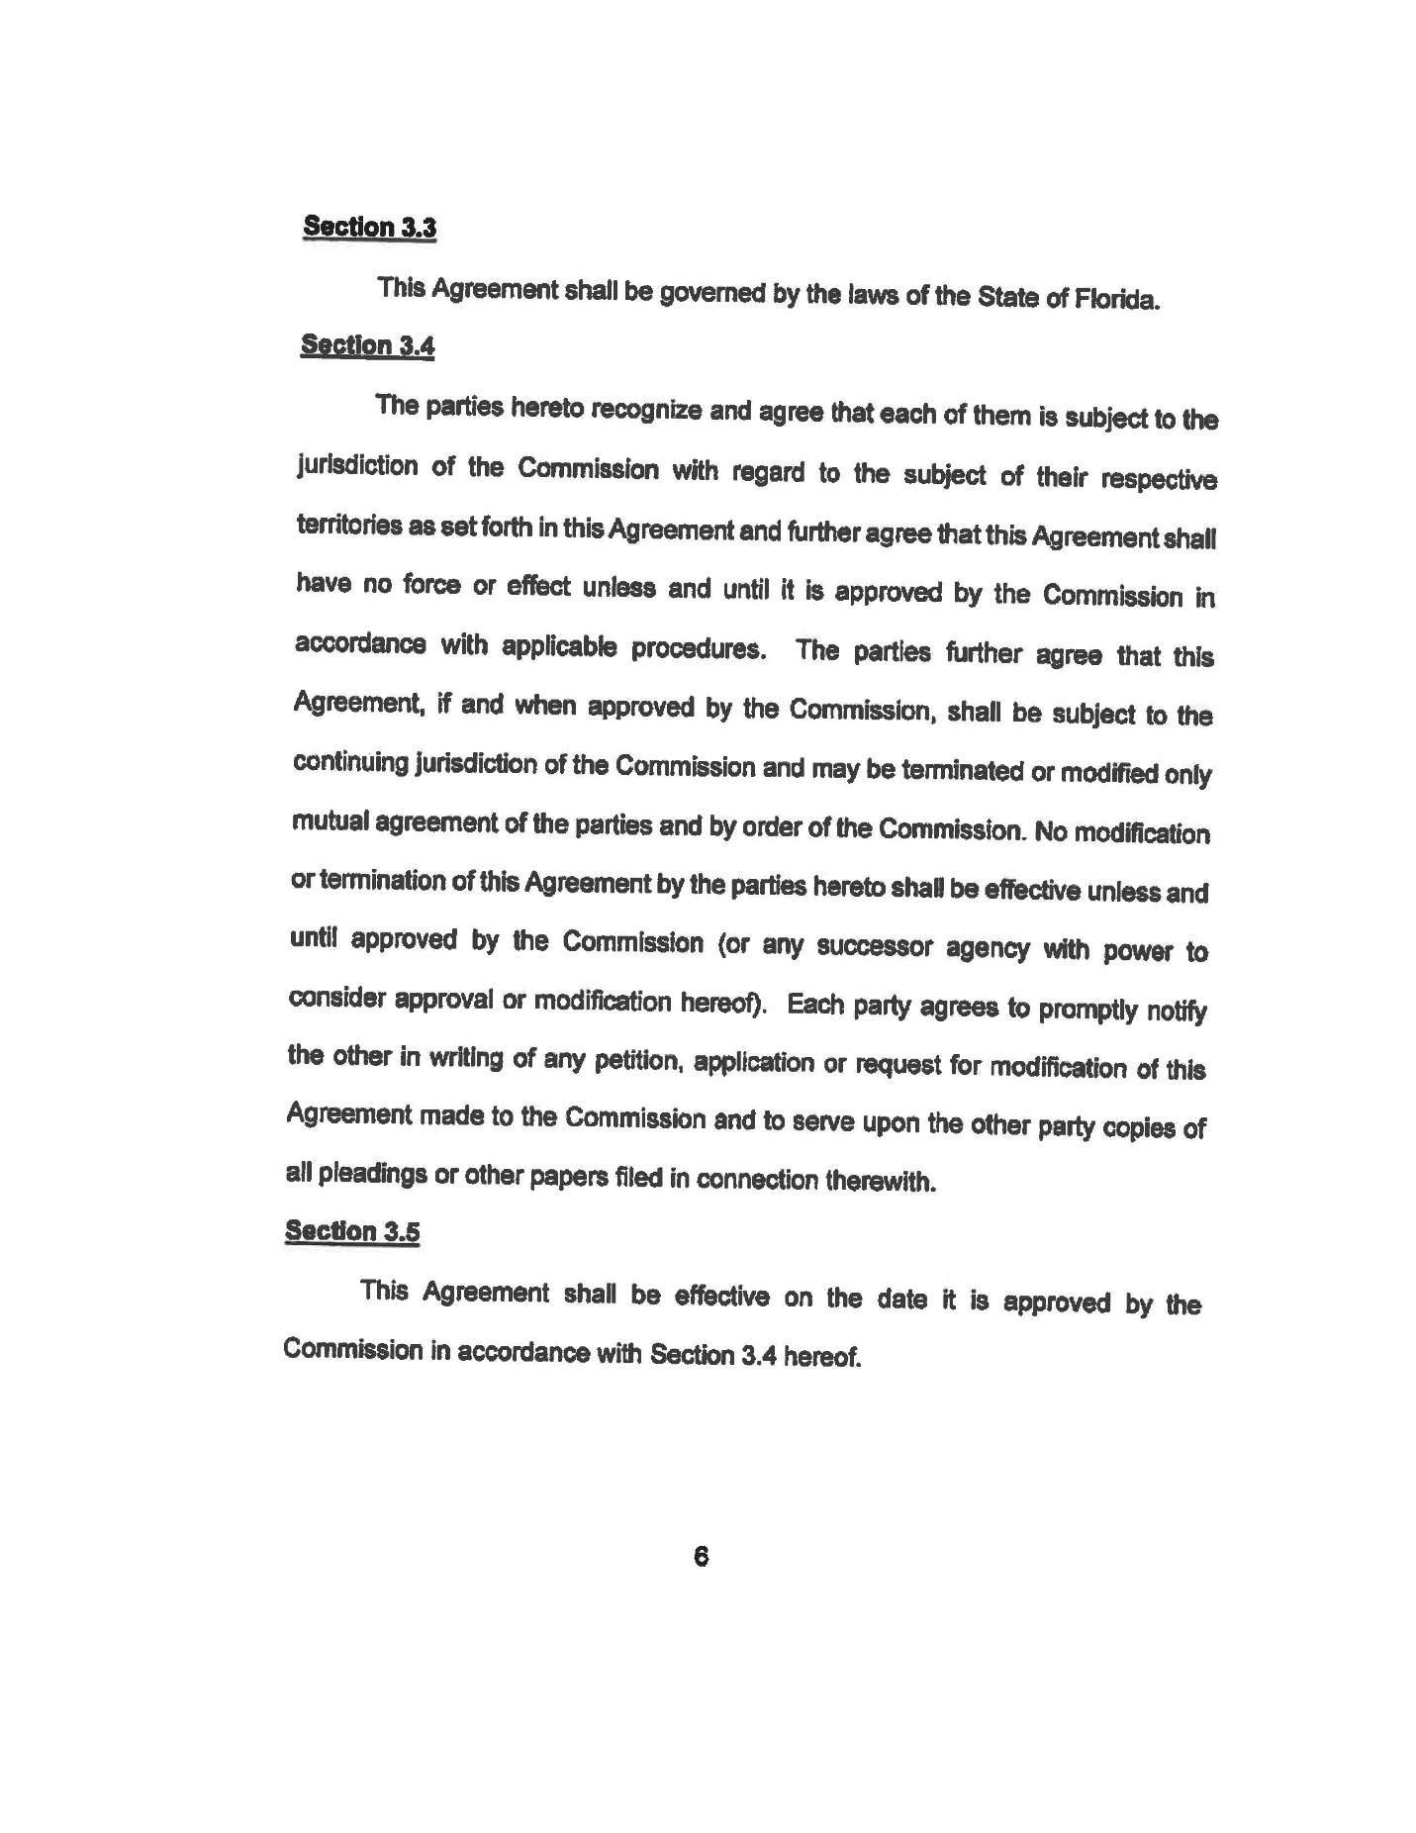

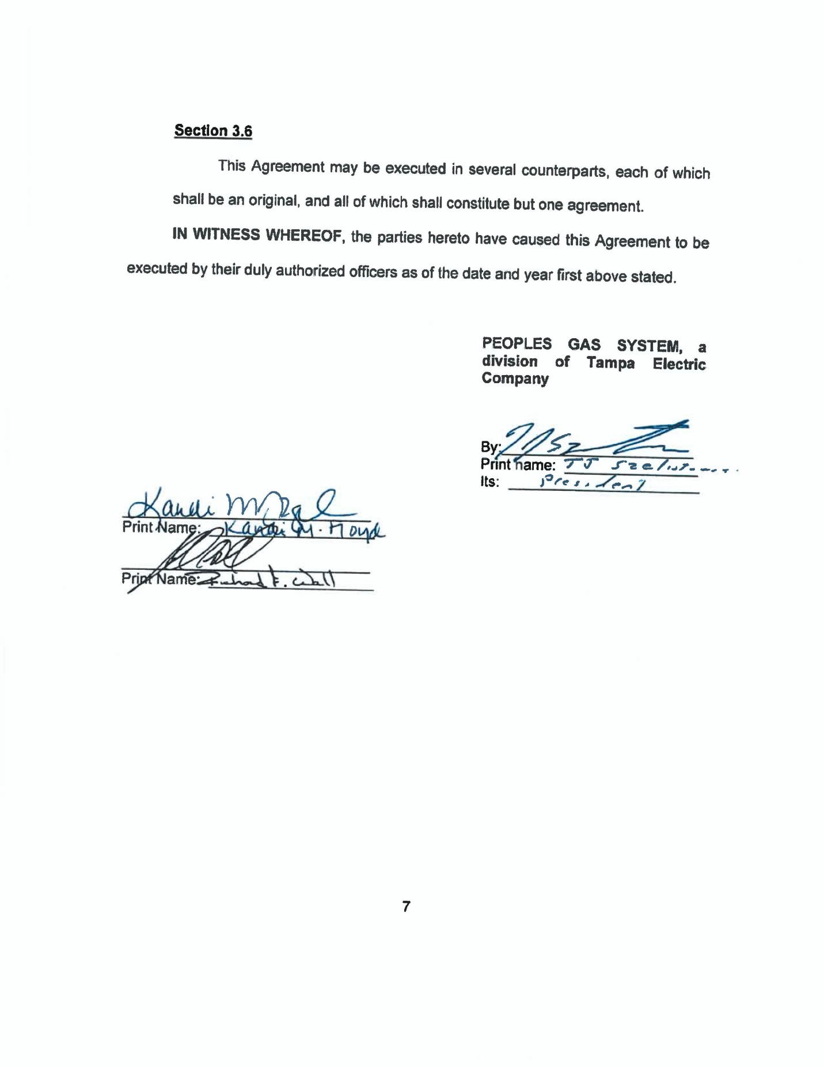

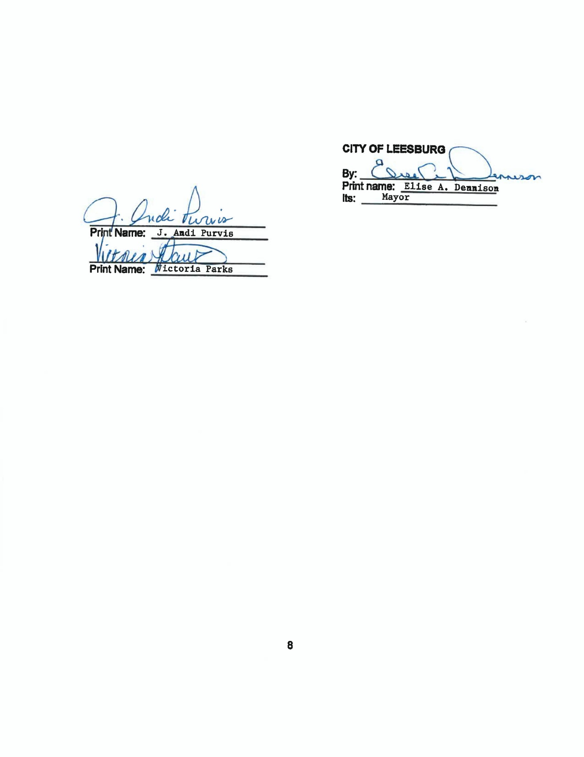

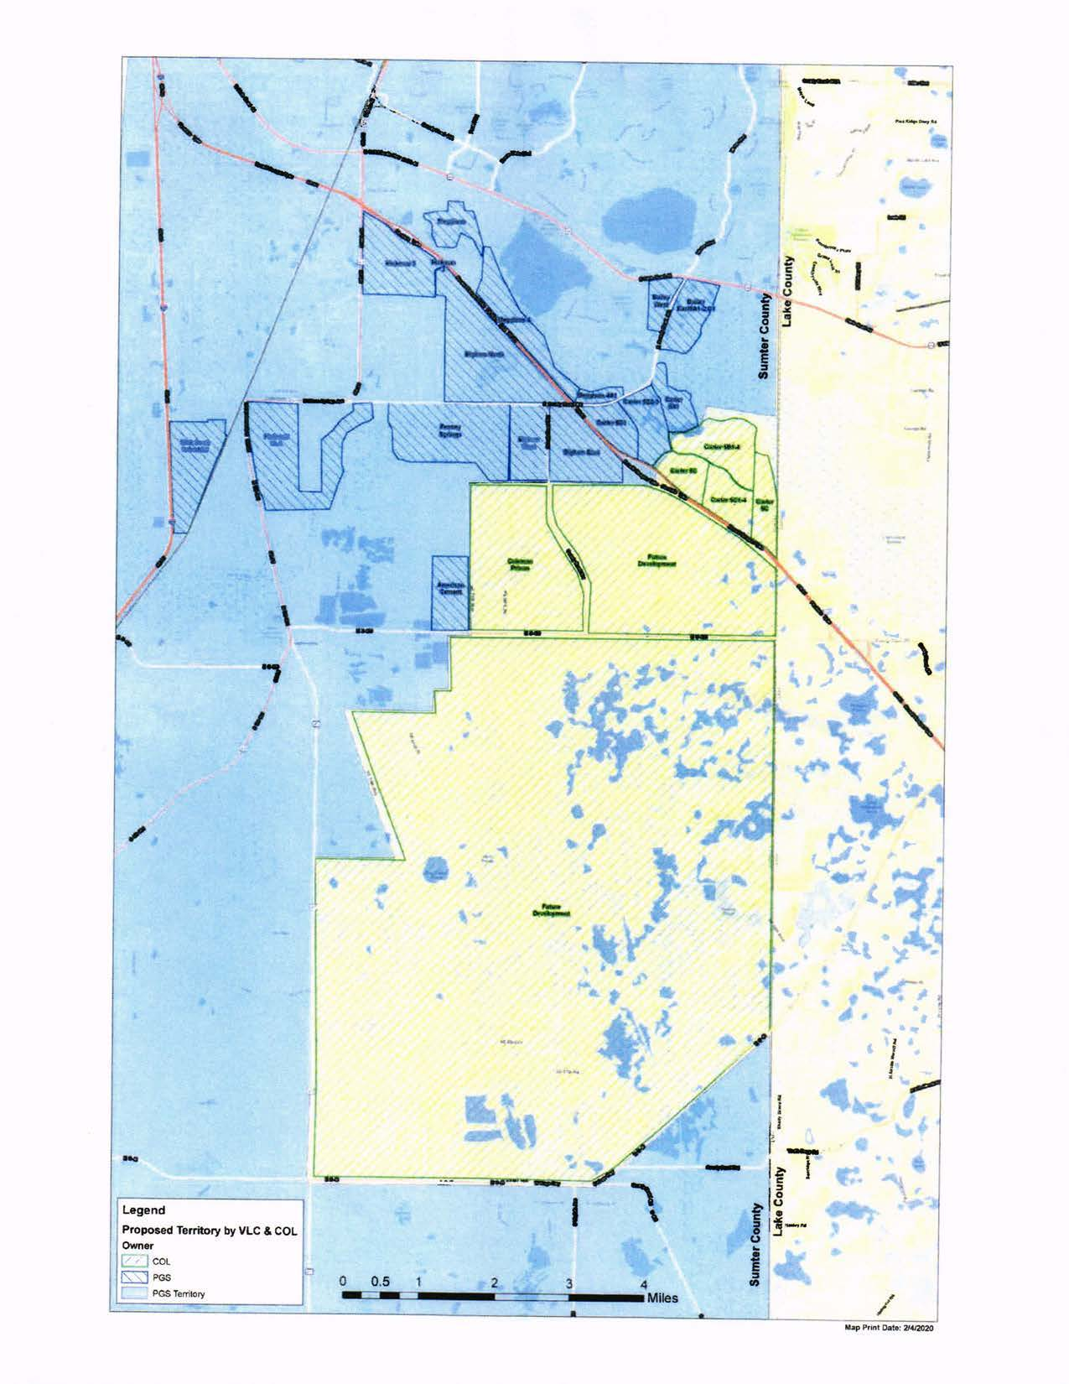

In re: Petition to resolve territorial dispute in Sumter County and/or Lake County with City of Leesburg and/or South Sumter Gas Company, LLC, by Peoples Gas System.
"Recommended Order" is defined in Section 120.52(15), F.S., as the official recommendation of the ALJ assigned by DOAH or of any other duly authorized presiding officer, other than the agency head or member thereof.
Peoples Gas System vs. South Sumter Gas Company, LLC, and City of Leesburg, DOAH Case No. 18-4422, Recommended Order issued on September 30, 2019.
Order No. PSC-2020-0052-FOF-GU, issued February 11, 2020, in Docket No. 20180055-GU, In re: Petition to resolve territorial dispute in Sumter County and/or Lake County with City of Leesburg and/or South Sumter Gas Company, LLC, by Peoples Gas System.
Utilities Commission of the City of New Smyrna Beach v. Florida Public Service Commission, 469 So. 2d 731 (Fla. 1985).
Order No. PSC-2020-0052-FOF-GU at p. 92 (Conclusion of Law 160).

