BEFORE THE FLORIDA PUBLIC SERVICE COMMISSION

In re: Joint petition to approve territorial agreement in Sumter, Lake, Marion, Levy, and Citrus Counties, by Sumter Electric Cooperative, Inc. and Duke Energy Florida, LLC. | DOCKET NO. 20200106-EU  ORDER NO. PSC-2020-0252-PAA-EU  ISSUED: July 23, 2020

The following Commissioners participated in the disposition of this matter:

GARY F. CLARK, Chairman
ART GRAHAM
JULIE I. BROWN
DONALD J. POLMANN
ANDREW GILES FAY

PROPOSED AGENCY ACTION
ORDER APPROVING TERRITORIAL AGREEMENT

BY THE COMMISSION:

NOTICE is hereby given by the Florida Public Service Commission that the action discussed herein is preliminary in nature and will become final unless a person whose interests are substantially affected files a petition for a formal proceeding, pursuant to Rule 25-22.029, Florida Administrative Code (F.A.C.).

I. Background
On March 27, 2020, Sumter Electric Cooperative, Inc. (SECO) and Duke Energy Florida, LLC (DEF), collectively the joint petitioners, filed a petition seeking our approval of a Territorial Agreement (Agreement) delineating their respective service boundaries in Sumter, Lake, Marion, Levy, and Citrus counties. The proposed Agreement, approved herein, is shown in Attachment A, and composite maps depicting the proposed service territories in Sumter, Lake, Marion, Levy, and Citrus counties are shown in Attachment B. The detailed, complete set of maps delineating the service territories and the written descriptions are contained in the joint petition as Exhibits A and B, respectively. Due to their voluminous nature, the detailed maps and written descriptions are not attached.

In April 2009, we approved the current territorial agreement by Order No. PSC-09-0276-PAA-EU. In the instant docket, the joint petitioners seek to gain further operational efficiencies and customer improvements in their respective retail service territories by requesting to replace the current territorial agreement with an amended Agreement dated March 27, 2020. The proposed Agreement includes the transfer of 546 DEF customers to SECO and 49 SECO customers to DEF.

We have jurisdiction over this matter pursuant to Section 366.04, Florida Statutes (F.S.).

II. Decision
Pursuant to Section 366.04(2)(d), F.S., and Rule 25-6.0440, F.A.C., we have jurisdiction to approve territorial agreements between and among rural electric cooperatives, municipal electric utilities, and other electric utilities. Unless we determine that the agreement will cause a detriment to the public interest, the agreement should be approved.

Proposed 2020 Territorial Agreement

The joint petitioners stated they have agreed to replace the current territorial agreement with the proposed Agreement executed on March 27, 2020. The intent of the proposed Agreement is to further prevent duplication of facilities, correct encroachments, and to reduce the number of service providers in a residential development to a single provider when feasible. The joint petitioners stated that avoiding duplication of services enhances aesthetics, safety and reliability, and reduces restoration times and safety concerns during storm events. As such, the joint petitioners assert that these changes will allow for further operational efficiencies and customer service improvements in their respective retail service territories in Sumter, Lake, Marion, Levy, and Citrus counties.

Pursuant to Section 6.1 of the proposed Agreement, the term of the Agreement is 20 years from the effective date. After the expiration of the first 20-year term, the Agreement will remain in effect unless either party provides written notice of termination at least 12 months prior to the termination of the agreement. The effective date of the Agreement will be the date on which we issue a final order granting approval of this proposed Agreement in its entirety and it is no longer subject to judicial review. In addition, any modification to the proposed Agreement will be submitted for our approval.

Customer and Asset Transfer

Paragraph 5 of the petition states that 546 DEF customers (443 residential and 103 commercial) will be transferred to SECO; and 49 SECO customers (20 residential, 28 commercial, and 1 industrial) will be transferred to DEF. There are 379 residential accounts to be transferred from DEF to SECO within a single apartment complex and are expected to be transferred in the first year after the Agreement is approved. SECO intends to transfer all other remaining customers within three years and DEF will transfer the 49 customers in six phases within 36 months. Pursuant to Sections 3.1 and 3.5 of the proposed Agreement, the joint petitioners will file, annually in March, a written report with us on the status of the transfer of customers.

The joint petitioners agree that no lost revenue or going concern value shall be paid for the transfer of customers. Upon the transfer of customers between the utilities, the receiving utility may elect to purchase the facilities of the transferring utility that relate to providing electric service to the impacted customers. If service facilities are transferred, the proposed Territorial Agreement contains provisions for the value of the facilities based upon the replacement cost (new), less depreciation. The joint petitioners intend to undertake a valuation process of facilities using a common engineering cost estimation methodology such as the Handy-Whitman Index. The joint petitioners stated that valuing the facilities is time-consuming and often takes at least one year to complete. If there are facilities of one utility located in the service area of the other utility which are not subject to transfer or removal as a result of the proposed agreement, those facilities shall be operated and maintained in such a manner as to minimize any interference with the operations of the other utility.

Customer Notification

Pursuant to Rule 25-6.0440(1)(d), F.A.C., both SECO and DEF provided written notification to customers that will be transferred pursuant to the proposed Territorial Agreement. These letters included sample rate comparisons between SECO and DEF, as well as information regarding refunds of deposits. As of February 2020, the rate comparison for customers using 1,000 kilowatt-hours was $123.99 for DEF and $119.89 for SECO. The customer notifications are included as Exhibit E to the joint petition.

The joint petition stated that two SECO customers objected to being transferred to DEF and that these customers communicated to the joint petitioners that they would contact us directly after the petition was filed. We received correspondence from one SECO customer objecting to the transfer to DEF. Based on information provided by neighbors, the SECO customer expressed concerns about DEF’s vegetation management practices and alleged poor maintenance of overhead facilities. The customer included pictures of DEF power lines in trees. The customer also stated that they currently have an underground service drop, that they paid for, and do not wish additional overhead poles to receive power. The joint petitioners stated that the overhead facilities identified by the customer are owned by DEF and that the facilities are scheduled for trimming in the second quarter of 2020. In addition, DEF confirmed the customer, when transferred, would continue to be served through their current underground service drop. A written response containing this information was sent to the customer and a copy was filed in the instant docket.

Conclusion

The joint petitioners state that they have worked collaboratively to structure the proposed amendments to their territorial agreement and that it furthers the goals of avoiding duplication of service and enables each to achieve operational efficiency. After review of the joint petition, the proposed Territorial Agreement, and the entire record of this docket, we find that the amended Territorial Agreement will not cause a detriment to the public interest, will eliminate any potential uneconomic duplication of facilities and will not cause a decrease in reliability of electric service to the customer. Therefore, we hereby approve the proposed Territorial Agreement between SECO and DEF in Sumter, Lake, Marion, Levy, and Citrus counties.
Based on the foregoing, it is

ORDERED by the Florida Public Service Commission that the proposed Territorial Agreement between Sumter Electric Cooperative, Inc. and Duke Energy Florida, LLC in Sumter, Lake, Marion, Levy, and Citrus counties is hereby approved. It is further
ORDERED that the provisions of this Order, issued as proposed agency action, shall become final and effective upon the issuance of a Consummating Order unless an appropriate petition, in the form provided by Rule 28-106.201, Florida Administrative Code, is received by the Commission Clerk, 2540 Shumard Oak Boulevard, Tallahassee, Florida 32399-0850, by the close of business on the date set forth in the “Notice of Further Proceedings” attached hereto. It is further

ORDERED that in the event this Order becomes final, this docket shall be closed.

By ORDER of the Florida Public Service Commission this 23rd day of July, 2020.

/s/ Adam J. Teitzman
ADAM J. TEITZMAN
Commission Clerk
Florida Public Service Commission
2540 Shumard Oak Boulevard
Tallahassee, Florida 32399
(850) 413-6770
www.floridapsc.com

Copies furnished: A copy of this document is provided to the parties of record at the time of issuance and, if applicable, interested persons.

WLT

NOTICE OF FURTHER PROCEEDINGS OR JUDICIAL REVIEW

The Florida Public Service Commission is required by Section 120.569(1), Florida Statutes, to notify parties of any administrative hearing that is available under Section 120.57, Florida Statutes, as well as the procedures and time limits that apply. This notice should not be construed to mean all requests for an administrative hearing will be granted or result in the relief sought.

Mediation may be available on a case-by-case basis. If mediation is conducted, it does not affect a substantially interested person's right to a hearing.

The action proposed herein is preliminary in nature. Any person whose substantial interests are affected by the action proposed by this order may file a petition for a formal proceeding, in the form provided by Rule 28-106.201, Florida Administrative Code. This petition must be received by the Office of Commission Clerk, 2540 Shumard Oak Boulevard, Tallahassee, Florida 32399-0850, by the close of business on August 13, 2020.

In the absence of such a petition, this order shall become final and effective upon the issuance of a Consummating Order.

Any objection or protest filed in this/these docket(s) before the issuance date of this order is considered abandoned unless it satisfies the foregoing conditions and is renewed within the specified protest period.

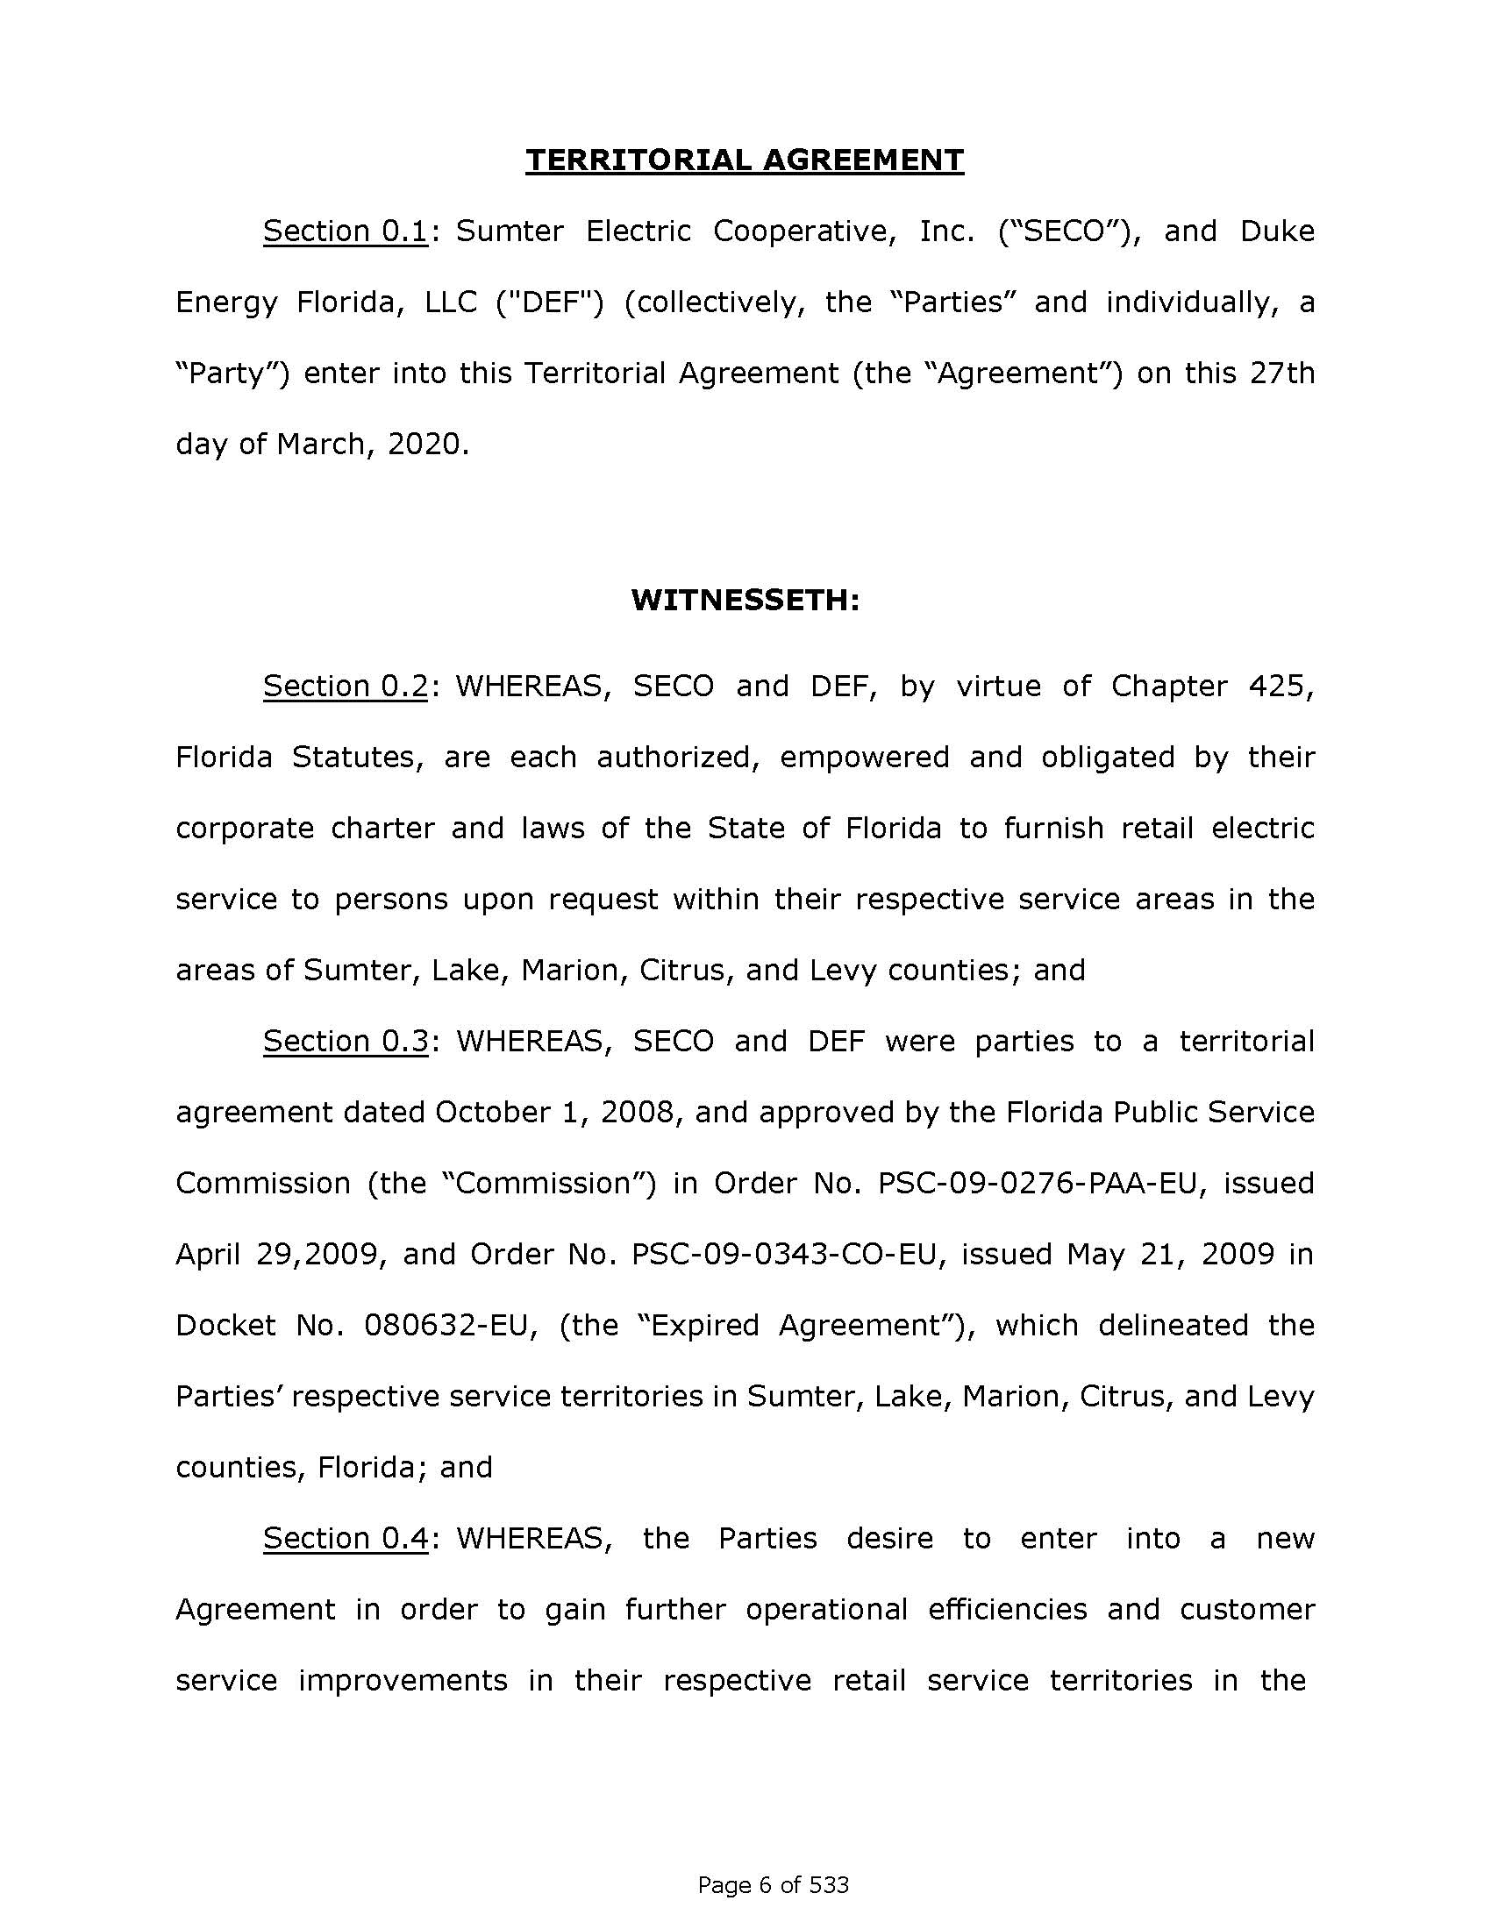
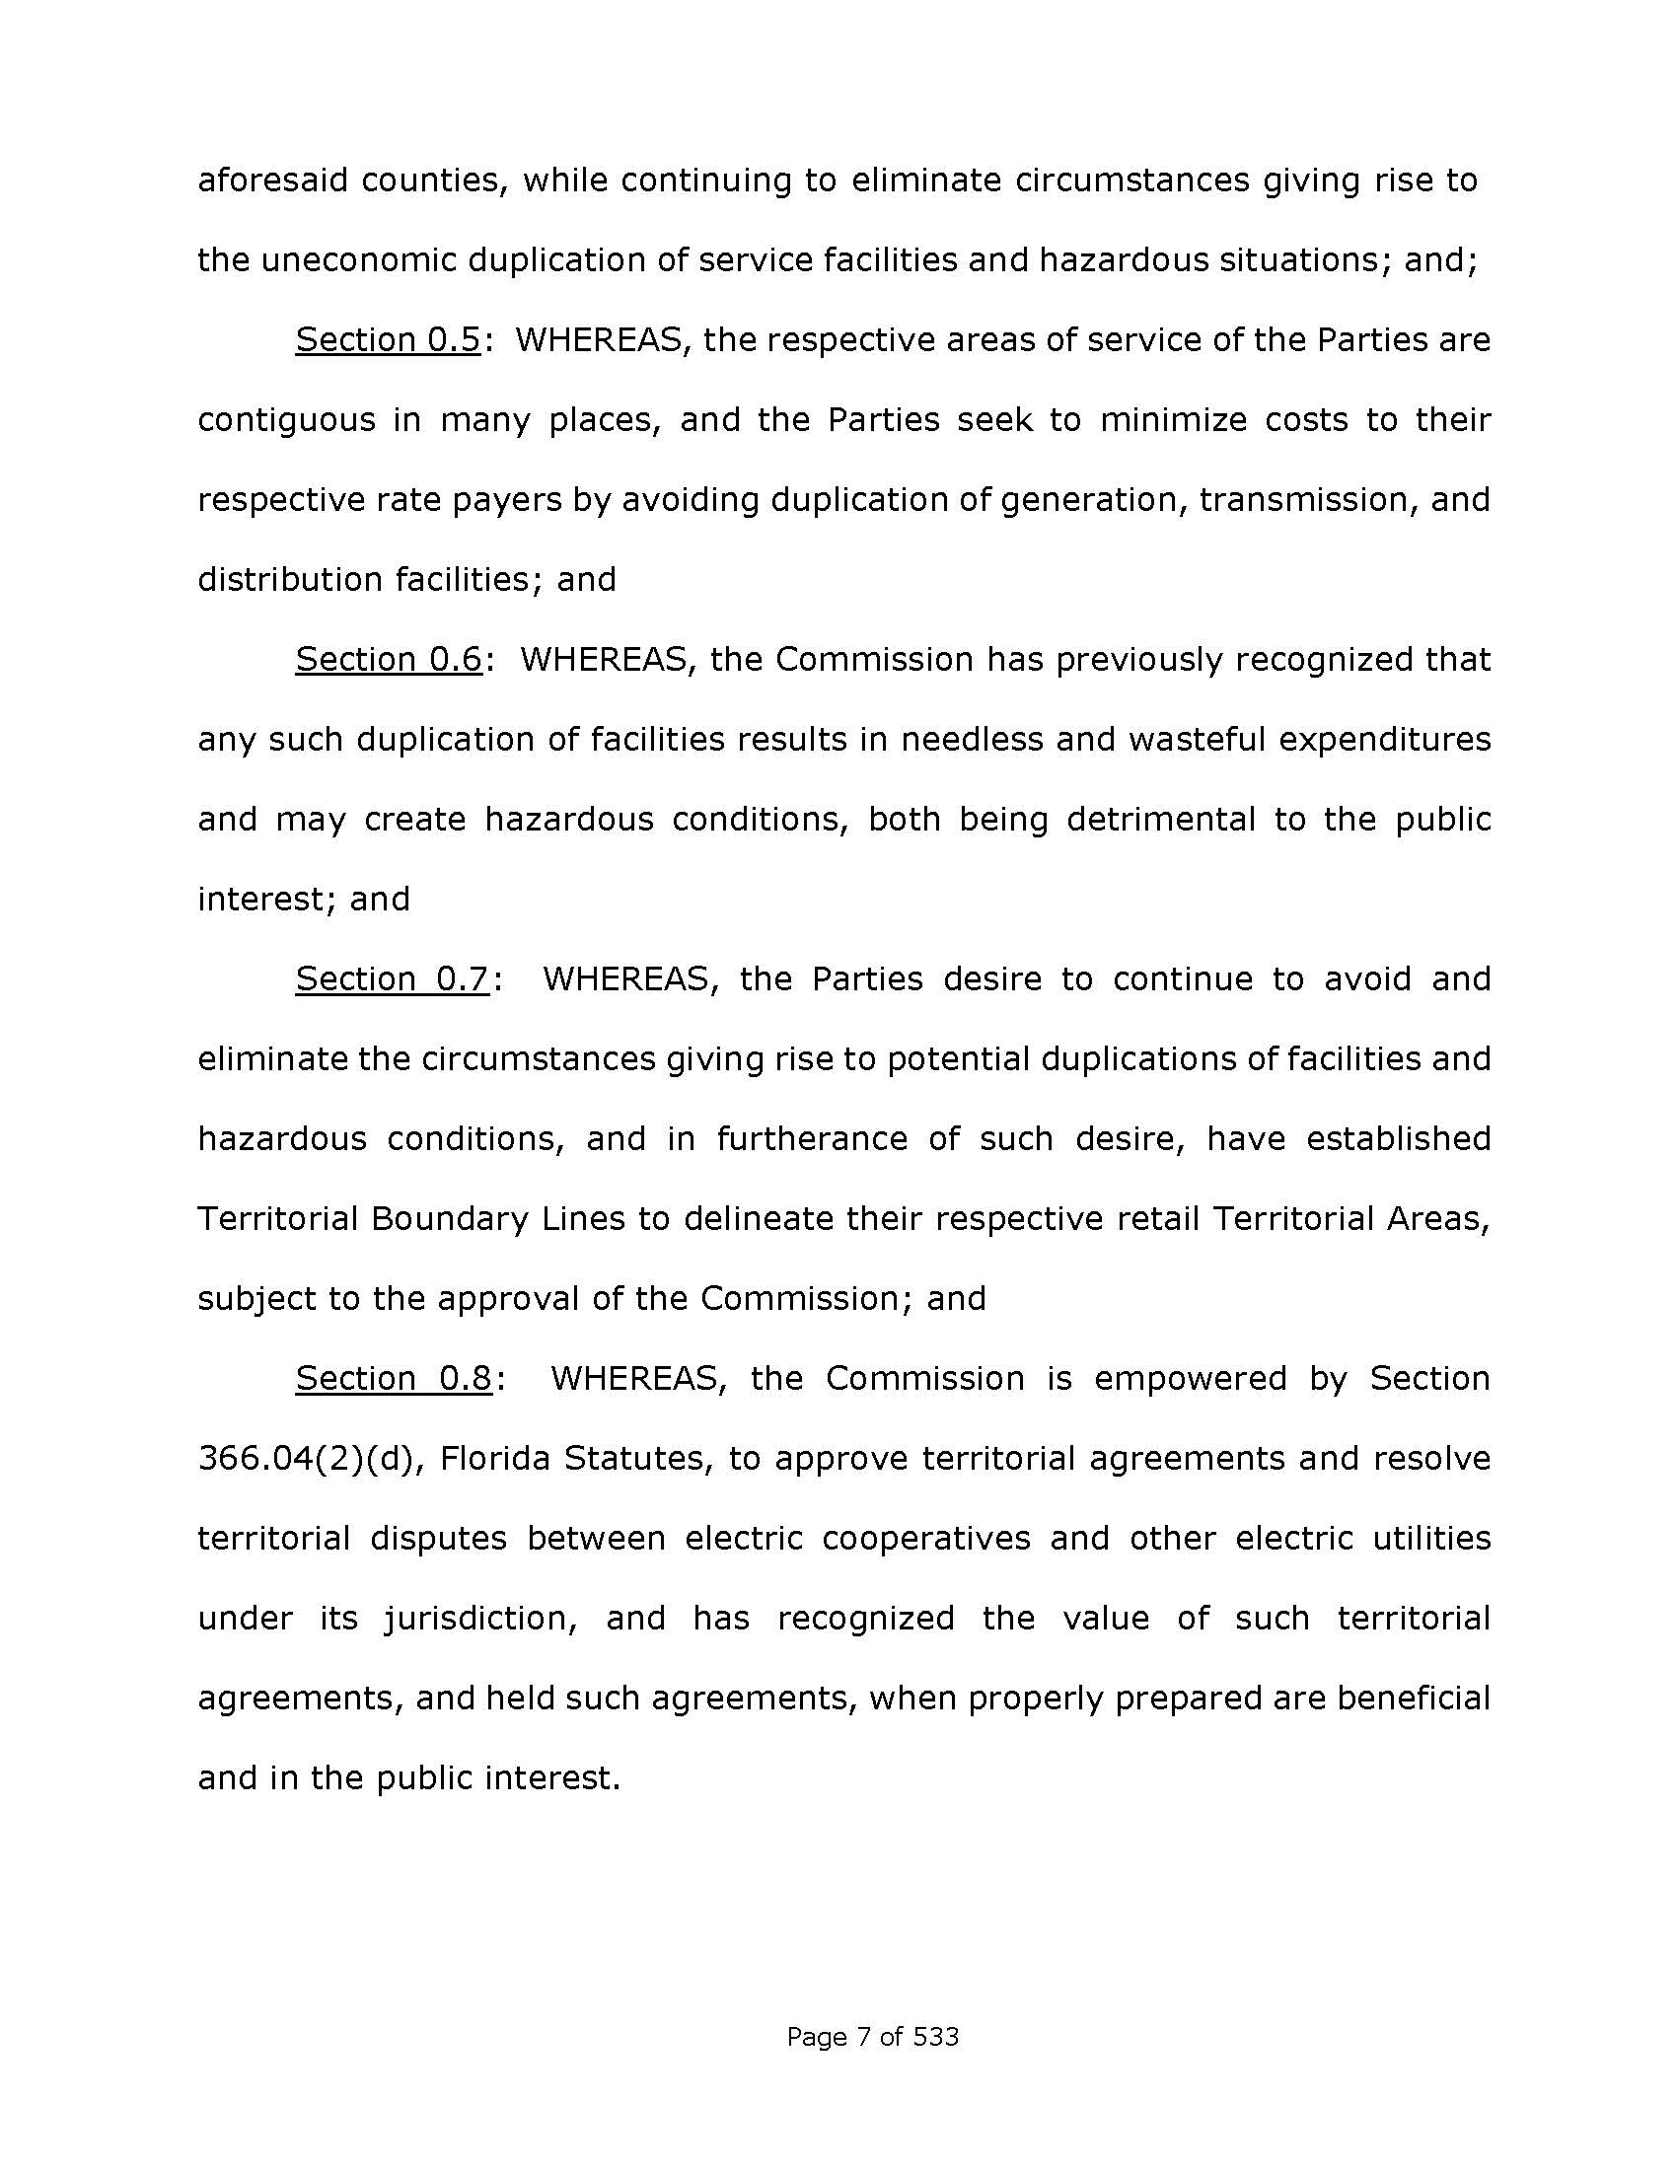
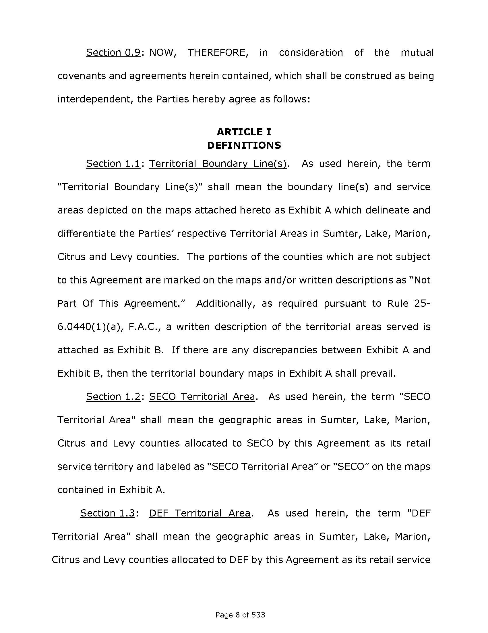
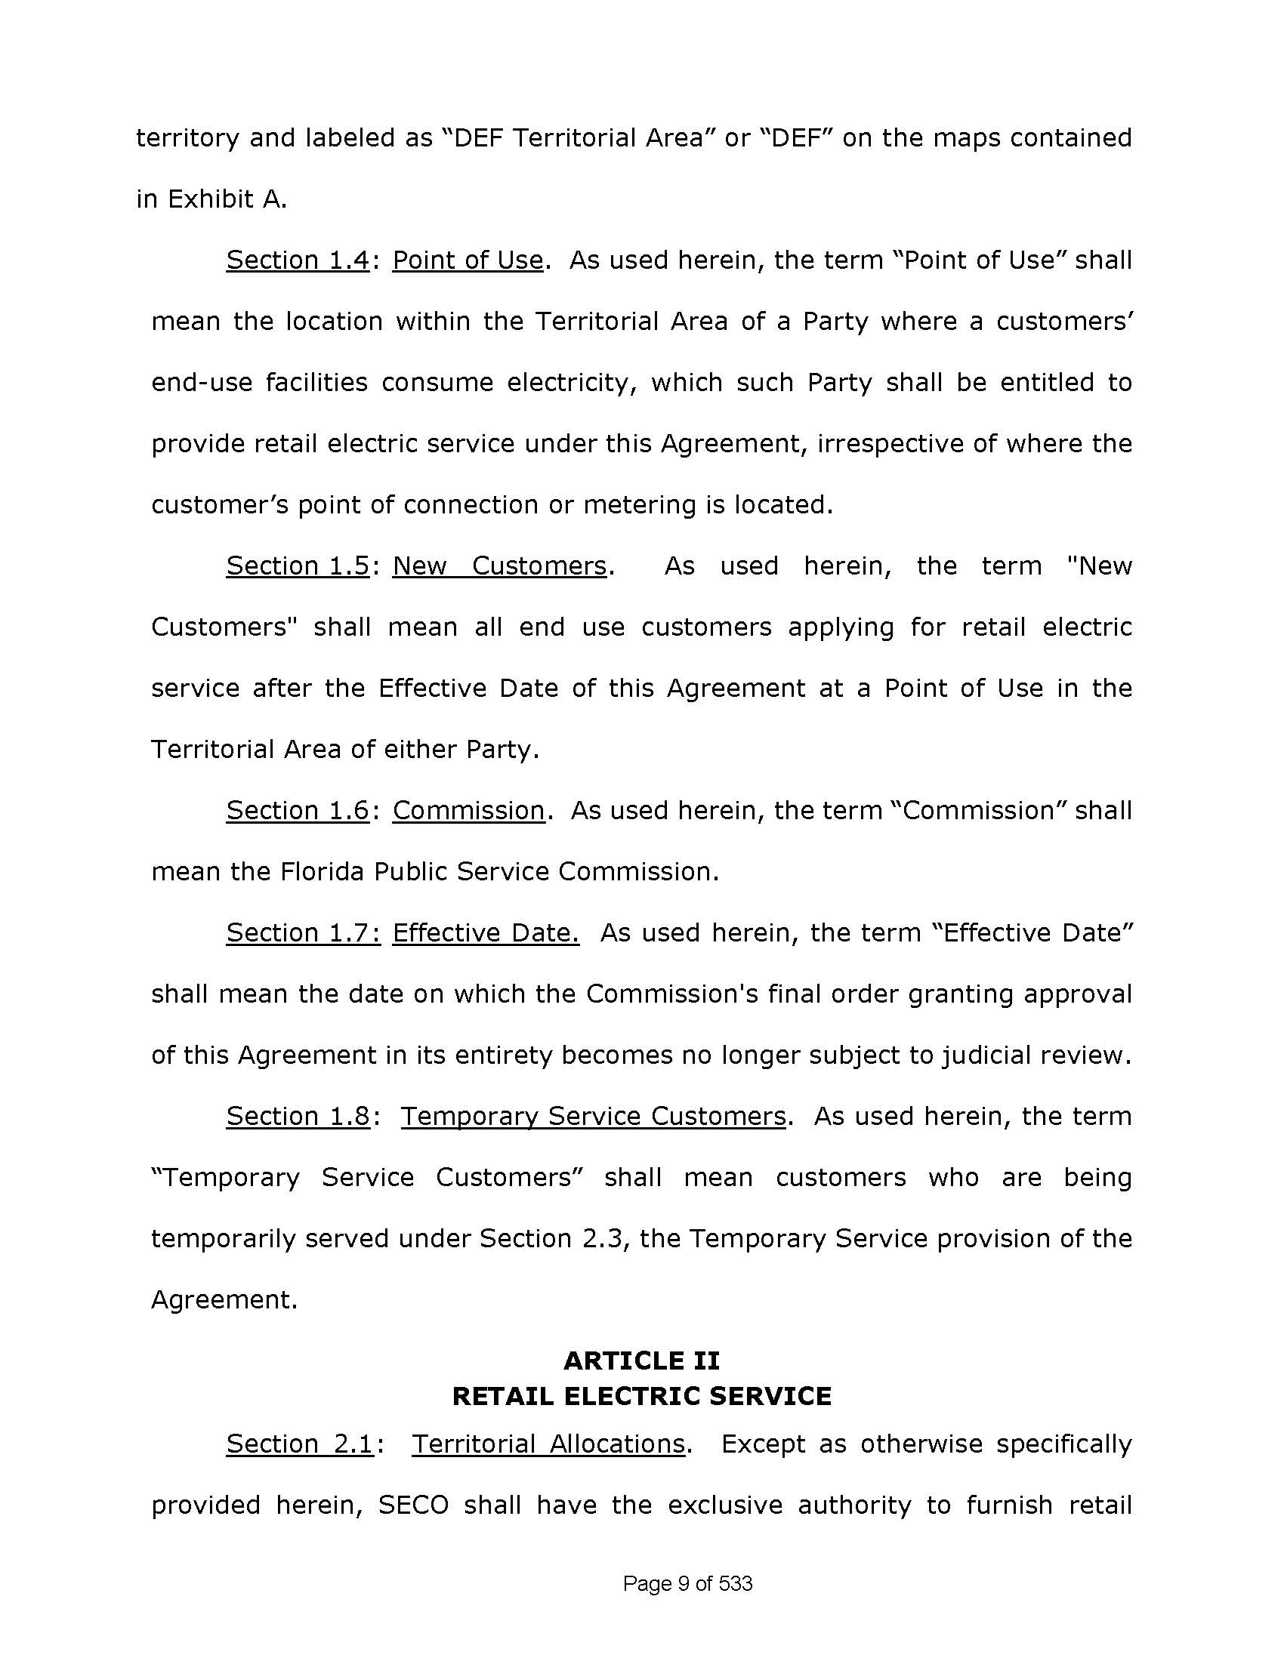
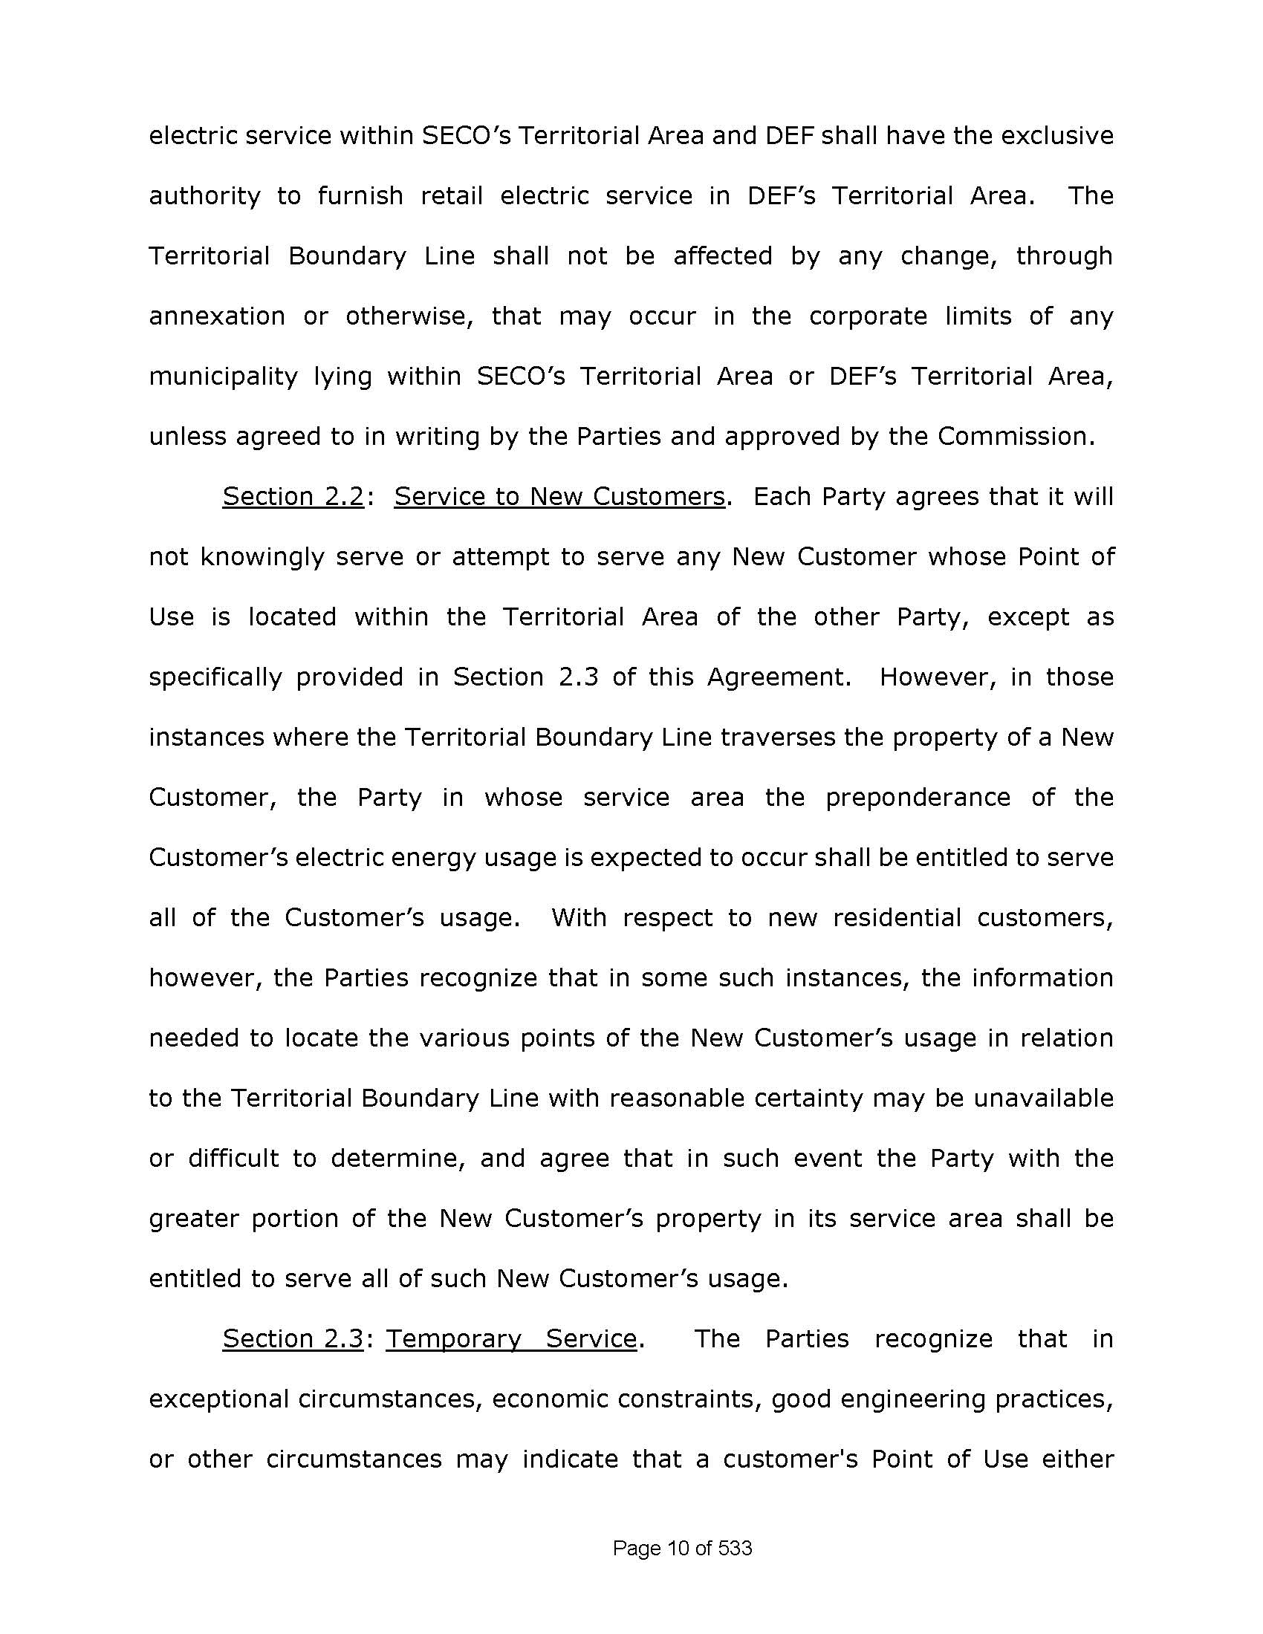
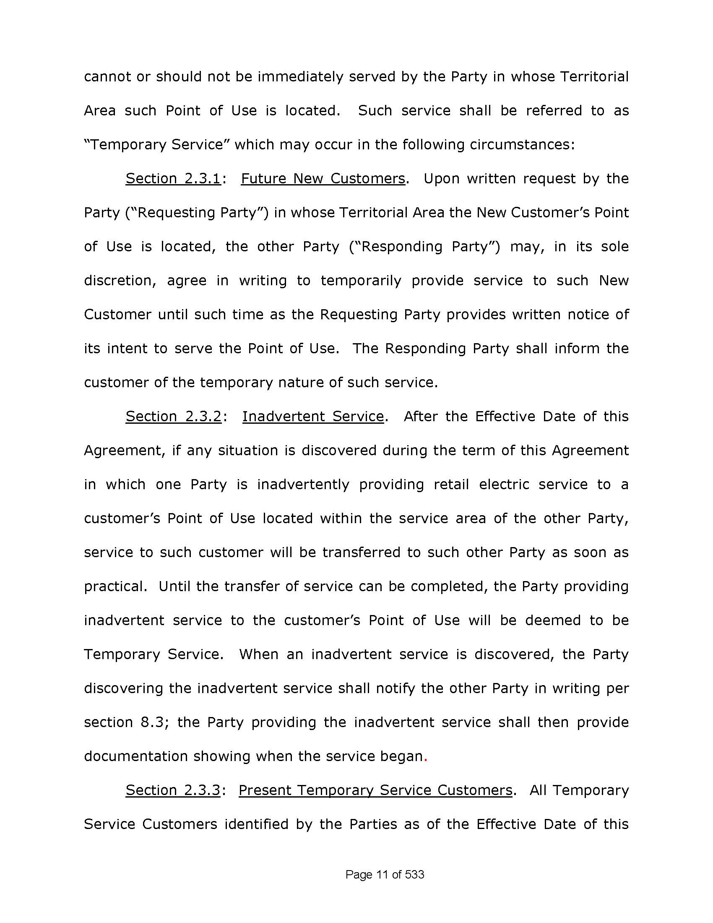
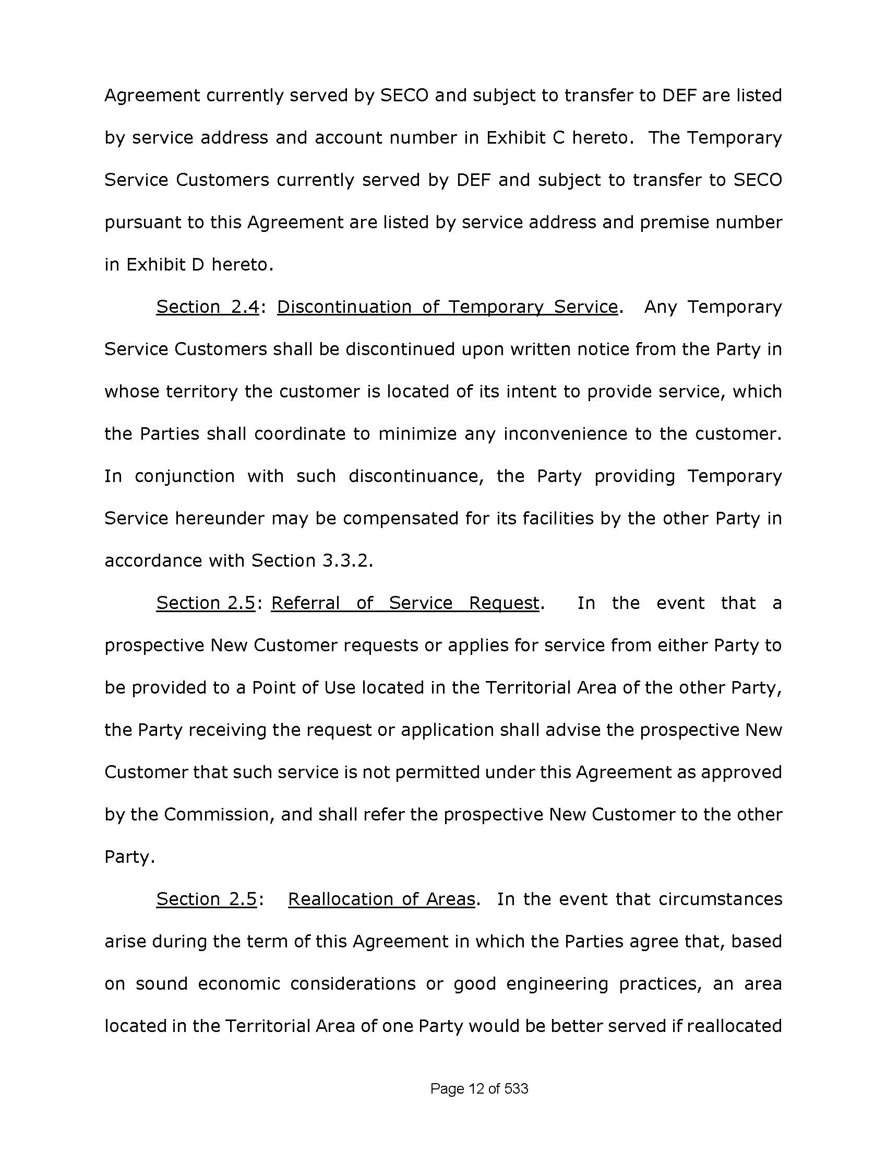
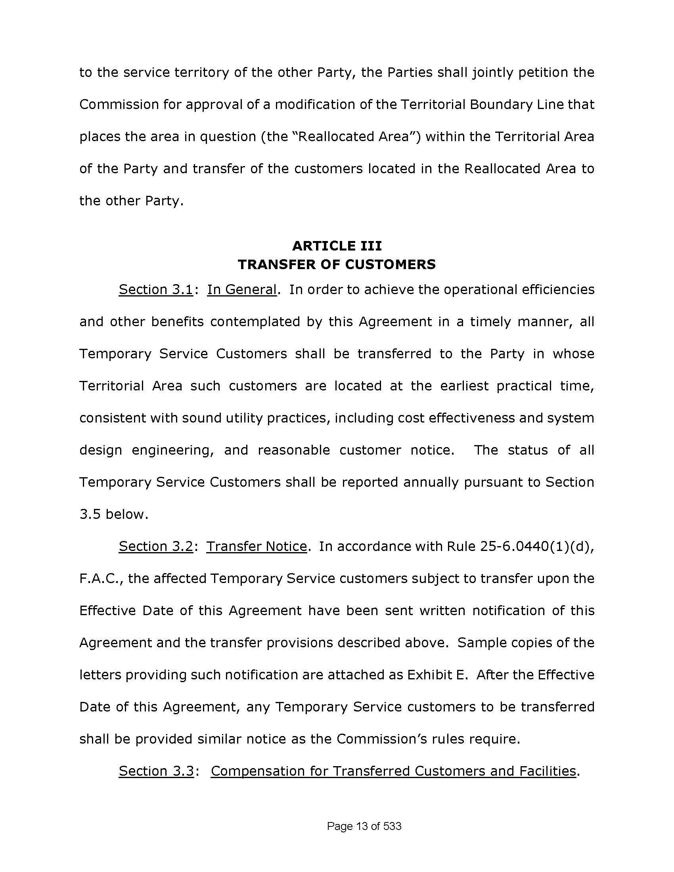
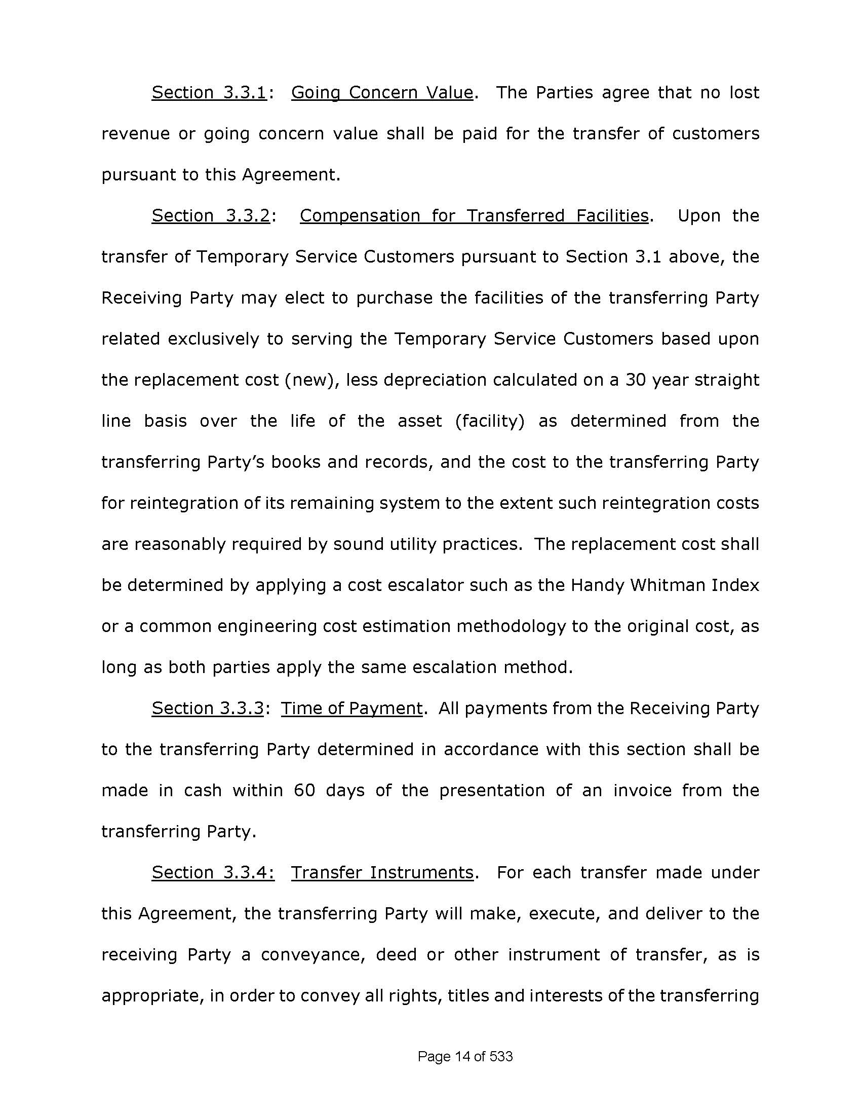
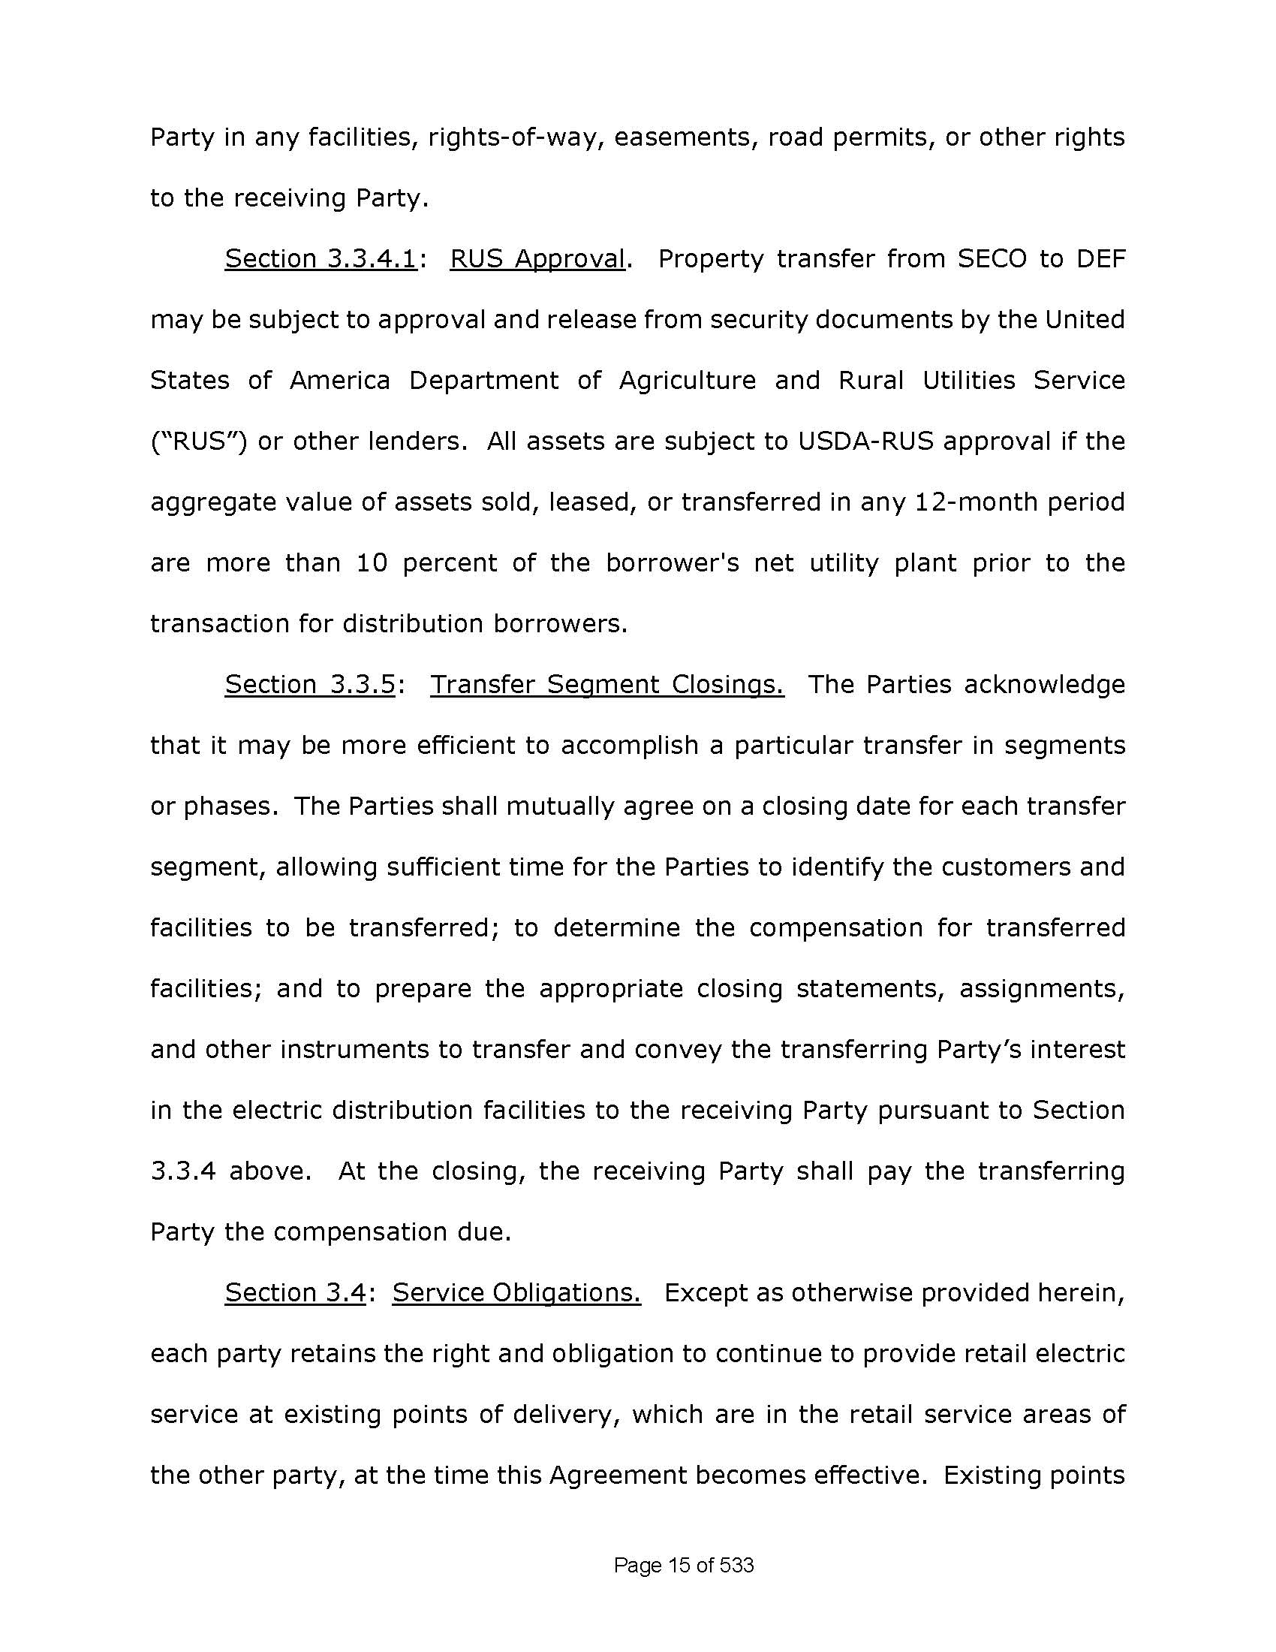
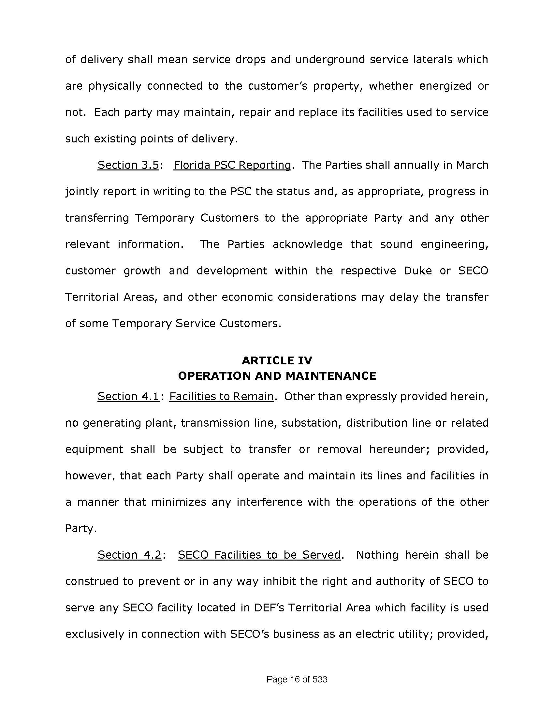
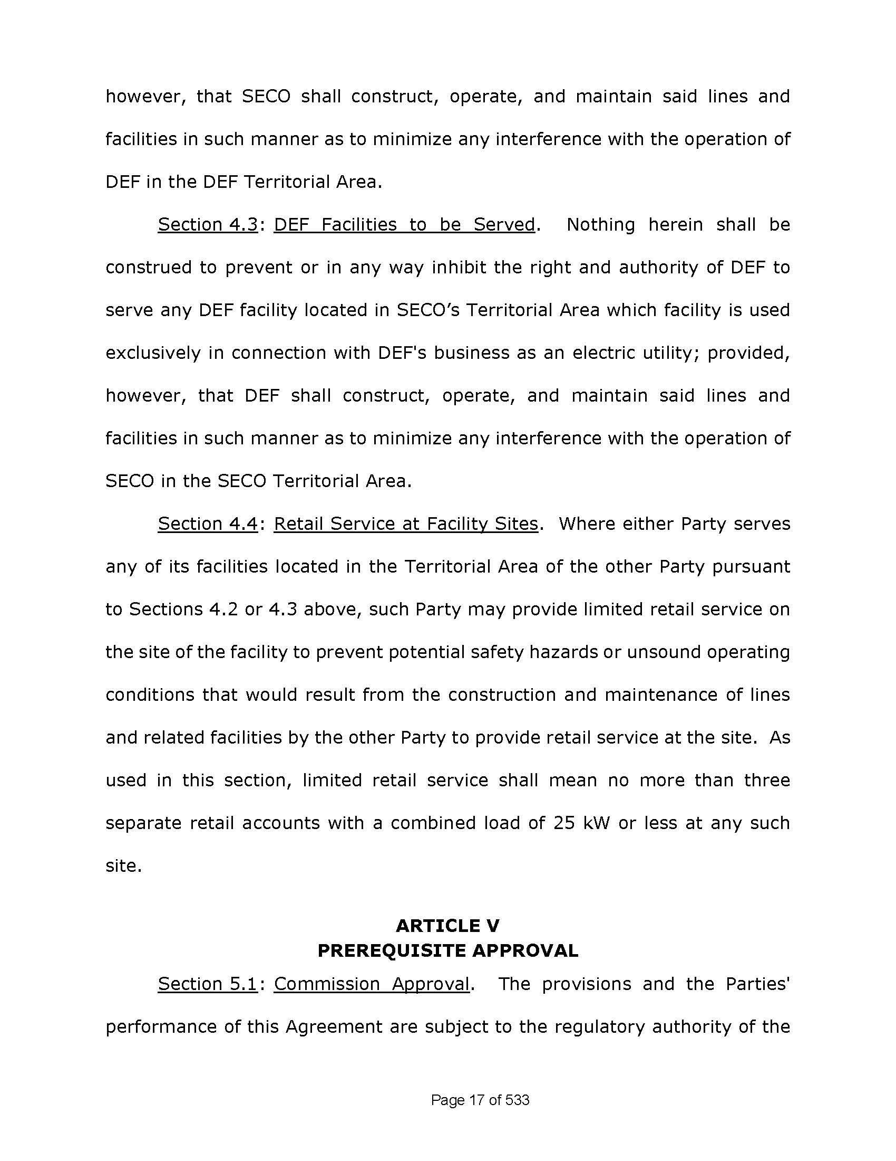
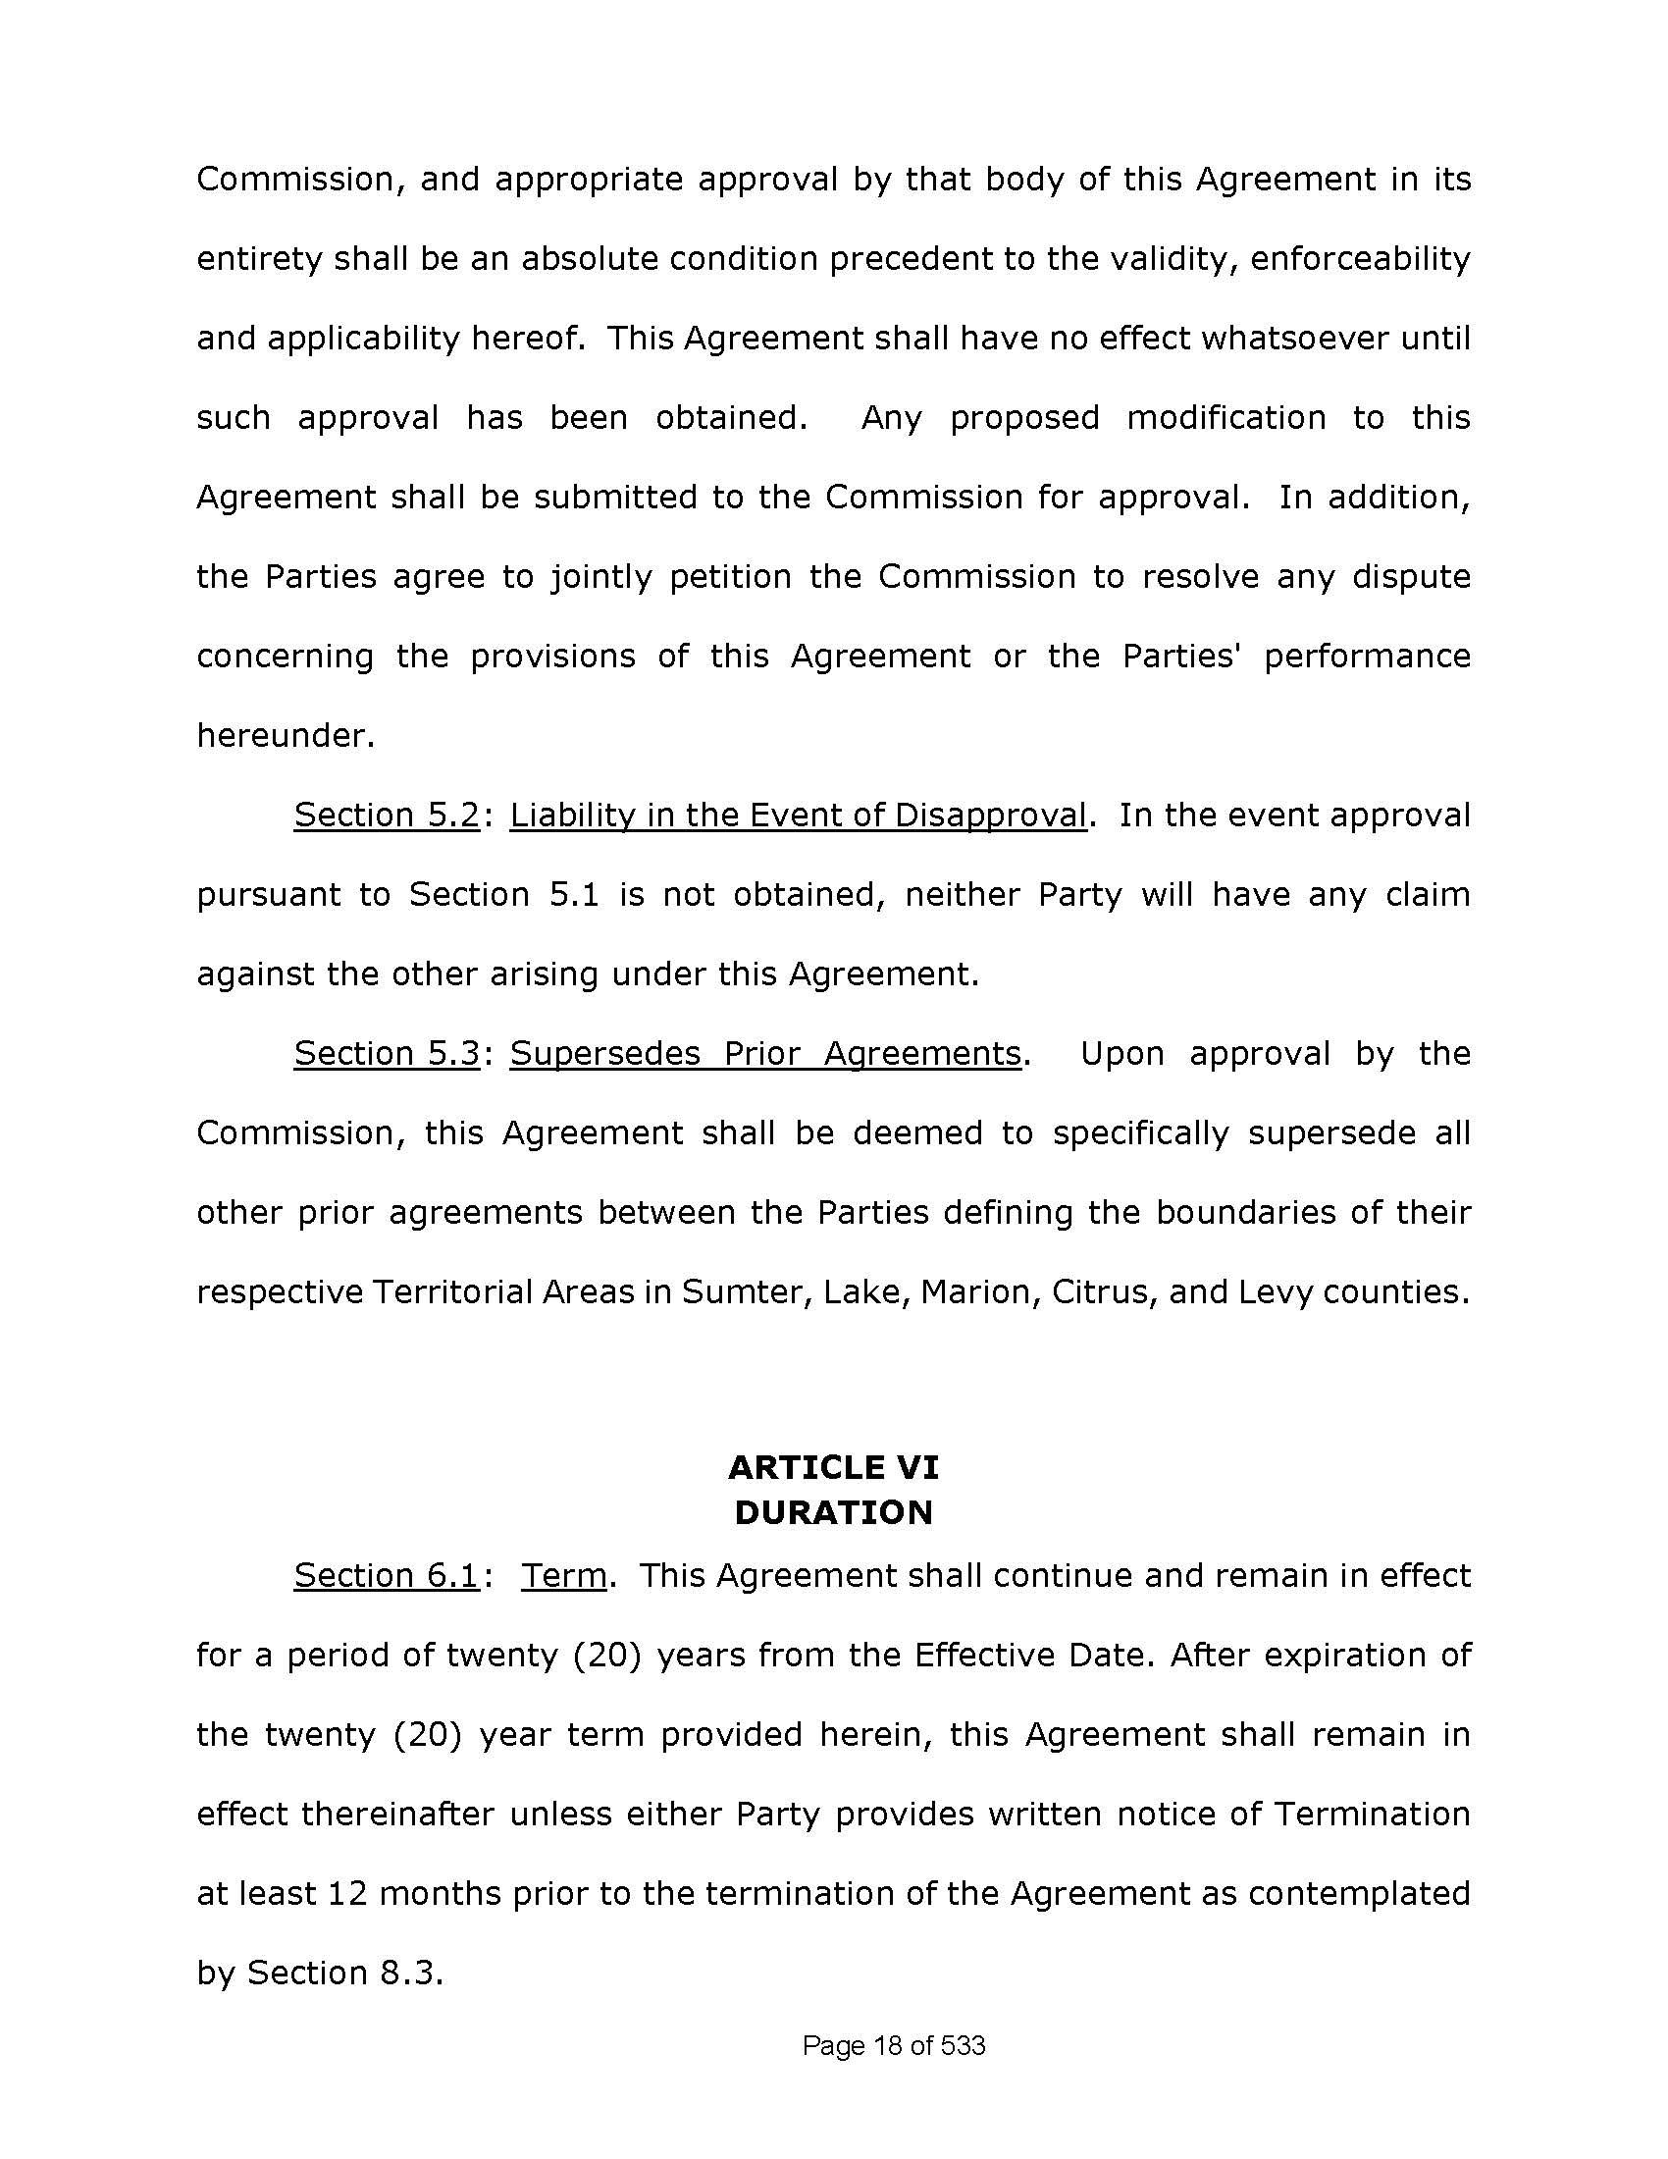
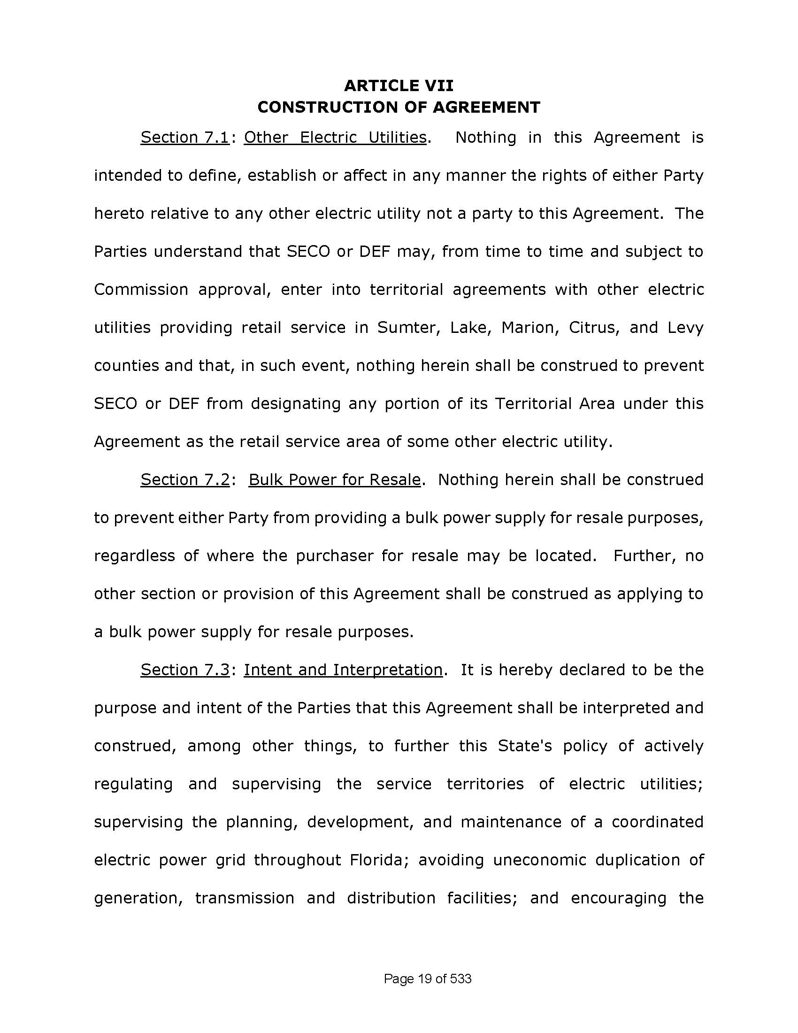
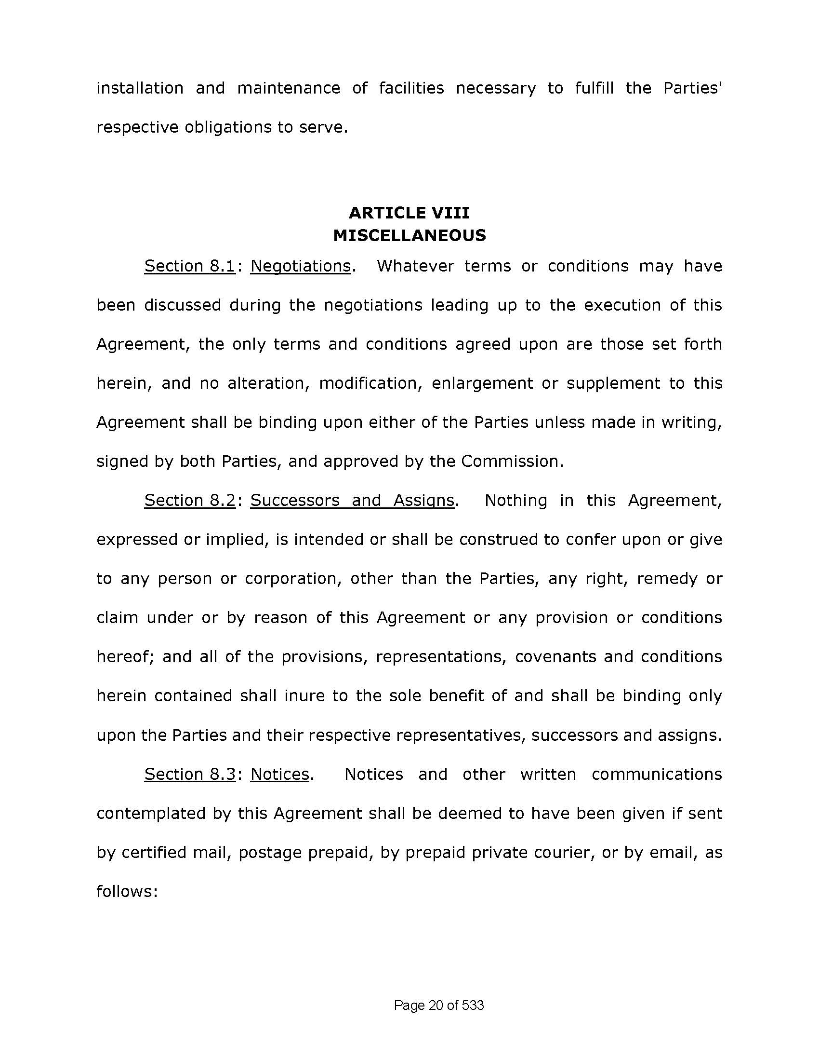
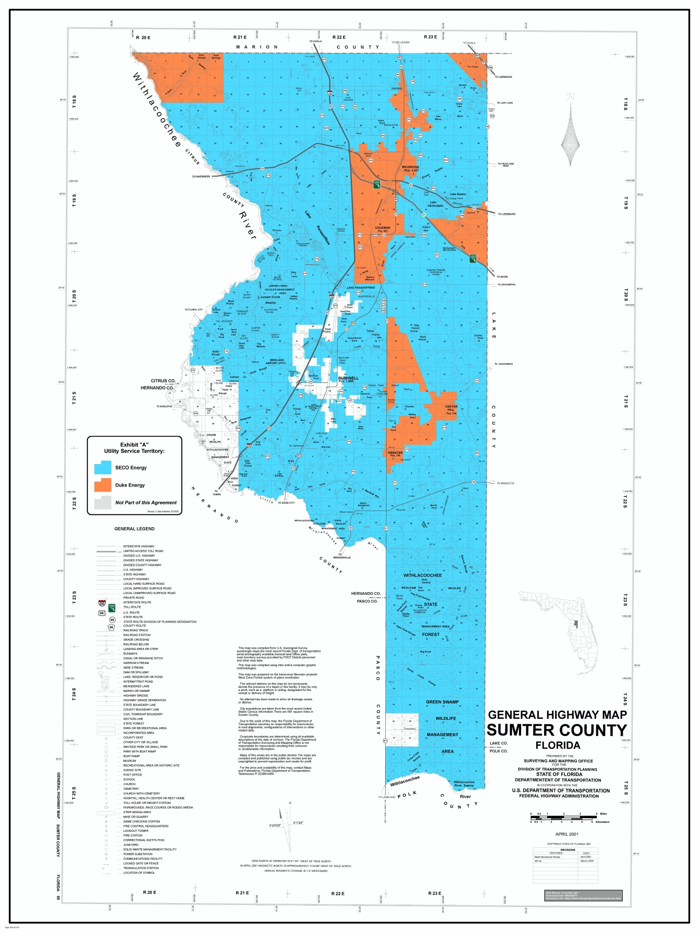
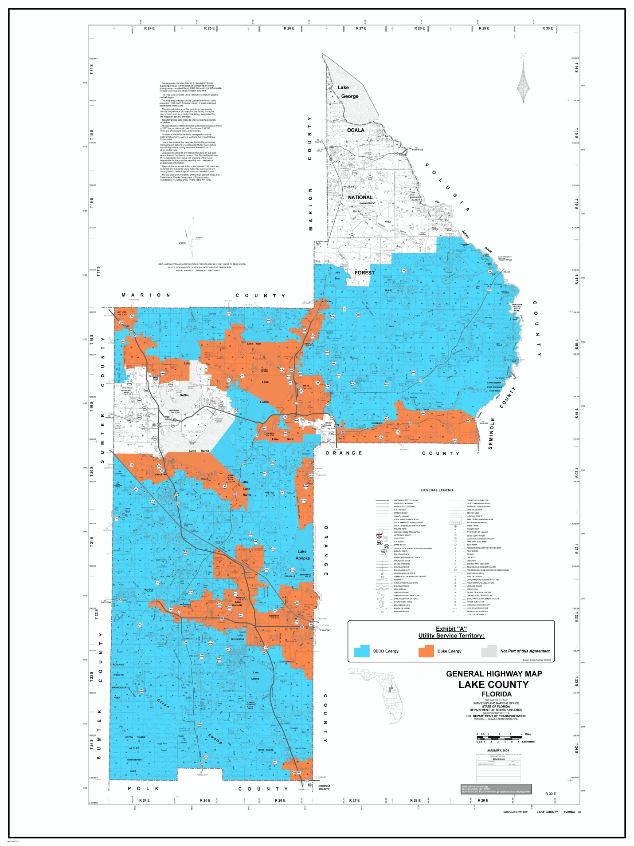
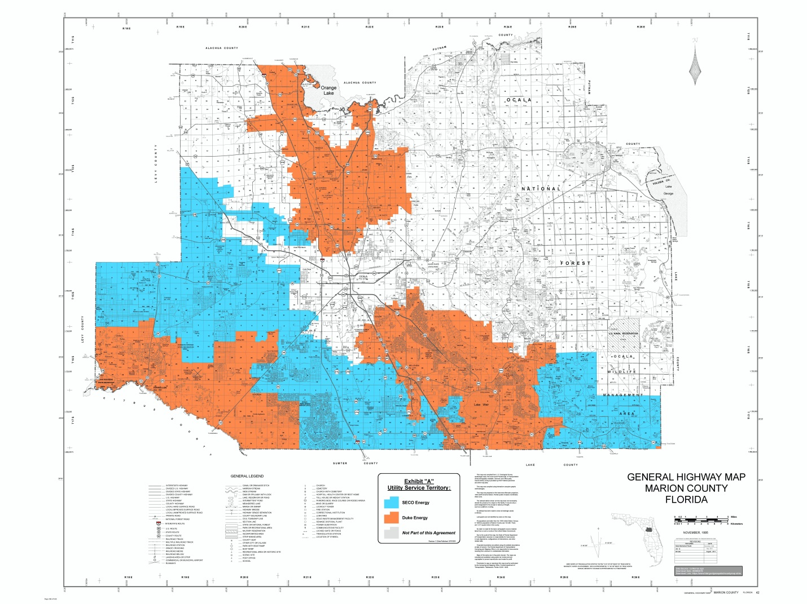

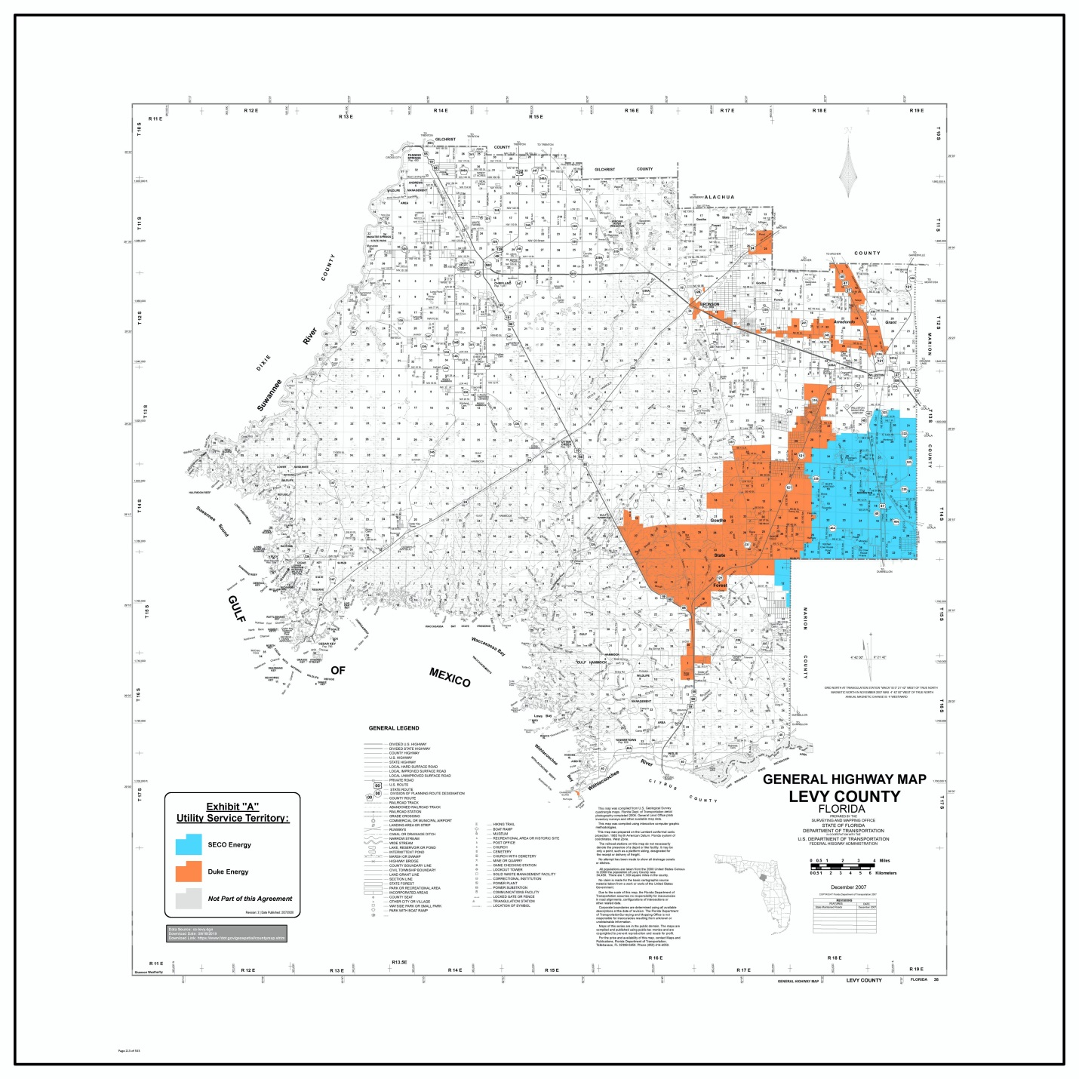

Order No. PSC-09-0276-PAA-EU, issued April 29, 2009, in Docket No. 20080632-EU, In re: Joint petition for approval of amended territorial agreement in Sumter, Lake, Marion, Citrus, and Levy Counties by Sumter Electric Cooperative, Inc. and Progress Energy Florida, Inc.
Utilities Commission of the City of New Smyrna Beach v. Florida Public Service Commission, 469 So. 2d 731 (Fla. 1985).
Consumer Correspondence (Document No. 01969-2020).
Consumer Correspondence (Document No. 03194-2020).

