BEFORE THE FLORIDA PUBLIC SERVICE COMMISSION

In re: Petition for approval of 2020 revisions to underground residential tariffs and for approval of initial commercial differential tariffs, by Gulf Power Company. | DOCKET NO. 20200113-EI  ORDER NO. PSC-2020-0257-TRF-EI  ISSUED: July 24, 2020

The following Commissioners participated in the disposition of this matter:

GARY F. CLARK, Chairman
ART GRAHAM
JULIE I. BROWN
DONALD J. POLMANN
ANDREW GILES FAY

ORDER APPROVING 2020 REVISIONS TO UNDERGROUND RESIDENTIAL
TARIFFS AND INITIAL COMMERCIAL DIFFERENTIAL
TARIFFS FOR GULF POWER COMPANY

BY THE COMMISSION:

Background
On April 1, 2020, Gulf Power Company (Gulf or utility) filed a petition for approval of revisions to its 2020 underground residential distribution (URD) tariffs and associated charges. These tariffs represent the additional costs, if any, Gulf incurs to provide underground service in place of overhead service in new residential subdivisions. Gulf’s current URD charges were approved by Order No. PSC-2019-0448-TRF-EI. The proposed URD tariffs (legislative version) are contained in Attachment A to this Order.
In this same petition, Gulf is also seeking approval of its initial underground commercial differential tariff sheets. The utility stated that the tariffs would apply to requests for underground service facilities made by small commercial/industrial applicants for new service. The proposed underground commercial differential tariffs (legislative version), as approved herein, are contained in Attachment B to this Order.
Gulf waived the 60-day file and suspend provision pursuant to Section 366.06(3), Florida Statutes (F.S.), in an email dated April 7, 2020. During the review of this petition, Commission staff issued one data request, to which responses were received on May 8, 2020. We have jurisdiction over this matter pursuant to Sections 366.03, 366.04, 366.05, and 366.06, F.S.

Decision
Rule 25-6.078, Florida Administrative Code (F.A.C.), specifies investor- owned utilities' (IOU) responsibilities for filing updated URD tariffs. Gulf filed the instant petition pursuant to subsection (3) of the rule, which requires IOUs to file supporting data and analyses for updated URD tariffs if the cost varies from the Commission-approved differential by more than ten percent. On October 15, 2019, pursuant to Rule 25-6.078, F.A.C., Gulf informed us that while it was not finished calculating the avoided storm costs associated with Hurricane Michael, it anticipated filing supporting data and analysis by April 1, 2020 demonstrating a 10 percent low-density differential in URD costs. The proposed URD tariffs, therefore, include Hurricane Michael data in the calculation of the operational cost differential.
The URD tariffs provide charges for underground service in new residential subdivisions and represent the additional costs, if any, the utility incurs to provide underground service in place of overhead service. The cost of standard overhead construction is recovered through base rates from all ratepayers. In lieu of overhead construction, customers have the option of requesting underground facilities. Any additional cost is paid by the customer as contribution-in-aid-of construction. Typically, the URD customer is the developer of a subdivision.
Gulf’s URD charges are based on two standard model subdivisions: a 210-lot low density subdivision and a 176-lot high density subdivision. While actual construction may differ from the model subdivisions, the subdivisions are designed to reflect average overhead and underground design plans.
Table 1 shows the current and proposed URD differentials for the low and high density subdivisions. The charges shown are per-lot charges. While the charges noted in this table represent the utility performing all construction, Gulf’s URD tariffs also provide cost options for a customer who may choose to supply, or install, the primary trench, secondary trench, or duct system.
Table 1
Comparison of URD Differential per Lot
Type of Subdivision | Current URD  Differential | Proposed URD  Differential
Low Density | $568 | $0
High Density | $609 | $0
Source: Commission Order No. PSC-2019-0448-TRF-EI and 2020 Petition.

Labor and Material Costs

The installation costs of both underground and overhead facilities include the labor and material costs to provide primary, secondary, and service distribution lines, as well as transformers. The costs of poles are specific to overhead service, while the costs of trenching and backfilling are specific to underground service. Utilities are required by Rule 25-6.078(5), F.A.C., to use current labor and materials costs in calculating underground and overhead differentials.
Gulf stated in this petition that it has made design modifications for installations in both low and high density subdivisions. The utility explained that these changes were necessary to ensure its designs met the extreme wind loading requirements and the utility’s improved construction standards related to storm hardening. These changes increased certain materials costs, such as poles and transformers.
The assumed contributions of Gulf employee and contractor labor remains the same as in 2019. Gulf employees continue to perform distribution construction activities, while contract labor is utilized to perform distribution overhead construction. Both Gulf and contractor labor rates have increased as specified in their respective contracts. Table 2 below compares total 2019 and 2020 per-lot labor and material costs for the two subdivisions.
Table 2
Labor and Material Costs per Lot
 | 2019 Costs | 2020 Costs | Difference
Low Density
Underground Labor/Material Costs | $2,749 | $3,080 | $331
Overhead Labor/Material Costs | $1,972 | $2,521 | $549
Per lot Differential | $777 | $560 | $218
High Density
Underground Labor/Material Costs | $2,198 | $2,421 | $223
Overhead Labor/Material Costs | $1,528 | $2,075 | $547
Per lot Differential | $670 | $346 | $324
Source: Commission Order No. PSC-2019-0448-TRF-EI and 2020 Petition.

Operational Costs

Rule 25-6.078(4), F.A.C., requires that the differences in net present value (NPV) of operational costs between overhead and underground systems, including average historical storm restoration costs over the life of the facilities, be included in the URD charge. The inclusion of the operational cost is intended to capture longer term costs and benefits of undergrounding.
Operational costs include operations and maintenance costs and capital costs and represent the cost differential between maintaining and operating an underground versus an overhead system over the life of the facilities. The inclusion of the storm restoration cost in the URD differential lowers the differential, since an underground distribution system generally incurs less damage than an overhead system as a result of a storm and, therefore, less restoration costs when compared to an overhead system.
The utility used a 5-year average of historical operational costs (2015-2019) for its calculations in this docket. The methodology used by Gulf for calculating the NPV of operational costs was approved by Order No. PSC-12-0531- TRF-EI. Gulf’s NPV calculation used a 32-year life of the facilities and a 7.35 percent discount rate. Operational costs may vary in amount for different IOUs as a result of differences in size of service territory, miles of coastline, regions subject to extreme winds, age of the distribution system, or construction standards.
Prior to adding the year 2019 to its operational cost calculation cycle, the utility did not have a significant amount of avoided storm operational costs in its URD calculation. In 2019, the utility incorporated the impact of Hurricane Michael in its avoided storm cost calculations. In response to staff’s data request, Gulf states that its overhead storm restoration costs related to Hurricane Michael were approximately $342 million, compared to $38 million in underground costs. The incorporation of these costs created a significant shift in the operational cost offset. The proposed differential is $0 when the calculation results in a negative number.
Table 3 presents the pre-operational, non-storm operational, and the avoided storm restoration cost differentials between overhead and underground systems.
Table 3
NPV of Operational Costs Differential per Lot
Type of Subdivision | Pre-Operational  (A) | Non-Storm Operational Costs  (B) | Avoided Storm Costs  (C) | Proposed URD Differentials  (A)+(B)+(C)
Low Density | $560 | $816 | ($9,480) | $0
High Density | $346 | $599 | ($9,376) | $0
Source: 2020 Petition.

Revised Underground Residential Distribution Tariffs

In this petition, Gulf has proposed to restructure certain language in its URD tariffs. In its response to the data request, the utility stated that the modified language offers a more simplified cost structure which should allow customers to better gauge the total costs for installing underground facilities. Additionally, the new language allows the customer to choose either credits per lot or per distance, which should provide flexibility in the amount of work a customer is able to contribute in undergrounding their facilities. Overall, the utility believes the changes will encourage customers to install new underground facilities. We find that the changes are clear and the restructuring maintains the intent of the tariffs. We also note that the proposed tariff language is similar to Florida Power & Light Company’s current Commission-approved URD tariffs.

Proposed Underground Commercial Differential Tariffs

Along with its revised URD tariffs, Gulf is requesting approval of its initial underground commercial differential (UCD) tariffs. These tariffs would apply to requests for underground service facilities made by small commercial/industrial applicants for new service. UCD tariffs are not required by Rule 25-6.078, F.A.C., and as such, are not required to use the operational or avoided storm cost methodology in calculating the overhead/underground cost differentials. Gulf stated in its petition that while it considered the effects of overhead hardening in its UCD calculation, the operational cost structure used in its URD tariffs is not directly transferable to its UCD calculation approach. Gulf stated that its proposed UCD tariff charges are tailored to specific equipment and materials that are utilized to provide underground service to a single or limited number of commercial buildings. The utility stated that commercial facilities can vary widely and differ between customers. As such, the utility did not apply the operational cost differential to UCD tariffs; rather, the tariffs provide specific labor and material cost differential for differing construction options.
We have reviewed the proposed initial UCD tariffs and determined that the utility provided appropriate support for the material and labor costs associated with the differing commercial overhead and underground installations. Gulf stated in its petition that the cost estimates were based on standard company design criteria and system-wide costs, as of the end of 2019. We find that the UCD tariffs are appropriate and provide additional clarity for commercial customers. As with the revised URD tariffs, we recognize that Gulf’s UCD tariffs are similarly structured to those approved for Florida Power & Light Company.

Conclusion

We have reviewed Gulf’s proposed URD and UCD tariffs and associated charges, its accompanying work papers, and responses to staff’s data request, and find that the proposed URD and UCD tariffs and associated charges are reasonable. We approve Gulf’s proposed URD and UCD tariffs and associated charges, as shown in Attachments A and B, effective August 6, 2020.
Based on the foregoing, it is

ORDERED by the Florida Public Service Commission that Gulf Power Company’s revised URD tariffs as shown in Attachment A are approved effective August 6, 2020. It is further

ORDERED that the utility’s proposed UCD tariffs as shown in Attachment B are approved effective August 6, 2020. It is further

ORDERED that if a protest is filed within 21 days of issuance of the Order, the tariff shall remain in effect with any charges held subject to refund pending resolution of the protest. It is further

ORDERED that if no timely protest is filed, this docket shall be closed upon the issuance of a Consummating Order.

By ORDER of the Florida Public Service Commission this 24th day of July, 2020.

/s/ Adam J. Teitzman
ADAM J. TEITZMAN
Commission Clerk
Florida Public Service Commission
2540 Shumard Oak Boulevard
Tallahassee, Florida 32399
(850) 413-6770
www.floridapsc.com

Copies furnished: A copy of this document is provided to the parties of record at the time of issuance and, if applicable, interested persons.

SPS

NOTICE OF FURTHER PROCEEDINGS

The Florida Public Service Commission is required by Section 120.569(1), Florida Statutes, to notify parties of any administrative hearing or judicial review of Commission orders that is available under Sections 120.57 or 120.68, Florida Statutes, as well as the procedures and time limits that apply. This notice should not be construed to mean all requests for an administrative hearing or judicial review will be granted or result in the relief sought.

Mediation may be available on a case-by-case basis. If mediation is conducted, it does not affect a substantially interested person's right to a hearing.

The Commission's decision on this tariff is interim in nature and will become final, unless a person whose substantial interests are affected by the proposed action files a petition for a formal proceeding, in the form provided by Rule 28-106.201, Florida Administrative Code. This petition must be received by the Office of Commission Clerk, 2540 Shumard Oak Boulevard, Tallahassee, Florida 32399-0850, by the close of business on August 14, 2020.

In the absence of such a petition, this Order shall become final and effective upon the issuance of a Consummating Order.

Any objection or protest filed in this docket before the issuance date of this order is considered abandoned unless it satisfies the foregoing conditions and is renewed within the specified protest period.

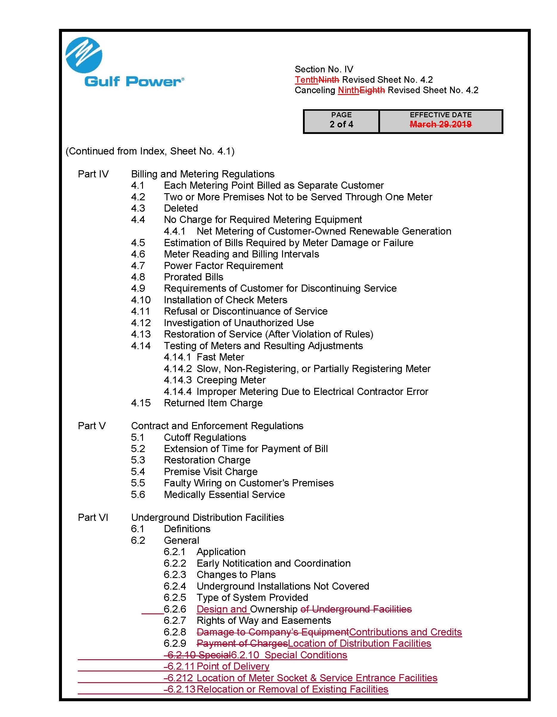

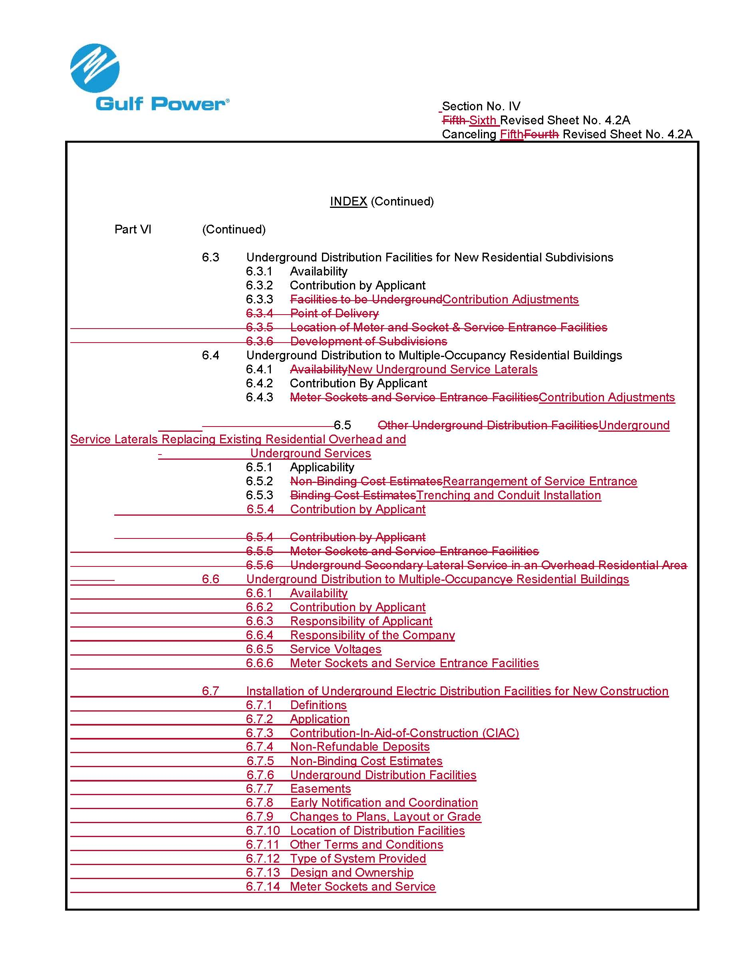

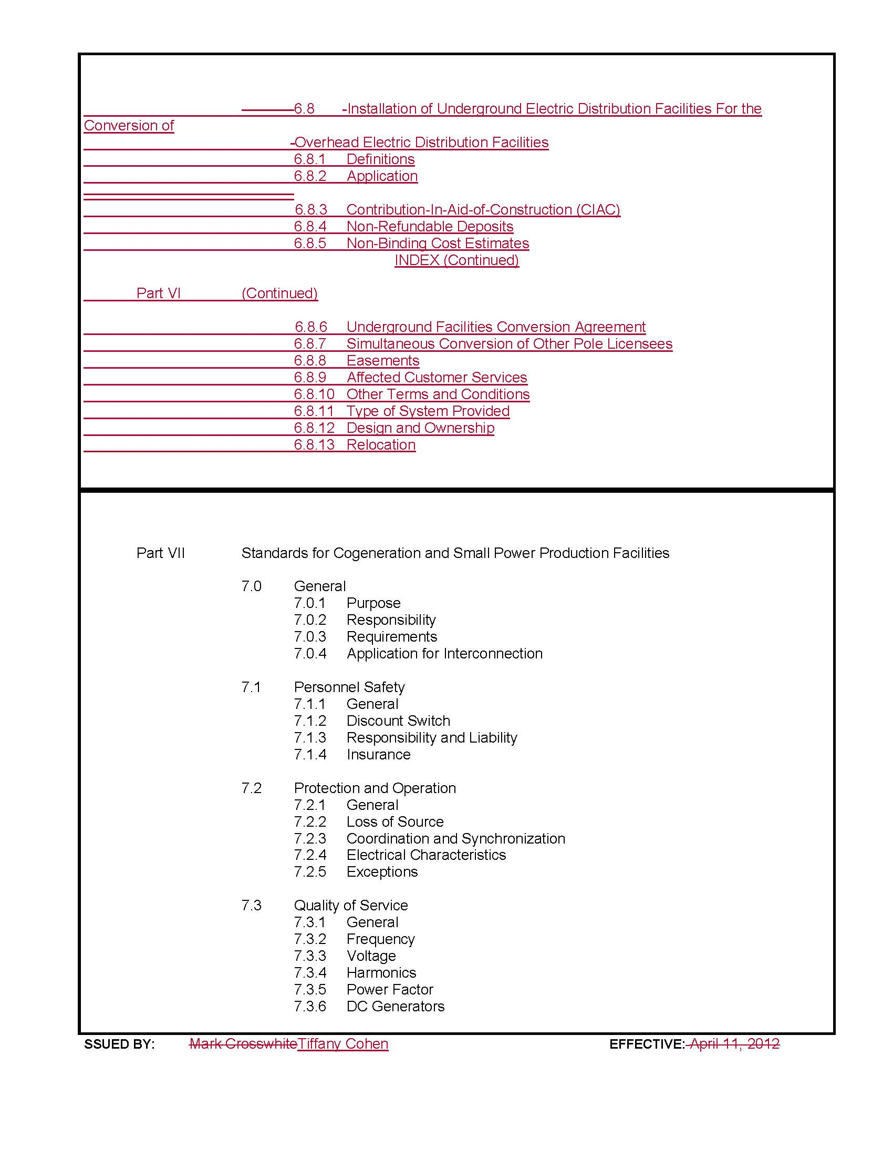

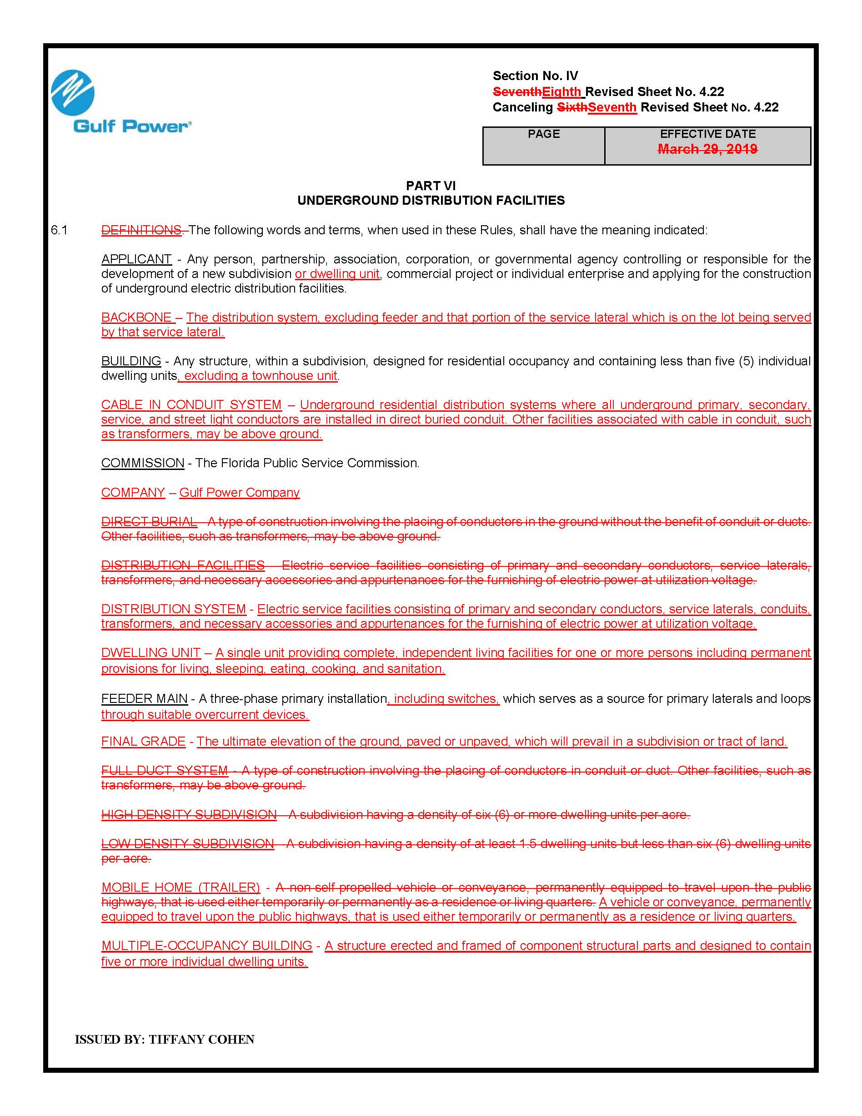

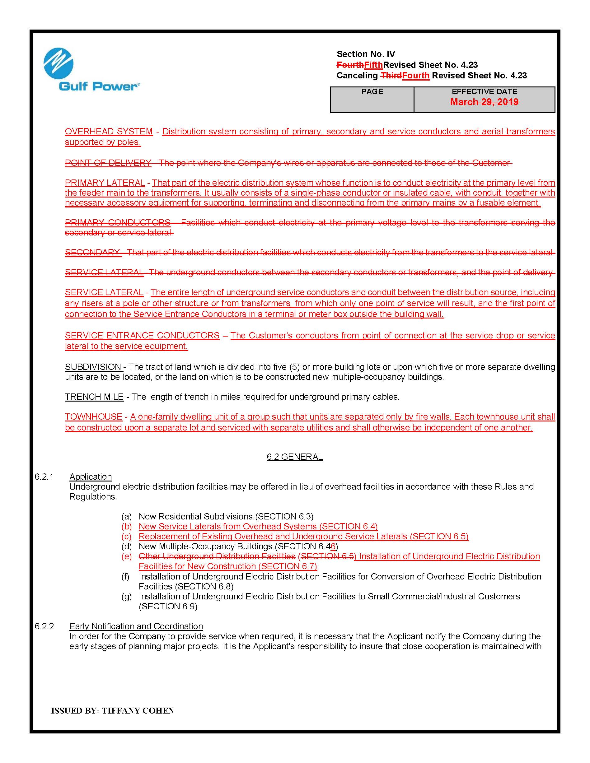

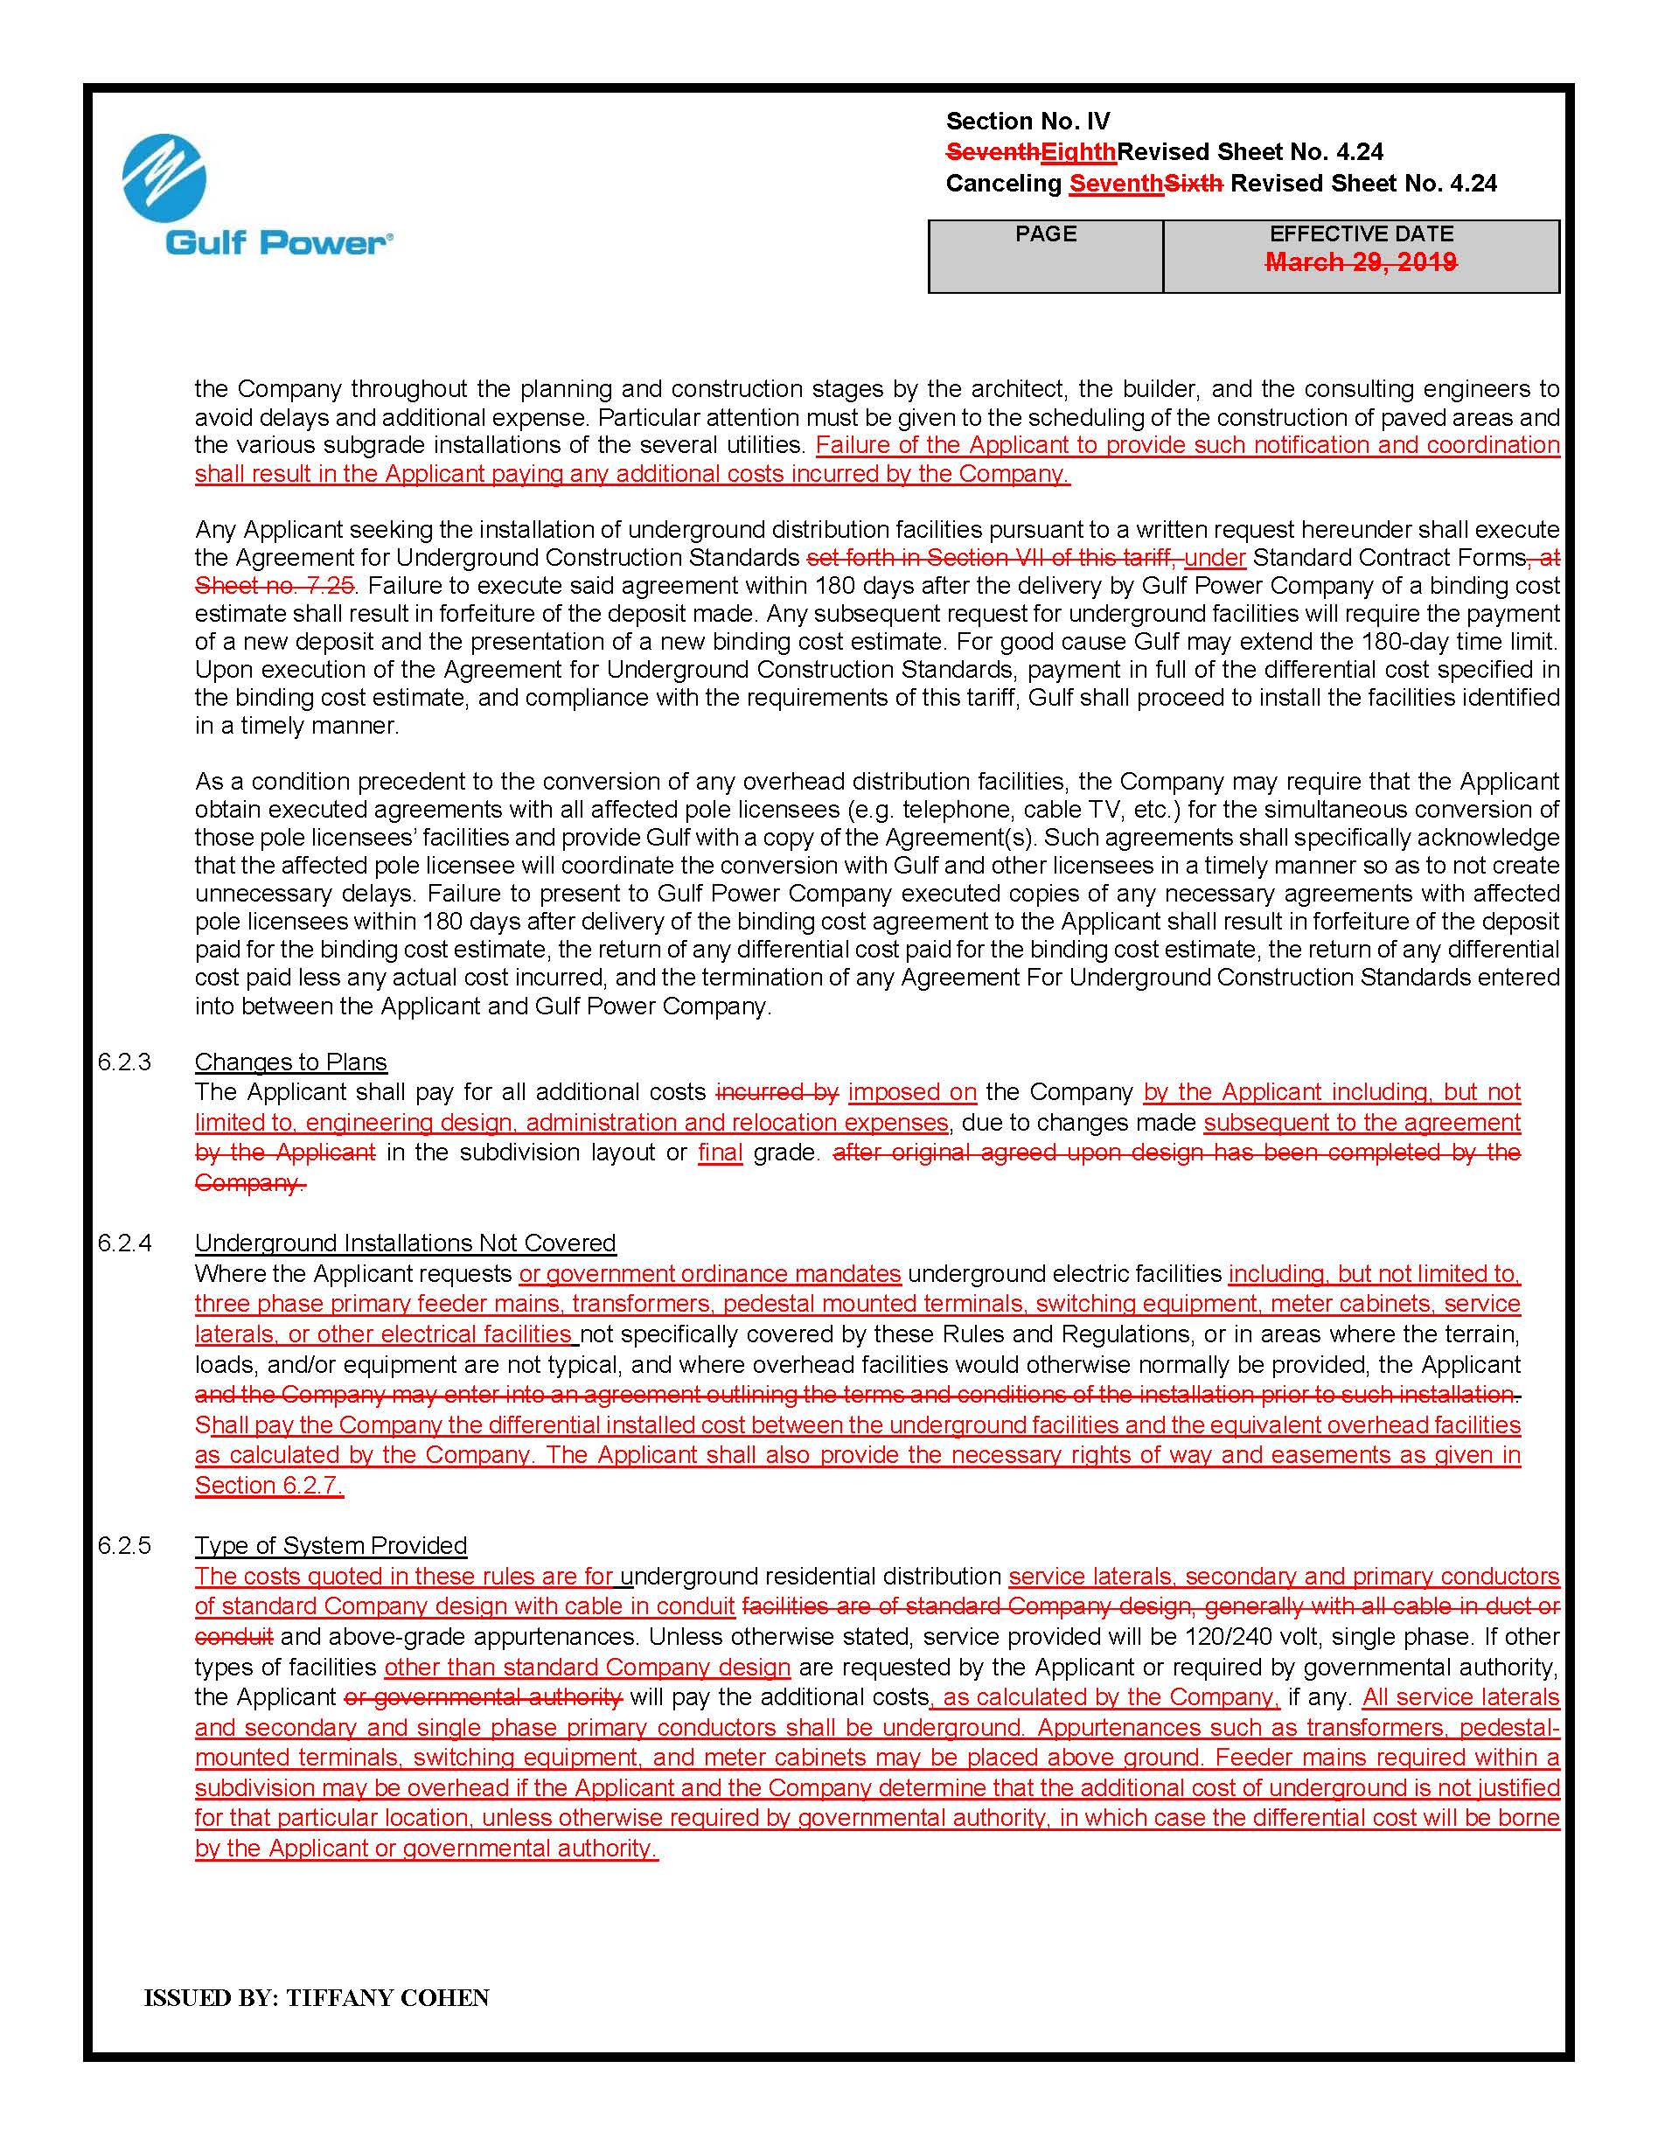

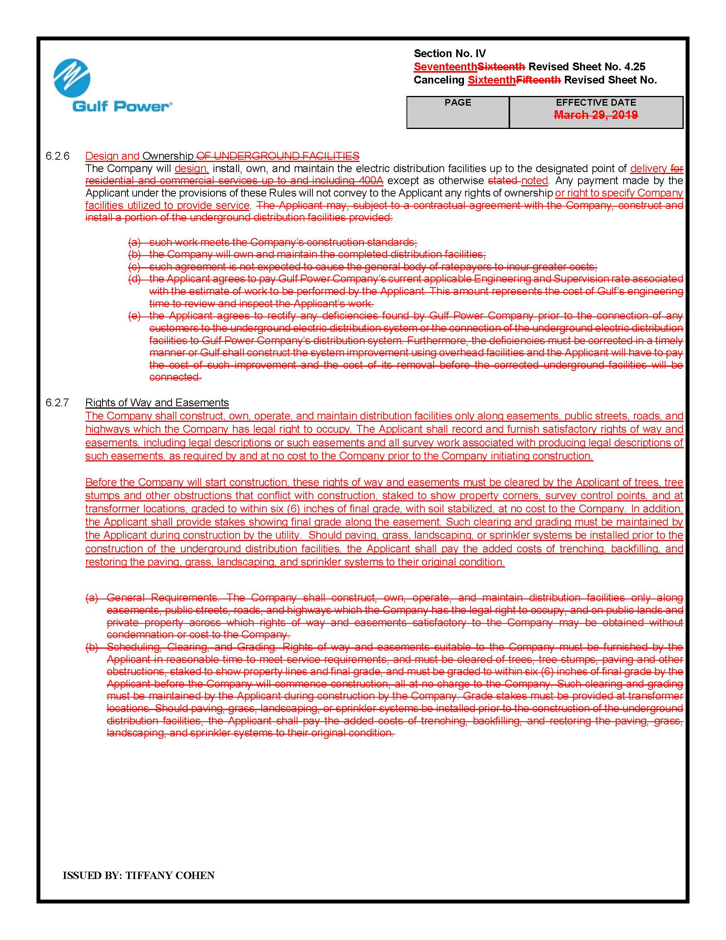

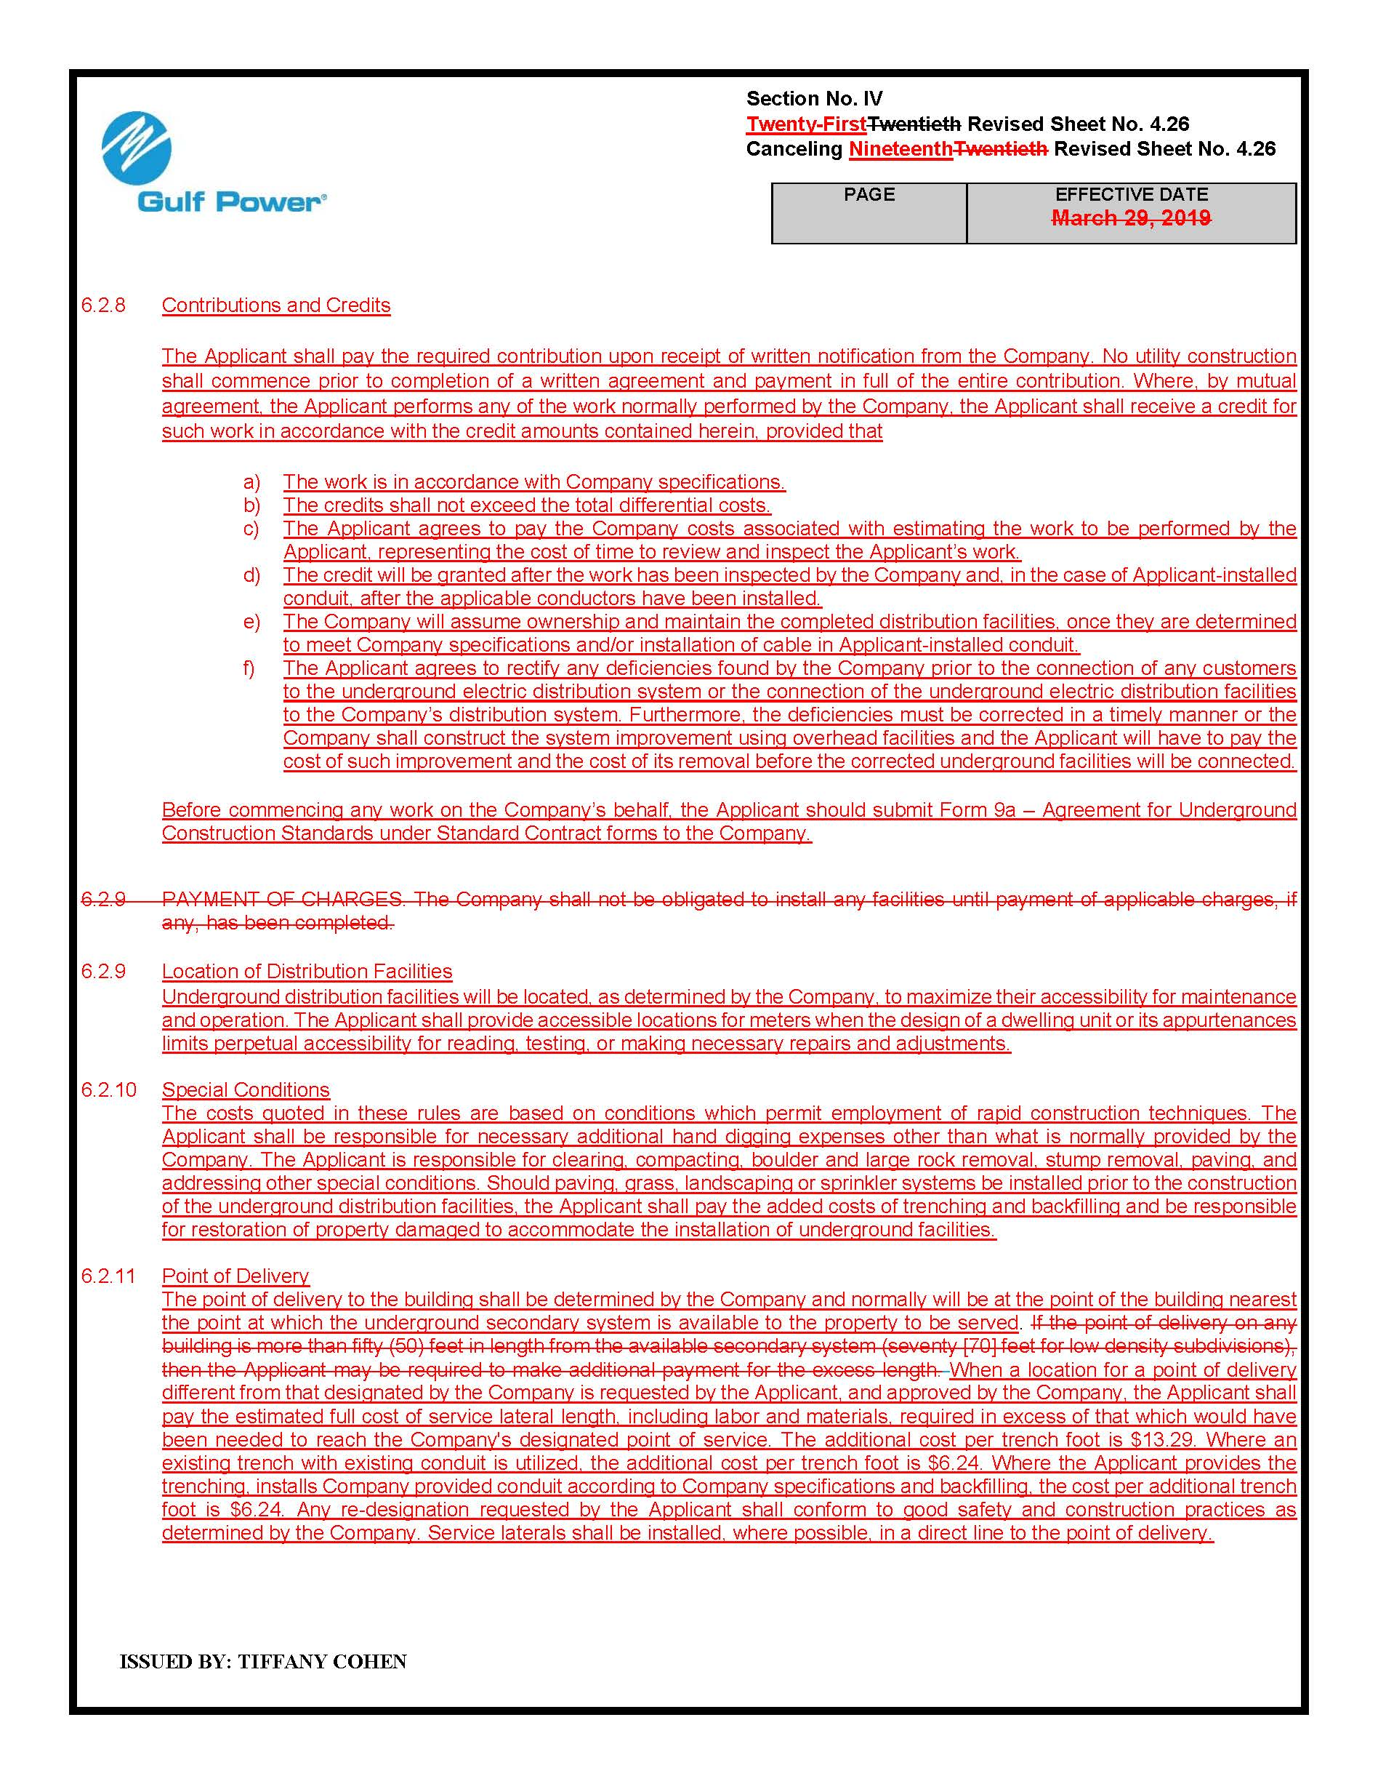

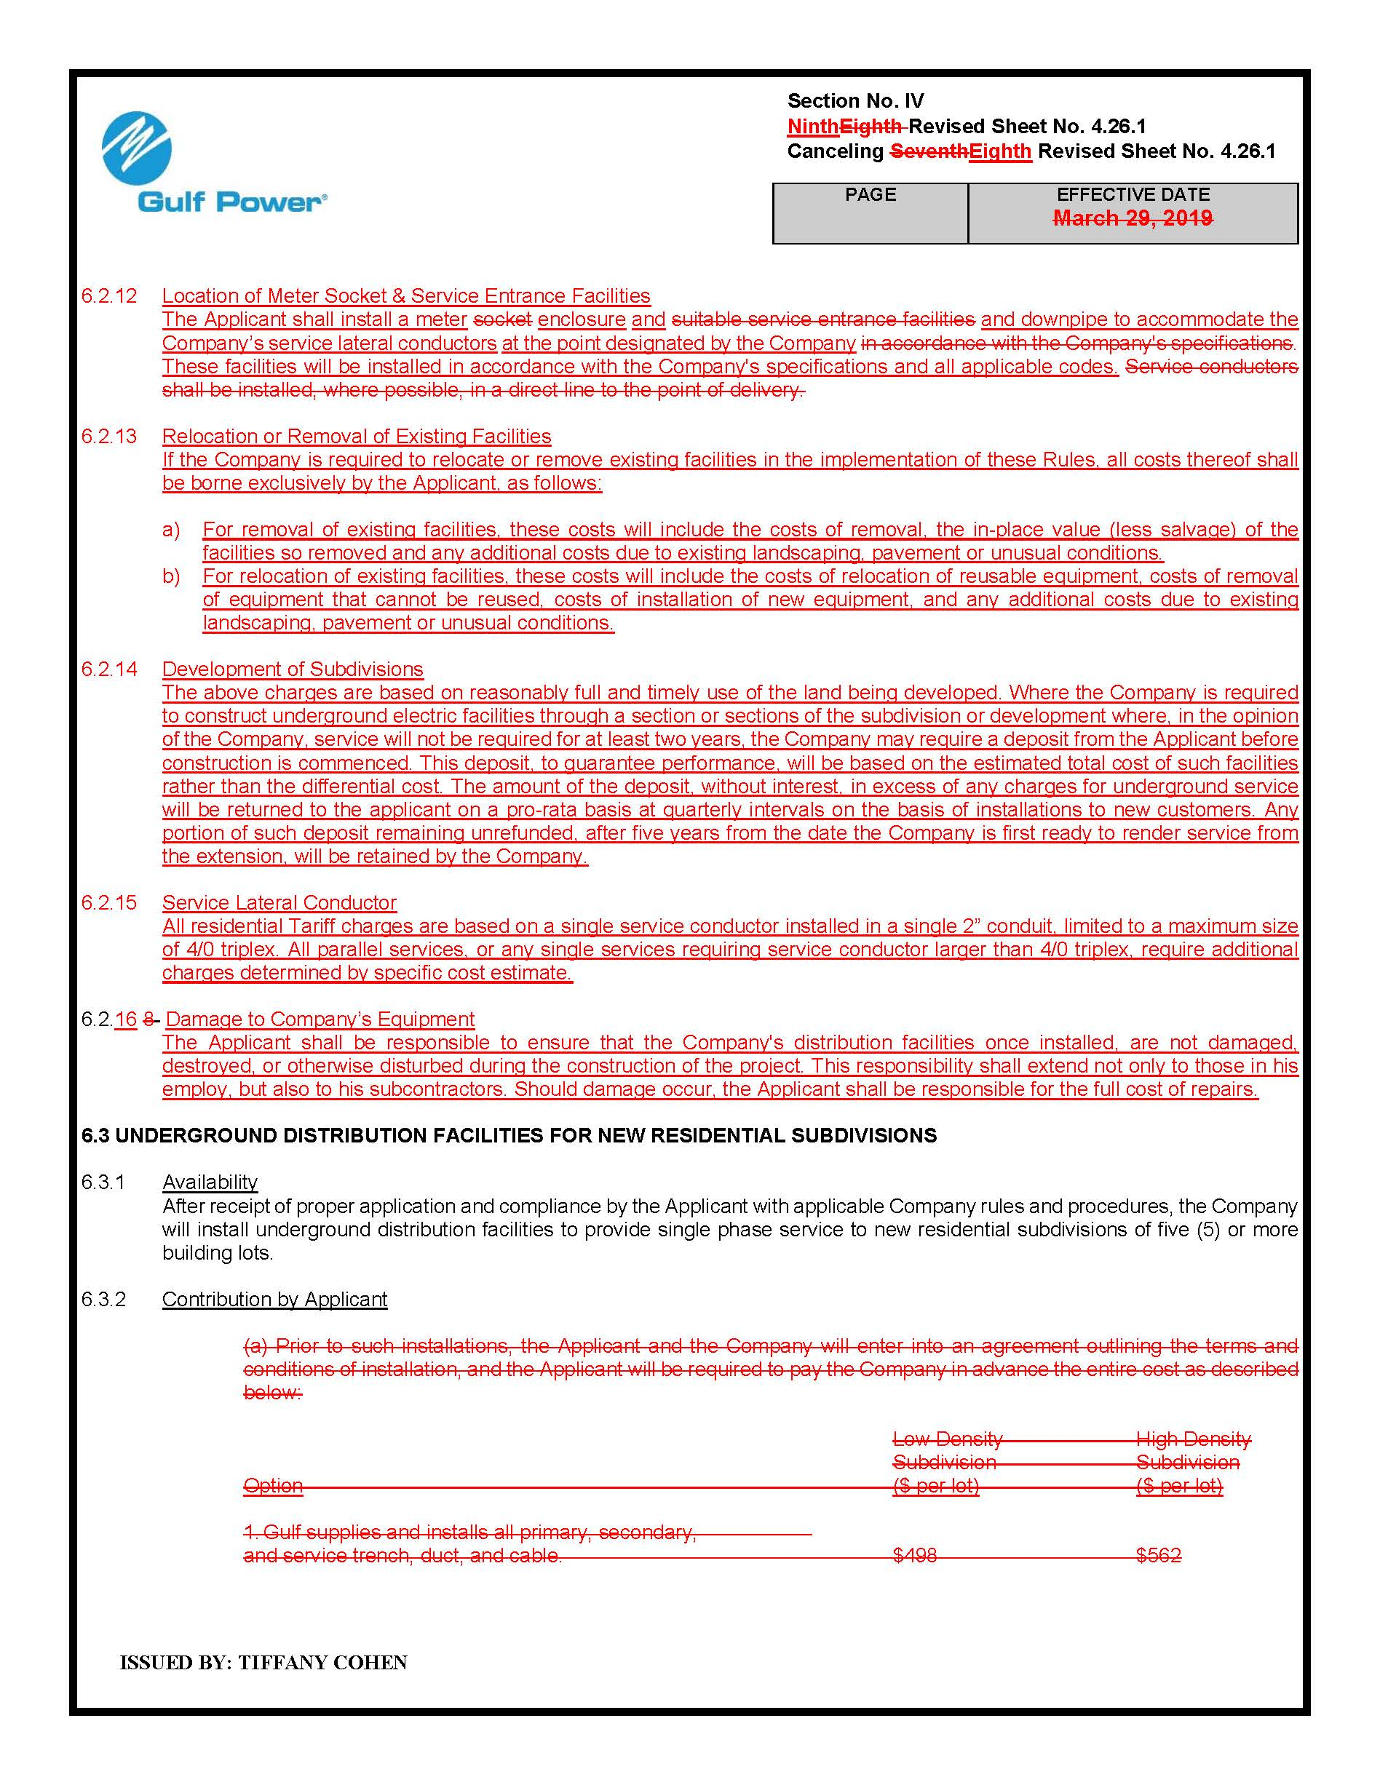

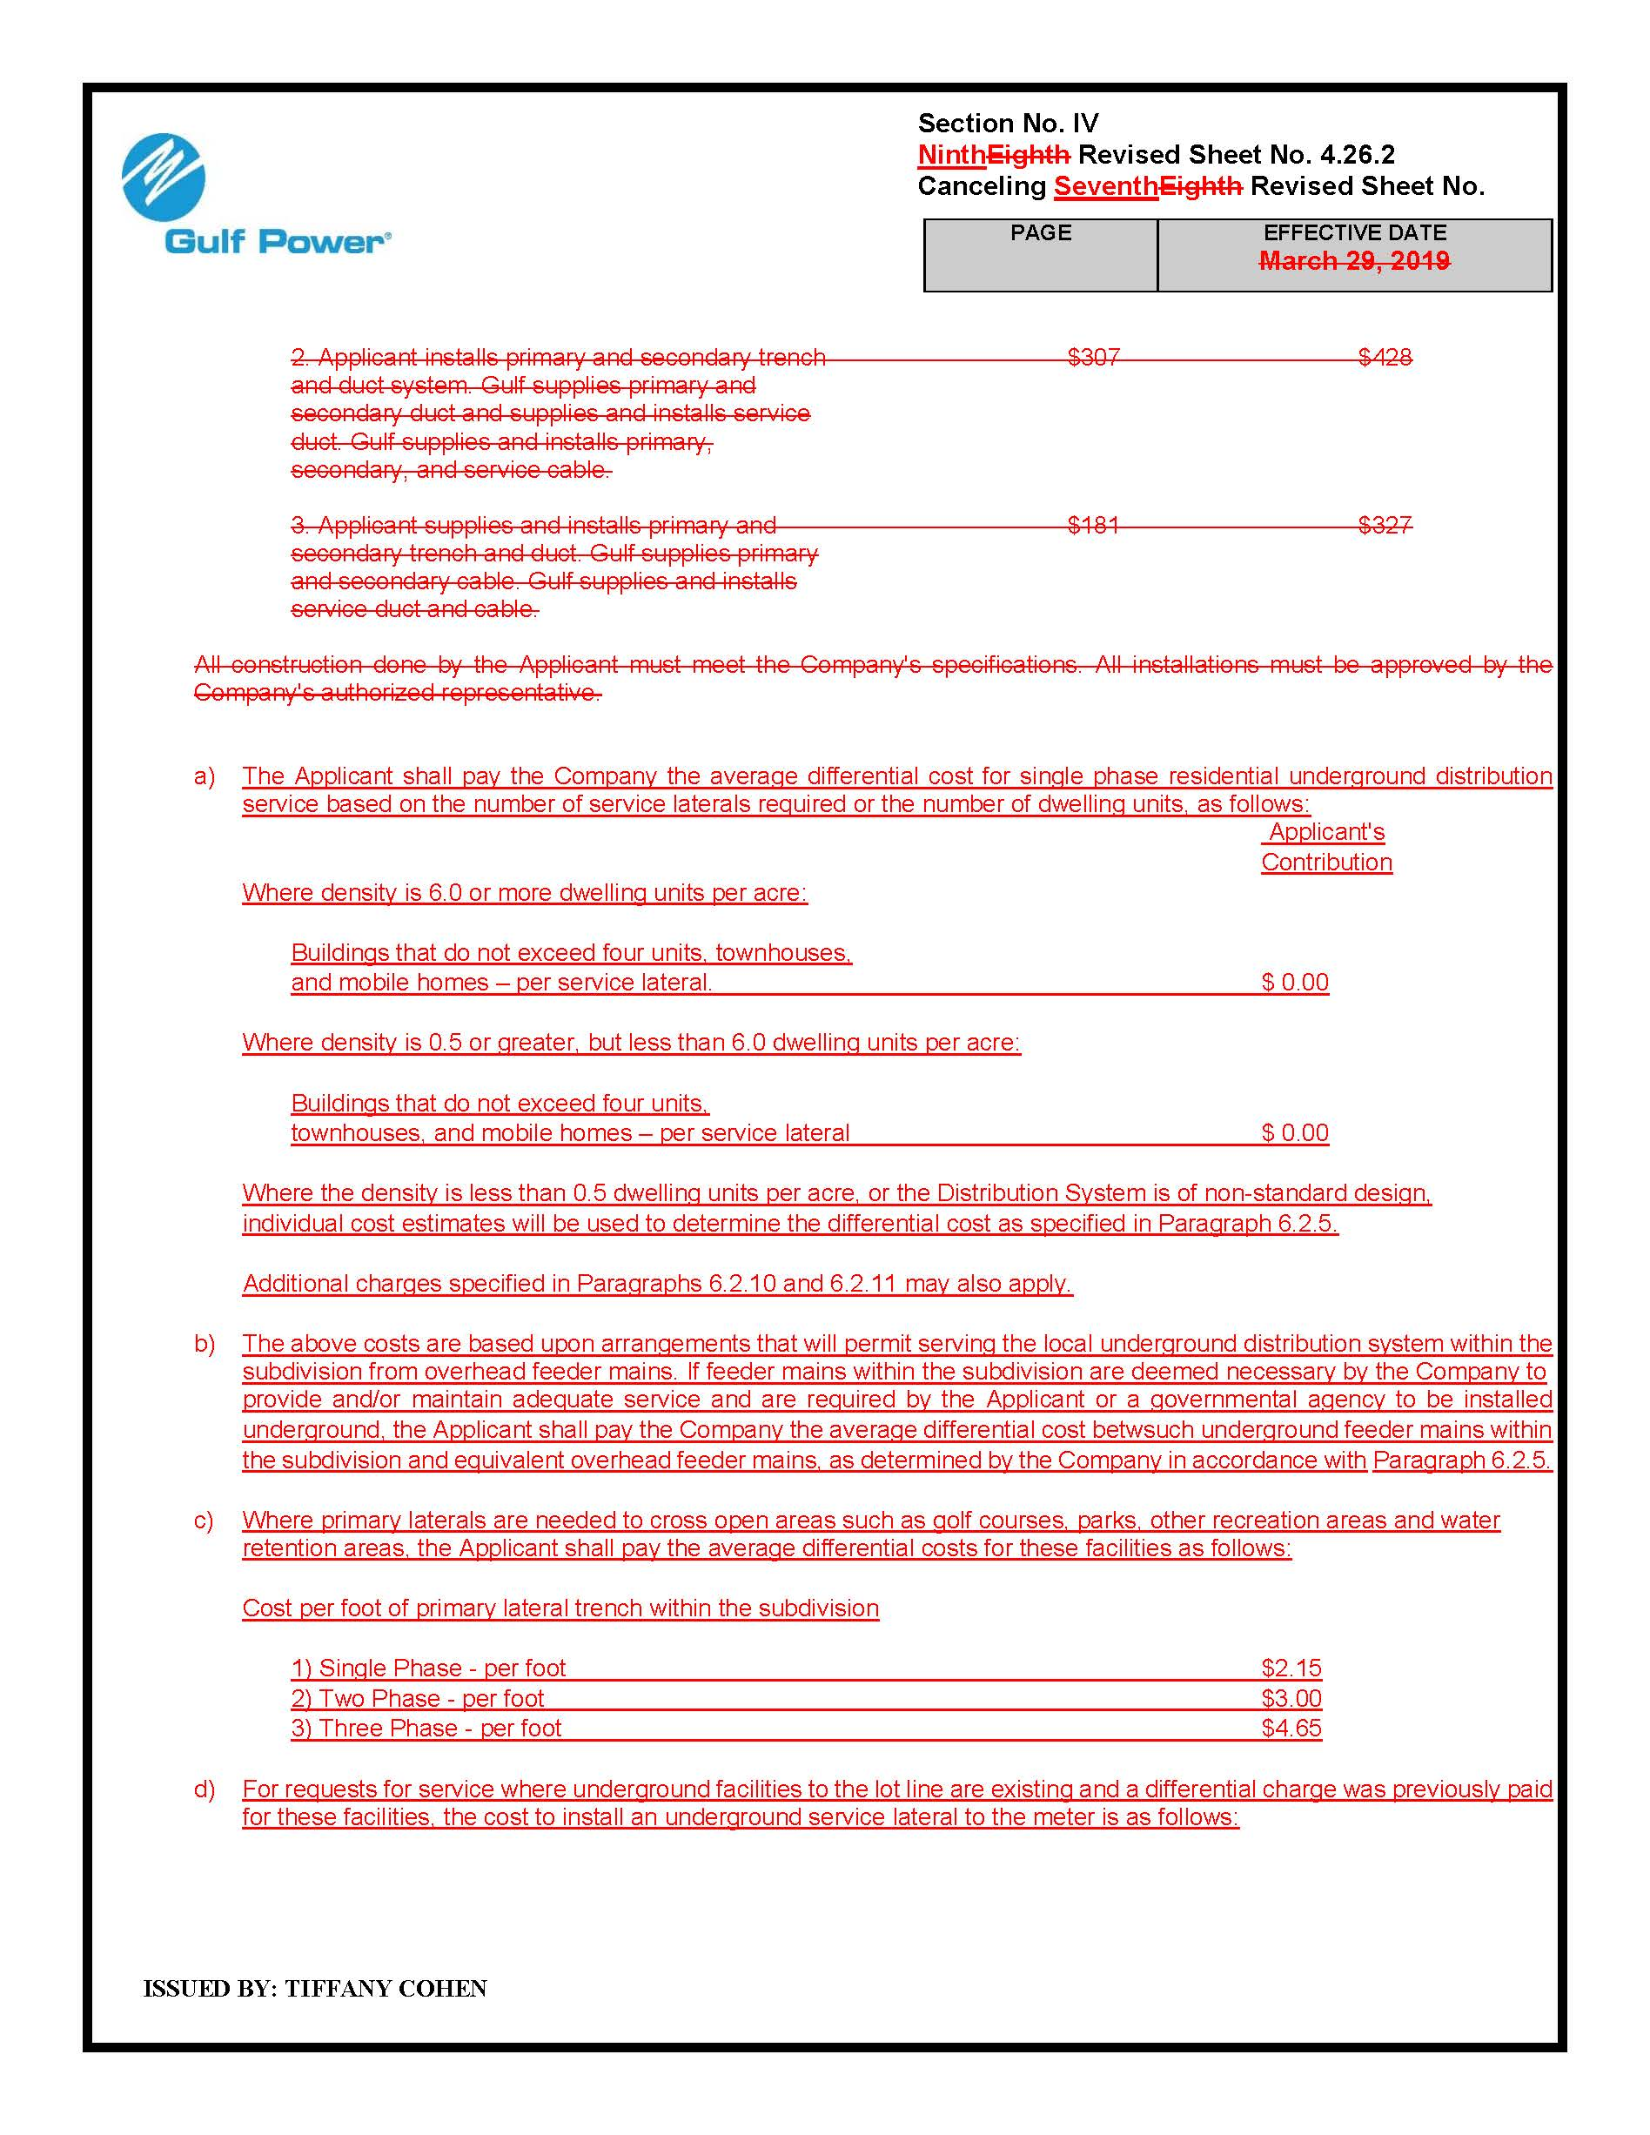

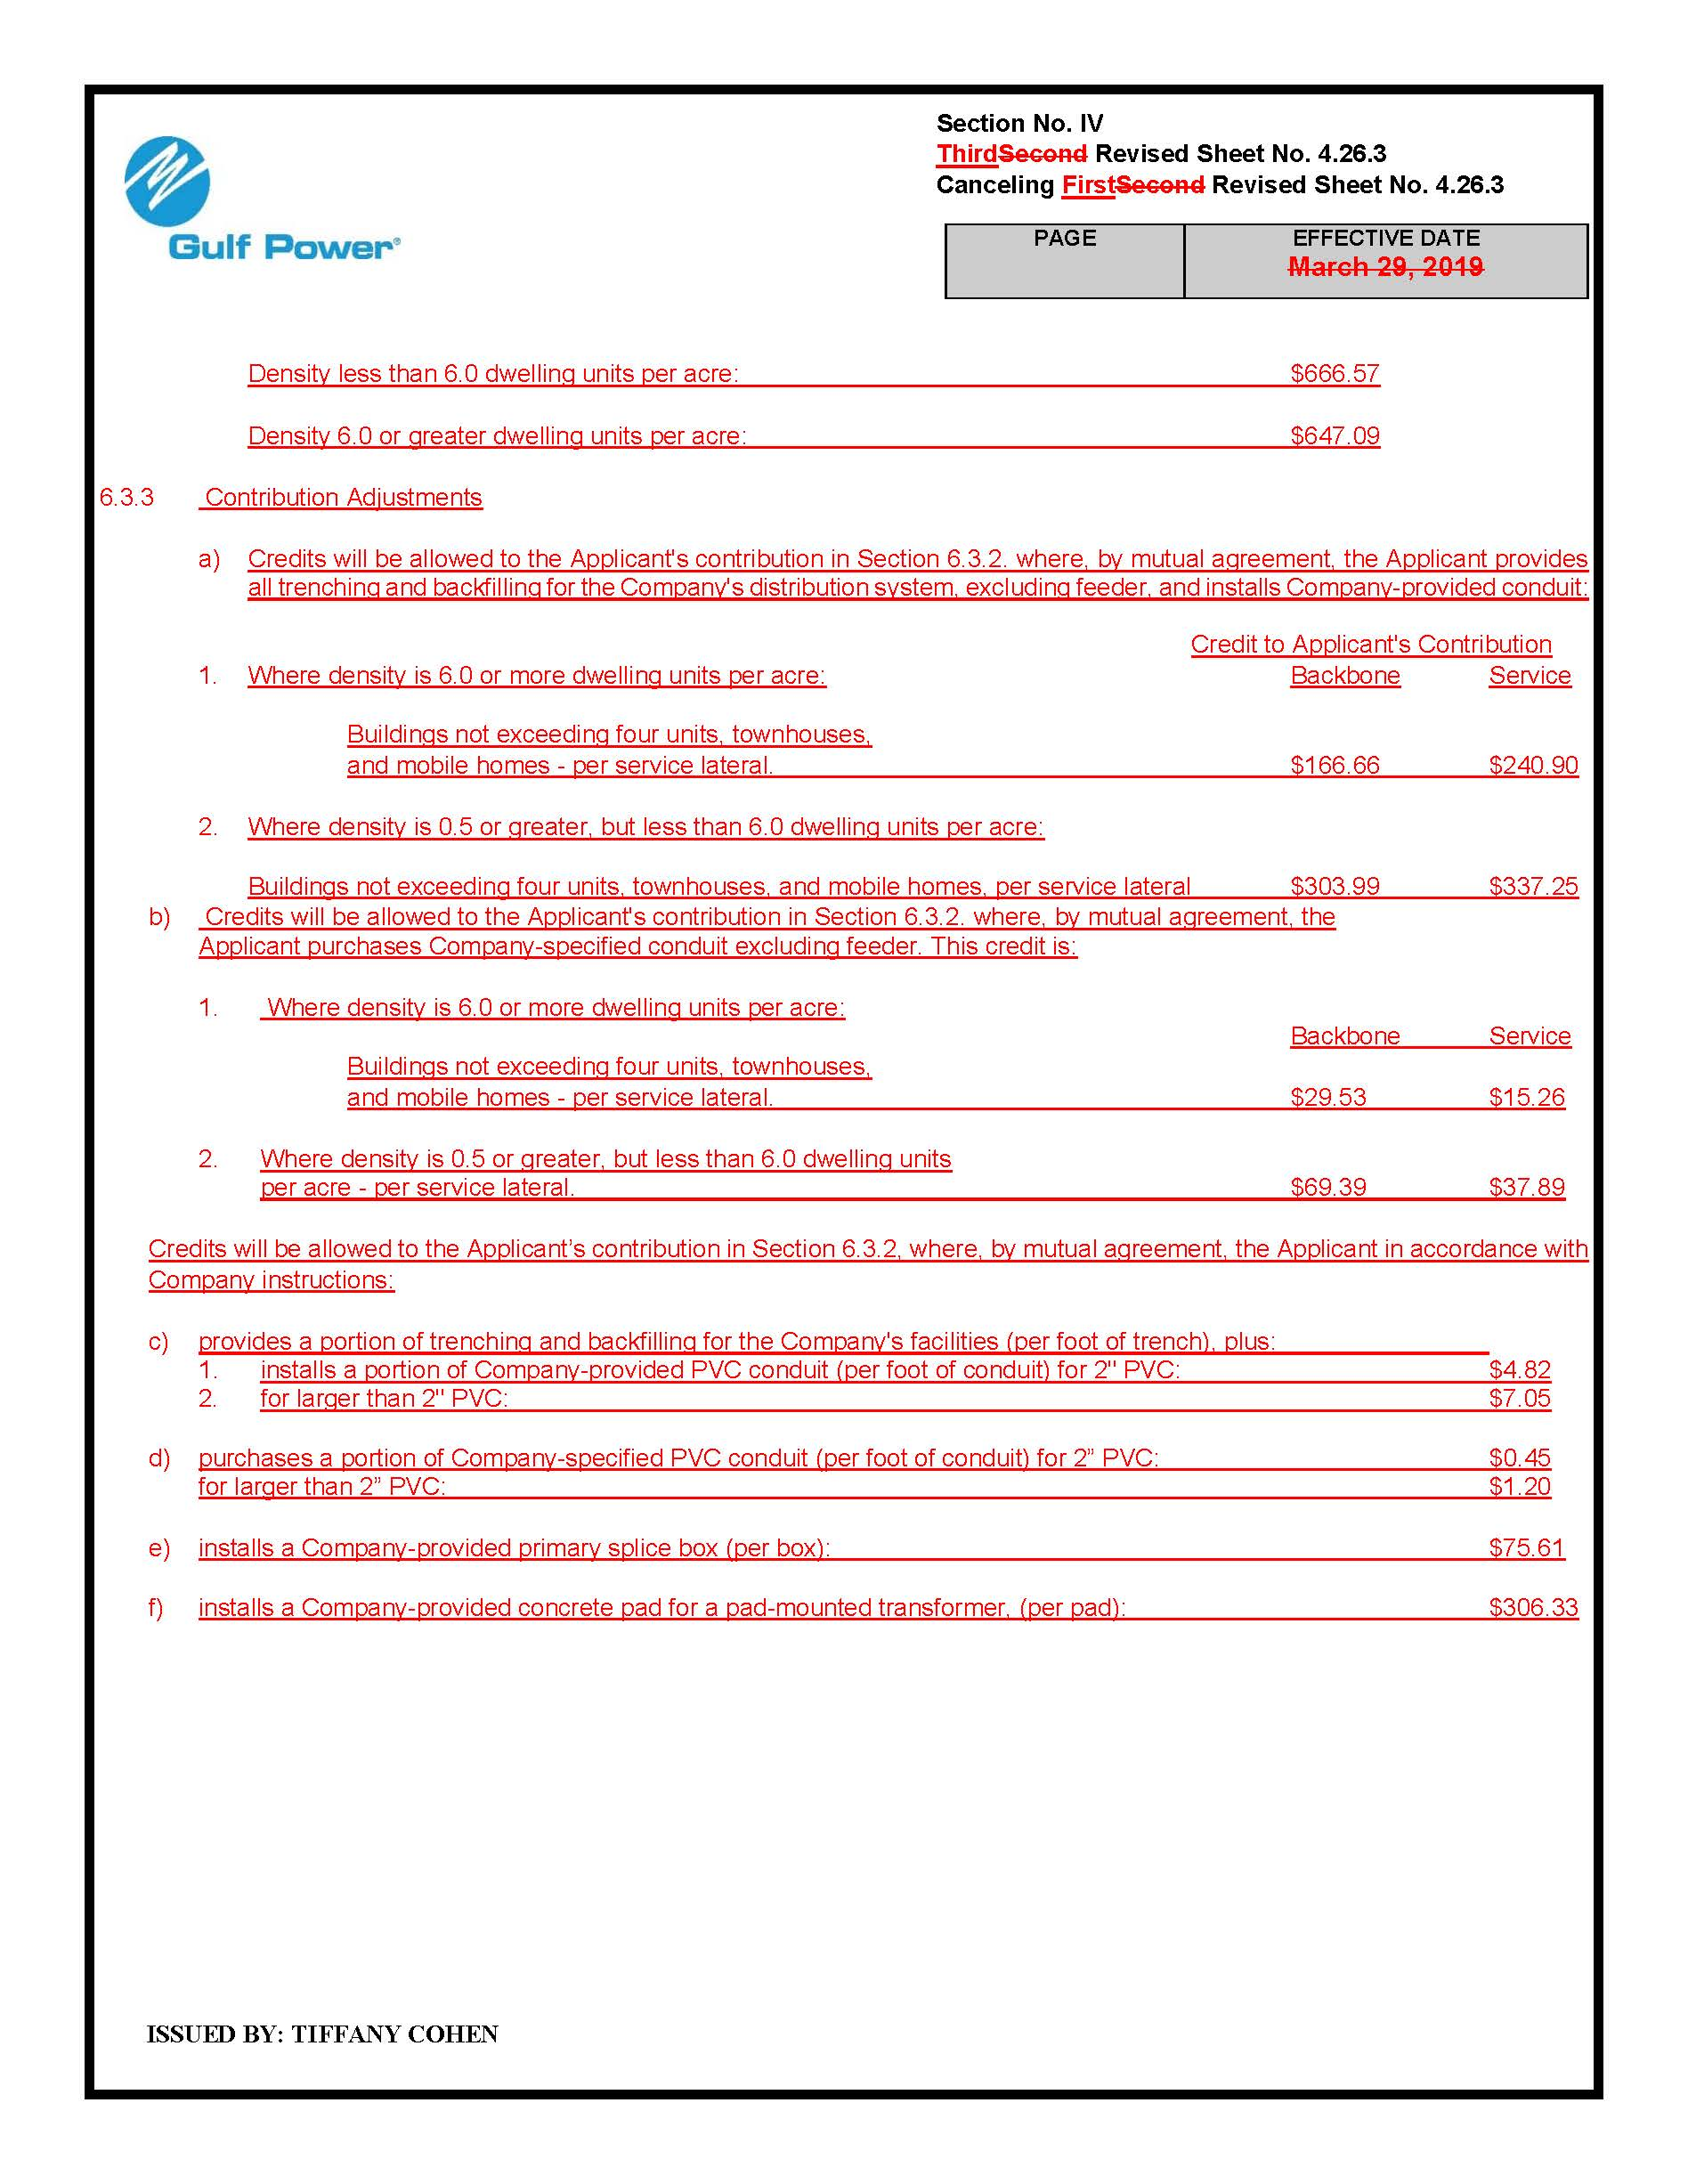

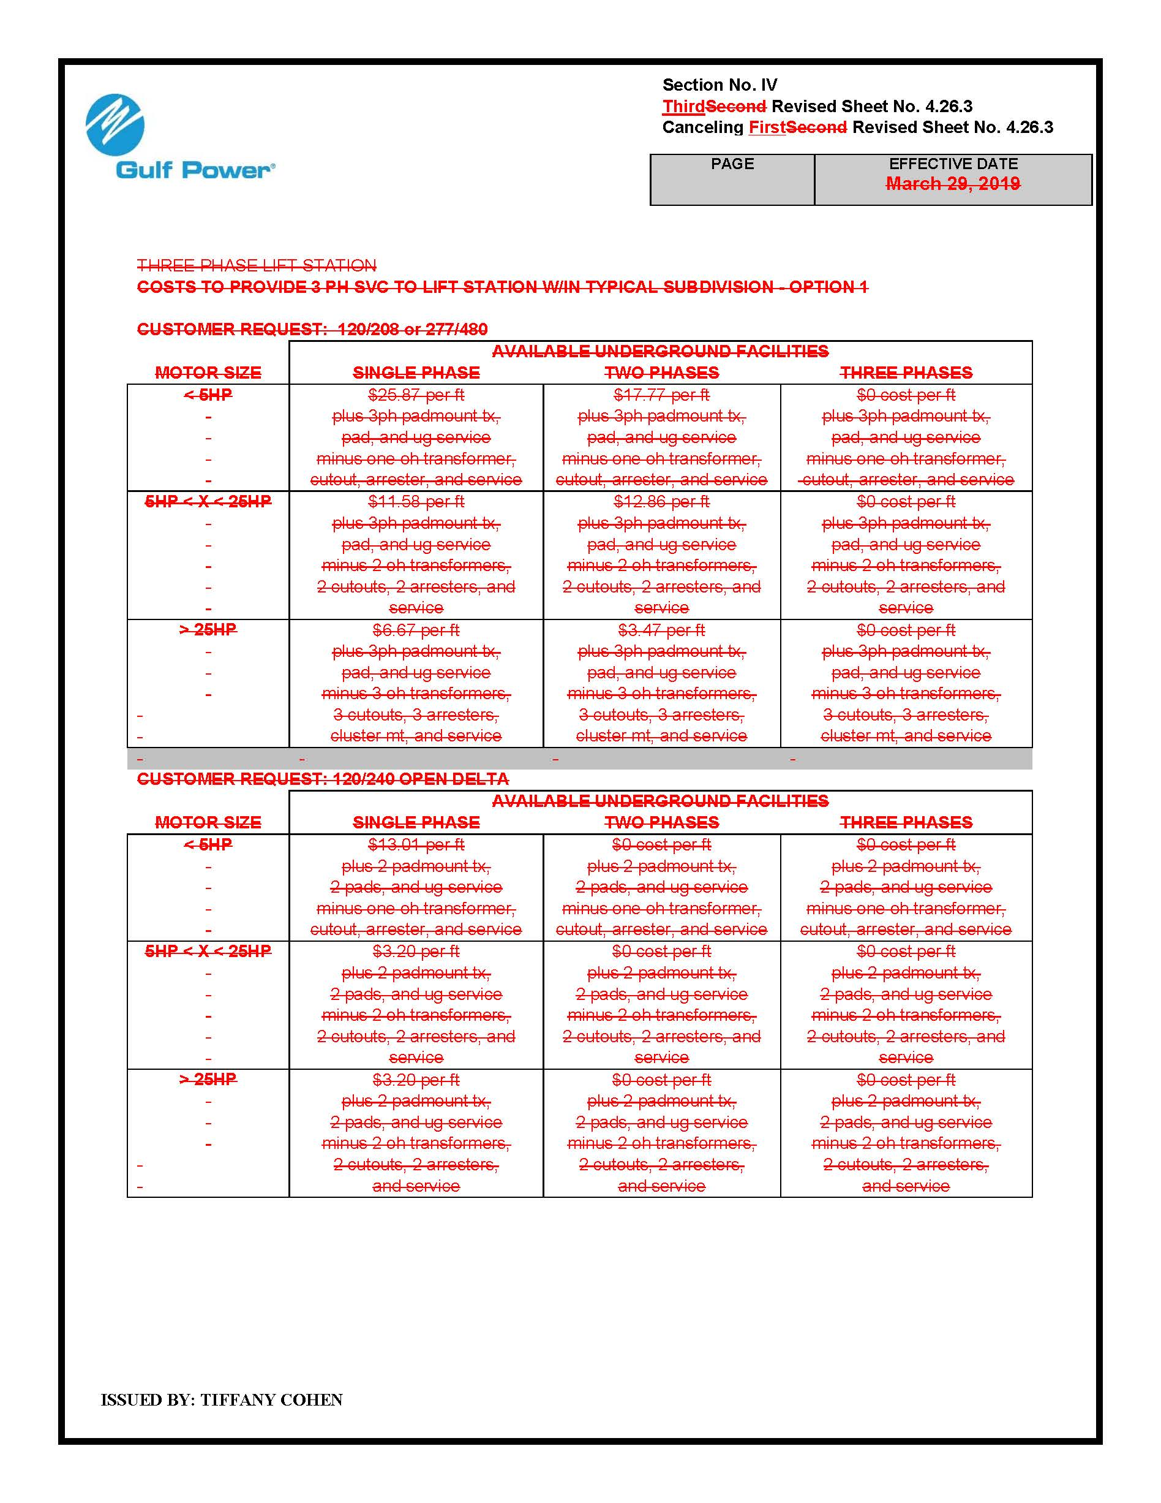

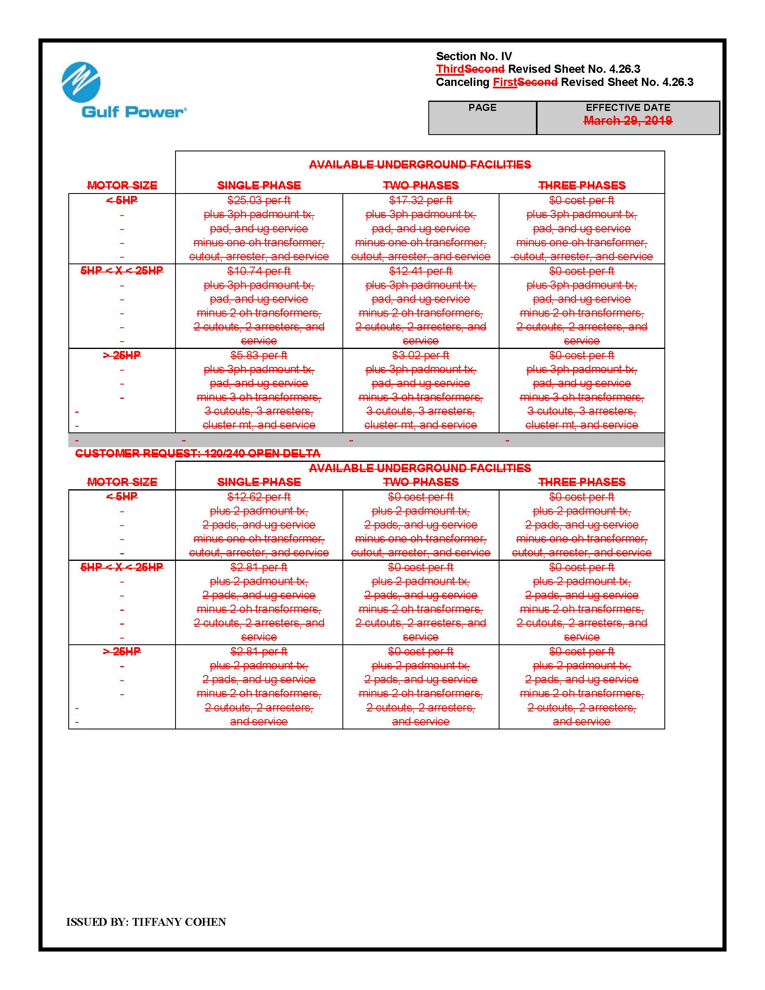

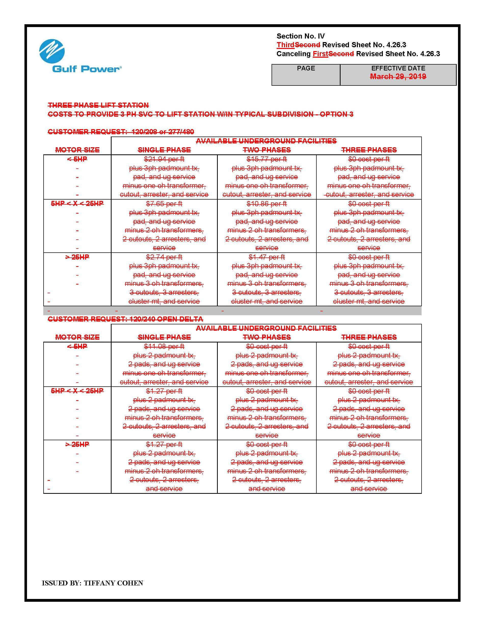

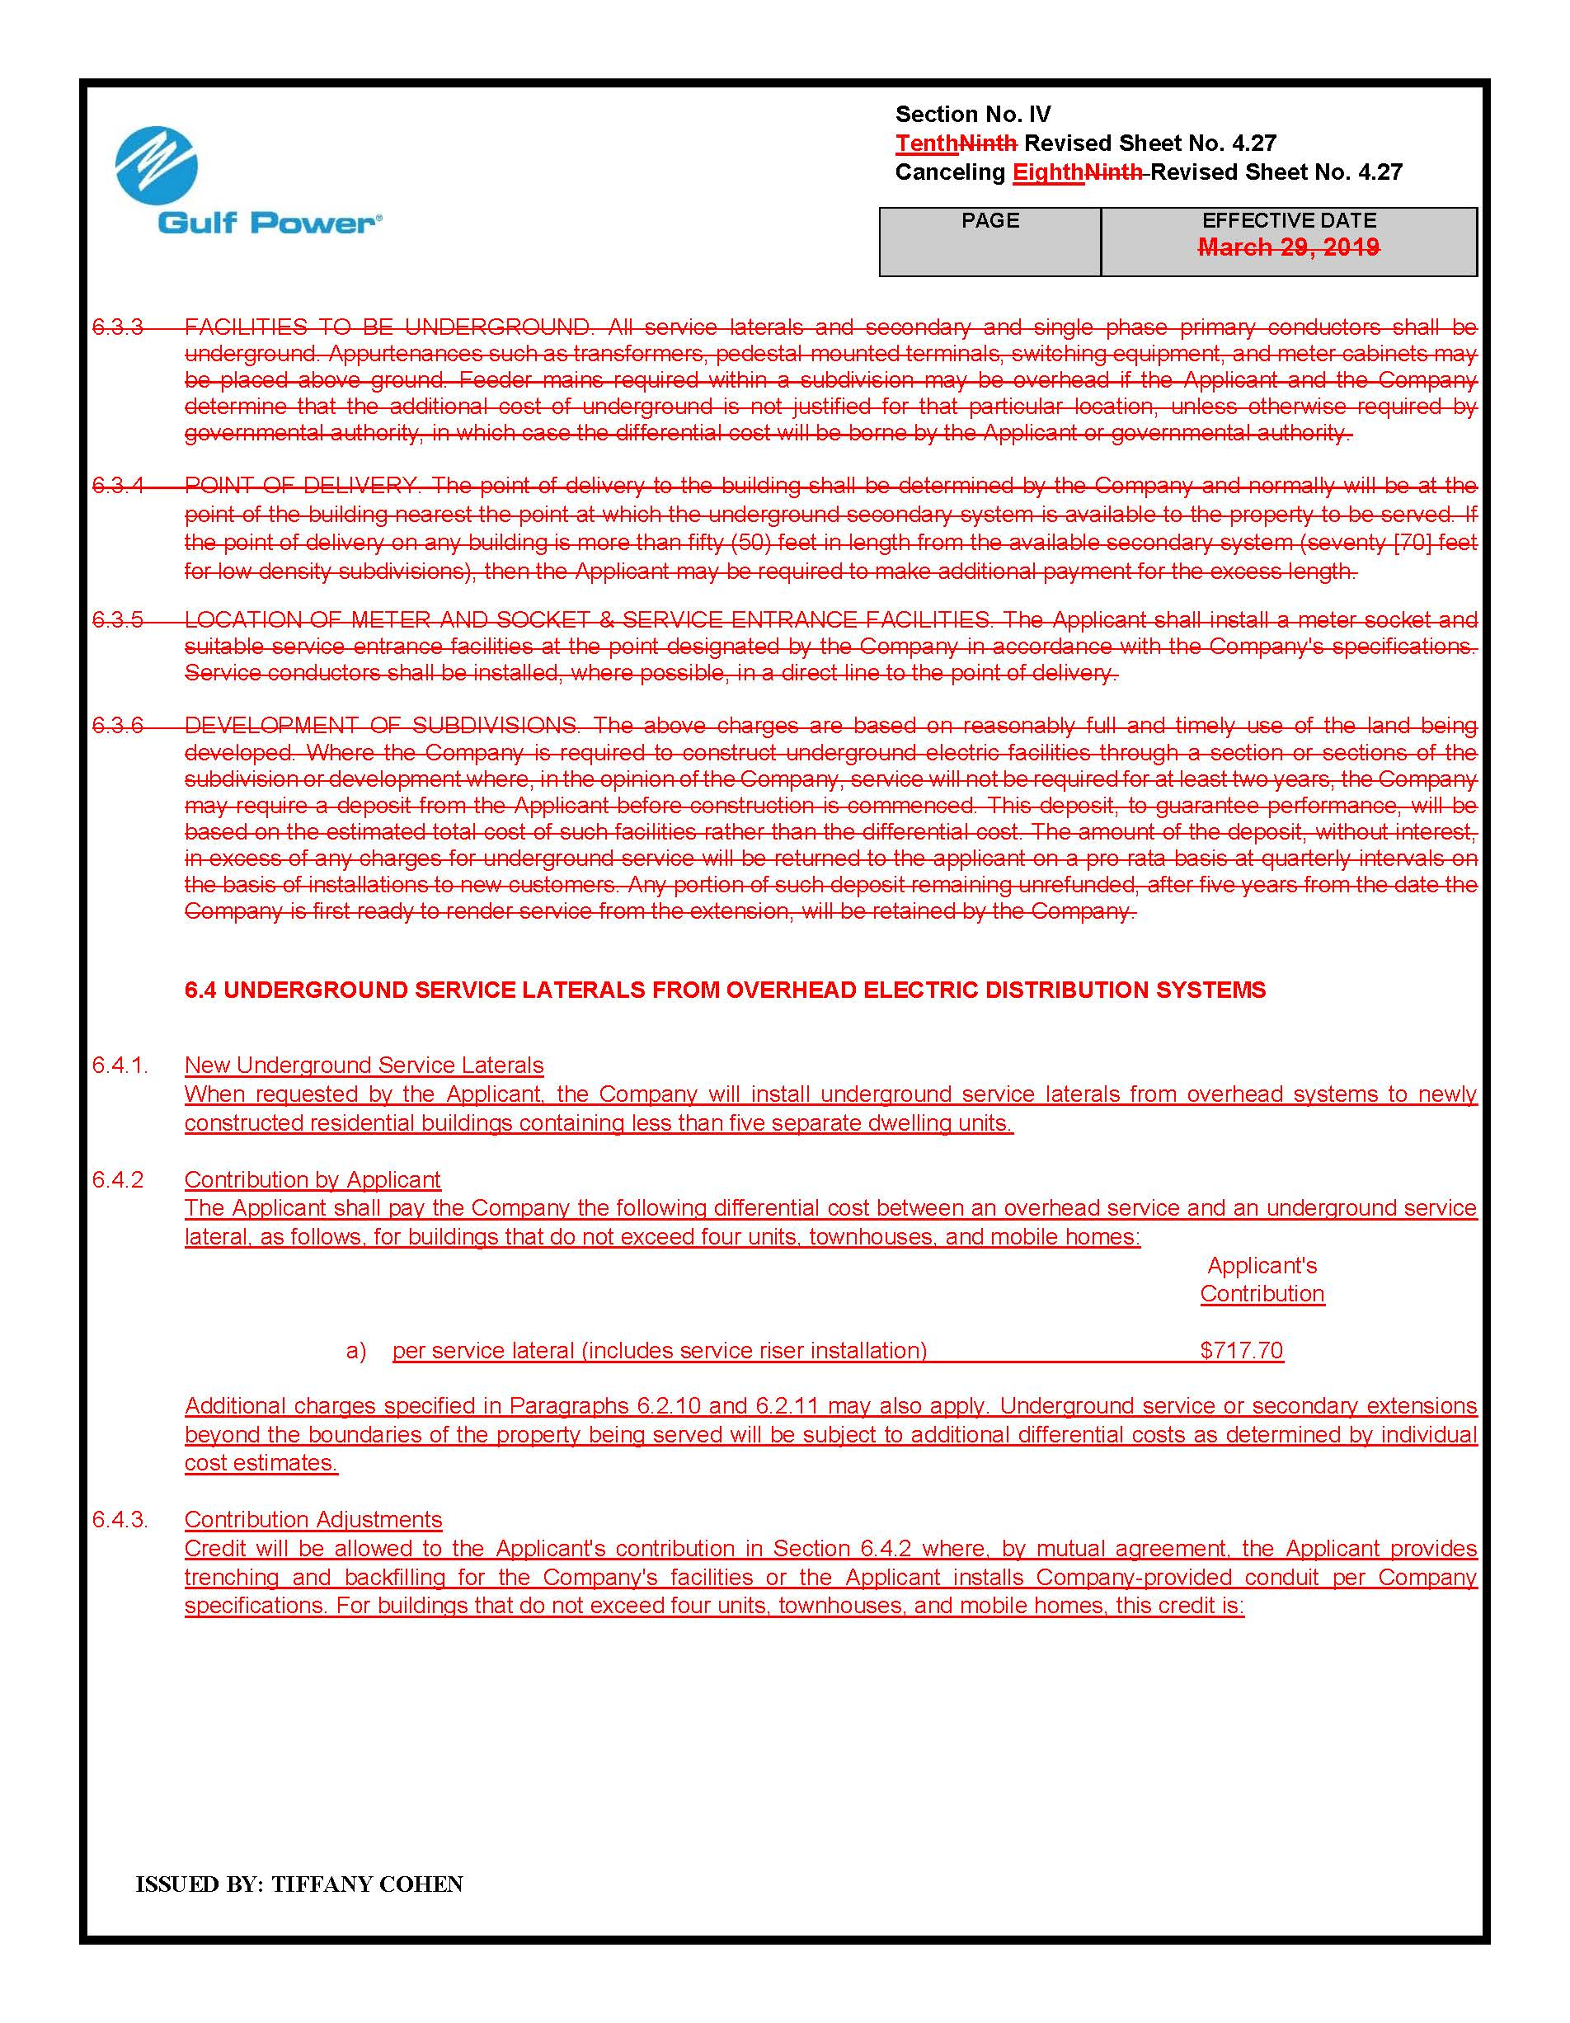

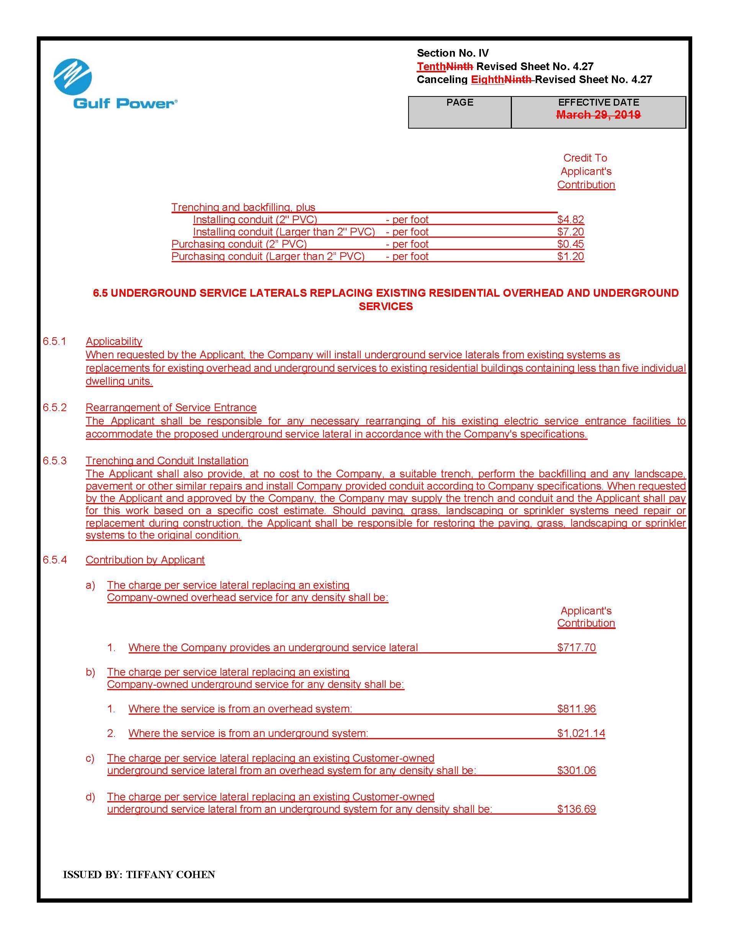

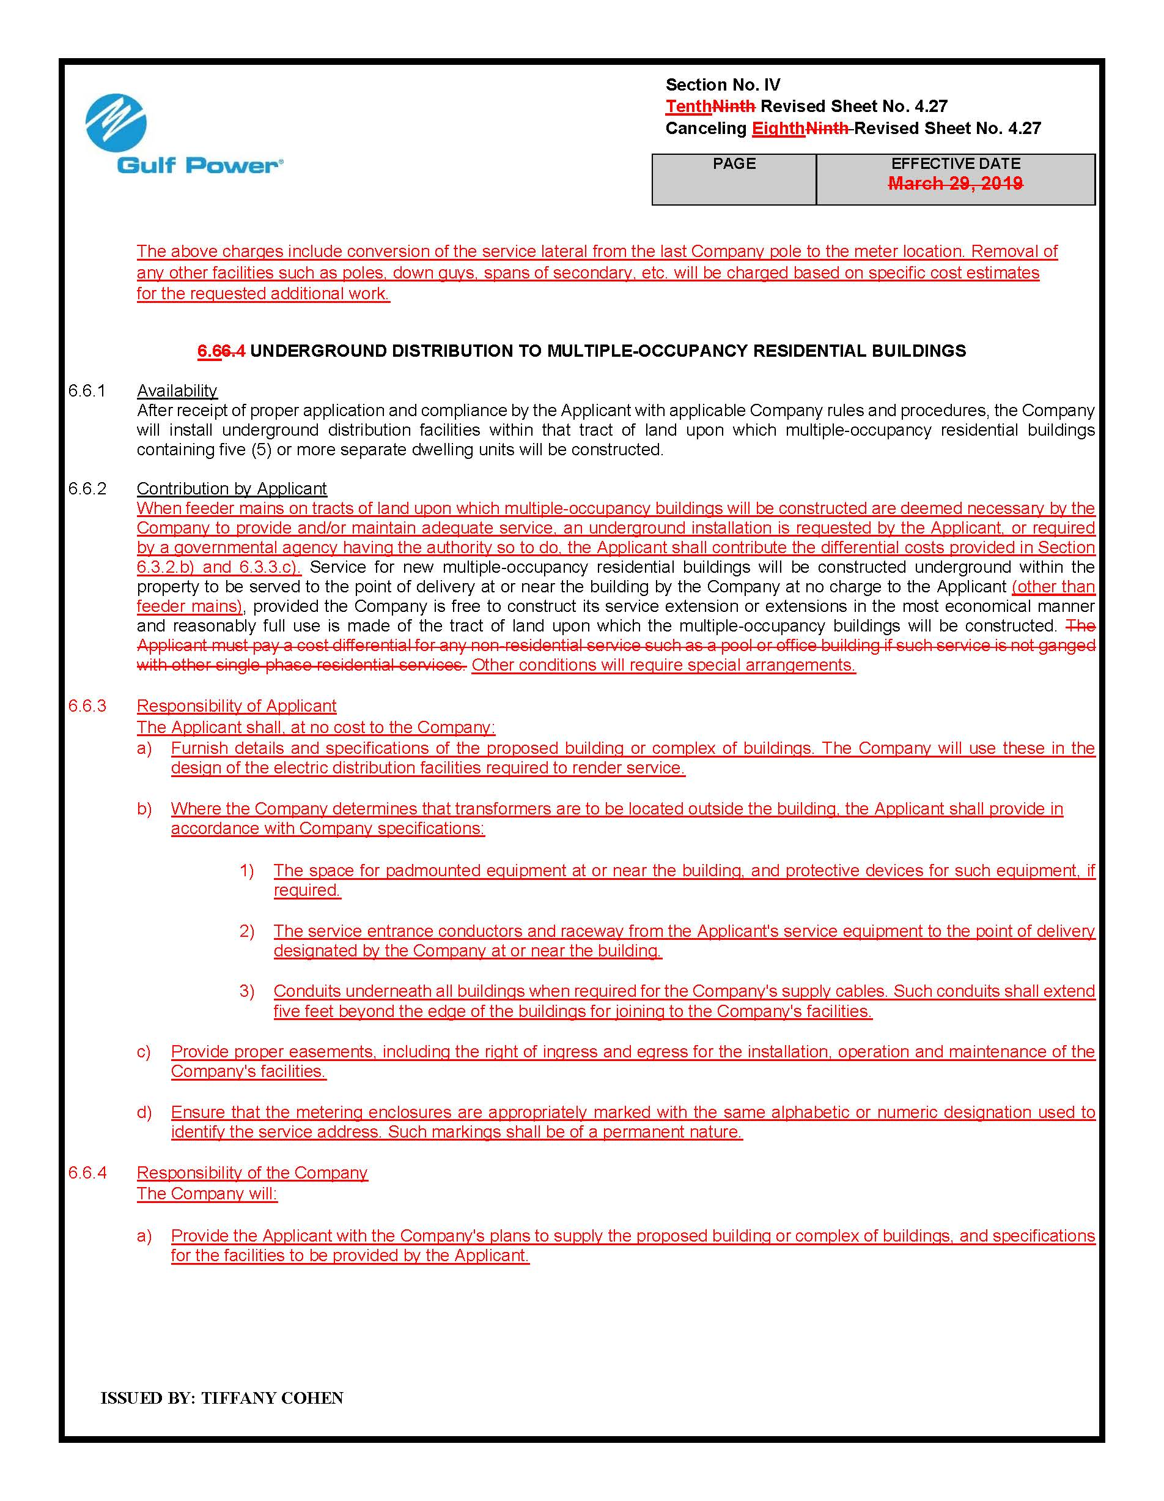

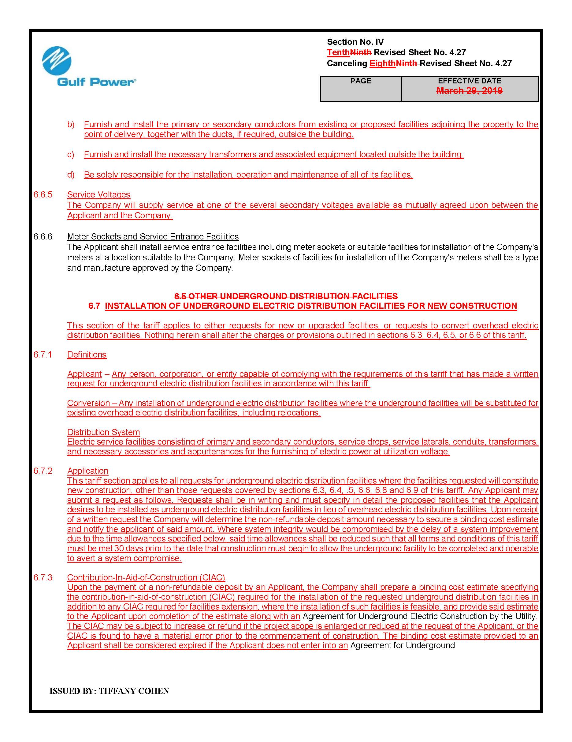

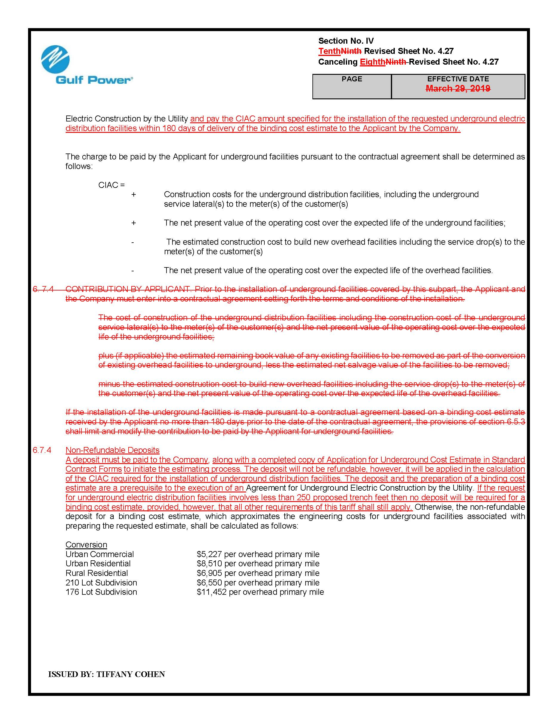

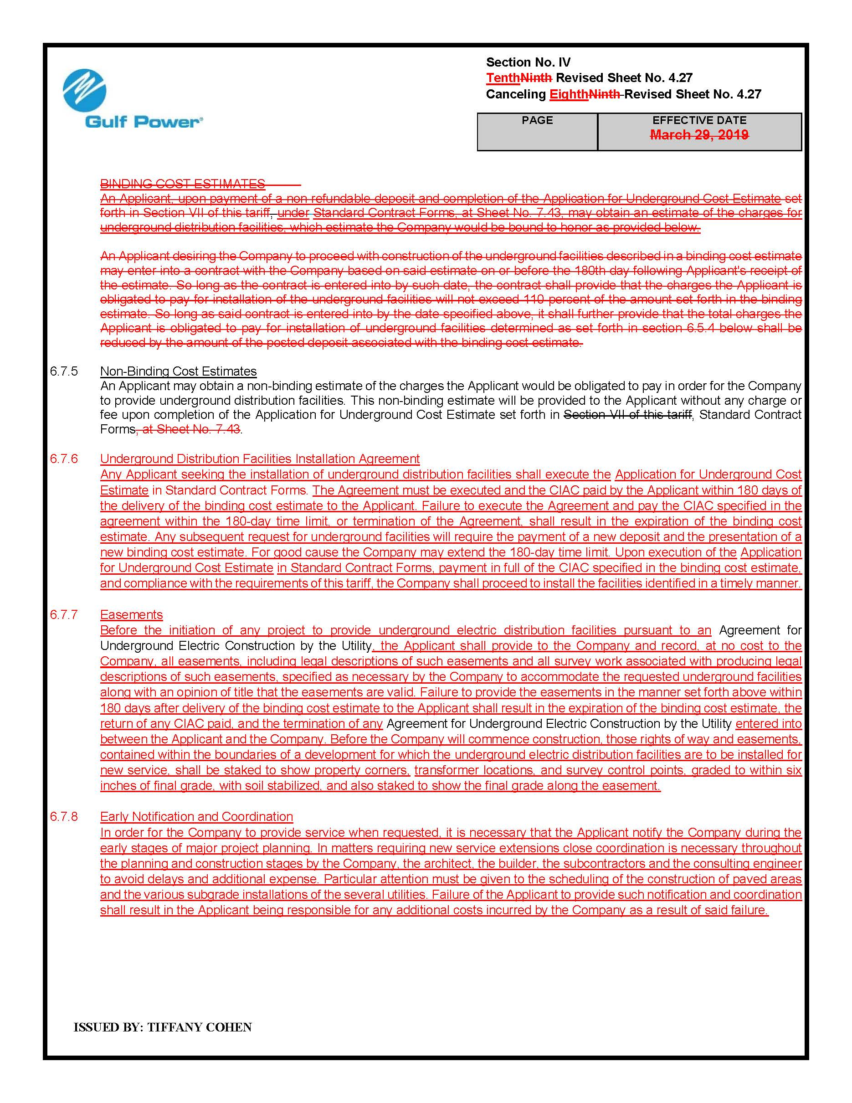

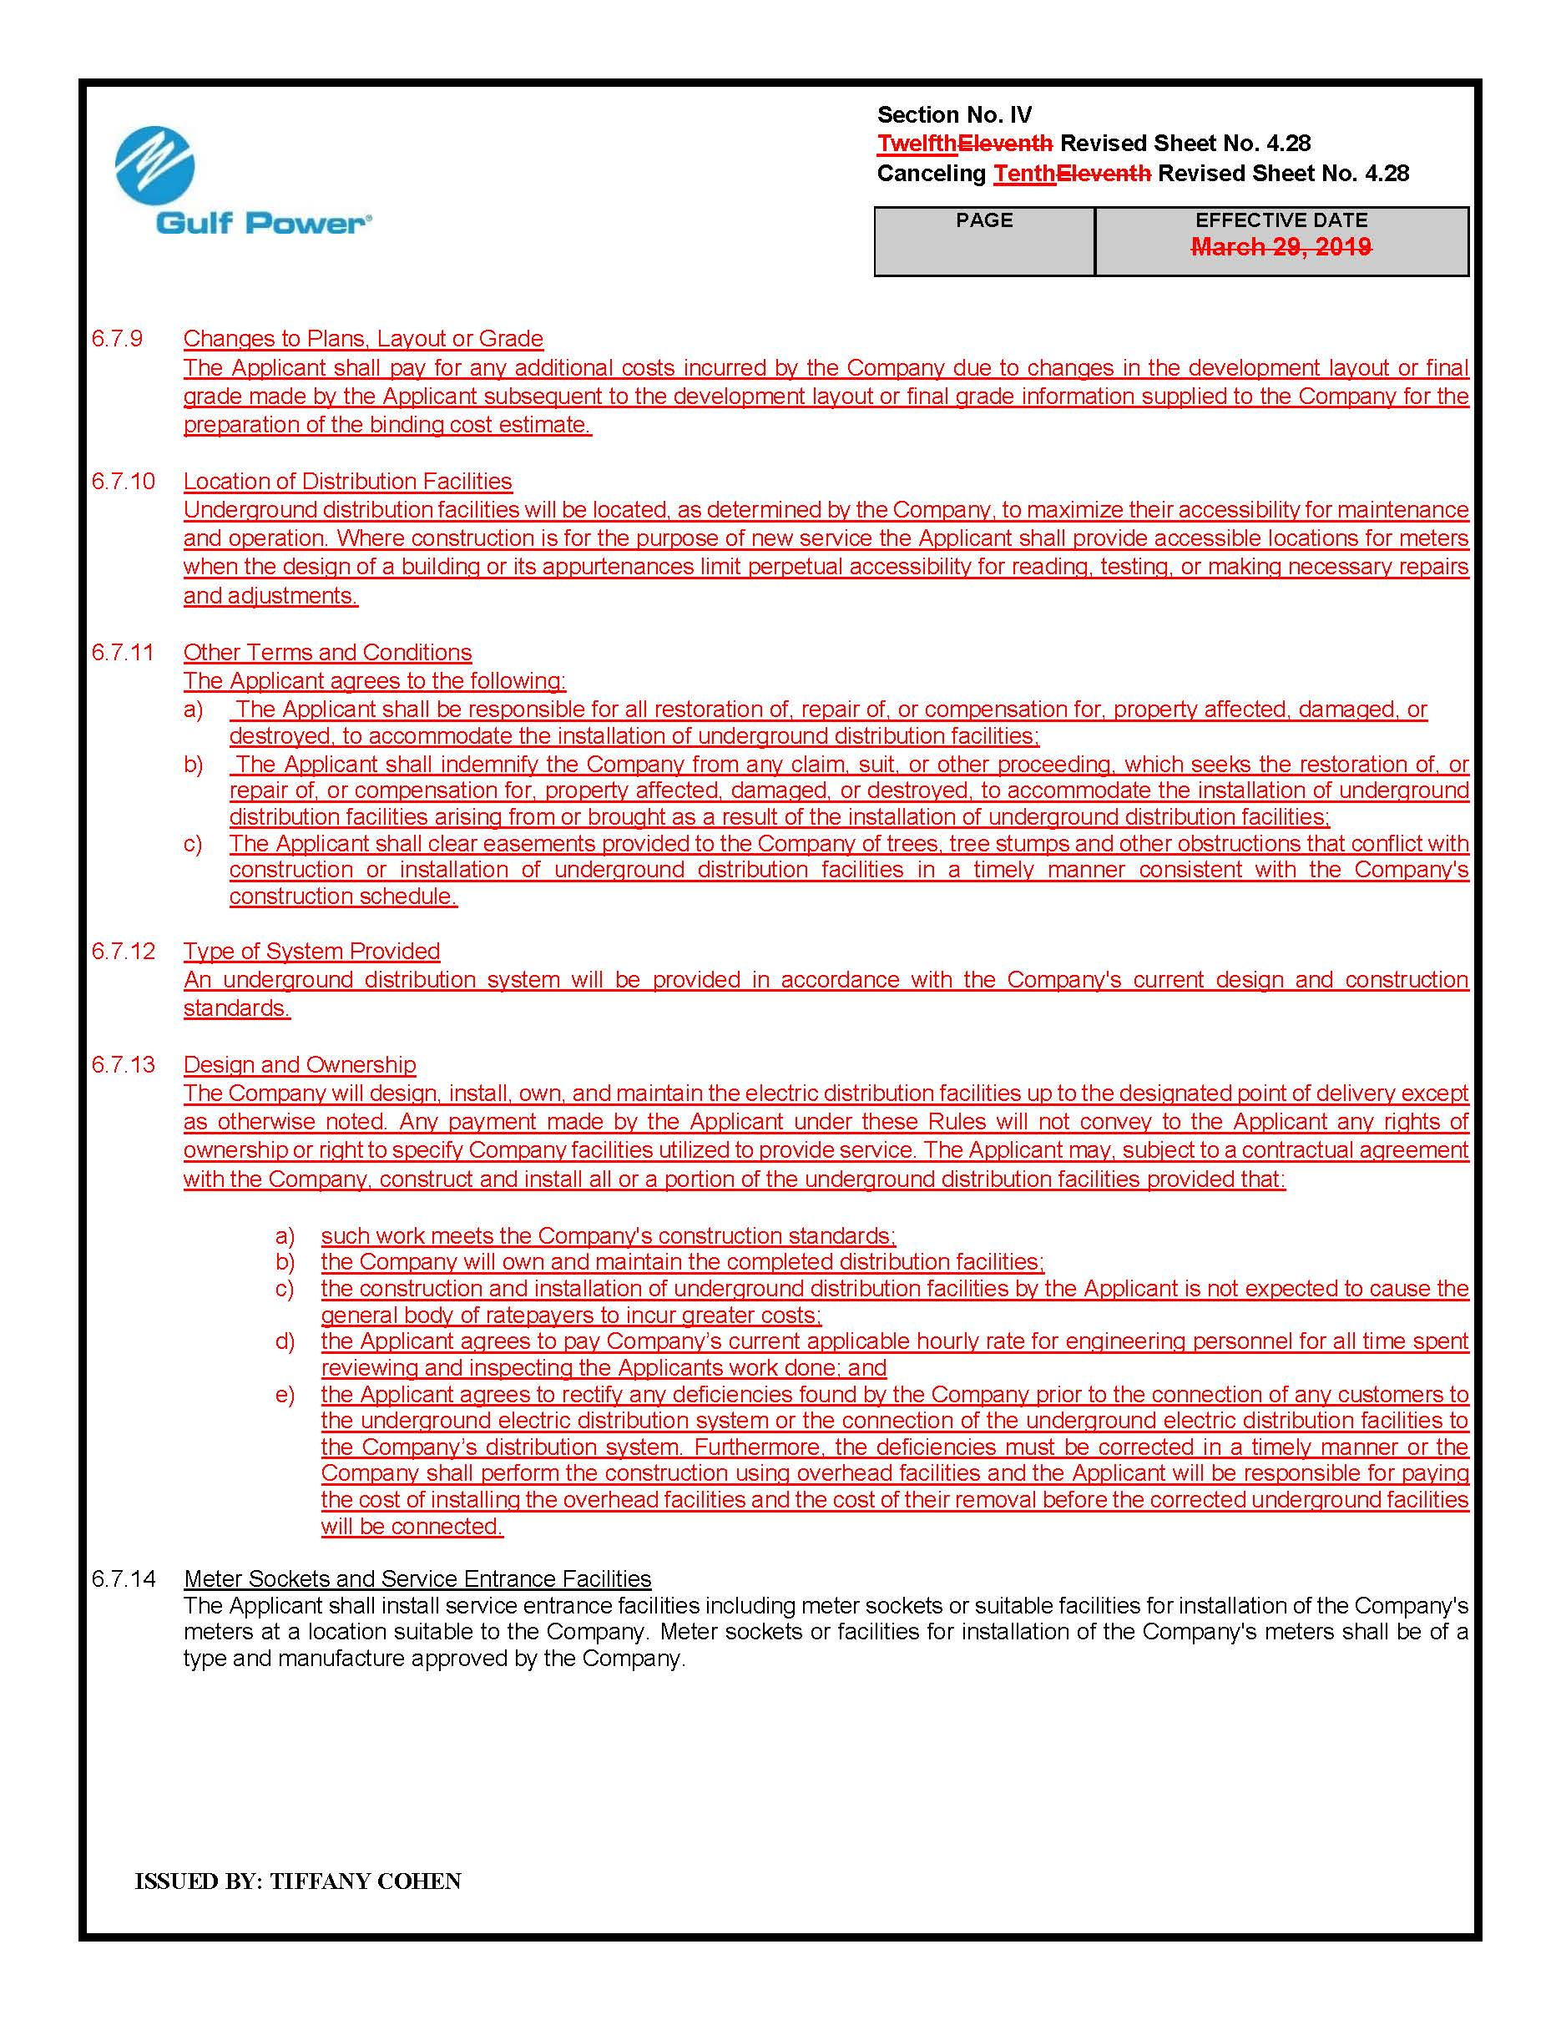

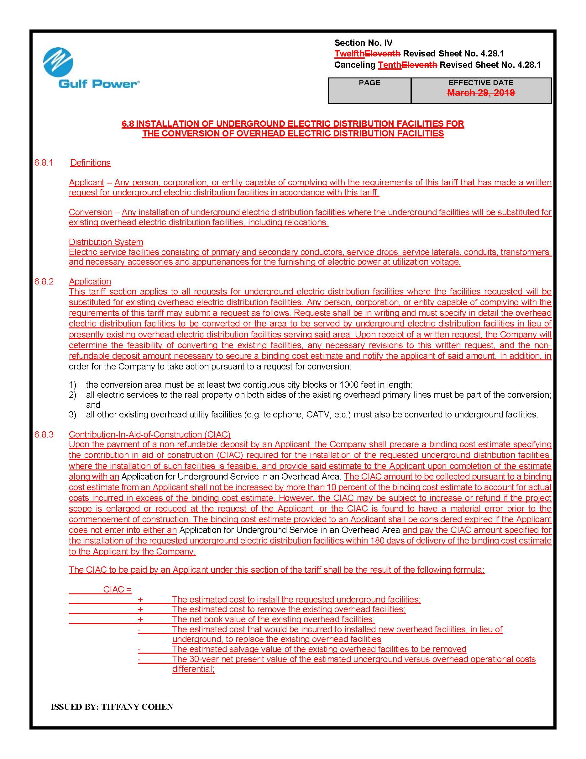

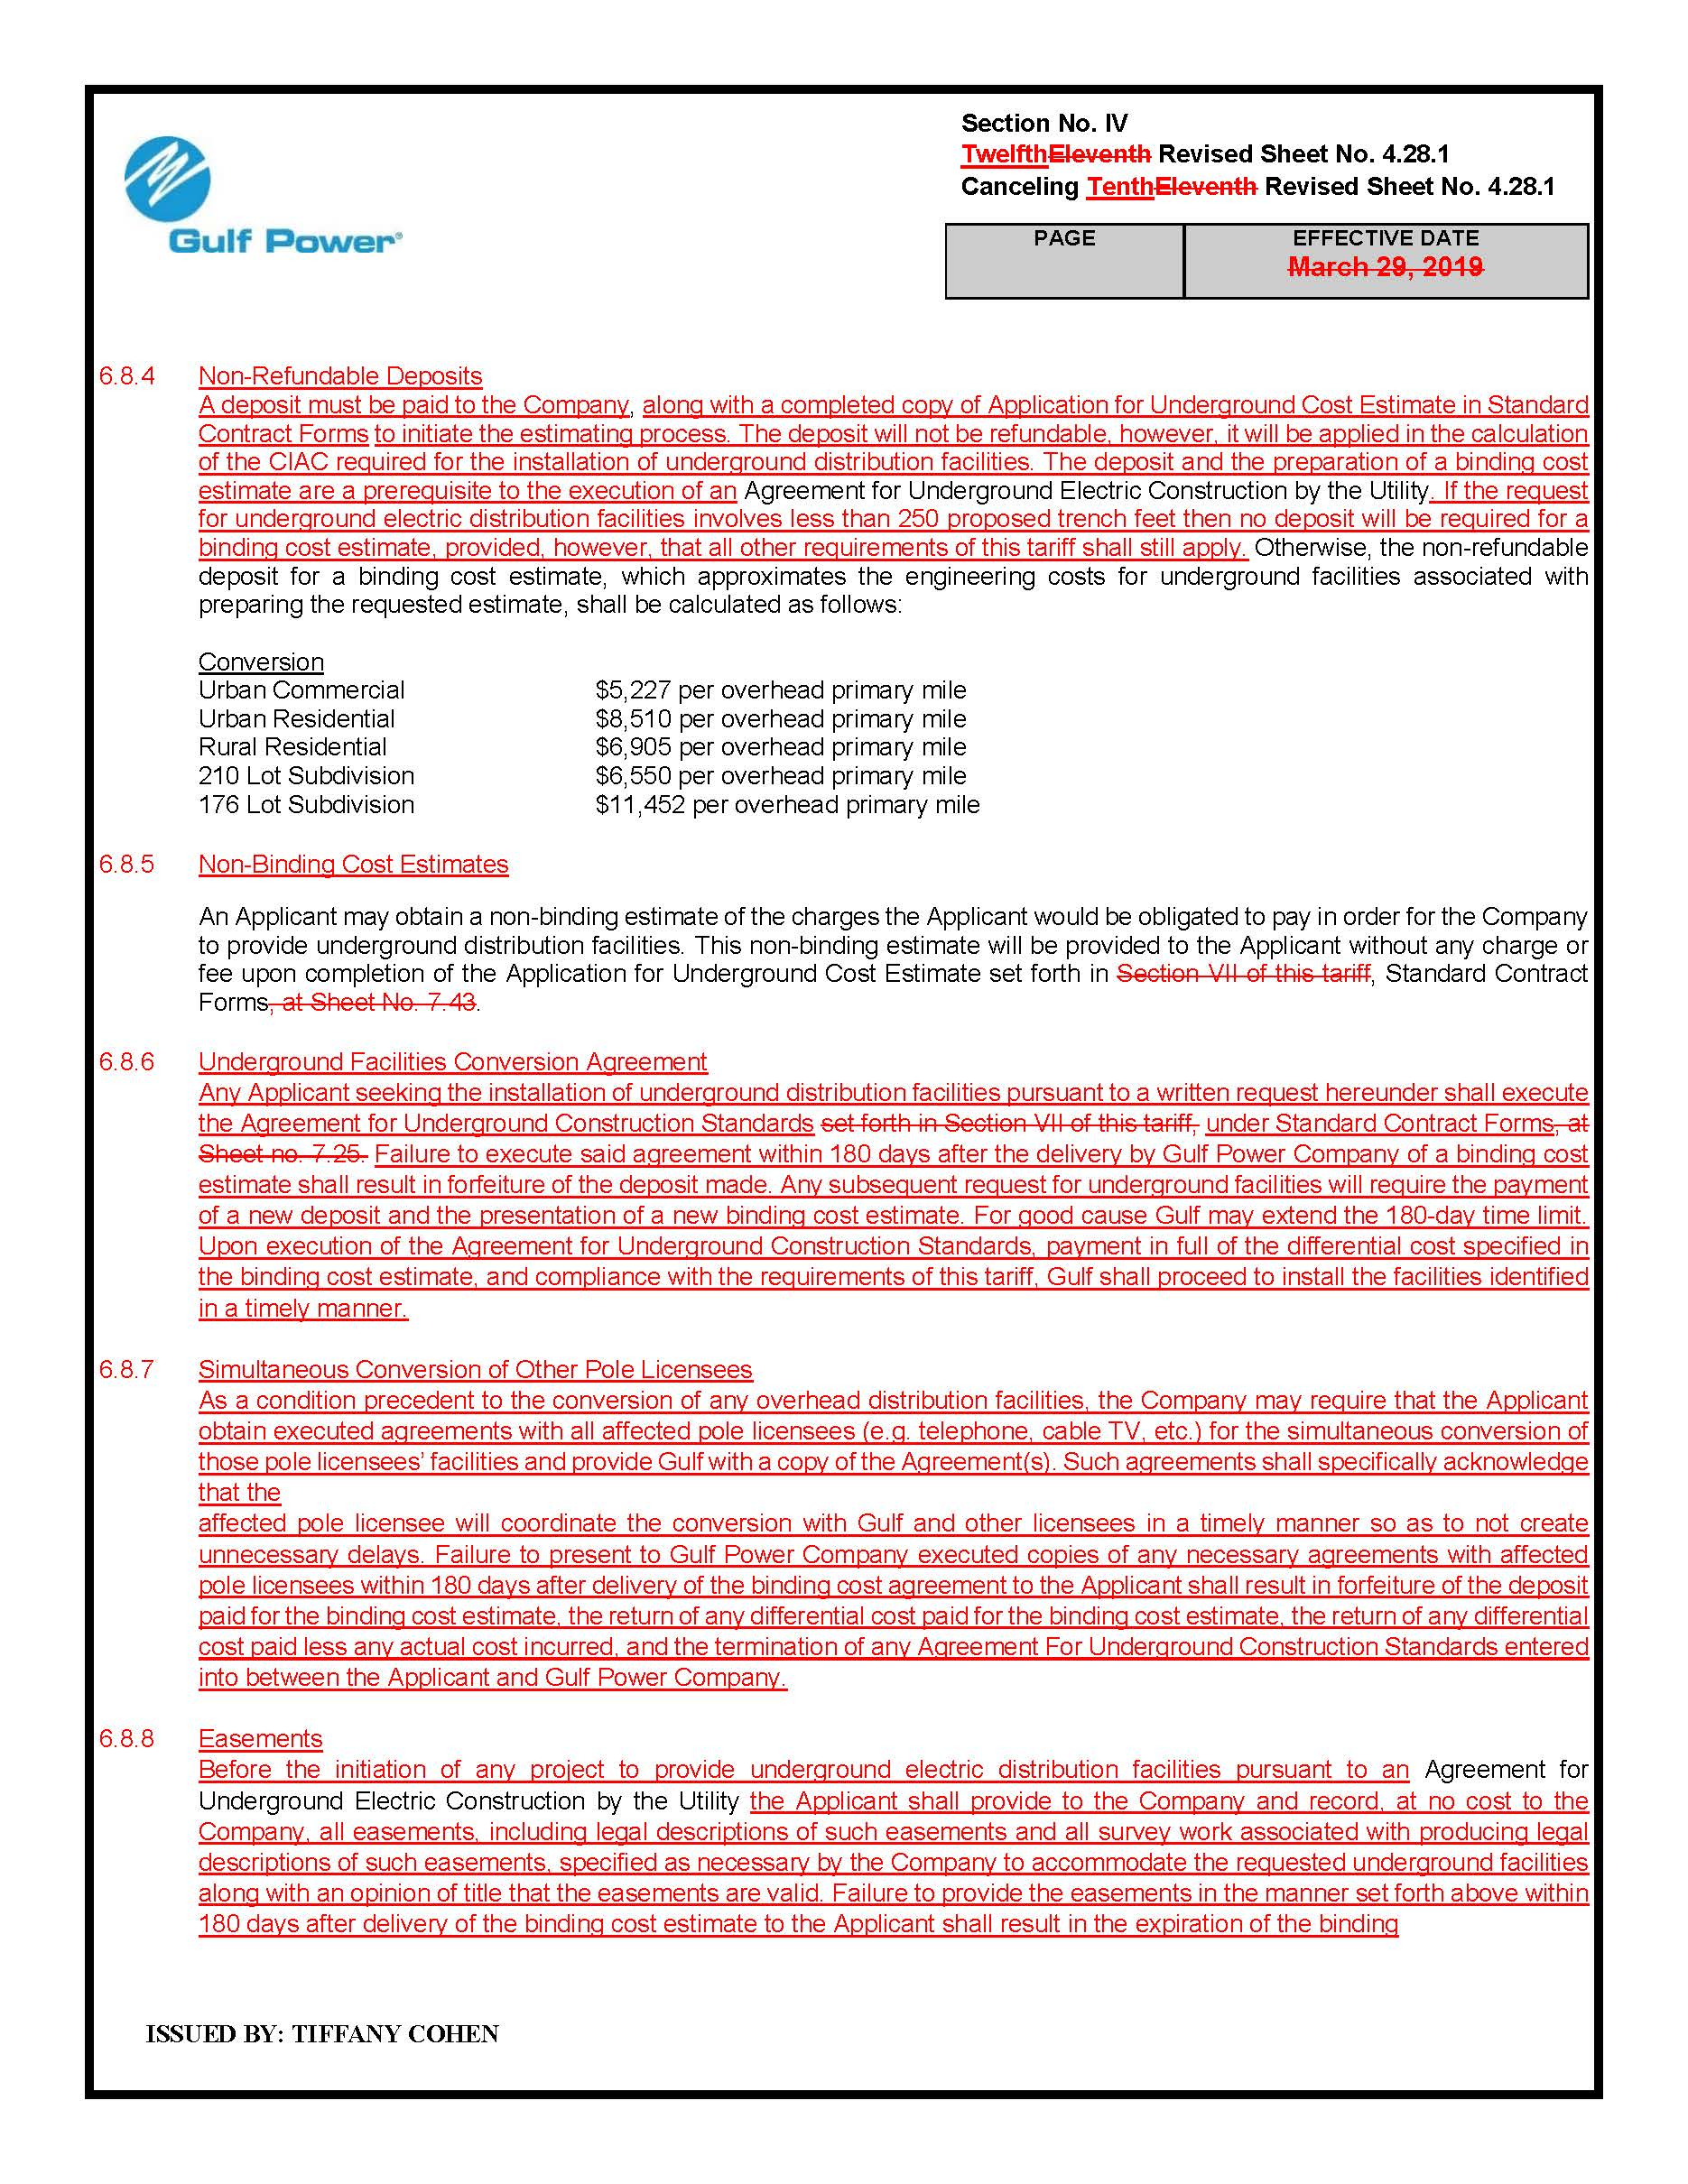

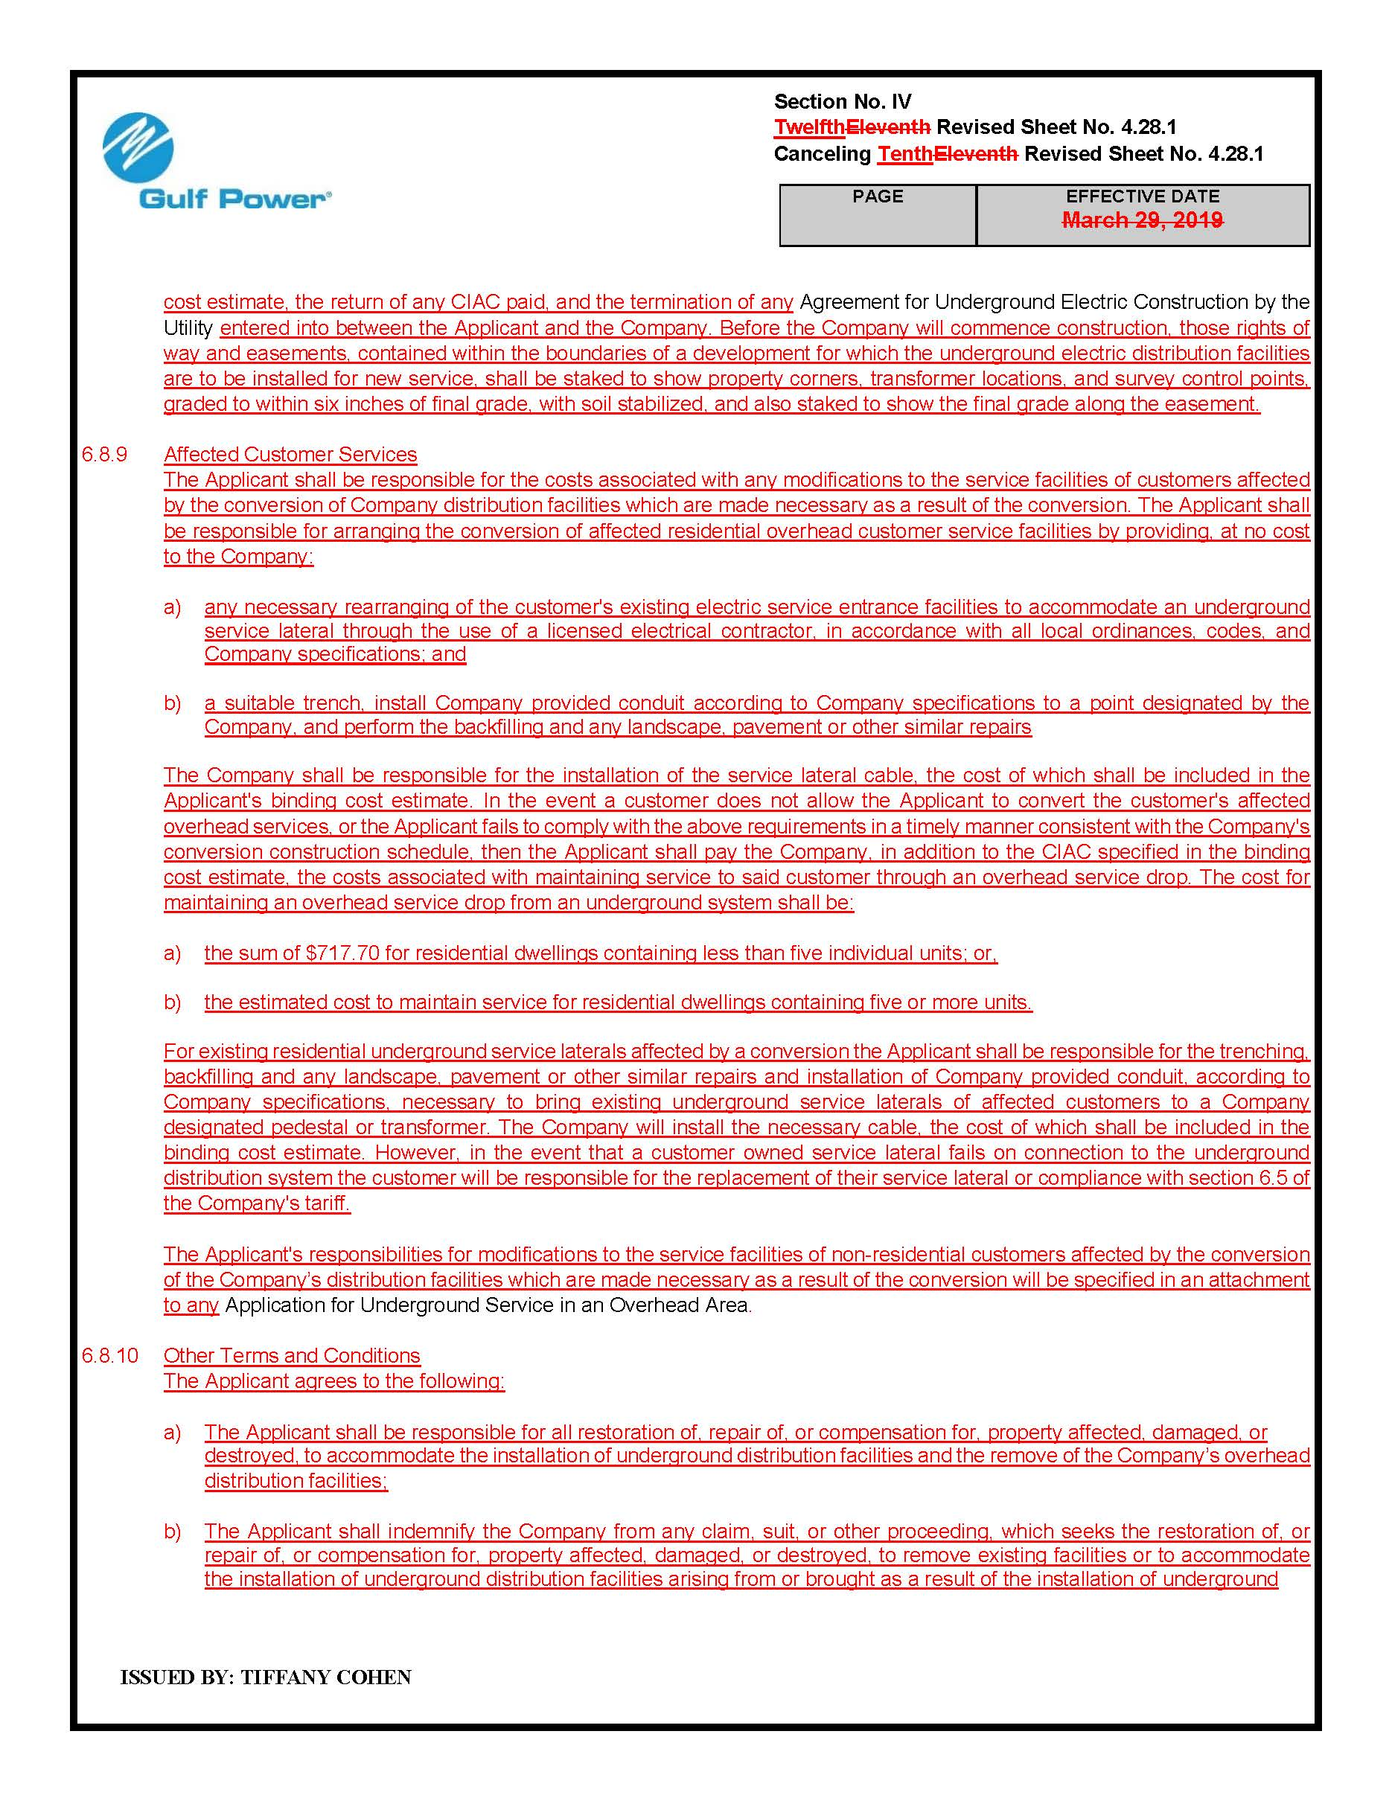

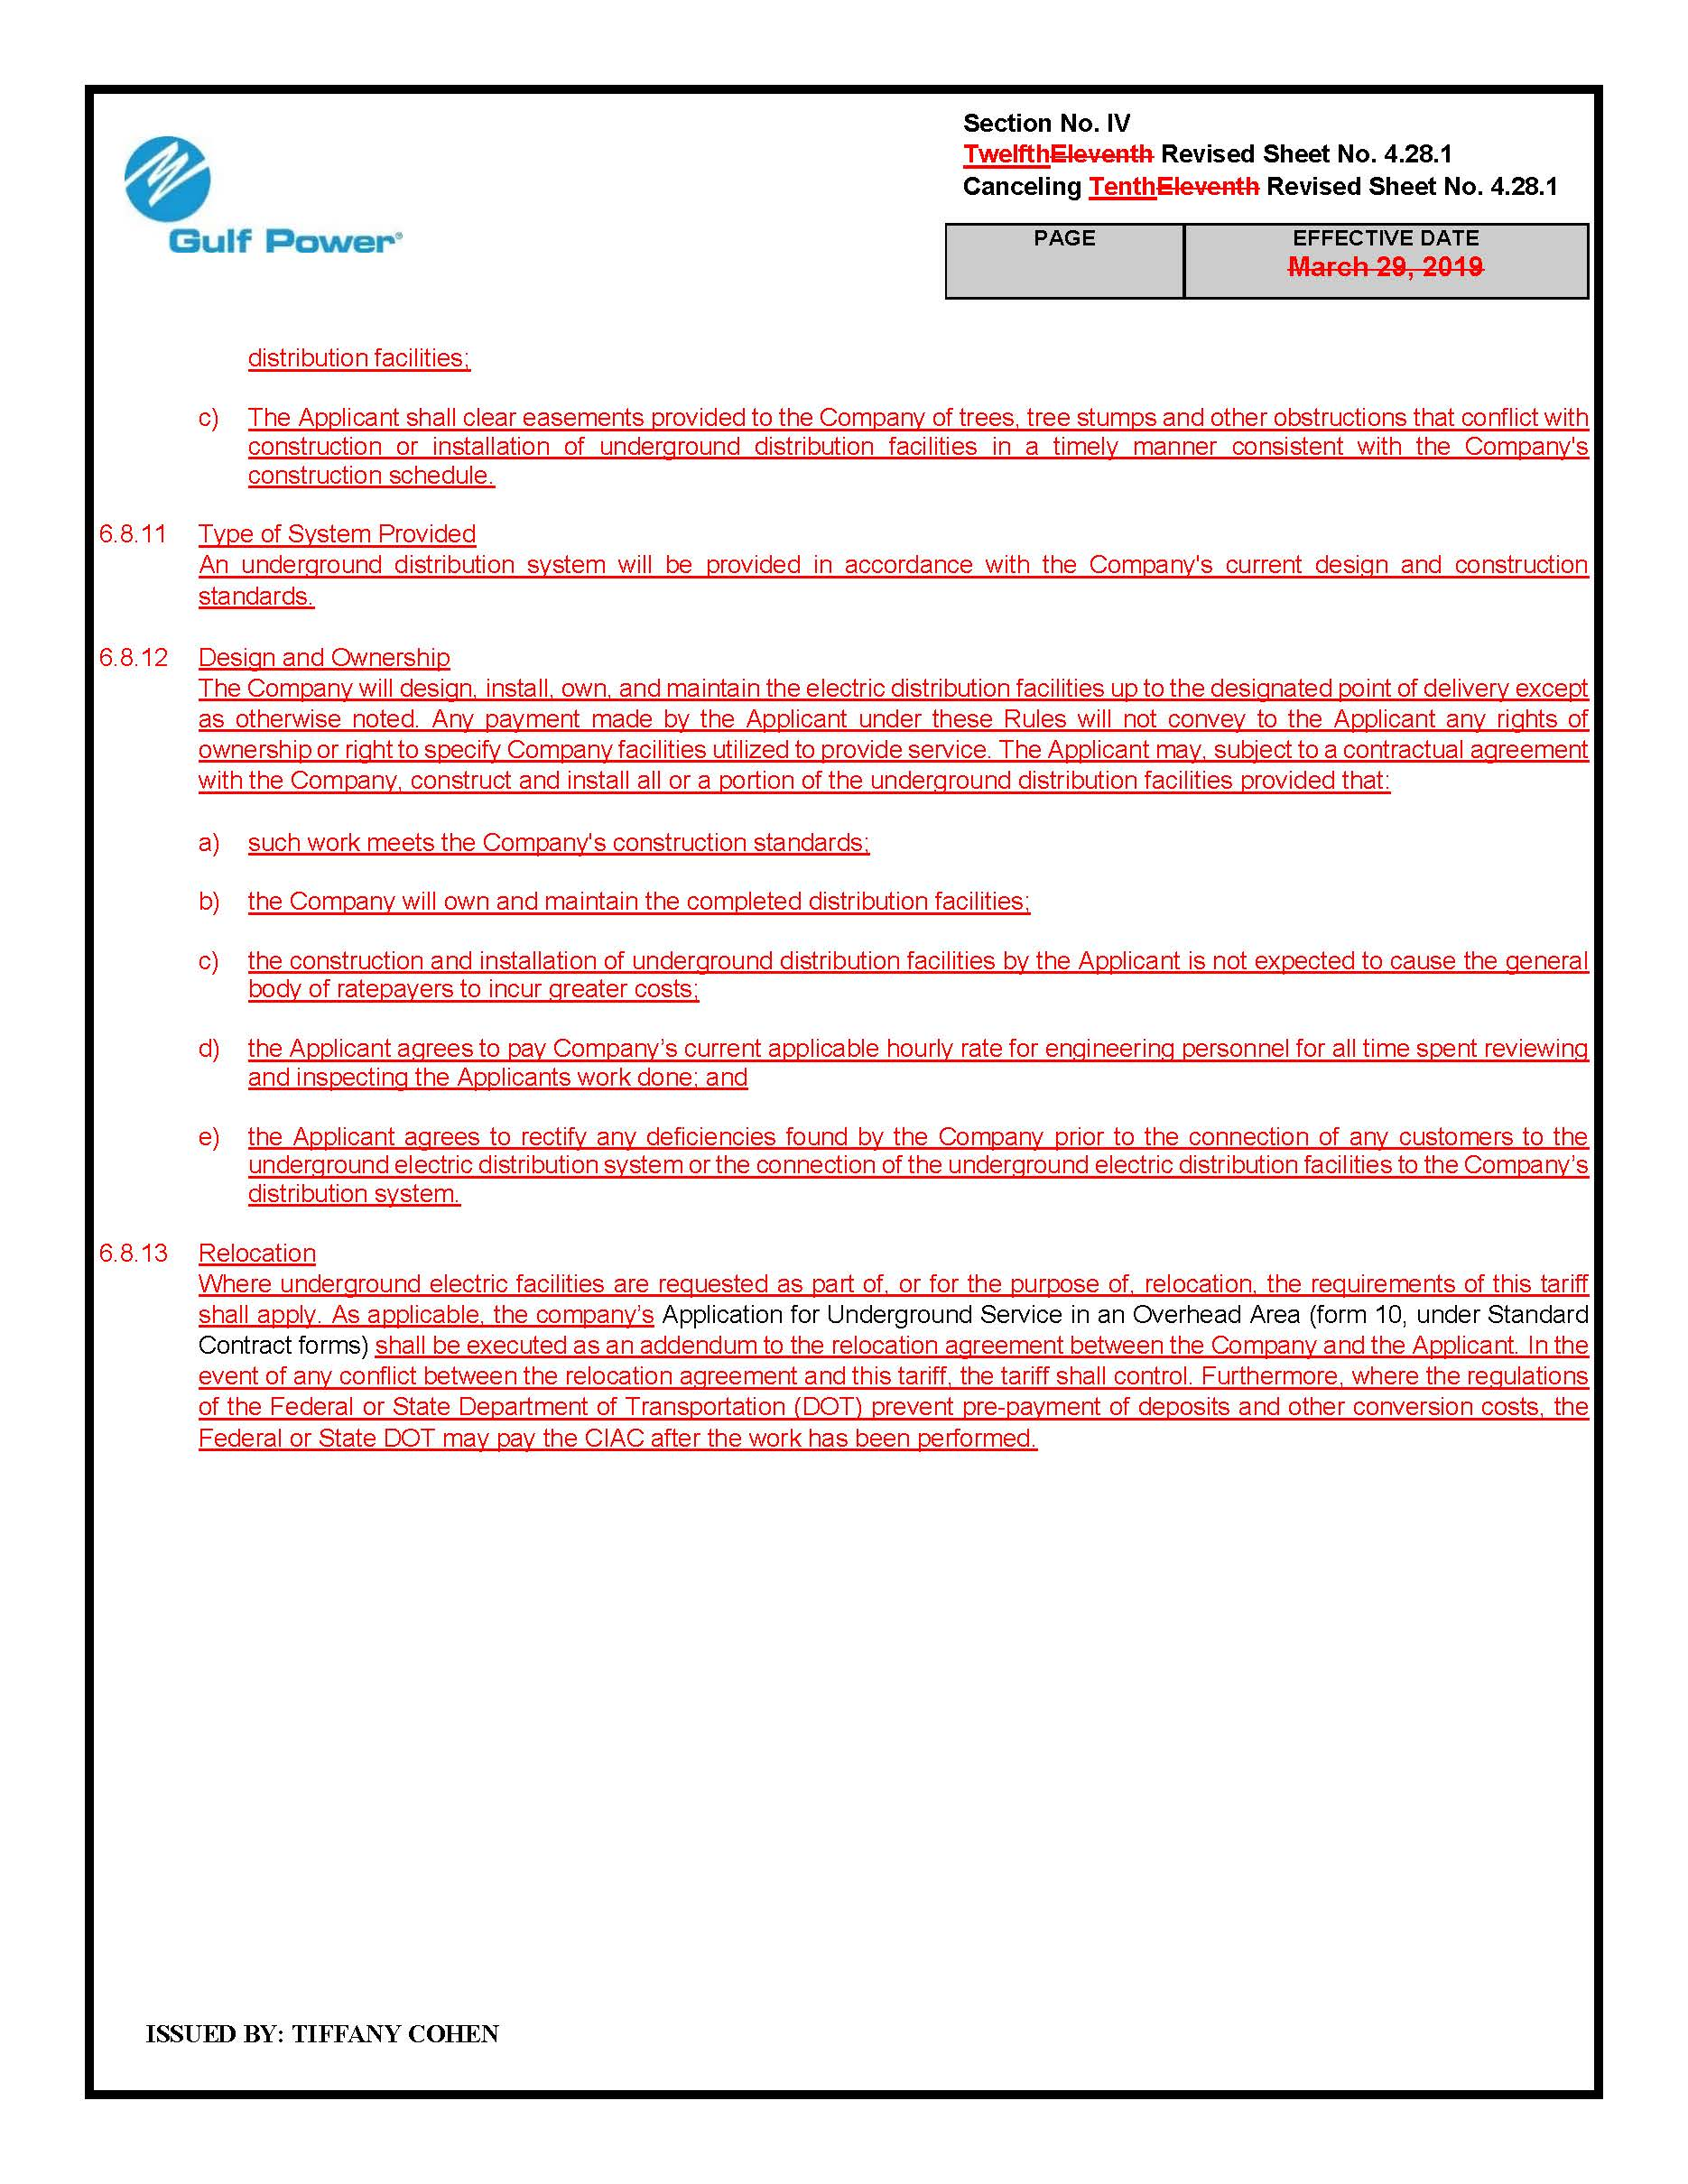

Order No. PSC-2019-0448-TRF-EI, issued October 23, 2019, in Docket No. 20190078-EI, In re: Petition for approval of 2019 revisions to underground residential distribution tariffs, by Gulf Power Company.
Order No. PSC-2019-0360-TRF-EI, issued August 26, 2019, in Docket No. 20190081-EI, In re: Petition for approval of 2019 revisions to underground residential and commercial differential tariffs, by Florida Power & Light Company.

