State of Florida |  | Public Service Commission  Capital Circle Office Center ● 2540 Shumard Oak Boulevard  Tallahassee, Florida 32399-0850  -M-E-M-O-R-A-N-D-U-M-
DATE: | August 20, 2020
TO: | Office of Commission Clerk (Teitzman)
FROM: | Division of Economics (Ward, Coston)  Office of the General Counsel (Schrader)
RE: | Docket No. 20200093-GU – Petition for approval of tariff modifications for liquified natural gas service by Peoples Gas System.
AGENDA: | 09/01/20 – Regular Agenda –Tariff Filing – Interested Persons May Participate
COMMISSIONERS ASSIGNED: |  |  | All Commissioners
PREHEARING OFFICER: |  |  | Fay
CRITICAL DATES: |  |  | 11/16/20 (8-Month Effective Date)
SPECIAL INSTRUCTIONS: |  |  | None

Case Background
On March 16, 2020, Peoples Gas System (Peoples or utility) filed a petition for approval of a Liquified Natural Gas (LNG) Service tariff. LNG is natural gas that has been cooled to negative 260 degrees Fahrenheit, which causes the gas to condense into a liquid. Once in liquid form, the natural gas is 1/600th of its original volume, allowing for increased storage potential. LNG is currently used in Florida as a transportation fuel for maritime, rail, and other transportation applications. The proposed LNG tariff is contained in Attachment A of the recommendation.
Peoples waived the 60-day file and suspend provision pursuant to Section 366.06(3), Florida Statutes (F.S.), in an email dated April 9, 2020. Staff issued two data requests in this docket. Staff issued its first data request to Peoples on April 2, 2020, to which the utility responded on April 17, 2020. Staff issued its second data request on July 31, 2020, to which the utility responded on August 7, 2020. The Commission acknowledged the intervention of the Office of the Public Counsel (OPC) in this docket by Order No. PSC-2020-0181-PCO-GU, issued June 10, 2020. OPC served interrogatories and requests for production on Peoples on June 5, 2010, which Peoples responded to on July 6, 2020.
On May 22, 2020, a noticed informal telephonic meeting was held with Commission staff, Peoples, OPC, and other interested persons. At the meeting, Peoples provided a presentation that has been placed in the docket file. On July 31, 2020, Eagle LNG Partners (Eagle LNG), an interested person in the docket, submitted a letter to the Commission stating its opposition to the proposal. On August 13, 2020, Peoples submitted to the Commission a letter in response to Eagle LNG’s letter of opposition. Copies of both letters have been filed as correspondence in this docket. On August 17, 2020, a second noticed informal telephonic meeting was held with Commission staff, Peoples, OPC, Eagle LNG, and other interested persons.
Commission Jurisdiction
Section 366.02(1), F.S., in part, defines a "public utility" as an entity that supplies gas (natural, manufactured, or similar gaseous substance) to the public within Florida. Section 366.02(1), F.S., also excludes from the definition of “public utility” municipal utilities, rural cooperatives, and:

persons supplying liquefied petroleum gas, in either liquid or gaseous form, irrespective of the method of distribution or delivery, or owning or operating facilities beyond the outlet of a meter through which natural gas is supplied for compression and delivery into motor vehicle fuel tanks or other transportation containers, unless such person also supplies electricity or manufactured or natural gas. [Emphasis added]

Therefore, staff believes that Peoples’ proposed LNG service would fall under the activities of a public utility, as contemplated under Section 366.02(1), F.S., and the Commission may exercise jurisdiction over Peoples’ rates and service in this area, pursuant to Section 366.04, F.S. Based on this interpretation, the Commission would also have jurisdiction over this matter pursuant to Sections 366.03, 366.05, and 366.06, F.S.

Discussion of Issues

Issue 1:
Should the Commission approve Peoples’ proposed LNG tariff?

Recommendation:
Yes. Staff recommends that the Commission should approve Peoples’ proposed LNG tariff, as shown in Attachment A, effective with the issuance of the final Order in this docket. The LNG tariff would provide Peoples with an opportunity to provide LNG services to interested customers. A participating customer would enter into a contract with Peoples and all capital and operating costs associated with the LNG facility should be borne by the customer. (Ward, Coston)

Staff Analysis:
In its petition, Peoples stated that major maritime and cruise companies, along with several of Florida’s largest ports, have expressed interest in the utility providing an LNG fuel option through the development of LNG infrastructure. The utility highlighted that the International Maritime Organization, the specialized United Nations agency that sets global standards for the safety, security and environmental performance of international shipping, has required the marine sector to reduce sulphur emissions from ships by 80 percent beginning January 1, 2020. As a result, many maritime companies are considering natural gas as a fuel for cruise ships, container vessels, and bulk carriers.
In addition to the maritime industry, the utility also stated that other industries have expressed an interest in using LNG for transportation fuel. Examples provided in the petition include refuse companies using natural gas for transportation fleets and railroads using natural gas to power locomotives. Peoples stated that a significant challenge to using LNG as a transportation fuel is the lack of storage and bunkering facilities in Florida. The proposed tariff would allow Peoples the opportunity to work with these industries to create the supply infrastructure needed to meet the growing demand for LNG. Florida currently has three LNG plants (two in Jacksonville, one in Miami) that are owned and operated by unregulated LNG providers.
Potential Benefits of LNG
Peoples stated that the benefit of natural gas in its liquid state is that it is approximately 600 times less voluminous than gas in its traditional gaseous state. Converting natural gas into a liquid state makes it possible to transport natural gas to places that pipelines may not currently serve, thus potentially expanding the use of natural gas as a transportation fuel. Additionally, on-site LNG could serve as an immediate solution for customers who are unable to wait for pipeline infrastructure installation. The utility stated that LNG facilities could also provide greater resiliency for participating customers by avoiding disruptions caused by weather or supply interruptions. Currently, Florida does not have any large-scale storage facilities and relies on natural gas to be transported through interstate and intrastate pipeline systems.
The provision of LNG in Florida is a competitive market and other operators in this market are not subject to the Commission’s jurisdiction. Peoples seeks to include LNG service under its regulated tariff, rather than through an unregulated subsidiary, because Peoples believes that doing so creates operating efficiencies in terms of customer points of contact, operations and management expense, and economies of scale.
Peoples explains that a prospective LNG customer would typically issue a Request for Proposals for the construction and maintenance of LNG facilities and Peoples could potentially compete with other unregulated LNG providers for the provision of such LNG service. Peoples’ petition is the first request by a Florida investor-owned natural gas company for an LNG tariff.
Proposed Liquified Natural Gas Tariff
Under Peoples’ proposed tariff, a participating customer would receive distribution service from the utility and pay Peoples’ otherwise applicable rates, clauses and riders, and taxes based on the volume of the natural gas delivered to the LNG facility. Additionally, customers would pay a monthly LNG services charge specific to that customer, which would be calculated based on Peoples’ gross investment in the storage and/or liquefaction facilities that serve the customer, as established in the LNG tariff. These facilities would be installed and maintained by Peoples and could be installed on either utility-owned property or the customer’s premises. Peoples stated that “each LNG facility built by Peoples pursuant to the tariff will be unique to the particular customer(s) and industries served by such facility.” Peoples expects that the requested LNG facilities will be in one of the following categories: (1) LNG liquefaction, storage, regasification and truck loading facilities; (2) LNG storage facilities; or (3) LNG mobile storage and regasification facilities.
As outlined in the proposed tariff, Peoples would enter into an agreement with the customer to construct the LNG facility and provide the liquified natural gas. The agreement would include the required monthly services charge, which is designed for all costs to be fully paid by the customer over the life of the agreement.
The utility asserted that the monthly services charge would be designed to recover the cost of service to provide LNG service to a customer. The cost of service would include, but not be limited to, depreciation expense, return on capital, property taxes, insurance, operational expenses, and the fuel and electricity used to operate the LNG facilities. The costs of an LNG facility would include all of the necessary components and equipment needed to build the specific LNG facility for a customer’s end use. Peoples stated that each facility would be designed for the specific needs and anticipated demand of each customer and the final costs would reflect that specific unit. Proposed tariff sheet No. 7.406 provides a listing of specific equipment that could be necessary for the construction of an LNG facility.
Peoples stated in its response to staff’s first data request that the potential costs to construct an LNG facility under this tariff could range from $25 million to over $100 million. The utility stated that it would evaluate each potential customer’s credit worthiness prior to initiating an agreement under the tariff. Specifically, proposed tariff sheet No. 7.406-1 states that:
The agreement between Company and Customer may require a commitment by the Customer to purchase LNG Service for a minimum period of time, to take or pay for a minimum amount of LNG Service, to make a contribution in aid of construction, to furnish a guarantee, such as a surety bond, letter of credit, other means of establishing credit, and/or to comply with other provisions as determined appropriate by the Company.
In addition, Peoples stated that the contract agreements under the proposed LNG tariff would be required to comply with the utility’s Corporate Governance policy. This policy requires that contracts of a certain amount be reviewed and authorized by differing levels of senior management prior to execution. For the contract to be authorized by Peoples’ governance body, the customer must have demonstrated that it meets or exceeds a level of credit worthiness. Peoples stated that this step would help ensure that a customer taking service under this tariff should have the long-term financial stability to meet its obligations under the LNG service agreement. Peoples does not intend to bring individual LNG contracts before the Commission for approval.
Comments filed by Eagle LNG and Peoples’ Response
On July 31, 2020, Eagle LNG submitted a letter to the Commission requesting that the Commission deny Peoples’ proposed LNG tariff. Eagle LNG asserts four reasons as to why the Commission should deny the proposed tariff. First, Eagle LNG states that the LNG market is competitive and Commission regulation is only required when there is a natural monopoly. Second, approval of the tariff would put the general body of ratepayers at risk if the LNG customer can not fulfill its obligation under the contract and ratepayer risk is not justified in a competitive market. Third, Eagle LNG believes that Peoples should offer LNG services through a separate, non-regulated, company (i.e., a subsidiary of the corporate parent Emera). Finally, Eagle LNG believes that approval of the proposed LNG tariff sends the wrong signal to the competitive LNG market in Florida and puts Eagle LNG at a competitive disadvantage.
On August 13, 2020, Peoples submitted a letter to the Commission in response. First, Peoples asserts that the proposed tariff does not require Commission oversight of the LNG market; rather the LNG tariff is a natural extension of Peoples’ natural gas business. Second, Peoples states that the LNG tariff would not put ratepayers at risk as Peoples will not be building speculative facilities, rather the utility will be building specific facilities to meet a requesting customer’s needs. Peoples further states it will be contracting with well-capitalized customers and it is thus extremely unlikely that an LNG customer would default or declare bankruptcy. Third, Peoples states the proposed LNG tariff will not cause cross subsidization or regulatory inefficiency. Creating a separate company for LNG services would create greater inefficiencies and adding additional customers benefits the general body of ratepayers. Finally, Peoples asserts that the proposed LNG tariff would provide another LNG option to potential customers, increasing competition.

Similar Tariff Concepts
Peoples believes that the Commission has previously approved tariffs for Peoples that are similar in concept. The Commission first approved Peoples’ Natural Gas Vehicle Service (NGVS) tariffs in 1992 and more recently modified the NGVS tariff in 2017. The NGVS tariffs provide options for Peoples to install and maintain private or public fueling stations for compressed natural gas customers while allowing Peoples to recover its cost of providing these services. The monthly services charge calculation methodology under this tariff is 1.6 times the utility’s gross investment in the facilities. Similar to the LNG market, the provision of fueling stations for compressed natural gas customers is a competitive market.

In 2017, the Commission approved a tariff to accommodate the receipt of renewable natural gas (RNG) on Peoples’ distribution system. The RNG tariff allows Peoples to recover from biogas producers the cost of upgrading the biogas and does not contain standard charges, as the services provided varies based on the steps needed to upgrade the biogas to RNG. The monthly services charge is equal to a mutually agreed upon percentage (between Peoples and the biogas producer) multiplied by Peoples’ gross investment in the facilities necessary to provide biogas upgrading services.

Impact on General Body of Ratepayers
Peoples asserted that all costs associated with building and operating an LNG facility under this tariff would be borne by the end-use customers and would have no impact on the general body of ratepayers. The utility stated in response to staff’s second data request that the assets, revenue, and expenses associated with this tariff would be included as part of its rate base surveillance reports; however, the utility stated that the LNG monthly services charge received from the LNG customer would offset the revenue requirements for these facilities.

In response to OPC’s interrogatory No. 4, the utility stated that in the unlikely event that unforeseen “risks impact an LNG investment based on the proposed tariff any application of cost to the general body of rate payers would have to be sought through a general base rate increase proceeding and approved by the Public Service Commission.” Based on this response, and discussions during the informal meetings, Peoples could consider seeking cost recovery for any remaining costs of an LNG facility from its general body of ratepayers should a customer default on an LNG contract. Peoples believes that the likelihood of such an event to be very remote. Additionally, if Peoples were to seek cost recovery from the general body of ratepayers for an LNG facility, the Commission would evaluate the prudency of Peoples’ decision to enter into the contract and any impacts, including costs and benefits, to the general body of ratepayers.

An additional impact on the general body of ratepayers under this tariff could be potential technical and administrative personnel costs associated with implementing the tariff. Peoples stated in response to staff’s second data request that the utility does not anticipate incurring significant upfront costs to implement this tariff. The utility does anticipate hiring technical and administrative support in order to respond to customer requests for LNG services and will incorporate this program into its existing pipeline, compressed natural gas, and renewable natural gas development team. The utility stated that the additional staffing cost would be subject to review by the Commission as part of a future base rate proceeding.

Under this tariff, the utility would actively participate in Requests for Proposals by companies interested in obtaining LNG services. This process will require Peoples to place resources towards bidding for, and potentially negotiating, an LNG services contract. In response to staff’s data request, the utility stated that it does not anticipate requesting recovery from its general body of ratepayers of any costs incurred as a result of an LNG bid or contract negotiations that does not result in a constructed facility.

With respect to the Commission’s Purchased Gas Adjustment (PGA) clause, Peoples asserted in response to OPC’s interrogatory No. 2 that the proposed LNG tariff is not contemplated to have any impact on the PGA costs for the general body of ratepayers. Peoples explained that an LNG customer will procure its own natural gas supply and, therefore, will not be included as a PGA customer.

Staff is recommending approval of the petition based, in part, on Peoples’ assertion that it will implement a reasonable process to evaluate the credit worthiness of a potential customer and the utility’s internal risk assessment policies. Based on this process, the utility does not anticipate any cost impact on the general body of ratepayers. Nonetheless, staff does recognize that, if approved, the Commission may be asked to evaluate cost recovery for any tariff default or under-recovery in a future rate petition. If this occurs, the utility should be put on notice that, as part of its review, the Commission will complete a thorough analysis of the utility’s due diligence in entering into the contract, including the sufficiency of contract provisions designed to protect the general body of ratepayers.

Potential Benefit to the General Body of Ratepayers
Peoples stated that the proposed tariff would provide a benefit to the general body of ratepayers. The utility stated that potential customers under this tariff would increase the volume of gas on the existing distribution system. The utility stated this should result in lower overall costs to Peoples’ general body of ratepayers through economies of scale, by spreading fixed costs across a larger customer base. Peoples noted that customers receive the same benefit through its existing NGVS tariff.

In addition, Peoples stated that LNG has been used as a viable option by natural gas utilities to meet peak customer demand. While not currently planned, the utility highlighted that there could be a potential scenario in which Peoples could expand its supply portfolio for diversity and reliability using LNG by partnering with a customer under this tariff, potentially taking advantage of economies of scale. If this scenario were to arise, the utility stated that the capacity or reliability needs that benefit the general body of ratepayers would require recovery through a general base rate proceeding.

Conclusion
Staff has reviewed Peoples’ proposed LNG tariff, the utility’s responses to staff’s and OPC’s data and discovery requests, and the letter submitted by Eagle LNG and Peoples’ response. Staff believes that Peoples’ proposed LNG service would fall under the activities of a public utility, as contemplated under Section 366.02(1), F.S., and the Commission may exercise jurisdiction over Peoples’ rates and service in this area, pursuant to Section 366.04, F.S. Based on this interpretation, the Commission would also have jurisdiction over this matter pursuant to Sections 366.03, 366.05, and 366.06, F.S.
Staff recognizes that, if approved, the Commission may be asked to evaluate cost recovery for any tariff default or under-recovery in a future rate petition. If this occurs, the utility should be put on notice that, as part of its review, the Commission will complete a thorough analysis of the utility’s due diligence in entering into the contract, including the sufficiency of contract provisions designed to protect the general body of ratepayers.
Staff recommends approval of Peoples’ proposed LNG tariff, as shown in Attachment A, effective with the issuance of the final Order in this docket. The LNG tariff would provide Peoples with an opportunity to provide LNG services to interested customers and the utility has demonstrated a reasonable approach to implementing the tariff. A participating customer would enter into a contract with Peoples and all capital and operating costs associated with the LNG facility should be borne by the customer over the life of the contract.

Issue 2:
Should this docket be closed?

Recommendation:
If no protest is filed by a substantially affected person within 21 days of the issuance of the order, a consummating order should be issued and the docket should be closed. (Schrader)

Staff Analysis:
If no protest is filed by a substantially affected person within 21 days of the issuance of the order, a consummating order should be issued and the docket should be closed.

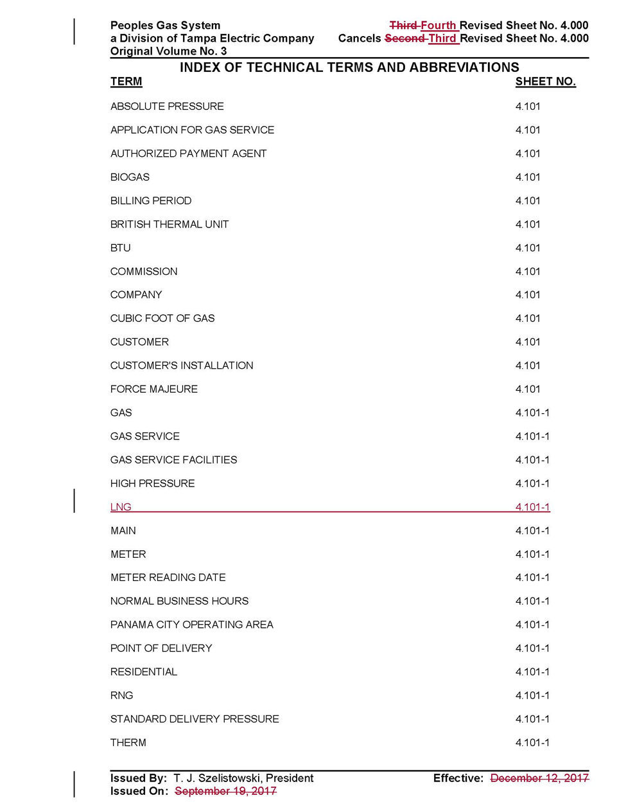
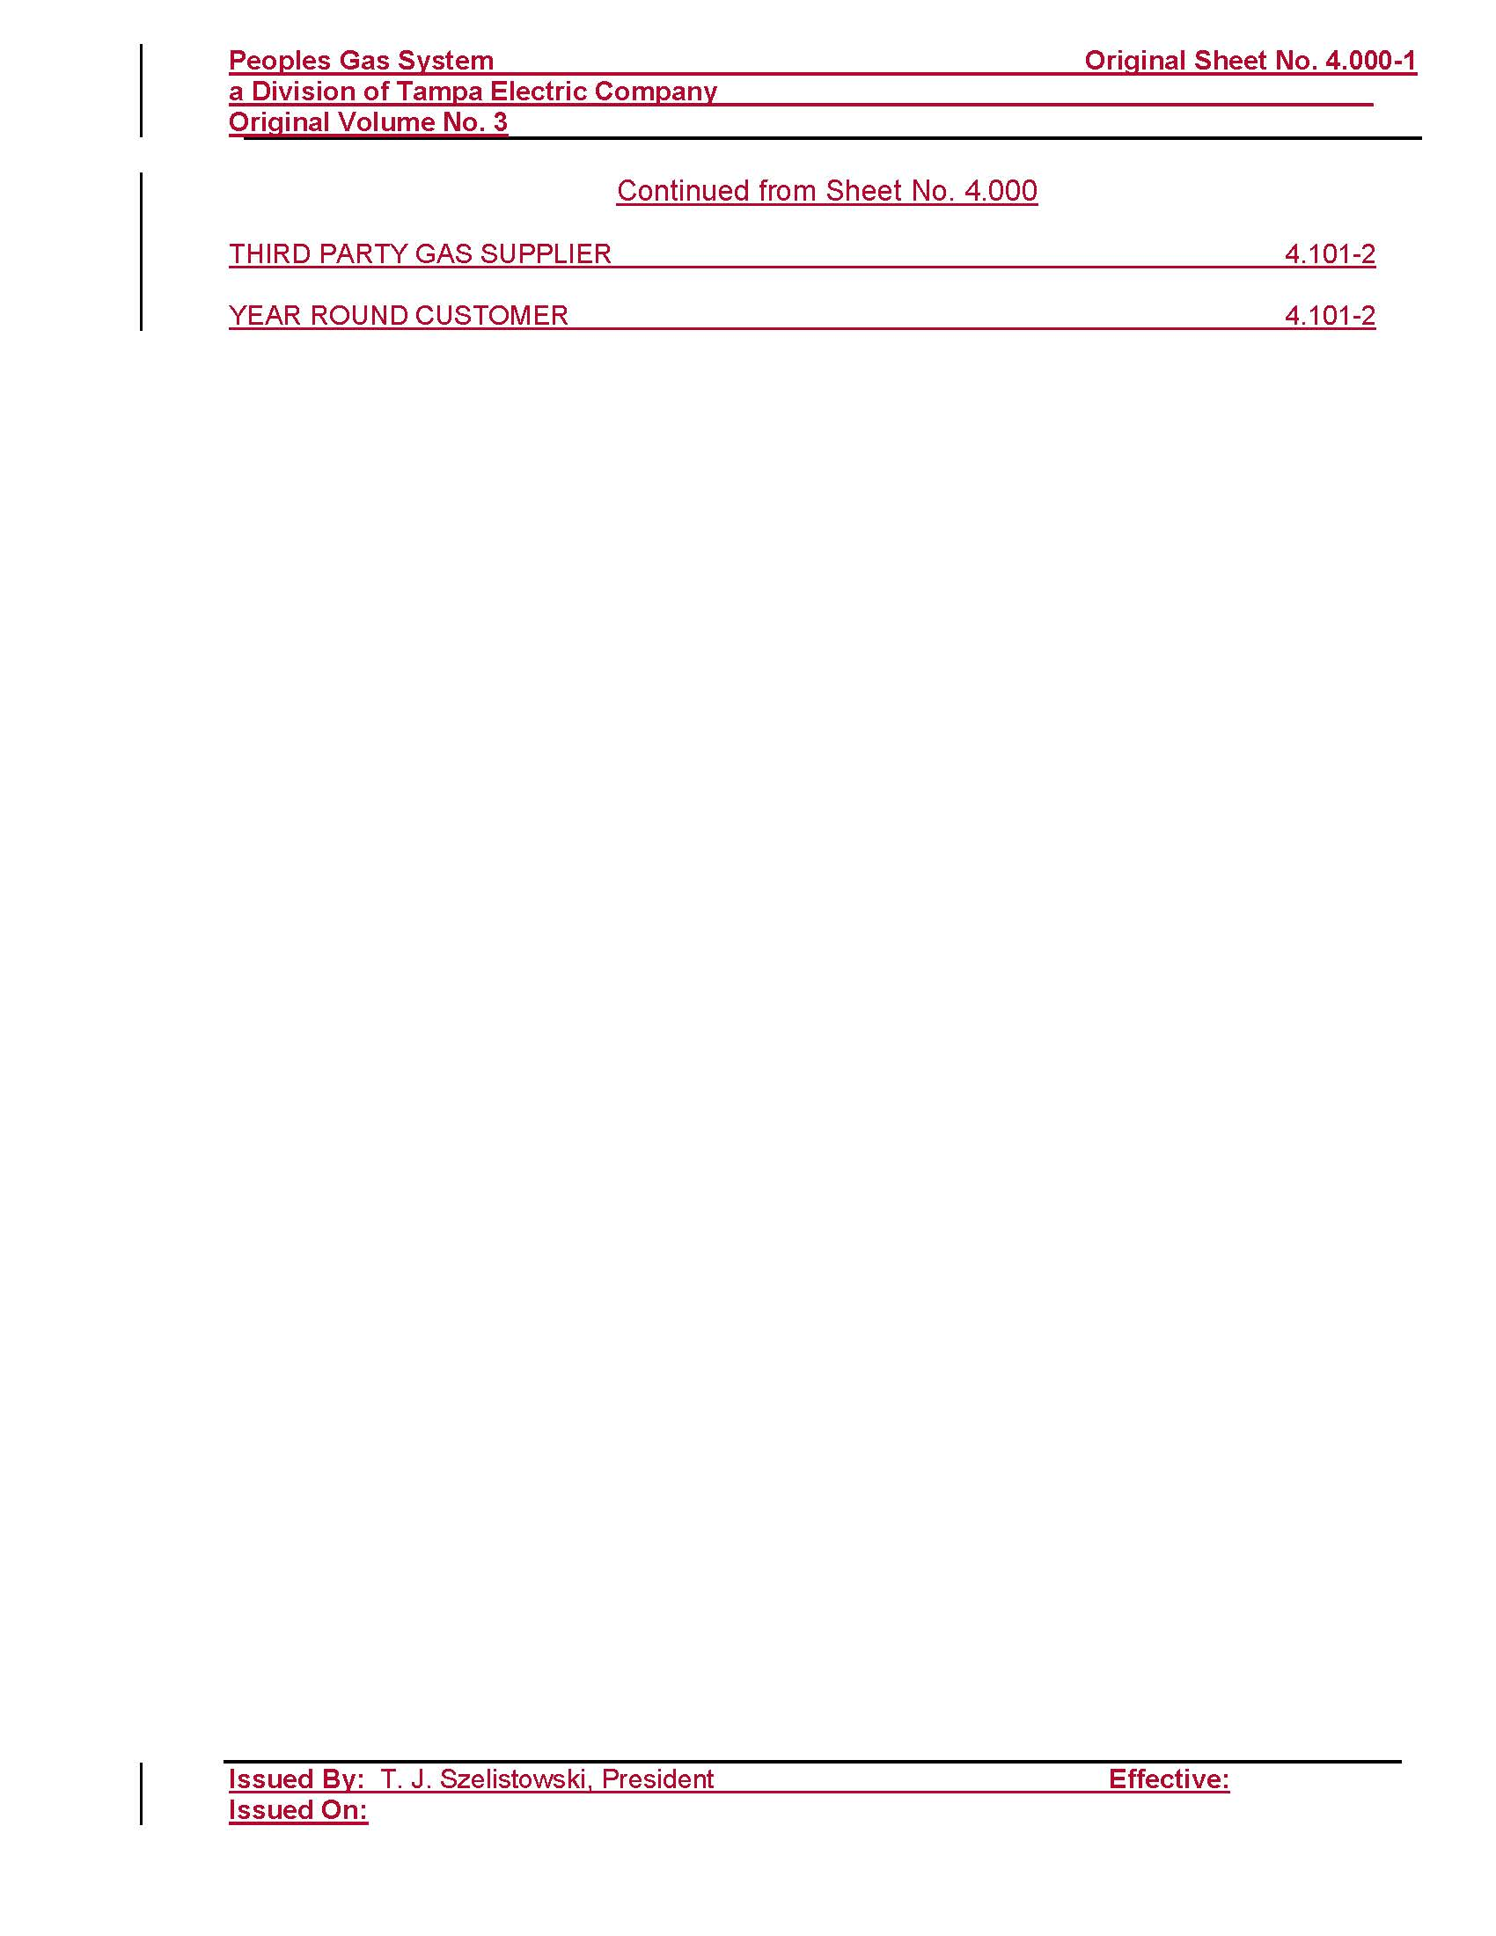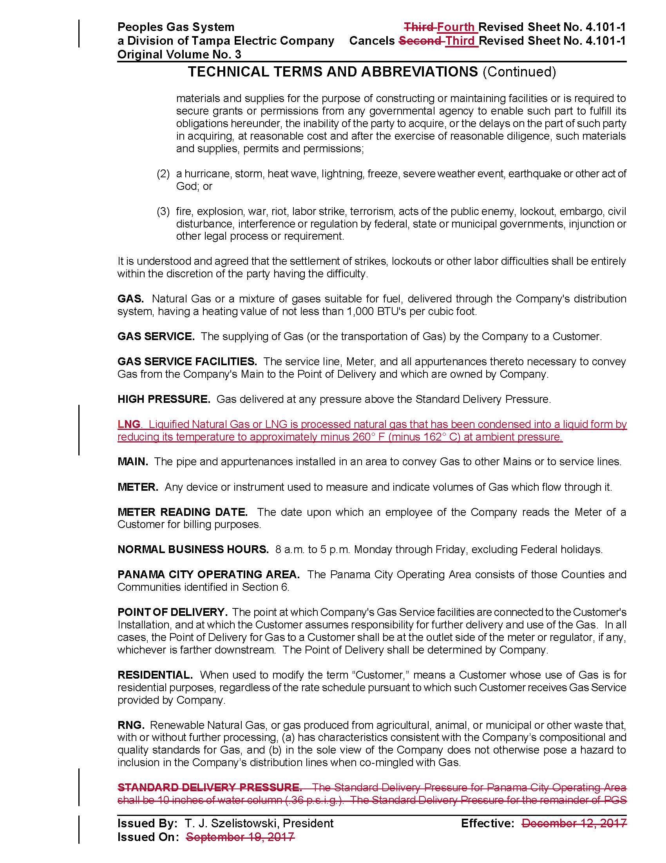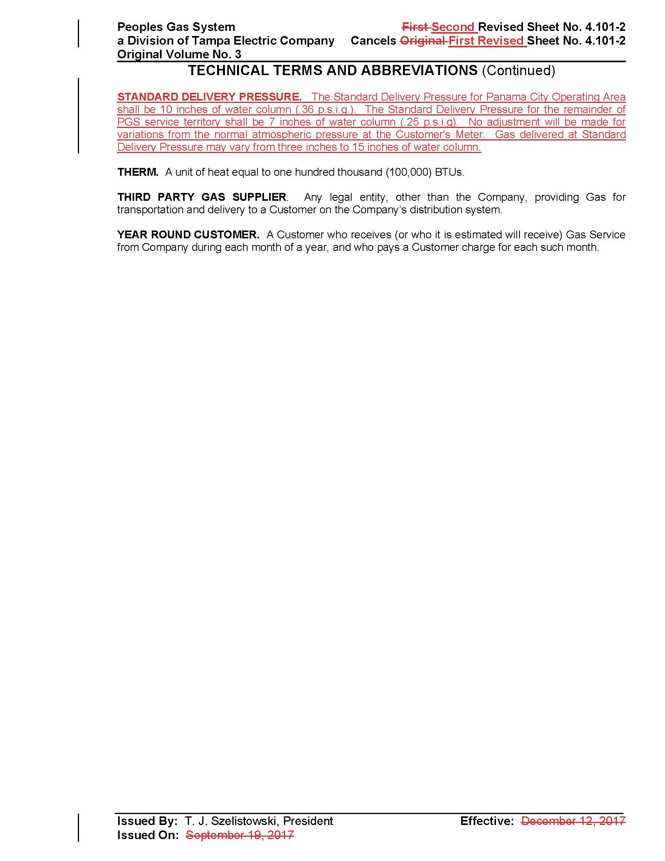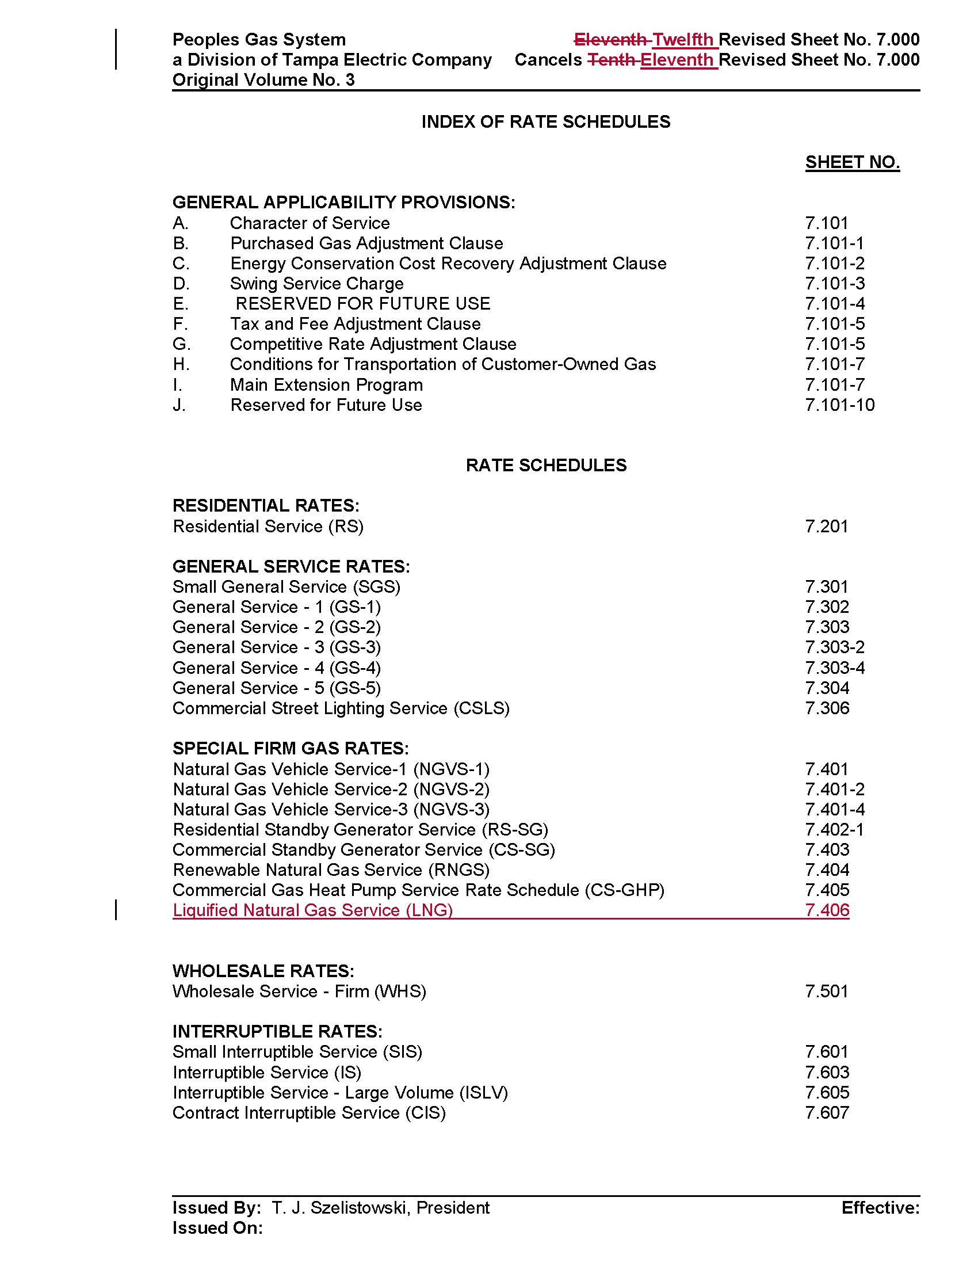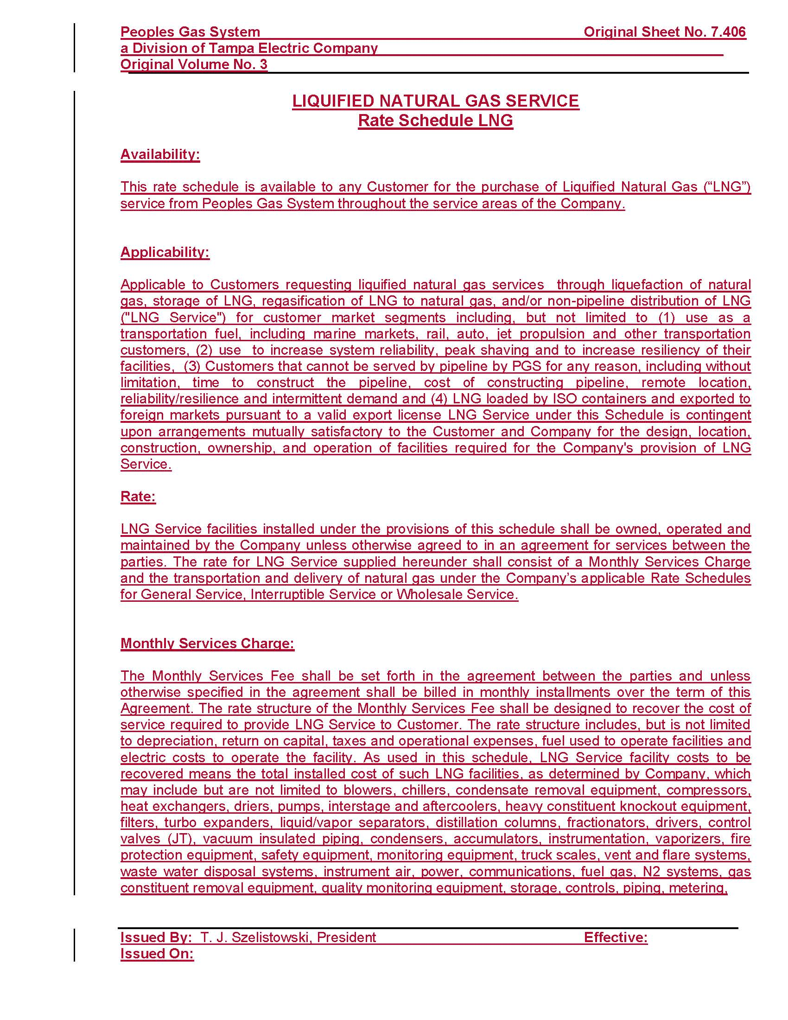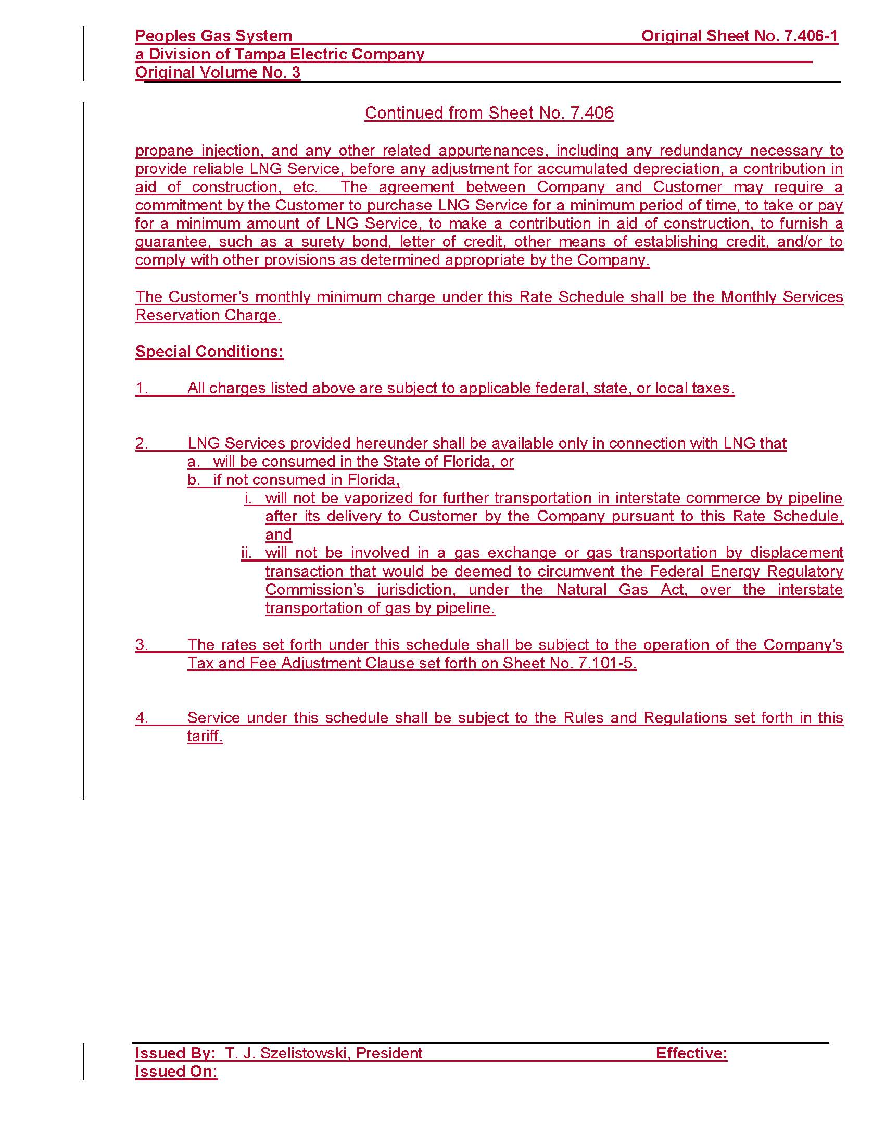

Document No. 01864-2020.
Interested persons in the docket are: Eagle LNG Partners LLC, Thigpen Solutions LLC, Applied LNG Technologies LLC, Zion Jacksonville LLC, and Nopetro – CH4 Holdings LLC.
Document No. 02719-2020.
Document No. 04200-2020.
Document No. 04409-2020.
Peoples’ response to staff’s second data request No. 2 (Document No. 04280-2020).
Peoples’ response to First Set of Interrogatories of Office of Public Counsel, Interrogatory No. 1 (Document No. 04738-2020).
Peoples’ response to staff’s first data request No. 3 (Document No. 02065-2020).
Order No. 25626, issued January 22, 1992, Docket No. 910942-EG, in Re: Petition for approval of Natural Gas Vehicle Conservation Program by Peoples Gas System, Inc.
Order No. PSC-2017-0195-TRF-GU, issued May 19, 2017, Docket No. 170038-GU, in Re: Request for approval of tariff modifications related to natural gas vehicles and fueling facilities by Peoples Gas System.
Order No. PSC-2017-0497-TRF-GU, issued December 29, 2017, Docket No. 20170206-GU, in Re: Petition for approval of tariff modifications to accommodate receipt and transportation of renewable natural gas from customers, by Peoples Gas System.
Peoples’ response to staff’s second data request No. 2 (Document No. 04280-2020).
Peoples’ response to First Set of Interrogatories of Office of Public Counsel, Interrogatory No. 4 (Document No. 04738-2020).
Peoples response to staff’s second data request No. 1 (Document No. 04280-2020).
Docket No. 20200003-GU, In re: Purchased gas adjustment (PGA) true-up.
Order No. PSC-2017-0195-TRF-GU, issued May 19, 2017, Docket No. 2010038-GU, in Re: Request for approval of tariff modifications related to natural gas vehicles and fueling facilities by Peoples Gas System..

