BEFORE THE FLORIDA PUBLIC SERVICE COMMISSION

In re: Joint petition for declaratory statement regarding application of MFR requirements in Rule 25-6.043(1), F.A.C. or, in the alternative, petition for variance, by Florida Power & Light Company and Gulf Power Company. | DOCKET NO. 20200182-EI  ORDER NO. PSC-2020-0312-PAA-EI  ISSUED: September 15, 2020

The following Commissioners participated in the disposition of this matter:

GARY F. CLARK, Chairman
ART GRAHAM
JULIE I. BROWN
DONALD J. POLMANN
ANDREW GILES FAY

FINAL ORDER DENYING JOINT PETITION FOR DECLARATORY STATEMENT
AND
NOTICE OF PROPOSED AGENCY ACTION
ORDER GRANTING JOINT PETITION FOR VARIANCE FROM RULE 25-6.043(1), F.A.C., BY FLORIDA POWER & LIGHT COMPANY AND GULF POWER COMPANY

BY THE COMMISSION:

NOTICE is hereby given by the Florida Public Service Commission that the Commission’s action granting a variance from Rule 25-6.043(1), Florida Administrative Code (F.A.C.) as discussed herein is preliminary in nature and will become final unless a person whose interests are substantially affected files a petition for a formal proceeding, pursuant to Rule 25-22.029, F.A.C. The Commission’s action denying the joint petition for declaratory statement is final agency action and subject to reconsideration and appeal as described below under the heading, “NOTICE OF FURTHER PROCEEDINGS OR JUDICIAL REVIEW.”

I. Background

On July 9, 2020, Joint Petitioners, Florida Power & Light Company (FPL) and Gulf Power Company (Gulf), filed a joint petition for a declaratory statement or, in the alternative, a variance from Rule 25-6.043(1), F.A.C. (Joint Petition). FPL and Gulf ask us to declare that, based on the facts presented, Joint Petitioners’ proposed approach for preparing Minimum Filing Requirements (MFRs) for a rate case filed in 2021 would meet the MFR requirements set forth in Rule 25-6.043(1), F.A.C. In the alternative, Joint Petitioners request a variance from Rule 25-6.043(1), F.A.C., that would allow use of the proposed approach, as described within the Joint Petition.

A. Rule 25-6.043(1), F.A.C.

Rule 25-6.043(1), F.A.C., sets forth the general filing instructions for investor-owned electric utilities’ MFRs when submitting applications for changes in rates.

Rule 25-6.043(1), F.A.C., states, in pertinent part:

(a) The petition under Sections 366.06 and 366.071, F.S., for adjustment of rates must include or be accompanied by:
1. The information required by Commission Form PSC/AFD/011-E (2/04), entitled “Minimum Filing Requirements for Investor-Owned Electric Utilities” which is incorporated into this rule by reference. The form may be obtained from the Commission’s Division of Accounting and Finance.

This requirement implements our authority under Section 366.06, Florida Statutes (F.S.), to investigate, determine, and consider certain costs and factors when fixing and changing rates for investor-owned electric utilities.

Section 366.06(1), F.S., states, in pertinent part:

All applications for changes in rates shall be made to the commission in writing under rules and regulations prescribed, and the commission shall have the authority to determine and fix fair, just, and reasonable rates that may be requested, demanded, charged, or collected by any public utility for its service. The commission shall investigate and determine the actual legitimate costs of the property of each utility company, actually used and useful in the public service . . .. In fixing fair, just, and reasonable rates for each customer class, the commission shall, to the extent practicable, consider the cost of providing service to the class, as well as the rate history, value of service, and experience of the public utility; the consumption and load characteristics of the various classes of customers; and public acceptance of rate structures.

B. Joint Petition

The Joint Petition states that NextEra Energy, FPL’s parent company, completed its acquisition of Gulf in January 2019. Subsequently, FPL and Gulf began to consolidate various aspects of their utility operations but still presently operate as separate entities with their own sets of books and rates for their respective customers. FPL and Gulf have requested the Federal Energy Regulatory Commission’s approval of an internal corporate reorganization in which Gulf will merge with and into FPL, effective January 1, 2021. Joint Petitioners state that this decision is expected no later than the end of October 2020.

Joint Petitioners reviewed the MFR requirements for a rate filing in 2021 that would result in new consolidated rates reflecting the integration of FPL and Gulf operations in a fully-consolidated FPL (“Consolidated FPL”). Joint Petitioners’ review identified that although MFR data for 2022 and beyond would be based on the operations of Consolidated FPL, only limited data will be available on a consolidated basis prior to 2022.

Accordingly, in paragraph 8 of the Joint Petition, FPL and Gulf propose to prepare the individual MFRs that seek data for the test period and prior years for which consolidated data are not available as follows:

(a) There are 55 MFRs that contemplate the reporting of accounting and other data for years prior to the test year. Those MFRs are identified on Exhibit 1 to this petition. For the Exhibit 1 MFRs, FPL proposes to provide Consolidated FPL data for the 2022 test year on an initial page or set of pages (“Page 1”). Then, for reporting on any years prior to the 2022 test year on the Exhibit 1 MFRs, FPL and Gulf would provide standalone data for legacy FPL operations on a second page or set of pages (“Page 2”) and standalone data for legacy Gulf operations on a third page or set of pages (“Page 3”). Together, Pages 1, 2 and 3 would provide a complete view of the requested data for all of the years required by the Exhibit 1 MFRs, while recognizing the reality that in the years prior to 2022, FPL and Gulf were operated as separate entities with their own standalone rate base, operating expenses, etc. Attached as part of Exhibit 1 is a mock-up of MFR B-22 showing on Pages 1, 2 and 3 illustrative data for Consolidated FPL, standalone legacy FPL and standalone legacy Gulf, respectively.

(b) In addition to the 55 MFRs identified in Exhibit 1, there are 8 other MFRs that likewise contemplate the reporting of accounting and other data for years prior to the test year but also require calculations and/or comparisons of data between the 2022 test year and the earlier years. The calculations and comparisons would not be meaningful if made using Consolidated FPL data for the 2022 test year and standalone legacy FPL (or standalone legacy Gulf) data for the prior years. Those MFRs are identified on Exhibit 2 to this petition. In order to provide a basis for the calculations and comparisons required for the Exhibit 2 MFRs, FPL and Gulf propose to add the legacy FPL and legacy Gulf data together for years prior to 2022 and report the resulting totals in the necessary locations on Page 1 of the Exhibit 2 MFRs. FPL would include a footnote to those MFRs making it clear that the totals may not precisely reflect what the results of actual consolidation would have been if FPL and Gulf had been operated as one company but represent the available information for the purpose of the MFRs. Attached as part of Exhibit 2 is a mock-up of each Exhibit 2 MFR showing where the “Legacy FPL + Legacy Gulf” totals would be provided, along with the appropriate footnote.

Joint Petitioners’ response to Staff’s First Data Request, filed July 24, 2020, stated that two additional MFR schedules, Schedules F6 and F7, should be included with the 55 schedules in Exhibit 1. Schedule F6 is “Forecasting Models – Sensitivity of Output to Changes in Input Data,” and Schedule F7 is “Forecasting Models – Historical Data.”

Joint Petitioners request that we issue a declaratory statement confirming Joint Petitioners’ assertion that the proposed approach in Paragraphs 8(a) and 8(b) of the Joint Petition, as described above, would adequately and appropriately satisfy the MFR requirements of Rule 25-6.043(1), F.A.C. Alternatively, Joint Petitioners request that we grant FPL a variance from Rule 25-6.043(1), F.A.C., to allow FPL to complete and file the Exhibit 1 and Exhibit 2 MFRs as proposed in Paragraphs 8(a) and 8(b) of the Joint Petition, as described above.

C. Procedural Matters

Pursuant to Section 120.565(3), F.S., and Rule 28-105.0024, F.A.C., a Notice of Declaratory Statement was published in the July 13, 2020 edition of the Florida Administrative Register to inform interested persons of the Joint Petition. No requests to intervene were filed, and the time for filing such a request expired on August 3, 2020.

Pursuant to Section 120.542(6), F.S., a Notice of Variance or Waiver was published in the July 13, 2020 edition of the Florida Administrative Register. On August 31, 2020, the Office of Public Counsel (OPC) filed a jointly agreed statement in support of our staff’s recommendation dated August 20, 2020, on behalf of OPC, FPL, and Gulf. OPC also read this jointly agreed statement into the record at the September 1, 2020 Agenda Conference. The statement is attached to this Order as Attachment A. No other comments were received.

We have jurisdiction pursuant to Sections 120.542 and 120.565, F.S., and Chapter 366, F.S.

II. Decision on Joint Petition for Declaratory Statement

Joint Petitioners request that we issue a declaratory statement confirming that the proposed approach described in Paragraphs 8(a) and 8(b) of the Joint Petition would meet the MFR requirements set forth in Rule 25-6.043(1), F.A.C.

A. Law Governing Petitions for Declaratory Statement

Section 120.565, F.S., sets forth the necessary elements of a petition for declaratory statement. This section provides:

(1) Any substantially affected person may seek a declaratory statement regarding an agency’s opinion as to the applicability of a statutory provision, or of any rule or order of the agency, as it applies to the petitioner’s particular set of circumstances.
(2) The petition seeking a declaratory statement shall state with particularity the petitioner’s set of circumstances and shall specify the statutory provision, rule, or order that the petitioner believes may apply to the set of circumstances.

Rule 28-105.001, F.A.C., states the purpose of a declaratory statement:

A declaratory statement is a means for resolving a controversy or answering questions or doubts concerning the applicability of statutory provisions, rules, or orders over which the agency has authority. A petition for declaratory statement may be used to resolve questions or doubts as to how the statutes, rules, or orders may apply to the petitioner’s particular circumstances. A declaratory statement is not the appropriate means for determining the conduct of another person.

Rule 28-105.002(5), F.A.C., requires that a petition for declaratory statement include a description of how the statutes, rules, or orders may substantially affect the petitioner in the petitioner’s particular set of circumstances. A party seeking a declaratory statement must not only show that it is in doubt as to the existence of some right or status, but also that there is a bona fide, actual, present, and practical need for the declaration. State Department of Environmental Protection v. Garcia, 99 So. 3d 539, 544-45 (Fla. 3d DCA 2011). A declaratory statement is intended to enable members of the public to definitively resolve ambiguities of law in the planning of their future affairs and to enable the public to obtain definitive binding advice as to the applicability of agency law to a particular set of facts. Department of Business and Professional Regulation, Div. of Pari-Mutual Wagering v. Investment Corp. of Palm Beach, 747 So. 2d 374, 382 (Fla. 1999).

B. Declaratory Statement Requested by FPL and Gulf

FPL and Gulf ask us to issue a declaratory statement affirming that:

Preparing the Exhibit 1 and Exhibit 2 MFRs as described in Paragraphs 8(a) and 8(b) of FPL’s and Gulf’s July 9, 2020 joint petition for declaratory statement would adequately and appropriately satisfy the MFR requirements of Rule 25-6.043(1) for years prior to 2022 when FPL and Gulf operations were not yet consolidated.

C. Analysis of Joint Petition for Declaratory Statement

The purpose of a declaratory statement is to address the applicability of statutory provisions, orders, or rules of the agency in particular circumstances. Section 120.565, F.S.; See Chiles v. Department of State, Division of Elections, 711 So. 2d 151, 154 (Fla. 1st DCA 1998). Further, pursuant to Rule 28-105.001, F.A.C., a petition for a declaratory statement may be used to resolve questions or doubts as to how an agency’s statutes and rules may apply to the petitioner’s particular circumstances.

The Joint Petition contains specific facts as required by Section 120.565(2), F.S., and provides that the requested declaratory statement will enable Joint Petitioners to file MFRs for the establishment of rates for Consolidated FPL that provide a meaningful representation of operations for both the pre- and post-consolidation periods. However, the Joint Petition does not ask us to issue a declaratory statement concerning the applicability of our pertinent statutes and rules to Joint Petitioners’ particular circumstances. Rather, the Joint Petition asks us to permit Joint Petitioners to provide alternative MFR information in lieu of the MFR information required by Rule 25-6.043(1), F.A.C., due to unavailability or impossibility stemming from Joint Petitioners’ particular circumstances.

The declaratory statement procedure is meant to help individuals resolve ambiguities of law encountered in the planning of their future affairs regarding the applicability of an agency’s laws to the individual’s particular set of facts. Dept. of Bus. and Prof’l Reg., 747 So. 2d at 382. The Joint Petition does not allege that ambiguity exists regarding the applicability of Section 366.06, F.S., and Rule 25-6.043(1), F.A.C., to Joint Petitioners’ 2021 rate case filing. To the contrary, the Joint Petition acknowledges the requirement to file MFRs in a 2021 rate case filing and outlines Joint Petitioners’ proposal to provide information that will satisfy the requirements of the applicable laws. More narrowly, the requested declaratory statement imparts a procedure for how a merged company can submit satisfactory MFR filings, not if a merged company is required to submit satisfactory MFR filings. Thus, a declaratory statement is not the proper vehicle for the relief requested by the Joint Petitioners.

D. Conclusion

Based on the above, we hereby deny Joint Petitioners’ request for a declaratory statement.

III. Decision on Alternative Request for Variance from Rule 25-6.043(1), F.A.C.

Joint Petitioners ask, if the requested declaratory statement is denied, that we grant FPL a variance from Rule 25-6.043(1), F.A.C., to allow FPL to complete and file the MFRs attached as Exhibits 1 and 2 as proposed in Paragraphs 8(a) and 8(b) of the Joint Petition for a 2021 rate case filing. Upon our staff’s inquiry, Joint Petitioners later modified Exhibit 1 to include two additional MFR schedules. The rule requires investor-owned electric utilities to file MFR schedules when submitting a petition for rate relief. These schedules include substantial accounting, engineering, rate, cost of capital, and other data that this Commission, our staff, and the parties use in reviewing the rate request. Joint Petitioners assert that their proposed approach would achieve the purpose of the underlying statute implemented by Rule 25-6.043(1), F.A.C., and that not permitting their proposed approach would create a substantial hardship and violate principles of fairness.

A. Law Governing Petitions for Variance

Section 120.542(2), F.S., directs agencies to grant variances or waivers from agency rules when the person subject to the rule demonstrates that the purpose of the underlying statute will be or has been achieved by other means and application of the rule would cause the person substantial hardship or violate the principles of fairness. As defined by Section 120.542(2), F.S., “substantial hardship” means a demonstrated economic, technological, legal, or other type of hardship.

B. Purpose of the Underlying Statute

The purpose of Section 366.06, F.S., is to ensure that investor-owned electric utilities only charge or receive Commission-approved rates; to ensure that we only approve rates that are fair, just, and reasonable for each customer class; and to set a procedure for fixing and changing rates.

Joint Petitioners request a variance from the Rule 25-6.043(1), F.A.C., requirement for submission of certain MFR information for a 2021 rate case filing because certain consolidated data does not yet exist. Instead, FPL would submit the MFR information as described in Paragraphs 8(a) and 8(b) and Exhibits 1 and 2 of the Joint Petition for a 2021 rate case filing. Joint Petitioners assert that this proposed approach will provide us with the type of information contemplated by those MFRs, to the maximum extent available, and ensure that we can evaluate a rate case filing based on those MFRs. For these reasons, Joint Petitioners assert that its proposed filings would achieve the underlying purpose of Section 366.06, F.S.

Joint Petitioners’ proposed approach to preparing MFRs for a 2021 rate case filing will allow us to evaluate the rate case based on those MFRs and fulfill our statutory obligation to approve rates that are fair, just, and reasonable, as long as this Commission, our staff, and the parties maintain the ability to conduct appropriate discovery and cross-examination on such information. Therefore, we find that the purpose of the underlying statute will be achieved by other means for a 2021 rate case filing, provided that discovery and cross-examination procedures remain intact.

C. Substantial Hardship

Joint Petitioners assert that application of the rule would create a substantial hardship and violate principles of fairness because they do not believe that a more reasonable or meaningful way exists to submit MFRs for a 2021 rate case filing. Joint Petitioners further state that if no variance is granted, FPL risks being found deficient in its rate case filing, which would impose a substantial hardship and violate principles of fairness.

Strict application of Rule 25-6.043(1), F.A.C., in Joint Petitioners’ potential 2021 rate case filing would create a substantial hardship for Joint Petitioners based on the unavailability of certain MFR information. Therefore, we find that Joint Petitioners have demonstrated that a strict application of the rule would create a substantial hardship under the circumstances described by Joint Petitioners.

D. Conclusion

Based on the above, we hereby grant Joint Petitioners’ request for variance from Rule 25-6.043(1), F.A.C., to allow FPL to complete and file the Exhibit 1 MFRs (as modified to include Schedules F6 and F7) and Exhibit 2 MFRs as proposed in Paragraphs 8(a) and 8(b) of the Joint Petition for a 2021 rate case filing, subject to discovery and cross-examination procedures remaining intact.

Based on the foregoing, it is

ORDERED by the Florida Public Service Commission that Florida Power & Light Company and Gulf Power Company’s joint petition for declaratory statement is denied for the reasons set forth in the body of this Order. It is further

ORDERED that Florida Power & Light Company and Gulf Power Company’s alternative request for a variance from Rule 25-6.043(1), Florida Administrative Code, is granted as set forth in the body of this Order, subject to discovery and cross-examination procedures remaining intact. It is further

ORDERED that the provisions of this Order, issued as proposed agency action, shall become final and effective upon the issuance of a Consummating Order unless an appropriate petition, in the form provided by Rule 28-106.201, Florida Administrative Code, is received by the Office of Commission Clerk, 2540 Shumard Oak Boulevard, Tallahassee, Florida 32399-0850, by the close of business on the date set forth in the “Notice of Further Proceedings” attached hereto. It is further

ORDERED that if no person whose substantial interests are affected by the proposed agency action files a protest within 21 days of the issuance of the order, this docket shall be closed upon the issuance of a Consummating Order.

By ORDER of the Florida Public Service Commission this 15th day of September, 2020.

/s/ Adam J. Teitzman
ADAM J. TEITZMAN
Commission Clerk
Florida Public Service Commission
2540 Shumard Oak Boulevard
Tallahassee, Florida 32399
(850) 413-6770
www.floridapsc.com

Copies furnished: A copy of this document is provided to the parties of record at the time of issuance and, if applicable, interested persons.

MAD

NOTICE OF FURTHER PROCEEDINGS OR JUDICIAL REVIEW

The Florida Public Service Commission is required by Section 120.569(1), Florida Statutes, to notify parties of any administrative hearing or judicial review of Commission orders that is available under Sections 120.57 or 120.68, Florida Statutes, as well as the procedures and time limits that apply. This notice should not be construed to mean all requests for an administrative hearing or judicial review will be granted or result in the relief sought.

As identified in the body of this order, the Commission action granting a variance from Rule 25-6.043(1), Florida Administrative Code, is preliminary in nature. Any person whose substantial interests are affected by the action proposed by this order may file a petition for a formal proceeding, in the form provided by Rule 28-106.201, Florida Administrative Code. This petition must be received by the Office of Commission Clerk, at 2540 Shumard Oak Boulevard, Tallahassee, Florida 32399-0850, by the close of business on October 6, 2020. If such a petition is filed, mediation may be available on a case-by-case basis. If mediation is conducted, it does not affect a substantially interested person's right to a hearing. In the absence of such a petition, this order shall become effective and final upon the issuance of a Consummating Order.

Any objection or protest filed in this docket before the issuance date of this order is considered abandoned unless it satisfies the foregoing conditions and is renewed within the specified protest period.

The Commission action denying the petition for declaratory statement is final agency action. Any party adversely affected by the Commission's final action in this matter may request: (1) reconsideration of the decision by filing a motion for reconsideration with the Office of Commission Clerk, within fifteen (15) days of the issuance of this order in the form prescribed by Rule 25-22.060, Florida Administrative Code; or (2) judicial review by the Florida Supreme Court in the case of an electric, gas or telephone utility or the First District Court of Appeal in the case of a water or wastewater utility by filing a notice of appeal with the Office of Commission Clerk and filing a copy of the notice of appeal and the filing fee with the appropriate court. This filing must be completed within thirty (30) days after the issuance of this order, pursuant to Rule 9.110, Florida Rules of Appellate Procedure. The notice of appeal must be in the form specified in Rule 9.900(a), Florida Rules of Appellate Procedure.

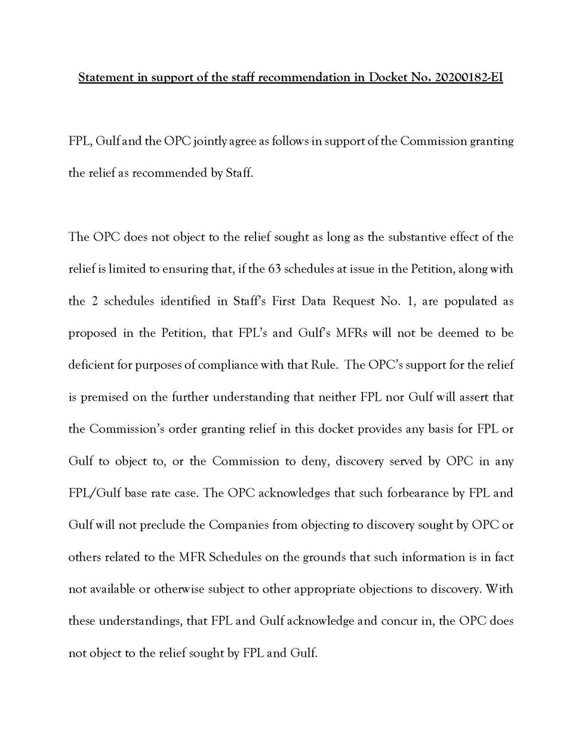

Joint Petitioners provided that Schedules F6 and F7, omitted from the Joint Petition, should be included with the 55 schedules appearing in Exhibit 1. Schedule F6 is “Forecasting Models – Sensitivity of Output to Changes in Input Data” and Schedule F7 is “Forecasting Models – Historical Data.”
Pursuant to Section 120.542(1), F.S., agencies are authorized to impose conditions on a grant of variance to the extent necessary in order to achieve the purpose of the underlying statute.

