BEFORE THE FLORIDA PUBLIC SERVICE COMMISSION

In re: Joint petition for approval of amendment to territorial agreement in St. Johns County, by Florida Power & Light Company and JEA. | DOCKET NO. 20200162-EU  ORDER NO. PSC-2020-0319-PAA-EU  ISSUED: September 21, 2020

The following Commissioners participated in the disposition of this matter:

GARY F. CLARK, Chairman
ART GRAHAM
JULIE I. BROWN
DONALD J. POLMANN
ANDREW GILES FAY

NOTICE OF PROPOSED AGENCY ACTION
ORDER FOR APPROVAL OF AMENDMENT TO TERRITORIAL AGREEMENT

BY THE COMMISSION:

NOTICE is hereby given by the Florida Public Service Commission that the action discussed herein is preliminary in nature and will become final unless a person whose interests are substantially affected files a petition for a formal proceeding, pursuant to Rule 25-22.029, Florida Administrative Code (F.A.C.).

Background
On June 3, 2020, Florida Power & Light Company (FPL) and JEA, collectively the joint petitioners or parties, filed a petition seeking our approval of a Third Amendment to their existing territorial agreement in St. Johns County. The existing service boundary line bifurcates a planned subdivision located in St. Johns County. The proposed Third Amendment allows FPL and JEA to swap certain parcels within their respective service territories in St. Johns County, which will allow JEA to serve the entire planned subdivision. The proposed Third Amendment, legal descriptions, and maps depicting the swapped land parcels and revised service boundaries are provided in Attachment A to this order.
We approved the parties’ first territorial agreement in St. Johns County in 1965. Thereafter, we re-affirmed the territorial boundary in 1980. In 1996, as the result of a territorial dispute, FPL and JEA entered into a new territorial agreement which replaced the prior agreement. After the discovery of an inconsistency between the 1996 Agreement and a territorial agreement between JEA and Clay Electric Cooperative, we approved a new territorial agreement between FPL and JEA in 1998. In 2012, we approved an amendment that altered a segment of the territorial boundaries between the parties so that a single utility could serve the electric needs of a new private development planned for an undeveloped area. In 2014, the parties entered into the second amendment to the existing territorial agreement to alter the boundary to align it with planned roadways and accommodate new expanding development.

In this order we address the proposed Third Amendment to the existing territorial agreement. We have jurisdiction over this matter pursuant to Section 366.04, Florida Statutes (F.S.).

Decision
Pursuant to Section 366.04(2)(d), F.S., and Rule 25-6.0440, F.A.C., we have jurisdiction to approve territorial agreements between and among rural electric cooperatives, municipal electric utilities, and other electric utilities. Unless we determine that the agreement will cause a detriment to the public interest, the agreement shall be approved.
On June 3, 2020, FPL and JEA entered into the Third Amendment to their 1998 territorial agreement, which shall continue and remain in effect until we issue an order modifying or withdrawing our approval of this Agreement after proper notice and hearing. Other than the proposed parcel swaps, all other parts of the territorial agreement remain in effect. The proposed Third Amendment finalizes the territorial boundary adjustments between FPL and JEA that are necessary to accommodate development and facilitate the provision of electricity to the expanding development by one utility, and is also intended to avoid duplication of services in the areas subject to the parcel swaps. Pursuant to the agreed upon amendment, three parcels (5, 6, and 7) located within JEA’s territory will be transferred to FPL and one parcel (parcel 4) located within FPL’s territory will be transferred to JEA. Total acreage of the swapped parcels is 22.30 acres located in St. Johns County.

Currently, the subject parcels are undeveloped; therefore, there are no customers or electric facilities in parcels 4, 5, 6, and 7 pursuant to paragraph 2 of the proposed 2020 Amendment. With the parcel swap, JEA will provide electricity to 342 residential customers in the planned development for parcel 4 (13.43 acres), and FPL will provide electricity to parcels 5, 6, and 7 (total of 8.87 acres) if developed in the future. With the parcel swap, the Parties will be better positioned to provide electric service in the future to other development within this area.

Paragraph 18 of the petition states that since the areas subject to the parcel swap in this 2020 Amendment are currently undeveloped, there are no infrastructure or customer accounts to be transferred; therefore, no customers were notified pursuant to Rule 25-6.0440(1), F.A.C.
In paragraph 20 of the petition, the Parties state that approval of the proposed 2020 Amendment will not cause a decrease in reliability of electric service to the existing or future customers.

Conclusion

After review of the petition and record, we find that the proposed Third Amendment will enable FPL and JEA to exchange four land parcels within their respective retail service territories, achieve necessary changes to accommodate development, and serve their current and future customers efficiently. We have determined that the proposed Third Amendment to the existing agreement eliminates any potential uneconomic duplication of facilities and will not cause a decrease in reliability of electric service. We hereby approve the proposed Third Amendment dated June 3, 2020, to the exiting territorial agreement between FPL and JEA in St. Johns County. The proposed Third Amendment to the territorial agreement shall become effective on the date our Order becomes final.
Based on the foregoing, it is

ORDERED by the Florida Public Service Commission that the proposed Third Amendment, dated June 3, 2020, to the existing territorial agreement between Florida Power & Light Company and JEA in St. Johns County. It is further

ORDERED that the provisions of this Order, issued as proposed agency action, shall become final and effective upon the issuance of a Consummating Order unless an appropriate petition, in the form provided by Rule 28-106.201, Florida Administrative Code, is received by the Commission Clerk, 2540 Shumard Oak Boulevard, Tallahassee, Florida 32399-0850, by the close of business on the date set forth in the “Notice of Further Proceedings” attached hereto. It is further

ORDERED that in the event this Order becomes final, this docket shall be closed.

By ORDER of the Florida Public Service Commission this 21st day of September, 2020.

/s/ Adam J. Teitzman
ADAM J. TEITZMAN
Commission Clerk
Florida Public Service Commission
2540 Shumard Oak Boulevard
Tallahassee, Florida 32399
(850) 413-6770
www.floridapsc.com

Copies furnished: A copy of this document is provided to the parties of record at the time of issuance and, if applicable, interested persons.
WLT

NOTICE OF FURTHER PROCEEDINGS OR JUDICIAL REVIEW

The Florida Public Service Commission is required by Section 120.569(1), Florida Statutes, to notify parties of any administrative hearing that is available under Section 120.57, Florida Statutes, as well as the procedures and time limits that apply. This notice should not be construed to mean all requests for an administrative hearing will be granted or result in the relief sought.

Mediation may be available on a case-by-case basis. If mediation is conducted, it does not affect a substantially interested person's right to a hearing.

The action proposed herein is preliminary in nature. Any person whose substantial interests are affected by the action proposed by this order may file a petition for a formal proceeding, in the form provided by Rule 28-106.201, Florida Administrative Code. This petition must be received by the Office of Commission Clerk, 2540 Shumard Oak Boulevard, Tallahassee, Florida 32399-0850, by the close of business on October 12, 2020.

In the absence of such a petition, this order shall become final and effective upon the issuance of a Consummating Order.

Any objection or protest filed in this/these docket(s) before the issuance date of this order is considered abandoned unless it satisfies the foregoing conditions and is renewed within the specified protest period.

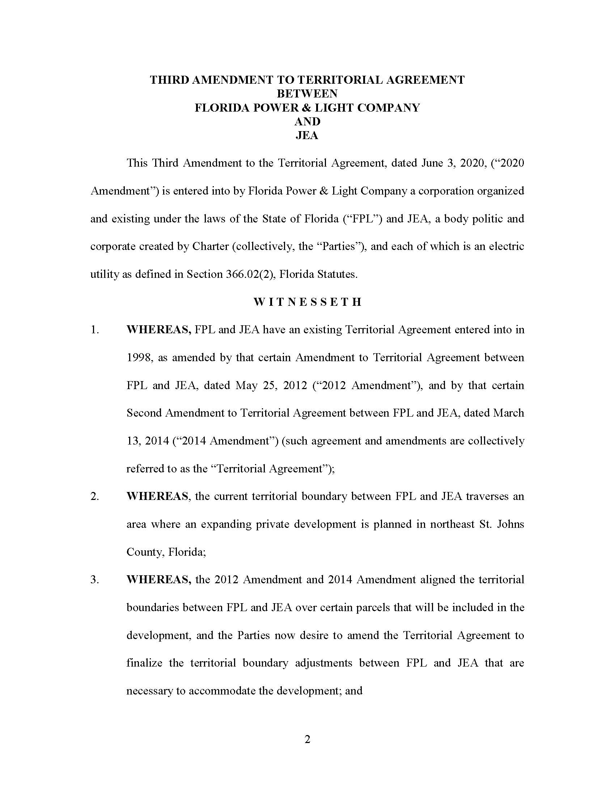

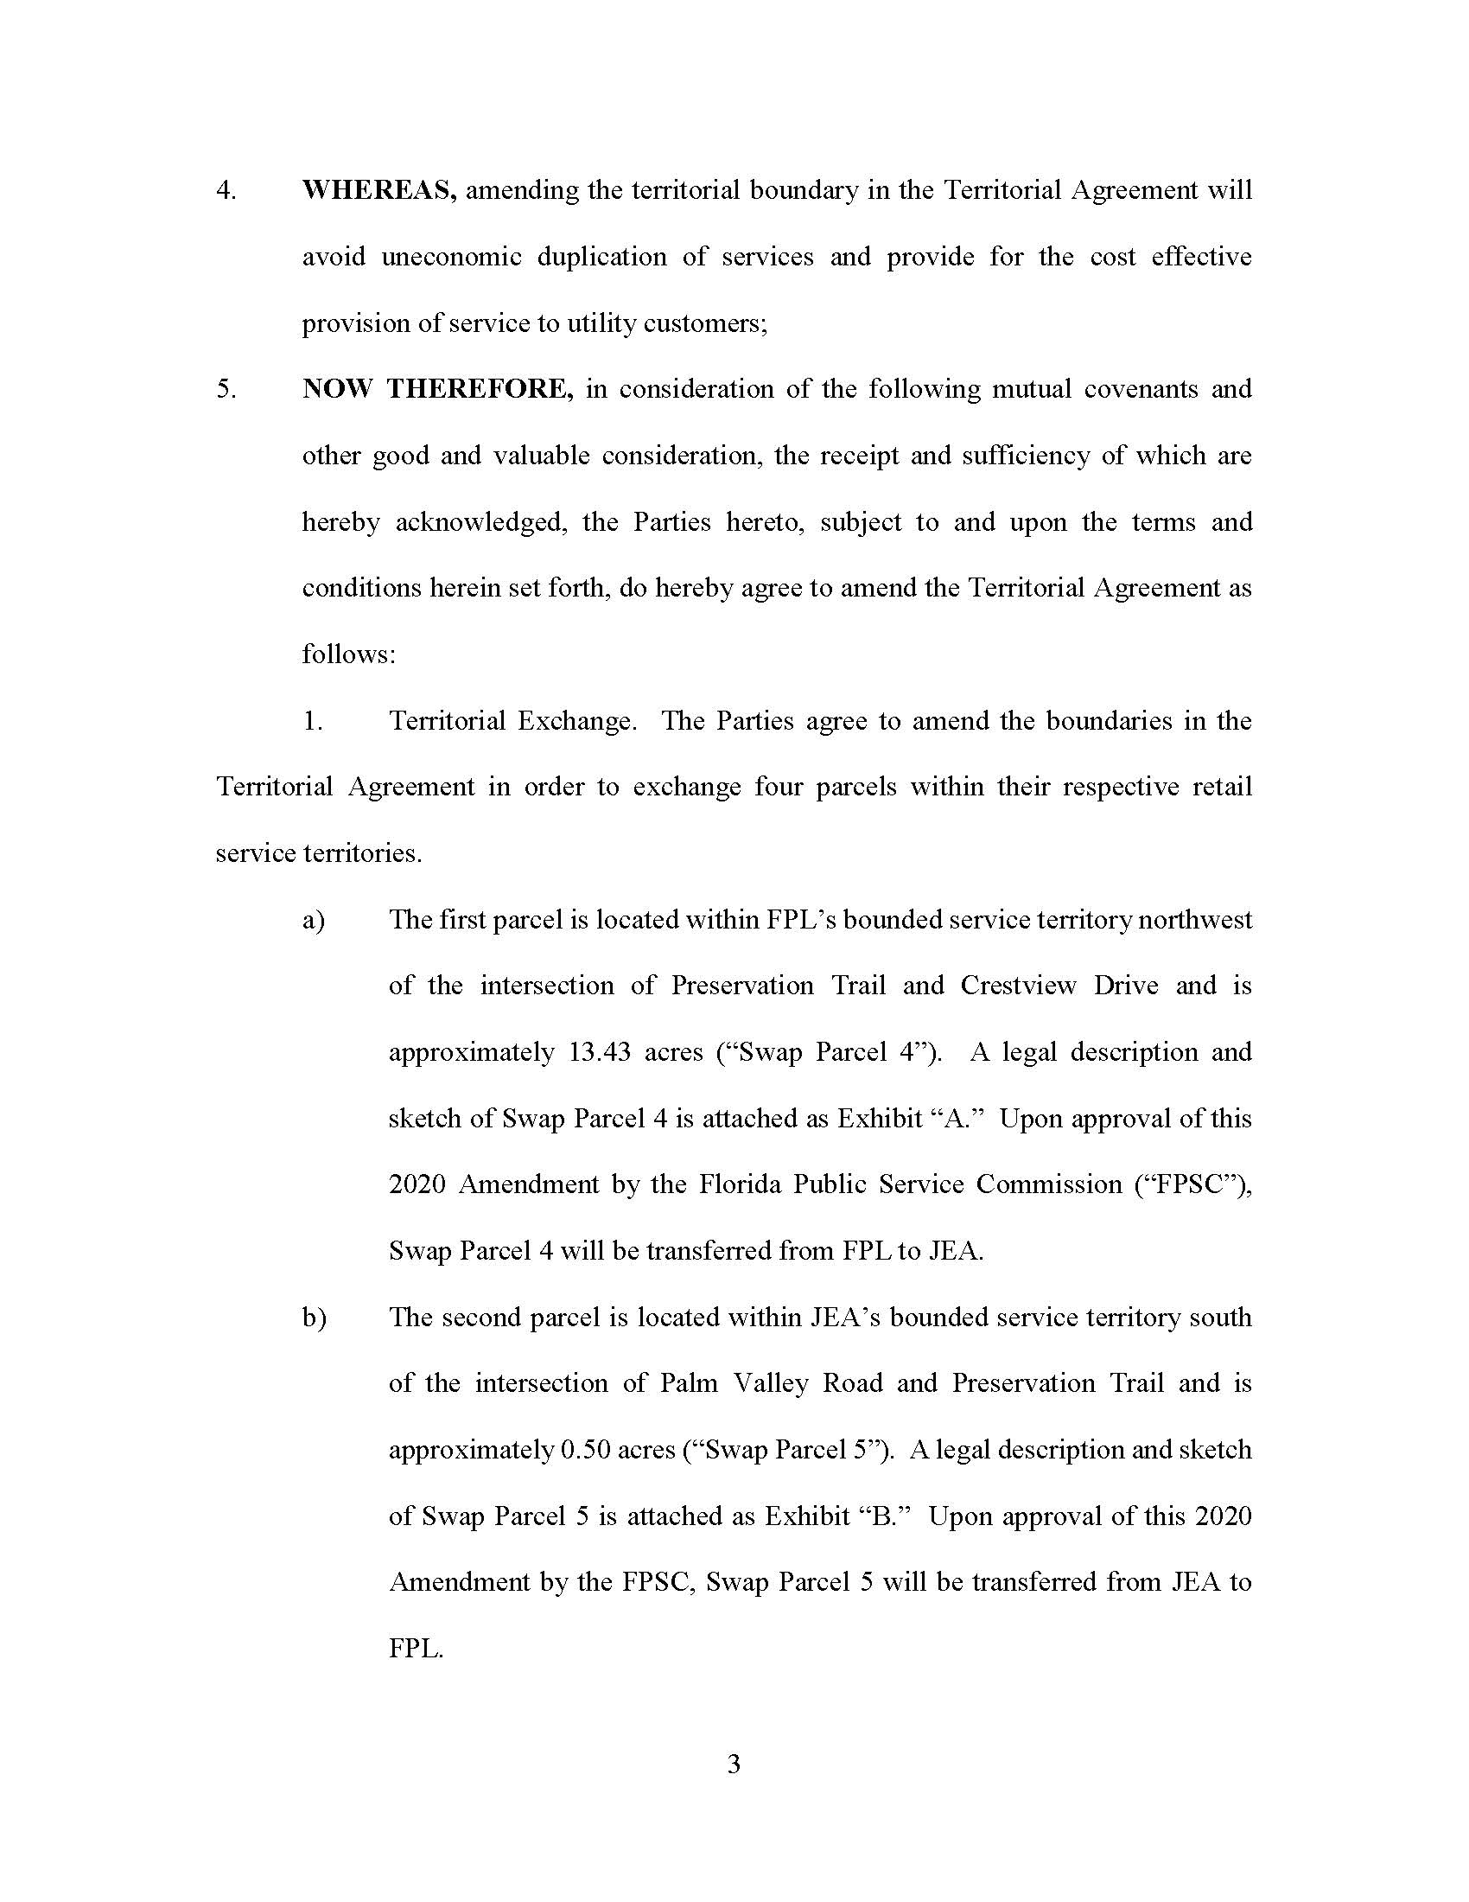

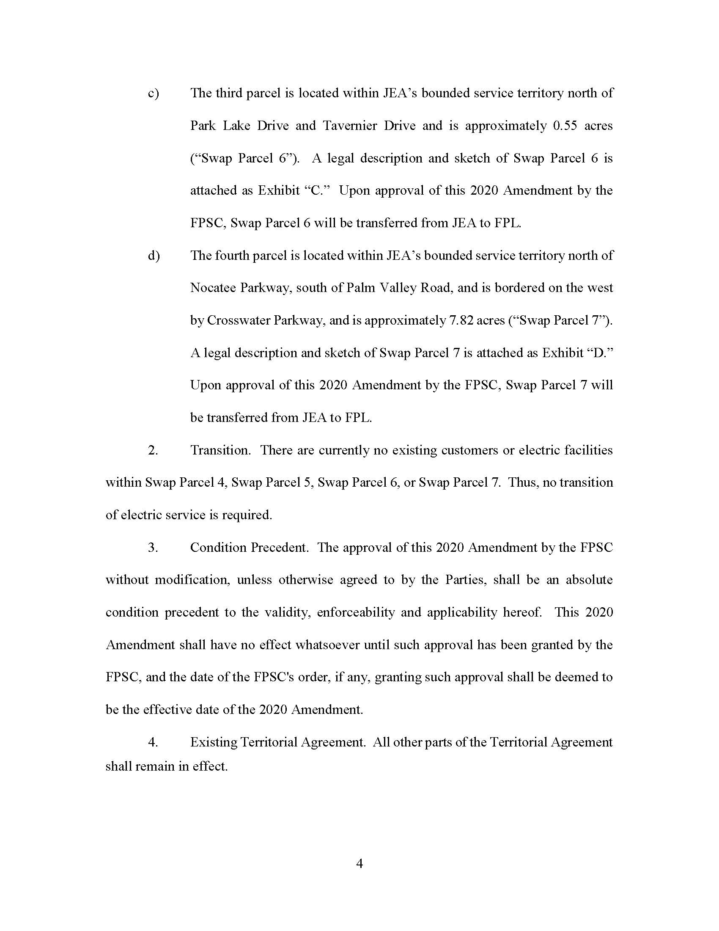

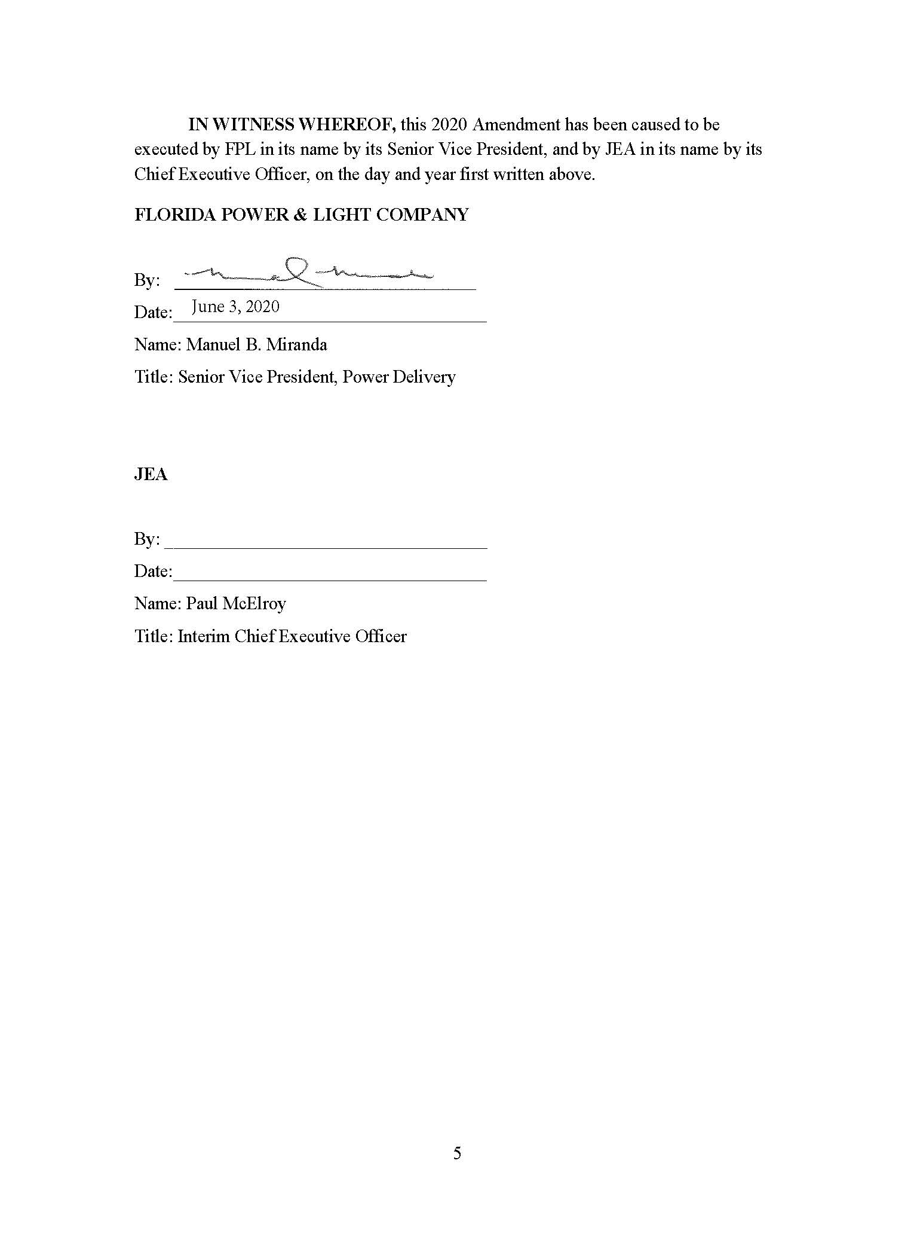

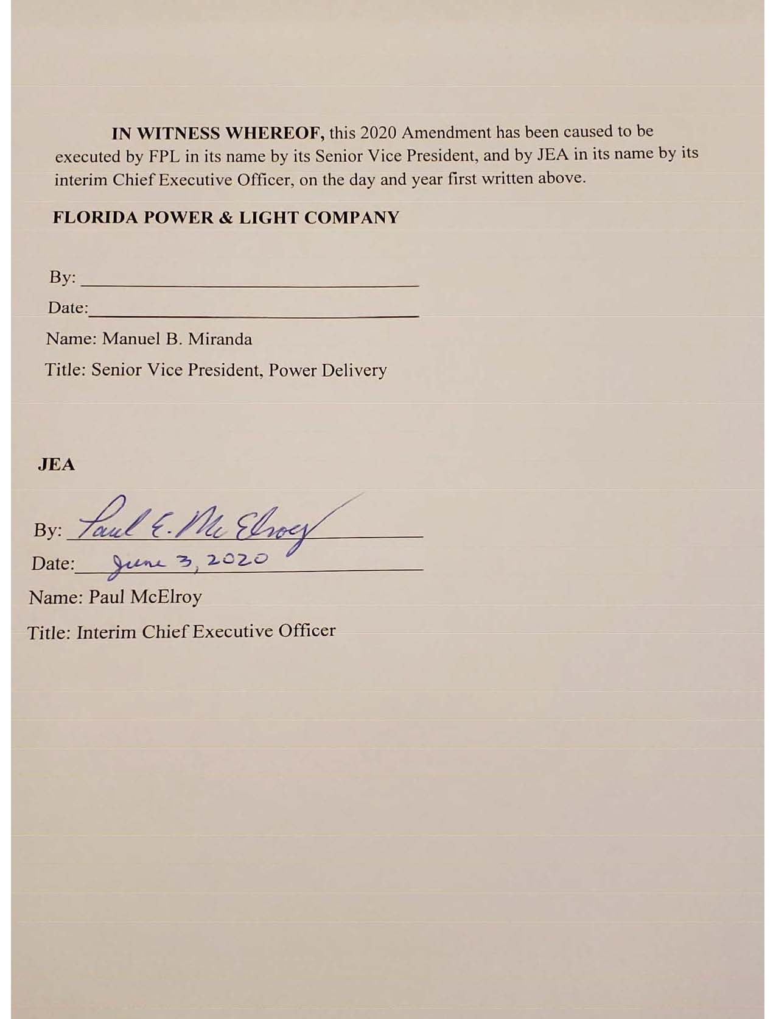

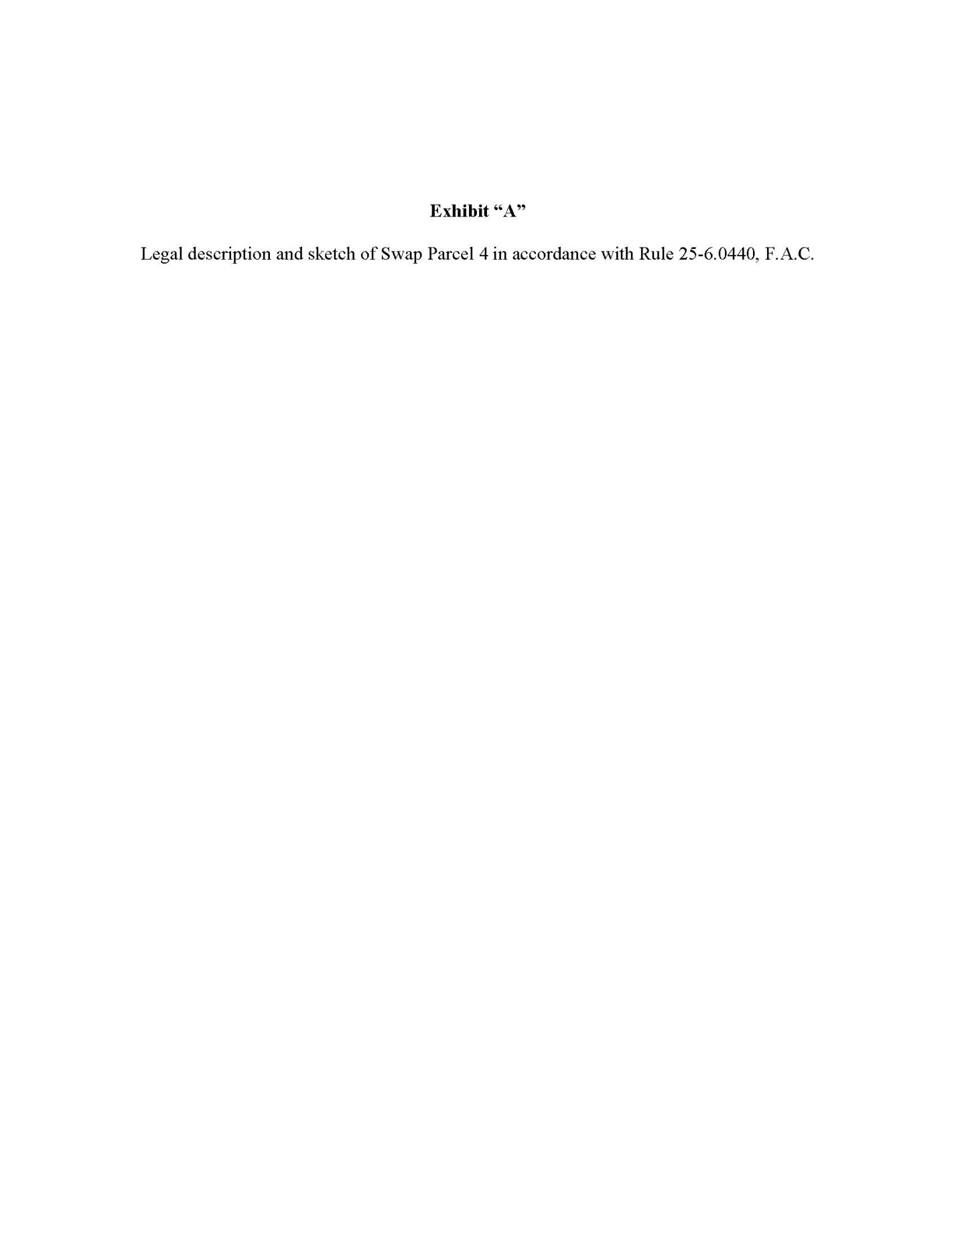

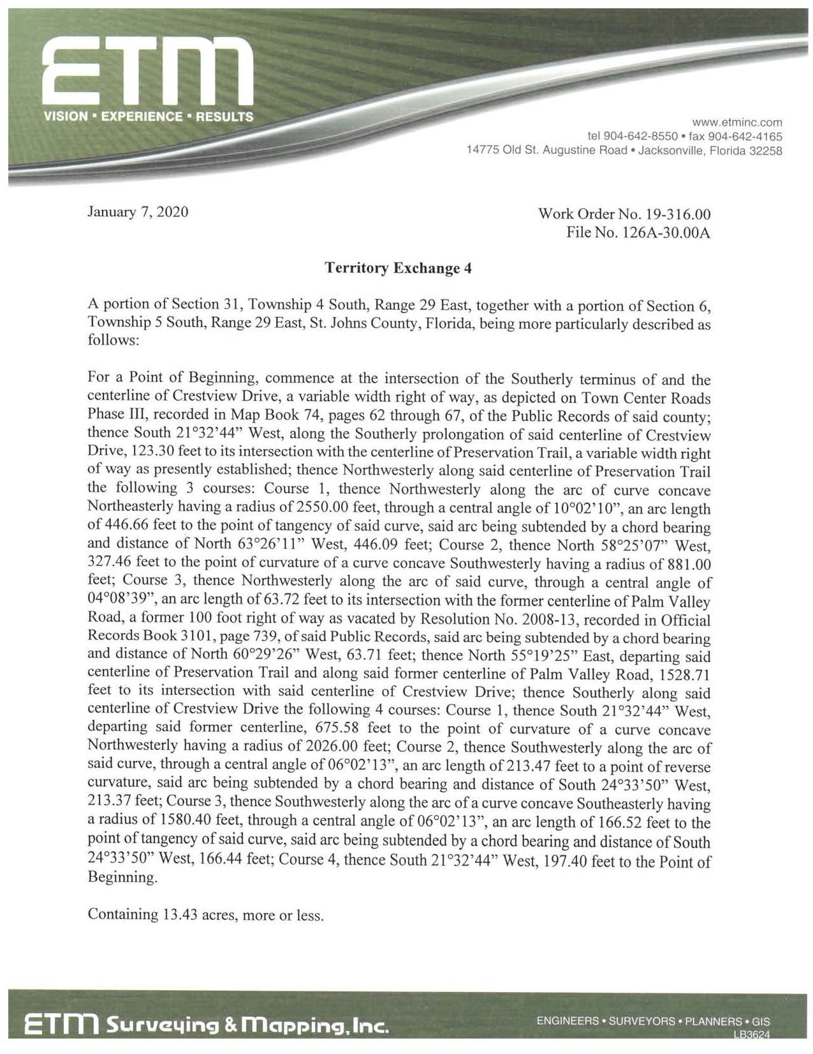

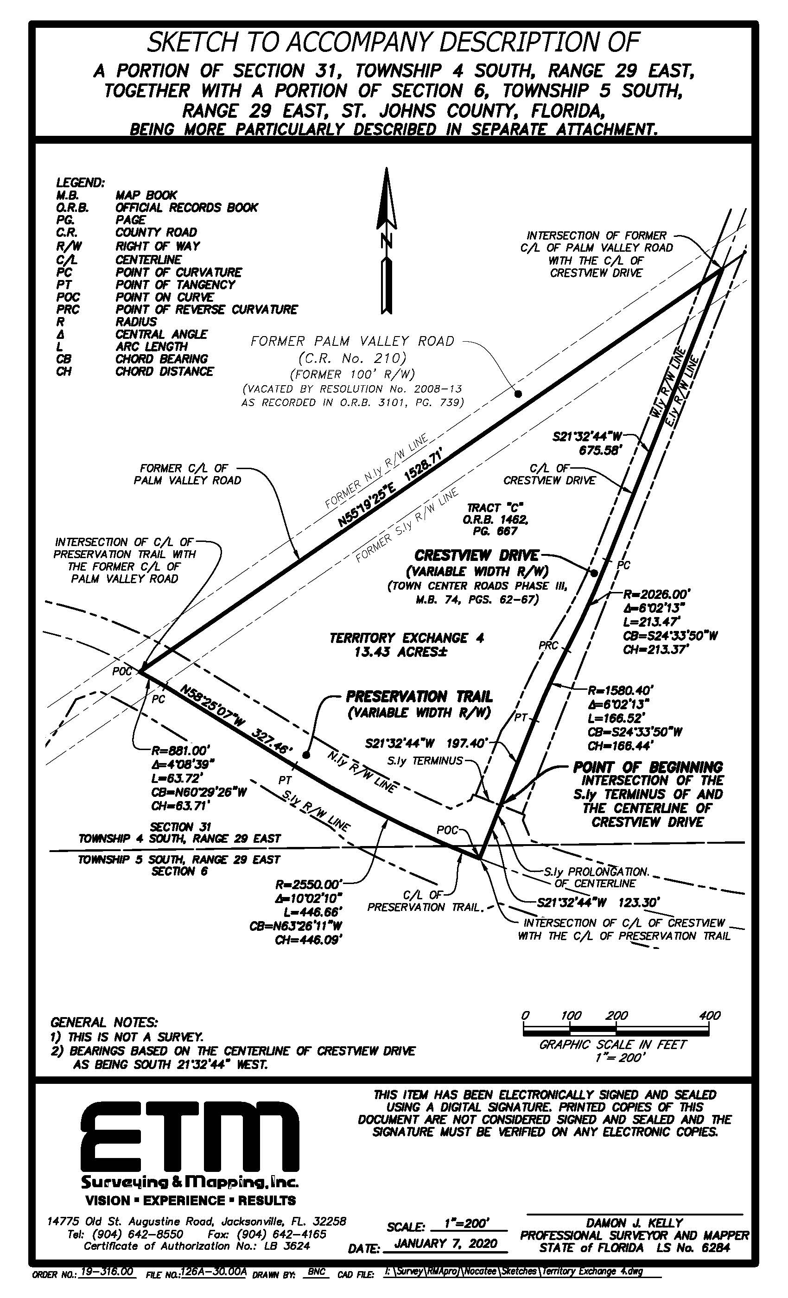
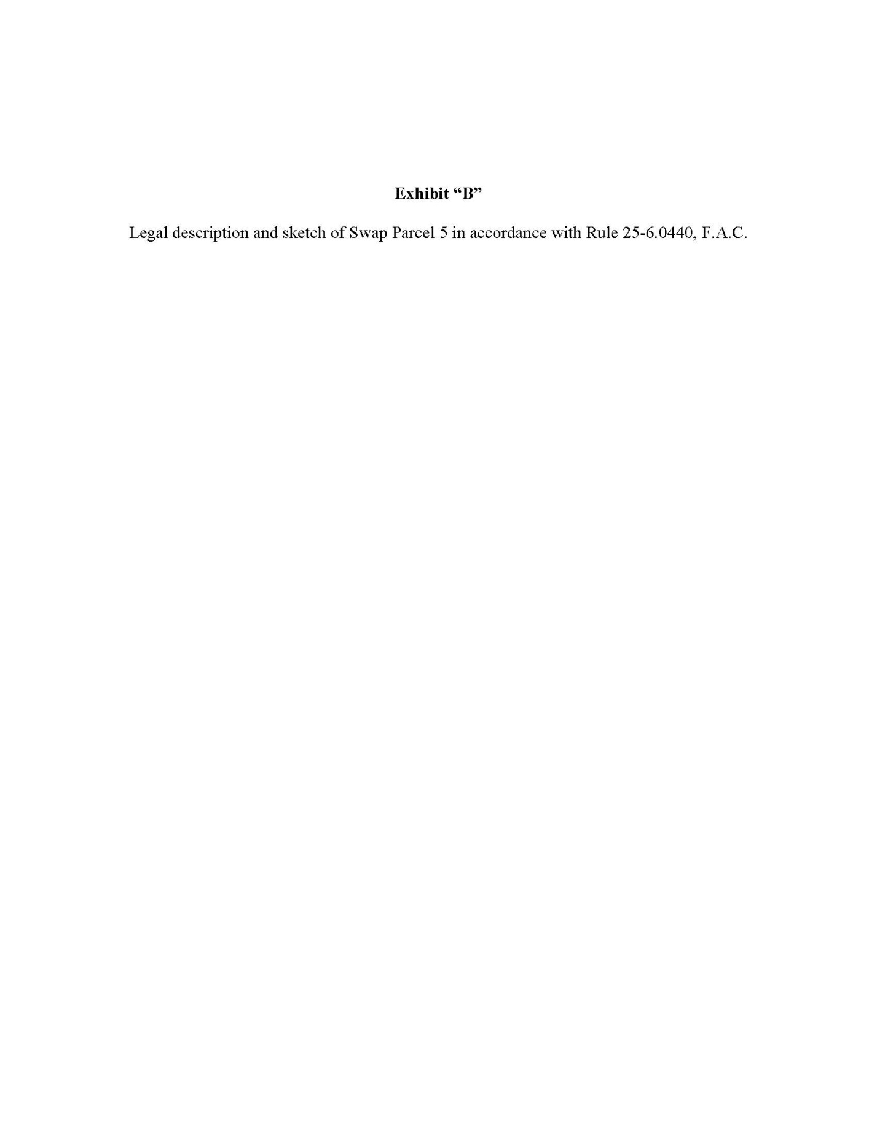

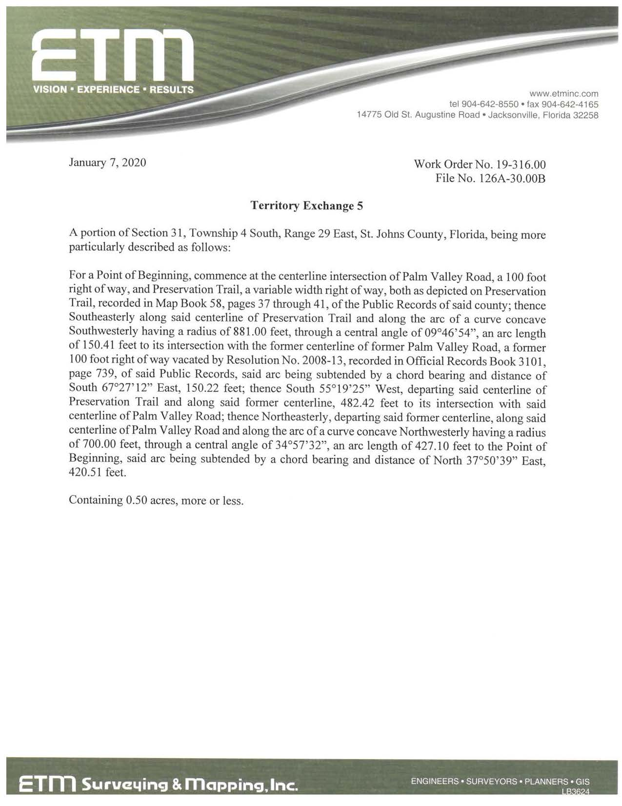

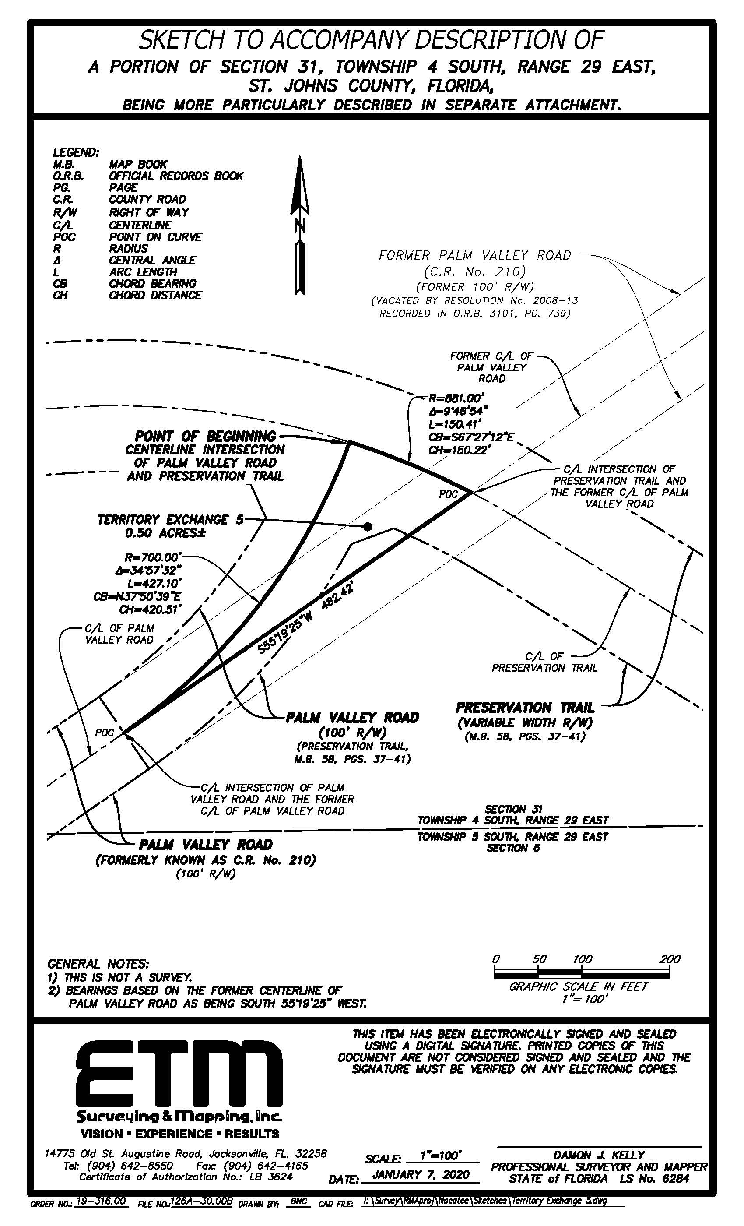
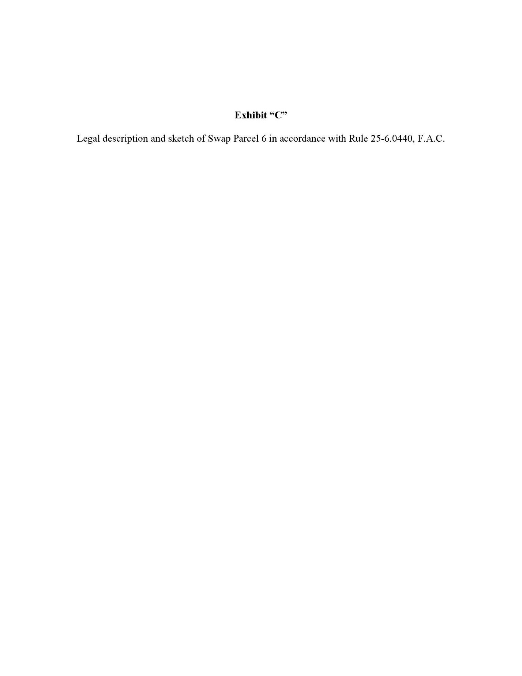

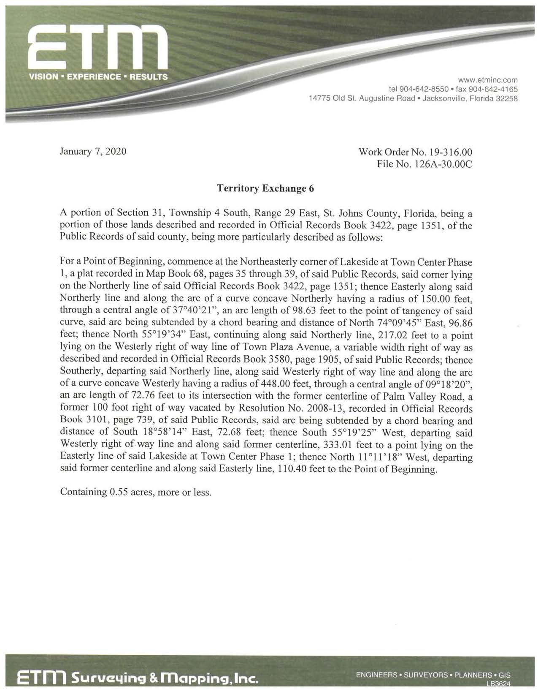

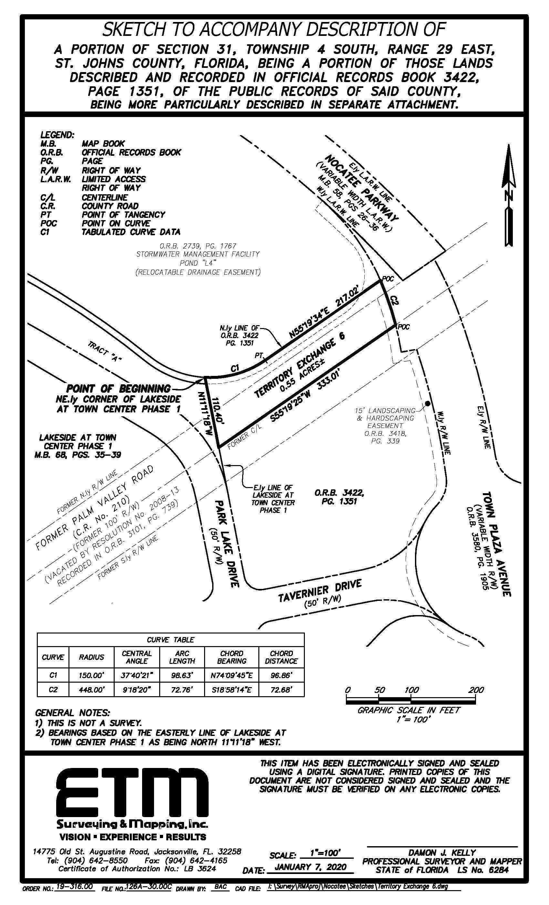
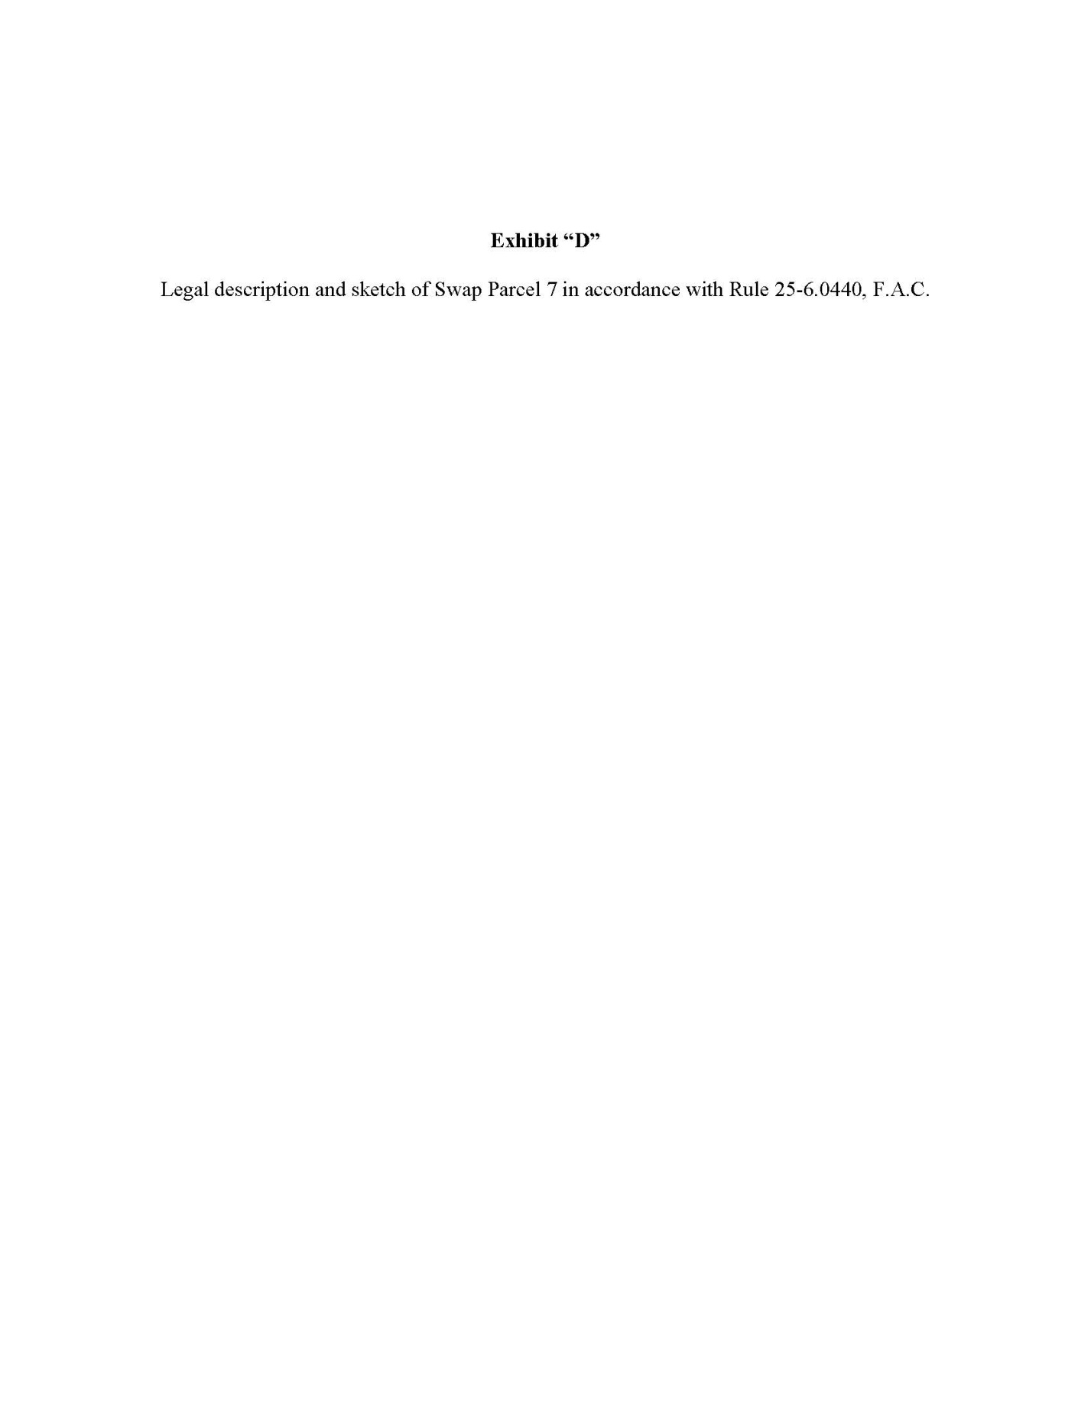

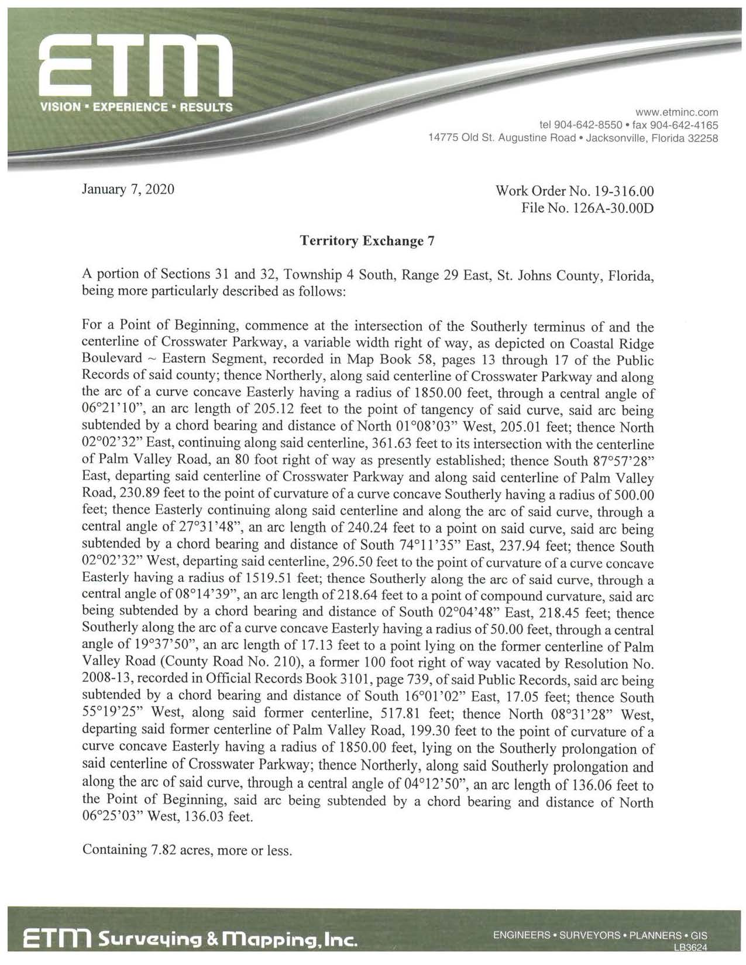

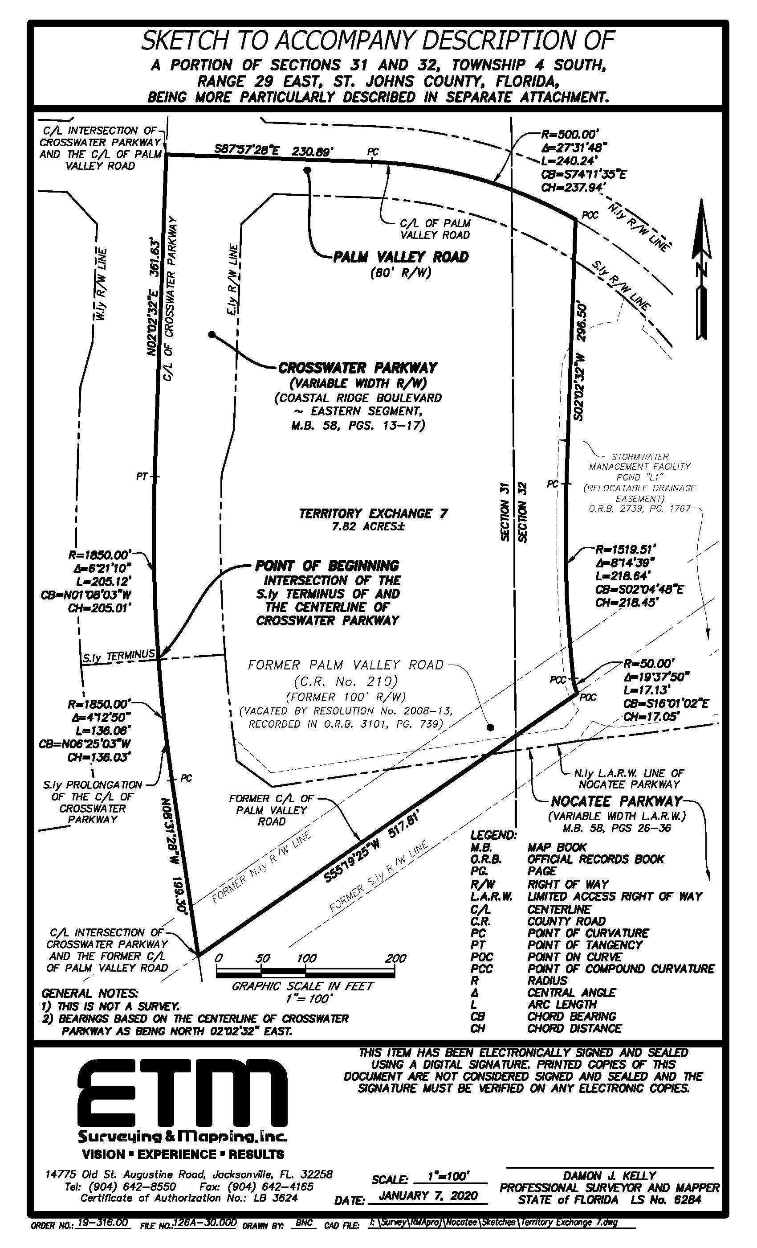
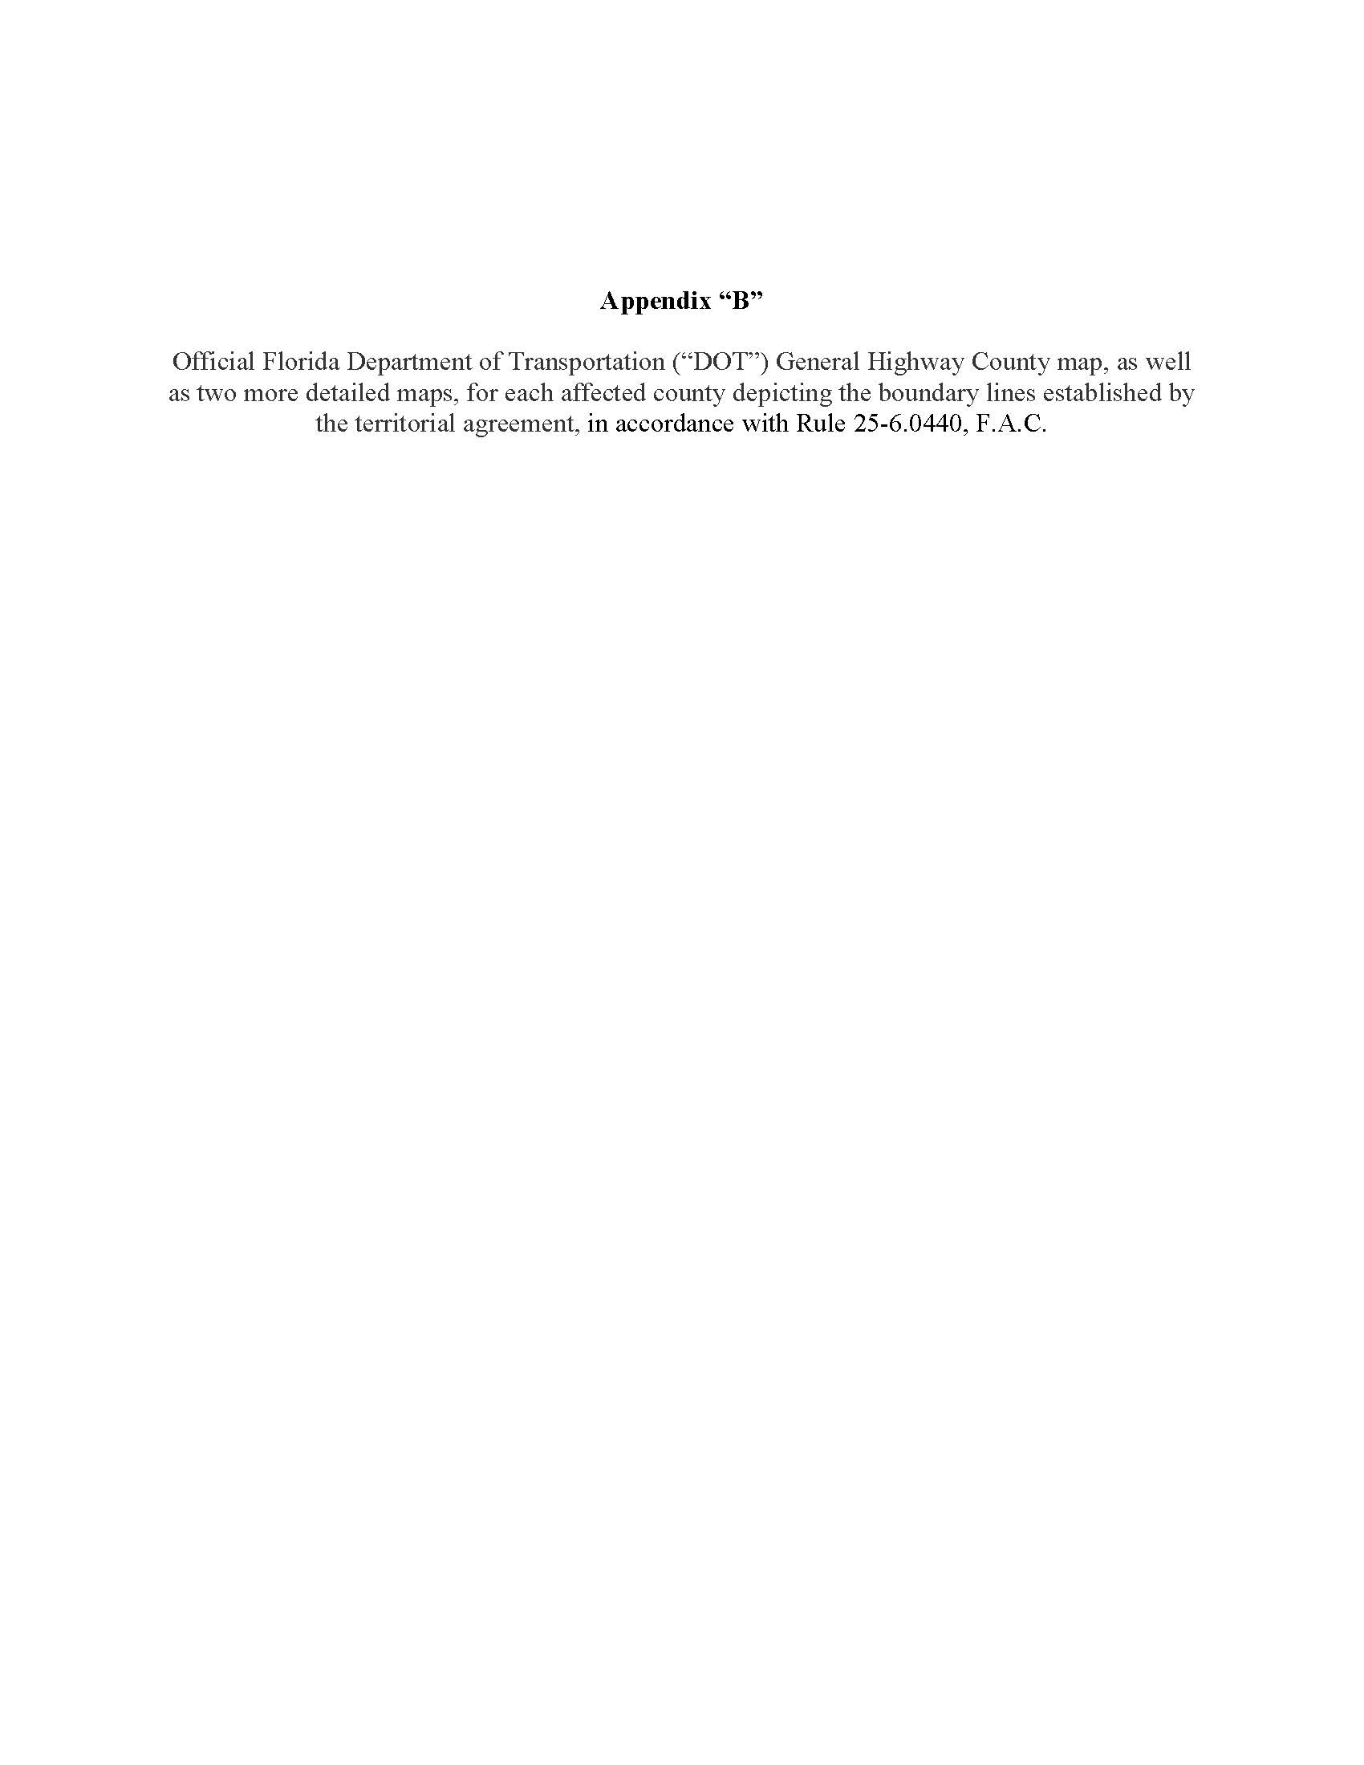

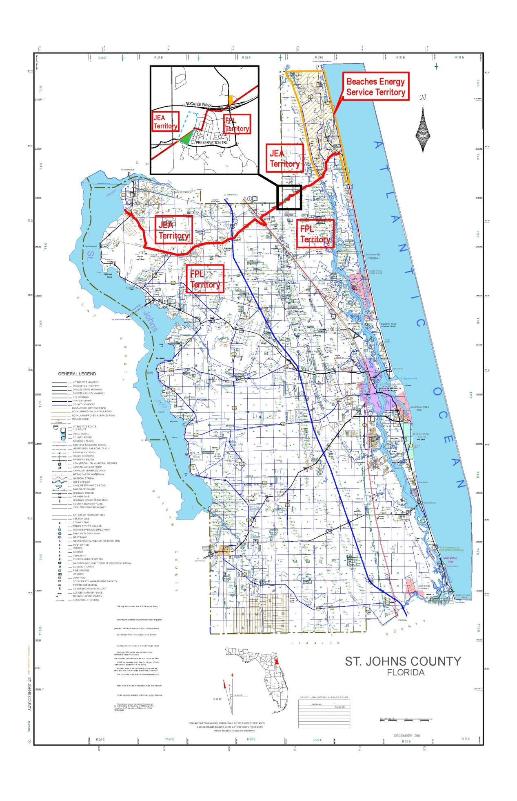
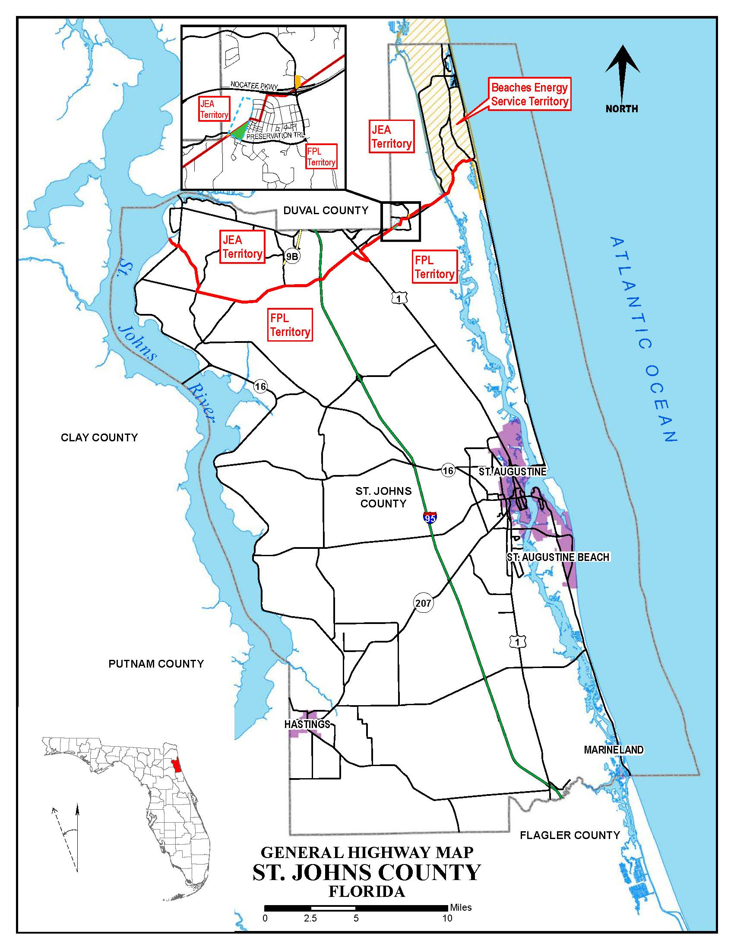
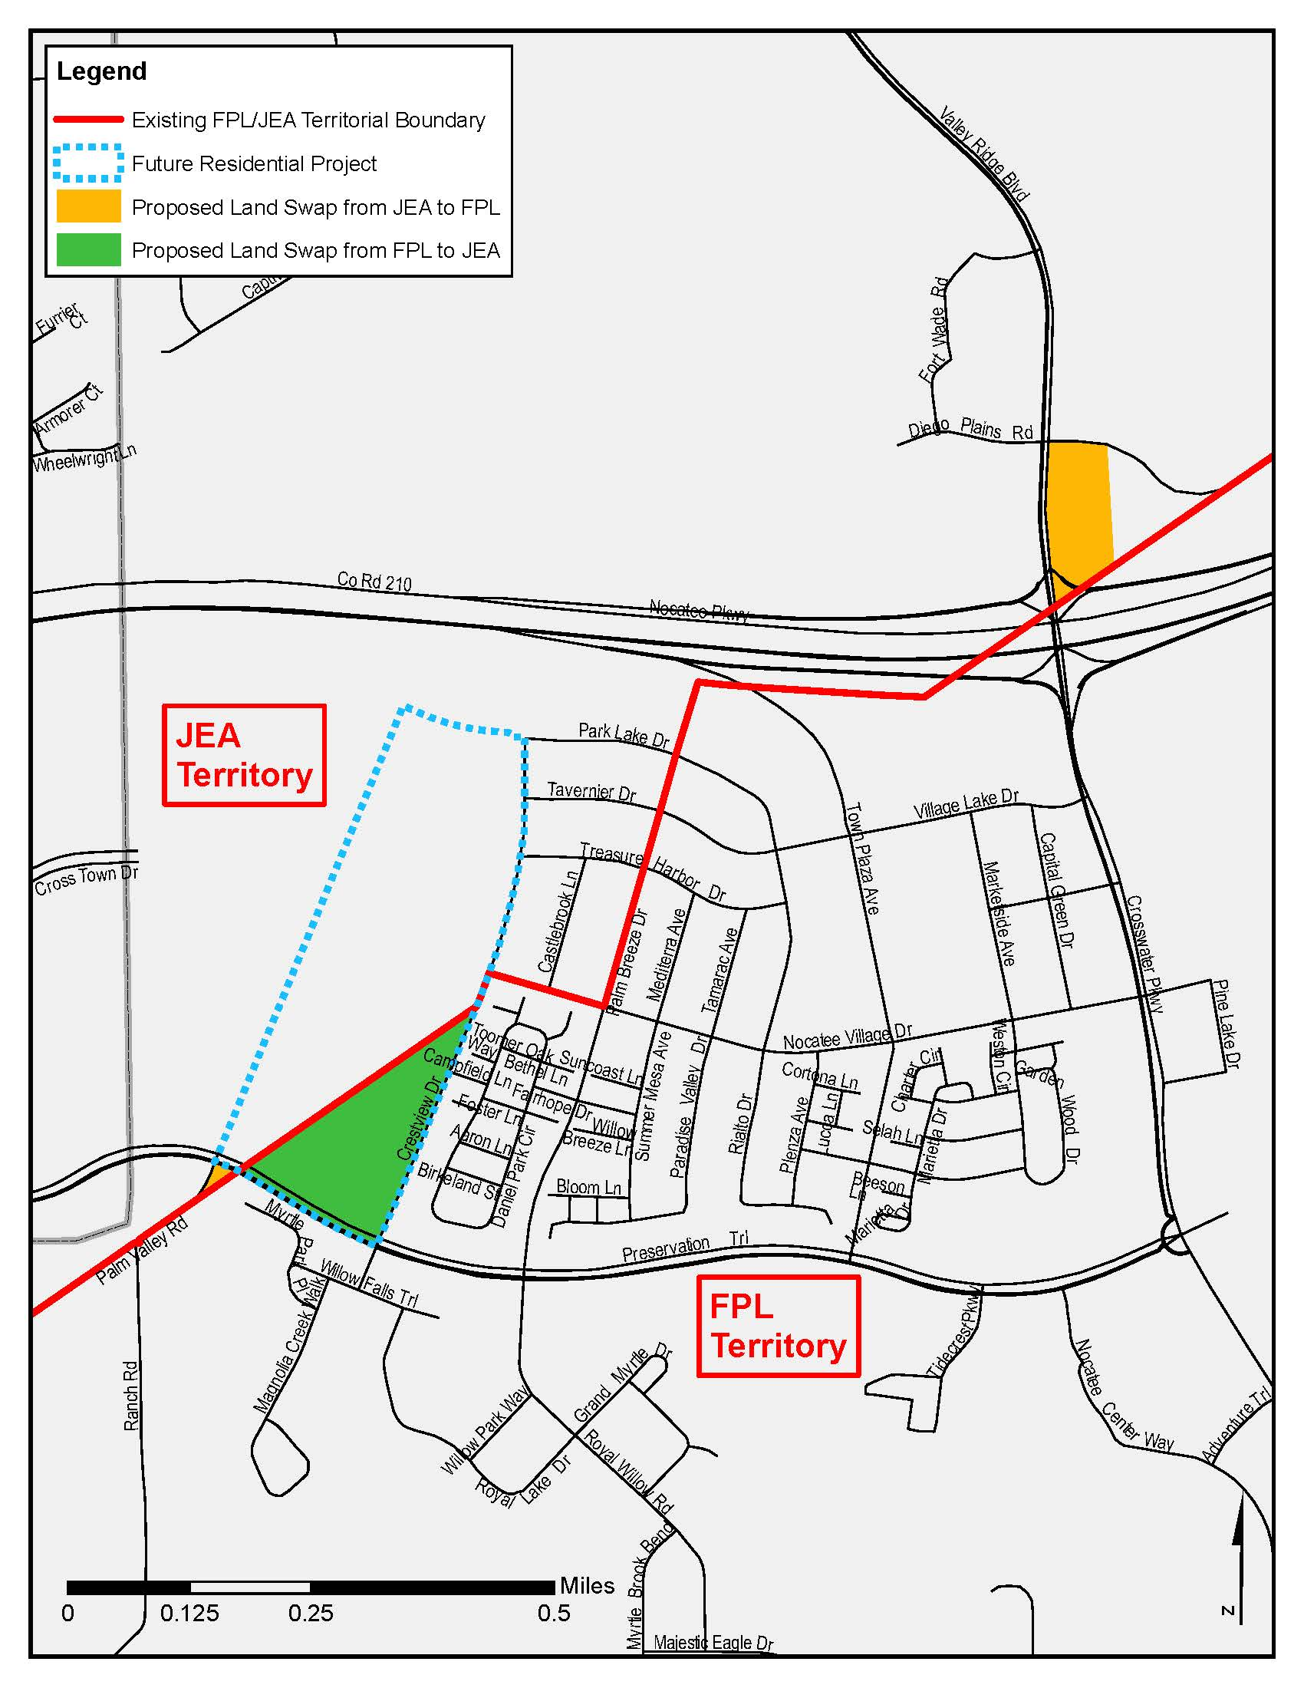

Order No. 3799, issued April 28, 1965, in Docket No. 7421-EU.
Order No. 9363, issued May 9, 1980, in Docket No. 790886-EU, In re: Petition of Jacksonville Electric Authority for approval of a territorial agreement between JEA and Florida Power and Light Company.
Order No. PSC-96-0212-FOF-EU, issued February 14, 1996, and finalized by Order No. PSC-96-0755-FOF-EU, issued June 10, 1996, in Docket No. 950307-EU, In re: Petition of Jacksonville Electric Authority to Resolve a Territorial Dispute With Florida Power & Light Company in St. Johns County.
Order No. PSC-98-1687-FOF-EU, issued December 14, 1998, in Docket No. 980755-EU, In re: Joint petition for approval of new territorial agreement between Florida Power & Light Company and Jacksonville Electric Authority.
Order No. PSC-12-0561-PAA-EU, issued October 22, 2012, in Docket No. 120171-EU, In re: Joint petition for approval of amendment to territorial agreement in St. Johns County between Florida Power & Light Company, a Florida corporation, and JEA, a Florida municipal corporation.
Order No. PSC-14-0469-PAA-EU, issued August 29, 2014, in Docket No. 20140130-EU, In re: Joint petition for approval of amendment to territorial agreement between Florida Power & Light Company and JEA.
Utilities Commission of the City of New Smyrna Beach v. Florida Public Service Commission, 469 So. 2d 731 (Fla. 1985).

